Two Variables: Regression
Orville D. Hombrebueno
2024-12-04
Table of contents

The Data

Motor Trend Car Road Tests
The data was extracted from the 1974 Motor Trend US magazine, and comprises fuel consumption and 10 aspects of automobile design and performance for 32 automobiles (1973–74 models).
A data frame with 32 observations on 11 (numeric) variables.
- mpg Miles/(US) gallon
- cyl Number of cylinders
- disp Displacement (cu.in.)
- hp Gross horsepower
- drat Rear axle ratio
- wt Weight (1000 lbs)
- qsec 1/4 mile time
- vs Engine (0 = V-shaped, 1 = straight)
- am Transmission (0 = automatic, 1 = manual)
- gear Number of forward gears
- carb Number of carburetors
The first 6 rows of the data set is shown in Table 1
Table 1: The first 6 observations of the data set.
 | mpg | cyl | disp | hp | drat | wt | qsec | vs | am | gear | carb
Mazda RX4 | 21.0 | 6 | 160 | 110 | 3.90 | 2.620 | 16.46 | 0 | 1 | 4 | 4
Mazda RX4 Wag | 21.0 | 6 | 160 | 110 | 3.90 | 2.875 | 17.02 | 0 | 1 | 4 | 4
Datsun 710 | 22.8 | 4 | 108 | 93 | 3.85 | 2.320 | 18.61 | 1 | 1 | 4 | 1
Hornet 4 Drive | 21.4 | 6 | 258 | 110 | 3.08 | 3.215 | 19.44 | 1 | 0 | 3 | 1
Hornet Sportabout | 18.7 | 8 | 360 | 175 | 3.15 | 3.440 | 17.02 | 0 | 0 | 3 | 2
Valiant | 18.1 | 6 | 225 | 105 | 2.76 | 3.460 | 20.22 | 1 | 0 | 3 | 1

Descriptive Statistics
The mean, standard deviation, minimum, and maximum of mpg and wt is shown in Table 2. There are a total of 32 observations.
Table 2: Summary statistics.
Characteristic | N = 32¹
mpg | 20.09 ± 6.03 (10.40 - 33.90)
wt | 3.22 ± 0.98 (1.51 - 5.42)
¹Mean ± SD (Min - Max)

Linear Regression
A linear regression model was used to approximate the relationship between miles/(US) gallon and Weight (1000 lbs). The response variable is mpg and the explanatory variable is wt. The model summary is shown in Table 3.
Table 3: Summary of least squares fit for the mpg and wt.
term | estimate | std_error | statistic | p_value | lower_ci | upper_ci
intercept | 37.285 | 1.878 | 19.858 | 0 | 33.450 | 41.120
wt | -5.344 | 0.559 | -9.559 | 0 | -6.486 | -4.203

With the p-values less than 5%, there is strong evidence that the estimates are significantly different from 0. Weight (1000lb) significantly predicts miles/(US) gallon. For each additional weight (1000lb), the model predicts a decrease of 5.344 miles/(US) gallon. Figure 1 shows the plot of mpg vs wt and the predicted values. About 75% of the variability in miles/(US) gallon is explained by weight (1000lb) in the model. This also suggests a strong negative linear association between the variables.
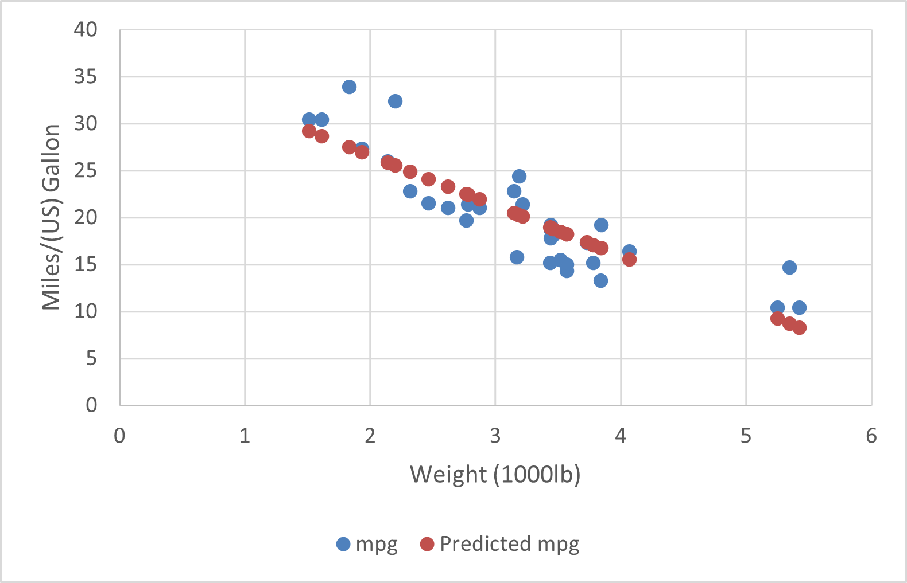
Figure 1: Scatterplot of mpg and hp.

