Two Variables: Quantitative
Orville D. Hombrebueno
2024-12-04
Table of contents

The Data

Motor Trend Car Road Tests
The data was extracted from the 1974 Motor Trend US magazine, and comprises fuel consumption and 10 aspects of automobile design and performance for 32 automobiles (1973–74 models).
A data frame with 32 observations on 11 (numeric) variables.
- mpg Miles/(US) gallon
- cyl Number of cylinders
- disp Displacement (cu.in.)
- hp Gross horsepower
- drat Rear axle ratio
- wt Weight (1000 lbs)
- qsec 1/4 mile time
- vs Engine (0 = V-shaped, 1 = straight)
- am Transmission (0 = automatic, 1 = manual)
- gear Number of forward gears
- carb Number of carburetors
The first 6 rows of the data set are shown in Table 1
Table 1: The first 6 observations of the data set.
 | mpg | cyl | disp | hp | drat | wt | qsec | vs | am | gear | carb
Mazda RX4 | 21.0 | 6 | 160 | 110 | 3.90 | 2.620 | 16.46 | 0 | 1 | 4 | 4
Mazda RX4 Wag | 21.0 | 6 | 160 | 110 | 3.90 | 2.875 | 17.02 | 0 | 1 | 4 | 4
Datsun 710 | 22.8 | 4 | 108 | 93 | 3.85 | 2.320 | 18.61 | 1 | 1 | 4 | 1
Hornet 4 Drive | 21.4 | 6 | 258 | 110 | 3.08 | 3.215 | 19.44 | 1 | 0 | 3 | 1
Hornet Sportabout | 18.7 | 8 | 360 | 175 | 3.15 | 3.440 | 17.02 | 0 | 0 | 3 | 2
Valiant | 18.1 | 6 | 225 | 105 | 2.76 | 3.460 | 20.22 | 1 | 0 | 3 | 1

Descriptive Statistics
The mean, standard deviation, minimum, and maximum of hp and mpg in the mtcars data set are shown in Table 2. There are a total of 32 observations.
Table 2: Summary statistics of the data set.
Characteristic | N = 32¹
mpg | 20.09 ± 6.03 (10.40 - 33.90)
hp | 146.69 ± 68.56 (52.00 - 335.00)
¹Mean ± SD (Min - Max)
A visualization of miles/(US) gallon and gross horsepower is shown in Figure 1.
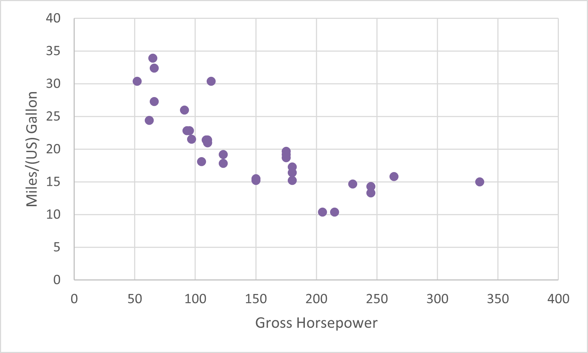
Figure 1: Scatterplot of mpg and hp.

Hypothesis Testing

Research Question
Is there a significant relationship between gross horsepower and miles/(US) gallon?

Hypothesis and Test Statistics
- $H_{0}:ρ=0$; there is no linear relationship between gross horsepower and miles/(US) gallon.
- $H_{a}:ρ≠0$; there is a linear relationship between gross horsepower and miles/(US) gallon.
- Significance level, $α=5\%$.
- Pearson correlation
- $n>30$; large sample.

Results and Interpretation
The test statistics is shown on Table 3.
Table 3: Test statistics.
estimate | statistic | p.value | method
-0.78 | -6.74 | 0 | Pearson’s product-moment correlation

Based on the p-value being less than 5% (p-value = .001), we reject the null hypothesis. There is strong evidence of a linear relationship between gross horsepower and miles/(US) gallon. The correlation ($ρ=−0.78$) suggests a moderate negative relationship between the two variables. Increased gross horsepower is moderately associated with decreased miles/(US) gallon.

