Two Variables: Qualitative and Quantitative
Orville D. Hombrebueno
2024-12-04
Table of contents

The Data

Motor Trend Car Road Tests
The data was extracted from the 1974 Motor Trend US magazine, and comprises fuel consumption and 10 aspects of automobile design and performance for 32 automobiles (1973–74 models).
A data frame with 32 observations on 11 (numeric) variables.
- mpg Miles/(US) gallon
- cyl Number of cylinders
- disp Displacement (cu.in.)
- hp Gross horsepower
- drat Rear axle ratio
- wt Weight (1000 lbs)
- qsec 1/4 mile time
- vs Engine (0 = V-shaped, 1 = straight)
- am Transmission (0 = automatic, 1 = manual)
- gear Number of forward gears
- carb Number of carburetors
The first 6 rows of the data set are shown in Table 1
Table 1: The first 6 observations of the data set.
 | mpg | cyl | disp | hp | drat | wt | qsec | vs | am | gear | carb
Mazda RX4 | 21.0 | 6 | 160 | 110 | 3.90 | 2.620 | 16.46 | 0 | 1 | 4 | 4
Mazda RX4 Wag | 21.0 | 6 | 160 | 110 | 3.90 | 2.875 | 17.02 | 0 | 1 | 4 | 4
Datsun 710 | 22.8 | 4 | 108 | 93 | 3.85 | 2.320 | 18.61 | 1 | 1 | 4 | 1
Hornet 4 Drive | 21.4 | 6 | 258 | 110 | 3.08 | 3.215 | 19.44 | 1 | 0 | 3 | 1
Hornet Sportabout | 18.7 | 8 | 360 | 175 | 3.15 | 3.440 | 17.02 | 0 | 0 | 3 | 2
Valiant | 18.1 | 6 | 225 | 105 | 2.76 | 3.460 | 20.22 | 1 | 0 | 3 | 1

Descriptive Statistics
The mean, standard deviation, minimum, and maximum of mpg when grouped according to am are shown in Table 2. There are a total of 32 observations.
Table 2: Summary statistics.
Characteristic | Automatic N = 19¹ | Manual N = 13¹
mpg | 17.15 ± 3.83 (10.40 - 24.40) | 24.39 ± 6.17 (15.00 - 33.90)
¹Mean ± SD (Min - Max)
A visualization of miles/(US) gallon when grouped according to transmission is shown in Figure 1.
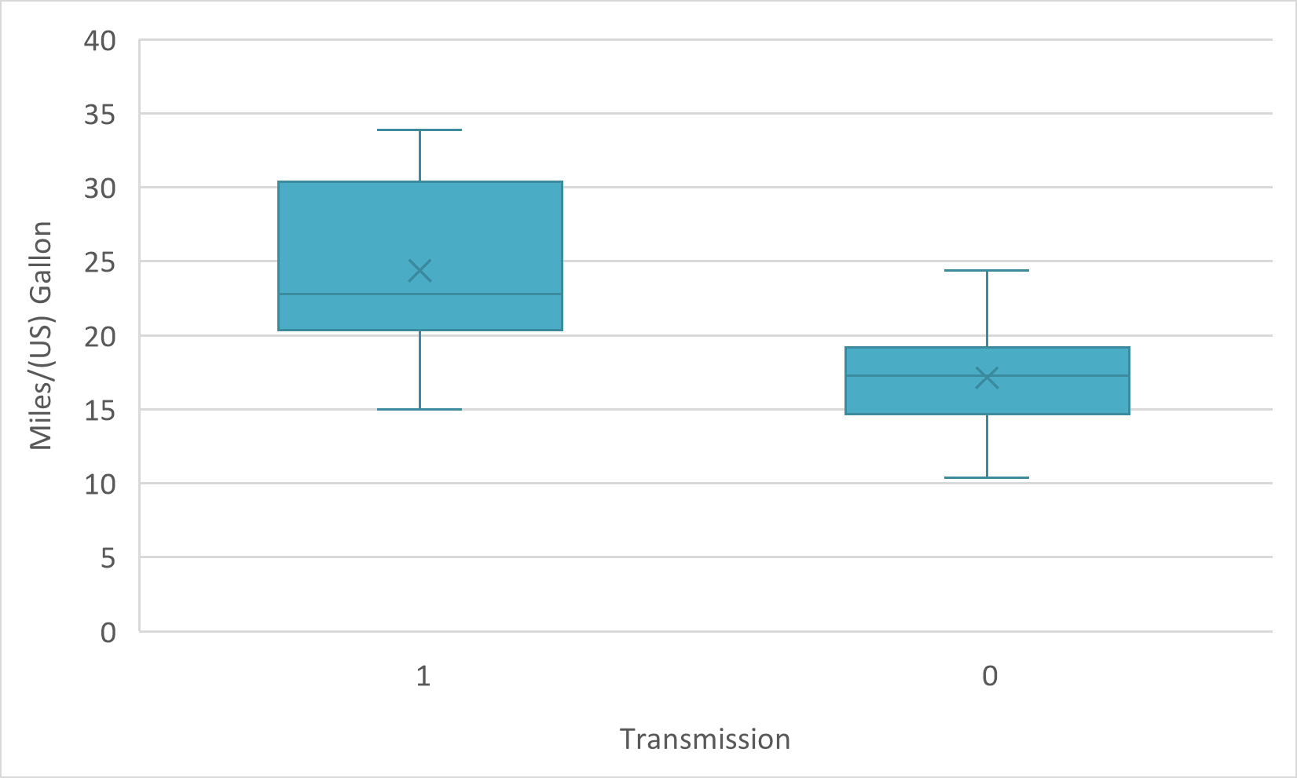
Figure 1: Box plot of mpg by am.

Hypothesis Testing

Research Question
Is there a significant difference in miles/(US) gallon when grouped according to transmission?

Hypothesis and Test Statistics
- $H_{0}:μ_{A}=μ_{M}$; the mean miles/(US) gallon is the same when grouped according to transmission.
- $H_{a}:μ_{A}≠μ_{M}$; the mean miles/(US) gallon is different when grouped according to transmission.
- Significance level, $α=5\%$.
- Welch’s t-test for 2 independent samples
- Unknown and unequal variance (see Table 3).
Table 3: Levene’s test for homogeneity of variance.
statistic | p.value | df | df.residual
5.92 | 0.02 | 1 | 30

- Both samples follow a normal distribution (see Table 4).
Table 4: Jarque-Bera normality test.
transmission | statistic | p.value | method
Automatic | 0.24 | 0.89 | Jarque Bera Test
Manual | 0.77 | 0.68 | Jarque Bera Test

Results and Interpretation
The test statistics is shown in Table 5.
Table 5: Test statistics.
automatic | manual | statistic | p.value | method | alternative
17.15 | 24.39 | -3.77 | 0 | Welch Two Sample t-test | two.sided

Based the p-value being less than 5% (p-value = .001), we reject the null hypothesis. There is strong evidence that the mean miles/(US) gallon is different when grouped according to transmission. Cars with manual transmission tend to have a higher mean miles/(US) gallon. Thus, manual cars are more fuel efficient compared to automatic cars.

