Matthew Ell

2015_05_26

PART III

What is GitHub?

**Github is a collaboration tool for building software. It works with Git, the version tracking software and provides features such as bug tracking, wiki and code review. It’s most powerful feature (arguably) is that a project can be made public and anyone can contribute code to the project.**

When was it created? Why? By who? What similar platforms exist?

**Github was founded in early 2008 by Tom Preston-Werner, Chris Wanstrath and PJ Hyett. It was created out of a need to securely share private code. The only other option at the time was to setup user accounts on Unix machines and use that as a ad-hoc solution. Bitbucket is another service similar to Github but does not have the social networking aspect to it.**

Why would you use such a platform? (Answer between 5 and 10 lines)

**I currently use Github but would like to utilize it more. I’d like to use it to open source things like plugins, scripts and pollyfills, which would allow others to contribute, make improvements and comment. Additionally, I’d like to make use of the Wiki and Issue tracker that comes along with each project. Of course, these are features that require team collaboration. Currently, I use Github to host my personal homepage which provides a lot of convenience when making edits to my site.**

PART IV

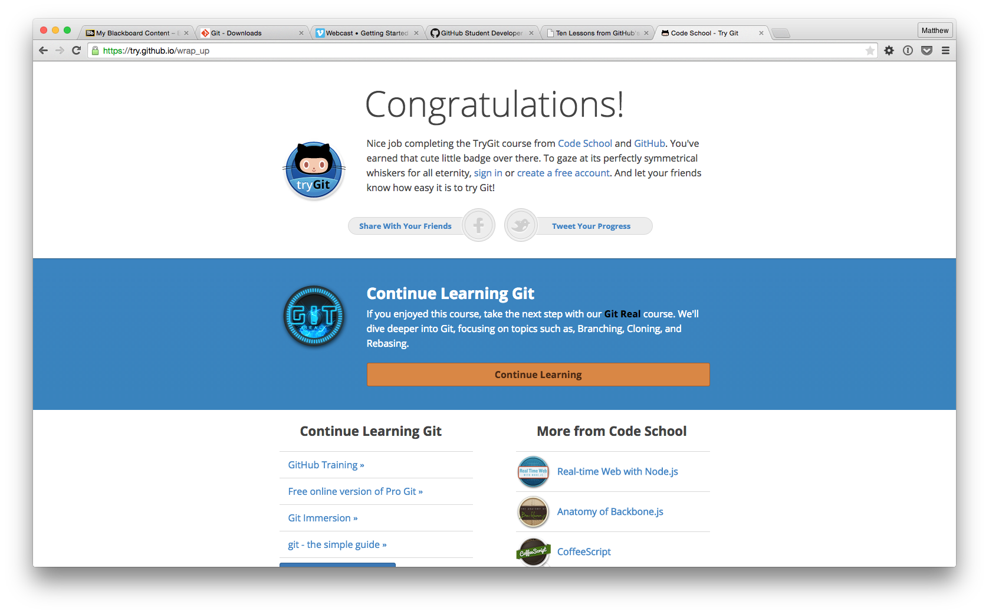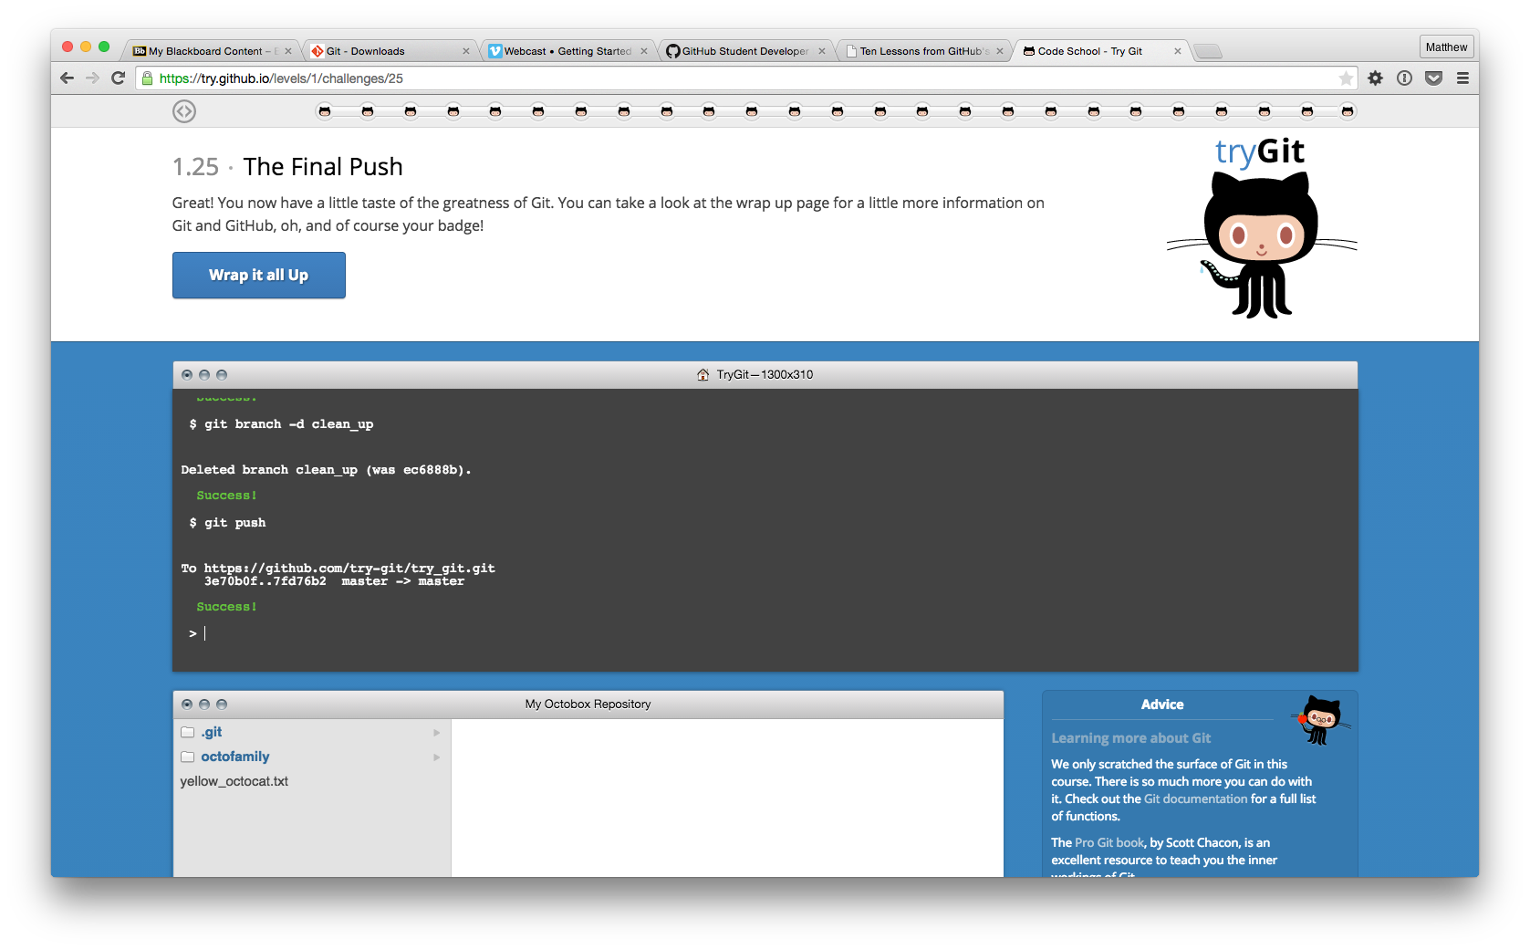

PART V

Define the following terms in the context of Git (2 lines maximum):

Repository

**The directory where all the code lives: files, folders, etc.. When creating a new repository, a folder called .git/ is created which contains all the git files.**

Commit

**A commit is a “snapshot” of a directory, which gets saved to the repository. A commit message is added to provide context.**

Push

**A push is made when changes are sent from one repository to another. This is usually done from a local repository to a remote version of that repository.**

Branch

**A branch is a version of the repository that can live separately from other branches in a repository. A branch can be used to develop new code on a clean version.**

Fork

**A fork is essentially a clone of a repository which starts with a code base but ultimately ends with added features or repurposed code.**

Merge

**A merge is used to combine two branches in a repository.**

Clone

**Cloning a repository essentially means to copy/download. When cloning you get all the files in a repository as well as the actual git files.**

Pull

**Pulling can be considered downloading changes in a remote repository to a local version.**

Pull request

**A pull request is proposed code that the contributor would like to be merged into a projects repository. This requires the repository author to approve the code first.**

PART VII

**To update the README.md file on** [**https://github.com/paceuniversity/courses**](https://github.com/paceuniversity/courses) **I needed to submit a pull request in Github. I was not able to clone the repository and push my changes locally because of permissions. Github allows you to submit a pull request through there web interface. This was the most convenient way to do it.**

PART X

What is your experience with GitHub? Describe it in 5-10 lines.

**I’ve used Github on a personal basis for several years. I’ve used it to host code for projects I’ve built for the blogging CMS WordPress. I also have tried to contribute to a few projects but nothing substantial. At work, I use Bitbucket simply because it gives us free private repositories. However, I do think that Github provides a better service.**