Fokker-Planck Diffusion Approximation

Assumptions:
- Succesive moves are independent.
- Individual at location x moves at rate μ(x,t):
Pr{move in (t,t+τ )}=τμ(x,t)+O(τ²)
Pr{more than one move in (t,t+τ )}= O(τ²)
- The step-length λ, for a move starting at x is random with density M(λ,x,t).
- Movement is the only process affecting the population density p(x,t).

Balance law:
Be here now = [been here, stayed put]
+ [made a move here]
+ [moved >1 time]

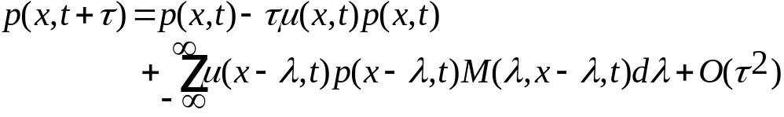

Re-arrange to get

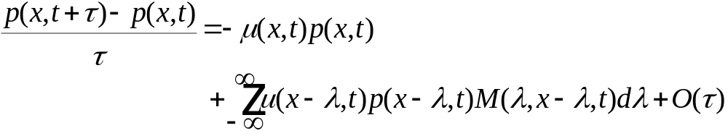
Let τ→0

(1) 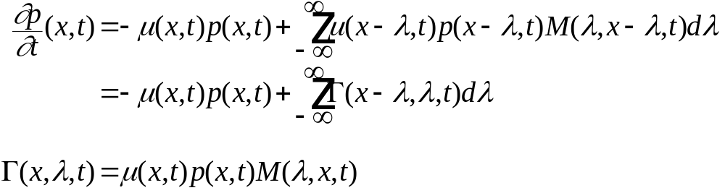

(1) 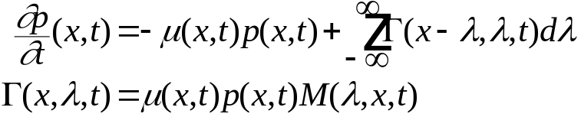

Diffusion Approximation to (1)
Taylor-series for 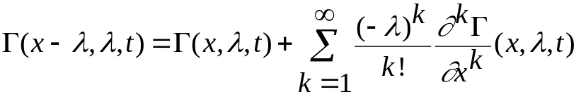
Do the integrals

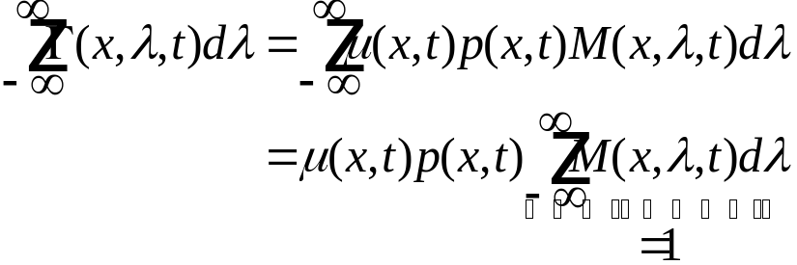

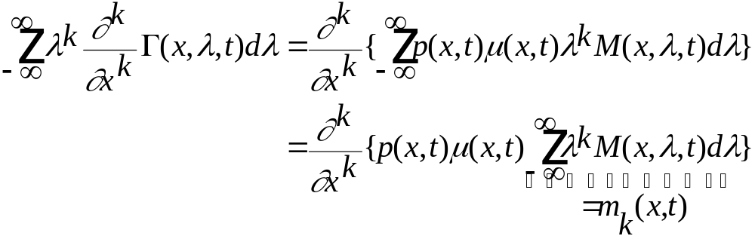
Plug back into (1)

(2) 