Assignment#2  
Ellaha Samadi

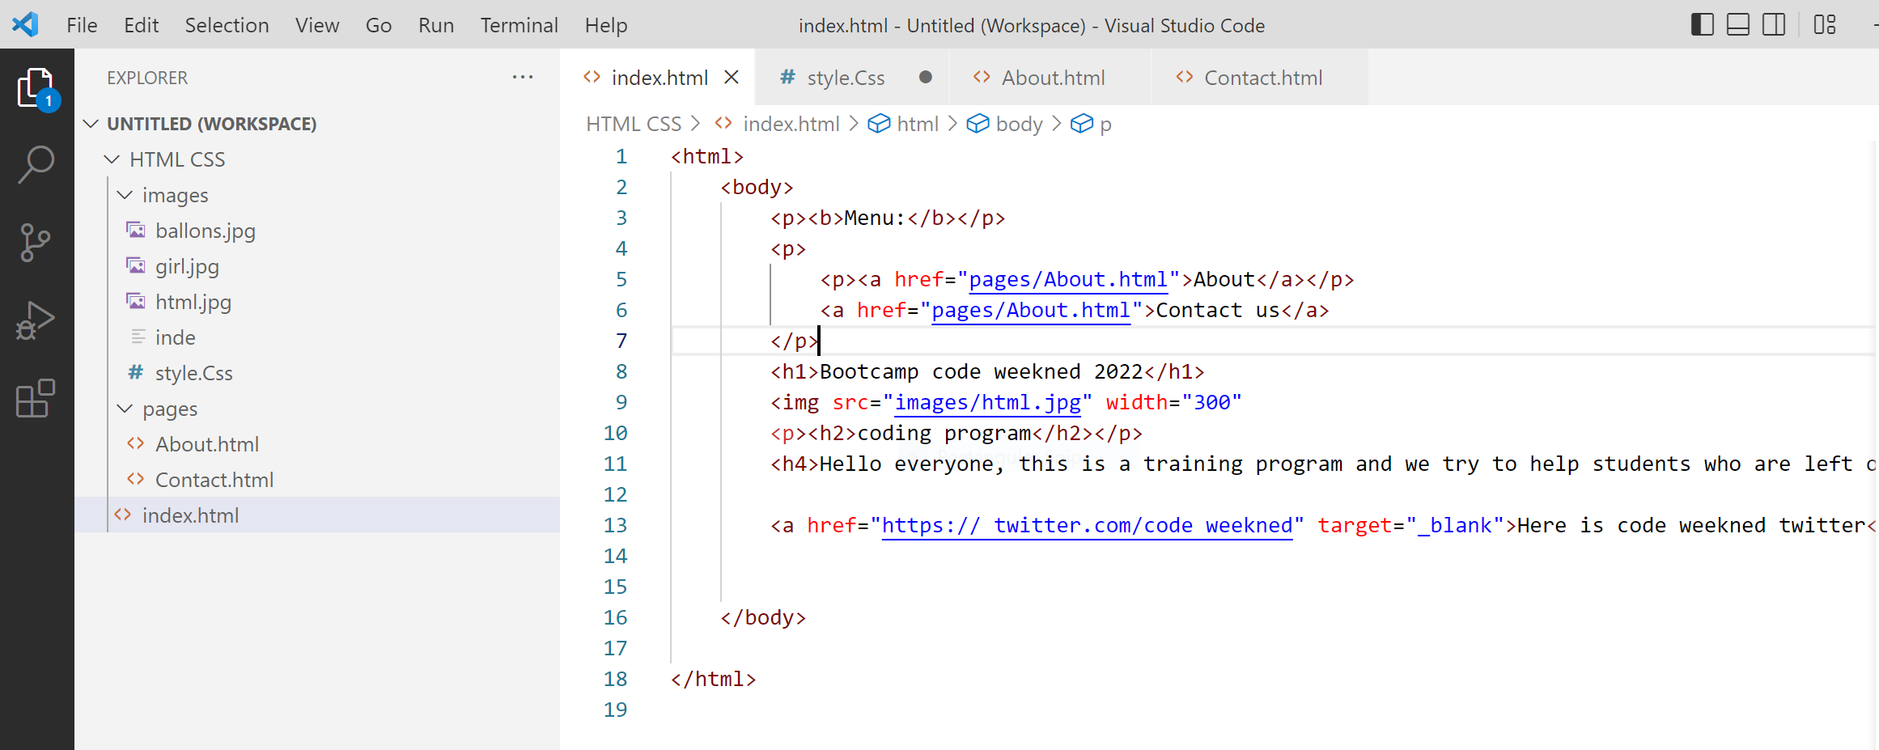

Index page

In this page I can add link of about and contact I can add heading and a profile picture and title and a short description.

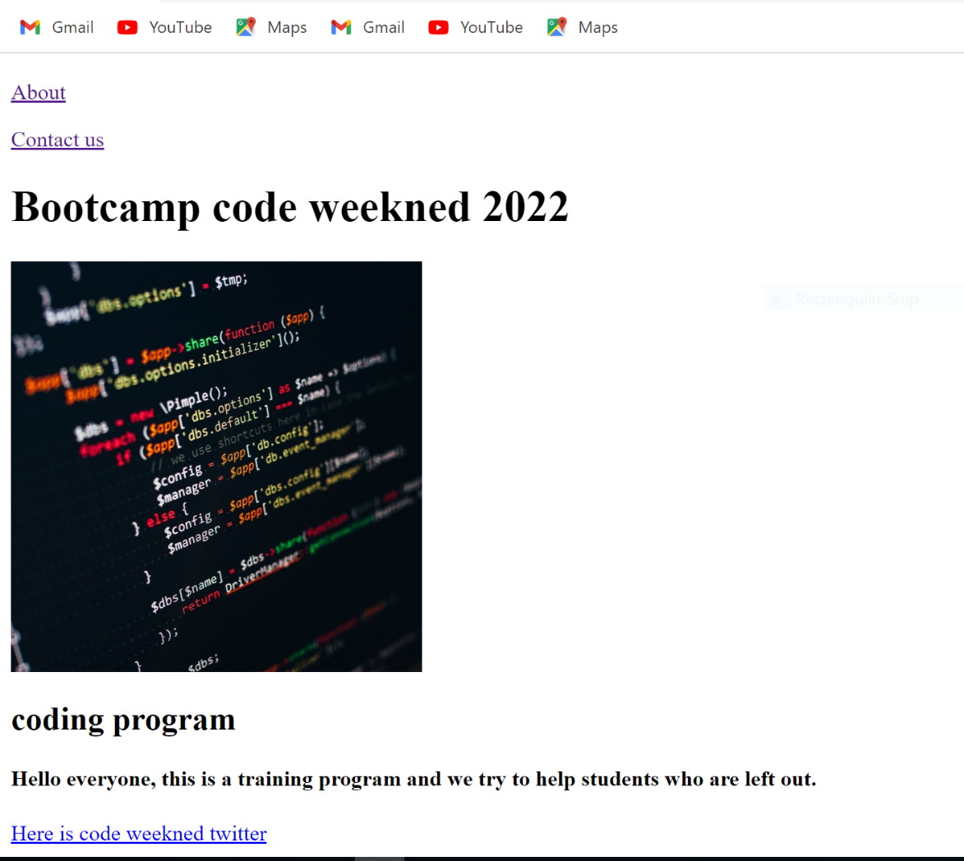

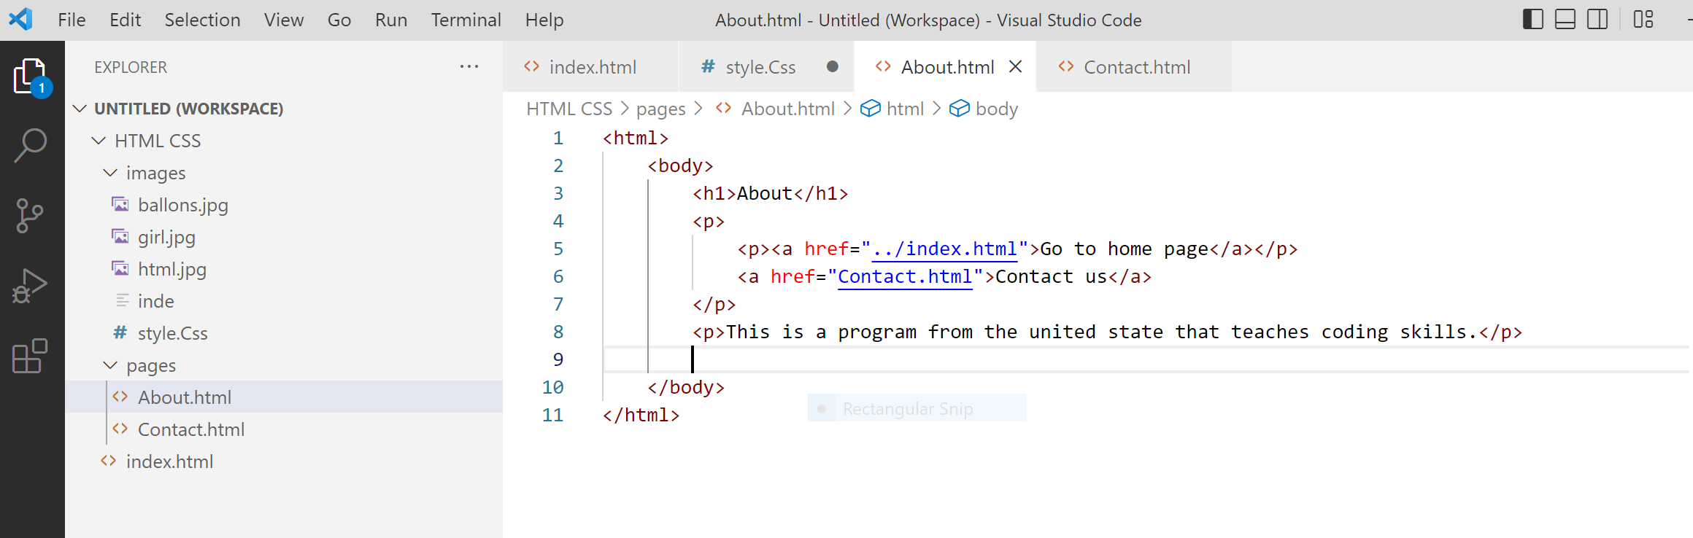

About page

In this page I can add link of go to home page and contact us and a small paragraph.

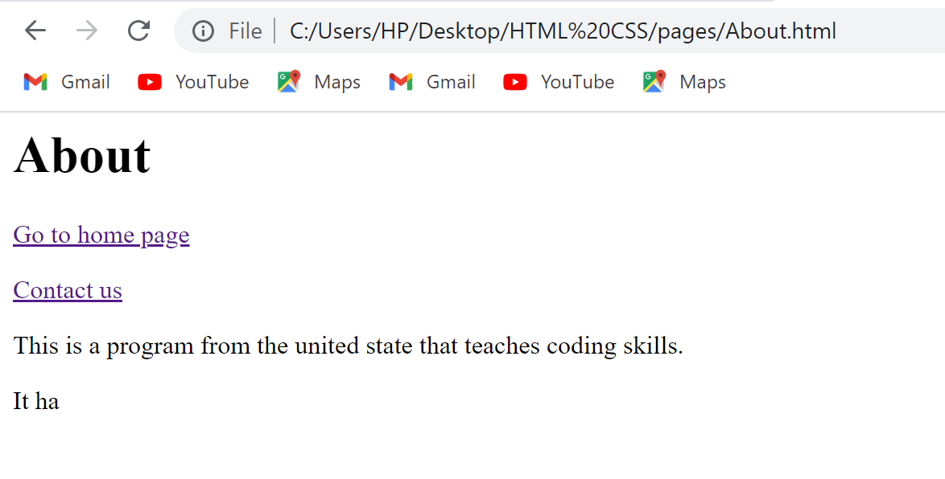

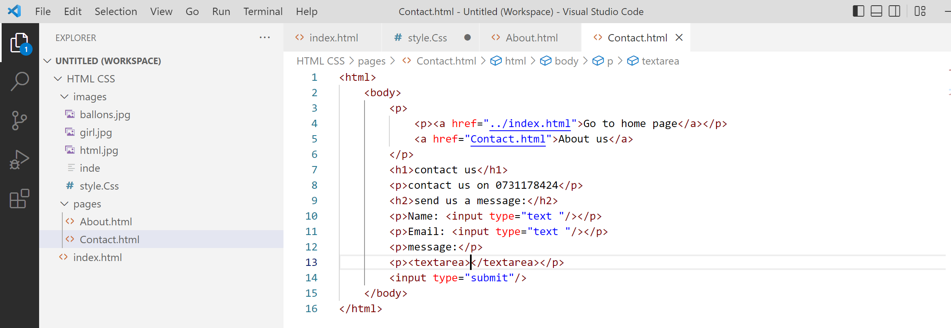

Contact page

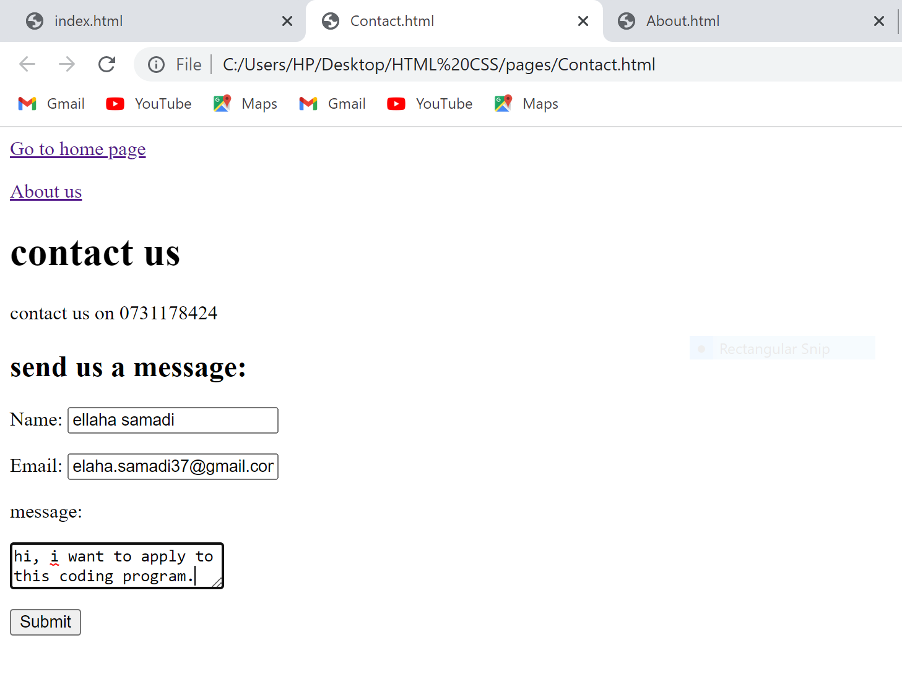

In this page I can add link of go to home page and about us