

Process

Carmen Gagnon

Februrary 2024

Content

Work Organization 3

Step 1 – Encode the orders 4

Step 2 – Print Summary of Orders 6

Step 3 – Print Summary of Deliveries 7

Step 4 – Print the Order Slips 8

Step 5 – After Delivery Modifications 9

Step 6 – Payments 10

# Work Organization

The work is organized around orders that arrive in multiple ways. All orders must be entered into the system as they come. Order slips can be printed individually or depending on the area and the order date.

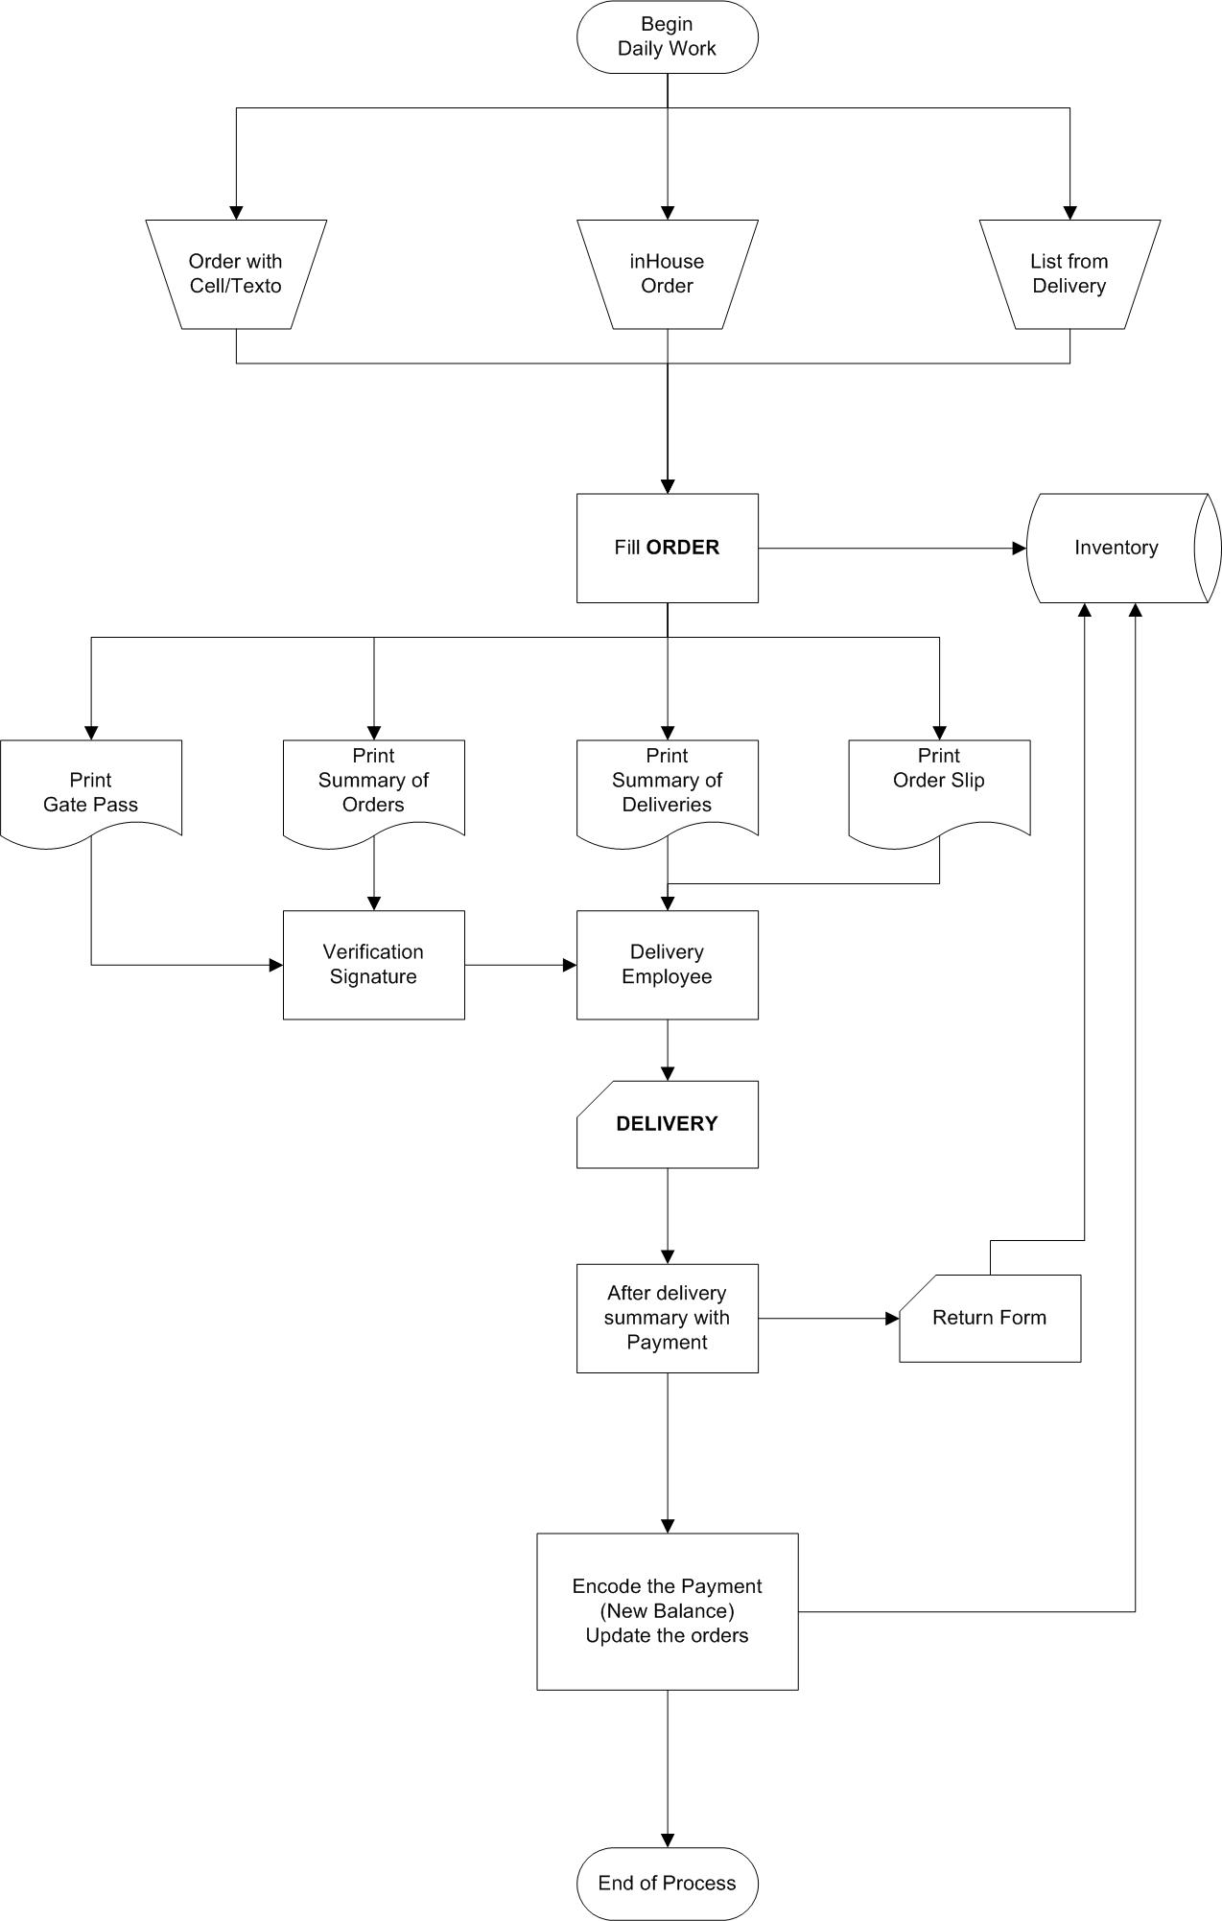

Deliver

Adjust

Payment

Orders

## Step 1 – Encode the orders

Each order will be entered into the system as it comes from textos, cell phone or deliveries reports. I would suggest that you continue to write manually the orders to the factory.

It can be encoded in an Excel sheet like before and at the end of the day, create all orders in POSAM. But I think it will be more effective if you encode directly in the database.

Orders – Add Order

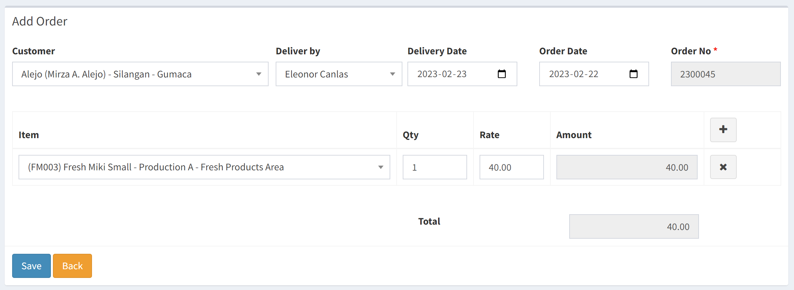

Since the delivery is normally one day later, delivery date will be automatically for tomorrow. You can change the delivery date.

When you press SAVE, you get the order updated. You will see the previous balance and amount due. You can modify the order if you need and/or add new items with the +. It’s also possible to modify the rate of the item. In this case, the customer will be charged the rate you indicated in the order. You can print the order after updating but I would suggest you wait at the end of the day to print all the orders of the day at the same time. If you wait, the customer can add more items during the day and you won’t have to print again the order. If you want to see the details about the customer you can press the icon. You will then be redirected in the customer details. The order will also appear in the order list of the customer and you can press the order to come back to the order.

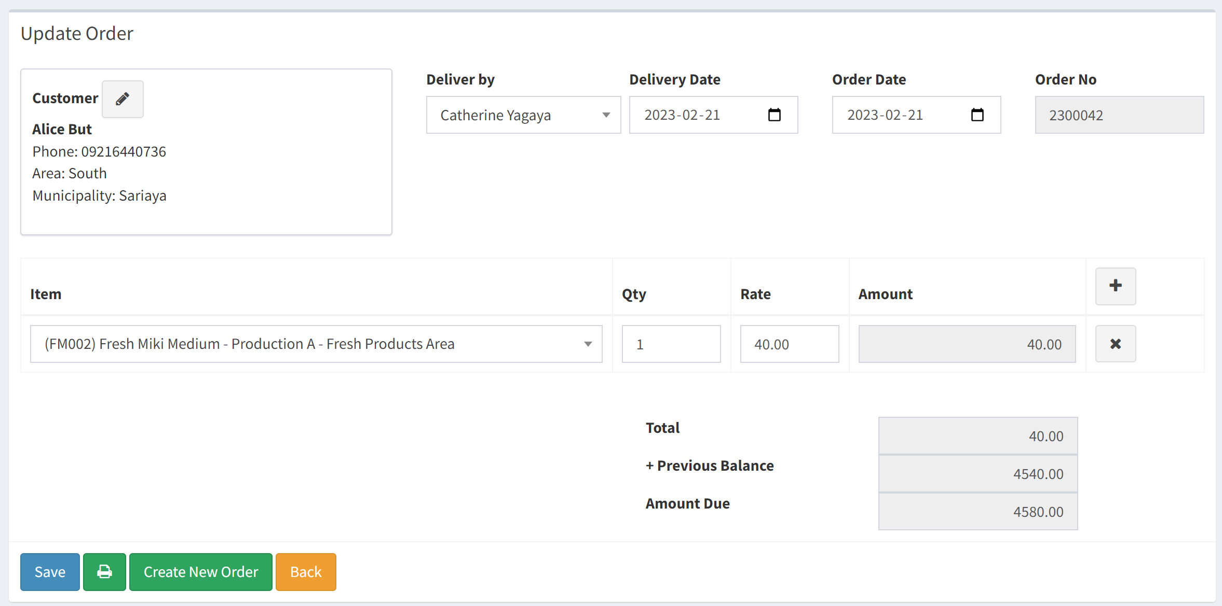

You don’t need to save again the order if nothing changed. From here, you can create the next order by pressing Create New Order. This would be the normal sequence of creating all the orders.

During the day, you will update the orders of the customer. You can print the summary of orders to help the working sequence on the factory. This summary can be print for a specific area and the extraction is on the order date.

To check if a customer has already placed their order TODAY, you can use the Customer section. A column will tell you if an order has already been placed. You will be able to contact the customer quickly using the telephone number indicated.

You can search quickly a customer by using the Search box. You can enter the name or if you want to work the customer by area, just enter the area. You can change the sorting of data by tapping on the column. So you will quickly see who placed an order or not.

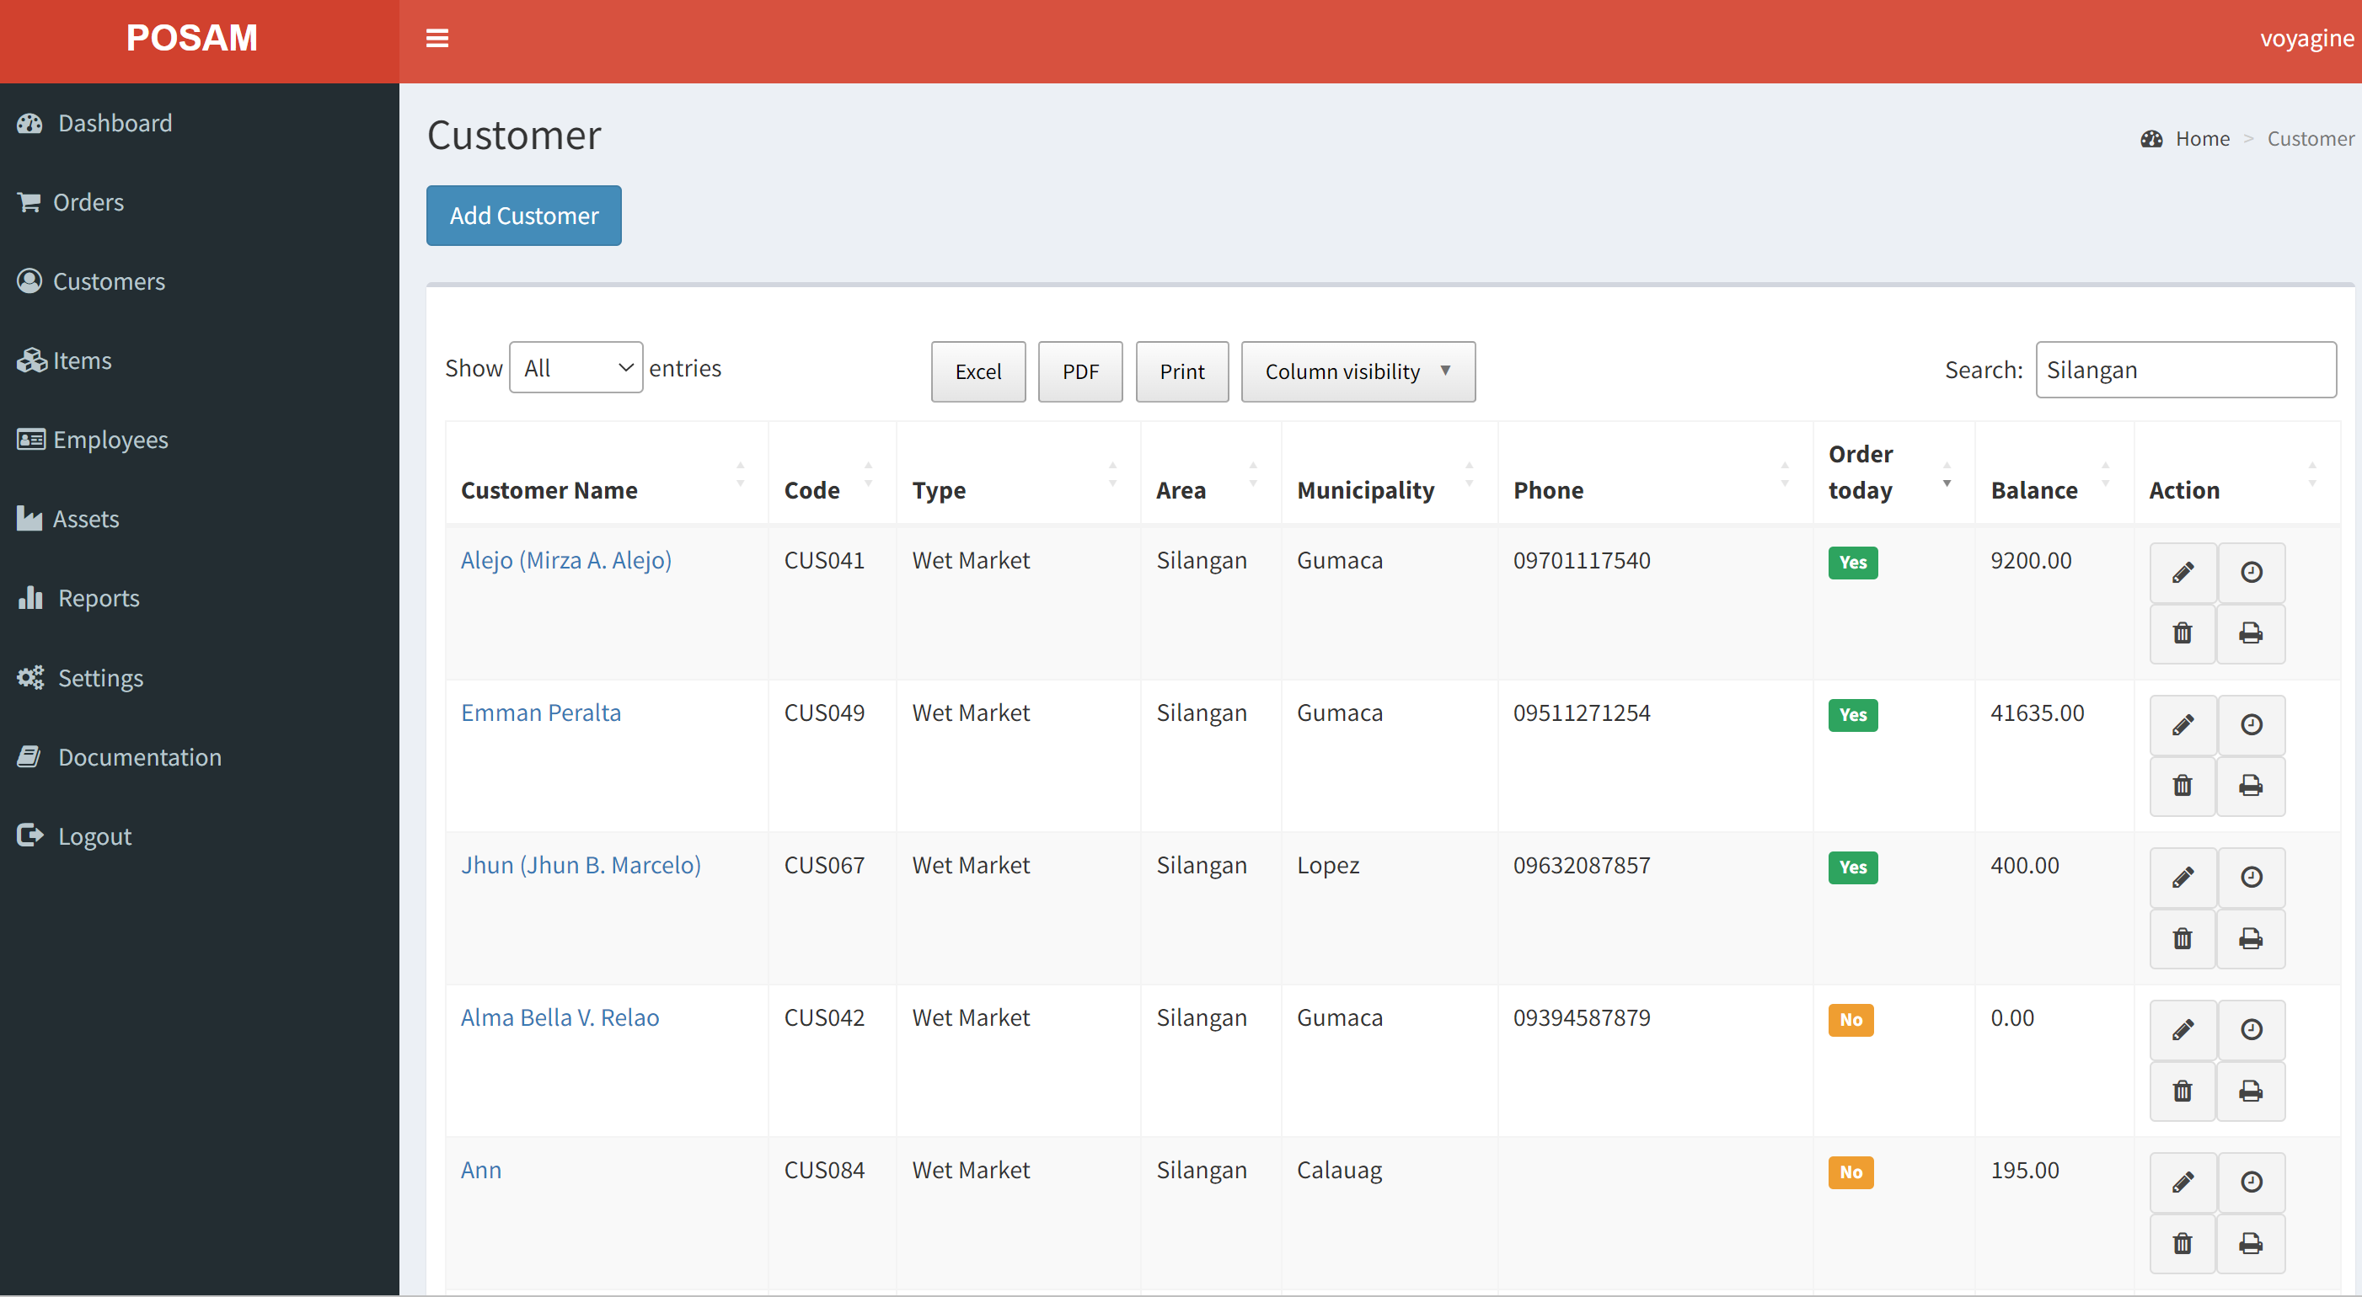

You can modify the orders of the customer from here or update the payments.

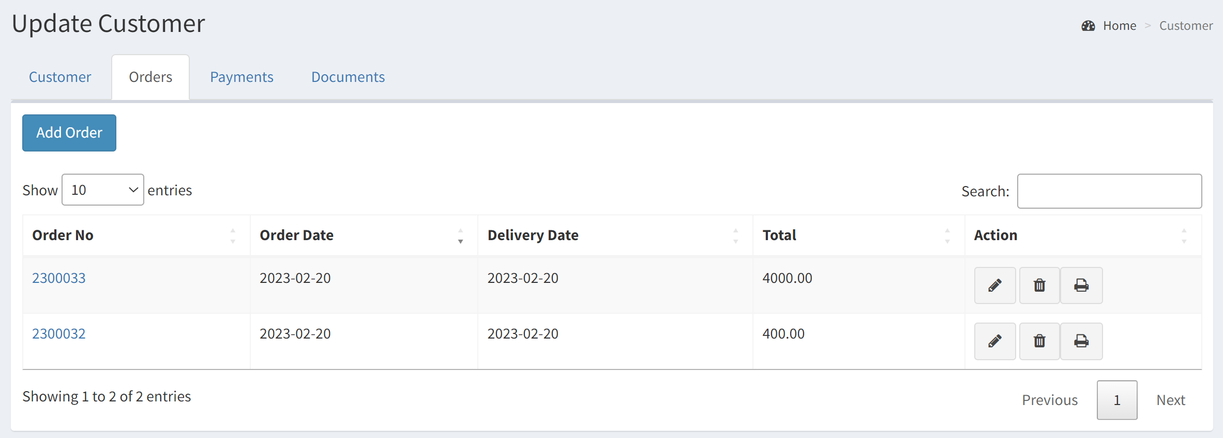

## Step 2 – Print Summary of Orders

Once you have completed the orders for the day, you will be ready to print the Summary of Orders.

Go to Reports – REP06 Summary of Orders

The date of the day will automatically appear but you can change the dates. You can even print the report for many days if it’s required.

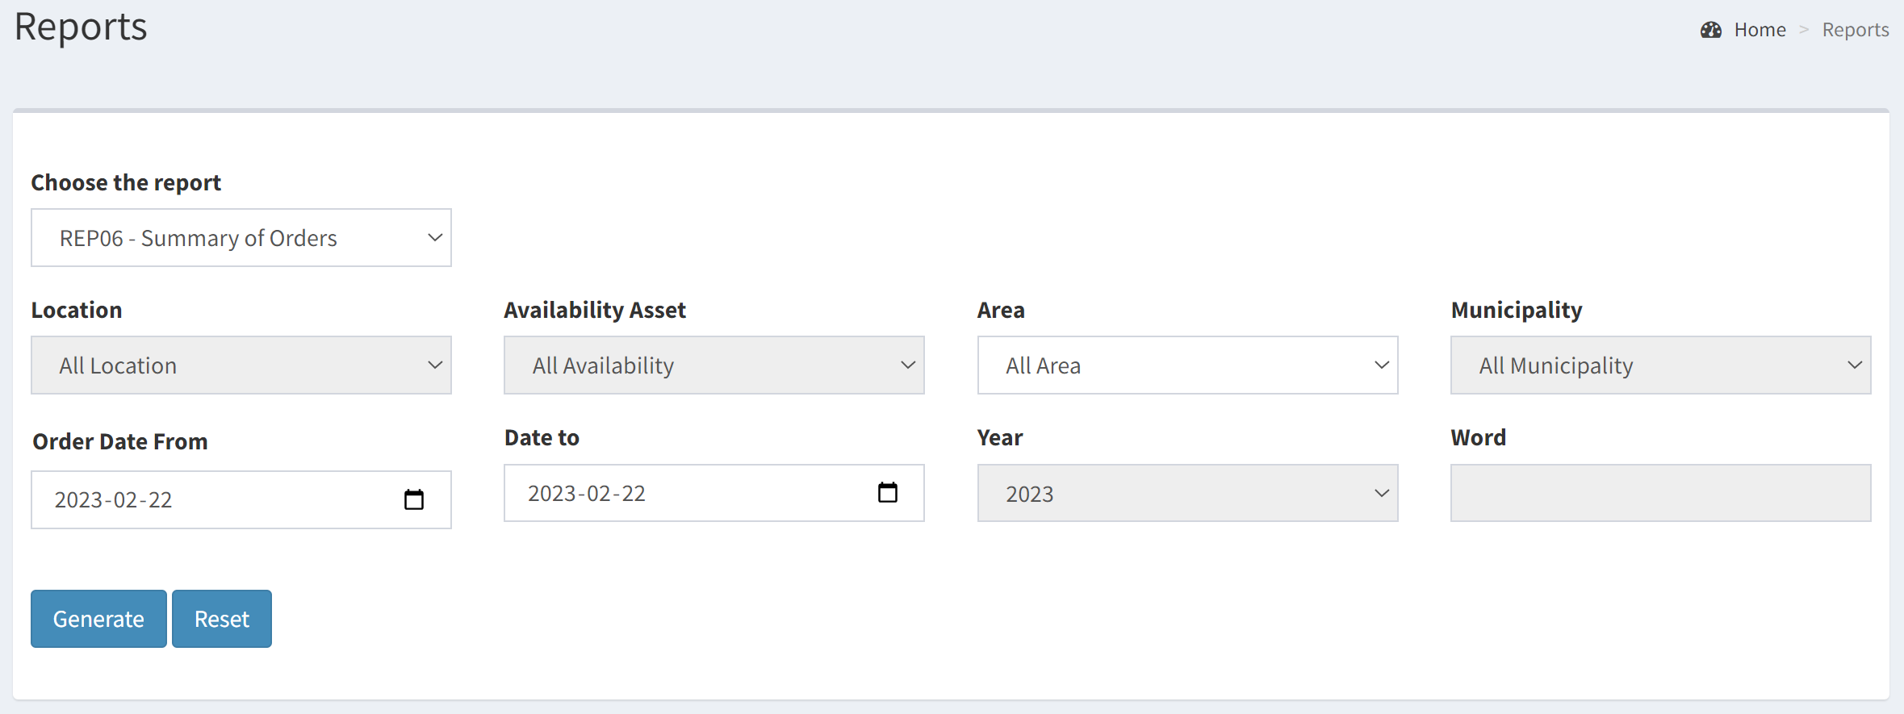

The report will be given by Area – Municipality with a page break by Area and a total of the items by area.

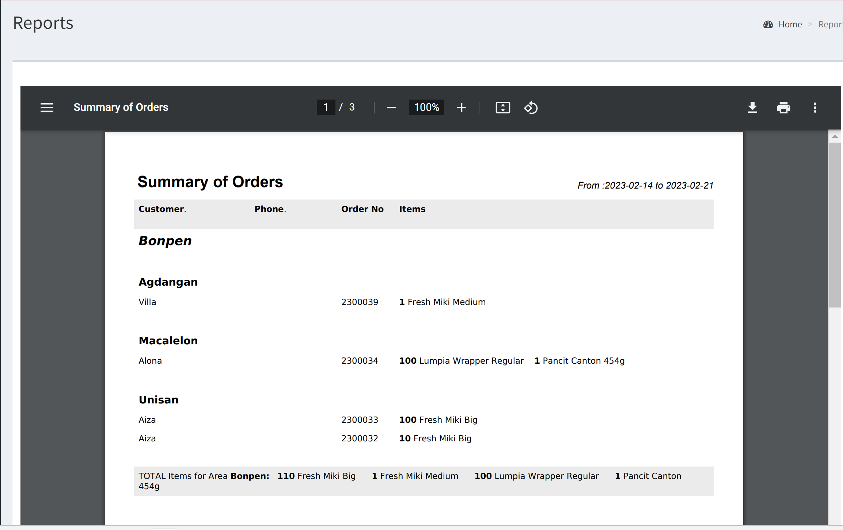

The last page will have total of items for all areas. You can ask the report for one specific area but in this case, you won’t get the total item for all areas.

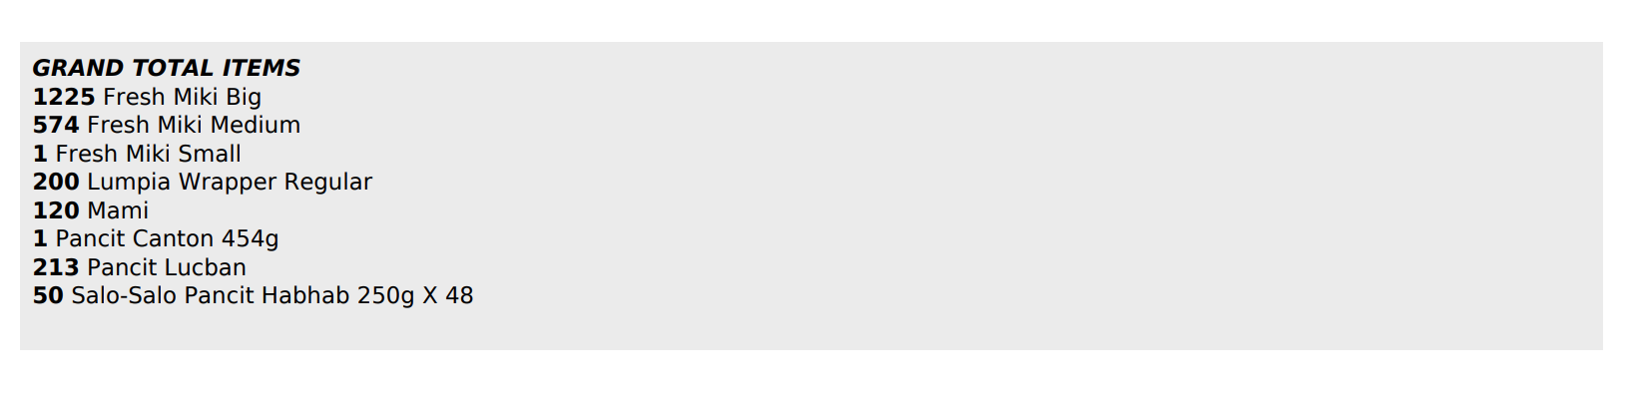

## Step 3 – Print Summary of Deliveries

The summary of deliveries will be the report for the drivers. You will find all the orders by Area – Municipality. The list of the items, total of the order, previous balance and new balance appears. A zone will be filled by the driver if a payment is given. Like the Summary of Orders, you can extract for a range of dates and for a specific area or all areas. The date of extraction will be Delivery Date.

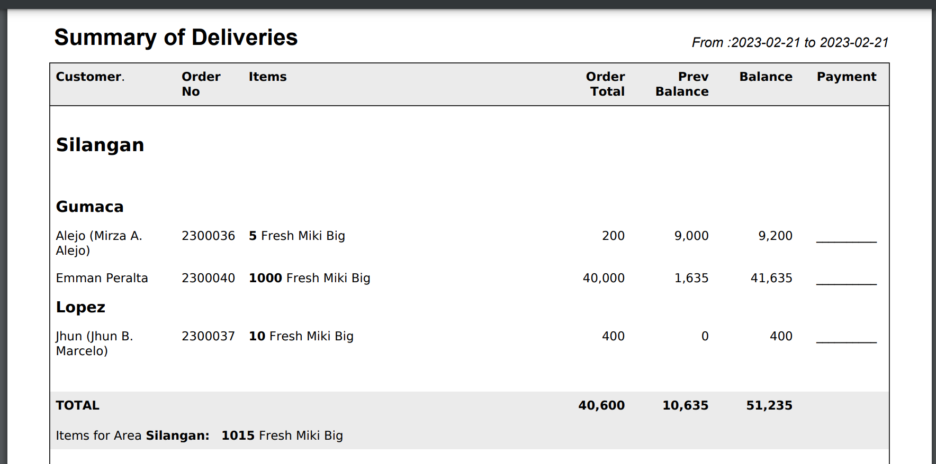

You will find in the bottom of the report an Extra items zone where the driver can write who gets extra items. The driver will correct the information like it was done before on the excel sheets. The Outgoing Delivery to be signed by the guard is included in the report.

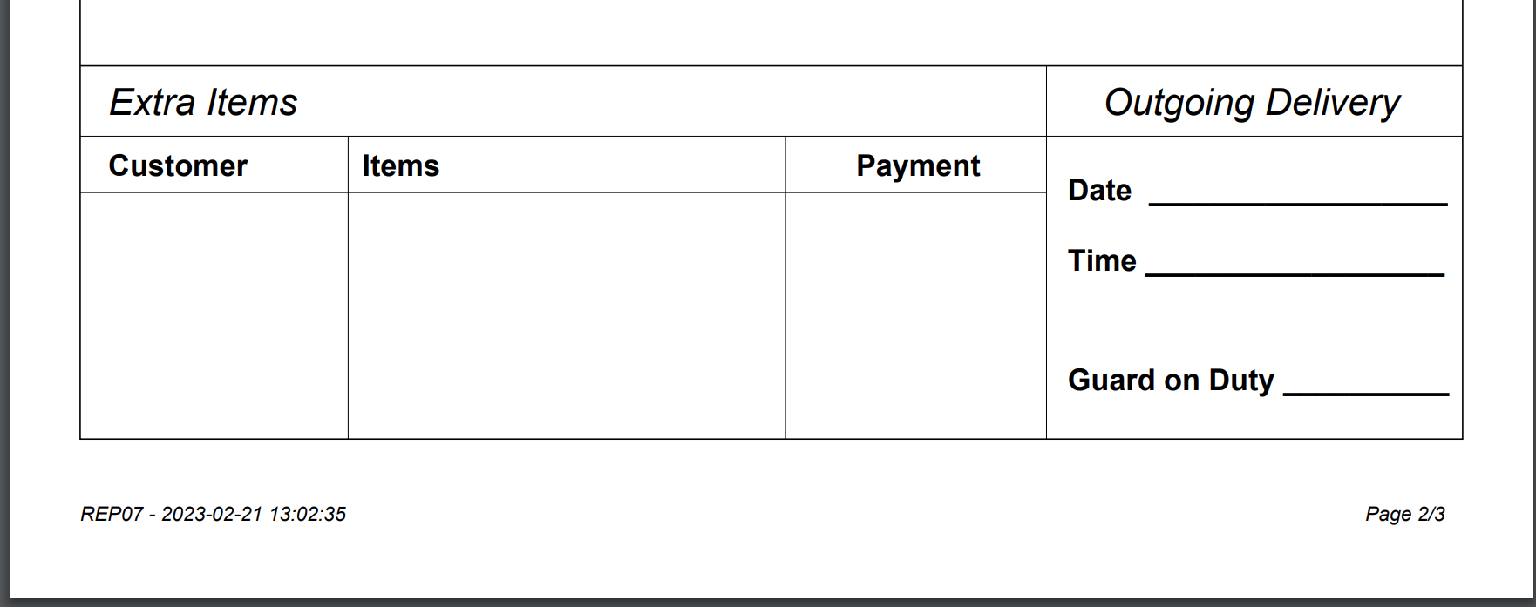

## Step 4 – Print the Order Slips

You will decide if you print or not the order slips when you encode the orders. But if you wish, you can print all order slips by area and also by dates. The order slip will be printed with a page break on each order. The extraction will be on Delivery Date.

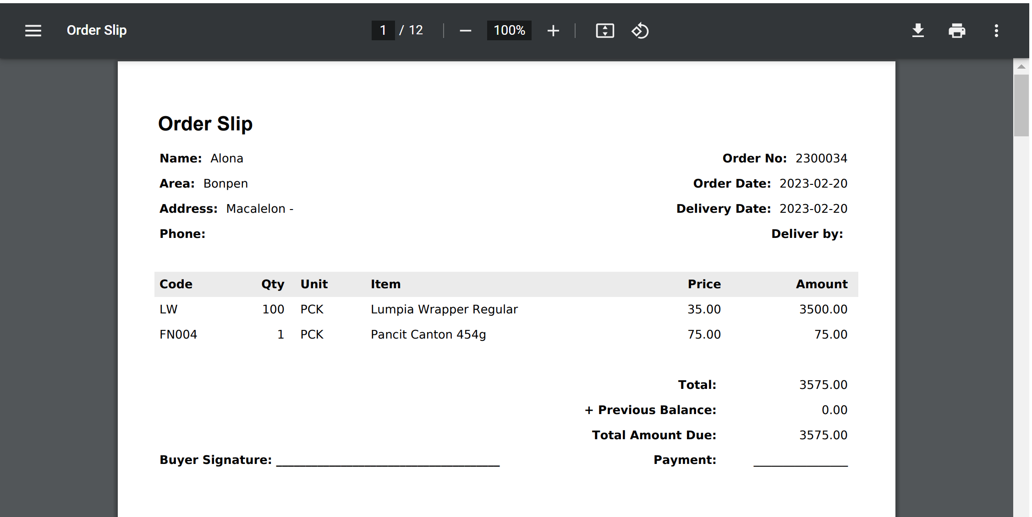

The last page will give a Summary of orders printed by Area with the total of items for each area.

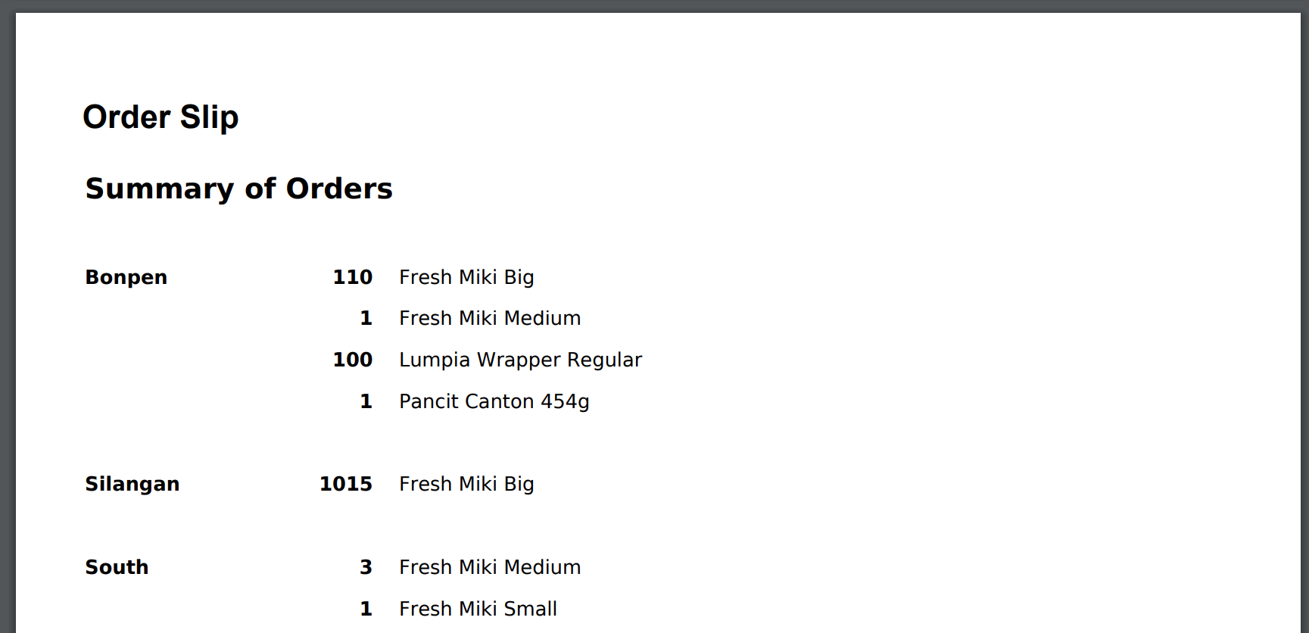

## Step 5 – After Delivery Modifications

The driver will bring back the Summary of Deliveries with the modifications. You will need to modify the orders if you want the balance to be calculated by the system. You need also to add the orders given to customer that were not included in the deliveries of the day.

Go to Orders – Find your order using the Order No. Change the data and Save. The balance will be automatically corrected. In the example, the original order was for 10 Fresh Miki Big but finally it was 8. And the customer added 5 Medium…. You need to correct the order first and the balance of the customer will be automatically corrected. Don’t forget to SAVE!

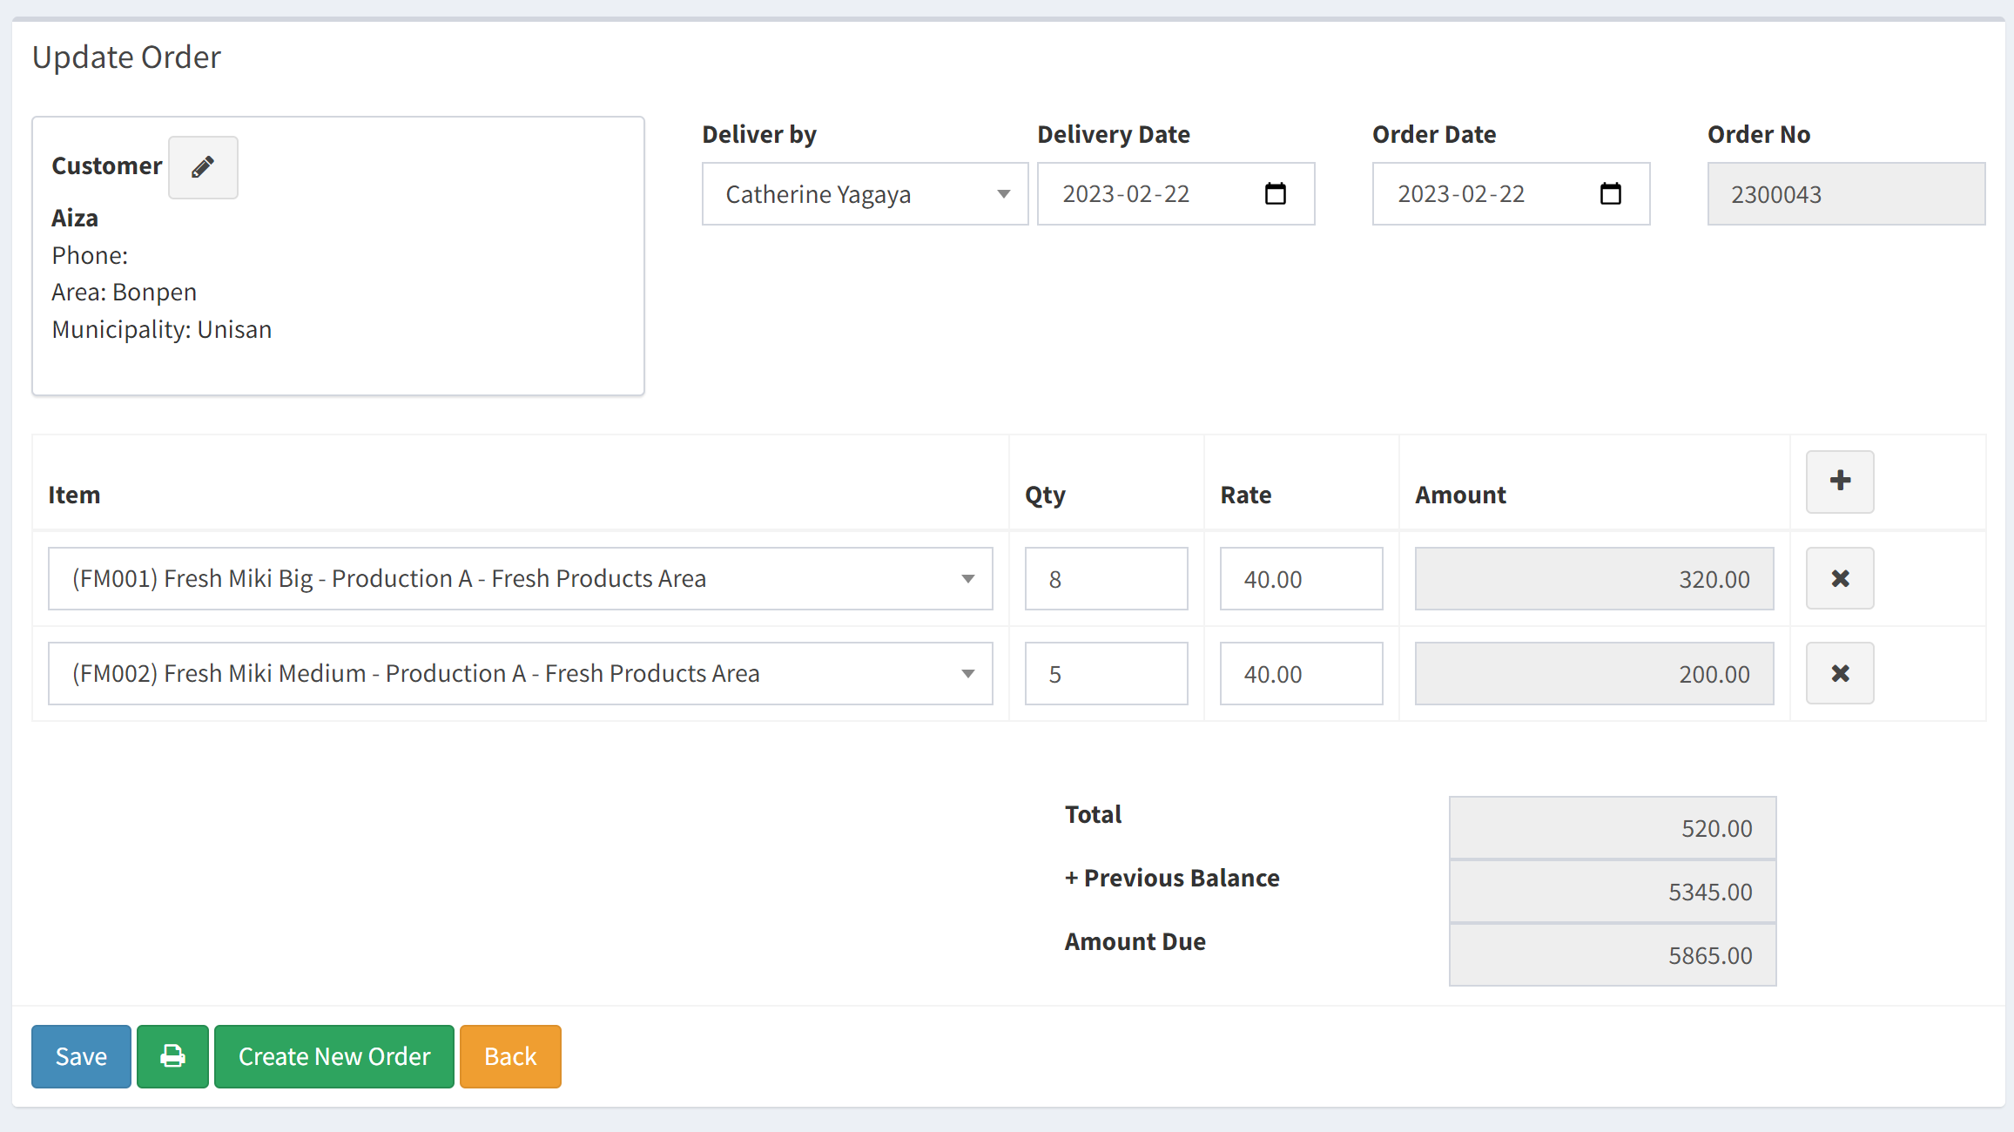

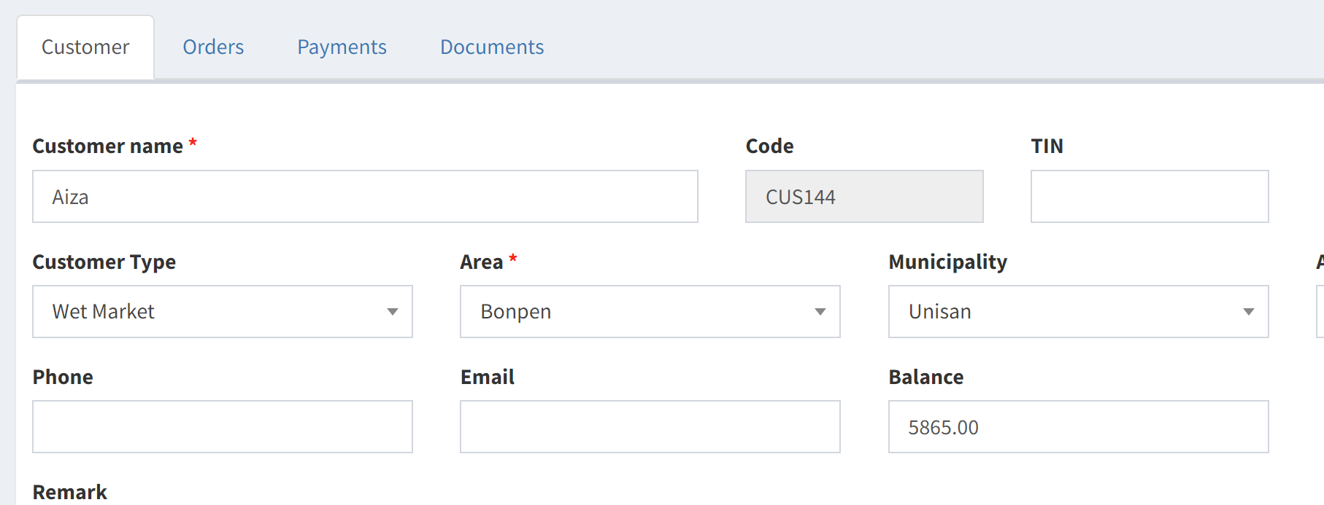

## Step 6 – Payments

The payment received by the driver or any other way, must be inserted in the system.

Go to Customers – Find the customer and update

You will find the balance in the customer tab. You can modify the balance manually if required but this option can be given to a specific profile. Only one person could have the possibility to manually change the balance.

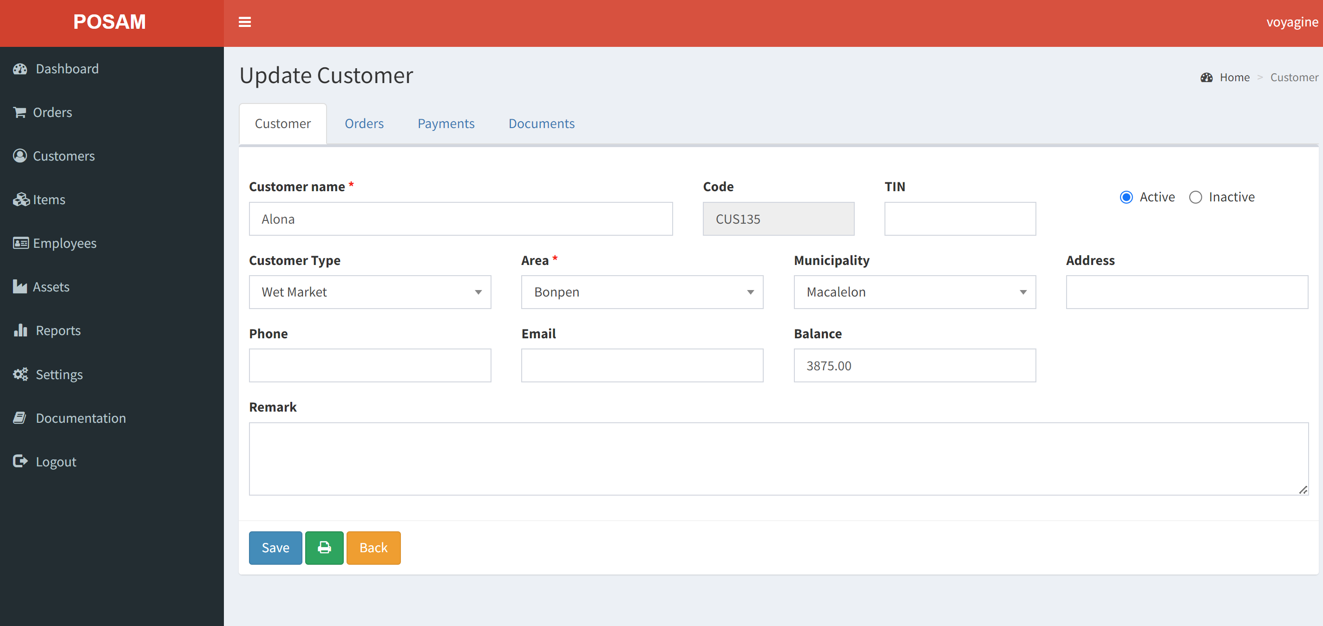

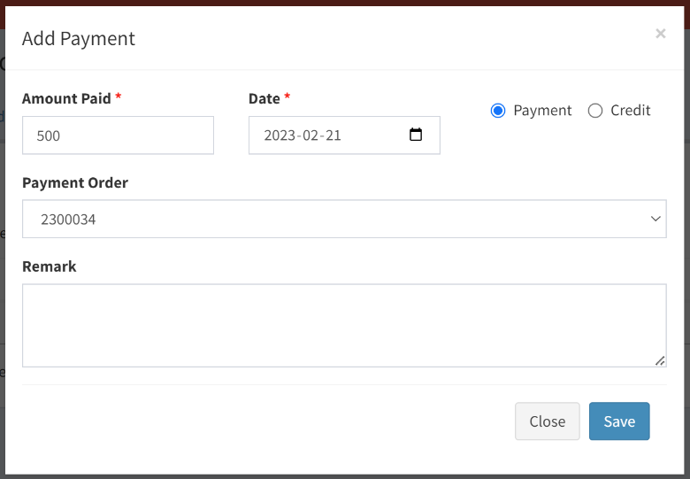Go to the tab Payment and Add payment. You can indicate the order that cover this payment but it’s not compulsory. Most of the time the customer will pay for the balance and not for a specific order. A payment will decrease the balance.

You can also give a credit for items damaged or for any reason you can indicate in the Remark. A credit will decrease the balance and you will keep the information about the credit given.

You can’t modify a payment. Delete the payment and create a new one.

