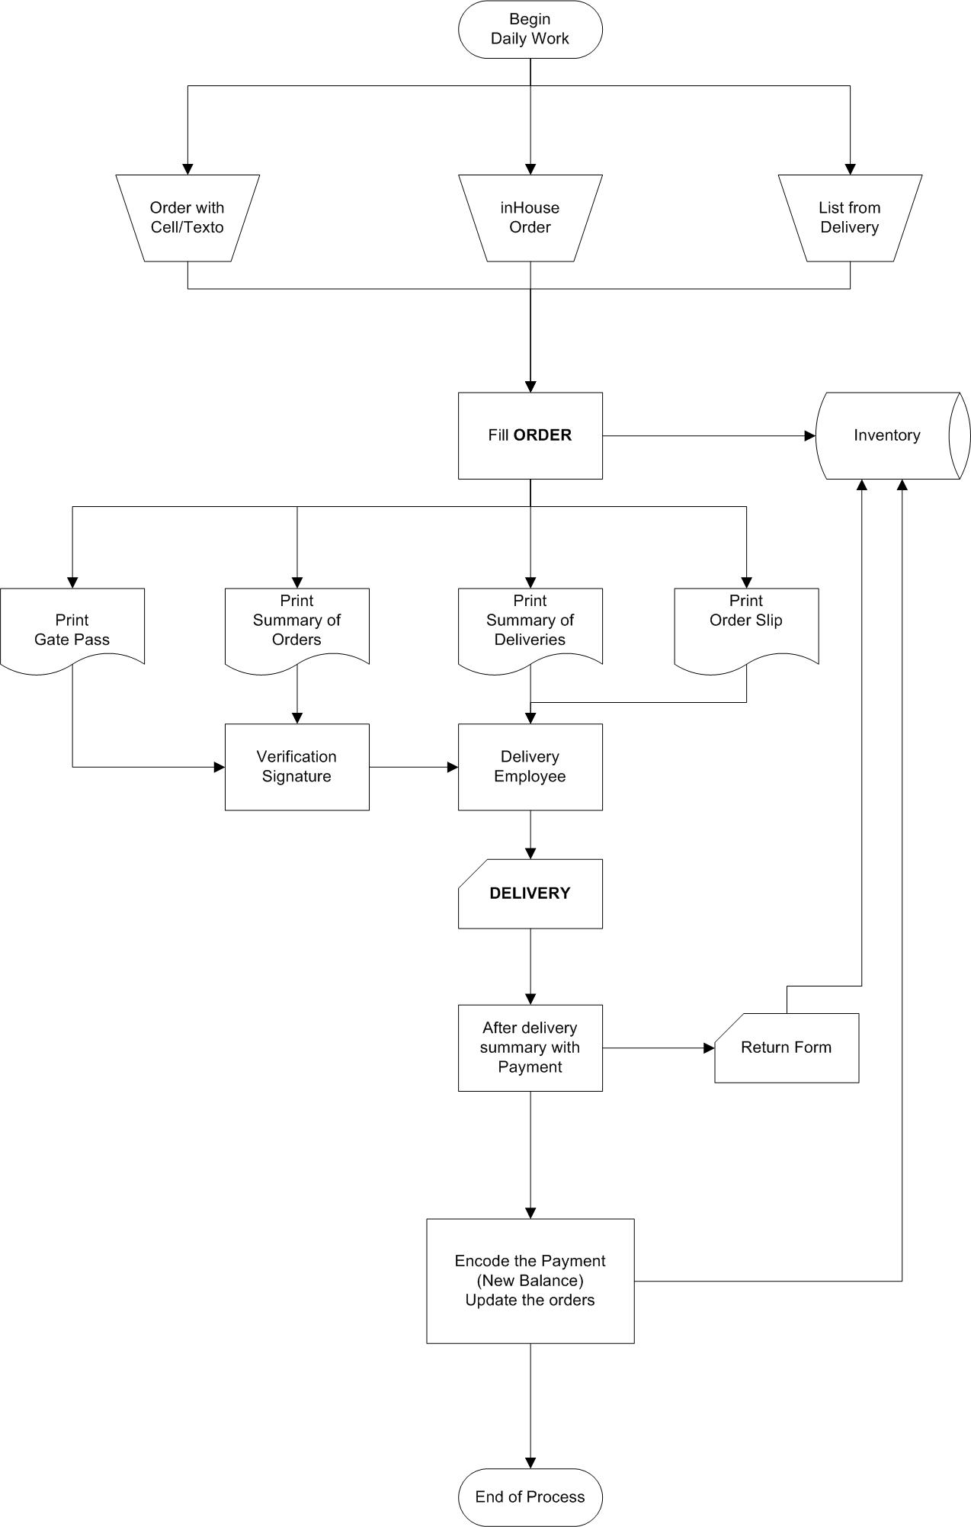

Delivery

Adjust

Payment

Orders