Down-weighting unreliable frames in synthetic endoscopy segmentation
Ellrin (fixture)

Introduction
Drug-induced sleep endoscopy (DISE) frames vary in quality. Discarding hard frames is common, but it removes the cases that matter most. We instead give every frame $x_{b}$ a weight $w_{b}∈\left[0,1\right]$.

Methods
Let ${\tilde{q}}_{b}$ denote the predicted quality of frame $b$ and $a_{b}=\frac{\left|y_{b}\right|}{\left|I_{b}\right|}$ its airway area ratio. The linear baseline mixes the two cues,
$$w_{b}^{lin}=λ{\tilde{q}}_{b}+\left(1−λ\right) a_{b}, λ∈\left[0,1\right].$$
The fuzzy weight uses rule activations $α_{mn}$ and consequents $ρ_{mn}$:
wb=m,n​αmn ρmnm,n​αmn+ϵ.
The batch loss is shown below as a picture, the way an old equation editor leaves it:
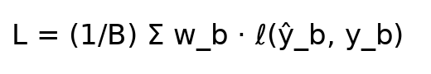
Equation as a picture (no math inside).
Rule prototypes form a matrix
$$V=\left(\begin{matrix}v_{11} & v_{12} \\ v_{21} & v_{22}\end{matrix}\right), \begin{matrix}μ_{Low}\left(q\right) & =1−σ\left(k\left(q−c_{1}\right)\right) \\ μ_{High}\left(q\right) & =σ\left(k\left(q−c_{2}\right)\right)\end{matrix}$$
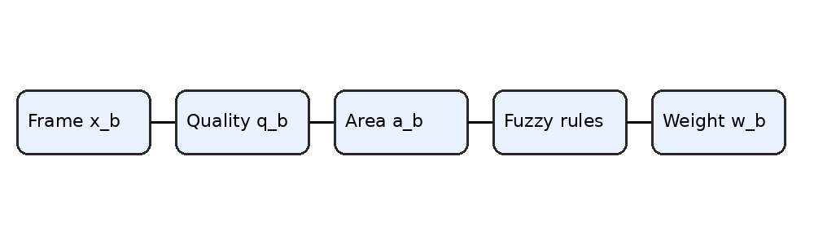
Pipeline from frame to weight.

Results
Segmentation performance of frame-handling strategies (5×5-fold CV).
Strategy | Dice | IoU
All frames | 0.690 | 0.588
Discard levels 1–2 | 0.695 | 0.591
Linear ($λ=0.5$) | 0.704 | 0.602
Fuzzy | 0.720 | 0.619
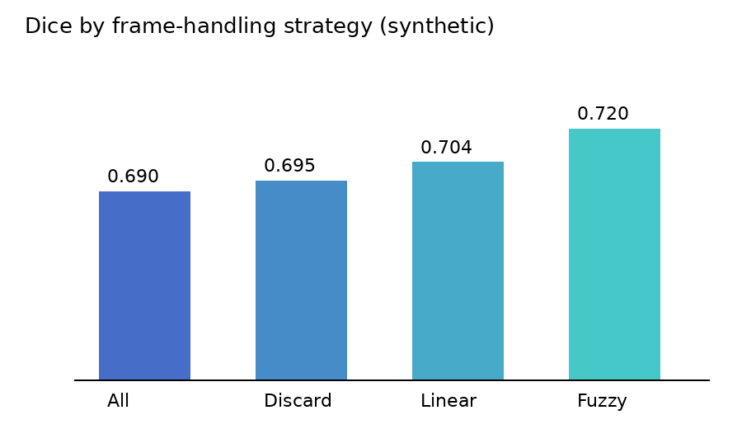
Dice by strategy.
Is the gain larger than one standard deviation? The gain over linear weighting is small but consistent.

Conclusion
Down-weighting keeps the clinically important frames while limiting their influence.

