Internet>Dog S1  
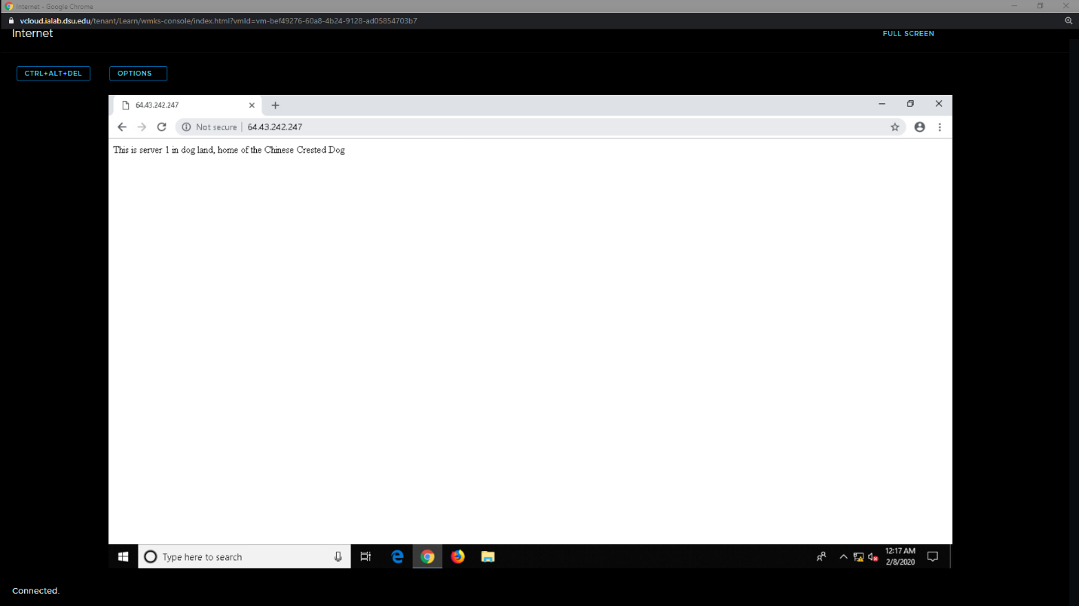  
Goat admin > Dog S2  
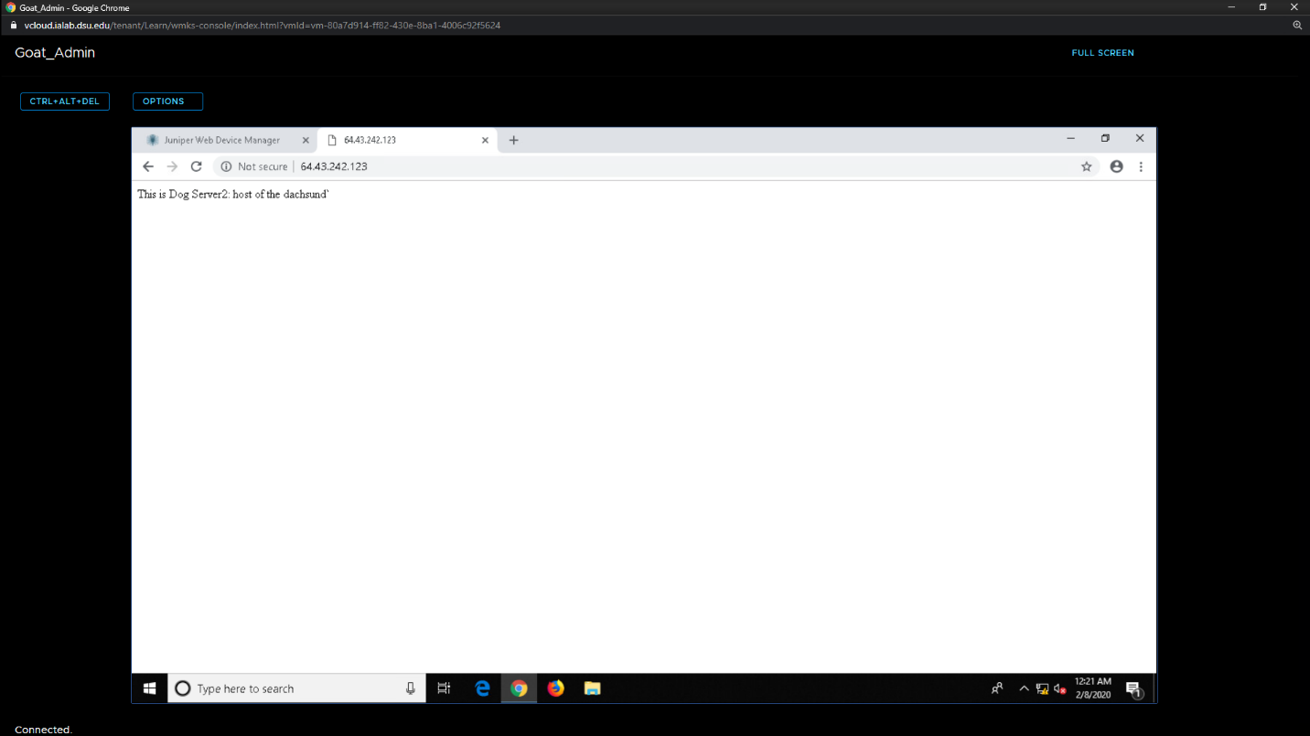

Dog Rules:  
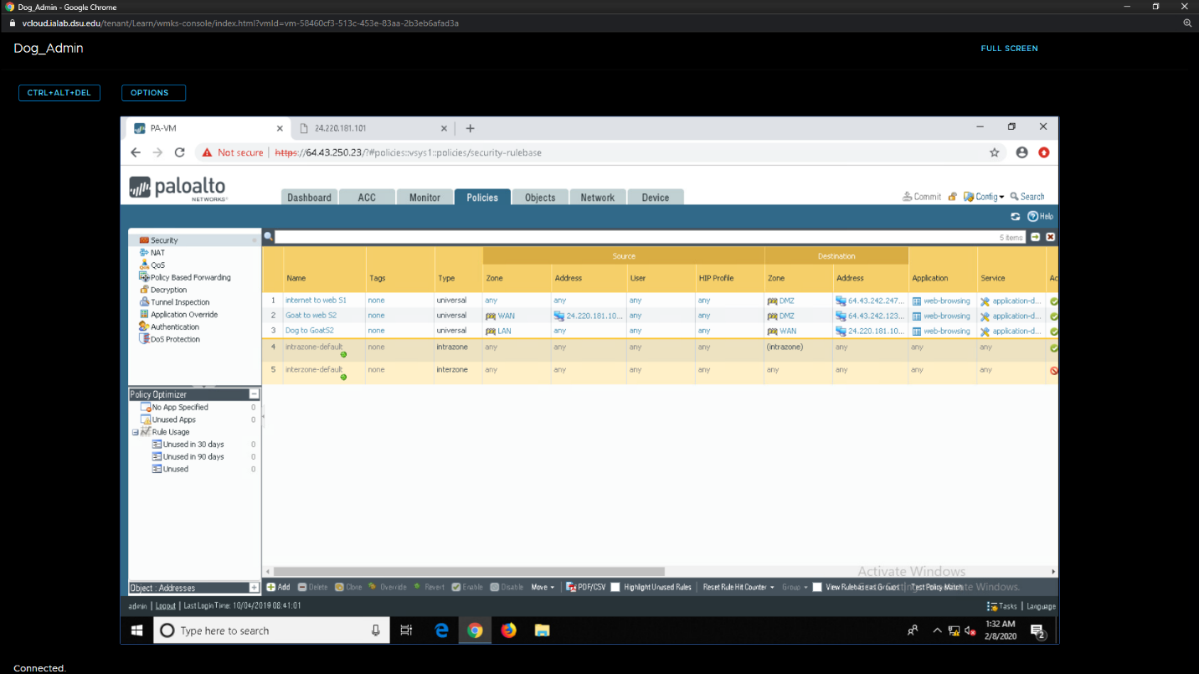

Internet > Goat S1:  
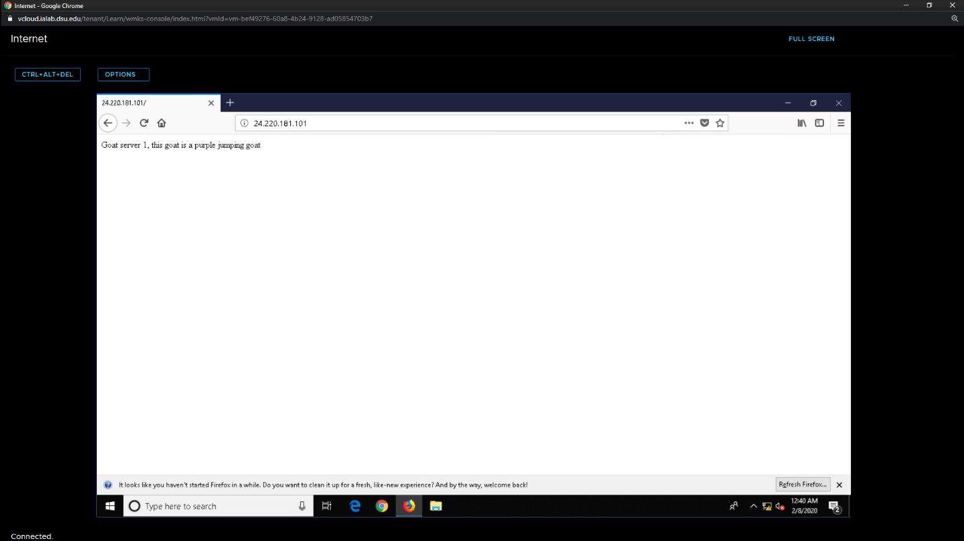  
Dog> Goat S2:

Goat Rules:  
note: rule Internet_to_S1_web source address says Dog_Net. The exclude box Is checked so it allows all traffic except Dog_net to S1.