**Vmware workstation pro**   
I have a personal license for 15.5, not sure if there is anything newer, butI would prefer to stick to it since I have it – hope that’s all good.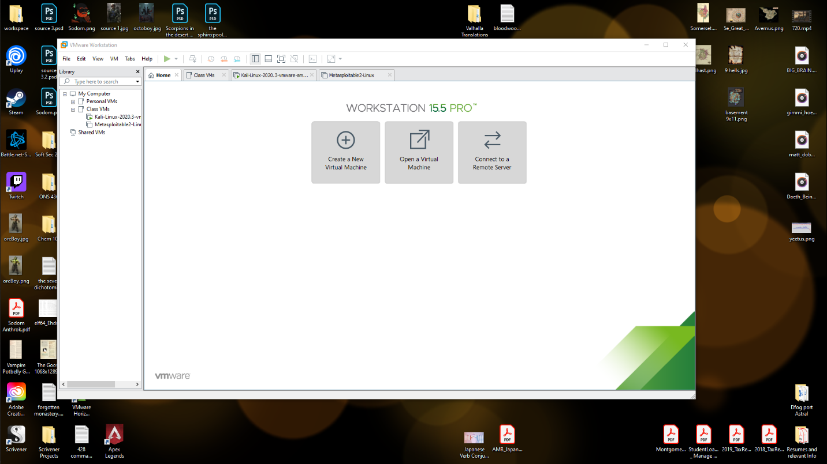

**Kali VM**the name is in the cli prompt: chrisg@kali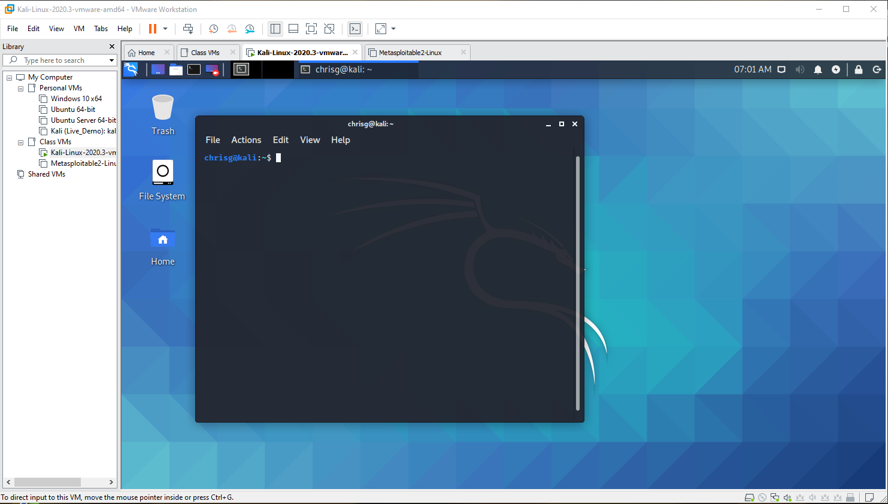

**Metasploitable**name is in the login prompt

