Q2
In xv6 a new program is normally started by the user program doing fork() to make a child and then the child calling exec() to replace its memory image with the new program. xv6 keeps the model simple so fork + exec is the canonical two-step process.
Mini flowchart (Linux)
Shell → fork()/clone() (child is COW copy) → child → execve() → kernel maps ELF (+ PT_INTERP) → runtime linker → program entry (libc → main).
Mini flowchart (Windows)
Caller → CreateProcess() → kernel (NtCreateUserProcess) creates process + primary thread + PEB → map PE image, load DLLs, resolve IAT → ntdll loader/CRT → main

Aspect | xv6 | Linux (≥6.0) | Windows 10/11
Common API seen by programs | fork() + exec() | fork()/clone() + execve() (or posix_spawn) | CreateProcess()
Binary format | simple a.out (teaching) | ELF (+ PT_INTERP for dynamic linker) | PE (Portable Executable) and DLLs
Loader behaviour | simple replace image | kernel maps ELF, may call dynamic linker ld.so → runtime linker finishes startup. ( | kernel + user-mode loader map PE, resolve imports, set up PEB/parameters.
Memory copy strategy for fork | naive (teaching) | copy-on-write / clone optimizations. | no fork() primitive — new process gets its own address space; threads created by kernel
Handles / descriptors | file table inherited | FDs inherited unless FD_CLOEXEC | handles may be inherited depending on flag; security token controls context.
In modern Linux systems (version 6.0 and above), the process of starting a program is built on the traditional UNIX model but has been optimized for performance. Typically, a shell or parent process first creates a child using fork or the lower-level clone() system call. Instead of copying the entire memory space, Linux uses copy-on-write (COW) so that the child initially shares the same pages with the parent until either side modifies them, which saves both time and memory. Once the child exists, it replaces its memory image with the desired program using the execve() system call. At this stage, the kernel loads the ELF binary, maps the program segments into memory, and if necessary, invokes the runtime dynamic linker specified in the binary header. The dynamic linker (ld.so) then resolves shared libraries, performs relocations, and hands control over to the C standard library’s startup code, which finally calls the program’s main function. From the user’s point of view this looks simple, but under the hood it involves careful coordination between the kernel, the ELF loader, and the dynamic linker.

Q3
When a user types a command, input is first read from the terminal using getcmd(). The input line is then parsed using parsecmd(), which converts the string into a structured command representation (struct cmd) and identifies the command type, such as an executable, a pipeline, an I/O redirection, or a sequence of commands. The parsed command is passed to runcmd(), which determines the command type from the struct cmd. If the command is built-in, such as cd <dir> or exit, it is executed directly by the shell. For external programs, runcmd() calls fork() to create a child process. The parent process then calls wait() while the child process runs the command. This prevents the parent’s virtual address space from being overwritten or lost as now the child process calls exec(), causing its memory to be replaced with that of the executable program. After exec(), the kernel sets up CPU registers for the user process and calls swtch() to switch from the kernel scheduler context to the new process. Execution then begins in user space at the program’s entry point. The executable runs start(), setting up its own stack and calling the program’s main() function. Once the child process terminates, control returns to the parent shell, which is then ready to process the next command.

Q1 & 4
Execution videos link
https://drive.google.com/drive/folders/1u2aeJj-ymSMigub-fLuuWKMy2biAGcFh
Q1 explanation
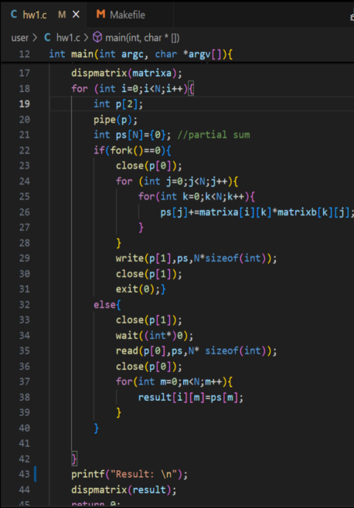

-Creating a pipe to communicate between Parent & child Processes.
-I created fork to divide the process. Each child calculates one output flow. And the Parent compiles them together.
-fork() = 0 makes sure the multiplication happen in Child processes.
-closing read ends in children as they only write to the pipe.
-closing write end in parent as they only read

Q4 Explanation
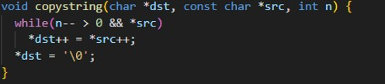
Since xv-6 doesn’t have a copy function, we make one ourselves. This simple function just take the pointer to the string in src, the number of characters to copy in n, and the destination buffer address in dst.

Simply adds the new command (cmd) to the circular array built to store the command history.

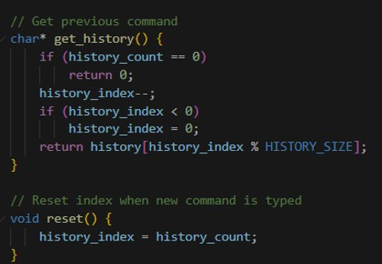
Function to return the history of commands. If no commands, return 0, else return the command on the current index number. Reset is self explanatory

