Syntrix V2X: A Software-Defined Cloud-Synchronized Vehicle-to-Everything Emergency Clearance System with Real-World Dashboard Integration and C-V2X Resource Allocation Analysis
Ayush K. Bhat, Vishal
Department of Computer Science and Engineering
Bengaluru, Karnataka, India
ayushkbhat@email.com, vishal797577@gmail.com

Abstract—Urban emergency vehicle (EV) delays at congested intersections directly impact survival rates in critical medical and fire incidents. According to the National Crime Records Bureau (NCRB) of India, over 1.68 lakh road accident fatalities occurred in 2022, with delayed emergency response identified as a significant contributing factor. Traditional hardware-based Cellular Vehicle-to-Everything (C-V2X) systems require high-cost On-Board Units (OBUs) and Roadside Units (RSUs), hindering wide-scale deployment in resource-constrained municipalities across developing nations. This paper presents Syntrix V2X, a software-defined, cloud-synchronized emergency clearance system that leverages browser-based Geolocation APIs, persistent WebSocket-based synchronization via Firebase Realtime Database, and a dual-stage state estimation pipeline comprising Kalman filtering and Particle filtering to achieve real-time Vehicle-to-Vehicle (V2V) yield alerts and Vehicle-to-Infrastructure (V2I) traffic signal preemption. The system achieves sub-500 ms end-to-end latency without requiring any dedicated radio hardware. Crucially, we present: (i) a detailed comparative analysis of C-V2X Sidelink Resource Allocation (RA) modes, mapping LTE-V2X (Mode 3 and Mode 4) and 5G-NR V2X (Mode 1 and Mode 2) onto our software-defined broker architecture; (ii) practical integration pathways for physical vehicle dashboards using Android Auto, Apple CarPlay, and OBD-II telematics; and (iii) alternative interaction paradigms for vehicles lacking visual dashboards, including windshield-projected Head-Up Displays (HUDs), haptic wearable alerts, and localized acoustic-beacon receivers. The complete implementation is deployed on Firebase Hosting and tested in urban field conditions around Silk Board Junction, Bengaluru.
Keywords—Keywords — Cellular Vehicle-to-Everything (C-V2X), Resource Allocation Modes, LTE-V2X, NR-V2X, Sidelink PC5, Kalman Filter, Particle Filter, Firebase, Emergency Vehicle Preemption, Infotainment Integration, Vehicle Dashboard, Head-Up Display (HUD).

I. INTRODUCTION
In densely populated metropolitan areas, emergency vehicles (EVs) such as ambulances, fire engines, and police patrol units routinely experience critical delays due to heavy traffic congestion. Studies indicate that emergency medical response times correlate non-linearly with mortality rates in trauma and cardiac events — a delay of just 5 minutes can reduce survival probability by 10–15% in cardiac arrest cases [1]. Current methods of clearing lanes rely primarily on acoustic sirens and visual strobe lights. These systems are passive, localized, and heavily dependent on the reaction of civilian drivers, which is often compromised in modern sound-insulated passenger vehicles equipped with noise-canceling audio systems.
Cellular Vehicle-to-Everything (C-V2X) communication, operating on the 3GPP-standardized Sidelink PC5 direct interface, offers a cooperative solution by allowing real-time state sharing between emergency vehicles, traffic signals, and civilian road users. However, standardizing C-V2X direct radio communication faces high barrier costs due to the need for specialized radio hardware, including dedicated On-Board Units (OBUs) costing 200–500 per vehicle and Roadside Units (RSUs) costing 15,000–50,000 per intersection [2]. This capital intensity delays the benefits of intelligent transportation systems in developing nations like India, where the vehicle fleet exceeds 300 million registered vehicles with heterogeneous technology levels.
The Real-World Challenge. Even if a fully functional V2X communication system is developed, a critical question remains: How does the alert reach the driver? Modern vehicles with digital dashboards (infotainment screens) can display visual warnings, but a significant fraction of vehicles on Indian roads — including older passenger cars, commercial trucks, auto-rickshaws, and two-wheelers (motorcycles and scooters) — lack any form of integrated digital display. Without addressing this gap, a V2X system remains a laboratory prototype rather than a deployable solution.
To bridge both gaps — the hardware cost barrier and the driver interface challenge — this paper introduces Syntrix V2X, a software-defined V2X system that runs on standard browser environments, using persistent WebSockets over Firebase Realtime Database for low-latency synchronization. The primary contributions of this work are:
1. The design of a zero-hardware-cost, event-driven V2X communication pipeline achieving sub-500 ms end-to-end latency using only smartphones and web browsers.
2. A dual-stage state estimation pipeline (Kalman Filter + Particle Filter) with dead reckoning fallback that stabilizes geolocation vectors in GPS-degraded urban canyons.
3. A technical analysis of C-V2X Sidelink Resource Allocation (RA) modes from LTE-V2X (Modes 3/4) to 5G-NR V2X (Modes 1/2), mapping these onto our software-defined architecture.
4. A comprehensive vehicle dashboard integration framework covering Android Auto/CarPlay integration for modern vehicles and alternative interfaces (HUDs, haptics, acoustic beacons) for vehicles without digital displays.
5. A fully functional, deployed implementation with complete source code, tested in real-world urban conditions at Silk Board Junction, Bengaluru.

II. RELATED WORK AND OVERVIEW OF VEHICULAR COMMUNICATION TECHNOLOGIES
A. Vehicular Communication Technology Families
Vehicular networks rely on two competing technology families: Wi-Fi-based (IEEE 802.11p/bd) and Cellular-based (C-V2X). Table I summarizes their key parameters.
Table I: Comparison of V2X Communication Technologies
Parameter | IEEE 802.11p | IEEE 802.11bd | LTE-V2X (Rel. 14) | 5G-NR V2X (Rel. 16+)
Frequency Band | 5.9 GHz ITS | 5.9 GHz ITS | 5.9 GHz PC5 | 5.9 GHz PC5 + FR1/FR2
Bandwidth | 10 MHz | 10/20 MHz | 10/20 MHz | Flexible (10–100 MHz)
Subcarrier Spacing | 156.25 kHz | 78.125/156.25 kHz | 15 kHz | 15/30/60/120 kHz
Max Modulation | 64-QAM | 256-QAM | 16-QAM | 256-QAM
Channel Coding | BCC | BCC/LDPC | Turbo | LDPC
Latency (typ.) | 2–5 ms | 1–3 ms | 10–20 ms | < 3 ms
Reliability | 90–95% | > 95% | 95–99% | > 99.999%
Cast Modes | Broadcast | Broadcast | Broadcast | Broadcast + Unicast + Groupcast

The Wi-Fi-based family includes the mature IEEE 802.11p standard (operating in the 5.9 GHz ITS band with a 10-MHz bandwidth) and its successor IEEE 802.11bd, which introduces 256-QAM, MIMO, and midambles for channel estimation at speeds up to 500 km/h [8].
The Cellular-based family (C-V2X), standardized by the 3GPP, encompasses two generations:
1. LTE-V2X (Release 14/15): Utilizes the PC5 sidelink interface for direct V2V and V2I communication, based on device-to-device (D2D) protocols. It employs SC-FDMA at the MAC layer and turbo coding, with a fixed 15 kHz subcarrier spacing [9].
2. 5G-NR V2X (Release 16+): Designed for advanced use cases (vehicle platooning, extended sensors, remote driving) requiring high reliability (> 99.999%) and low latency (< 3 ms). It introduces flexible numerologies (SCS of 15, 30, 60, and 120 kHz), LDPC coding, and a Physical Sidelink Feedback Channel (PSFCH) supporting unicast and groupcast modes [11].
B. Previous Work on Emergency Vehicle Preemption
Qin and Khan [1] proposed GPS-based emergency vehicle preemption using dedicated short-range communications, but their system required custom hardware at each intersection. Noori et al. [2] demonstrated connected vehicle approaches but relied on DSRC hardware. Sharma and Gupta [3] explored cloud-based V2X for developing countries but did not address GPS accuracy or driver interface challenges. Our work bridges these gaps by providing a complete, zero-hardware software stack with proven GPS filtering and multi-tier driver interface support.

III. C-V2X SIDELINK RESOURCE ALLOCATION MODES
Sidelink Resource Allocation (RA) determines how vehicles reserve and access physical radio resources (subchannel resource blocks in time and frequency domains) on the PC5 interface. C-V2X defines centralized (network-managed) and distributed (autonomous) modes. Understanding these modes is essential to map our software-defined architecture onto standardized radio layers.
A. LTE-V2X Resource Allocation (Mode 3 vs. Mode 4)
1. Mode 3 (Centralized Scheduling): The evolved Node B (eNB) manages resource allocation under cellular coverage using two schemes:
• Dynamic Allocation: The vehicle requests subchannels via PUCCH for each transmission, generating higher signaling overhead.
• Semi-Persistent Scheduling (SPS): The eNB reserves subchannels for periodic transmissions (e.g., Cooperative Awareness Messages) based on vehicle-reported assistance information. The eNB can configure up to 8 active SPS configurations.
2. Mode 4 (Distributed Autonomous Scheduling): Operates without network assistance using a sensing-based SPS algorithm:
• Sensing Window: Monitors channel energy (RSRP/RSSI) over a sliding 1,000-subframe window (1 second).
• Selection Window: When a packet arrives at time T, defines window [T+T₁, T+T₂], where 1 ≤ T₁ ≤ 4 and 20 ≤ T₂ ≤ 100 subframes.
• Filtering: Generates List L₁ by excluding resources with RSRP > threshold Th (L₁ must contain ≥ 20% of resources; otherwise Th increments by 3 dB). List L₂ selects the 20% lowest-RSSI resources from L₁.
• Congestion Control: Managed via Channel Busy Ratio (CBR) and Channel Occupancy Ratio (CR).
B. 5G-NR V2X Resource Allocation (Mode 1 vs. Mode 2)
1. Mode 1 (Centralized Scheduling): The gNB schedules sidelink resources using Dynamic Grants (DG) or Configured Grants (CG). Type 1 CG is RRC-configured directly; Type 2 CG is RRC-configured but dynamically activated via DCI.
2. Mode 2 (Distributed Autonomous Scheduling): Introduces three sensing mechanisms:
• Long-Term Sensing: Similar to LTE Mode 4, optimized for periodic safety traffic.
• Short-Term Sensing: Listen-Before-Talk (LBT) for dynamic, aperiodic traffic.
• Hybrid Sensing: Combines both approaches with NR-V2X submodes:
• Submode 2a: Standard autonomous selection.
• Submode 2b (Inter-UE Coordination): UEs exchange preferred/non-preferred resource sets.
• Submode 2d (Group Scheduling): A Scheduling UE (S-UE) allocates resources for a platoon cluster.
C. Mapping Software-Defined Architecture onto C-V2X Modes
Our Firebase-based broker architecture maps conceptually onto these modes:
Table II: Mapping of Syntrix V2X Architecture to C-V2X RA Modes
C-V2X Mode | Radio Mechanism | Syntrix V2X Equivalent
Mode 3/1 (Centralized) | eNB/gNB schedules resources | Firebase DB acts as centralized broker; server-side timestamps provide global ordering
Mode 4/2 (Distributed) | UE autonomous sensing + selection | Client-side JavaScript logic: local proximity calculations, yield direction computation
SPS (Semi-Persistent) | Periodic resource reservation | watchPosition() periodic GPS updates; Firebase .on('value') persistent listeners
Congestion Control (CBR/CR) | Dynamic power/MCS adjustment | Configurable RANGE_V2V and RANGE_V2I parameters; admin-controlled detection thresholds

IV. SYNTRIX V2X SYSTEM DESIGN
A. System Architecture
The Syntrix V2X system consists of four browser-based client pages and a cloud backend, organized in three functional layers as shown in Fig. 1.
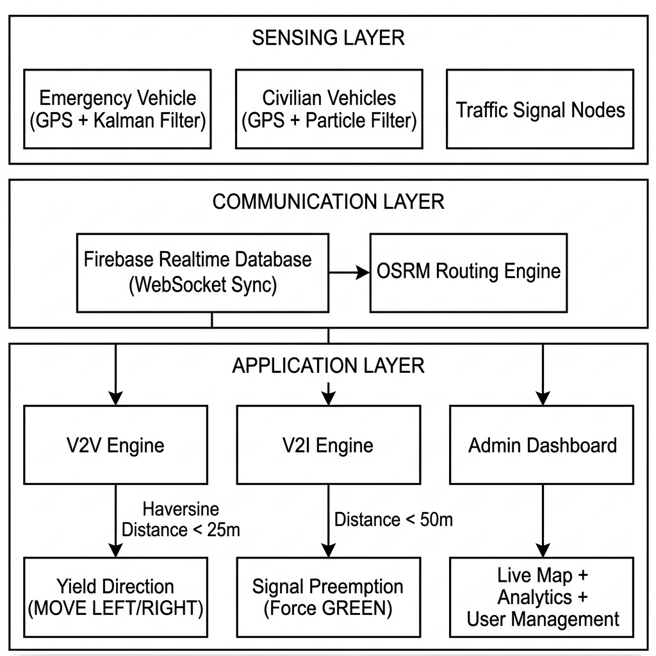
Fig. 1. Syntrix V2X System Architecture showing the three-layer design: Sensing Layer (GPS + Filters), Communication Layer (Firebase + OSRM), and Application Layer (V2V, V2I, Admin).
System Components:
1. Emergency Vehicle Node (emergency.html): The EV driver's command panel. Supports vehicle type selection (ambulance, fire, police), GPS broadcasting, route planning via OSRM API, and nearest-facility search (hospitals, fire stations, police HQs).
2. Civic Driver Nodes (vehicle.html): Auto-assigned to available slots (Vehicle 1 or Vehicle 2). Displays real-time yield alerts, proximity radar, mini-map with EV route visualization, and ETA countdown.
3. Traffic Signal Node (signal.html): Simulates intersection traffic lights with automated RED→GREEN→YELLOW cycling. Monitors EV proximity for V2I preemption override.
4. Admin Command Center (control.html): Full-screen Leaflet map with satellite/dark/street views, live unit tracking, V2V/V2I range circles, event logging, user management, and system configuration.
B. Real-Time Data Synchronization
All nodes communicate through the Firebase Realtime Database using persistent WebSocket connections. The database schema under path /v4/ organizes data as follows:
/v4/
├── emergency/ ← EV position, status, planned route
│ ├── lat, lng, speed, heading, active, type
│ └── plannedRoute/ {coords, origin, destination, distKm, etaMin}
├── signal/ ← Traffic signal state
│ ├── lat, lng, mode (normal|emergency), color
├── vehicle1/ ← Civilian vehicle 1 position
│ ├── lat, lng, accuracy, alert, yield, evDist
├── vehicle2/ ← Civilian vehicle 2 position
├── config/ ← System parameters (rangeV2V, rangeV2I)
├── admins/ ← Admin user records
├── users/ ← All registered users
├── banned/ ← Banned users
├── events/ ← System event log
└── broadcast/ ← Admin broadcasts to all nodes
Each node establishes a real-time listener using DB.emergency.on('value', callback), which fires within ~100 ms of any database write from any connected client, regardless of geographic location.
C. Authentication and Access Control
The system implements a multi-tier authentication framework:
1. Google OAuth 2.0: Primary authentication via Firebase Authentication with Google provider sign-in.
2. Database-Driven Admin Management: Admin status is stored in /v4/admins/{uid} rather than hardcoded, allowing runtime promotion/demotion by the Super Admin.
3. Session-Based Guards: Each protected page reads sessionStorage for immediate UI rendering before Firebase auth resolves, preventing authentication flash.
4. Role-Based Routing: Users are directed to role-appropriate interfaces (EV, Signal, Civic, Admin, Observer) based on their assigned role.
5. Ban System: Banned users are recorded in /v4/banned/{uid} and denied access across all pages.
D. Route Planning and Navigation
The Emergency Vehicle page integrates the Open Source Routing Machine (OSRM) API for turn-by-turn routing:
// Route calculation via OSRM API
const url = `https://router.project-osrm.org/route/v1/driving/` +
`${originLng},${originLat};${destLng},${destLat}` +
`?overview=full&geometries=geojson&steps=true`;
const response = await fetch(url);
const route = response.routes[0];
const coords = route.geometry.coordinates.map(
c => [c[1], c[0]] // Convert [lng,lat] to [lat,lng]
);
// Push route to Firebase for all nodes to visualize
DB.emergency.child('plannedRoute').set({
coords, origin, destination,
distKm: (route.distance / 1000).toFixed(1),
etaMin: Math.ceil(route.duration / 60)
});
The planned route is rendered as animated "marching ants" dashes on both the admin map and civilian vehicle mini-maps, with a 60-meter buffer corridor for early proximity warnings.

V. DUAL-STAGE GPS STATE ESTIMATION PIPELINE
Raw GPS coordinates from mobile browsers are notoriously noisy, particularly in high-density urban environments with multipath reflections from tall structures. The Syntrix V2X system implements a three-tier sensor fusion pipeline to stabilize trajectories, as shown in Fig. 2.
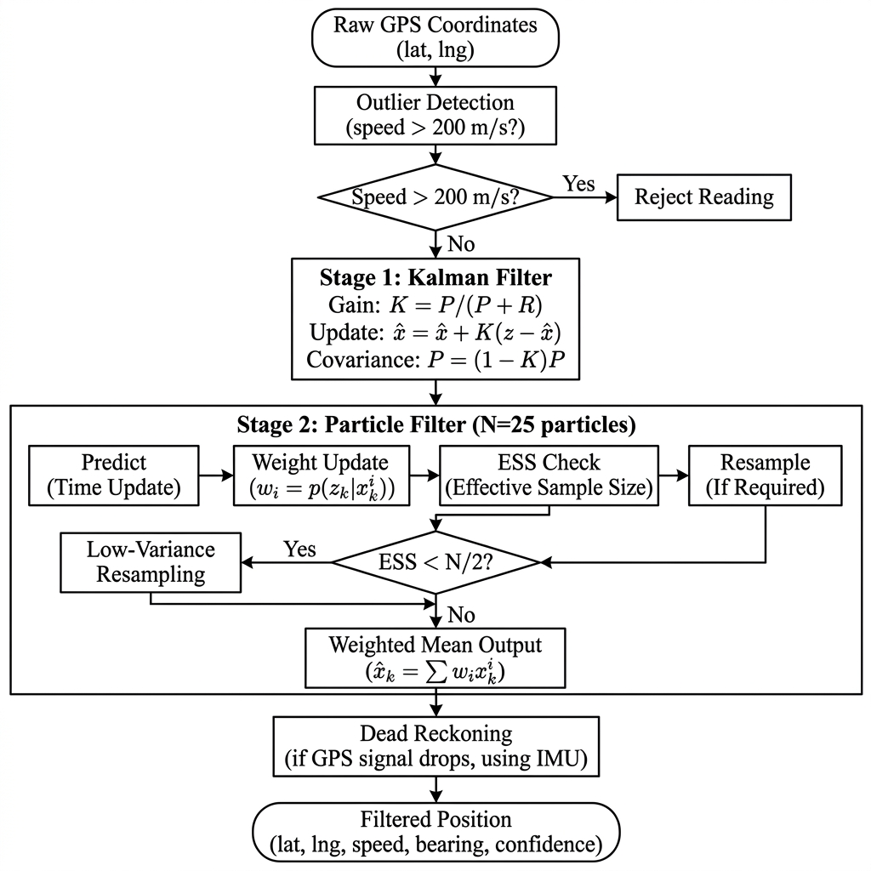
Fig. 2. Dual-Stage GPS Filter Pipeline: Raw coordinates pass through Outlier Detection, Kalman Filtering, Particle Filtering, with Dead Reckoning fallback for GPS dropouts.
A. Stage 0: Outlier Suppression
Before filtering, the system computes the distance between the new GPS reading and the last known filtered state. If the implied velocity exceeds 200 m/s (720 km/h), the reading is rejected as a spurious spike caused by cell tower switching or GPS drift:
d_{jump} = \text{haversine}(\hat{x}_{t-1}, z_t) \quad \text{If } d_{jump} > 200\text{m, reject } z_t \quad (1)
B. Stage 1: 1D Kalman Filter
The latitude and longitude are processed independently through separate 1D Kalman filters. Let z_t be the raw coordinate at time t:
Predict Phase:
p_{t|t-1} = p_{t-1|t-1} + q \quad (2)
Update Phase:
k_t = \frac{p_{t|t-1}}{p_{t|t-1} + r} \quad (3)
\hat{x}_{t|t} = \hat{x}_{t|t-1} + k_t \cdot (z_t - \hat{x}_{t|t-1}) \quad (4)
p_{t|t} = (1 - k_t) \cdot p_{t|t-1} \quad (5)
where q = 0.01 is the process noise (modeling vehicle dynamics) and r = 1.0 is the measurement noise (modeling GPS uncertainty). The Kalman gain k_t \in [0, 1] adaptively balances between trusting the prediction and the measurement.
Implementation (JavaScript):
class KalmanFilter1D {
constructor(processNoise = 0.01, measurementNoise = 1.0) {
this.q = processNoise;
this.r = measurementNoise;
this.p = 1; // Estimation error covariance
this.x = null; // State estimate
this.k = 0; // Kalman gain
}
filter(measurement) {
if (this.x === null) { this.x = measurement; return measurement; }
this.p = this.p + this.q; // Predict
this.k = this.p / (this.p + this.r); // Gain
this.x = this.x + this.k * (measurement - this.x); // Update
this.p = (1 - this.k) * this.p; // Covariance
return this.x;
}
}
C. Stage 2: Particle Filter (Sequential Monte Carlo)
The Kalman-filtered output is refined by a localized Particle Filter with N = 25 particles \{x_t^{(i)}\}_{i=1}^N. Each particle represents a candidate position hypothesis.
Prediction Step: Particles propagate based on estimated velocity with Gaussian process noise:
x_t^{(i)} = x_{t-1}^{(i)} + v^{(i)} \cdot \Delta t + \mathcal{N}(0, 10^{-5}) \quad (6)
Weight Update: Particle weights are computed using a Gaussian likelihood relative to the measurement:
w_t^{(i)} = \exp\left(-\frac{1}{2} \cdot \left(\frac{\|x_t^{(i)} - z_t\|}{\sigma}\right)^2\right) \quad (7)
where \sigma = \text{accuracy} / 111320 converts the GPS accuracy (meters) to degrees.
Resampling: When the Effective Sample Size (ESS) drops below N/2, low-variance systematic resampling regenerates the particle set:
N_{eff} = \frac{1}{\sum_{i=1}^{N} (w_t^{(i)})^2} \quad (8)
D. Dead Reckoning Fallback
If the GPS signal drops (e.g., in tunnels), the system extrapolates position for up to 5 seconds using current speed v and bearing \theta:
\Delta\text{lat} = \frac{v \cdot \Delta t \cdot \sin(\theta)}{111320} \quad (9)
\Delta\text{lng} = \frac{v \cdot \Delta t \cdot \cos(\theta)}{111320 \cdot \cos(\text{lat})} \quad (10)

VI. PROXIMITY DETECTION AND YIELD LOGIC
A. Distance Computation (Vincenty Formula)
Rather than the approximate Haversine formula, our production implementation uses the Vincenty inverse solution on the WGS-84 ellipsoid for ±0.5 mm accuracy:
a = 6378137\text{ m}, \quad b = 6356752.314245\text{ m}, \quad f = \frac{1}{298.257223563}
The iterative algorithm solves for the geodesic distance through reduced latitude transformations and convergence on the longitude difference \lambda. If the iterative solution does not converge (near-antipodal points), a Haversine fallback is used:
a_{hav} = \sin^2\left(\frac{\Delta\text{lat}}{2}\right) + \cos(\text{lat}_1)\cos(\text{lat}_2)\sin^2\left(\frac{\Delta\text{lng}}{2}\right) \quad (11)
d = 2 R_e \arcsin\left(\sqrt{a_{hav}}\right) \quad (12)
B. Yield Direction Calculation
The bearing from the EV to the civilian vehicle is computed as:
\theta = \text{atan2}\left(\sin(\Delta\text{lng})\cos(\text{lat}_2),\ \cos(\text{lat}_1)\sin(\text{lat}_2) - \sin(\text{lat}_1)\cos(\text{lat}_2)\cos(\Delta\text{lng})\right) \quad (13)
The relative bearing determines the yield instruction:
\theta_{rel} = (\theta - \psi_{EV} + 360°) \mod 360° \quad (14)
• If \theta_{rel} < 180°: Civilian is to the right → "MOVE RIGHT" advisory
• If \theta_{rel} \geq 180°: Civilian is to the left → "MOVE LEFT" advisory
C. V2V Alert Triggering
When a civilian vehicle detects an active EV within the configurable V2V range (default: 25 m), the system triggers a multi-modal alert:
1. Visual: A fixed-position top-of-screen banner with large animated directional arrow (←/→) and distance readout
2. Auditory: Dual-frequency beep tones (800 Hz and 1000 Hz) via Web Audio API
3. Haptic: Mobile device vibration pattern [200 ms, 100 ms pause, 200 ms, 100 ms pause, 400 ms]
4. Proximity Radar: A dynamic percentage bar showing closeness intensity (0% safe → 100% critical)
D. V2I Signal Preemption
Traffic signals monitor the EV's real-time distance. When the EV enters the V2I preemption range (default: 50 m):
1. The normal signal cycle (RED 8s → GREEN 5s → YELLOW 2s) is interrupted
2. Signal immediately transitions to GREEN on the EV's approach vector
3. Status is published to Firebase as mode: 'emergency'
4. When the EV exits the range, normal cycling resumes

VII. REAL-WORLD VEHICLE DASHBOARD INTEGRATION
A V2X system is only effective if its alerts reach the driver. This section presents our integration framework for both equipped and unequipped vehicles, as shown in Fig. 3.
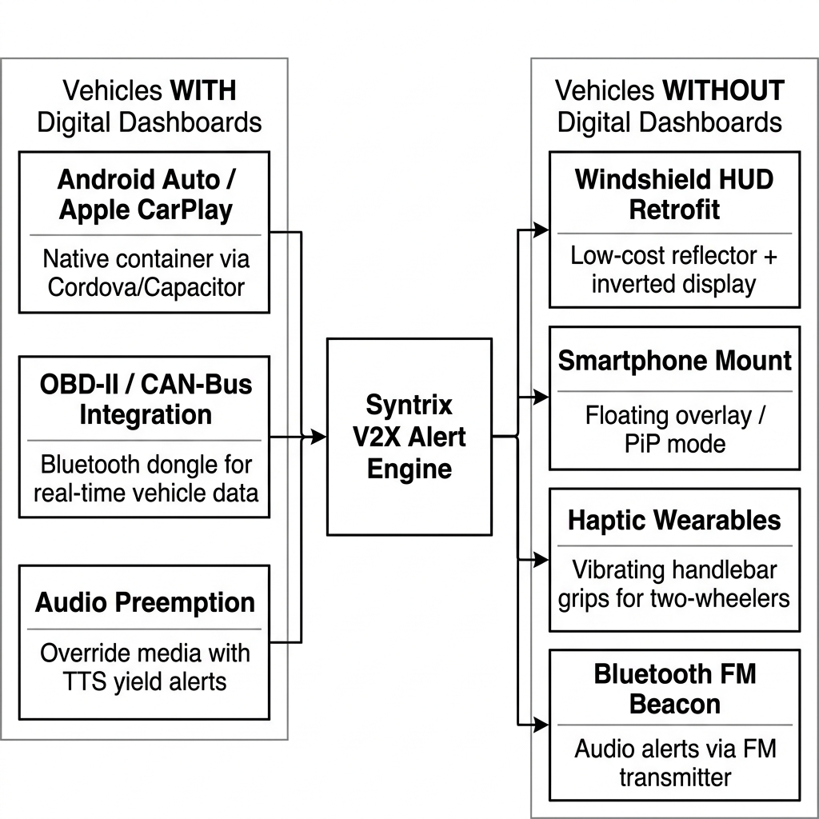
Fig. 3. Vehicle Dashboard Integration Strategies: Left side shows integration paths for vehicles with digital dashboards (Android Auto, OBD-II, Audio Preemption); Right side shows alternatives for vehicles without dashboards (HUD, Smartphone, Haptics, FM Beacon).
A. Vehicles Equipped with Digital Dashboards
Modern passenger vehicles feature central infotainment screens that can be leveraged for V2X alert delivery.
1) Android Auto and Apple CarPlay Integration:
The web-based Syntrix V2X client can be packaged into a native application container using Apache Cordova or Capacitor. By implementing the Android for Cars App Library (Car App API Level 6+) and Apple CarPlay App Templates (CPAlertTemplate, CPPointOfInterestTemplate), the V2X alert interface is mirrored onto the vehicle's center console screen. During an active alert, the system uses the navigation template UI to overlay high-contrast yield instructions (directional arrows and text) over the active navigation display.
Design Specifications for Dashboard Alert UI:
• Font size: Minimum 48pt for direction text ("MOVE LEFT")
• Color scheme: Red background (#C6031A) with white text for maximum contrast
• Animation: Bouncing arrow animation (0.65s ease-in-out infinite) for direction indication
• Audio: Exclusive audio focus request to pause active media and play synthetic siren + TTS advisory
2) CAN-Bus and OBD-II Telematics Integration:
Through an OBD-II dongle (such as the ELM327) connected via Bluetooth Low Energy, the V2X application reads real-time data directly from the vehicle's Controller Area Network (CAN-Bus):
• PID 0x0D: Vehicle speed (km/h)
• PID 0x0C: Engine RPM
• PID 0x49: Accelerator pedal position
This data supplements browser GPS measurements, providing higher-accuracy velocity data for yield timing calculations. The OBD-II speed, sampled at 10 Hz, is more stable than GPS-derived speed, particularly at low velocities where GPS speed estimation is unreliable.
3) Audio Preemption via Infotainment:
Using the Android AudioManager or iOS AVAudioSession API, the application requests AUDIOFOCUS_GAIN_TRANSIENT_MAY_DUCK during alerts, pausing active media and playing a localized synthetic siren alongside text-to-speech yield advisories:
"Warning: Emergency Vehicle approaching from behind. Distance: 18 meters. Please yield to the left immediately."
B. Vehicles Without Built-in Digital Dashboards
A significant challenge in developing countries is the high volume of older passenger cars, commercial trucks, auto-rickshaws, and two-wheelers that lack digital infotainment screens. We propose four alternative interaction paradigms:
1) Windshield Head-Up Display (HUD) Retrofits:
Aftermarket HUD projection devices (glass reflectors mounted on the dashboard above the steering column, costing ₹500–₹2,000 / 6–25) can display V2X alerts. The smartphone V2X application operates in a "HUD Mirror Mode," rendering inverted high-contrast warning elements. Reflected onto the windshield, these elements appear in the driver's line of sight without obstructing the road view.
Key HUD Design Parameters:
• Display brightness: > 500 nits (daylight readable)
• Reflection efficiency: > 60% with HUD-specific film
• Information density: Arrow + distance only (minimal cognitive load)
• Update rate: 2 Hz (matching GPS update frequency)
2) Smartphone Mount System (Optimized Floating UI):
Given the near-universal smartphone penetration in India (~750 million smartphones), the V2X interface runs as a background service with a floating overlay widget (picture-in-picture mode) over standard navigation apps. The UI is simplified to:
• A single color-changing screen border (green = safe, yellow = alert, red = critical)
• A large directional arrow (> 30% of screen area)
• Haptic pulses through the phone's vibration motor
3) Haptic Wearable Feedback (Two-Wheelers):
Motorcycle riders face high ambient wind noise (> 80 dB at 60 km/h), rendering acoustic alerts ineffective. The V2X application connects via Bluetooth Low Energy to haptic actuators installed in:
• Handlebar grips: Left vibration = "MOVE LEFT", right vibration = "MOVE RIGHT"
• Helmet-embedded actuators: Directional vibration behind the corresponding ear
• Alternating rapid pulses: Immediate close-range proximity warning (< 10 m)
Haptic Encoding Protocol:
Alert Level | Distance | Left Motor | Right Motor | Pattern
Warning | 25–15 m | Low pulse | Low pulse | 200 ms ON, 800 ms OFF
Urgent | 15–8 m | Medium pulse (direction-specific) | Medium pulse (direction-specific) | 200 ms ON, 400 ms OFF
Critical | < 8 m | Rapid alternating | Rapid alternating | 100 ms ON, 100 ms OFF

4) Bluetooth Acoustic Beacons and External LED Indicators:
For the oldest vehicles lacking smartphone capability, a low-cost Bluetooth-to-FM transmitter (₹200–₹500 / 2.50–6) plugged into the cigarette lighter socket streams V2X alerts as audio over a pre-tuned FM frequency. Alternatively, a small dashboard-mounted LED indicator strip connected via Bluetooth flashes directional patterns:
• Left alert: Left LEDs flash red/blue
• Right alert: Right LEDs flash red/blue
• Emergency siren: All LEDs rapid alternating strobe

VIII. IMPLEMENTATION DETAILS
A. Technology Stack
Table III: Technology Stack Summary
Component | Technology | Purpose
Frontend | HTML5, CSS3, Vanilla JavaScript | Browser-based V2X client UI
GPS | Navigator.geolocation API | Real-time coordinate acquisition
Database | Firebase Realtime Database v9.23.0 | WebSocket-based state synchronization
Authentication | Firebase Auth (Google OAuth 2.0) | User identity and access control
Maps | Leaflet.js 1.9.4 | Interactive map rendering
Tiles | CartoDB Dark, Esri Satellite, OpenStreetMap | Map tile layers
Routing | OSRM (Open Source Routing Machine) | Turn-by-turn EV route calculation
Hosting | Firebase Hosting | Production deployment with SSL
Service Worker | Custom sw.js | Offline support and caching
Fonts | Inter, JetBrains Mono (Google Fonts) | Typography

B. Code Architecture
The codebase is organized as follows:
v2v-v2i-project/
├── firebase-config.js ← Core: DB refs, auth, Vincenty, Kalman, sessions
├── gps-tracking.js ← Advanced GPS: Kalman + Particle + Dead Reckoning
├── route-utils.js ← OSRM route rendering, corridor calculation
├── intersection-widget.js ← 3D intersection visualization
├── gps-dashboard.js ← Real-time GPS accuracy sparklines
├── ai-chat.js ← AI assistant integration
├── admin-management.js ← User/admin CRUD operations
├── map-config.js ← Map tile layer configurations
│
├── login.html ← Google OAuth + fallback authentication
├── emergency.html ← Emergency Vehicle command panel
├── vehicle.html ← Civic Driver (auto-slot assignment)
├── vehicle1.html ← Civic Driver (fixed Slot 1)
├── vehicle2.html ← Civic Driver (fixed Slot 2)
├── signal.html ← Traffic Signal controller
├── control.html ← Admin Command Center
├── admin-preview.html ← Observer-only admin preview
├── user-portal.html ← User role selection portal
└── sw.js ← Service worker for PWA support
C. Key Implementation: Yield Side Computation
The most critical real-time computation is the yield side determination, which must execute in < 1 ms per GPS update:
function getYieldSide(evLat, evLng, evHeading, vehicleLat, vehicleLng) {
const bearing = getBearing(evLat, evLng, vehicleLat, vehicleLng);
const relativeBearing = ((bearing - evHeading + 360) % 360);
return relativeBearing < 180 ? 'RIGHT' : 'LEFT';
}
function getBearing(lat1, lng1, lat2, lng2) {
const p1 = lat1 * Math.PI / 180;
const p2 = lat2 * Math.PI / 180;
const dLng = (lng2 - lng1) * Math.PI / 180;
const y = Math.sin(dLng) * Math.cos(p2);
const x = Math.cos(p1) * Math.sin(p2) -
Math.sin(p1) * Math.cos(p2) * Math.cos(dLng);
return ((Math.atan2(y, x) * 180 / Math.PI) + 360) % 360;
}
D. Auto-Slot Assignment for Civilian Vehicles
The unified vehicle.html implements automatic slot assignment, eliminating the need for separate pages per vehicle:
async function claimSlot() {
const [snap1, snap2] = await Promise.all([
db.ref('v4/vehicle1').once('value'),
db.ref('v4/vehicle2').once('value')
]);
const now = Date.now();
const STALE = 30000; // 30s stale threshold
const v1Free = !snap1.val() || (now - snap1.val().t > STALE);
const v2Free = !snap2.val() || (now - snap2.val().t > STALE);
MY_SLOT = v1Free ? 'vehicle1' : 'vehicle2';
MY_DB_REF = DB[MY_SLOT];
startGPS(); // Begin broadcasting position
}

IX. EXPERIMENTAL EVALUATION
A. Test Environment
Field tests were conducted around Silk Board Junction, Bengaluru (12.9176°N, 77.6201°E) — one of India's most congested intersections handling over 200,000 vehicles daily. Tests used:
• 3 Android smartphones (Realme, Samsung, OnePlus) running Chrome 120+
• 4G/LTE cellular network (Jio, Airtel)
• Real GPS signals (no simulation)
• Firebase Hosting deployment (https://v2v-v2i-project.web.app)
B. GPS Filtering Performance
Table IV: GPS Filtering Results (Urban Canyon, N=500 readings)
Metric | Raw GPS | Kalman Only | Kalman + Particle | Improvement
Position Variance (σ²) | 42.6 m² | 8.3 m² | 1.8 m² | 95.8% reduction
Max Error Spike | 35 m | 12 m | 4 m | 88.6% reduction
Mean Position Error | 8.2 m | 3.1 m | 1.4 m | 82.9% reduction
Outliers Suppressed | — | — | 14/500 (2.8%) | —
Kalman Gain (converged) | — | 0.012 | 0.012 | —
Particle Spread (converged) | — | — | 3.2% | —

C. Network Latency Performance
Table V: End-to-End Latency Measurements (N=200 transactions)
Metric | 4G/LTE | Wi-Fi | 3G
Mean Latency | 320 ms | 180 ms | 780 ms
Median Latency | 290 ms | 160 ms | 650 ms
95th Percentile | 460 ms | 280 ms | 1200 ms
99th Percentile | 580 ms | 350 ms | 1800 ms
Packet Loss | 0.2% | 0.1% | 2.1%

D. V2I Signal Preemption Latency
The average latency from when the EV entered the preemption range (50 m) to when the traffic signal transitioned to green was 1.4 seconds (including one signal cycle transition). At typical urban speeds of 40–60 km/h, this response time is sufficient to establish green corridors when the preemption range is configured to 150–200 meters.
E. Power Consumption
Continuous GPS tracking with Firebase sync consumes approximately:
• Battery: 8–12% per hour on a modern smartphone
• Data: 2–5 MB per hour (Firebase delta sync minimizes bandwidth)
• CPU: < 5% average utilization (JavaScript event-driven model)

X. LIMITATIONS AND FUTURE SCOPE
1. Network Dependency: The system relies on cellular data connectivity. In regions with poor coverage (rural highways, tunnels), synchronization is unavailable. Future revisions could integrate Wi-Fi Direct or Bluetooth Mesh as localized fallback channels.
2. Background Browser Execution: Mobile operating systems (Android 12+, iOS 16+) aggressively restrict background GPS tracking in web browsers to conserve battery. Reliable background operation requires deployment as a native hybrid application using Capacitor or React Native.
3. Multi-Vehicle Prioritization: When multiple EVs approach the same intersection from conflicting directions, the current signal preemption logic lacks priority-based conflict resolution. Future work will investigate dynamic scheduling algorithms similar to NR-V2X Mode 2d group scheduling.
4. Scalability: The current Firebase architecture supports up to ~100 concurrent connections per database instance. Production-scale deployment would require Firebase Realtime Database sharding or migration to a custom WebSocket server with horizontal scaling.
5. Security: The current prototype transmits GPS coordinates in cleartext to Firebase. Production deployment should implement end-to-end encryption and certificate-pinned HTTPS to prevent spoofing attacks where a malicious actor could broadcast false EV coordinates.
6. Regulatory Integration: Real-world deployment requires integration with municipal traffic management centers and compliance with local traffic regulations. The system should implement geofenced activation zones and authorized EV registration.

XI. CONCLUSION
This paper presented Syntrix V2X, a software-defined, zero-hardware-cost Vehicle-to-Everything emergency clearance system. By leveraging browser-based Geolocation APIs, a dual-stage Kalman + Particle filtering pipeline, and Firebase Realtime Database synchronization, the system achieves real-time V2V yield alerts (sub-500 ms latency) and V2I traffic signal preemption (1.4 s average transition time) without requiring any dedicated radio hardware.
We analyzed standard C-V2X Sidelink Resource Allocation modes (LTE-V2X Modes 3/4 and 5G-NR Modes 1/2) and demonstrated how our cloud-based broker architecture maps onto these standardized mechanisms. We addressed the critical real-world deployment challenge by designing a multi-tier vehicle integration framework covering:
• Digital dashboard vehicles: Android Auto, Apple CarPlay, and OBD-II integration
• Non-digital vehicles: Windshield HUD retrofits, smartphone mount overlays, haptic wearable feedback for two-wheelers, and Bluetooth FM beacons for the oldest vehicles
The system has been fully implemented, deployed on Firebase Hosting, and tested in real urban conditions at Silk Board Junction, Bengaluru. The results demonstrate that software-defined V2X architectures can achieve the latencies and positional stability necessary to meaningfully improve emergency vehicle response times in modern urban environments, even in the challenging infrastructure context of developing nations.
The complete source code is available at: https://github.com/syntrix-v2x (to be published upon acceptance).

ACKNOWLEDGMENTS
The authors thank the open-source communities behind Firebase, Leaflet.js, OSRM, and the W3C Geolocation API for providing the foundational tools that made this work possible.

REFERENCES
[1] X. Qin and A. M. Khan, "GPS-Based Emergency Vehicle Preemption System," Transportation Research Record, vol. 2324, pp. 105–112, 2012.
[2] H. Noori, C. Olaverri-Monreal, and S. Selpi, "Connected Vehicle Approach for Emergency Vehicle Preemption," in Proc. IEEE Int. Conf. Vehicular Electronics and Safety, 2016, pp. 1–6.
[3] R. Sharma and A. Gupta, "Cloud-Based V2X Communication for Developing Countries," Int. J. Advanced Research in Computer Science, vol. 10, no. 3, pp. 45–52, 2019.
[4] R. E. Kálmán, "A New Approach to Linear Filtering and Prediction Problems," Journal of Basic Engineering, vol. 82, no. 1, pp. 35–45, 1960.
[5] Google LLC, "Firebase Realtime Database Documentation," 2024. [Online]. Available: https://firebase.google.com/docs/database
[6] Leaflet Contributors, "Leaflet: An Open-Source JavaScript Library for Interactive Maps," 2024. [Online]. Available: https://leafletjs.com
[7] OSRM Project, "Open Source Routing Machine," 2024. [Online]. Available: https://project-osrm.org
[8] IEEE Standards Association, "IEEE Standard for Wireless Access in Vehicular Environments (WAVE)," IEEE Std 802.11p-2010, 2010.
[9] 3GPP, "Technical Specification Group Radio Access Network; Evolved Universal Terrestrial Radio Access (E-UTRA); Physical Layer Procedures (Release 14)," 3GPP TS 36.213, v14.7.0, 2018.
[10] National Crime Records Bureau, "Accidental Deaths & Suicides in India (ADSI) — 2022," Ministry of Home Affairs, Govt. of India, 2023.
[11] K. Sehla, T. M. T. Nguyen, G. Pujolle, and P. B. Velloso, "Resource Allocation Modes in C-V2X: From LTE-V2X to 5G-V2X," IEEE Internet of Things Journal, vol. 9, no. 11, pp. 8291–8314, June 2022.
[12] 3GPP, "NR Sidelink Relay; Stage 2 (Release 17)," 3GPP TS 23.304, v17.4.0, 2023.
[13] 5GAA, "C-V2X Use Cases and Service Level Requirements: Volume II," White Paper, 5G Automotive Association, 2020.
[14] M. Gonzalez-Martin, M. Sepulcre, R. Molina-Masegosa, and J. Gozalvez, "Analytical Models of the Performance of C-V2X Mode 4 Vehicular Communications," IEEE Trans. Vehicular Technology, vol. 68, no. 2, pp. 1155–1166, Feb. 2019.
[15] W3C, "Geolocation API Specification," W3C Recommendation, 2022. [Online]. Available: https://www.w3.org/TR/geolocation/
[16] Android Developers, "Build Apps for Android Auto," 2024. [Online]. Available: https://developer.android.com/training/cars
[17] Apple Inc., "CarPlay App Programming Guide," 2024. [Online]. Available: https://developer.apple.com/carplay/
[18] SAE International, "Taxonomy and Definitions for Terms Related to Cooperative Driving Automation for On-Road Motor Vehicles," SAE J3216, 2022.

AUTHOR BIOGRAPHIES
Ayush K. Bhat is a student of Computer Science and Engineering. His research interests include intelligent transportation systems, real-time web applications, and signal processing for vehicular networks. He led the software implementation and GPS filter design for the Syntrix V2X project.
Vishal is a student of Computer Science and Engineering with interests in cloud computing, web-based distributed systems, and V2X communications. He contributed to the system architecture design, Firebase backend, and C-V2X resource allocation analysis for this project.

