HTML-CSS:

# HTML:

* Create the html file and drag it from the file explorer to chrome browser, it shows the output of that particular html file.
* Download Five Server extension in visual studio code to automatically update the file in the browser without refreshing the file.
  + You can turn it on or off by using the command palette in the view menu of visual studio code.
    - The command palette should have the greater than symbol to check the installed extensions.
* ctrl+/ for comments(<!-- -->)
* <blockquote> this tag makes the text inside this tag to look different and gives the quote look.
* <div> tag works as the container to hold the content of the page.
* <img src=”path of the source image” width=”200”>
  + Don’t prefer putting height of an image, automatically the required height of the image will be used.
* <a href="popular_tags.html" target="_blank">CLICK ME</a>
  + Here the target attribute with value ‘_blank’ is used to open the source link in new tab.
* We can make anything clickable-
  + <a href="popular_tags.html" target="_blank"><img src="images/dynatrace associate.jpg"></a>
  + Here we are making the clickable image, in the same way we can keep any element inside the <a></a> tags which makes them clickable.
* Tables:

<table>

<thead>

<tr>

<th>Name</th>

<th>Last Name</th>

</tr>

</thead>

<tbody>

<tr>

<td>John</td>

<td>Smidth</td>

</tr>

<tr>

<td>Nicolas</td>

<td>Mart</td>

</tr>

</tbody>

</table>

* This is the professional syntax of table and we can get the same output even without using the thead and tbody tags as well.
* Forms:

<div id="form">

<form action="process.php">

<label for="name">Name:</label> &nbsp; &nbsp; &nbsp;

<input type="text" placeholder="Name" name="name"></br></br>

<label for="name">Email:</label> &nbsp; &nbsp; &nbsp;

<input type="email" placeholder="Mail Id" name="email"></br></br>

<label for="name">Subject:</label> &nbsp; &nbsp;

<input type="text" placeholder="Subject" name="subject"></br></br>

<label for="name">Message:</label> &nbsp;

<textarea id="message" name="message" placeholder="Message" rows="3" cols="20"></textarea> </br>

<input type="submit" name="submit" id="button" value="Send Message">

</form>

</div>

# CSS:

* Inline CSS:
  + <p style="color:red; font-size:20px">This is a paragraph</p>
* Internal CSS:

<!DOCTYPE html>

<html lang="en">

<head>

<meta charset="UTF-8">

<meta name="viewport" content="width=device-width, initial-scale=1.0">

<title>Internal CSS</title>

<style>

p{

color:red;

font-size: 20px;

font-weight: bold

}

</style>

</head>

<body>

<p>This is the paragraph</p>

</body>

</html>

* External CSS:
  + We can also apply the css by using the external file that has .css extension.
  + <link rel="stylesheet" href="css/external.css" > should be used to link the external css file to it.
  + We can use Ids and classes for any tags using which we can apply css to the respective tag.
  + id – #idname
  + class - .classname

<!DOCTYPE html>

<html lang="en">

<head>

    <meta charset="UTF-8">

    <meta name="viewport" content="width=device-width, initial-scale=1.0">

    <title>External CSS</title>

    <link rel="stylesheet" href="css/external.css" >

</head>

<body>

    <p>This is the content of the external HTML file.</p>

</body>

</html>

 #first-para{ /*id*/

    color:purple;

 }

 .first-para{ /*class*/

    color:green;

 }

* + Ids are used if we want to apply css for one particular element.
  + Classes are used to apply css on multiple elements or some set of elements.
  + This is just for best practice, we can use either of them for anything.
* 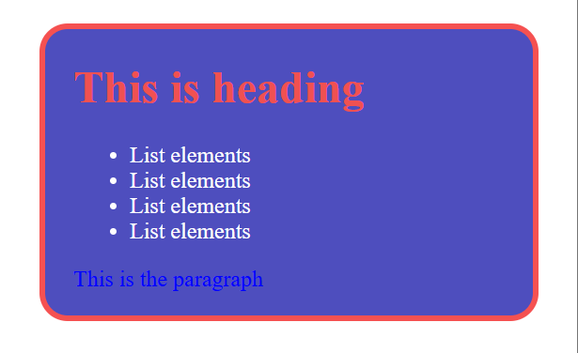Padding: The space inside the border and content of that block.
* Margin : The space outside the border and the page.
* We can also insert the image in the web page using the CSS (background-image property).
* We can apply the hover effect to any element by using the respective id and hover keyword.
  + Eg.: if the id of our element is images,
  + #images:hover{
  + The properties represented inside this are applied when we hover over the object that has id images.
  + }
* Use the name of tag we want to use and .class name we want to give to that tag and tab.
  + We automatically get the tag with the specified class name.
* <nav><a></a></nav> for menus(navigation bar).
* <aside></aside> for side bars.

**box-shodow**- this property is used to give the 3d effect to the page.

# How to deploy my website online?

Requirements:

* Hosting website company
* Domain Name