TradeBook Trade Blotter and Position Keeper

FUNCTIONAL SPECIFICATIONS DOCUMENT

Version 0.1

15 September 2026

Document Prepared By
No | Name | Role & Contact email | Signature | Date

Change Record
Date | Author | Version | Description of Changes

Document References
No | Document Name | Version | Date | Author

Table of Contents
1 Introduction 1
1.1 Background 1
1.2 Purpose 1
1.3 Intended Audience 1
1.4 Dependencies & Assumptions 2
1.5 Acronym 2
1.6 Document Layout 3
1.6.1 User Stories 3
1.6.2 Work Process 3
1.6.3 Acceptance Criteria 4
2 Overall Business Process Flow 5
3 Features 8
3.1 Trade Capture 8
3.1.1 User Story 8
3.1.2 Work Process 8
3.1.3 Acceptance Criteria 8
3.2 Position Keeping 9
3.2.1 User Story 9
3.2.2 Work Process 9
3.2.3 Acceptance Criteria 9
3.3 Live Position Valuation 10
3.3.1 User Story 10
3.3.2 Work Process 10
3.3.3 Acceptance Criteria 10
3.4 Trade Blotter Enquiry 11
3.4.1 User Story 11
3.4.2 Work Process 11
3.4.3 Acceptance Criteria 11
3.5 User Authentication and Account Access Control 12
3.5.1 User Story 12
3.5.2 Work Process 12
3.5.3 Acceptance Criteria 12
3.6 Reference Data Maintenance 13
3.6.1 User Story 13
3.6.2 Work Process 13
3.6.3 Acceptance Criteria 13
4 Reports 14
4.1 End-of-Day Position and Activity Extract 14
4.1.1 User Story 14
4.1.2 Work Process 14
4.1.3 Acceptance Criteria 14
5 Appendices 15
5.1 Appendix A: Worked Example of Holding and Profit Calculation 15
5.2 Appendix B: Out of Scope 15
5.3 Appendix C: Related Documents 16

Introduction

Background
A trading desk generates executions continuously and needs to know, at any moment, what it holds and what those holdings are worth. In many desks that answer is maintained in a spreadsheet kept alongside the execution record. The two drift apart, and the drift is usually discovered at end of day during reconciliation, when the cost of correcting it is highest.
TradeBook was initiated to remove that drift by construction. Executions are recorded once and never amended. Every holding the system reports is derived from those executions, so any figure on screen can be traced back to the trades that produced it. The initiative covers equity instruments in a single currency; it is a working build intended to prove the approach, not a production trading platform.

Purpose
This document specifies the functional behaviour of TradeBook: the features the system provides, the business rules it applies to trades and positions, and the criteria by which each feature is accepted. It describes what the system does and the rules it follows. It does not describe how the system is built; the technical design, data structures and deployment arrangements are held in the accompanying design document.

Intended Audience
This document is intended for the following audience:
- Trading desk users who capture executions and monitor positions
- Operations staff responsible for the blotter, reference data and end-of-day checks
- Business analysts and process owners approving the functional scope
- The implementation team building the system
- Quality assurance staff preparing and executing test cases

Dependencies & Assumptions
Below are the assumptions for this implementation. Any amendment to the assumptions may impact the scope of this implementation.
  - Only equity instruments are traded. Derivatives, foreign exchange and fixed income are outside this scope.
  - All accounts and instruments operate in a single currency. No currency conversion is performed at any point.
  - Cost of holdings is measured on a weighted-average basis. Lot-level methods such as first-in first-out are outside this scope.
  - Prices are supplied by a generated feed within the system. No external market data vendor is connected, and prices are therefore indicative rather than traded levels.
  - An identity provider is available to authenticate users and issue access tokens. TradeBook does not hold passwords and does not register users.
  - Fees, commissions, taxes, settlement and corporate actions are excluded. Profit and loss figures are gross.
  - Executions are captured after the fact. TradeBook does not route, amend or cancel orders in any market.
  - A captured execution is never amended or deleted. A correction is made by capturing an offsetting execution.
  - Each account has one owner. Shared or delegated account access is outside this scope.

Acronym
Abbreviations | Description
FSD | Functional Specifications Document
IdP | Identity Provider. The external service that authenticates users and issues access tokens.
P&L | Profit and Loss
UTC | Coordinated Universal Time. All times recorded by the system are held in UTC.
WAC | Weighted Average Cost. The method used to value the quantity still held.

Document Layout
In general, each chapter of this document contains the description of a process and its sub-processes. Each sub-process consists of the breakdown on the objectivity and value streams which define the needs of the process, such as:
- Work Process; and
- Use case; and
- Acceptance criteria.

User Stories
This is the initial most important guideline of each process for Juris to identify our target customer and their main goals, behavior, touch points and context of their required input and output of the process. By using use case, it enables us to articulate three important questions as below:
- Who are we building it for, who the user is? – As a (type of user, role or actor)
- What are we building, what is the intention? – I need (the goal or objective of the process)
- Why are we building, what value it brings for the user? – So that (the benefit or value delivered)

Work Process
Work process defines the flowchart with visualization of the process flow, using swim lanes which consists of multiple stakeholders (business users, system, etc.). There are certain flowchart notations used in the swim lane flow charts as depicted below:
Notation | Description
Start/End | This notation describes the start or end of a process
Process | This notation describes the action/activity of a process
Decision | This notation describes the decision required in a process
Manual Process | This notation describes the manual action/activity of a process. (out of system activity)
On-page reference | This notation describes an incoming/outgoing connecting reference of a process within the same flowchart/page
Off Page reference (outgoing) | This notation describes an outgoing connecting reference of a process/other process in a different flowchart/page.
Off Page reference (incoming) | This notation describes an incoming connecting reference of a process/other process in a different flowchart/page.

Each process in the flowchart shall be further described in the description table as below:
(Process title, as shown on the flowchart)
No | Business Process Description | Reference
(No.) | (Process name, as shown on the flowchart)  (Detailed description of the process step) | (Number of the next process step)

- Process Title – Describes the title of the process based on the flowchart
- No – Process number depicted in the flowchart.
- Business Process Description – Detailed description of each process
- Reference – define the reference to the next process/activity, data entry & business rule Multiple reference will be defined if it is a “decision” notation.

Acceptance Criteria
These are the minimum criteria which guide the development to make sure the objective mentioned in the user story is fulfilled. An acceptance criterion is made up of few components as followed.
- Scenario – High level description of the possible event
- Given – Example of the scenario
- When – Example of action for the scenario
- Then – Anticipated outcome for the scenario

Overall Business Process Flow
The desk operates a single continuous cycle. A trade is executed in the market, the execution is captured in TradeBook, the affected holding is recalculated, and the revised holding is shown to the desk together with its current value. The cycle repeats for every execution, and the valuation refreshes independently of it as prices move.
Two principles govern the whole process. First, a captured execution is a permanent record: it is never edited or removed, and a mistake is corrected by capturing an offsetting execution. Second, a holding is never entered directly; it is always calculated from the executions captured against that account and instrument. Together these mean every figure the desk sees can be explained by the trades behind it.
The process is shown below, followed by a description of each step.

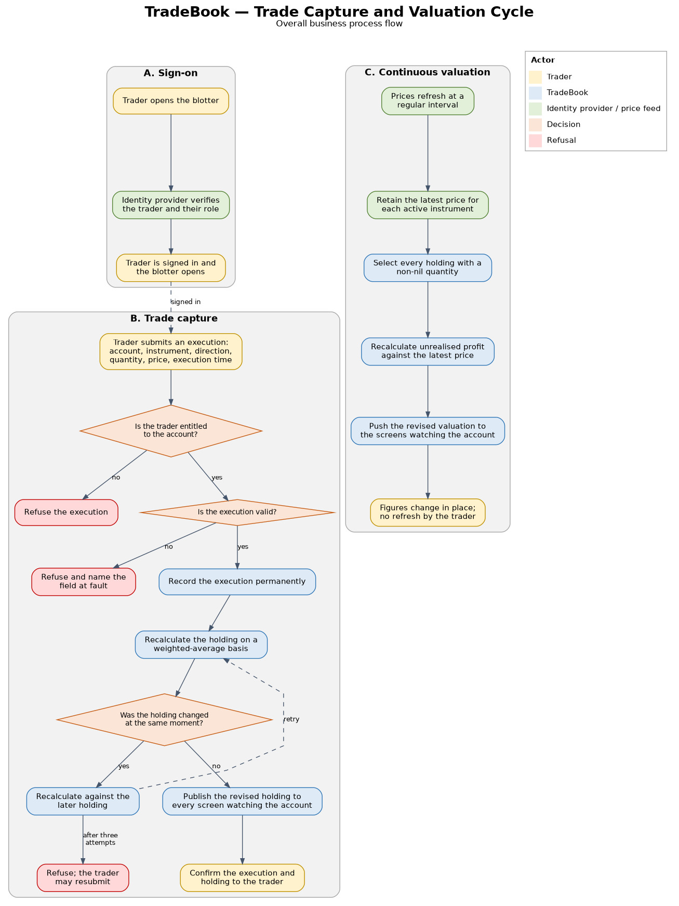

TradeBook Trade Capture and Valuation Cycle
2.0 Trade Capture and Valuation Cycle
Process | Description | Workflow
1 | Sign on — The trader signs in through the identity provider and returns to TradeBook with a valid access token. | 2
2 | Capture execution — The trader enters the account, instrument, direction, quantity, price and execution time, and submits the execution. | 3
3 | Check entitlement — The system confirms the trader is entitled to trade the account. Where they are not, the execution is refused and nothing is recorded. | 4, or End
4 | Validate execution — The instrument must be active, the quantity and price must both exceed zero, and the execution time must not be in the future. | 5, or End
5 | Record execution — The execution is recorded permanently. It cannot afterwards be amended or deleted. | 6
6 | Recalculate holding — Net quantity, average cost and realised profit are recalculated on a weighted-average basis and stored with the execution in one step. | 7
7 | Publish holding — The revised holding is sent to every screen watching the account, and the trader receives confirmation. | 8
8 | Value holding — Prices refresh at a regular interval. Unrealised profit is recalculated for every open holding and pushed to the screen. | 8

Features

Trade Capture

User Story
As a trader, I need to record an execution as soon as it is done, so that my holding and profit figures reflect it without waiting for an end-of-day process.

Work Process
- The trader enters the account, instrument, direction, quantity, price and execution time, and submits the execution.
- The system confirms that the trader is entitled to trade the account. A trader who does not own the account is refused, and the refusal does not disclose whether the account exists.
- The system validates the entry: the instrument must be recognised and active, the quantity and price must both be greater than zero, and the execution time must not be in the future. A failed check names the field at fault.
- The system records the execution and recalculates the holding for that account and instrument together, so the two can never disagree.
- If the same execution is submitted twice with the same external reference, the system returns the original record rather than creating a duplicate.
- The revised holding is sent to every screen watching that account, and the trader receives confirmation with both the execution and the resulting holding.

Acceptance Criteria
Scenario: A new holding is opened
- Given the trader holds nothing in the instrument
- When a purchase of 300 units at 10.00 is captured
- Then the holding shows 300 units at an average cost of 10.00 and no realised profit
Scenario: An execution is rejected for an unowned account
- Given the trader does not own the account
- When an execution is submitted against it
- Then the execution is refused and nothing is recorded
Scenario: A duplicate submission is ignored
- Given an execution carrying an external reference has already been captured
- When the same reference is submitted again
- Then the original execution is returned and no second record is created
Scenario: An invalid quantity is rejected
- Given the trader owns the account
- When an execution with a quantity of zero is submitted
- Then the execution is refused and the quantity field is named as the cause

Position Keeping

User Story
As a trader, I need my holding and cost to be maintained automatically from my executions, so that I can rely on the figures without maintaining a separate record.

Work Process
- The system maintains one holding per account and instrument, recording the net quantity, the average cost of the quantity still held, and the profit realised so far.
- A purchase or sale in the same direction as the existing holding increases it. The average cost becomes the quantity-weighted average of the existing cost and the new execution price.
- An execution in the opposite direction reduces the holding. The profit realised on the quantity closed is added to the running total, and the average cost of the remaining quantity is unchanged.
- Where an execution is larger than the holding it opposes, the holding is closed in full, the profit on the closed quantity is realised, and the excess opens a holding in the opposite direction at the price of that execution. The previous average cost is discarded rather than carried forward.
- A holding reduced to nil retains its realised profit and its average cost returns to nil.
- Where two executions for the same account and instrument are captured at the same moment, the system recalculates against the later state so that neither is lost.

Acceptance Criteria
Scenario: Cost is averaged across purchases
- Given a holding of 300 units at an average cost of 10.00
- When a further 200 units are bought at 12.00
- Then the holding shows 500 units at an average cost of 10.80
Scenario: Profit is realised on a partial sale
- Given a holding of 500 units at an average cost of 10.80
- When 100 units are sold at 13.00
- Then realised profit increases by 220.00 and the average cost stays at 10.80
Scenario: A holding reverses direction
- Given a holding of 400 units at an average cost of 10.80
- When 600 units are sold at 9.00
- Then the holding becomes 200 units short at an average cost of 9.00, and realised profit falls by 720.00
Scenario: Simultaneous executions are both recorded
- Given two executions for the same account and instrument are captured at the same moment
- When both are processed
- Then both are recorded and the resulting net quantity reflects each of them

Live Position Valuation

User Story
As a trader, I need the value of my holdings to update as prices move, so that I can see my exposure without refreshing the screen.

Work Process
- The system generates a current price for every active instrument at a regular interval and retains the latest price for each.
- For every holding with a non-nil quantity, the system calculates unrealised profit as the difference between the current price and the average cost, applied to the quantity held.
- The calculation is directional. A holding sold short shows a gain when the price falls.
- Revised valuations are sent to the screens watching the affected account, and the displayed figures change in place.
- The latest price for each instrument is retained so that holdings continue to value correctly immediately after the system is restarted.

Acceptance Criteria
Scenario: Valuation follows the price
- Given a holding of 400 units at an average cost of 10.80
- When the price moves to 11.00
- Then unrealised profit shows as 80.00 without any action by the trader
Scenario: A short holding gains when the price falls
- Given a holding of 200 units short at an average cost of 9.00
- When the price moves to 8.50
- Then unrealised profit shows as 100.00
Scenario: Nil holdings are not valued
- Given a holding has been closed in full
- When prices move
- Then no unrealised profit is reported for that holding
Scenario: Valuation survives a restart
- Given prices have been received and the system is restarted
- When the trader opens the screen
- Then holdings are valued at the most recent prices received before the restart

Trade Blotter Enquiry

User Story
As an operations user, I need to list the executions captured for an account over a chosen period, so that I can review and reconcile the day's activity.

Work Process
- The user selects an account and, optionally, an instrument and a date and time range.
- The system lists the matching executions with the most recent first, showing direction, quantity, price, execution time and external reference.
- Results are returned in pages so that a long history can be reviewed without a single oversized response.
- A trader sees only accounts they own. An operations user may list any account.
- Every holding shown elsewhere in the system can be reconciled against this list, because the list is the record from which the holding is calculated.

Acceptance Criteria
Scenario: Executions are listed for a period
- Given executions exist for the account across several days
- When the user requests a single day
- Then only that day's executions are listed, most recent first
Scenario: Access is limited to owned accounts
- Given the user is a trader
- When they request an account they do not own
- Then the request is refused
Scenario: Results are paged
- Given an account has more executions than one page holds
- When the user requests the first page
- Then the first page is returned together with the means to request the next

User Authentication and Account Access Control

User Story
As a desk manager, I need each user to be identified before they can act and limited to their own accounts, so that activity is attributable and exposure is not visible across desks.

Work Process
- Users authenticate with the organisation's identity provider. TradeBook does not hold or verify passwords and does not register users.
- The identity provider returns an access token that identifies the user and the role they hold. TradeBook accepts a request only when the token is valid, current, and issued for this system.
- A user holding the trader role may capture executions and view holdings for accounts they own. A user holding the operations role may view any account and maintain reference data.
- The same check applies to the live update channel as to ordinary requests. A user cannot subscribe to updates for an account they are not entitled to see.
- Every captured execution records the identity of the user who captured it.
- An expired or missing token results in refusal, and the user is returned to the identity provider to sign in again.

Acceptance Criteria
Scenario: An unauthenticated request is refused
- Given no valid token is presented
- When any request is made
- Then the request is refused and no data is disclosed
Scenario: A trader cannot view another desk's account
- Given the trader does not own the account
- When they request its holdings
- Then the request is refused
Scenario: Live updates observe the same limits
- Given the trader does not own the account
- When they attempt to subscribe to its updates
- Then the subscription is refused and no updates are delivered
Scenario: Capture is attributable
- Given an execution has been captured
- When the record is examined
- Then it identifies the user who captured it

Reference Data Maintenance

User Story
As an operations user, I need to maintain the list of instruments and accounts, so that traders can only capture executions against valid references.

Work Process
- An operations user creates an instrument with its symbol, name, currency, price increment and trading unit. The symbol must be unique.
- An operations user creates an account with its code, name, base currency and owning user. The code must be unique.
- An instrument or account may be deactivated. Deactivation prevents new executions and leaves existing records and holdings untouched.
- Traders may view active instruments. Only operations users may create or amend them.
- Instruments carry a type so that classes beyond equities can be introduced later without altering existing records.

Acceptance Criteria
Scenario: Duplicate symbols are prevented
- Given an instrument already exists with a given symbol
- When an operations user creates another with the same symbol
- Then the request is refused and the existing instrument is unchanged
Scenario: Deactivation blocks new executions
- Given an instrument has been deactivated
- When a trader attempts to capture an execution against it
- Then the execution is refused and existing holdings remain visible
Scenario: Traders cannot maintain reference data
- Given the user holds the trader role
- When they attempt to create an instrument
- Then the request is refused

Reports

End-of-Day Position and Activity Extract

User Story
As an operations user, I need a single extract of the day's executions and closing holdings per account, so that I can reconcile the desk's records at the end of the session.

Work Process
- The user selects a business date and, optionally, one account. Leaving the account blank produces the extract for every account the user is entitled to see.
- The extract has two parts. The first lists every execution captured on that date with its account, instrument, direction, quantity, price, execution time and external reference.
- The second lists the closing holding for each account and instrument with a non-nil quantity, showing net quantity, average cost, realised profit, the closing price used and unrealised profit at that price.
- Both parts carry the business date and the time the extract was produced, so that two extracts taken at different times can be told apart.
- The extract is produced in a format that opens directly in a spreadsheet.

Acceptance Criteria
Scenario: The extract reconciles to the blotter
- Given executions were captured on the selected date
- When the extract is produced
- Then the executions it lists match the blotter enquiry for the same date and account
Scenario: Closing holdings agree with the executions
- Given a series of executions across the day for one account and instrument
- When the extract is produced
- Then the closing net quantity equals the net of those executions
Scenario: Access is limited
- Given the user holds the trader role
- When the extract is produced without naming an account
- Then it covers only the accounts that trader owns

Appendices

Appendix A: Worked Example of Holding and Profit Calculation
The sequence below shows how a single account and instrument behaves across six executions, starting from no holding. It covers each of the cases described in Position Keeping, including the reversal from long to short. These figures are the reference the calculation is tested against.
- 1. Buy 300 at 10.00. Holding 300 long, average cost 10.00, realised profit nil.
- 2. Buy 200 at 12.00. Holding 500 long, average cost 10.80, realised profit nil. The average is the weighted combination of 300 at 10.00 and 200 at 12.00.
- 3. Sell 100 at 13.00. Holding 400 long, average cost 10.80, realised profit 220.00. The 100 units sold realised 2.20 each.
- 4. Sell 600 at 9.00. The 400 units held are closed at a loss of 720.00, taking realised profit to a loss of 500.00. The remaining 200 units open a short holding at an average cost of 9.00. The previous average of 10.80 is discarded.
- 5. Buy 50 at 8.00. Holding 150 short, average cost 9.00, realised loss 450.00. Buying back below the average cost of a short holding realises a gain of 50.00.
- 6. Buy 150 at 9.50. The holding closes in full at a further loss of 75.00, leaving a realised loss of 525.00, no quantity held and an average cost of nil.

Appendix B: Out of Scope
The following are recognised as absent from this release and are recorded here so that their absence is a decision rather than an oversight.
- Asset classes other than equities, and any instrument requiring a contract size or multiplier.
- Currency conversion and any account holding positions in more than one currency.
- Lot-level cost methods such as first-in first-out, and the lot history they require.
- Fees, commissions, taxes, settlement, dividends and other corporate actions.
- Externally sourced market data, and the licensing that accompanies it.
- Order management: routing, amendment and cancellation in a market.
- Risk limits, margin calculation and pre-trade checks against either.
- Amendment or deletion of a captured execution. Corrections are made by capturing an offsetting execution.

Appendix C: Related Documents
The technical design, covering the application structure, data model, interfaces and deployment arrangements, is held in the TradeBook Design Document. The agreement governing the interface to the identity provider is held in the TradeBook Interface Agreement.

