**IRREGULATORS**

**Team Roles**

* **Julius — Data & Backend Lead**  
  Primary: database, data models, APIs, order history, sales summary.  
  Secondary: support backend-heavy pages (login, cart).
* **Axel — UI/Frontend Lead**  
  Primary: landing, client pages, admin UI, CSS/design, wireframes.  
  Secondary: assist with frontend parts of admin & order pages.
* **Ellyza — Integration, Backend & QA Lead (Coordinator)**  
  Primary: backend app logic, integration between DB & frontend, testing, deployment coordination.  
  Secondary: help with API endpoints, manage tracking, manage orders pages, final QA sign-off.

# Task Distribution (Main / Support)

|  |  |  |
| --- | --- | --- |
| **Module / Task** | **Main** | **Support** |
| Database Schema & Setup | Julius | Ellyza |
| Landing Page (public) | Axel | Julius |
| Sign-Up Page | Ellyza | Axel |
| Login Page | Ellyza | Julius |
| Client Landing (after login) | Axel | Ellyza |
| Cart & Place Ordering | Julius | Axel |
| Track Order Page | Ellyza | Julius |
| Order History Page | Julius | Ellyza |
| Admin Dashboard (UI) | Axel | Ellyza |
| Sales Summary (reports) | Julius | Axel |
| Managing Items (admin) | Axel | Julius |
| Managing Orders (admin) | Ellyza | Axel |
| Testing & QA | Ellyza | Julius / Axel |
| Deployment & Cutover | Ellyza | Julius |
| Project coordination / sync | Ellyza | Axel / Julius (rotate) |

**Workload Balance (Est. Days)**

* **Julius (~10 days)**  
  DB (3d), Cart & Ordering (3d), Order History (2d), Sales Summary (2d)
* **Axel (~9 days)**  
  Landing + Client UI (3d), Admin UI + Managing Items (4d), Wireframes & styling (2d)
* **Ellyza (~11 days)**  
  Signup/Login (4d), Tracking & Managing Orders (3d), Testing & Deployment (3–4d)

**RAD Phase Leadership**

* **Requirements Planning** → *All three*
* **User Design** → *Axel leads* (wireframes, mockups)
* **Construction** → *Split per role* (parallel work)
* **Cutover (Testing & Deployment)** → *Ellyza leads*

**Suggested Sprint (2 weeks)**

* **Day 1–2** → Requirements + wireframes (Axel lead)
* **Day 3–6** → Parallel build:
  + Julius (DB, schema, APIs)
  + Axel (UI mock pages, admin skeleton)
  + Ellyza (auth endpoints, backend logic)
* **Day 7** → Integration (Ellyza leads)
* **Day 8–10** → Remaining modules (cart, orders, admin pages)
* **Day 11–12** → Testing (Ellyza lead, Julius & Axel fix bugs)
* **Day 13–14** → Deployment & polish

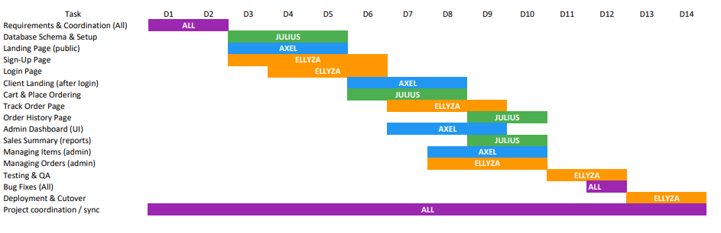**GNATT CHART (VISUALS)**