Lab1: Object, Class, JUnit

# Objective

* Design the basic principles of program design with objects and classes (OOP) including setters & getters, constructor, etc.
* Understand the class UML diagram and be able to implement java project in Eclipse
* Be able to use JUnit Test Framework in order to make a program without errors

# Problem Statement: Art Museum

Mr.Somchai is a curator at a local art museum. He wants a program that helps him keep track of artworks and artists in each exhibition. Write an object oriented program to help Mr.Somchai with his job.

# Implementation Details

In this part, you will write a program which contains three classes:

1. Artist
   * This class encapsulates the details of each artist.
2. ArtWork
   * This class encapsulates the details of each artwork including its artist(s).
3. Exhibition
   * This class encapsulates the details of each exhibition including its artworks.
   * This is the main class of the program

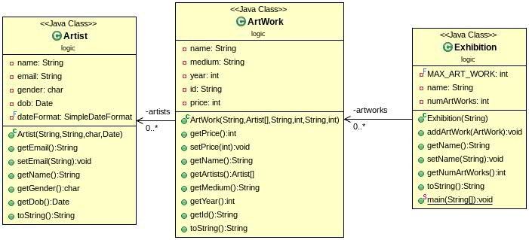

Figure 1. The UML diagram of the program.

## Class: Artist

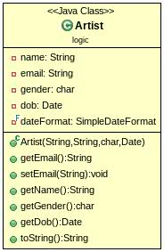

Figure 2. The UML diagram of Artist

### Field

* String name: name of the artist
* String email: email of the artist
* char gender: geneder of the artist
* Date dob: date of birth of the artist
* SimpleDateFormat dateFornat: set the date format to "dd/MM/yyyy"

### Constructor

* Artist(String name, String email, **char** gender, Date dob);

### Method

* Getters & Setters
  + Create getters for name, email, gender, dob
  + Create a setter for email
* String toString() : Please look at our JUnit test module for an expected result.

## Class: ArtWork

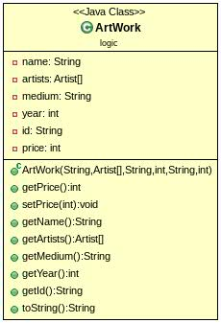

Figure 3. The UML diagram of ArtWork

### Field

* String name: name of the artwork
* Artist [] artists: An array that contains a list of artists 
* String medium: the medium of the artwork (e.g. paper)
* int year: year when the artwork was created
* int price: price of the artwork

### Constructor

* ArtWork(String name, Artist [] artists, String medium, **int** year, String id, **int** price)

### Method

* Getters & Setters
  + Create getters for name, artists, medium, year, price
  + Create a setter for price
* String toString() : Please look at our JUnit test module for an expected result.

## Class: Exhibition

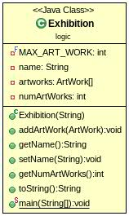Figure 4. The UML diagram of Exhibition

### Field

* final int MAX_ART_WORK; Maximum number of artworks in the exhibition
* String name: name of the exhibition
* Artwork [] artworks: artworks in the exhibition (the size of the array shold be MAX_ART_WORK)
* int numArtWorks: Current number of artworks in the exhibition

### Constructor

* Exhibition(String name)

### Method

* Getters for name and numArtworks
* Setter for name
* void addArtWork(ArtWork artWork) : Add ArtWork to the exhibition if the number of artworks has not reached the maximum number. Else, Print a message to tell Mr.Somchai to tell him thatwe cannot add another artwork. (The message could be anything)
* String toString() : Please look at our JUnit test module for an expected result.