Lab1: Object, Class, JUnit (Worksheet)

Section 33 Date 25/08/2017

Student ID 5931049121 Name Phakhin Deesee

# Part A: Implementation

1. Summarize the step to export your project into jar file.

File -> Export -> {Select} Java -> JAR file -> Next -> {Select} Project {Lab1_2017_...} -> {Check box} Export Java source file and resources -> Browse…{Where to export .jar } -> Next -> Next -> Browse…{your main class} -> Finish.

1. Create a UML diagram of the program using eclipse and tell us the name of software/eclipse extension you are using.

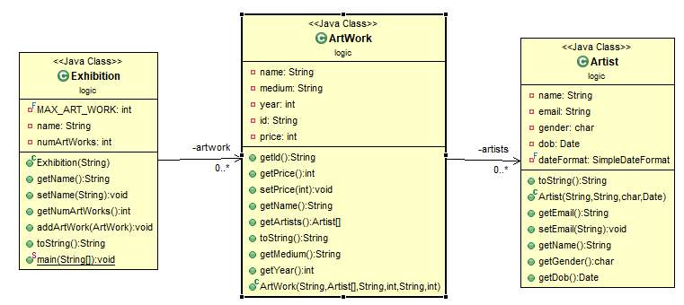

ObjectAid UML plugin for Eclipse

1. Capture the screen of JUnit Test Cases.

