Mapping Human-Centered Knowledge:
Participatory Design, Semantic Web and gendered perspectives in GLAM
Elena Gómez¹, Nuria Ferran-Ferrer² and Miquel Centelles²
¹ Barcelona University, Spain
² Barcelona University, Melcior de Palau, 140, Barcelona-Spain
Abstract

This work is framed within a doctoral research project at the University of Barcelona, HerStory NeSy Ai, which seeks to identify pivotal literature on human-centered computation projects and information architectures within a given interdisciplinary framework: semantic and neurosymbolic technologies, participatory design and GLAM (galleries, libraries, archives, and museums). Furthermore, it will examine the visibility of specific topics related to epistemic injustice, gender and intersectional perspectives, and misrepresented groups in them. This study uses a metadata and bibliometric analysis method based on scientific maps and keywords to construct the conceptual structure of a section of a knowledge domain situated at the intersection of various topics over the last decade. The mapping reveals significant, albeit weak, co-occurrence patterns, given the terminological diversity within each topic. The clusters' evolution shows a decrease in density and a subtle increase in centrality, except for one cluster that grows in density by gaining a new keyword, 'women'.

Keywords
Participatory Design, Human Centered Computing, Human Centered Design, User-centered design, Human-machine interaction, Semantic Web, Open Linked Data, RFD, Ontologies, GLAM (Galleries, Libraries, Archives, Museums).

Introduction
Research areas have emerged, driven by the social impact of technology-centered design while simultaneously seeking to integrate human needs and perceptions into the design process. However, substantial ambiguity persists in a comprehensive understanding of these fields, especially in the conceptual and methodological frameworks.
This study, as part of PhD research in the context of HerStory project (PID2023-147673OB-I00), explores how Neuro‑Symbolic Artificial Intelligence (NeSyAI) and Information Architecture can contribute to mitigating gender bias in information systems (Smith, A., Johnson, B., 2023). The project seeks to enhance the ways data about women and misrepresented groups is searched, navigated, organized, labeled, visualized, and narrated. For knowledge-based technologies to address biases and informational gaps, advances are required not only in semantic technologies and IA theory, including their ontological designs and metadata, but also in human participation frameworks (Capel, T., Brereton, M 2023). Participatory approaches such as user-centered design (UCD) contribute to system coherence from social science and humanistic perspectives. By improving the design processes in the context of richer data and metadata in the context of co-production of knowledge (Jasanoff, S. 2004), these strategies may help to identify and counteract representational gaps caused by information appropriation and access, making them essential for addressing issues of gender, intersectionality and other marginalized groups. As Fricker, M (2007) observes, epistemic advantages often follow from material advantages, underscoring the need for critical engagement with knowledge management infrastructures.
Participatory design (PD) and related approaches (human-centered, user-centered, and co-creation) are therefore essential (García, M., López, P., 2024). They suggest that technology development with active participation of the stakeholders—particularly those most affected by it — can improve their feasibility, viability and desirability (García, M., López, P., 2024; Chen, L., Wang, H., 2023). When such technology is knowledge-based the need for participation goes beyond usability. It becomes a matter of social and ethical responsibility with “its social context because archives, systems and media only have meaning as part of a community practice” (Escobar, A. 2019).
This development context calls for ways to explore relevant academic literature acknowledging its multidisciplinarity. This can be challenging due to the use of different terminologies and epistemological understandings (Fidel, R. 2012) and incompatible disciplinary taxonomies (Wacnik, P., et al. 2025). Traditional inquiries in databases like Scopus and Web of Science (WoS) yield partial or broad results even with sound conceptual questions. Using academic metadata and bibliometric techniques allows the understanding of the relationship between the multidisciplinary queries such as these and reveals its latent thematic structures (Cobo, M. et al. 2011a; Ermel, A. et al. 2021).

Recognizing and clarifying the conceptual structure of these intersecting domains is thus crucial for establishing solid methodological foundations. Only then can the development of technological processes genuinely reflect a user-centered design philosophy (Cobo, M. 2011b).

Methodology
To explore the interdisciplinary field at the intersection of participatory design, semantic web technologies, and gender perspectives in GLAM institutions, a combined methodological approach was adopted. This approach integrates a SALSA scoping review framework (Lopezosa, C. et al. 2023) with metadata analysis and bibliometric mapping techniques - scientific maps (Cobo, M. et al. 2011a) - to capture both the breadth of the literature and the conceptual relationships between key themes. The scoping review provides a systematic framework for the bibliometric mapping to show the thematic clusters positioned strategically. Together, these methods offer a comprehensive view of the field’s conceptual structure and support the identification of research gaps and emerging directions through four sequential phases.
In the search phase, search equations were built (Cobo, M. 2011b) and its results refined (Lopezosa, C., Codina, L. 2023) ensuring a significant and representative sample of literature (primary documents and their metadata) to apply bibliometric techniques effectively. The search strategy made use of focused, proximity, and broad operators (e.g., W/n, NEAR/n, wild cards *, and field-specific labels) for metadata extraction from Scopus (2,657 records) and Web of Science (613 records) from 2014–2025, yielding 3,250 unique records after deduplication. The appraisal phase involved the systematic evaluation and refinement of the metadata corpus. The Synthesis phase consisted of the application of the bibliometric mapping techniques (Cobo, M. et al. 2011a; Ermel, A. et al. 2021) using SciMAT software (Snyder, H. 2019). This generated a thematic network with 14,151 nodes and 231,319 edges divided into two five-year periods (2014–2019 and 2020–2025) to identify what are termed “strategic zones”. These networks are based on bibliometrics of 45,650 retrieved and normalized keywords co-occurrence (Callon, M. et al 1991) and clustering algorithms (Cobo, M. 2011b; Cobo, M. et. al. 2012) (such as simple centers). This approach ensured both thematic coverage and the minimization of bias by avoiding manual keyword inclusion. The resulting clusters were then positioned into four quadrants—motor themes, specialized themes, emerging or declining themes, and basic/transversal themes (based on Callon’s centrality and density measures) (Callon, M. et al 1991) —allowing the description of a conceptual structure based on metadata across the last decade. Finally, the analysis phase consisted of the examination of both the general conceptual structure of the field and the thematic positioning of the project-specific topics. This methodological design enables both quantitative mapping of the field’s conceptual structure and qualitative identification of relevant projects, user-centered or participatory design methodologies, and the presence of semantic web technologies within GLAM contexts.
Seven reviews are considered relevant within the search themes although none integrating all of them. The work made by Wacnik, P. et al. (2025) integrates the literature basis for participative design from its emergence context since 1990. From a complementary perspective, Bhandari, A. (2023) builds a bibliometric map about design thinking research trends. Another study (Delgado, F. et al., 2023) focuses on AI design processes, examining the theoretical frameworks in which participatory approaches mark a significant shift in the design of these processes. Baghini, M., et al. (2024) compiles usability testing literature, its trends and methodologies. The work of Hamilton, K. et al. (2024) structured a review analyzing reported advances on neurosymbolic AI in terms of natural language processing. There is also the state of the art made by Desul, S. et al. (2025) focused on the use of semantic technology for cultural heritage, its benefits and discussions. This review looks at two of the four topics that are of interest. It lacks both the gender perspective and the participatory design methodologies to complete the picture. Addressing the gender perspective, Ferran-Ferrer, N. et al. (2023) study the gender gap in Wikipedia as a knowledge architecture and platform with great visibility and social impact.

Although these reviews contribute to the context in which this bibliometric process is analyzed, they do not allow the results to be contrasted or discussed directly. They provide disciplinary insight into this interdisciplinary endeavor.

Results: bibliometric analysis of the fields’ conceptual structures (2014-25)
The general analysis of the conceptual structure of this intersection of fields, as revealed through the bibliometric mapping, is shown in two strategic diagrams (Cobo, M., M. et al. 2018) for each period (P1:2014–19 -Figure 1- and P2:2020–25 - Figure 2). The bibliometric analysis exposes distinct conceptual structures built from the co-occurrence patterns of the authors' keywords plus those of the analyzed databases at a given time. Such structure is shown by crossing two normalized and measured dimensions (Cobo, M. et al. 2018): centrality, as a cluster interaction measure; and density, as the strength of the inner patterns of co-occurrence (Ermel, A. et al., 2021, p. 181) for each cluster. This is how a two-dimensional field is created with four strategic zones:
- Motor zone (high density and high centrality) shows both, clusters with strong co-occurrence patterns and active interaction between them, “they are well developed and they are important for the structure of the research field” (Cobo, M. et al. 2018. p. 265).
- Specialized and peripheral themes (high density and low centrality) indicate highly developed themes that are isolated and have less interaction with others.
- Basic and transversal themes (low density and high centrality) point to structural and disciplinary themes highly interacting with other clusters but lacking the level of development necessary to be a motor theme.
- Emergent/declining themes (low density and low centrality) indicate clusters of keywords that are on the verge of disappearing or becoming central, motor or specialized themes.
This map enables future researchers to conduct systematic literature searches by expanding the disciplinary logics using the keywords materialized in existing articles and indexed systems instead of relying solely on those within each disciplinary paradigm, which is essential for interdisciplinary reading and interpretation. This is the subsequent course of action that will be pursued to elucidate the conceptual architecture of the field that has been revealed by the co-occurrence of keywords, a phenomenon which presents elements for comparison across different periods.
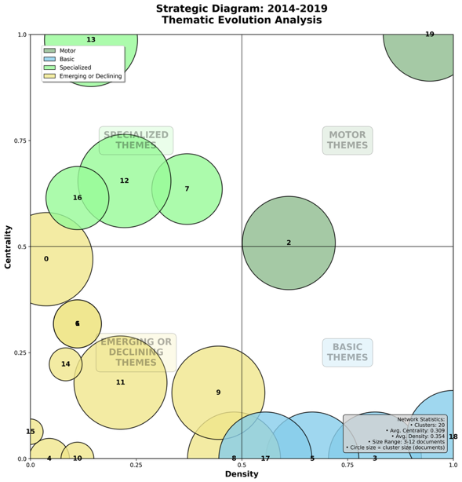  Figure 1. SciMAT Strategic map for period 1: 2014-2019 (made by the authors) | 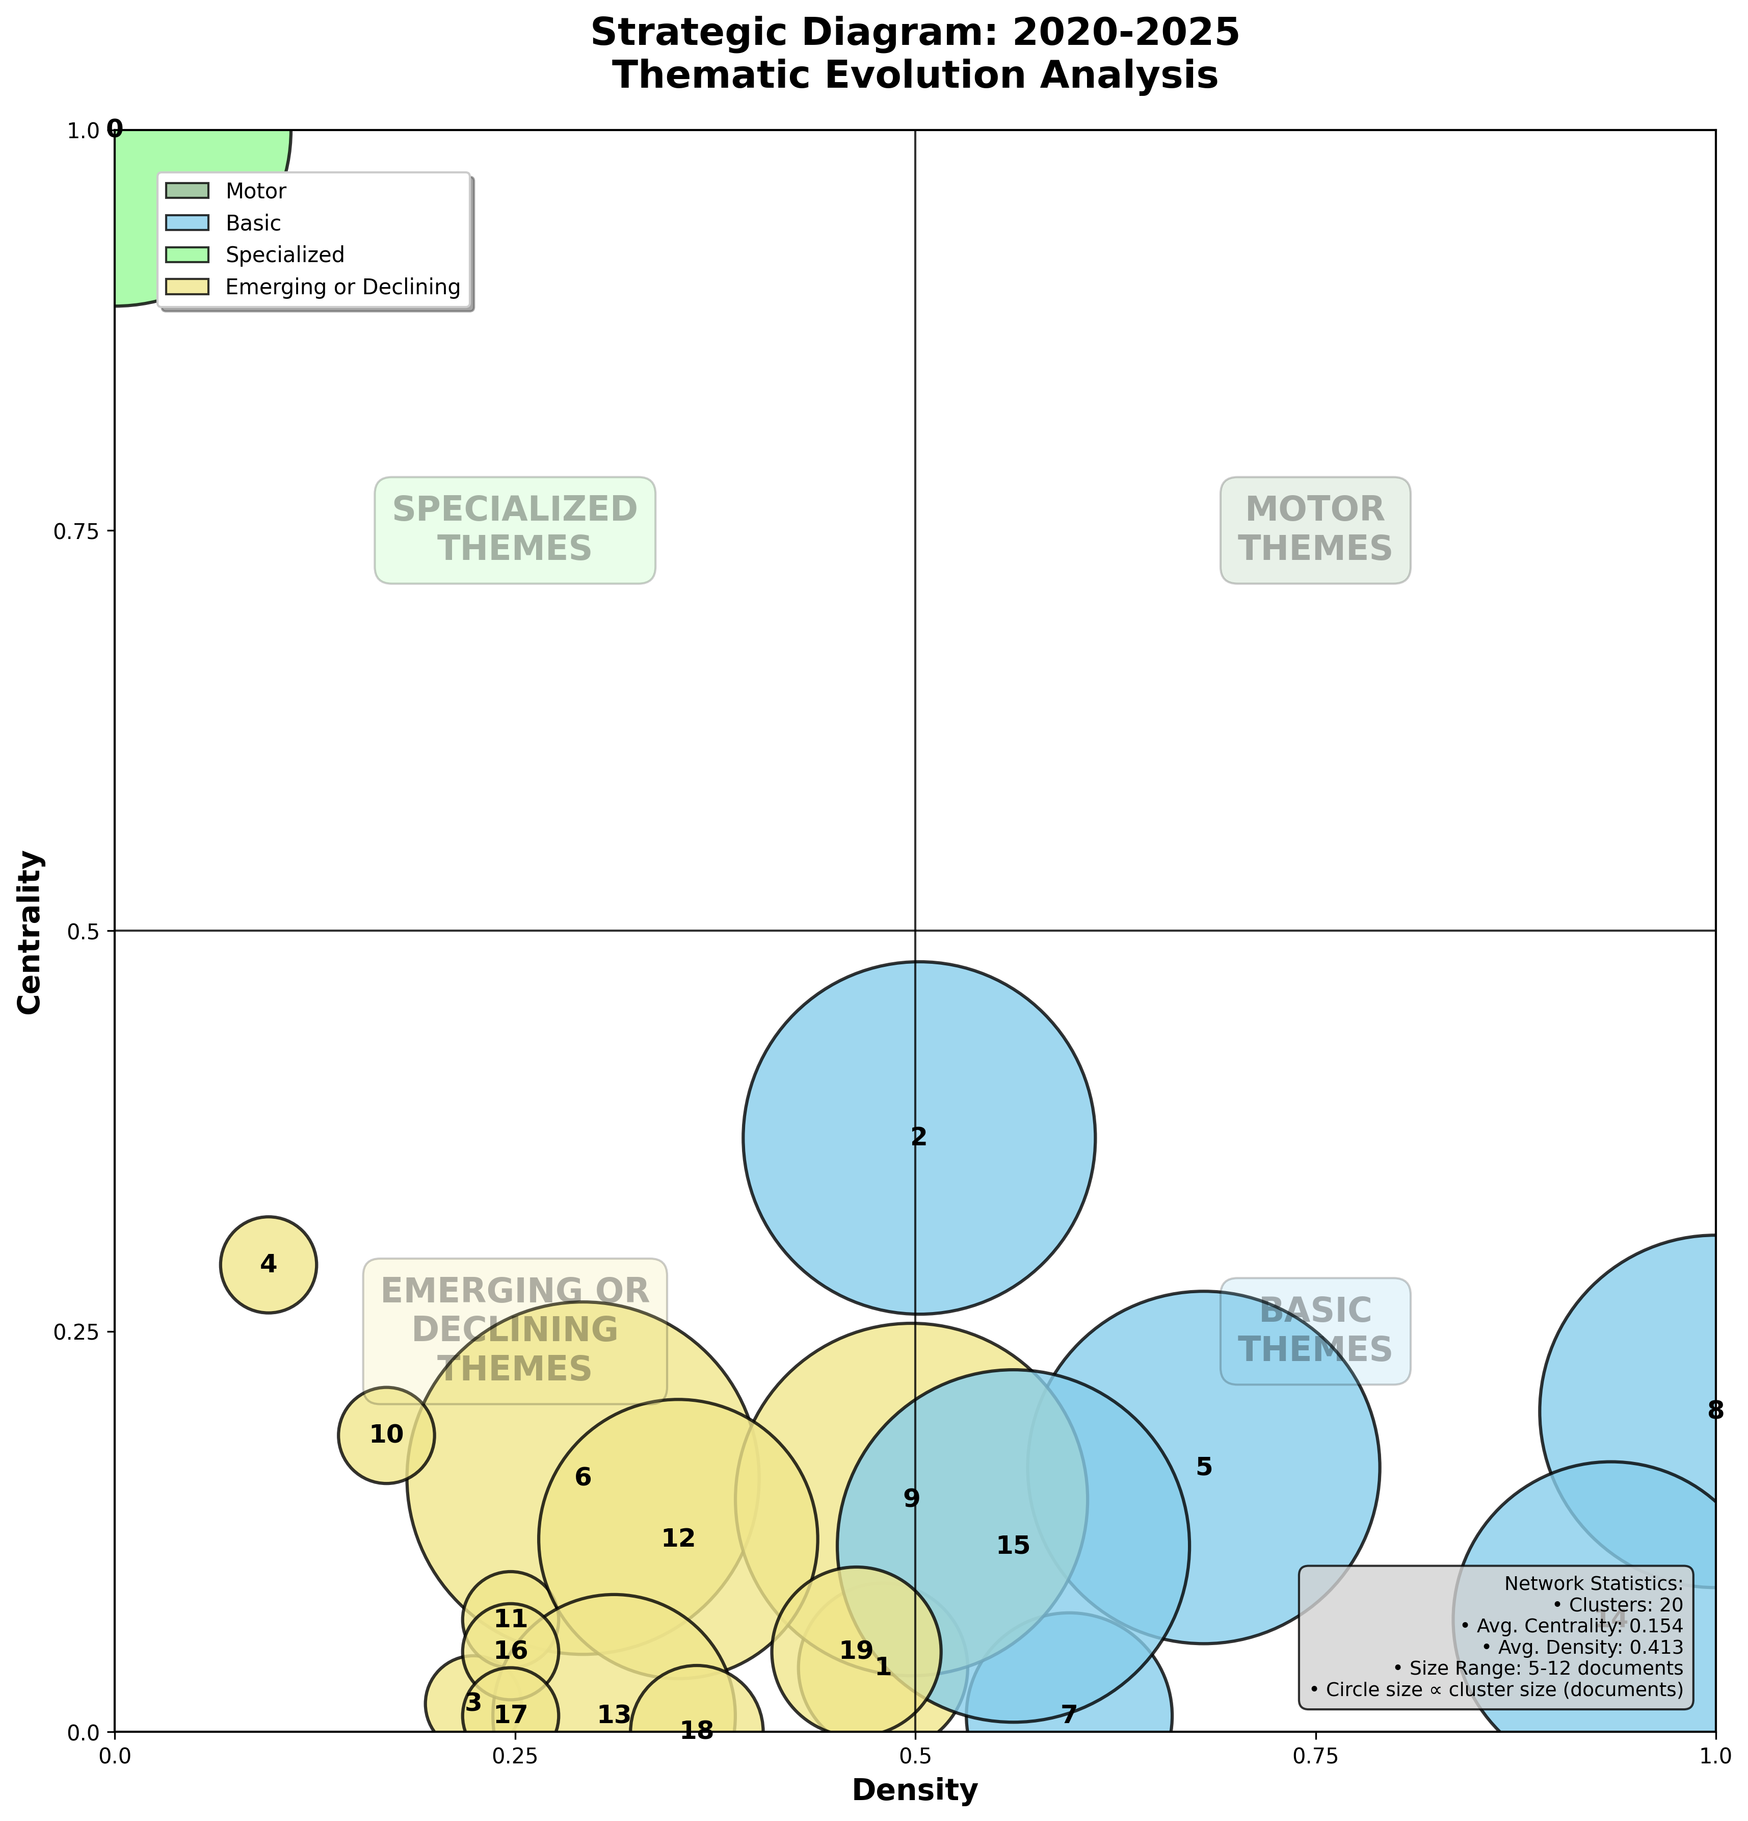  Figure 2. SciMAT Strategic map for the period 2: 2020-2025 (made by the authors)
The conceptual structure of the field, derived from keyword co-occurrence, reveals notable differences between the two analyzed moments (P1: 2014–2019, P2: 2020–2025). As the majority of clusters are placed in the emergent/declining zone (for both periods), a disciplinary dispersion trend, or a low concept consolidation needs to be considered when approaching searches on such topics. The keywords in a cluster are named directly, and no names were generated for these networks, as simply naming them allows us to illustrate the contexts in which they are found without erasing the granularity through interpretation. This creates a difficulty in reading, which will be better illustrated below by reviewing some clusters of interest.

Motor themes present in the first period map can be read as cultural heritage in general and it’s connected with folk songs, minorities culture, vocational education, ethnic cultures and migration (see Figure 3 and Figure 4).

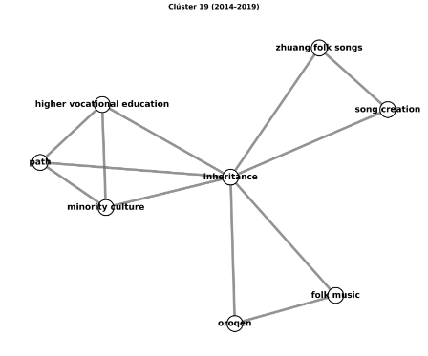  Figure 3. Cluster 19-P1 | 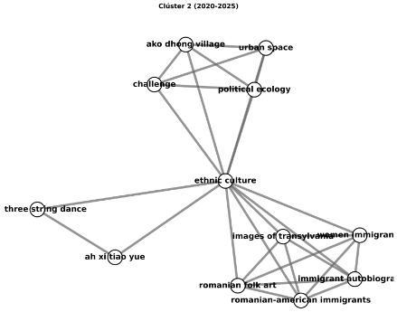  Figure 4. Cluster 2-P1
In the same period the specialized and niche themes reveal keywords around music education, art in general, dancing with geographical references. There is also a maritime-related theme, focusing on issues such as ecological preservation, cultural heritage and social wellbeing. Other, less dense clusters, which are still specialized, include keywords such as social innovation, sustainability and co-creation dynamics, as well as value co-creation. This suggests that these activities are neither central nor interacting with the other keywords. In addition, identity-related clusters are, on the one hand, related to either ethnicity or race and education, and, on the other hand, to social image perceptions and standards.
Emergent/declining clusters are common in an interdisciplinary search as initial condition of this analysis. For this reason, the clusters in this zone must be interpreted as novel interests in the research communities or new technological developments, but also to observe keywords intrinsically related with the fields of knowledge interacting. These are not expected to evidence high interdisciplinary co-occurrences patterns. The topics here for period 1 are related to cultural heritage in critical terms with keywords such as gentrification (for exacerbated thematic tourism around patrimony), critical studies around race and information (as misrepresented groups), experiential pedagogies, minority’s cultural heritage, participatory methodologies and Storytelling, slow data and ethnobotany through a patrimonial approach.
Basic themes in period 1 present near to cero density suggesting that there are no clear central themes in the intersection of these specific fields. This is expected too as a general result although the themes positioned in this zone can elucidate potential subjects for impactful interactions in the field with keywords such as ethnic minorities in national cultural heritage, empowerment, media literacy (cluster 18-P1), multilingualism, human rights declaration (cluster 3-P1) and social capital, co-creation and hyper-connected users (cluster 5-P1).
The first five years of the analyzed period sets a knowledge production context to analyze the second period (Figure 2). Keyword clusters in such period show academic interests in community-based research, Participative active research (IAP), participative design (related to heritage tourism and urban matters), gender and feminism, inclusion and accessibility, and identity processes; on occasions with a different approach from period 1, as follows. First, several clusters strongly related with the keyword identity evidencing changes in time. The academic output on P1 relates to keywords concerning migration and ethnicity (Cluster 12-P1, see Figure 5); which are then integrated to P2 clusters related to gender perspectives and intersectionalities for men (in cluster 9-P2, see Figure 6), as well as to keywords such as feminism, female identity and marginalization (cluster 10-P2, see Figure 7).
P1 (2014-2019) | P2 (2020-2025)
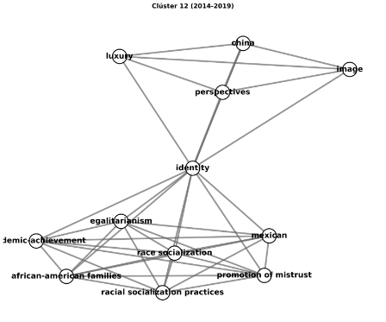  Figure 5. Cluster 12-P1 | 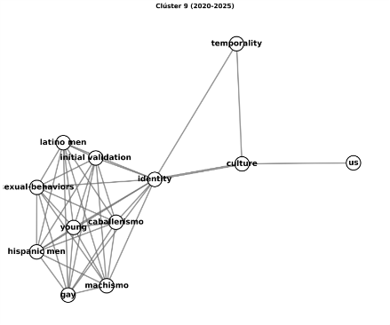  Figure 6. Cluster 9-P2
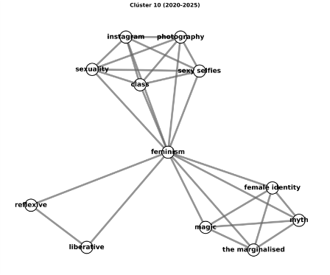
Figure 7. Cluster 10-P2
Keywords related with maritime cultural heritage show strong inner patterns and high development as a specialized theme in P1 (Figure 8) and as an emergent one (Figure 9). Its keywords changed but a general interpretation of their theme did not.
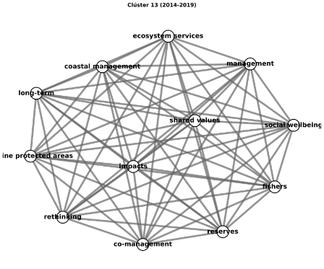  Figure 9. Cluster 13-P1 | 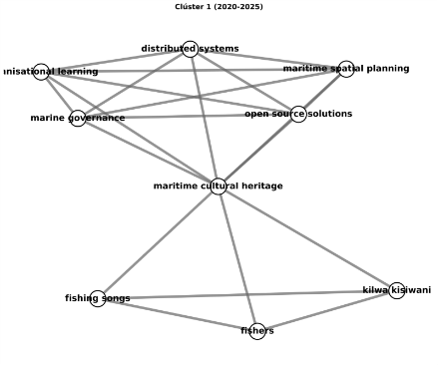  Figure 10. Cluster 1-P2

Subsequent to an analysis of the general aspects of period's 2 clusterization and its evolution from period 1, the strategic zones in such a period complement the reading of the academic production. The map show, in general terms, that cluster density decreases and so is the strength of the internal ties within each cluster. This implies a significant decrease in motor and specialized themes and an increase in both transversal/basic themes and emerging/declining ones. This evolution can be due to the continuous diversification on all the implicated fields that can be explored through a detailed observation of the clustering patterns occurring on those zones. On the one hand, the central and transversal themes are related with pedagogies in digital humanities, ethnic culture, mental health (in the context of students), participation-cultural heritage and tourism themes continues in this period maintaining its latter position. Also, science communication (Figure 10) appears as a new theme related with minorities and cultural heritage as a central and transversal theme.
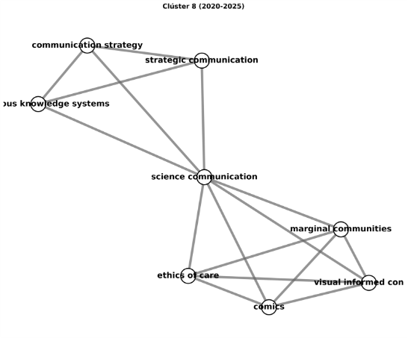
Figure 11. Cluster 8-P2
To gain a more in-depth understanding of this relationship and others, a future study that explores them in more detail can delve deeper into the actual titles, authors, journals, countries, institutions, interdisciplinarity and other contextual data from this academic discourse.
The literature review made by Desul, S. et al. (2025), which examines the field of semantic technologies in the GLAM-heritage sector, identifies ontologies and digital humanities as motor themes; among the specialized themes are ontology learning, big data, and the CIDOC-CRM semantic model; among the emerging/marginal themes are semantic annotation and intangible cultural heritage; and finally, among the basic/cross-cutting themes are knowledge management, cultural heritage, and link data. This is coherent with the current study, especially if the clusters 0-P1 (Figure 11) and 0-P2 (Figure 12) are observed.
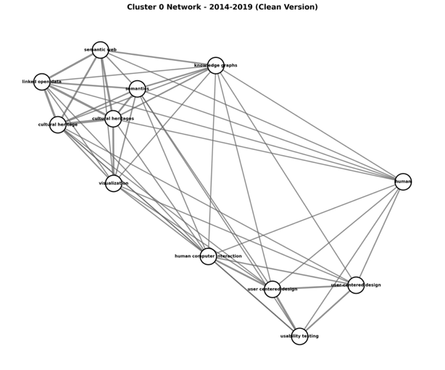  Figure 12. Cluster 0-P1 | 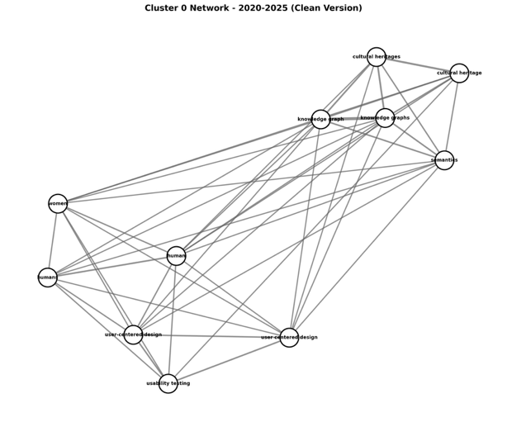  Figure 13. Cluster 0-P2

The 0-P1 (Figure 11) cluster’s keywords seem to have gained density from period 1 to the second as there is an almost identical cluster. It transitioned into a specialized theme (Figure 1), even though it was previously categorized in the emerging/declining zone (Figure 2). This cluster contains the most central search terms of the metadata sample, but its structure shows a new keyword: “women” besides stronger internal relationships. This keyword is also present in the P1 but lacking strong connections to be visible in the map. Its consolidation in P2 represents an important development, which will be further examined in relation to the positioning of misrepresented social groups, gender perspective and intersectionalities theme.

The general exercise shows the thematic areas that have been addressed by the studies included in the sample designed to find the direct topics of the searches, but also those that are connected by keywords to other areas of the field in order to situate themselves, with a scope, in the context of knowledge production and distribution (Bourdieu, P. 1997; Chartier, R. 2006).
Heritage issues arise from its immateriality, both in P1 and P2. The clusters refer to keywords such as intangible cultural heritage, intangible cultural heritage protection, minority intangible cultural heritage, intangible culture, among others. This trend could be reviewed in depth in future research intended to contribute to the digital archives dedicated to such subject.
In general, the conceptual structure of the field can be described with some trends that connect P1 and P2. Identity issues related to migration and ethnicity in P1 and specific gender issues in P2 were reviewed. Issues related to gender and intersectionality are clearer in the last five years, according to the sample material, and are present in seven clusters (P2) and, previously (P1), in only two. The maritime theme and the use of intangible cultural heritage remain possibilities for future study, as does the relationship with the theme of science communication, in the movement of keyword co-occurrence between the periods described by the sample collected.

Positioning of transversal themes and strategic interpretation
To identify the positioning of topics related to the HerStory NeSy Ai project, the initial search terms are reviewed, along with keywords that reveal the structures of the strategic maps. Keywords directly related to topics of interest are present in 13/20 clusters in P1 (in emerging and specialized topics) and in 16/20 clusters in P2, aligned with the reading already carried out as an overview.
From the search terms related to (i) historical heritage and GLAM context, it can be seen that clusters containing intangible cultural heritage, cultural heritage, and both libraries and virtual museums are located, for P1, in all areas, and for P2, they remain in emerging/marginal topics. This shows a widespread presence of these keywords, demonstrating the dispersion of the topic among interdisciplinary thematic groups which, according to the inclusion index measurements, do not have such strong homogenized relationships (as a single field, although internally, as already explained).

Regarding (ii) digital humanities or semantic search technologies, the gender perspective and misrepresentation topic is included in very specific clusters at both periods. It is part of Clusters 0, 9, 10, and 16 - P1 (Figure 1), across a broad spectrum of densities, and Clusters 0 (specialized), 15, 5 (basic), and 11 (emerging/marginal) - P2, each in a different area (see Figure 2). Keywords such as knowledge graphs, semantics, metadata models and aggregation, RDF schemata, linked open data, among others, were found, as shown below (see Table 1):
P1 | P2
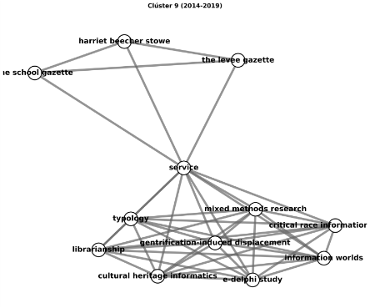 | 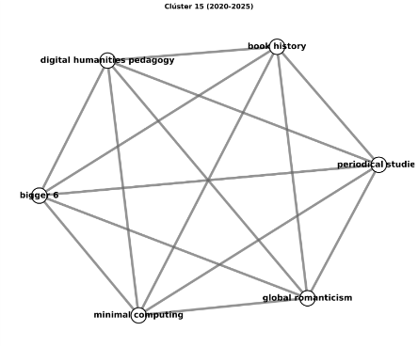
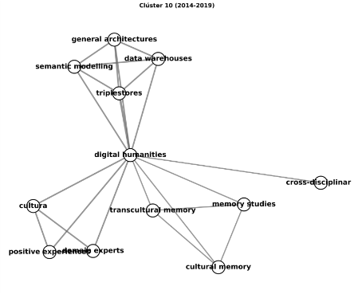 | 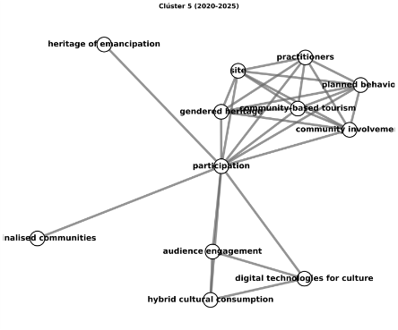
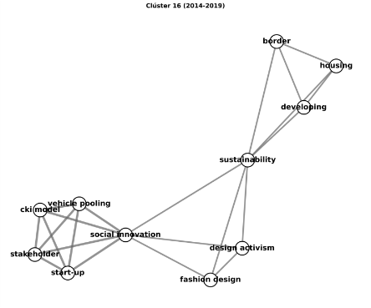 | 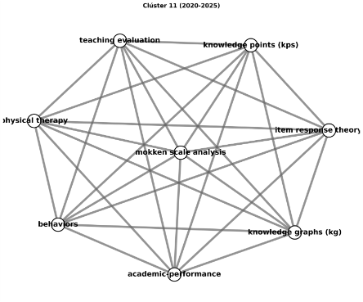
Table 1. Cluster selection including keywords related with digital humanities, semantic technologies, and others.
Among the topics related to (iii) heritage, gender, minorities, and intersectionalities, keywords (see Table 2) such as ethnic minorities, minority cultural heritage, social justice, gender, women's issues, women's rights, lack of diversity, and identity, among others, are found in P2. In P1, there are related keywords, but their co-occurrence patterns are not strong enough to form clusters. In general, there is no clear location; these are cross-cutting themes in the clusters, so the reading corresponds to the general reading already done in the previous section.

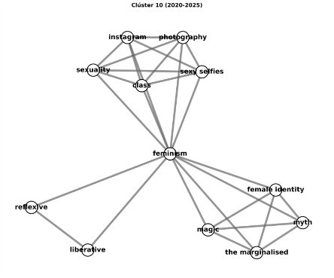 | 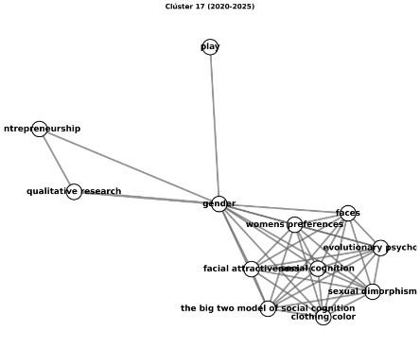
Table 2. Cluster selection integrating gender perspectives, intersectionalities and misrepresentation
Regarding keywords related to (iv) UCD, this same keyword and others such as co-creation, social innovation, design activism, participatory approach, usability testing, and community-based participation are observed. These are also located following the general reading. The keyword co-creation, which refers to frameworks similar to those of UCD, is located in the center of Clusters 5-P1, 7-P1, and 3-P2, indicating that it is the strongest in co-occurrence relationships (see Table 3). The clusters formed invite us to take a broad view of what UCD entails, as it is addressed in very different ways in the literature. Although they do not specifically refer to this specific practice in design studies, they directly address the inclusion of users or participants in the technology design process, which can be interpreted as a strong affinity with UCD or participatory design perspectives and contribute to them from there. These can be explored in the following clusters:
P1 | P2
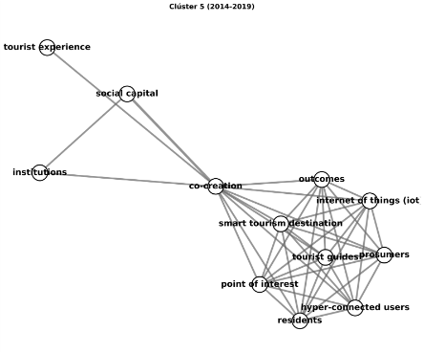 | 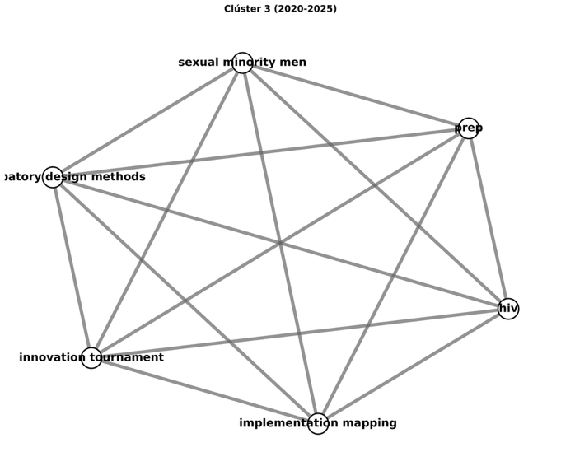
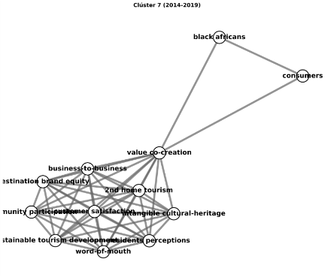 | 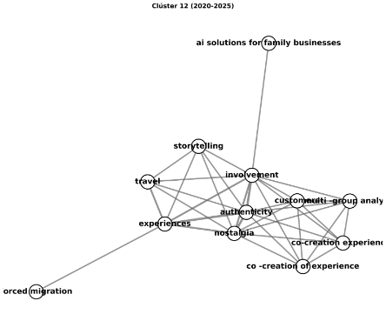
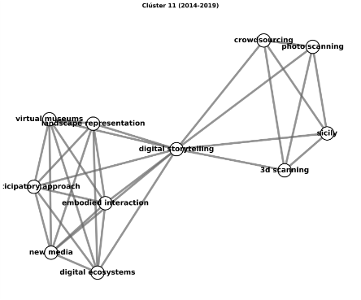 | 
Table 3. Selection of clusters integrating keywords related with UCD, partipatory design and human-centered design.
To conclude the position analysis, greater visibility was expected for keywords that are conceptually broader than those found. Although the number of co-occurrences is greater, the inclusion algorithm and the simple center algorithm applied allow those with stronger relationships to be displayed, even if they are not the exact taxonomical conceptual terms. From this, the bridge concepts mentioned as such could be analyzed.

In sum, Keywords related to (i) historical heritage and GLAM context, are located across all zones in P1, while in P2 they remain in emerging/declining themes, with presence across all clusters. As for (ii) digital humanities, data retrieval or specific type-semantic technologies, it was identified they appear in very specific clusters in both review moments, moving from the specialized to the emerging/declining, and basic zone suggesting more interaction with the subjects. For topics related to (iii) gender, minorities, and intersectionality, keywords such as ethnic minorities, minority cultural heritage, social justice, gender, women's issues, women's rights, lack of diversity, and identity are transversal themes across clusters. Same observation for (iv) UCD, human-computer interaction, co-creation, social innovation, design activism, participatory approach, usability testing, community-based participation.
Greater visibility was expected for keywords that are conceptually more encompassing than many found (as link data, metadata, metadata aggregation, metadata model). Although the number of co-occurrences is high, its relationships aren’t. These work as cluster bridges, which can be explored in future research.

Conclusions
This study demonstrates the usefulness of scientific mapping techniques for examining interdisciplinary fields that combine participatory design, semantic web technologies, GLAM contexts, and gender perspectives. By applying bibliometric analysis, it was possible to generate an overview of the conceptual structure of the field and to observe how its thematic composition has evolved over the last decade (Cobo, M. 2011b; Callon, M. et al 1991).
The analysis shows a fragmented but evolving landscape. From the first to the second period, motor themes disappear, specialized themes decrease (from three to one), and basic themes expand (from three to six). Emerging and declining themes remain relatively stable. These results indicate low levels of conceptual consolidation and a trend toward disciplinary dispersion, but they also reveal areas where important connections are strengthening.
A particularly relevant finding is the consolidation of a cluster that brings together knowledge graphs, participatory design methodologies, cultural heritage, and women. This cluster, which was previously located in the emerging/declining zone, gains density and is set as a specialized theme, confirming the increasing relevance of gender perspectives in relation to semantic technologies and participatory approaches, besides proposing more interaction with other GLAM subjects in the future. This result directly supports the objectives of the HerStory NeSyAI (2025, June 18) project and highlights its contribution to the field.
In sum, the findings provide a conceptual framework that encourages cross-disciplinary research, as needed for subjects such as participation, misrepresentation, and gender perspectives (Fricker, M. 2023; Escobar, A. 2019). This allows the articulation of different areas such as interactive information retrieval, digital humanities, and human-computer interaction (Fidel, R. 2012) through metadata representing the academic knowledge production and ultimately fostering more inclusive and gender-aware knowledge infrastructures.

References
Baghini, M. S., Mohammadi, M., & Norouzkhani, N. (2024). Usability testing: a bibliometric analysis based on WoS data. Journal of Scientometric Research, 13(1), 9-24. https://doi.org/10.5530/jscires.13.1.2.

Bhandari, A. (2023). Design thinking: From bibliometric analysis to content analysis, current research trends, and future research directions. Journal of the Knowledge Economy, 14(3), 3097-3152. https://doi.org/10.1007/s13132-022-00920-3.

Bourdieu, P. (1997). Capital cultural, escuela y espacio social. Siglo xxi.

Capel, T., Brereton, M., (2023) What is Human-Centered about Human-Centered AI? A Map of the Research Landscape, in: Proceedings of the 2023 CHI Conference on Human Factors in Computing Systems.

Callon, M., Courtial, J.P., Laville, F., (1991) Co-word analysis as a tool for describing the network of interactions between basic and technological research: The case of polymer chemistry, Scientometrics 22.

Chartier, R. (2006). ¿Qué es un texto?. Círculo de Bellas Artes. ISBN:84-86418-73-9.

Chen, L., Wang, H., (2023) Participatory design: A systematic review and insights for future practice, International Journal of Heritage Studies 29.

Cobo, M.J., López-Herrera, A.G., Herrera-Viedma, E., Herrera, F., (2011a) Science mapping software tools: Review, analysis, and cooperative study among tools, Journal of the American Society for Information Science and Technology 62.

Cobo, M.J., López-Herrera, A.G., Herrera-Viedma, E., Herrera, F., (2011b) An approach for detecting, quantifying, and visualizing the evolution of a research field: A practical application to the Fuzzy Sets Theory field, Journal of Informetrics 5.

Cobo, M.J., López-Herrera, A.G., Herrera-Viedma, E., Herrera, F., (2012) SciMAT: A new science mapping analysis software tool, Journal of the American Society for Information Science and Technology 63.

Cobo, M. J., Jürgens, B., Herrero-Solana, V., Martínez, M. A., & Herrera-Viedma, E. (2018). Industry 4.0: a perspective based on bibliometric analysis. Procedia computer science, 139, 364-371.

Delgado, F., Yang, S., Madaio, M., & Yang, Q. (2023, October). The participatory turn in ai design: Theoretical foundations and the current state of practice. In Proceedings of the 3rd ACM Conference on Equity and Access in Algorithms, Mechanisms, and Optimization (pp. 1-23). https://doi.org/10.1145/3617694.3623261.

Desul, S., Mahapatra, R. K., Patra, R. K., Sethy, M., & Pandey, N. (2025). Semantic technology for cultural heritage: a bibliometric-based review. Global Knowledge, Memory and Communication, 74(5/6), 1356-1380. https://doi.org/10.1108/GKMC-04-2023-0125.

Ermel, A. P. C., Lacerda, D. P., Morandi, M. I. W., & Gauss, L. (2021) Literature reviews: modern methods for investigating scientific and technological knowledge. Springer Nature.

Escobar, A. (2019) Autonomía y diseño: la realización de lo comunal. Editorial Universidad del Cauca.

Ferran-Ferrer, N., Boté-Vericad, J. J., & Minguillón, J. (2023). Wikipedia gender gap: a scoping review. Profesional de la información, 32(6). https://doi.org/10.3145/epi.2023.nov.17.

Fidel, R. (2012) Human Information Interaction: An Ecological Approach to Information Behavior. The MIT Press. http://www.jstor.org/stable/j.ctt5vjsbw.

Fricker, M., (2011) Epistemic Injustice: Power and the Ethics of Knowing, Oxford University Press, USA. ISBN: 9780191519307.

García, M., López, P., (2024) Human-AI Co-Creation: A Framework for Collaborative Design in Intelligent Systems, Artificial Intelligence Review 57.

Hamilton, K., Nayak, A., Božić, B., & Longo, L. (2024). Is neuro-symbolic AI meeting its promises in natural language processing? A structured review. Semantic Web, 15(4), 1265-1306. https://doi.org/10.3233/sw-223228.

HerStory&NeSyAI. (2025, June 18) Research Project, PID2023-147673OB-I00, 2023-2027. Research Institution. https://www.ub.edu/wikiwomen/research/herstory-2024-27/

Jasanoff, S. (2004). The idiom of co-production. In States of knowledge (pp. 1-12). Routledge.

Lopezosa, C., Codina, L., Codina (2023) Buscadores-alternativos - perplexity - note.

Lopezosa, C., Codina, L., & Ferran Ferrer, N. (2023). ChatGPT como apoyo a las systematic scoping reviews: integrando la inteligencia artificial con el framework SALSA. https://hdl.handle.net/2445/193691

Snyder, H., (2019) Literature review as a research methodology: An overview and guidelines, Journal of Business Research 104.

Smith, A., Johnson, B., (2023) Assessing knowledge organization systems from a gender perspective: Wikipedia taxonomy analysis, Journal of Documentation 79.

Wacnik, P., Daly, S. R., & Verma, A. (2025) Participatory design: a systematic review and insights for future practice. Design Science, 11, e21,. https://doi.org/10.1017/dsj.2025.10009.

© 2025 Copyright for this paper by its authors. Use permitted under Creative Commons License Attribution 4.0 International (CC BY 4.0).
Given its capability to restrict searches to academic sources, Perplexity AI was used to assist with the syntax and keyword refining process [8].
IAP ….

