

Applied Analytical Models
00204412

Section (1)

Submitted to
Dr. Bassam Alkasasbeh

Submitted by
Ayah El-Manaseer

2025-2026 3

This is the Flow chart for my flask app:
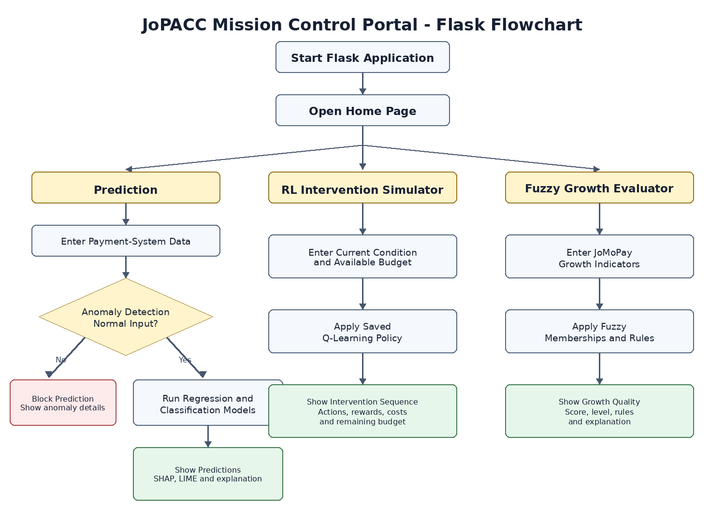

Activity 1: Explainable Payment-System Prediction
- Justification for features:
These following features were chosen manually based on the domain knowledge and the meta-data in the dataset. They are representative of the key characteristics which define the (payment-system) behavior in terms of usage and operation of a particular system, and include transaction volume, user engagement, time impact, and system specific behavioral aspects. Attributes that characterize overall activity across multiple payment systems were considered as "General" features, also, "System-Specific" features characterized the unique characteristics of CliQ, JoMoPay, eFAWATEERcom, ACH, and ECCU. Variables with direct reference to the target variable were omitted so as to avoid information leakage.
Feature | Simple Justification
Month | It helps capture monthly and seasonal patterns because payment activity can change across different months.
Report_year | It helps the model to captures changes and growth payment-system activity over time.
Transactions_total | Directly represents the number of transactions processed which help the models to get a strong indicate about system activity and transaction value.
Users_total | Represents the size of the active user base which help the model to indicate that a larger user base can produce more transactions and greater transaction value.
Customer_legal_entity_count | Used for CliQ and represents participation by companies and organizations, which can affect transaction activity and value
Wallet_comercial_count | Used for JoMoPay and represents the number of commercial mobile wallets, which gives the model an indicator of business wallet usage
Tx_money_transfers_count | Represents the number of money-transfer transactions which help the model to reach to the level of transaction activity because it related to it.
Ef_digital_payment_count | Used for eFAWATEERcom and represents the number of digitally paid bills, which help the model to indicate the level of digital payment activity.
Ach_jod_transaction_count | Used for ACH because it represents the number of JOD transactions processed through ACH, which help the model to estimate the level of ACH activity and can contribute to predicting both transaction value and activity level.
Returned_cheque_count | Used for ECCU and represents the number of returned cheques, providing information about cheque activity and system behavior.
System_ACH, System_Cliq,  System_ECCU, System_JoMoPay, System_eFAWATEERcom | The payment system was included because CliQ, JoMoPay, eFAWATEERcom, ACH, and ECCU operate differently and have very different transaction patterns and scales

System-specific attributes were chosen as each of the JoPACC payment systems provides a specific service. Such as, CliQ provides legal entity participation, JoMoPay is used for tracking mobile wallet transactions, while eFAWATEERcom is utilized to track digital bill payments, ACH is a system that tracks currency-based transfers, and ECCU captures cheque related variables. As such, the use of these attributes will allow the models to identify behaviorally relevant patterns that could not have been identified through the general nature of the transaction characteristics. The System attribute is necessary in order to allow the model to determine if a given number has a different meaning based upon which payment system it represents.

- Regression Justification: Two regression models have been run: Linear Regression and Random Forest Regressor.
- Linear Regression: it has been chosen because of its simplicity, and it can be useful for establishing the existence of a linear association between the selected input variables and transaction_value_jod.

- Random Forest: it has been chosen because the input features may depend on not only a linear relationship with transaction_value_jod.
Both models assessed using all three of the appropriate regression metrics: MAE, RMSE, and R². The code will select the model with the highest R², because this indicates that the model is explaining the largest proportion of the total variance observed in transaction_value_jod. Both MAE and RMSE are also being compared to assess the magnitude of error associated with each model. Lower values represent better predictive accuracy.
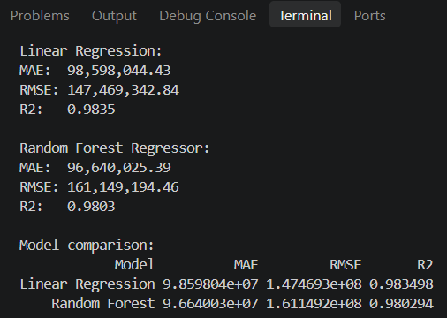
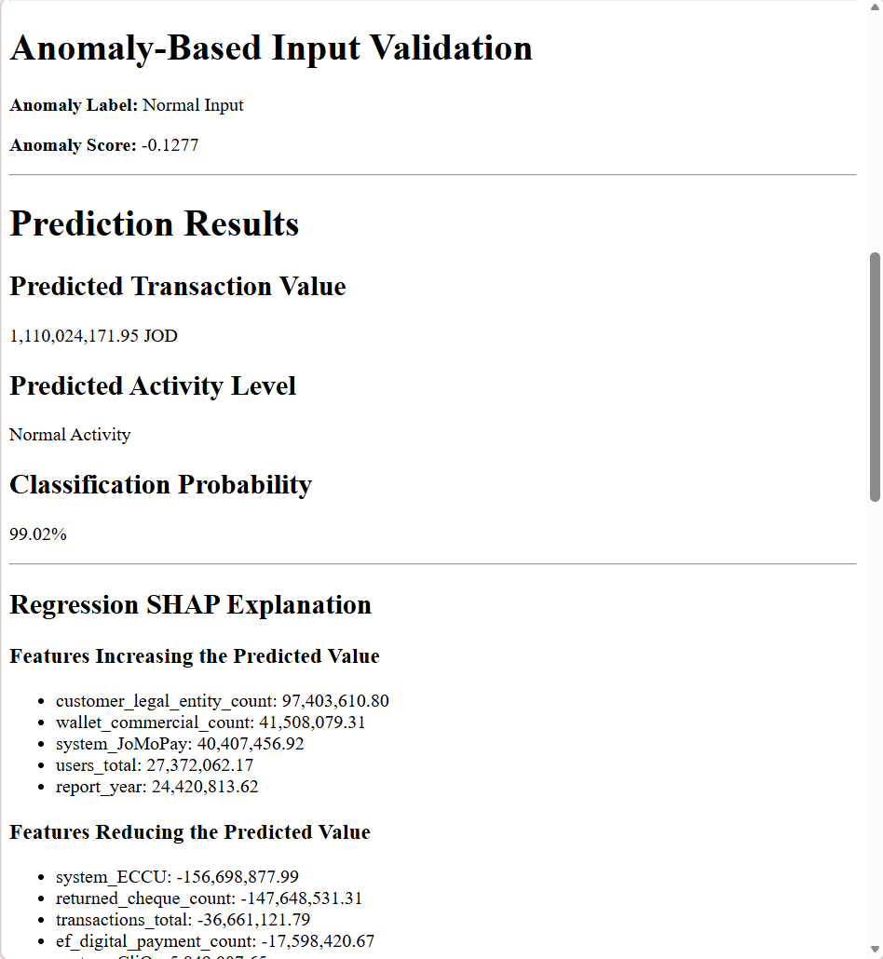
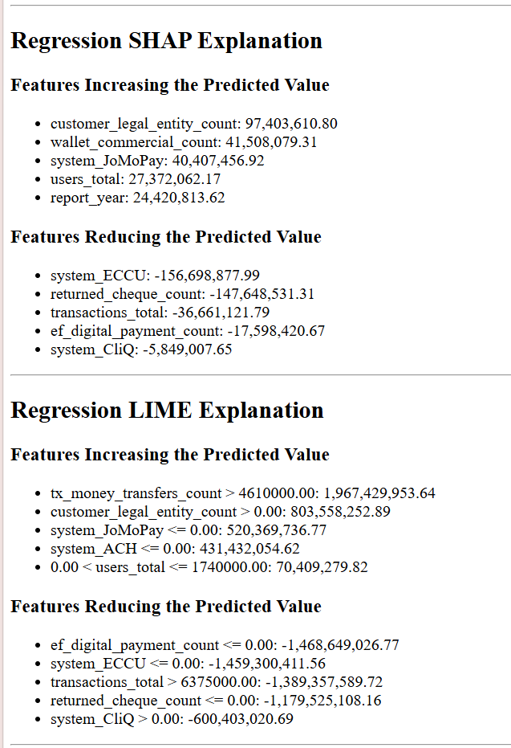
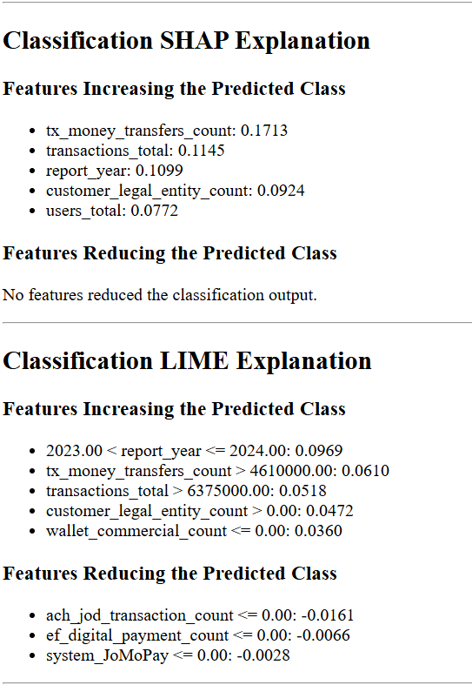
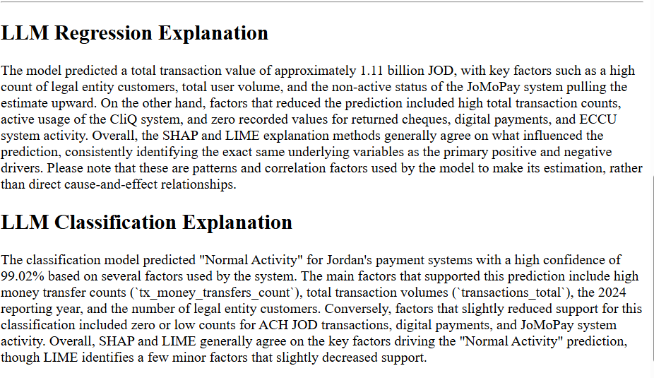

- Classification Justification: Two classification models have been run: Linear Regression and Random Forest Regressor.
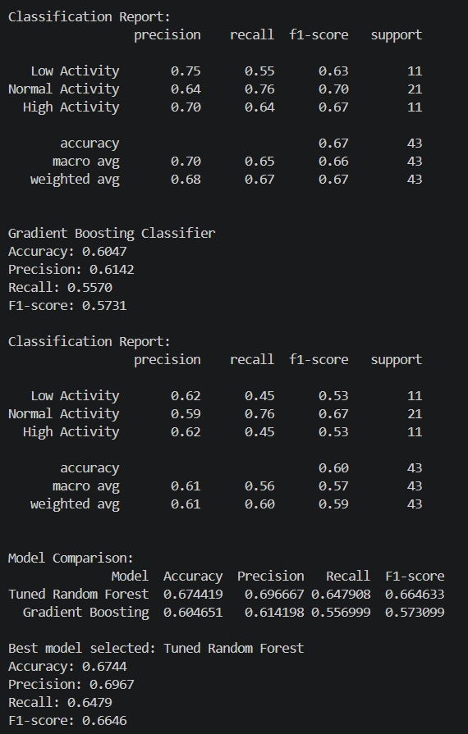
- Tuned Random Forest: has been chosen as it is able to detect the possible classification relationships that may exist between the input features of and the activity_level_target output.
GridSearchCV has been utilized in order to optimize the classifier's parameters so as to achieve optimal results with regard to accuracy of classification.

- Gradient Boosting: has been chosen because this classifier uses a method in which multiple decision trees are created one after another, also, this classifier should provide the ability to learn a more complex pattern of classification.

- SHAP & LIME.
LIME and SHAP were applied in order to determine which features contributed positively (increasing a specific prediction) or negatively (decreasing a specific prediction). The positive contributions from features indicate they either supported the predicted classification or increased the actual prediction. Conversely, the negative contributions indicate they decreased the actual prediction and/or reduced their support of the predicted classification.

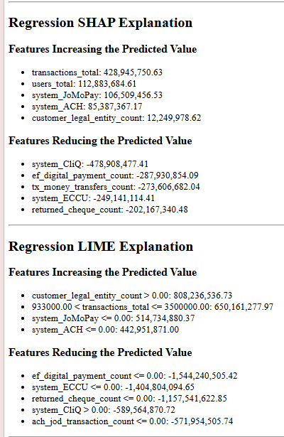
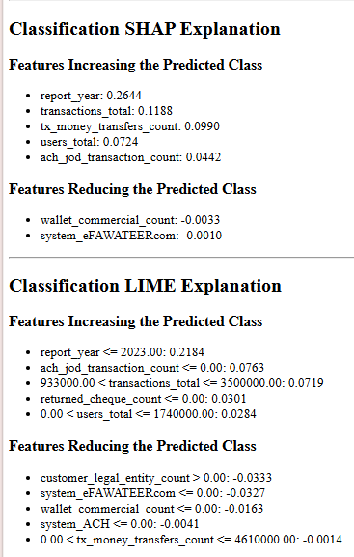

Activity 2: Anomaly-Based Input Validation
Two anomaly detection techniques were implemented: Isolation Forest and One Class SVM.
- Isolation Forest: it was chosen because it is able to isolate a record as an outlier based on how much the record deviates from what has normally been observed in your database. This model is ideal for finding global outliers of payment-system behavior.
- One Class SVM: it was chosen because it finds the "boundary" that describes all of what you would consider normal, therefore, when there is an observation that falls outside of the boundary, the model will flag that observation as an anomaly.
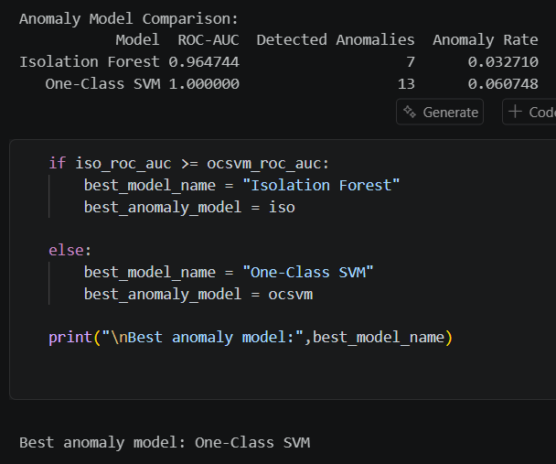
Since there were no labeled anomalies in the original data set, synthetic anomalies were manually generated for testing purposes. Approximately 3% of all records were manipulated with respect to increasing each record's transactions_total by five (5) times, users_total by four (4) times, and returning each record's returned_cheque_count to approximately three (3) times its highest possible value. The modified records were assigned a label to identify them as synthetic anomalies to allow the anomaly detection performance of both models to be tested.
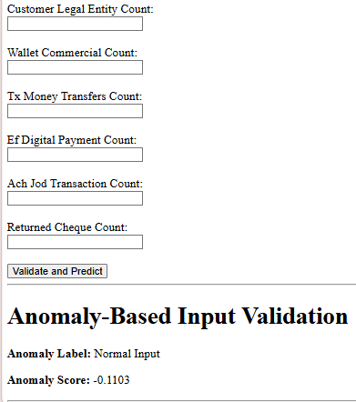
As a result of achieving an ROC-AUC score of 1.0000 (the highest possible), One-Class SVM was chosen to be the best anomaly detection model over Isolation Forest which achieved an ROC-AUC score of 0.9647. Thus, this indicates that One-Class SVM did a much better job at distinguishing the normal data from the artificially created anomalies than Isolation Forest did in this evaluation.
Before making a prediction by regression or classification for an incoming request, the application will determine whether that request is valid by evaluating it against the One-Class SVM model chosen. If normal data is provided, the application proceeds with a prediction, if abnormal (anomalous) data is entered, the application prevents entry of that data from continuing into a prediction process.

Activity 3: Fuzzy Payment-System Growth Quality Evaluator
For this task, I selected the JoMoPay payment to study its performance characteristics.
These are the three input features that were used: Total Transaction Activity, Commercial Wallet Count, Cash-Out Transaction Count.
These features were chosen based on what represents both a high volume of transactions being made and the degree of involvement with the commercial wallets, in addition to how heavily reliant each is on their ability to perform cashouts. The JoMoPay records were analyzed to determine appropriate fuzzy range limits.
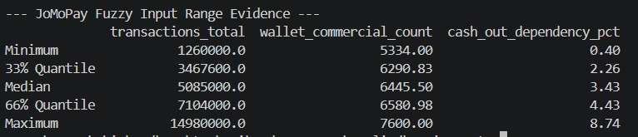
A series of logical rules then applied by the fuzzy system to aggregate the three inputs and assess if the present rate of development is: Fragile Growth, Unbalanced Growth, Healthy Growth, Sustainable Growth. Once all the rule systems have been activated, the outputs will be aggregated using centroid defuzzification to determine an overall final "Growth Quality Score" on a scale of 0-100.
In addition, it identifies the resulting final growth-quality level, which rules were active, and a brief description for why the outcome occurred based on what primary contributing factors was most influential.
This fuzzy model has now been incorporated as part of the user interface in the portal built with Flask, users can input their current JoMoPay transaction activity, Commercial Wallets, and Cash-Out Count, at which time they will receive both their final growth score and a detailed explanation.
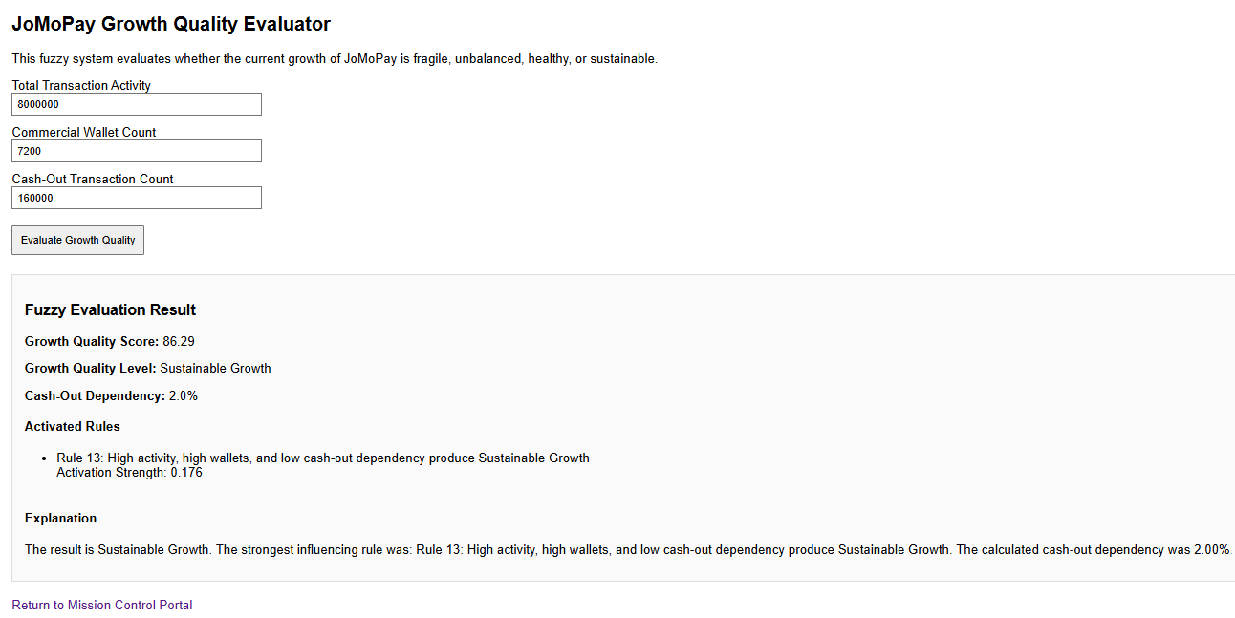
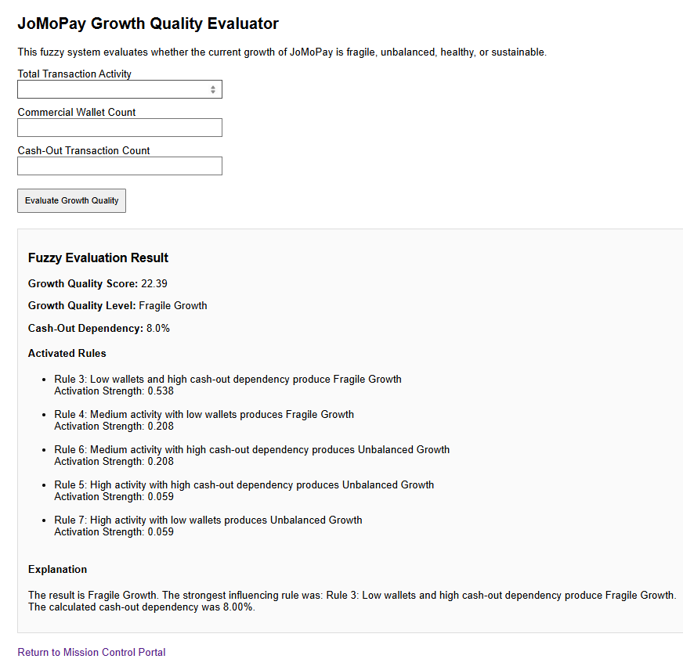
Activity 4: Reinforcement Learning for Payment-System Intervention
A tabular Q-learning approach was used for developing a recommendation-based simulation of interventions with respect to the activity level, payment system, two indicator systems (the latter two being system specific), and budget. The three levels of each of the indicators were created as Low, Medium, and High. Budget was also categorized as Insufficient, Low, Medium, and High.
Four different actions were developed in terms of all three payment systems. The actions include continuing to monitor, a low-cost operational review, and two specifics to the payment systems. Each action had an associated "simulated" cost, and actions which had costs exceeding the available budget could not be selected.
Two reward mechanisms were tested:
- Improvement-Focused: The Improvement-Focused Policy is focused on making improvements to the current system. The policy is less harsh than the Cost-Aware Policy. It has a -25 penalty for each time a budget violation occurs. However, if there is no improvement resulting from a particular action, it has an additional -8 penalty.
- Cost-Aware: It penalizes high-cost violations of budgets (and lack of improvement) more severely than the Cost-Oriented mechanism. In addition to the -30 penalty for violating budgets, it has an additional -10 penalty if an action does nothing to improve the system. It will reward actions that are in line with what you would expect from your limited budget (up to +4) as long as they have at least some positive effects on the system.
Both policies trained by an epsilon-greedy strategy which allowing the agent to explore different actions at the beginning and gradually use the learned Q-values to select better actions.
The Cost-Aware Policy was chosen as the most successful with an average success rate of .7465 and the lowest average cost of $6.4315; each policy had an identical violation rate for budget violations (0%).
