

E-Commerce
40201460

Submitted to
Dr. Orwa Aladaileh

Submitted by
Ayah El-Manaseer

2025-2026 3

Luxury Chocolate Jordan | Personalized Gift Boxes

Part 1:

Introduction:
E-commerce is basically about transactions that are digitally enabled, for commercial purposes, between people and organizations. They happen through various digital technologies like websites, mobile phones, apps, and also social media platforms. In other words, there is this exchange of value for products or services.
For the proposed Luxury Chocolate website, the idea is a business-to-consumer online shop that sells high end Belgian chocolate, chocolate-covered dates, and those luxury gift boxes. Shoppers can browse the catalog, pick something appropriate, submit their order, and organize delivery directly from the website. Next, the following part connects the eight unique features of e-commerce technology to this particular business, a bit more in detail.

Unique features of e-commerce technology:
- Ubiquity:
Ubiquity means that e-commerce is available everywhere and at any time, using devices connected to the Internet. For “Luxury Chocolate,” customers can browse chocolate products, compare gift boxes, and place orders 24 hours a day without having to visit a physical store or even order via social media platforms. This is particularly useful when customers need to quickly arrange gifts for birthdays, graduations, anniversaries, or other small occasions.
- Positive Impact on Business:
The website enhances convenience, helps the company receive orders outside of regular business hours, and reduces the time and effort customers would otherwise have to expend.
- Potential Negative Impact:
Customers may begin to expect immediate responses and round-the-clock service. In the event of technical glitches or delayed responses, this could lead to a decline in customer satisfaction.

- Global Reach:
Global Reach means that how well ecommerce technologies can overcome geographical barriers (national borders) and cultural barriers so that companies can sell products across many regions around the world. Although “Luxury Chocolate” will initially target a local customer base within Jordan, its online store also allows people outside Jordan to purchase chocolate and have it shipped to their relatives and friends in Jordan.

- Positive Impact on Business:
The company has the opportunity to reach a larger number of customers than an Instagram page or a local physical store. This is because expanding to many locations means that you will have access to a larger market with potentially greater opportunities for revenue.
- Potential Negative Impact:
When expanding into multiple countries, there will be a number of possible negatives associated with this expansion. These include Shipping costs for each country or region, Chocolate Temperature Control (to maintain chocolate quality), Customs Requirements in each country, Delivery Time in each country or region, Customer Preferences in each country.

- Universal Standards:
Universal Standards are the common formats for web developers to follow on the internet as well as in the world of web development. The Luxury Chocolate site is built with WordPress and WooCommerce, users can visit their site using all major web browsers and mobile devices. In addition, since the site will follow a common template for all product pages, shopping cart process and payment options etc., users will find the Luxury Chocolate site similar in design to other e-commerce websites they have used.
- Positive Impact on Business:
There are positive business implications from utilizing universal standards because they provide economies of scale when building and maintaining an e-commerce site as well as enabling customers to utilize the site without having to install custom browser plugins.
- Potential Negative Impact:
Since many businesses build their e-commerce sites using universal standards (like WordPress), they share the same security vulnerabilities that could potentially harm their business if not properly maintained/updated. Therefore, WordPress/WooCommerce themes/plugins, along with regular updates to them, need to be securely maintained by Luxury Chocolate.

- Richness:
A company's richness is measured in terms of the quantity and type of data provided across a variety of mediums (text, image, audio/video). The company Luxury Chocolate could utilize product photography taken by professionals, short chocolate-making videos, detailed descriptions of each item, images of their packaging, ingredient lists, flavor profiles, weight of items, and gift ideas for example.
- Positive Impact on Business:
Rich content enables potential buyers to see what they are purchasing, enhances an emotional appeal to purchase and helps reduce customer uncertainty prior to making a purchase.
- Potential Negative Impact:
Additionally, large images and videos will likely result in a slower website loading time. Also, poor quality/realistic images may create customer expectations which the delivered product does not meet.

- Interactivity:
The interactivity enables both ways of communication from the side of the company to its consumers. The site is able to include contact forms, product review, interactive tool for choosing products, search features, support via WhatsApp and other buttons which will react on the actions of clients.
- Positive Impact on Business:
Improved level of client involvement, Ability to answer to their questions, Collection of comments and suggestions, an impression of personalized assistance similar to what would be experienced by the customer in a physical store.
- Potential Negative Impact:
Continuous supervision over the interactive elements. Negative reviews, slow responses or absence of response to consumer’s message may weaken the credibility of the company.

- Information Density:
Information Density is a measure that shows how much (quantity) and how accurate (quality), available (availability) and reliable (accuracy) information there is about the products or services offered by a company to its customers. Luxury Chocolate web site could present all this information on one page with respect to product pricing, product ingredients, whether they have an item in stock, size of the box, shipping options and other customer reviews. Using WooCommerce to develop the business website will be able the business to track its sale and orders, what are the most popular items, what are the behavior patterns of the customers as well as their inventory levels.
- Positive Impact on Business:
Information allows for good purchasing decision-making by customers, it also provides the business with accurate product management and demand forecasting.
- Potential Negative Impact:
Price comparisons are easily available, incorrect pricing, inaccurate inventory, or incorrect shipping/delivery information will lead to customer complaints and abandonment of purchase.

- Personalization and Customization:
Personalization is creating tailored marketing and recommendation messages to an individual's profile, customization is tailoring the product and service to fit a particular customer's preferences. Luxury Chocolate could use personalization by recommending chocolates that were previously purchased or based on occasion. Luxury Chocolate could use customization in allowing their customers to create customized gift boxes with various chocolate options, add chocolate covered dates, choose packaging and include a customized message. The Chocolate Personality feature would provide recommendations for customers based upon their taste preferences.

- Positive Impact on Business:
Customer Experience through personalization provides customers with an exclusive experience, increased customer satisfaction, and supports gift sales.
- Potential Negative Impact:
Continuous supervision over the interactive elements. Negative reviews, slow responses or absence of response to consumer’s message may weaken the credibility of the company.

- Social Technology:
Users and businesses are able to create, share and interact with each other through content many-to-many using social technology. Luxury Chocolate can link their website to their Instagram account so that customers can view and comment on actual chocolate products and go directly from a post on their social media account to a page of one of their products.
- Positive Impact on Business:
Increased brand awareness, potential customer referrals generated by sharing social media accounts, attracting new followers who follow Luxury Chocolate's Instagram account, increased social proof created by posting user generated reviews.
- Potential Negative Impact:
Negative comments about luxury chocolate can be shared across the internet at an alarming rate.
The eight features allow Luxury Chocolate to operate outside of what is traditionally expected from an Instagram page business. These features enable Luxury Chocolate to expand its accessibility, increase its market reach, enhance customer communication, provide an attractive and appealing way for customers to see products, make it easier and more convenient for customers to shop, and provide customers with the tools they need to make informed decisions about which products to purchase. Luxury Chocolates' success in these areas will depend upon how well their website functions provide the right information to customers, securely handles customer data, promptly responds to customers inquiries, and consistently delivers high-quality products. As such, Luxury Chocolate's eight features can be said to add business value only if they are successfully implemented and managed.

E-Commerce Competitive Analysis of Luxury Gift Businesses:
three companies were assessed as follows: The Delights Shop, Siwa, Craves Jordan.
As the competitive companies identified above utilize e-commerce to sell their handcrafted chocolates, chocolate covered dates, and luxury gifts which are identical in nature to the types of products to be sold by the proposed Luxury Chocolate company, these companies were determined to be suitable competitive companies.
- The Delights Shop: The Delights Shop | A story behind each piece
- Richness (Strongly Implemented):
The Delights Shop has successfully implemented rich media on its website by using high-quality product images, providing detailed product descriptions, categorizing products clearly, and providing information regarding the origin and quality of its ingredients.
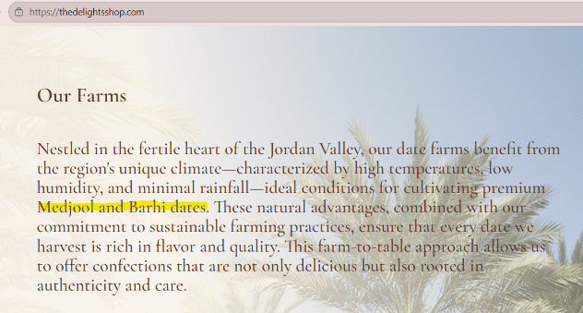
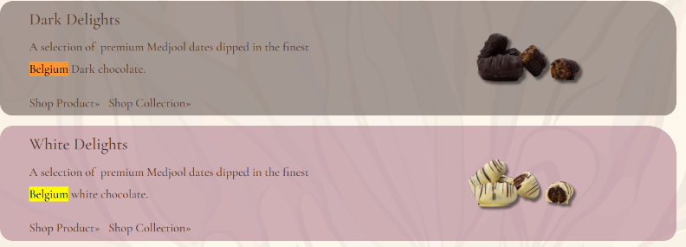
For instance, the website describes the Belgian chocolates it sells, its use of Medjool dates, natural ingredients used in many of its products, and that some of its products are made with a "farm-to-table" approach. Additionally, the website contains a narrative about the Delight Shop's date farms located in the Jordan Valley.
Additionally, when the customer moves the mouse when using the laptop cursor on top of some of the product images, it shows the name of the product currently being displayed. like moving the mouse cursor on top of an image of chocolate will show "Hazelnut Gianduja Praline Milk Chocolate." The combination of product presentation visually with descriptive text adds another layer of information for the customer as they try to determine what is being displayed.
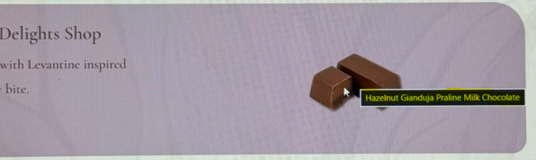

- Personalization/Customization (Strongly Implemented):
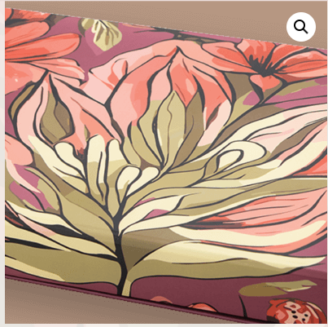
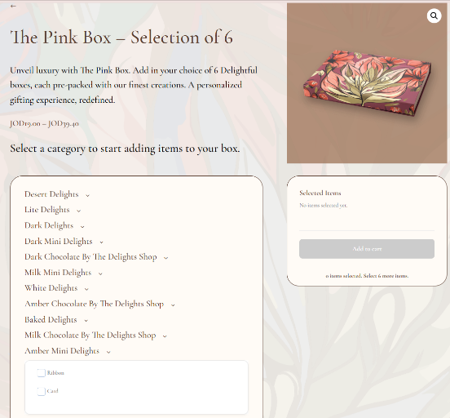
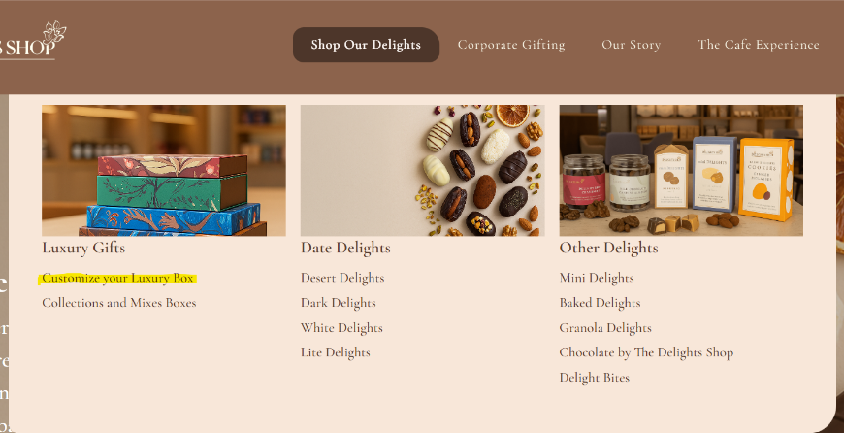
Delights Shop has a feature called "Customize Your Luxury Box" which enables customers to select the specific types of items they wish to include within a custom box such as chocolate covered dates, mini treats etc. Customers can therefore either purchase a pre-packaged selection or create a customized selection of items tailored specifically to fit a particular occasion or gift recipient. This feature is very well implemented due to the fact that customers have unlimited options regarding the products they can place into their luxury boxes. This ability may result in increased customer satisfaction by enabling customers to create gifts that are more meaningful.
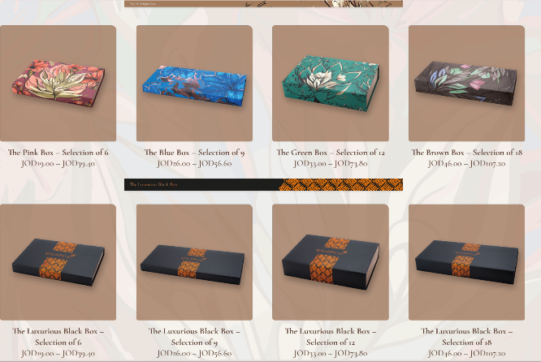
Also, when you hover your mouse over an image, it zooms in so the customer can see the details of the boxes and products.

- Social Technology (Weak Implemented):
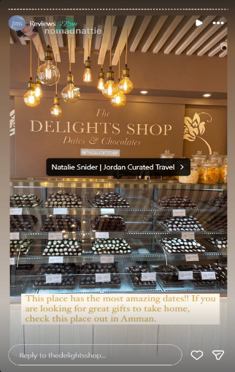
DelightsShop.com has include links to the company's Facebook and Instagram pages at the footer of the homepage. Furthermore, these social media platforms include customer reviews. Additionally, past customers have been able to post reviews about their experiences with the site. However, since many of the existing reviews are older than 240 weeks, there appear to be few if any recent reviews on the site. As such, even though the technological components for social technology are present on the site, they provide neither timely nor trustworthy social evidence. Consequently, potential new customers may not feel confident in their decision based on those prior customer comments and reviews, especially when buying high-end chocolate items and gift boxes online does not allow for visual inspection or tasting of the products prior to purchase.

- Siwa: Siwa Flavors | Luxury Medjool Dates & Belgian Chocolate Gifts Amman
- Information Density (Weak Implemented):
Siwa's pricing appears to be inconsistent during the course of its purchase process. First, the price for the product is shown in search results as 18 JOD. Then it is increased to 22 JOD once an auto-paid option is added, then finally reaches 25 JOD once the item has been delivered. Although the math is correct, there was no explanation for the increase that will cause confusion with customers.
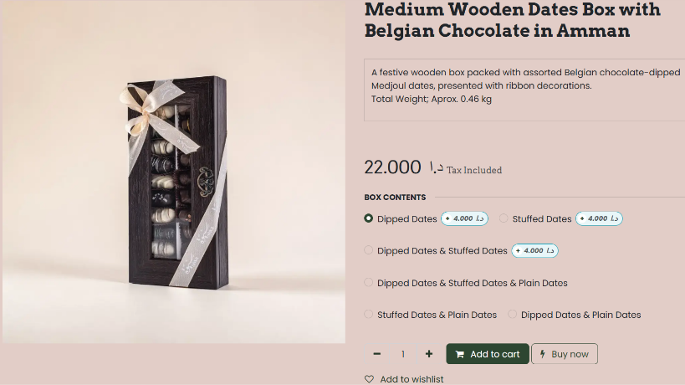
To provide better clarity into their pricing structure, Siwa can use the term "starting at" on their search results page ("starting at 18 JOD"). Also, they need to define each part of the base price (the cost of the item), what additional paid items you have chosen to add (and how much each cost), the delivery charge (and how much), and your final bill total.
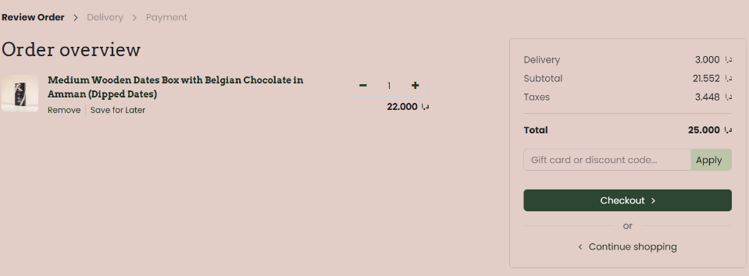
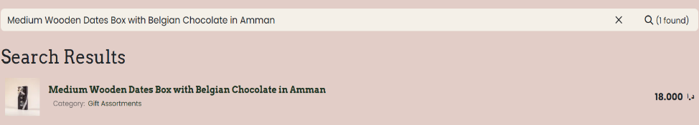

- Ubiquity (Strongly Implemented):
Siwa uses "guest check-out" (no need for a login) to allow customers to find products on the site, add items to their shopping-cart and make the delivery & payment process completely without ever having to create an account. This provides the opportunity to shop at any time, from any Internet-enabled device and reduces the amount of time and effort that is needed when purchasing as a first-time customer.
The evidence of this is shown through the fact that once you have finished browsing, checking out can be completed all the way to delivery and purchase being required to sign-in or sign-up. This adds to the convenience, increases accessibility and therefore increases the probability of completing the sales.
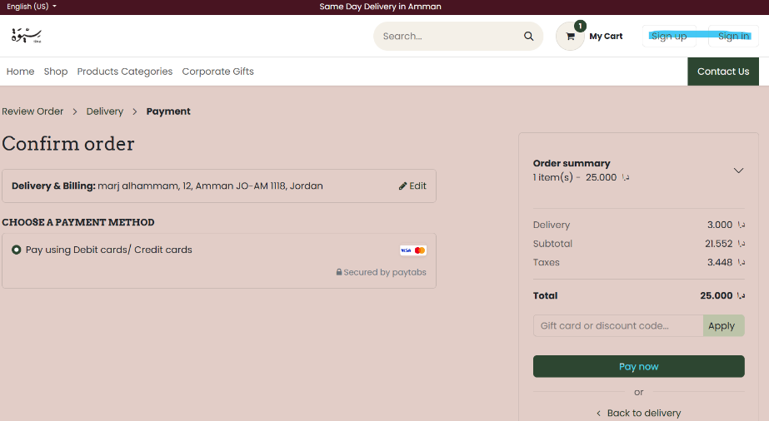

- Universal Standards (Medium Implementation)
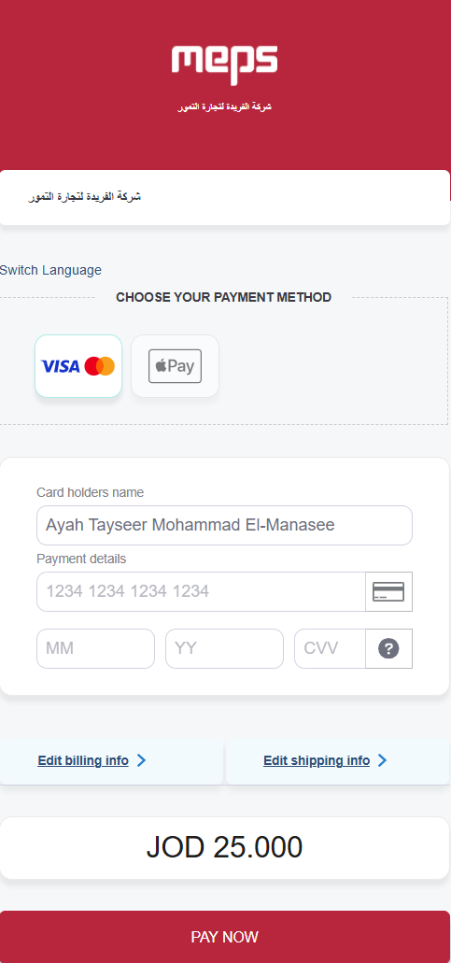
Siwa will be able to offer secure MEPS payment services that provide its customers with an opportunity to use well-known payment systems like Visa, Mastercard and also Apple Pay. The security of these payment systems is recognized worldwide and there is no need in additional software or technical skills to complete the transaction.
In order to get better results from this service, Siwa should consider offering other payment methods to the users such as CliQ and cash on delivery. The option of using various types of payments can help increase the number of completed transactions among those who have never used credit cards or have been afraid to use them when making online purchases or simply want to receive them and then pay for goods.

- Craves Jordan: Craves Jordan
- Interactivity (Strongly Implemented):
Craves Jordan has provided a very unique, active, online shopping experience with many of the components that are common to most retail stores including, a search function, various categories for browsing products, a shopping cart to collect purchases, ability to control the quantity of each item purchased, as well as the opportunity to browse other products based on their purchase history. All of these functions make it easier for customers to find what they want while also creating a fun and enjoyable experience for them when they shop online. For evidence, the website contains Search box (search), Add to Cart button (collecting purchases), Quantity Controls (quantity), Shopping Cart (collecting purchases) and "you might be interested in..." (other products).
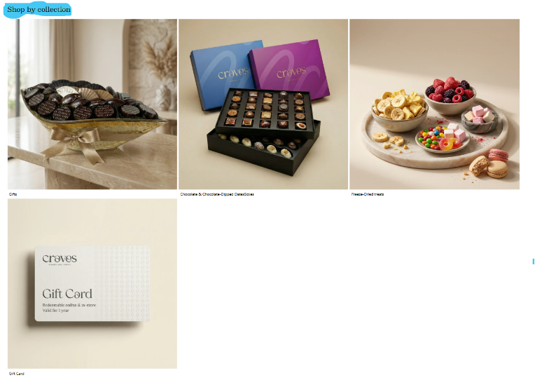
Craves Jordan has an interactive element with the "shop by collection" feature on their website. This gives customers the option of looking at all items from one particular category. There is a virtual customer service chat assistant as well. Both of these elements are very interactive for customers so they can quickly locate products they want, get answers to their questions and be active participants in the shopping experience.
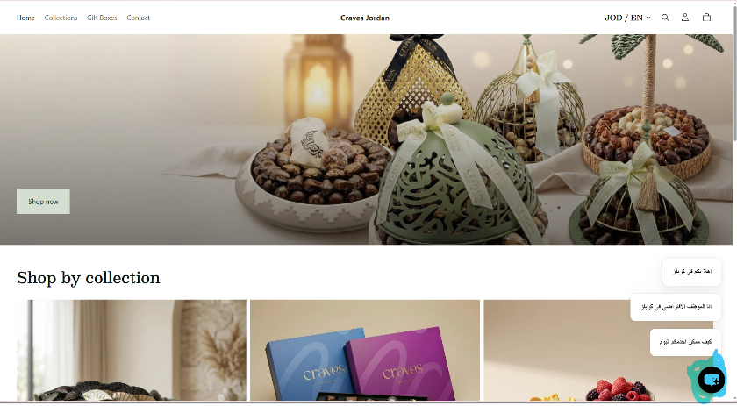

- Global Reach (Weakly Implemented):
Craves Jordan shows Jordan and Saudi Arabia in its region selector, suggesting an intention to reach customers outside Jordan. However, its shipping policy states that delivery is currently available within Amman only. Therefore, the regional option is not fully supported by the company’s actual delivery service, limiting its ability to reach customers nationally or internationally.
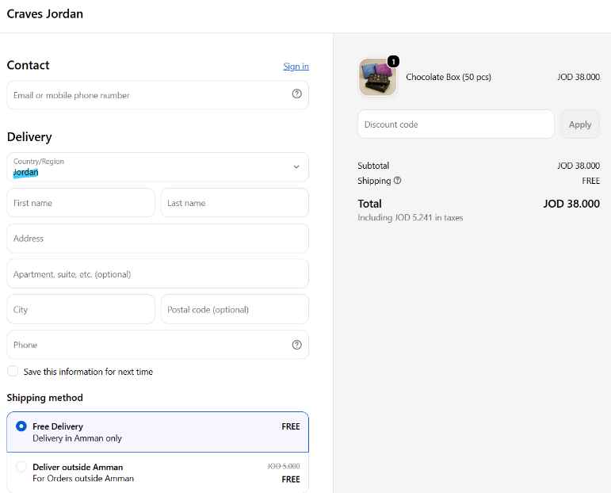
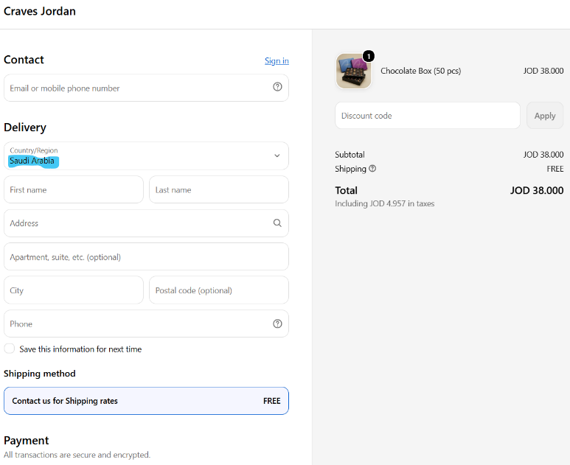
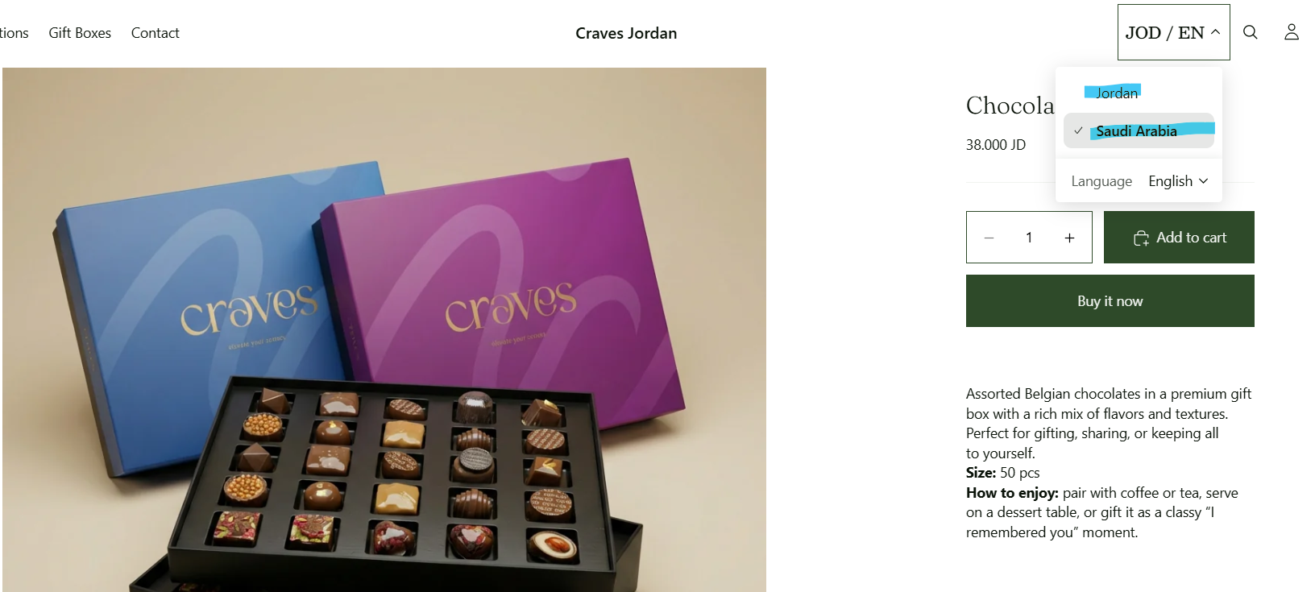
E-Commerce Competitive Recommendations:
- The Delights Shop: The Delights Shop | A story behind each piece
The Delights Shop utilizes social technology through customer reviews displayed in both a Facebook link and an Instagram link and also has a social media presence where customers can interact with the brand outside of the website. While this does provide the shop with some form of social proof and allows for interaction, most reviews are over 240 weeks old and therefore likely do not reflect the shop's current product line or service standards. Therefore, while the functionality exists it is not being utilized effectively. First time customers may have less confidence based on older reviews as chocolate cannot be physically inspected prior to making an online purchase.
The company could automatically request verified reviews upon delivery and add recent Instagram post images along with approved customer photos onto the website. Providing small loyalty incentives for customers to review their experience could be effective; however, these should not be dependent upon them providing positive reviews. This recommendation is supported due to recent and verified content will provide a stronger basis for social proof, create greater trust and drive higher levels of engagement without having to make significant changes to the shopping process.
- Siwa: Siwa Flavors | Luxury Medjool Dates & Belgian Chocolate Gifts Amman
If you do not want to have this problem anymore, then Siwa needs to provide product description, price, weight, customized choices, tax details and delivery fees. But they are using inconsistent pricing. For instance, when I searched for an item it was listed at 18 JOD, then increased by 4 JOD (to 22 JOD) once a paid option was automatically selected, and finally to 25 JOD with delivery charges. The way these costs are calculated correctly, but the 18 JOD price is not displayed clearly as a "starting" price. Customers might think additional charges were added unexpectedly. This can also cause an increase in the number of abandoned carts.
Siwa should include the words "Starting at 18 JOD", use no automatic selection on the paid options, and list the base price of the items, all selections made with regards to customizations or upgrades, delivery charge, and final amount owed in separate columns. This is a good idea because it will allow Siwa to build transparency into their pricing and therefore create less uncertainty and generate more trust. It will also enable them to keep their useful ability to customize products.
- Craves Jordan: Craves Jordan
The intent of Craves Jordan's showing both Jordan and Saudi Arabia as options on their "Region Selector" for its web site indicates that they intend to target a regional (or local) customer base. Nonetheless, their shipping policy specifically states that delivery can only occur inside Amman at this time. This represents a disconnection between the scope of service presented by the web site and the services that are being offered by Craves Jordan. A potential consequence of this disconnection could be frustration experienced by customers residing in areas outside Amman who browse products prior to learning that delivery to those locations is not possible. As such, these customers may have a tendency to abandon their shopping experience after becoming frustrated.
In order to provide a better experience for their customers, Craves Jordan should include only the cities or regions where delivery is available in the drop-down menu of the "Region Selector", and clearly indicate which locations can receive delivery on each product detail page prior to completing checkout. In addition, Craves Jordan should expand its delivery capabilities throughout Jordan in phases rather than attempting to deliver internationally immediately. Prior to expanding into Saudi Arabia, Craves Jordan should develop appropriate packaging for its chocolate products; establish reasonable delivery times and costs; and provide clear and accurate currency information. Implementing a phased expansion plan based upon the characteristics described above will likely result in less confusion among prospective customers with respect to delivery expectations. Additionally, implementing such a plan will support sustainable growth for Craves Jordan in the markets of interest.

Major Types of Ecommerce:
Type | Main Characteristics | Advantages | Suitable Business Applications | Examples
B2C | It refers to the sales model in which companies sell products directly to consumers. One of the key characteristics of the B2C model is the need to establish a strong brand identity to attract and retain customers. | Convenient shopping experiences for customers, larger potential consumer bases, and businesses being able to communicate directly with their customers. | Clothing, electronics, food, cosmetics and other retail products. | Nike || Nike. Just Do It. Nike.com
B2B | It is a business model where commercial transactions of goods, services, or information occur between two or more organizations, either directly or through digital, e-commerce platforms. Instead of selling directly to individual consumers. B2B companies provide other businesses with the products and solutions they need to operate, grow, or resell. | It is the largest form of e commerce, lower unit costs, and it is a long-term relationship. | Net marketplaces, private industrial networks, manufacturing materials, office supplies and procurement | Alibaba ||  Alibaba.com: Manufacturers, Suppliers, Exporters & Importers from the world's largest online B2B marketplace
C2C | It provides a way for consumers to sell to each other, with the help of an online market maker (also called a platform provider) | Consumers can sell unwanted products, while buyers can access a wide variety of new and used items. | Used products, collectibles, household items and auctions. | Example of a platform that help the consumer to produce its product: eBay ||  Electronics, Cars, Fashion, Collectibles & More | eBay
Mobile ecommerce | Mobile ecommerce is the buying and selling of products or services through smartphones and tablets. | Shoppers can buy from almost anywhere, Checkout can take less time, Notifications can bring interested shoppers back, and Mobile data shows where shoppers struggle. | Food ordering, retail applications, ticketing and mobile banking. | Noon App  noon Online Shopping & Grocery - Apps on Google Play
Social ecommerce | It is buying and selling products directly through social media platforms like DMs and Messenger, driven by personal relationships, creator influence, and online communities. | Word-of-mouth promotion, increase in social media platforms provides more opportunities for companies to reach a larger audience, The more people are talking about your brand online in social platforms, the more valuable it is in the eyes of search engines. | Fashion, cosmetics, accessories and creator-promoted products, home accessories, cars, Electronics. | Facebook Marketplace || (20+) Facebook Marketplace | Facebook
Local ecommerce | It is a business practice where you sell your products and services to local customers via an online storefront, also, it focuses on engaging the consumer based on his or her current geographic location. | Fast delivery, relevant local options and support for nearby businesses. | Restaurants, groceries, pharmacies, flowers and local services. | Talabat Jordan || Food delivery from your nearest restaurants in Jordan | Talabat
B2G | It occurs as a result of a public organization ordering from a private business in an electronic procurement environment. Government agencies typically prepare prenegotiated contracts and invite businesses to participate in bidding processes. | Government contracts tend to be larger and more stable compared to private-sector agreements, completing a government contract can enhance a company's reputation and ease the process of securing future contracts and less competition. | government tenders and enables registered suppliers to participate and submit offers electronically. | JORDAN::JONEPS
C2G | It refers to transactions between consumers and government entities, C2G platform allows you to act as a link between consumers and the government. You give the citizens a direct channel to share their thoughts, feedback, or information with the public sector. | It can improve government accountability and transparency.  Also, it can lead to better management of public services because it lets government agencies collect data and analyze it to improve how services are delivered. | pay government fees, such as traffic fines, taxes or work-permit fees. | eFAWATEERcom – Jordan's Official Online Bill Payment System
G2C | It is an ecommerce that the government provides information, documents or public services directly to individual citizens through a digital platform. | convenient access, less paperwork, fewer government-office visits and faster service delivery. | It is suitable for passports, official certificates, health insurance and digital records requests. | الصفحة الرئيسية | Sanad

Understanding B2C: Characteristics, Marketing Strategies, and Challenges
B2C (Business-to-Consumer) Business Model: Definition, Examples, Advantages, and Disadvantages - Businesses Model
B2B (Business-to-Business): Definitions, Main Features & Benefits
14 Advantages of B2B Ecommerce Every Business Should Know
C2C Business Model Advantages and Disadvantages - The Business Scroll
Mobile ecommerce: Types, benefits, and examples
Top 6 Benefits Of Social Commerce For Businesses | Flowspace
Complete Guide To Local Ecommerce And How To Get Started
Understanding B2G ecommerce: Advantages, Disadvantages, and Examples
What is C2G eCommerce? Understanding the Basics

Why does each example fit the type of e-commerce assigned to it:
- B2C: Nike
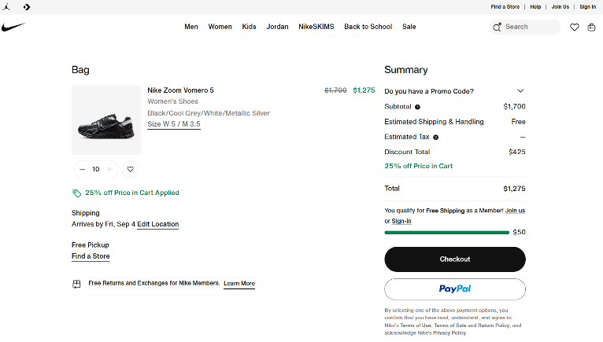
Nike is a B2C ecommerce because it sells there products directly to the customer via its website. Also, the cart limit is 10 pieces which indicate that Nike is not a B2B business because it is designed for personal purchases rather than wholesale B2B transactions.

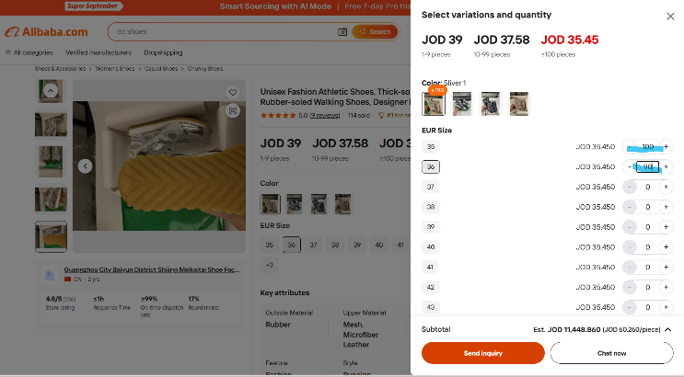
- B2B: Alibaba
Alibaba is a B2B ecommerce because it connects manufacturers and suppliers with businesses purchasing products in wholesale quantities, and we can choose a big number of units.

- C2C: eBay
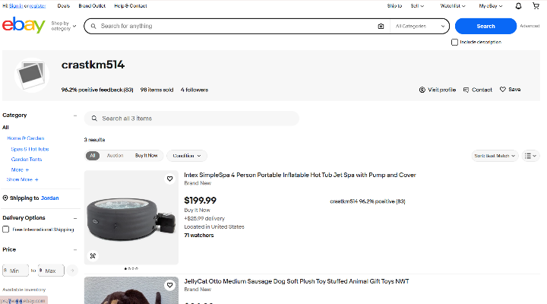
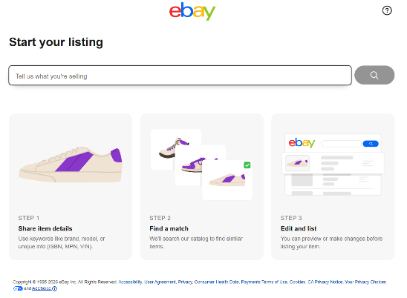

eBay is a C2C ecommerce because consumers (individuals) can list and sell new or used products to other consumers (individuals) through eBay marketplace, also, we can visit individuals’ profiles and see what products they sell.

- Mobile: Noon App
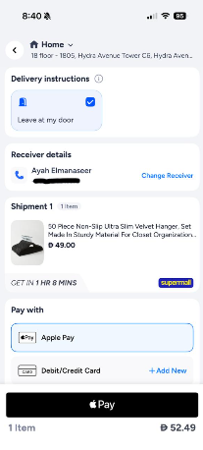
The Noon application is a mobile ecommerce because customers can complete the shopping process through its mobile application which includes product selection, payment and order placement.

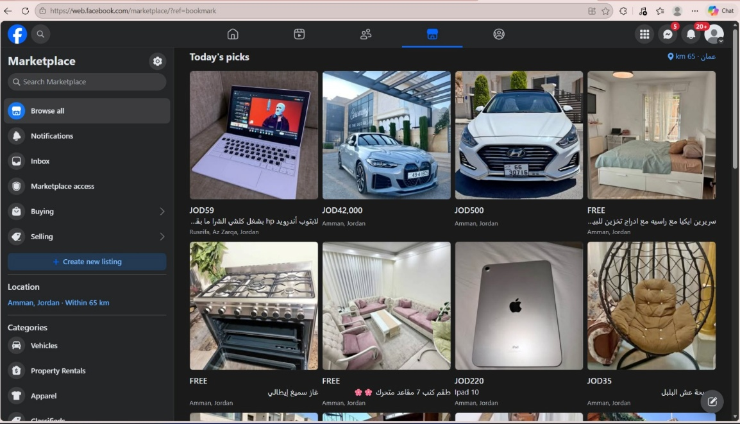
- Social: Facebook Marketplace
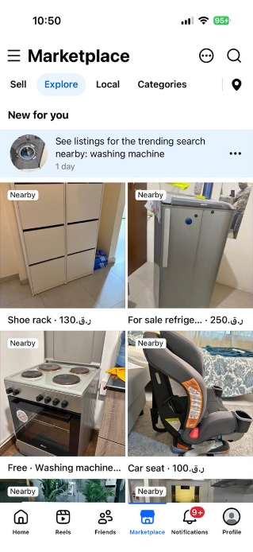Facebook is a social ecommerce because customers can discover products via social content and recommendations and can purchase them within the social platform by using messenger (as a DMs) and arrange purchases through the social platform. It also supports product discovery through social interaction and word-of-mouth.
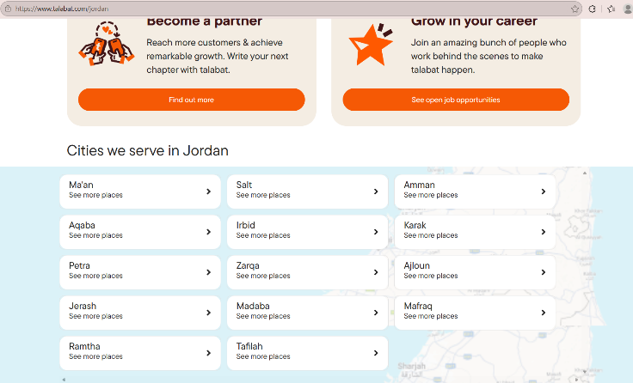
- Local: Talabat Jordan
Talabat-Jordan is a local e-commerce because it uses the customer’s geographical location to display nearby businesses and provide delivery within the selected area.

- B2G: JONEPS
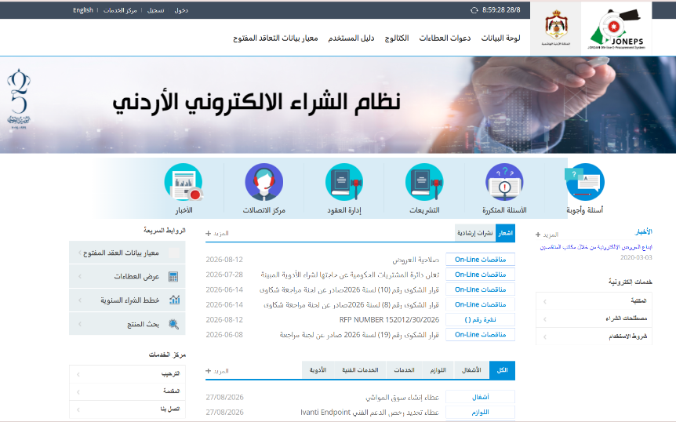
JONEPS is a B2G ecommerce because businesses can electronically submit offers to supply products or services to Jordanian government organizations.

- C2G: eFAWATEERcom
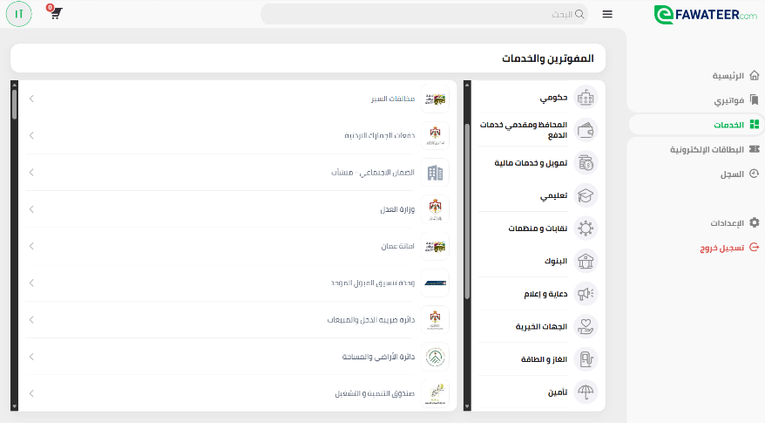
eFAWATEERcom is a C2G ecommerce because an individual uses it to pay fees, fines or other financial obligations to a government organizations.

- G2C: Sanad
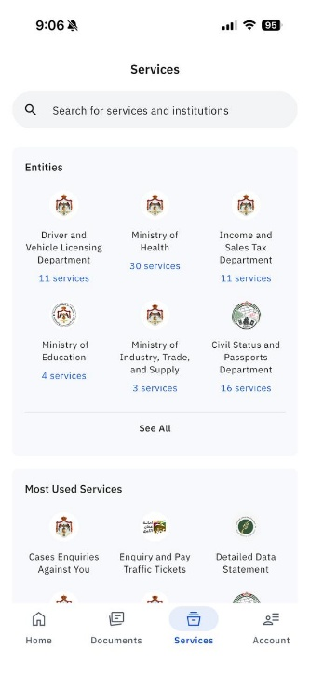
Sanad is a G2C ecommerce because the Jordanian government provides digital documents, information and public services directly to citizens (consumers) through the platform.

Part 2:

Business Objectives:
- Business Idea: Luxury Chocolate is an online chocolate store which offers a wide variety of premium Belgian chocolate products, including chocolate covered dates, chocolate bars, luxury chocolate gift boxes, and custom-made chocolate boxes with the customer's selection from the website in terms of chocolate types, chocolate, box size, and other elements.
- What is Luxury Chocolate Website Selling?
- Premium Belgium chocolate bars.
- Chocolates of different fillings dates covered by chocolates.
- Gift boxes made of luxury chocolates.
- Customized gift boxes of chocolates to celebrate a special occasion.
- A wide range of flavors, types of coating, and gift box sizes.
- Who are Luxury Chocolate selling to?
Luxury Chocolate is targeting those in Jordan purchasing luxury chocolate as an individual, gift item, celebration or for that special occasion. Luxury Chocolate's primary target market are young adults, family units, Employee gift purchases, and individuals looking to purchase customized elegant gifts.
- What Problem are Luxury Chocolate Solving?
The challenge of locating unique, luxurious and custom chocolates online can be challenging due to limited availability of such items, unclear information about the product being purchased, limited online payment security methods available to consumers, and difficulty in obtaining fast delivery on a product that was ordered.
- Why should customers choose Luxury Chocolate?
- Because it provides a luxury quality Belgian chocolate.
- The ability to customize and personalize their own gift choices.
- Variety of Flavors, Fillings & Box Sizes to Choose From.
- Easy Online Ordering Options, which provides Cash on delivery for those who don’t have digital payment methods, also, it provides Apple Pay, Google Pay, and Visa Card.
- Secured Payment Methods.
- Quick Delivery Throughout Jordan (Express Delivery Service)
- Gift Packaging attracts attention.
- The Main Objectives of Luxury Chocolate:
Luxury Chocolate is aiming to make available high-quality custom-made chocolates via an easy & safe online service. Luxury Chocolates will be targeting customers all over Jordan, Increase Sales of their Brand Products, Build a Brand Name & Encourage Customer Loyalty.

Target Audience:
- DEMOGRAPHICS

Luxury Chocolate is targeting age 18 – 45 years old in Jordan, specifically, people residing in Amman and surrounding areas. This demographic includes university students, employed people, families and those with a middle-to-high income that are willing to spend on premium chocolate and unique gift items.
- BEHAVIOR PATTERN

Targeted customers will value the luxury of quality, attractiveness of packaging, convenience and customization. Customers typically purchase chocolate as a birthday, holiday, graduation, wedding, visit from family members etc. gift item.
- CURRENT CONSUMPTION BEHAVIORS

Presently, customers can purchase chocolate by ordering it via social media. Luxury Chocolate will provide an additional level of convenience to customers by allowing them to view available products, customize the box they choose, price comparison and checkout process all in one location (online).
- DIGITAL USAGE BEHAVIOR

Targeted customers primarily utilize mobile devices to shop for products, communicate with sellers and make purchases. Targeted customers also consistently use websites such as Instagram, Facebook and WhatsApp to locate products and research prices and read reviews.
- CONTENT PREFERENCES
Targeted customers find product photography showcasing superior quality, short video presentations, (reals), promotions and discounts, customer written reviews, and images of customized chocolate boxes appealing. Instagram and Facebook have been found ideal for displaying this visual type of content and connecting with targeted consumers.
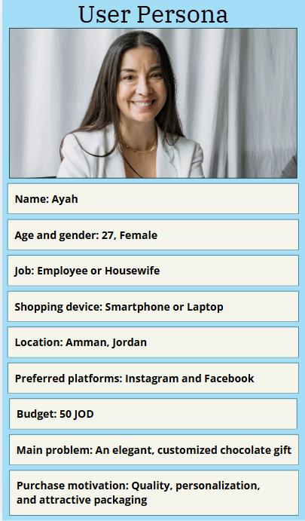

Business Model:
Luxury Chocolate is an E-tailer business because it has a B2C model for selling premium chocolate via its e-commerce web site. It provides customer with the ability to view product categories, pick flavors and sizes of chocolate they want, add Customized gifts or gift boxes, make payment and schedule delivery anywhere in Jordan. By operating totally online at all times, Luxury Chocolate can serve a larger number of customers and be less dependent upon opening a retail location.

Revenue Model:
- Sales Revenue Model:
The major sources of income for this company are the sales of their chocolate goods via the company's e-commerce site. The chocolate bars, chocolate covered dates, gift boxes with a variety of chocolate filled items in them and custom-made chocolate boxes that customers may buy will all be sold through this internet store. The cost of these items will depend upon the chosen type of item, flavor, filling, box size and how much customization the customer chooses.
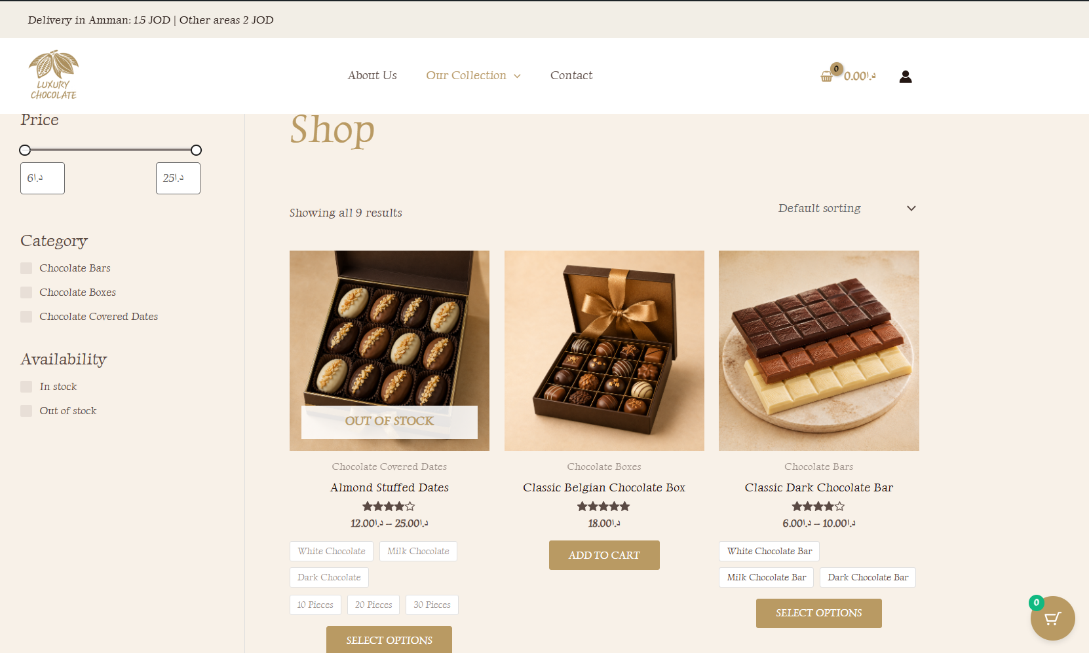
- Advertising Revenue Model:
Luxury Chocolate also has the ability to advertise other businesses that are complementary to the products sold at Luxury Chocolate, such as flower shops and gift shops. 100 Wardeh has been advertised on the home page by way of an image, a brief summary, and a link to their site.
Luxury Chocolate charges 25JD per month, in advance for each advertisement. Each advertisement will run for 30 days from the date of posting but can be renewed monthly.
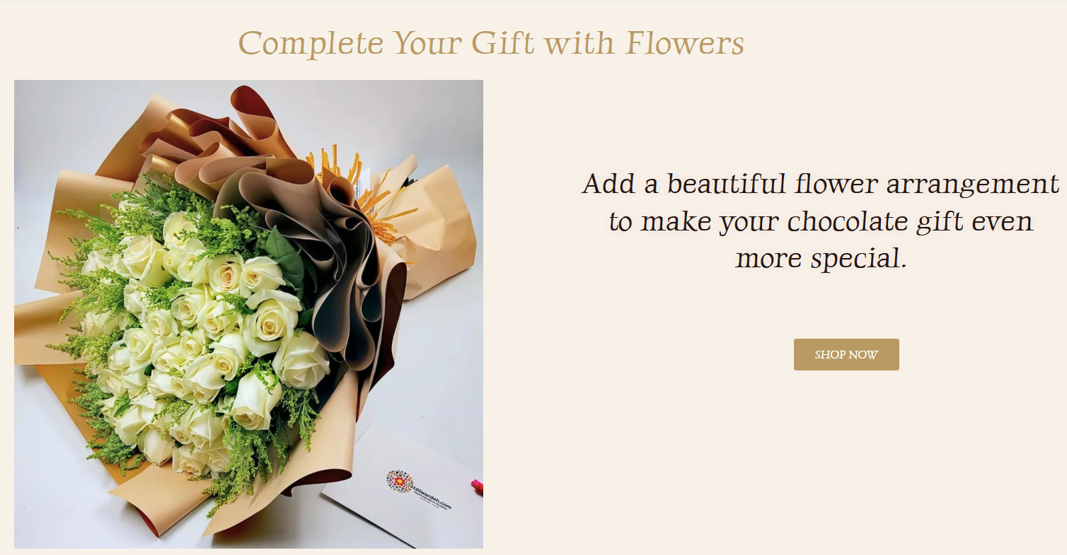
Thus, the sale of products represents the primary form of revenue generation for the company, whereas the promotion of the product via advertisements also contributes to a secondary, monthly revenue stream which complements gift items with chocolate.

Functional Requirements:
- Functional Customers Requirements:
- Customers will have ability to browse all products that are categorized.
- Customers will be able to search for and filter all products.
- Customers will have the ability to view product images, product description, price and option of product.
- Customer will be able to choose flavor of chocolate, type of filling, size of box and number of boxes.
- Customers will have the opportunity to personalize their chosen chocolate boxes.
- Customers will be able to use a 360-degree product view of the products they wish to purchase.
- Customers will be able to add, delete and modify items within their shopping cart.
- Customer will be able to complete the checkout process as either a Guest User or
Registered User.
- Customers will be able to choose from the variety of ways available to pay (Visa, Apple pay, and google pay or Cash On Delivery).
- Customers will be able to input a delivery address and see how much it would cost to deliver the items they chose.
- Customers will be able to apply any and all valid discount codes during the checkout process.
- Customers will be able to register for an account with us and look at previous orders.
- Customers will be able to give a rating and leave a review of products purchased.
- Customers will be able to send questions, comments, and requests to our business via Contact Page or Live Chat.
- Customers will be able to click on advertisement links for other businesses similar to ours.

- Functional Client Requirements (Business Owner / Administrator):
The client is the business owner who will have full access to and control over the administration and management of the Luxury Chocolate website using the WordPress/WooCommerce Administration Dashboard upon completion of this project.

- The system admin will have the ability to add, modify and delete product offerings.
- The system admin will have the ability to add, modify and delete product pricing, product images, categories, variations and quantity of items in inventory for a specific product offering.
- The system admin will be able to add, modify and delete orders placed by customers.
- The system admin will be able to add, modify and delete methods of payment as well as delivery methods.
- The system admin will be able to create and manage special discounts or promotions such as coupons and discounts.
- The system admin will have the option to approve, reply or remove reviews from customers regarding their orders.
- The system admin will be able to interact with customers via live chat to answer questions about orders.
- The system admin will have the ability to add, modify and remove advertising being presented to users.

Website Vision:
To become Luxury Chocolate store the most trusted online resource in Jordan for selling high-quality, Custom-made, Beautifully presented Chocolate, and to have a Customized product to make the customer Gift more special.

Marketplace Characteristics:
Luxury Chocolate competes in a segment of Jordan's Premium Gift and Chocolates Market. Luxury Chocolate markets chocolate bars, chocolate covered dates, custom gift boxes, and custom gifts for special events or occasions that include birthday celebrations, graduation parties, wedding receptions and holidays during the months of Ramadan and Eid. In this market demand is generated by those consumers aged 18-45 years old that are middle income to medium-income individuals who place an emphasis on the quality of products purchased, individualized service and visually appealing product packaging.
The Market Structure of this business contains direct competitors like Siwa and Craves Jordan who are offering Premium Chocolate, Chocolate-Covered Dates & Occasion Gifts. Suppliers will be providing a variety of items for the company such as Belgian Chocolate, Medjool Dates, Nuts, Packaging Materials, Ribbons and Customized Decorations like . Substitute Products available would include flowers, cake, perfume, candies, and gift boxes.
The E-Commerce Market in Jordan has continued to grow with an increasing number of consumers using their computers or smartphones to browse for goods online through websites utilizing digital payment systems and receiving deliveries directly at their homes. In 2025 alone the E-Commerce Market produced over $229 Million, and it is estimated that by 2026 there will be a 5 – 10 % increase in sales (ECDB, 2026).
Mobile presence is important because most customers use their smartphones for product discovery, comparing options, communicating with businesses, and making orders. The internet user base in Jordan was estimated at around 10.6 Million, with an internet penetration rate of 92.5%, which indicates how accessible are both online and mobile platforms (Kemp, 2025).
The compound annual growth rate of the Jordanian confectionery market, including chocolates, will be 4% during the period of 2025-2031, in addition, e-retailers have experienced large scale increases with regards to their use as a distribution channel for confections due to e-commerce platforms enabling consumers to make convenient purchases of confections from the comfort of their homes (Bhandari, 2023).
Chocolate and gift products generate interest on social media platforms including Instagram, TikTok and Facebook, especially during holidays and special occasions. There are many ways that consumers engage with product images, short videos of products being unboxed, Customized box designs, promotions, reviews and unboxing content. These ways also show that social networks are important in discovering products and interacting with customers in this marketplace.

Content Strategy:
Content Type | How it is used in Luxury Chocolate | Source | Static/Dynamic and Why? | Purpose
Product content | Product descriptions, prices, flavors, sizes, photographs, availability ,and 360-degree views. | Created and updated by the business owner. | Static & Dynamic.  most items (product description, flavor, size) will remain the same. And then there are the images for each item which also remain the same. While it is possible that the price of an item won't always keep changing. The only thing changing in this case would be the number in stock, which could possibly go up or down daily depending on how many were sold. | Provides consumers with an understanding of the products offered by Luxury Chocolate in order to aid them in making purchasing decisions.
Marketing content | Homepage banners, advertisements, discount codes, seasonal offers, Instagram, TikTok, and Facebook. | Created by the business owner. | Dynamic.  A banner, advertisement, discount code, seasonal offer or something else created for social media, all of these things change from day-to-day based on a seasons and holidays. | Attracts potential clients as well as creates awareness for products being promoted along with special offers.
User-generated content | Customer reviews, star ratings, photos and complaints that is generated on the Contact Us page. | Created by Customers. | Dynamic.  A review, rating, customer photo or complaint about a product on your site changes constantly over time. | Supports building customer confidence through enabling other customers to rate the quality of the products available online.
AI-assisted content | Product descriptions, promotional captions, marketing ideas, and product images. | Created by any AI agent tool and reviewed by the business owner. | Static & Dynamic.  Some of the AI generated content (the product description and images) do not necessarily need to be changed. However, the promotional captions and marketing ideas do. | Faster production of content can be supported while at the same time maintaining consistent branding.

Timeline:
Phase 1: Planning Phase 2: Strategy Phase 3: Design
Week 1 Week 2 Week 3-4
1. Business idea & objectives 1. Business model 1. Theme selection
2. Target audience 2. Revenue model 2. Branding
3. Website Requirements 3. Competitor analysis 3. Sitemap
4. SWOT 4. Content preparation
5. Competitor analysis

Phase 4: Implementation Phase 5: Testing & Launch
Week 5-6 Week 7-8
1. WordPress and WooCommerce setup 1. Functionality and mobile testing
2. Product and customization options 2. Payment and delivery testing
3. Payment methods 3. Security and performance testing
4. Delivery 4. Fixing technical issues
5. Live Chat and customer reviews 5. Website deployment and official launch

Phase 6: Marketing & Presence
Week 9-10
1. Establish Instagram and Facebook presence
2. Connect social media accounts to the website
3. Publish photos, videos, and seasonal offers
4. Apply SEO and launch online advertisements
5. Monitor website traffic, engagement, reviews, and sales

The total scope of this project will take approximately 2.5 months (10 weeks). For the first 8 weeks the website was built, developed, tested and launched. Then in the final 2 weeks we have established our first e-commerce platform as well as start creating content for the site and continue advertising and monitor performance over time. Also, we worked on Marketing to employ the presence to get closer toward it.

SWOT:
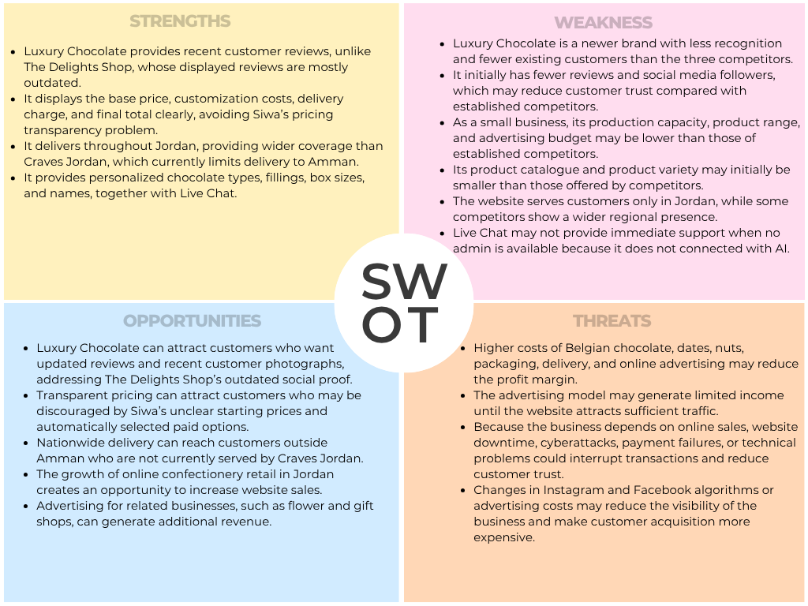

- Justification:
Luxury Chocolate is going to be built on the strengths and advantages from weaknesses in the three competitor businesses. To enhance The Delights Shop's dated social proof, Luxury Chocolate will utilize recent reviews, to address pricing confusion at Siwa, Luxury Chocolate will use transparent price listings for each item, and, to expand their reach beyond that of Craves Jordan, they will deliver products to all of Jordan. This supports Luxury Chocolate's overall goal of providing customers with an easily accessible, highly trusted and wide-coverage luxury chocolate service.

Although Luxury Chocolate has recently started up as a business, it will likely face challenges of low brand awareness at start-up with little to no customer reviews, a limited budget for marketing and branding, and lower capacity to produce chocolates compared to its established competitor. The e-tailer business model Luxury Chocolate uses relies on the web site, online payment processing system, and delivery companies. As such, Luxury Chocolate's Sales Revenue Model is susceptible to rising material (chocolate) and shipping cost increases, whereas Luxury Chocolate's Advertising Revenue Model relies on generating sufficient traffic on the web site in addition to offering advertisement options which are consistent with the luxury brand.

E-Commerce Presence Map:
- Website and Mobile Presence:
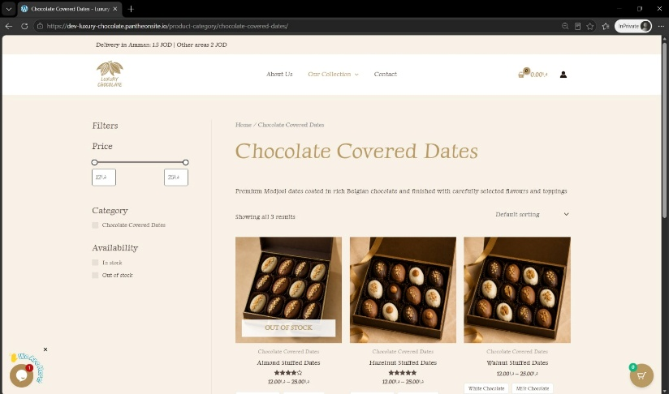
A luxury chocolate WooCommerce website is the primary online store (e-commerce) for customers to access on their desktop computer, smartphone or tablet. On this site the customer will find all the products categorized by type as well as images and descriptions of each item. From the site a customer will be able to enter the quantity they would like to order, proceed with checkout, and pay. There are also live chat options for customers that have questions about items or would like information about shipping and other details. Customer Reviews will be available so that customers will see how other customers feel about your chocolates.
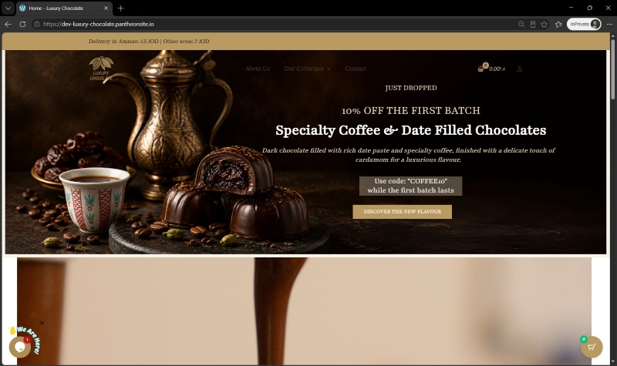

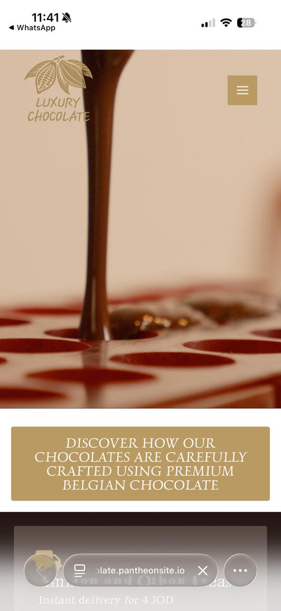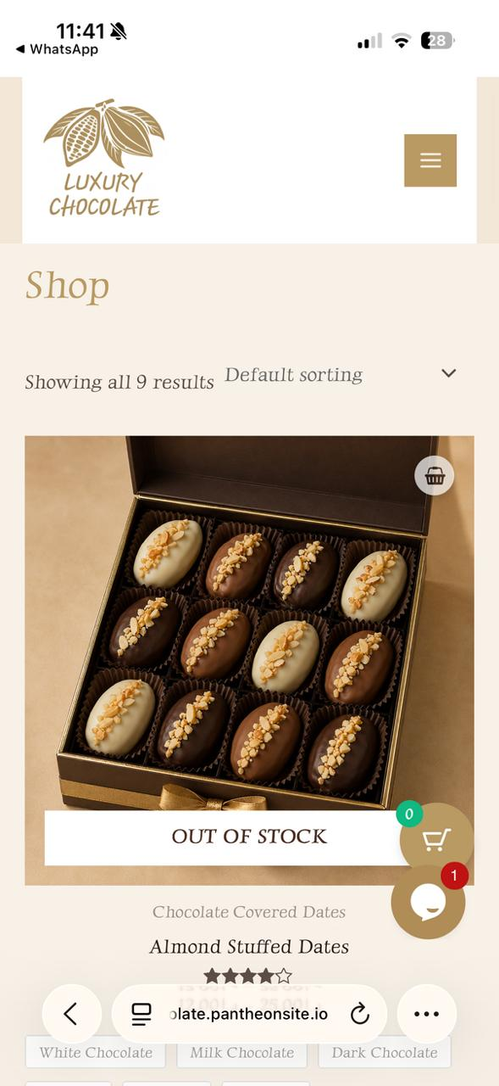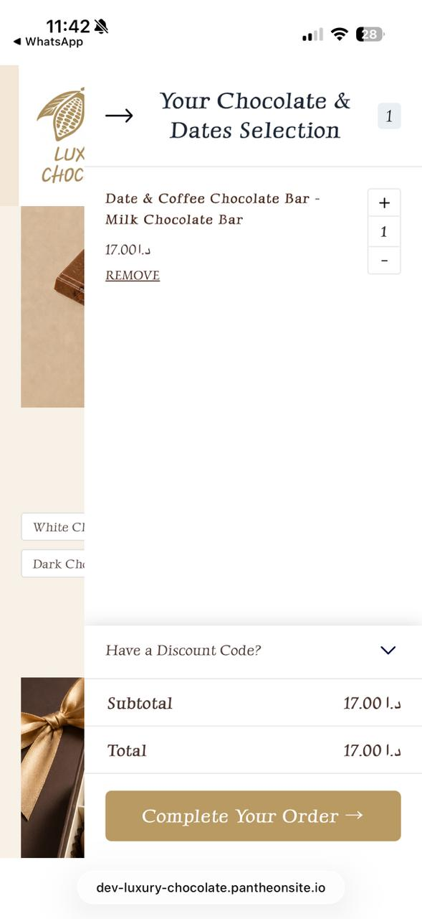

- Social Media Presence:
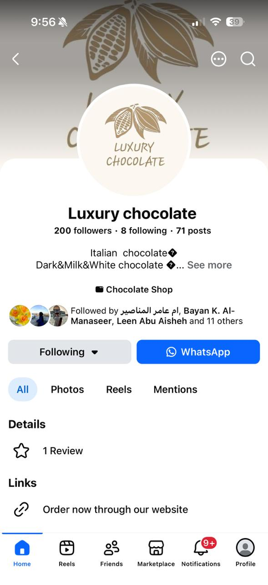
Luxury Chocolate posts photos of their products on both Facebook along with short videos of the making of some items and seasonally produced promotional materials. Their customers are able to communicate with them using these platforms as well as click an "Order Now Through Our Website" button which will allow the customer to go straight from a post on either Facebook or Instagram to the Luxury Chocolate website.
The website link appears on the profile after the reviews.

- Email Presence:
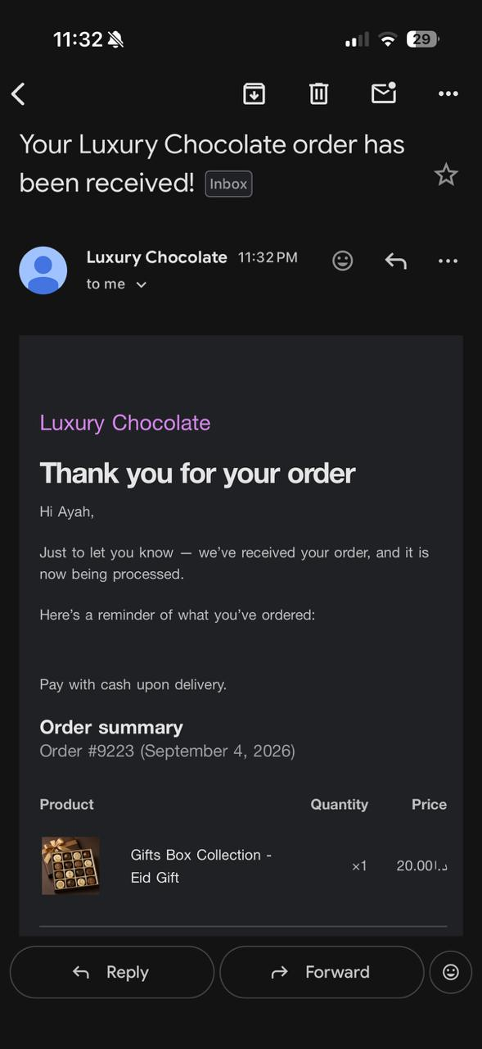
Customers receive order information via email. Order confirmations and updated statuses are delivered via email as well. This provides assurance to customers that they have placed an order successfully, while providing continuous contact with their order. Also, an email delivered to the admin after the order placed by the customer which contains Order details.
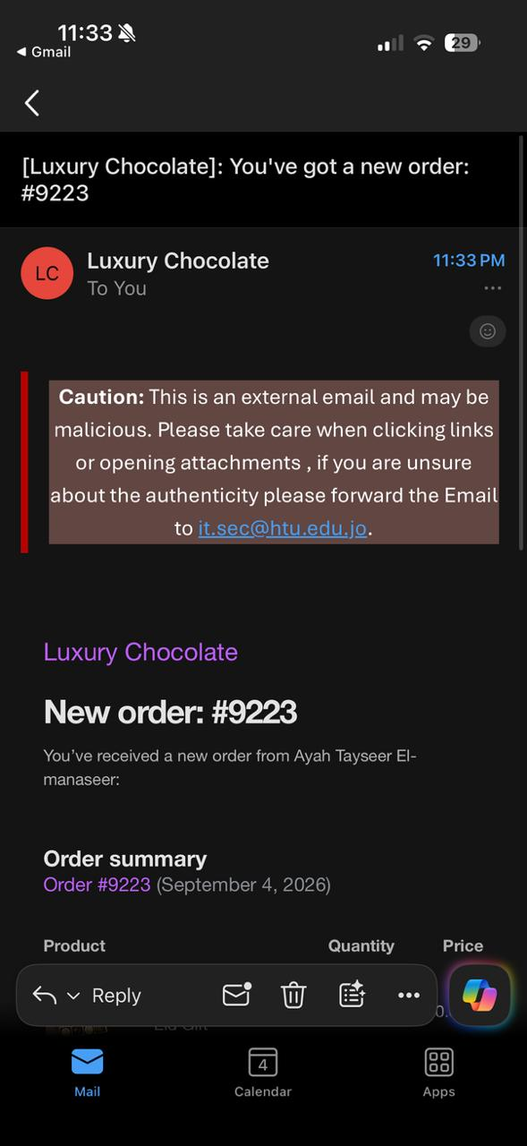

- Offline Presence:
Luxury Chocolate uses printed forms of promotional materials and product packaging that contain the company name and a QR code. The customer may scan the QR code to be directed to the site. As an example, this helps connect offline brand promotion with the online store and with its physical chocolate products.
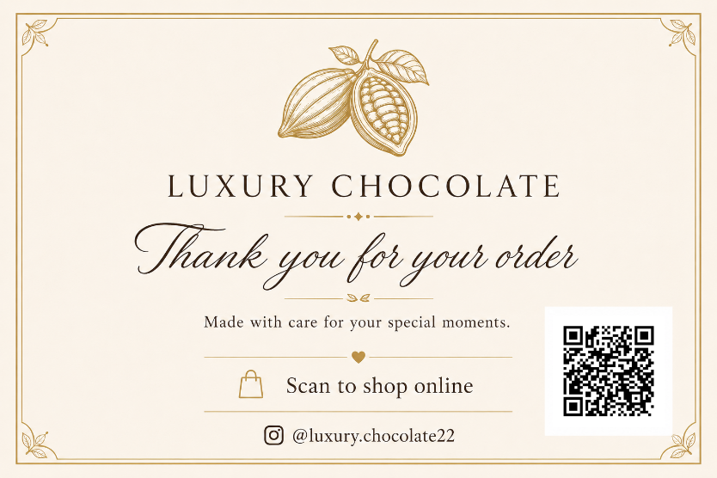

- Justification:
This e-commerce presence map enables the company's overall objectives in multiple ways that are interdependent with the customer experience. First, it creates a major B2C outlet via the web site. Second, because of the mobile friendly nature of the web site, the web is an easier way for smart phone users to order products. Third, social media brings potential buyers to the web site through images, and fourth, email builds credibility with customers as confirmation emails and order updates allow customers to track their purchase process. Fifth, all of the above are used to create brand awareness and encourage engagement and therefore sales and loyalty.

Evaluating Alternative E-commerce Strategies:
The competitive e-commerce strategies of The Delights Shop, Siwa and Craves Jordan have been reviewed as alternative models for the proposed Luxury Chocolate Strategy. Each competitor has been evaluated in terms of their Business Model, Revenue Model, Marketing Channels and Online Presence Approach. Evaluation identifies useful practice which Luxury Chocolate may want to use and areas in which it is wise for Luxury Chocolate's proposed strategy to be avoided.
- The Delights Shop:
- Business Model:
The Delights Shop uses an integrated B2C Click-and-Mortar Business Model. This can be concluded from their e-commerce-enabled website that lists the company's physical stores, as well as a cafe located in City Mall and Abdoun, which enables both of these types of shopping experiences. They are able to provide each type of experience individually for the consumer. Additionally, the site enables consumers to order customized luxury gift boxes for themselves or through Corporate Ordering (for other organizations).
This model allows customers to be flexible in how they buy as it offers both an e-commerce platform along with a Physical location (shop). The ability of a customer to visually view the product in a physical store before buying may contribute to increased trust with regard to purchasing the product. However, due to the additional costs associated with the need for a physical location such as rental space, employee salaries, inventory acquisition and management, and operational expenses, the initial investment and ongoing resource requirements are higher than for a virtual-only business model.
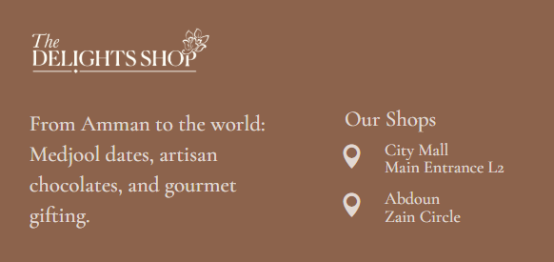
Luxury Chocolate has chosen a B2C e-commerce (e-tail) model to start with, this makes sense for Luxury Chocolate as it allows the company to sell directly from their website rather than having to incur the expenses associated with opening multiple storefronts until they have an established customer base and sufficient revenue. Therefore, a hybrid "click & mortar" strategy could be considered at a later time when The Delights Shop has developed enough sales volume and cash flow to expand into physical retail space.

- Revenue Model:
The Delight Shop uses a Sales revenue model. On their site they sell: Dates, Belgian Chocolate, Baked Products, Luxury Boxes and many other forms of Confectionery. A second type of sales is corporate orders, which allow the company to provide gift items for Companies and Larger Events.
A broader variety of products allows for increased revenue due to the various needs of customers. Larger corporate orders can also occur in greater quantities than individual consumer orders. Nevertheless, a larger number of products can create an increased inventory size and operational complexity.
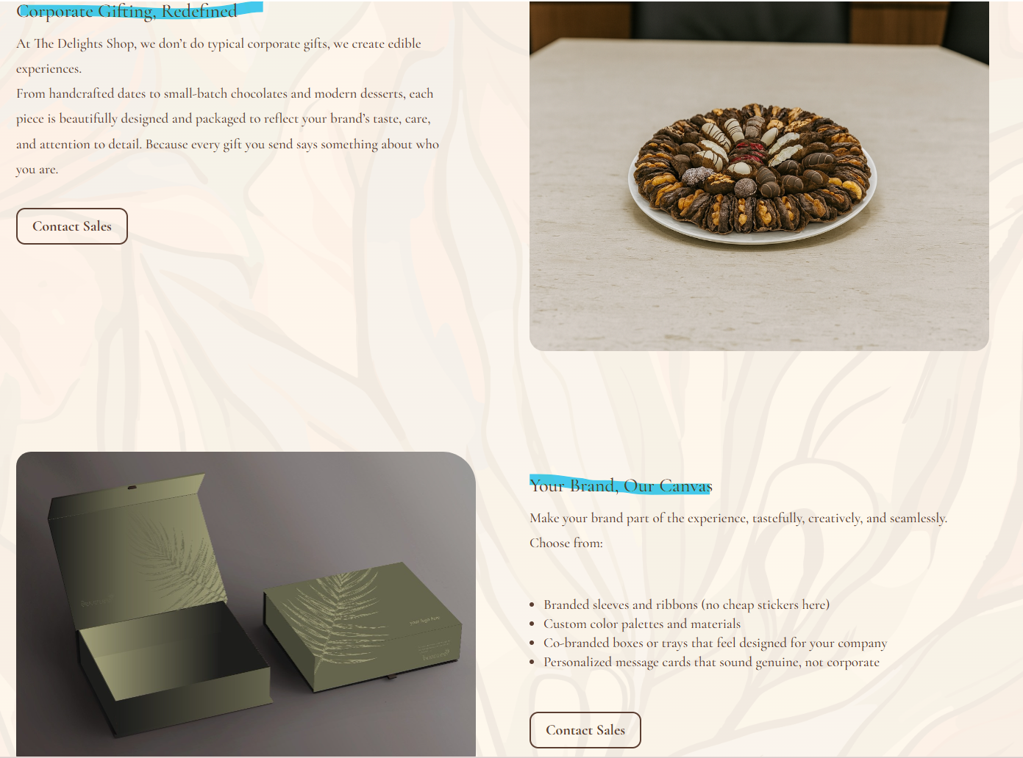
Luxury Chocolate is similar in that they use sales as their main method of generating revenue, however, Luxury Chocolate starts off with a smaller line of chocolate bars, chocolate covered dates, and customized gift boxes. Therefore, controlling both the quality of each product and inventory is easier. A second form of revenue is through advertisement provided by complimentary businesses. However, this advertisement will have to be very closely monitored so as to avoid including unrelated content that could detract from Luxury's Premium Brand Image.

- Marketing Channels:
Instagram is used by The Delights Shop in conjunction with visually appealing website content to generate interest in their date items, chocolate items, custom packaging options and event-themed collections. Social media accounts are directed to the web site allowing an easy transition from discovering new products on social media to making purchases online.
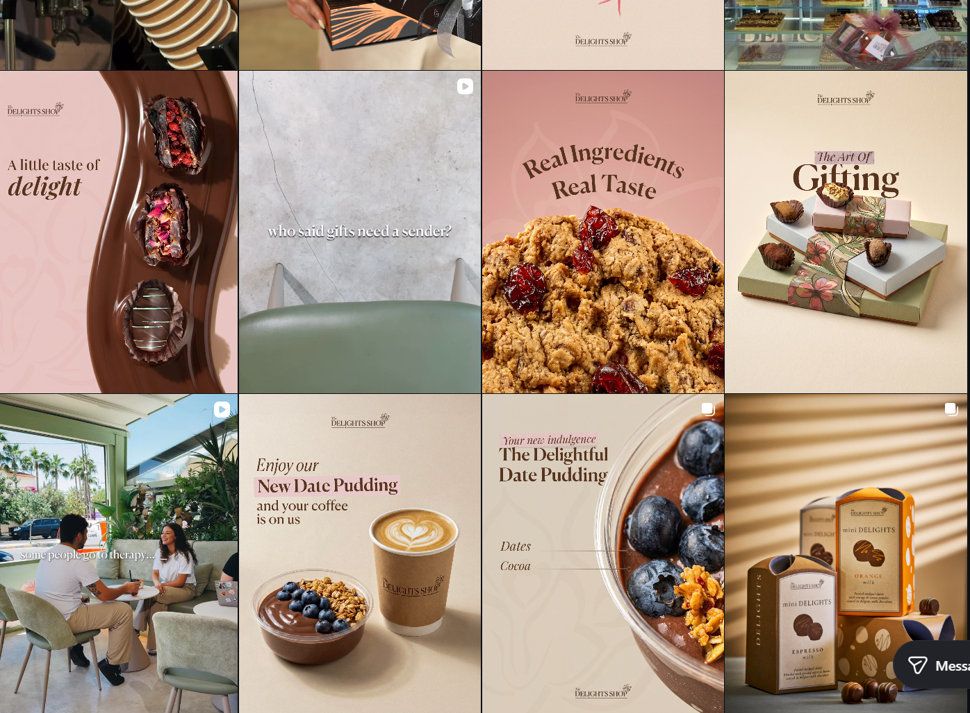
Customer Reviews as an additional type of Electronic Word-Of-Mouth will also have an effect on customer confidence (reducing uncertainty) when purchasing food from a supplier over the web. The review posted to the site was old so it may not reflect the current product line or the quality of service that Luxury Chocolate offers today. Luxury Chocolate has employed the same visual approach using Facebook and Instagram for their posting and in attempting to post content that is current as well as gather new customer feedback. Using these platforms to post current content and to allow customers to post reviews will support customer confidence, build engagement, increase the level of trust among potential customers and contribute to increased online sales.

- Online Presence:
The Delights Shop has an integrated presence by using its e-Commerce website, social media (Instagram), transactional emails sent from the site and its city mall and Abdoun physical stores/cafe's. The e-commerce website is used as a platform for the customer to view the products available at the shop, build their own customized gift box, place orders through corporate ordering and make purchases directly online. Additionally, The Delights Shop uses Instagram as a means to engage in conversation with customers and direct them back to the e-commerce site. A new password reset email was sent during the review process showing that the company utilizes transactional email to assist customers with account management.
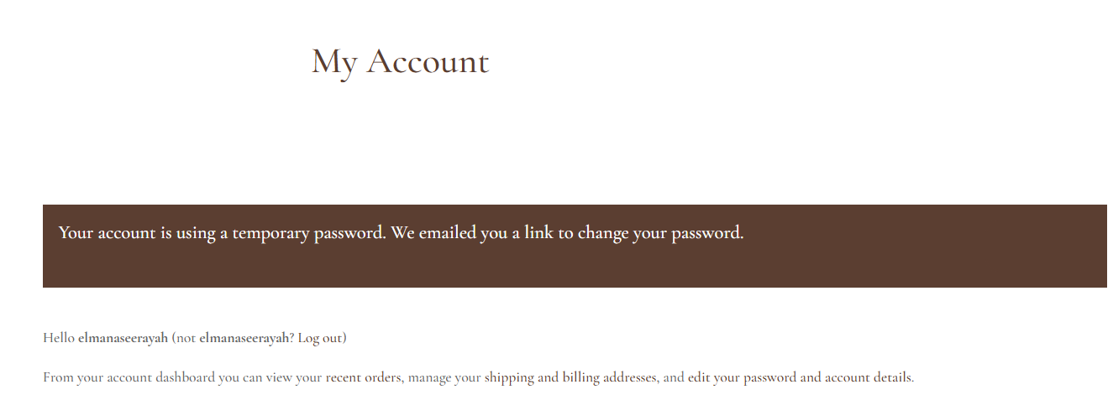
This multi-channel strategy will likely increase access to customers. However, maintaining traditional storefronts is resource intensive with respect to both operational costs and capital investment. Therefore, Luxury Chocolate employs a cost-effective hybrid model that includes a WooCommerce-based e-commerce website, as well as Facebook and Instagram social media platforms. In addition to these digital marketing tools, the company also utilizes order confirmation emails (transactional) and printed QR cards to connect the offline promotional efforts directly to the online retail site.

- Siwa:
- Business Model:
Siwa uses a B2C e-tailer business model for its web site is where all of their products (premium medjool dates, Belgian chocolates, gift items and special occasion products) are browsed by customers and purchased. Additionally, to customers purchases on the site, Siwa offers customizable corporate gifts that include organization logo which shows Siwa can offer to both consumers and businesses.
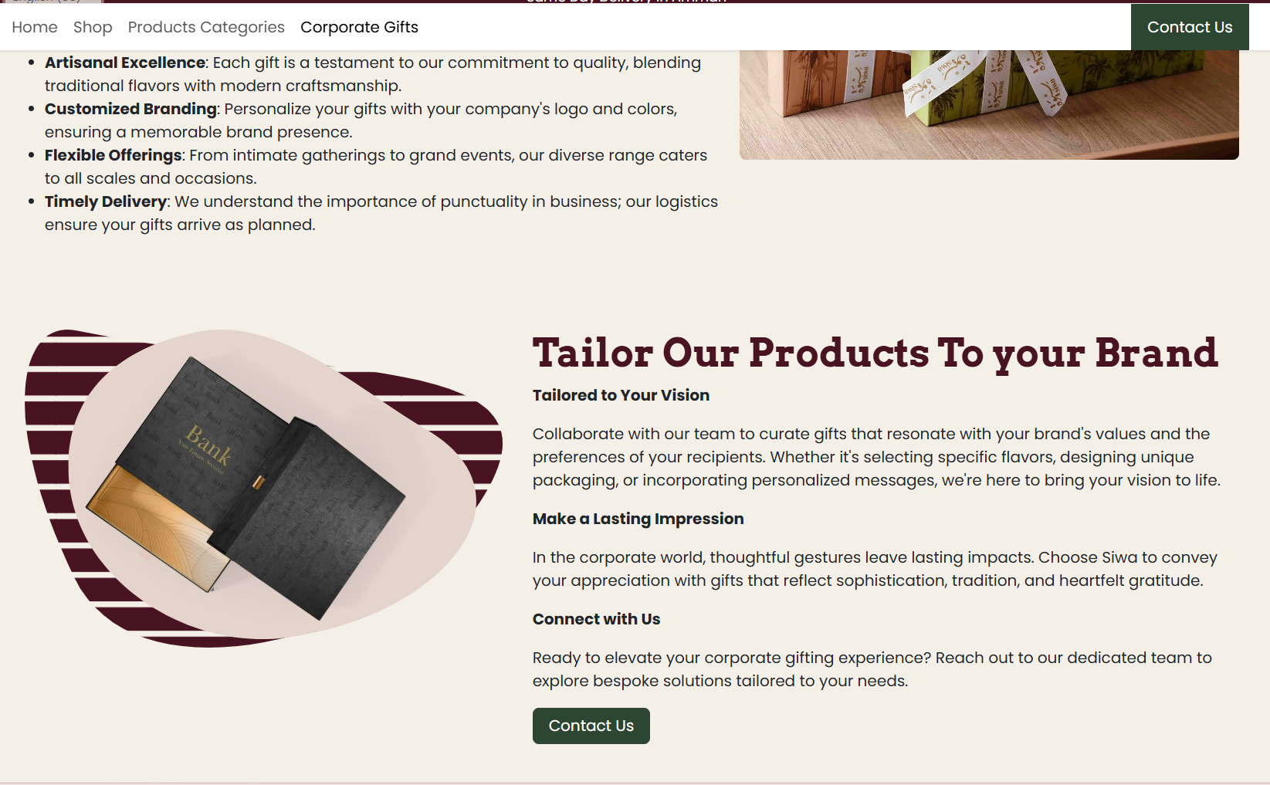
The Business Model is similar to the Luxury Chocolate model in this regard and also supports the use of Direct Online Sales for Premium Chocolates and Gifts. The Corporate Gift Service by Siwa has value in that it may allow for larger orders and serve a different target market. But Luxury Chocolate initially will focus primarily on taking individual consumer orders due to their smaller size and being easier for a small company to handle, however, customizable corporate gift boxes could be offered as an expansion of the custom gift service.
- Revenue Model:
Siwa's primary source of sales is through chocolate, dates, custom made boxes, gift assortment and corporate gift items. Customization allows for an order's total cost to be higher in comparison to standard orders since the customer will be charged for additional decorations, product options and gift features. So, it relies only on Sales revenue.
The Siwa store also has a location where customers may physically purchase productsو therefore the store is another sales channel for Siwa and does not represent a second (or different) way of a revenue model. An advantage of having this additional sales channel is that it will allow Siwa to potentially be able to sell its products to a wider range of people and build consumer confidence.
Upon conducting a review of Siwa's website, a product was shown with an original price of 18 JD, then was increased to 22 JD after selection of a paid option and finally was increased to 25 JD when delivery was selected. Although the charges may be legitimate, there is no clear indication on the site that the original amount (of 18 JD) is the base price. Automatic inclusion of a paid option during checkout could lead to an impression by some customers that they have been assessed an additional charge which could result in a higher abandonment rate at the cart.
Luxury Chocolate uses product sales as well, however, this strategy will attempt to show the product price, selected customization, delivery cost, and the overall amount of the customer's order on one screen. The goal is for this method to support the goals of a transparent price structure, building consumer confidence in the business, and successfully completing an online purchase.

- Marketing Channels:
Siwa's content includes visually appealing product photos, seasonal collections based on special occasions (Ramadan, Eid), as well as its website, blog, Facebook page, contact info, and Google Maps location. All this content links the products to occasions such as weddings, graduation, and corporate gifting.
The reason for this method being successful is that chocolate and gifts are largely purchased due to their visual appeal and in connection to an event and occasion. Also, the blog provides additional content to help consumers find products through searching on the site.
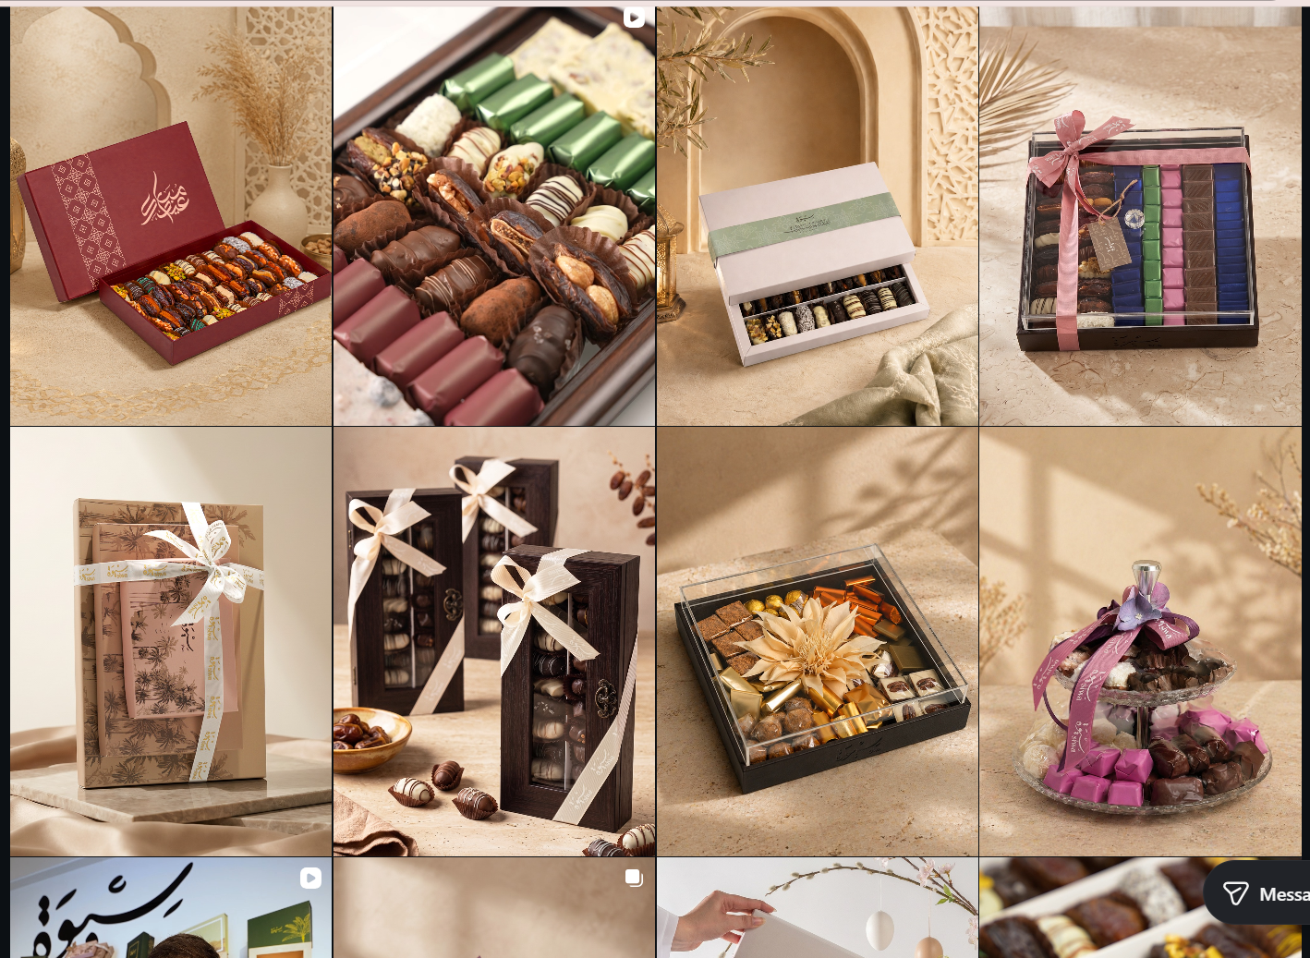
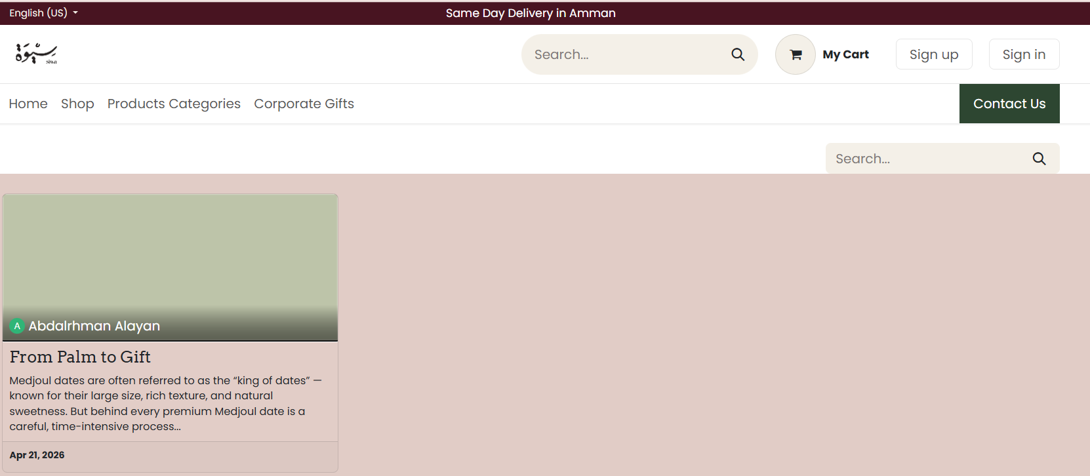
Luxury Chocolate has similar use of social media platforms like Facebook and Instagram but in addition to posting photos and short video clips, it also posts customized designs as well as seasonal offers.
Luxury Chocolate website can replicate Siwa's blogging on its website through creating content that is related to flavors of chocolate, how to choose gifts, customized options, how to take care of products, and other special events like Ramadan, Eid, weddings, and graduation celebrations. In addition to helping increase the company's visibility in search engines, this type of blog content will help drive potential customers who are looking for gift ideas directly to the relevant product page. However, it is essential that the blog content is updated frequently, since posting old or subpar information will have little additional benefit. Consequently, if the company can create a focused blog that has useful seasonal content, it may lead to increased traffic at the company's website, customer confidence in purchasing from the company online, and ultimately higher online sales.

- Online Presence:
Siwa's overall presence is made up of several things, their website (for ordering), Facebook page, blog posts, contact info and their actual store locations. Their website offers product browsing options, price views, customization options for gift items, and an option for placing online orders. There was no way to find to send an email through Siwa’s site as part of this evaluation. When attempting to complete the sign-up process on Siwa’s website, I encountered problems with getting into my new account. A technical issue that prevents consumers from being able to use their accounts and other related services can be frustrating and make it difficult for a consumer to access his/her past orders, account communications and so forth.
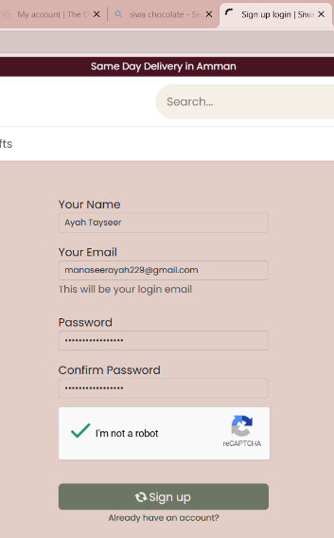
Luxury chocolate offers a much more personal shopping experience via its own WooCommerce site where customers can register on their site and send emails and receive order detailed emails. As such, luxury chocolates post purchase communications with clients are in place and are far better than many of their competitors, however, as with all things online, this will need to be checked regularly to ensure that these features remain functioning properly.

- Craves Jordan:
- Business Model:
Craves Jordan is using a B2C e-tailer business model by operating from a Shopify site where it offers handmade chocolates, chocolate-dipped Medjool Dates, Freeze-Dried Products, Gift Boxes and Gift Cards. The Jordan and Saudi Arabia in the Region Selector shows Craves Jordan is taking a regional approach. Expanding regionally would allow for access to many new potential customers, however this will require proper packaging for luxury items (chocolate), reliable delivery, up-to-date currency information, and well-defined boundaries or areas of service.
Based on its current delivery capabilities, Luxury Chocolate has chosen to pursue a much narrower focus as their first market. Using a "smaller geographic area" will limit the business's ability to expand rapidly, however it limits the company's exposure when providing customer service with a larger geographic footprint than they are able to support at this time.
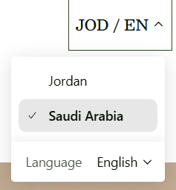
- Revenue Model:
Craves Jordan primarily earns revenue through the sale of chocolate, date, treat, and gift items. Additionally, the company has begun selling gift cards on the site which offers customers another option for earning revenue. Gift cards offer customers an opportunity to make a payment at a time that they may prefer but allows the gift card purchaser's designated individual to select a preferred item.
Luxury Chocolate currently utilizes direct product sales and limited advertising as their primary source of income for two reasons. Firstly, both methods will provide them with an easy opportunity to market their current products and web site. Secondly, gift cards can be considered a viable option in the future when they have increased their product line and established a repeat customer base. Because Gift Card will increase special occasion sales and the revenue in advance of choosing the last product. The firm will be able to contend with unused vouchers, vouchers that expire.
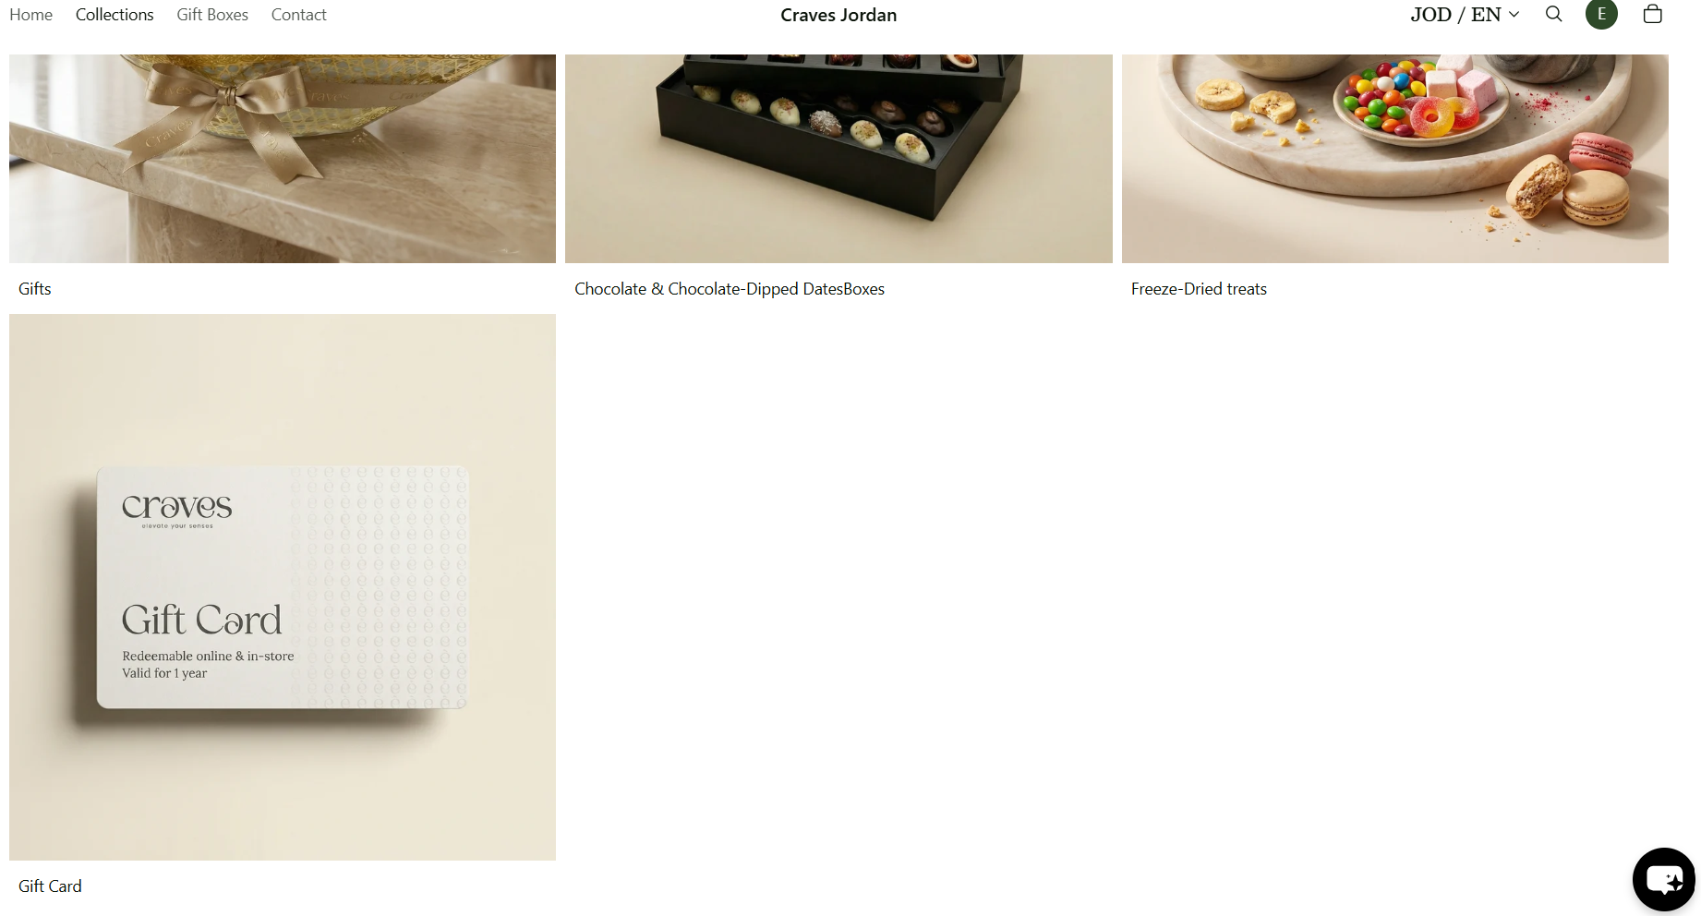
- Marketing Channels:
Craves Jordan has used the majority of their digital marketing strategies through their main platform of their website, product collection pages, how visually presented items are, and messaging on the site such as "Handmade in Amman" and " Same day delivery is available." The message conveys that the products are locally produced and delivered quickly. However, while I evaluated the site it looked very basic with minimal content for marketing purposes. There wasn't an easy-to-locate About Us page to describe what the company is about, the company's location wasn't clearly visible on the home page either, nor were there promotional sliders or pop-up windows to promote new arrivals, seasonal collections, or promotions. All of these shortcomings could lead to less customer confidence and have made it more challenging for the company to draw attention to the most valuable or important products. Additionally, they did not reference the ability to ship to Saudi Arabia.
Luxury Chocolate is able to create a more promotional experience on their website by using features such as a home page slide that showcases their product line and seasonal promotions, an About Us page, easy to access Contact information, Facebook and Instagram posting, Transactional email communications. Also, we focused on new arrival products and Sales or Coupons.
- Online Presence:
Craves Jordan’s use of online presence is primarily based around a Shopify website that can be accessed via either desktop or mobile devices. This website includes many aspects such as, Product Collections, Online Checkout Functionality, Customer Accounts, Gift Cards, Policies, Region and Language Options. Unfortunately, there are no signs of an integrated Email Presence (that has been used) or Offline Presence from the review. As a result, it would appear that Craves Jordan's online presence is largely dependent upon their website alone and does not provide multiple points of contact for the customer. Also, it uses Social precense in Instagram and Facebook.
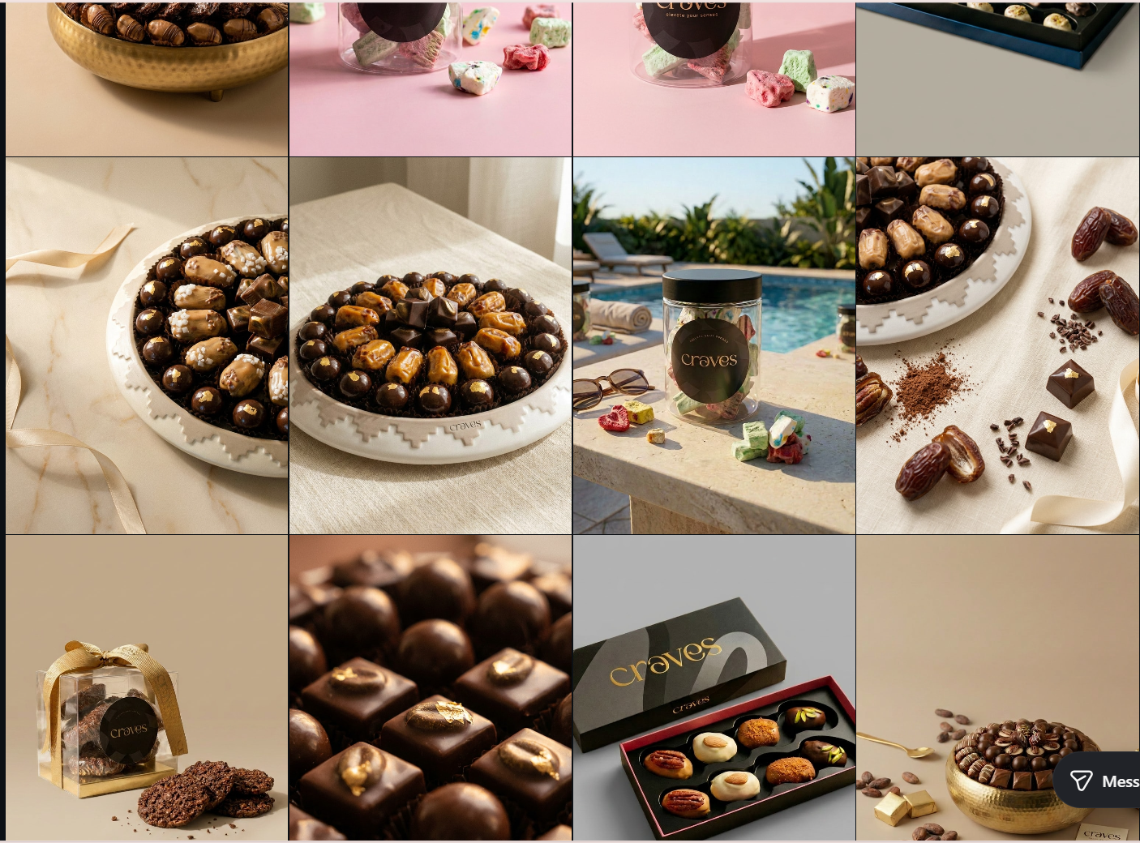

Evaluating the Selected Luxury Chocolate Strategy:
The competitor assessment illustrates that there are various valuable practices that each alternative can demonstrate. For example, Delights Shop represents the benefits of being a hybrid (both in-store & online) retailer. Additionally, as a brand with high-end quality visual products, Siwa presents the importance of having customized items, and giving away company gifts. In addition to this, Craves Jordan presents the opportunities for developing the brand through localized retailing, as well as gift card programs.
Like The Delights Shop's previous review requests, Luxury Chocolate intends to ask for customer reviews immediately upon completion of a purchase. In direct response to Siwa's Pricing Presentation, Luxury Chocolate plans on clearly displaying various product options available, all additional costs, all applicable delivery fees, the total cost of the selected products prior to the customer placing their order. In direct response to the issue of inconsistent information presented by Craves Jordan as related to the regional selectors and delivery availability, Luxury Chocolate will present the delivery coverage based upon the service that Luxury Chocolate is able to presently offer.
Opening an e-commerce site will be a better option for this business in terms of cost (it has lower operational costs than opening store), provides more control over how they interact with potential customers through the website, as well as allows for more direct contact with consumers throughout the buying process. Corporate gift giving, gift cards, or reginal delivery service may also become options at some point in the future based upon consumer requests and resources that are available.
In general, the proposed strategy aligns with business objectives by creating a balance between cost, customer experience, brand reputation, trust, sales, and true growth. It draws on insights from the three competing websites to adopt effective practices while avoiding the limitations identified during their evaluation.

Part 3:

Evaluating the selected theme:
Luxury chocolate chose astra due to its compatibility with Elementor, WooCommerce, and the fact that astra can create responsive layouts for all device types (desktops, tablets & smartphones). Astra provides the ability to change color scheme, typography, headers/footers/menu items/page layout's as well as add various functions (sliders for promotions, live chat, customer reviews, product customization options, e-mail functionality, ads) via plugins.
In addition to this, however, Astra's standard layout was too generic and therefore could not create an independent look that would differentiate it from other sites as a luxury chocolate site. In addition, some of the more advanced Astra design features may require Elementor or other plugins. This would increase both the amount of time to set up, test and maintain your new website.

Evaluating the Logo and the Slogan:
The Luxury Chocolate business already had its own logo, so I kept and used the original elegant gold design to maintain the existing brand identity and premium image.
The business also already had its own slogan, so I used the existing slogan on the website to keep the branding consistent.
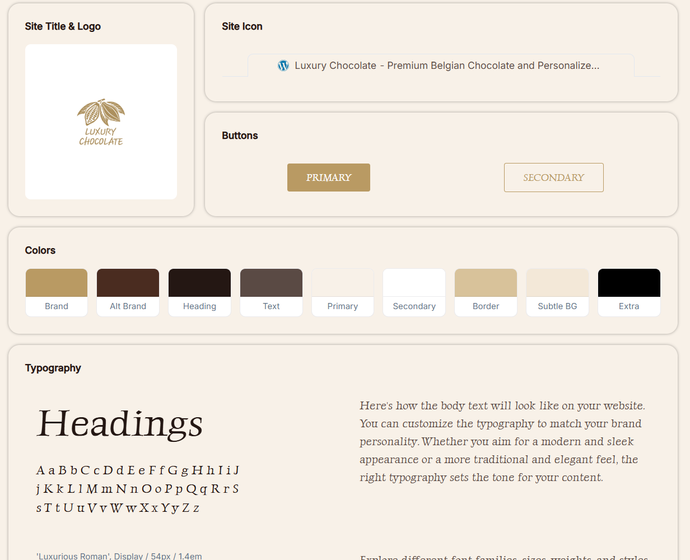

Justify the purpose of the selected plugins:
- Starter Templates: These predesigned templates were used as a starting point for developing the website. Once the template was incorporated into Luxury Chocolates’ website, it could be customized to reflect Luxury Chocolates' branding, merchandise and online shopping needs.
- Smart Slider 3: This is used on the home page to generate the promotional sliders. Smart Slider 3 will allow Luxury Chocolates to show its customers seasonal promotions, customer-specified products and feature collections in a visually appealing way which can also be viewed by mobile devices.
- AddOnBoss – Product Options & Personalization: Provided additional custom fields for products and personalization that cannot be achieved with standard WooCommerce. Allows customers to make name requests, decoration requests, packaging requests or other types of gift box customization.
- Sirv: To optimize (image) and allow users to interact with their product media in a way that is responsive to how they view it on their device. Responsive images are used as well as zoom capabilities and 360-degree product views.
- Tawk.to Live Chat: Adds real-time customer support. Customers can get answers to questions regarding products, personalization, payment, and shipping prior to completing their purchase.
- Forminator: Forminator provides customized forms using a drag-and-drop form builder. Custom forms allow customers to communicate with you beyond what is included in the standard WooCommerce features such as making inquiries and providing feedback.
- UpdraftPlus: UpdraftPlus creates back-ups of the site's database, plugins, theme, and uploaded files. Reduces loss of data from errors or failed updates to the site.
- Stick My Header for Astra / Sticky Header Effects for Elementor: Made sure that customers could still see important elements like category pages, the cart, contact information and their own accounts as they scrolled down the page.
- FluentSMTP: Fluent SMTP connects WordPress and WooCommerce to a trusted, third-party email sending service. An alternative was chosen because it will help improve the delivery of account creation emails, password reset emails, and order related emails.

Configure appropriate WordPress user roles and permissions
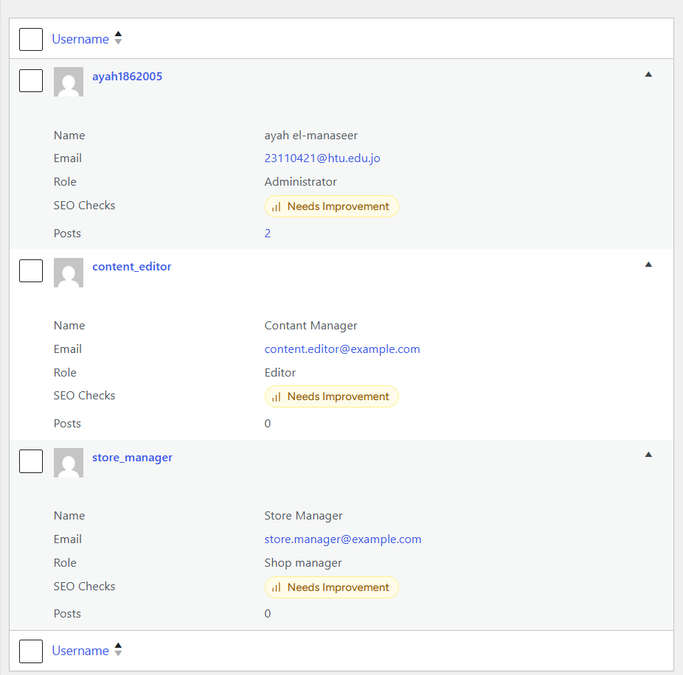

Content Editor:
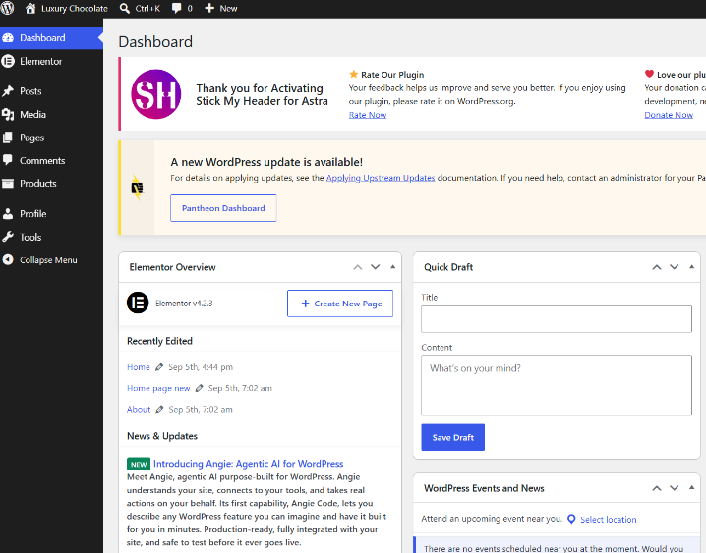
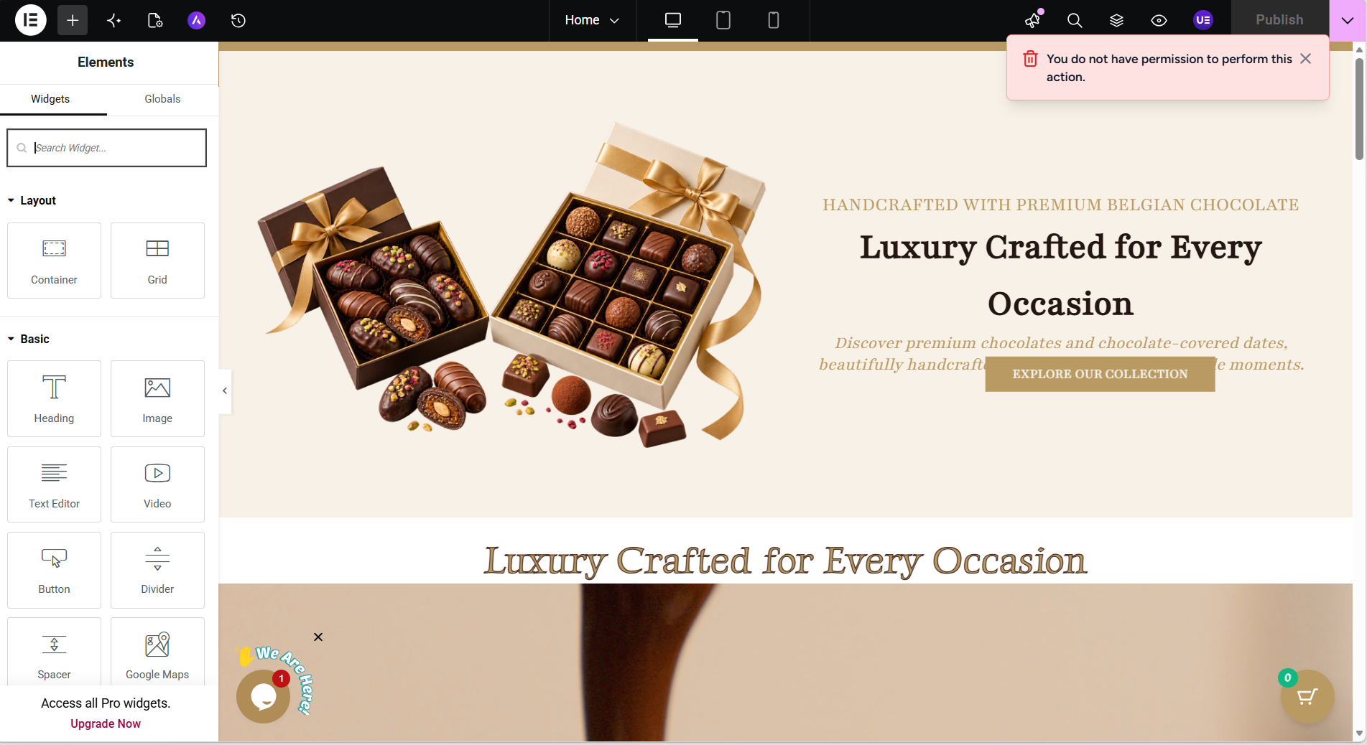

Store Manager:
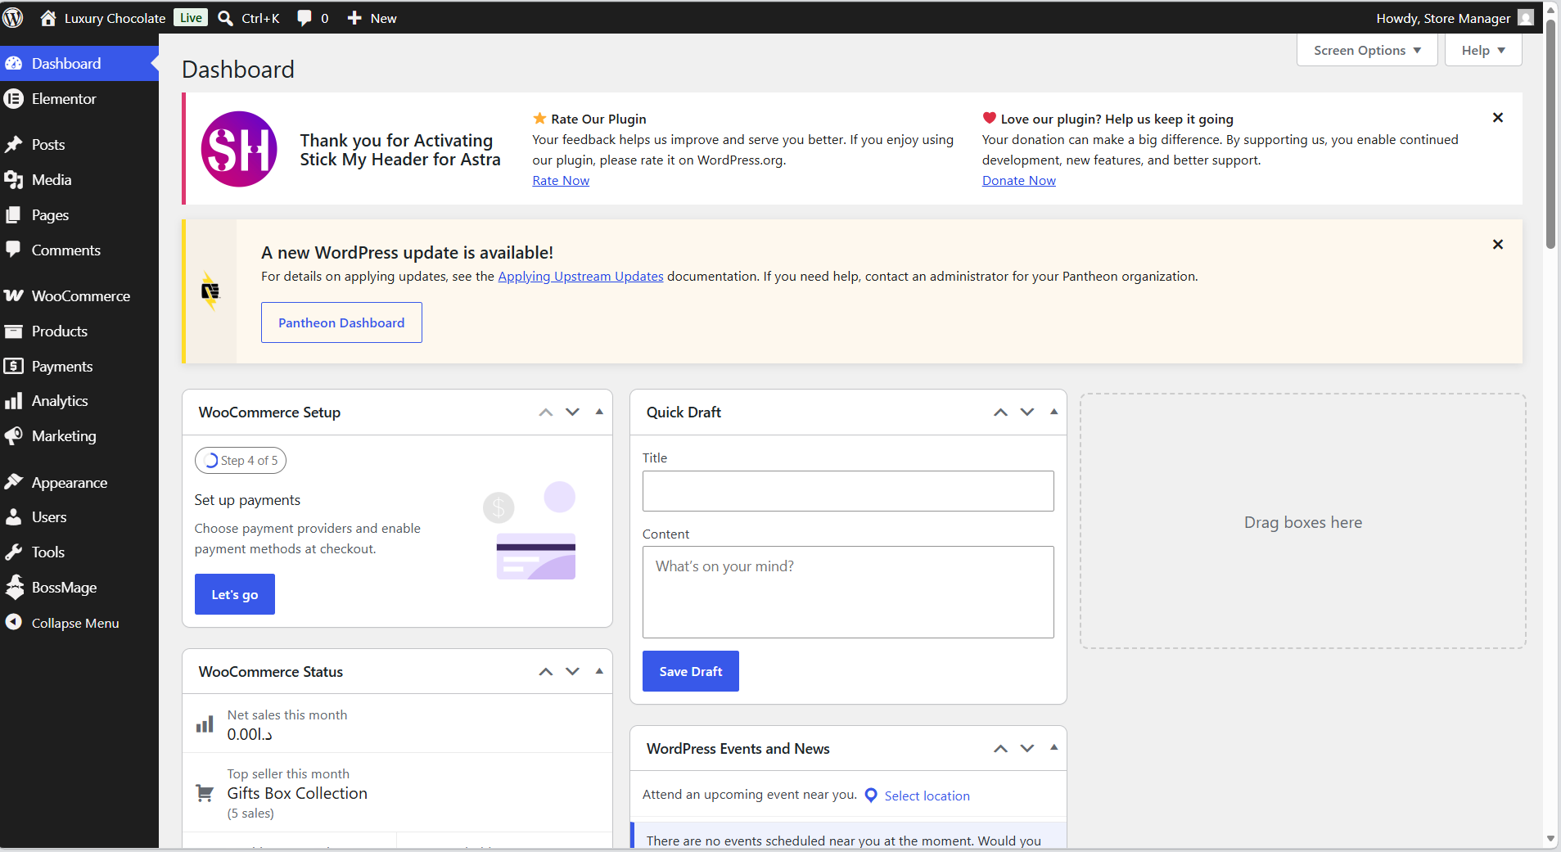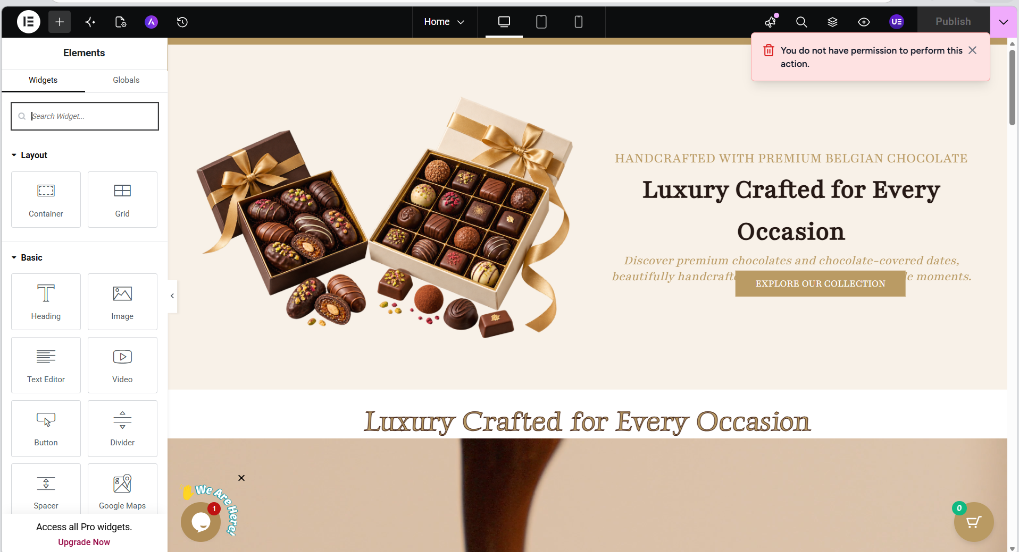

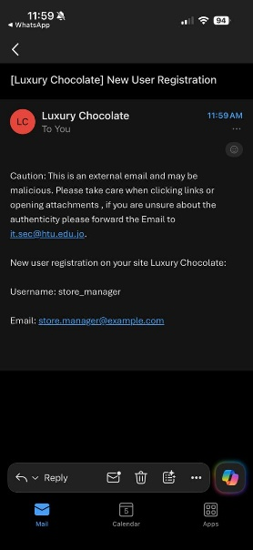
After the admin created these users, the admin reserved an email that shows a user was created:
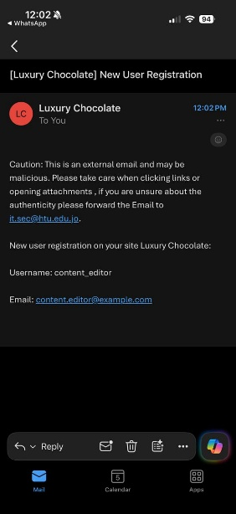

Review of the techniques used for improving the e-commerce website ranking in search engines:
To improve the search engine rank of Luxury Chocolate's Ecommerce website through application of a variety of Search Engine Optimization (SEO) methods utilizing Sure Rank SEO, as well as to ensure that the search engine has an easy time crawling & understanding the site so it can be displayed in relevant search results.
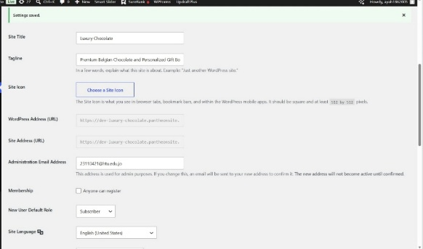
- Optimizing Luxury Chocolate Website Title & Tagline: A clear website title is needed in order to tell search engines what your site is about (luxury chocolate) while a tagline describes the main product or service you are offering in this case, a tagline that lists all items sold on the site premium Belgian chocolates, and customized gift boxes. Having a clearly worded title and tagline will help search engines know exactly what your site has to do with specific searches by consumers searching for terms like "luxury chocolate".

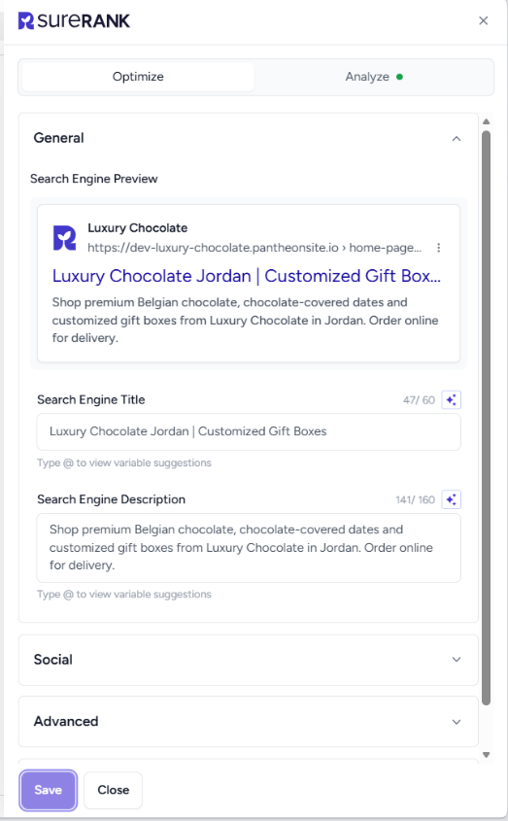
- Optimizing the Website's Search Engine Title and Meta Description: The Search Engine Title was configured as follows:
Luxury Chocolate Jordan | Customized Gift Boxes
The Search Engine Description was configured as follows: Shop premium Belgian chocolate, chocolate-covered dates and customized gift boxes from Luxury Chocolate in Jordan. Order online for delivery.
It is an important technique to use a descriptive title and description as they may be shown in search engine results. The descriptions provide clear information about the website including some keywords that are related to the site (like Luxury Chocolate Jordan, Belgian chocolate, and customized gift boxes).

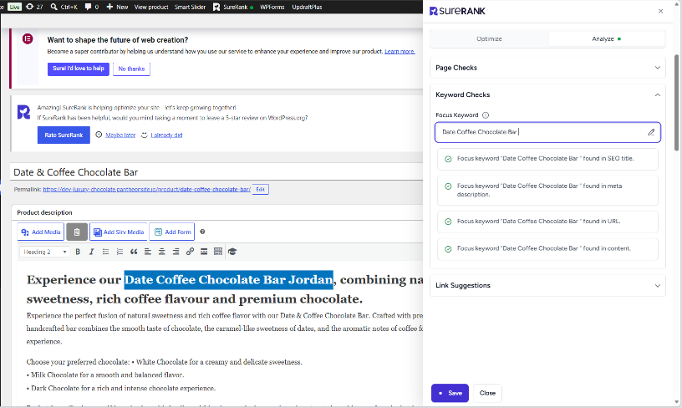
- Using the relevant keywords that is related to the products: For example, "customized gift box" has several keywords that are used within it. In fact, the product also uses some of these same words in its title and in other parts of the description: Chocolate Box. These have been added into the product description because they are a legitimate piece of product information, and not simply repeated. Thus, this increases the likelihood that your products will appear on search results when someone is searching online for a chocolate gift in Jordan.
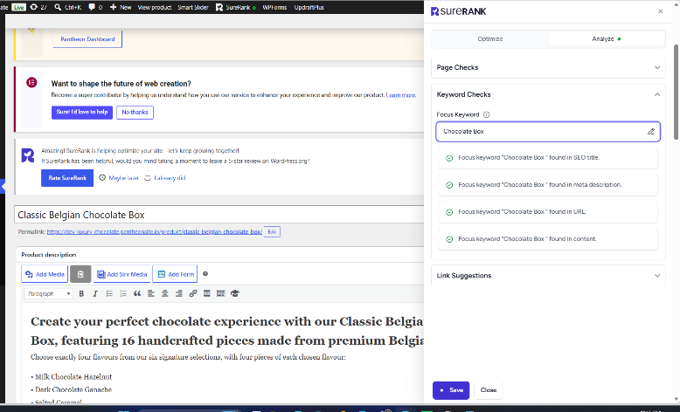
- Using Heading Structure: The home page uses an appropriate hierarchical structure (heading levels) as indicated by the SureRank SEO Audit. A proper heading hierarchy provides a way to help search engines know what the primary subject of your page is as well as how they relate to each other. Additionally, it makes it easier for visitors to read through the content on your web site. The SureRank SEO Audit indicates that the Home Page has: One H1 Heading, At Least One H2 Heading.
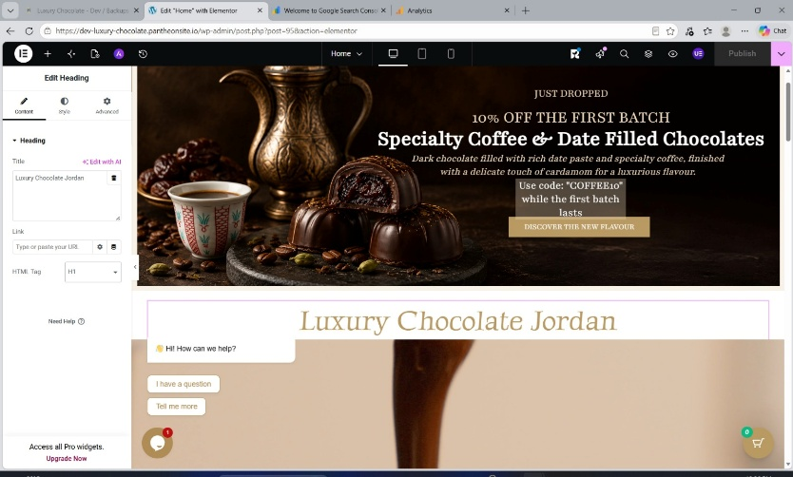

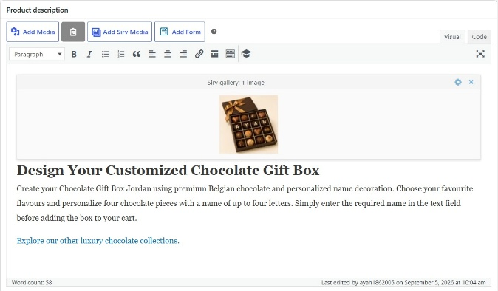
- Adding A heading and Internal URL to each product: each product’s description should have: One H1 Heading, And one Internal link. SureRank included internal links in the design of the website for navigation from one page or product collection to another page. An example is the "Explore our other luxury chocolate collections" on each of the products (product descriptions). By including internal linking on your website, you allow both your users customers to easily move around your website and also inform search engines about how they relate to each other.

- Product Optimization Pages: In addition to analyzing SureRank for overall website performance it was also utilized to evaluate individual WooCommerce products. In the product listing display (Product List), there is a "SEO Checks" column which will indicate if the product is either Optimized or Needs Improvement.
As an example, the Date & Coffee Chocolate Bar was listed in the optimized category, but others needed additional work on their descriptions, titles, headings, links and other SEO-related items so that they could be improved.
It was beneficial for this type of analysis because it would allow you to apply SEO related enhancements on a page-by-page basis as opposed to simply working to optimize your home page.
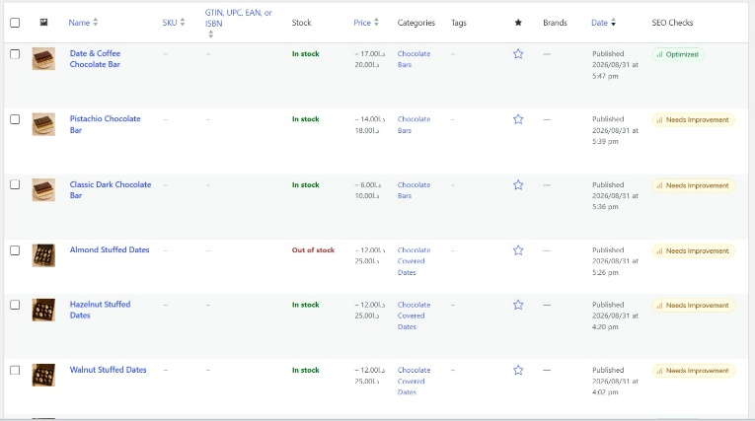
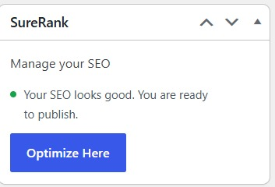
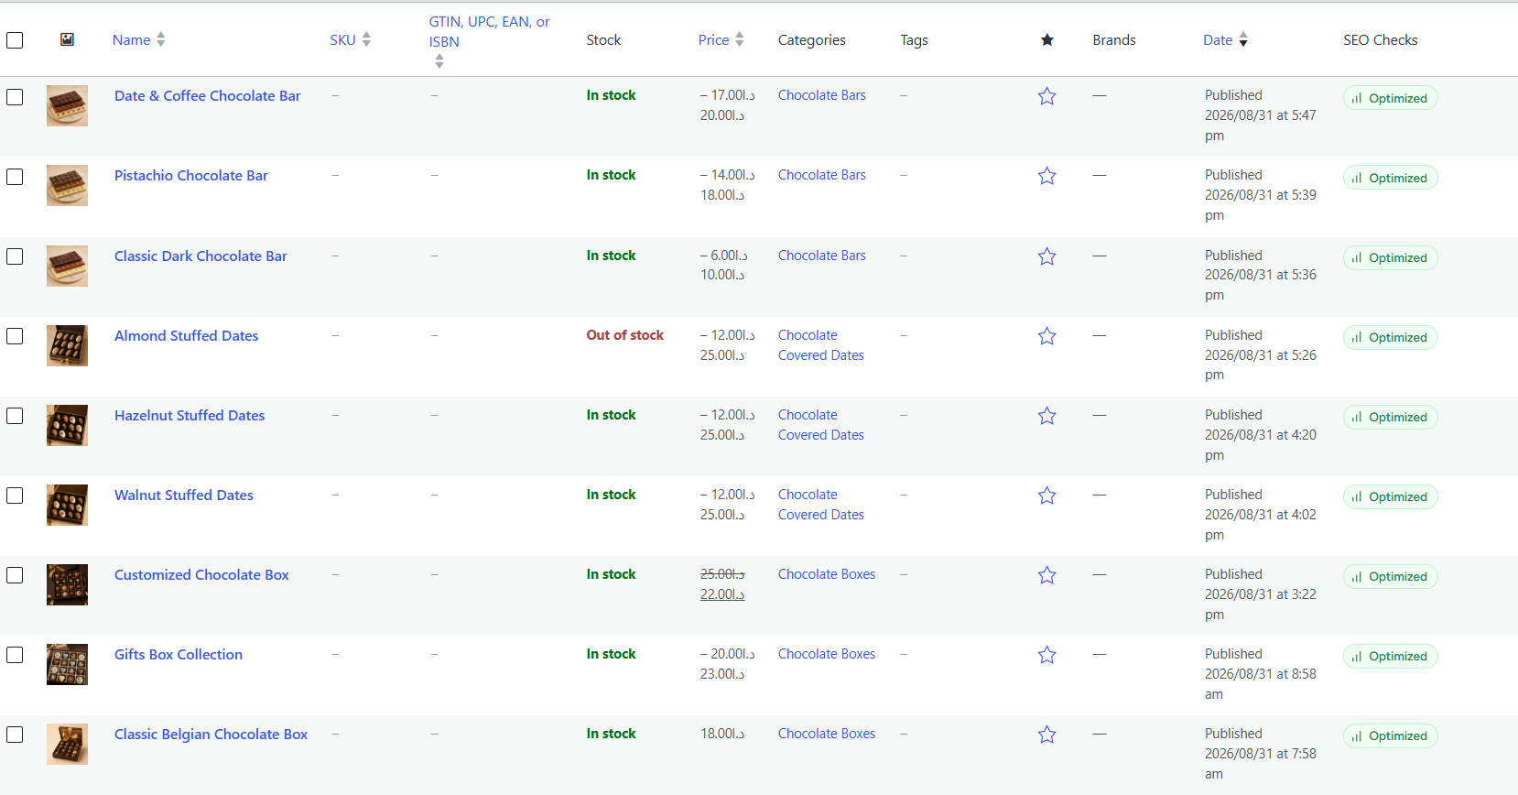

Review and Evaluation: Overall, SureRank was useful for improving both on page SEO and technical SEO on the Luxury Chocolate website. The audit confirmed successful implementation of several important techniques, including optimized titles and descriptions, heading structure, image alt text, internal links, canonical URLs, structured data, HTTPS, Open Graph tags, and an accessible XML sitemap.
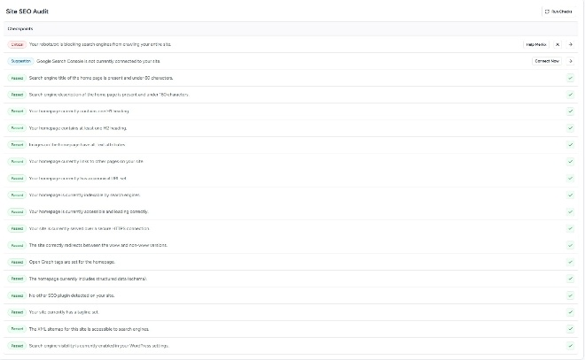
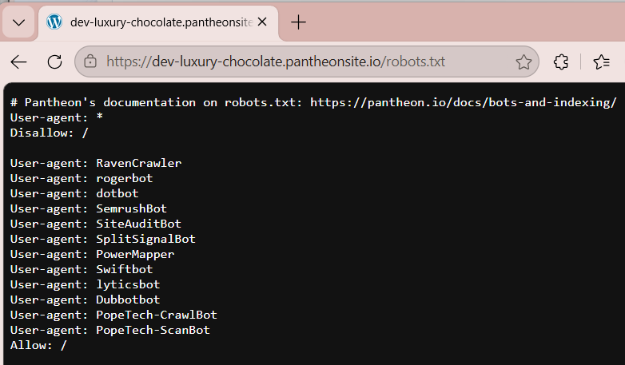
However, the Site SEO Audit also identified two important areas that still require attention. First, it reported that the site's robots.txt blocks search engines from crawling the entire site, which could seriously affect visibility in search results. This is caused by Panthion because we need to have a domain. Second, Google Search Console is not currently connected. Therefore, before the final public launch, the robots.txt configuration should be corrected and Google Search Console should be connected so that indexing and search performance can be monitored. Therefore, the SEO techniques implemented have created a strong foundation for improving the Luxury Chocolate website's search but continuous.

An analysis of the best practices:
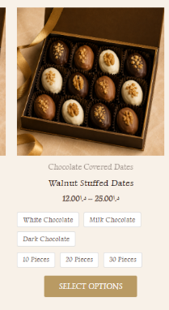
- Product detail page:
- Feature Image: The use of a primary Feature image for every product at the Top of the product page.
- Title and overview: Displaying the product name, pricing, key information, available options and purchasing control in an easy-to-view format at the top of the product details page.

This picture is related to the 2 practices behind

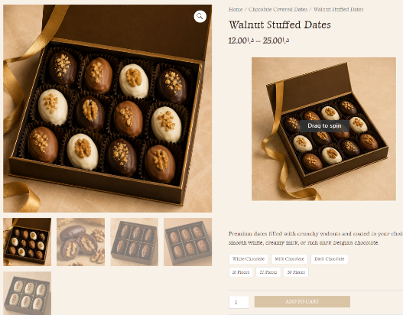
- Use big and clear image: The use of large, clear images is used to display them on the product details pages so they can be seen prior to purchase and a 360 image.
- Gallery of product photos: The use of product photo galleries or additional product images (product media) are provided to show customers many different views of the product.
- Add prominent call to action: Clear Buttons, like "Add to Cart" and "Select Options", provide clear calls to action to encourage customers to make their next step easier also, when we hover over the image, we can add the product immediately.

This picture is related to the 3 behind

- Create urgency: Limited time promotion messages and offers create a sense of urgency ( "while the first batch lasts") displayed on the Homepage.

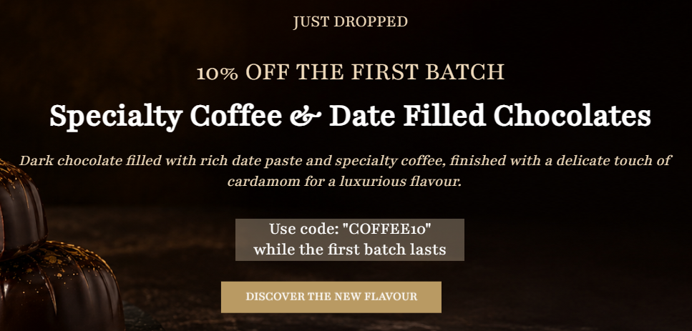
- Compare Prices: Customers can see how much they save by seeing the discount in relation to the regular price for each of our discounted items.
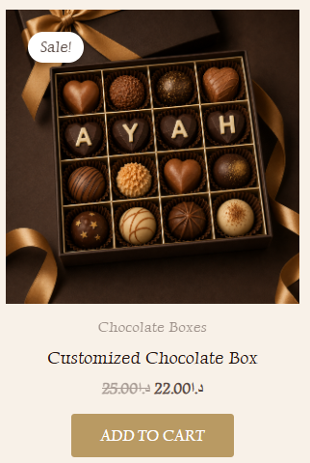
- Write Crisp And Informative Product Descriptions: Clear descriptions are used for all products as a way to provide customers with an understanding of what they’re purchasing, types of chocolates, fillings, size and any customizations available etc.
- Help Users Explore and Purchase Related Products: Allowing users to easily purchase additional products or "related" products from your site is easy when you use product links and recommendations that take them directly to similar products.
This picture for the previous 2 practices
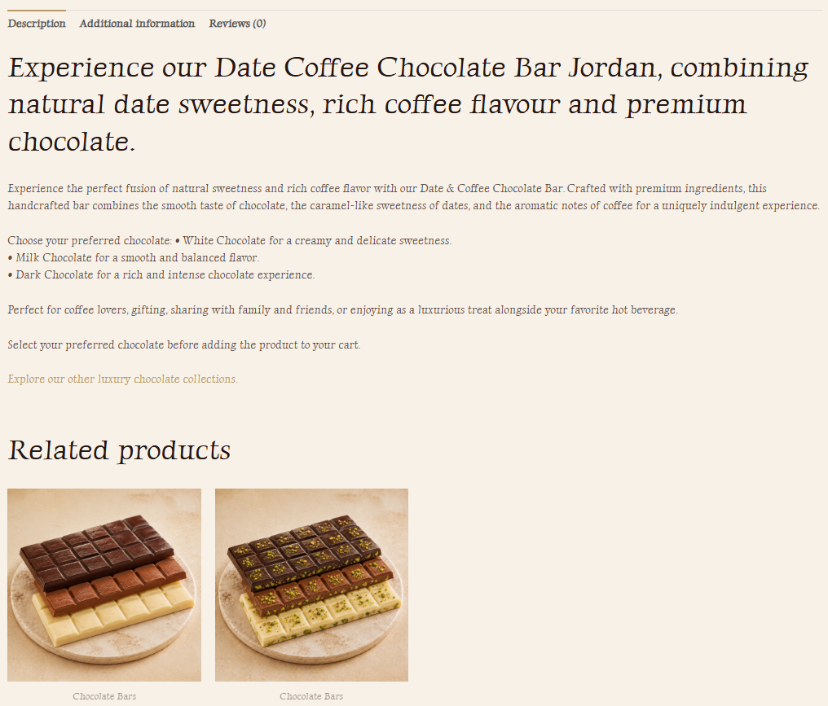
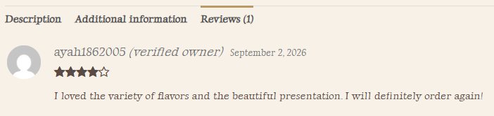
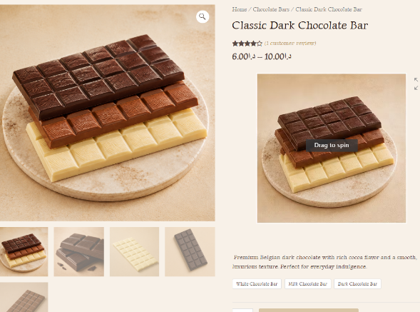
- Reviews and ratings: Using user reviews and rating systems like stars allows customers to know if others liked the product.

- Shipping Information: I put the delivery information as a sticky bar at the top of the website on all pages
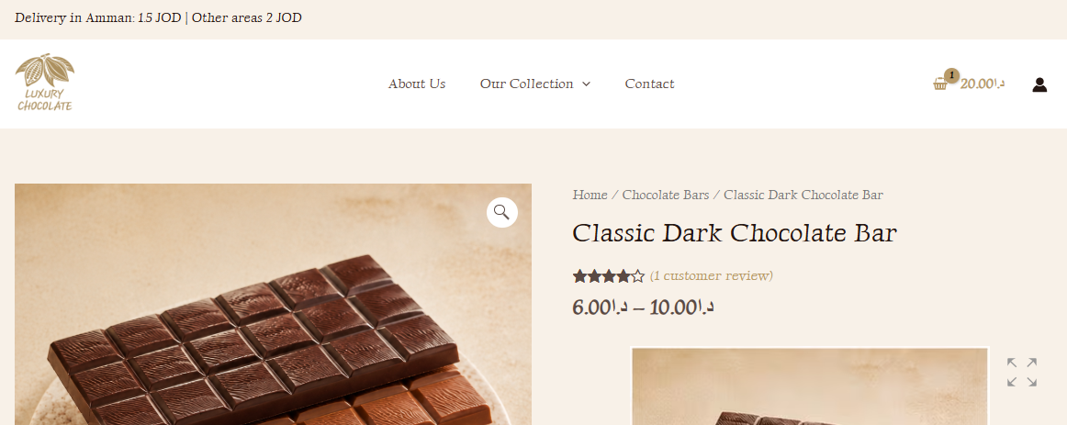
- Offer pricing in the local currency: Applying this by listing all product prices in Jordanian Dinars (JOD) as it aligns with your target audience of people who live in Jordan.
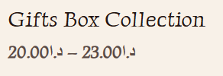
- Payment options that your users love: Provide customers with multiple payment options during the checkout process.
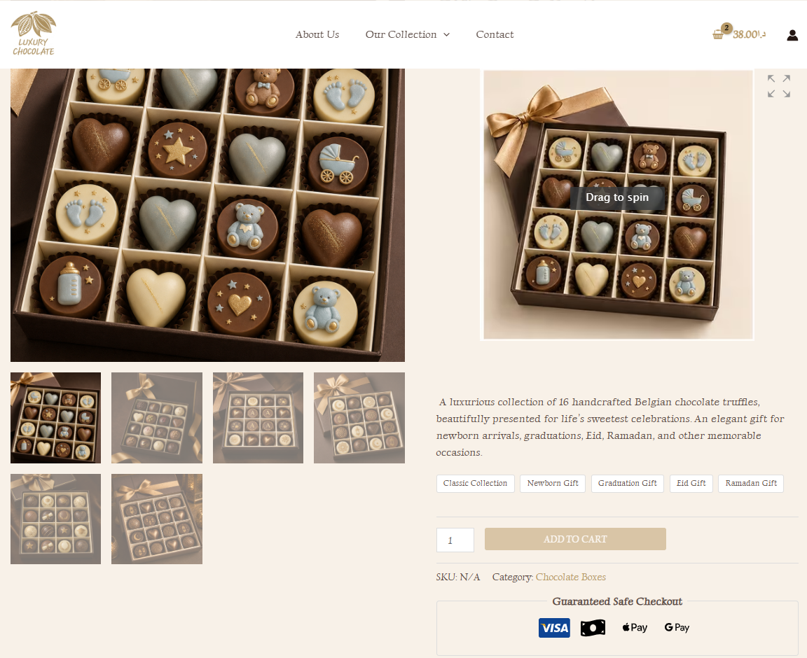
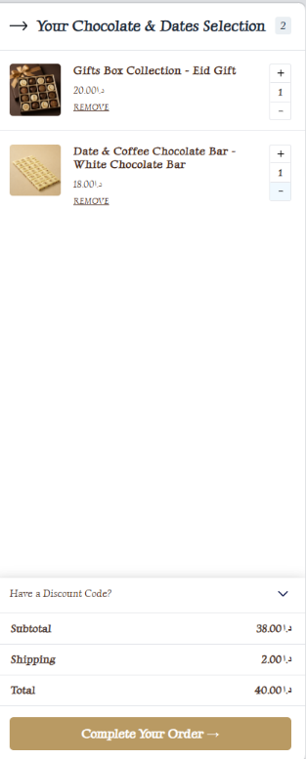
- Shopping Cart:
- Clear, user-friendly color code: A consistent and recognizable brand color palette has been used for all Luxury Chocolate features, with an emphasis on making your cart information and buttons easy to see.

- Convenient size and Resolution: Product thumbnail images are clearly shown in your cart to allow customers to quickly identify their items.

- Clearly show the price, quantity: The product price, selected quantity that are displayed throughout the shopping experience.

- Provide the ability to change the quantity of the product: Customers may increase/decrease quantities on the cart page to adjust the number of each product they would like to purchase.

- Provide the ability to remove a product from the shopping cart: Each item in the cart has the capability to remove it.

- Show the cart total on your shopping cart page: Used by clearly displaying subtotal and total before proceeding to check out.

- Design your cart for mobile-first conversions: Use a responsive design of your WooCommerce cart layout for desktops and mobile devices.
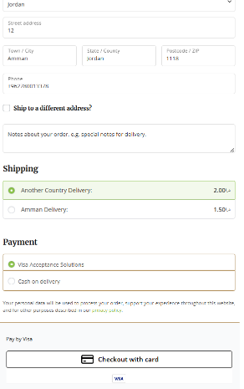
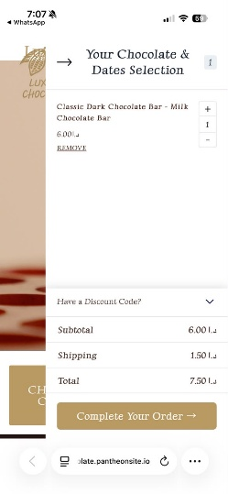
- Payment options that your users love: Provide customers with multiple payment options during the checkout process.
- Explicit and detailed information about shipping and returns: Clearly present delivery information on the site prior to purchase completion.
- Show Estimated Tax and Shipping Costs: This is applied at time of check-out, when users will see estimated shipping costs prior to completion of the purchase.

- Phone, chat or email assistance: Provide live support options through website contact and chat options for customers to request assistance.
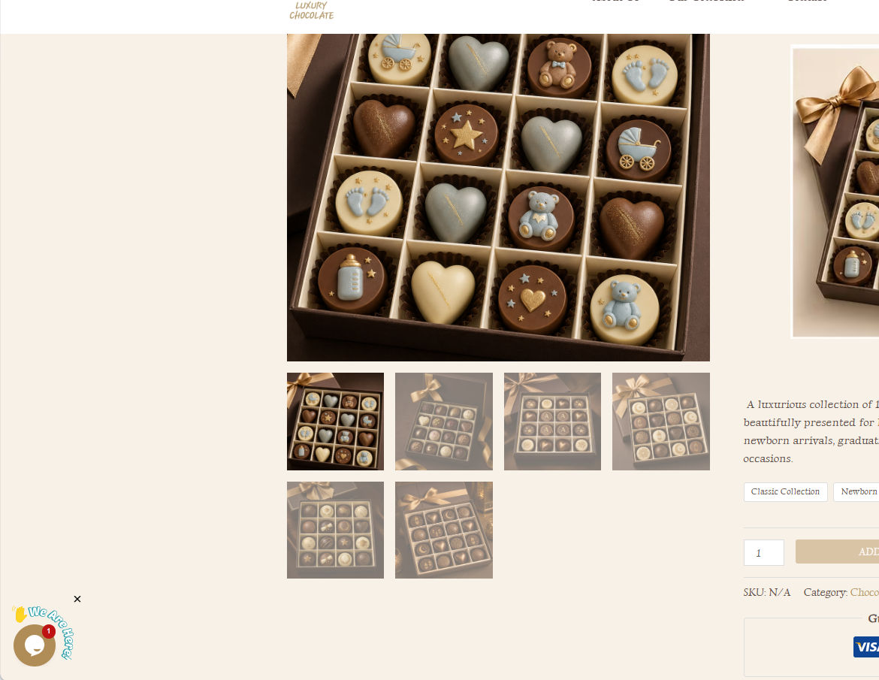

- Let your customers add as many items to the cart as they want. They will go to your checkout page when they are ready.

- Add a Mini Cart: A mini-shop cart available from the upper of each webpage allows the customer to view selected products at any time.

- Place the shopping cart icon in the upper right corner of all pages: Applied by adding a cart icon in top-right section of web-site header.

- Use the shopping cart icon to display the number of items in the cart: Applied by displaying number of added products next to or above the shopping cart icon.

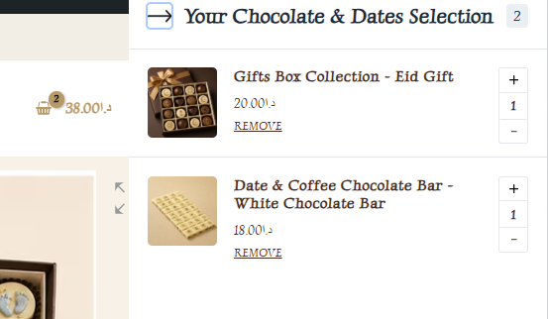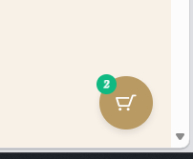

- Give Customers the Option to Complete Their Purchase as a Guest: Applied by giving guests the option to complete check out without having to create an account.
- Let Customers Review Their Cart Before They Log In: Applied so that users may be able to view their cart, and review it, without logging into the site.
- Provide a description about the added product on the Cart:
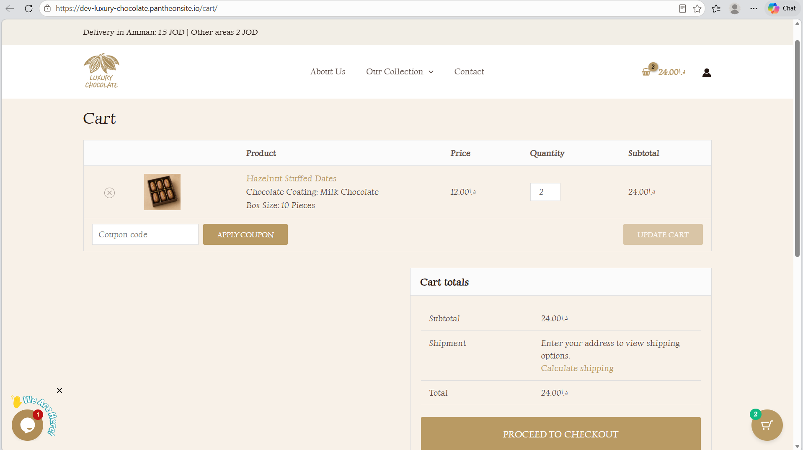
- Products page:
- Page Layout & Speed: Organized in a grid layout with all of your products displayed equally making it easy for consumers to browse
- Product Descriptions: Displayed by showing key product details like product name, product price, rating, and whether or not the item is available, along with purchasing options
- Sales & Savings: Displayed by pointing out sales and promotions so your customers will see what items are discounted.
- Calls to Action: Included via using buttons like add to cart, select options, shop now, and a Quick add when hover at the picture.
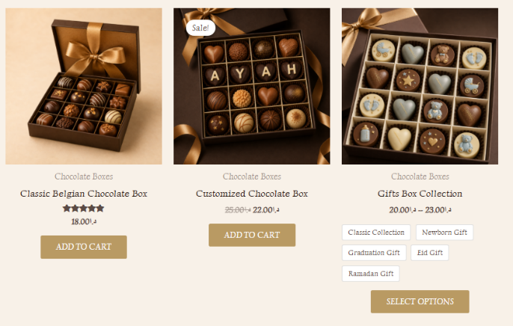
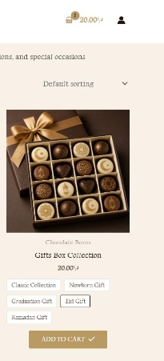Confirm when added to the cart

- Make filters prominent and sticky: The site utilizes the prominent filter section by creating obvious filters for pricing, categories, and availability. However, they do not currently stick when you scroll down.
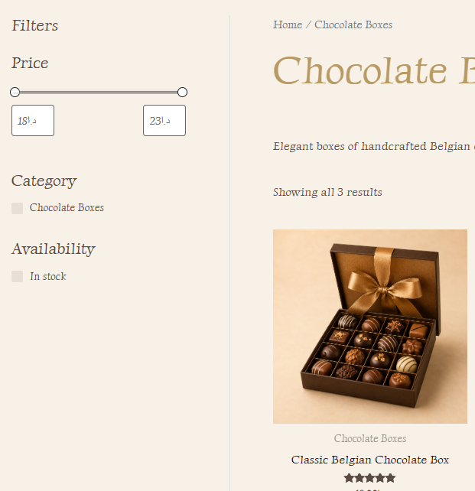
- Ease navigation between pages: Navigation from one part of the website to another is made simple with the website's navigation menu and product/category links.
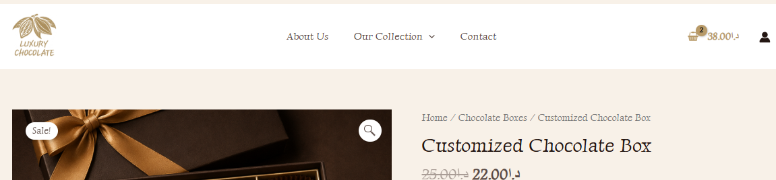
- Continue shopping button:
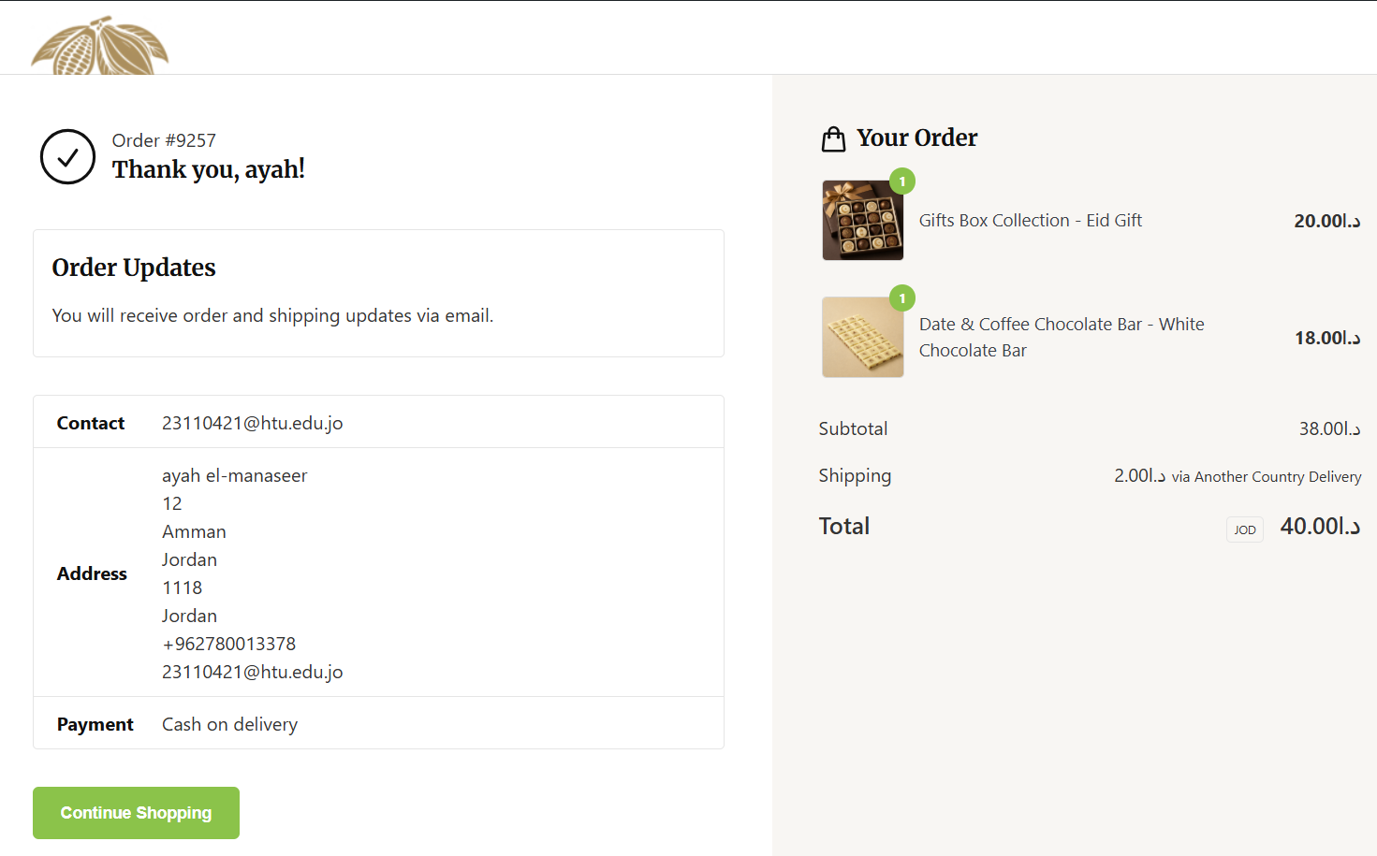

Testing:
- Hero Image (Slider):
Test Case | Expected Result | Actual Result | Status
Auto Scroll,  Slide Interval | The slider should move automatically between slides.  Slides should change after the configured time interval (6s). | 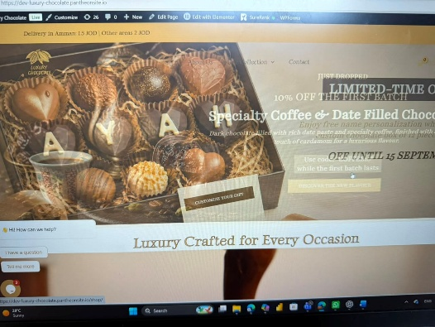 | Pass
Hover Behavior, Hover Interaction | Hovering over the slider should not cause an error and the slider should pause, The slider elements respond correctly when the mouse is placed over them. | 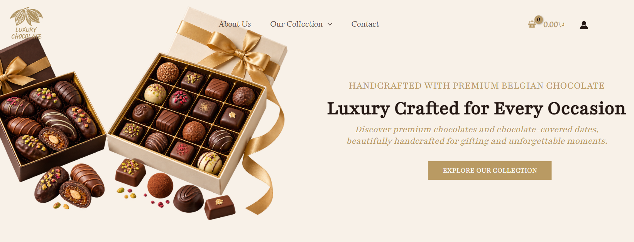  Before and After I put the mouse  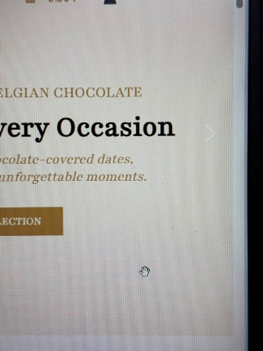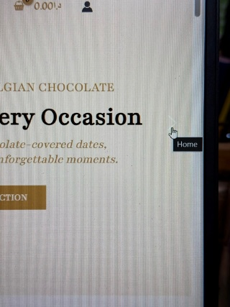 | Pass
Clickable CTA | Buttons or clickable elements on the slider should respond when clicked. | 1- Before hovering  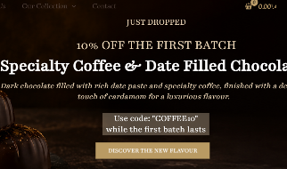  2-After hover on the button to click it  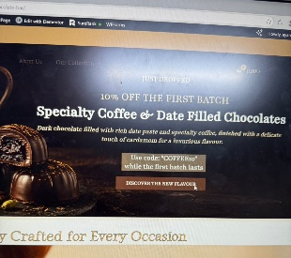 | Pass
Correct Destination | Clicking the CTA should lead to the correct product, collection, or offer page. | 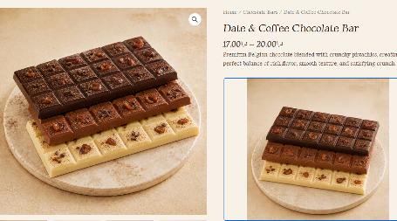 | Semi Pass- because it delays for 3s
Loading | The slider should load properly with the homepage without noticeably delaying the rest of the page. | 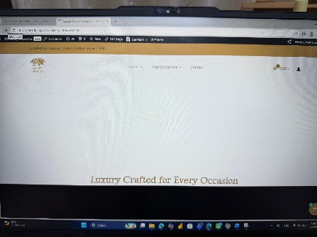  Delays for 3s only  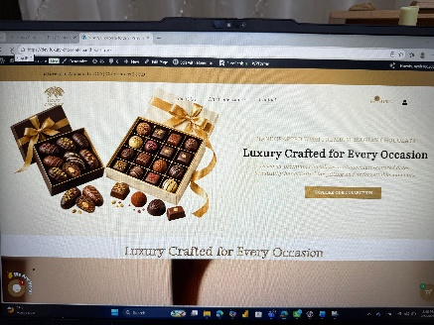
Rest of Page Content | Other homepage content should remain visible and accessible. | 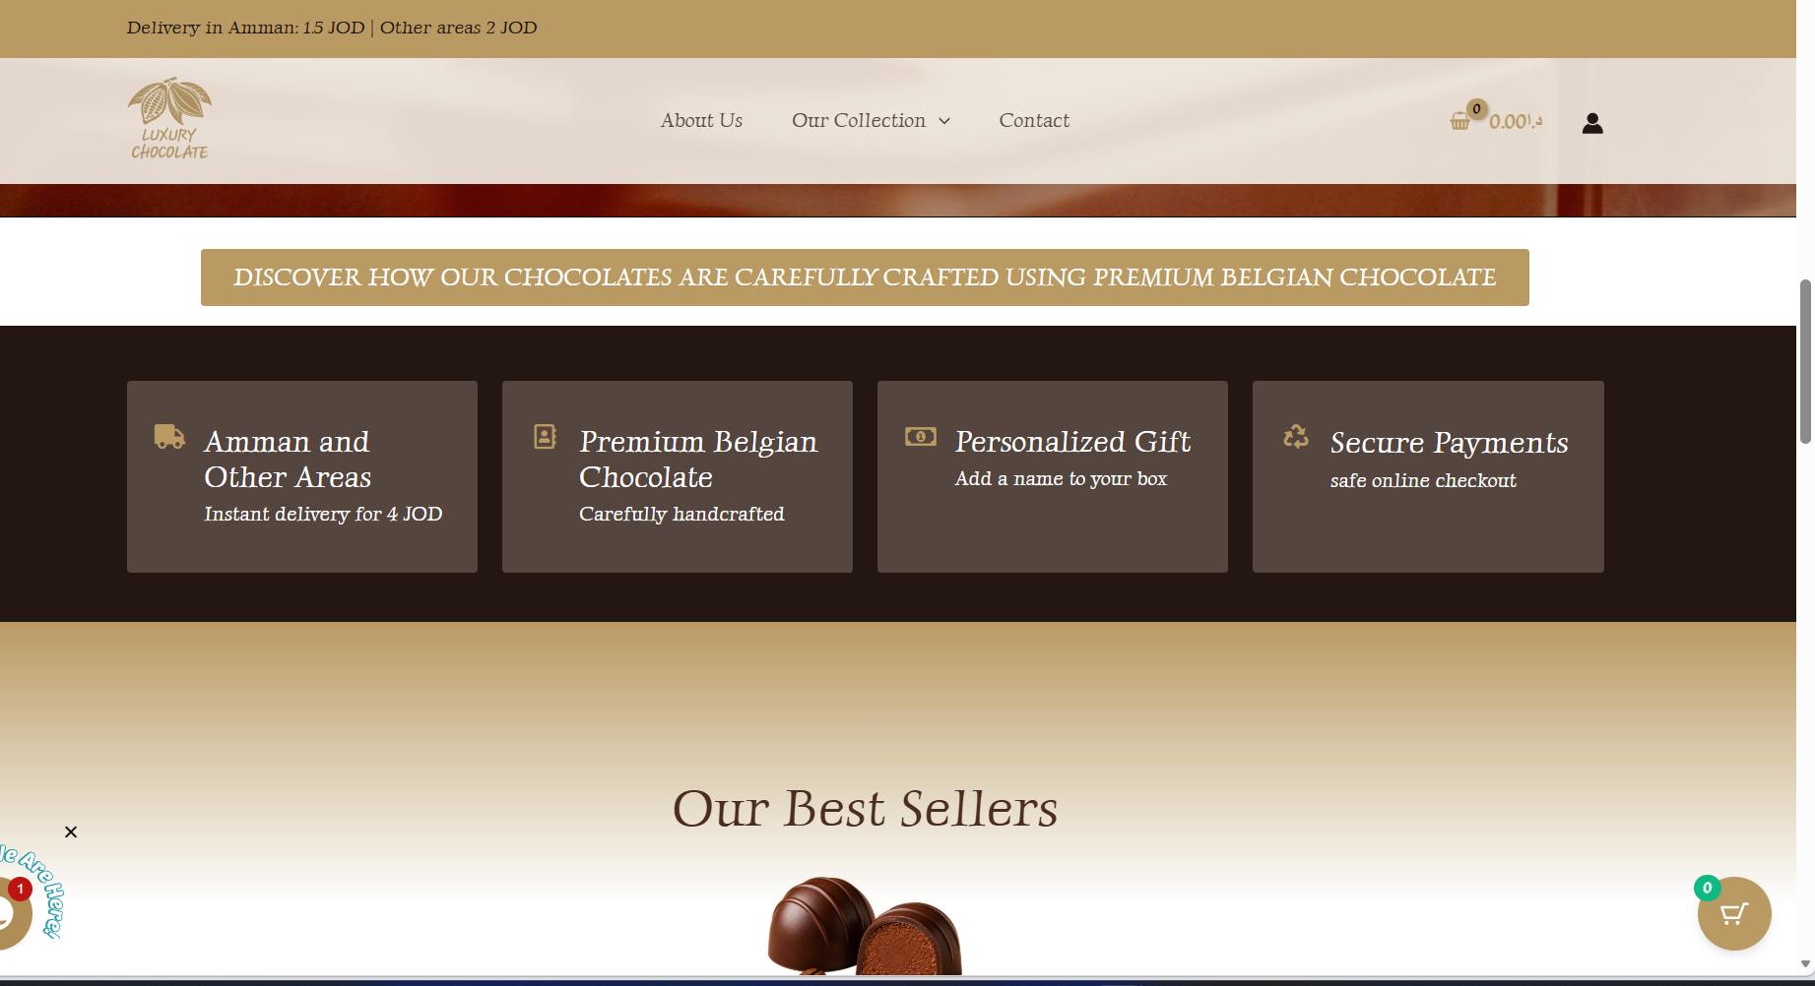  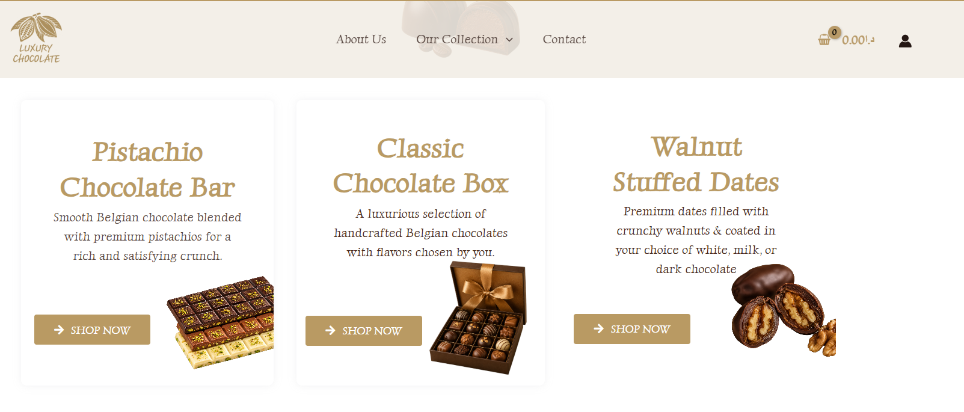  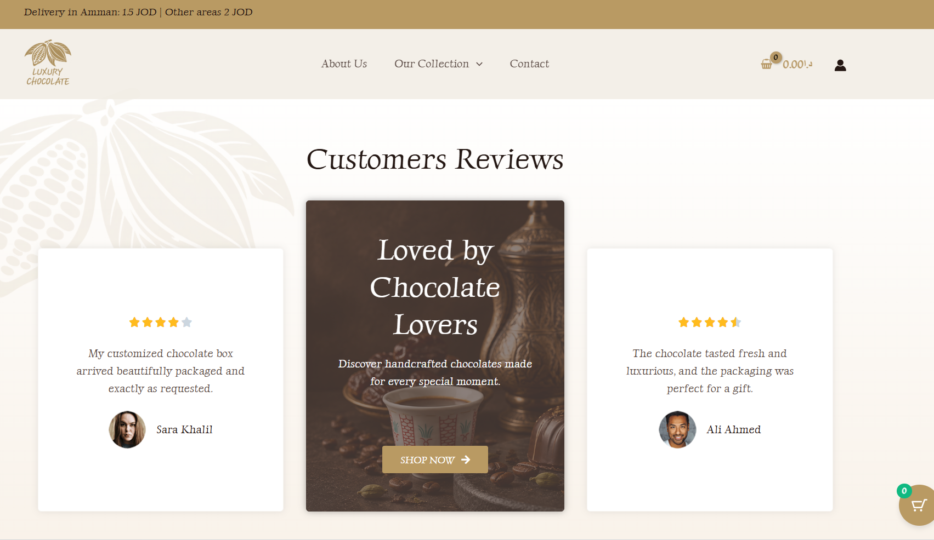 | Pass
Browser Compatibility | Slider should work correctly in different browsers. | Edge:  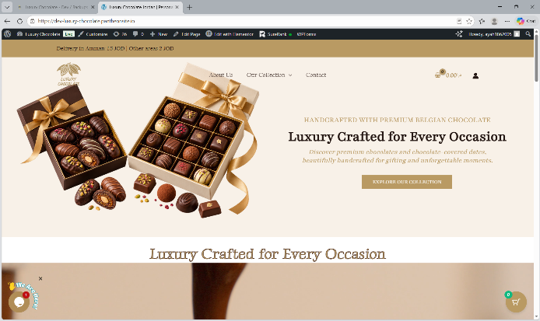Chrome:  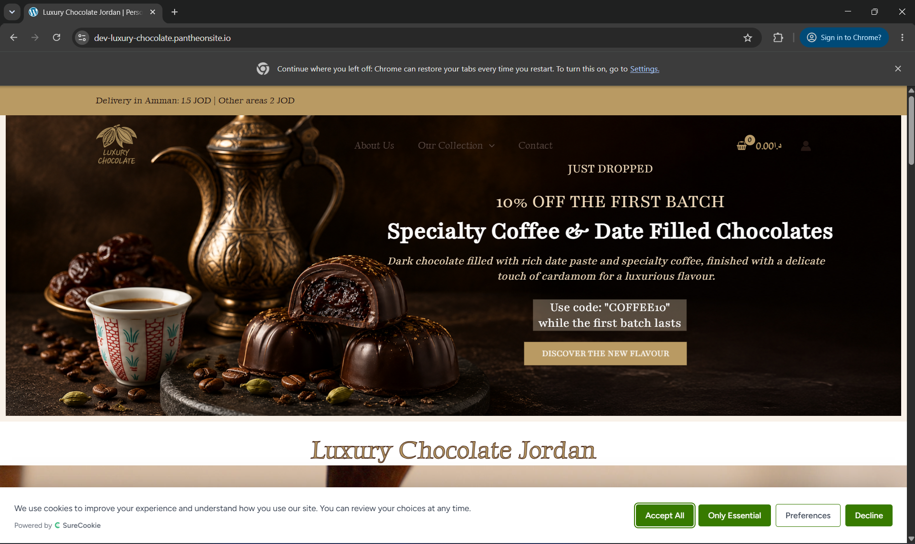 | Pass
Screen Resolution / Responsiveness | Slider should adapt correctly to different screen sizes | Slider displayed correctly only on desktop. However, it is not adaptable for mobile and tablet view, so I disabled it on these two. | Failed

- Search:
Test Case | Expected Result | Actual Result | Status
Search based on Product Name | Searching by the exact product name should display the product. | 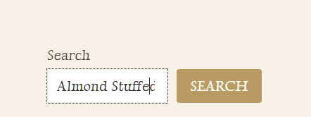  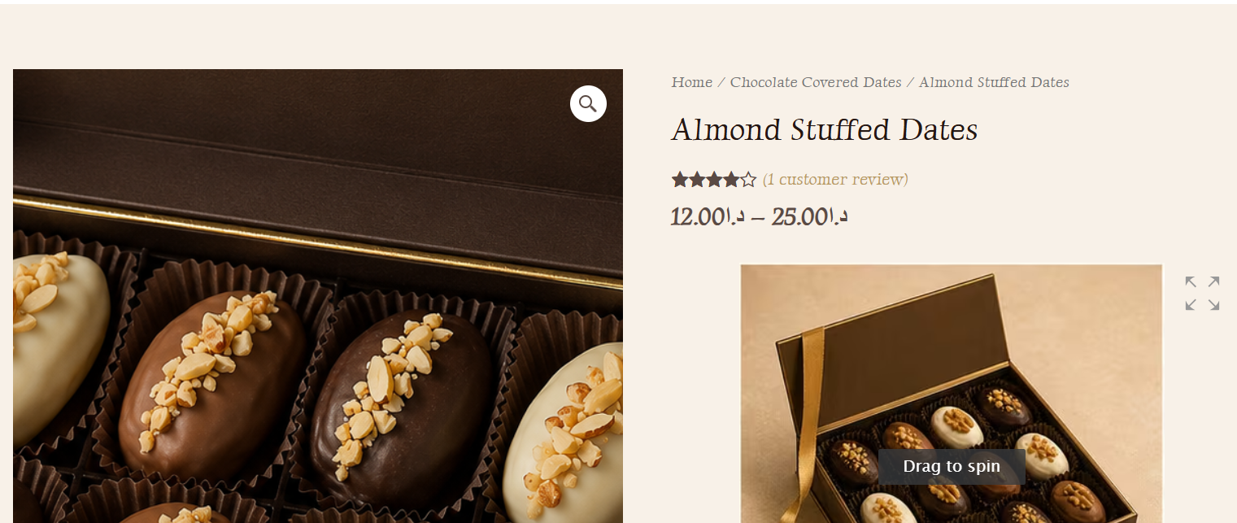 | Pass
Search based on Category | Searching using a category-related term displayed relevant chocolate products. | 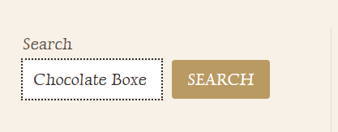  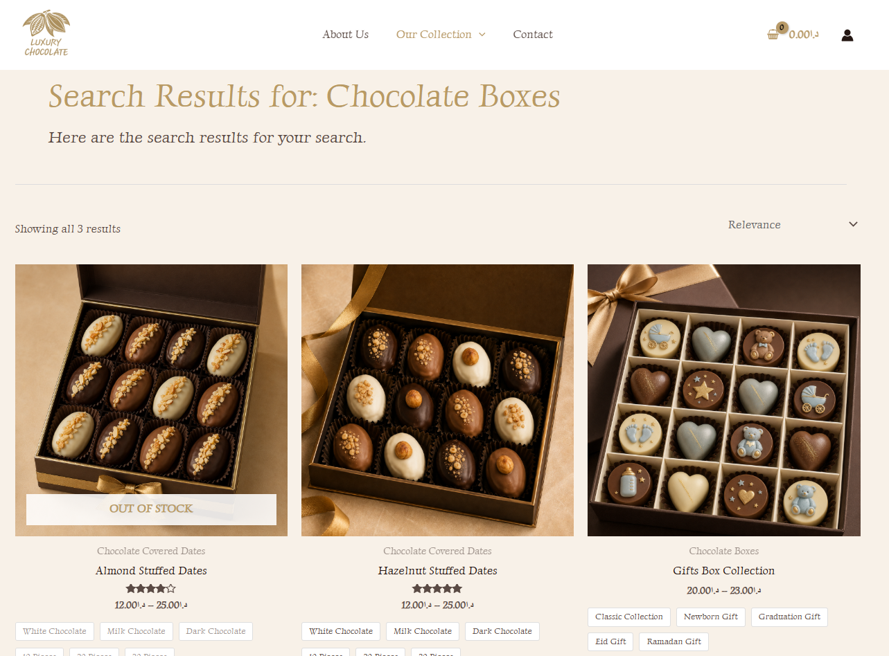 | Failed, because the Search box is responsible for Products not Categories.
Search Results Relevance | The displayed results matched the entered search term. | 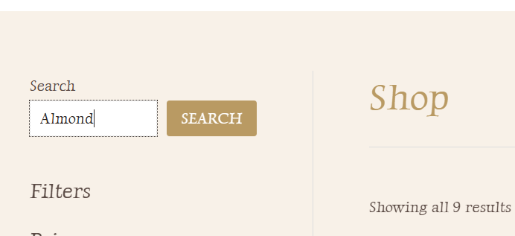  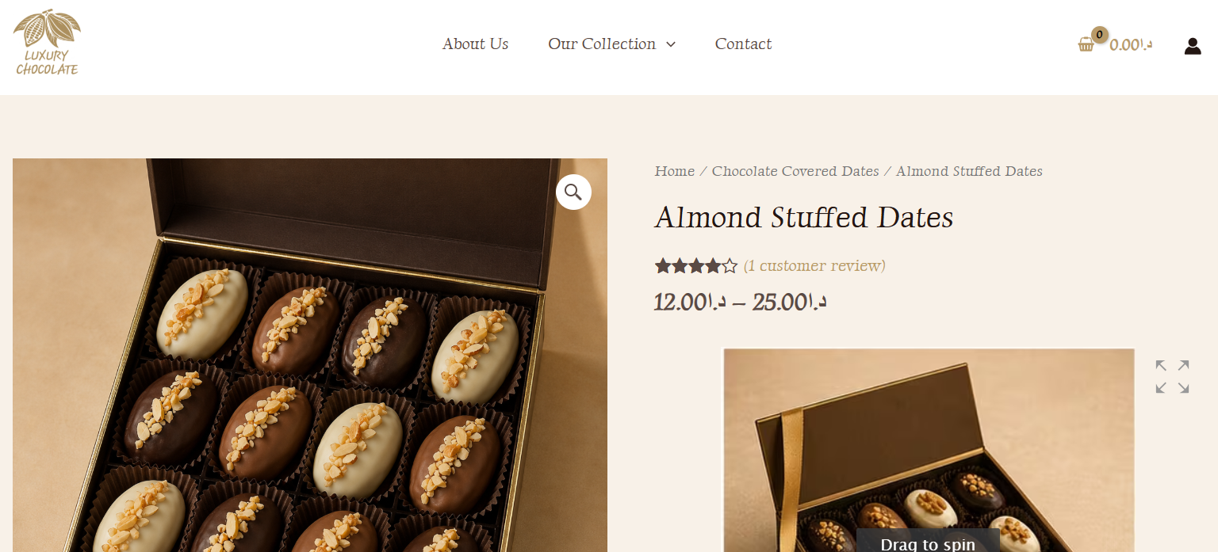 | Pass
Different Sort Options | Sorting options are available on the product listing page and allow customers to change the order of displayed products. | 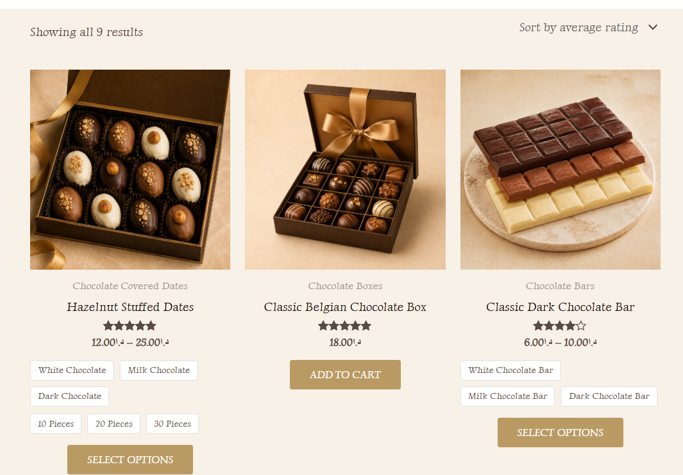  True because I add these 3 products at the end  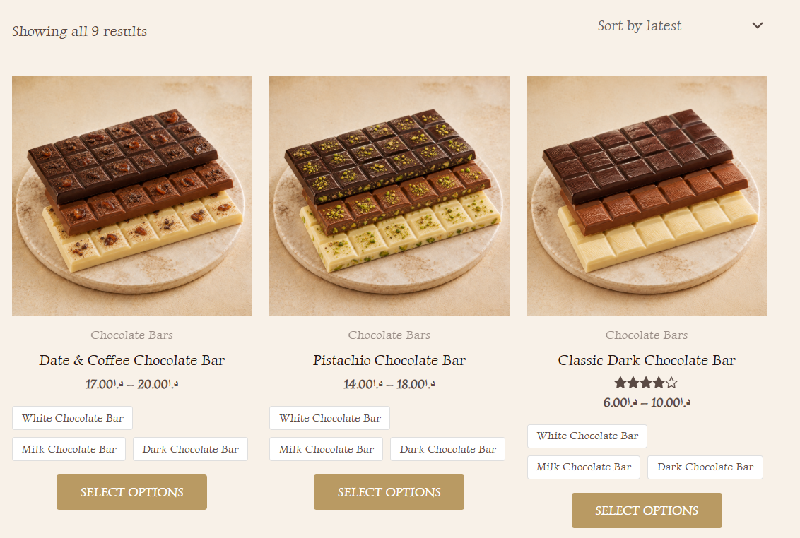  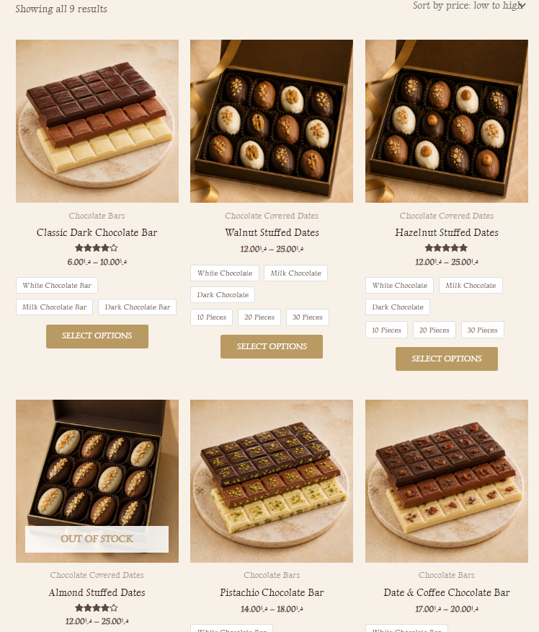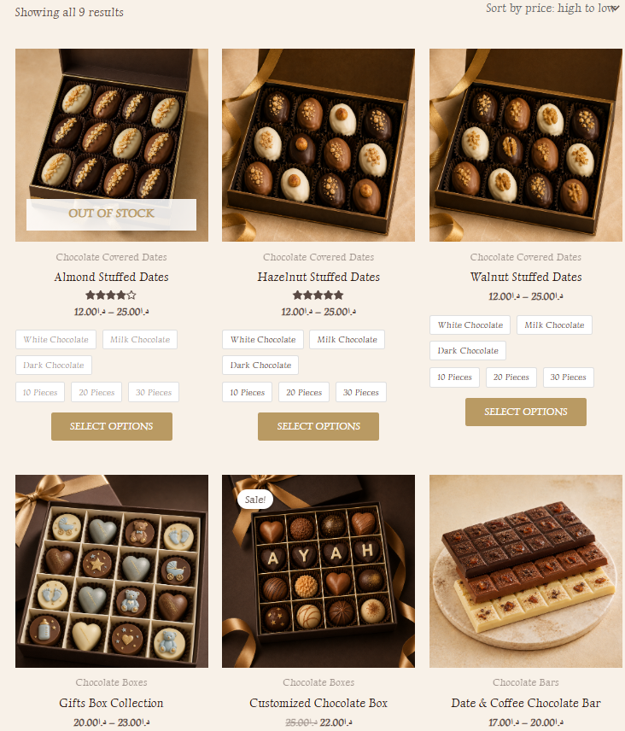 | Pass
Number of Results Per Page | The website displays the available products clearly within the product listing layout. | 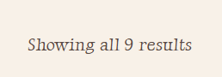  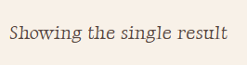 | Pass
Multi-page Result Navigation | If search results extend across multiple pages, navigation should allow users to move between pages. | The website currently has a small product catalogue, so search results do not require multiple pages. | -
Search Drilling Down into Multiple Levels  (Multiple filters at the same time) | Customers can combine product browsing with category, price, and availability filters to narrow down products. | 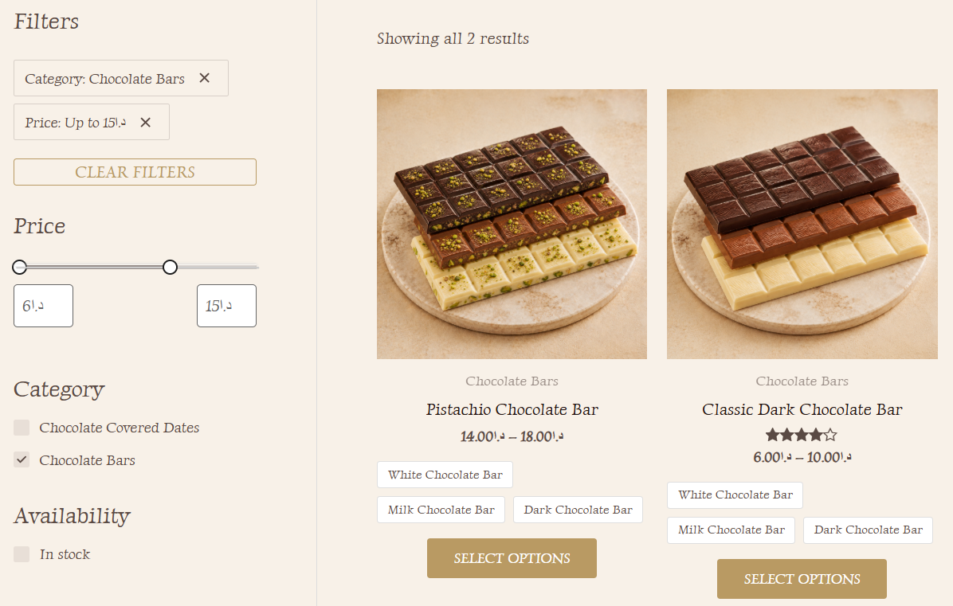 | Pass

- Product Details Page:
Test Case | Expected Result | Actual Result | Status
Images of the product | Product images are displayed clearly on the product page. | 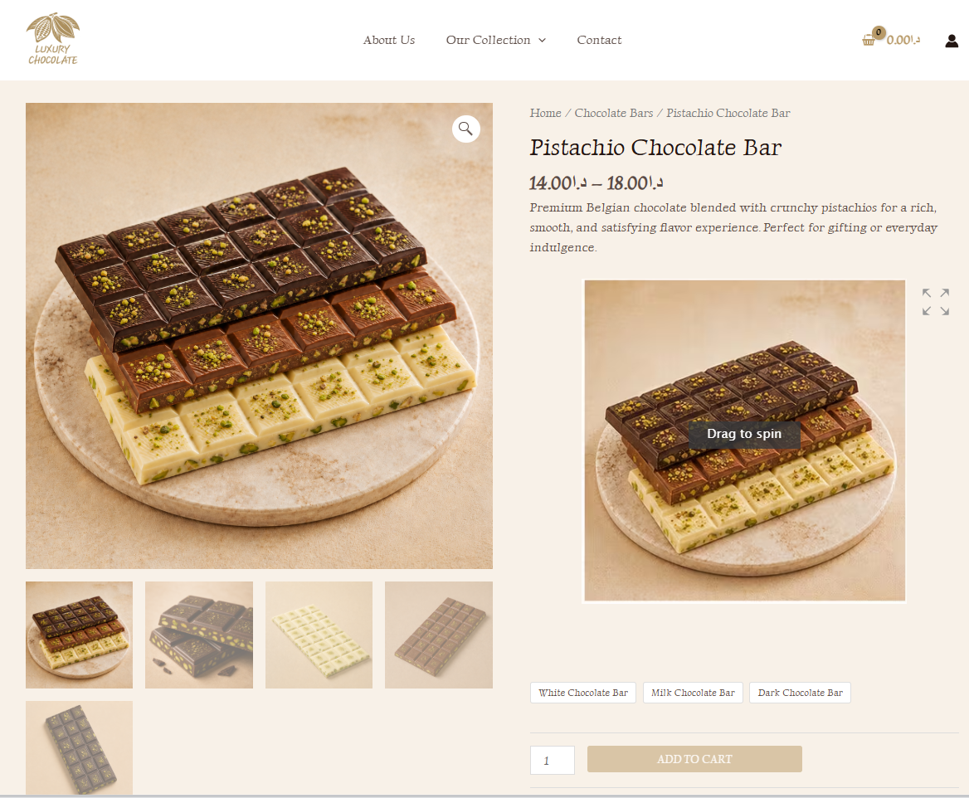 | Pass
Price of the product | The product price is clearly displayed in JOD. | 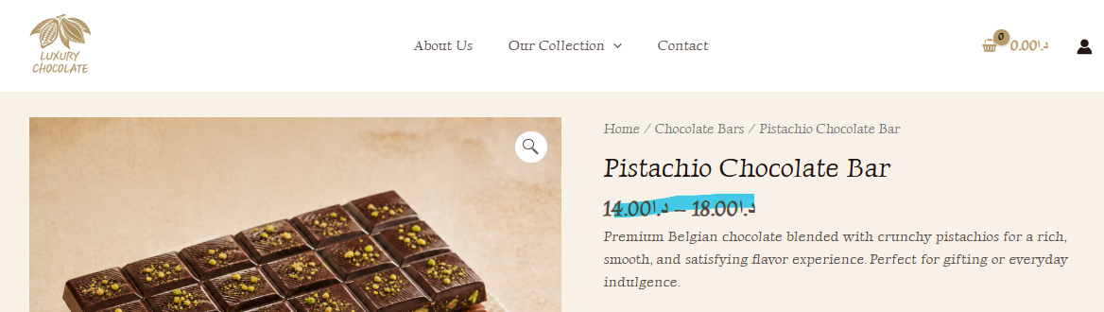  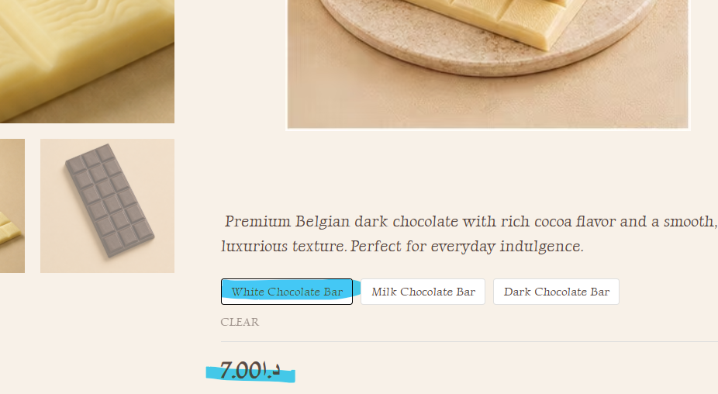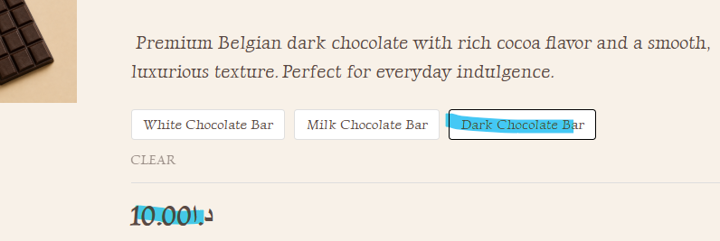 | Pass
Reviews | Ratings and review functionality are available on the product page. | 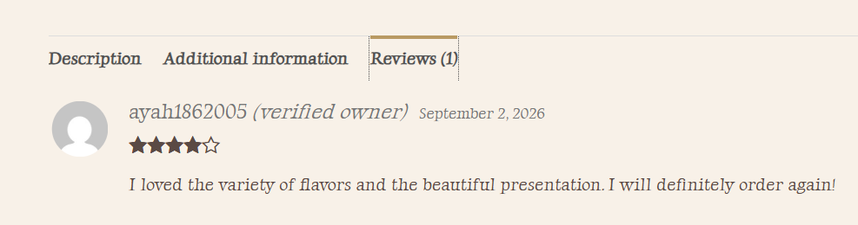 | Pass
Check out options | Add to Cart is available and the product can be added successfully. | 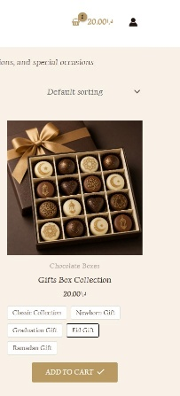  Add to cart will have a tic icon a after adding the product to the cart and the small cart open automatically to show that the product was added.  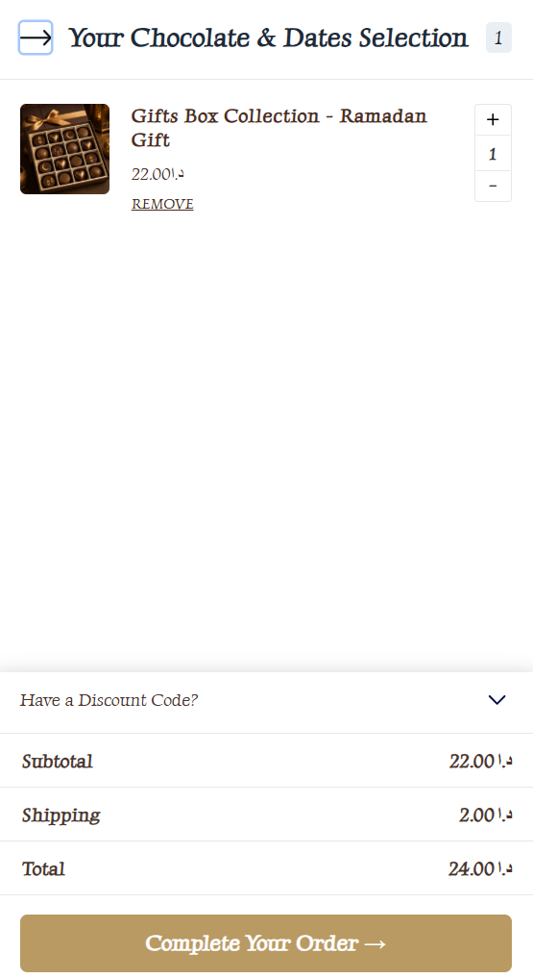 | Pass
Delivery options | Delivery options are available during cart/checkout. | 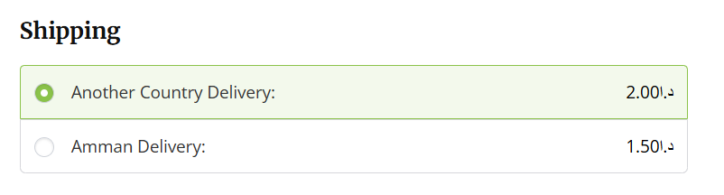 | Pass
Multiple flavors or variations options | Customers can select options such as chocolate coating, box size, or other variations. | 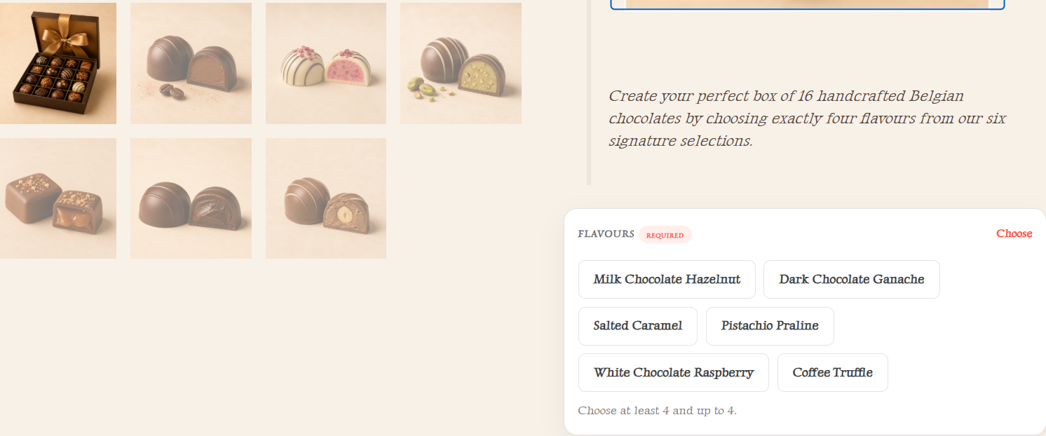  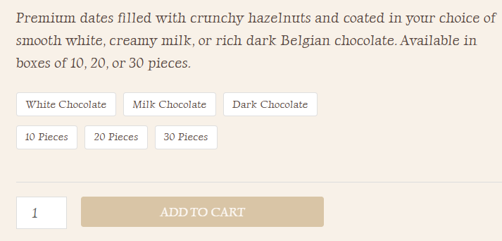 | Pass
Breadcrumb navigation | Breadcrumb navigation is displayed and links correctly back to the Shop/category pages. |  | Pass

- Categories/Featured Products/Related or Recommended Products:
Test Case | Expected Result | Actual Result | Status
Category Navigation | Selecting a category such as Chocolate Bars displayed the relevant products only. | 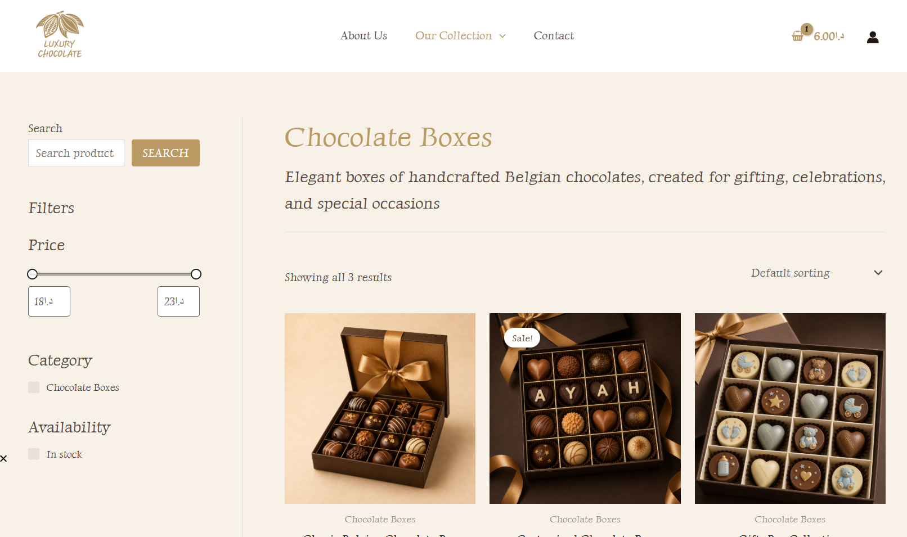 | Pass
Featured Products  (Feature Image) | Featured image was displayed correctly and opened the matching product pages. |  | Pass
Related Products | Related chocolate products were displayed and linked correctly. | The product was: 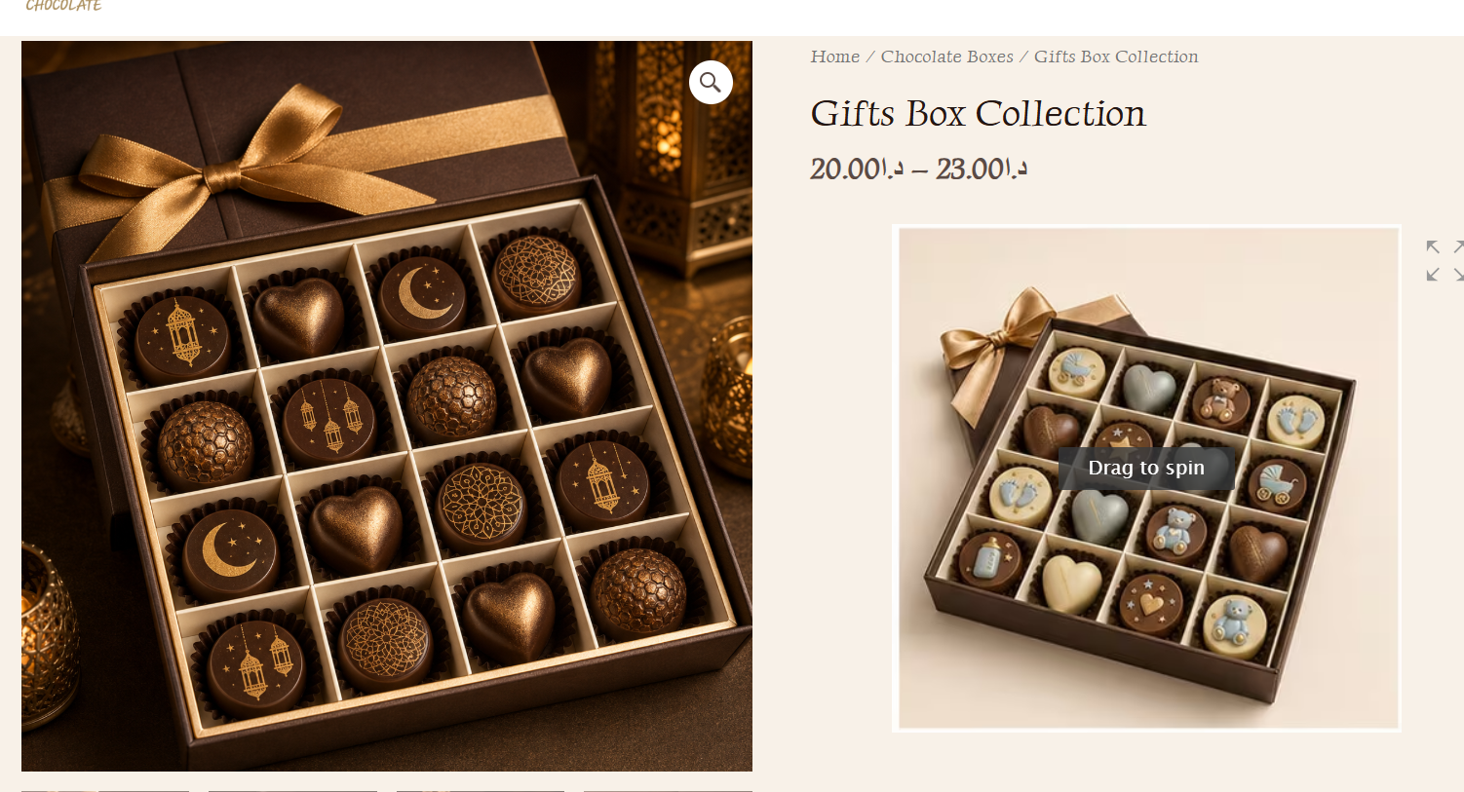  The related:  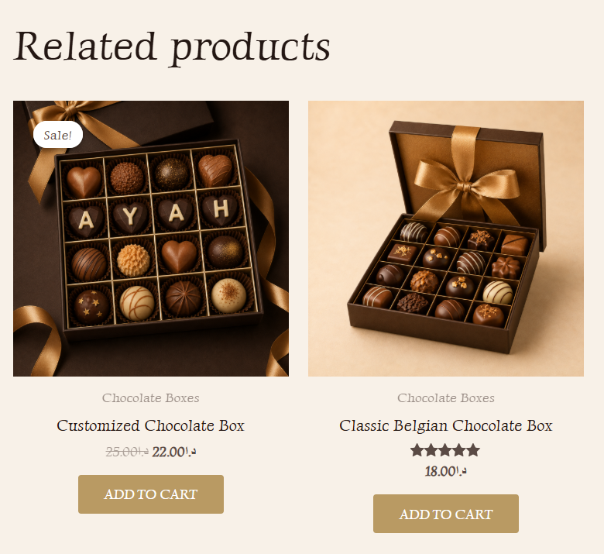 | Pass
Recommended Products | Recommended products, when displayed, should provide relevant suggestions to the customer. | The website doesn’t contain it. | -

- Payments
Test Case | Expected Result | Actual Result | Status
Check different payment options  &  Order Confirmation Email | The available payment methods were displayed correctly during checkout and could be selected.  &  A confirmation email containing the order number and order information was successfully received. | 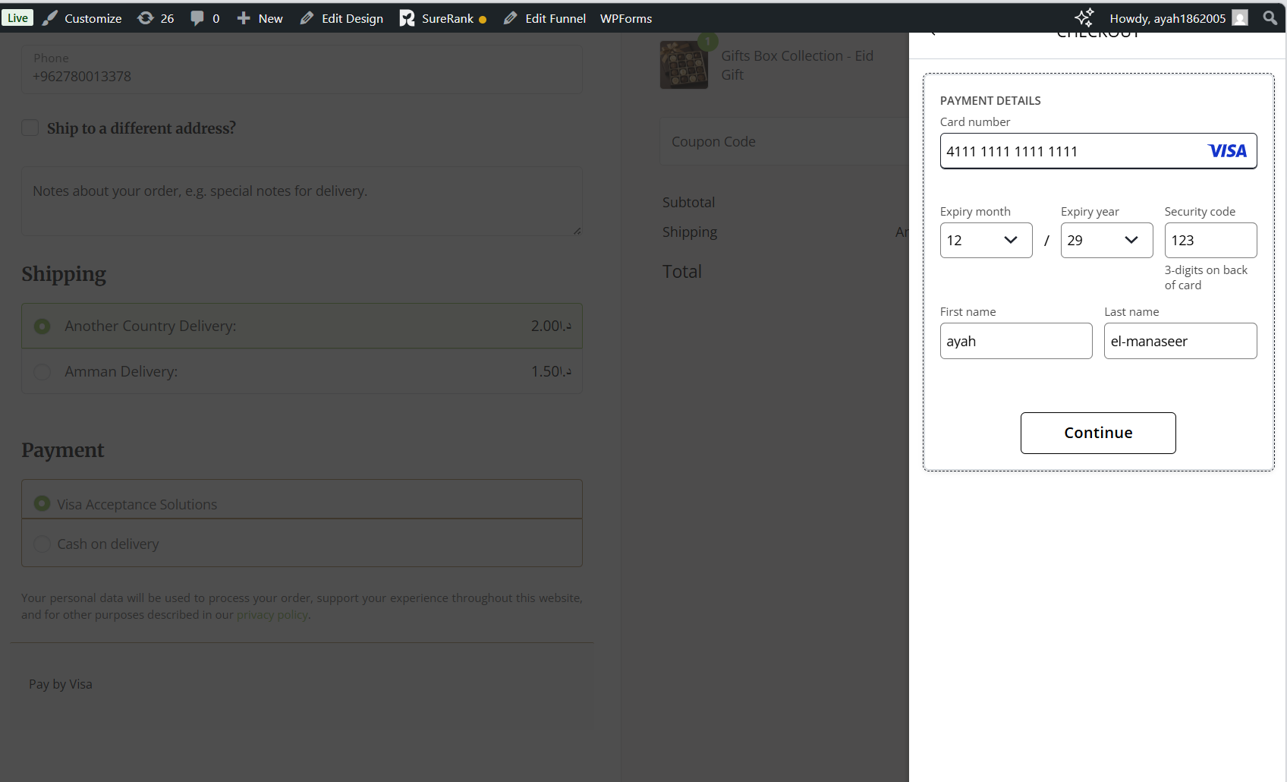  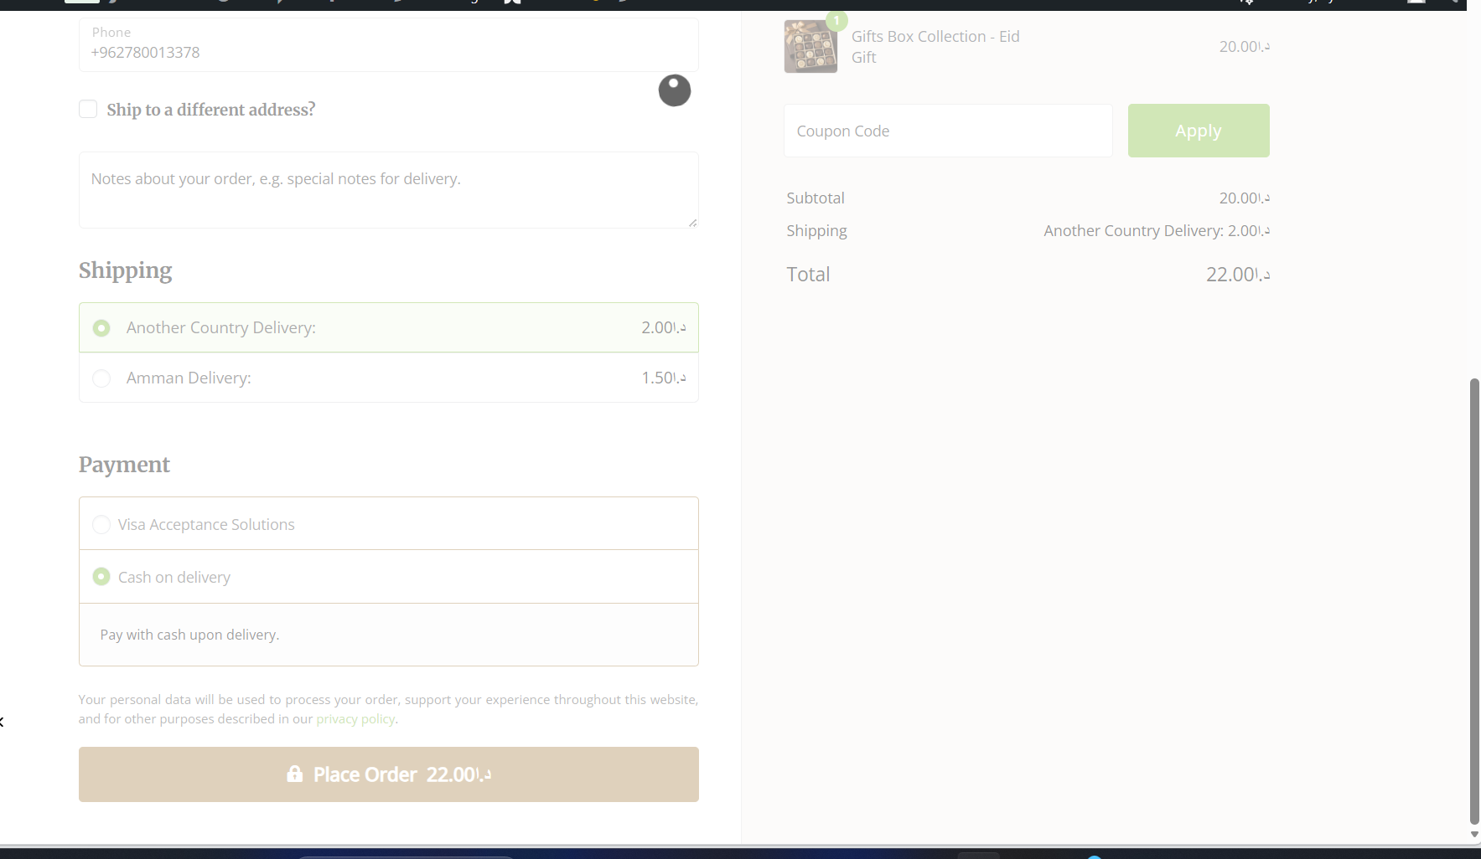  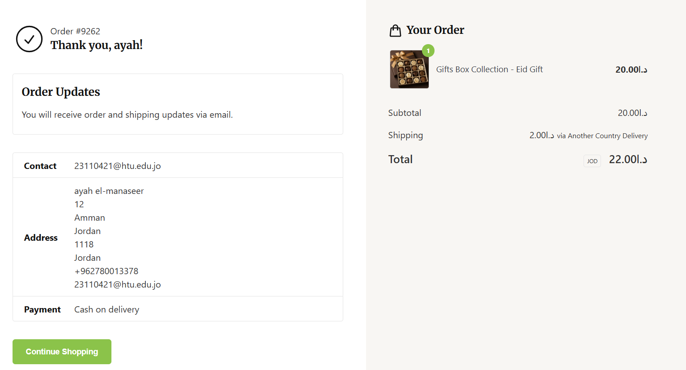  payment requirement was partially achieved because Google and Apple Pay doesn’t work because of the policy and the need to have a domain and the Commercial Registry. | The VISA Payment Passed but because it is a tested VISA so only the transaction Failed and send to the Customer this 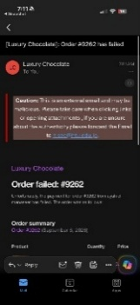Email  The Cash Method is Passed and sent to the customer Thank you Email with Order details  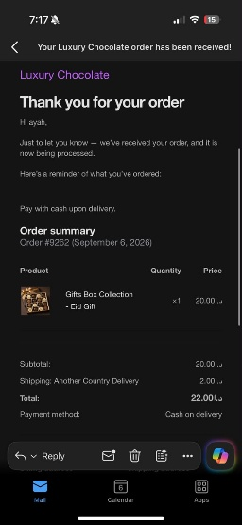  and for the admin a New Order Email  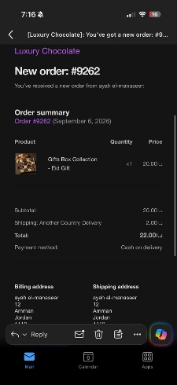  payment requirement was partially achieved because Google and Apple Pay doesn’t work because of the policy and the need to have a domain and the Commercial Registry.
Guest Checkout | Guest checkout was available and the customer could proceed without logging in. | 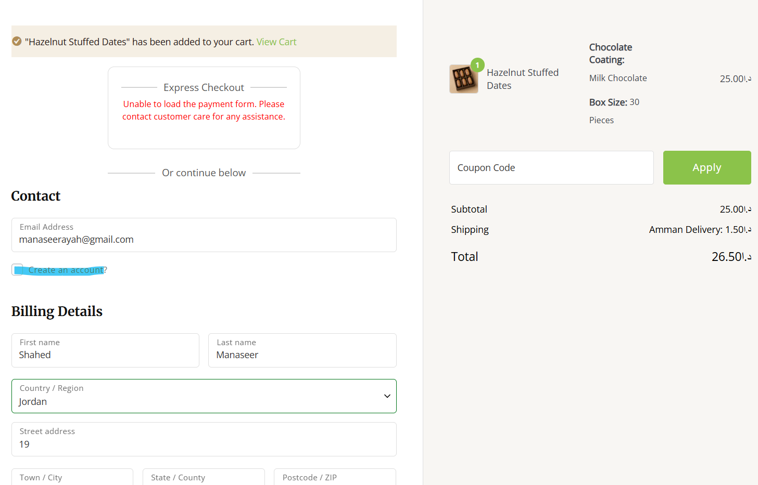  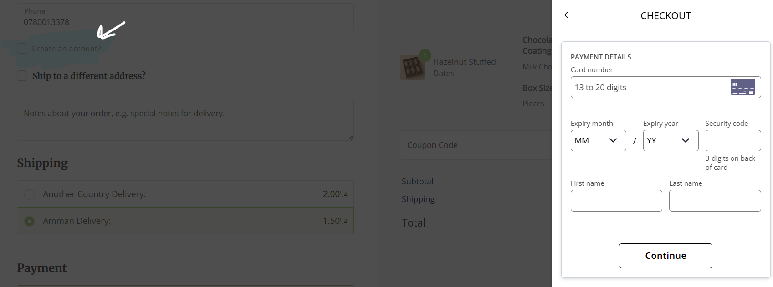 | Pass
Returning Customer Login | Returning customers were able to log in and access the checkout process. | 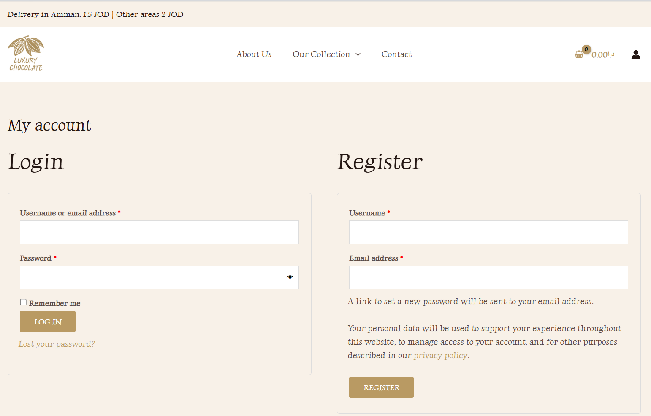  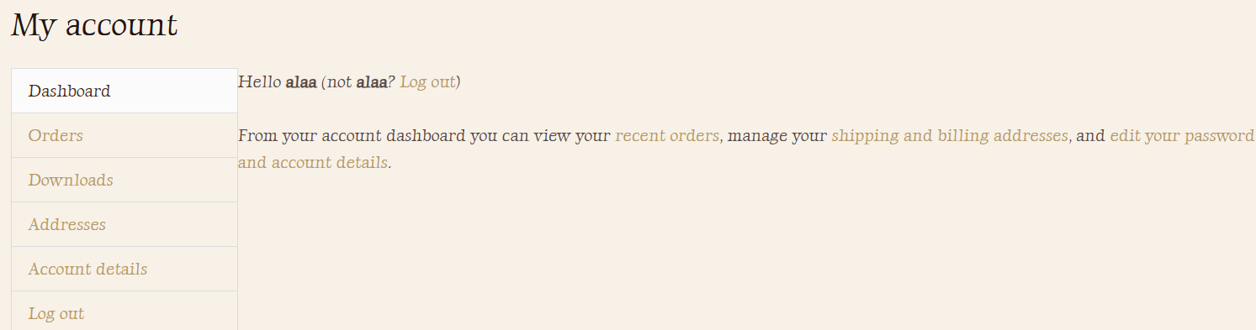  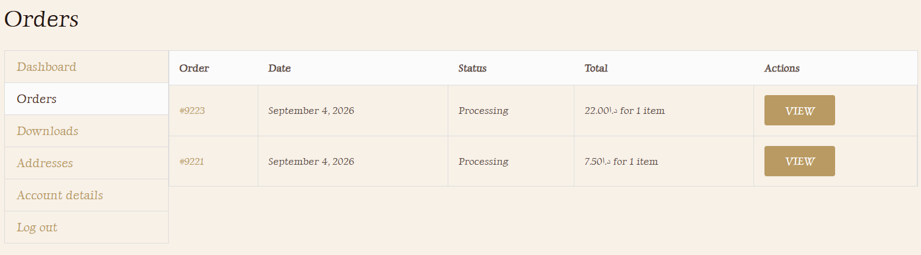  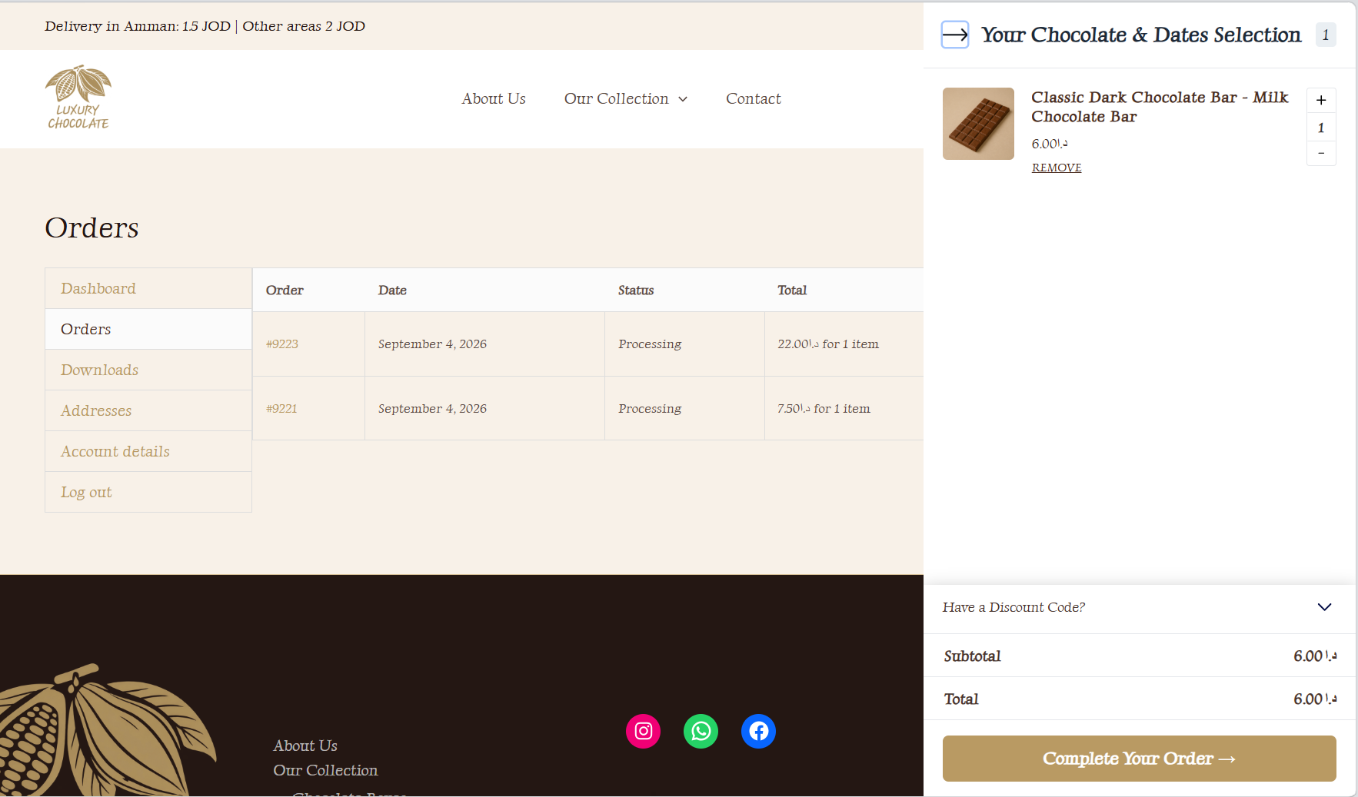  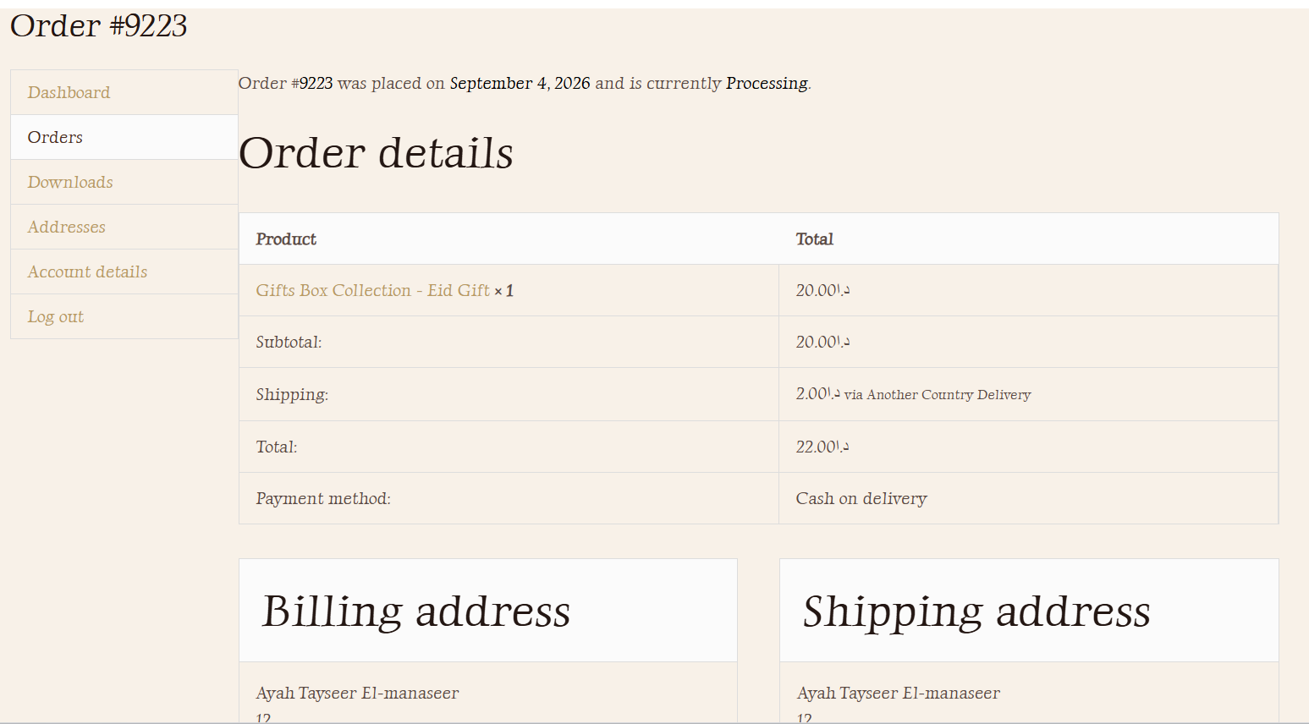 | Pass
User Sign Up | A new customer account could be created successfully. | 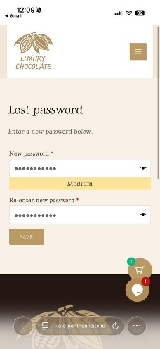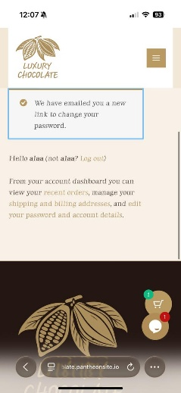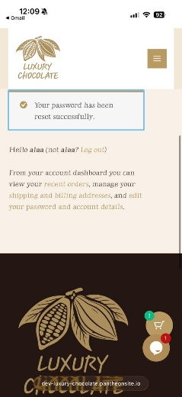 | Pass

- Shopping Cart
Test Case | Expected Result | Actual Result | Status
Add items to the cart and continue shopping | The customer should be able to add a product and continue browsing without being forced to check out & The product was added successfully, and the customer could continue shopping. | 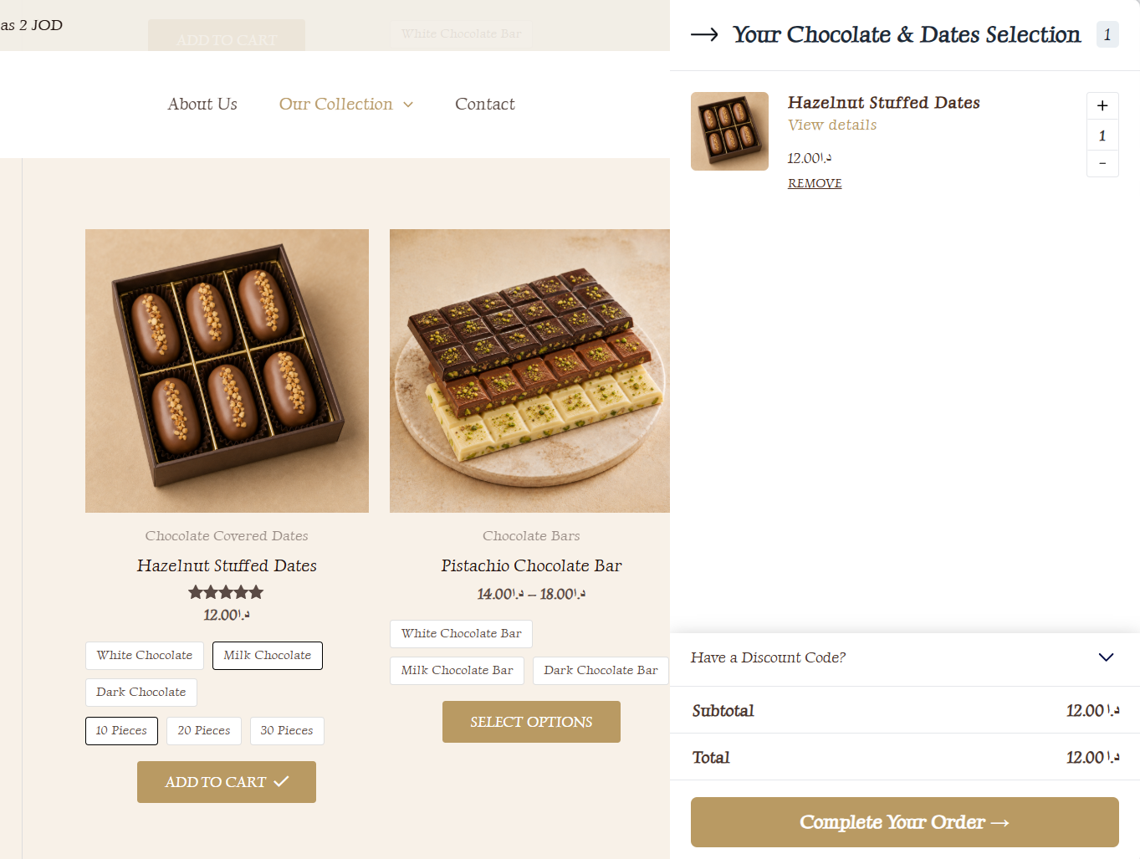 | Pass
Add the same item again | The product quantity increased correctly when the same item was added again. | 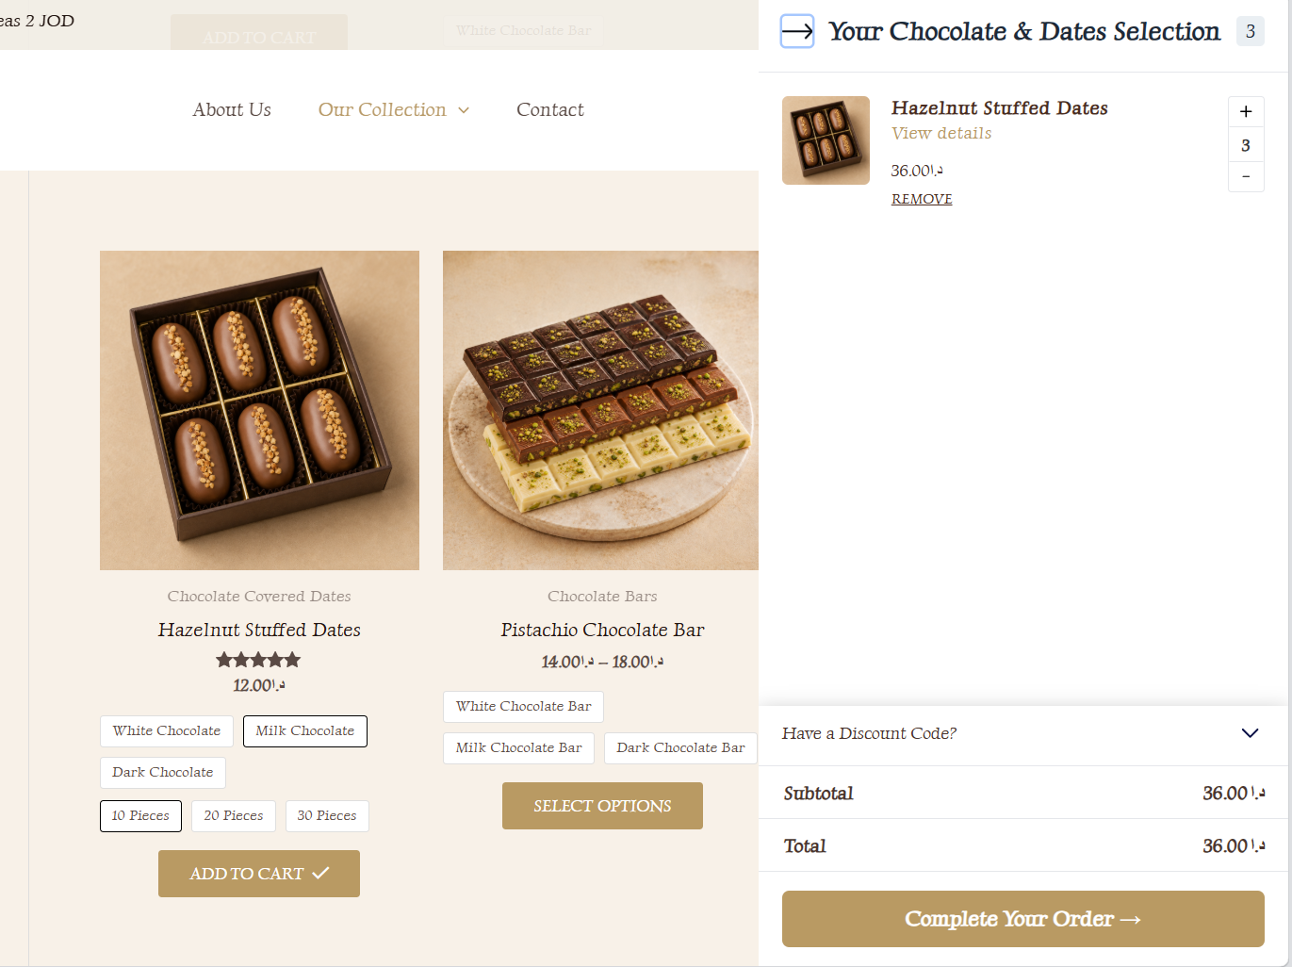 | Pass
Add more items to the cart | Customers should be able to add different products and the total was recalculated correctly. | 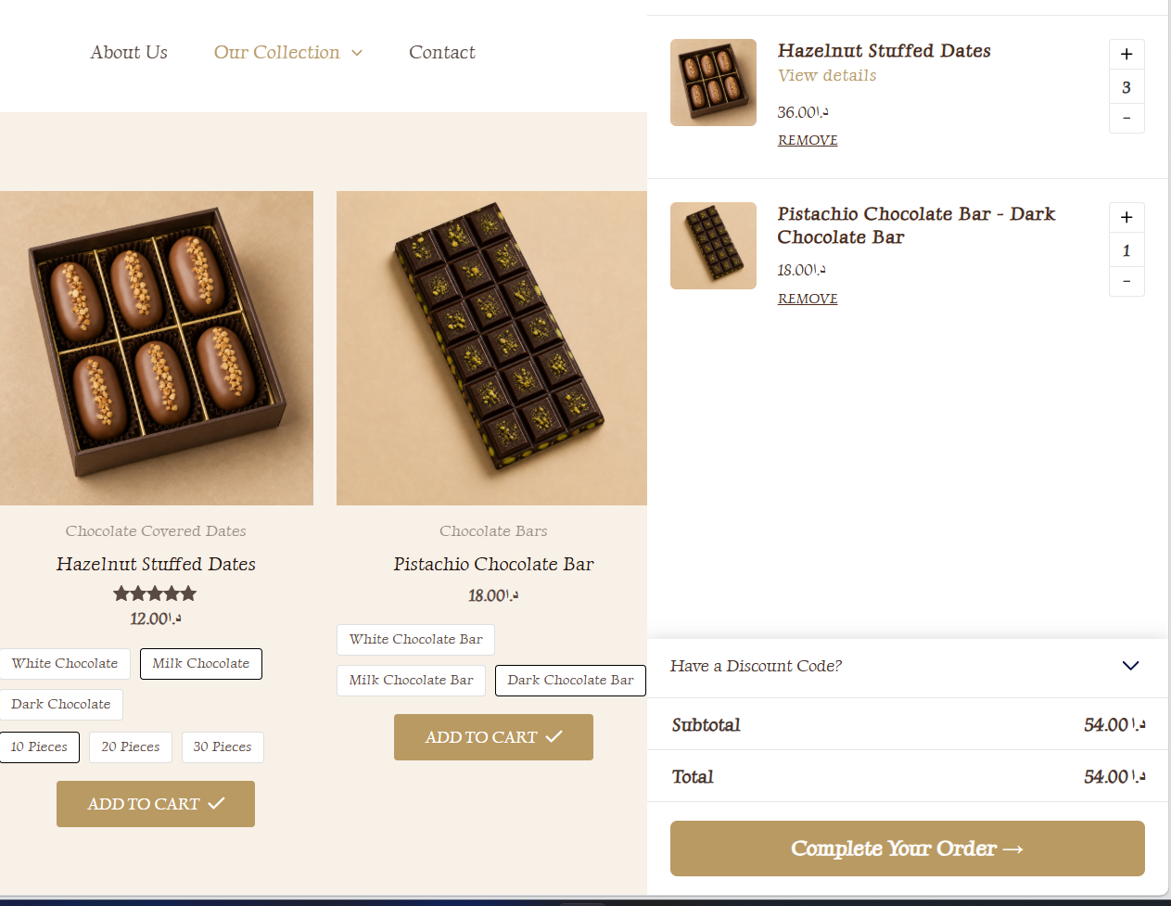 | Pass
Update cart contents | The quantity and cart total updated correctly. | 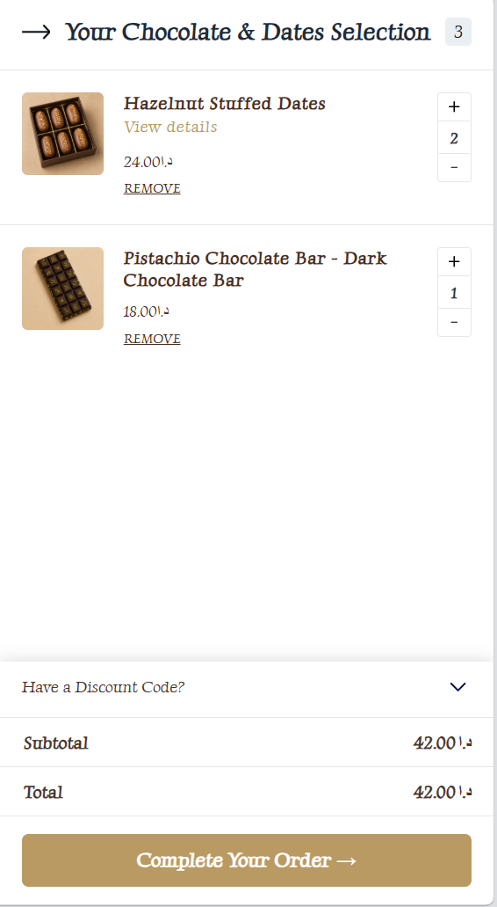 | Pass
Remove items from the cart | The selected product was removed and the cart total updated correctly. | 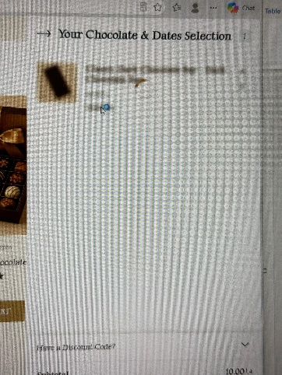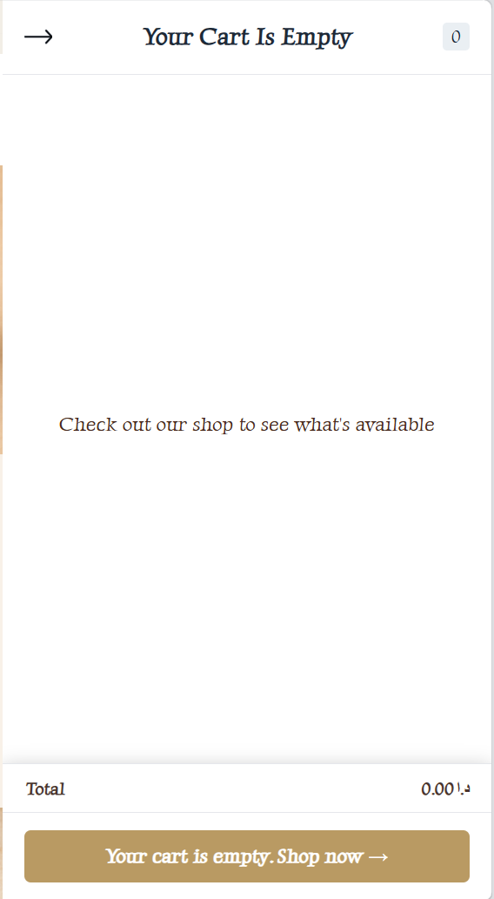 | Pass
Proceed to checkout | The checkout page opened successfully. | 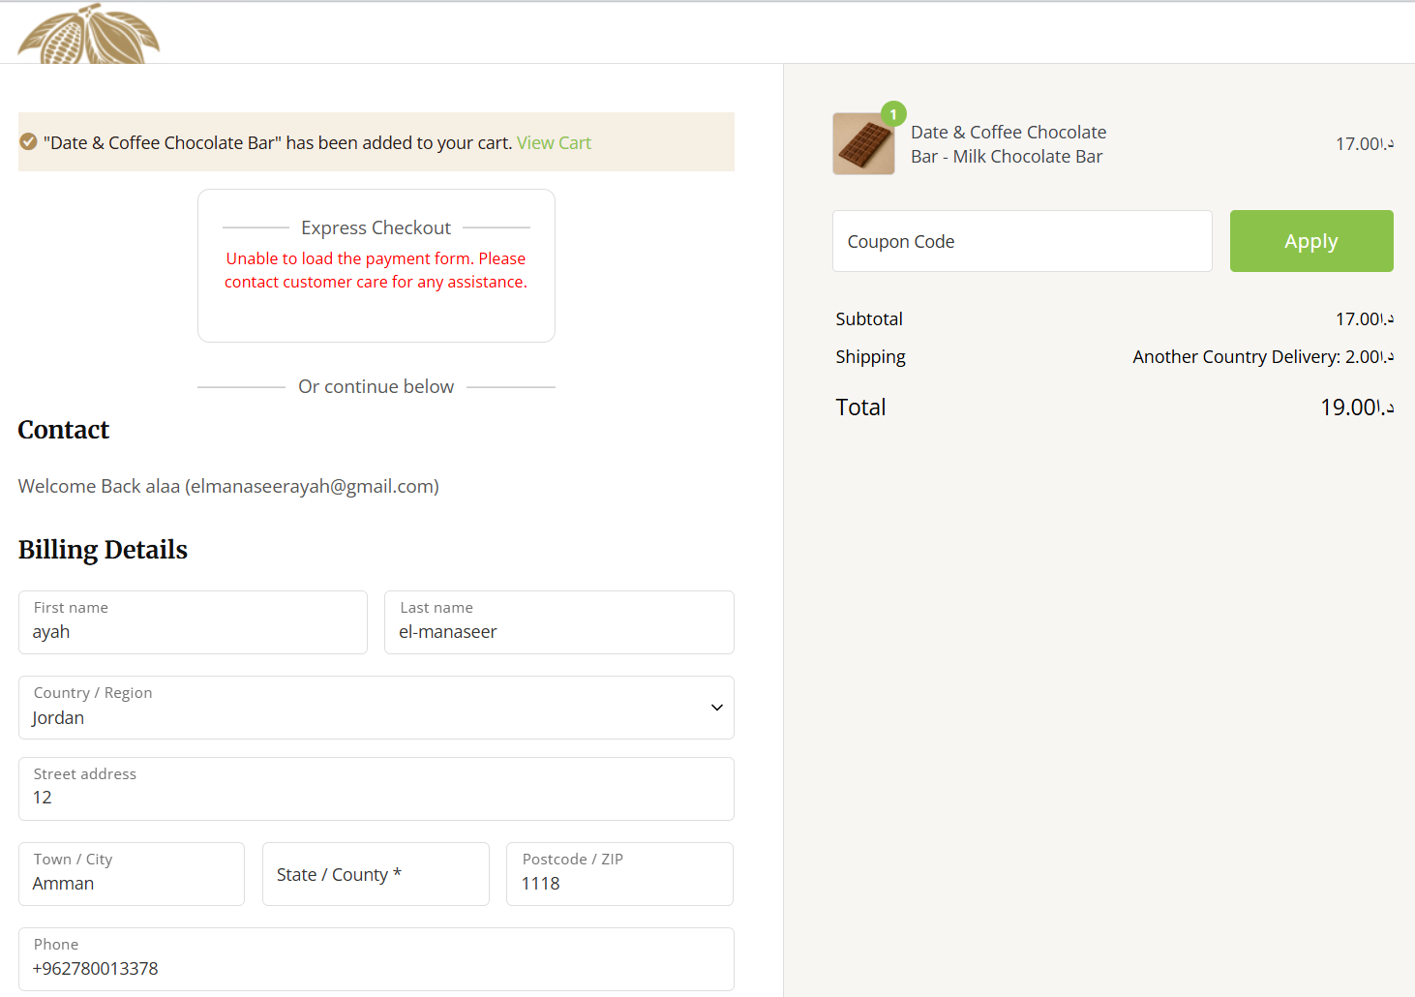 | Pass
Calculate shipping cost | The appropriate delivery cost should be calculated/displayed according to the delivery location. | 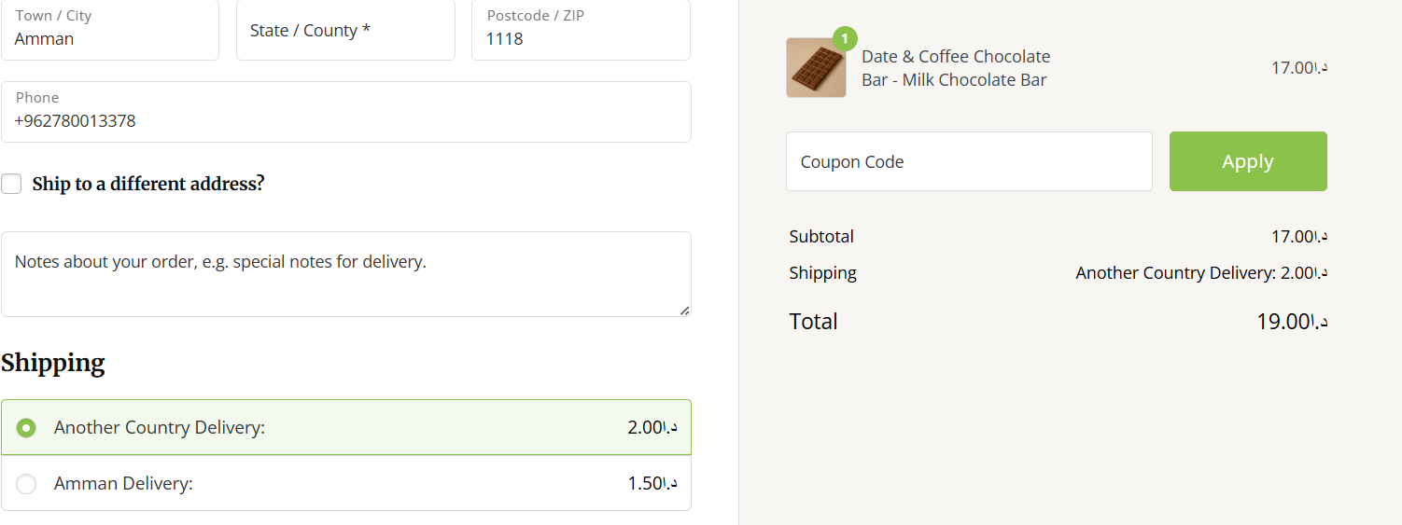  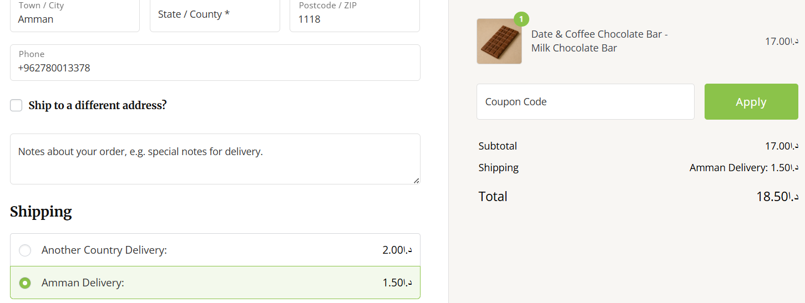 | Pass
Apply coupons |  | 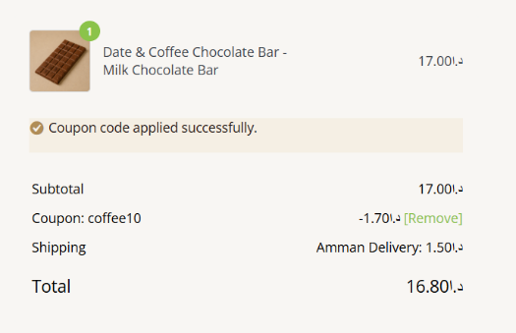  In the Check out  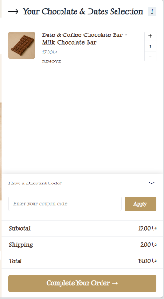  In the cart  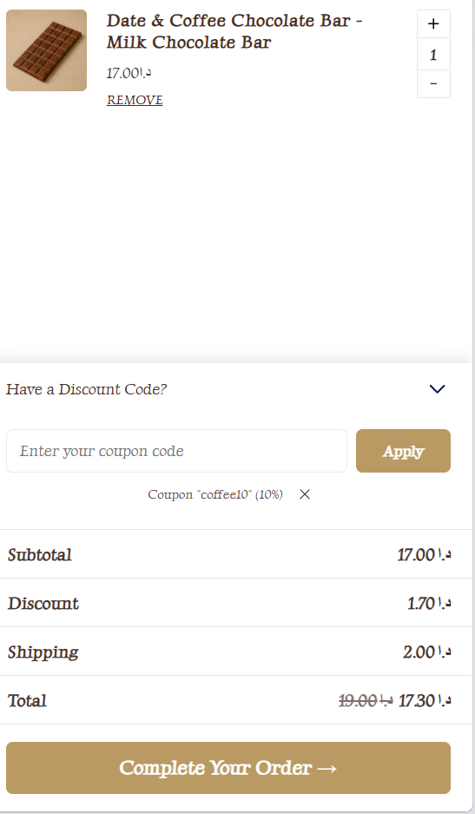 | Pass
Retain cart items after leaving the site | Products remained in the cart after closing and reopening the website. |  | Pass

- After-Order Tests:
Test Case | Expected Result | Actual Result | Status
Change the Order | Customer should be able to modify an order after it has been placed | This function doesn’t exist | -
Cancel the Order | Customer should be able to cancel an order after placement | This function doesn’t exist | Pass
Track the Order | Customers can view the order status and order details through My Account, also, the admin can send an email to the customer about the status | 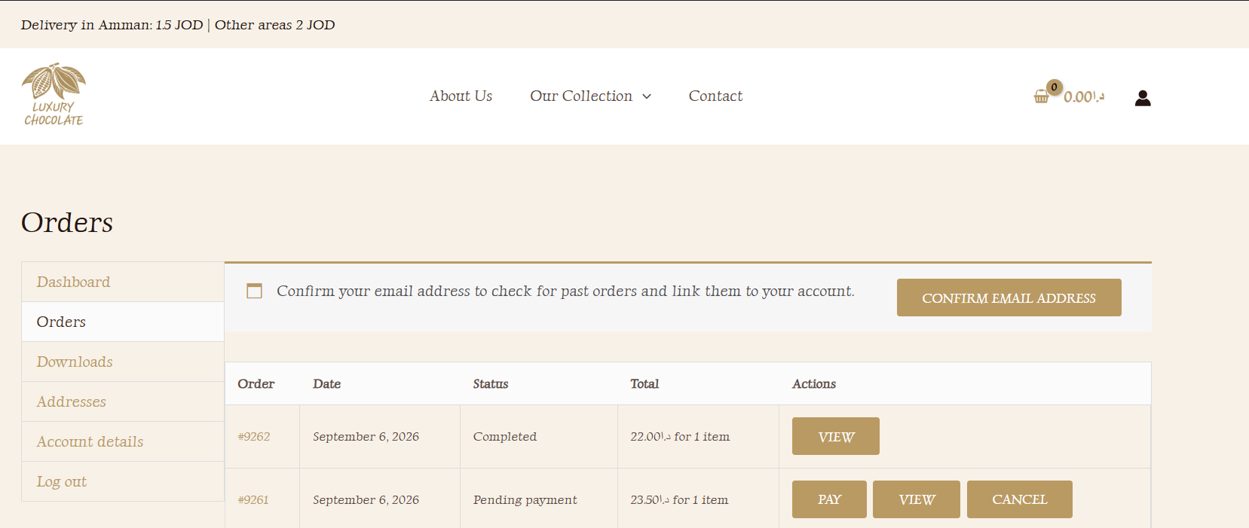  Change the status to Completed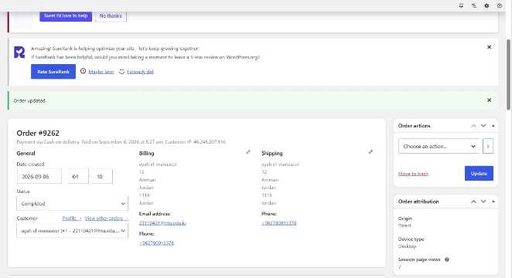  Send an Email to the Customer  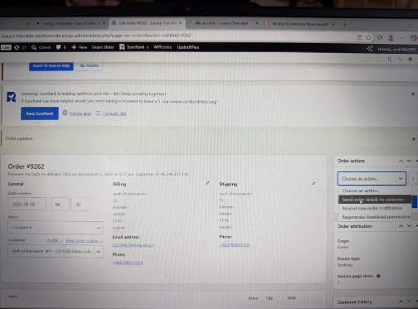  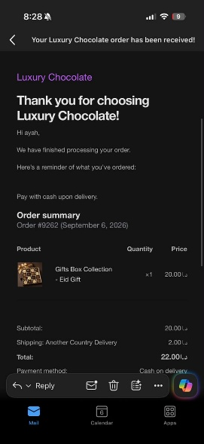 | Pass
Returns | Customers should be able to access or request a return according to the store policy. | This function doesn’t exist | -

- Other Tests:
Test Case | Expected Result | Actual Result | Status
Reviews | The customer should have ability to give a review of the item and its rating. After that the submitted review will appear as pending in WordPress Admin panel where the Administrator can approve/reject the review. Once approved by the Administrator the submitted review will appear on the product page. | 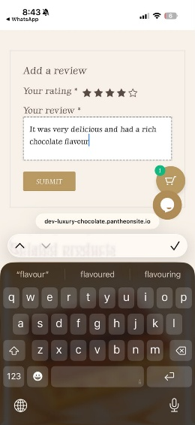  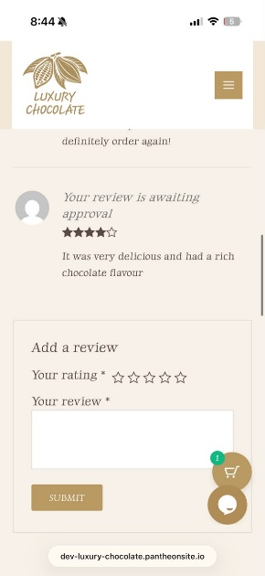  2-  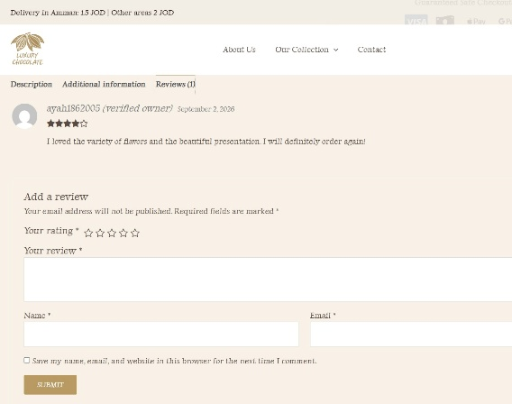  3-  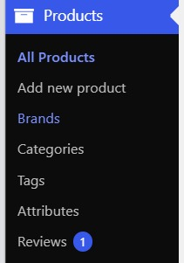  4-  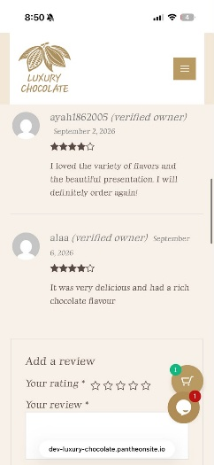  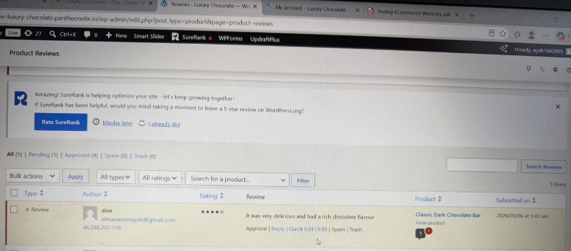  5-  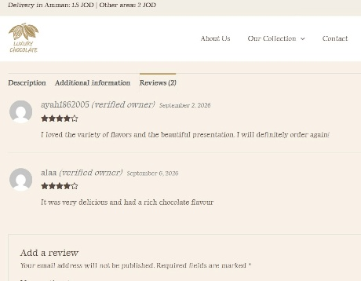  6- | Pass
Contact Us Page | The Contact Us page should display the contact form correctly and allow customers to submit a message. | 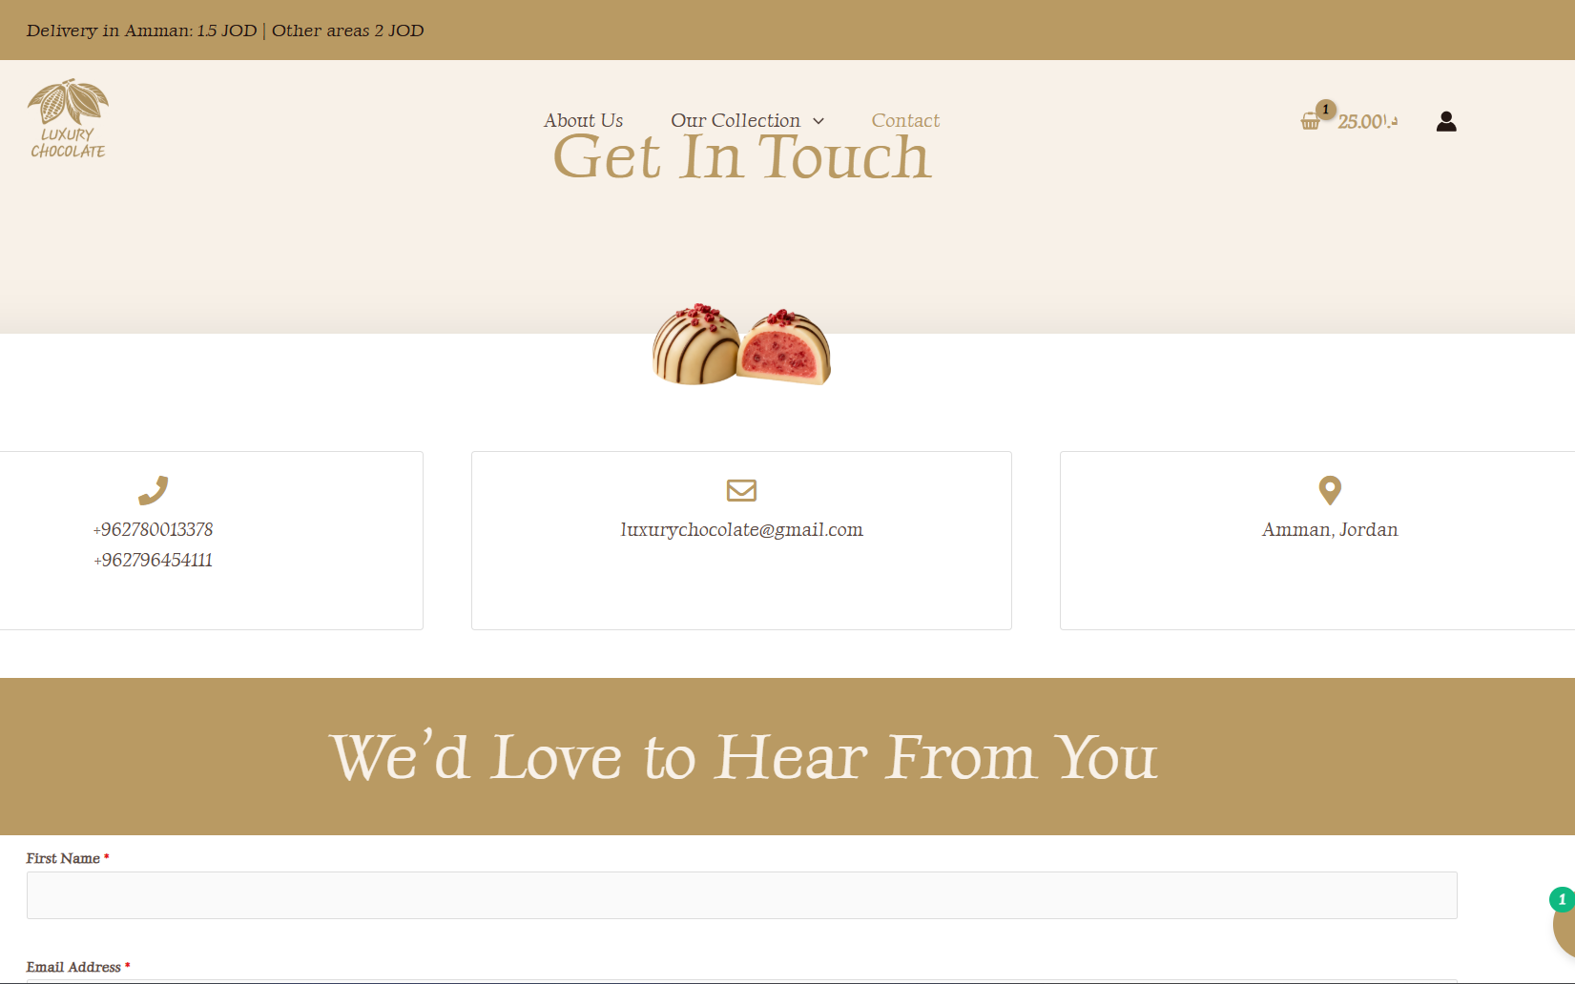  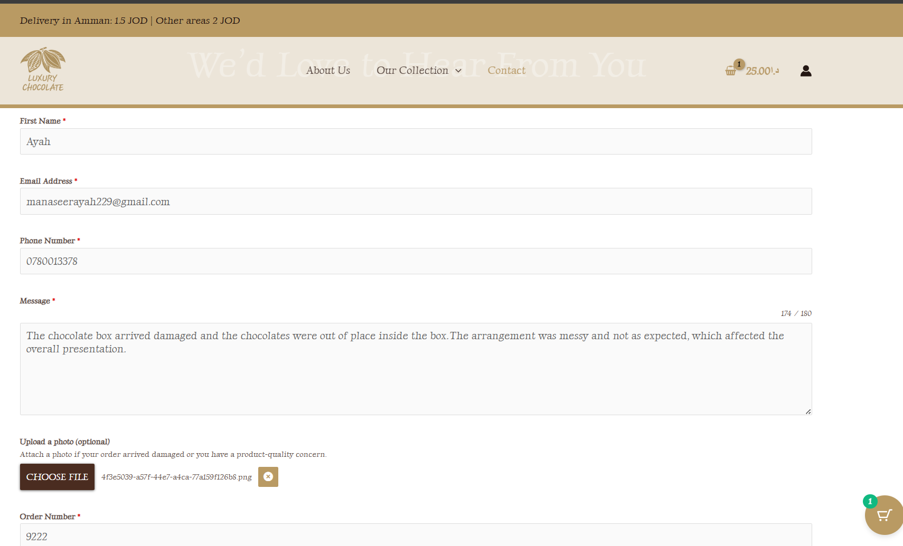  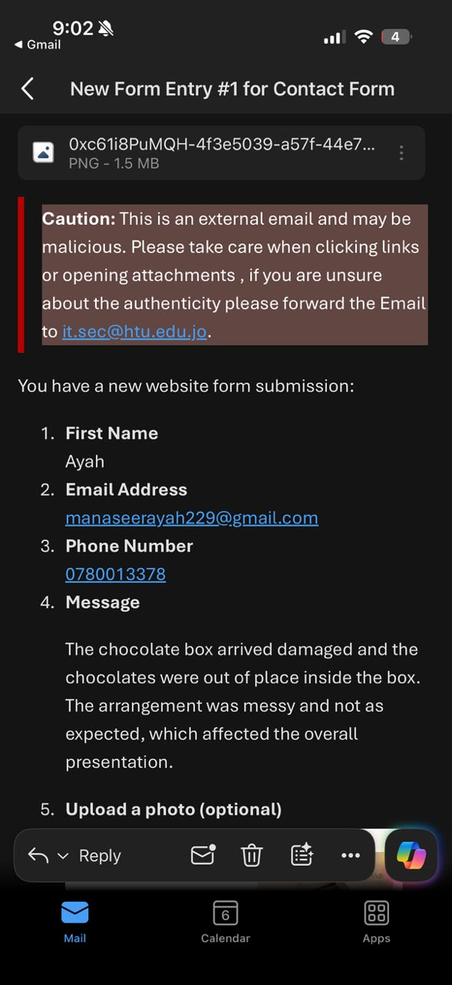  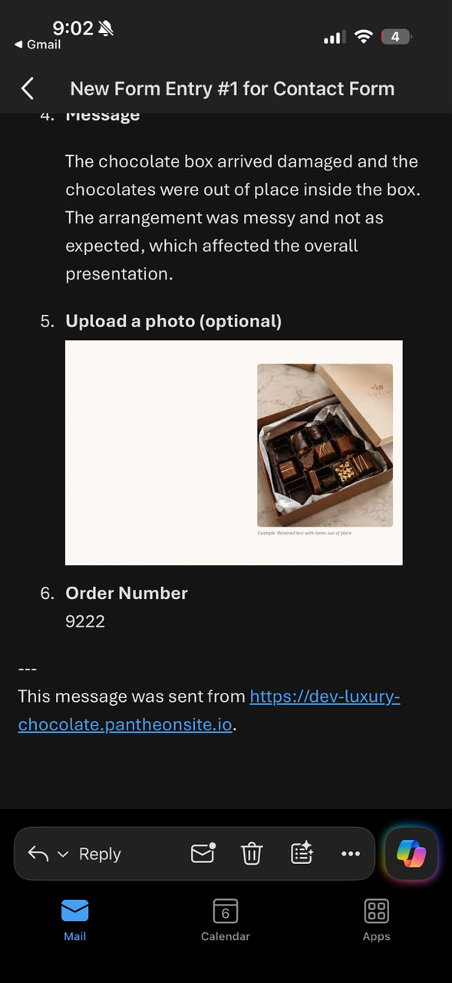 | Pass
- CMS Testing:
Test case | Expected Result | Justification | Actual Result
Products and Stock | The admin should be able to add, edit and manage products, prices, variations and stock availability. | This setting is required to keep product information and availability accurate. It supports the admin (client) requirement of managing products and inventory and prevents customers from ordering unavailable products. | 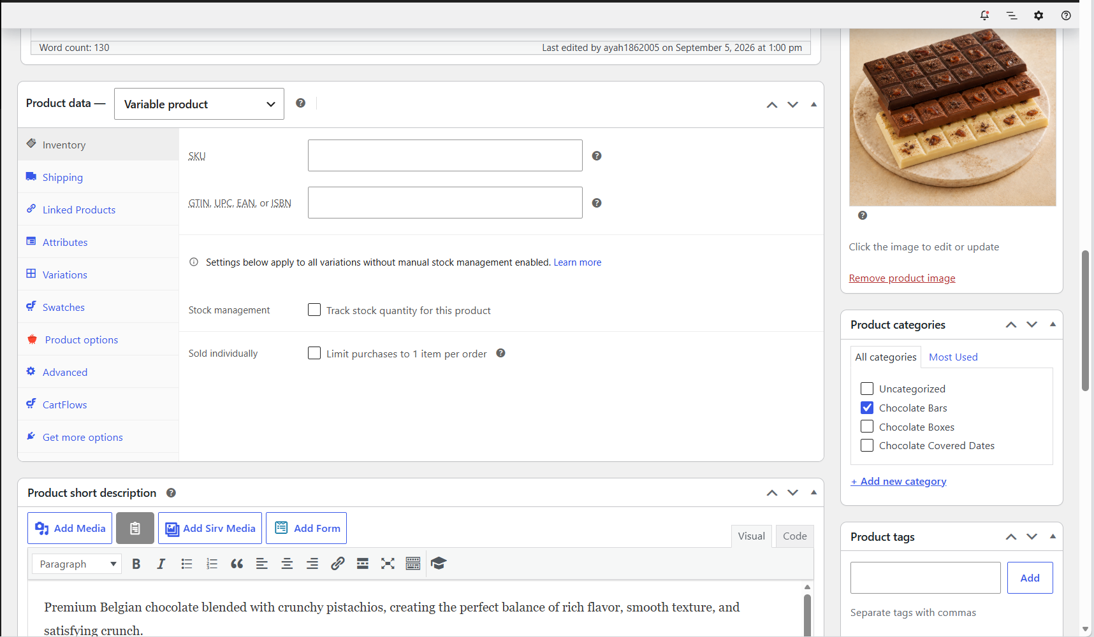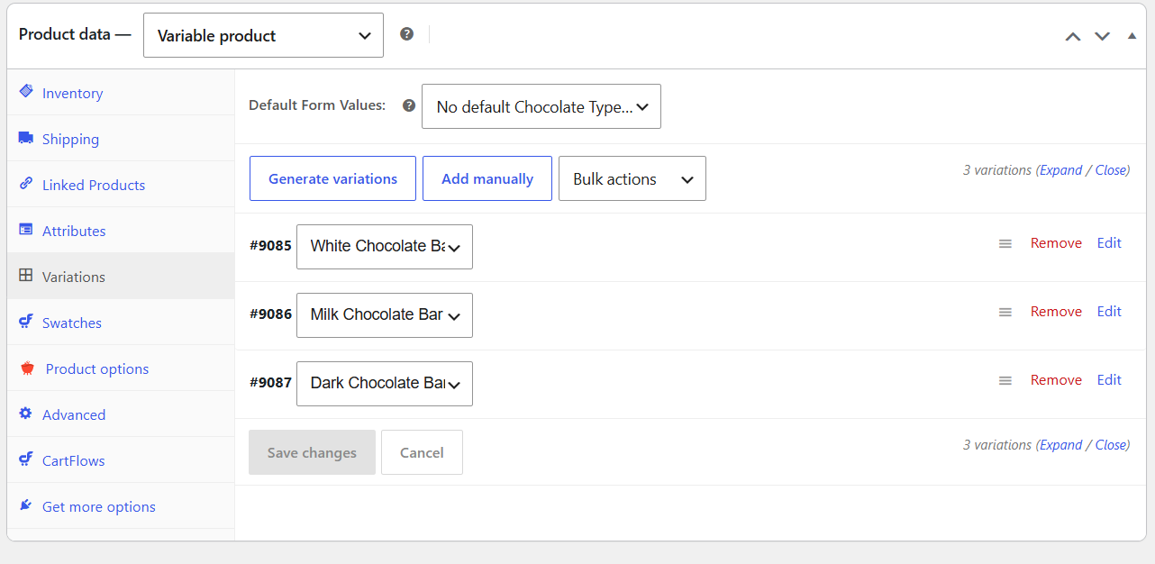  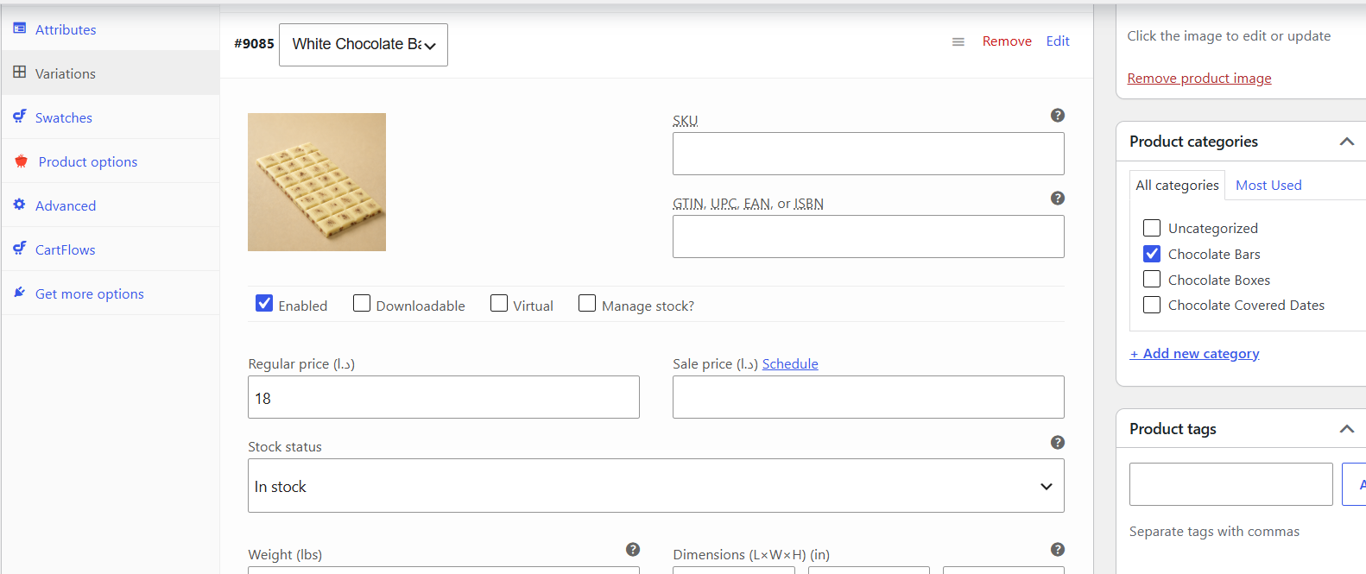  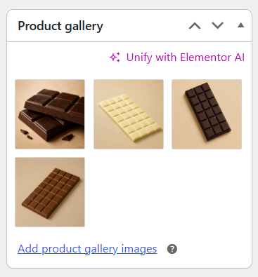
Categories | The admin should group the products into clear categories and customers should be able to browse products by category. | Categories were configured to organize the product catalogue and make it easier and faster for customers to find the type of chocolate they want. | 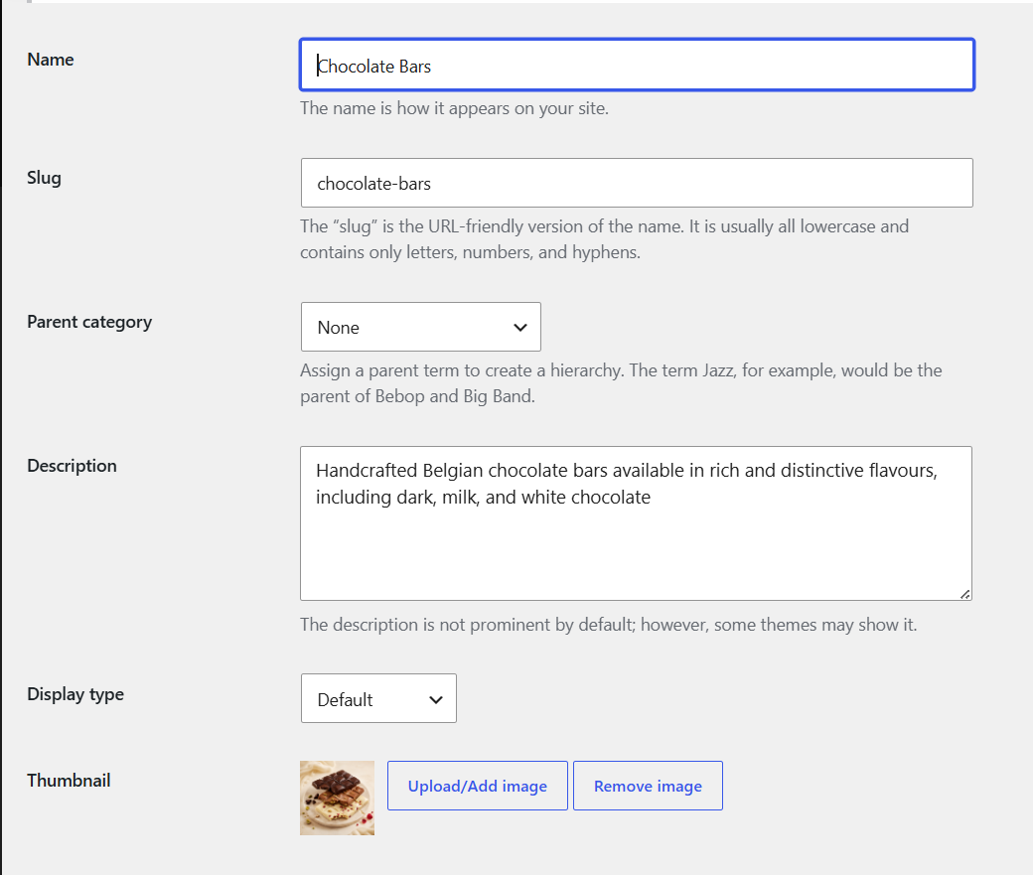  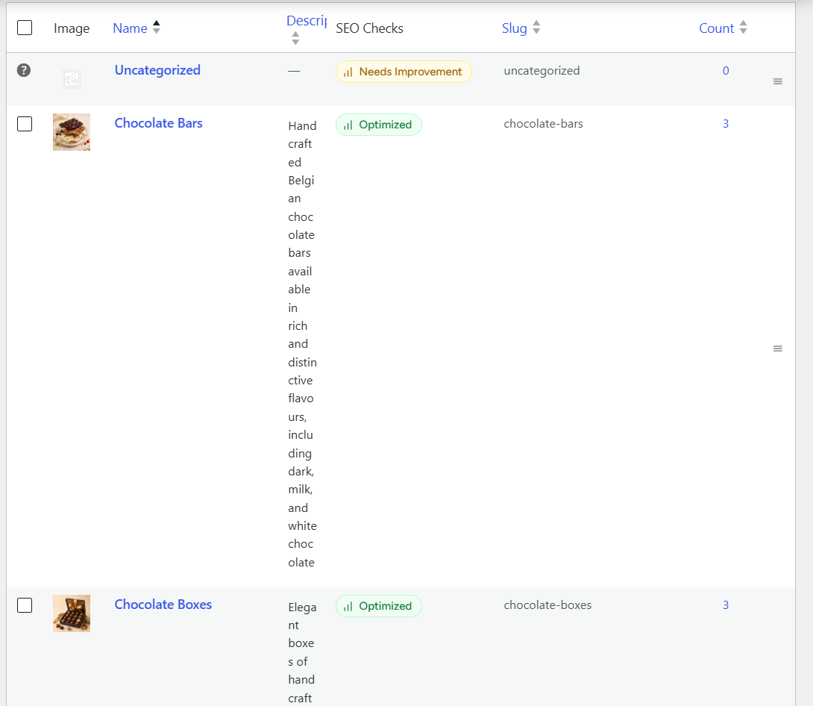
Shipping | The admin should add correct delivery option, and cost should be displayed according to the customer's delivery location. | Shipping was configured to provide clear delivery costs before order completion. This improves price transparency and supports Luxury Chocolate's requirement to deliver products to customers in different areas. | 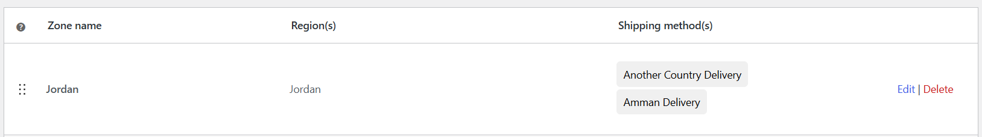  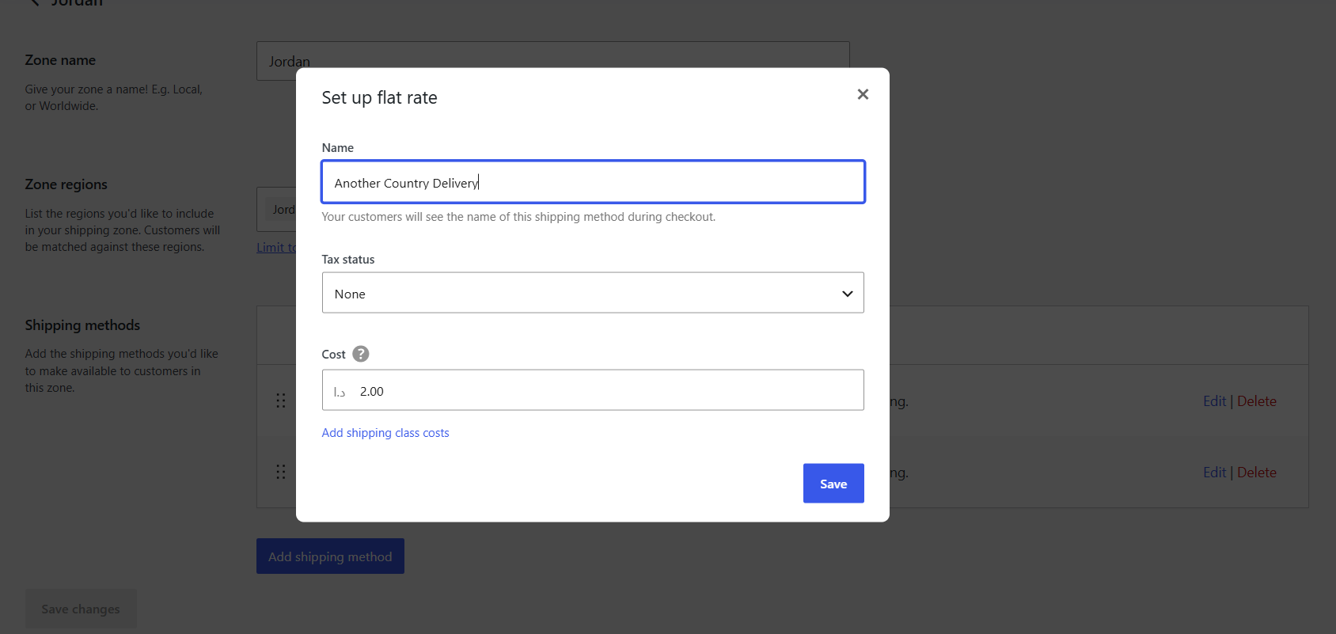
Payment | The admin should make the Customers able to select an available payment method during checkout. | Multiple payment options were configured to give customers flexibility. Cash on Delivery supports customers who prefer not to pay digitally, while online payment provides a convenient alternative. | 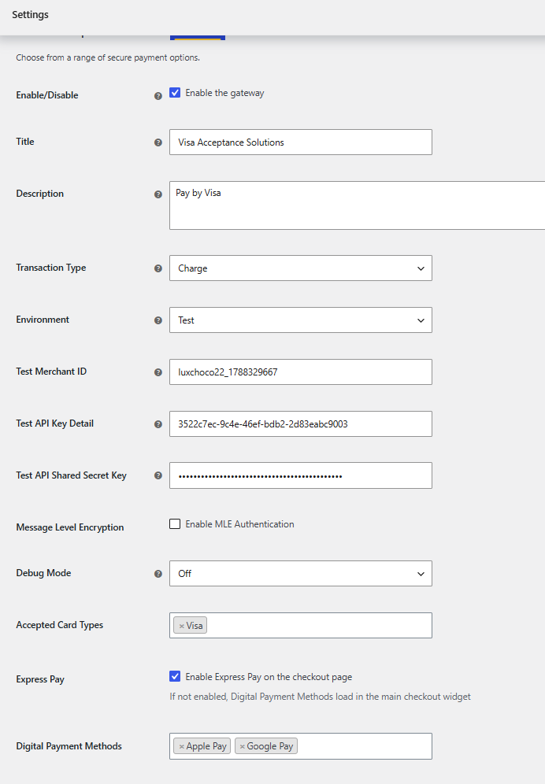
Checkout | The admin should make the Customers able to enter their details, view delivery costs, select a payment method and complete checkout as a guest or registered user. | Checkout was configured to make purchasing simple and accessible. Guest checkout reduces unnecessary registration steps, while registered customers can maintain an account and access their previous orders. | 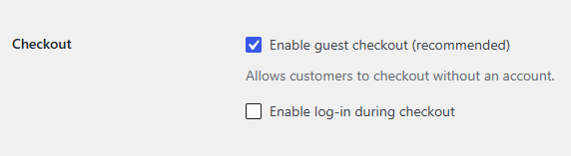
Orders | The admin should be able to view customer orders, check order details and update the order status. | Order management was configured so the business owner can monitor and process purchases efficiently and keep customers informed about the progress of their orders. | 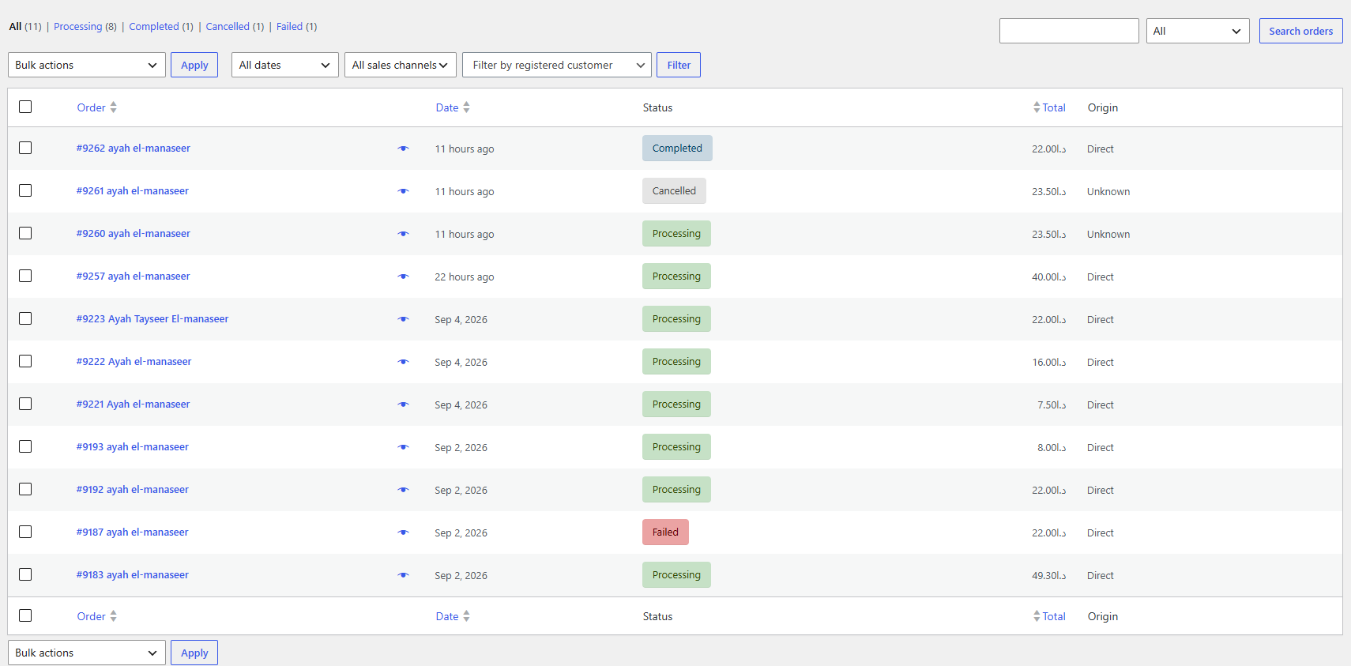  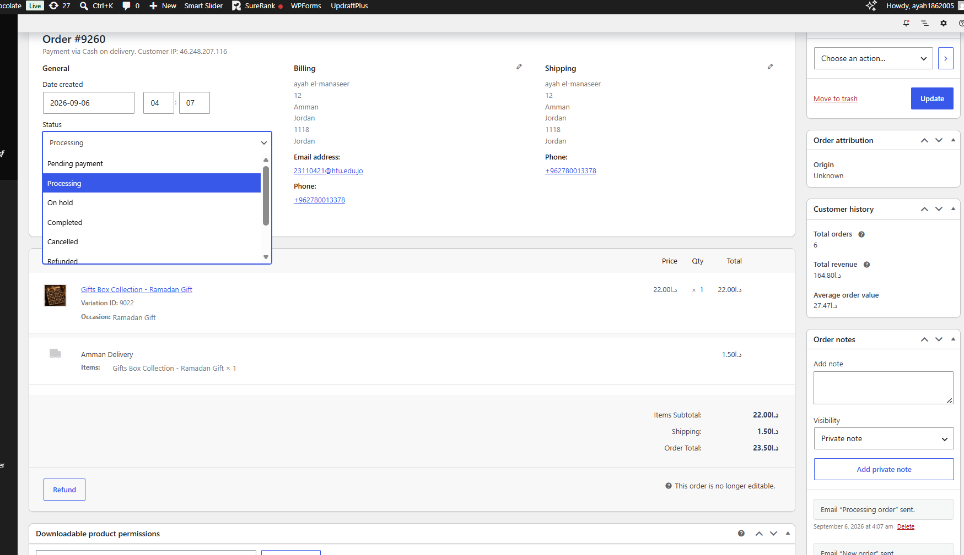

Critically Evaluate how successful the Luxury Chocolate ecommerce design is:
- Alignment with Business Objectives and Website Vision:
Business Objectives: The new website is also very well aligned with the previous business objectives as well as the overall vision of the website. The primary objective of this site was to make it possible for customers in Jordan to easily and safely buy high quality (premium) Belgian chocolate and custom gifts online. At the same time, increase sales, build the luxury chocolate brand name and encourage repeat customers to use the site again. The website is supportive of each of those objectives by having product categories, allowing customers to customize their products, have a feature that allows them to order online, display delivery information, allow customers to leave reviews about the company or its products, show promotional items available at all times, include features such as creating customer accounts and communicating directly with customers via "live chat" and "contact us" form. Also, the Client asked me to make this website to increase the revenue because her business was relied only on Instagram and Facebook DMs.

Website Vision: The website vision as an online store was to be one of the most trusted luxury online stores in all of Jordan offering beautiful, quality and customized chocolate boxes and bars. A reflection of that goal can be found throughout the site (luxury visual design, clear and detailed product photos, beautiful, customized chocolate boxes, customer reviews and ratings, price transparency, shipping/delivery clear info within the sticky delivery bar on all pages, secure check-out process, so therefore, the final product has been very successful at achieving the same goal of being able to provide a luxurious online shopping experience for consumers looking to purchase high-end chocolates. And by adding the feature of Customized your chocolate by names and flavor give the website Unique selling product within all the chocolate ecommerce in Jordan.

The application of SEO techniques on both the homepage and product pages was part of an effort to make the website more noticeable and recognizable online. Therefore, on each of these types of pages, various elements such asو keywords relating to products, page titles and meta tags, H1-H6 Headings (hierarchical), Internal Linking, Product Page SEO Checks have been included into this project. In addition to being able to help drive traffic to the site through search engine listings when customers are searching using terms including but limited to "Luxury Chocolate", "Customized Chocolate Boxes" because it is the Unique selling product, "Belgian Chocolate" in Jordan, it would also assist in establishing credibility for the company. Nevertheless, prior to the full potential of the completed SEO Work could be realized, additional improvements will need to be made regarding the Robots.txt file issue and connection with Google Search Console.

However, these improvements are still required to fully support this vision. The mobile slider should be optimized and visible because the target audience mainly uses smartphones and on the slider we focused on Coupons and The Customized Gift service.

- Alignment with Functional Requirements:
In general, the Luxury Chocolate web site has been able to meet most of the user and client functional requirements.

User: In general, the Luxury Chocolate web site has been able to meet most of the user and client functional requirements. The web site is able to allow users (customers) to browse categorized products, search for products by product names, display products based on a variety of filters, see product information, select different options, create customized gift boxes, add/remove items from their carts, use coupon codes, make purchases as guests or with registered accounts, calculate and pay for delivery write product reviews and communicate directly with the company using either the "Live Chat" function located on the home page or send e-mail messages to the company via the "Contact Us" link, and preview how much the customer will save when an item has an offer on it.

Client: The website is for the customer (the company's owner & administrator) as well.
The site will allow the business owner to work with products and their price, images, categories, various product options, inventory, orders, payments, shipping, discount coupons, consumer comments, live chats, approve the reviews, answer for the messages from Contact Us, and change the order statues and send an email for the customer based on the statues.

Although some of the requirements that were planned in advance have been partially met. The product name search feature works, however, the category name search feature does not. Therefore, users can view all products within the same category by using filter options. The slider on the home page will also not fit properly on mobile and tablet screen formats. Thus, a responsive design for the slider specifically designed for use with smartphones would need to be developed since the target audience primarily uses their smart phone.

Customers may also see their past purchases and the current status of those purchases, however, once a customer has made an order, the user is unable to cancel that order or make changes to it after placement the order. Also, the user cannot initiate a return because it is a food product and returns this type of product is not allowed within the Luxury Chocolate policy. The company could allow for these options as part of the process in the future to provide the customer with more control over the user purchase and to minimize the number of manual communications between the business and the customer.

There were a few successes with the overall SEO implementation. Title tags, meta-descriptions, headings, internal linking, and product optimization have been done well. But SureRank's crawl audit revealed that our current robots.txt file is blocking crawlers from search engines, and our Search Console account has never been set up. Therefore, before we go live commercially, it would be good to move the site to the correct production environment, enable crawling and connect Search Console so the SEO efforts will actually improve how visible the site is on Google.

The implementation was very successful as all of the major planned use cases for users, clients and business requirements were met (except in a few minor areas). Most importantly, the main shopping, customization, cart, checkout, product review and admin functionality worked properly. There were a few limitations that were largely to do with the technical side of things such as: setting up an additional payment method, making the slider responsive on mobile devices, improving the search function, adding after post order functionality, and enhancing Search Engine Optimization (SEO) settings.

References
Bhandari, R., 2023. Jordan Confectionery Market (2025-2031) | Value, Revenue, Industry, Trends, Outlook, Size, Companies, Analysis, Growth, Forecast & Share. [Online]
Available at: https://www.6wresearch.com/industry-report/jordan-confectionery-market-2020-2026?utm_source=chatgpt.com
[Accessed 4 9 2026].
ECDB, 2026. E-Commerce Industry in Jordan. [Online]
Available at: https://ecdb.com/resources/sample-data/market/jo/all#market-size-and-growth
[Accessed 4 9 2026].
Kemp, S., 2025. Digital 2026: Jordan. [Online]
Available at: https://datareportal.com/reports/digital-2026-jordan?utm_source=chatgpt.com
[Accessed 4 9 2026].

