Docker lab 2
1- Run a container nginx with name my-nginx and attach a and attach a volume 2 volumes
- Volume1 for containing static html file
- Volume2 for containing nginx configuration
Edit the html content
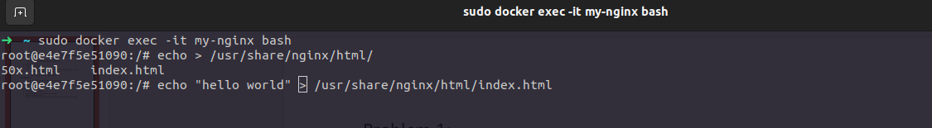
Remove the container
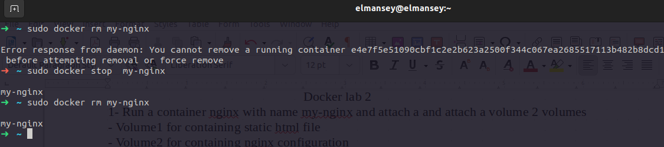
2- Run a new 2 containers with the following:
§ Attach the 2 volumes that was attached to the previous container in two
different ways (volume mount – bind mount)
§ Map port 80 to port 8080 on you host machine
§ Access the html files from your browser

volume mount
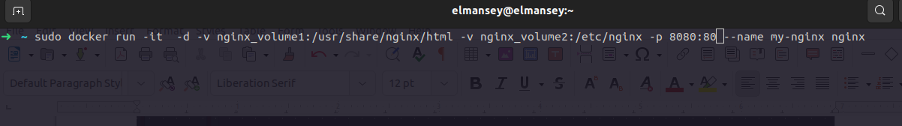
bind mount
