Docker – lab 1

1- Run the container hello-world
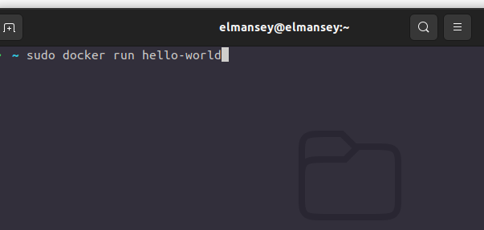
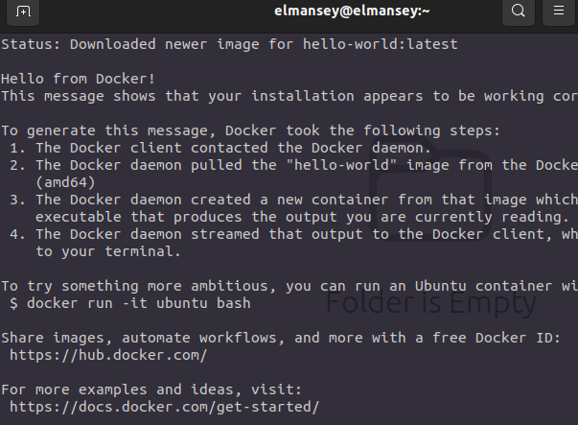

2-Check the container status
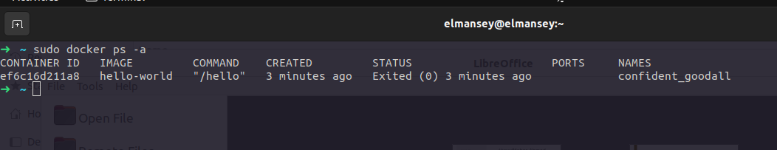
3-Start the stopped container
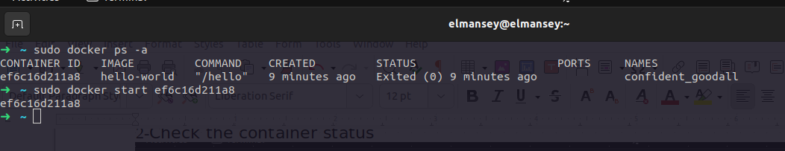
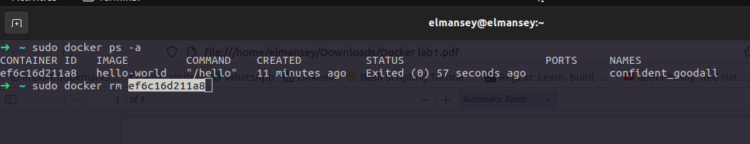
4-Remove the container

5-Remove the image
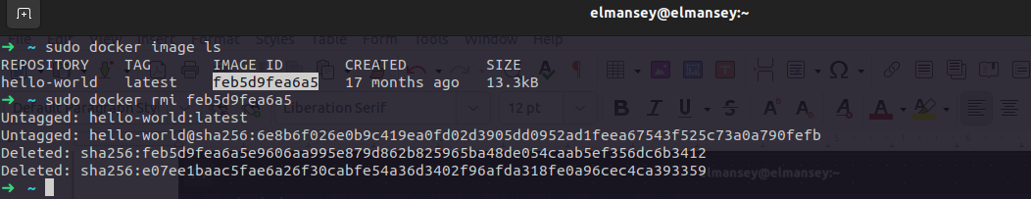
6-Run container centos or ubuntu in an interactive mode
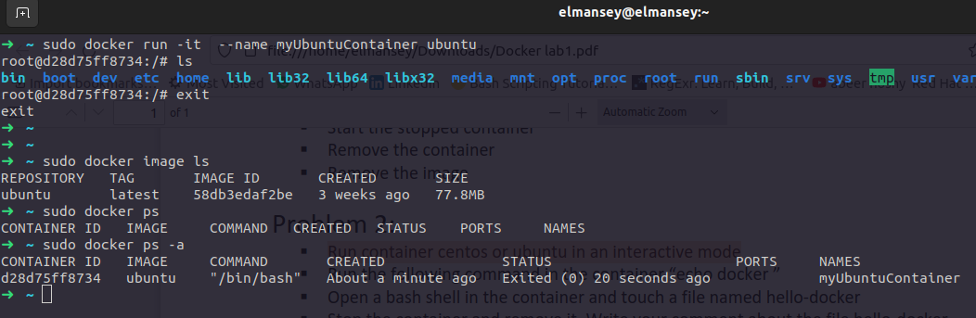

7-Run the following command in the container “echo docker ”
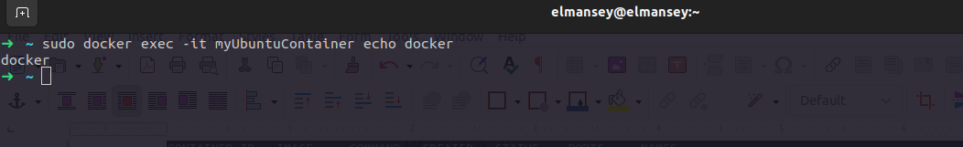
8-Open a bash shell in the container and touch a file named hello-docker
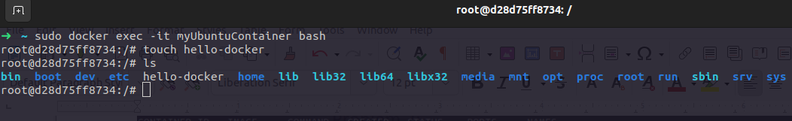
9-Stop the container and remove it. Write your comment about the file hello-docker
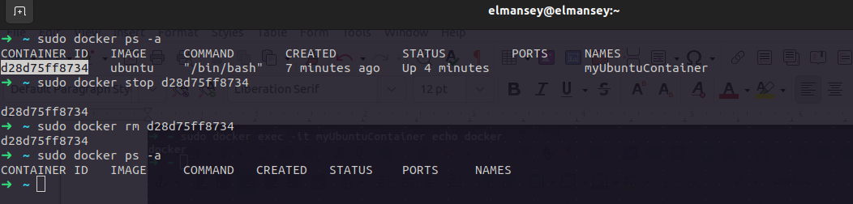
10-Remove all stopped containers
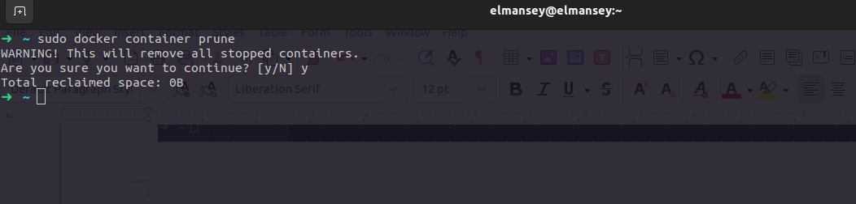
11-Deploy a MySQL database called app-database.
Use the mysql latest image, and use the -e flag to set MYSQL_ROOT_PASSWORD to P4sSw0rd0!. The container should run in
the background.
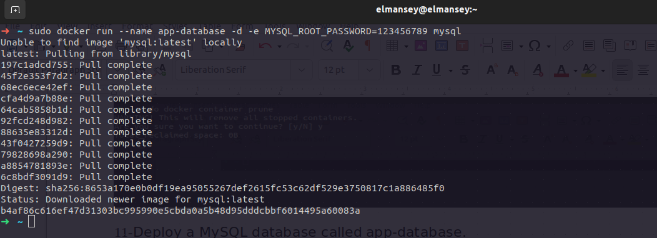
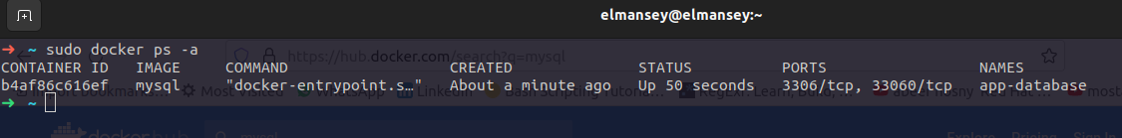

12-Run the image Nginx
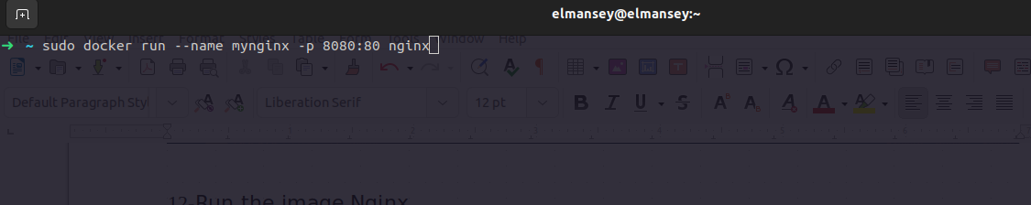

13-Add html static files to the container and make sure they are accessible
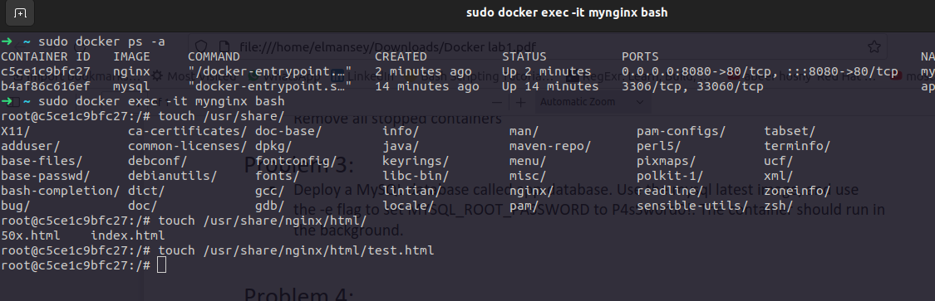
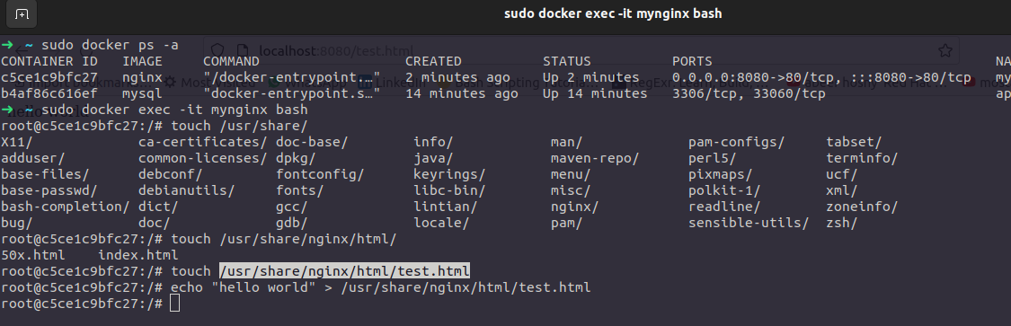
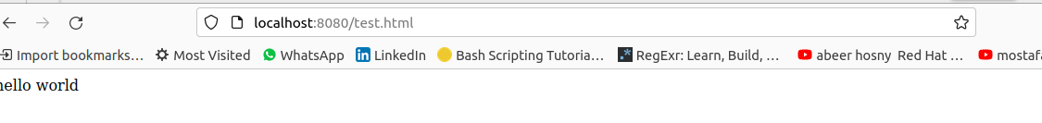
14-Commit the container with image name IMAGE_NAME
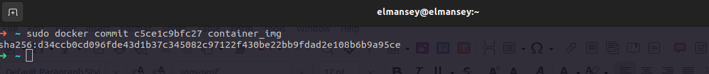

15- Run a container Nginx with name mynginx and attach a volume for containing static html file

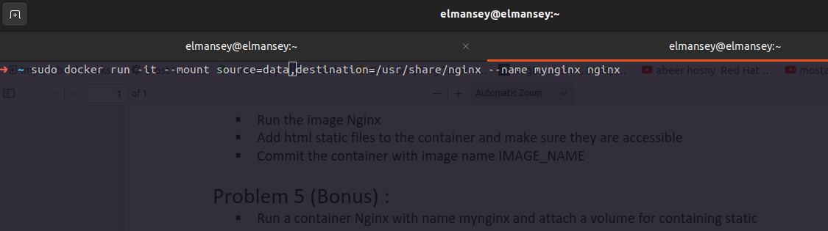
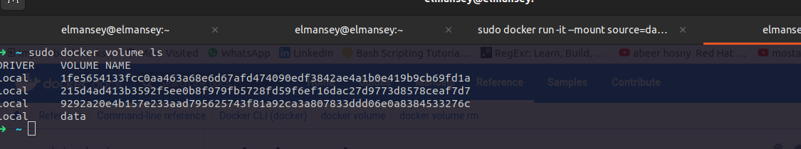
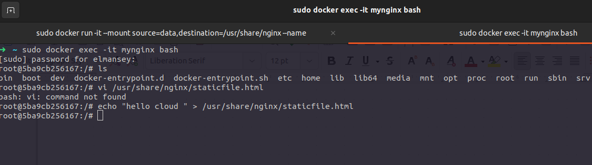

17-Remove the container

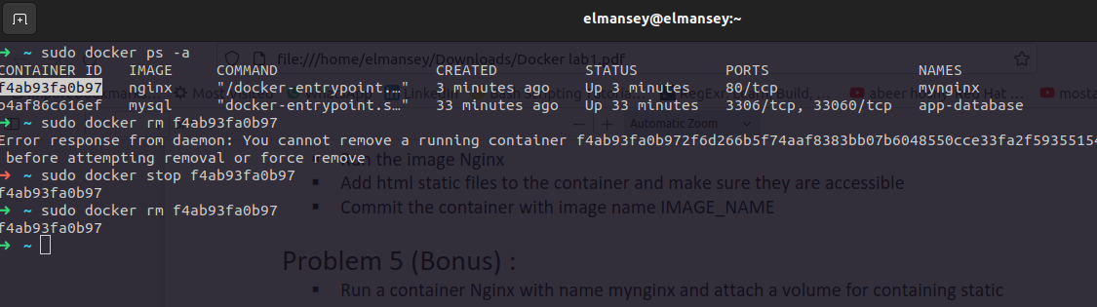
18-
Run a new container with the following:
§ Attach the volume that was attached to the previous container
§ Map port 80 to port 9898 on you host machine
§ Access the html files from your browse

