Docker lab 2
1- Run a container nginx with name my-nginx and attach a and attach a volume 2 volumes
- Volume1 for containing static html file
- Volume2 for containing nginx configuration
Edit the html content
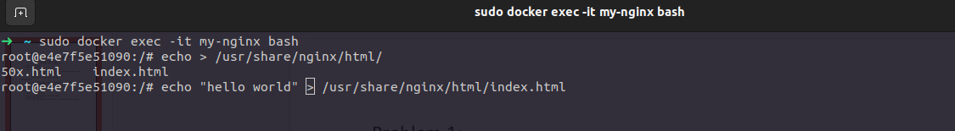
Remove the container
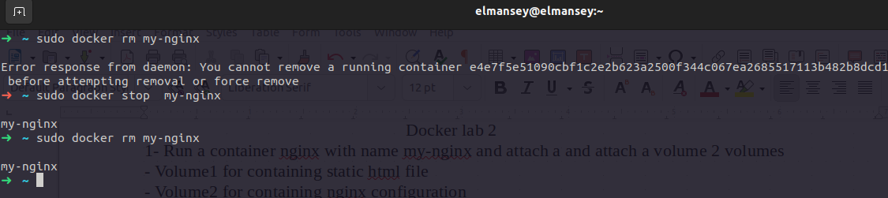
2- Run a new 2 containers with the following:
§ Attach the 2 volumes that was attached to the previous container in two
different ways (volume mount – bind mount)
§ Map port 80 to port 8080 on you host machine
§ Access the html files from your browser

volume mount
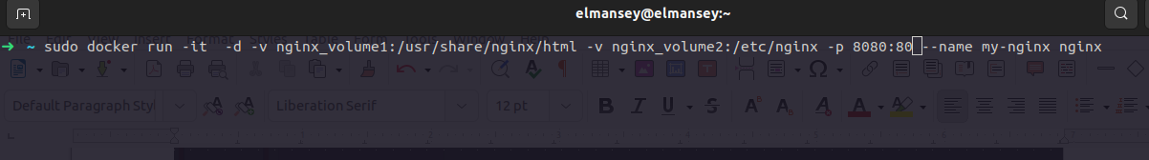
bind mount
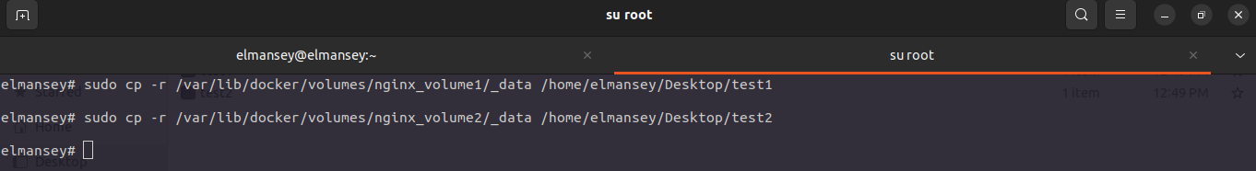
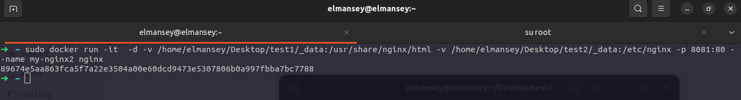
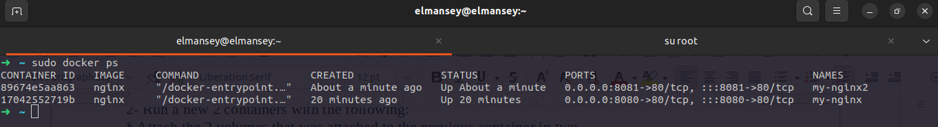
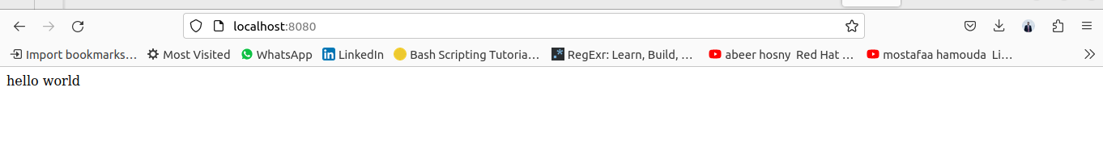
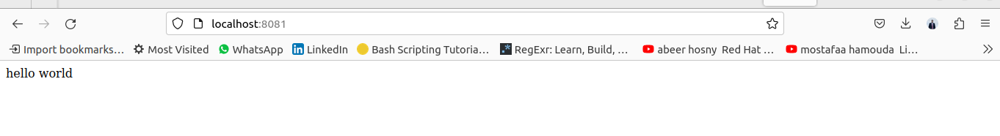
2- Create a dockerfile for nginx image with different html content and different nginx conf
that listen to port 8080 instead of port 80 on the container
Create container from the new \image
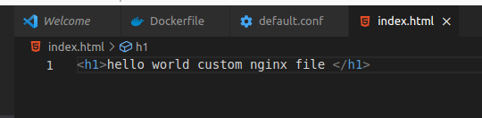

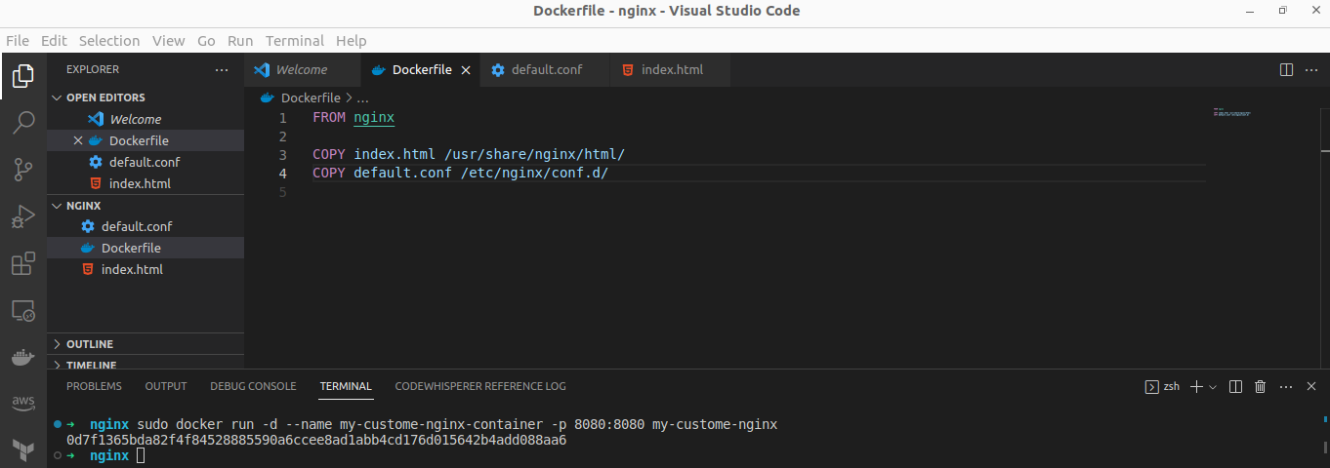
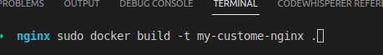

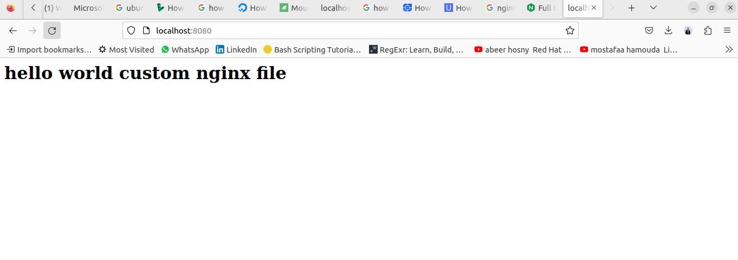
3-Create a reactjs simple app
Create a dockerfile to containerize the reactapp
Build the image and test it
(Bonus) create a dockerfile for the same app in smaller size using multi staging
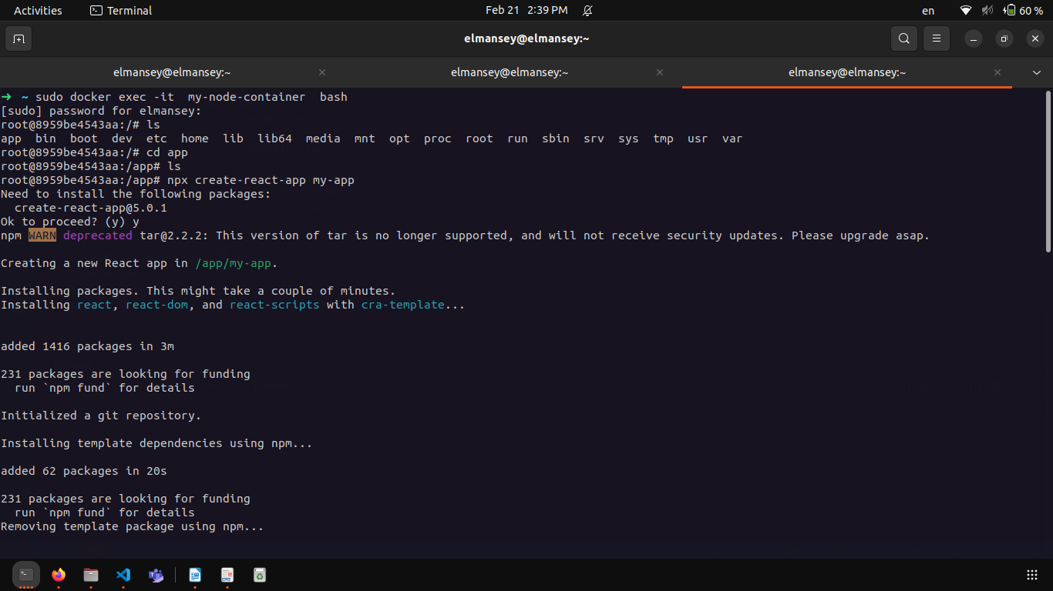

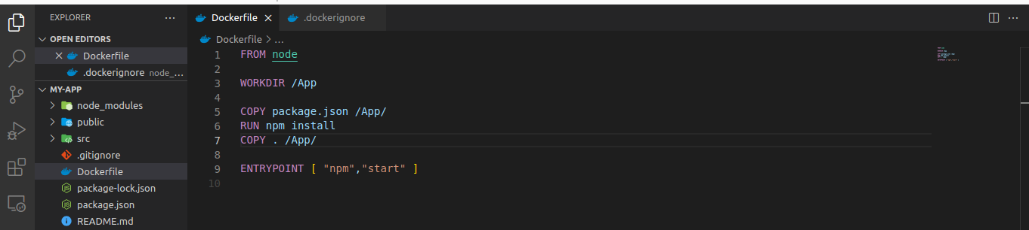
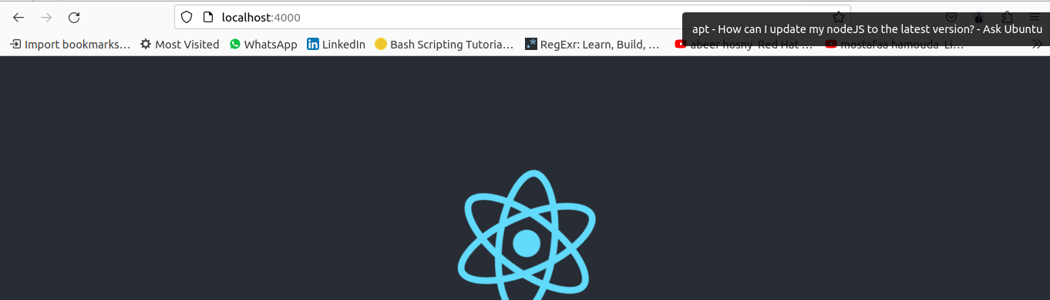
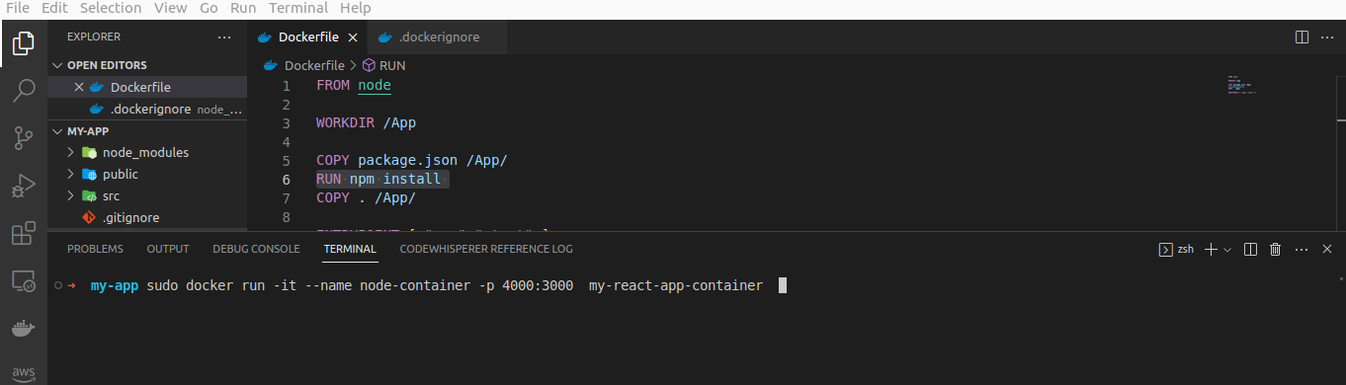

bounes

