Docker 3

1- Create a reactjs simple app
- Create a dockerfile to containerize the reactapp
- Build the image and test it
- create a dockerfile for the same app in smaller size using multi staging

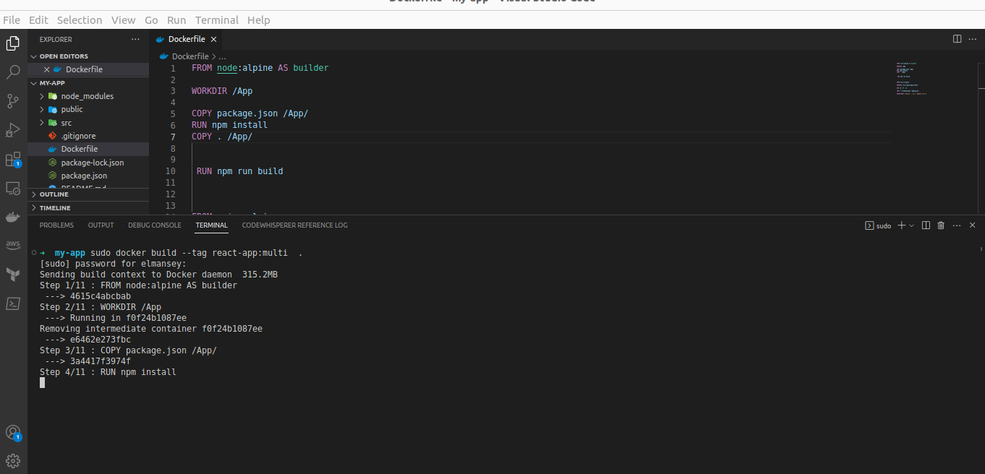

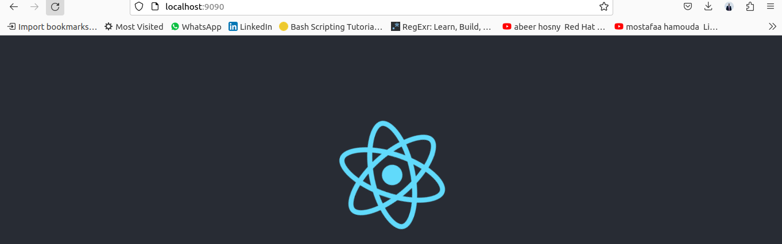

2-Create a dockerfile for ubuntu image which sleeps by default for 5 sec or sleeps
according to the given number in the docker command

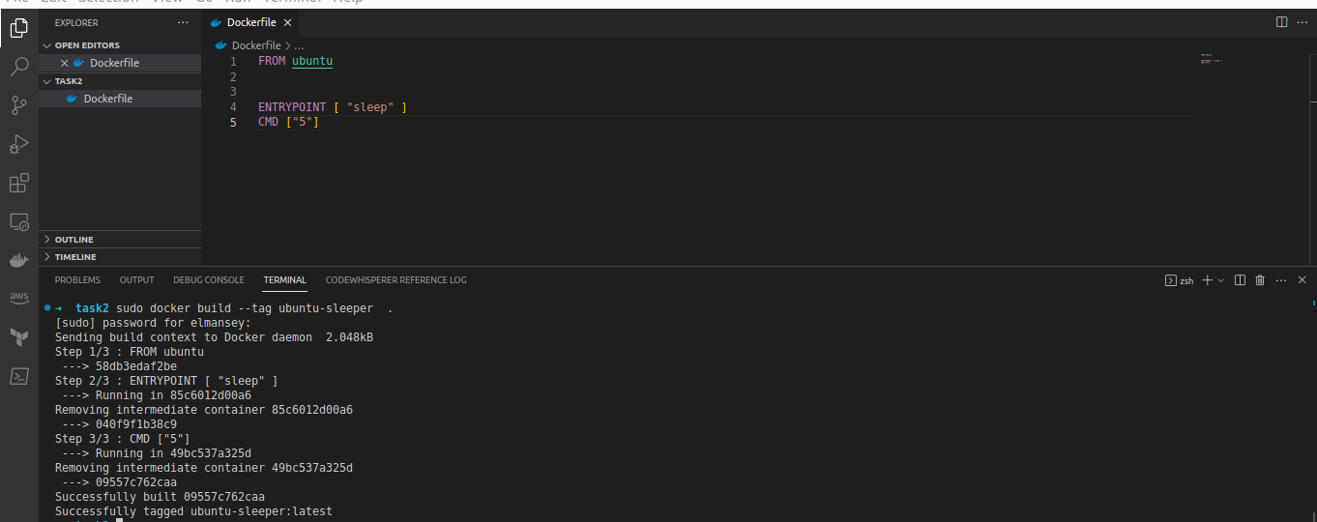

3-Push the images created in Problem 1&2 into your docker hub repo

react-app
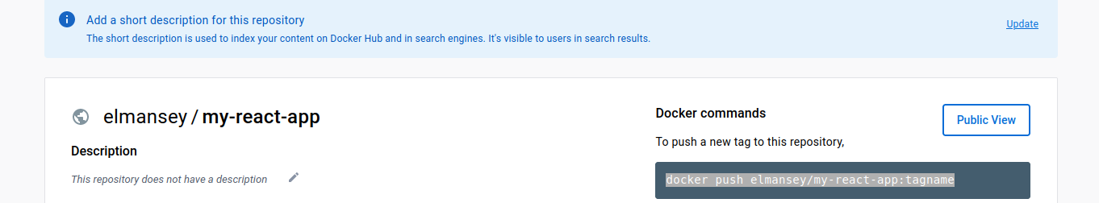

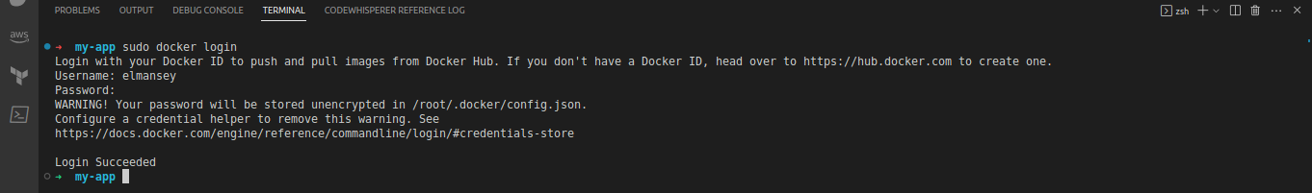

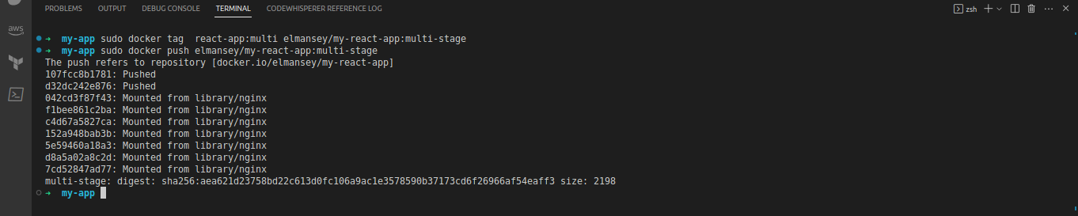
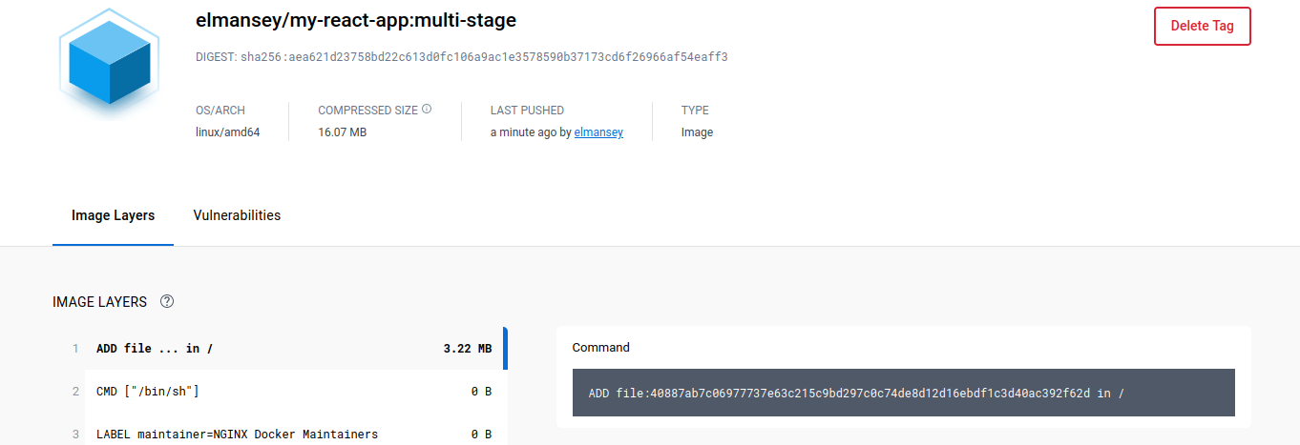

upuntu-app
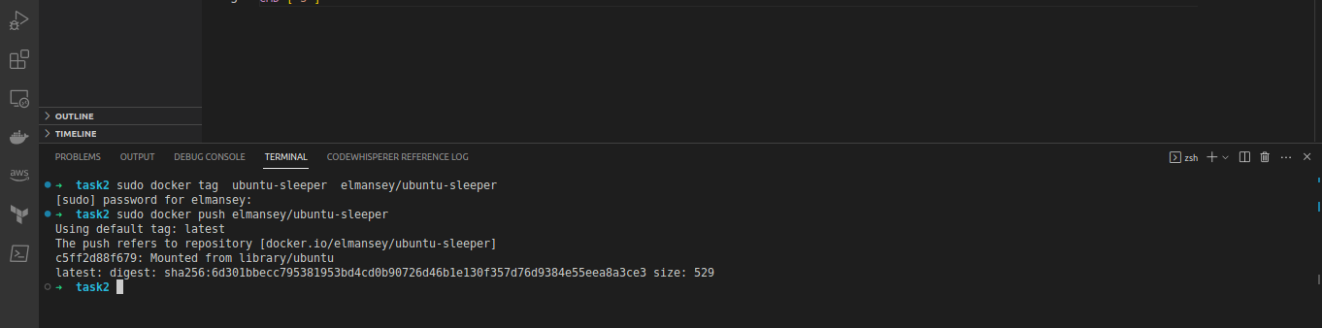

3-Create 2 nginx containers with network type bridge, enter to one of them and use curl command to view the ccontent of the other container

