TDP-43 knockdown is associated with reduced store-operated Ca²⁺ entry and altered calcium-regulatory RNA profiles in SH-SY5Y cells
Elmasnur Yılmazᵃ, Yasemin Eraçᵃ,*
ᵃ Department of Pharmacology, Faculty of Pharmacy, Ege University, Erzene Mahallesi, Ankara Caddesi No: 172/98, 35040 Bornova, İzmir, Türkiye
* Corresponding author: Yasemin Eraç, yasemin.erac@ege.edu.tr

Abstract
TDP-43 loss is implicated in amyotrophic lateral sclerosis (ALS), but its relationship to store-operated Ca²⁺ entry (SOCE) is unclear. After shRNA-mediated TARDBP depletion in SH-SY5Y cells, TRPC1, STIM1, ORAI1 and ATP2A3 mRNAs increased 1.7- to 3.2-fold, while the Fura-2 Ca²⁺-readdition amplitude was 84% lower after knockdown (n = 3 independent cultures; Welch’s t-test p = 0.035). ER Ca²⁺ release was 33% lower (p = 0.31), and readdition normalised to each culture’s own release remained 77% lower. At 48 h, the WST-1 signal was 38.5% lower (n = 4). We reanalysed six public TDP-43-depletion RNA-seq comparisons (38 libraries) for calcium-regulatory expression and splicing, screened eleven comparisons for unannotated junction changes, and assessed alternative polyadenylation and nonsense-mediated decay. CBARP was the most reproducible splicing candidate across species, whereas STIM2, STIMATE and ORAI3 events were supported in the primary RNA-seq model. No confirmed RNA-processing event in the core SOCE machinery explained the functional change. In ALS tissue, TRPC1 and SARAF increased and CBARP decreased in six brain regions, and SARAF and CBARP changed in the same direction in cervical and lumbar cord, but these tissue associations could not be attributed to TDP-43 loss. TDP-43 knockdown is associated with reduced SOCE and altered calcium-regulatory RNA profiles, without evidence for a single causal RNA event.
Keywords: TDP-43; store-operated Ca²⁺ entry; calcium homeostasis; alternative splicing; CBARP; SARAF; amyotrophic lateral sclerosis

1. Introduction
TAR DNA-binding protein 43 (TDP-43, encoded by TARDBP) is a ubiquitously expressed RNA-binding protein that governs splicing, transcript stability and transport. Nuclear clearance with cytoplasmic accumulation of TDP-43 is found in approximately 97% of amyotrophic lateral sclerosis (ALS) cases and about half of frontotemporal lobar degeneration cases (Neumann et al., 2006; Arai et al., 2006; Ling et al., 2013), and in limbic-predominant age-related TDP-43 encephalopathy (Nelson et al., 2019), making TDP-43 dysfunction one of the few molecular events shared across otherwise distinct neurodegenerative syndromes.
The principal consequence of nuclear TDP-43 loss is failure to repress cryptic splicing. The best-characterised targets, STMN2 and UNC13A (Ling et al., 2015; Klim et al., 2019; Melamed et al., 2019; Brown et al., 2022; Ma et al., 2022), are now the basis of antisense oligonucleotide strategies (Baughn et al., 2023; Keuss et al., 2024), establishing that TDP-43-dependent mis-splicing is both measurable and, in principle, correctable. This has motivated systematic searches for further TDP-43-dependent RNA processing events with functional consequences.
Disturbed intracellular Ca²⁺ homeostasis is a longstanding feature of ALS. Vulnerable motor neurons are notable for low cytosolic Ca²⁺-buffering capacity (Grosskreutz et al., 2010), and Ca²⁺-dependent excitotoxicity, mitochondrial dysfunction and endoplasmic reticulum (ER) stress have all been implicated. Store-operated Ca²⁺ entry (SOCE), the STIM1/ORAI-mediated influx triggered by ER store depletion (Putney, 2010; Prakriya and Lewis, 2015), with contributions from canonical transient receptor potential (TRPC) channels (Ambudkar et al., 2007), is a principal route of Ca²⁺ entry in non-excitable and many excitable cells, and in a human neuroblastoma cell line it depends on TRPC1 (Selvaraj et al., 2012). STIMATE promotes the conformational switch that activates STIM1 (Jing et al., 2015); ORAI2 and ORAI3 can form heteromers with ORAI1 and restrain SOCE (Vaeth et al., 2017; Yoast et al., 2020), and SARAF facilitates slow Ca²⁺-dependent inactivation of SOCE (Palty et al., 2012) and, in SH-SY5Y cells, restrains store-independent arachidonate-regulated Ca²⁺ entry (Albarran et al., 2016). Disease-associated TDP-43 has been reported to disrupt VAPB–PTPIP51 tethering and thereby ER–mitochondrial Ca²⁺ transfer (Stoica et al., 2014), but whether TDP-43 loss affects the SOCE pathway itself, and whether it does so through RNA processing, has not been examined systematically.
We first measure SOCE and target mRNAs after shRNA-mediated TDP-43 depletion in SH-SY5Y cultures. We then use public RNA-seq datasets to examine calcium-regulatory transcript abundance and RNA processing, applying read-support and robustness checks to the splicing results. Finally, we assess how the candidate transcripts behave in ALS brain and selected neurological comparison cohorts.

2. Materials and Methods

2.1 Public RNA-seq datasets
Six comparisons with paired controls and publicly available raw reads were selected for the expression and event-level splicing analyses: SH-SY5Y (GSE296712), induced pluripotent stem cell (iPSC) colonies (GSE230647, bulk CTRL KD/TDP-43 KD arm, 4 + 4 libraries; Hruska-Plochan et al., 2024), iPSC-derived motor neurons (GSE77702; Kapeli et al., 2016), mouse striatum (GSE27394/GSE27218; Polymenidou et al., 2011), and mouse C2C12 and NSC34 (GSE171714/SRP314028; Šušnjar et al., 2022), comprising 38 libraries in total and counting the pooled technical fragments of GSE27394 as one library per biological replicate. Two further comparisons, K562 total RNA and poly(A)+ mRNA (ENCODE ENCSR372DZW/ENCSR455TNF and ENCSR129RWD/ENCSR134JRE; Van Nostrand et al., 2020), were added for the annotation-free junction analysis only (Section 2.5) and were not processed with rMATS or DESeq2. Inclusion required a condition reducing TARDBP expression or TDP-43 protein, at least two biological replicates and open raw reads, and for the human datasets the ability to evaluate STMN2 and UNC13A as positive controls. TDP-43-repressed cryptic exons are largely not conserved between species (Ling et al., 2015), and the STMN2 and UNC13A events are absent from the mouse genes (Melamed et al., 2019; Ma et al., 2022), so the mouse comparisons have no equivalent literature positive control. GSE296712, a subseries of the dataset reported by Bryce-Smith et al. (2025), was designated the primary human model because the laboratory experiments use the same cell line.
Reads were downloaded with NCBI SRA Toolkit v3.2.1 (NCBI, 2025), quality-assessed with FastQC v0.12.1 (Andrews, 2010), trimmed with Trim Galore v0.6.11 (Cutadapt v5.2, Martin, 2011; Illumina TruSeq adapter auto-detected, Phred Q20, minimum length 20 bases) and aligned with HISAT2 v2.2.2 (Kim et al., 2019) in --dta mode with a known-splice-site file, to the GRCh38 primary assembly or, for mouse data, to the mm10 index distributed with HISAT2. GENCODE v47 (basic annotation) and vM25 (Frankish et al., 2019) were used for read counting and for junction annotation. The transcript-level quantification of Section 2.4 uses the comprehensive GENCODE v47 annotation. Alignments were sorted and indexed with SAMtools v1.23 (Danecek et al., 2021) and summarised with MultiQC v1.25.1 (Ewels et al., 2016). The junction and coverage analyses of Sections 2.5 and 2.7 were run with SAMtools v1.21. Library strandedness was determined per dataset and rMATS was re-run accordingly (fr-secondstrand for SH-SY5Y; fr-firststrand for iPSC colony, iPSC-MN and mouse single-end).
The public SH-SY5Y subseries used a doxycycline-inducible knockdown assessed after approximately 10 days of induction; it is distinct from the constitutive shRNA cultures used for the laboratory assays.
For GSE27394, two technical sequencing fragments (SRR107072, SRR107073) showed lower alignment rates; these are fragments of the same biological replicate and counts were pooled within biological replicates, yielding four control and four knockdown replicates.

2.2 Differential expression
Gene counts were generated with featureCounts v2.1.1 (Liao et al., 2014) at meta-feature level against the same annotation (-s 0 -g gene_name, with -p --countReadPairs for paired-end libraries; multi-mapping and multi-overlapping reads not counted) and modelled with DESeq2 v1.42.1 (Love et al., 2014) within each dataset, with Benjamini–Hochberg correction (Benjamini and Hochberg, 1995). Genes with p_adj < 0.05 and |log2FC| ≥ 1 were called differentially expressed. Sensitivity to unmodelled variation was assessed with svaseq (sva v3.50.0; Leek, 2014); the principal findings were unchanged.

2.3 Alternative splicing and robustness assessment
Splicing was quantified with rMATS Turbo v4.3.0 (Shen et al., 2014) with --novelSS for skipped exons, alternative 5′ and 3′ splice sites, mutually exclusive exons and retained introns, using both junction-count (JC) and junction+exon-body (JCEC) models. Events were called at a false discovery rate (FDR) < 0.05 with an absolute change in percent spliced in (|ΔPSI|) ≥ 0.10.
Because rMATS applies FDR correction across all events irrespective of read support, we additionally applied a coverage pre-filter before correction, retaining events with ≥ 10 informative reads per sample on average and ≥ 5 informative reads in every sample, and recomputing Benjamini–Hochberg q-values within the filtered set. For the TRPC1 event of Section 3.3, and for the events that met the thresholds and the coverage criteria in the twelve core entry components (STIM1, STIM2, STIMATE, SARAF, CRACR2A, CRACR2B, ORAI1–3, TRPC1, ATP2A2 and ATP2A3), we further computed (i) per-replicate PSI from raw inclusion and skipping junction counts (IJC/SJC), (ii) replicate-level bootstrap 95% confidence intervals for ΔPSI (20,000 resamples for the TRPC1 analysis of Section 3.3; 10,000 for the SOCE candidate events of Section 3.4), and (iii) leave-one-out ΔPSI, removing each replicate in turn. Group assignment (b1 = knockdown, b2 = control) was verified from the labelled group files of GSE27394. Exon coordinates taken from rMATS output are reported here as 1-based, inclusive intervals. For the 24-nucleotide STIM2 exon whose inclusion produces STIM2.1 (Section 3.5), the rMATS ΔPSI of the six datasets were combined by fixed-effect inverse-variance meta-analysis; the variance of each estimate was the between-replicate variance of PSI divided by the number of replicates, summed over the two groups; heterogeneity was assessed with Cochran’s Q and I² (Supplementary Table S15).
Detection power was estimated by simulation over the observed coverage distribution for a 3 + 3 design.

2.4 Isoform usage
Transcript-level quantification used Salmon v1.11.4 (Patro et al., 2017) against an index built from the comprehensive GENCODE v47 transcript set (384,354 transcripts). Transcript estimates were aggregated to genes with the transcript-to-gene map of the same comprehensive annotation. The map of the basic annotation covers only 157,588 of those transcripts and would discard 26% of the transcripts per million at the aggregation step, so it was not used for any gene-level summary. Differential isoform usage was assessed with IsoformSwitchAnalyzeR v2.6.0 (Vitting-Seerup and Sandelin, 2019), DRIMSeq v1.34.0 (Nowicka and Robinson, 2016) and stageR v1.28.0 (Van den Berge et al., 2017), including prediction of open reading frames, premature termination codons, sensitivity to nonsense-mediated decay (NMD) and protein-domain consequences. As an annotation-independent comparison, LeafCutter v0.2.9 (Li et al., 2018) was run on the same alignments, and SUPPA2 v2.3 (Trincado et al., 2018) was run on the three control and three 75 ng/mL libraries as a check of method concordance.

2.5 Annotation-free junction-level analysis
Splice junctions were extracted directly from the alignments in two independent ways, so that no conclusion rests on a single extraction rule. The first set was produced with regtools v1.0.0 (Cotto et al., 2023; junctions extract -s XS -a 8 -m 50 -M 1000000). The second was produced with an in-house extractor that parses N operations from the CIGAR string and additionally requires a mapping quality (MAPQ) ≥ 30, primary non-duplicate alignment, an 8 bp matched anchor on both sides, and an intron length between 50 and 500,000 bp. Junctions are reported as 1-based, intron-inclusive intervals. On the primary SH-SY5Y comparison the two raw sets share 217,550 junctions, counted before strand-independent merging and before the read-support filters below; the sets differ in size because regtools applies no mapping-quality threshold and admits longer introns. All eleven comparisons were run on the regtools set; the SH-SY5Y comparison was run on both, and every conclusion drawn from it holds in each.
Junctions were classified against GENCODE v47 (human) or vM25 (mouse) as annotated, novel combination (both splice sites annotated, the junction not), novel site (one site unannotated), or fully novel. Local splicing variations (LSVs) were defined by shared donor and by shared acceptor, and the share of an LSV’s reads carried by each junction defined its percent-spliced-in (Vaquero-Garcia et al., 2016). Differences between groups were tested with a beta-binomial likelihood-ratio test using a dataset-wide overdispersion parameter chosen by profile likelihood, with Benjamini–Hochberg correction across all tested junctions, and replicate-level bootstrap 95% confidence intervals (2,000 resamples). An LSV required at least 20 reads per sample on average and non-zero coverage in every sample; a junction required at least 5 reads in at least one sample.
The calling threshold was calibrated against a control-versus-control null: in datasets with four control replicates, the controls were split 2 + 2, the analysis repeated unchanged, and every call counted as a false positive. The permissive definition required an unannotated junction, ΔPSI ≥ 0.05, q < 0.05, control PSI ≤ 0.05 and a bootstrap lower bound above zero (Supplementary Table S14). Because this definition produced about as many split-control calls as real calls, or more (Section 3.5), we adopted an effect-based definition: a high-confidence unannotated splicing change requires a novel splice site, ΔPSI ≥ 0.20, q < 0.05, a bootstrap lower bound above 0.05, at least 20 reads in the knockdown group, and non-zero counts in every knockdown replicate. A requirement of zero counts in controls was deliberately not imposed, because it removes genuinely cryptic exons with basal leakiness, STMN2 among them. Positive-control recovery, not call count, is used throughout as the measure of whether an analysis worked; because the sixteen literature controls are human cryptic events, this check is available only for the human comparisons.
Eleven comparisons were analysed: SH-SY5Y at 75 and at 25 ng/mL doxycycline, iPSC colonies, iPSC-derived motor neurons with TDP-43, FUS or TAF15 knockdown, K562 total RNA and poly(A)+ mRNA, C2C12, NSC34, and mouse striatum. For mouse striatum, technical sequencing fragments were pooled within biological replicates, giving four per group.

2.6 Aberrant splicing outlier detection
FRASER v1.14.1 (Mertes et al., 2021) was run on the nine-sample SH-SY5Y doxycycline series (0, 25 and 75 ng/mL), counting split and non-split reads from the alignments and modelling ψ5, ψ3 and splicing efficiency θ. FRASER treats aberrant splicing as a rare, sample-specific deviation from a cohort norm; because depleted samples form two-thirds of this cohort, results are reported as per-sample outlier burden.

2.7 Alternative polyadenylation
Alternative and cryptic polyadenylation (APA) were assessed from coverage rather than from junctions. Windows were built for 696 genes: those of the 732-gene expanded Ca²⁺ panel for which annotated introns and terminal exons could be retrieved, together with the cryptic positive controls. Introns were taken as the gaps between the merged exons of all basic-annotation transcripts of a gene and numbered in the direction of transcription; these unit numbers need not match canonical intron numbers (the STMN2 unit ‘intron 2’, for example, corresponds to the canonical intron 1, which contains cryptic exon 2a), and the genomic windows of every reported unit are listed in Supplementary Table S11. Two 500 bp windows were placed at the 5′ and 3′ ends of every such intron of at least 1,200 bp (50 bp buffer from each splice site), and the terminal exon of each gene of at least 400 bp was split into proximal and distal halves, both in the direction of transcription. An exon missing from the basic annotation that lies inside a window adds to that window’s coverage, so a unit containing an alternatively spliced exon also reports that exon’s inclusion. Depth was summed with samtools bedcov (MAPQ ≥ 30) while excluding CIGAR reference skips and deletions with -j. Equivalent windows were built for 687 orthologous mouse genes. The analysis was run in the four knockdown comparisons whose alignments were available: SH-SY5Y, iPSC-derived motor neurons, C2C12 and NSC34; results are reported only for units whose input windows passed the depth filter.
The intronic polyadenylation index is the 5′ window’s share of the two intronic windows. Premature termination within an intron raises the 5′ window relative to the 3′ window; uniform intron retention raises coverage in both windows and may leave the index largely unchanged, so the index responds to a coverage gradient rather than to retention. The distal 3′ untranslated region (3′UTR) usage index is the distal half’s share of the terminal exon, following the logic of DaPars (Xia et al., 2014). Both indices are reported as point estimates with bootstrap intervals obtained by complete enumeration of the replicate combinations rather than by sampling: 3⁶ = 729 combinations for the three-versus-three comparisons and 2⁴ = 16 for the two-versus-two iPSC-derived motor neurons, where the interval is correspondingly coarse. No p or q values are produced. A unit was retained only if, in every sample, the mean per-base depths of its two windows summed to at least 3.

2.8 Nonsense-mediated decay inhibition
Gene-level counts were obtained from GSE307054, the dataset of a preprint (Sinha et al., 2025; i3Neurons; TDP-43 knockdown crossed with knockdown of XRN1, UPF1 and SMG6 in four combinations, two replicates each) and normalised with the authors’ size factors. Sequencing batch is confounded with TDP-43 status in that design, so the interaction was formed as a difference of within-batch differences:
interaction(c) = [log2(TDP-43 knockdown + NMD inhibition c) − log2(TDP-43 knockdown)] − [log2(control + NMD inhibition c) − log2(control)]
for each of the four NMD-inhibition conditions c, giving four condition-level interaction values per gene; the two replicates within each condition are averaged. A positive interaction indicates a transcript that is produced upon TDP-43 loss and degraded by NMD. Genes with at least 10 normalised counts were tested (n = 19,145) with a four-condition one-sample t-test and an exact sign test. Because the TDP-43 factor is confounded with sequencing batch, these results are treated as exploratory.

2.9 Ca²⁺ gene panels and enrichment testing
Four cumulative gene panels were assembled from curated SOCE/TRP components (n = 51), channels and transport systems (n = 117), curated Ca²⁺-handling genes (n = 258) and an expanded Ca²⁺-associated set from KEGG and Gene Ontology (n = 732; Supplementary Table S2). Symbols were harmonised to HGNC/MGI and orthology verified via Ensembl Compara. Where results are summarised for the SOCE machinery, this refers to a fixed set of nineteen genes: STIM1, STIM2, ORAI1–3, TRPC1, SARAF, STIMATE, CBARP, CRACR2A, CRACR2B, SELENOK, ATP2A1–3, MCU, MCUB, MICU1 and MICU2; the core SOCE/TRP panel is Tier 1. CBARP was included in this fixed panel for the subsequent cross-dataset event ranking. The twelve genes examined event by event in Section 2.3 are a subset of these nineteen and are called the core entry components.
Enrichment of significant splicing events within panels was tested both by hypergeometric test against all testable genes and against a covariate-matched empirical null: for each panel gene, the 25 nearest background genes in the space of log event count (a proxy for gene length and testability) and log total read support (a proxy for expression) were identified, and 5,000 permutations were drawn from these matched pools. The matched permutation p-value is reported as the primary result, because detection power for splicing events scales with gene length and expression and Ca²⁺ channel genes lie at the extreme of both distributions. Neither p value is corrected across the 24 combinations of dataset and panel.

2.10 Transcript-family abundance
Transcripts per million (TPM) from Salmon were summed to gene level for the primary SH-SY5Y comparison (0 vs 75 ng/mL doxycycline, n = 3 + 3), so that members of a family are compared on a length-corrected scale. TPM sums to the same total in every library, so a large gain by a few abundant transcripts lowers the TPM of every other gene: in the knockdown libraries CHGA rose from 1,857 to 10,675 TPM and ribosomal-protein and mitochondrially encoded transcripts also took a larger share, so that the median gene expressed in both groups (mean TPM > 5) had 24% lower TPM than in controls. Before conditions were compared, each library’s TPM was therefore divided by a median-of-ratios factor computed over the 13,907 genes with TPM > 1 in all six libraries, the normalisation principle of DESeq2; after this adjustment gene-level changes agreed with the DESeq2 fold changes (median difference −0.02 log2 units). For each functional family (STIM, ORAI, sarco/endoplasmic reticulum Ca²⁺-ATPase [SERCA], TRPC, SOCE regulators, mitochondrial Ca²⁺ uptake and plasma-membrane Ca²⁺-ATPase [PMCA]) we computed each member’s share of the family total in control cells and the change in its adjusted TPM. Fold changes and adjusted p-values for the same genes come from DESeq2 applied to the gene-level Salmon counts of the same six libraries. These summaries remain transcript-level measures and are not estimates of absolute molecule number, protein abundance or complex stoichiometry.

2.11 Patient tissue and cross-disease comparison
ALS post-mortem RNA-seq was taken from the New York Genome Center (NYGC) ALS Consortium/Target ALS collection (GSE153960; Prudencio et al., 2020; 1,641 samples with metadata after filtering). After a low-expression filter (counts per million [CPM] > 0.40), comparisons used log2 CPM with per-sample median centring, Mann–Whitney U tests, Benjamini–Hochberg correction within each region and Cliff’s δ as effect size (Cliff, 1993). Ten regions were analysed at the expression level: seven brain regions (cerebellum; frontal, occipital and temporal cortex; lateral and medial motor cortex; hippocampus) and three spinal cord levels (cervical, thoracic, lumbar). The junction-level analysis of Section 3.9 covers eleven regions, adding motor cortex of unspecified subdivision. Within the same cohort, the “Other Neurological Disorders” group was compared against the same non-neurological controls as ALS, so that control-side confounders (RNA quality, post-mortem interval, collection site, library batch) are shared between the two comparisons; case numbers allowed this comparison in three regions. The public metadata do not identify the constituent disorders, which the NYGC provides on request; these regions contained 49 cerebellar, 45 frontal-cortex and 35 temporal-cortex case samples (Table 5). Age, RNA integrity number and post-mortem interval were not included as covariates. Per-sample median centring removes sample-wide expression shifts and the shared controls equalise control-side confounders, but neither adjusts for case–control differences in these variables, so residual confounding by them cannot be excluded.
Independent cohorts were analysed identically: Alzheimer’s disease (GSE125583, fusiform gyrus, 219 cases/70 controls; Srinivasan et al., 2020), Parkinson’s disease (GSE68719, prefrontal cortex, Brodmann area 9 [BA9], 29/44; Dumitriu et al., 2016) and multiple sclerosis (MS; GSE138614, white matter, 10 MS/5 control donors, 98 samples; Elkjaer et al., 2019; and GSE123496, five brain regions, 5/5 donors; Voskuhl et al., 2019). GSE138614 is white matter, whereas the ALS, Alzheimer’s and Parkinson’s comparisons are predominantly grey matter; the tissue compartment therefore differs and is not controlled for. For multiple sclerosis, TRPC1 contributes to SOCE in oligodendrocyte precursor cells (Paez et al., 2011), so a fall in TRPC1 could reflect loss of oligodendrocyte-lineage cells; two additional controls were therefore applied: analysis restricted to normal-appearing white matter, in which myelin markers are preserved, and regression of TRPC1 on MBP, PLP1 and GFAP with testing of the residuals. For the latter, ordinary least squares was fitted across all samples with an intercept; Mann–Whitney U and Cliff’s δ compared residuals at sample level and after donor averaging. Several GSE138614 samples come from the same donor, so the lesion-type and normal-appearing white matter comparisons were run both at sample level and after averaging within donors; both are reported, and the donor-level values, which count each donor once, are treated as primary.
Cell-composition markers (GFAP, AIF1, SNAP25, RBFOX3, MBP, PLP1) were carried through all comparisons.
Junction-level quantification of the truncated STMN2 transcript was obtained without access to the original alignments: the same SRA study (SRP270799) is present in recount3 (Wilks et al., 2021) as a junction count matrix of 12,653,421 junctions across 2,256 libraries, from which the 215,321 junctions falling in 171 target genes were extracted. Cryptic PSI was computed at the shared exon-1 donor as cryptic junction reads divided by all reads leaving that donor, requiring at least 20 reads at the donor. The cryptic junction coordinates were not taken from the literature but from our own de novo discovery in SH-SY5Y (Section 3.5); their agreement with published positions is therefore an independent check rather than an assumption. Libraries were linked to the cohort metadata through the CGND identifier.

2.12 Cell culture and TDP-43 knockdown
SH-SY5Y cells were maintained in DMEM/F12 with L-glutamine and 15 mM HEPES (Gibco, cat. no. 11330032) supplemented with 10% fetal bovine serum (FBS) and 1% MEM non-essential amino acids, at 37 °C in 5% CO₂, and were tested for mycoplasma by PCR and by a luminescence assay. TARDBP was silenced with a pLKO.1-TRC lentiviral short hairpin RNA (shRNA; Dharmacon TRC Lentiviral shRNA, cat. no. RHS3979); a non-targeting shRNA in the same vector served as control. Lentiviral particles were produced in HEK293T cells co-transfected with 1 µg transfer plasmid, 750 ng psPAX2 (Addgene 12260) and 250 ng pMD2.G (Addgene 12259) using LipoFectMax (ABP Biosciences; 3 µL per µg DNA); supernatants were collected 48 and 72 h after transfection, cleared by centrifugation, passed through a 0.45 µm filter and stored at −80 °C. SH-SY5Y cells were seeded at 375,000 per well in 6-well plates and transduced overnight with 20% (v/v) viral supernatant in medium containing 8 µg/mL polybrene (Sigma-Aldrich, H9268); the medium was replaced 24 h after transduction. Selection with 2 µg/mL puromycin (Cayman Chemical, 13884; concentration chosen from a kill curve) began no earlier than 24 h after transduction and was complete on day 5, when puromycin-treated non-transduced cells had all died. Three groups were compared: non-transduced cells, a non-targeting (scrambled) shRNA control and shTDP-43. TARDBP knockdown was measured against both control groups; the target-gene reverse-transcription quantitative PCR (RT-qPCR), Fura-2 and WST-1 experiments compared shTDP-43 cells with the non-targeting shRNA control. Lentiviral work followed institutional biosafety rules.

2.13 RT-qPCR
After puromycin selection was completed on day 5, total RNA was isolated with the Total RNA Purification Kit (Norgen Biotek, cat. no. 17200) with on-column DNase I treatment, and samples with A260/A280 > 1.8 were used. cDNA was synthesised from 500 ng total RNA with oligo(dT) priming and the OneScript Plus cDNA Synthesis Kit (abm, cat. no. G236). Reactions of 10 µL, containing 1 µL cDNA and 0.5 µM of each primer, were run with iTaq Universal SYBR Green Supermix (Bio-Rad, cat. no. 1725121) on a LightCycler 480 II (Roche). Targets and GAPDH were run on the same plate with no-template and no-reverse-transcriptase controls, and specificity was checked from a single melt-curve peak. Relative expression was calculated by the 2^{−ΔΔCt} method (Livak and Schmittgen, 2001), with non-transduced cells as the calibrator for TARDBP and the non-targeting shRNA control for the target genes (n = 4; TARDBP knockdown and the target genes were measured on separate RNA sets, 14 April – 21 May 2026 and 3 June – 10 July 2026). Primer sequences, product sizes, annealing temperatures and the thermal cycling profile are given in Supplementary Table S1.
GAPDH was used as the sole reference gene because its mean Ct was essentially unchanged in the four-target RNA set: 19.49 in non-targeting shRNA controls and 19.50 in shTDP-43 cells (n = 4 each). Amplification efficiencies were not determined for the individual assays, and the 2^(−ΔΔCt) calculation therefore assumes near-equal efficiencies. Knockdown was verified in the RNA set collected in April and May and was not re-measured in the June and July set in which the four targets were quantified. Reporting guidelines for quantitative PCR recommend at least two validated reference genes, so the single-reference design and these two points are listed among the limitations.

2.14 Cytosolic Ca²⁺ measurement
Non-targeting shRNA control and shTDP-43 cells were prepared for measurement 72 h after transduction, while puromycin selection was still in progress; the RNA of Section 2.13 came from parallel cultures of the same transduction on day 5, after selection was complete. Both groups were seeded in 24-well plates at the same density, 40,000 cells per well, and the samples of a group were prepared and measured on the same day. Cells were loaded with 5 µM Fura-2/AM (Invitrogen, F1221) and 0.02% Pluronic F-127 (Invitrogen, P3000MP) in HEPES-buffered saline (HBS) containing 1% bovine serum albumin (BSA) for 60 min at 25 °C in the dark and washed three times for 15 min in 1% BSA/HBS. HBS contained 135 mM NaCl, 5.9 mM KCl, 1.2 mM MgCl₂, 1.5 mM CaCl₂, 11.6 mM HEPES, 5 mM NaHCO₃ and 11.5 mM D-glucose (pH 7.3). Cytosolic free Ca²⁺ was followed spectrofluorometrically as the F340/F380 ratio (excitation 340 and 380 nm, emission 510 nm; Grynkiewicz et al., 1985) on a cuvette-based QM8/2005 spectrofluorometer (Photon Technology International) with peristaltic perfusion, following the protocol of Selli et al. (2009). Loaded cells were transferred to Ca²⁺-free HBS containing 1 mM EGTA; SERCA was then inhibited with 10 µM cyclopiazonic acid (Sigma-Aldrich, cat. no. C1530) and the transient rise in F340/F380 was recorded as ER Ca²⁺ release. CaCl₂ was then introduced at a nominal concentration of 1.5 mM and the subsequent rise was recorded as store-operated Ca²⁺ entry (SOCE), following the established depletion–readdition paradigm. Peak amplitudes in both phases were quantified as Δ(F340/F380) relative to the respective preceding baseline. Each group comprised three independent cultures (n = 3), and both phases were read from the same recording of each culture.
The Fura-2 ratio records net cytosolic Ca²⁺ accumulation; the measurement does not isolate membrane influx from extrusion or ER re-uptake. Free extracellular Ca²⁺ after readdition was not measured independently, and neither the cell number nor the dye loading of each cuvette was recorded, so a difference in either between the groups cannot be excluded.

2.15 WST-1 assay
Transduced cells were seeded at 10,000 per well in 100 µL in 96-well plates. Cellular metabolic activity was assessed 48 h after seeding with the WST-1 assay (Premix WST-1, Takara Bio, cat. no. MK400); at 48 h, 10 µL reagent was added for 3 h at 37 °C, and absorbance was read at 450 nm against a 620 nm reference on a Varioskan Flash reader (Thermo Scientific). The absorbance of cell-free wells containing medium and reagent was subtracted, and values were normalised to the mean of the non-targeting shRNA control. At 48 h, n = 4 wells per group from one of the three experiments performed; values are reported as mean ± SEM.

2.16 Statistics
Bioinformatic thresholds are given above. Laboratory data are mean ± SEM. TARDBP knockdown was assessed by one-way ANOVA on log2-transformed relative expression with Tukey’s multiple comparison test. The four target-gene RT-qPCR comparisons used two-tailed Student’s t-tests with Holm adjustment across the four targets (GraphPad Prism 10). Fura-2 amplitudes from three independent cultures per group were compared with Welch’s two-tailed t-test (SciPy v1.12.0), which does not assume equal variances, and are reported with the difference in means and its 95% confidence interval; these two pre-specified comparisons were not adjusted for multiplicity. With three samples per group the smallest two-sided p value attainable by a rank or permutation test is 0.10, so these comparisons rest on the parametric assumption of Welch’s test rather than on a distribution-free one. The readdition-to-release ratio of each culture was summarised descriptively. The 48-h WST-1 wells (n = 4) come from one experiment and were summarised descriptively, because wells within an experiment are not independent replicates. Significance was set at p < 0.05, Holm-adjusted for the four-target RT-qPCR family.

3. Results

3.1 TDP-43 knockdown is associated with a smaller Ca²⁺-readdition amplitude despite increased SOCE-related mRNAs
Lentiviral shRNA reduced TARDBP mRNA by 94.4% relative to the non-targeting shRNA control and 94.8% relative to non-transduced cells (one-way ANOVA with Tukey’s test, p < 0.0001, n = 4; Figure 1A).
Relative to the non-targeting shRNA control, mRNA levels of four SOCE-associated targets increased: TRPC1 ≈ 1.8-fold (Holm-adjusted p = 0.00091), STIM1 ≈ 1.9-fold (adjusted p = 0.0011), ORAI1 ≈ 1.7-fold (adjusted p = 0.0011) and ATP2A3/SERCA3 ≈ 3.2-fold (adjusted p = 0.00038; n = 4, two-tailed t-tests; Figure 1B). All four directions matched the RNA-seq results in the same cell line (STIM1 log2FC = 0.929, p_adj = 4.3 × 10⁻⁴⁷; TRPC1 0.958, 1.3 × 10⁻¹²; ORAI1 0.433, 2.4 × 10⁻⁴; ATP2A3 1.306, 1.4 × 10⁻²⁹).
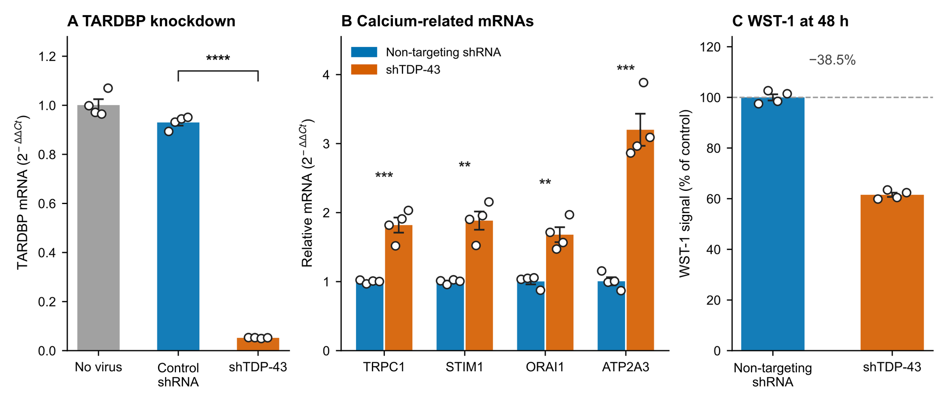
Figure 1. TDP-43 knockdown, calcium-related mRNAs and WST-1 signal in SH-SY5Y cells. (A) TARDBP mRNA in untransduced cells (“No virus”), non-targeting shRNA controls and shTDP-43 cells (n = 4; one-way ANOVA on log2 values with Tukey’s test; **** p < 0.0001 for the indicated pair). (B) Relative mRNA of TRPC1, STIM1, ORAI1 and ATP2A3 (n = 4; two-tailed t-tests with Holm adjustment across the four targets; ** adjusted p < 0.01, *** adjusted p < 0.001). (C) WST-1 metabolic signal at 48 h (n = 4; descriptive summary only). Bars represent means ± SEM; dots are individual measurements.
The Fura-2 Ca²⁺-readdition amplitude was markedly lower in shTDP-43 cells (Figure 2). The readdition amplitude fell from 1.542 ± 0.282 to 0.245 ± 0.083 Δ(F340/F380) (mean ± SEM, n = 3 independent cultures per group; difference −1.30, 95% CI −2.40 to −0.19; Welch’s t-test p = 0.035). ER Ca²⁺ release fell less and not significantly, from 0.268 ± 0.042 to 0.180 ± 0.061 (difference −0.09, 95% CI −0.30 to +0.13; p = 0.31). Because both phases come from the same recording, readdition was also expressed relative to each culture’s own release. This ratio was 5.88 ± 1.10 in controls and 1.36 ± 0.01 after knockdown, 77% lower, and every shTDP-43 culture had a lower ratio than every control culture (Supplementary Table S1). A smaller releasable store therefore does not account for most of the decrease. Plotted on common axes, the two representative recordings had similar baselines before readdition (Figure 2E). At 48 h, the WST-1 signal was 61.5 ± 0.8% of control, a 38.5% decrease (n = 4 wells; descriptive; Figure 1C).
The transcript changes and functional change are therefore in opposite directions. This is the central observation of the study.
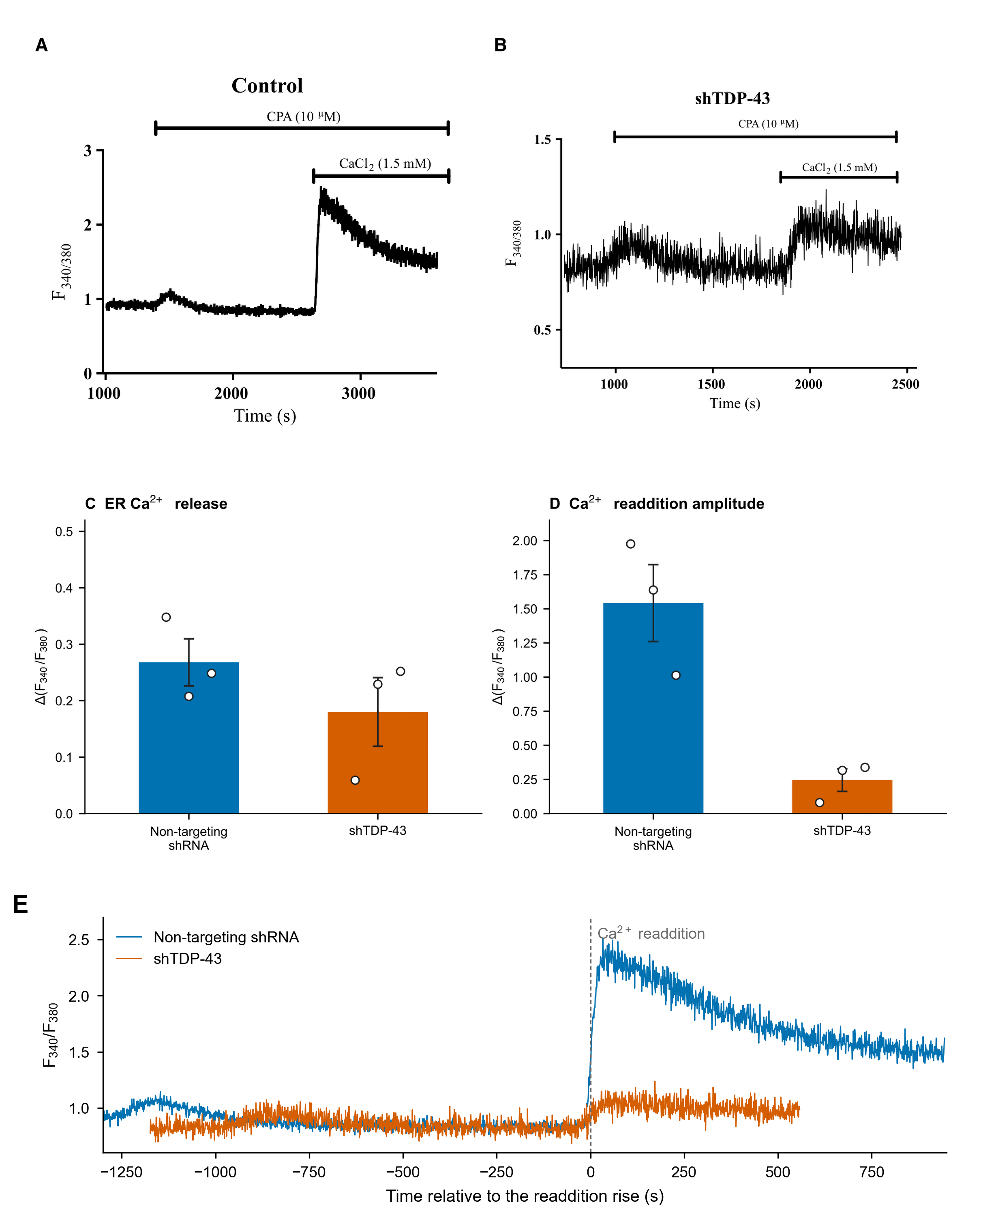
Figure 2. Fura-2 calcium measurements following TDP-43 knockdown in SH-SY5Y cells. (A, B) Original representative traces from non-targeting shRNA control and shTDP-43 cells, each shown at the axis range of its own recording: the y axis spans 0–3 in A and 0.5–1.5 in B, and the time windows differ, so the two panels are not directly comparable by eye; panel E replots them on common axes. CPA (10 µM) and CaCl₂ (nominally 1.5 mM) additions are indicated. (C) ER Ca²⁺ release after CPA. (D) Ca²⁺-readdition amplitude. Panels C and D show the three independent cultures per group and mean ± SEM (readdition, Welch’s t-test p = 0.035; ER release, p = 0.31). (E) The recordings in A and B replotted from their exported ratio values on common axes, with time aligned to the steepest point of the readdition rise. The traces illustrate individual recordings; group amplitudes were calculated from the original Prism measurements.

3.2 Transcript-family abundance contextualises the discordance
The independent public SH-SY5Y RNA-seq comparison provides transcript-level context for this laboratory observation (Figure 3; Table 1). Transcript-family abundance complements fold-change alone. Because a few abundant transcripts take a larger share of the TPM total in the knockdown libraries, unadjusted TPM makes most knockdown-to-control changes appear lower than the composition-adjusted estimates; the values below are adjusted for library composition (Methods 2.10).
The public inducible RNA-seq model and the constitutive laboratory knockdown differ in duration and selection, so agreement for the four assayed mRNAs does not establish matching protein composition or splicing in the laboratory cells.
In control cells ORAI2 and ATP2A2 are the dominant members of their families (77% and 98% of the family total), whereas ORAI1 and ATP2A3 are minor members (15% and 1.5%); STIM1 and TRPC1 dominate their families (64% and 98%), and SARAF accounts for 82% of the SOCE-regulator pool. In knockdown the dominant ORAI2 and ATP2A2 transcripts fell modestly (DESeq2 log2FC −0.17 and −0.25; p_adj = 2.2 × 10⁻³ and 8.7 × 10⁻⁹), while ORAI1, ATP2A3, STIM1, TRPC1 and SARAF rose and ORAI3 rose about fivefold in adjusted TPM (DESeq2 log2FC 2.06; p_adj = 2.3 × 10⁻⁶⁴). At family level the ORAI pool therefore grew (+27%) and changed in composition: ORAI3 went from 8% to 30% of ORAI transcripts and ORAI2 from 77% to 53%. The STIM (+48%) and SOCE-regulator (+30%) pools also rose, whereas the SERCA and mitochondrial-uptake pools fell (−12% and −25%), the latter mainly through MCU, MICU2 and MCUB.
For STIMATE, adjusted TPM increased by 9.9% while the DESeq2 count-model estimate was log2FC −0.050 (p_adj = 0.72). Both changes are small; their opposite signs reflect different estimators and do not support a directional STIMATE abundance effect. MCUR1 shows the same kind of sign difference: adjusted TPM fell by 7.8%, whereas DESeq2 log2FC was +0.044 (p_adj = 0.62).
Two of these changes point towards reduced entry. ORAI2 and ORAI3 both form heteromers with ORAI1 and restrain SOCE; deleting either increases it (Vaeth et al., 2017; Yoast et al., 2020); so the rise in ORAI3 is a candidate contributor to the phenotype, whereas the fall in ORAI2 would, on the same evidence, be expected to increase entry. SARAF, which facilitates slow Ca²⁺-dependent inactivation of SOCE (Palty et al., 2012), rose by about half (log2FC 0.55). The mitochondrial panel also changes, but MCU, MCUB and MICU proteins have distinct and context-dependent roles (Lambert et al., 2019), so their summed transcript change does not establish a change in mitochondrial Ca²⁺ uptake. The STIM1:ORAI1 RNA ratio is not a measurement of the protein ratio at ER–plasma-membrane junctions (Hoover and Lewis, 2011) and is not used here as a mechanistic readout.
Together, the changes in ORAI-family composition and SOCE regulators provide candidate molecular explanations for the reduced SOCE phenotype.
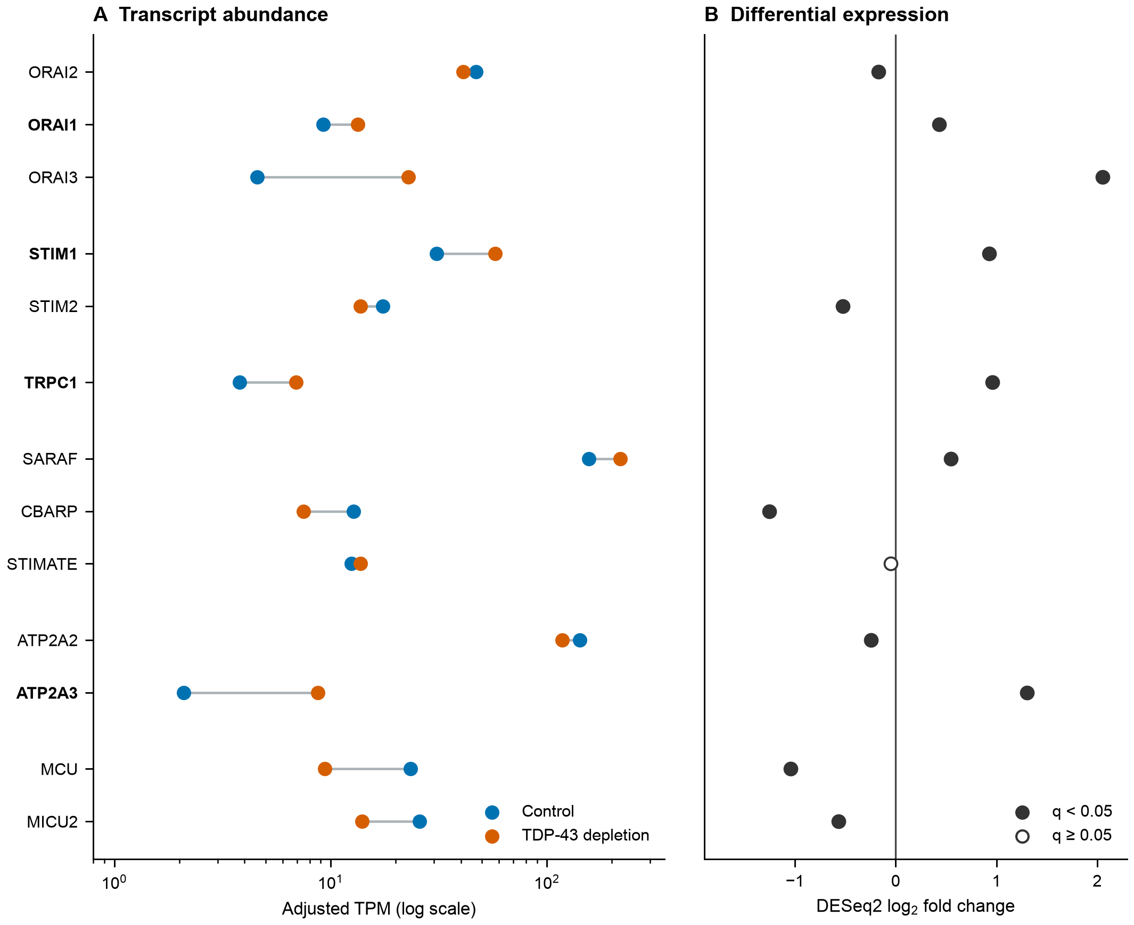
Figure 3. Calcium-regulatory transcript profile in the independent public SH-SY5Y RNA-seq comparison. (A) Adjusted gene-level TPM in control and TDP-43-depleted libraries (three libraries per group), on a logarithmic scale; connecting lines link the two group estimates of the same gene. (B) DESeq2 gene-level log2 fold changes from the same libraries; filled markers indicate Benjamini–Hochberg q < 0.05. Bold gene labels mark the four RT-qPCR targets. These RNA-seq libraries are distinct from the cultures used for Figures 1 and 2. TPM values are descriptive transcript-abundance estimates and do not measure protein abundance or channel composition.

3.3 TDP-43 depletion alters splicing across Ca²⁺ homeostasis genes, but most individual events are underpowered
Across the six comparisons, TDP-43 depletion produced widespread splicing changes; in the primary SH-SY5Y model 7,854 events met FDR < 0.05 and |ΔPSI| ≥ 0.10 before coverage filtering. Positive-control behaviour of STMN2 and UNC13A was consistent with published direction of change. SUPPA2 gave a more conservative result on the same libraries. It tested 31,474 events in 5,345 genes and returned no event meeting the shared FDR and |ΔPSI| ≥ 0.10 thresholds. Among 9,369 skipped-exon events matched by coordinates, the tools agreed weakly on ΔPSI (Spearman ρ = 0.319; 62.4% directional concordance). SUPPA2 builds its null from the between-replicate ΔPSI distribution, which makes it conservative in a three-versus-three design, so the disagreement bounds how much weight any single event call can carry rather than showing that one tool is wrong.
However, a substantial proportion of nominally significant events rested on very low read support. Applying a coverage pre-filter before FDR correction removed 18–78% of tested events depending on dataset (Table 2) and reduced the number of significant calls by 33–76%, with the largest losses in the two single-end datasets (iPSC-derived motor neurons 70%; mouse striatum 76%).
Simulation over the observed coverage distribution showed why (Supplementary Figure S1). For a 3 + 3 design at 10 informative reads per sample, a coverage typical of the lower quartile of events, power to detect a true ΔPSI of 0.10 is only 0.08, and even at 100 reads per sample it reaches only 0.28. Attaining 80% power at realistic depth requires |ΔPSI| ≳ 0.30. Nominally significant events at low coverage are therefore expected to be substantially inflated in effect size, and individual events at the |ΔPSI| ≥ 0.10 threshold should not be interpreted without explicit read-level support.
We applied this reasoning to a TRPC1 skipped-exon event (chr3:142,792,824–142,792,967; ΔPSI = +0.108, FDR = 0.0459) that passes the conventional thresholds and would be prioritised on them alone. Replicate-level inspection showed that the entire signal derived from seven skipping reads across six libraries, with the skipping form absent in four of six samples; the bootstrap 95% confidence interval spanned zero (−0.093 to +0.522); removing one control replicate reversed the sign of ΔPSI (−0.074); and the event did not survive coverage pre-filtering. LeafCutter did not call TRPC1 in the same comparison. We therefore do not report this event as a finding, and present it instead as an illustration of why threshold-based prioritisation of splicing events requires read-level verification (Supplementary Figure S2).

3.4 Robust splicing changes concentrate in SOCE regulators
Applying the robustness criteria to the twelve core entry components examined event by event (Methods 2.3) identified three events with adequate coverage and bootstrap intervals excluding zero: STIMATE, ORAI3 and STIM2 (Table 3; Figure 4A).
In the primary SH-SY5Y model these were STIMATE (ΔPSI = +0.244; FDR = 9.0 × 10⁻⁷; 95% CI +0.095 to +0.368), ORAI3 (−0.269; 1.0 × 10⁻²; −0.404 to −0.107) and STIM2 (−0.120; < 1 × 10⁻¹⁶; −0.165 to −0.064). A STIM1 event (chr11:4,088,702–4,088,738; 37 bp, frame-disrupting) reached ΔPSI = +0.145 (FDR = 4.0 × 10⁻⁴) with a confidence interval marginally including zero, and was positive in all three human datasets. Isoform-level testing supported STIM1 (DRIMSeq gene-level q = 5.49 × 10⁻⁷) with two isoforms predicted to carry premature termination codons.
CBARP, encoding a suppressor of voltage-gated Ca²⁺ channel activity and Ca²⁺-evoked exocytosis (Béguin et al., 2014), was the most reproducible candidate. Thirty-two events met both the threshold and the coverage criteria in five of the six datasets (iPSC colonies, mouse striatum, SH-SY5Y, C2C12 and NSC34) at the orthologous human chr19 and mouse chr10 loci. Their |ΔPSI| ranged from 0.11 to 0.74 (median 0.37), with 61 to 4,559 junction reads per event (median 246; 26 of the 32 above 100 reads; Supplementary Table S3). The locus is therefore affected in every model except the iPSC-derived motor neurons. The sign of the rMATS events varies: all three qualifying SH-SY5Y events show reduced inclusion of their rMATS-defined form, whereas most events in the other four datasets are positive. The sign follows how each event is defined, and none of the three SH-SY5Y events contrasts the canonical exon 4–exon 5 junction with its alternative. Coverage and split reads from the alignments show the change directly (Supplementary Figure S3). In the two human models compared at junction level the canonical junction nearly disappeared after knockdown, and exon 4 was instead joined to an annotated alternative 3′ splice site 197 nucleotides upstream of the exon 5 acceptor. This junction carried 17% of exon-4 donor reads in SH-SY5Y controls and 86% after knockdown, and 1% and 78% in iPSC colonies (Figure 4C). The mouse loci were not compared at junction level. CBARP also showed the largest expression change of any SOCE regulator in SH-SY5Y (log2FC = −1.254; p_adj = 3.1 × 10⁻²⁵).
LeafCutter, which does not use the reference annotation to define events, independently called CBARP (p_adj = 0.0133) and STIM2 (p_adj = 0.0288) in SH-SY5Y. Three approaches, namely coverage-filtered rMATS, bootstrap interval estimation and LeafCutter, therefore converge on the same candidates.
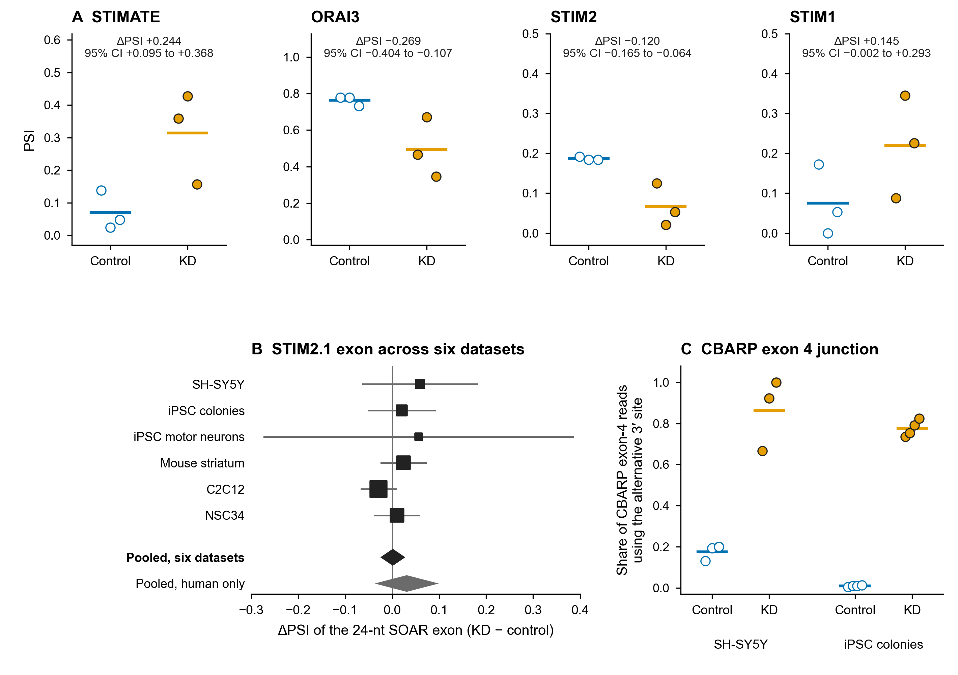
Figure 4. Splicing evidence in SOCE-related genes. (A) Per-library PSI for the four skipped-exon events of Table 3 in the public SH-SY5Y comparison (three libraries per group); lines show group means, and the text gives the rMATS ΔPSI with its replicate-level bootstrap 95% interval. The STIM1 interval includes zero. (B) The 24-nucleotide SOAR exon that converts STIM2 into STIM2.1, measured as an rMATS event in six datasets. Squares are sized by inverse-variance weight, bars are 95% intervals and diamonds are fixed-effect pooled estimates for all six datasets and for the three human datasets (Supplementary Table S15). (C) CBARP: share of exon-4 donor reads joined to the alternative 3′ splice site at chr19:1,235,342 rather than to exon 5, per library, in SH-SY5Y and iPSC colonies. Reads were counted from the alignments with the rules of Methods 2.5; the full locus is shown in Supplementary Figure S3.

3.5 Annotation-free analysis recovers cryptic exons genome-wide but finds no high-confidence event in the SOCE machinery of the primary model
rMATS and LeafCutter both constrain what can be found, the first by the event classes and annotation it works from, the second by clustering rules that discard sparse junctions. To remove those constraints we extracted splice junctions directly from the alignments and tested local splicing variations with a beta-binomial model across eleven comparisons, repeating the primary SH-SY5Y comparison on a second, independently produced junction set (Methods 2.5).
The approach recovered the established TDP-43 cryptic targets without being given their coordinates (Supplementary Figure S4A). In SH-SY5Y at 75 ng/mL doxycycline, 188,491 junctions passed the read-support filters with the mapping-quality-filtered extractor, 23,421 of them absent from GENCODE v47, and 117 high-confidence unannotated splicing changes in 87 genes were called (Supplementary Table S5). Twelve of the sixteen literature positive controls (Supplementary Table S6) were among them: STMN2 (chr8:79,611,215–79,616,821; PSI 0.985 in knockdown versus 0.028 in control, ΔPSI +0.957, q = 2.0 × 10⁻³⁰⁴, 10,926 versus 176 reads), UNC13A, ACTL6B, PFKP, HDGFL2, AGRN, ARHGAP32, ATG4B, ELAVL3, SETD5, RSF1 and GPSM2. The acceptor of the STMN2 cryptic junction falls one base before the published start of the cryptic exon, and both flanking junctions of the UNC13A cryptic exon were recovered separately, placing that exon at chr19:17,642,414–17,642,541. On the regtools set the same comparison gave 165 high-confidence events in 113 genes and the same twelve positive controls plus KALRN; twelve were recovered at 25 ng/mL (Table 4; Supplementary Table S12).
Specificity was tested by running the same analysis on FUS and TAF15 knockdown in the same iPSC-derived motor neurons, at the same depth and with the same design (Supplementary Figure S4C). Under the permissive definition the three comparisons produced call counts of the same order (141 for TDP-43, 124 for FUS and 126 for TAF15), but only TDP-43 knockdown recovered positive controls, two of the sixteen (STMN2 and KALRN). This dataset is too shallow for the high-confidence threshold to recover a control in any of the three comparisons (18, 26 and 23 events, none of them a control gene), and two controls against none is not by itself a significant difference (Fisher’s exact test p = 0.48), so the specificity of the procedure rests on the deeper comparisons, in which the same permissive analysis recovered thirteen of sixteen positive controls in SH-SY5Y and fifteen in iPSC colonies. The background call rate is therefore not specific to TDP-43, whereas the genes the analysis identifies are.
The null test also sets the limits of interpretation. Under the permissive rule, the null-to-real call ratios were 0.98 in iPSC colonies and 2.01 in K562 total RNA (Supplementary Table S14). The high-confidence null could be run in the three datasets with four control replicates: for every real call the split-control null produced 0.64 calls in iPSC colonies, 2.17 in K562 total RNA and 0.83 in mouse striatum (Supplementary Table S14). These ratios are not calibrated false-discovery rates, because the two analyses differ in sample size and in the number of tests, but they show that call counts are not interpretable on their own. In the remaining eight comparisons the controls could not be split, and positive-control recovery is the only available check. Across the eleven comparisons the burden of high-confidence unannotated splicing changes ranged from 12 to 477 events, and of the three datasets with a null, the one with the largest burden also had the largest null.
Applied to the Ca²⁺ panels, the analysis returned an almost complete negative (Supplementary Table S7). The negative is informative where the analysis demonstrably worked: in SH-SY5Y at both doses and in K562 poly(A)+ mRNA, where positive controls were recovered at the high-confidence threshold, and less strongly in the TDP-43 knockdown of iPSC-derived motor neurons, where two were recovered under the permissive definition only. In K562 total RNA no positive control was recovered, and the three mouse comparisons have no conserved control, so the absence of calls there carries little information. Within the coverage, models and calling criteria used here, the only high-confidence unannotated change anywhere in the SOCE panel was the CBARP junction in iPSC colonies, called there together with TRPM3; STIM1, STIM2, ORAI1–3, TRPC1, SARAF, STIMATE and the SERCA and mitochondrial uptake genes carried none in any comparison. That single call comes from the dataset whose null test produced 0.64 calls for every real call, so it is not evidence on its own, although the CBARP junction is corroborated below. Permissive-tier and annotated-site events are detailed in Supplementary Table S7 and Figure S4B. This finding does not exclude lower-abundance or context-specific events, but it provides no support for a cryptic-splicing switch as the explanation for the observed SOCE phenotype.
What the annotation-free analysis did confirm were the annotated events. CBARP showed the largest local change of any SOCE gene in SH-SY5Y, in the junction from exon 4 to the alternative 3′ splice site (ΔPSI +0.74, 95% CI +0.51 to +0.83, q = 2.7 × 10⁻¹²; +0.76, q = 5.6 × 10⁻¹⁷ in the regtools set), and one arm of the CBARP event uses a splice site absent from the annotation (Supplementary Figure S3). This is the third method, after rMATS with --novelSS and LeafCutter, to converge on this locus; isoform-level testing did not detect a CBARP isoform switch (IsoformSwitchAnalyzeR gene-level q = 0.12; DRIMSeq q = 0.34). The same unannotated CBARP splice site was recovered independently in iPSC colonies (ΔPSI +0.33, q = 4.3 × 10⁻¹⁶, 201 versus 137 reads), where it met the cryptic criteria outright. ORAI2, the most abundant ORAI-family gene in the transcript estimates, showed a change of +0.16 (q = 1.9 × 10⁻³) in the mapping-quality-filtered set and +0.15 (q = 0.087) in the unfiltered set; the two extraction methods therefore provide unequal support.
One specific mechanism could be tested directly. Inclusion of a 24-nucleotide exon in the STIM–ORAI activating region (SOAR) converts STIM2 into STIM2.1 (STIM2β), an isoform that inhibits SOCE (Miederer et al., 2015; Rana et al., 2015), so increased inclusion upon TDP-43 loss would be a simple route to reduced entry. Measured as an rMATS event, inclusion was higher in knockdown in five of six datasets, but the fixed-effect meta-analysis estimate was negligible (pooled ΔPSI +0.0013, 95% CI −0.022 to +0.024; p = 0.914; Figure 4B; Supplementary Table S15). The three mouse datasets carry 86% of the weight, but the human datasets alone give the same answer (+0.031, 95% CI −0.030 to +0.091; p = 0.32), and the estimates are not heterogeneous (Cochran’s Q = 4.84, 5 df, p = 0.44; I² = 0%). At junction level the exon (chr4:27,007,983–27,008,006) was positive in direction in all five TDP-43 comparisons in which it was measurable, but small and inconsistent: ΔPSI +0.149 in SH-SY5Y at 75 ng/mL (q = 0.033, 20 versus 3 reads), +0.116 at 25 ng/mL (q = 0.14) and +0.020 in iPSC colonies (q = 0.82), the best-powered comparison with 441 versus 281 reads (Supplementary Table S13). The junction-level estimate is larger than the rMATS estimate for the same exon in the same libraries (+0.149 versus +0.059; Supplementary Table S15) because rMATS combines both flanking junctions and normalises by effective length, whereas the junction-level PSI is the share of the single downstream junction among all junctions leaving that donor, the more sensitive and the noisier measure for a lowly used exon. On either measure the magnitude is too small to support an isoform switch, and the negative conclusion of the meta-analysis stands.
FRASER, run on the nine-sample doxycycline series, returned no genome-wide significant outlier and no difference in per-sample outlier burden between depleted and control libraries (4.8 versus 2.3 events at p < 10⁻⁵; p = 0.35). This is the expected behaviour of an outlier method in a cohort where the aberrant state is the majority, and we report it as a limit of that approach at this cohort size rather than as evidence against aberrant splicing.

3.6 Exploratory NMD interactions prioritise CBARP but do not confirm an NMD target
Cryptic exons frequently introduce premature termination codons, which can make their transcripts susceptible to nonsense-mediated decay (NMD) and under-represented in steady-state RNA. An independent experiment in which TDP-43 knockdown is crossed with knockdown of XRN1, UPF1 and SMG6 (GSE307054) provides an exploratory interaction test (Supplementary Figure S5): a transcript pool produced upon TDP-43 loss and degraded by NMD would be expected to rise preferentially when both perturbations are present (Methods 2.8).
Because the four interventions reuse the same control and knockdown libraries, the eight difference-of-differences values that the design yields are not eight independent observations. We therefore took the four NMD-inhibition conditions as the unit of inference, averaging the two replicates within each condition and retaining the shared controls only within each contrast. Several positive-control and calcium-gene interactions were positive, but no gene passed genome-wide FDR correction in this conservative analysis (smallest q = 0.053). The result is therefore supportive at the level of a ranked exploratory signal, not a confirmatory NMD test.
CBARP had the largest SOCE-panel interaction (+1.52 log₂; positive in all four conditions; Supplementary Table S10), but its conservative condition-level q-value was 0.145 (two-sided t-test; exact one-sided sign-test q = 0.310). It is therefore a prioritised candidate rather than an established NMD target. RYR2 and MCU also had positive interactions, without genome-wide significance.
Two negative results follow. First, the prediction from isoform-level testing that STIM1 produces a premature-termination-codon-bearing, NMD-sensitive isoform was not supported: in the four-condition analysis the interaction was −0.325 (p = 0.317, q = 0.508), in the opposite direction. Second, in the same four-condition analysis none of the four Ca²⁺ panels showed collective NMD sensitivity (one-sided Mann–Whitney p = 0.44, 0.91, 0.96 and 0.91 for Tiers 1–4), and the sixteen positive-control genes were not NMD-sensitive as a group either (p = 0.62; Supplementary Table S10b), consistent with the absence of cryptic events in the SOCE machinery.

3.7 A coverage-based APA screen yields candidate gradients but no confirmed APA event in the SOCE machinery
Cryptic polyadenylation accounts for a substantial part of TDP-43-dependent RNA processing (Bryce-Smith et al., 2025). The truncated STMN2 transcript is generated this way, but APA had not been assessed for the Ca²⁺ gene set. We measured it from coverage, as the 5′ share of the two ends of each intron (an intronic polyadenylation index) and as the distal share of each terminal exon (a 3′UTR usage index), across the 696 qualifying genes of the expanded Ca²⁺ panel and the cryptic positive controls (Methods 2.7; Supplementary Figure S6A; Supplementary Table S11).
Excluding CIGAR reference skips matters for this positive control: including them would have changed the STMN2 intron 2 index difference from +0.145 to +0.489. With skips excluded, the STMN2 intronic index shifted only moderately in the primary SH-SY5Y model, by +0.145 over all six libraries (bootstrap 95% CI +0.085 to +0.205). STMN2 falls outside the depth-filtered summary table because one control library has a summed two-window depth of 2.97, just below the pre-specified threshold of 3; one knockdown library has zero measured coverage in the 3′ window, which by the definition of the index contributes a value of 1.0 rather than missing data, and excluding that library gives +0.121 (+0.068 to +0.173) (Supplementary Figure S6B).
Among the depth-qualified units of the SOCE machinery in the full-panel analysis, two intronic units showed moderate decreases (STIM1 intron 17, Δ = −0.173, bootstrap 95% CI −0.233 to −0.123; STIM2 intron 13, Δ = −0.156, −0.239 to −0.037). Neither is independent of the splicing results: the 5′ window of the STIM2 unit contains the alternatively spliced STIM2 exon of Table 3 (chr4:27,021,494–27,021,612), whose inclusion falls in knockdown and whose exon reads dominate that window (control index 0.96), so the decrease reports that splicing change, and the STIM1 unit is the intron immediately upstream of the alternatively included STIM1 exon of Table 3, ending 50 bp before it. Both are candidate coverage gradients rather than localised poly(A) sites. Sparse intronic windows produced unstable point estimates and were excluded by the pre-specified depth filter.
The analysis therefore identifies at most one moderate candidate gradient in the SOCE machinery, in STIM1, and does not establish a direct APA event in any of its genes. No index change of 0.05 or more was found for ORAI1–3, TRPC1, SARAF, STIMATE, CBARP or the SERCA genes, and the two units of those genes whose intervals exclude zero are negligible in size (SARAF terminal exon −0.036, ORAI2 terminal exon +0.012). Outside the SOCE machinery, three units of the Ca²⁺ panel likewise exclude zero: the ITPR3 terminal exon (−0.152), the MICU3 terminal exon (+0.097) and the ITPR1 terminal exon (−0.055), so the ER-release and mitochondrial-uptake arms show the same kind of candidate gradient as STIM1 rather than being spared. Larger shifts occur in the cryptic positive controls analysed alongside the panel, the UNC13A intron 2 unit most of all (−0.267), which is how the assay is expected to behave in this model. Because the positive control responded only moderately here, absence of a signal is not evidence that these genes are spared.
We therefore repeated the analysis in the iPSC-derived motor neurons, where 59 units in 29 genes passed the same depth filter and the positive control behaved as intended: the index of STMN2 intron 2, which contains cryptic exon 2a, rose from 0.570 in controls to 0.819 in knockdown (Δ = +0.249, interval +0.208 to +0.290). Against it the SOCE-machinery genes again showed only small shifts, the largest being ATP2A2 intron 3 (−0.164) and, below 0.10, SARAF intron 5 (+0.097), TRPC1 intron 1 (+0.083) and the STIM2 terminal exon (−0.074). The SH-SY5Y STIM1 intron 17 unit did not reach the depth filter here (STIM2 intron 13 gave −0.024, interval spanning zero). Here n = 2, so the enumerated bootstrap has sixteen draws and its intervals are coarse, and the point estimates carry the information.
The two mouse lines gave 74 qualifying units in C2C12 and 131 in NSC34, neither with a positive control for this assay, because the STMN2 cryptic polyadenylation site is absent from the mouse gene (Melamed et al., 2019), so the Stmn2 units cannot serve as one. No SOCE-machinery unit exceeded |Δ| = 0.30 in either line, and the two largest (Atp2a2 intron 6, +0.285, and Trpc1 intron 7, +0.260, both in C2C12) have intervals that include zero and are not reproduced in the other line. One unit is positive in both motor-neuron models: the SARAF intron 5 index rises in the iPSC-derived motor neurons (+0.097) and the Saraf intron 5 index in NSC34 (+0.204), while in SH-SY5Y the same unit is uninformative (0.000, interval −0.264 to +0.241). We record it as a candidate rather than a finding: the NSC34 interval is wide, the myoblast line shows nothing there, the units are matched by number rather than by sequence alignment, and a coverage gradient is not a poly(A) site.
Taken together, these analyses support altered calcium-related RNA profiles but do not establish whether any SOCE-machinery gene is a direct target of cryptic splicing, APA or NMD-coupled degradation.

3.8 Enrichment of splicing changes in Ca²⁺ genes is model-dependent
Testing whether Ca²⁺ genes are enriched for splicing changes required care, because power to detect an event scales with gene length, exon number and expression, and Ca²⁺ channel genes are extreme on all three.
In SH-SY5Y, the expanded Ca²⁺ panel showed 133 of 383 testable genes with at least one significant event (34.7%) against a background of 30.7%, giving an uncorrected hypergeometric p = 0.051. Against the covariate-matched empirical null, however, the expected rate was 32.4% and the permutation p-value was 0.139 (Supplementary Table S4). Against that null the excess is not significant, so this model provides no evidence of enrichment beyond the length and expression properties of Ca²⁺ genes.
The result differed by model. In iPSC-derived motor neurons, the most disease-relevant system examined, enrichment survived matching for both the channel/transport panel (p = 0.046) and the curated Ca²⁺-handling panel (p = 0.032), although neither p value would survive correction across the 24 dataset–panel combinations tested. In iPSC colonies, by contrast, nominally significant enrichment (hypergeometric p = 0.018–0.022) disappeared entirely against the matched null (p = 0.54–0.64).
We therefore regard enrichment of splicing changes in Ca²⁺ homeostasis genes as a tentative, motor-neuron-associated observation rather than a general property of TDP-43 depletion.

3.9 TRPC1, SARAF and CBARP differ across ALS and neurological comparison cohorts
We next asked whether these transcript-level changes are present in patient tissue (Figure 5; Table 5).
In the NYGC ALS cohort, TRPC1 was increased in six of the seven brain regions tested (Cliff’s δ = +0.447 to +0.699, q < 0.05), the exception being occipital cortex, in which no gene reached significance in any comparison. SARAF was increased and CBARP decreased in the same six regions, and both also changed significantly in cervical and lumbar cord (SARAF δ = +0.48 and +0.50; CBARP δ = −0.46 and −0.45). ORAI1, a lower-relative-abundance member of its transcript family in the cellular model, showed no significant change in any ALS region. ATP2A3, the other low-abundance member that rises in the cellular model, moved in the opposite direction in tissue: it was significantly decreased in frontal and lateral motor cortex, hippocampus, and cervical and lumbar cord (δ = −0.36 to −0.57).
Notably, the ALS increase in TRPC1 was confined to brain: none of the three spinal cord levels reached significance, and thoracic cord trended negative (δ = −0.321). Cervical and lumbar cord are well powered in this cohort, so the absence there is informative; thoracic cord and occipital cortex are not, since no gene reached significance in either.
The “Other Neurological Disorders” group within the same cohort was compared against the same controls. TRPC1 decreased in all three testable regions (δ = −0.407 to −0.717), the opposite direction to ALS. Shared controls remove confounding specific to the control samples, but do not resolve differences in disease composition, brain region, case processing or cell composition between the case groups. GFAP and SNAP25 moved more strongly in the comparison group than in ALS while TRPC1 fell; these markers make a simple neurodegeneration explanation less compelling but do not provide comprehensive cell-composition adjustment.
Three independent diseases, in four datasets, extended this (Supplementary Figure S7). TRPC1 was decreased in Alzheimer’s disease (δ = −0.447; q = 1.6 × 10⁻⁷, with Braak-stage correlation ρ = −0.183, p = 1.8 × 10⁻³) and in Parkinson’s disease (δ = −0.677; q = 1.8 × 10⁻⁴). In multiple sclerosis, TRPC1 was decreased at donor level across all sampled lesion types (δ = −0.840; q = 0.038) and in lesions at sample level (δ = −0.594; q = 1.3 × 10⁻⁴); the direction was the same in the second multiple sclerosis cohort, which was underpowered (five regions pooled, δ = −0.226; q = 0.49). Because TRPC1 contributes to SOCE in oligodendrocyte precursor cells (Paez et al., 2011), we asked whether the decrease simply reflected demyelination and loss of oligodendrocyte-lineage cells. In normal-appearing white matter, where the myelin markers MBP (δ = +0.051), PLP1 (−0.074), MOG (−0.257) and MAG (−0.299) were unchanged, TRPC1 was lower at sample level (δ = −0.482, p = 0.005), although not after Benjamini–Hochberg correction (q = 0.10), and lower again with the donor as the unit of inference (seven of ten multiple sclerosis donors with NAWM samples versus five control donors, δ = −0.771, uncorrected p = 0.030). In the full GSE138614 comparison, regression of TRPC1 on MBP, PLP1 and GFAP attenuated the difference at both levels: from δ = −0.562 to Cliff’s δ of −0.418 on the residuals at sample level (p = 0.002), and from δ = −0.840 to −0.640 at donor level, where the adjusted difference did not reach significance (p = 0.055). TRPC1 was lower in every lesion type, including remyelinating and inactive lesions (donor-level δ = −1.000 for both), and multiple sclerosis showed marked astrogliosis (GFAP δ = +0.84 to +0.96), again with TRPC1 falling (Supplementary Table S16).
Among the disease cohorts and regions surveyed here, ALS was the only setting in which TRPC1 was significantly increased (Supplementary Figure S7).
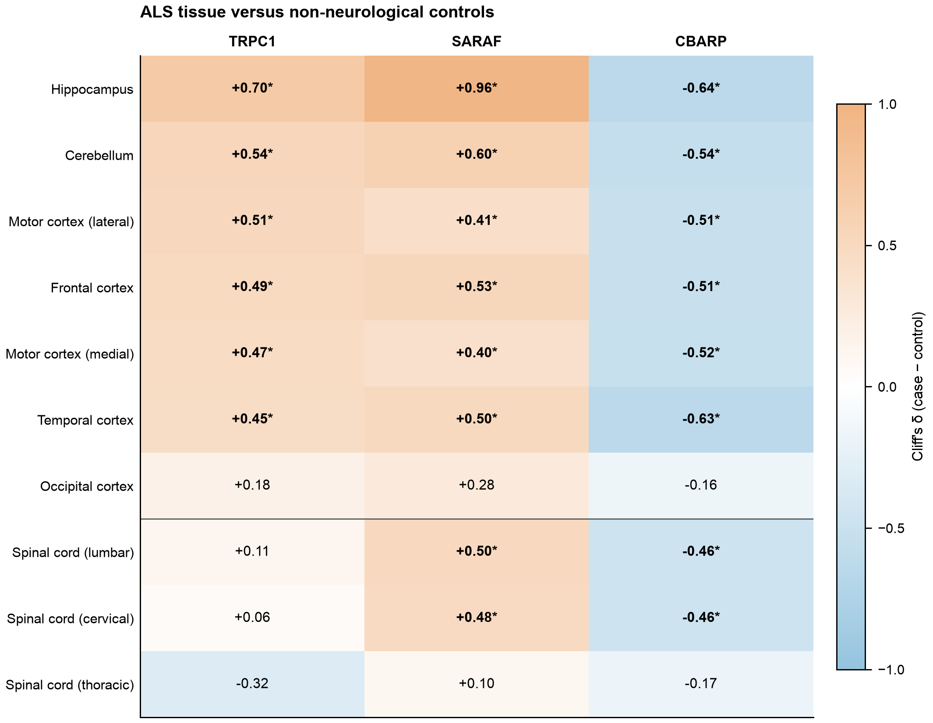
Figure 5. ALS tissue expression of TRPC1, SARAF and CBARP by region. Cliff’s δ compares ALS with non-neurological controls within each NYGC region (case minus control); positive and negative values are shown with an accessible orange and blue scale and printed numerically. An asterisk marks Benjamini–Hochberg q < 0.05. Sample counts and exact q values are given in Table 5. The horizontal rule separates brain regions from spinal cord levels. These bulk-tissue associations do not establish that TDP-43 loss caused the expression differences.
The ALS-control comparisons above establish disease-associated expression differences, but they do not establish that TDP-43 loss caused them. We therefore used cryptic STMN2 junction inclusion as an exploratory per-sample indicator of TDP-43-dependent RNA processing (Methods 2.11). The cryptic junction was most frequent in spinal cord and was significantly increased in lumbar cord, cervical cord, medial motor cortex and temporal cortex relative to non-neurological controls (Supplementary Figure S8A; Supplementary Table S8).
Gene-level STMN2 correlated strongly with the neuronal marker SNAP25 within ALS samples (ρ = 0.66 to 0.93 across regions), whereas cryptic STMN2 PSI did not (ρ = −0.28 to +0.05; Supplementary Figure S8B,C). Total STMN2 expression was therefore not used as a specific indicator of TDP-43 dysfunction in bulk tissue.
Within ALS samples the proxy did not track the three candidate transcripts. Across the ten regions, correlations of TRPC1, SARAF and CBARP with cryptic STMN2 PSI ranged from ρ = −0.29 to +0.18, and only one of these thirty tests reached significance (SARAF in lumbar cord, ρ = −0.194, q = 0.049), in the direction opposite to the increase seen in ALS tissue. This exploratory analysis therefore does not support attributing the regional expression differences to TDP-43-dependent RNA processing; all tested correlations are provided in Supplementary Table S9.

4. Discussion
This study identifies a marked reduction in Fura-2-measured SOCE after TDP-43 knockdown and connects that functional phenotype to coordinated changes in calcium-regulatory transcripts. The central feature is a mismatch between abundance and function: the adjusted STIM and ORAI transcript pools increased, yet the SOCE amplitude decreased by approximately 84%. The transcript data do not show a simple loss of core SOCE mRNAs; they do not establish protein abundance. Channel composition, feedback inhibition, ER refilling and cellular bioenergetics remain possible interacting determinants. This combination defines a multilayered calcium-homeostasis phenotype rather than uniform suppression of one channel or one RNA-processing event.
Architecture of the functional phenotype. ER release fell by 33% and not significantly, whereas readdition fell by 84% and remained 77% lower when each culture was normalised to its own release, so a smaller releasable store does not account for most of the SOCE decrease. The transcript data identify two mechanistic layers that could act together. First, ATP2A2, which dominates the SERCA family in these cells, decreased modestly and could reduce the efficiency of ER refilling. Second, the ORAI family shifted sharply: ORAI3 rose from 8% to 30% of ORAI transcripts, ORAI2 decreased from 77% to 53%, and SARAF increased. Channel output depends on the relative abundance, assembly and localisation of STIM and ORAI proteins rather than their summed RNA abundance; even the STIM1:ORAI1 protein ratio can change CRAC-channel trapping and gating (Hoover and Lewis, 2011). A rise in these transcripts could also be compensatory after reduced Ca²⁺ signalling; the present measurements do not establish which change came first.
Interpretation of the Fura-2 readdition signal also depends on Ca²⁺ clearance. The adjusted PMCA transcript pool rose by 35.2% in the public SH-SY5Y model (Table 1); ATP2B2 and ATP2B3 increased by 207% and 307%, respectively, from low baseline abundance, while ATP2A3 rose and ATP2A2 fell. Faster plasma-membrane extrusion or ER re-uptake could reduce the cytosolic peak even if channel influx were unchanged. These RNA measurements do not establish pump protein abundance or activity, and the present assay does not resolve influx from clearance.
Channel composition and neural context. SARAF promotes slow Ca²⁺-dependent inactivation, while ORAI2 and ORAI3 can modify ORAI1-mediated channel kinetics and restrain entry in heteromeric settings (Palty et al., 2012; Vaeth et al., 2017; Yoast et al., 2020). The fivefold ORAI3 increase and higher SARAF are consequently plausible contributors to a smaller SOCE amplitude, whereas the ORAI2 decrease predicts an effect in the opposite direction. ORAI3 should not, however, be treated as intrinsically inhibitory: in primary astrocytes, STIM1 together with ORAI1 and ORAI3 mediates most SOCE, with additional contributions from ORAI2 and TRPC1 (Kwon et al., 2017). SARAF also regulates calcium entry in SH-SY5Y cells (Albarran et al., 2016).
Comparison with ALS calcium phenotypes. The direction of SOCE dysregulation is not uniform across ALS models. SOD1(G93A) astrocytes show enhanced store-operated entry and abnormal Ca²⁺-dependent exocytosis that contributes to astrocyte-mediated toxicity (Kawamata et al., 2014). Primary spinal-cord astrocytes from the same genetic model also show increased SOCE together with reduced SERCA abundance and lower resting ER Ca²⁺ (Norante et al., 2019). TDP-43-depleted SH-SY5Y cells instead showed strongly reduced readdition. Genetic lesion, cell identity, differentiation state and compensatory timing are therefore likely to determine the direction of the measured phenotype. The smaller store-depletion-evoked Ca²⁺-readdition response in SH-SY5Y cells complements, rather than reproduces, the SOD1 astrocyte phenotype.
Metabolic and organelle coupling. The 48-h WST-1 signal was 38.5% lower after knockdown, consistent with evidence that TARDBP silencing reduces metabolic activity, cell growth, oxygen consumption and ATP production in human iPSC-derived motor neurons and other human cells (Ceron-Codorniu et al., 2024). The mitochondrial-uptake transcript pool also fell by approximately 25%, mainly through MCU, MICU2 and MCUB. These proteins have distinct effects on uniporter composition and stress-induced mitochondrial Ca²⁺ loading, so their combined RNA decrease cannot be translated directly into flux (Lambert et al., 2019). Reduced ATP supply could impair SERCA-dependent store refilling, while altered mitochondrial uptake could change local cytosolic Ca²⁺ clearance near ER and plasma-membrane junctions. This provides a mechanistic route by which cell state, ER release and readdition can decline together without requiring every change to arise from the same channel subunit.
RNA-processing specificity. The annotation-free analysis recovered established TDP-43-dependent cryptic targets, including the STMN2 and UNC13A programmes described across neuronal systems (Ling et al., 2015; Melamed et al., 2019; Brown et al., 2022; Ma et al., 2022). Their recovery, together with their absence from the corresponding FUS and TAF15 knockdowns, supports the biological specificity of the analysis. The SOCE genes did not show an equivalent universal cryptic-splicing programme. STMN2 shifted clearly in iPSC-derived motor neurons while the SOCE machinery changed little in the APA analysis, and the NMD interaction analysis yielded no genome-wide significant gene. These results separate two levels of TDP-43 biology: canonical loss of RNA repression is reproducible across suitable neuronal models, whereas the calcium phenotype is accompanied by a smaller set of context-dependent processing events and broader changes in transcript-family composition.
CBARP, TRPC1 and junctional regulators. CBARP is the strongest recurrent RNA-processing candidate: it was affected in five of six datasets across two species, was independently supported by the annotation-free analysis and showed the largest expression change among the SOCE-regulatory genes (Figure 4C; Supplementary Figure S3). BARP, the CBARP product, binds CaVβ subunits and suppresses voltage-gated Ca²⁺ channel activity and Ca²⁺-evoked exocytosis (Béguin et al., 2014). This established function concerns voltage-gated rather than store-operated channels, but it suggests that TDP-43 loss may remodel more than one route of calcium entry and secretion. TRPC1 provides a complementary comparison: reduced TRPC1-dependent entry has been linked to ER stress and loss of AKT/mTOR survival signalling in neuronal cells (Selvaraj et al., 2012), yet the apparent TRPC1 splicing event in our analysis failed replicate-level robustness checks. CBARP is therefore prioritised by recurrent RNA evidence, whereas TRPC1 remains a biologically plausible effector whose regulation is more likely to involve abundance, assembly or cellular context than a reproducible splice switch.
STIM2, STIMATE and ORAI3. The 24-nucleotide exon that produces the inhibitory STIM2.1/STIM2β isoform was higher after knockdown in five of six datasets (Miederer et al., 2015; Rana et al., 2015), but the pooled effect was negligible (Supplementary Table S15). A shared STIM2.1 switch therefore cannot explain the functional decrease. STIMATE is mechanistically attractive because it promotes the conformational transition that activates STIM1 at ER–plasma-membrane junctions (Jing et al., 2015), while the ORAI3 event and ORAI-family redistribution could alter channel assembly in the primary model. Read-support and matched-background analyses were decisive here: they removed isolated events and apparent panel enrichment while retaining CBARP and a small number of model-specific candidates.
Relevance to disease tissue. TRPC1 and SARAF increased and CBARP decreased in six ALS brain regions, matching the direction observed in the public SH-SY5Y model. TRPC1 remained unchanged in the well-powered cervical and lumbar spinal-cord comparisons and decreased in the neurological comparison cohorts. Among the disease cohorts surveyed, ALS alone showed a significant TRPC1 increase, concentrated in brain regions. Because bulk-tissue expression is sensitive to region and cellular composition, these observations identify disease-associated candidates rather than a direct TDP-43-driven mechanism.
Integrated mechanism and testable predictions. Previous work connecting TDP-43 to Ca²⁺ signalling has centred on ER–mitochondrial contacts: disease-associated TDP-43 disrupts VAPB–PTPIP51 tethering and reduces IP₃-receptor-mediated Ca²⁺ delivery to mitochondria (Stoica et al., 2014), whereas increasing VAPB or PTPIP51 restores mutant-TDP-43-associated Ca²⁺ transfer and synaptic function (Markovinovic et al., 2024). The present findings extend this framework to the plasma-membrane replenishment phase. The working model in Figure 6 is that TDP-43 loss reduces metabolic and ER-refilling capacity while simultaneously changing the composition and feedback control of the entry machinery; recurrent CBARP processing may add a parallel effect on voltage-gated entry and exocytosis. This model makes discriminating predictions. Correcting ATP2A2 or cellular bioenergetics should improve both ER release and readdition, whereas reducing SARAF or restoring the ORAI balance should preferentially improve the readdition phase. An isoform-specific CBARP perturbation should have a larger effect on depolarisation-evoked Ca²⁺ entry or secretion than on CPA-triggered SOCE. These outcomes would distinguish store, channel-composition and broader calcium-network mechanisms and place the functional phenotype within a directly testable neurochemical framework.
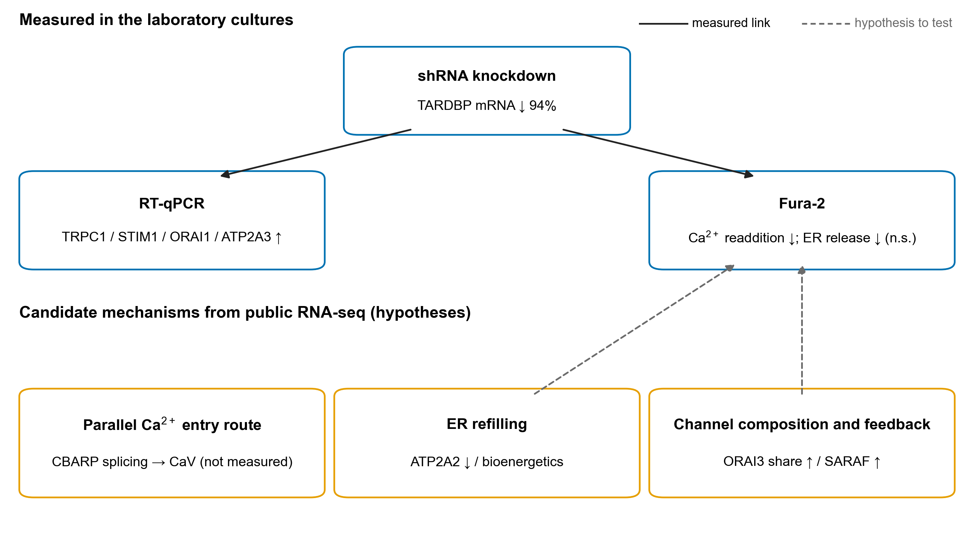
Figure 6. Working model of the observed calcium phenotype and candidate RNA changes. Blue boxes and solid arrows summarise what was measured in the laboratory cultures after TARDBP knockdown: higher TRPC1, STIM1, ORAI1 and ATP2A3 mRNA, a smaller Ca²⁺-readdition amplitude and a smaller, non-significant decrease in ER Ca²⁺ release. Orange boxes are candidate mechanisms suggested by the public RNA-seq data; dashed arrows mark hypotheses for future perturbation, not demonstrated causal links. CBARP is placed on a parallel voltage-gated channel branch that was not measured here.

Limitations
TARDBP depletion was verified by RT-qPCR but not at the protein level, and one TDP-43-targeting shRNA was used without a rescue experiment. The Fura-2 comparison rests on three independent cultures per group. At that size no rank or permutation test can reach a two-sided p below 0.10, so the difference is supported by a parametric test alone and would be more convincing with five to six cultures per group. The readdition signal was not characterised pharmacologically, for example with a store-operated channel blocker such as BTP2, Synta66 or Gd³⁺, so it is defined by the depletion–readdition protocol rather than by pharmacology. The WST-1 signal is reported at 48 h only, from four wells of one experiment; it is not a cell count and cannot separate fewer cells from lower metabolic activity per cell. Because metabolic activity was 38.5% lower, a smaller or less healthy cell population could contribute to the smaller Fura-2 signal; the ratiometric readout is in principle independent of cell number, but neither cell number nor maximum response was measured in the cuvettes. RT-qPCR was normalised to a single reference gene, GAPDH, whose Ct did not differ between groups. In the public inducible RNA-seq comparison GAPDH rose (log2FC +0.61) whereas TBP and B2M were stable; a similar rise in the laboratory cells would have led the target increases to be underestimated, and two-gene normalisation would be preferable. The laboratory assay used undifferentiated SH-SY5Y cells, whereas the public SH-SY5Y RNA-seq study used an inducible model and the motor-neuron datasets did not include matched Ca²⁺ measurements. Cuvette Fura-2 ratios report net cytosolic accumulation and do not separate influx from extrusion or reuptake. Normalising readdition to the release of the same culture removes differences in store content but not their consequences, because a smaller release also means weaker STIM activation, so the ratio bounds rather than eliminates the contribution of the store.
Bulk post-mortem expression can reflect cell composition, and age, RNA integrity and post-mortem interval were not modelled as covariates. The NMD dataset confounds TDP-43 status with sequencing batch, so its interaction results are exploratory.

5. Conclusion
TDP-43 depletion in SH-SY5Y cells was associated with a large reduction in Fura-2-measured SOCE and with altered expression and splicing of calcium-regulatory genes. Transcript-family summaries and reproducible CBARP splicing identify candidate explanations, but they do not establish protein stoichiometry or a single causal RNA switch. Coverage-based APA and conservative NMD analyses do not provide confirmatory evidence that SOCE-machinery genes are direct targets of those pathways. In ALS tissue, TRPC1, SARAF and CBARP showed region-dependent expression differences. CBARP, SARAF and TRPC1 are therefore priorities for targeted protein-level and functional follow-up.

Declarations
Ethics approval. No new human or animal material was collected for this study. All RNA-seq datasets are publicly available and were reanalysed under the terms of the repositories that host them. The laboratory experiments used an established cell line (SH-SY5Y) and no human participants or animals. Lentiviral work was carried out under the institutional biosafety rules of Ege University.
Funding. This work was supported by the Ege University Scientific Research Projects Coordination Unit (BAP), project 31901.
Author contributions (CRediT). Elmasnur Yılmaz: Investigation, Formal analysis, Software, Visualization, Writing – original draft. Yasemin Eraç: Conceptualization, Methodology, Resources, Funding acquisition, Supervision, Writing – review & editing. Both authors read and approved the final manuscript.
Declaration of competing interests. The authors declare no competing interests.
Data availability. All RNA-seq datasets analysed are public and none were generated for this study; accessions are listed in Supplementary Table S17. The publicly accessible analysis package is deposited at https://github.com/elmasnuryilmaz/tdp43-soce-manuscript. It includes scripts in execution order, including the coverage, NMD, transcript-family and donor-level scripts used for the results reported here, the four Ca²⁺ gene panels, per-event count tables, junction and LSV tables, and the code that draws every figure. The versioned submission snapshot is available as GitHub release v1.0.5 at https://github.com/elmasnuryilmaz/tdp43-soce-manuscript/releases/tag/v1.0.5. The complete 23 GB rMATS output is not redistributed; the package provides the thresholded event table and the scripts and public accessions required to regenerate it. The package downloads the two externally hosted resources it needs (the recount3 junction matrix for SRP270799 and the GSE307054 count table) at run time. Every rMATS event that meets the thresholds of Section 2.3, with its event coordinates, form lengths and raw junction counts, is provided as Supplementary Table S3. RT-qPCR, Fura-2 and WST-1 source data, including per-replicate values and the statistics behind every laboratory figure panel, are provided in Supplementary Table S1.

Declaration of generative AI and AI-assisted technologies in the manuscript preparation process
During preparation of this manuscript, the authors used Anthropic Claude for an initial manuscript draft and OpenAI Codex to assist with editorial review, language revision, formatting and consistency checks. The authors reviewed and edited the output and take full responsibility for the content of the submitted article.

Acknowledgements
This article is derived from the doctoral thesis of Elmasnur Yılmaz (Ege University, Graduate School of Natural and Applied Sciences, Department of Biotechnology, 2026). The authors thank the ALS Consortium of the New York Genome Center and Target ALS for making the post-mortem RNA-seq data available, the ENCODE Consortium for the K562 knockdown data, and the authors of GSE296712, GSE230647, GSE77702, GSE27394, GSE171714, GSE307054, GSE125583, GSE68719, GSE138614 and GSE123496 for depositing their raw data.

References
Albarran L, Lopez JJ, Woodard GE, Salido GM, Rosado JA. Store-operated Ca²⁺ entry-associated regulatory factor (SARAF) plays an important role in the regulation of arachidonate-regulated Ca²⁺ (ARC) channels. J Biol Chem. 2016;291:6982–6988. doi:10.1074/jbc.M115.704940
Ambudkar IS, Ong HL, Liu X, Bandyopadhyay BC, Cheng KT. TRPC1: the link between functionally distinct store-operated calcium channels. Cell Calcium. 2007;42:213–223. doi:10.1016/j.ceca.2007.01.013
Andrews S. FastQC: a quality control tool for high throughput sequence data. Babraham Bioinformatics; 2010. https://www.bioinformatics.babraham.ac.uk/projects/fastqc/
Arai T, Hasegawa M, Akiyama H, et al. TDP-43 is a component of ubiquitin-positive tau-negative inclusions in frontotemporal lobar degeneration and amyotrophic lateral sclerosis. Biochem Biophys Res Commun. 2006;351:602–611. doi:10.1016/j.bbrc.2006.10.093
Baughn MW, Melamed Z, López-Erauskin J, et al. Mechanism of STMN2 cryptic splice-polyadenylation and its correction for TDP-43 proteinopathies. Science. 2023;379:1140–1149. doi:10.1126/science.abq5622
Béguin P, Nagashima K, Mahalakshmi RN, et al. BARP suppresses voltage-gated calcium channel activity and Ca²⁺-evoked exocytosis. J Cell Biol. 2014;205:233–249. doi:10.1083/jcb.201304101
Benjamini Y, Hochberg Y. Controlling the false discovery rate: a practical and powerful approach to multiple testing. J R Stat Soc Series B. 1995;57:289–300.
Brown AL, Wilkins OG, Keuss MJ, et al. TDP-43 loss and ALS-risk SNPs drive mis-splicing and depletion of UNC13A. Nature. 2022;603:131–137. doi:10.1038/s41586-022-04436-3
Bryce-Smith S, Brown AL, Chien MZYJ, et al. TDP-43 loss induces cryptic polyadenylation in ALS/FTD. Nat Neurosci. 2025;28:2190–2200. doi:10.1038/s41593-025-02050-w
Ceron-Codorniu M, Torres P, Fernàndez-Bernal A, et al. TDP-43 dysfunction leads to bioenergetic failure and lipid metabolic rewiring in human cells. Redox Biol. 2024;75:103301. doi:10.1016/j.redox.2024.103301
Cliff N. Dominance statistics: ordinal analyses to answer ordinal questions. Psychol Bull. 1993;114:494–509. doi:10.1037/0033-2909.114.3.494
Cotto KC, Feng YY, Ramu A, et al. Integrated analysis of genomic and transcriptomic data for the discovery of splice-associated variants in cancer. Nat Commun. 2023;14:1589. doi:10.1038/s41467-023-37266-6
Danecek P, Bonfield JK, Liddle J, et al. Twelve years of SAMtools and BCFtools. Gigascience. 2021;10:giab008. doi:10.1093/gigascience/giab008
Dumitriu A, Golji J, Labadorf AT, et al. Integrative analyses of proteomics and RNA transcriptomics implicate mitochondrial processes, protein folding pathways and GWAS loci in Parkinson disease. BMC Med Genomics. 2016;9:5. doi:10.1186/s12920-016-0164-y
Elkjaer ML, Frisch T, Reynolds R, et al. Molecular signature of different lesion types in the brain white matter of patients with progressive multiple sclerosis. Acta Neuropathol Commun. 2019;7:205. doi:10.1186/s40478-019-0855-7
Ewels P, Magnusson M, Lundin S, Käller M. MultiQC: summarize analysis results for multiple tools and samples in a single report. Bioinformatics. 2016;32:3047–3048. doi:10.1093/bioinformatics/btw354
Frankish A, Diekhans M, Ferreira A-M, et al. GENCODE reference annotation for the human and mouse genomes. Nucleic Acids Res. 2019;47:D766–D773. doi:10.1093/nar/gky955
Grosskreutz J, Van Den Bosch L, Keller BU. Calcium dysregulation in amyotrophic lateral sclerosis. Cell Calcium. 2010;47:165–174. doi:10.1016/j.ceca.2009.12.002
Grynkiewicz G, Poenie M, Tsien RY. A new generation of Ca²⁺ indicators with greatly improved fluorescence properties. J Biol Chem. 1985;260:3440–3450.
Hoover PJ, Lewis RS. Stoichiometric requirements for trapping and gating of Ca²⁺ release-activated Ca²⁺ (CRAC) channels by stromal interaction molecule 1 (STIM1). Proc Natl Acad Sci USA. 2011;108:13299–13304. doi:10.1073/pnas.1101664108
Hruska-Plochan M, Wiersma VI, Betz KM, et al. A model of human neural networks reveals NPTX2 pathology in ALS and FTLD. Nature. 2024;626:1073–1083. doi:10.1038/s41586-024-07042-7
Jing J, He L, Sun A, et al. Proteomic mapping of ER–PM junctions identifies STIMATE as a regulator of Ca²⁺ influx. Nat Cell Biol. 2015;17:1339–1347. doi:10.1038/ncb3234
Kapeli K, Pratt GA, Vu AQ, et al. Distinct and shared functions of ALS-associated proteins TDP-43, FUS and TAF15 revealed by multisystem analyses. Nat Commun. 2016;7:12143. doi:10.1038/ncomms12143
Kawamata H, Ng SK, Diaz N, et al. Abnormal intracellular calcium signaling and SNARE-dependent exocytosis contributes to SOD1G93A astrocyte-mediated toxicity in amyotrophic lateral sclerosis. J Neurosci. 2014;34:2331–2348. doi:10.1523/JNEUROSCI.2689-13.2014
Keuss MJ, Harley P, Ryadnov E, et al. Loss of TDP-43 induces synaptic dysfunction that is rescued by UNC13A splice-switching ASOs. bioRxiv. 2024:2024.06.20.599684. doi:10.1101/2024.06.20.599684
Kim D, Paggi JM, Park C, Bennett C, Salzberg SL. Graph-based genome alignment and genotyping with HISAT2 and HISAT-genotype. Nat Biotechnol. 2019;37:907–915. doi:10.1038/s41587-019-0201-4
Klim JR, Williams LA, Limone F, et al. ALS-implicated protein TDP-43 sustains levels of STMN2, a mediator of motor neuron growth and repair. Nat Neurosci. 2019;22:167–179. doi:10.1038/s41593-018-0300-4
Kwon J, An H, Sa M, et al. Orai1 and Orai3 in combination with Stim1 mediate the majority of store-operated calcium entry in astrocytes. Exp Neurobiol. 2017;26:42–54. doi:10.5607/en.2017.26.1.42
Lambert JP, Luongo TS, Tomar D, et al. MCUB regulates the molecular composition of the mitochondrial calcium uniporter channel to limit mitochondrial calcium overload during stress. Circulation. 2019;140:1720–1733. doi:10.1161/CIRCULATIONAHA.118.037968
Leek JT. svaseq: removing batch effects and other unwanted noise from sequencing data. Nucleic Acids Res. 2014;42:e161. doi:10.1093/nar/gku864
Li YI, Knowles DA, Humphrey J, et al. Annotation-free quantification of RNA splicing using LeafCutter. Nat Genet. 2018;50:151–158. doi:10.1038/s41588-017-0004-9
Liao Y, Smyth GK, Shi W. featureCounts: an efficient general purpose program for assigning sequence reads to genomic features. Bioinformatics. 2014;30:923–930. doi:10.1093/bioinformatics/btt656
Ling JP, Pletnikova O, Troncoso JC, Wong PC. TDP-43 repression of nonconserved cryptic exons is compromised in ALS-FTD. Science. 2015;349:650–655. doi:10.1126/science.aab0983
Ling S-C, Polymenidou M, Cleveland DW. Converging mechanisms in ALS and FTD: disrupted RNA and protein homeostasis. Neuron. 2013;79:416–438. doi:10.1016/j.neuron.2013.07.033
Livak KJ, Schmittgen TD. Analysis of relative gene expression data using real-time quantitative PCR and the 2^{−ΔΔCt} method. Methods. 2001;25:402–408. doi:10.1006/meth.2001.1262
Love MI, Huber W, Anders S. Moderated estimation of fold change and dispersion for RNA-seq data with DESeq2. Genome Biol. 2014;15:550. doi:10.1186/s13059-014-0550-8
Ma XR, Prudencio M, Koike Y, et al. TDP-43 represses cryptic exon inclusion in the FTD–ALS gene UNC13A. Nature. 2022;603:124–130. doi:10.1038/s41586-022-04424-7
Markovinovic A, Martín-Guerrero SM, Mórotz GM, et al. Stimulating VAPB–PTPIP51 ER–mitochondria tethering corrects FTD/ALS mutant TDP43-linked Ca²⁺ and synaptic defects. Acta Neuropathol Commun. 2024;12:32. doi:10.1186/s40478-024-01742-x
Martin M. Cutadapt removes adapter sequences from high-throughput sequencing reads. EMBnet J. 2011;17:10–12. doi:10.14806/ej.17.1.200
Melamed Z, López-Erauskin J, Baughn MW, et al. Premature polyadenylation-mediated loss of stathmin-2 is a hallmark of TDP-43-dependent neurodegeneration. Nat Neurosci. 2019;22:180–190. doi:10.1038/s41593-018-0293-z
Mertes C, Scheller IF, Yépez VA, et al. Detection of aberrant splicing events in RNA-seq data using FRASER. Nat Commun. 2021;12:529. doi:10.1038/s41467-020-20573-7
Miederer AM, Alansary D, Schwär G, et al. A STIM2 splice variant negatively regulates store-operated calcium entry. Nat Commun. 2015;6:6899. doi:10.1038/ncomms7899
National Center for Biotechnology Information (NCBI). SRA Toolkit, version 3.2.1. 2025. https://github.com/ncbi/sra-tools/
Nelson PT, Dickson DW, Trojanowski JQ, et al. Limbic-predominant age-related TDP-43 encephalopathy (LATE): consensus working group report. Brain. 2019;142:1503–1527. doi:10.1093/brain/awz099
Neumann M, Sampathu DM, Kwong LK, et al. Ubiquitinated TDP-43 in frontotemporal lobar degeneration and amyotrophic lateral sclerosis. Science. 2006;314:130–133. doi:10.1126/science.1134108
Norante RP, Peggion C, Rossi D, et al. ALS-associated SOD1(G93A) decreases SERCA pump levels and increases store-operated Ca²⁺ entry in primary spinal cord astrocytes from a transgenic mouse model. Int J Mol Sci. 2019;20:5151. doi:10.3390/ijms20205151
Nowicka M, Robinson MD. DRIMSeq: a Dirichlet-multinomial framework for multivariate count outcomes in genomics. F1000Res. 2016;5:1356. doi:10.12688/f1000research.8900.2
Paez PM, Fulton D, Spreuer V, Handley V, Campagnoni AT. Modulation of canonical transient receptor potential channel 1 in the proliferation of oligodendrocyte precursor cells by the golli products of the myelin basic protein gene. J Neurosci. 2011;31:3625–3637. doi:10.1523/JNEUROSCI.4424-10.2011
Palty R, Raveh A, Kaminsky I, Meller R, Reuveny E. SARAF inactivates the store operated calcium entry machinery to prevent excess calcium refilling. Cell. 2012;149:425–438. doi:10.1016/j.cell.2012.01.055
Patro R, Duggal G, Love MI, Irizarry RA, Kingsford C. Salmon provides fast and bias-aware quantification of transcript expression. Nat Methods. 2017;14:417–419. doi:10.1038/nmeth.4197
Polymenidou M, Lagier-Tourenne C, Hutt KR, et al. Long pre-mRNA depletion and RNA missplicing contribute to neuronal vulnerability from loss of TDP-43. Nat Neurosci. 2011;14:459–468. doi:10.1038/nn.2779
Prakriya M, Lewis RS. Store-operated calcium channels. Physiol Rev. 2015;95:1383–1436. doi:10.1152/physrev.00020.2014
Prudencio M, Humphrey J, Pickles S, et al. Truncated stathmin-2 is a marker of TDP-43 pathology in frontotemporal dementia. J Clin Invest. 2020;130:6080–6092. doi:10.1172/JCI139741
Putney JW. Pharmacology of store-operated calcium channels. Mol Interv. 2010;10:209–218. doi:10.1124/mi.10.4.4
Rana A, Yen M, Sadaghiani AM, et al. Alternative splicing converts STIM2 from an activator to an inhibitor of store-operated calcium channels. J Cell Biol. 2015;209:653–670. doi:10.1083/jcb.201412060
Selli Ç, Eraç Y, Kosova B, Tosun M. Post-transcriptional silencing of TRPC1 ion channel gene by RNA interference upregulates TRPC6 expression and store-operated Ca²⁺ entry in A7r5 vascular smooth muscle cells. Vascul Pharmacol. 2009;51:96–100. doi:10.1016/j.vph.2009.04.001
Selvaraj S, Sun Y, Watt JA, et al. Neurotoxin-induced ER stress in mouse dopaminergic neurons involves downregulation of TRPC1 and inhibition of AKT/mTOR signaling. J Clin Invest. 2012;122:1354–1367. doi:10.1172/JCI61332
Shen S, Park JW, Lu Z-x, et al. rMATS: robust and flexible detection of differential alternative splicing from replicate RNA-Seq data. Proc Natl Acad Sci USA. 2014;111:E5593–E5601. doi:10.1073/pnas.1419161111
Sinha IR, Ye Y, Li Y, et al. Inhibition of nonsense-mediated decay in TDP-43 deficient neurons reveals novel cryptic exons. bioRxiv [preprint]. 2025. doi:10.1101/2025.06.28.661837
Srinivasan K, Friedman BA, Etxeberria A, et al. Alzheimer’s patient microglia exhibit enhanced aging and unique transcriptional activation. Cell Rep. 2020;31:107843. doi:10.1016/j.celrep.2020.107843
Stoica R, De Vos KJ, Paillusson S, et al. ER–mitochondria associations are regulated by the VAPB–PTPIP51 interaction and are disrupted by ALS/FTD-associated TDP-43. Nat Commun. 2014;5:3996. doi:10.1038/ncomms4996
Šušnjar U, Škrabar N, Brown AL, et al. Cell environment shapes TDP-43 function with implications in neuronal and muscle disease. Commun Biol. 2022;5:314. doi:10.1038/s42003-022-03253-8
Trincado JL, Entizne JC, Hysenaj G, et al. SUPPA2: fast, accurate, and uncertainty-aware differential splicing analysis across multiple conditions. Genome Biol. 2018;19:40. doi:10.1186/s13059-018-1417-1
Vaeth M, Yang J, Yamashita M, et al. ORAI2 modulates store-operated calcium entry and T cell-mediated immunity. Nat Commun. 2017;8:14714. doi:10.1038/ncomms14714
Van den Berge K, Soneson C, Robinson MD, Clement L. stageR: a general stage-wise method for controlling the gene-level false discovery rate in differential expression and differential transcript usage. Genome Biol. 2017;18:151. doi:10.1186/s13059-017-1277-0
Van Nostrand EL, Freese P, Pratt GA, et al. A large-scale binding and functional map of human RNA-binding proteins. Nature. 2020;583:711–719. doi:10.1038/s41586-020-2077-3
Vaquero-Garcia J, Barrera A, Gazzara MR, et al. A new view of transcriptome complexity and regulation through the lens of local splicing variations. eLife. 2016;5:e11752. doi:10.7554/eLife.11752
Vitting-Seerup K, Sandelin A. IsoformSwitchAnalyzeR: analysis of changes in genome-wide patterns of alternative splicing and its functional consequences. Bioinformatics. 2019;35:4469–4471. doi:10.1093/bioinformatics/btz247
Voskuhl RR, Itoh N, Tassoni A, et al. Gene expression in oligodendrocytes during remyelination reveals cholesterol homeostasis as a therapeutic target in multiple sclerosis. Proc Natl Acad Sci USA. 2019;116:10130–10139. doi:10.1073/pnas.1821306116
Wilks C, Zheng SC, Chen FY, et al. recount3: summaries and queries for large-scale RNA-seq expression and splicing. Genome Biol. 2021;22:323. doi:10.1186/s13059-021-02533-6
Xia Z, Donehower LA, Cooper TA, et al. Dynamic analyses of alternative polyadenylation from RNA-seq reveal a 3′-UTR landscape across seven tumour types. Nat Commun. 2014;5:5274. doi:10.1038/ncomms6274
Yoast RE, Emrich SM, Zhang X, et al. The native ORAI channel trio underlies the diversity of Ca²⁺ signaling events. Nat Commun. 2020;11:2444. doi:10.1038/s41467-020-16232-6
S1. Laboratory source data: raw Ct values and per-replicate relative expression, Fura-2 amplitudes, 48-h normalised WST-1 signal values, primer sequences and thermal profile, and the summary statistics behind Figures 1 and 2.
S2. Ca²⁺ gene panels (four cumulative sets).
S3. rMATS events meeting FDR < 0.05 and |ΔPSI| ≥ 0.10, JC and JCEC, six datasets, with the raw junction counts needed to reproduce the coverage pre-filter.
S4. Matched permutation enrichment results, all datasets and panels.
S5. High-confidence unannotated splicing changes in every comparison, including the independently produced mapping-quality-filtered SH-SY5Y junction set.
S6. Cryptic positive controls, the sixteen literature genes, and the dataset × gene recovery matrix for the human comparisons.
S7. SOCE genes in the annotation-free analysis.
S8. Cryptic STMN2 PSI in ALS versus control by region (NYGC).
S9. Correlations of both TDP-43 proxies with target genes within ALS samples; the in_correction_family column marks the 220 informative tests over which the Benjamini–Hochberg correction was applied.
S10. Nonsense-mediated decay interaction for the SOCE panel and the panel-level tests, four-condition analysis.
S11. Depth-qualified intronic polyadenylation and 3′UTR usage estimates in all four comparisons, with the genomic windows of every unit; these are coverage gradients, not direct poly(A)-site calls. The candidate_gradient column marks the units with |Δ| ≥ 0.05 whose interval excludes zero; the remaining rows are the other depth-qualified units of the core genes and of the cryptic positive controls.
S12. Machine-readable version of Table 4: cryptic event counts by comparison, with the FUS and TAF15 knockdown controls and the null-test ratios.
S13. STIM2 SOAR exon measured at junction level, with both flanking junctions, in every comparison in which it was measurable.
S14. Control-versus-control null test of the cryptic calling procedure, under the permissive definition and three stricter thresholds.
S15. The same STIM2.1/SOAR exon measured as an rMATS event, with per-replicate PSI and bootstrap intervals, across six datasets; this estimate is compared with S13 in Section 3.5.
S16. Multiple sclerosis analysis, both cohorts, with myelin adjustment and the donor-level re-analysis.
S17. Accession list for every dataset analysed, with design, library type, run-level groups for knockdown experiments and group definitions for patient cohorts. The supplementary material also contains Figures S1–S8 and their legends.

Tables
Table 1. Transcript-family abundance of SOCE-related genes in SH-SY5Y: unadjusted and composition-adjusted TPM (Methods 2.10), each member’s share of its family in control cells, and DESeq2 fold changes.
Family | Gene | TPM, control | TPM, knockdown | Adjusted TPM, control | Adjusted TPM, knockdown | Share of family, control (%) | Adjusted change (%) | log2FC | p_adj
STIM (ER Ca²⁺ sensor) | STIM1 | 35.46 | 50.54 | 30.95 | 57.74 | 64.0 | +86.5 | +0.929 | 4.3 × 10⁻⁴⁷
 | STIM2 | 20.01 | 12.02 | 17.45 | 13.73 | 36.0 | −21.3 | −0.527 | 1.8 × 10⁻⁷
 | Family total | 55.47 | 62.55 | 48.40 | 71.47 | 100.0 | +47.7 | NA | NA
ORAI (CRAC channel) | ORAI1 | 10.60 | 11.70 | 9.25 | 13.37 | 15.2 | +44.5 | +0.433 | 2.4 × 10⁻⁴
 | ORAI2 | 53.78 | 35.86 | 46.92 | 40.98 | 77.2 | −12.7 | −0.173 | 2.2 × 10⁻³
 | ORAI3 | 5.24 | 20.06 | 4.57 | 22.92 | 7.5 | +401.4 | +2.056 | 2.3 × 10⁻⁶⁴
 | Family total | 69.62 | 67.62 | 60.75 | 77.27 | 100.0 | +27.2 | NA | NA
SERCA (Ca²⁺ re-uptake into ER) | ATP2A1 | 0.67 | 0.96 | 0.58 | 1.10 | 0.4 | +87.8 | +0.959 | 0.024
 | ATP2A2 | 162.38 | 103.10 | 141.71 | 117.80 | 98.1 | −16.9 | −0.247 | 8.7 × 10⁻⁹
 | ATP2A3 | 2.40 | 7.64 | 2.09 | 8.73 | 1.5 | +317.0 | +1.306 | 1.4 × 10⁻²⁹
 | Family total | 165.45 | 111.70 | 144.39 | 127.63 | 100.0 | −11.6 | NA | NA
TRPC | TRPC1 | 4.34 | 6.06 | 3.79 | 6.92 | 98.2 | +82.9 | +0.958 | 1.3 × 10⁻¹²
 | TRPC3 | 0.06 | 0.02 | 0.05 | 0.02 | 1.3 | NA | −0.938 | 0.47
 | TRPC4 | 0.00 | 0.00 | 0.00 | 0.00 | 0.0 | NA | NA | NA
 | TRPC5 | 0.02 | 0.00 | 0.02 | 0.00 | 0.4 | NA | −1.633 | 0.45
 | TRPC6 | 0.00 | 0.00 | 0.00 | 0.00 | 0.1 | NA | NA | NA
 | Family total | 4.42 | 6.08 | 3.86 | 6.95 | 100.0 | +80.3 | NA | NA
SOCE regulators | SARAF | 179.27 | 191.68 | 156.45 | 218.99 | 82.4 | +40.0 | +0.548 | 5.9 × 10⁻³⁷
 | STIMATE | 14.31 | 12.01 | 12.49 | 13.72 | 6.6 | +9.9 | −0.050 | 0.72
 | CRACR2A | 8.31 | 4.35 | 7.25 | 4.97 | 3.8 | −31.4 | −0.560 | 4.3 × 10⁻⁴
 | CRACR2B | 1.18 | 1.55 | 1.03 | 1.77 | 0.5 | +72.0 | +0.925 | 0.017
 | CBARP | 14.57 | 6.56 | 12.73 | 7.49 | 6.7 | −41.1 | −1.254 | 3.1 × 10⁻²⁵
 | Family total | 217.64 | 216.15 | 189.95 | 246.96 | 100.0 | +30.0 | NA | NA
Mitochondrial Ca²⁺ uptake | MCU | 26.79 | 8.21 | 23.39 | 9.38 | 13.5 | −59.9 | −1.041 | 2.9 × 10⁻²³
 | MICU1 | 70.93 | 50.30 | 61.91 | 57.47 | 35.7 | −7.2 | −0.069 | 0.41
 | MICU2 | 29.50 | 12.21 | 25.72 | 13.95 | 14.8 | −45.8 | −0.566 | 6.9 × 10⁻⁷
 | MICU3 | 3.20 | 2.97 | 2.79 | 3.40 | 1.6 | +21.6 | +0.565 | 0.028
 | MCUR1 | 49.95 | 35.18 | 43.58 | 40.17 | 25.1 | −7.8 | +0.044 | 0.62
 | MCUB | 18.28 | 4.69 | 15.96 | 5.36 | 9.2 | −66.4 | −1.655 | 1.5 × 10⁻³⁰
 | Family total | 198.64 | 113.57 | 173.34 | 129.73 | 100.0 | −25.2 | NA | NA
PMCA (Ca²⁺ extrusion) | ATP2B1 | 20.26 | 18.77 | 17.70 | 21.45 | 59.0 | +21.2 | +0.290 | 2.8 × 10⁻⁵
 | ATP2B2 | 2.79 | 6.54 | 2.43 | 7.48 | 8.1 | +207.3 | +1.346 | 8.6 × 10⁻³⁹
 | ATP2B3 | 0.31 | 0.97 | 0.27 | 1.11 | 0.9 | +306.6 | +2.584 | 2.2 × 10⁻²⁴
 | ATP2B4 | 10.99 | 9.21 | 9.58 | 10.52 | 32.0 | +9.8 | +0.308 | 5.0 × 10⁻⁶
 | Family total | 34.34 | 35.49 | 29.99 | 40.56 | 100.0 | +35.2 | NA | NA
Note. TPM, transcripts per million (mean of three libraries per group); adjusted TPM uses median-of-ratios scaling (Methods 2.10). Share is calculated from unrounded control values; bold, dominant member (> 50%). log2FC and p_adj are from DESeq2 gene-level counts; NA, not computed; CRAC, Ca²⁺ release-activated Ca²⁺.
Table 2. Effect of coverage pre-filtering on event counts and significance, by dataset.
Dataset | Events tested | Events after filter | Removed (%) | Significant before filter | Significant after filter | Significant calls lost (%)
SH-SY5Y (GSE296712) | 118,664 | 90,143 | 24.0 | 7,854 | 5,282 | 32.7
iPSC colonies (GSE230647) | 392,236 | 302,415 | 22.9 | 15,512 | 10,055 | 35.2
iPSC-derived motor neurons (GSE77702) | 49,392 | 28,463 | 42.4 | 1,465 | 443 | 69.8
Mouse striatum (GSE27394) | 23,000 | 4,969 | 78.4 | 644 | 157 | 75.6
C2C12 (GSE171714) | 225,016 | 184,869 | 17.8 | 5,468 | 3,140 | 42.6
NSC34 (GSE171714) | 338,017 | 273,077 | 19.2 | 8,142 | 4,599 | 43.5
Note. Significant: FDR < 0.05 and |ΔPSI| ≥ 0.10. After the filter, Benjamini–Hochberg q values were recomputed within the retained events (Methods 2.3). FDR, false discovery rate; PSI, percent spliced in.
Table 3. Splicing events assessed for robustness in the primary SH-SY5Y model among the twelve core entry components examined event by event (Methods 2.3), with bootstrap confidence intervals; all four are skipped-exon events. CBARP belongs to the wider nineteen-gene SOCE panel of Methods 2.9 but not to these twelve; its events are in Supplementary Table S3.
Gene | Exon, GRCh38 (strand) | Length (bp) | Reading frame | ΔPSI | FDR | Bootstrap 95% CI | PSI, knockdown replicates | PSI, control replicates | Mean reads per sample | Minimum reads in a sample
STIMATE | chr3:52,895,878–52,895,955 (−) | 78 | Preserved | +0.244 | 9.0 × 10⁻⁷ | +0.095 to +0.368 | 0.359; 0.427; 0.157 | 0.138; 0.024; 0.048 | 21.7 | 14
ORAI3 | chr16:30,953,185–30,953,460 (+) | 276 | Preserved | −0.269 | 0.010 | −0.404 to −0.107 | 0.465; 0.671; 0.346 | 0.778; 0.778; 0.733 | 39.7 | 8
STIM2 | chr4:27,021,494–27,021,612 (+) | 119 | Disrupted | −0.120 | < 1 × 10⁻¹⁶ | −0.165 to −0.064 | 0.125; 0.021; 0.053 | 0.192; 0.184; 0.184 | 24.7 | 9
STIM1 | chr11:4,088,702–4,088,738 (+) | 37 | Disrupted | +0.145 | 4.0 × 10⁻⁴ | −0.002 to +0.293 | 0.088; 0.345; 0.226 | 0.172; 0.000; 0.053 | 25.5 | 9
Note. SH-SY5Y, 0 versus 75 ng/mL doxycycline, three libraries per group. ΔPSI is knockdown minus control from rMATS junction counts; the confidence interval is a replicate-level bootstrap (10,000 resamples). Coordinates are 1-based and inclusive. The STIM1 interval crosses zero; that event is included for context and is not counted among the three interval-supported events. CI, confidence interval; FDR, false discovery rate; PSI, percent spliced in.
Table 4. Cryptic events recovered by annotation-free junction analysis in eleven comparisons, with RNA-binding-protein specificity controls. Positive-control recovery is not assessed in the three mouse comparisons, because the sixteen literature controls are human cryptic events that are not conserved in mouse.
Comparison | Permissive calls (genes) | Positive controls, permissive | High-confidence calls (genes) | Positive controls, high-confidence | Positive-control genes, high-confidence | Tier 1 genes | SOCE-machinery genes | Split-control null: calls (ratio)
SH-SY5Y 75 ng/mL | 400 (288) | 13 | 165 (113) | 13 | ACTL6B, AGRN, ARHGAP32, ATG4B, ELAVL3, GPSM2, HDGFL2, KALRN, PFKP, RSF1, SETD5, STMN2, UNC13A | NA | NA | NA
SH-SY5Y 25 ng/mL | 351 (264) | 13 | 122 (86) | 12 | ACTL6B, AGRN, ARHGAP32, ATG4B, ELAVL3, GPSM2, HDGFL2, KALRN, PFKP, SETD5, STMN2, UNC13A | NA | NA | NA
iPSC colonies | 1,561 (1,013) | 15 | 477 (326) | 12 | ACTL6B, ARHGAP32, ATG4B, CAMK2B, ELAVL3, GPSM2, HDGFL2, KALRN, PFKP, SETD5, STMN2, UNC13A | CBARP, TRPM3 | CBARP | 307 (0.64)
iPSC-MN, TDP-43 KD | 141 (108) | 2 | 18 (11) | 0 | NA | NA | NA | NA
iPSC-MN, FUS KD | 124 (80) | 0 | 26 (15) | 0 | NA | NA | NA | NA
iPSC-MN, TAF15 KD | 126 (88) | 0 | 23 (13) | 0 | NA | NA | NA | NA
K562 total RNA | 330 (229) | 0 | 23 (17) | 0 | NA | NA | NA | 50 (2.17)
K562 poly(A)+ mRNA | 1,683 (1,030) | 6 | 145 (94) | 4 | AGRN, ATG4B, HDGFL2, PFKP | NA | NA | NA
C2C12 | 566 (379) | n/a | 158 (110) | n/a | n/a | NA | NA | NA
NSC34 | 643 (421) | n/a | 264 (166) | n/a | n/a | NA | NA | NA
Mouse striatum | 43 (32) | n/a | 12 (9) | n/a | n/a | NA | NA | 10 (0.83)
Note. Calls are unannotated splicing changes in the regtools junction set, with the number of genes carrying them in parentheses (Methods 2.5). Positive controls are counted among the sixteen literature cryptic genes (Supplementary Table S6); n/a, not assessed in mouse. The null column gives the high-confidence calls of the control-versus-control split and their ratio to the real calls; NA, fewer than four control replicates. In the Tier 1, SOCE-machinery and positive-control columns NA means that no gene of that set carried a high-confidence call, whereas in the null column it means that the dataset has fewer than four control replicates. The CBARP junction of Section 3.5 is not counted for SH-SY5Y: the high-confidence definition requires a novel splice site carrying at least 20 knockdown reads, and the novel-site junction at this locus carried six, while the junction that changes most in SH-SY5Y uses two annotated sites and is already used in controls (17% of exon-4 donor reads). iPSC-MN, iPSC-derived motor neurons; KD, knockdown.
Table 5. Cross-disease comparison of TRPC1, SARAF and CBARP.
Cohort | Region | n, case/control | TRPC1 δ (q) | SARAF δ (q) | CBARP δ (q)
ALS (NYGC, GSE153960) | Cerebellum | 158/38 | +0.538 (1.5 × 10⁻⁶) | +0.599 (2.3 × 10⁻⁷) | −0.544 (1.2 × 10⁻⁶)
 | Frontal cortex | 154/56 | +0.486 (4.3 × 10⁻⁷) | +0.525 (6.1 × 10⁻⁸) | −0.511 (1.2 × 10⁻⁷)
 | Motor cortex (lateral) | 82/18 | +0.511 (8.8 × 10⁻³) | +0.415 (0.025) | −0.509 (8.9 × 10⁻³)
 | Motor cortex (medial) | 81/19 | +0.465 (0.013) | +0.402 (0.027) | −0.523 (8.0 × 10⁻³)
 | Occipital cortex | 45/11 | +0.176 (0.67) | +0.277 (0.51) | −0.160 (0.70)
 | Temporal cortex | 25/24 | +0.447 (0.038) | +0.503 (0.025) | −0.633 (0.019)
 | Hippocampus | 29/11 | +0.699 (2.1 × 10⁻³) | +0.956 (1.9 × 10⁻⁴) | −0.636 (5.0 × 10⁻³)
 | Spinal cord (cervical) | 155/41 | +0.058 (0.63) | +0.479 (1.1 × 10⁻⁵) | −0.461 (2.4 × 10⁻⁵)
 | Spinal cord (lumbar) | 140/43 | +0.112 (0.33) | +0.499 (3.9 × 10⁻⁶) | −0.455 (2.5 × 10⁻⁵)
 | Spinal cord (thoracic) | 43/10 | −0.321 (0.49) | +0.102 (0.88) | −0.172 (0.77)
Other neurological disorders (NYGC, same controls) | Cerebellum | 49/38 | −0.407 (1.0 × 10⁻²) | −0.061 (0.76) | −0.088 (0.64)
 | Frontal cortex | 45/56 | −0.717 (6.5 × 10⁻⁸) | −0.437 (5.3 × 10⁻⁴) | +0.094 (0.49)
 | Temporal cortex | 35/24 | −0.571 (2.5 × 10⁻³) | −0.500 (6.6 × 10⁻³) | −0.283 (0.12)
Alzheimer’s disease (GSE125583) | Fusiform gyrus | 219/70 | −0.447 (1.6 × 10⁻⁷) | NA | NA
Parkinson’s disease (GSE68719) | BA9 | 29/44 | −0.677 (1.8 × 10⁻⁴) | NA | NA
Multiple sclerosis (GSE123496) | Corpus callosum | 5/5 | −0.520 (0.42) | −0.200 (0.73) | +0.760 (0.16)
 | Frontal cortex | 5/5 | −0.040 (1.0) | +0.040 (1.0) | −0.360 (1.0)
 | Hippocampus | 5/5 | −0.440 (1.0) | −0.280 (1.0) | +0.040 (1.0)
 | Internal capsule | 5/5 | +0.200 (0.78) | +0.120 (0.84) | −0.520 (0.54)
 | Parietal cortex | 5/5 | −0.280 (0.89) | −0.040 (1.0) | −0.200 (0.89)
 | Five regions pooled | 25/25 | −0.226 (0.49) | −0.075 (0.88) | −0.043 (0.88)
Multiple sclerosis (GSE138614) | Normal-appearing white matter | 21/25 | −0.482 (0.10) | −0.166 (0.74) | +0.051 (0.82)
 | Lesions | 52/25 | −0.594 (1.3 × 10⁻⁴) | −0.138 (0.52) | +0.327 (0.050)
 | All samples, averaged per donor | 10/5 | −0.840 (0.038) | −0.120 (0.77) | +0.120 (0.77)
Note. δ, Cliff’s delta, case minus control, with the Benjamini–Hochberg q value in parentheses; bold, q < 0.05; NA, not tested. n counts samples, or donors in the donor-level row. The NYGC comparisons of each region share its non-neurological controls. BA9, Brodmann area 9; NYGC, New York Genome Center.

