Supplementary Material
TDP-43 knockdown is associated with reduced store-operated Ca²⁺ entry and altered calcium-regulatory RNA profiles in SH-SY5Y cells
Elmasnur Yılmazᵃ, Yasemin Eraçᵃ,*
ᵃ Department of Pharmacology, Faculty of Pharmacy, Ege University, Erzene Mahallesi, Ankara Caddesi No: 172/98, 35040 Bornova, İzmir, Türkiye
* Corresponding author: Yasemin Eraç, yasemin.erac@ege.edu.tr
Contents
Supplementary data files S1–S18
Supplementary results 1–4
Supplementary figures S1–S8

Supplementary data files
The machine-readable files listed below accompany the manuscript and provide the source values, event-level results and cohort-level analyses used in the main text and supplementary figures.
S1. Laboratory source data: raw Ct values and per-replicate relative expression, Fura-2 amplitudes, 48-h normalised WST-1 signal values, primer sequences and thermal profile, and the summary statistics behind Figures 1 and 2.
S2. Ca²⁺ gene panels (four cumulative sets).
S3. rMATS events meeting FDR < 0.05 and |ΔPSI| ≥ 0.10, JC and JCEC, six datasets, with the raw junction counts needed to reproduce the coverage pre-filter.
S4. Matched permutation enrichment results, all datasets and panels.
S5. High-confidence unannotated splicing changes in every comparison, including the independently produced mapping-quality-filtered SH-SY5Y junction set.
S6. Cryptic positive controls, the sixteen literature genes, and the dataset × gene recovery matrix for the human comparisons.
S7. SOCE genes in the annotation-free analysis.
S8. Cryptic STMN2 PSI in ALS versus control by region (NYGC).
S9. Correlations of both TDP-43 proxies with target genes within ALS samples; the in_correction_family column marks the 220 informative tests over which the Benjamini–Hochberg correction was applied.
S10. Nonsense-mediated decay interaction for the SOCE panel and the panel-level tests, four-condition analysis.
S11. Depth-qualified intronic polyadenylation and 3′UTR usage estimates in all four comparisons, with the genomic windows of every unit; these are coverage gradients, not direct poly(A)-site calls. The candidate_gradient column marks the units with |Δ| ≥ 0.05 whose interval excludes zero; the remaining rows are the other depth-qualified units of the core genes and of the cryptic positive controls.
S12. Machine-readable version of Table 4: cryptic event counts by comparison, with the FUS and TAF15 knockdown controls and the null-test ratios.
S13. STIM2 SOAR exon measured at junction level, with both flanking junctions, in every comparison in which it was measurable.
S14. Control-versus-control null test of the cryptic calling procedure, under the permissive definition and three stricter thresholds.
S15. The same STIM2.1/SOAR exon measured as an rMATS event, with per-replicate PSI and bootstrap intervals, across six datasets, the estimate compared with S13 in Section 3.5.
S16. Multiple sclerosis analysis, both cohorts, with myelin adjustment and the donor-level re-analysis.
S17. Accession list for every dataset analysed, with design, library type, run-level groups for knockdown experiments and group definitions for patient cohorts.
S18. Cell-composition adjustment of TRPC1 in the NYGC cohort: Cliff’s δ for ALS and for the comparison group against the same controls, unadjusted and after regression on SNAP25 or RBFOX3 with or without GFAP, together with the differences in the marker genes themselves.
S18b. Cryptic STMN2 junction by group and region, on the samples of Table 5: samples and donors, samples with the junction detected, samples above 1% PSI, mean PSI, and the comparison group against controls. In cerebellum the junction was detected in three control samples and in no comparison-group sample; the resulting difference (δ = −0.08) is negligible.
S18c. Within the comparison group, Spearman and partial (on SNAP25) correlations of TRPC1, SARAF, CBARP and SNAP25 with cryptic STMN2 PSI; and the Spearman correlation of TRPC1 with SNAP25 in every group and region.

Supplementary results
The analyses below were carried out as described in the Methods and are reported here in full. They are placed in the supplementary material because each is limited in a way that is stated in its own text: the outlier method cannot work in a cohort where the perturbed state is the majority, the nonsense-mediated decay dataset confounds batch with TDP-43 status and shows no sensitivity even in the literature positive controls, the mouse polyadenylation screen has no available positive control, and the multiple sclerosis analysis is a cross-disease comparison rather than part of the ALS argument.

Supplementary Results 1. Aberrant splicing outlier detection (FRASER)
FRASER v1.14.1 was run on the nine-sample SH-SY5Y doxycycline series (0, 25 and 75 ng/mL), counting split and non-split reads from the alignments and modelling ψ5, ψ3 and splicing efficiency θ (Methods 2.6).
The run returned no genome-wide significant outlier and no difference in per-sample outlier burden between depleted and control libraries: 4.8 versus 2.3 events at p < 10⁻⁵, p = 0.35. This is the expected behaviour of an outlier method applied to a cohort in which the aberrant state is the majority, because the method treats aberrant splicing as a rare, sample-specific deviation from a cohort norm and two thirds of these samples are depleted. We therefore report the result as a limit of that approach at this cohort size rather than as evidence against aberrant splicing.

Supplementary Results 2. Nonsense-mediated decay interaction
Gene-level counts were taken from GSE307054 (i3Neurons; TDP-43 knockdown crossed with knockdown of XRN1, UPF1 and SMG6 in four combinations, two replicates each) and normalised with the authors’ size factors. Because sequencing batch is confounded with TDP-43 status in that design, the interaction was formed as a difference of within-batch differences:
interaction(c) = [log2(TDP-43 knockdown + NMD inhibition c) − log2(TDP-43 knockdown)] − [log2(control + NMD inhibition c) − log2(control)]
for each of the four NMD-inhibition conditions c, giving four condition-level interaction values per gene; the two replicates within each condition are averaged. A positive interaction indicates a transcript that is produced upon TDP-43 loss and degraded by NMD. Genes with at least 10 normalised counts were tested (n = 19,145) with a four-condition one-sample t-test and an exact sign test.
Because the four interventions reuse the same control and knockdown libraries, the eight difference-of-differences values that the design yields are not eight independent observations. We therefore took the four NMD-inhibition conditions as the unit of inference, averaging the two replicates within each condition and retaining the shared controls only within each contrast. Several positive-control and calcium-gene interactions were positive, but no gene passed genome-wide FDR correction in this conservative analysis (smallest q = 0.053).
CBARP had the largest SOCE-panel interaction (+1.52 log₂; positive in all four conditions; Supplementary Table S10), but its conservative condition-level q-value was 0.145 (two-sided t-test; exact one-sided sign-test q = 0.310). RYR2 and MCU also had positive interactions, without genome-wide significance.
Two negative results follow. First, the interaction for STIM1 was −0.325 (p = 0.317, q = 0.508), in the direction opposite to NMD sensitivity. This is consistent with the isoform analysis itself: the two STIM1 isoforms predicted to carry premature termination codons are not the ones whose usage changes (Section 3.4), so there was never a switching isoform for NMD to degrade. Second, none of the four Ca²⁺ panels showed collective NMD sensitivity (one-sided Mann–Whitney p = 0.44, 0.91, 0.96 and 0.91 for Tiers 1–4), and the sixteen literature positive-control genes were not NMD-sensitive as a group either (median interaction −0.11 log₂; p = 0.62; Supplementary Table S10b). The last result matters for interpretation: genes that are known to produce cryptic, premature-termination-codon-bearing transcripts show no NMD sensitivity in this dataset, so the dataset does not demonstrate the sensitivity that would make a negative result for the SOCE machinery informative. The screen is therefore hypothesis-generating, and the main text uses it only to rank CBARP.

Supplementary Results 3. Polyadenylation screen in the two mouse lines
The coverage-based polyadenylation screen of Methods 2.7 gave 74 qualifying units in C2C12 and 131 in NSC34. Neither line has a positive control for this assay, because the STMN2 cryptic polyadenylation site is absent from the mouse gene (Melamed et al., 2019), so the Stmn2 units cannot serve as one.
No SOCE-machinery unit exceeded |Δ| = 0.30 in either line, and the two largest (Atp2a2 intron 6, +0.285, and Trpc1 intron 7, +0.260, both in C2C12) have intervals that include zero and are not reproduced in the other line. One unit is positive in both motor-neuron models: the SARAF intron 5 index rises in the iPSC-derived motor neurons (+0.097) and the Saraf intron 5 index in NSC34 (+0.204), while in SH-SY5Y the same unit is uninformative (0.000, interval −0.264 to +0.241). We record it as a candidate rather than a finding: the NSC34 interval is wide, the myoblast line shows nothing there, the human and mouse units are matched by number rather than by sequence alignment, and a coverage gradient is not a poly(A) site. All values are in Supplementary Table S11.

Supplementary Results 4. Multiple sclerosis in detail
TRPC1 was decreased in multiple sclerosis at donor level across all sampled lesion types (δ = −0.840; q = 0.038) and in lesions at sample level (δ = −0.594; q = 1.3 × 10⁻⁴). In the second cohort (GSE123496) the direction was the same but the study was underpowered (five regions pooled, δ = −0.226; q = 0.49).
Because TRPC1 contributes to SOCE in oligodendrocyte precursor cells (Paez et al., 2011), we asked whether the decrease simply reflected demyelination and loss of oligodendrocyte-lineage cells. In normal-appearing white matter, where the myelin markers MBP (δ = +0.051), PLP1 (−0.074), MOG (−0.257) and MAG (−0.299) were unchanged, TRPC1 was lower at sample level (δ = −0.482, p = 0.005), although not after Benjamini–Hochberg correction (q = 0.10), and lower again with the donor as the unit of inference (seven of ten multiple sclerosis donors with normal-appearing white matter samples versus five control donors, δ = −0.771, uncorrected p = 0.030).
In the full GSE138614 comparison, regression of TRPC1 on MBP, PLP1 and GFAP attenuated the difference at both levels: from δ = −0.562 to Cliff’s δ of −0.418 on the residuals at sample level (p = 0.002), and from δ = −0.840 to −0.640 at donor level, where the adjusted difference did not reach significance (p = 0.055). TRPC1 was lower in every lesion type, including remyelinating and inactive lesions (donor-level δ = −1.000 for both), and multiple sclerosis showed marked astrogliosis (GFAP δ = +0.84 to +0.96) with TRPC1 still falling. All values are in Supplementary Table S16 and the donor-level re-analysis in Supplementary Table S16b.

Supplementary Figure S1
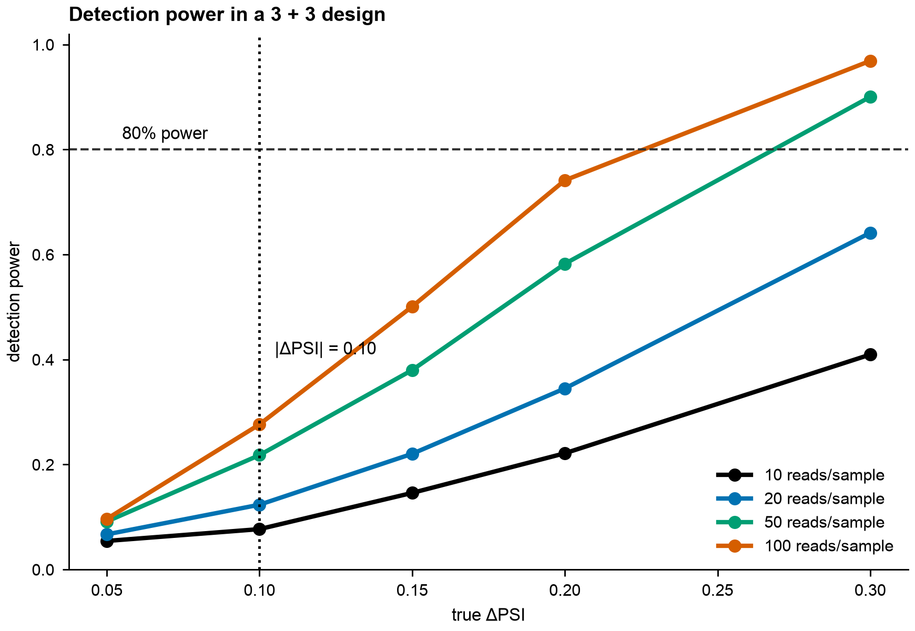
Supplementary Figure S1. Detection power for splicing events. Simulated detection power for a three-versus-three design over observed coverage levels and true ΔPSI values from 0.05 to 0.30. The horizontal line marks 80% power and the vertical line marks |ΔPSI| = 0.10.

Supplementary Figure S2
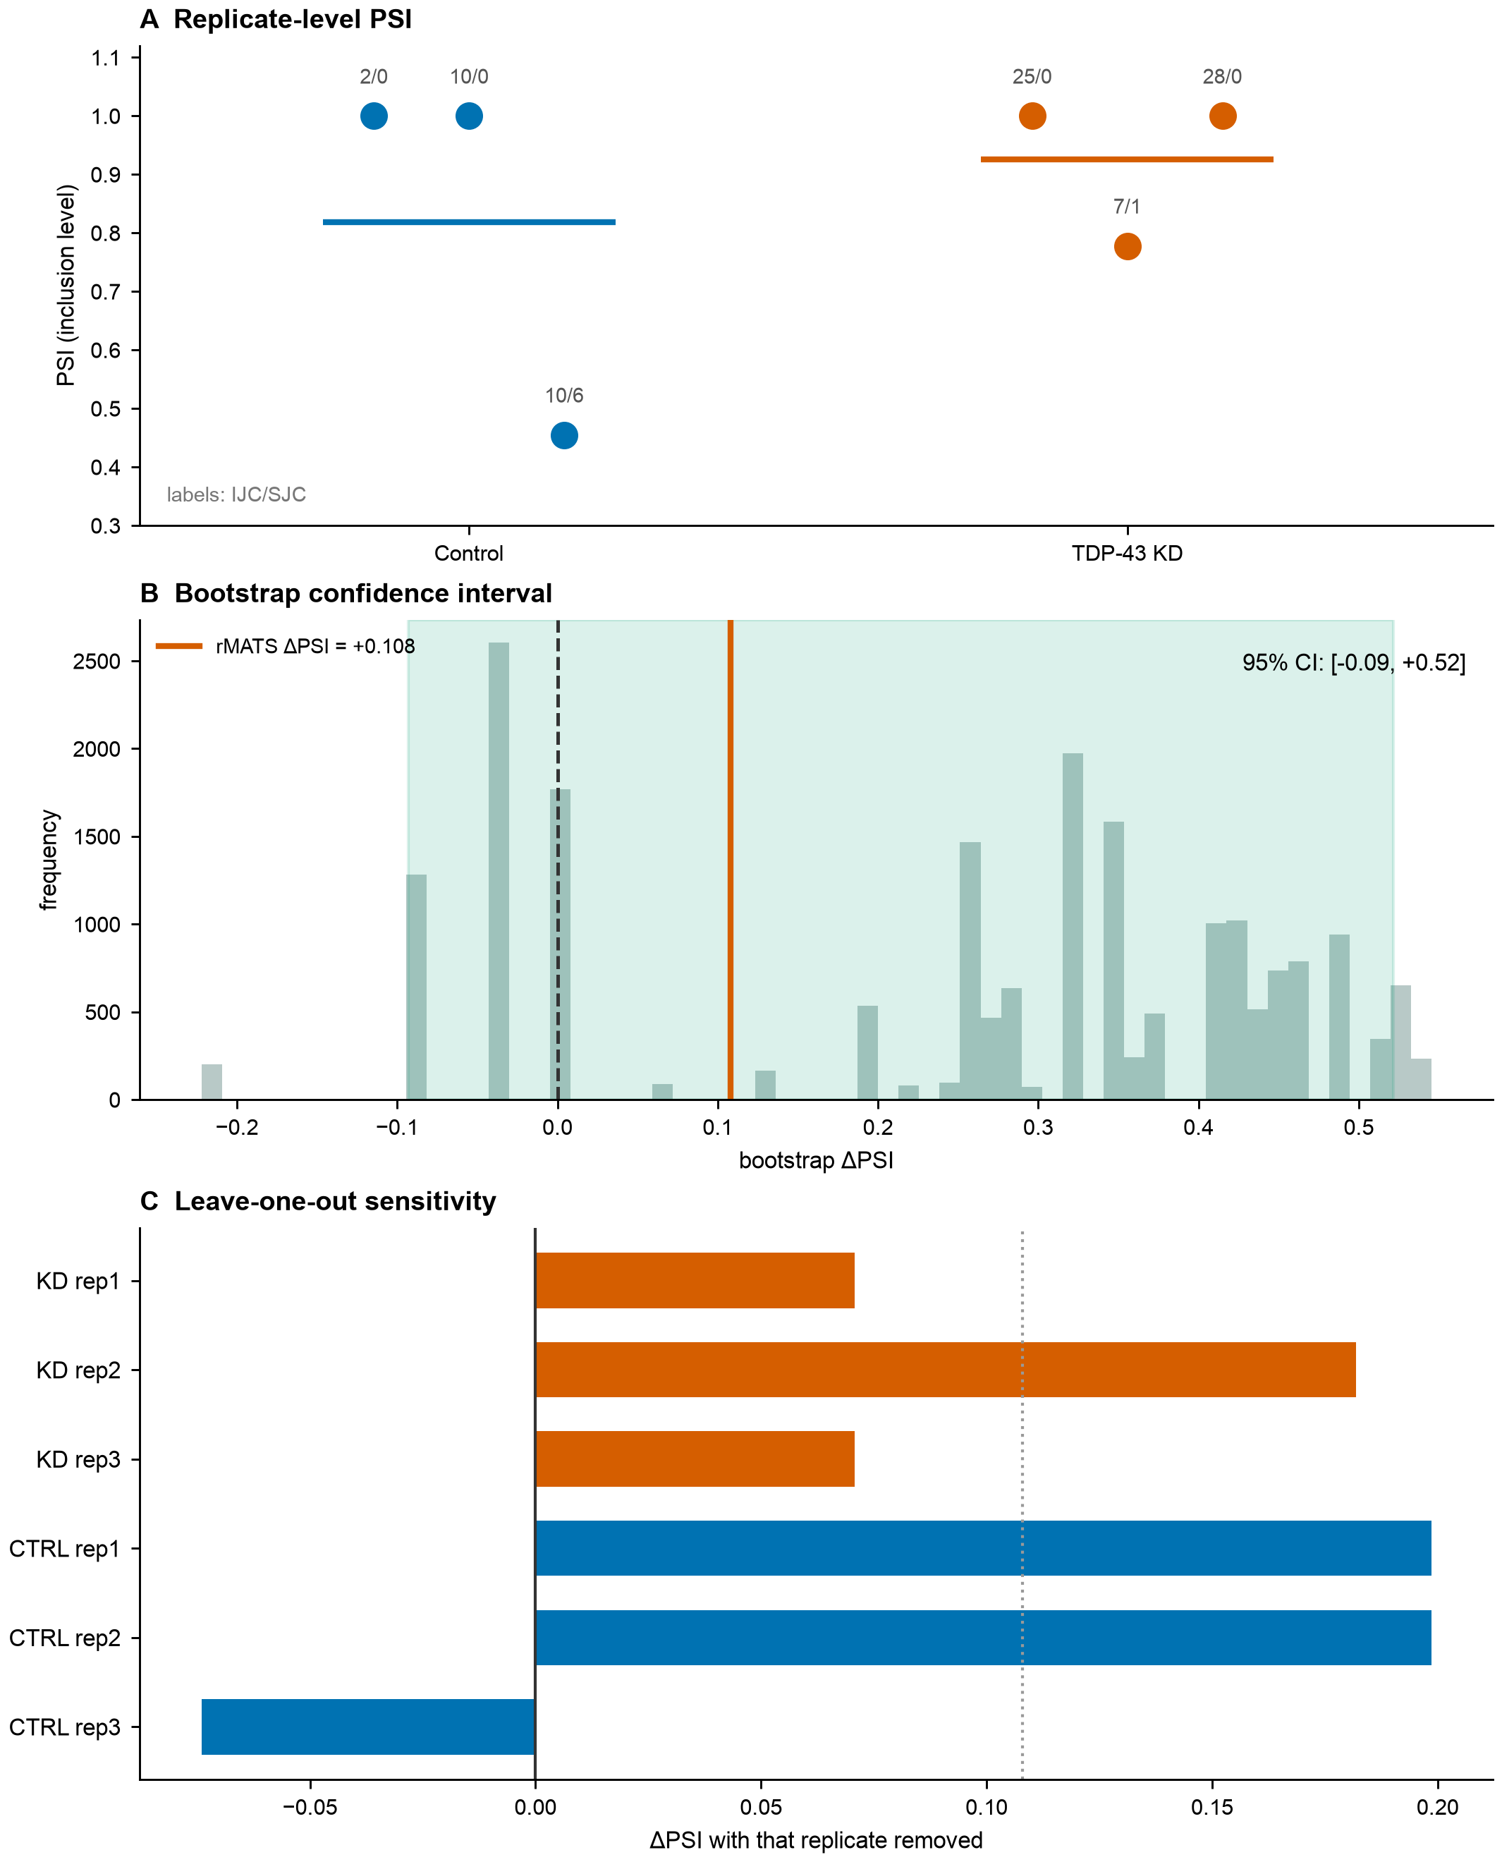
Supplementary Figure S2. Replicate-level assessment of a TRPC1 skipped-exon call. (A) Individual PSI values with inclusion/skipping junction counts. (B) Bootstrap distribution of ΔPSI from 20,000 resamples; the 95% interval includes zero. (C) Leave-one-out estimates; removing one control replicate reverses the sign. The event is presented as an example of a conventional call that fails the additional robustness criteria.

Supplementary Figure S3
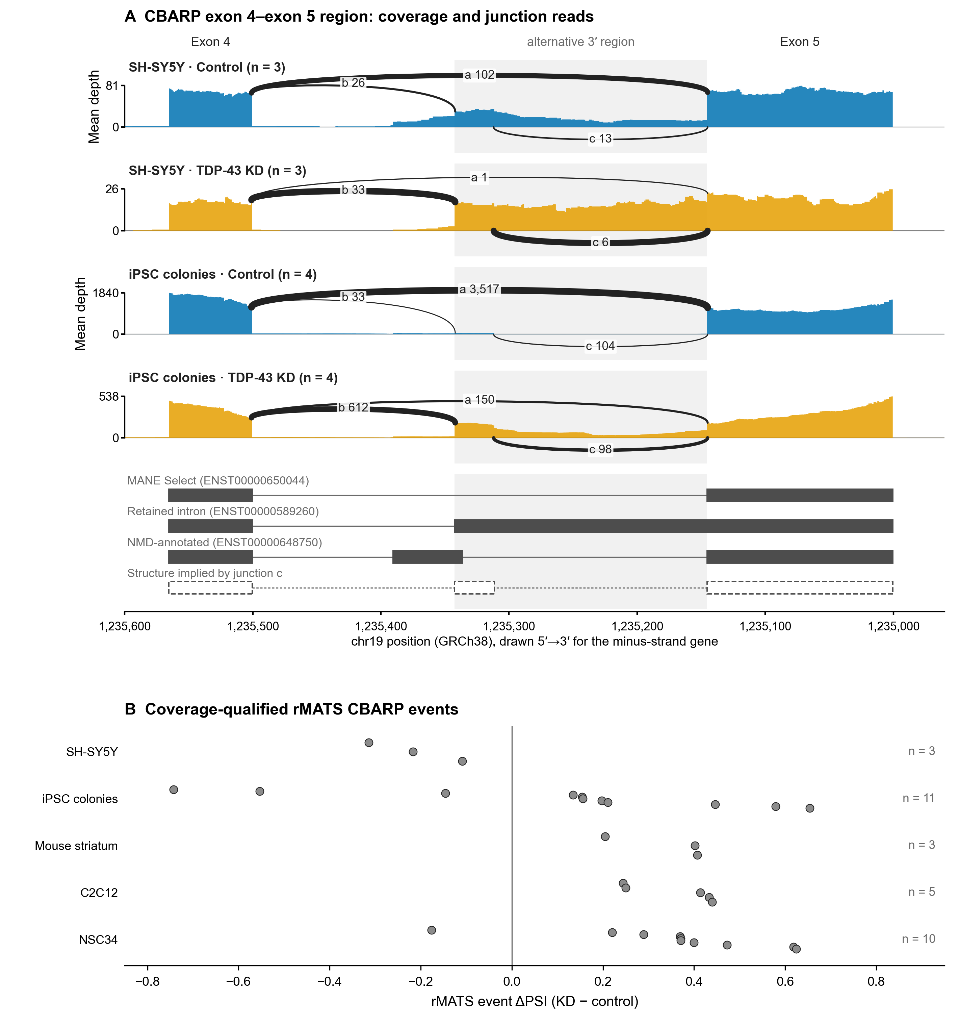
Supplementary Figure S3. CBARP exon 4–exon 5 region after TDP-43 depletion. (A) Sashimi plot of the public SH-SY5Y comparison (0 versus 75 ng/mL doxycycline, three libraries per group) and of iPSC colonies (four libraries per group), drawn from the alignments; the minus-strand gene is shown 5′→3′. Filled profiles are the mean per-base read depth of the libraries in each group, and each track has its own y-axis. Arcs show split reads summed over the libraries of a group, with width proportional to the junction’s share of reads at its shared splice site. Reads were counted with the junction rules of Methods 2.5 (MAPQ ≥ 30, primary non-duplicate alignments, 8 bp anchors); the SH-SY5Y counts are those of the local-splicing-variation test in Section 3.5. Junction a is the canonical exon 4–exon 5 junction (chr19:1,235,146–1,235,500); b joins exon 4 to the annotated alternative 3′ splice site at 1,235,342 (1,235,343–1,235,500); c leaves the 31-nt segment through the unannotated donor at 1,235,312 (1,235,146–1,235,311). The shaded interval lies between the alternative and canonical 3′ splice sites. Transcript models are from GENCODE v47; the dashed model is the exon structure implied by junction c. (B) ΔPSI of the 32 coverage-qualified rMATS CBARP events in five datasets (Supplementary Table S3). The sign refers to each event’s rMATS-defined inclusion form, which differs between events.

Supplementary Figure S4
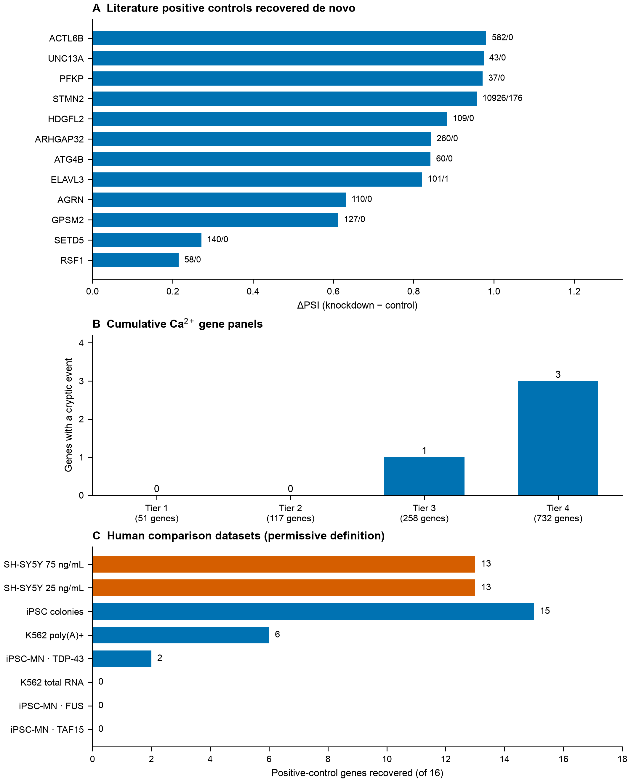
Supplementary Figure S4. Positive controls and specificity of the annotation-free junction screen. (A) Literature cryptic-splicing positive controls recovered de novo in SH-SY5Y, with knockdown/control junction-read counts. (B) Genes with a high-confidence unannotated splicing change in each of four cumulative Ca²⁺ panels; the numbers below the tiers are panel sizes, and tiers are not independent sets. (C) Number of literature positive-control genes recovered under the permissive definition in human comparisons, including the FUS and TAF15 knockdown controls. Mouse comparisons are omitted because the literature control events are human cryptic events.

Supplementary Figure S5
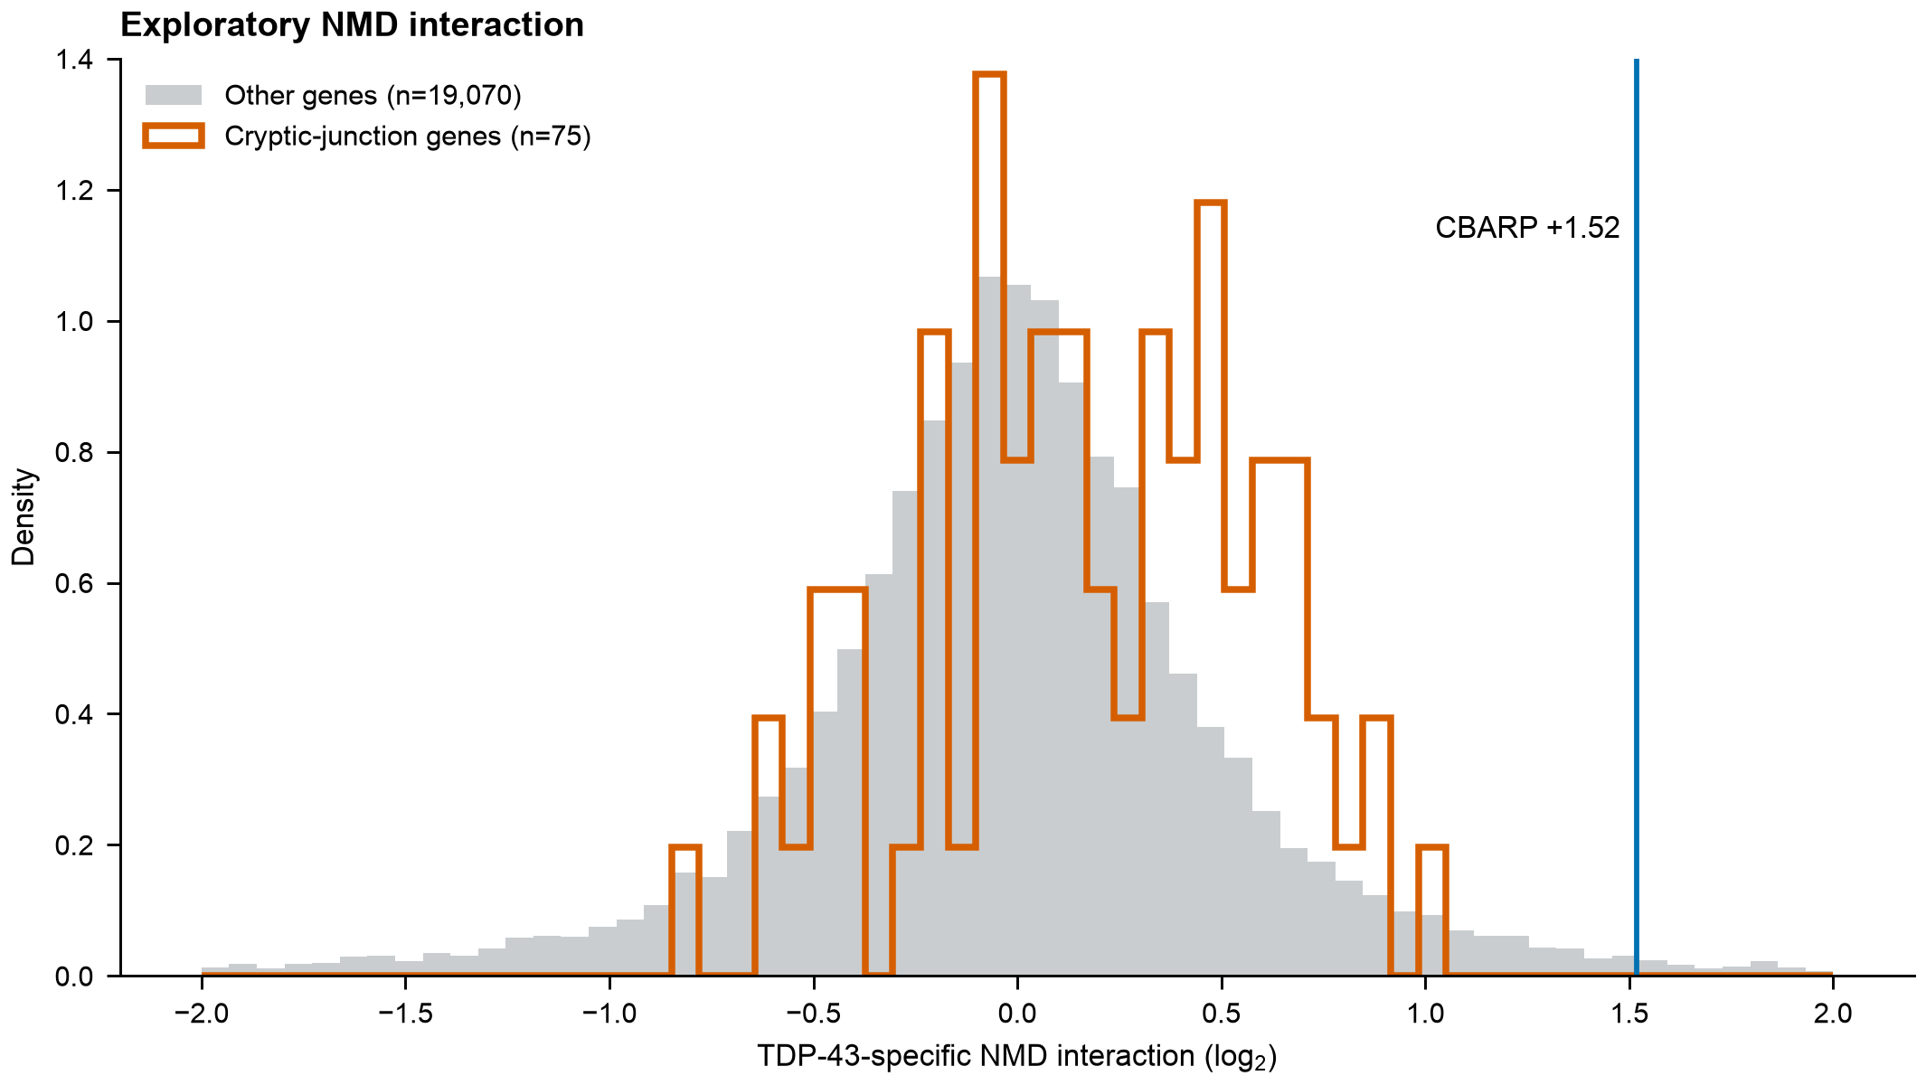
Supplementary Figure S5. Exploratory NMD interaction. Condition-level TDP-43-specific interaction estimates for genes with a cryptic junction and the remaining genes, with CBARP marked. The four NMD-inhibition conditions are the units of inference; the TDP-43 factor is confounded with sequencing batch.

Supplementary Figure S6
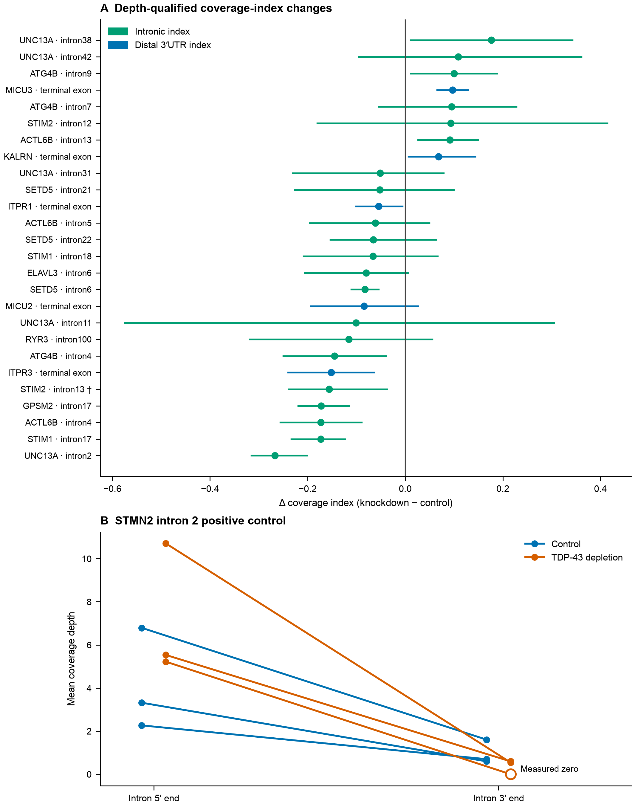
Supplementary Figure S6. Coverage-based alternative-polyadenylation screen and STMN2 control. (A) Depth-qualified SH-SY5Y intronic and distal 3′UTR index changes with bootstrap 95% intervals. The STIM2 intron 13 unit (†) contains the alternatively spliced STIM2 exon and is not independent evidence for a polyadenylation event. (B) Coverage at both ends of STMN2 intron 2 in each replicate after reference skips are excluded; the open marker is a measured zero at the 3′ end in one knockdown replicate. The indices measure coverage gradients, not poly(A) sites.

Supplementary Figure S7
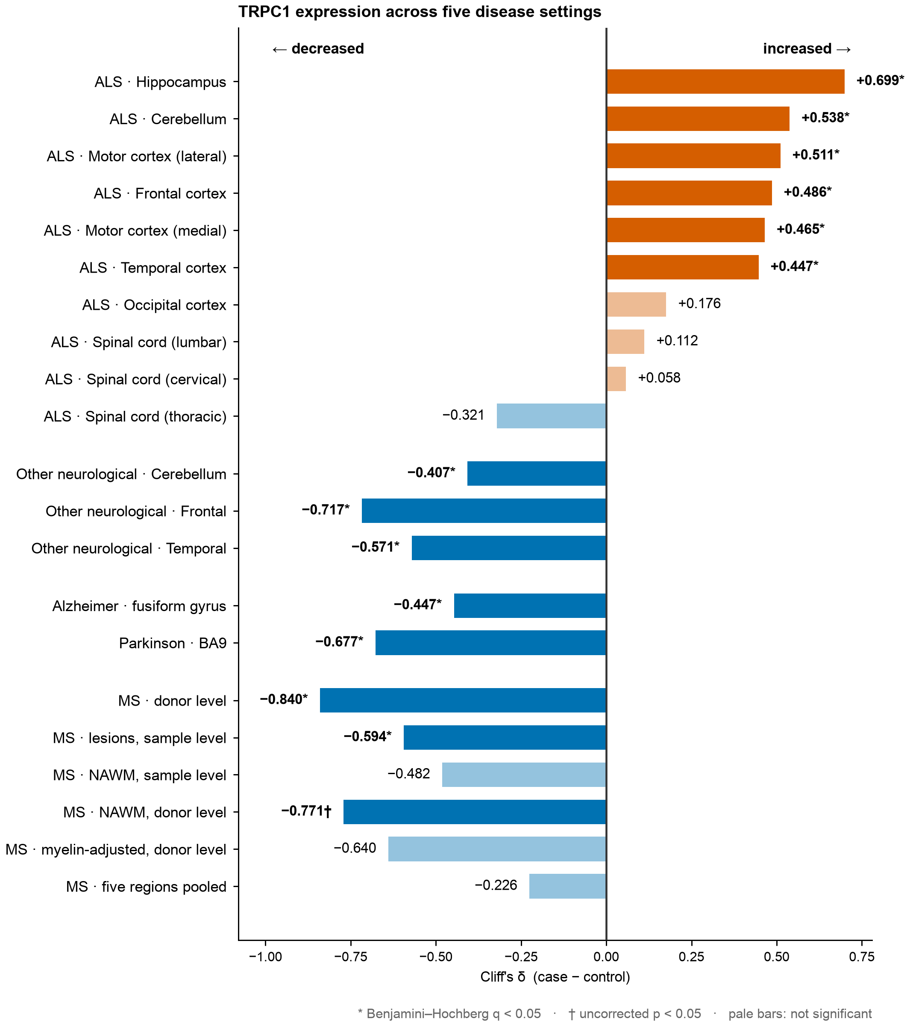
Supplementary Figure S7. TRPC1 expression across neurological comparison cohorts. Cliff’s δ (case minus control) is shown for ALS regions, other neurological disorders, Alzheimer’s disease, Parkinson’s disease and multiple sclerosis. Asterisks mark Benjamini–Hochberg q < 0.05; daggers mark uncorrected p < 0.05 for the donor-level normal-appearing white matter and myelin-adjusted comparisons. Pale bars are not significant. Cohorts and tissue compartments differ, so the display is descriptive across diseases.

Supplementary Figure S8
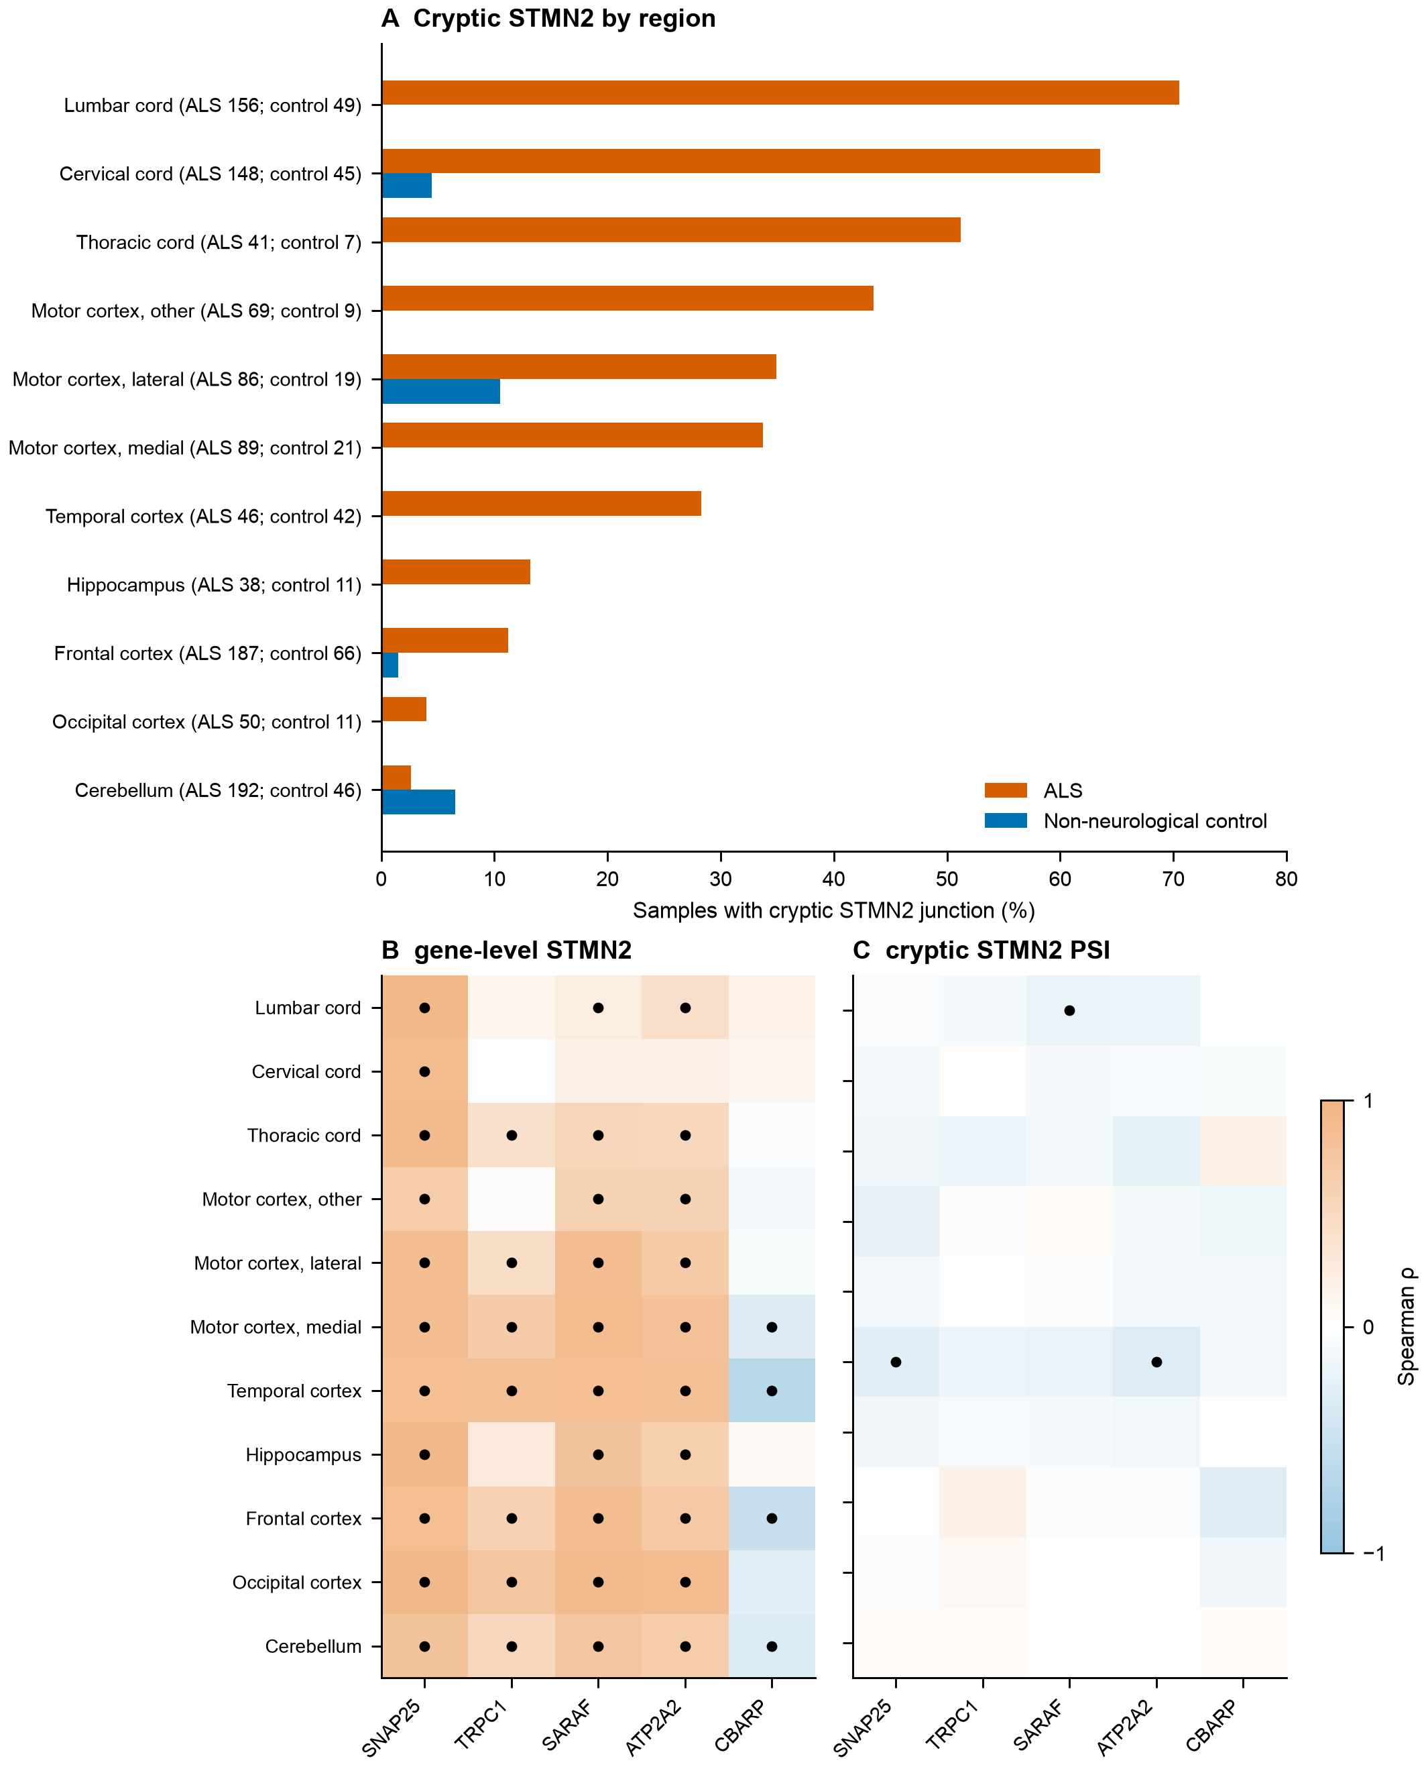
Supplementary Figure S8. STMN2 expression and cryptic junction inclusion in ALS tissue. (A) Percentage of ALS and non-neurological control samples with a cryptic STMN2 junction, by region, among samples with at least 20 junction reads at the donor; sample counts for each group are printed in the labels. (B, C) Within-ALS Spearman correlations of selected genes with total STMN2 expression and cryptic STMN2 PSI, respectively. Black dots mark q < 0.05 across the stated correction family. The heatmaps use the same colour scale; exact coefficients and q values for all tested genes are in Supplementary Table S9. Total STMN2 expression also tracks neuronal content, whereas cryptic junction PSI more directly reflects TDP-43-dependent RNA processing.

