

024935100
Contact center
Customer Support

Via email
Website
info@smartcollection.co

{{TENANT_NAME}}
www.smartcollection.co
{{TOWER}}
{{UNIT}}
Date
{{DATE}}
Contract Number
{{TENANT_CONTRACT}}

No Objection Certificate
No Object Certificate

The Customer Service Department in Smart Payments Collection LLC certifies that the above customer has paid all outstanding debts for chilled water of the mentioned contract.
Once issuance of the no objection certificate, the premise will be automatically transferred to the (Landlord/Properties Management Company) who will be responsible for any future chilled water consumption and district cooling (capacity charge) on the given account number.
{{TENANT_CONTRACT}}
{{TENANT_NAME}}
Tenant Information
Consumer Name
Contract Number

Owner Information
{{OWNER_CONTRACT}}
{{OWNER_NAME}}
Consumer Name

Contract Number

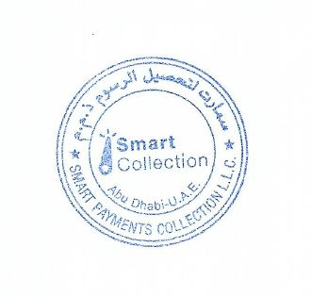

Regards
Customer Service Division
Smart Payments Collection LLC

2nd floor Office 213 Ali & Sons Business Center Plot no.29 Al Ain Rd, Umm Al Anar Abu Dhabi, UAE - Po Box 129865

