
SMART PAYMENTS COLLECTION

SUBJECT: CLEARANCE LETTER

IN RELATION TO MOVE IN AND ACCOUNT ACTIVATION

DATE | {{noc_date}}

This is a confirmation clearance letter from the customer service team in Smart Payments Collection LLC to confirm that the following account details have been received from the customer and successfully registered in our system.

ACCOUNT HOLDER FULL NAME | {{account_holder_name}}
ACCOUNT TYPE | {{account_type}}
TOWER NAME | {{tower_name}}
UNIT NUMBER | {{unit_no}}
SPC ACCOUNT NUMBER | {{spc_account_no}}

For any further clarification kindly don’t hesitate to contact us

Customer Service Division Smart Payments Collection
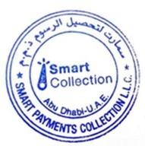

ADRESS
Office 213, Abu Dhabi United Arab Emirates
CONTACTS
info@smartcollection.co
+971 2 493 5100
WEB
www.smartcollection.co 600 521 000

