CSE 211 Web Programming, Fall Semester 24/25

Assignment #1: Websites conceptual Design and mock-up

222101420 Mohamed Emad Elmazahi

**Part I: Research**

The term often used for the internet is World Wide Web, referred to as the web.

does not mean the same thing as the internet but is the most noticeable part of the online world that is characterized as a blend of technology and social interaction System that uses technological networks to ease human interaction.

Web 2.0, defined in 2004 by Dale Dougherty. Web 2.0 is the technological advancement in the business world. The industry was affected by the shift to the internet as a platform, and an effort to understand the guidelines for achievement in that unfamiliar domain stage.

Some of its characteristics are focusing on content created by users leading to platforms like blogs, wikis, folksonomy, and mashups. Improving functionality and design, including AJAX (Asynchronous JavaScript and XML) for dynamic content updates. The beginning and the rise of social networking and community building.

Web 3.0 (The Semantic Web) brough up in 2006 by John Markoff and thought by Tim Bernes-Lee, the inventor of World Wide Web; The aim of design web of data is machines first, humans later. As mentioned in an article by Dr. Hitendra Patil.

|  |  |  |
| --- | --- | --- |
| No. | Web 2.0 | Web 3.0 |
| 1 | Tom O’ Riley | Tim Bernes-Lee |
| 2 | Write and read web | Executable web |
| 3 | Social web | Semantic web |
| 4 | Participation and interaction | Understanding self |
| 5 | Bi-Directional | Multiuser virtual environment |
| 6 | Connect people | Connect knowledge |
| 7 | Wikis | Semantic Wikis |
| 8 | Google personalized | Semantic search |
| 9 | Google scholar | Semantic digital libraries |
| 10 | Community portals | Semantic forums |
| 11 | Online social networks | Semantic social networks |

Web 4.0 is a fresh iteration of the Web concept that relies on various models, technologies, and social connections.  
Web 4.0 is a highly interconnected, intelligent, and responsive ecosystem that seamlessly integrates AI, IoT, and immersive technologies to deliver personalized, autonomous, and ethically responsible user experiences.

Social media websites, content created by users, application programming interfaces (APIs), and blending different services together.  
These characteristics contributed to building a more communal, engaging, and interconnected internet that uses the combined strength of its users.  
Semantic Web Technologies, Artificial Intelligence, Machine Learning, Compatibility, and Decentralization.  
Web 3.0 provides significance to data and improves relationships by increasing accessibility and comprehension of information.  
Integration of Internet of Things, sophisticated Artificial Intelligence, and understanding of context.  
These characteristics lead to a future where the internet serves as a continuation of human intellect, reacting cleverly and independently to user requirements.  
Collective intelligence uses communities to collect insights, forming a knowledge base beyond the capability of an individual.  
Social networking and media platforms enhance this by enabling users to connect, share, and work together instantly.  
Social bookmarking helps to organize and categorize information, improving how data is found and adding to a connected online society. User participation and collective ability are harnessed to drive innovation and broaden knowledge.  
Businesses can utilize web2, web3, and web4 technologies to connect with customers in more interactive and customized ways.  
In my view, in the context of web 3, I could use it on standalone platforms and websites, such as Lisk which allows me to create decentralized applications with JavaScript.  
Web 4 focuses on the symbiotic relationship between humans and machines.  
It will be a significant advancement that will positively affect my career.

**Part II: Website Planning**

1. **Define the purpose of your intended website; it might be about a favorite hobby or subject, family business, a church, a mosque or a club, a company etc.**

The purpose of BeatHaven is simple. A ticketing website for people interested in partying, concerts, and music events, it might not be a favorite hobby but it's an experience, everyone looks for trendy stuff these days.

1. **What would you like the website to** **accomplish?**

A user-friendly ticketing platform for music events in Egypt, this site enables easy browsing for all upcoming events. Making it smooth and easy for all people interested in music with all its genres.

1. **Who is your intended audience?**

Music enthusiasts, young adults and students, tourists and expats. People interested in music of all kinds.

1. **What opportunities, problems, or issues does your planned website address?**

Opportunities:

* Providing a single platform for users to find tickets easily instead of searching multiple sources.
* Helping musicians and organizers reach a wider audience by showing their events on a well-designed, smoothly accessible website.
* Assuring and guaranteeing customers in buying the tickets without hesitation or worry.

Problems/Issues:

* Some users often struggle finding information about events, this website provides all the information needed and FAQs answered in social media accounts of the brand.
* People find it difficult facing unreliable complex ticketing systems, BeatHaven offers an easy navigation system and simple payment options.
* Many people miss out on an event by finding out too late, Beathaven could send notifications and advertisements for all upcoming events so no one misses out.

1. **What kind of content could be incorporated in your website**

Event listing, Ticket purchasing, Personalized notifications, social media integration, and finally Map and venue information.

1. **How will the site serve the client?**

First by increasing the event’s visibility and by managing the ticket sales directly.

Features like personalized notifications, email campaigns, and social media integration help clients promote their events and reach potential attendees, the site fosters a community around the global music scene, creating more loyal attendees for future events.

Through database analytics the client can gain insights into ticket sales trends.

1. **What’s the best method for the user to do what’s wanted?**

A user dashboard where users can see what’s the trending and recommended events, and a one-click ticket buying where users can securely save payment information for faster checkout.

1. **How will users find the function?**

Intuitive navigation menu which has all the sections a user might need, plus a personalized homepage with all the upcoming events in Egypt with a one-click button “Book Now!”. Also, a help and support chat with a hotline, social media accounts and email. Finally, links from Google Maps for the venue's location so that people can arrive on time without getting lost.

1. **How will the results of the function be received?**

After actions like ticket purchasing the user will see a confirmation page with event details, ticket quantity, and payment information and an email if the website window is closed. Then a section called “Our Stores” found in the navigation menu will have all the outlets that serve the tickets; by choosing the nearest branch the customer is able to get their tickets.

1. **What will the receiver do with the received entries?**

Review confirmation details to verify their ticket purchase ensuring all details are correct.

They will either keep the email confirmation handy for the entry to the event or print them from our accredited outlets. (Depending on the event) sometimes it could be a QR sent in the confirmation email.

They could provide feedback and share their experiences via our verified accounts.

1. **How will the receiver deal with results?**

Verification, event preparation/participation, feedback, review, and social sharing.

1. **What follow-up will be needed?**

* Search Bar with filters
* Artist Profiles
* Event Reviews and ratings
* Content Updates
* Promotional Offers

1. **List at least two related or** **similar sites found on the Web. Explain why you chose them.**

* Tazkarti: is one of the biggest ticket sellers in Egypt specialized in football matches and entertainment.
* TicketsMarche: is the most trusted and popular ticket seller website known for their good organizing management on heavy-crowded events.
* TicketsEgypt Venflare: they are one of the best also, but what makes them special is the type of events they present and the globally famous artists they bring to perform in the country.

**14a**. The goal of BeatHaven is simple. To connect music fans with tickets to live events, from house music parties to concerts in all genres, making it easy and exciting to enjoy live music.

**14b.**

* Ticket booking portal.
* Payment Portal.
* Navigation menu.
* About us.
* Profile.
* Our stores.
* Contact Us

**14c.**

The Home page which has all the events listed with two magic buttons, the navigation menu and the “Book Now!” button. With the navigation menu sliding from the right side of the screen you can navigate through all these sections: Home, Profile, Our Stores, Contact Us, About Us. During the first time booking a ticket he/she is going to have to create an account and provide us with the required information, that's when he can visit his profile while the Our stores section is the locations of our outlets that prints tickets. The Contact us section is for helping our customers and aiding them with a better and clearer experience. Finally, from the navigation menu is the “About us” section which answers the main question: What is BeatHaven? Back to the booking part, whereby just clicking the button “Book Now!” The user will teleport to another page where he/sheare free to choose the type of ticket and quantity, then to the final part, the payment section.

**14d**.

Users on **BeatHaven** will use forms to register for events, subscribe to newsletters, leave feedback, take part in polls, and sign up for accounts, helping to personalize and enhance their experience on the platform.

**14e.** 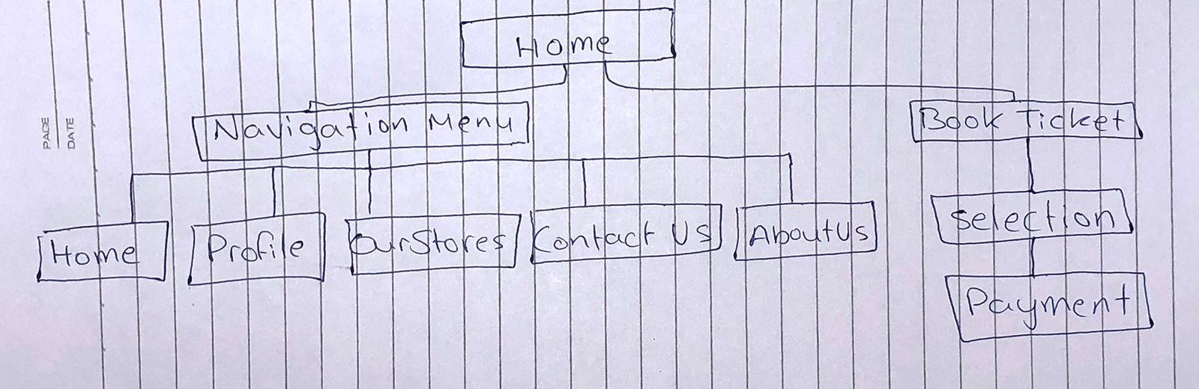

**Part III: Website Design**

Law of Prägnanz: By using this law I tried making the website simpler than other competitive sites. By using less buttons and clear view.

Closure: all events are listed on the home pages, no need to search for something specific.

Symmetry and Order: Everything is symmetric left as right, organized so that it's easier to use.

Figure/Ground: Contrast buttons for focus areas.

Uniform Connectedness: Consistent color and font for interactive elements.

Common Region: All event details are shown.

Continuation: Guide user flow with subtle lines or arrows.

Common Fate: Synchronized animations for interactive elements.

Parallelism: Grid format for event listings.

Similarity: Consistent icons and styles for similar functions.

Screen Resolution: Responsive design for different devices.

Color Palette: Vibrant, high-contrast colors, better for color blind people and with acceptable accessibility ratio.



**References:**

[1] Hendler, J, and Berners-Lee, T. 2010. From the Semantic Web to social machines: A research challenge for AI on the World Wide Web. Artificial Intelligence, 174, 156-161. [2] Shadbolt, N., Kleek, M., and Binns, R. 2016. The Rise of Social Machines. IEEE Consumer Electronics Magazine, April, 106-111.

[3] Bhasker, L. 2013. Pervasive Computing Issues, Challenges and Applications. International Journal of Engineering and Computer Science (IJECS), 2(12), 3337-339.

**Web Design Figma Link:** <https://www.figma.com/design/5HRZcxRxIjnt7t5ANHh7TX/CSE-212-ASSIGNMENT?node-id=0-1&t=uvC6aX8e2bfN5AT8-1>