1. Exploratory Data Analysis
Before building any model we ran a systematic EDA to understand the raw data. We are doing this to support decisions that we will take in the preprocessing phase.
1.1 Dataset Overview
WaRP-C is an industrial waste classification dataset recorded on a recycling conveyor belt. Images are bounding-box crops extracted by an object detector, meaning each image contains exactly one object, but crop size, aspect ratio, lighting, and zoom level vary considerably. So we need to take this into consideration.
Total training images | 8,823 (across 28 classes)
Total test images | 1,551
Number of classes | 28 (grouped into 5 parent categories)
Parent categories | bottle, glass, detergent, canister, cans, cardboard
Image format | JPEG / PNG (RGB)
Capture environment | Industrial conveyor belt, fixed camera

1.2 Class imbalance
The most critical finding of the EDA was the severe class imbalance. We used the following formula: Imbalance Ratio = max_count / min_count so in our case we found an imbalance ratio of 1432 / 24 = 59.67 where bottle-transp: 1,432 images and bottle-oil-full: 24 images which is 1.7 percent of the majority.
Without correction, a mini-batch of 32 images drawn uniformly contains on average 5.2 bottle-transp samples but only 0.09 bottle-oil-full samples, meaning most batches contain zero examples of the rarest class. The model's weights for that class are never updated.
Class | Train Images | Test Images | Ratio to Mean | Status
bottle-transp | 1,432 | 234 | 4.55× | Majority
bottle-blue | 634 | 104 | 2.01× | Above mean
cans | 562 | 98 | 1.78× | Above mean
bottle-milk | 347 | 57 | 1.10× | Near mean
glass-transp | 177 | 36 | 0.56× | Below mean
detergent-box | 66 | 17 | 0.21× | Minority
bottle-blue5l-full | 89 | 24 | 0.28× | Minority
bottle-oil-full | 24 | 8 | 0.08× | Minority

1.3 Image Size and Aspect Ratio
WaRP-C images are detector crops, so they are NOT uniform in size.
Width median | 162 px (range: 40–703 px)
Height median | 154 px (range: 35–668 px)
Aspect ratio median | 1.1 (range: 0.2 – 5.2)
Final decision | 224 px : required by all pretrained backbones

Example
An image of 80 × 200 px has aspect ratio 0.4. Naive Resize(224,224) squashes it to a square → bottle shape distorted. PadToSquare first → 200×200 → then Resize(224,224) → no distortion.
1.4 Pixel Statistics & Normalisation
We computed per-channel (R, G, B) mean and standard deviation from 1,500 sampled training images and compared them to ImageNet statistics, the standard reference used by all pretrained deep learning models.
What is ImageNet? ImageNet is a dataset of 1.2 million natural photographs used to pretrain almost every modern vision model. ResNet, ViT, EfficientNet, all are pretrained on ImageNet and therefore expect inputs normalised with ImageNet's colour statistics: mean=[0.485, 0.456, 0.406], std=[0.229, 0.224, 0.225].
Statistic | WaRP-C (our data) | ImageNet (pretrained models)
Mean R | 0.337 | 0.485
Mean G | 0.344 | 0.456
Mean B | 0.350 | 0.406
Std R | 0.216 | 0.229
Std G | 0.209 | 0.224
Std B | 0.218 | 0.225
Mean difference | 0.105 | — threshold = 0.05
From the threshold we can deduce that: Mean difference 0.105 > threshold 0.05 → use WaRP-C statistics, because WaRP-C images are darker (industrial belt lighting) than ImageNet natural photos. Using ImageNet stats would over-subtract from every pixel, degrading model inputs.
1.5 Per-Class Brightness
We measured mean luminance per class to understand lighting variability.
Darkest class | glass-dark (mean brightness = 0.213)
Brightest class | detergent-white (mean brightness = 0.481)
Brightness range | 0.481 − 0.213 = 0.268 (large variation)
Dataset std | 0.066
Decision | ColorJitter brightness=0.4 (covers the 0.268 real range)
Example: glass-dark mean brightness = 0.213 (very dark, nearly black background). detergent-white mean brightness = 0.481 (bright white packaging). ColorJitter brightness=0.4 multiplies pixels by a random factor in [0.6, 1.4], making dark images look brighter and bright images look darker pushing the model to recognise objects regardless of ambient lighting.
1.6 Data Leakage Check
We performed a filename-level duplicate check between train and test splits.we found that 18 duplicate filenames appear in BOTH train and test. If kept in train: model has 'seen the answer' for 18 test images.
2. Preprocessing Pipeline:
All preprocessing steps are implemented in Pipeline_/preprocessor.py as the WaRPPreprocessor class.

# | Decision | EDA Finding That Drove It | What We Did | Why
1 | Input size | EDA recommended 192px. Minimum image size = 40px (upscale factor 5.6× — pure artefacts) | 224px | All pretrained models (ResNet, ViT, YOLO, EfficientNet) were trained on ImageNet at 224px. Images below 75px are flagged as noise via check_upscale_risk()
2 | Padding before resize | Aspect ratios range 0.2–5.2. A 80×200px bottle naively resized becomes a distorted square | PadToSquare(reflect) before Resize(224) | Preserves object shape. Reflect padding avoids black borders that CNNs learn as spurious features
3 | Normalisation stats | Mean difference from ImageNet = 0.105, above 0.05 threshold | WaRP-C stats: mean=[0.337, 0.344, 0.350], std=[0.216, 0.209, 0.218] | WaRP-C images are darker than ImageNet natural photos. Using ImageNet stats would mis-normalise every input
4 | Data leakage | 18 filenames appear in both train and test splits | Remove 18 files from train only | Keeping in train = model has seen test answers. Removing from test = benchmark incomparable to published results
5 | ColorJitter strength | Brightness range across classes = 0.268 (glass-dark 0.213 → detergent-white 0.481) | brightness=0.4, contrast=0.3, saturation=0.3, hue=0.05 | Covers the full real brightness range. hue=0.05 kept tiny to avoid blue→green label corruption
6 | Random rotation | Items tumble freely on conveyor belt | RandomChoice([±30°, 90°, 180°, 270°]) | Covers both continuous and discrete rotations seen in practice
7 | GaussianBlur | Industrial cameras capture moving objects | p=0.2, kernel=3 | Forces model to rely on shape/colour not high-frequency texture
8 | RandomErasing | Objects overlap on the belt (occlusion) | p=0.3, scale=2–20% of image area | Model must recognise partial objects. Minority pipeline uses p=0.4, scale up to 25%
9 | Imbalance Layer 1 — WeightedRandomSampler | ρ = 59.67 (bottle-transp 1432 vs bottle-oil-full 24) | weight = 1/class_count per sample, replacement=True | Without it most batches contain zero minority images. Minority drawn ~13× more per epoch
10 | Imbalance Layer 2 — Weighted CrossEntropyLoss | ρ = 59.67 > 50 → Buda et al. 2018 Tier 3 requires both | w_c = (1/count_c) × (N/C) | Sampler controls frequency. Weighted loss controls gradient magnitude. Both needed for ρ > 50
11 | Imbalance Layer 3 — Minority augmentation | bottle-oil-full (24 imgs) seen ~13× per epoch by sampler | Stronger pipeline: crop 0.5–1.0, brightness=0.5, erasing p=0.4 | Without augmentation diversity the model memorises 24 exact images. Stronger aug creates synthetic variants
12 | MixUp | bottle-blue and bottle-transp are visually very similar | λ~Beta(0.4,0.4): mixed = λ×img1 + (1-λ)×img2 | Forces model to handle ambiguous in-between examples. Improves calibration on hard class pairs
13 | Test-Time Augmentation | Minority classes have low model confidence at inference | 5 variants: original, H-flip, V-flip, 90° rotation, +10% brightness — softmax averaged | +1–3% accuracy at zero training cost. No retraining needed
14 | Augmentation saved to disk? | — | NO — original cleaned images saved, transforms applied in RAM per batch | Saving augmented images would require 50–100GB and kills diversity. On-the-fly = fresh variant every epoch

Model | Pipeline | Sampler | Minority Aug | MixUp | Crop Scale | Flip H | Flip V | Rotation | ColorJitter | Blur | Erasing
CNN (scratch) | Light | ✗ | ✗ | ✗ | No crop | 50% | ✗ | ±15° | b=0.2 c=0.2 | ✗ | ✗
ResNet50 | Standard | ✓ | ✓ | ✗ | 0.6–1.0 | 50% | 30% | 30°/90°/180°/270° | b=0.4 c=0.3 | 20% | 30%
EfficientNet | Standard | ✓ | ✓ | ✓ | 0.6–1.0 | 50% | 30% | 30°/90°/180°/270° | b=0.4 c=0.3 | 20% | 30%
Swin | Strong | ✓ | ✓ | ✓ | 0.5–1.0 | 50% | 30% | 30°/90°/180°/270° | b=0.4 c=0.4 | 25% | 35%
ViT | Strong | ✓ | ✓ | ✓ | 0.5–1.0 | 50% | 30% | 30°/90°/180°/270° | b=0.4 c=0.4 | 25% | 35%
ConvNeXt | Strong | ✓ | ✓ | ✓ | 0.5–1.0 | 50% | 30% | 30°/90°/180°/270° | b=0.4 c=0.4 | 25% | 35%
EdgeViT | Gentle | ✓ | ✓ | ✗ | 0.7–1.0 | 50% | 30% | 30°/90°/180°/270° | b=0.4 c=0.3 | 20% | 30%
MobileViT | Gentle | ✓ | ✓ | ✗ | 0.7–1.0 | 50% | 30% | 30°/90°/180°/270° | b=0.4 c=0.3 | 20% | 30%
LLaVA | Val only | ✗ | ✗ | ✗ | No crop | ✗ | ✗ | ✗ | ✗ | ✗ | ✗
GNN | Val only | ✗ | ✗ | ✗ | No crop | ✗ | ✗ | ✗ | ✗ | ✗ | ✗
Minority classes | Extra-strong | — | — | — | 0.45–1.0 | 50% | 50% | 45°/90°/180°/270° | b=0.5 c=0.4 | 30% | 40%

3. CNN Baseline Model:
This model follows the baseline CNN used in: Ogrezeanu et al. (2024) "Automated Waste Sorting: A Comprehensive Approach Using Deep Learning for Detection and Classification on WaRP-C" IEEE Mediterranean Conference on Control and Automation (MED 2024). They tested CNN, LeNet-5, AlexNet, VGG16, MobileNetV2, Inception, and DenseNet on WaRP-C. The simple CNN served as the lower-bound baseline that all pretrained transfer learning models were expected to beat. As you will see on the notebook (CNN_Baseline.ipynb) we have achieved a very an accuracy of 54% on the test data. The backbone of the model is as of the following: we built convolutional blocks consisting of a sequence of conv2d layer that takes the input channels at first we have 3 channels (R-G-B) we move to 32 and so on so forth and in each block we apply batch normalization and we allow the beta and alpha parameters to be learnable, then we apply the RELU for non-linearity and finally we do a max pool with a kernel size of 2 and a stride of 2 so the image is halved (24→112→56→28→14) across the four blocks. Afterwards we apply the adaptive average pooling that actually turns our output from the convolutional blocks (B, 256, 14, 14) to (B, 256, 1, 1). We opted for this instead of flattening since the flatten will make the model more sensitive to the position of each feature which is not what we are looking for and also the average pooling reduces the complexity of the number of weights. At the end we follow up with the classifier head which takes as input the output of the gap does a dropout add a linear hidden layer a ReLu for non-linearity another lighter dropout and finally a linear layer with the output as number of classes we do not use the softmax here as we leave the choice at the level of the notebook to deduce right class based on probabilies. For weights initialization we are actually using Kaiming He which is good for ReLu networks since it assumes that Relu actually reduce the variance of activations by half.
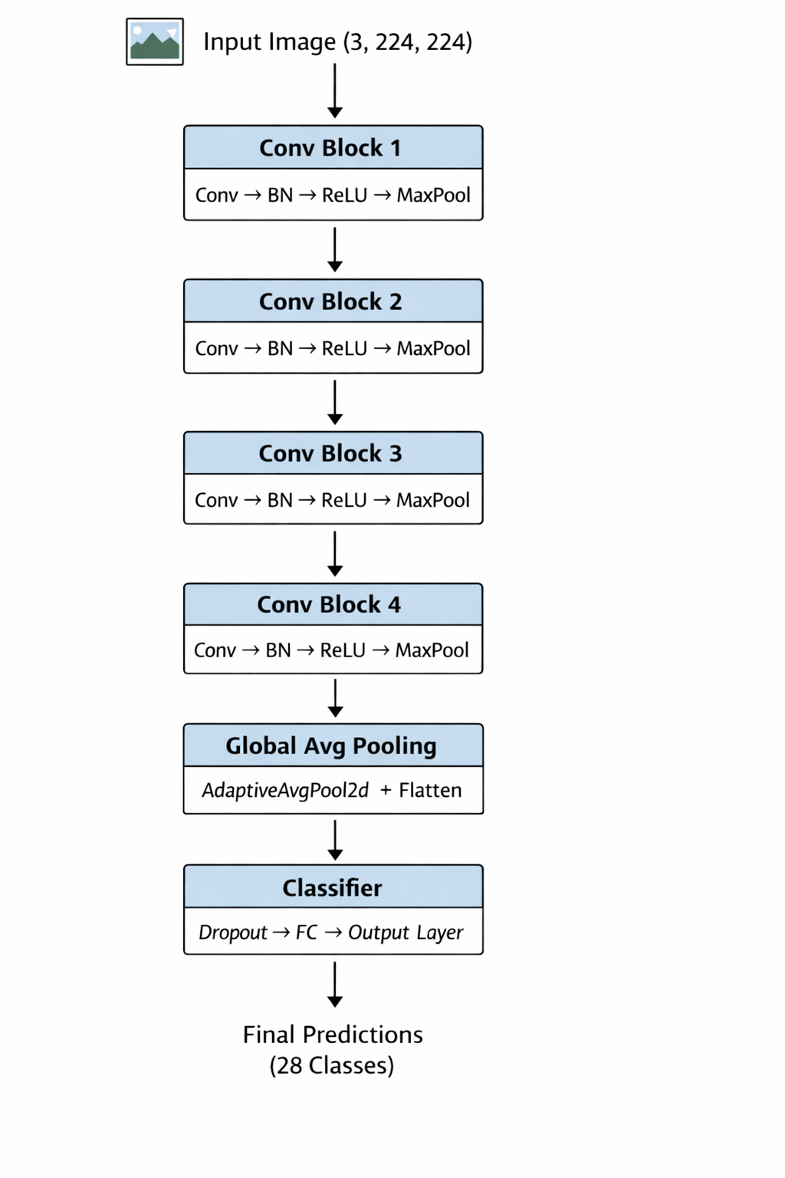

The CNN baseline achieved a Top-1 accuracy of 54.35%, establishing a lower-bound performance for the classification task. While the model demonstrates strong performance on visually distinctive classes such as glass-dark (F1 = 0.846) and bottle-dark (F1 = 0.786), it fails completely on several classes including bottle-oil and detergent-transparent, where F1-scores drop to zero.
The confusion matrix reveals significant misclassification among visually similar categories, particularly between transparent and filled containers, indicating that the CNN struggles to capture higher-level semantic distinctions such as content state (full vs empty).
Additionally, the model exhibits bias toward dominant classes such as bottle-transp, which achieves high recall due to its larger representation in the dataset. These findings highlight the limitations of convolutional architectures in capturing global context and fine-grained semantic differences, motivating the use of Transformer-based models in subsequent experiments.

