Creating and cloning a GitHub repository

# Disclaimer

The following instructions are for creating a GitHub Repository and then cloning it to a Windows personal computer. These instructions are designed for someone who is already familiar with programing terms and methods. These instructions assume that a Github account has already been created, and Git has been installed on a PC.

These instructions are based on using Windows 10, Chrome Browser, and git version 2.21.0.windows.1.

# Introduction

These instructions will explain how to create a new repository in Github and then clone that repository to your local computer using HTTPS. This will help provide the initial steps using version control while developing source code.

Github is one of largest cloud development platforms in the world. It is a well-known user-friendly website that provides an interface to Git.

Git is an open-source project version control system that tracks changes to computers files. Its most commonly used to allow development of source code and coordinating work among developers.

Cloning is a computer term used for making a copy of the Git repository in a new location. For the purpose of these instructions, we will be cloning the Github repository to the local PC.

HTTPS stands for Hypertext transfer protocol secure. It’s the primary protocol for transferring with a website. Though there are several protocols that can be used with Git, for these instructions we will be using HTTPS.

# Discussion

## Step 1: Creating a repository

The goal is to create a new repository in the GitHub website. This repository will be later cloned to the PC.

1. In your web browser visit: <https://github.com/>
2. Sign in to Github with your account.
3. Click on the New button. (See Figure 1)

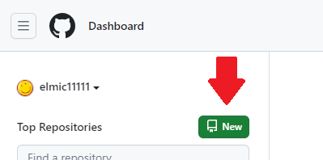

Figure 1

1. Enter a repository name. The repository name should be short but descriptive (See Figure 2)

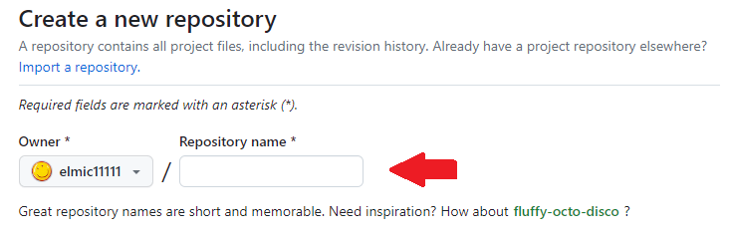

Figure 2

1. Though optional, it is recommended that you add a description. Good descriptions generally contain 1-2 sentences. The maximum length allowed for a description is 1,000 characters. (See Figure 3)



Figure 3

1. Select if you want your repository public or private. (See Figure 4) For these instructions we’ll use public.

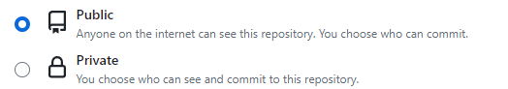

Figure 4

1. (Optional Step) You can choose to add a README file to the repository by checking the “Add a README file” box. (See Figure 5) It is recommended that you always have a README. A README file is a common documentation file containing source code.



Figure 5

1. (Option Step) Choose to add .gitignore (See Figure 6). An ignore file provides Git instructions about ignoring certain files in your repository when committing changes. This is generally based on the language you plan to write the source code in.

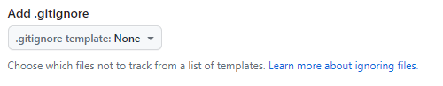

Figure 6

1. (Optional Step) You can Choose a license to include. (See Figure 7) A license sets the terms concerning other people and companies using part or all your code. 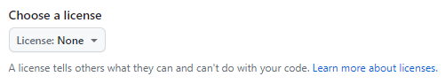

Figure 7

1. Click the Create Repository button (See Figure 8)



Figure 8

## Step 2: Cloning Git repository

Cloning a repository is the process of making a copy of the repository located on the Github website to your PC. In this step we will retrieve the HTTPS address for the repository and use the address to clone.

1. Click the <> Code Button to expand that section, and select the Copy icon to copy the repository HTTPS address to your clipboard. (See Figure 9)

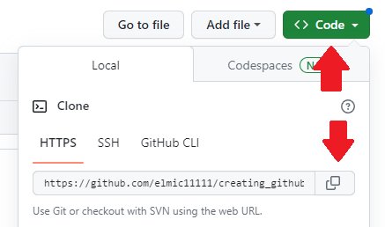

Figure 9

1. Click Windows Start Menu, type PowerShell, and select “PowerShell” from the list (See Figure 10)

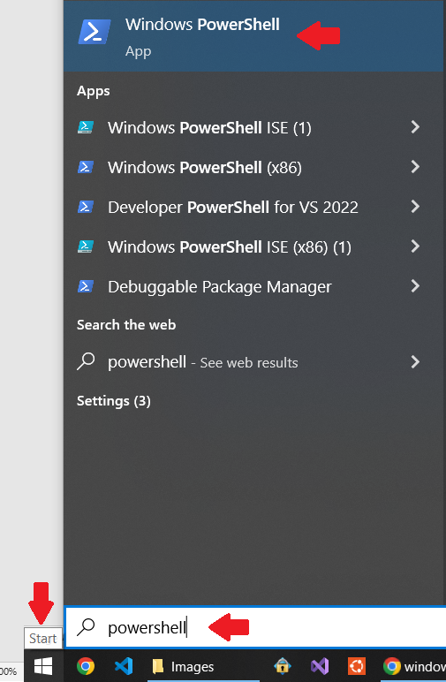

Figure 10

1. Type “git –version” to verify the git is installed properly. (See Figure 11)

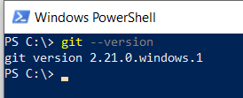

Figure 11

1. Type “git clone “ and then paste the URL from Github (See Figure 12). This will clone your repository into a directory.

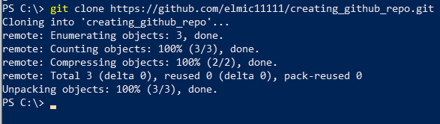

1. Use the cd command to change to the directory created and confirm the repository was cloned. (See Figure 13)



# Conclusion

Creating a Git repository is a great way to version control source code. Making sure as you make changes that you are able to track those changes and reverse them if you make a mistake. This is an essential skill for any programmer. It is recommended that you explore all the functionality of Git.

# Additional Information

ReadMe File - <https://docs.github.com/github/creating-cloning-and-archiving-repositories/about-readmes>

Ignore File - <https://docs.github.com/en/get-started/getting-started-with-git/ignoring-files>

License File - <https://docs.github.com/github/creating-cloning-and-archiving-repositories/licensing-a-repository>

Git Documentations - <https://git-scm.com/docs>

GitHub Docs - <https://docs.github.com/>