COMPARATIVE ANALYSIS OF LOGISTIC REGRESSION AND XGBOOST FOR COGNITIVE LOAD DETECTION USING EYE TRACKING FEATURES WITH FEATURE IMPORTANCE ANALYSIS
In Partial Fulfillment of the Requirements for the
Degree Bachelor of Science in Computer Science
Submitted by:
Caacbay, Miguel John C.
Magkasi, Sophia Bianca J.
Uaje, James Paul B.
Ventura, James Christian B.
October 2026

CHAPTER 1
THE PROBLEM AND ITS BACKGROUND

PROJECT CONTEXT
Cognitive load refers to the amount of mental effort that a task demands from a person’s limited processing capacity [1], [2]. It is a central concept in ergonomics and human factors because the mental demands placed on a person are closely linked to performance and safety in complex tasks [3]. As digital systems and technology-driven environments become more demanding, monitoring cognitive load has gained importance in fields such as education, healthcare, transportation and human–computer interaction.
Traditional methods for measuring cognitive load rely mainly on subjective questionnaires such as the NASA Task Load Index (NASA-TLX) [4], or on physiological measures such as electroencephalography and cardiac activity [5]. Questionnaires are collected after a task and depend on how participants judge their own effort, and different workload measures do not always agree with each other [6]. Physiological sensors can also be intrusive and difficult to use outside the laboratory. Eye tracking offers a less intrusive alternative: a camera-based tracker records pupil size, blinks, fixations and saccades while a person works, and a systematic review of 91 studies found that several of these measures respond to changes in mental workload, with pupil diameter significant in 79% of the studies that tested it, fixation duration in 73% and blink rate in 71% [5].
Machine learning makes it possible to combine these eye-tracking measures into a model that classifies a person’s load level. Logistic Regression is a linear model whose coefficients show how each feature pushes the prediction, which makes it a common interpretable baseline [7], [8]. XGBoost is a gradient-boosted decision-tree method that can represent nonlinear relationships and interactions in tabular data [9], [10]. Comparing the two shows whether the added flexibility of an ensemble method improves detection over a simpler model that is easier to interpret.
Existing eye-tracking studies, however, differ widely in their datasets, labels, features and validation procedures, which makes it difficult to judge how the two model families compare on the same task. Studies that compared Logistic Regression and XGBoost used different eye-tracking settings and reported different outcomes [11], [12], [13]. Many studies also tested their models on data from the same people they were trained on, which can overestimate performance for new users [14], [15]. Finally, few studies report which eye-tracking features each model relied on, and those that did usually explained only one model [16], [17].
To address these gaps, this study compares Logistic Regression and XGBoost for cognitive load detection using eye-tracking features from the publicly available COLET dataset [18]. COLET records the raw gaze, pupil and blink data of 47 participants performing visual-search tasks under four conditions that combine time pressure and a secondary counting task. The study evaluates both models on participants not seen during training and analyzes which eye-tracking features each model relied on, using the same explanation framework (SHAP) for both models.

PURPOSE AND DESCRIPTION
This study aims to develop and evaluate a machine learning framework for detecting cognitive load from eye-tracking features. It focuses on a direct comparison between Logistic Regression and XGBoost in classifying low and high cognitive load, using features that describe pupil size, blinking, fixations, saccades and the spread of gaze.
The framework follows a structured workflow. Raw eye-tracking recordings are obtained from the COLET dataset [18]. The single-task activity without time pressure (A1) is labeled as low load and the activity combining a counting task with time pressure (A4) is labeled as high load. The recordings are cleaned following published guidelines for Pupil Core data, fixations and saccades are detected with the velocity threshold and minimum fixation duration used by the COLET authors, and ten features are computed for each recording. Both models are then trained and evaluated with leave-one-participant-out validation, so that every prediction is made for a person whose data were not used in training [14].
In addition to comparing performance, the study analyzes feature importance to identify the eye-tracking indicators that each model relied on. Logistic Regression coefficients are reported, and SHAP values are computed for both models so that their rankings can be compared on the same scale [19], [20]. Permutation importance is computed as a model-agnostic check [21], [22].
The intended output is a comparative framework that shows how well each model detects cognitive load in new participants and which eye-tracking features drive their predictions. Because the counting task is spoken aloud, the study also tests a model that uses pupil features only, to check whether the results depend on effects of talking on the eyes [23].

OBJECTIVES OF THE STUDY

General Objective
The general objective of this study is to compare Logistic Regression and XGBoost for cognitive load detection using eye-tracking features, and to analyze the features that each model relies on.

Specific Objectives
Specifically, the study aims:
1. To prepare whole-activity eye-tracking features (pupil, blink, fixation, saccade and gaze-dispersion measures) from the COLET dataset for binary classification of low (A1) versus high (A4) cognitive load.
2. To train and evaluate Logistic Regression and XGBoost under leave-one-participant-out validation, with participant-grouped tuning and an equal tuning budget for both models.
3. To compare the performance of the two models using ROC-AUC, balanced accuracy, macro-F1, per-class recall and the Brier score, against a majority-class baseline.
4. To determine whether the comparison holds when only pupil features are used, as a check against the effects of the spoken secondary task.
5. To analyze and compare feature importance using Logistic Regression coefficients, SHAP values for both models and permutation importance, and to measure the agreement between the two models’ rankings.

SIGNIFICANCE OF THE STUDY
This study is significant to education, healthcare, safety-critical work and human–computer interaction, because it examines how well an interpretable model and an ensemble model can detect cognitive load from eye movements alone.
In education, the findings may support adaptive learning systems that detect when learners are overloaded and adjust content difficulty or pacing. This relates to Sustainable Development Goal 4 (Quality Education) [24].
In healthcare, eye-tracking indicators such as pupil size and blink rate have been used to assess workload in surgical training and surgery [17], [25]. Understanding which indicators models rely on may support the design of workload-monitoring tools, in line with Sustainable Development Goal 3 (Good Health and Well-being) [24].
In safety-critical settings such as transportation and industrial operations, mental workload is closely tied to human performance and safety [3]. Reliable detection of high load may help systems warn operators or redistribute tasks, which relates to Sustainable Development Goals 3 and 9 (Industry, Innovation and Infrastructure) [24].
In human–computer interaction, load-aware interfaces could adapt to a user’s mental state and reduce frustration and errors. The comparison between Logistic Regression and XGBoost also adds evidence, as in clinical prediction [26], on when interpretable models are sufficient.
For the research community, the study offers a fully specified evaluation on a public dataset, using participant-independent validation, with scaling and imputation fitted only on training data, practices that reduce overly optimistic results [15]; the per-person standardization, which uses each participant’s own unlabeled recordings, is stated as a limitation. Because COLET is openly available, other researchers can reproduce and extend the analysis.

SCOPE AND LIMITATIONS
This study focuses on comparing Logistic Regression and XGBoost for cognitive load detection using eye-tracking features. It uses the publicly available COLET dataset [18], which contains raw Pupil Core recordings of 47 participants performing visual-search tasks in four activities. The analysis uses the two extreme activities: A1 (single task, no time pressure) as low load and A4 (counting backwards aloud under time pressure) as high load. After excluding recordings of insufficient quality, 45 participants and 90 recordings are analyzed, one sample per whole activity.
The scope includes data preprocessing, detection of fixations and saccades, extraction of ten eye-tracking features, per-person standardization, model training and tuning, leave-one-participant-out evaluation, and feature importance analysis. Two analyses are required: the main analysis with all ten features, and a pupil-only analysis that checks the influence of the spoken secondary task.
The study has several limitations. It uses eye-tracking data only and does not include other signals such as electroencephalography or heart rate. It is limited to Logistic Regression and XGBoost and does not cover other machine learning or deep learning models. The data come from a laboratory task with a chin rest and a screen, so the findings may not transfer directly to real-world settings [27]. The sample of 45 participants is small, which widens the uncertainty of the results [28].
The high-load activity requires participants to count aloud, and talking is known to raise the blink rate [23]. The study does not statistically separate talking from workload; instead, it reports a pupil-only model as a robustness check. Even this model is not fully independent of talking, because the tracker re-fitted its pupil model more often in the counting activities. Per-person standardization uses each participant’s own unlabeled recordings, which makes the test somewhat easier than meeting a complete stranger; a deployed system would therefore need a calibration session.
Finally, the study is an offline, analytical comparison. Real-time detection, live eye-tracking implementation, hardware deployment and testing on other datasets are beyond its scope. Self-reported workload is used only to confirm that the conditions differed, not as the classification target.

CONCEPTUAL FRAMEWORK
The conceptual framework follows an input–process–output structure (Figure 1). The input consists of the raw gaze, pupil and blink recordings of the COLET dataset together with the condition labels, A1 as low load and A4 as high load [18].
The process begins with preprocessing: invalid samples and low-quality recordings are removed, and each signal is cleaned following published guidelines for pupil and Pupil Core data [29], [30]. Fixations and saccades are then detected with a velocity-threshold algorithm [31], and ten features are computed per recording. Each feature is standardized within each participant to remove stable individual differences in eye behavior [32]. The resulting features are given as common inputs to Logistic Regression and XGBoost, which are trained and evaluated with leave-one-participant-out validation with nested tuning [33] and an equal tuning budget.
The framework produces two outputs. The first is the comparative performance of the two models on held-out participants. The second is the set of feature importance rankings, obtained from Logistic Regression coefficients, SHAP values for both models and permutation importance [20], [22]. Together, these outputs show how effective and how interpretable each approach is for detecting cognitive load from eye-tracking features.
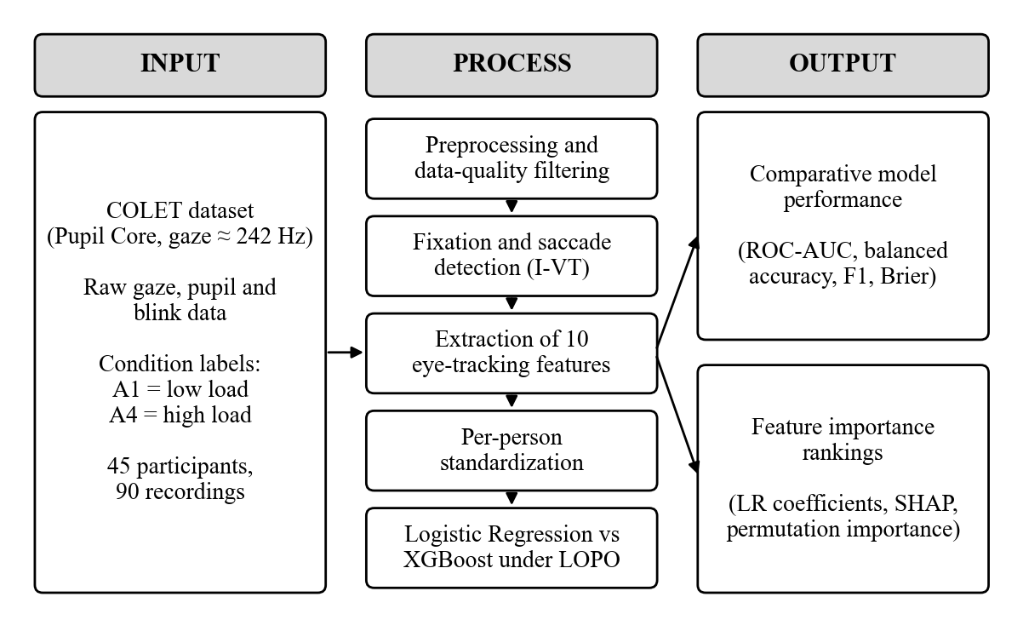
Figure 1. Conceptual framework of the study.

OPERATIONAL DEFINITION OF TERMS
Balanced Accuracy – The average of the recall obtained for each class. In this study it is reported alongside ROC-AUC to summarize correct classification of both load levels.
Binary Classification – A task in which each observation is assigned to one of two classes. In this study, each recording is classified as low (A1) or high (A4) cognitive load.
Blink Rate – The number of blinks per minute of valid recording time. In this study it is one of the ten input features.
Brier Score – The mean squared difference between predicted probabilities and actual outcomes. In this study it measures how well calibrated each model’s probabilities are.
Cognitive Load – The mental effort required to perform a task. In this study it is defined by the COLET activity: A1 as low load and A4 as high load.
COLET Dataset – A publicly available dataset of raw eye-tracking recordings from 47 participants performing visual-search tasks under four workload conditions. In this study it is the sole source of data.
Elastic Net – A penalty for regression models that combines L1 and L2 regularization. In this study it is used to keep Logistic Regression coefficients stable with a small sample.
Eye Tracking – The measurement of where and how the eyes move, and of pupil size, using a camera-based tracker. In this study the data were recorded with a Pupil Labs Pupil Core tracker.
Feature Importance Analysis – The analysis of how much each input feature contributes to a model’s predictions. In this study it uses Logistic Regression coefficients, SHAP values and permutation importance.
Fixation – A period in which the eyes remain relatively still on one location. In this study fixation rate and fixation duration are input features.
F1-Score – The harmonic mean of precision and recall. In this study the macro-averaged F1-score over both classes is reported.
Gaze Dispersion – The spread of gaze direction during a recording, measured as the standard deviation of gaze angle horizontally and vertically. In this study both directions are input features.
I-VT (Velocity-Threshold Identification) – An algorithm that labels eye samples as fixation or saccade depending on whether eye speed is below or above a threshold. In this study a threshold of 45°/s is used.
Leave-One-Participant-Out (LOPO) Validation – A validation procedure in which all data from one participant are held out for testing while the remaining participants are used for training, repeated for every participant.
Logistic Regression – A classification model that estimates the probability of a class from a weighted sum of input features. In this study it is the interpretable baseline model.
NASA-RTLX – The raw, unweighted version of the NASA Task Load Index questionnaire. In this study it is used only to confirm that the activities differed in workload.
Per-Person Standardization – Transforming each feature into a z-score using the mean and standard deviation of the same participant’s recordings. In this study it removes stable individual differences.
Permutation Importance – The drop in model performance when the values of one feature are randomly shuffled. In this study it is computed for both models on held-out predictions.
Pupil Diameter – The size of the pupil in millimetres, estimated by the tracker’s 3D eye model. In this study the mean and standard deviation of pupil diameter are input features.
ROC-AUC – The area under the Receiver Operating Characteristic curve, which measures how well a model ranks high-load above low-load recordings across all thresholds. In this study it is the primary metric.
Saccade – A rapid eye movement between fixations. In this study saccade rate, saccade amplitude and saccade peak velocity are input features.
SHAP (SHapley Additive exPlanations) – A method that divides each prediction into the contribution of each feature. In this study it is applied to both models so their feature rankings can be compared.
XGBoost – An implementation of gradient-boosted decision trees that builds trees sequentially to correct earlier errors. In this study it is the ensemble model compared with Logistic Regression.

CHAPTER 2
REVIEW OF RELATED LITERATURE AND STUDIES
This chapter reviews the literature on cognitive load and its measurement, eye-tracking indicators of workload, the COLET dataset and its prior use, the use of Logistic Regression and XGBoost for workload classification, participant-independent validation, and feature importance analysis. It ends with a synthesis of the closest studies and the research gap addressed by this study.

COGNITIVE LOAD AND ITS MEASUREMENT
Cognitive load describes the share of a person’s limited mental capacity that a task requires [1]. In cognitive load theory, working memory is limited, so tasks that exceed it impair learning and performance [2]. In ergonomics, mental workload is studied because of its relationship with performance and safety in complex work [3].
Workload is commonly measured in three ways: subjective ratings, performance measures and physiological signals. The NASA Task Load Index is the most widely used rating scale [34]; it asks participants to rate six dimensions of workload after a task [4], and its unweighted “raw” form is common in practice [34]. Ratings, however, are given after the task and reflect each person’s own judgement, and different workload measures are each sensitive to load but do not always agree [6]. Physiological measures are recorded continuously during the task. A systematic review of 91 studies found eye measures to be among the most widely used physiological indicators of workload [5].

EYE-TRACKING INDICATORS OF COGNITIVE LOAD
Pupil diameter is the most established eye-tracking indicator of mental effort. The pupil dilates with increasing cognitive demand, but it also responds strongly to light, so luminance must be controlled or accounted for [35]. In the review by Tao et al., pupil diameter was significant in 79% of the studies that measured it [5].
Blink rate is also sensitive to workload, but its direction depends on the task: mental load tends to increase blinking, while visually demanding tasks suppress it [36]. Blinking also rises when people talk [23], which matters when a workload task involves speaking aloud.
Saccades and fixations describe how the eyes move. Saccade amplitude has been reported to decrease under load [37], and saccadic peak velocity has been proposed as a workload index [38], [39]. Fixation rate and duration are related to both perceptual and cognitive load [40]. Under higher load, gaze also tends to concentrate in a smaller area, so measures of gaze dispersion can reflect workload [41], [42].
Because fixations and saccades are not measured directly, they must be detected from raw gaze samples. The velocity-threshold algorithm (I-VT) labels samples as saccades when eye speed exceeds a threshold [31]. Evaluations of detection algorithms show that results depend strongly on the chosen algorithm and thresholds, so settings should be reported and the output checked [43], [44].

THE COLET DATASET AND ITS PRIOR USE
COLET was published by Ktistakis et al. in 2022 as an open dataset for cognitive workload estimation based on eye tracking [18]. Forty-seven participants solved visual-search puzzles in four activities that crossed two factors: time pressure and a secondary task of counting backwards aloud. Eye movements were recorded with a Pupil Labs Pupil Core tracker, and participants rated each activity with the NASA-RTLX. The authors extracted pupil, blink, fixation and saccade features and reported that Logistic Regression distinguished the single-task activity without time pressure (A1) from the multitask activity with time pressure (A4) with an accuracy of 0.85 (k-nearest neighbours reached 0.86). That result was obtained with a 20% hold-out test set and five-fold cross-validation that were not described as participant-independent, and with feature selection performed on the full dataset. An earlier conference paper by the same group described the approach [45].
Several later studies used COLET. Fuhl et al. proposed a feature based on the distribution of pupil diameters over time and evaluated it with a random split of 10–30 s windows [46]. Wibirama et al. applied deep learning to eye-movement indices using windows that overlapped by about 80% and plain five-fold cross-validation [47], and Dell’Acqua et al. used large language models on symbolic gaze sequences with a 70/15/15 split of the 188 recordings, stratified by workload level [48]. Neither split was grouped by participant. These protocols allow data from the same participant, or even the same recording, to appear on both sides of the split. Fenoglio et al. applied federated learning to COLET and evaluated on unseen users through four-fold user-grouped cross-validation, using windowed features with Gaussian Naive Bayes, random forest and neural network models [49]. None of these studies applied Logistic Regression and XGBoost together, and none reported feature importance.

LOGISTIC REGRESSION AND XGBOOST FOR COGNITIVE LOAD CLASSIFICATION
Logistic Regression models the probability of a class as a function of a weighted sum of features [7]. With small samples, its coefficients can become unstable, so regularization is used; the elastic net combines L1 and L2 penalties and handles groups of correlated features [50]. Kaczorowska et al. used elastic-net Logistic Regression for three-level workload classification from eye-tracking features and used its coefficients to rank feature importance [8].
XGBoost builds an ensemble of decision trees sequentially, with regularization to control overfitting [9]. Tree-based ensembles often perform well on tabular data [10]. In workload research, Walocha et al. tuned XGBoost with nested leave-one-subject-out validation and found that shallow trees were usually selected on their small dataset [51], while Shafiei et al. combined EEG and eye tracking with XGBoost and SHAP in a surgical task [17].
Studies that compared the two models directly reached different conclusions. Rolon-Merette et al. compared Logistic Regression, XGBoost and deep learning models on their own n-back data; when tested on held-out participants, XGBoost stayed above chance while Logistic Regression, which received raw time series, remained near chance [11]. Nerella et al. compared both models for cognitive load prediction in augmented reality [12], Chakraborty et al. compared Logistic Regression with boosting using eye-tracking data [52], and Shao et al. found no significant ROC-AUC difference between the two models with eye-only features in driving, although accuracy favored different models in different analyses [13]. More broadly, a systematic review in clinical prediction found no consistent performance benefit of machine learning over Logistic Regression [26]. A similar result for the two models therefore cannot be ruled out in advance.

PARTICIPANT-INDEPENDENT VALIDATION AND DATA LEAKAGE
How a dataset is split strongly affects reported performance. When records from the same person appear in both training and test sets, a model can recognize the person rather than the condition, and accuracy is overestimated; participant-independent validation better represents use on new people [14], [53]. Leakage also occurs when preprocessing steps such as feature selection or scaling are fitted on the full dataset before splitting [15]. Hyperparameter tuning must likewise be kept inside the training data, through nested cross-validation, to avoid optimistic estimates [33], [54]. With small samples, cross-validated estimates have wide error bars, so uncertainty should be reported [28], [55].
Individual differences in eye behavior are large and stable [32], which is why many cross-participant workload studies standardize features within each participant [16], [56], [57], [58]. In an EEG workload study, z-score normalization gave the best cross-subject accuracy of the normalization schemes tested [59]. Preprocessing that uses test data is a recognized source of optimistic results [15]; because this step uses unlabeled data from the test participant, its effect on reported performance should be acknowledged.

FEATURE IMPORTANCE ANALYSIS
Feature importance analysis identifies which inputs a model relies on. For linear models, coefficients on inputs placed on a common scale show the direction and relative size of each feature’s association with the outcome [60]. SHAP assigns each feature a share of every prediction based on Shapley values and can be applied to any model [19]; TreeSHAP computes these values efficiently for tree ensembles such as XGBoost [20]. Permutation importance measures the loss in performance when a feature is shuffled [21], [22]. Built-in importance measures of tree ensembles can be biased toward certain features, as shown for random forests [61], and importance should be read as what a model relied on, not as a causal effect [62].
In eye-tracking workload research, Božak et al. combined condition labels, leave-one-subject-out validation and SHAP explanations, and found subject-normalized features and fixation dispersion among the most important [16]. Xu et al., using wearable physiological sensors with nested leave-one-subject-out validation, cautioned that SHAP rankings computed from models trained on all data should be treated as exploratory [63]. These studies explained a single model or a single model family; Logistic Regression studies used coefficients [8], while tree-based studies used SHAP [17].

SYNTHESIS
Table 1 summarizes the studies closest to this research.
Table 1. Summary of the closest related studies.
Study | Data | Models | Validation | Feature importance
Ktistakis et al. [18] | COLET | Several classifiers incl. LR, k-NN and GNB | 20% hold-out and 5-fold CV, not described as participant-independent | – (ANOVA feature selection only)
Fuhl et al. [46] | COLET | Classifiers on a pupil feature | Random split of windows | –
Fenoglio et al. [49] | COLET | GNB, RF, neural networks | 4-fold user-grouped CV | –
Wibirama et al. [47] | COLET | Deep learning | 5-fold CV on overlapping windows | –
Dell’Acqua et al. [48] | COLET | Large language models | 70/15/15 split of recordings | –
Rolon-Merette et al. [11] | Own n-back data | LR, XGBoost, SVM, CNN, Transformer | 10 held-out participants | –
Kaczorowska et al. [8] | Own data | Elastic-net LR and others | Repeated random train-test splits | LR coefficients
Božak et al. [16] | Own data | Feature-based models | Leave-one-subject-out | SHAP
Shafiei et al. [17] | EEG + eye | XGBoost | Random split | SHAP
This study | COLET | LR (elastic net), XGBoost | Leave-one-participant-out | LR coefficients, SHAP for both models, permutation

Among the studies identified in the literature search of this study, none applied XGBoost or SHAP to COLET, and none combined a comparison of Logistic Regression and XGBoost with leave-one-participant-out validation and SHAP for both models. On COLET, the one participant-independent evaluation found [49] used neither Logistic Regression, XGBoost nor feature importance, and the other COLET studies used splits that were not grouped by participant [18], [46], [47], [48]. This study addresses that gap by comparing the two models on COLET under leave-one-participant-out validation and by explaining both models with the same method.

CHAPTER 3
METHODOLOGY
This chapter describes the research design, dataset, labels, preprocessing, feature extraction, models, validation procedure, evaluation metrics, feature importance analysis and ethical considerations of the study. Figure 2 gives an overview of the methodology.
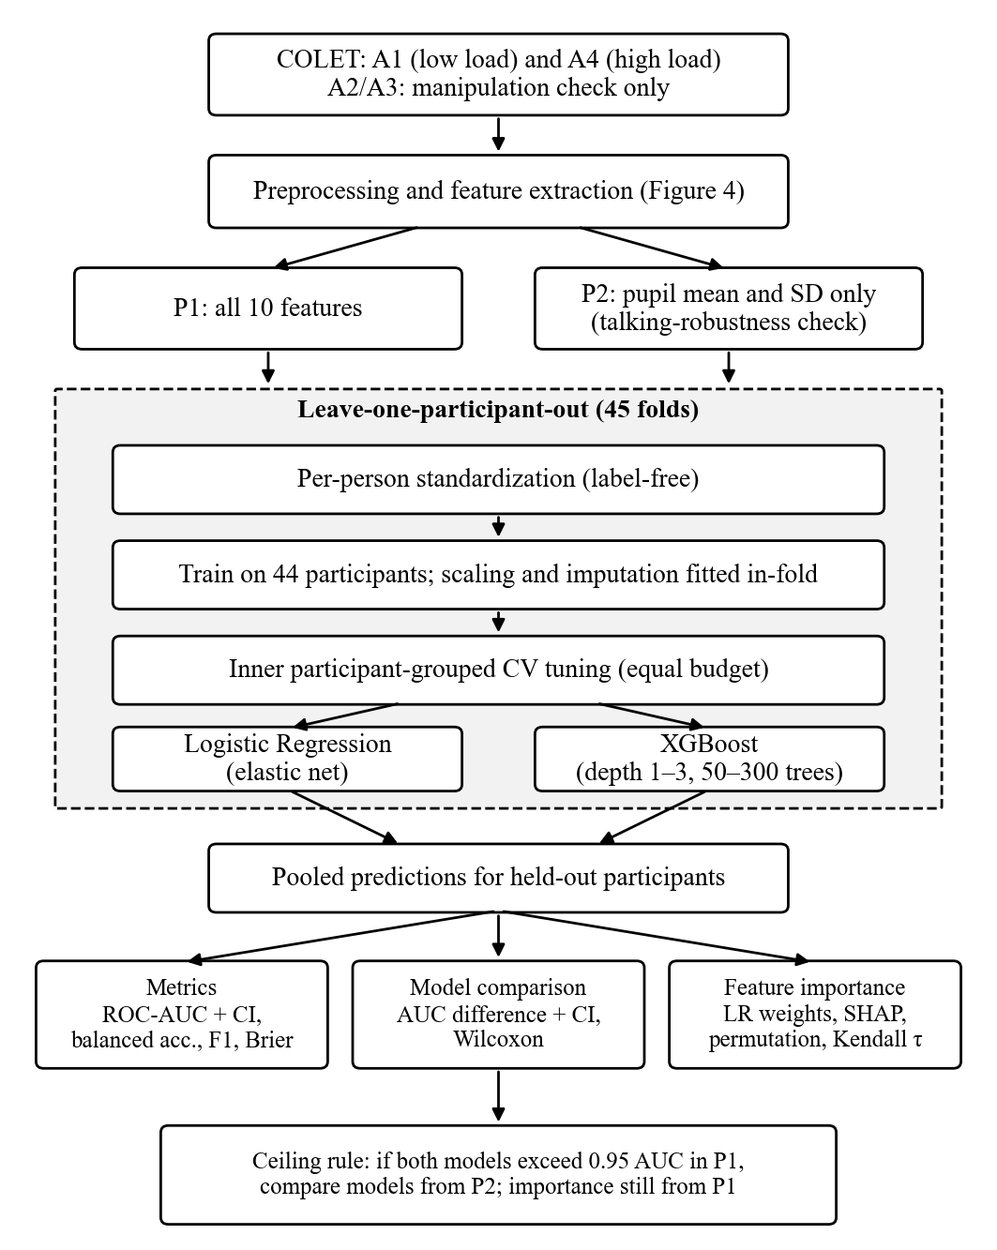
Figure 2. Overview of the methodology.

RESEARCH DESIGN
The study uses a quantitative, comparative design based on secondary analysis of a public dataset. Two classification models are trained and evaluated on the same features, with the same folds and the same tuning budget, so that differences in performance can be attributed to the models. To keep the analysis focused, only the steps needed for two pre-specified analyses are included: the main analysis (P1) with all ten features and a pupil-only analysis (P2). All thresholds and settings were fixed before any model was trained, after a data-quality inspection that summarized data by activity but did not compare feature values between A1 and A4, apart from the blink-presence and data-loss summaries by activity reported below.

DATASET
The study uses COLET, version 3, downloaded from Zenodo (record 7766785) and released under a CC BY 4.0 license [18]. Table 2 summarizes the dataset.
Table 2. Description of the COLET dataset.
Item | Description
Participants | 56 recruited; 9 excluded by the authors; 47 released (26 female, 21 male; age 32 ± 8 years)
Setting | Laboratory with chin and head rest; 24-inch screen (1280 × 720) at 80 cm; controlled lighting (400–450 lx)
Eye tracker | Pupil Labs Pupil Core, binocular; gaze ≈ 242 Hz, pupil ≈ 121 Hz per eye (measured; nominal 240 Hz); gaze resampled to a uniform 240 Hz grid
Task | Visual-search puzzles, five images per activity; activities in random order with 2-minute breaks
Design | 2 × 2: time pressure × secondary task (counting backwards aloud from 1000 in steps of 4)
Released data | Raw gaze, pupil and blink exports per participant and activity; NASA-RTLX per activity; no fixation or saccade events

The dataset is distributed as a single 3.8 GB MATLAB file in which the recordings are nested: each of the 47 participants contains four activities, and each activity contains separate tables for gaze, pupil, blink and NASA-RTLX data. Because standard Python tools cannot read MATLAB table objects, the file was decoded once with the open-source mat-io package, after the archive’s checksum was verified, and flattened into one table per participant, activity and signal (Figure 3). This produced 564 Parquet files (188 recordings × 3 signals) and two CSV files holding the NASA-RTLX ratings and participant information. Parquet is an open, compressed file format for tables that stores the same rows and columns as a CSV file but loads much faster for large data. No values were changed; cells containing non-numeric objects were stored as text. The flattened gaze files contain about 2.25 million samples and the pupil files about 4.51 million samples, from which the preprocessing described below produces one row of ten features for each of the 90 analyzed recordings.
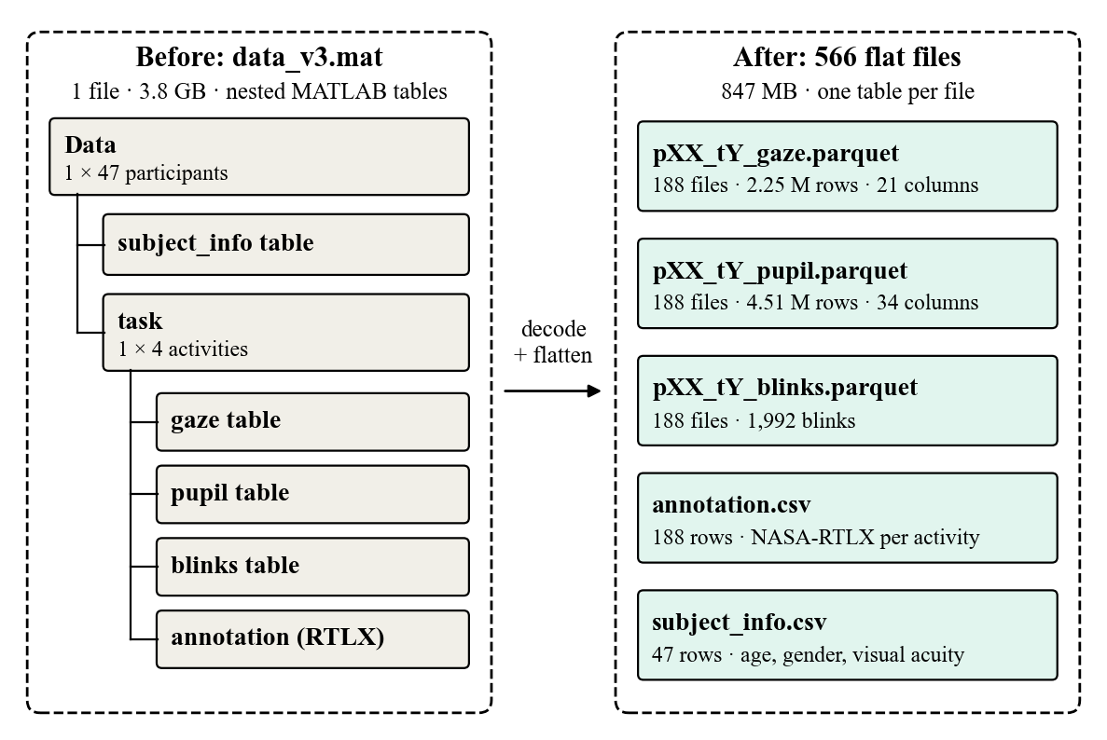
Figure 3. Structure of the COLET data before and after flattening.

LABELS AND UNIT OF ANALYSIS
Labels are taken from the experimental conditions. For every participant, activity A1 (single task, no time pressure) is labeled low load and activity A4 (counting aloud under time pressure) is labeled high load. The visual-search task is the same in every activity; the high load is induced by adding a concurrent verbal arithmetic task (counting backwards aloud in steps of four) and time pressure, a dual-task design. Because the added task is spoken, the high-load condition also differs from the low-load condition in speech, which is addressed by the pupil-only analysis. The middle conditions, A2 and A3, are left out of the classification, following studies that compare the extremes of a workload manipulation [25], [64]. Condition labels are used rather than self-reports because ratings are affected by how each participant uses the rating scale [34].
The NASA-RTLX ratings collected by the COLET authors [18], the common unweighted form of the NASA-TLX [34], are used as a manipulation check. A Friedman test compares the ratings across the four activities, and each participant’s A4 rating is compared with their A1 rating. In the released data, all 47 participants rated A4 higher than A1.
Because the activities are short (11 to 141 s), the unit of analysis is one sample per whole activity, the same unit used by the COLET authors [18]. This gives two samples per participant (Table 3).
Table 3. COLET activities and their role in this study (NASA-RTLX means for all 47 released participants).
Activity | Condition | Median duration | Mean NASA-RTLX | Role
A1 | Single task, no time pressure | 37 s | 19.4 | Low load
A2 | Single task, time pressure | 29 s | 28.7 | Manipulation check; standardization baseline
A3 | Counting aloud, no time pressure | 62 s | 45.0 | Manipulation check; standardization baseline
A4 | Counting aloud and time pressure | 51 s | 51.9 | High load

DATA PREPROCESSING
COLET provides raw tracker data, so the signals must be cleaned before features can be computed. The preprocessing has four stages (Figure 4): removing bad data, cleaning each signal, detecting fixations and saccades, and computing features. Table 4 lists each step and its source.
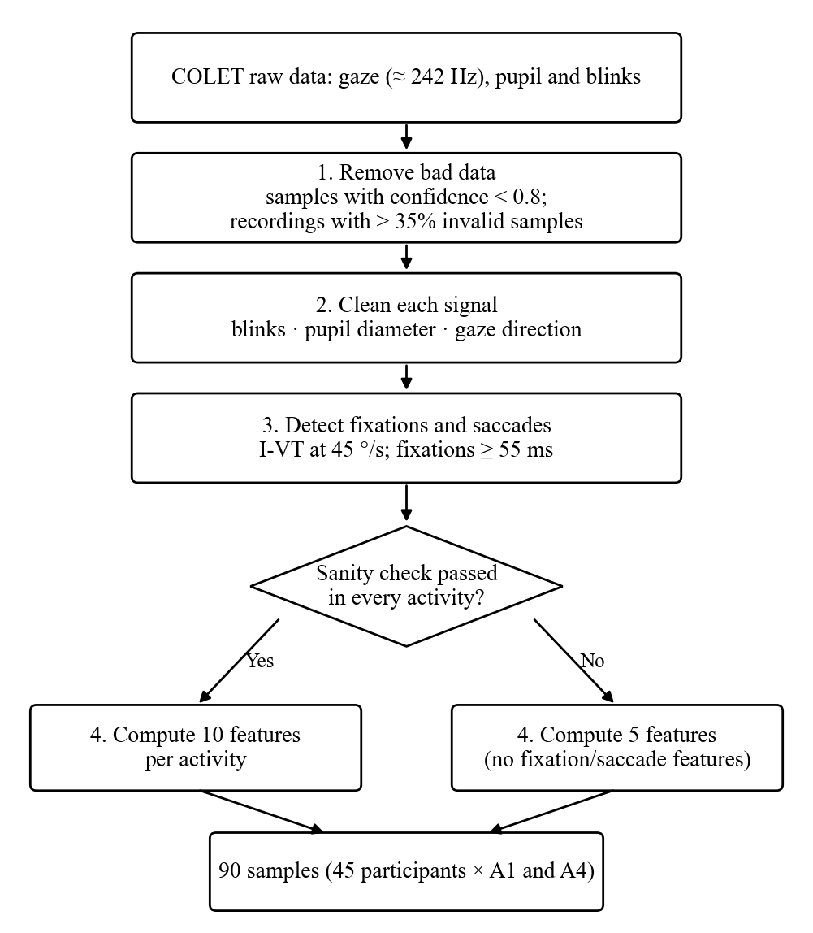
Figure 4. Preprocessing stages.
Table 4. Preprocessing steps.
Step | Procedure | Source
Time alignment | Pupil and blink data trimmed to each recording’s gaze time range (stray samples found in one participant) | Data check
Sample validity | Samples with tracker confidence below 0.8 treated as invalid | [30], [65]
Recording exclusion | Recordings with more than 35% invalid samples excluded; participants missing A1 or A4 dropped (P06, P17) | [66]
Valid time | Blink rate computed over valid recording time (gaps longer than 1 s excluded); fixation and saccade rates over time with a valid gaze direction | Data check
Blinks | Tracker blink events merged if less than 100 ms apart, then kept if 50–500 ms (own choice around the typical ~200 ms blink); blink periods treated as missing | [67], [68]
Gaze gaps | Gaps shorter than 75 ms linearly interpolated; longer gaps left missing | [30]
Pupil | 3D-model diameter in mm; 1.5–9 mm range; dilation-speed outlier removal (median + 16 MAD, the default of the authors’ published code); both eyes averaged; gaps up to 250 ms filled; 4 Hz low-pass filter; model refits counted | [29], [68], [69]
Gaze direction | Each eye’s unit gaze direction vector, averaged across the two eyes and resampled to a uniform 240 Hz grid; velocity from the change in direction (see Fixation and Saccade Detection) | [70], [71], [72]
Quality report | Share of valid samples reported per recording and condition; never used as a feature | [30]

Recording exclusion removed three of 188 recordings (P06 A3, P06 A4 and P17 A4). Because P06 and P17 lack a valid A1–A4 pair, they are dropped, leaving 45 participants and 90 balanced samples.
Gaze angles are computed from each eye’s own gaze direction rather than from the tracker’s combined 3D gaze point. The 3D gaze point depends on an estimate of viewing distance from the angle between the two eyes, and pupil-based video eye trackers do not measure vergence accurately enough to determine the viewing distance, as shown at 77 cm with a desktop tracker [70]; with Pupil Core, gaze depth was severely underestimated [71]. In COLET this estimate was implausible: the median estimated distance was about 113 mm against a true viewing distance of 800 mm, and some samples were placed behind the camera. Eye speed is therefore computed from the change in direction of the gaze vector, averaged across the two eyes, following the vector-angle approach used for Pupil Labs data by Kothari et al. [72]. Samples with only one valid eye are treated as missing and handled by the gap rule, because each eye’s direction alone was biased inward by about 10° in these data; this follows the practice of treating unreliable samples as gaps [30].

FIXATION AND SACCADE DETECTION
Fixations and saccades are detected with the velocity-threshold algorithm (I-VT) [31], using the velocity threshold and minimum fixation duration of the COLET authors [18]. The gaze directions are first resampled to a uniform 240 Hz grid, and eye velocity is computed with a five-point smoothed central difference of the unit gaze vectors; velocity filtering of this kind is described by Duchowski [73], but the coefficients used here are the researchers’ own choice. Velocities above 1000°/s are rejected as artifacts [74]. Samples faster than 45°/s are classified as saccades, and fixations shorter than 55 ms are discarded; both values follow COLET [18]. The 45°/s threshold corresponds to the minimum peak velocity of human-coded saccades in Andersson et al., and the 55 ms minimum to the human-derived minimum fixation duration in the same study [43]. Neither value was validated for a 240 Hz Pupil Core; the 55 ms minimum lies within the 50–75 ms range evaluated by Trabulsi et al. [75].
Because detection results depend on the algorithm and its settings [43], [44], a sanity check is applied to each activity separately before the features are used: the median fixation duration must lie between 150 and 400 ms, and the ratio of saccades to fixations must lie between 0.8 and 1.25. If either condition fails in any activity, the main analysis uses only the five features that do not depend on event detection (pupil mean, pupil standard deviation, blink rate and gaze dispersion in both directions), following the use of feature subsets in prior work [16]. The tolerance of 0.8–1.25 is the researchers’ own choice.

FEATURE EXTRACTION
Ten features are computed for each whole activity (Table 5). Blink rate is expressed per minute of valid recording time. Fixation and saccade rates are expressed per second of time with a valid gaze direction, because gaze is missing more often in the high-load activity and events cannot be detected while it is missing. The feature set is fixed in advance and is the same in every fold, which keeps feature importance comparable across folds.
Table 5. Eye-tracking features.
Group | Feature | Support
Pupil | Pupil diameter mean; pupil diameter standard deviation | [5], [18], [35]
Blink | Blink rate (per minute) | [5], [36]
Fixation | Fixation rate; mean fixation duration | [5], [40]
Saccade | Saccade rate; mean saccade amplitude; mean saccade peak velocity | [5], [37], [38]
Gaze dispersion | Standard deviation of gaze angle, horizontal and vertical | [16], [41]

Some features used in prior work are excluded. Blink duration is undefined when no blink occurs, which happened only in low-load recordings (13 of 45 A1 recordings and none of the A4 recordings); its missingness would therefore reveal the label [15]. Mean saccade velocity and saccade duration are near-duplicates of peak velocity and amplitude (ρ = 0.95 and 0.83 in a preliminary data inspection; 0.99 and 0.80 in the final features) [16], [76]. The higher-order statistics used by the COLET authors are omitted to keep the number of features small relative to the 90 samples. Because pupil size also responds to light [35], stimulus brightness was considered: room lighting was controlled at 400–450 lx, and although the puzzle images differ in brightness, the COLET authors found pupil size following image brightness in only 2 of 47 participants [18]. No further luminance correction is applied, which is stated as a limitation.

PER-PERSON STANDARDIZATION
Each feature is converted to a z-score using the mean and standard deviation of the same participant’s four activities. This removes stable individual differences, in eye movements [32] and pupil size [11], which are much larger than the workload effect, and follows the closest prior studies [16], [56], [57]. The step does not use labels. It does, however, use the test participant’s own unlabeled recordings and relies on COLET’s balanced design, in which every participant completed both easier and harder activities; this is stated as a limitation.

MODEL DEVELOPMENT
Two models are trained (Table 6). Logistic Regression uses an elastic-net penalty, with the penalty strength and the L1/L2 mix tuned inside the training folds [8], [50]. XGBoost is restricted to shallow, regularized trees because only 88 samples (44 participants) are available for training in each fold [9], [51]. Both models receive the same tuning budget (a design choice) and identical folds, and tuning is nested to avoid selection bias [33]. Missing values are imputed with the training-fold median for Logistic Regression and handled natively by XGBoost; Perez-Lebel et al. found native handling competitive for gradient boosting [77]. Plain median imputation without missingness indicators is a simplification; it was never applied, because no feature had missing values in the final data.
Table 6. Model settings.
Model | Settings searched
Logistic Regression | Elastic-net penalty; C log-uniform 10⁻³–10²; L1 ratio 0–1; features standardized in-fold
XGBoost | Maximum depth 1–3; 50–300 trees; learning rate 0.05–0.1; row and column subsampling 0.7–1.0; L2 penalty 0.01–10 and L1 penalty 0.001–1 (log-uniform)

VALIDATION PROCEDURE
Models are evaluated with leave-one-participant-out validation over the 45 participants: in each fold, both recordings of one participant form the test set and the other 44 participants form the training set [14], [53]. Hyperparameters are tuned by random search with 30 candidate settings per model (the equal tuning budget), scored by ROC-AUC in a five-fold inner cross-validation that is also grouped by participant [33], [54]. The in-fold scaling and imputation are fitted on the training participants only [15]. Per-person standardization is the one exception: it uses each participant’s own unlabeled recordings, including those of the test participant (see Per-Person Standardization).

PERFORMANCE METRICS AND STATISTICAL ANALYSIS
The primary metric is ROC-AUC computed on the pooled out-of-fold predictions [78], with a 95% confidence interval from a bootstrap that resamples participants (2000 resamples) [28]. Balanced accuracy, macro-F1, per-class recall and the Brier score [79], [80] are also reported, together with a majority-class baseline [16] and the share of participants whose A4 recording is ranked above their A1 recording.
The two models are compared through the difference in pooled ROC-AUC with a participant-bootstrap confidence interval. A paired Wilcoxon signed-rank test on each participant’s margin, the predicted probability for A4 minus that for A1, is reported as a supporting test; because margins depend on each model’s probability scale, it is secondary to the ROC-AUC difference. The test is adapted from comparisons across datasets to comparisons across participants [81], and a grouped permutation test, in which each participant’s two labels are swapped at random, checks performance against chance [82]. The permutation test uses each model’s default hyperparameters, so that the real and the permuted runs are treated identically; its p-value therefore concerns the untuned pipeline, while the headline result is the tuned, nested ROC-AUC. With 200 permutations, the smallest attainable p-value is 1/201 ≈ 0.005.

FEATURE IMPORTANCE ANALYSIS
Feature importance is analyzed in three ways. First, the standardized elastic-net coefficients of Logistic Regression are reported [8]. Second, SHAP values are computed on held-out data for both models, using TreeSHAP for XGBoost and linear SHAP for Logistic Regression, so that both rankings are on the same scale [19], [20]. Applying SHAP to both models is the researchers’ own choice, justified by SHAP being applicable to any model. The linear explainer uses the interventional convention, which treats features as independent; because several eye features are correlated, the attributions describe the model’s reliance rather than unique feature effects. TreeSHAP is run without background data and therefore uses the tree-path-dependent convention, which follows the dependencies between features in the training data, so the two rankings rest on slightly different assumptions about correlated features. Third, permutation importance is computed for both models on the pooled out-of-fold predictions, with 50 repeats per feature [21], [22].
Agreement between the two models’ rankings is measured with Kendall’s τ, reported with a bootstrap confidence interval, and the stability of the model weights across folds is examined, in the spirit of feature-selection stability analysis [83]. Built-in gain importance is reported in the appendix only, because built-in importance can be biased, as shown for random forests [61]. Importance is interpreted as what each model relied on, not as a cause of cognitive load [62].

ANALYSIS PLAN
Two analyses are required (Table 7). The main analysis (P1) uses all ten features. Because the high-load activity involves counting aloud, which raises the blink rate [23], [84], a second analysis (P2) repeats P1 with the two pupil features only, since pupil size is the most established workload signal [5] and has been used alone in prior workload models [11], [85], [86].
Table 7. Required analyses.
Analysis | Features | Purpose
P1 | All 10 features | Main comparison of Logistic Regression and XGBoost
P2 | Pupil mean and pupil standard deviation | Robustness check against effects of talking

P1 is the headline result regardless of which analysis scores higher. A ceiling rule was stated before any results were seen: if both models exceed 0.95 ROC-AUC in P1, the model comparison is interpreted mainly from P2, because top-performing models often tie [8], while feature importance is still reported from P1. P2 is not fully independent of the spoken task, because the tracker re-fitted its pupil model more often in the counting activities; this is stated as a limitation.

IMPLEMENTATION
The pipeline was implemented in Python 3.11 with NumPy 2.2.4, pandas 2.3.1, SciPy 1.15.2, scikit-learn 1.7.1, XGBoost 3.2.0 and SHAP 0.51.0, and every threshold is held in a single configuration file. All random processes use a fixed seed, so repeated runs in the same environment and package versions give identical results. A Google Colab notebook with the same pinned package versions allows the analysis to be reproduced. The pipeline was tested on synthetic data with a known structure before it was applied to COLET, and the full analysis was run once, after all settings had been fixed. A shuffled-label control (Chapter 4) was added after that run as a post-hoc check.

ETHICAL CONSIDERATIONS
This study is a secondary analysis of the publicly available, de-identified COLET dataset (CC BY 4.0), whose collection was approved by the Ethics Committee of the Foundation for Research and Technology – Hellas (110/12-02-2021) [18]. No new data were collected, and no attempt is made to identify participants. The dataset and the original article are cited as required by the license.

DESIGN CHOICES
Some settings have no published source for their exact value and are the researchers’ own choices, justified by the data checks described above: the 35% exclusion threshold applied to whole recordings, the 1 s gap rule for valid time, the 0.8–1.25 tolerance of the detection sanity check, the use of each eye’s gaze direction, treating samples with only one valid eye as missing, merging blinks before applying the 50–500 ms range, a 120 Hz grid and a second-order Butterworth filter for the pupil signal, the 240 Hz resampling grid, and the five-point velocity filter.
One limitation of the event detection is also noted here. A blink or a gap longer than 75 ms inside a fixation splits it into two, and blinks were far more frequent in the high-load activity. This would tend to raise the fixation rate and shorten fixations in A4; the gaze-time denominator corrects the rates for missing time but not for this splitting.

CHAPTER 4
RESULTS AND DISCUSSION
This chapter presents the results in the order of the analysis: the manipulation check, data quality, the event-detection sanity check, the features, the two required analyses, the model comparison, feature importance, and a control for leakage. It ends with a discussion of the findings against the related studies in Chapter 2. All values come from a single run made after every setting had been fixed.

MANIPULATION CHECK
The NASA-RTLX ratings rose across the four activities (Table 8, Figure 5). A Friedman test confirmed that the activities differed in rated workload (χ²(3) = 84.86, p < 0.001, n = 45). Every one of the 45 analyzed participants rated A4 higher than A1, with a median difference of 31.7 points. The low- and high-load labels therefore correspond to a clear difference in experienced workload.
Table 8. NASA-RTLX ratings of the 45 analyzed participants.
Activity | Condition | Mean NASA-RTLX (SD) | Median
A1 | Single task, no time pressure | 18.7 (11.7) | 16.7
A2 | Single task, time pressure | 28.4 (13.7) | 29.2
A3 | Counting aloud, no time pressure | 44.9 (15.6) | 44.2
A4 | Counting aloud and time pressure | 51.7 (17.6) | 52.5

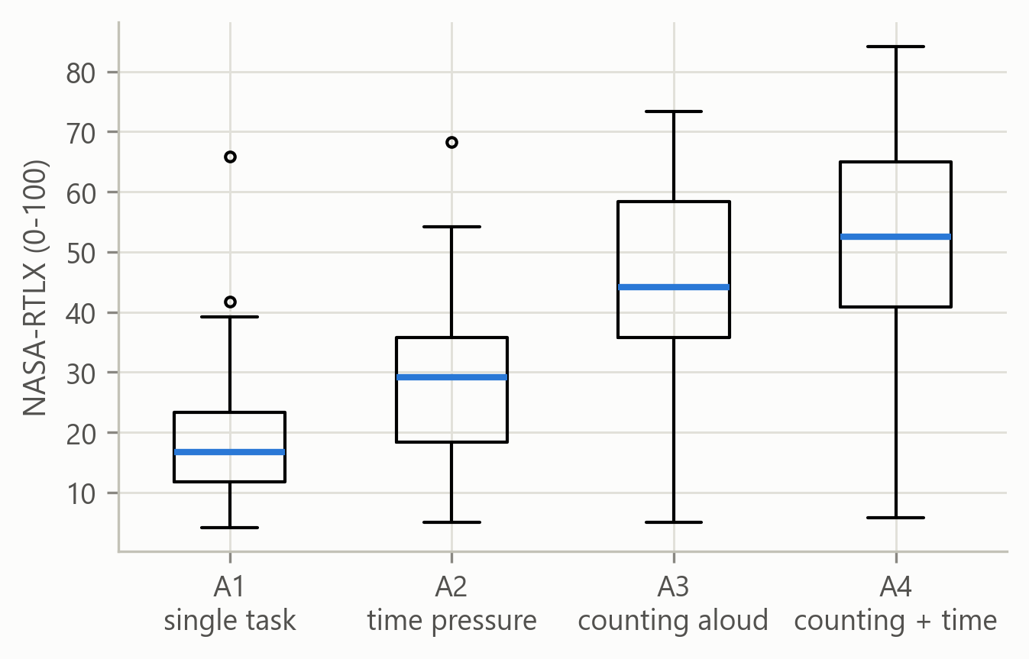
Figure 5. NASA-RTLX ratings per activity.

DATA QUALITY AND RETENTION
Of the 188 recordings, three exceeded the 35% invalid-sample limit and were excluded: P06 A3 (57.4% invalid), P06 A4 (38.8%) and P17 A4 (48.6%). Participants P06 and P17 therefore lacked a valid A1–A4 pair and were dropped, leaving 45 participants, each with all four activities retained, and 90 samples for the classification. Table 9 summarizes data quality per activity.
Table 9. Data quality per activity (retained recordings).
Activity | Invalid samples (median) | Samples with both eyes (median) | Recordings with a pupil-model refit
A1 | 0.9% | 99.5% | 8
A2 | 0.7% | 99.6% | 11
A3 | 7.2% | 98.7% | 20
A4 | 7.3% | 98.7% | 18

Invalid samples were about eight times more frequent in the counting activities, consistent with more blinking and with tracking loss while talking; outside blink periods, data loss was also several times higher in A3 and A4. The requirement that both eyes be valid removed little data (about 1% of samples). Pupil-model refits were about twice as common in the counting activities (38 vs 19 recordings), which is the reason P2 is not fully independent of the spoken task. None of the ten features had missing values in any activity, so imputation played no role in the results.

EVENT-DETECTION SANITY CHECK
The pre-stated sanity check passed in every activity (Table 10). Median fixation durations fell between 212.5 and 237.5 ms, inside the 150–400 ms range, and the ratio of saccades to fixations was between 0.93 and 0.99, inside the 0.8–1.25 range. The detected events are therefore plausible, and P1 used all ten features as planned rather than the five-feature fallback.
Table 10. Event-detection sanity check per activity.
Activity | Recordings | Median fixation duration (ms) | Saccades per fixation | Passed
A1 | 45 | 212.5 | 0.98 | Yes
A2 | 45 | 212.5 | 0.99 | Yes
A3 | 45 | 237.5 | 0.93 | Yes
A4 | 45 | 225.0 | 0.93 | Yes

EYE-TRACKING FEATURES BY CONDITION
Table 11 gives the median of each feature in the low- and high-load activities before standardization. Under high load, participants blinked far more, their pupils were larger, they made fewer but longer fixations and fewer saccades, and their saccades were slightly larger and faster. The fixation durations here are medians of per-recording means and are therefore higher than the medians of all fixations in Table 10.
Table 11. Median feature values in A1 and A4 (45 participants, before standardization).
Feature | A1 (low) | A4 (high) | Unit
Pupil diameter, mean | 3.58 | 3.74 | mm
Pupil diameter, SD | 0.145 | 0.168 | mm
Blink rate | 1.6 | 12.2 | per minute
Fixation rate | 3.37 | 3.15 | per second
Fixation duration | 268 | 290 | ms
Saccade rate | 3.36 | 2.84 | per second
Saccade amplitude | 3.22 | 3.53 | degrees
Saccade peak velocity | 139 | 148 | °/s
Gaze spread, horizontal | 3.47 | 3.56 | degrees
Gaze spread, vertical | 2.73 | 3.06 | degrees

MAIN ANALYSIS (P1)
With all ten features, both models separated low from high load almost perfectly in participants they had not seen during training (Table 12, Figures 6 and 7). Logistic Regression reached a pooled ROC-AUC of 0.990 (95% CI 0.973–1.000) and XGBoost 0.983 (0.962–0.999). The majority-class baseline reached a balanced accuracy of 0.500, against 0.944 and 0.922 for the two models. Logistic Regression ranked the A4 recording above the A1 recording for 44 of the 45 participants, and XGBoost for all 45. The grouped permutation test, run with default hyperparameters, placed the untuned pipelines above chance (observed ROC-AUC 0.991 for Logistic Regression and 0.976 for XGBoost; p = 0.005, the smallest attainable value).
Table 12. Classification results under leave-one-participant-out validation (90 samples).
Analysis | Model | ROC-AUC (95% CI) | Balanced accuracy | Macro-F1 | Recall low / high | Brier | A4 > A1
P1 | Logistic Regression | 0.990 (0.973–1.000) | 0.944 | 0.944 | 0.978 / 0.911 | 0.043 | 44/45
P1 | XGBoost | 0.983 (0.962–0.999) | 0.922 | 0.922 | 0.933 / 0.911 | 0.053 | 45/45
P2 | Logistic Regression | 0.851 (0.763–0.922) | 0.811 | 0.811 | 0.844 / 0.778 | 0.166 | 38/45
P2 | XGBoost | 0.804 (0.692–0.901) | 0.756 | 0.755 | 0.800 / 0.711 | 0.179 | 39/45

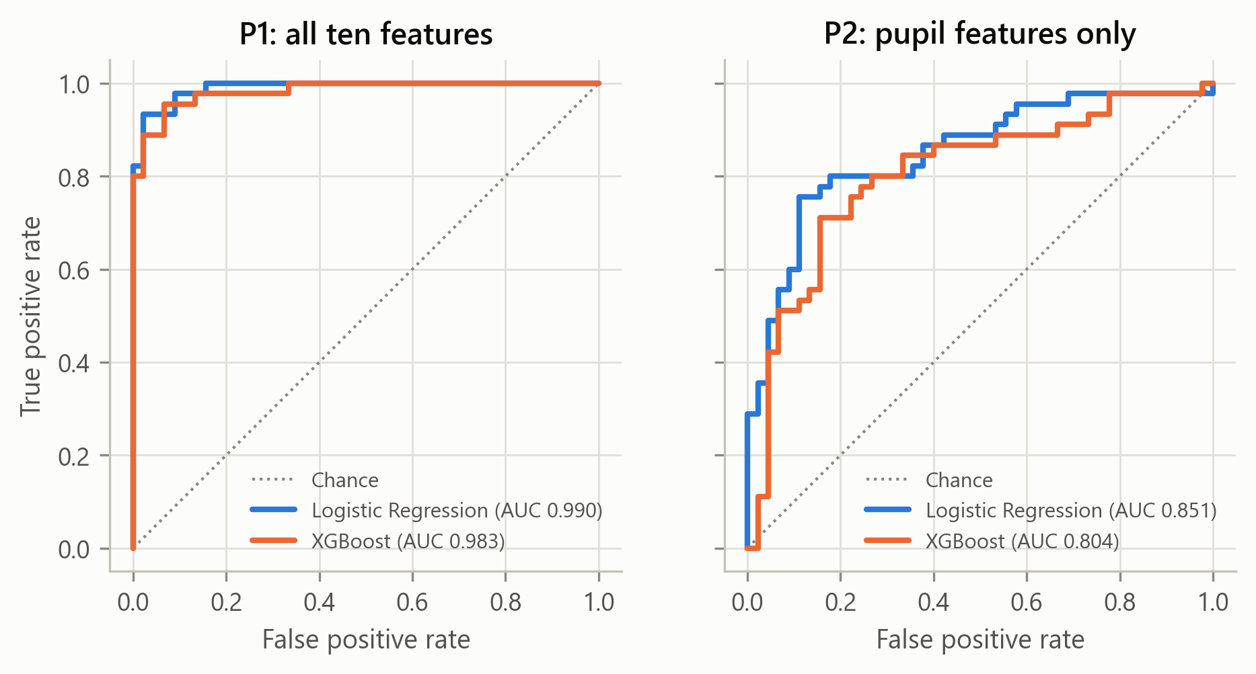
Figure 6. ROC curves of the pooled held-out predictions for P1 and P2.
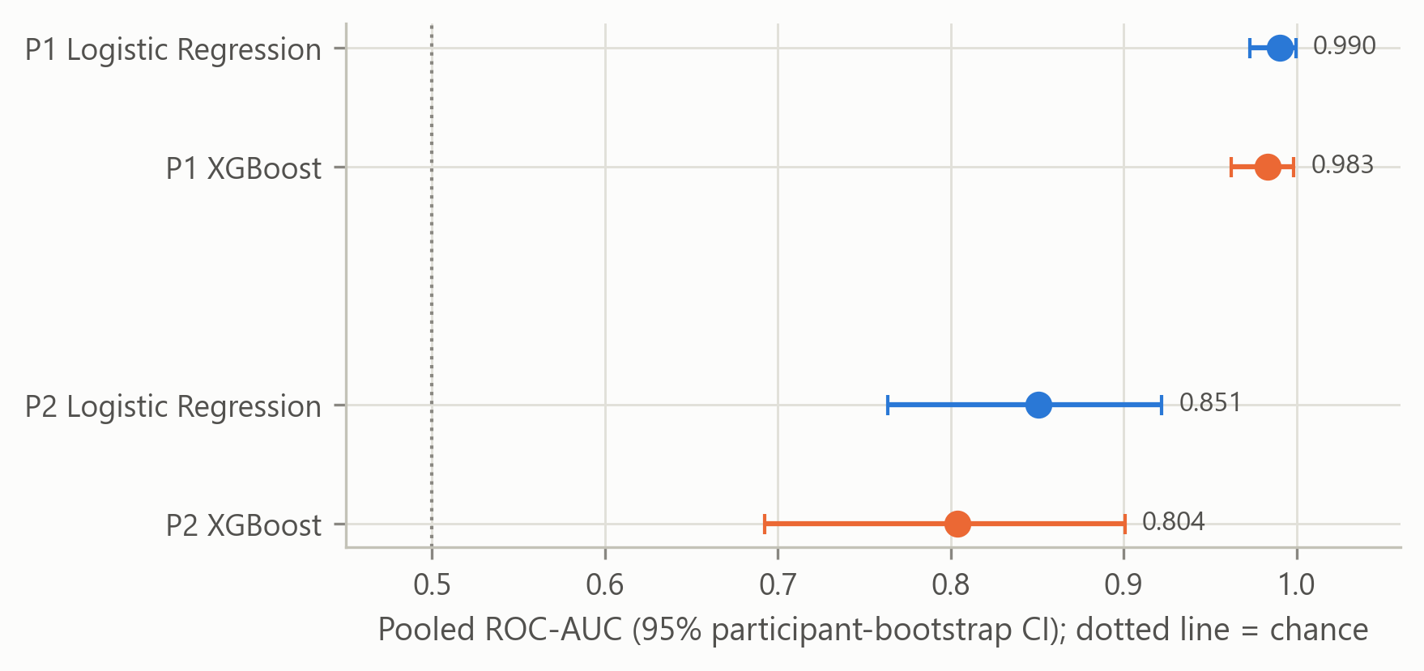
Figure 7. Pooled ROC-AUC with 95% participant-bootstrap confidence intervals.
Both models exceeded 0.95 ROC-AUC in P1, so the pre-stated ceiling rule applies: the two models cannot be meaningfully separated in P1, and the model comparison is interpreted mainly from P2. The selected Logistic Regression settings varied across folds (median C = 1.03, IQR 8.40; median L1 ratio 0.87), and XGBoost most often chose depth 2 (28 of 45 folds; median 167 trees). In P2, XGBoost chose depth 1 in 44 of 45 folds, and Logistic Regression chose a stronger penalty (median C = 0.13).

PUPIL-ONLY ANALYSIS (P2)
With only the mean and standard deviation of pupil diameter, both models remained well above chance (Table 12). Logistic Regression reached 0.851 (0.763–0.922) and XGBoost 0.804 (0.692–0.901); both permutation tests gave p = 0.005 (untuned ROC-AUC 0.854 and 0.819). Because blinking, the feature most directly raised by speaking [23], is left out, this result suggests that the eye signal carries information about the high-load condition beyond the most obvious speech effect, although pupil-model refits and any pupil response to speaking itself cannot be excluded. The drop from P1 to P2 (about 0.14–0.18 in ROC-AUC) indicates how much the non-pupil features, above all the blink rate, added.

MODEL COMPARISON
Table 13 compares the two models.
Table 13. Comparison of XGBoost with Logistic Regression.
Analysis | AUC difference, XGBoost − LR (95% CI) | Wilcoxon on per-participant margins
P1 | −0.007 (−0.025 to 0.010) | p = 0.341
P2 | −0.047 (−0.116 to 0.017) | p = 0.006, larger margins for XGBoost

In P1 the two models were practically identical, as the ceiling rule anticipated. In P2, which the rule designates for the comparison, XGBoost scored 0.047 lower than Logistic Regression. The confidence interval of this difference includes zero, so the pooled ROC-AUC does not establish a difference. The per-participant margins, the gap between each person’s predicted probabilities for A4 and A1, were larger for XGBoost in 31 of the 45 participants (Wilcoxon p = 0.006). This partly reflects the more extreme probabilities of XGBoost: Logistic Regression was strongly regularized in P2 (median C = 0.13), which pulls its probabilities towards 0.5, and margins depend on each model’s probability scale. The evidence is therefore mixed, and neither model was consistently better; the added flexibility of XGBoost brought no clear benefit. P2 is, however, a low-dimensional test: mean pupil diameter carried almost all the information, and XGBoost chose single-split trees in 44 of 45 folds, so this comparison cannot reward its ability to model interactions between features.

FEATURE IMPORTANCE
Both models relied on the same three features most (Figure 8): blink rate, mean pupil diameter and fixation rate. The rankings of the two models agreed closely (Kendall’s τ = 0.78, 95% CI 0.64–0.87). Permutation importance gave the same leading features: shuffling blink rate lowered the pooled ROC-AUC by 0.31 for Logistic Regression and 0.25 for XGBoost, and shuffling mean pupil diameter by 0.12 and 0.03.
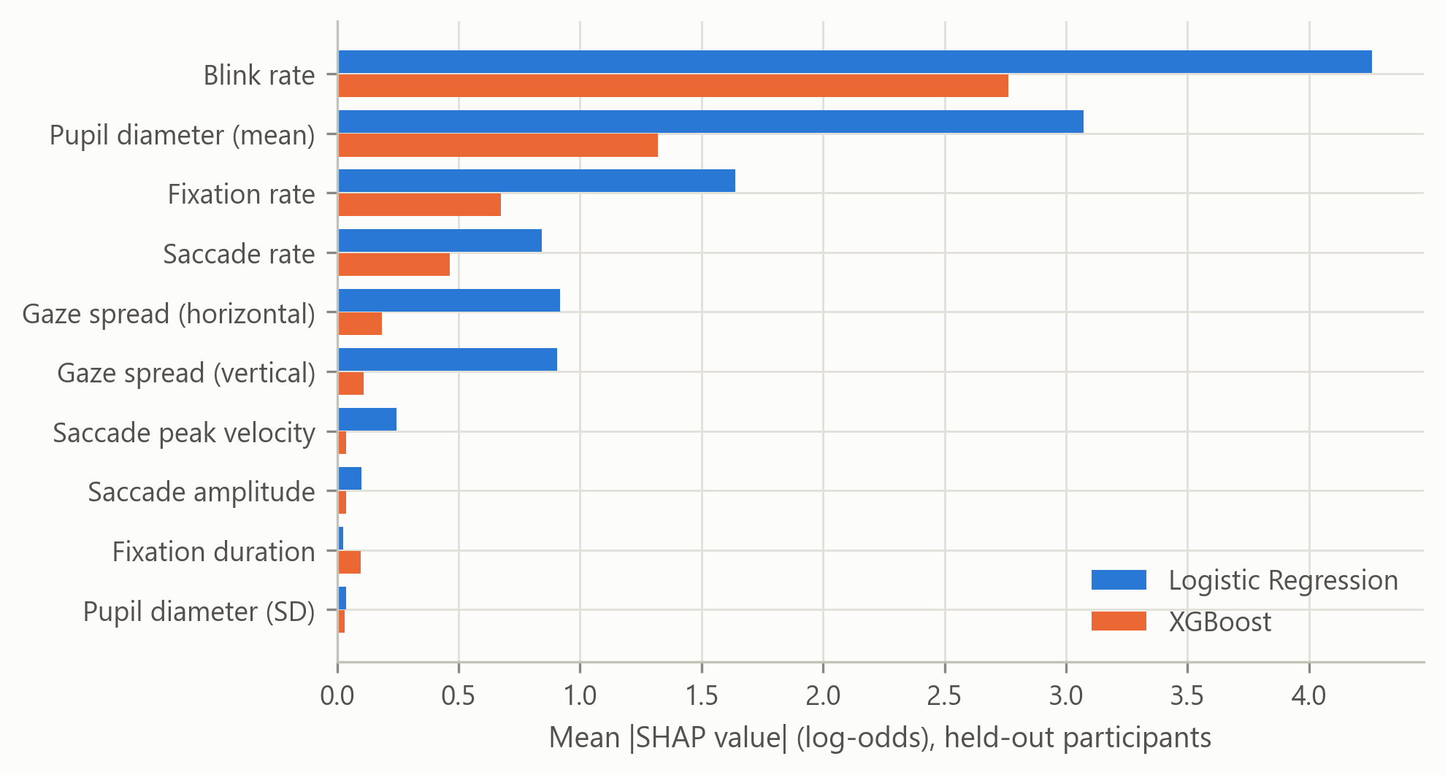
Figure 8. Mean absolute SHAP value per feature in P1 for both models.
The Logistic Regression coefficients show the direction of each effect (Table 14). A higher blink rate and a larger pupil pushed predictions towards high load, while a higher fixation rate and a wider gaze spread pushed them towards low load; these five coefficients kept the same sign in at least 93% of the folds. Because fixation and saccade rates are strongly related and blink rate is in the model, these signs are conditional on the other features and should not be read as single-feature directions. The elastic-net penalty set the remaining saccade and pupil-variability coefficients to zero in many folds. Gain importance for XGBoost is reported in Appendix A (Table A1).
Table 14. Logistic Regression coefficients in P1 (standardized features; leading six).
Feature | Mean coefficient | Same sign across folds | Set to zero in folds
Blink rate | +4.79 | 100% | 0%
Pupil diameter, mean | +3.45 | 100% | 0%
Fixation rate | −1.89 | 100% | 0%
Gaze spread, horizontal | −1.17 | 98% | 2%
Gaze spread, vertical | −0.95 | 93% | 7%
Saccade rate | +0.89 | 51% | 47%

CONTROL FOR LEAKAGE
Because near-perfect results can signal leakage, the pipeline was rerun with default hyperparameters and shuffled labels after the main analysis, as a post-hoc check that was not part of the pre-specified plan. With labels swapped at random within participants, the mean ROC-AUC over 40 repetitions fell to 0.48 for Logistic Regression and 0.49 for XGBoost; with labels shuffled across all recordings it fell to 0.46 and 0.48. The untuned pipeline therefore scores highly only with the true labels, which gives no evidence that label information leaked through the preprocessing or model fitting; the per-person standardization does not use labels, and its effect on the difficulty of the task is discussed below. Single features show why the task is easy: blink rate alone separated A1 from A4 with an ROC-AUC of 0.97 after per-person standardization (0.90 without it), and 43 of the 45 participants blinked more in A4.

DISCUSSION
The near-perfect separation in P1 reflects two properties of the design rather than a flaw in the pipeline. First, the high-load activity added a spoken secondary task, and speaking raises the blink rate [23]; blink rate was the strongest feature for both models. The eye measures in this study therefore capture the dual-task condition as a whole, including its speech component, and not mental effort alone. Second, per-person standardization removes stable differences between people [32]. This helped most for pupil size, whose single-feature ROC-AUC rose from 0.62 to 0.87, but it uses each test participant’s own unlabeled recordings and so makes the test easier than meeting a complete stranger. The pupil-only result (ROC-AUC 0.80–0.85) suggests that a load-related signal remains when the speech-sensitive features are removed, although pupil-model refits and any pupil response to speaking cannot be excluded; this is in line with the strong support for pupil size as a workload measure [5], [35].
The COLET authors reported an accuracy of 0.85 for Logistic Regression on the same A1-versus-A4 task with a split that was not described as participant-independent [18]. Here, Logistic Regression reached a balanced accuracy of 0.944 (equal to accuracy, because the classes are balanced) under a stricter, participant-independent protocol in which no labeled data from the test participant were used, so the higher value is not explained by labeled participant overlap. Plausible reasons are the per-person standardization, which uses each test participant’s own unlabeled recordings, and the whole-activity features, which average out moment-to-moment noise; no run without standardization was made to confirm this. The two results are not directly comparable because the protocols differ.
XGBoost did not clearly outperform Logistic Regression. This is in line with Shao et al., who found no significant ROC-AUC difference between the two models with eye-only features [13], and with the finding that machine-learning models often bring no benefit over Logistic Regression in clinical prediction [26]. It differs from Rolon-Merette et al., where XGBoost clearly beat Logistic Regression [11]; there, however, Logistic Regression received raw time series, whereas here both models received the same ten summary features. With 90 samples and one dominant feature, the extra flexibility of boosted trees has little to exploit.
Longer fixations under high load agree with the pattern reported in the workload literature [5], whereas the COLET authors reported shorter fixations [18]. Other directions differed from the literature: saccades became slightly larger and faster, unlike the decreases reported earlier [37], [38], and gaze spread increased rather than concentrated [41], [42]. Saccade rate fell, whereas the COLET authors reported an increase. These differences may come from the different gaze-to-angle conversion and event detection, and from speaking during A4. Because a blink splits a fixation in two, the much higher blink rate in A4 would, if anything, have increased the fixation rate there, so the observed decrease is not an artifact of blink splitting. The final features also confirmed that mean saccade velocity and saccade duration, excluded in advance, were near-duplicates of peak velocity and amplitude (Chapter 3).

CHAPTER 5
CONCLUSION AND RECOMMENDATION

SUMMARY OF FINDINGS
This study compared Logistic Regression and XGBoost for detecting cognitive load from eye-tracking features on the COLET dataset, using leave-one-participant-out validation and feature importance analysis for both models. The main findings are the following.
1. Ten whole-activity features (pupil, blink, fixation, saccade and gaze-spread measures) were prepared for 45 participants. The event-detection sanity check passed in all four activities, and no feature had missing values.
2. Under leave-one-participant-out validation, both models distinguished the low-load activity (A1) from the high-load activity (A4) almost perfectly (ROC-AUC 0.990 for Logistic Regression and 0.983 for XGBoost; balanced accuracy 0.944 and 0.922; Brier score 0.043 and 0.053; majority-class baseline 0.500).
3. Because both models exceeded the pre-stated ceiling of 0.95, the comparison was read from the pupil-only analysis. There, Logistic Regression scored 0.851 and XGBoost 0.804; the difference was not established by the pooled ROC-AUC, while per-participant margins were larger for XGBoost (p = 0.006). Neither model was consistently better.
4. With pupil features alone, both models remained well above chance, consistent with a load-related pupil signal beyond the most obvious effects of speaking, although pupil-model refits and any pupil response to speaking itself cannot be excluded.
5. Both models relied mainly on blink rate, mean pupil diameter and fixation rate, and their feature rankings agreed closely (Kendall’s τ = 0.78). Permutation importance confirmed blink rate and mean pupil diameter as the leading features, and the Logistic Regression coefficients kept stable signs for the five leading features.

CONCLUSIONS
Eye-tracking features can detect a high-load dual-task condition in people who were not part of model training, and XGBoost did not outperform a simple, interpretable Logistic Regression (the upper 95% bound of the ROC-AUC difference was 0.010 in P1 and 0.017 in P2). The added flexibility of the ensemble model brought no clear benefit with this feature set and sample size. The two models also agreed on which eye measures mattered, so the leading features did not depend on the choice of model.
The results must be read with the design of COLET in mind. The high-load activity added a spoken arithmetic task, and the strongest feature, blink rate, is also raised by speaking. The study therefore shows that eye features detect a dual-task condition that includes speech; the pupil-only analysis indicates that the detection does not rest on blinking alone and is consistent with a load-related pupil response.

LIMITATIONS
• The high-load condition includes speaking, which raises the blink rate [23] and, in these data, increased tracking loss, so the full-feature results combine mental load with speech effects.
• The 45°/s velocity threshold was adopted from COLET and was not validated for this tracker; no threshold sensitivity analysis was run.
• The permutation test used untuned models, and no analysis without per-person standardization was run, so the contribution of the standardization to performance is not measured.
• The pupil-only analysis is not fully independent of speaking, because the tracker re-fitted its pupil model more often in the counting activities.
• Per-person standardization uses each participant’s own unlabeled recordings and relies on the balanced design; a deployed system would need a calibration session.
• Blinks and short tracking gaps split fixations, which can bias fixation counts in the activity with more blinks.
• Blink events were taken from the tracker’s own blink detector and were not validated independently; part of the higher blink rate in the counting activities may reflect tracking loss while talking.
• Features are computed over whole activities, and A4 recordings were usually longer than A1 (median 51 vs 37 s). Rates are normalized by time, but the standard-deviation features (gaze spread and pupil standard deviation) partly grow with recording length.
• The puzzle images differ in brightness and no stimulus-luminance correction was applied; the COLET authors’ check [18] suggests a small effect, but it was not re-tested here.
• The sample is small (45 participants, 90 samples) and comes from a laboratory task with a chin rest, which limits generalization to other people and settings.
• Only the two extreme activities were classified, so the results do not show how well finer load levels could be distinguished.

RECOMMENDATIONS
For future research, the following are recommended:
1. Repeat the comparison on a dataset whose high-load condition does not involve speaking, for example a silent working-memory task, to separate mental load from speech effects.
2. Compare A1 with A2 in COLET, which differ only in time pressure, as a speech-free test of load detection.
3. Report a version without per-person standardization, or with calibration from a separate baseline recording, to measure how much the standardization adds.
4. Handle pupil-model refits explicitly, for example by computing pupil features per stable model segment.
5. Extend the work to more than two load levels and to real-time detection on shorter time windows once a suitable dataset is available.
For practitioners who want interpretable workload monitoring from eye tracking, Logistic Regression on a small set of well-established features (blink rate, pupil size and fixation rate) is a reasonable candidate to evaluate in tasks that do not involve speaking (Recommendations 1 and 2), provided that each user’s data can be standardized against their own baseline.

REFERENCES
[1] D. Kahneman, Attention and Effort. Englewood Cliffs, NJ, USA: Prentice-Hall, 1973.
[2] F. Paas and J. J. G. van Merriënboer, “Cognitive-load theory: Methods to manage working memory load in the learning of complex tasks,” Curr. Dir. Psychol. Sci., vol. 29, no. 4, pp. 394–398, 2020, doi: 10.1177/0963721420922183.
[3] M. S. Young, K. A. Brookhuis, C. D. Wickens, and P. A. Hancock, “State of science: Mental workload in ergonomics,” Ergonomics, vol. 58, no. 1, pp. 1–17, 2015, doi: 10.1080/00140139.2014.956151.
[4] S. G. Hart and L. E. Staveland, “Development of NASA-TLX (Task Load Index): Results of empirical and theoretical research,” in Human Mental Workload (Advances in Psychology, vol. 52), P. A. Hancock and N. Meshkati, Eds. Amsterdam, The Netherlands: North-Holland, 1988, pp. 139–183, doi: 10.1016/S0166-4115(08)62386-9.
[5] D. Tao, H. Tan, H. Wang, X. Zhang, X. Qu, and T. Zhang, “A systematic review of physiological measures of mental workload,” Int. J. Environ. Res. Public Health, vol. 16, no. 15, Art. no. 2716, 2019, doi: 10.3390/ijerph16152716.
[6] G. Matthews, L. E. Reinerman-Jones, D. J. Barber, and J. Abich, “The psychometrics of mental workload: Multiple measures are sensitive but divergent,” Hum. Factors, vol. 57, no. 1, pp. 125–143, 2015, doi: 10.1177/0018720814539505.
[7] C. M. Bishop, Pattern Recognition and Machine Learning. New York, NY, USA: Springer, 2006.
[8] M. Kaczorowska, M. Plechawska-Wójcik, and M. Tokovarov, “Interpretable machine learning models for three-way classification of cognitive workload levels for eye-tracking features,” Brain Sci., vol. 11, no. 2, Art. no. 210, 2021, doi: 10.3390/brainsci11020210.
[9] T. Chen and C. Guestrin, “XGBoost: A scalable tree boosting system,” in Proc. 22nd ACM SIGKDD Int. Conf. Knowl. Discov. Data Min., 2016, pp. 785–794, doi: 10.1145/2939672.2939785.
[10] L. Grinsztajn, E. Oyallon, and G. Varoquaux, “Why do tree-based models still outperform deep learning on typical tabular data?,” in Adv. Neural Inf. Process. Syst. (Datasets and Benchmarks Track), vol. 35, 2022.
[11] T. Rolon-Merette et al., “Towards a cross-participant cognitive load classification using eye tracking and deep learning,” in Proc. Int. FLAIRS Conf., vol. 39, no. 1, 2026, doi: 10.32473/flairs.39.1.141863.
[12] G. Nerella, D. Gan, B. David-John, and R. Alghofaili, “Gaze-based prediction of cognitive load in augmented reality,” Proc. ACM Hum.-Comput. Interact., vol. 10, no. 3, pp. 1–18, 2026, doi: 10.1145/3806040.
[13] X. Shao, X. Ma, F. Chen, and X. Pan, “Multimodal machine learning framework for driver mental workload classification: A comparative and interpretable approach,” Appl. Sci., vol. 16, no. 7, Art. no. 3581, 2026, doi: 10.3390/app16073581.
[14] S. Saeb, L. Lonini, A. Jayaraman, D. C. Mohr, and K. P. Kording, “The need to approximate the use-case in clinical machine learning,” GigaScience, vol. 6, no. 5, Art. no. gix019, 2017, doi: 10.1093/gigascience/gix019.
[15] S. Kapoor and A. Narayanan, “Leakage and the reproducibility crisis in machine-learning-based science,” Patterns, vol. 4, no. 9, Art. no. 100804, 2023, doi: 10.1016/j.patter.2023.100804.
[16] T. Božak, S. Goyal, M. Langheinrich, M. Gjoreski, and G. Slapničar, “Evaluating feature-based machine-learning models with post hoc explainability for eye-tracking-based task type and workload inference,” AI, vol. 7, no. 8, Art. no. 325, 2026, doi: 10.3390/ai7080325.
[17] S. B. Shafiei, S. Shadpour, and J. L. Mohler, “An integrated electroencephalography and eye-tracking analysis using eXtreme Gradient Boosting for mental workload evaluation in surgery,” Hum. Factors, vol. 67, no. 5, pp. 464–484, 2025, doi: 10.1177/00187208241285513.
[18] E. Ktistakis et al., “COLET: A dataset for COgnitive workLoad estimation based on eye-tracking,” Comput. Methods Programs Biomed., vol. 224, Art. no. 106989, 2022, doi: 10.1016/j.cmpb.2022.106989.
[19] S. M. Lundberg and S.-I. Lee, “A unified approach to interpreting model predictions,” in Adv. Neural Inf. Process. Syst., vol. 30, 2017.
[20] S. M. Lundberg et al., “From local explanations to global understanding with explainable AI for trees,” Nat. Mach. Intell., vol. 2, no. 1, pp. 56–67, 2020, doi: 10.1038/s42256-019-0138-9.
[21] L. Breiman, “Random forests,” Mach. Learn., vol. 45, no. 1, pp. 5–32, 2001, doi: 10.1023/A:1010933404324.
[22] A. Fisher, C. Rudin, and F. Dominici, “All models are wrong, but many are useful: Learning a variable’s importance by studying an entire class of prediction models simultaneously,” J. Mach. Learn. Res., vol. 20, no. 177, pp. 1–81, 2019.
[23] A. R. Bentivoglio, S. B. Bressman, E. Cassetta, D. Carretta, P. Tonali, and A. Albanese, “Analysis of blink rate patterns in normal subjects,” Mov. Disord., vol. 12, no. 6, pp. 1028–1034, 1997, doi: 10.1002/mds.870120629.
[24] United Nations General Assembly, “Transforming our world: The 2030 Agenda for Sustainable Development,” Resolution A/RES/70/1, Oct. 21, 2015.
[25] C. Wu et al., “Eye-tracking metrics predict perceived workload in robotic surgical skills training,” Hum. Factors, vol. 62, no. 8, pp. 1365–1386, 2020, doi: 10.1177/0018720819874544.
[26] E. Christodoulou, J. Ma, G. S. Collins, E. W. Steyerberg, J. Y. Verbakel, and B. Van Calster, “A systematic review shows no performance benefit of machine learning over logistic regression for clinical prediction models,” J. Clin. Epidemiol., vol. 110, pp. 12–22, 2019, doi: 10.1016/j.jclinepi.2019.02.004.
[27] T. Foulsham, E. Walker, and A. Kingstone, “The where, what and when of gaze allocation in the lab and the natural environment,” Vision Res., vol. 51, no. 17, pp. 1920–1931, 2011, doi: 10.1016/j.visres.2011.07.002.
[28] G. Varoquaux, “Cross-validation failure: Small sample sizes lead to large error bars,” NeuroImage, vol. 180, pp. 68–77, 2018, doi: 10.1016/j.neuroimage.2017.06.061.
[29] M. E. Kret and E. E. Sjak-Shie, “Preprocessing pupil size data: Guidelines and code,” Behav. Res. Methods, vol. 51, no. 3, pp. 1336–1342, 2019, doi: 10.3758/s13428-018-1075-y.
[30] Y. Faraji et al., “A toolkit for wide-screen dynamic area of interest measurements using the Pupil Labs Core Eye Tracker,” Behav. Res. Methods, vol. 55, no. 7, pp. 3820–3830, 2023, doi: 10.3758/s13428-022-01991-5.
[31] D. D. Salvucci and J. H. Goldberg, “Identifying fixations and saccades in eye-tracking protocols,” in Proc. Symp. Eye Tracking Res. Appl. (ETRA), 2000, pp. 71–78, doi: 10.1145/355017.355028.
[32] G. Bargary, J. M. Bosten, P. T. Goodbourn, A. J. Lawrance-Owen, R. E. Hogg, and J. D. Mollon, “Individual differences in human eye movements: An oculomotor signature?,” Vision Res., vol. 141, pp. 157–169, 2017, doi: 10.1016/j.visres.2017.03.001.
[33] G. C. Cawley and N. L. C. Talbot, “On over-fitting in model selection and subsequent selection bias in performance evaluation,” J. Mach. Learn. Res., vol. 11, pp. 2079–2107, 2010.
[34] S. G. Hart, “NASA-Task Load Index (NASA-TLX); 20 years later,” Proc. Hum. Factors Ergon. Soc. Annu. Meet., vol. 50, no. 9, pp. 904–908, 2006, doi: 10.1177/154193120605000909.
[35] S. Mathôt, “Pupillometry: Psychology, physiology, and function,” J. Cogn., vol. 1, no. 1, Art. no. 16, 2018, doi: 10.5334/joc.18.
[36] M. A. Recarte, E. Pérez, A. Conchillo, and L. M. Nunes, “Mental workload and visual impairment: Differences between pupil, blink, and subjective rating,” Span. J. Psychol., vol. 11, no. 2, pp. 374–385, 2008, doi: 10.1017/s1138741600004406.
[37] J. G. May, R. S. Kennedy, M. C. Williams, W. P. Dunlap, and J. R. Brannan, “Eye movement indices of mental workload,” Acta Psychol., vol. 75, no. 1, pp. 75–89, 1990, doi: 10.1016/0001-6918(90)90067-p.
[38] L. L. Di Stasi et al., “Saccadic peak velocity sensitivity to variations in mental workload,” Aviat. Space Environ. Med., vol. 81, no. 4, pp. 413–417, 2010, doi: 10.3357/asem.2579.2010.
[39] L. L. Di Stasi, A. Antolí, and J. J. Cañas, “Main sequence: An index for detecting mental workload variation in complex tasks,” Appl. Ergon., vol. 42, no. 6, pp. 807–813, 2011, doi: 10.1016/j.apergo.2011.01.003.
[40] J. C. Liu, K. A. Li, S. L. Yeh, and S. Y. Chien, “Assessing perceptual load and cognitive load by fixation-related information of eye movements,” Sensors, vol. 22, no. 3, Art. no. 1187, 2022, doi: 10.3390/s22031187.
[41] Y. Wang, B. Reimer, J. Dobres, and B. Mehler, “The sensitivity of different methodologies for characterizing drivers’ gaze concentration under increased cognitive demand,” Transp. Res. Part F, Traffic Psychol. Behav., vol. 26, pp. 227–237, 2014, doi: 10.1016/j.trf.2014.08.003.
[42] M. A. Recarte and L. M. Nunes, “Mental workload while driving: Effects on visual search, discrimination, and decision making,” J. Exp. Psychol. Appl., vol. 9, no. 2, pp. 119–137, 2003, doi: 10.1037/1076-898x.9.2.119.
[43] R. Andersson, L. Larsson, K. Holmqvist, M. Stridh, and M. Nyström, “One algorithm to rule them all? An evaluation and discussion of ten eye movement event-detection algorithms,” Behav. Res. Methods, vol. 49, no. 2, pp. 616–637, 2017, doi: 10.3758/s13428-016-0738-9.
[44] O. V. Komogortsev, D. V. Gobert, S. Jayarathna, D. H. Koh, and S. M. Gowda, “Standardization of automated analyses of oculomotor fixation and saccadic behaviors,” IEEE Trans. Biomed. Eng., vol. 57, no. 11, pp. 2635–2645, 2010, doi: 10.1109/TBME.2010.2057429.
[45] V. Skaramagkas et al., “Cognitive workload level estimation based on eye tracking: A machine learning approach,” in Proc. IEEE 21st Int. Conf. Bioinformatics Bioeng. (BIBE), 2021, pp. 1–5, doi: 10.1109/BIBE52308.2021.9635166.
[46] W. Fuhl, A. Herrmann-Werner, and K. Nieselt, “A temporally quantized distribution of pupil diameters as a new feature for cognitive load classification,” in Proc. ACM Symp. Eye Tracking Res. Appl. (ETRA), 2023, pp. 1–2, doi: 10.1145/3588015.3590116.
[47] S. Wibirama, S. A. I. Alfarozi, A. R. Suhari, A. H. Fristiana, H. Nurlatifa, and P. I. Santosa, “Classification of cognitive load using deep learning based on eye movement indices,” IEEE Access, vol. 13, pp. 167324–167343, 2025, doi: 10.1109/ACCESS.2025.3613292.
[48] P. Dell’Acqua, M. Garofalo, F. La Rosa, and M. Villari, “Inferring cognitive workload from symbolic gaze sequences using large language models,” IEEE Access, vol. 13, pp. 215160–215176, 2025, doi: 10.1109/ACCESS.2025.3646271.
[49] D. Fenoglio et al., “Federated learning for privacy-aware cognitive workload estimation,” in Proc. 22nd Int. Conf. Mobile Ubiquitous Multimedia (MUM), 2023, pp. 25–36, doi: 10.1145/3626705.3627783.
[50] H. Zou and T. Hastie, “Regularization and variable selection via the elastic net,” J. R. Stat. Soc. Ser. B, vol. 67, no. 2, pp. 301–320, 2005, doi: 10.1111/j.1467-9868.2005.00503.x.
[51] F. Walocha, A. Schrank, H. P. Nguyen, and K. Ihme, “Multimodal assessment of mental workload during automated vehicle remote assistance: Modeling of eye-tracking-related, skin conductance, and cardiovascular indicators,” Information, vol. 16, no. 1, Art. no. 64, 2025, doi: 10.3390/info16010064.
[52] S. Chakraborty, P. Kiefer, and M. Raubal, “Estimating perceived mental workload from eye-tracking data based on benign anisocoria,” IEEE Trans. Hum.-Mach. Syst., vol. 54, no. 5, pp. 499–507, 2024, doi: 10.1109/THMS.2024.3432864.
[53] M. A. Little et al., “Using and understanding cross-validation strategies. Perspectives on Saeb et al.,” GigaScience, vol. 6, no. 5, 2017, doi: 10.1093/gigascience/gix020.
[54] S. Varma and R. Simon, “Bias in error estimation when using cross-validation for model selection,” BMC Bioinformatics, vol. 7, Art. no. 91, 2006, doi: 10.1186/1471-2105-7-91.
[55] G. Varoquaux, P. R. Raamana, D. A. Engemann, A. Hoyos-Idrobo, Y. Schwartz, and B. Thirion, “Assessing and tuning brain decoders: Cross-validation, caveats, and guidelines,” NeuroImage, vol. 145, pp. 166–179, 2017, doi: 10.1016/j.neuroimage.2016.10.038.
[56] M. P. Oppelt et al., “ADABase: A multimodal dataset for cognitive load estimation,” Sensors, vol. 23, no. 1, Art. no. 340, 2023, doi: 10.3390/s23010340.
[57] S. Gado, K. Lingelbach, M. Wirzberger, and M. Vukelić, “Decoding mental effort in a quasi-realistic scenario: A feasibility study on multimodal data fusion and classification,” Sensors, vol. 23, no. 14, Art. no. 6546, 2023, doi: 10.3390/s23146546.
[58] T. Appel et al., “Cross-task and cross-participant classification of cognitive load in an emergency simulation game,” IEEE Trans. Affect. Comput., vol. 14, no. 2, pp. 1558–1571, 2023, doi: 10.1109/TAFFC.2021.3098237.
[59] I. Albuquerque, J. Monteiro, O. Rosanne, and T. H. Falk, “Estimating distribution shifts for predicting cross-subject generalization in electroencephalography-based mental workload assessment,” Front. Artif. Intell., vol. 5, Art. no. 992732, 2022, doi: 10.3389/frai.2022.992732.
[60] A. Gelman, “Scaling regression inputs by dividing by two standard deviations,” Stat. Med., vol. 27, no. 15, pp. 2865–2873, 2008, doi: 10.1002/sim.3107.
[61] C. Strobl, A.-L. Boulesteix, A. Zeileis, and T. Hothorn, “Bias in random forest variable importance measures: Illustrations, sources and a solution,” BMC Bioinformatics, vol. 8, Art. no. 25, 2007, doi: 10.1186/1471-2105-8-25.
[62] C. Molnar et al., “General pitfalls of model-agnostic interpretation methods for machine learning models,” in xxAI – Beyond Explainable AI (LNAI 13200). Cham, Switzerland: Springer, 2022, pp. 39–68, doi: 10.1007/978-3-031-04083-2_4.
[63] R. Xu, S. Cao, M. Barnett-Cowan, E. Irving, E. Niechwiej-Szwedo, and S. Kearns, “Consumer-grade wearable sensors for classifying pilot workload and stress during real flight training: A leave-one-subject-out validation study,” Sensors, vol. 26, no. 12, Art. no. 3627, 2026, doi: 10.3390/s26123627.
[64] M. A. Hogervorst, A.-M. Brouwer, and J. B. F. van Erp, “Combining and comparing EEG, peripheral physiology and eye-related measures for the assessment of mental workload,” Front. Neurosci., vol. 8, Art. no. 322, 2014, doi: 10.3389/fnins.2014.00322.
[65] M. Kassner, W. Patera, and A. Bulling, “Pupil: An open source platform for pervasive eye tracking and mobile gaze-based interaction,” in Proc. ACM UbiComp Adjunct, 2014, pp. 1151–1160, doi: 10.1145/2638728.2641695.
[66] F. Nenna, V. Orso, D. Zanardi, and L. Gamberini, “The virtualization of human–robot interactions: A user-centric workload assessment,” Virtual Reality, vol. 27, no. 2, pp. 553–571, 2023, doi: 10.1007/s10055-022-00667-x.
[67] R. Hershman, A. Henik, and N. Cohen, “A novel blink detection method based on pupillometry noise,” Behav. Res. Methods, vol. 50, no. 1, pp. 107–114, 2018, doi: 10.3758/s13428-017-1008-1.
[68] S. R. Steinhauer, M. M. Bradley, G. J. Siegle, K. A. Roecklein, and A. Dix, “Publication guidelines and recommendations for pupillary measurement in psychophysiological studies,” Psychophysiology, vol. 59, no. 4, Art. no. e14035, 2022, doi: 10.1111/psyp.14035.
[69] B. Petersch and K. Dierkes, “Gaze-angle dependency of pupil-size measurements in head-mounted eye tracking,” Behav. Res. Methods, vol. 54, no. 2, pp. 763–779, 2022, doi: 10.3758/s13428-021-01657-8.
[70] I. T. C. Hooge, R. S. Hessels, and M. Nyström, “Do pupil-based binocular video eye trackers reliably measure vergence?,” Vision Res., vol. 156, pp. 1–9, 2019, doi: 10.1016/j.visres.2019.01.004.
[71] A. Velisar and N. M. Shanidze, “Noise estimation for head-mounted 3D binocular eye tracking using Pupil Core eye-tracking goggles,” Behav. Res. Methods, vol. 56, no. 1, pp. 53–79, 2024, doi: 10.3758/s13428-023-02150-0.
[72] R. Kothari, Z. Yang, C. Kanan, R. Bailey, J. B. Pelz, and G. J. Diaz, “Gaze-in-wild: A dataset for studying eye and head coordination in everyday activities,” Sci. Rep., vol. 10, Art. no. 2539, 2020, doi: 10.1038/s41598-020-59251-5.
[73] A. T. Duchowski, Eye Tracking Methodology: Theory and Practice, 3rd ed. Cham, Switzerland: Springer, 2017, doi: 10.1007/978-3-319-57883-5.
[74] P. Hausamann, C. Sinnott, and P. R. MacNeilage, “Positional head-eye tracking outside the lab: An open-source solution,” in Proc. ACM Symp. Eye Tracking Res. Appl. (ETRA), 2020, pp. 1–5, doi: 10.1145/3379156.3391365.
[75] J. Trabulsi, K. Norouzi, S. Suurmets, M. Storm, and T. Z. Ramsøy, “Optimizing fixation filters for eye-tracking on small screens,” Front. Neurosci., vol. 15, Art. no. 578439, 2021, doi: 10.3389/fnins.2021.578439.
[76] C. F. Dormann et al., “Collinearity: A review of methods to deal with it and a simulation study evaluating their performance,” Ecography, vol. 36, no. 1, pp. 27–46, 2013, doi: 10.1111/j.1600-0587.2012.07348.x.
[77] A. Perez-Lebel, G. Varoquaux, M. Le Morvan, J. Josse, and J.-B. Poline, “Benchmarking missing-values approaches for predictive models on health databases,” GigaScience, vol. 11, Art. no. giac013, 2022, doi: 10.1093/gigascience/giac013.
[78] T. Fawcett, “An introduction to ROC analysis,” Pattern Recognit. Lett., vol. 27, no. 8, pp. 861–874, 2006, doi: 10.1016/j.patrec.2005.10.010.
[79] A. Niculescu-Mizil and R. Caruana, “Predicting good probabilities with supervised learning,” in Proc. 22nd Int. Conf. Mach. Learn. (ICML), 2005, pp. 625–632, doi: 10.1145/1102351.1102430.
[80] B. Van Calster, D. J. McLernon, M. van Smeden, L. Wynants, and E. W. Steyerberg, “Calibration: The Achilles heel of predictive analytics,” BMC Med., vol. 17, Art. no. 230, 2019, doi: 10.1186/s12916-019-1466-7.
[81] J. Demšar, “Statistical comparisons of classifiers over multiple data sets,” J. Mach. Learn. Res., vol. 7, pp. 1–30, 2006.
[82] M. Ojala and G. C. Garriga, “Permutation tests for studying classifier performance,” J. Mach. Learn. Res., vol. 11, pp. 1833–1863, 2010.
[83] S. Nogueira, K. Sechidis, and G. Brown, “On the stability of feature selection algorithms,” J. Mach. Learn. Res., vol. 18, no. 174, pp. 1–54, 2018.
[84] P. Pluchino et al., “Advanced workstations and collaborative robots: Exploiting eye-tracking and cardiac activity indices to unveil senior workers’ mental workload in assembly tasks,” Front. Robot. AI, vol. 10, Art. no. 1275572, 2023, doi: 10.3389/frobt.2023.1275572.
[85] T. Appel, C. Scharinger, P. Gerjets, and E. Kasneci, “Cross-subject workload classification using pupil-related measures,” in Proc. ACM Symp. Eye Tracking Res. Appl. (ETRA), 2018, doi: 10.1145/3204493.3204531.
[86] M. Stolte, B. Gollan, and U. Ansorge, “Tracking visual search demands and memory load through pupil dilation,” J. Vis., vol. 20, no. 6, Art. no. 21, 2020, doi: 10.1167/jov.20.6.21.

APPENDIX A. XGBOOST GAIN IMPORTANCE (P1)
Gain importance is the average improvement in the training objective when a feature is used for a split. It is reported here for completeness only, because built-in tree importance measures can be biased towards certain features; the main importance results in Chapter 4 use SHAP and permutation importance. Values are averaged over the 45 leave-one-participant-out folds.
Table A1. XGBoost gain importance in P1.
Feature | Mean gain | SD | Folds in which the feature was used
Blink rate | 8.30 | 2.74 | 45
Saccade rate | 2.60 | 2.28 | 45
Pupil diameter, mean | 1.88 | 1.21 | 45
Fixation rate | 1.38 | 0.69 | 45
Fixation duration | 1.19 | 0.65 | 43
Gaze spread, horizontal | 0.46 | 0.31 | 43
Saccade amplitude | 0.43 | 0.27 | 40
Saccade peak velocity | 0.25 | 0.21 | 36
Gaze spread, vertical | 0.24 | 0.18 | 38
Pupil diameter, SD | 0.24 | 0.24 | 36

