**UAMovie.com Phase II**

CS301—001

Benjamin Jones, Parker Jones, Ethan Mines, Abigail Payne

{bdjones13, pajones3, elmines, aepayne3}@crimson.ua.edu

# Enhanced Entity Relationship (EER) Diagram

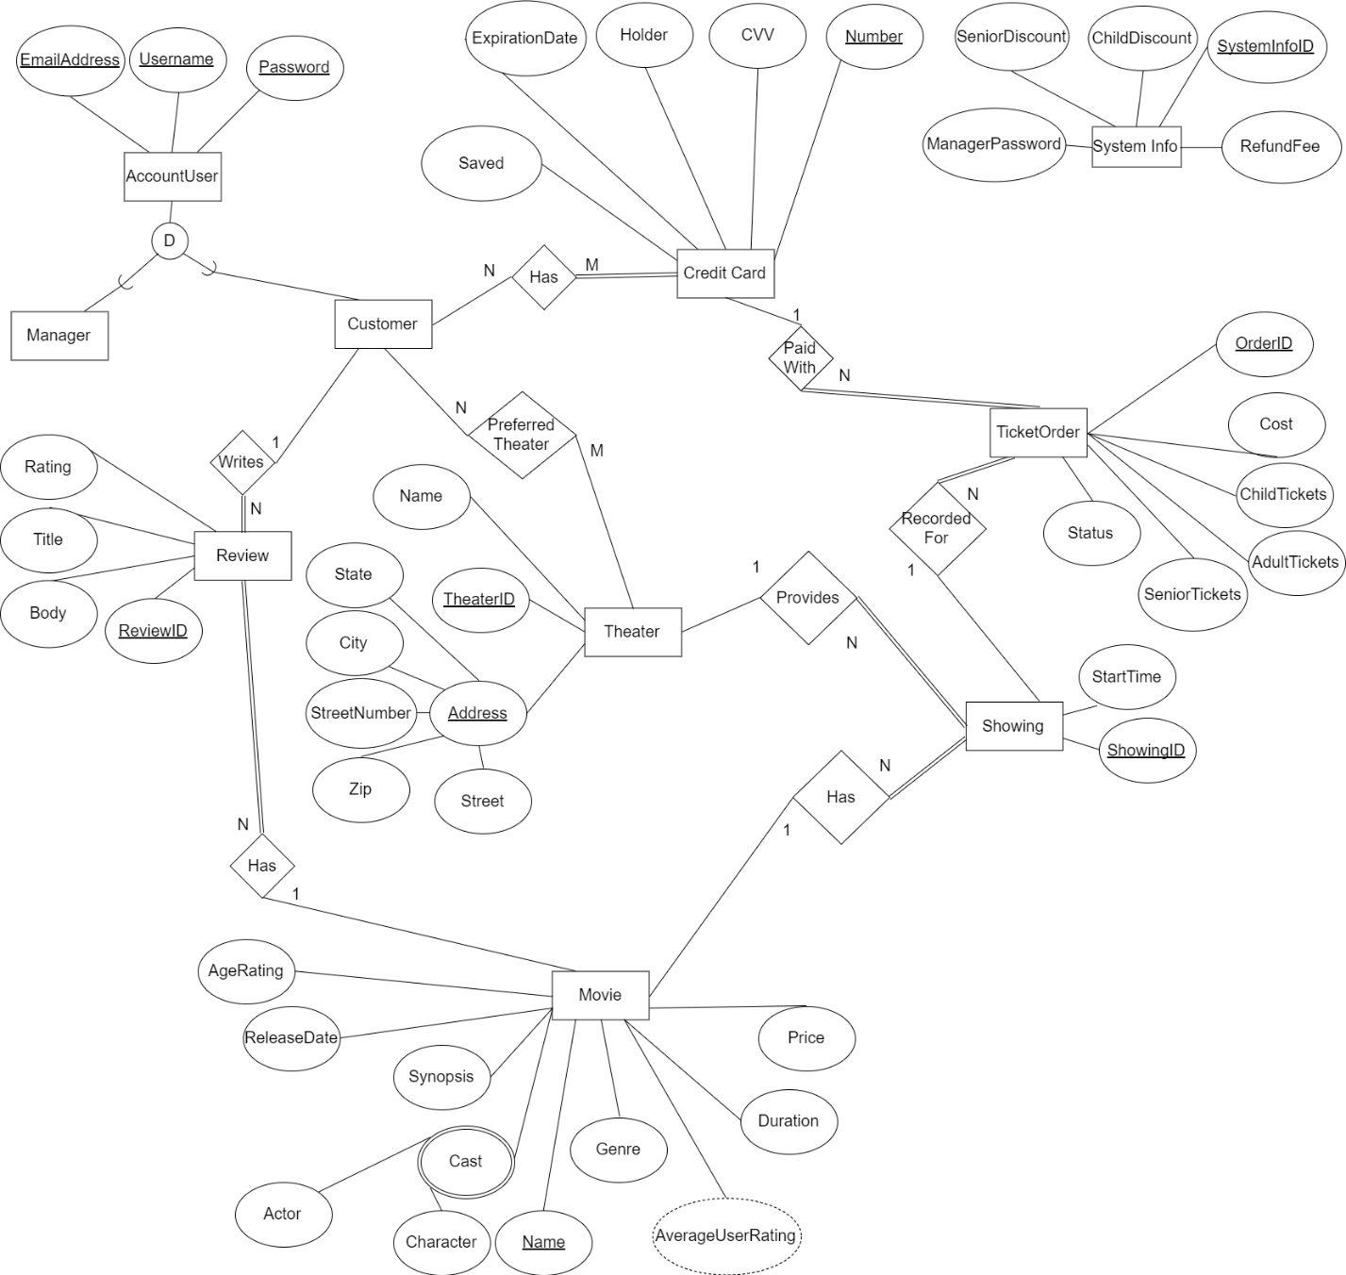

# Information Data Flow Diagram

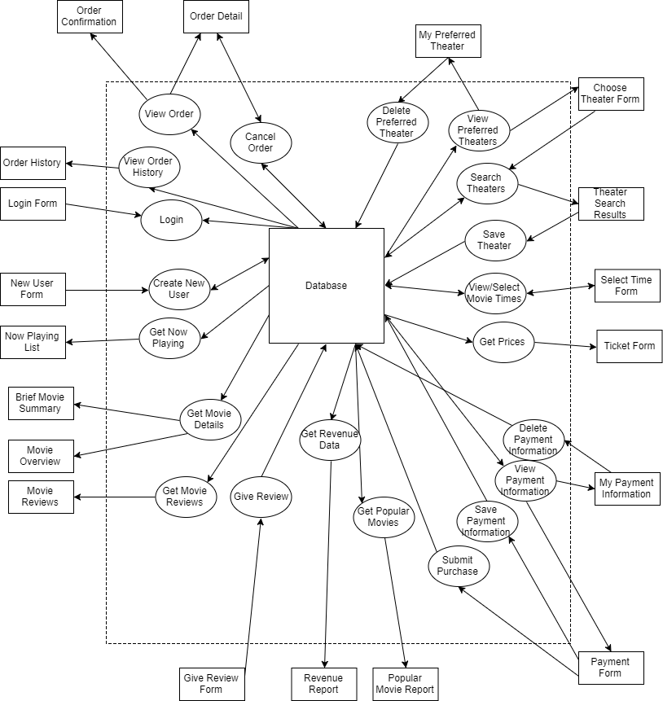

# Relational Schema Diagram

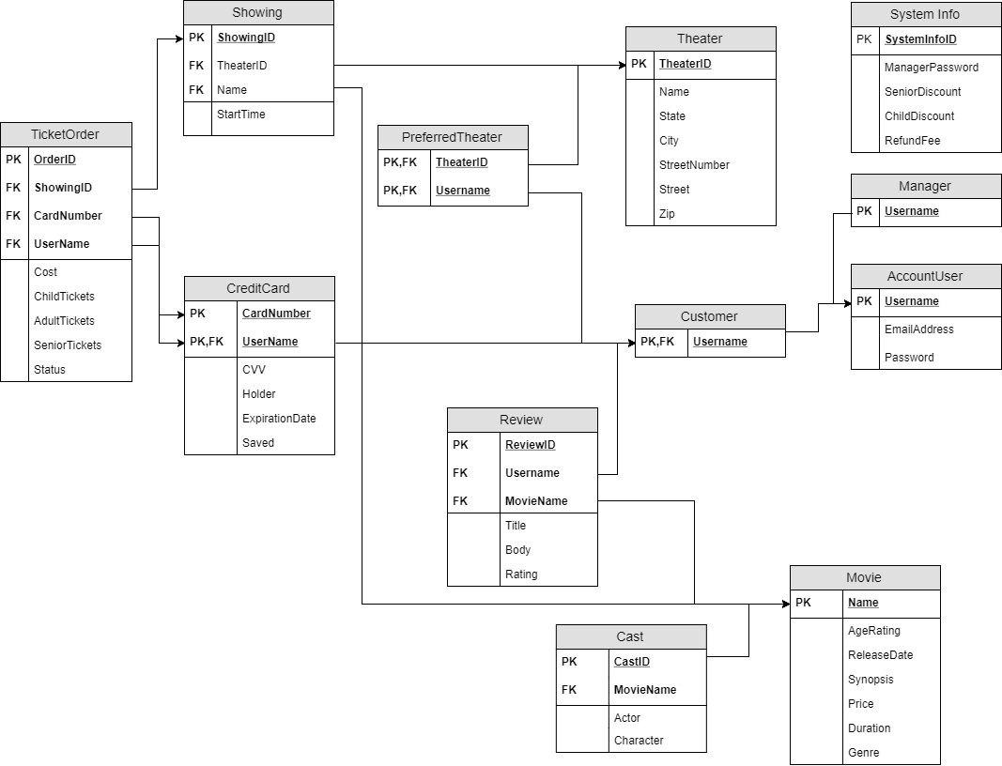

# Create Table Statements

create table Theater (

TheaterID int primary key,

Name varchar(255),

State varchar(255),

City varchar(255),

StreetNumber varchar(255),

Street varchar(255),

Zip char(5),

constraint Address unique (State, City, StreetNumber, Zip, Street)

);

create table AccountUser (

Username varchar(255) primary key,

EmailAddress varchar(255) not null unique,

Password varchar(255) not null unique

);

create table Manager (

Username varchar(255) primary key references AccountUser(Username)

);

create table Customer (

Username varchar(255) primary key references AccountUser(Username)

);

create table PreferredTheater (

TheaterID int references Theater(TheaterID),

Username varchar(255) references Customer(Username),

primary key (TheaterID, Username)

);

create table CreditCard (

CardNumber char(16) not null,

Username varchar(255) references Customer(Username),

CVV char(3) not null,

Holder varchar(255) not null,

ExpirationDate varchar(255) not null,

Saved int,

primary key (CardNumber, UserName)

);

create table Movie (

Name varchar(255) primary key,

AgeRating varchar(255),

ReleaseDate varchar(255),

Synopsis varchar(255),

Price float not null,

Duration int,

Genre varchar(255)

);

create table Showing (

ShowingID int primary key,

Name varchar(255) references Movie(Name),

TheaterID int references Theater(TheaterID),

StartTime timestamp

);

create table Review (

ReviewID int primary key,

MovieName varchar(255) references Movie(Name),

Username varchar(255) references Customer(Username),

Title varchar(255),

Body varchar(2047),

Rating int not null

);

create table Cast (

CastID int primary key,

MovieName varchar(255) references Movie(Name),

Actor varchar(255),

Character varchar(255)

);

create table TicketOrder (

OrderID int primary key,

ShowingID int references Showing(ShowingID),

Username varchar(255),

CardNumber char(16),

Cost float not null,

ChildTickets int,

AdultTickets int,

SeniorTickets int,

Status varchar(255),

foreign key (CardNumber, Username) references CreditCard(CardNumber, UserName)

);

create table SystemInfo (

SystemInfoID int primary key,

ManagerPassword varchar(255) not null,

SeniorDiscount float not null,

ChildDiscount float not null,

RefundFee float not null

);