**UAMovie.com Phase I**

CS301—001

Benjamin Jones, Parker Jones, Ethan Mines, Abigail Payne

{bdjones13, pajones3, elmines, aepayne3}@crimson.ua.edu

# Enhanced Entity Relationship (EER) Diagram

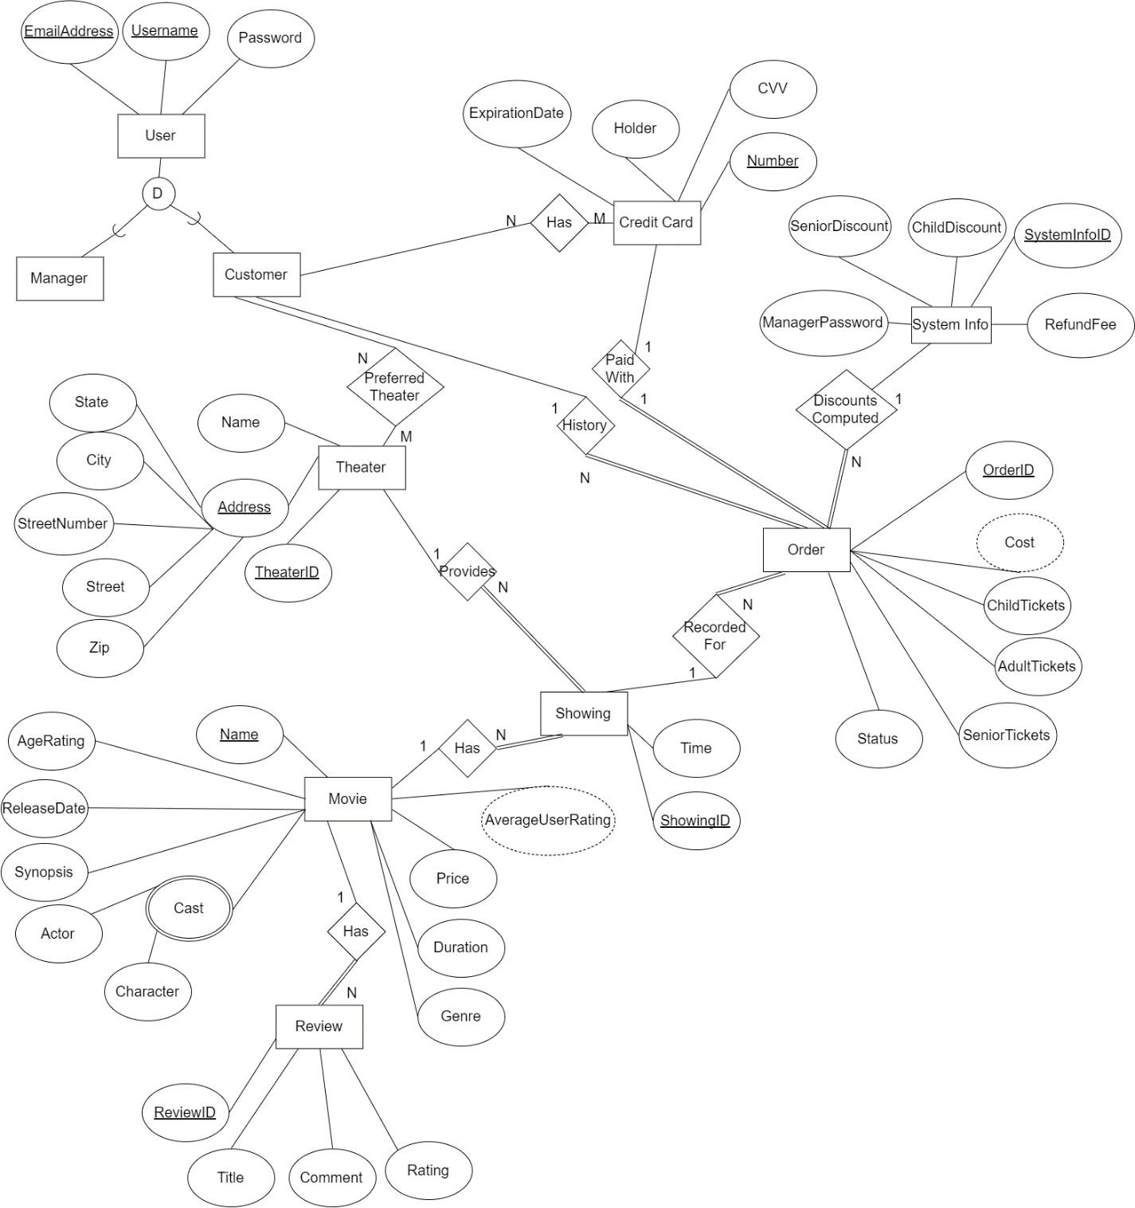

# Information Data Flow Diagram

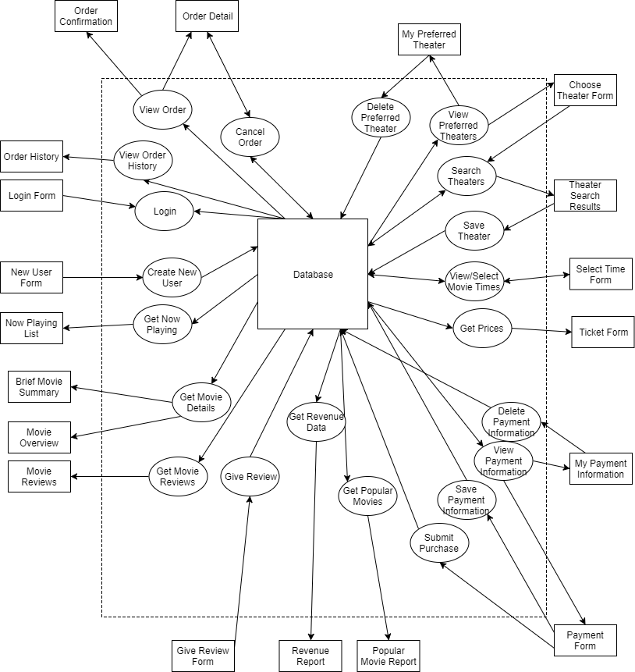

# Logical Constraints

|  |  |  |
| --- | --- | --- |
| **No.** | **Types/Attributes Involved** | **Constraint Definition** |
| 1 | SystemInfo | Only one SystemInfo may exist. |
| 2 | Movie.Name | A 3D version of a movie should be named appropriately to distinguish it from the 2D version (“Avatar 3D” instead of “Avatar”) |
| 3 | Order.Status, Order.Cost, SystemInfo.RefundFee | A cancelled order must have a cost of $5—the $5 refund fee. |
| 4 | Review, Customer, Order, Movie | A customer cannot review a movie he/she has not seen. |

# Assumptions

* The “Me” page for customers is simply a static page and does not interact with the database; hence, it is not noted on the IDF diagram.
* The manager’s “Choose Functionality” page is not noted on the IDF diagram for the same reasons as the “Me” page.
* Managers’ reports are computed from the database entities; they need not be represented as entities themselves.
* Multiple customers can have the same credit card; for example, two spouses could have separate accounts but the same credit card.