# CKME 136 Capstone Project

# Melbourne House Sales Price Predictive Analysis

#### Driginal data and code can be found at <https://github.com/ludejia/CapstoneProject>

#### Dejia Lu

#### Ryerson University 501005537

## Introduction

Since 2010, Melburne housing market was experiencing a housing bubble and some expert said it might burst soon. However, there was a cooling period in 2018. The contributor of the housing market dataset was considering buying an apartment. He was seeking data experts to help him draw some insights on the data to assist his decision making.

In Capstone Project, my goal is to explore and understand the relation between the final sold price and different variable factors, perform Predictive Analytics using various machine learning algorithms, compare the performances and differences among these models and find the best model for property price prediction. The procedures I will be following are exploratory analysis, date cleaning, feature engineering, model building and model evaluation.

## Literature Review

After reviewing books, website, journals and video, I found some methodologies and techniques are especially helpful in data visualization and preparation, feature selection & modelling building, and model performance evaluation.

EDA (exploratory data cleaning) is a very important step when conducting initial analyse, De Jonge & Van Der Loo’s book (2013) detail various data preprocessing techniques including missing value handling, data conversion and data manipulation. They also give examples in R environment. They suggested various way to impute missing value such as hot-deck imputation and knn imputation. The book ‘Hands-on exploratory data analysis with R’(Datar & Garg, 2019) not only demonstrates practical data manipulation process using different R packages but also dedicated a big portion in data visualizing utilizing ggplot2 package which makes the data much more easily to be understood. For example, in scatter plot and density plot, colors are used as a new dimension to differentiate categories.

The dataset provides GPS location information for each house. It would be especially helpful to visualize the houses on the map and to color these points by different properties to understand the geographic impact on the houses. The book ggmap: Spatial visualization with ggplot2(Kahle & Wickham, 2013) showed the step by step approach to import map from google map and plot those points in a meaningful way.

In terms of feature selection and modeling building, An introduction to statistical learning: With applications in R (James et al. 2013) has a comprehensive coverage on all the popular algorithms and their mathematical explanations. For each algorithm, it has multiple lab exercise in R environment dedicated to it so you can apply the theory to real dataset. In the section of linear model selection, it provided multiple ways to select the best features of the dataset. I learned Ridge Regression, Lasso Regression, Random Forest and Support Vector Machine and their application in this book. The elements of statistical learning: Data mining, inference, and prediction (Hastie et al., 2009) gives an in-depth math and statistical concepts on modelling and model evaluations. Due to its missing of application in R environment, I used this book as a supplement reading to the previous modelling book for the concepts that I am not so clear about.

## Dataset

The dataset I am using was posted on Kaggle and scraped by the contributor Pino(2018) from an Australian property website (Domain.com.au) for the period from 2016 to 2018. The data set contains the propterty information of has 34857 observations. Each observation has 21 attributes. Price is the attribute I am building model to predict. Below provides the summary for the data and visualizaiton of missing values.

Google's Terms of Service: https://cloud.google.com/maps-platform/terms/.

Please cite ggmap if you use it! See citation("ggmap") for details.

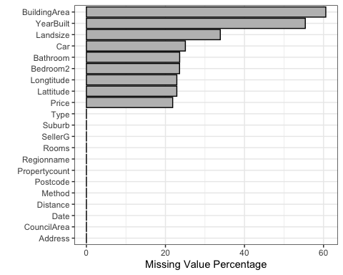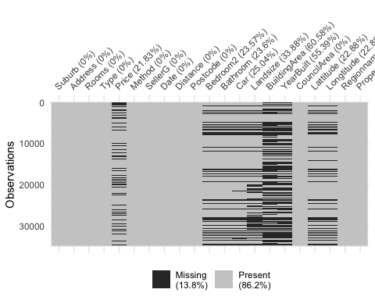

#### *Attributs explnation and selection*

* Lattitude & Longtitude

They gave the GPS location on the map. 23% of the data are missing. Below we can visualize the location of the properties on google map and see which area has the high density of the property.

Replacing old key (AIzaSyCyjfy52N) with new key in /Users/dejialu/.Renviron

Source : https://maps.googleapis.com/maps/api/staticmap?center=Melbourne&zoom=10&size=640x640&scale=2&maptype=terrain&language=en-EN&key=xxx-yvo76okcOhh4sc1wSqSMi8oI

Source : https://maps.googleapis.com/maps/api/geocode/json?address=Melbourne&key=xxx-yvo76okcOhh4sc1wSqSMi8oI

Warning: Removed 8100 rows containing missing values (geom_point).

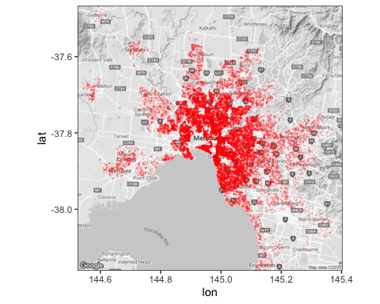

*Suburb, Postcode, Regionname, CouncilArea

Suburb, Postcode, Regionname, CouncilArea divide Melbourne into deferent sections. Below we can find Suburb has the finest divisions (351) whereas regionname only has 9 divisions. 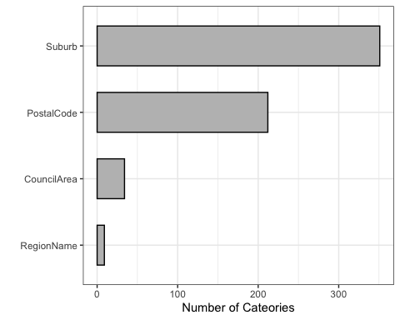 We can also see 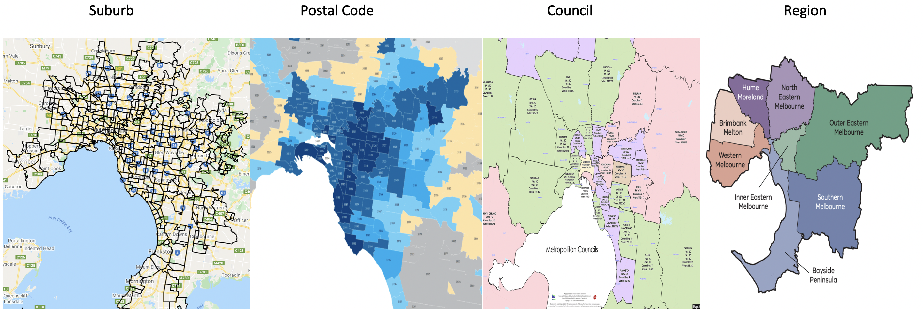

* Builing area & Landsize

## Approach

* Step 1
* Step 2
* Step 3

## Reference

De Jonge, E., & Van Der Loo, M. (2013). An introduction to data cleaning with R. Heerlen: Statistics Netherlands.

Datar, R., & Garg, H. (2019). Hands-on exploratory data analysis with R: Become an expert in exploratory data analysis using R packages (1st ed.). UK: Packt Publishing.

Kahle, D., & Wickham, H. (2013). ggmap: Spatial visualization with ggplot2. The R Journal, 5(1), 144. <doi:10.32614/RJ-2013-014>

James, G., Hastie, T., Tibshirani, R., & Witten, D. (2013). An introduction to statistical learning: With applications in R Springer New York.

Hastie, T., Tibshirani, R., Friedman, J. H., & SpringerLink (Online service). (2009;2013;2001;). The elements of statistical learning: Data mining, inference, and prediction (2nd ed.). New York, NY: Springer. <doi:10.1007/978-0-387-21606-5>

Pino, T. P. (2018, October 14). Melbourne Housing Market. Retrieved May 7, 2020, from <https://www.kaggle.com/anthonypino/melbourne-housing-marke>

Melbourne Suburb Map. (n.d.). Retrieved June 7, 2020, from <http://melbournesuburbsmap.com>

LocalCouncilMaps. (n.d.). Retrieved June 7, 2020, from <https://enrol.vec.vic.gov.au/ElectoralBoundaries/LocalCouncilMaps.html>

Melbourne Regions. (n.d.). Retrieved June 7, 2020, from <https://www.education.vic.gov.au/about/department/structure/Pages/regions.aspx>