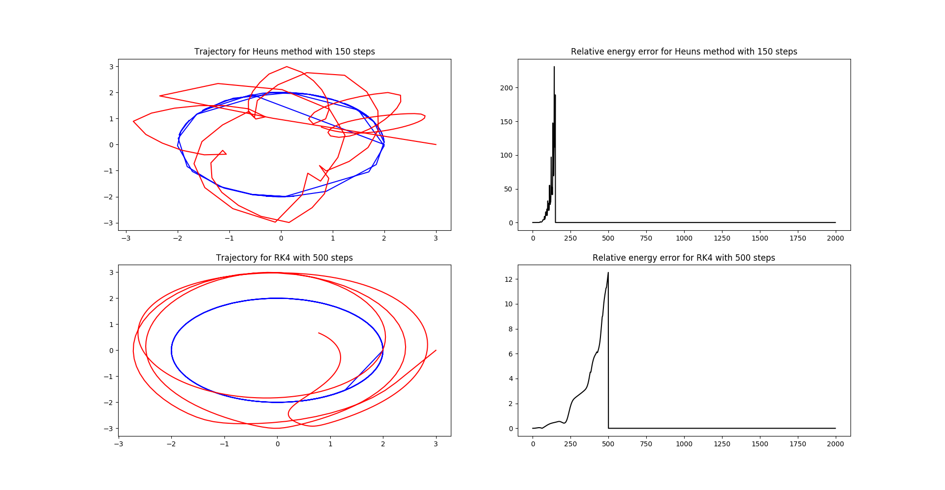
Comment on exercises (c) and (d):

I implemented the schemes as given in the lecture, but each time I ran the simulation it broke down after roughly 150 steps (500 for RK4). The plots above show the behavior of the system until the breakdown. The trajectory looks meaningful, but the relative energy error goes well beyond the expected limits (should be between 0 and 1)
I do not know what exactly the problem is, but I triple-checked my code and calculations and could not find any errors.

Still, the error seems to be much smaller for the RK4 scheme compared to the Heun scheme, which is also what I would expect as Heun’s scheme is second order accurate while RK4 is fourth-order accurate.

