Connect To Data Base Project (RAM BANK)

Preparation

1. رفعت ربيع العبد
2. محمد ذكي الاعصر
3. عبدالله ناصف المسيري
4. مصطفي عبدالنبي المرشدى

Submitted to

Dr.Lobna Mohamed Abo El-Magd

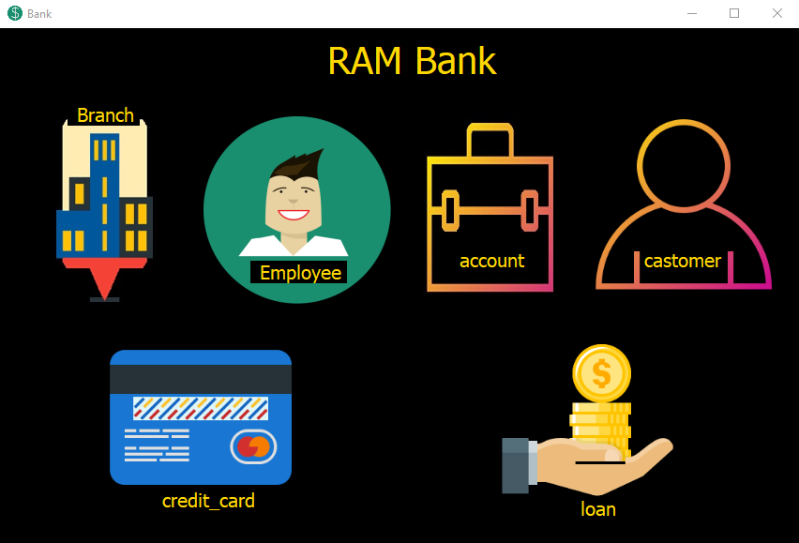

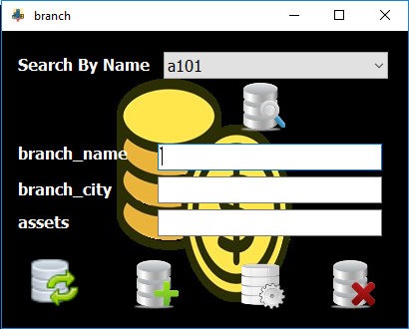

To search in database primary key of table and full of the textbox with data



To add a new row



To updat selected row pk in combobox



To Delet selected row pk in combobox



To Refresh the combobox items and clear textbox

|  |
| --- |
| Employee form |
|  |
| Account form |
|  |
| Customer form |
|  |

|  |
| --- |
| Credit Card form |
|  |
| Loan form |
|  |