FINAL PROJECT

Group-3

2022-12-10

#Business problem Most telecom companies suffer from voluntary churn. Churn rate has strong impact on the life time value of the customer because it affects the length of service and the future revenue of the company. For example if a company has 25% churn rate then the average customer lifetime is 4 years; similarly a company with a churn rate of 50%, has an average customer lifetime of 2 years. It is estimated that 75 percent of the 17 to 20 million subscribers signing up with a new wireless carrier every year are coming from another wireless provider, which means they are churners. Telecom companies spend hundreds of dollars to acquire a new customer and when that customer leaves, the company not only loses the future revenue from that customer but also the resources spend to acquire that customer. Churn erodes profitability.

#Approaches adapted by telecom companies to address churn. Untargeted and targeted aproach.

In this project, we will be working as a part of a team to use historical data from ACB Wireless Inc. to build a model that can predict/identify their customers who are likely to churn.

#### Importing the dataset

churn.train_data <- read.csv("/Users/ELMYLUKA/Desktop/MS BA/Business Analytics/Assignment-4/Churn_Train.csv")  
  
#Analysing the data  
  
str(churn.train_data)

## 'data.frame': 3333 obs. of 20 variables:  
## $ state : chr "NV" "HI" "DC" "HI" ...  
## $ account_length : int 125 108 82 NA 83 89 135 28 86 65 ...  
## $ area_code : chr "area_code_510" "area_code_415" "area_code_415" "area_code_408" ...  
## $ international_plan : chr "no" "no" "no" "no" ...  
## $ voice_mail_plan : chr "no" "no" "no" "yes" ...  
## $ number_vmail_messages : int 0 0 0 30 0 0 0 0 0 0 ...  
## $ total_day_minutes : num 2013 292 300 110 337 ...  
## $ total_day_calls : int 99 99 109 71 120 81 81 87 115 137 ...  
## $ total_day_charge : num 28.7 49.6 51 18.8 57.4 ...  
## $ total_eve_minutes : num 1108 221 181 182 227 ...  
## $ total_eve_calls : int 107 93 100 108 116 74 114 92 112 83 ...  
## $ total_eve_charge : num 14.9 18.8 15.4 15.5 19.3 ...  
## $ total_night_minutes : num 243 229 270 184 154 ...  
## $ total_night_calls : int 92 110 73 88 114 120 82 112 95 111 ...  
## $ total_night_charge : num 10.95 10.31 12.15 8.27 6.93 ...  
## $ total_intl_minutes : num 10.9 14 11.7 11 15.8 9.1 10.3 10.1 9.8 12.7 ...  
## $ total_intl_calls : int 7 9 4 8 7 4 6 3 7 6 ...  
## $ total_intl_charge : num 2.94 3.78 3.16 2.97 4.27 2.46 2.78 2.73 2.65 3.43 ...  
## $ number_customer_service_calls: int 0 2 0 2 0 1 1 3 2 4 ...  
## $ churn : chr "no" "yes" "yes" "no" ...

glimpse(churn.train_data)

## Rows: 3,333  
## Columns: 20  
## $ state <chr> "NV", "HI", "DC", "HI", "OH", "MO", "NC"…  
## $ account_length <int> 125, 108, 82, NA, 83, 89, 135, 28, 86, 6…  
## $ area_code <chr> "area_code_510", "area_code_415", "area_…  
## $ international_plan <chr> "no", "no", "no", "no", "no", "no", "no"…  
## $ voice_mail_plan <chr> "no", "no", "no", "yes", "no", "no", "no…  
## $ number_vmail_messages <int> 0, 0, 0, 30, 0, 0, 0, 0, 0, 0, 0, NA, 32…  
## $ total_day_minutes <dbl> 2013.4, 291.6, 300.3, 110.3, 337.4, 178.…  
## $ total_day_calls <int> 99, 99, 109, 71, 120, 81, 81, 87, 115, 1…  
## $ total_day_charge <dbl> 28.66, 49.57, 51.05, 18.75, 57.36, 30.38…  
## $ total_eve_minutes <dbl> 1107.6, 221.1, 181.0, 182.4, 227.4, NA, …  
## $ total_eve_calls <int> 107, 93, 100, 108, 116, 74, 114, 92, 112…  
## $ total_eve_charge <dbl> 14.93, 18.79, 15.39, 15.50, 19.33, 19.86…  
## $ total_night_minutes <dbl> 243.3, 229.2, 270.1, 183.8, 153.9, 131.9…  
## $ total_night_calls <int> 92, 110, 73, 88, 114, 120, 82, 112, 95, …  
## $ total_night_charge <dbl> 10.95, 10.31, 12.15, 8.27, 6.93, 5.94, 9…  
## $ total_intl_minutes <dbl> 10.9, 14.0, 11.7, 11.0, 15.8, 9.1, 10.3,…  
## $ total_intl_calls <int> 7, 9, 4, 8, 7, 4, 6, 3, 7, 6, 7, NA, 4, …  
## $ total_intl_charge <dbl> 2.94, 3.78, 3.16, 2.97, 4.27, 2.46, 2.78…  
## $ number_customer_service_calls <int> 0, 2, 0, 2, 0, 1, 1, 3, 2, 4, 1, NA, 3, …  
## $ churn <chr> "no", "yes", "yes", "no", "yes", "no", "…

#Summary of the dataset  
summary(churn.train_data)

## state account_length area_code international_plan  
## Length:3333 Min. :-209.00 Length:3333 Length:3333   
## Class :character 1st Qu.: 72.00 Class :character Class :character   
## Mode :character Median : 100.00 Mode :character Mode :character   
## Mean : 97.32   
## 3rd Qu.: 127.00   
## Max. : 243.00   
## NA's :501   
## voice_mail_plan number_vmail_messages total_day_minutes total_day_calls  
## Length:3333 Min. :-10.000 Min. : 0.0 Min. : 0.0   
## Class :character 1st Qu.: 0.000 1st Qu.: 149.3 1st Qu.: 87.0   
## Mode :character Median : 0.000 Median : 190.5 Median :101.0   
## Mean : 7.333 Mean : 418.9 Mean :100.3   
## 3rd Qu.: 16.000 3rd Qu.: 237.8 3rd Qu.:114.0   
## Max. : 51.000 Max. :2185.1 Max. :165.0   
## NA's :200 NA's :200 NA's :200   
## total_day_charge total_eve_minutes total_eve_calls total_eve_charge  
## Min. : 0.00 Min. : 0.0 Min. : 0.0 Min. : 0.00   
## 1st Qu.:24.45 1st Qu.: 170.5 1st Qu.: 87.0 1st Qu.:14.14   
## Median :30.65 Median : 209.9 Median :100.0 Median :17.09   
## Mean :30.63 Mean : 324.3 Mean :100.1 Mean :17.08   
## 3rd Qu.:36.84 3rd Qu.: 257.6 3rd Qu.:114.0 3rd Qu.:20.00   
## Max. :59.64 Max. :1244.2 Max. :170.0 Max. :30.91   
## NA's :200 NA's :301 NA's :200 NA's :200   
## total_night_minutes total_night_calls total_night_charge total_intl_minutes  
## Min. : 23.2 Min. : 33.0 Min. : 1.040 Min. : 0.00   
## 1st Qu.:167.3 1st Qu.: 87.0 1st Qu.: 7.530 1st Qu.: 8.50   
## Median :201.4 Median :100.0 Median : 9.060 Median :10.30   
## Mean :201.2 Mean :100.1 Mean : 9.054 Mean :10.23   
## 3rd Qu.:235.3 3rd Qu.:113.0 3rd Qu.:10.590 3rd Qu.:12.10   
## Max. :395.0 Max. :175.0 Max. :17.770 Max. :20.00   
## NA's :200 NA's :200 NA's :200   
## total_intl_calls total_intl_charge number_customer_service_calls  
## Min. : 0.00 Min. :0.000 Min. :0.000   
## 1st Qu.: 3.00 1st Qu.:2.300 1st Qu.:1.000   
## Median : 4.00 Median :2.780 Median :1.000   
## Mean : 4.47 Mean :2.762 Mean :1.561   
## 3rd Qu.: 6.00 3rd Qu.:3.270 3rd Qu.:2.000   
## Max. :20.00 Max. :5.400 Max. :9.000   
## NA's :301 NA's :200 NA's :200   
## churn   
## Length:3333   
## Class :character   
## Mode :character   
##   
##   
##   
##

##transforming categorical variables to numeric.

churn.train_data$state <- as.factor(churn.train_data$state)  
churn.train_data$area_code <- as.factor(churn.train_data$area_code)  
churn.train_data$international_plan <- as.factor(churn.train_data$international_plan)  
churn.train_data$voice_mail_plan <- as.factor(churn.train_data$voice_mail_plan)  
churn.train_data$churn <- as.factor(churn.train_data$churn)  
churn_true <- subset(churn.train_data, churn.train_data$churn == "yes")  
churn_false <- subset(churn.train_data, churn.train_data$churn == "no")

#churn count number of yes/no

churn_count_number<-table(churn.train_data$churn)  
churn_count_number

##   
## no yes   
## 2850 483

#examining the skewness and distribution of each variable in the dataset.

churn.train_data[, 6:19] %>%  
 gather(key = Variable, value = Value) %>%  
 ggplot() +  
 geom_histogram(aes(x = Value), fill = "light green") +  
 facet_wrap(~Variable, scales='free') +  
 theme_classic() +  
 theme(aspect.ratio = 0.5, axis.title = element_blank(), panel.grid = element_blank())

## `stat_bin()` using `bins = 30`. Pick better value with `binwidth`.

## Warning: Removed 2802 rows containing non-finite values (stat_bin).

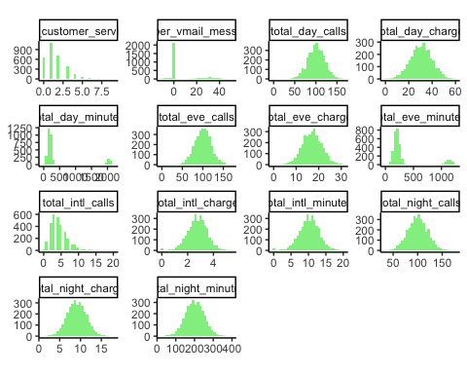 We can determine from the output that there is a bell curve distribution of data or variables for the majority of the data.It is also an observation that “total day minutes” and total evening minutes” have a tiny percentage or sizeable quantity of outliers. An other observation determined is that “Customer_Service_calls” has an irregular skewness.

#Determining the number of customers from the dataset.

churn_count_number

##   
## no yes   
## 2850 483

barplot(churn_count_number,xlab ="Churn",ylab="Count" ,col = "purple" ,main = "Total number of customers(CHURN DATASET)")

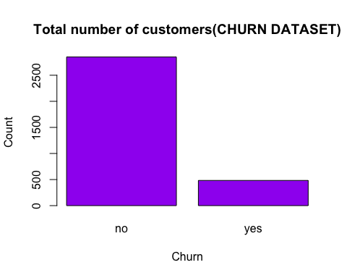 It can be determined from the above graph that among the customers, 483 customers have switched to other providers while the remaining 2850 of them have decided to stay.

#Determing the number of customers as per the States

count_state<-churn_true %>% group_by(state) %>% summarise(count_churn_state=n())  
churn_state <- churn.train_data %>%group_by(churn.train_data$state, churn.train_data$churn) %>% summarise(count = n())

## `summarise()` has grouped output by 'churn.train_data$state'. You can override  
## using the `.groups` argument.

## “summarise()” function has grouped output by ’Churn_Data$state’. Therefore we can override using the ’.groups‘ argument.

ggplot(count_state) +  
 aes(x = state, weight = count_churn_state) +  
 geom_bar(width=0.5, position = position_dodge(width=0.5), fill = "#FFB6C1") + scale_x_discrete(guide = guide_axis(n.dodge=2))+  
 labs(x = "State", y = "Count", title = "CHURN RATE FOR EACH STATE")+theme_light()

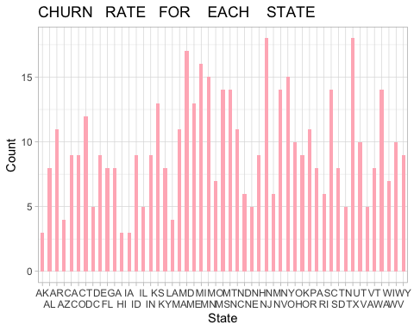

It is determined from the graph that Maryland, New Jersey, Michigan and Texas are the states with high churn rates.

#Distributing the dataset by the Total day charges.

ggplot(churn.train_data) +  
 aes(x = churn, y = total_day_charge, fill = churn) +  
 geom_boxplot(shape = "square") +  
 scale_fill_manual(breaks = churn.train_data$churn,  
 values = c("yellow", "light blue"))+ labs(x = "Churn", y = "total_day_charge",title = "CHURN DATA FOR TOTAL DAY CHARGE")

## Warning: Removed 200 rows containing non-finite values (stat_boxplot).

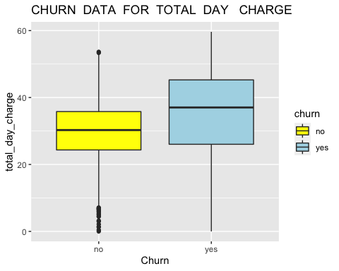

theme_minimal()+  
 theme(plot.title = element_text(size = 16L,  
 face = "bold", hjust = 0.5))

## List of 93  
## $ line :List of 6  
## ..$ colour : chr "black"  
## ..$ size : num 0.5  
## ..$ linetype : num 1  
## ..$ lineend : chr "butt"  
## ..$ arrow : logi FALSE  
## ..$ inherit.blank: logi TRUE  
## ..- attr(*, "class")= chr [1:2] "element_line" "element"  
## $ rect :List of 5  
## ..$ fill : chr "white"  
## ..$ colour : chr "black"  
## ..$ size : num 0.5  
## ..$ linetype : num 1  
## ..$ inherit.blank: logi TRUE  
## ..- attr(*, "class")= chr [1:2] "element_rect" "element"  
## $ text :List of 11  
## ..$ family : chr ""  
## ..$ face : chr "plain"  
## ..$ colour : chr "black"  
## ..$ size : num 11  
## ..$ hjust : num 0.5  
## ..$ vjust : num 0.5  
## ..$ angle : num 0  
## ..$ lineheight : num 0.9  
## ..$ margin : 'margin' num [1:4] 0points 0points 0points 0points  
## .. ..- attr(*, "unit")= int 8  
## ..$ debug : logi FALSE  
## ..$ inherit.blank: logi TRUE  
## ..- attr(*, "class")= chr [1:2] "element_text" "element"  
## $ title : NULL  
## $ aspect.ratio : NULL  
## $ axis.title : NULL  
## $ axis.title.x :List of 11  
## ..$ family : NULL  
## ..$ face : NULL  
## ..$ colour : NULL  
## ..$ size : NULL  
## ..$ hjust : NULL  
## ..$ vjust : num 1  
## ..$ angle : NULL  
## ..$ lineheight : NULL  
## ..$ margin : 'margin' num [1:4] 2.75points 0points 0points 0points  
## .. ..- attr(*, "unit")= int 8  
## ..$ debug : NULL  
## ..$ inherit.blank: logi TRUE  
## ..- attr(*, "class")= chr [1:2] "element_text" "element"  
## $ axis.title.x.top :List of 11  
## ..$ family : NULL  
## ..$ face : NULL  
## ..$ colour : NULL  
## ..$ size : NULL  
## ..$ hjust : NULL  
## ..$ vjust : num 0  
## ..$ angle : NULL  
## ..$ lineheight : NULL  
## ..$ margin : 'margin' num [1:4] 0points 0points 2.75points 0points  
## .. ..- attr(*, "unit")= int 8  
## ..$ debug : NULL  
## ..$ inherit.blank: logi TRUE  
## ..- attr(*, "class")= chr [1:2] "element_text" "element"  
## $ axis.title.x.bottom : NULL  
## $ axis.title.y :List of 11  
## ..$ family : NULL  
## ..$ face : NULL  
## ..$ colour : NULL  
## ..$ size : NULL  
## ..$ hjust : NULL  
## ..$ vjust : num 1  
## ..$ angle : num 90  
## ..$ lineheight : NULL  
## ..$ margin : 'margin' num [1:4] 0points 2.75points 0points 0points  
## .. ..- attr(*, "unit")= int 8  
## ..$ debug : NULL  
## ..$ inherit.blank: logi TRUE  
## ..- attr(*, "class")= chr [1:2] "element_text" "element"  
## $ axis.title.y.left : NULL  
## $ axis.title.y.right :List of 11  
## ..$ family : NULL  
## ..$ face : NULL  
## ..$ colour : NULL  
## ..$ size : NULL  
## ..$ hjust : NULL  
## ..$ vjust : num 0  
## ..$ angle : num -90  
## ..$ lineheight : NULL  
## ..$ margin : 'margin' num [1:4] 0points 0points 0points 2.75points  
## .. ..- attr(*, "unit")= int 8  
## ..$ debug : NULL  
## ..$ inherit.blank: logi TRUE  
## ..- attr(*, "class")= chr [1:2] "element_text" "element"  
## $ axis.text :List of 11  
## ..$ family : NULL  
## ..$ face : NULL  
## ..$ colour : chr "grey30"  
## ..$ size : 'rel' num 0.8  
## ..$ hjust : NULL  
## ..$ vjust : NULL  
## ..$ angle : NULL  
## ..$ lineheight : NULL  
## ..$ margin : NULL  
## ..$ debug : NULL  
## ..$ inherit.blank: logi TRUE  
## ..- attr(*, "class")= chr [1:2] "element_text" "element"  
## $ axis.text.x :List of 11  
## ..$ family : NULL  
## ..$ face : NULL  
## ..$ colour : NULL  
## ..$ size : NULL  
## ..$ hjust : NULL  
## ..$ vjust : num 1  
## ..$ angle : NULL  
## ..$ lineheight : NULL  
## ..$ margin : 'margin' num [1:4] 2.2points 0points 0points 0points  
## .. ..- attr(*, "unit")= int 8  
## ..$ debug : NULL  
## ..$ inherit.blank: logi TRUE  
## ..- attr(*, "class")= chr [1:2] "element_text" "element"  
## $ axis.text.x.top :List of 11  
## ..$ family : NULL  
## ..$ face : NULL  
## ..$ colour : NULL  
## ..$ size : NULL  
## ..$ hjust : NULL  
## ..$ vjust : num 0  
## ..$ angle : NULL  
## ..$ lineheight : NULL  
## ..$ margin : 'margin' num [1:4] 0points 0points 2.2points 0points  
## .. ..- attr(*, "unit")= int 8  
## ..$ debug : NULL  
## ..$ inherit.blank: logi TRUE  
## ..- attr(*, "class")= chr [1:2] "element_text" "element"  
## $ axis.text.x.bottom : NULL  
## $ axis.text.y :List of 11  
## ..$ family : NULL  
## ..$ face : NULL  
## ..$ colour : NULL  
## ..$ size : NULL  
## ..$ hjust : num 1  
## ..$ vjust : NULL  
## ..$ angle : NULL  
## ..$ lineheight : NULL  
## ..$ margin : 'margin' num [1:4] 0points 2.2points 0points 0points  
## .. ..- attr(*, "unit")= int 8  
## ..$ debug : NULL  
## ..$ inherit.blank: logi TRUE  
## ..- attr(*, "class")= chr [1:2] "element_text" "element"  
## $ axis.text.y.left : NULL  
## $ axis.text.y.right :List of 11  
## ..$ family : NULL  
## ..$ face : NULL  
## ..$ colour : NULL  
## ..$ size : NULL  
## ..$ hjust : num 0  
## ..$ vjust : NULL  
## ..$ angle : NULL  
## ..$ lineheight : NULL  
## ..$ margin : 'margin' num [1:4] 0points 0points 0points 2.2points  
## .. ..- attr(*, "unit")= int 8  
## ..$ debug : NULL  
## ..$ inherit.blank: logi TRUE  
## ..- attr(*, "class")= chr [1:2] "element_text" "element"  
## $ axis.ticks : list()  
## ..- attr(*, "class")= chr [1:2] "element_blank" "element"  
## $ axis.ticks.x : NULL  
## $ axis.ticks.x.top : NULL  
## $ axis.ticks.x.bottom : NULL  
## $ axis.ticks.y : NULL  
## $ axis.ticks.y.left : NULL  
## $ axis.ticks.y.right : NULL  
## $ axis.ticks.length : 'simpleUnit' num 2.75points  
## ..- attr(*, "unit")= int 8  
## $ axis.ticks.length.x : NULL  
## $ axis.ticks.length.x.top : NULL  
## $ axis.ticks.length.x.bottom: NULL  
## $ axis.ticks.length.y : NULL  
## $ axis.ticks.length.y.left : NULL  
## $ axis.ticks.length.y.right : NULL  
## $ axis.line : list()  
## ..- attr(*, "class")= chr [1:2] "element_blank" "element"  
## $ axis.line.x : NULL  
## $ axis.line.x.top : NULL  
## $ axis.line.x.bottom : NULL  
## $ axis.line.y : NULL  
## $ axis.line.y.left : NULL  
## $ axis.line.y.right : NULL  
## $ legend.background : list()  
## ..- attr(*, "class")= chr [1:2] "element_blank" "element"  
## $ legend.margin : 'margin' num [1:4] 5.5points 5.5points 5.5points 5.5points  
## ..- attr(*, "unit")= int 8  
## $ legend.spacing : 'simpleUnit' num 11points  
## ..- attr(*, "unit")= int 8  
## $ legend.spacing.x : NULL  
## $ legend.spacing.y : NULL  
## $ legend.key : list()  
## ..- attr(*, "class")= chr [1:2] "element_blank" "element"  
## $ legend.key.size : 'simpleUnit' num 1.2lines  
## ..- attr(*, "unit")= int 3  
## $ legend.key.height : NULL  
## $ legend.key.width : NULL  
## $ legend.text :List of 11  
## ..$ family : NULL  
## ..$ face : NULL  
## ..$ colour : NULL  
## ..$ size : 'rel' num 0.8  
## ..$ hjust : NULL  
## ..$ vjust : NULL  
## ..$ angle : NULL  
## ..$ lineheight : NULL  
## ..$ margin : NULL  
## ..$ debug : NULL  
## ..$ inherit.blank: logi TRUE  
## ..- attr(*, "class")= chr [1:2] "element_text" "element"  
## $ legend.text.align : NULL  
## $ legend.title :List of 11  
## ..$ family : NULL  
## ..$ face : NULL  
## ..$ colour : NULL  
## ..$ size : NULL  
## ..$ hjust : num 0  
## ..$ vjust : NULL  
## ..$ angle : NULL  
## ..$ lineheight : NULL  
## ..$ margin : NULL  
## ..$ debug : NULL  
## ..$ inherit.blank: logi TRUE  
## ..- attr(*, "class")= chr [1:2] "element_text" "element"  
## $ legend.title.align : NULL  
## $ legend.position : chr "right"  
## $ legend.direction : NULL  
## $ legend.justification : chr "center"  
## $ legend.box : NULL  
## $ legend.box.just : NULL  
## $ legend.box.margin : 'margin' num [1:4] 0cm 0cm 0cm 0cm  
## ..- attr(*, "unit")= int 1  
## $ legend.box.background : list()  
## ..- attr(*, "class")= chr [1:2] "element_blank" "element"  
## $ legend.box.spacing : 'simpleUnit' num 11points  
## ..- attr(*, "unit")= int 8  
## $ panel.background : list()  
## ..- attr(*, "class")= chr [1:2] "element_blank" "element"  
## $ panel.border : list()  
## ..- attr(*, "class")= chr [1:2] "element_blank" "element"  
## $ panel.spacing : 'simpleUnit' num 5.5points  
## ..- attr(*, "unit")= int 8  
## $ panel.spacing.x : NULL  
## $ panel.spacing.y : NULL  
## $ panel.grid :List of 6  
## ..$ colour : chr "grey92"  
## ..$ size : NULL  
## ..$ linetype : NULL  
## ..$ lineend : NULL  
## ..$ arrow : logi FALSE  
## ..$ inherit.blank: logi TRUE  
## ..- attr(*, "class")= chr [1:2] "element_line" "element"  
## $ panel.grid.major : NULL  
## $ panel.grid.minor :List of 6  
## ..$ colour : NULL  
## ..$ size : 'rel' num 0.5  
## ..$ linetype : NULL  
## ..$ lineend : NULL  
## ..$ arrow : logi FALSE  
## ..$ inherit.blank: logi TRUE  
## ..- attr(*, "class")= chr [1:2] "element_line" "element"  
## $ panel.grid.major.x : NULL  
## $ panel.grid.major.y : NULL  
## $ panel.grid.minor.x : NULL  
## $ panel.grid.minor.y : NULL  
## $ panel.ontop : logi FALSE  
## $ plot.background : list()  
## ..- attr(*, "class")= chr [1:2] "element_blank" "element"  
## $ plot.title :List of 11  
## ..$ family : NULL  
## ..$ face : chr "bold"  
## ..$ colour : NULL  
## ..$ size : int 16  
## ..$ hjust : num 0.5  
## ..$ vjust : num 1  
## ..$ angle : NULL  
## ..$ lineheight : NULL  
## ..$ margin : 'margin' num [1:4] 0points 0points 5.5points 0points  
## .. ..- attr(*, "unit")= int 8  
## ..$ debug : NULL  
## ..$ inherit.blank: logi FALSE  
## ..- attr(*, "class")= chr [1:2] "element_text" "element"  
## $ plot.title.position : chr "panel"  
## $ plot.subtitle :List of 11  
## ..$ family : NULL  
## ..$ face : NULL  
## ..$ colour : NULL  
## ..$ size : NULL  
## ..$ hjust : num 0  
## ..$ vjust : num 1  
## ..$ angle : NULL  
## ..$ lineheight : NULL  
## ..$ margin : 'margin' num [1:4] 0points 0points 5.5points 0points  
## .. ..- attr(*, "unit")= int 8  
## ..$ debug : NULL  
## ..$ inherit.blank: logi TRUE  
## ..- attr(*, "class")= chr [1:2] "element_text" "element"  
## $ plot.caption :List of 11  
## ..$ family : NULL  
## ..$ face : NULL  
## ..$ colour : NULL  
## ..$ size : 'rel' num 0.8  
## ..$ hjust : num 1  
## ..$ vjust : num 1  
## ..$ angle : NULL  
## ..$ lineheight : NULL  
## ..$ margin : 'margin' num [1:4] 5.5points 0points 0points 0points  
## .. ..- attr(*, "unit")= int 8  
## ..$ debug : NULL  
## ..$ inherit.blank: logi TRUE  
## ..- attr(*, "class")= chr [1:2] "element_text" "element"  
## $ plot.caption.position : chr "panel"  
## $ plot.tag :List of 11  
## ..$ family : NULL  
## ..$ face : NULL  
## ..$ colour : NULL  
## ..$ size : 'rel' num 1.2  
## ..$ hjust : num 0.5  
## ..$ vjust : num 0.5  
## ..$ angle : NULL  
## ..$ lineheight : NULL  
## ..$ margin : NULL  
## ..$ debug : NULL  
## ..$ inherit.blank: logi TRUE  
## ..- attr(*, "class")= chr [1:2] "element_text" "element"  
## $ plot.tag.position : chr "topleft"  
## $ plot.margin : 'margin' num [1:4] 5.5points 5.5points 5.5points 5.5points  
## ..- attr(*, "unit")= int 8  
## $ strip.background : list()  
## ..- attr(*, "class")= chr [1:2] "element_blank" "element"  
## $ strip.background.x : NULL  
## $ strip.background.y : NULL  
## $ strip.placement : chr "inside"  
## $ strip.text :List of 11  
## ..$ family : NULL  
## ..$ face : NULL  
## ..$ colour : chr "grey10"  
## ..$ size : 'rel' num 0.8  
## ..$ hjust : NULL  
## ..$ vjust : NULL  
## ..$ angle : NULL  
## ..$ lineheight : NULL  
## ..$ margin : 'margin' num [1:4] 4.4points 4.4points 4.4points 4.4points  
## .. ..- attr(*, "unit")= int 8  
## ..$ debug : NULL  
## ..$ inherit.blank: logi TRUE  
## ..- attr(*, "class")= chr [1:2] "element_text" "element"  
## $ strip.text.x : NULL  
## $ strip.text.y :List of 11  
## ..$ family : NULL  
## ..$ face : NULL  
## ..$ colour : NULL  
## ..$ size : NULL  
## ..$ hjust : NULL  
## ..$ vjust : NULL  
## ..$ angle : num -90  
## ..$ lineheight : NULL  
## ..$ margin : NULL  
## ..$ debug : NULL  
## ..$ inherit.blank: logi TRUE  
## ..- attr(*, "class")= chr [1:2] "element_text" "element"  
## $ strip.switch.pad.grid : 'simpleUnit' num 2.75points  
## ..- attr(*, "unit")= int 8  
## $ strip.switch.pad.wrap : 'simpleUnit' num 2.75points  
## ..- attr(*, "unit")= int 8  
## $ strip.text.y.left :List of 11  
## ..$ family : NULL  
## ..$ face : NULL  
## ..$ colour : NULL  
## ..$ size : NULL  
## ..$ hjust : NULL  
## ..$ vjust : NULL  
## ..$ angle : num 90  
## ..$ lineheight : NULL  
## ..$ margin : NULL  
## ..$ debug : NULL  
## ..$ inherit.blank: logi TRUE  
## ..- attr(*, "class")= chr [1:2] "element_text" "element"  
## - attr(*, "class")= chr [1:2] "theme" "gg"  
## - attr(*, "complete")= logi TRUE  
## - attr(*, "validate")= logi TRUE

It is observed from the box plot graph that customers having the day charge between 30-40 are more inclined towards cancelling their services with the current providers and shift to a different provider.

#Determing the customers who had the international package and shifted to another provider based on the dataset.

ggplot(data = churn.train_data, aes(x = international_plan, y = ..count.., fill = churn)) +  
 scale_fill_manual(breaks = churn.train_data$churn,  
 values = c("yellow", "light blue"))+  
 geom_bar(stat = "count") +  
stat_count(geom = "text", colour = "blue", size = 4.5,  
aes(label = ..count..),position=position_stack(vjust=0.5))

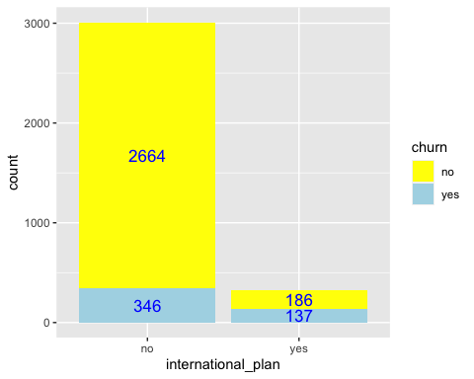

churn_true %>%  
 group_by(international_plan) %>%  
 select(international_plan) %>%  
 dplyr:: summarise("Churn Count" =n(), "Percent" = n()/483)

## # A tibble: 2 × 3  
## international_plan `Churn Count` Percent  
## <fct> <int> <dbl>  
## 1 no 346 0.716  
## 2 yes 137 0.284

The results depict the percentage of customers who are a part of the international plan and have moved to another provider i.e. 28% of the customers are likely to churn.

#Determining the customers who churned based on the number of customer service calls.

ggplot(churn.train_data) +  
 aes(x = churn, y = number_customer_service_calls, fill = churn) +  
 geom_boxplot(shape = "circle") +  
 scale_fill_manual(breaks = churn.train_data$churn,  
 values = c("yellow", "light blue"))+  
 labs(title = "CHURN DATA FOR NUMBER OF CUSTOMER SERVICE CALLS") +  
 theme_light() +  
 theme(plot.title = element_text(size = 14L, face = "bold", hjust = 0.5))

## Warning: Removed 200 rows containing non-finite values (stat_boxplot).

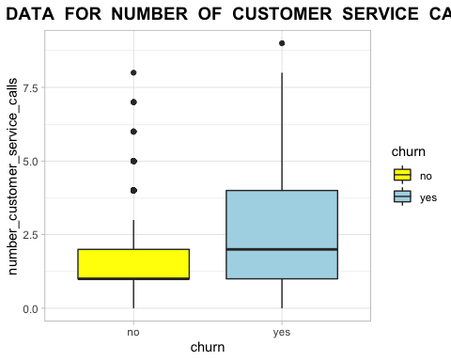

churn_true %>%filter(number_customer_service_calls >= 1 & number_customer_service_calls <= 4) %>%tally()/483

## n  
## 1 0.6397516

The box plot above depicts that the customers who have reached out to the customer services more than 2-4 times are likely to move to other providers. We can interpret that the customers who have churned are approximately 64% and the reason being, them reaching out to the customer service 1-4 times.

#Data Cleaning

#Sorting and imputing the missing values using mice package.   
set.seed(111)  
#As per mice, total_night_charge and total_intl_charge are multi-collinear variables.  
#Therefore mice will not impute missing values for these columns.  
churn.train_data$total_night_charge[1] <- 2  
churn.train_data$total_intl_charge[1] <- 0.5  
mice_model <- mice(churn.train_data[, -20], method="rf")

##   
## iter imp variable  
## 1 1 account_length number_vmail_messages total_day_minutes total_day_calls total_day_charge total_eve_minutes total_eve_calls total_eve_charge total_night_minutes total_night_charge total_intl_minutes total_intl_calls total_intl_charge number_customer_service_calls  
## 1 2 account_length number_vmail_messages total_day_minutes total_day_calls total_day_charge total_eve_minutes total_eve_calls total_eve_charge total_night_minutes total_night_charge total_intl_minutes total_intl_calls total_intl_charge number_customer_service_calls  
## 1 3 account_length number_vmail_messages total_day_minutes total_day_calls total_day_charge total_eve_minutes total_eve_calls total_eve_charge total_night_minutes total_night_charge total_intl_minutes total_intl_calls total_intl_charge number_customer_service_calls  
## 1 4 account_length number_vmail_messages total_day_minutes total_day_calls total_day_charge total_eve_minutes total_eve_calls total_eve_charge total_night_minutes total_night_charge total_intl_minutes total_intl_calls total_intl_charge number_customer_service_calls  
## 1 5 account_length number_vmail_messages total_day_minutes total_day_calls total_day_charge total_eve_minutes total_eve_calls total_eve_charge total_night_minutes total_night_charge total_intl_minutes total_intl_calls total_intl_charge number_customer_service_calls  
## 2 1 account_length number_vmail_messages total_day_minutes total_day_calls total_day_charge total_eve_minutes total_eve_calls total_eve_charge total_night_minutes total_night_charge total_intl_minutes total_intl_calls total_intl_charge number_customer_service_calls  
## 2 2 account_length number_vmail_messages total_day_minutes total_day_calls total_day_charge total_eve_minutes total_eve_calls total_eve_charge total_night_minutes total_night_charge total_intl_minutes total_intl_calls total_intl_charge number_customer_service_calls  
## 2 3 account_length number_vmail_messages total_day_minutes total_day_calls total_day_charge total_eve_minutes total_eve_calls total_eve_charge total_night_minutes total_night_charge total_intl_minutes total_intl_calls total_intl_charge number_customer_service_calls  
## 2 4 account_length number_vmail_messages total_day_minutes total_day_calls total_day_charge total_eve_minutes total_eve_calls total_eve_charge total_night_minutes total_night_charge total_intl_minutes total_intl_calls total_intl_charge number_customer_service_calls  
## 2 5 account_length number_vmail_messages total_day_minutes total_day_calls total_day_charge total_eve_minutes total_eve_calls total_eve_charge total_night_minutes total_night_charge total_intl_minutes total_intl_calls total_intl_charge number_customer_service_calls  
## 3 1 account_length number_vmail_messages total_day_minutes total_day_calls total_day_charge total_eve_minutes total_eve_calls total_eve_charge total_night_minutes total_night_charge total_intl_minutes total_intl_calls total_intl_charge number_customer_service_calls  
## 3 2 account_length number_vmail_messages total_day_minutes total_day_calls total_day_charge total_eve_minutes total_eve_calls total_eve_charge total_night_minutes total_night_charge total_intl_minutes total_intl_calls total_intl_charge number_customer_service_calls  
## 3 3 account_length number_vmail_messages total_day_minutes total_day_calls total_day_charge total_eve_minutes total_eve_calls total_eve_charge total_night_minutes total_night_charge total_intl_minutes total_intl_calls total_intl_charge number_customer_service_calls  
## 3 4 account_length number_vmail_messages total_day_minutes total_day_calls total_day_charge total_eve_minutes total_eve_calls total_eve_charge total_night_minutes total_night_charge total_intl_minutes total_intl_calls total_intl_charge number_customer_service_calls  
## 3 5 account_length number_vmail_messages total_day_minutes total_day_calls total_day_charge total_eve_minutes total_eve_calls total_eve_charge total_night_minutes total_night_charge total_intl_minutes total_intl_calls total_intl_charge number_customer_service_calls  
## 4 1 account_length number_vmail_messages total_day_minutes total_day_calls total_day_charge total_eve_minutes total_eve_calls total_eve_charge total_night_minutes total_night_charge total_intl_minutes total_intl_calls total_intl_charge number_customer_service_calls  
## 4 2 account_length number_vmail_messages total_day_minutes total_day_calls total_day_charge total_eve_minutes total_eve_calls total_eve_charge total_night_minutes total_night_charge total_intl_minutes total_intl_calls total_intl_charge number_customer_service_calls  
## 4 3 account_length number_vmail_messages total_day_minutes total_day_calls total_day_charge total_eve_minutes total_eve_calls total_eve_charge total_night_minutes total_night_charge total_intl_minutes total_intl_calls total_intl_charge number_customer_service_calls  
## 4 4 account_length number_vmail_messages total_day_minutes total_day_calls total_day_charge total_eve_minutes total_eve_calls total_eve_charge total_night_minutes total_night_charge total_intl_minutes total_intl_calls total_intl_charge number_customer_service_calls  
## 4 5 account_length number_vmail_messages total_day_minutes total_day_calls total_day_charge total_eve_minutes total_eve_calls total_eve_charge total_night_minutes total_night_charge total_intl_minutes total_intl_calls total_intl_charge number_customer_service_calls  
## 5 1 account_length number_vmail_messages total_day_minutes total_day_calls total_day_charge total_eve_minutes total_eve_calls total_eve_charge total_night_minutes total_night_charge total_intl_minutes total_intl_calls total_intl_charge number_customer_service_calls  
## 5 2 account_length number_vmail_messages total_day_minutes total_day_calls total_day_charge total_eve_minutes total_eve_calls total_eve_charge total_night_minutes total_night_charge total_intl_minutes total_intl_calls total_intl_charge number_customer_service_calls  
## 5 3 account_length number_vmail_messages total_day_minutes total_day_calls total_day_charge total_eve_minutes total_eve_calls total_eve_charge total_night_minutes total_night_charge total_intl_minutes total_intl_calls total_intl_charge number_customer_service_calls  
## 5 4 account_length number_vmail_messages total_day_minutes total_day_calls total_day_charge total_eve_minutes total_eve_calls total_eve_charge total_night_minutes total_night_charge total_intl_minutes total_intl_calls total_intl_charge number_customer_service_calls  
## 5 5 account_length number_vmail_messages total_day_minutes total_day_calls total_day_charge total_eve_minutes total_eve_calls total_eve_charge total_night_minutes total_night_charge total_intl_minutes total_intl_calls total_intl_charge number_customer_service_calls

## Warning: Number of logged events: 350

#mice imputation using random forests.  
mice_output <- complete(mice_model)   
# Generating the complete data.  
anyNA(mice_output)

## [1] FALSE

churn.train_data_imputed <- mutate(mice_output,churn=churn.train_data$churn)  
summary(churn.train_data)

## state account_length area_code international_plan  
## WV : 106 Min. :-209.00 area_code_408: 838 no :3010   
## MN : 84 1st Qu.: 72.00 area_code_415:1655 yes: 323   
## NY : 83 Median : 100.00 area_code_510: 840   
## AL : 80 Mean : 97.32   
## OH : 78 3rd Qu.: 127.00   
## OR : 78 Max. : 243.00   
## (Other):2824 NA's :501   
## voice_mail_plan number_vmail_messages total_day_minutes total_day_calls  
## no :2411 Min. :-10.000 Min. : 0.0 Min. : 0.0   
## yes: 922 1st Qu.: 0.000 1st Qu.: 149.3 1st Qu.: 87.0   
## Median : 0.000 Median : 190.5 Median :101.0   
## Mean : 7.333 Mean : 418.9 Mean :100.3   
## 3rd Qu.: 16.000 3rd Qu.: 237.8 3rd Qu.:114.0   
## Max. : 51.000 Max. :2185.1 Max. :165.0   
## NA's :200 NA's :200 NA's :200   
## total_day_charge total_eve_minutes total_eve_calls total_eve_charge  
## Min. : 0.00 Min. : 0.0 Min. : 0.0 Min. : 0.00   
## 1st Qu.:24.45 1st Qu.: 170.5 1st Qu.: 87.0 1st Qu.:14.14   
## Median :30.65 Median : 209.9 Median :100.0 Median :17.09   
## Mean :30.63 Mean : 324.3 Mean :100.1 Mean :17.08   
## 3rd Qu.:36.84 3rd Qu.: 257.6 3rd Qu.:114.0 3rd Qu.:20.00   
## Max. :59.64 Max. :1244.2 Max. :170.0 Max. :30.91   
## NA's :200 NA's :301 NA's :200 NA's :200   
## total_night_minutes total_night_calls total_night_charge total_intl_minutes  
## Min. : 23.2 Min. : 33.0 Min. : 1.040 Min. : 0.00   
## 1st Qu.:167.3 1st Qu.: 87.0 1st Qu.: 7.530 1st Qu.: 8.50   
## Median :201.4 Median :100.0 Median : 9.060 Median :10.30   
## Mean :201.2 Mean :100.1 Mean : 9.051 Mean :10.23   
## 3rd Qu.:235.3 3rd Qu.:113.0 3rd Qu.:10.590 3rd Qu.:12.10   
## Max. :395.0 Max. :175.0 Max. :17.770 Max. :20.00   
## NA's :200 NA's :200 NA's :200   
## total_intl_calls total_intl_charge number_customer_service_calls churn   
## Min. : 0.00 Min. :0.000 Min. :0.000 no :2850   
## 1st Qu.: 3.00 1st Qu.:2.300 1st Qu.:1.000 yes: 483   
## Median : 4.00 Median :2.780 Median :1.000   
## Mean : 4.47 Mean :2.761 Mean :1.561   
## 3rd Qu.: 6.00 3rd Qu.:3.270 3rd Qu.:2.000   
## Max. :20.00 Max. :5.400 Max. :9.000   
## NA's :301 NA's :200 NA's :200

str(churn.train_data)

## 'data.frame': 3333 obs. of 20 variables:  
## $ state : Factor w/ 51 levels "AK","AL","AR",..: 34 12 8 12 36 25 28 39 13 16 ...  
## $ account_length : int 125 108 82 NA 83 89 135 28 86 65 ...  
## $ area_code : Factor w/ 3 levels "area_code_408",..: 3 2 2 1 2 2 2 2 1 2 ...  
## $ international_plan : Factor w/ 2 levels "no","yes": 1 1 1 1 1 1 1 1 1 1 ...  
## $ voice_mail_plan : Factor w/ 2 levels "no","yes": 1 1 1 2 1 1 1 1 1 1 ...  
## $ number_vmail_messages : int 0 0 0 30 0 0 0 0 0 0 ...  
## $ total_day_minutes : num 2013 292 300 110 337 ...  
## $ total_day_calls : int 99 99 109 71 120 81 81 87 115 137 ...  
## $ total_day_charge : num 28.7 49.6 51 18.8 57.4 ...  
## $ total_eve_minutes : num 1108 221 181 182 227 ...  
## $ total_eve_calls : int 107 93 100 108 116 74 114 92 112 83 ...  
## $ total_eve_charge : num 14.9 18.8 15.4 15.5 19.3 ...  
## $ total_night_minutes : num 243 229 270 184 154 ...  
## $ total_night_calls : int 92 110 73 88 114 120 82 112 95 111 ...  
## $ total_night_charge : num 2 10.31 12.15 8.27 6.93 ...  
## $ total_intl_minutes : num 10.9 14 11.7 11 15.8 9.1 10.3 10.1 9.8 12.7 ...  
## $ total_intl_calls : int 7 9 4 8 7 4 6 3 7 6 ...  
## $ total_intl_charge : num 0.5 3.78 3.16 2.97 4.27 2.46 2.78 2.73 2.65 3.43 ...  
## $ number_customer_service_calls: int 0 2 0 2 0 1 1 3 2 4 ...  
## $ churn : Factor w/ 2 levels "no","yes": 1 2 2 1 2 1 1 1 1 2 ...

churn_yes<-churn.train_data_imputed %>% filter(churn=='yes')  
correlation_churn_cust<- cor(churn_yes[, 6:19])

#We will be using ggplot to represent the correlation between the variables where churn is equal to yes.

ggcorrplot(correlation_churn_cust, method = "square", type = "lower", ggtheme = theme_linedraw)

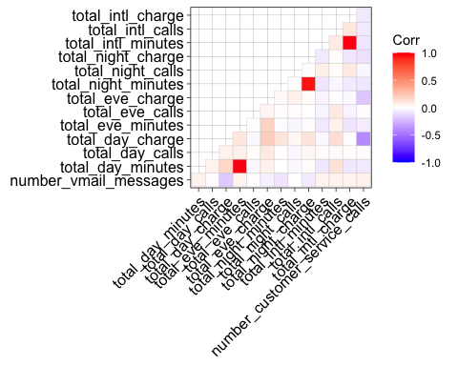 As per the ggplot, it can be depicted that for the people who have churned, there lies a significant negative correlation between total_day_charge and the number of customer_ service_calls and also total_international_charges and total_evening_charges. The statistics show that customer service calls have a greater churn rate than other calls since the charges are higher.

#Prediction Model Selection Using a predictive model based on regression and decision tree models. It is possible to demonstrate the influence of various variables and the importance of each in foreseeing the outcome of the dependent variable.

A logistic regression model is preferred to others since the dependent variable (target variable) in this data is categorical and also classification being our prime objective . While in a linear regression model, performance probability may be negative or more than 1, making it ineffective for predicting a binomial feature. The best result for this model is a likelihood of possibilities that falls between 0 and 1 i.e. logistic regression.

For our analysis we will be using both the models and select the best among the two to be the final model. Using Logistic Regression and Decision Tree Models to determine Predictive Ability: Before choosing a model, the following procedures were followed: - The dataset has been divided into training and validation sets to prevent overfitting the model. -Constructing a logistic regression model and forecasting the outcomes from the validation set. -Using a confusion matrix to confirm the validity of the model. -Making a decision tree model and predict the results of the validation set. -Validating the model’s performance with a confusion matrix. -Considering the results of both models and selecting the best one.

#Data Partitioning

set.seed(111)  
index<- createDataPartition(churn.train_data_imputed $churn,p=0.8,list=FALSE)  
train_data<-churn.train_data_imputed [index,]  
valid_data <- churn.train_data_imputed [-index,]

#Building a Logistic Regression model:- Logistic regression is a statistical analytic approach for predicting a binary outcome, such as yes or no.

set.seed(222)  
log_model <- glm(churn~.,data=train_data ,family = "binomial" ) #summary(Logistic Model)  
predict_valid<-predict(log_model,valid_data,type="response")  
head(predict_valid)

## 10 21 28 34 39 40   
## 0.16572725 0.07577522 0.05251576 0.02260023 0.22631119 0.02431119

result_check<-ifelse(predict_valid > 0.5,'yes','no')  
#Accuracy Check  
error<-mean(result_check!=valid_data$churn)  
accuracy <-1- error  
print(accuracy)

## [1] 0.8468468

plot.roc(valid_data$churn,predict_valid)

## Setting levels: control = no, case = yes

## Setting direction: controls < cases

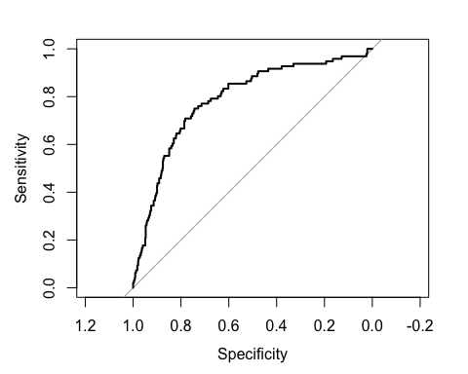 #Using confusion matrix for the logistic regression model.

set.seed(333)  
log_confusion_matrix <- confusionMatrix(as.factor(result_check),as.factor(valid_data$churn))  
log_confusion_matrix

## Confusion Matrix and Statistics  
##   
## Reference  
## Prediction no yes  
## no 549 81  
## yes 21 15  
##   
## Accuracy : 0.8468   
## 95% CI : (0.8172, 0.8734)  
## No Information Rate : 0.8559   
## P-Value [Acc > NIR] : 0.7653   
##   
## Kappa : 0.1613   
##   
## Mcnemar's Test P-Value : 5.162e-09   
##   
## Sensitivity : 0.9632   
## Specificity : 0.1562   
## Pos Pred Value : 0.8714   
## Neg Pred Value : 0.4167   
## Prevalence : 0.8559   
## Detection Rate : 0.8243   
## Detection Prevalence : 0.9459   
## Balanced Accuracy : 0.5597   
##   
## 'Positive' Class : no   
##

Results produced from the confusion matrix :- #1.Accuracy :- 84.68% #2. Sensitivity :- 96.32% #3. Specificity:- 15.62%

#Building a Decision Tree Model Decision tree analysis is basically producing a tree-shaped diagram to chart out a course of action or a statistical probability analysis.

set.seed(444)  
decisiontree_model<- rpart(churn ~ .,data=train_data,method = 'class')  
# Show the variable importance  
#DT_model$variable.importance  
# Show the split for variable  
head(decisiontree_model$splits)

## count ncat improve index adj  
## total_day_charge 2667 -1 78.51181 44.975 0  
## number_customer_service_calls 2667 -1 57.34523 3.500 0  
## international_plan 2667 2 37.82693 1.000 0  
## total_day_minutes 2667 -1 22.37794 263.600 0  
## state 2667 51 15.22592 2.000 0  
## number_customer_service_calls 2485 -1 59.34436 3.500 0

#Predicting the probability  
prob_decisiontree <- predict(decisiontree_model, newdata = valid_data, type = "prob")  
#determining AUC Value  
roc(valid_data$churn,prob_decisiontree[,2])

## Setting levels: control = no, case = yes

## Setting direction: controls < cases

##   
## Call:  
## roc.default(response = valid_data$churn, predictor = prob_decisiontree[, 2])  
##   
## Data: prob_decisiontree[, 2] in 570 controls (valid_data$churn no) < 96 cases (valid_data$churn yes).  
## Area under the curve: 0.8234

Using a Confusion Matrix for the Decision Tree Model.

set.seed(555)  
decisiontree_class<- predict(decisiontree_model, newdata = valid_data, type = "class")  
confusionMatrix(as.factor(decisiontree_class),as.factor(valid_data$churn))

## Confusion Matrix and Statistics  
##   
## Reference  
## Prediction no yes  
## no 555 42  
## yes 15 54  
##   
## Accuracy : 0.9144   
## 95% CI : (0.8905, 0.9345)  
## No Information Rate : 0.8559   
## P-Value [Acc > NIR] : 3.035e-06   
##   
## Kappa : 0.6072   
##   
## Mcnemar's Test P-Value : 0.0005736   
##   
## Sensitivity : 0.9737   
## Specificity : 0.5625   
## Pos Pred Value : 0.9296   
## Neg Pred Value : 0.7826   
## Prevalence : 0.8559   
## Detection Rate : 0.8333   
## Detection Prevalence : 0.8964   
## Balanced Accuracy : 0.7681   
##   
## 'Positive' Class : no   
##

From the Confusion Matrix, the following conclusions have been made :- #1. Accuracy :- 91.44% #2. Sensitivity :- 97.37% #3. Specificity:- 56.25%

#Choosing the optimal model

On the comparison of the two models, Decision Tree Model is interpreted the best model to put in use as it has higher accuracy than the logistical regression model.

Though the Sensitivities of both the models are almost equal, Decision Tree has a higher specificity. Therefore, Decision Tree Model is the right and optimal model to use.

#Predicting the churn using the test data and the decision tree algorithm for the final model analysis.

# After the accuracy has been tested for the validation and training data we can use the entire data to build the final model. Actual dataset can be used to predict the churn only after testing for accuracy.  
set.seed(666)  
ABC_model<- rpart(churn ~ .,data= churn.train_data_imputed,method = 'class')

#Model Splits.  
head(ABC_model$splits)

## count ncat improve index adj  
## total_day_charge 3333 -1 88.13813 44.975 0  
## number_customer_service_calls 3333 -1 68.18448 3.500 0  
## international_plan 3333 2 55.77483 1.000 0  
## total_day_minutes 3333 -1 26.21947 223.250 0  
## state 3333 51 14.95004 2.000 0  
## number_customer_service_calls 3116 -1 71.09667 3.500 0

#Plotting Decision Tree  
fancyRpartPlot(ABC_model)

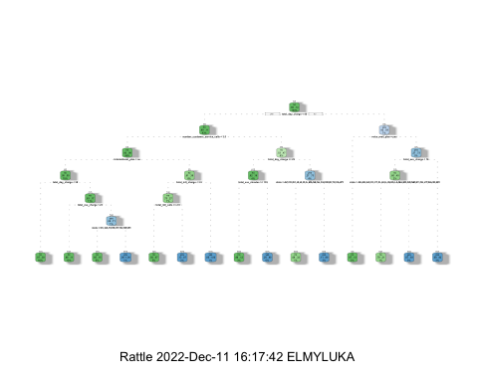

rpart.plot(ABC_model, cex=0.5)

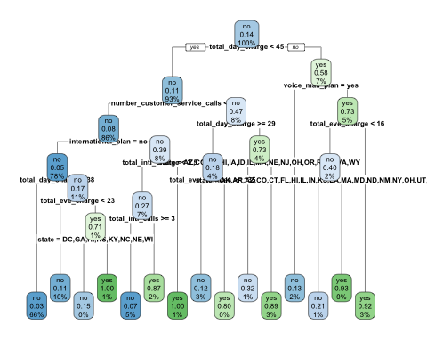

#Probability Prediction(decision tree)  
decisiontree_prob <- predict(ABC_model, newdata = churn.train_data_imputed, type = "prob")  
#Determining the AUC Value  
roc(churn.train_data_imputed$churn,decisiontree_prob[,2])

## Setting levels: control = no, case = yes

## Setting direction: controls < cases

##   
## Call:  
## roc.default(response = churn.train_data_imputed$churn, predictor = decisiontree_prob[, 2])  
##   
## Data: decisiontree_prob[, 2] in 2850 controls (churn.train_data_imputed$churn no) < 483 cases (churn.train_data_imputed$churn yes).  
## Area under the curve: 0.8879

#Prediction of the Test Data

set.seed(777)  
load("~/Desktop/MS BA/Business Analytics/Assignment-4/Customers_To_Predict.RData")  
  
count(Customers_To_Predict)

## # A tibble: 1 × 1  
## n  
## <int>  
## 1 1600

summary(Customers_To_Predict)

## state account_length area_code international_plan  
## Length:1600 Min. : 1.00 Length:1600 Length:1600   
## Class :character 1st Qu.: 71.00 Class :character Class :character   
## Mode :character Median : 98.00 Mode :character Mode :character   
## Mean : 98.52   
## 3rd Qu.:126.00   
## Max. :238.00   
## voice_mail_plan number_vmail_messages total_day_minutes total_day_calls   
## Length:1600 Min. : 0.000 Min. : 6.6 Min. : 34.00   
## Class :character 1st Qu.: 0.000 1st Qu.:143.8 1st Qu.: 86.00   
## Mode :character Median : 0.000 Median :180.9 Median : 99.00   
## Mean : 7.043 Mean :181.6 Mean : 99.06   
## 3rd Qu.: 0.000 3rd Qu.:215.9 3rd Qu.:112.00   
## Max. :52.000 Max. :351.5 Max. :160.00   
## total_day_charge total_eve_minutes total_eve_calls total_eve_charge  
## Min. : 1.12 Min. : 22.3 Min. : 38.0 Min. : 1.90   
## 1st Qu.:24.45 1st Qu.:165.8 1st Qu.: 88.0 1st Qu.:14.10   
## Median :30.76 Median :199.9 Median :101.0 Median :17.00   
## Mean :30.87 Mean :199.6 Mean :100.6 Mean :16.96   
## 3rd Qu.:36.70 3rd Qu.:231.8 3rd Qu.:114.0 3rd Qu.:19.70   
## Max. :59.76 Max. :359.3 Max. :169.0 Max. :30.54   
## total_night_minutes total_night_calls total_night_charge total_intl_minutes  
## Min. : 0.0 Min. : 0.00 Min. : 0.000 Min. : 0.00   
## 1st Qu.:166.6 1st Qu.: 86.00 1st Qu.: 7.500 1st Qu.: 8.60   
## Median :199.2 Median : 99.00 Median : 8.960 Median :10.40   
## Mean :199.2 Mean : 99.45 Mean : 8.963 Mean :10.32   
## 3rd Qu.:232.4 3rd Qu.:113.00 3rd Qu.:10.463 3rd Qu.:12.00   
## Max. :381.6 Max. :170.00 Max. :17.170 Max. :19.70   
## total_intl_calls total_intl_charge number_customer_service_calls  
## Min. : 0.000 Min. :0.000 Min. :0.000   
## 1st Qu.: 3.000 1st Qu.:2.320 1st Qu.:1.000   
## Median : 4.000 Median :2.810 Median :1.000   
## Mean : 4.356 Mean :2.786 Mean :1.583   
## 3rd Qu.: 5.000 3rd Qu.:3.240 3rd Qu.:2.000   
## Max. :19.000 Max. :5.320 Max. :7.000

#Checking NA Values  
colMeans(is.na(Customers_To_Predict))

## state account_length   
## 0 0   
## area_code international_plan   
## 0 0   
## voice_mail_plan number_vmail_messages   
## 0 0   
## total_day_minutes total_day_calls   
## 0 0   
## total_day_charge total_eve_minutes   
## 0 0   
## total_eve_calls total_eve_charge   
## 0 0   
## total_night_minutes total_night_calls   
## 0 0   
## total_night_charge total_intl_minutes   
## 0 0   
## total_intl_calls total_intl_charge   
## 0 0   
## number_customer_service_calls   
## 0

prob_churn <- predict(ABC_model,Customers_To_Predict,type = "prob")  
head(prob_churn)

## no yes  
## 1 0.9683973 0.03160271  
## 2 0.9683973 0.03160271  
## 3 0.9683973 0.03160271  
## 4 0.9289941 0.07100592  
## 5 0.9683973 0.03160271  
## 6 0.6756757 0.32432432

predict_churn <- predict(ABC_model,Customers_To_Predict,type = "class")  
head(predict_churn)

## 1 2 3 4 5 6   
## no no no no no no   
## Levels: no yes

predict_churn<- as.data.frame(predict_churn)  
summary(predict_churn)

## predict_churn  
## no :1460   
## yes: 140

ggplot(predict_churn) +  
 aes(x = predict_churn) +  
 geom_bar(fill = "red")+  
 labs(x = "Customers Not Churning/Churning",  
 y = "Number of Customers", title = "Number of Customers likely to Churn") +  
 theme_minimal() +  
 theme(plot.title = element_text(size = 14L,  
 face = "bold", hjust = 0.5), axis.title.y = element_text(size = 14L, face = "bold"), axis.title.x = element_text(size = 14L,face = "bold"))

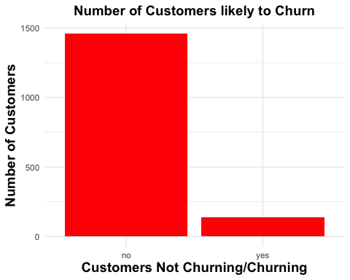

#From the above graph the following has been depicted.

Predict_Churn :- No :- 1460 Yes :- 140

#From the analysis of the data,the following are the conclusions:- #- Customers are more inclined to switch to another provider if they have paid more than $30 in daily fees. #- Customers will undoubtedly go to another supplier if they have to pay international day charges. This is evident from the data above, which indicates that about 28% of clients left the company. #-The results show that the company has dissatisfactory customers, and it is because of these results that we have concluded that customers who have called customer service 2-4 times have left the company. #-States with a higher rate of churn include Maryland, New Jersey, Michigan, and Texas.

#Recommendations to reduce customer Churn rate :- #- Enhancing client satisfaction through action. #- Using a competitive pricing strategy. #- In the states with a higher churn rate, conducting a thorough market analysis.