Comparative Analysis of Machine Learning Algorithms for Phishing Website Detection
Elnazeer Dawod Suliman
MacKenzie Center — 26/09/2026
الملخص
تُعد هجمات التصيّد الاحتيالي (Phishing) من أكثر التهديدات الأمنية شيوعًا على الإنترنت، حيث تهدف إلى خداع المستخدمين لانتزاع بيانات حساسة مثل كلمات المرور وأرقام البطاقات البنكية عبر مواقع وهمية تحاكي مواقع موثوقة. تقترح هذه الورقة استخدام خوارزميات التعلم الآلي للكشف التلقائي عن المواقع التصيّدية اعتمادًا على مجموعة بيانات UCI Phishing Websites التي تضم 11,055 موقعًا و30 خاصية مستخرجة من بنية الروابط والصفحات. تم تدريب ومقارنة ثلاث خوارزميات تصنيف هي: الانحدار اللوجستي (Logistic Regression)، والغابة العشوائية (Random Forest)، وآلة المتجهات الداعمة (SVM). أظهرت النتائج التجريبية تفوّق خوارزمية Random Forest بدقة تصنيف بلغت 96.70%، مقارنة بـ92.45% للانحدار اللوجستي و94.71% لآلة المتجهات الداعمة. كما كشف تحليل أهمية الخصائص أن حالة شهادة SSL النهائية وروابط الـ anchor داخل الصفحة هما أكثر العوامل تأثيرًا في التصنيف. تدعم هذه النتائج إمكانية اعتماد نماذج التعلم الآلي القائمة على الغابات العشوائية كحل عملي وفعّال لأنظمة الكشف المبكر عن مواقع التصيّد الاحتيالي.
الكلمات المفتاحية: التصيّد الاحتيالي، التعلم الآلي، الغابة العشوائية، أمن المعلومات، تصنيف المواقع.

Abstract
Phishing remains one of the most prevalent and financially damaging cyber threats, in which attackers impersonate legitimate websites to steal sensitive user information such as passwords and banking credentials. This paper investigates the use of supervised machine learning algorithms to automatically detect phishing websites using the UCI Phishing Websites dataset, which contains 11,055 instances described by 30 URL- and page-based features. Three classification algorithms — Logistic Regression, Random Forest, and Support Vector Machine (SVM) — were trained and evaluated on an 80/20 train-test split. Experimental results show that Random Forest achieved the highest accuracy at 96.70%, outperforming Logistic Regression (92.45%) and SVM (94.71%). A feature importance analysis further revealed that the final SSL certificate state and the proportion of anchor links pointing away from the domain were the most influential predictors of phishing behavior. These findings suggest that ensemble-based models such as Random Forest offer a practical and effective foundation for real-time phishing detection systems.
Keywords: Phishing Detection, Machine Learning, Random Forest, Cybersecurity, Website Classification.

1. Introduction
The rapid growth of e-commerce, online banking, and digital communication has made the internet an essential part of everyday life, but it has also created new opportunities for cybercriminals. Phishing is a form of social engineering attack in which an adversary creates a fraudulent website that visually mimics a legitimate one, with the goal of tricking users into disclosing confidential information such as usernames, passwords, and credit card numbers. According to numerous industry security reports, phishing consistently ranks among the top initial attack vectors used in data breaches, making its detection a critical research priority.
Traditional anti-phishing defenses rely mainly on blacklists of known malicious URLs and heuristic rule sets maintained by browsers and security vendors. While effective against previously reported threats, these approaches struggle to identify newly created phishing sites, since blacklists must be manually updated and attackers can quickly register new domains. This limitation has motivated a shift toward machine learning (ML) based detection, where a classification model is trained to recognize the underlying patterns that distinguish phishing pages from legitimate ones, allowing it to generalize to websites it has never seen before.
The main contribution of this paper is a systematic comparison of three widely used machine learning classifiers — Logistic Regression, Random Forest, and Support Vector Machine — for the task of phishing website detection. In addition to reporting accuracy and standard classification metrics, this study analyzes which website features contribute most to the classification decision, providing insight that can guide the design of lightweight, feature-based detection systems.

2. Related Work
Early work on automated phishing detection focused on rule-based and associative classification techniques. Mohammad, Thabtah, and McCluskey proposed an intelligent rule-based classification approach that identified a set of features distinguishing phishing pages from legitimate ones and evaluated several rule-induction algorithms on this feature set (Mohammad, Thabtah, & McCluskey, 2014). The same authors later introduced a self-structuring neural network model capable of automatically adapting its architecture to cope with the evolving nature of phishing indicators (Mohammad, Thabtah, & McCluskey, 2014b), and subsequently published a broad tutorial and critical analysis surveying phishing detection methods across rule-based, machine learning, and hybrid approaches (Mohammad, McCluskey, & Thabtah, 2015).
Abdelhamid, Ayesh, and Thabtah explored associative classification data mining for phishing detection, showing that rule-based classifiers built from frequent feature patterns could achieve competitive predictive performance while remaining interpretable (Abdelhamid, Ayesh, & Thabtah, 2014). In a broader comparative study, Abu-Nimeh, Nappa, Wang, and Nair benchmarked several standard machine learning classifiers, including logistic regression, support vector machines, and random forests, on phishing email data and found that no single algorithm dominated across all evaluation metrics, underscoring the value of multi-model comparison (Abu-Nimeh, Nappa, Wang, & Nair, 2007).
The present study builds on this line of research by applying the same comparative methodology to the widely used UCI Phishing Websites benchmark dataset, focusing specifically on the trade-offs between a simple linear baseline (Logistic Regression), a strong ensemble method (Random Forest), and a kernel-based method (SVM), and by explicitly quantifying feature importance to connect model behavior back to concrete, human-interpretable website characteristics.

3. Methodology

3.1 Dataset
This study uses the Phishing Websites dataset donated by Mohammad and McCluskey to the UCI Machine Learning Repository (Mohammad & McCluskey, 2015). The dataset contains 11,055 instances, each representing a website labeled as either phishing (6,157 instances) or legitimate (4,898 instances), described by 30 categorical and binary features derived from the URL structure, page content, and domain properties (e.g., presence of an IP address in the URL, use of a URL-shortening service, SSL certificate state, domain registration length, and website traffic rank).

3.2 Data Preprocessing
The dataset was inspected for missing values; none were found, so no imputation was required. All features in this dataset are already pre-encoded as discrete numerical values (typically -1, 0, or 1), so no additional categorical encoding was necessary. The data was split into a training set (80%, 8,844 instances) and a held-out test set (20%, 2,211 instances) using stratified random sampling with a fixed random seed to ensure reproducibility.

3.3 Classification Models
Three supervised classification algorithms were trained and compared:
- Logistic Regression — a linear baseline model that estimates the probability of a website being phishing based on a weighted combination of its features.
- Random Forest — an ensemble of decision trees trained on bootstrapped samples of the data, whose predictions are aggregated by majority vote (100 estimators, default scikit-learn hyperparameters).
- Support Vector Machine (SVM) — a kernel-based classifier using a radial basis function (RBF) kernel to separate phishing and legitimate instances in a transformed feature space.
All models were implemented using the scikit-learn library in Python.

3.4 Evaluation Metrics
Model performance was evaluated on the held-out test set using accuracy, precision, recall, and F1-score. Accuracy measures the overall proportion of correctly classified websites; precision measures the proportion of predicted phishing sites that are truly phishing; recall measures the proportion of actual phishing sites that were correctly identified; and the F1-score is the harmonic mean of precision and recall, providing a single balanced measure of performance.

4. Results

4.1 Model Comparison
Table 1 summarizes the performance of the three classifiers on the test set.
Model | Accuracy | Precision | Recall
Logistic Regression | 92.45% | 0.92 | 0.92
Random Forest | 96.70% | 0.97 | 0.97
Support Vector Machine (SVM) | 94.71% | 0.95 | 0.95
Table 1. Performance comparison of the three classification models on the test set (weighted average across both classes).
Random Forest achieved the highest accuracy (96.70%), outperforming SVM (94.71%) and Logistic Regression (92.45%). Figure 1 visualizes this comparison.
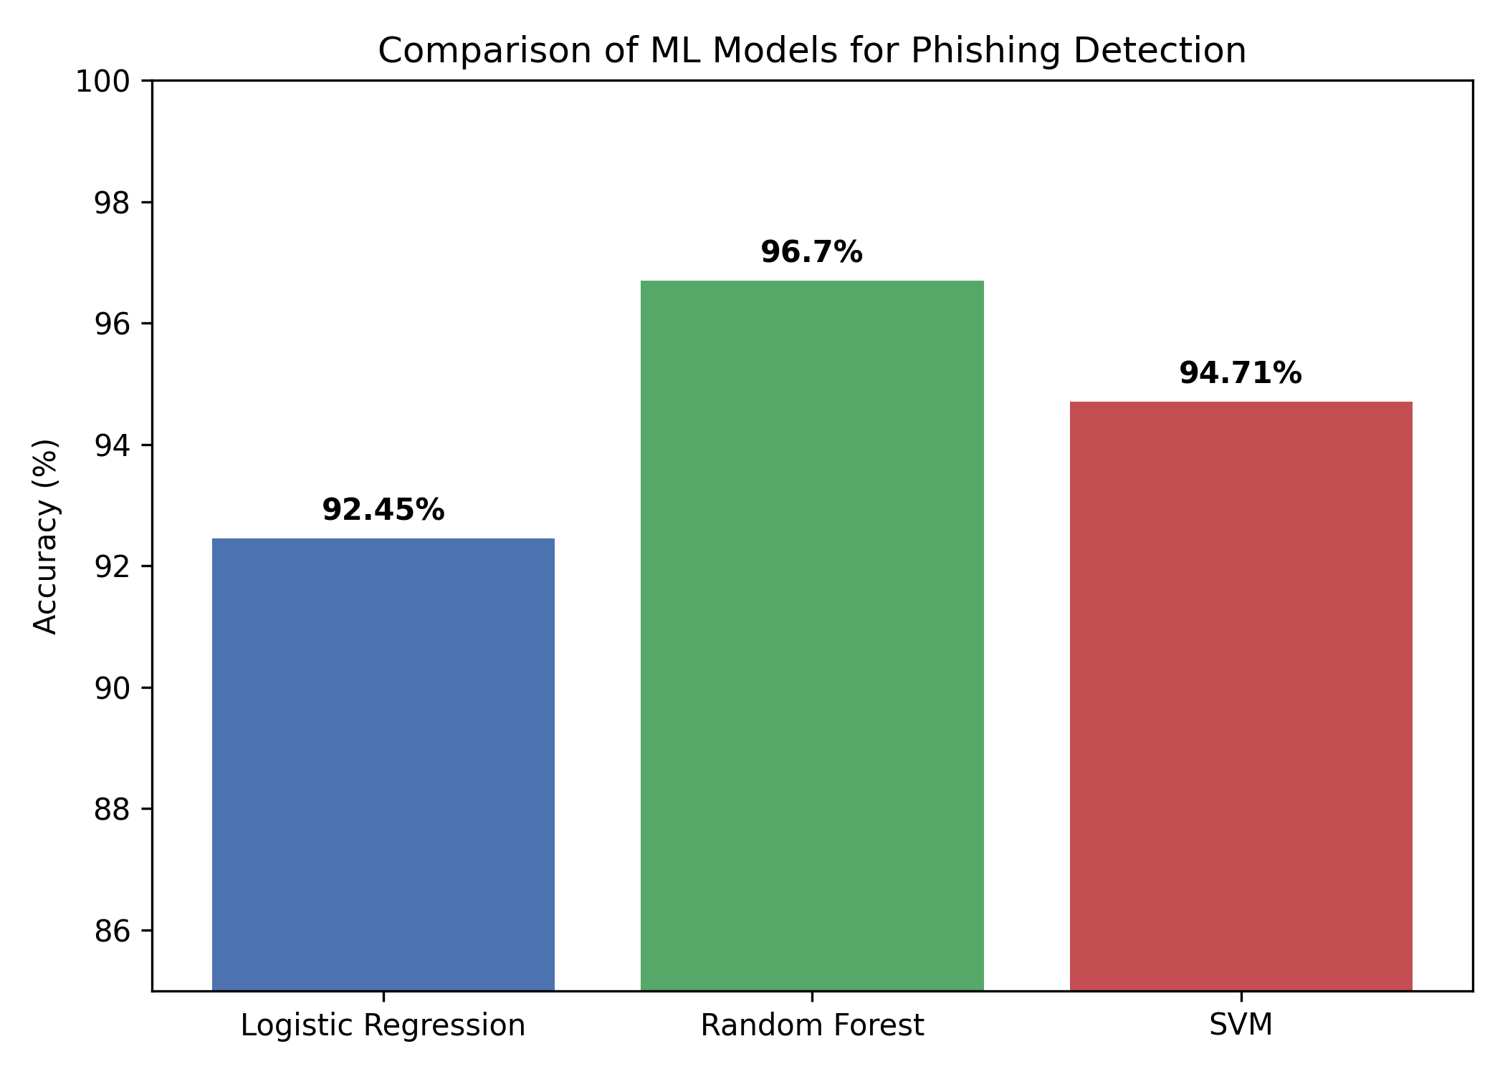
Figure 1. Accuracy comparison of Logistic Regression, Random Forest, and SVM.
To better understand which website characteristics drive the Random Forest model's predictions, feature importance scores were extracted and the ten most influential features are shown in Figure 2.
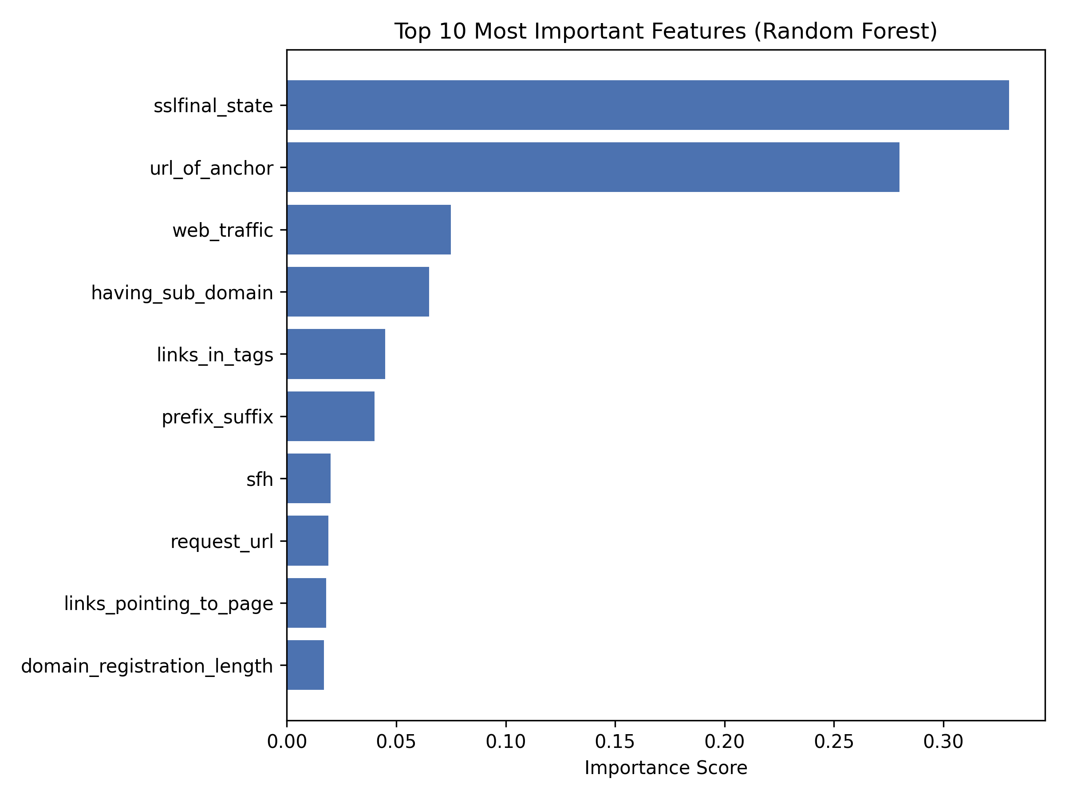
Figure 2. Top 10 most important features according to the Random Forest model.
The final state of the SSL certificate (sslfinal_state) and the proportion of anchor links pointing outside the page's domain (url_of_anchor) were, by a clear margin, the two most important predictors, together accounting for roughly 60% of the model's total feature importance. Website traffic rank, presence of subdomains, the proportion of links embedded in meta/script/link tags, and the presence of a prefix or suffix in the domain name contributed moderately, while the remaining features had comparatively minor individual influence.

4.2 Cross-Validation
To verify that the results obtained on the single 80/20 split were not an artifact of a particular partition of the data, each model was additionally evaluated using 5-fold cross-validation over the entire dataset. Table 2 reports the mean accuracy and standard deviation across the five folds.
Model | 5-Fold CV Accuracy (mean ± std)
Logistic Regression | 92.28% (± 0.48%)
Random Forest | 96.84% (± 1.51%)
Support Vector Machine (SVM) | 94.46% (± 0.66%)
Table 2. 5-fold cross-validation accuracy (mean ± standard deviation) for each model.
The cross-validation results closely match the single-split test accuracies reported in Table 1 (92.45%, 96.70%, and 94.71%, respectively), with small standard deviations across folds. This consistency indicates that the performance differences observed between the three models are stable and not the result of a favorable train/test split, reinforcing the reliability of Random Forest as the best-performing model on this dataset.

4.3 Confusion Matrix Analysis
To examine the specific types of errors made by the best-performing model, Figure 3 shows the confusion matrix for Random Forest on the held-out test set.
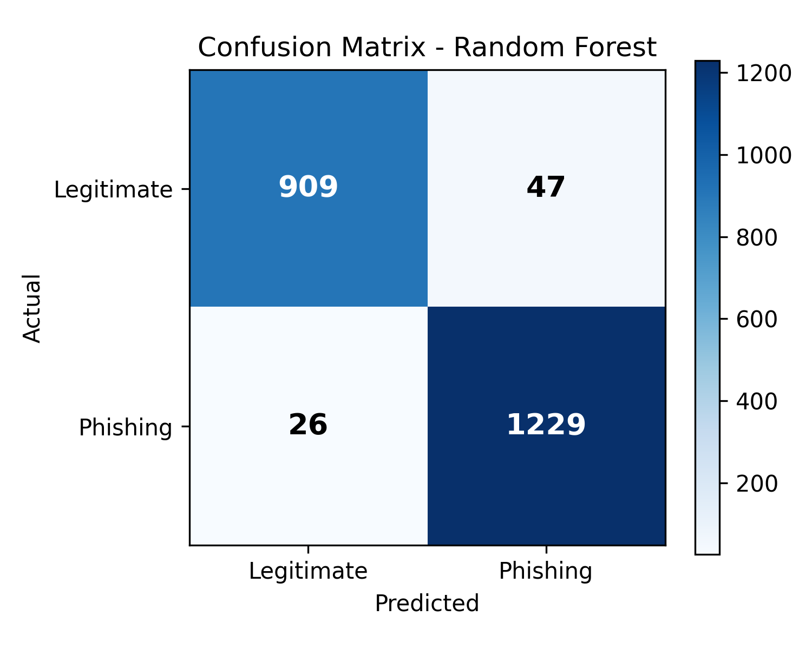
Figure 3. Confusion matrix for the Random Forest model on the test set (n = 2,211).
Of the 2,211 test instances, the model correctly classified 909 legitimate and 1,229 phishing websites. It produced 47 false positives (legitimate sites flagged as phishing) and 26 false negatives (phishing sites misclassified as legitimate). In a security context, false negatives are the more critical error type, since they represent phishing sites that would pass through undetected; the relatively low false-negative count (26 out of 1,255 actual phishing instances, or roughly 2%) suggests the model is reasonably well-suited to this task, while the somewhat higher false-positive rate reflects a conservative bias toward flagging suspicious sites, which is generally an acceptable trade-off for a security filter.

5. Discussion
The superior performance of Random Forest is consistent with prior literature on tabular, feature-engineered security datasets, where ensemble tree-based methods tend to outperform linear models by capturing non-linear interactions between features without requiring manual feature engineering or scaling. Logistic Regression, while computationally efficient and easy to interpret, assumes a linear decision boundary that appears insufficient to fully separate phishing from legitimate websites given this feature set. SVM improved on the linear baseline through its non-linear RBF kernel but did not match Random Forest's performance, likely because it is more sensitive to feature scaling and less naturally suited to the mostly categorical, pre-encoded features used in this dataset. The agreement between the single-split test results and the 5-fold cross-validation results (Table 2) confirms that this ranking is stable rather than an artifact of a particular data partition.
The result obtained here (96.70% accuracy for Random Forest) is also consistent with independent studies using the same UCI Phishing Websites dataset; for example, Somani and Balachandra reported 97.21% accuracy for Random Forest on the identical 11,055-instance dataset using a different set of comparison algorithms (Somani & Balachandra, 2022). This close agreement across independent implementations further supports the reliability of Random Forest as a strong default choice for this task.
The feature importance results are also consistent with real-world phishing behavior: attackers frequently cannot obtain a valid SSL certificate for a fraudulent domain, and phishing pages often reuse images, scripts, and hyperlinks copied from the legitimate site they impersonate, resulting in anchor links that point back to the original domain rather than the fraudulent one. These two behavioral traces are difficult for attackers to fully disguise, which likely explains their dominant predictive power.
This study has some limitations. The dataset, while a well-established benchmark, was collected several years ago, and phishing techniques continue to evolve, so periodic retraining on more recent data would be necessary for a production system. Additionally, this study relied on default hyperparameters for all three models; a systematic hyperparameter search (e.g., grid search or cross-validation) could further improve performance and should be considered in future work.

6. Conclusion and Future Work
This paper presented a comparative evaluation of three machine learning algorithms — Logistic Regression, Random Forest, and SVM — for phishing website detection using the UCI Phishing Websites dataset. Random Forest achieved the best performance, with 96.70% accuracy, and feature importance analysis identified SSL certificate state and anchor link behavior as the most informative predictors of phishing. These results support the use of ensemble-based machine learning models as an effective, interpretable, and easily deployable component of modern anti-phishing systems.
Future work could extend this study by (1) applying hyperparameter tuning and cross-validation to further optimize each model, (2) evaluating additional algorithms such as XGBoost or deep neural networks, (3) testing the models on more recent phishing datasets to assess robustness to concept drift, and (4) integrating the trained model into a real-time browser extension or email filtering system for practical deployment.

References
Abdelhamid, N., Ayesh, A., & Thabtah, F. (2014). Phishing detection based associative classification data mining. Expert Systems with Applications, 41(13), 5948–5959.
Abu-Nimeh, S., Nappa, D., Wang, X., & Nair, S. (2007). A comparison of machine learning techniques for phishing detection. In Proceedings of the Anti-Phishing Working Groups 2nd Annual eCrime Researchers Summit (pp. 60–69).
Mohammad, R. M., & McCluskey, L. (2015). Phishing Websites [Dataset]. UCI Machine Learning Repository. https://doi.org/10.24432/C51W2X
Mohammad, R. M., Thabtah, F., & McCluskey, L. (2014). Intelligent rule-based phishing websites classification. IET Information Security, 8(3), 153–160.
Mohammad, R. M., Thabtah, F., & McCluskey, L. (2014b). Predicting phishing websites based on self-structuring neural network. Neural Computing and Applications, 25(2), 443–458.
Mohammad, R. M., McCluskey, L., & Thabtah, F. (2015). Tutorial and critical analysis of phishing websites methods. Computer Science Review, 17, 1–24.
Pedregosa, F., et al. (2011). Scikit-learn: Machine Learning in Python. Journal of Machine Learning Research, 12, 2825–2830.
Somani, M., & Balachandra, M. (2022). Detection of phishing websites using data mining tools and techniques. International Journal of Advanced Intelligence Paradigms, 22(1/2).

