
Availability Management

Version: | 8.0.00

Table of Contents

1. Mission 3
2. Description 3
2.1 Service Infrastructure Design 4
2.2 Availability Tracking 6
3. Scope 8
4. Roles & Responsibilities 8
5. KPIs 8
6. Owner 9

Mission
The mission of the Availability Management process is to ensure that the duration, and the number, of service outages do not cause the availability or reliability targets of the SLAs to be violated.

Description
The Availability Management process consists of two procedures.

The first procedure is called "Service Infrastructure Design". This procedure is used by availability managers when they design new service infrastructures or when they adjust the design of existing service infrastructures.

The second procedure is called "Availability Tracking". It is used by availability managers when they track the availability and reliability of the services which availability they are responsible for.

A graphical representation of the process is provided below.

Availability Management Process
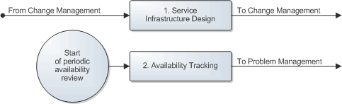

Service Infrastructure Design
A change coordinator requests the design of a new service infrastructure when he/she is planning a change to build a new service infrastructure. Similarly, a change coordinator requests the adjustment of an existing service infrastructure design when he/she believes that an adjustment might be necessary to satisfy the requirements for which he/she is planning the change. These requests are sent by email to the availability manager who is responsible for the availability of the service for which the change was requested.

Such a request is subsequently reviewed by the availability manager who determines if a new service infrastructure is to be built or if an existing service infrastructure needs to be altered.

If a new service infrastructure is to be built, the availability manager designs it in such a way that it will be capable of meeting the SLRs set by the service level manager. The availability manager specifies the SLTs that the proposed service infrastructure will be able to meet.

If an existing service infrastructure needs to be altered, the availability manager adjusts the design of the existing service infrastructure in such a way that the existing SLTs of the service will be met after the change has been implemented and the service infrastructure has been adjusted. However, if (one of) the objective(s) of the change is to adjust the existing SLTs, the availability manager adjusts the existing design of the service infrastructure to ensure that it will be capable of meeting the new SLRs.

After the new design has been prepared, the availability manager describes how it is to be built. The availability manager subsequently sends this information back to the change coordinator so that he/she can finalize the risk & impact analysis and plan the change accordingly.

The Service Infrastructure Design procedure is presented on the next page.

Procedure 1, Service Infrastructure Design
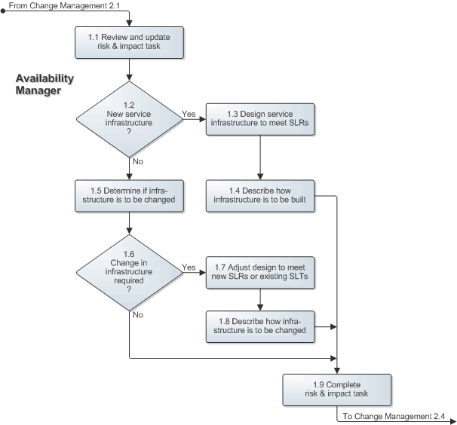

Availability Tracking
At the end of an availability tracking period, the availability manager finds out what the availability and reliability has been over the past period. He/she does this for every SLA that has been signed, and is still active, for the service(s) which availability he/she is responsible for. The availability manager then updates and publishes the availability tracking overview(s) of these service(s).

If the availability manager found out that the availability or reliability target of one or more SLAs is in danger of being violated, or if it has already been violated, he/she checks to find out if a problem investigation has already been registered for this. If this is the case, the availability manager ensures that the incident requests that have been caused by this problem during the past availability tracking period are linked to the problem investigation.

If multiple problem investigations have already been registered, because there are several root causes that are causing the availability and/or reliability targets to be(come) violated, the availability manager links the incident requests that appear to have been caused by these problems to the appropriate problem investigation.

If one or more incident requests appear to have been caused during the past availability tracking period by a root cause for which a problem investigation has not yet been registered, the availability manager registers a new problem investigation. He/she links the related incident request(s) to the new problem investigation and assigns it to the most appropriate specialist (in terms of skills, availability and access rights) for analysis.

The Availability Tracking procedure is presented on the next page.

Procedure 2, Availability Tracking
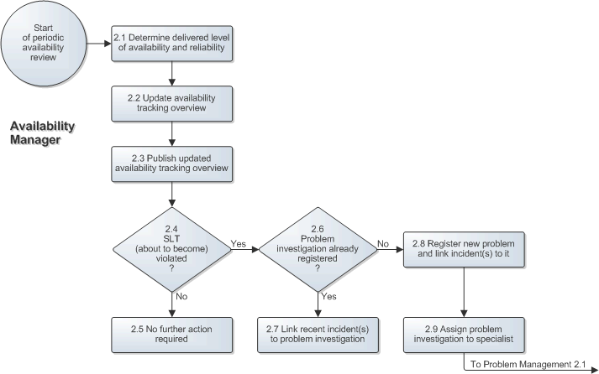

Scope
The scope of the Availability Management process is limited to the design of service infrastructures and the identification of problems that threaten to violate, or have already violated, the availability and/or reliability targets specified in active SLAs.

Roles & Responsibilities
The table below presents the only role that plays a part in the Availability Management process, along with its responsibilities.

Role | Responsibility
Availability Manager | - Designs service infrastructures for the service(s) for which he/she acts as the availability manager.  - Updates the design of the existing service infrastructures for which he/she acts as the availability manager, to ensure that the existing SLTs will be met after a change has been implemented, or to ensure that the new SLRs will be met if this is (one of) the objective(s) of the change.  - Tracks the availability and reliability for the service(s) for which he/she acts as the availability manager.  - Publishes the updated availability tracking overview of the service(s) for which he/she acts as the availability manager at the end of every availability tracking period.  - Registers problem investigations when the availability and/or reliability targets of the service(s) for which he/she acts as the availability manager have been, or are in danger of becoming, violated.

KPIs
The table below presents the key performance indicator (KPI) that has been selected for tracking the success of the Availability Management process.

KPI | Definition | Frequency | Unit
Availability or reliability violations | The number of SLAs for which the availability and/or reliability target has been violated, divided by the total number of active SLAs. | Monthly | %

Owner
The owner of the Availability Management process is the Service Management CAB.

This CAB is responsible for reviewing, and subsequently approving or rejecting, requests for improvement of the Availability Management process and its supporting functionality in the service management application.

