Finance Q&A with Named Entity Recognition (NER)
Ask questions and see named entities
(companies, names, addresses)
highlighted in the response.
Screenshots:
1 explain **GreenTech Inc. Sustainability Financial Statement**
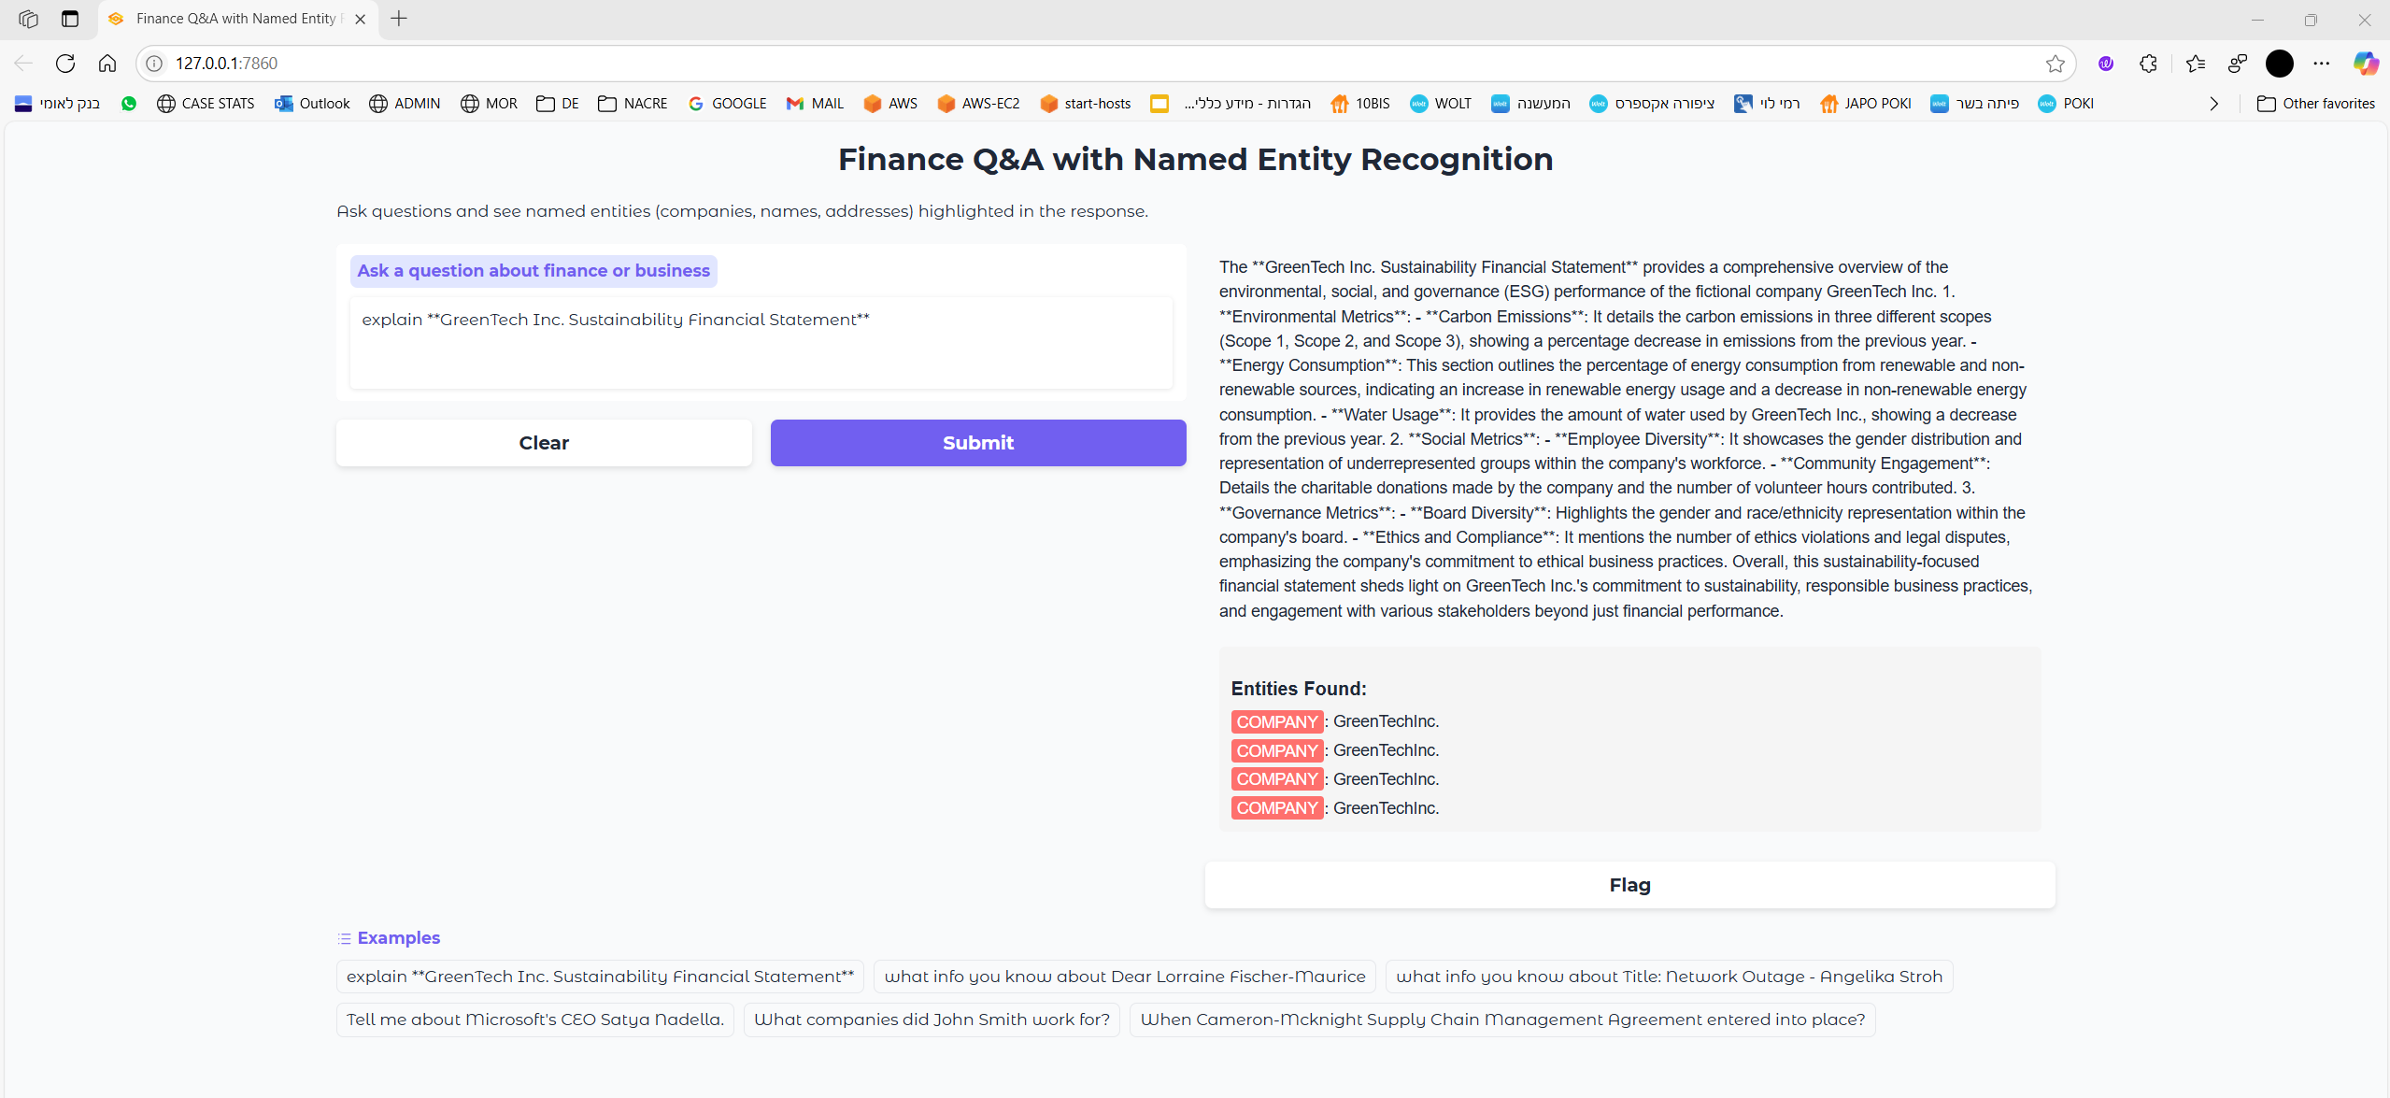
2 what info you know about Dear Lorraine Fischer-Maurice
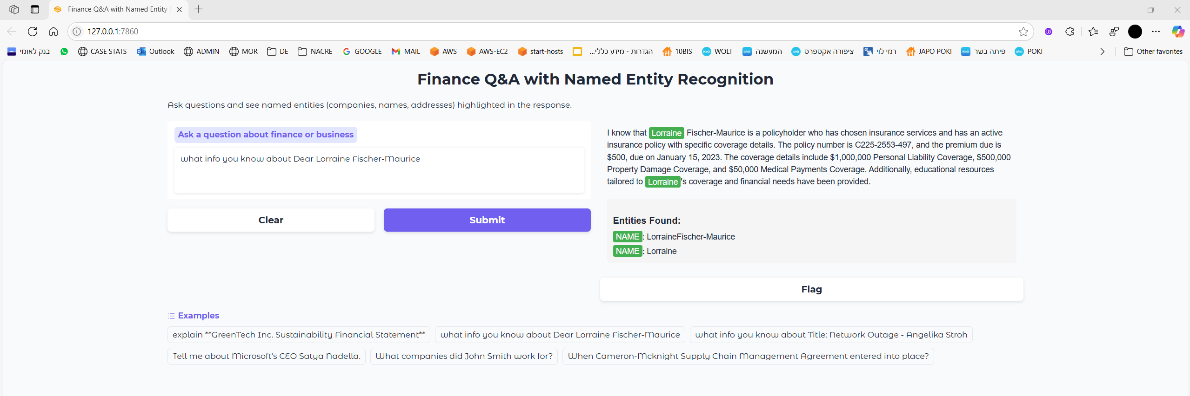
3 what info you know about Title: Network Outage - Angelika Stroh
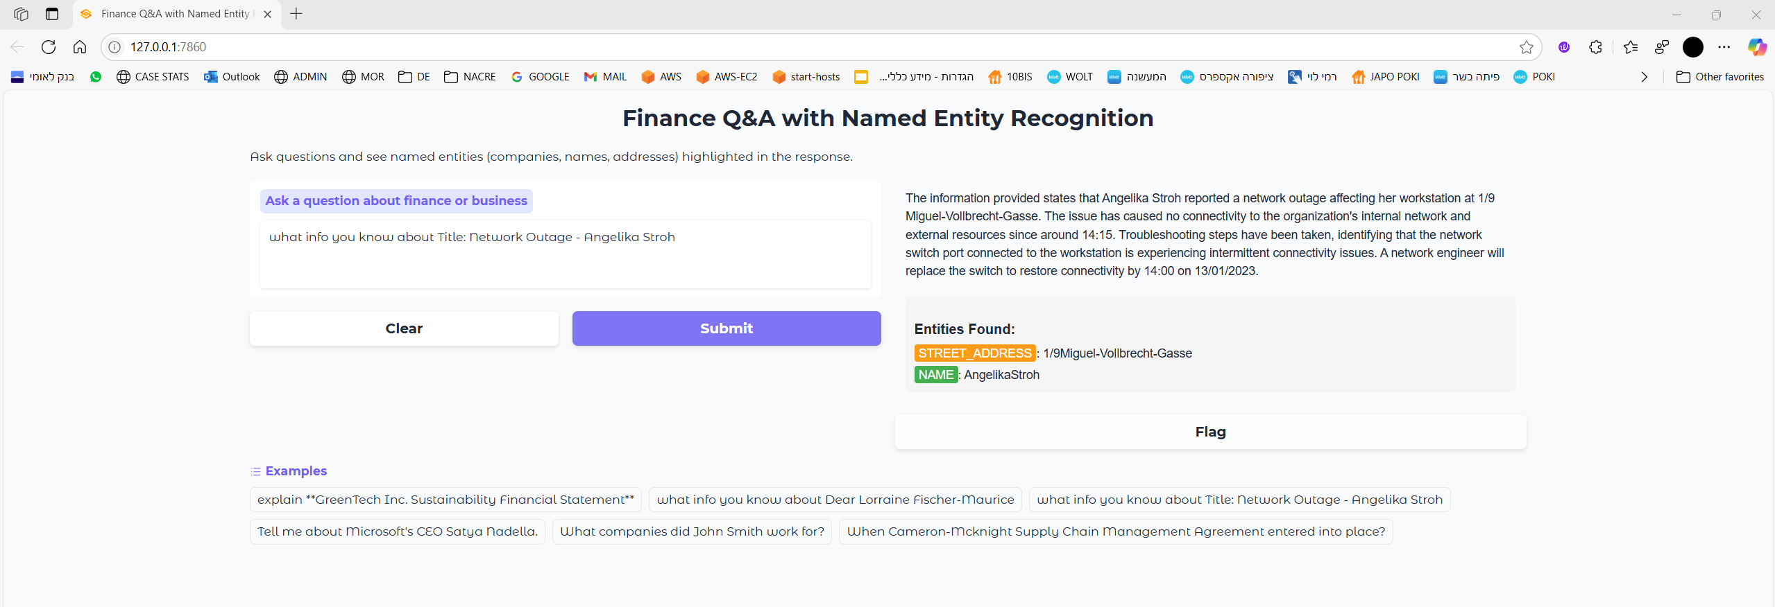

4 Tell me about Microsoft's CEO Satya Nadella.
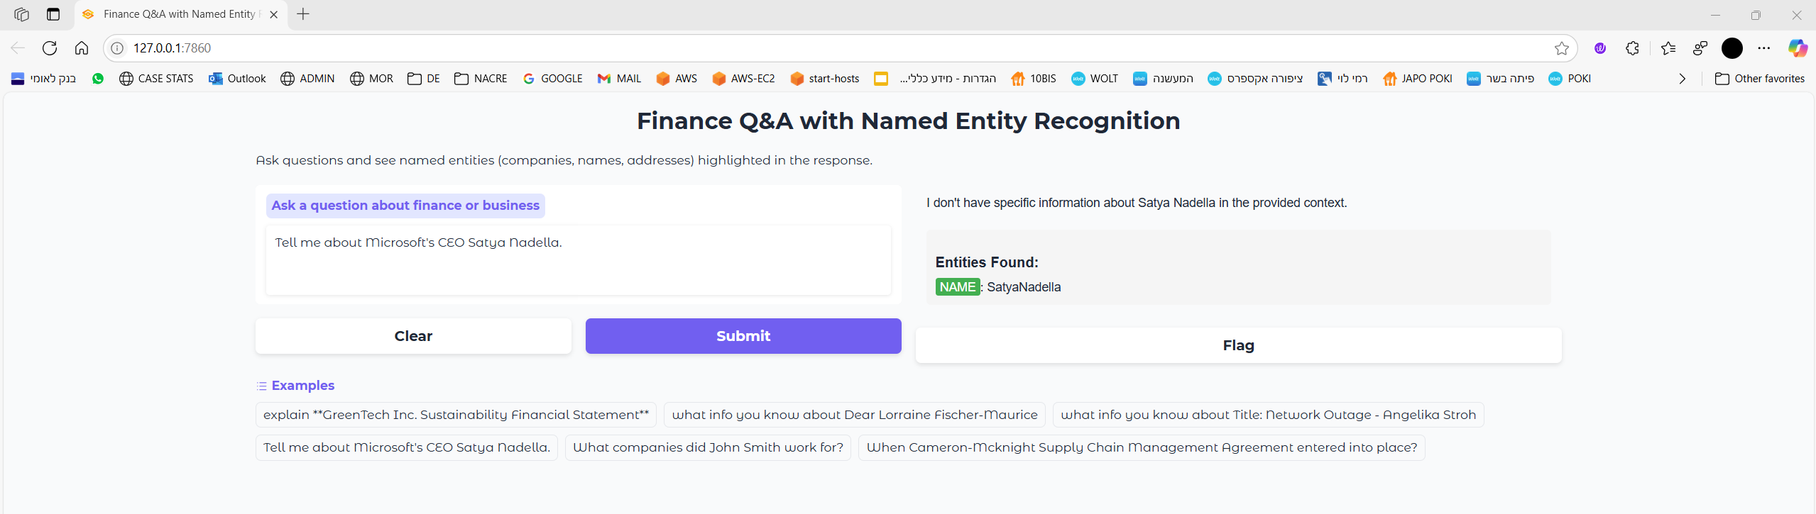
5 What companies did John Smith work for?
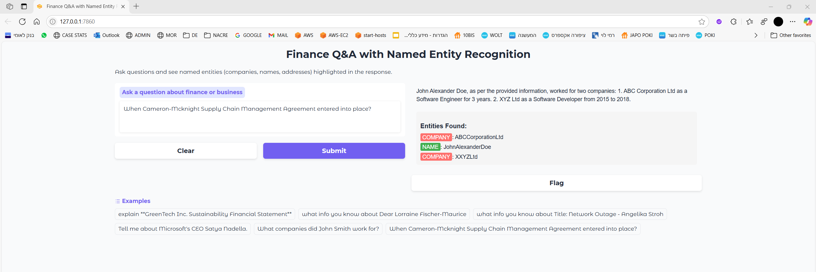
6 When Cameron-Mcknight Supply Chain Management Agreement entered into place?
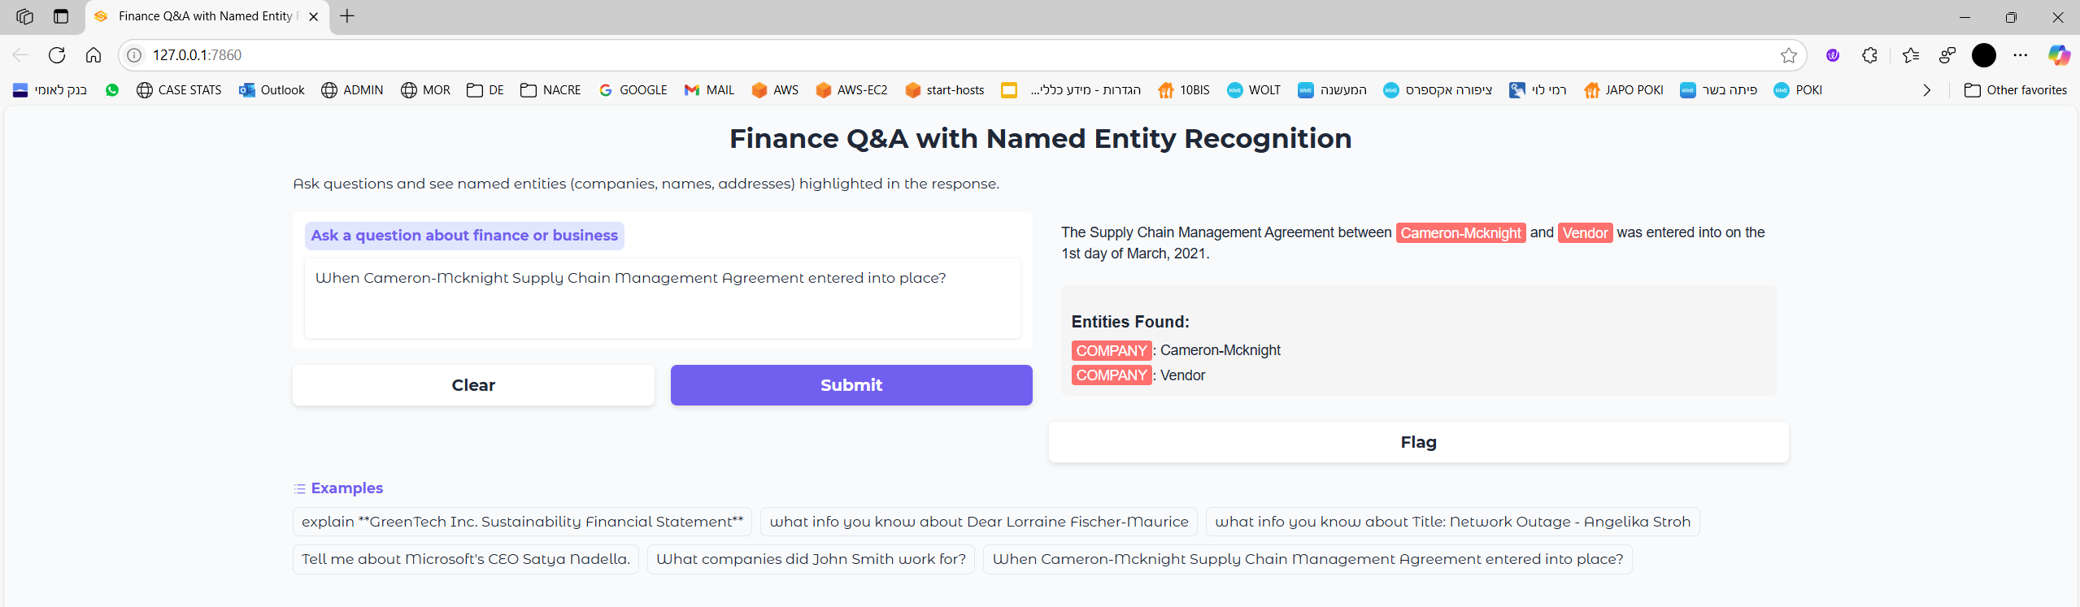
*Examples questions with answers taken from MongoDB.

MongoDB Structure:
1 news_articles
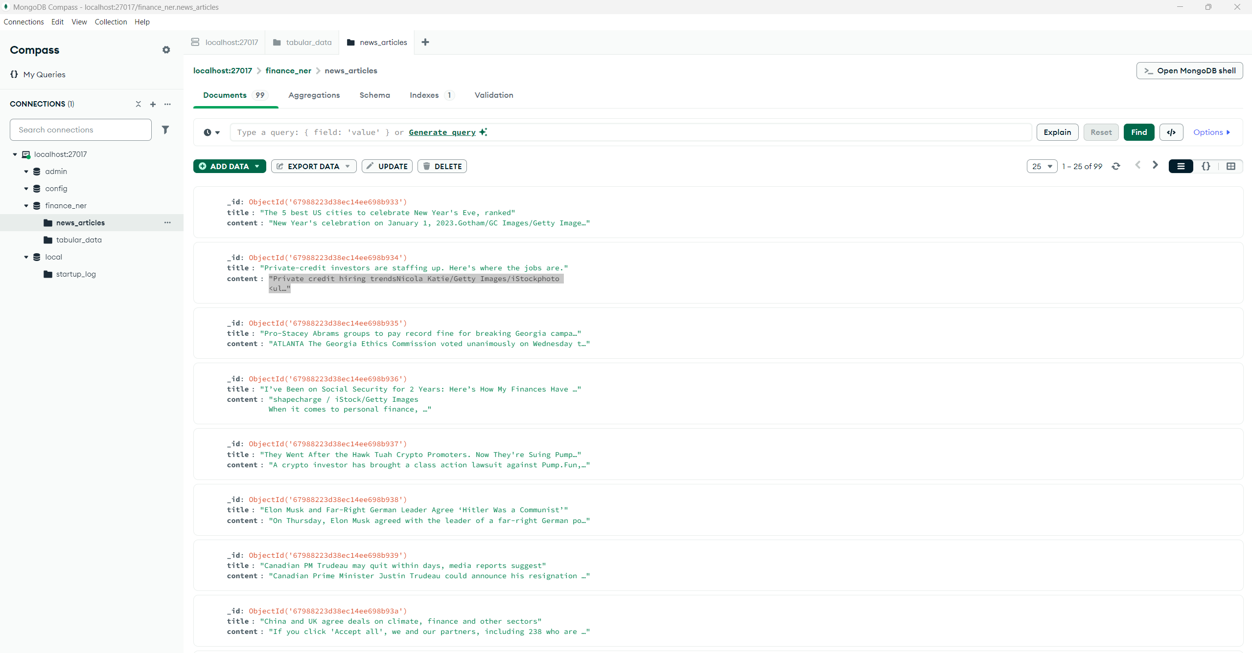
2 tabular_data
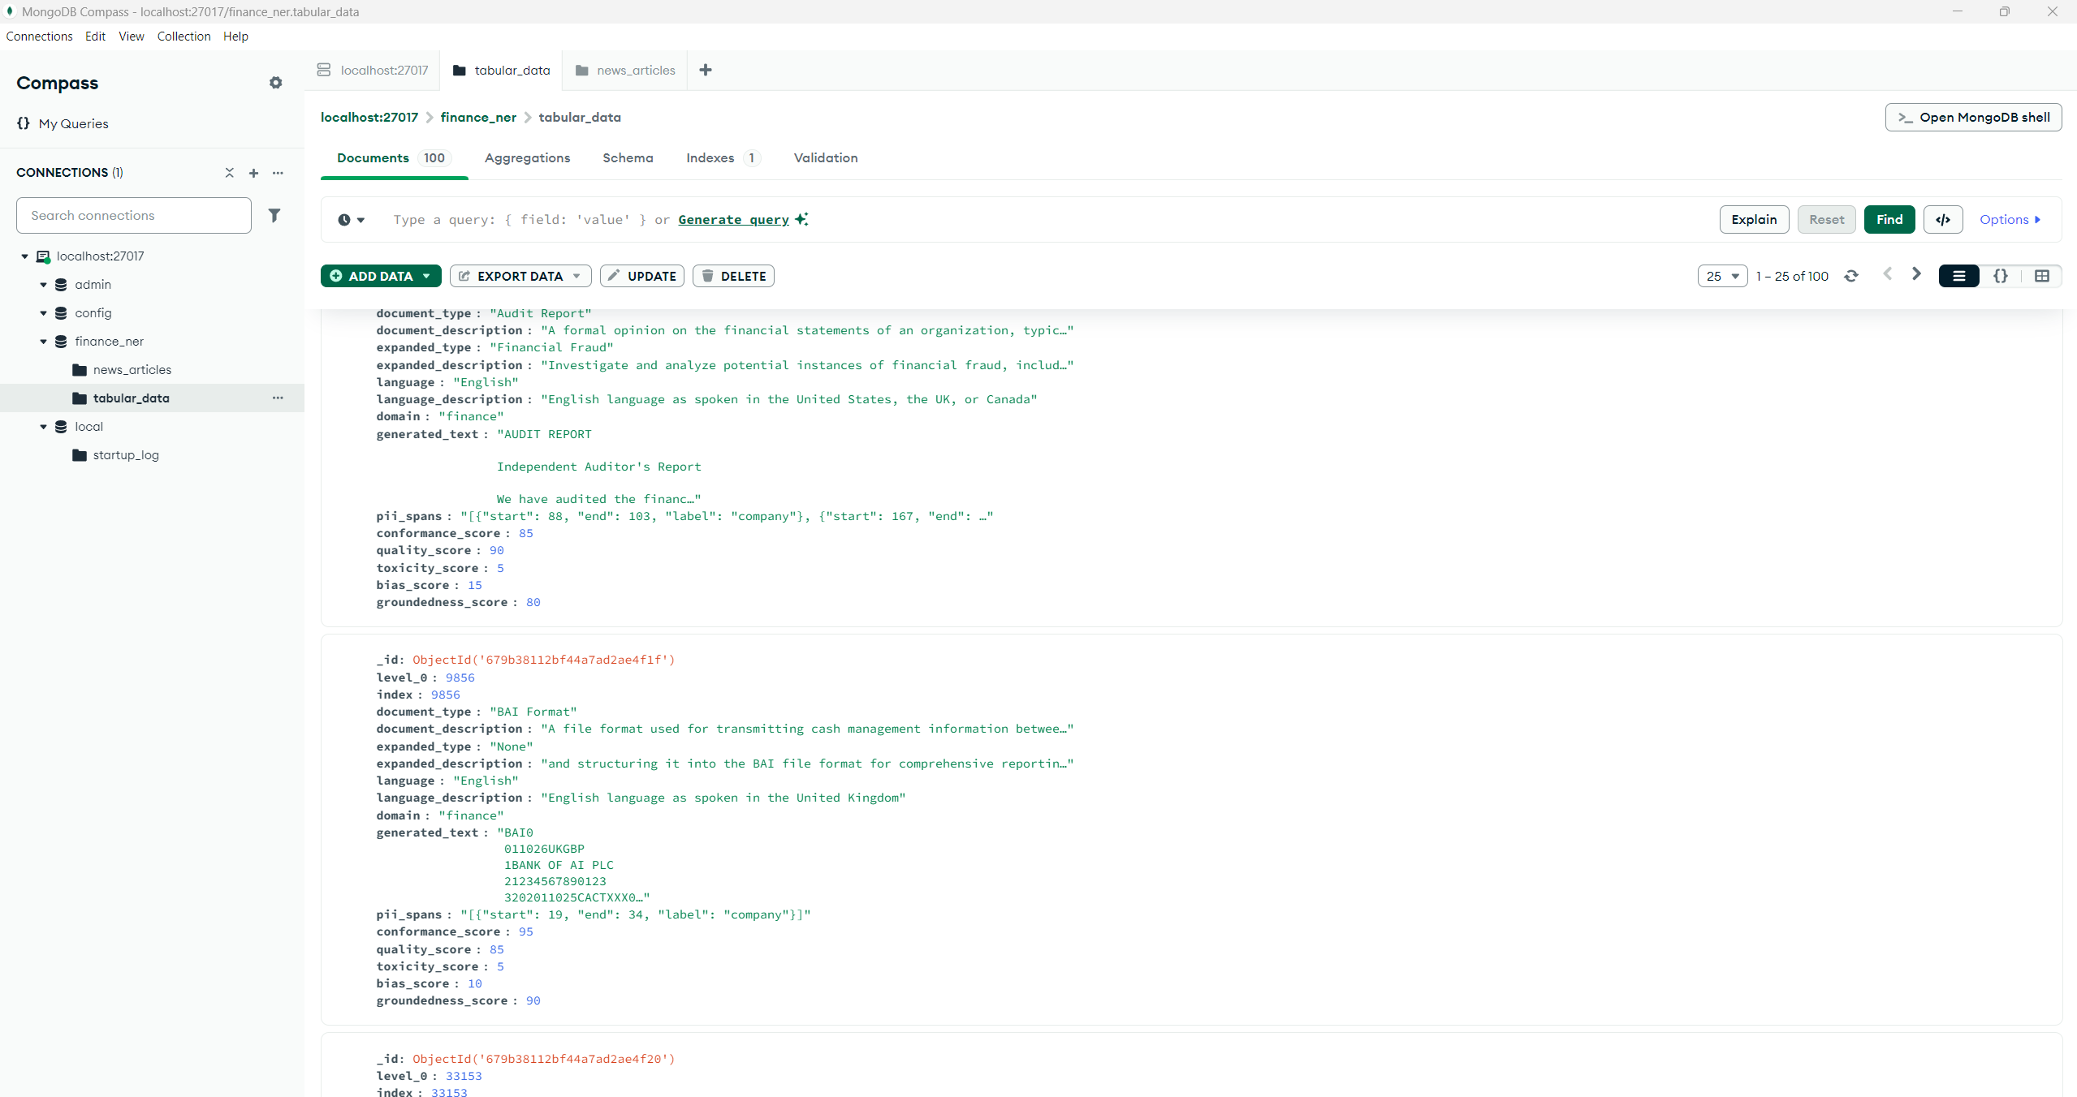

NER Explained:
The "B-" and "I-" prefixes in the label system are part of the BIO (Beginning, Inside, Outside) tagging scheme, which is a standard format used in Named Entity Recognition (NER) tasks. Here's what each prefix means:
B- (Beginning): Marks the first token of a named entity
Example: In "John Smith", "John" would be tagged as "B-PERSON"
Indicates the start of a new entity
I- (Inside): Marks subsequent tokens that are part of the same entity
Example: In "John Smith", "Smith" would be tagged as "I-PERSON"
Shows continuation of the entity that started with B-
O (Outside): Marks tokens that are not part of any named entity
Example: In "John lives in London", "lives" and "in" would be tagged as "O"
