WORK INSTRUCTIONS
Process | Order to Cash
DTP Name | Associated Supermarket Group

CURRENT VERSION HISTORY
UPDATE DESCRIPTION | DATE |  | AUTHOR
Added Ocean Spray to the Client Specific Validation Information section. (477516) |  | 8/3/2026 |  | Lindsay McGinnis

Link to complete version history: COMPLETE VERSION HISTORY

DEDUCTION TYPES COVERED
Sl No. | Deduction Type
 | Customer General Information
 | Backup Retrieval Information
 | Client Specific Information
1 | Billback
2 | Ad
3 | Slotting
4 | Retail Merchandising Program – ASG
5 | Food Show
6 | ASG Good Neighbor Program – Fairshare
 | BPS Team Information
Is the customer a wholesaler/distributor, direct or indirect customer? Indirect

Note: - ZZASSGNY is the sign-on used to work on ACOSTA Relay for Associated Supermarket (for example to search for a document and to refer to the customer on ACOSTA Relay).

Contracts can often be found via an Event Scheduler search using ZZASSGNY. Ad contracts for Metropolitan City Foods (Met Foods, Pioneer & Metropolitan Citymarkets) may be searched by using %METRO% in the event description.

Associated Supermarket Group may also be called Associated Food Stores.

The direct customer sign-on to pull reports out of ACOSTA Relay is CSWHNE.

Link to customer sign-on job aid:
https://acostaonline.sharepoint.com/sites/AS_Reporting/Claims_Reports/Forms/AllItems.aspx?web=1

Does this customer subscribe to IRI/Nielsen for price point verification? No

CUSTOMER GENERAL INFORMATION

Customer Invoice Info:

Is line level detail indexed on the customers documentation (customer invoice, customer check request, unsalable/spoils, post audit, EDI 812/820 or client deduction notice if one of these documents is included)? Yes

Associated Supermarket purchased Met, Pioneer, and Metropolitan Citymarkets. Met, Pioneer and Metropolitan Citymarkets bill through Associated Supermarket. These claims can be identified by reviewing the customer invoice. Checks are to be paid to Associated Supermarket.

Invoice for Met:
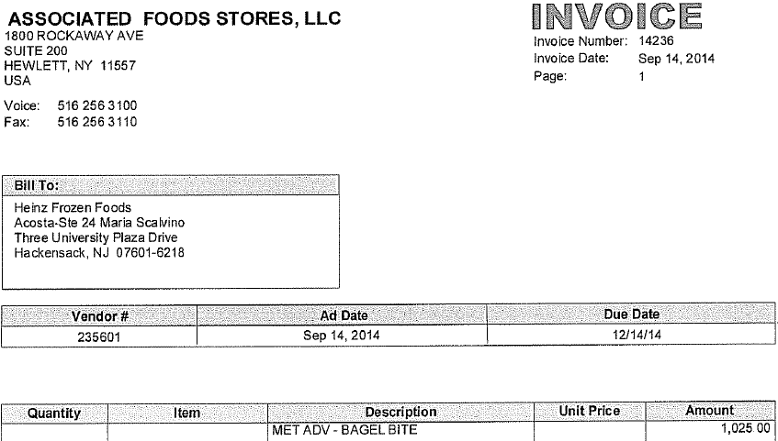
Customer invoice submitted by Associated Supermarket.
MET ADV identifies this as a Met claim.
i

For Pioneer:

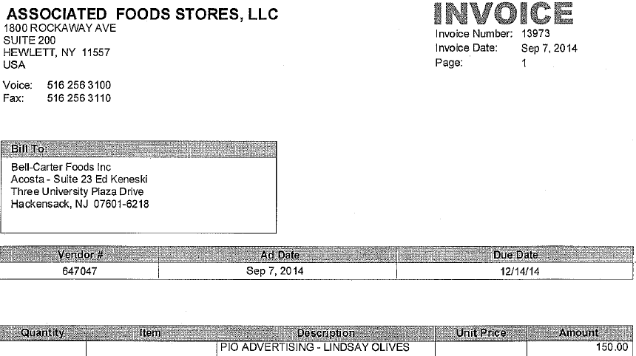
i
Customer invoice submitted by Associated Supermarket.
PIO ADVERTISING identifies this as a Pioneer claim.

For Metropolitan:
i
Customer invoice submitted by Associated Supermarket.
METRO ADV identifies this as a Metropolitan Citymarkets claim.
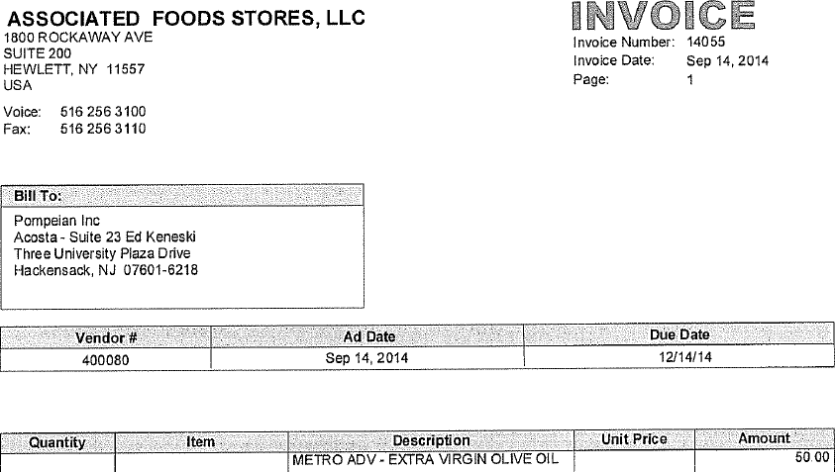

The programming in the system Associated uses to generate their customer invoices causes ad fees to appear at random locations throughout the invoice, and not just on the first line. Look for ad fees on any line of the customer invoice:

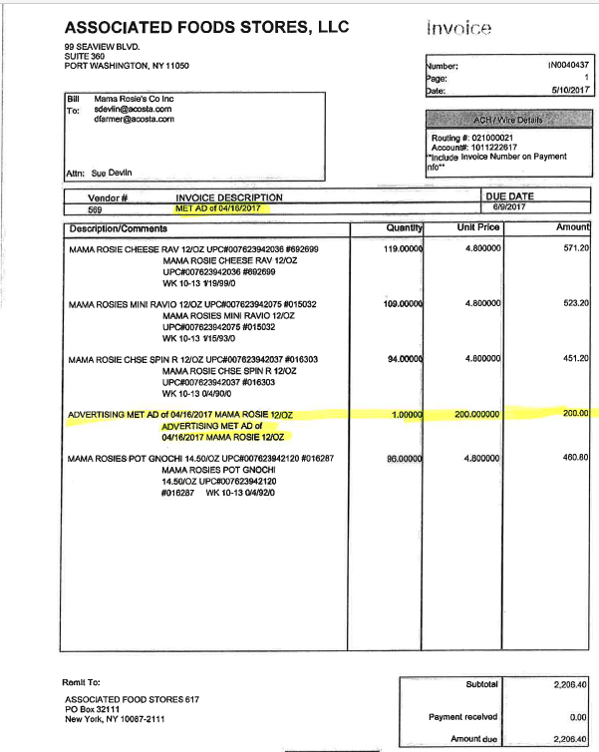
i
Detail for ad billing..
i
Invoice Description: Identifies that customer is billing for an Ad.

POP Info:

Other General Info:

Associated Supermarket Group will accept partial check payments.

BACKUP RETRIEVAL INFORMATION

GENERAL BACKUP RETRIEVAL INFORMATION

Is GCIT responsible for obtaining backup from the customer? Yes
- If yes, is there a customer portal? No
- If yes, does GCIT request backup? Yes

Is check remittance information required to request backup? Yes

GCIT SPECIFIC BACKUP RETRIEVAL INFORMATION

Non - Automated:

Customer Invoice or Note Identifier | Request From
All formats | Request from Sales

CLIENT SPECIFIC VALIDATION INFORMATION

Client
Barilla
Campbells Grocery Ecce Panis Inc Pepperidge Farm Bakery Pepperidge Farm Frozen Pepperidge Farm Snacks Plum Organics
Coca Cola
Ferrero USA
Harvest Hill Beverages Sunny D Company
J.M. Smucker Company
Kens
Nestle Coffee
Ocean Spray Cranberries, Inc
Tata (Eight O Clock, Tetley & Good Earth)

BARILLA
- ASG Good Neighbor Program Invoices for ASG Fairshare fee:
  - Clear to the trade agreement/event number.
  - A note Neighborhood Program is required.
  - No POP is required.
  - No contract is required.

Campbells Grocery Ecce Panis Inc Pepperidge Farm Bakery Pepperidge Farm Frozen Pepperidge Farm Snacks Plum Organics
- Customer payments are issued EFT.

COCA COLA
- Invoices that do not provide breakdown are approved to use the following percentage breakdown:
  - X2 Ades 30%; X3 Punches 70%
  - Grocery claims must be stepped to sales to provide a breakdown.
- Invoices for Ad Fees Punches/Ades need to be split 50/50. Example: $900.00 would be $450.00 X2 Ades and $450.00 X3 Punches
- Associated Supermarket Group has the option to move the ad date within two weeks before or after the contract suggested ad date.

FERRERO USA
- ASG deducts through C&S. Acosta does not process these as check requests.

HARVEST HILLS BEVERAGES SUNNY D COMPAY
- If sales provides a client event # and advises the contract is not yet available, proceed with validation. Note the claim 'CE# provided, validating without a contract.'

J.M. SMUCKER COMPANY
- Per case allowances can be cleared to a fixed fee event, so the allowance rate on the Event Detail Report will not match, however, the customer, dates, and PPG have to match.
- ASG is an indirect customer of C&S. As such, they have their own spin reports.
- All Check Request events for Hostess products only; are under planning account Cottage Distributing.

KENS
- If Acosta Relay reports do not pull any movement for slotting claims, the GCC will escalate the claim for POP. The CRA will pull a report from Ken’s system to determine whether the claim can be processed.

NESTLE COFFEE
- If a UPC is on the invoice or check request but the PPG or UPC is not on the contract, the claim can still be validated and cleared if that UPC is found on the spin report.
- When validating deductions with just the ASG invoice, the C&S cover sheet is required, as it has additional information of fees being charged and additional breakdown information.

OCEAN SPRAY CRANBERRIES, INC
- ASG should only be check requests to avoid deducting through C&S and charging the fee.

Tata (Eight O Clock, Tetley & Good Earth)
- Customer is deduct-only for all invoices. No checks are to be processed.

PROCESS STEPS

1 Deduction Type: Billback (BB)

A billback (BB) is a per case allowance offered for a specific performance requirement.
A per case billback allowance is claimed by the direct buying customer for product purchased from the client, or by the indirect customer for product purchased from the direct customer. This is an allowance the customer will bill the client for. This is not an automatic discount given off the face of the invoice.

  - Customer Check request for Billback, Example 1:

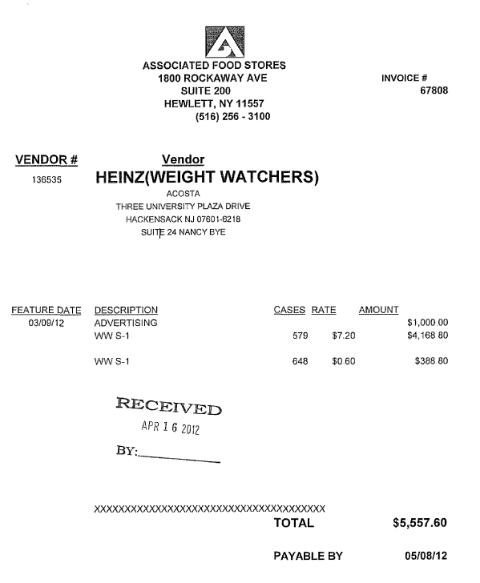
i
Vendor: This is the client the customer is requesting a check from.
Rate: This is the per case billback allowance being claimed by the customer, which must match the contract..
Description: The product/product group that the customer is claiming the billback allowance on, which must match the contract.

5
Feature date: The feature dates on the customer invoice, and the order date on the client order invoice must fall within the dates shown on the contract.

Cases: This is the number of cases on which the customer is claiming the BB.

2
Amount: This is the total amount claimed for the billback for each product or product group.
Payable By: The customer allows 60 days from this date before deducting. The check must be issued within 60 days of this date to avoid a deduction.
i
i
1
3

1.1 Customer Check request for Billback, Example 2:
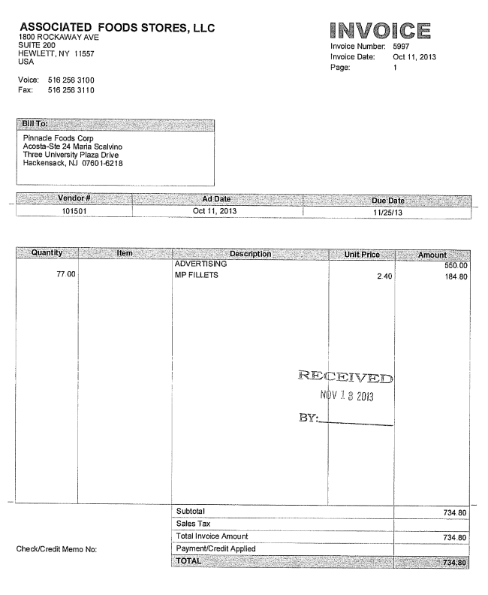
2
i
Bill To: The client the customer is requesting a check from.
Unit Price: The per case billback allowance being claimed by the customer, which must match the contract.
Description: The product/product group the customer is claiming the billback allowance on, which must match the contract.

i
1
3
Quantity: The number of cases the customer is claiming a billback on.

Due Date: The customer allows 60 days from this date before deducting. The check must be issued within 60 days of this date to avoid a deduction.

  - Customer Check request for Billback, Example 3: Accrual/EDLP. ***Summary***
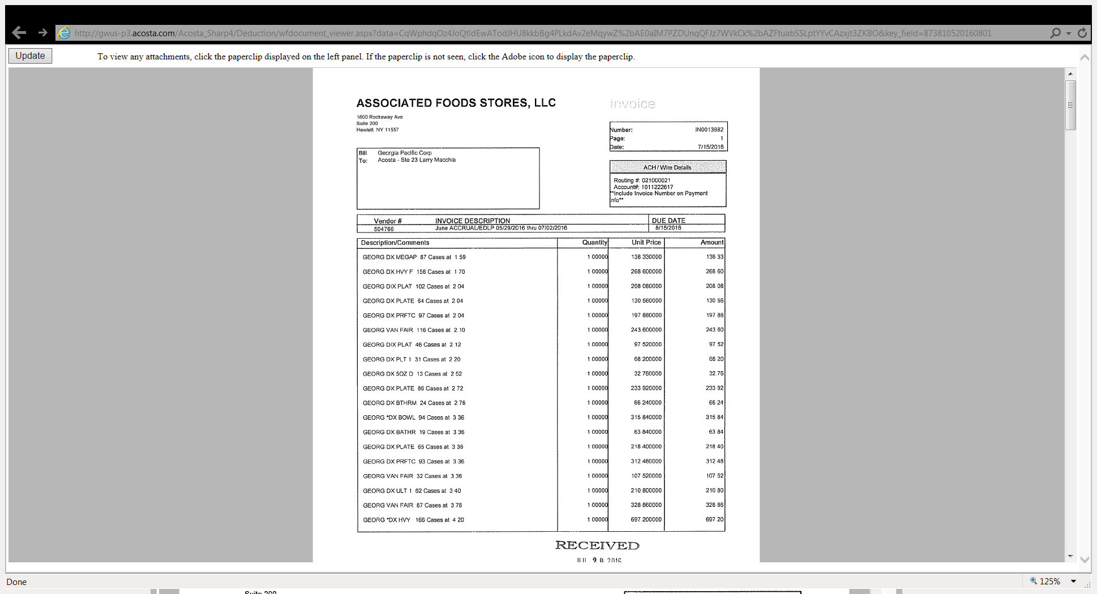
Item Description, quantity and rate is listed on the summary but the details in the following pages will provide the UPC information.
i

***Detail***
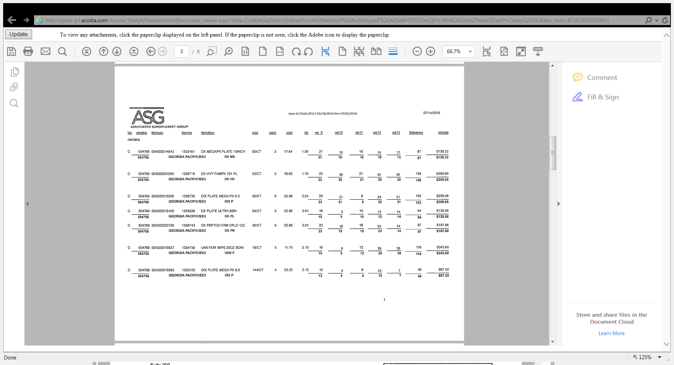
BB: The per case billback allowance being claimed by the customer, which must match the contract.

1
UPC Code/Description: The product the customer is claiming the billback on, which needs to match the contract.
3
Quantity: The number of cases on which the customer is claiming the billback.

2

  - Customer Check request for Billback, Example 4:

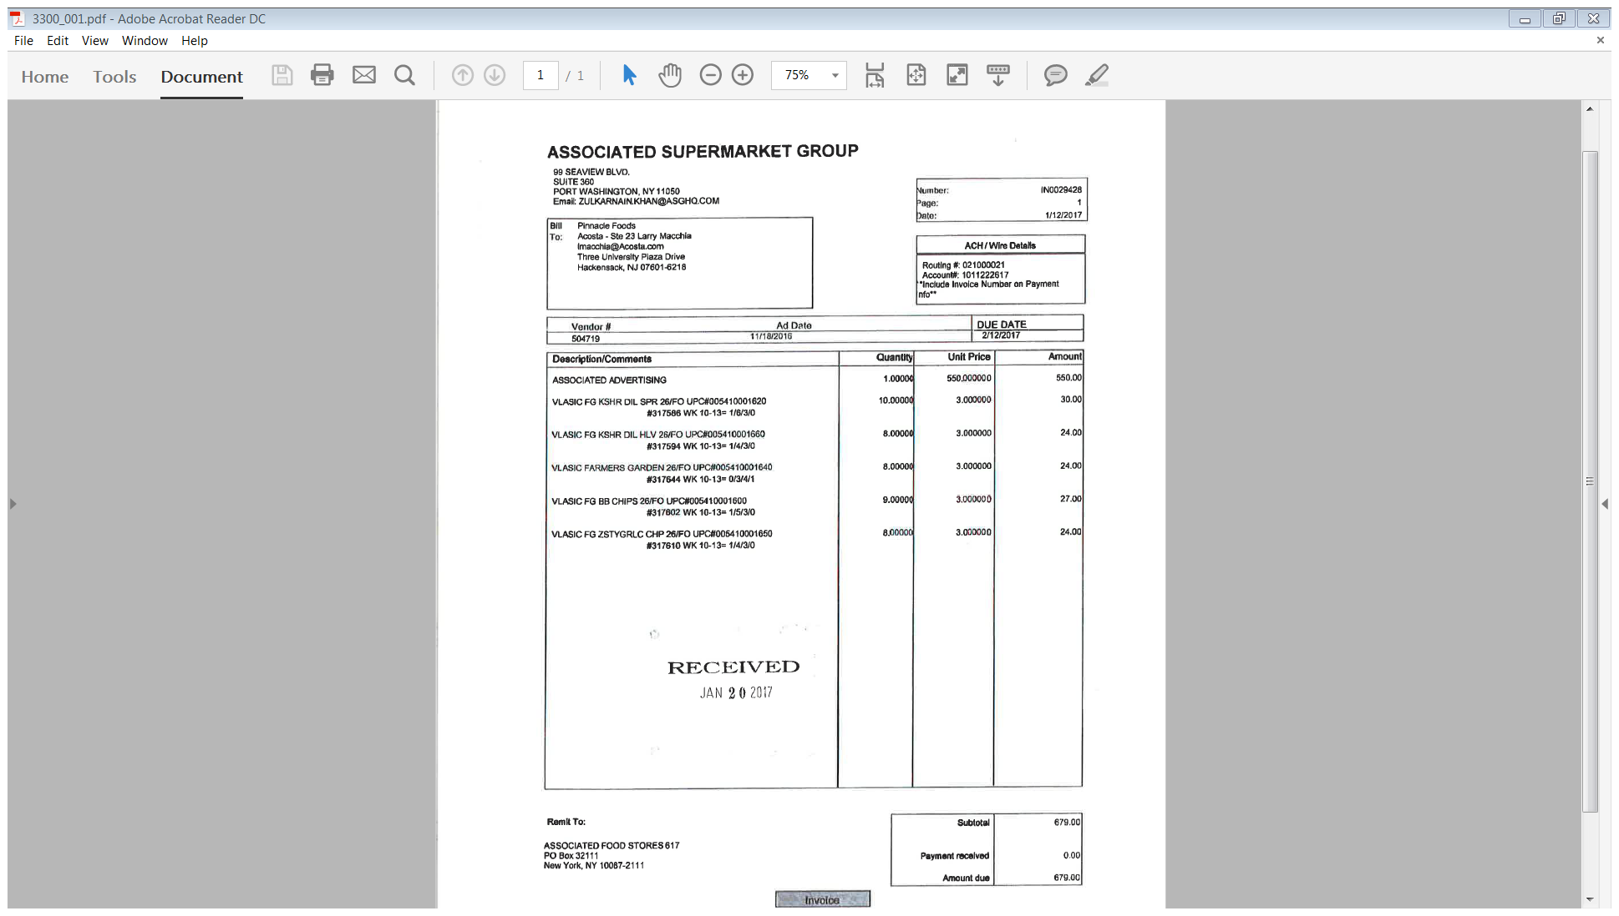
3
Quantity: The number of cases on which the customer is claiming the billback.

2
Unit Price: This is the per case BB allowance being claimed by the customer, which must match the contract.

Ad Date: The customer will bill for 2 weeks prior, the week of, and the week after this date.
i
1
UPC/Description: The product the customer is claiming the billback on, which must match the contract.
Weeks Billed: Associated bills for 4 weeks – 2 weeks prior to the ad, the week of, and the week after the ad date.

5
1.2 Customer Contract for Billback, Example 1: Contracts are found via Search For: Event Scheduler.

i

The client information given here may include the product group or category.
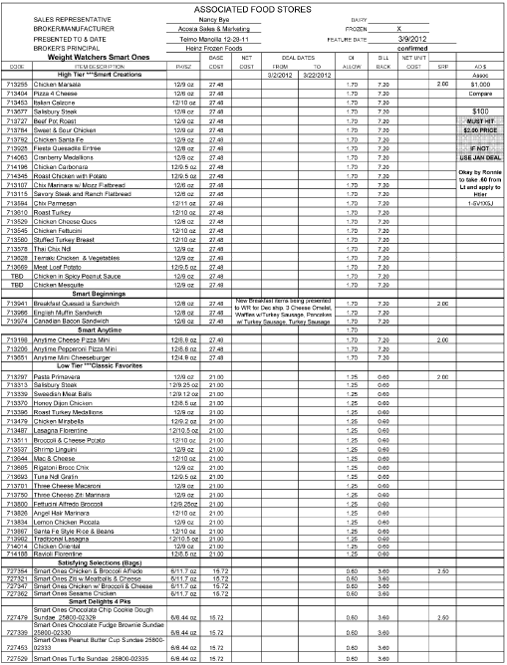
Bill Back This is the per case billback allowance amount. The rate claimed on the customer invoice must match.

Code: This is the customer’s internal item code. Associated Supermarket’s contracts do not reference UPCs. Use the Authorized Product Listing (APL) or customer specific DBW to cross reference to the client’s UPC.

2
5-
Deal dates: The feature dates on the customer invoice and the order date on the client order invoice must fall within the dates shown on the contract.

1
Product Description: The description of the items the customer is being offered a billback on. Note: Associated Supermarket does not reference this detail on their customer invoice.
i

1.2 Customer Contract for Billback: Contracts are found via Search For: Event Scheduler.

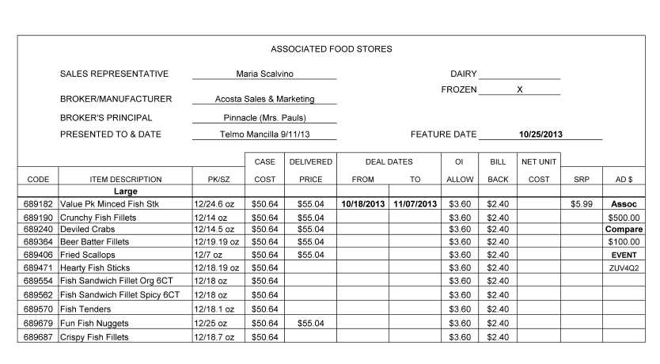
5
Deal dates: The ad date on the customer invoice and the order date on the client order invoice must fall within the dates shown on the contract.

2
1
Bill Back This is the per case billback allowance amount. The amount claimed on the customer invoice must match.

Code, Item Description, Pk/Sz: The customer’s internal item code, product description, pack and size for the products the billback is being offered on. Associated Supermarket’s contracts do not reference UPCs. Use the Authorized Product Listing (APL) or customer specific DBW to cross reference to the client’s UPC.

1.3 Refer to the SOPs/Generic Help File for POP requirements.

2. Deduction Type: Ad

A fee for featuring a client’s products in an advertisement.

NOTE: Associated Supermarket is often offered two ads. One is for Associated stores, and the other is for Compare stores. They will be billed separately. The customer name on each ad must match with the contract and customer invoice; i.e. an Associated customer invoice, contract and POP will all show Associated; a Compare customer invoice, contract and POP will all reference Compare. There is no exception to this. An Associated ad cannot be used as POP for a Compare ad claim; a Compare ad cannot be used as POP for an Associated ad claim. Also note that there may be more than one version of the Compare ad running at the same time. Ad content may differ based on the geographic market area of the stores. If the promoted product is not found in a Compare ad copy, you must find out whether there is another version for the same dates that does include the promoted product.

Associated, Compare, Met Food, Pioneer and Metropolitan Citymarket ads are available online. The site is www.metroadconnect.com or www.asgadconnect.com .

  - Customer check request for Ad, Example 1:

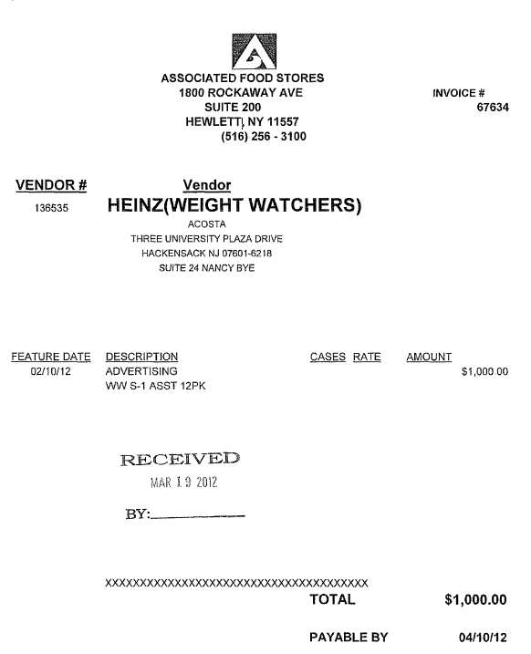
Amount: The lump sum ad amount claimed by customer for the ad. This must match the amount shown on the contract.
3
1
Description: The product/product group the customer is claiming the ad allowance on.
.

i
i
Deduction type: This indicates that this is an ad claim.

Feature Date: The feature date on the customer invoice must match the feature date shown on the contract.

.

2
Vendor: This is the client the customer is requesting a check from.

i
i

  - Customer Check request for Ad, Example 2 – Compare Ad:

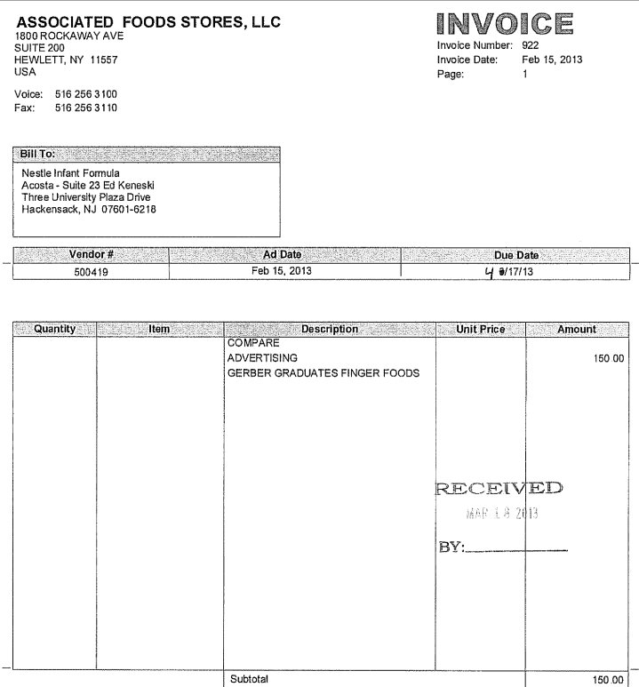
i
Compare: Proof of performance for this claim must be a Compare ad.

Description: This identifies that this is an ad claim.

Description: The product or product group the customer is claiming the ad allowance on.

2
i
Due Date: The customer allows 60 days from this date before deducting. The check must be issued within 60 days of this date to avoid a deduction.
3
Amount: The lump sum amount claimed by customer for the ad deduction, which must match the contract.
1
Ad Date: This indicates the ad date and must match the contract and the ad.

i
Bill To: The client the customer is requesting a check from.
i

2.2 Customer Contract for Ad, Example 1: Contracts are found via Search For: Event Scheduler.
2
Feature Date: This indicates the ad date and needs to match the customer invoice and the ad.

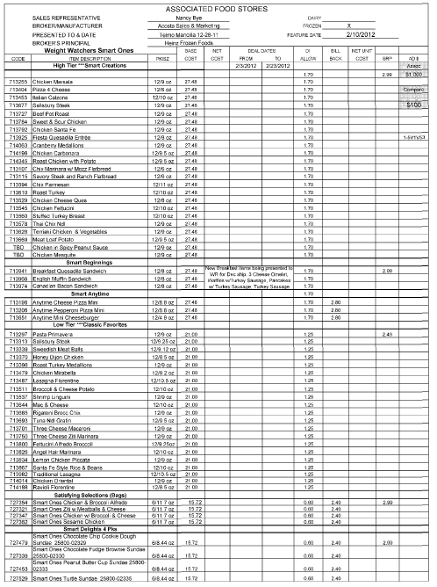
Code, Item Description, PK/SZ: The customer’s internal item code for the items to be featured in the ad, along with the description and pack/size for each.
Associated Supermarket’s contracts do not reference UPCs. Use the customer specific DBW or Authorized Product Listing (APL) to cross reference to the client’s UPC code.

1
3
Ad $: Amount offered to the customer for the ad. The amount on the customer invoice must match.

2.2 Customer Contract for Ad, Example 2 – Compare Ad: Contracts are found via Search For: Event Scheduler.
i

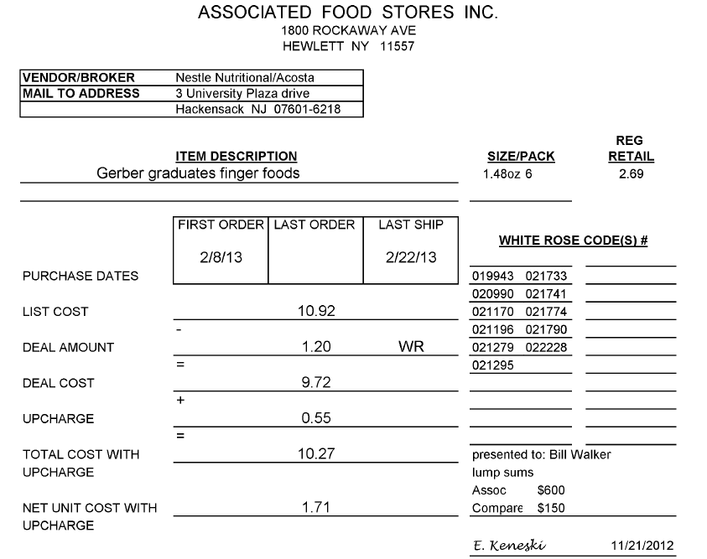
Lump Sums: The amount being offered for the ad. The amount being claimed on the customer invoice must match. Note that there are separate amounts for Associated and Compare.
1
Item Description & Size/Pack: The product/product group to be featured in the ad.

3
2
First Order/Last Ship: The ad needs to be run between these dates. The feature date on the customer invoice and the date on the ad must fall within these dates.

  - Proof of Performance for Ad, Example 1: Found via: Search For: Back-up documentation, Doc Type 6-POP: Ad. NOTE: When the customer invoice and contract are for an Associated ad, the POP must be an Associated ad. A Compare ad cannot be substituted. Search with ADCLIENT and ZZASSGNY.

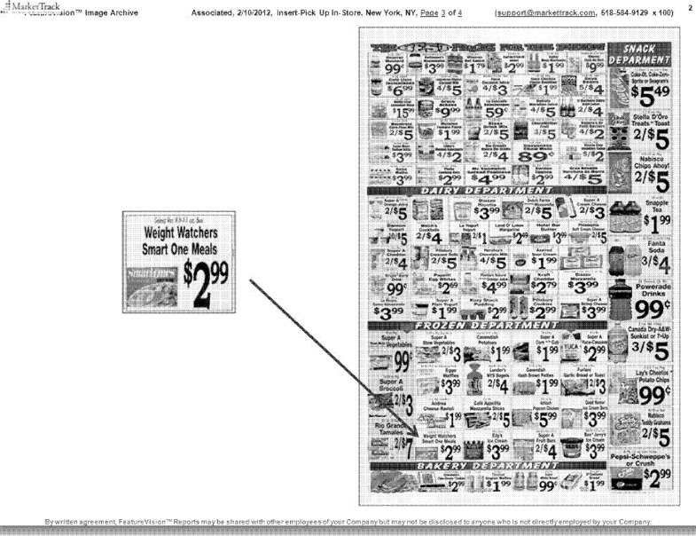
2
Store Banner and Performance date: The customer name and the date of the ad both need to match the contract and customer invoice.
1
Product: The product/product group featured in the ad must match the contract and customer invoice. Associated Supermarket’s contracts do not reference UPCs. Use the descriptions, customer specific DBW (if required for the claim) or Authorized Product Listing (APL) to verify that the correct product was featured in the ad.

2.3 Proof of Performance for Compare Ad: Search for: Backup Documentation, doc type POP-AD. NOTE: When the customer invoice and contract are for a Compare ad, the POP must be a Compare ad. An Associated ad cannot be substituted. Ads are available online; the site is www.metroadconnect.com or www.asgadconnect.com.

Compare Foods: The ad copy must show Compare Foods as the customer.
i

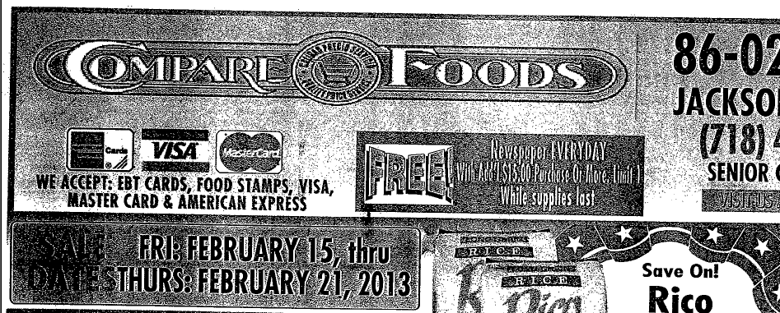
2
Performance date: The date on the ad must match the contract and customer invoice.

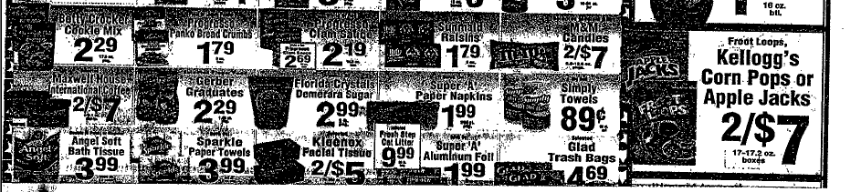
1
Description: The product that was advertised. This must match the contract and customer invoice.
i
Ad – This area provides the details of the Ad.

3. Deduction Type: Slotting

A slotting allowance is offered to the customer to purchase an item not currently stocked. It is a kind of promotional money offered to a customer as incentive to buy a new item and create a “slot” for that product on their warehouse storage shelves. It is a Trade Deduction. A slotting lump sum allowance can be offered for each item and/or an off invoice can be offered as an introductory allowance for the first 30 days.

3.1 Customer check request for Slotting:

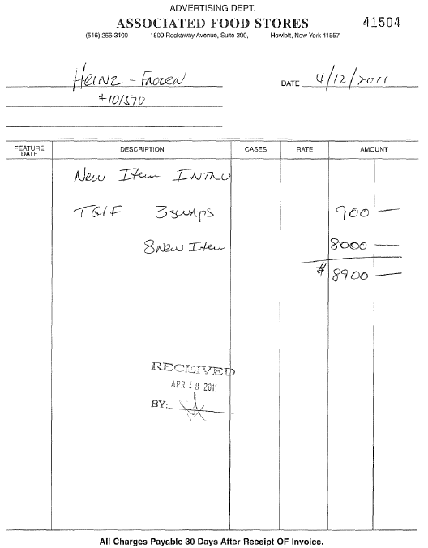
Amount: The amount the customer is claiming, which must match the contract.

Description: The product or product group the customer is claiming the slotting allowance on.

The client the customer is requesting a check from.
2
1
i

3.2 Customer Contract for Slotting: Contracts are found via Search For: Event Scheduler.

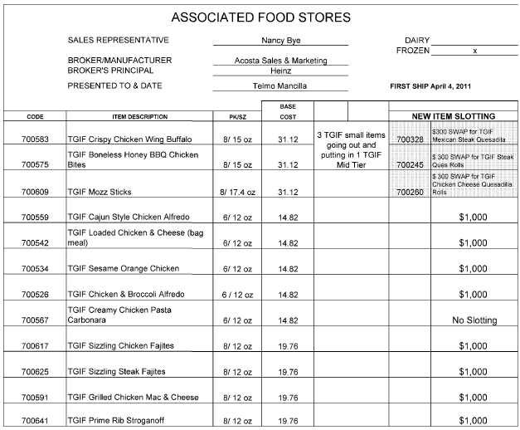
2
Slotting Amount – The amount being offered to the customer for each of the new products. The amount claimed on the customer invoice must match.

i
New Item Slotting: Indicates the type of offer.

i
First Ship: This is the first date the product will be available to ship to the customer.

SWAP: In addition to being offered slotting on new items, the customer is also being offered an amount for replacing product they have carried with new product.

2
1
Code & Item Description: The customer’s internal item code and the description for each product slotting is being offered on. The amount claimed on the customer invoice must match. Associated Supermarket’s contracts do not reference UPCs. Use the customer specific DBW or Authorized Product Listing (APL) to cross reference to the client’s UPC.

3.3 Refer to the SOPs/Generic Help File for POP requirements.

4.1 Retail Merchandising Program – ASG (Associated Supermarkets In-Store Execution Merchandising Program) ASG is a program for retail merchandising services.

NOTE: The program is sometimes refered to as ISE – In-store Execution.

Customer Invoice:
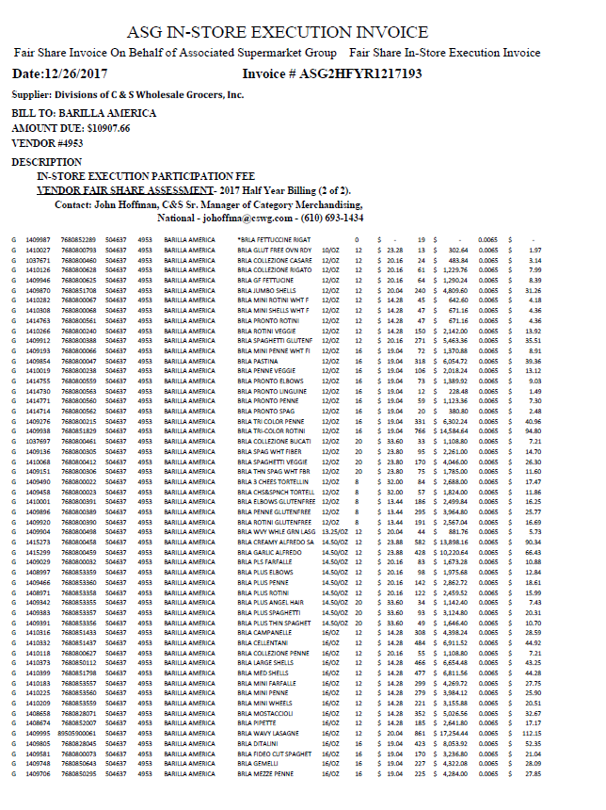
INVOICE #: Invoice number starting with ASG indicates the claim is for retail merchandising/ASG.
i

Retail Merchandising Program – ASG (Associated Supermarket Group) In-Store Execution Merchandising Program
Program agreement:
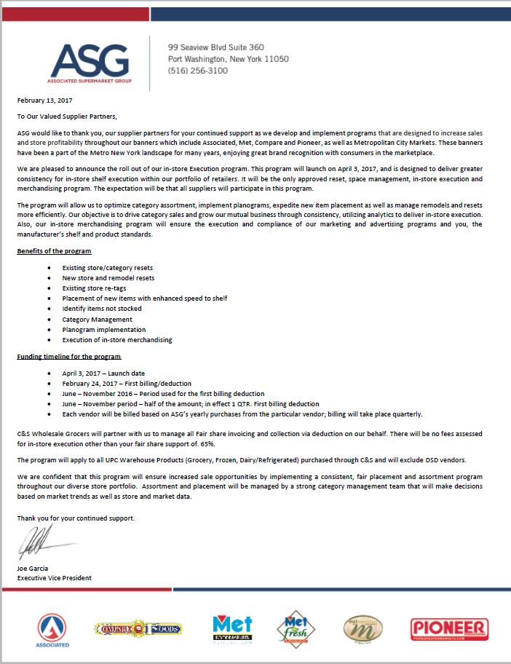

5 Deduction Type: Food Show
An event sponsored by a wholesaler exhibiting various clients’ products to indirect customers. There are various fees associated with participating in a food show and can include booth fees, show books, printing/survey charges, show samples and per case allowances for what is sold at the show.

5.1 Customer check request for Food Show:

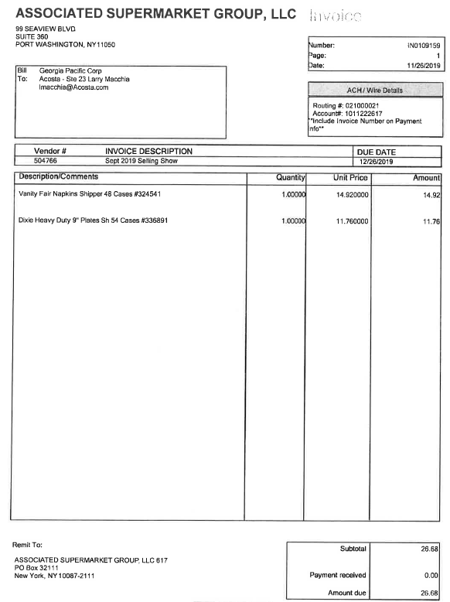
2
Unit Price: The amount being claimed for the products purchased via the food show. This needs to match the contract.
3
Invoice Description: Selling Show indicates the customer is billing for a food show. Sept 2019 indicates the dates the show took place. The date needs to match the contract.
Description/Comments: This is the description and customer store code for the products purchased via the food show. This needs to match the contract.
1
5.1 Customer contract for Food Show: Found via Search For: Event Scheduler

3
ASG Food Selling Show: Selling Show indicates the offer is for a food show. Sept 2019 indicates the dates the show took place. The date needs to match the customer invoice.

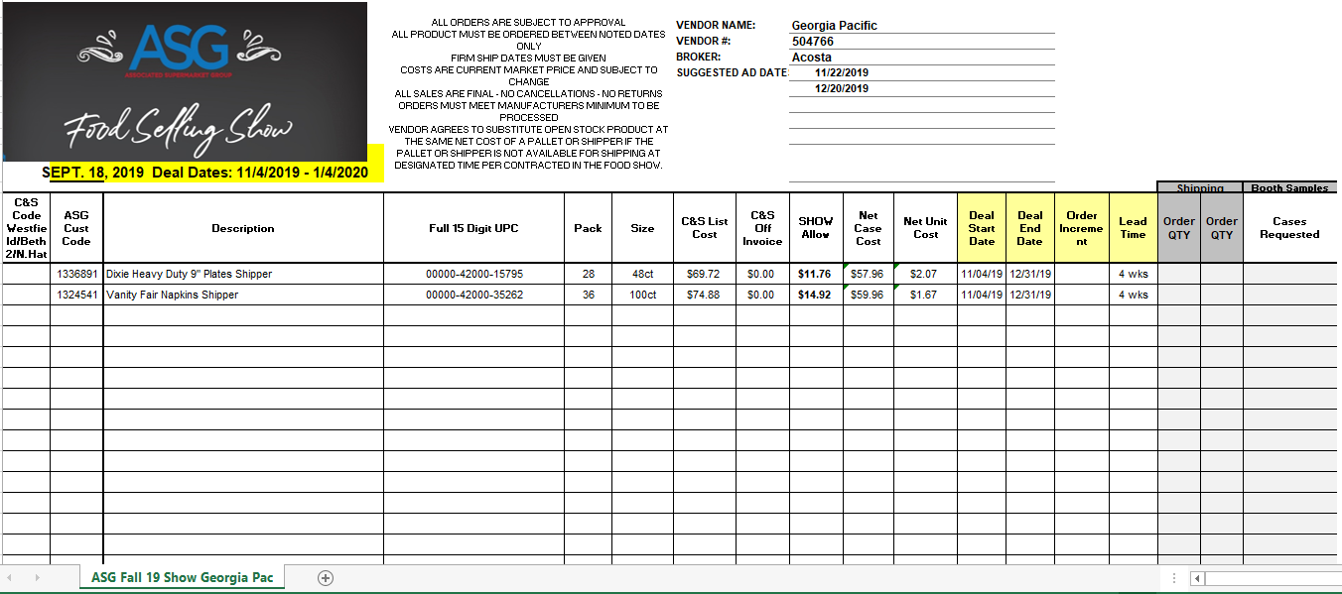
2
Show Allow: The amount being offered for the products purchased via the food show. The amount claimed on the customer invoice must match this amount.
ASG Cust Code, Description, Full 15 Digit UPC: The description and customer store code for the products the customer is being offered for the food show. This needs to match the customer invoice.
1

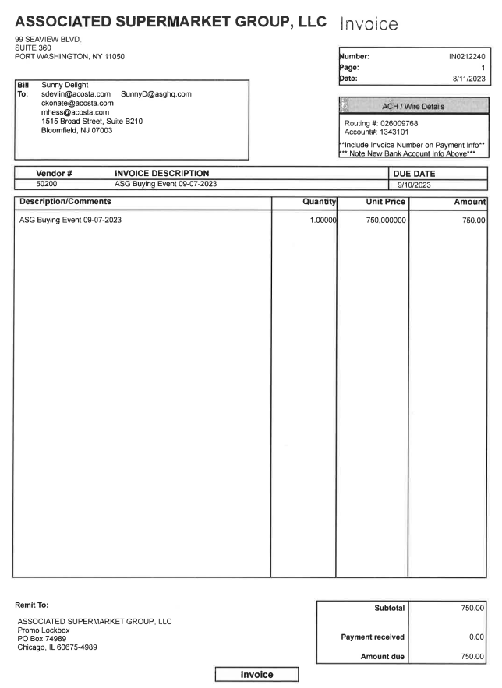
5.2 Customer check request for Food Show Booth Fee:
Description/Comments: ASG Buying Event indicates this is for Food Show Booth Fee.

5.3 Refer to the SOPs/Generic Help File for POP requirements.

6.1 Customer invoice for ASG Good Neighbor Program (Fairshare): Trade/Other

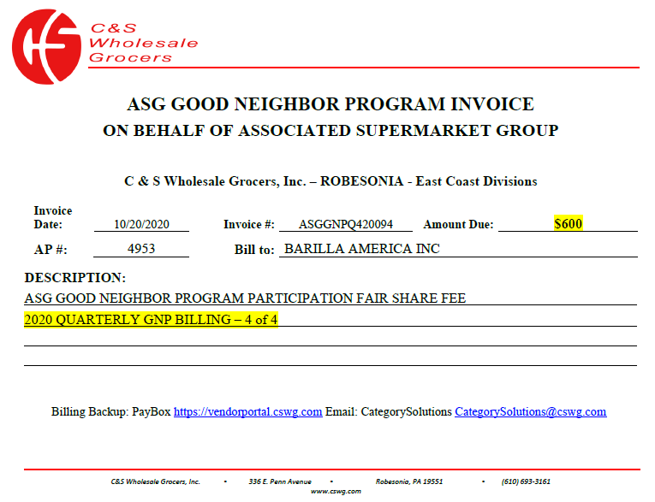
INVOICE #: Invoice number starting with ASGGNPQ indicates the claim is for ASG Good Neighbor Program (Fairshare)
i

6.2 Program agreement:

6.3 Refer to the SOPs/Generic Help File for POP requirements.

BPS TEAM INFORMATION

REPAY INFORMATION SECTION

- Repay requests for duplicate deductions must be submitted on the below form:
- Repay packages are sent to Jacqueline Campo - Jacqueline.campo@asghq.com and Gupreet Ahuja - gurpreet.ahuja@asghq.com.

PRS / CRA Client Specific

GEORGIA PACIFIC
- Repay packets should be sent to Lawrence Macchia (LMaccia@acosta.com) to be hand-delivered.

CCA CLEARING INFORMATION SPECIFIC

CCA Client Specific

GEORGIA PACIFIC
- This customer is planned with a blended rate, which means when clearing the rate may not match with the customer invoice.

HARVEST HILLS BEVERAGES SUNNY D COMPAY
- If the customer check request has items that are not present in the client system/client event # and the event has the same rate/brand name/pack size proceed with clearing.
- If the customer check request is noted as validating without a contract, proceed with requesting the check.
  - Step the claim to sales for the contract and note that the customer check request has been processed.
  - Once the contract is recieved attach it to the record in the clients system.

COMPLETE VERSION HISTORY
UPDATE DESCRIPTION | DATE |  | AUTHOR
First draft of the Associated Supermarket SOP |  | 04/29/2012 | Syed Ameenuddin
Reviewed by Geoffrey Van Syckle |  | 5/21/2012 | Geoffrey Van Syckle
Final update of flowcharts and definitions |  | 07/12/2012 | Sebin Paul
Final Trainer Review |  | 07/31/2012 | Geoffrey Van Syckle
Added IRI/Nielsen subscription info (pg 2) |  | 09/11/2012 | Mary Kay Dressman
Updated hyperlinks to deduction types |  | 09/16/2012 | Nagesh Kumar
Corrected POP in billback section  Added direct customer sign on info to help with pulling sales reports in ACOSTA RELAY  Added White Wave specific info – deduct vs ck request |  | 4/1/2013 | Michelle Roll
Have added an additional ad example for Compare with details on locating the Compare ads (2573 & 2711)  Added note about finding contracts under BU Docs |  | 4/29/2013 | Michelle Roll
Updated information on ad POP for Associated and Compare, page 7 (4367); added timeline requirement for check processing (4398) |  | 07/22/2013 | Suzy Fields
Added National PA Toolbox Exception information |  | 09/27/2013 | Suzy Fields
Added link to customer sign-on job aid (5675) |  | 10/04/2013 | Suzy Fields
Added info on ad fee increase (5437) |  | 10/28/2013 | Suzy Fields
Added ad location to 2.3 (5681) |  | 11/25/2013 | Suzy Fields
General edits, including instructions on finding UPC based on customer store code |  | 12/9/2013 | Suzy Fields
Added timeline clarification for checks to be cut before customer deducts (4398); updated info on contract generation (6651); added notes in Ad section clarifying Associated vs Compare ads (6655) |  | 1/20/2014 | Suzy Fields
Added instruction not to use Request Assist Customer Manager step to General Notes section (7728) |  | 3/31/2014 | Suzy Fields
Updated information on ad search criteria (8112)
Updated timeframe to pay before customer deducts, in all sections, to match header info for 60 days (10032); updated all references to search for: Event Scheduler |  | 9/3/2014 | Suzy Fields
Client specific section: added Ken’s POP for slotting (9616) |  | 9/29/2014 | Suzy Fields
Added note the Associated Supermarket is also called Associated Food Stores; added info regarding ad fees for Met/Pioneer/Metropolitan (11190) |  | 11/24/2014 | Suzy Fields
Updated general information regarding White Rose OIs due to White Rose’s bankruptcy and buyout by C&S (11341) |  | 12/3/2014 | Suzy Fields
Updated sign-ons for new C&S White Rose (11520) |  | 12/12/2014 | Suzy Fields
General Notes section: added information on finding Metropolitan Citymarkets ads (11747) |  | 1/5/2015 | Suzy Fields
Added Ads can be found online to customer specific section and ad section (12086) Added 2015 Metropolitan City Foods Ad contracts can be found by searching in promotions using event description Metro (11932) |  | 2/16/15 | Tracy Lewis
Added note for 2015 Metropolitan to customer specific section also updated ads are found under ZZASSGNY not ZZMETRNY (12458) |  | 3/2/15 | Tracy Lewis
Updated 2015 ads will no longer indexed under ADCLIENT to customer specific section (12583) |  | 3/16/15 | Tracy Lewis
Added customer is changing name to Associated Supermarket Group effective Q2 2015 (12828) |  | 3/30/15 | Tracy Lewis
Added this customer is a wholesaler/distributor, direct or indirect customer to customer sign-on box. (13429)  Added is Req CI from CIT used for this customer to BPS Team Info section (13772) |  | 4/27/15  5/25/15 | Tracy Lewis
Updated Ad website link in Customer specific section |  | 6/8/15 | Tracy Lewis
Added percentage breakdown for CL & SW for Starkist to Client section (13959) Added ad websites to ad POP section (14172) |  | 6/22/15 | Tracy Lewis
Added this customer will accept partial payments to Customer Specific section (14679) Added Michaels does not allow check payments for this customer to Client specific section (14869)  Updated line level detail in Customer Specific (15509)  Clean up and reorganization of information to new format structure & removal of out of date material (14730). |  | 8/31/15  10/26/15  12/21/15 | Tracy Lewis
Updated signon used for reports from CSWRNY to CSWHNE in signon box (16029) Added signons used for POP for Boulder Brands to Client Specific section (16101) |  | 01/18/16 | Tracy Lewis
Updated line level detail in Customer Specific (16702)  Removed Req Assist Customer Manager from Customer General section (17130) |  | 02/01/16  02/29/16 | Tracy Lewis
Added Shipment reports process for Nestle in Client Specifics section (17060) |  | 04/11/16 | Tracy Lewis
Added Clorox CCA Specific for clearing Ad funds (18477) Added GCC are not excluded from stepping to Sales for Clorox to Client Specifics (18482) |  | 06/20/16 | Tracy Lewis
Added percentage breakdown that can be used for Coke to the Client Specific section (18708)  Removed Boulder Brands client specifics (19016) |  | 07/18/16  08/01/16 | Tracy Lewis
Added Grocery specific for CCNA in Client Specific section (18381) |  | 07/18/16 | Tracy Lewis
Added Accrual/EDLP invoice example to Billback section (19169)  Removed extra contract copies and POP examples (19418) |  | 10/24/16 | Tracy Lewis
Added new Billback invoice example to Billback section and added information for spins to Customer General Info section (20810) |  | 03/13/17 | Tracy Lewis
Added GP clears to blended rate in BPS Team Info section (20186) Added lump sum breakdown for CCNA to Client Specific section (20644) |  | 04/10/17 | Tracy Lewis
Updated Nestle name to Nestle Nutrition_C-Store (21471); updated CIT to GCIT (21433) |  | 05/08/2017 | Suzy Fields
Customer General/Customer Invoice section: Added examples and explanation of CI format effective May 2017 (21756) |  | 6/19/2017 | Suzy Fields
Removed verbiage regarding locating contracts prior to 2013 as this timeframe is outside of the audit dates. Also removed 2014 information as it is general process (22561) ASG does not have a portal, changed Request CI from GCIT from Yes to No (22721) Added Colgate specific section to CCA Clearing Information regarding EFT checks (22680) |  | 10/9/2017 | Laurie Barber
Removed Nestle Nurtrition C-Store from client specifics section due to simplififed POP guidelines (22355) |  | 12/18/2017 | Laurie Barber
Updated hyperlinks for new Sharepoint Online (23751) |  | 01/29/2018 | Laurie Barber
Added new deduction type Retail Merchandising Program (23886) |  | 03/02/2018 | Laurie Barber
Removed POP Information from the Customer General Information section as ticket referenced in version history was not for spin information and this is incorrect (20810) |  | 04/23/2018 | Laurie Barber
Added Merchandising Agreement document – image and imbedded document (24506) |  | 5/21/2018 | Suzy Fields
Update to customer backup request information/realignment of information; no process change. |  | 8/13/2018 | Suzy Fields
Client Specific section: Removed White Wave (25874) |  | 9/28/2018 | Suzy Fields
Client Specific section: Added Coca Cola date flex info for ads (26358) |  | 2/25/2019 | Suzy Fields
Client Specific section: Removed Clorox as we no longer represent (28157) |  | 7/1/2019 | Suzy Fields
Client Specific section: Removed Starkist as we are no longer the broker effective 10.15.19 (28760) |  | 10/21/2019 | Suzy Fields
Created Backup Retrieval Section (28971) |  | 1/27/2020 | Suzy Fields
Client Specific section: Removed Colgate information as Acosta no longer represents (29496) |  | 2/24/2020 | Suzy Fields
Added Food Show section (29538) |  | 3/9/2020 | Suzy Fields
Added ASG Good Neighbor Program example to the Process Steps section (31360) Added ASG Good Neighbor Program info for Barilla to the Client Specific section (31361) |  | 1/25/2021 | Maria Ovalles
Added check request process for Harvest Hills Sunny D to the Client Specific and CCA info sections (31097) |  | 5/31/2021 | Maria Ovalles
Added Repay contact info to the BPS Team Info section (32559) |  | 8/23/2021 | Maria Ovalles
Added EFT payment info for Campbell to the Client Specific section (33516) Added check request info for Tata to the Client Specific section (33591) |  | 6/6/2022 | Maria Ovalles
Added Ferrero USA client-specific section. Acosta does not process ZZASSGNY check requests for Ferrero USA. (35238) |  | 7/31/2023 | Michael Huml
Added Nestle Coffee client-specific section: UPCs can be validated using spin report instead of contract. (35239) |  | 8/7/2023 | Michael Huml
Added Food Show Booth Fee invoice example. (35549) |  | 10/9/2023 | Michael Huml
Added additional repay instructions for Georgia Pacific. (35658) |  | 11/20/2023 | Michael Huml
Check remittance required for backup retrieval. (35899) |  | 1/8/2024 | Michael Huml
Added Georgia-Pacific client-specific section: added preclear process information. (36202) |  | 3/18/2024 | Michael Huml
Added ASG Repay Request form to repay section. (387397) |  | 5/27/2024 | Michael Huml
TATA client-specific – no check requests are to be processed. (386923) |  | 6/10/2024 | Michael Huml
Added JM Smucker Client Specific section regarding use of Fixed fee events |  | 7/15/2024 | Katy Dolan
Nestle Coffee client-specific: ASG invoices require C&S cover sheets for validation. (391042) |  | 7/22/2024 | Michael Huml
JM Smucker client-specific: ASG claims will have their own spin reports. (396445) |  | 9/16/2024 | Michael Huml
Updated BPS Team information section. Updated repay instructions. Updated repay contacts. (404612) |  | 10/28/2024 | Michael Huml
Updated repay contacts and uploaded revised repay form. (418779) |  | 03/24/2025 | Lindsay McGinnis
Removed pre-clear process specifically for Georgia Pacific from the client specific validation information. (424844) |  | 5/12/2025 | Lindsay McGinnis
Changed Michael’s to Michael Foods in the client specific section (425761). |  | 5/19/2025 | Lindsay McGinnis
Added customer check request information regarding client events numbers for Hostess product to the JM Smucker Client Specific Validation information section. (444999) |  | 11/3/2025 | Lindsay McGinnis
Replaced Repay Letter form for duplicate payments with new revised form. (459765) |  | 2/23/2026 | Lindsay McGinnis
Removed Michael Foods from the Client Specific Validation information section as we no longer handle this customer. (467684) |  | 5/11/2026 | Lindsay McGinnis
Updated client specific information for CCNA and removed breakdown for discontinued items (468685). |  | 5/18/2026 | Lindsay McGinnis
Updated client specific information for CCNA and removed breakdown for discontinued items (468685). |  | 6/15/2026 | Lindsay McGinnis

