WORK INSTRUCTIONS
Process | Order to Cash
DTP Name | BROOKSHIRE GROCERY CO. - Claims Validation Documents

CURRENT VERSION HISTORY
 | UPDATE DESCRIPTION | DATE |  | AUTHOR
Added Retail Merchandising Info for Beiersdorf in Client Specific Section (467295). |  |  | 05/04/2026 |  | Dawn Regan

Link to complete version history: Complete Version History

DEDUCTION TYPES COVERED

Sl. No. | Deduction Type
 | Customer General Information
 | Backup Retrieval Information
 | Client Specific
1 | Off Invoice
2 | Billback
3 | Scan
4 | Warehouse Withdrawal / Count Recount
5 | AD
6 | Slotting
7 | Post Audit
8 | Returns
9 | Shortages
10 | Reclamation
11 | Price Protection
12 | Retail Merchandising Program (Fair Share)
13 | In Store Promotion
 | BPS Specific Information
Is the customer a wholesaler/distributor, direct or indirect customer? Direct

Note: BROODA is the Sign-on used to work on Acosta Relay (for example to search a document and to refer to the customer on Acosta Relay).

Brookshire Grocery is not in any way related to Brookshire Brothers; they are two completely different customers.

Link to customer sign on job aid:
https://acostaonline.sharepoint.com/sites/AS_Reporting/Claims_Reports/Forms/AllItems.aspx?web=1

Does this customer subscribe to IRI/Nielsen for price point verification? No

CUSTOMER GENERAL INFORMATION

Customer Invoice Info:

Is line level detail indexed on the customer’s documentation (customer invoice, customer check request, unsaleable/spoils, post audit, EDI 812/820) or client deduction notice if one of these documents is included? YES

- For the Brookshire Grocery Customer, the Customer Invoice and Contract will be same for many of their deductions (claims where they have to bill the Client back for monies offered – Billbacks – Ads – Slotting). The Customer Invoice will be searched under Back UP Documentation and the Customer Contract will be available under Event Scheduler. There will be no dollar amount available to use in the Search Screen since we are using the Customer Contract as the Customer Invoice as well.
- If an invoice says ‘pricing error’ it could be for many things – list cost pricing, promotional allowances or freight discrepancies.
- All promotional deduction invoices reference the customer’s SAP portal processed check stub. The number in the first column is an internal number which is unnecessary to a CRA. Be sure to look at the check stub to make sure the invoice number on the claim is correct.
- We do not receive actual customer invoices for billback claims, lump sum ads, slotting, missed deals or price protection. The processed (accepted/approved) SAP documents serve as invoices for these types of deductions.
  - With the exception of billback claims, all of these will be in the form of lump sums.
  - It will be necessary to back into billback claims.
    - Divide the amount deducted by the billback rate on the SAP deal sheet to determine the number of cases being billed.
- Fair Share (retail merchandising) invoices may have a pre of “FS”.
- Po related/Invoice Reduction Notifications (IRN) for payment differences is mailed to the client the same day and the customer will not provide additional backup.
- Price changes require 60 days notice and approval per document:

Contract Info:

- Using the date ranges found on the Customer Invoice will help to narrow down the Event Scheduler search results.
- The “Deal Number” can sometimes be used in the Customer Event # field of the Search Screen to aid in finding the Customer Contract. NOTE: The Deal Number is not always loaded into this field by the sales team, so if the Customer Contract is not found by using this number in the Customer Event # field, you will need to refine the search.
- All contracts are done in the customer’s web SAP portal, and when accepted, the processed SAP deal is sent to the BMA to link to the VPF.
- All deals are contracted to this customer in ORDER DATES.

POP Info:
- The validity dates on the customer’s processed SAP document are the order dates for the promotion, so sales analysis reports can be based on these dates.
- Ads may be found in Feature Vision.

Other General Info:

- If Brookshire Grocery acknowledges that a repay is due to the client, the invoice will show this repayment. The repay line will have to be split from the valid claim amount, however, this line will be closed with a note stating that Brookshire Grocery repaid on the same check as the deduction. No repay letter is needed. The check remit must be attached to the claim as proof the amount was repaid.
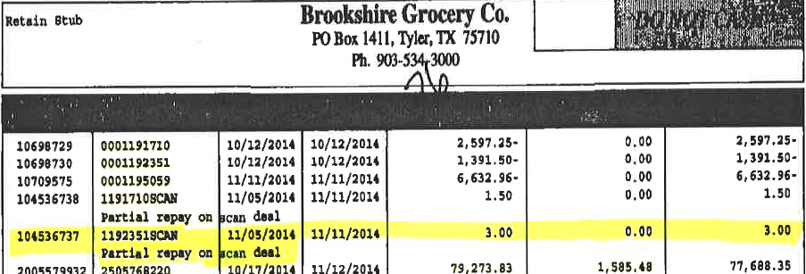

BACKUP RETRIEVAL INFORMATION

GENERAL BACKUP RETRIEVAL INFORMATION

Is GCIT responsible for obtaining backup from the customer? Yes
- If yes, is there a customer portal? No
- If yes, does GCIT request backup? Yes

Is check remittance information required to request backup? Yes

- CP Invoices that are under $100.00 will not be provided
- IRN invoices(PO Related) please refer to Customer General Information section for additional information. The invoices are requested from the client.

GCIT SPECIFIC BACKUP RETRIEVAL INFORMATION

Portal:

DG | IRC portal

Automated:

All Formats except:  DG, CP & ATG | Step to Sales
ATG | bgc@atgaudits.com
CP | vickiemitchell@brookshires.com

CLIENT SPECIFIC VALIDATION

Beiersdorf Inc.
Just Born
Mars Food
Mezzetta
Procter and Gamble Core

BEIERSDORF INC.
- Markdowns are coded as trade and cleared to event 25SEO001.
- When searching for events on the event detail report, please use customer SouthWest A/O filter in column C.
- 2026 Retail Merchandising Program – Reset: clear to Event # N26SEO008 and select all (Brand/Category).

JUST BORN
- Fair Share claims cleared to an event # provided by Sales and coded as Trade-Other.

MEZZETTA
- Acosta does not represent any downstream customers in Texas or New Mexico.

MARS FOODS
- This customer is part of the Mars Retail Merchandising Program.

PROCTER and GAMBLE CORE
- Fair Share claims code as Trade -Other to go on the Closed Claim Feed. A DBW is required. The performance dates will be the full month of the billing (ie.January 2020 is 1/1/20 thur 1/31/20). A contract is needed which contains the breakdown by event #.
- Family Care, Home Care and Fabric Care clims are not handled by Acosta step to Unknown/not Acosta/Closed.

PROCESS STEPS

1. Deduction Type: Off Invoice

A per-case off invoice allowance is given to the customer as an automatic discount for product purchased from the client. If the customer does not receive the allowance off the face of the invoice they will deduct for it. If the customer requested an allowance that is not valid, the CSC will send a notification to the customer in writing. Customers view purchase orders as contracts. If they are not notified of allowance discrepancies, they will pay according to their purchase order total.

1.1 Customer Invoice for Off Invoice: example 1
Page 1
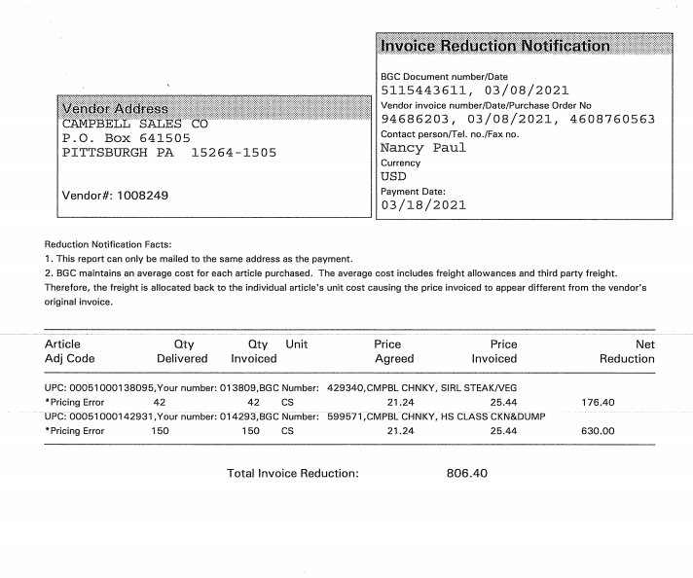
Net Reduction – Listed is the amount which the customer has deducted as part of the Off Invoice due. In this case the deduction amount is $176.40
Difference between the price invoiced and price agreed provides OI allowance rate. PI – PA = OI rate ($4.20 x 42 cases)
This indicates the Client’s Invoice number, Client invoice date & PO number. The PO number will be used to search Client Order Invoice within ACOSTA RELAY. This data is needed to validate if the particular product was ordered and invoiced with the off invoice allowance.
E.g.: In this case the PO # is 4603257037
This number was used as the Customer’s reference number on the claim and can be used to search for the Customer’s Invoice.
This indicates the difference amount between the price agreed and price invoiced. Please see note below
UPC Code – The Universal Product Code (UPC) is 5 digits from the last number (Excluding last digit). Customer is using the Package Code versus the actual Product Code.
This code is used to validate key data elements regarding the Customer Invoice and Client Order Invoice on the Review Order/View Document link within Acosta Relay. This is the product in which the customer is stating that there is an off invoice allowance due.
E.g.: In this case the UPC “Package Code” is the one highlighted in red 00014800001150. We will need to find the Product Code to verify product on the Client Order Invoice – 00117.

NOTE: “Pricing Error” will indicate for three below reasons:
- Off Invoice not given (Price Invoiced ($25.44) – Price Agreed ($21.24) = Off Invoice rate ($4.20) – This scenario would be considered Trade. Before considering the deduction to be a Non Trade type of claim, we need to exhaust all possibilities by thoroughly reviewing the Customer’s Purchase Order provided, the Client Order Invoice provided, and offers made on the Customer Contract.
- List Cost Pricing difference which will be treated as Non Trade
- Freight Adjustment due – This scenario would be considered Non Trade

  - Customer Contract for Off Invoice:
Page 2 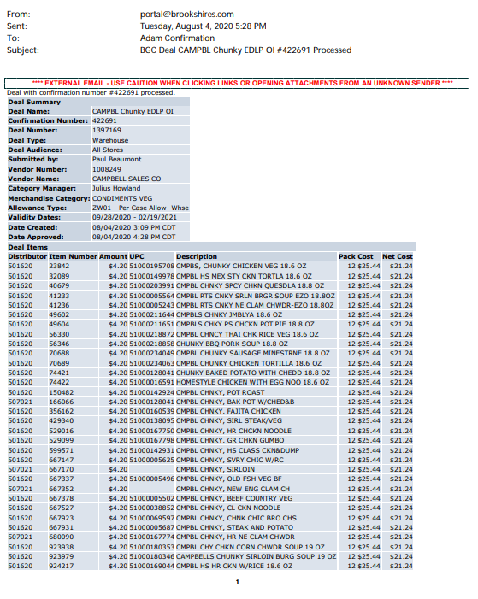
UPC: This is the “Package” UPC and should match the “Package” UPC found on the Customer Invoice.

Off Invoice Amount: This indicates the difference amount between the price agreed and price invoiced.

Code – “ZW01” represents this is for an Off Invoice allowance.
Validity dates – These dates can be used to search for the Customer Contract and to run the POP (Order Dates).

This Deal Number may help with the Event Scheduler search by placing this number in the Customer Event # field.

Refer to the SOPs/Generic Help File for POP requirements

2. Deduction Type: Billback

A Billback claim is a per-case allowance offered for a specific performance requirement.
A per case billback allowance is claimed by the direct buying customer for product purchased from the client, or by the indirect customer for product purchased from the direct customer. This is an allowance the customer will bill the client for. This is not an automatic discount given off the face of the invoice.

2.1 Customer Invoice for Billback: example 1
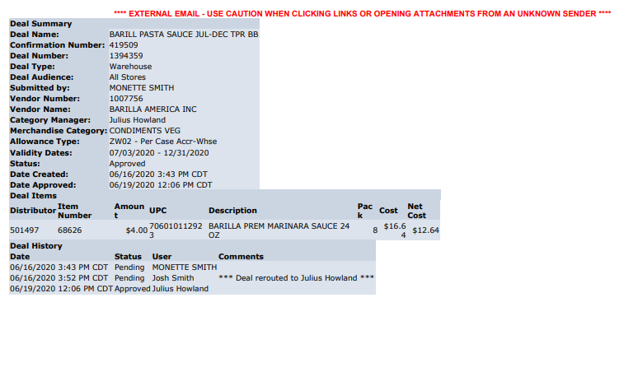
Item Number – This is the code the customer has assigned to the product.
This is an example of the “Customer Invoice” being the same document as the “Customer Contract”. In this example, the claim is for a “Billback” allowance being offered to the customer.

NOTE: When these customer invoices are indexed, they will have no dollar amount entered, therefore, if you search using the “deal number” in the Customer Reference # field, and show the amount as 0.00, you should be able to locate the customer invoice. ALSO, some clients will place leading zeros in front of the deal number when listing on the check remittance. These customer invoices are indexed with “no” leading zeros, therefore, we need to keep this in mind when searching as we may need to use our wild card (%) when doing our search to find the customer invoice.
Billback allowance – This is the rate per case Billback allowance amount.

UPC Code – The Universal Product Code (UPC) is 5 digits from the last number – Excluding the last digit. This code is used to validate key data elements regarding the customer invoice and client order invoice on the Review Order screen/view document link within Acosta Relay. This is the product in which the customer is stating that there is a Billback allowance due.
E.g.: In this case the UPC is the one highlighted in red
71100003079.

Validity dates - These dates can be used to search for the Customer Contract and to run the POP (Order Dates).
This Deal Number may help with the Event Scheduler search by placing this number in the Customer Event # field.
Code – “ZW02” represents Billback allowance.
UPC Code – The Universal Product Code (UPC) is 5 digits from the last number – Excluding the last digit. This code is used to validate key data elements regarding the Customer Invoice and Client Order Invoice on the Review Order screen/View Document link within ACOSTA RELAY. This is the product in which the customer is stating that there is a Billback allowance due.
E.g.: In this case the UPC is the one highlighted in red
71100003079.

Billback allowance – This is the rate per case Billback allowance amount.

Validity dates – These dates can be used to search for the Customer Contract and to run POP (Order Dates).

2.2 Customer Contract for Billback:

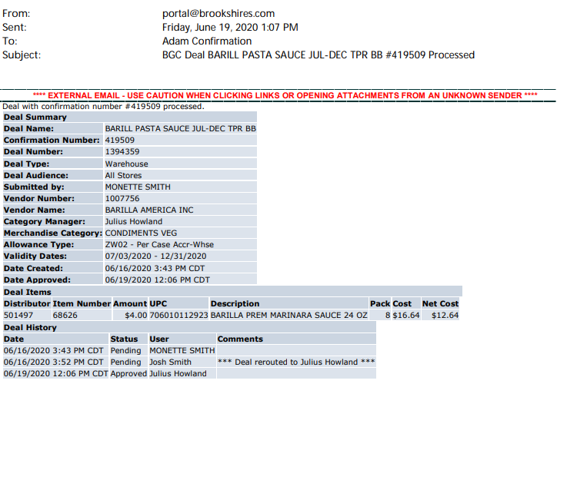
Item Number – This is the code the customer has assigned to the product.

Billback allowance – This is the rate per case Billback allowance amount.

UPC Code – The Universal Product Code (UPC) is 5 digits from the last number – Excluding the last digit. This code is used to validate key data elements regarding the customer invoice and client order invoice on the Review Order screen/view document link within Acosta Relay. This is the product in which the customer is stating that there is a Billback allowance due.
E.g.: In this case the UPC is the one highlighted in red
71100003079.

Allowance Type – “ZW02” represents Billback allowance.
Validity dates - These dates can be used to search for the Customer Contract and to run the POP (Order Dates).
This Deal Number may help with the Event Scheduler search by placing this number in the Customer Event # field.

Refer to the SOPs/Generic Help File for POP requirements

3. Deduction Type: Scan

Scan allowances are for product scanned at the store register and are usually billed in eaches, not cases.
The customer should not be referencing a purchase order on a scan allowance.

3.1 Customer Invoice for Scan:

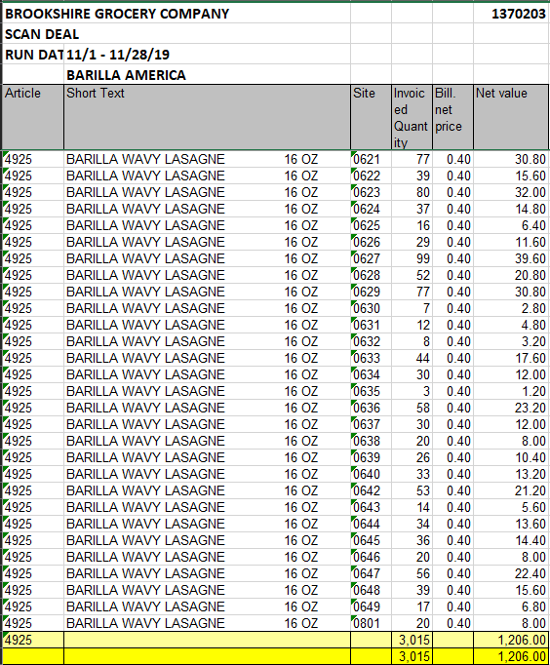
Total units being billed
Net Value is the extended amount per item with the total being billed.

Billed net price= per unit rate for scan

Customer Reference number, this is also the Event Scheduler Customer Event #

Invoiced Quantity= the quantity of units being billed
Scan Deal-this is for a Scan promotion
Run Date=promotion dates
Article=Brookshire’s Grocery store code number

Short Text=Product description and size

3.1 Contract for Scan:

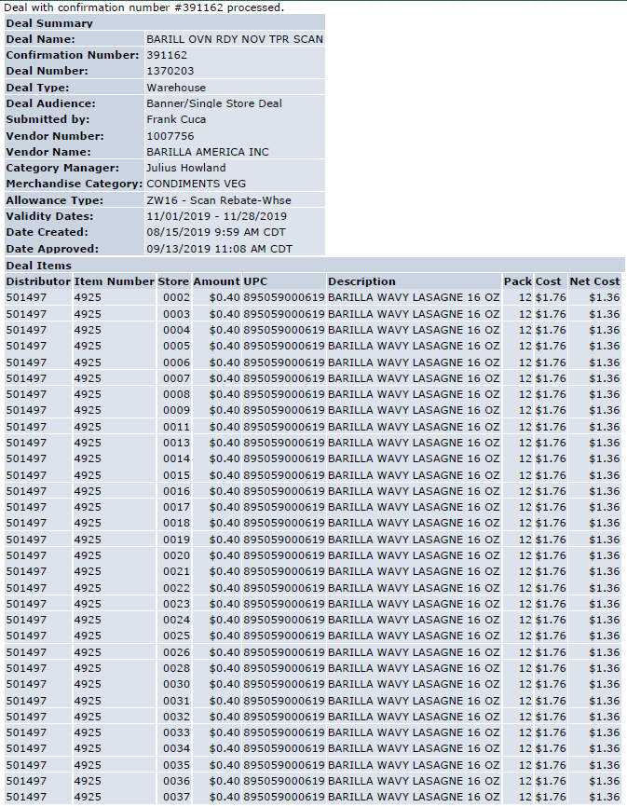
UPC=12 digit case UPC
Description=Product description and size
Pack=the units per case
Amount=the per unit scan rate offered
Item Number=Brookshires’s Grocery Store code number
Allowance Type=Scan
Validity Dates=Promotion Dates
The Deal Number is the same as the customer reference number and Event Scheduler Customer Event #

3.2 Customer Invoice for Scan:
Example # 1 Page 1
“Scan Deal” means that this is for a scan.

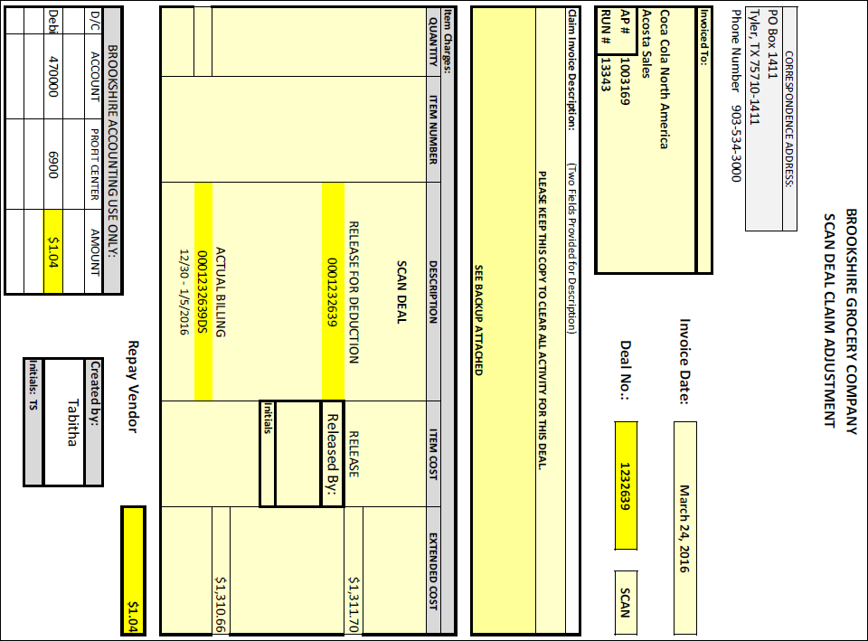
This is the Customer Reference Number and can assist us in finding the Customer Invoice in the Search Screen.

In this Scan example, we see a “Repay Vendor” positive amount. This was derived by taking the “Release for Deduction” amount $1,311.70, then subtract the “Actual Billing” amount $1,310.66 and it leaves a balance of $1.04 which the customer is repaying back to the Client.

If the claim comes in at the Actual Billing amount ($1,310.66), the Repay Vendor amount has already been considered and will not be a part of your claim. When the DBW is worked up using the additional back up to support the claim, the total on the DBW will match the total of the claim.

If the claim comes in at the Release amount ($1,311.70), we would validate the Actual Billing amount ($1,310.66). Enter the amount of the repay as an adjustment (ADJUSTME) on to the DBW as a negative amount.

Review the client SOP to determine if they can process negative lines. If the client allows negative lines, enter the Repay Vendor amount ($14.20) as a separate claim line and code as UNK - UNK - CCA with a line note stating this amount was repaid to the client on same check as the deduction was taken. If the client does not allow negative lines, merge the repay amount into the largest line on the claim. (The repay process does not need to be followed since the amount involved has already been repaid to the client.)

The dates found here should fall within the dates on the Customer Contract. These dates will also assist us when searching for the Customer Contract under Promotions.
This highlighted amount (the Release for Deduction) typically will be the amount of your claim, however, when the DBW is worked up based on the additional support found on the next pages, the total amount of the DBW will come out to this amount (Actual Billing amount).

This is because the customer has realized they owe the client monies which listed in the Repay Vendor area.

If we take this total (DBW total) and add what the customer shows they are repaying to the client, we get the amount that appears in the Release for Deduction area (our claim amount).

NOTE: For a Scan Deduction, if the “Release for Deduction” amount and the “Actual Billing” amount are exactly the same, we will not see this cover page as part of the Customer Invoice. We will only see what appears on this page and should work the claim from this page.

Example 1 - Page 2
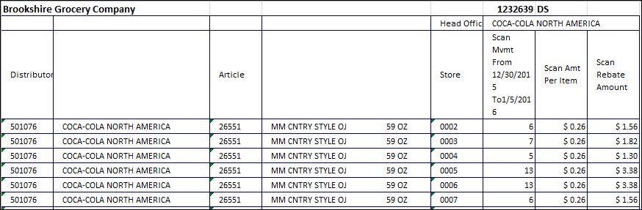
Qty and Scan rate: This column represents the Qty and Scan rate per store location.
Code – This is the “Item number” on the Customer Invoice. This code is assigned by the customer for the item being purchased. We should be able to find this number on the Customer Contract along with the correlating UPC.
In this case, the Item number is 26551.

Example 1 - Page 2 Continued
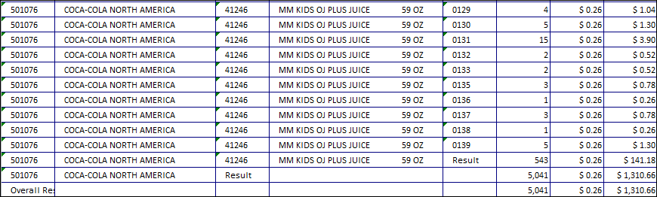
Grand Total – This highlighted area is the total of the entire Customer Invoice – Rate x Qty per store location = Grand Total of claim amount less the amount in the Repay Vendor area of the Customer Invoice. ($1,310.66)

3.2 Customer Contract for Scan:
Page 1
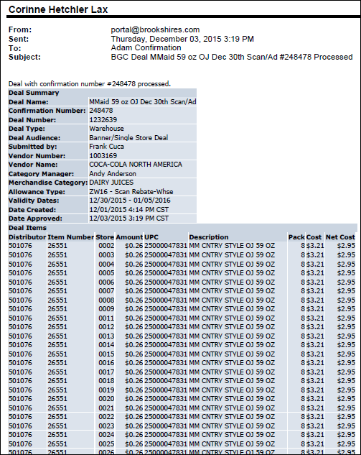
Code – This “Item number “can also be found on the Customer Invoice. This code is used to find the UPC number, which corresponds to this number.
In this case, the Item number is 26551.
Scan per unit – The highlighted rate has been approved for the Scan deduction. It should match with the Customer Invoice.

UPC/Product: The UPC codes and item description for which product is being billed. It should match with the product description mentioned on the Customer Invoice. In this example, UPC is 047831.
.
Code – “ZW16” represents a Scan allowance offer.
Validity dates – These dates can be used to search for a Customer Contract and also to run the POP – Sales Summary Report (Order Dates).

This Deal Number may help with the Event Scheduler search by placing this number in the Customer Event # field.

Page 2
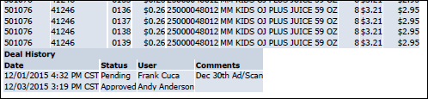
Comments – Read the additional comments for information about the promotion. An ad should have been ran per the comment on this contract.

Refer to the SOPs/Generic Help File for POP requirements

3.3 Customer Invoice for Scan:
Example # 2
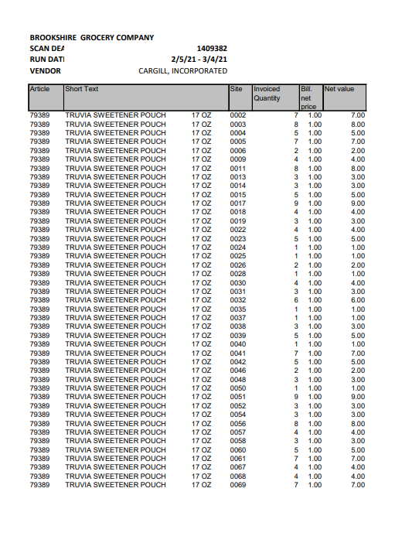
Qty and Scan rate: This column represents the Qty and Scan rate per store location.

3.3 Customer Invoice for Scan:
Example # 3 Page 1
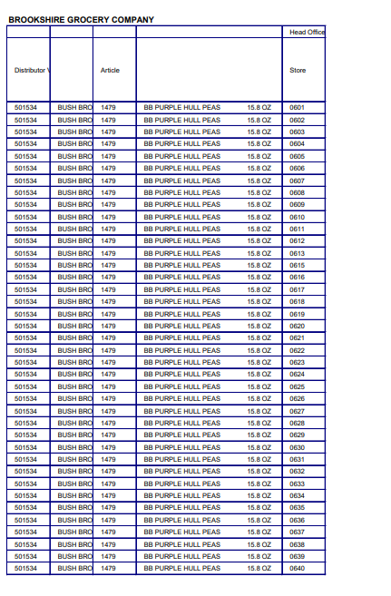

Customer Invoice for Scan:
Example 3 - Page 2
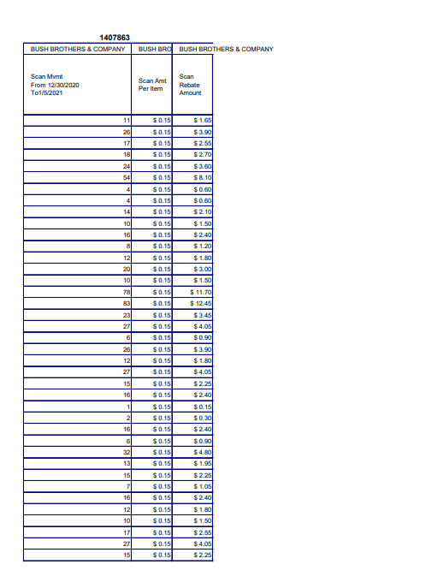
Qty and Scan rate: This column represents the Qty and Scan rate per store location.

NOTE: As with the prior examples, typically we would run a Sales Summary to make sure enough units were purchased to cover what the customer deducted for.
Grand Total: This represents the last page of the Customer Invoice which gives us the total being claimed by the customer. In this example, $6,141.30.

4. Deduction Type: Count-Recount
Warehouse Withdrawal/Count Recount is for cases shipped to stores from the main customer’s warehouse.

4.1 Customer Invoice for Count-Recount:

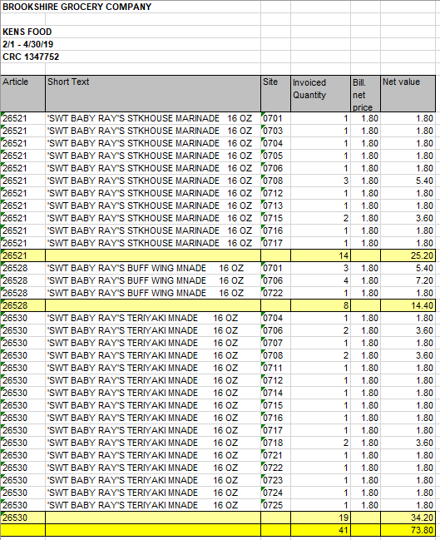
Customer Reference number, this is also the Event Scheduler Customer Event #
CRC =Count/Recount
Invoice Quantity=cases being billed for Count/Recount
Article=Brookshire’s Grocery store code number

Short Text=Product description and size

Amount being billed for Count/ Re-Count
Total quantity and dollar amount being billed

Promotion Dates

4.1 Customer Contract for Count-Recount:

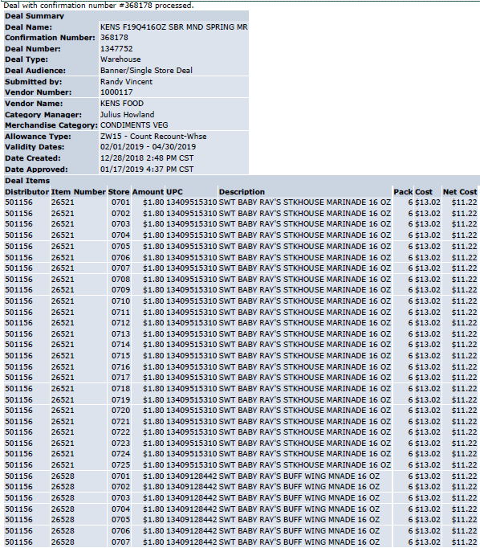
UPC=the 11 digit case UPC
Description=Product description and size
Amount=offered for Count/ Re-Count
Allowance Type=Count/Recount
Validity Dates=Promotion Dates
Item Number=Brookshire’s Grocery store code number

The Deal Number is the same as the customer reference number and Event Scheduler Customer Event #

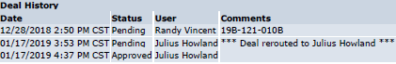
Refer to the SOPs/Generic Help File for POP requirements
5 Deduction Type: Ad

A fee for featuring a client's products in an advertisement.

5.1 Customer Invoice and contract for Ad: Example #1
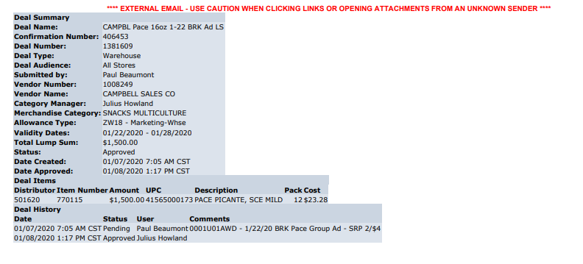
Performance date – This is the requirement for the Ad. In this example, the Ad must run between the dates mentioned.
Amount – This area would indicate the Lump Sum Fund approved for the Advertisement of the product.
This amount needs to be matched with the Customer Contract.

UPC: These are the items the Ad needs to cover. The UPC’s provided are actually the “Package” codes. We will need to find the corresponding “Product” UPC to validate the claim.

Validity dates – These dates can be used to search for the Customer Contract and also the Ad copy.

This Deal Number may help with the Promotion search by placing this number in the Customer Event # field.
Code – “ZW17” represents this is for an Ad allowance.

This is an example of the “Customer Invoice” being the same document as the “Customer Contract”. In this example, the claim is for an “Ad” allowance being offered to the customer.
NOTE: When these customer invoices are indexed, they will have no dollar amount entered, therefore, if you search using the “deal number” in the Customer Reference # field, and show the amount as 0.00, you should be able to locate the customer invoice. ALSO, some clients will place leading zeros in front of the deal number when listing on the check remittance. These customer invoices are indexed with “no” leading zeros, therefore, we need to keep this in mind when searching as we may need to use our wild card (%) when doing our search to find the customer invoice.

Refer to the SOPs/Generic Help File for POP requirements

5.1 Customer Invoice & contract for Ad: Example #2
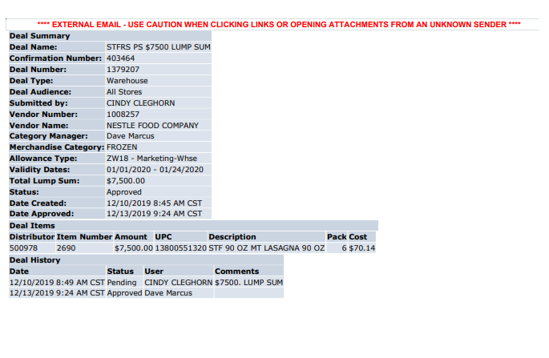
UPC: These are the items the Ad needs to cover. The UPC’s provided are actually the “Package” codes. We will need to find the corresponding “Product” UPC to validate the claim.

Amount – This area would indicate the Lump Sum Fund approved for the Advertisement of the product.
This amount needs to be matched with the Customer Contract.

Validity dates – These dates can be used to search for the Customer Contract and also the Ad copy.

Code – “ZW18” represents an Ad allowance.
This Deal Number may help with the Promotion search by placing this number in the Customer Event # field.

6. Deduction Type: Slotting

A slotting allowance is offered to the customer to purchase an item not currently stocked. A slotting lump sum allowance can be offered for each item and/or an off invoice can be offered as an introductory allowance for the first 30 days.

6.1 Customer Invoice and Contract for Slotting:

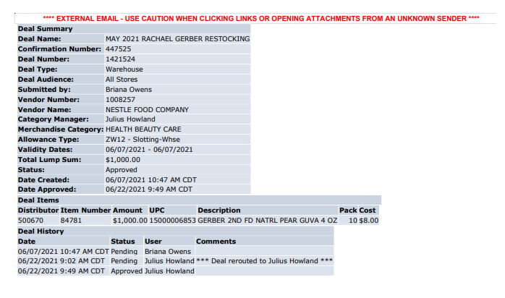
UPC=11 digit case UPC code
Description= Product description and size

Amount = amount offered for Slotting per UPC.
Item Number: customers store code number

Allowance Type= Slotting

Validity Dates=Date the promotion was offered but does not indicate they have to buy on that date.

Total Lump Sum=Total amount being offered for Slotting
The Deal Number is the same as the customer reference number and Event Scheduler Customer Event #

Customer Invoice for Slotting:

Example #2:
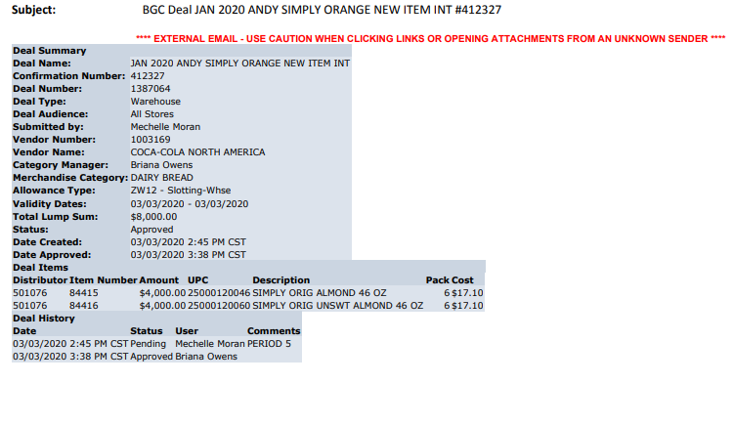
Amount: This column indicates a lump sum is being offered for Slotting.
UPC Code & description – The highlighted UPC and product description needs to be validated against the Customer Invoice.

Validity dates– In this particular example, this date has no significance which is why the date shows start and stop as same date.
Total Lump Sum: amount offered for Slotting.

This Deal Number may help with the Event Scheduler search by placing this number in the Customer Event # field.
Code – “ZW03” represents this is for a Slotting allowance.

Refer to the SOPs/Generic Help File for POP requirements
7. Deduction Type: Post Audit:

NOTE: The post audit claim must first be researched to ensure the customer has not already billed for the allowance before the normal validation process can begin.

Once the post audit claim has been researched to ensure the customer has not already billed for the allowance refer to the appropriate allowance section of the SOP to continue with validation. If the post audit is for an allowance not defined in an allowance section of the SOP refer to the post audit example for validation information.

Internal/external auditors find claims that the customer is entitled to but did not take from previous years. Post Audits should be researched in the same manner as other claims by accessing previous year’s files.

Identification – The email address of the auditor (btc@atgaudits.com) indicates that the claim is for a Post Audit.

Also, a reference number including ATG indicates the invoice is a Post Audit.

7.1 Customer Invoice for Post Audit: Example 1
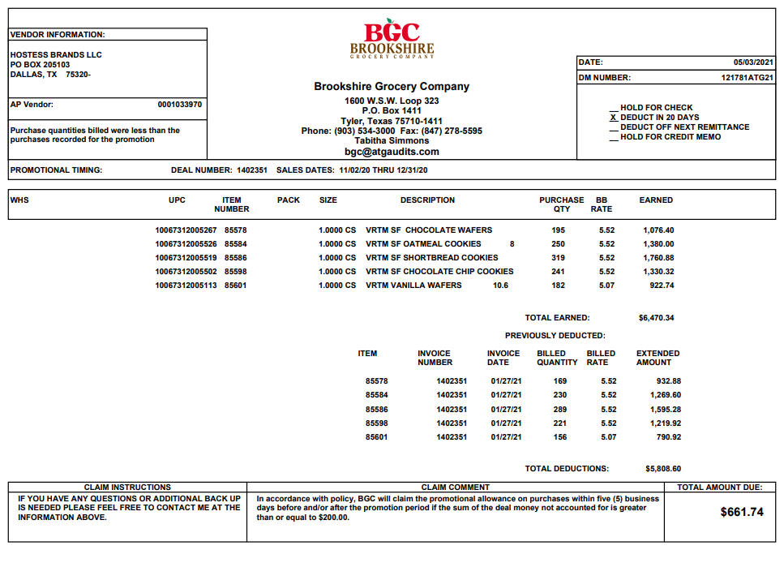
In this example the Promotional dates referenced on this page are for 11/2/20-12/31/20
This post audit example for a Billback. Please refer to the Billback section for validation requirements.

7.2 Customer Invoice for Post Audit: Example 2

In this example the Promotional dates referenced on this page are for 01/08/21-02/11/21
This post audit example for an OI. Please refer to the OI section for validation requirements.
Identification – The email address of the auditor (btc@atgaudits.com) indicates that the claim is for a Post Audit.

Also, a reference number including ATG indicates the invoice is a Post Audit.

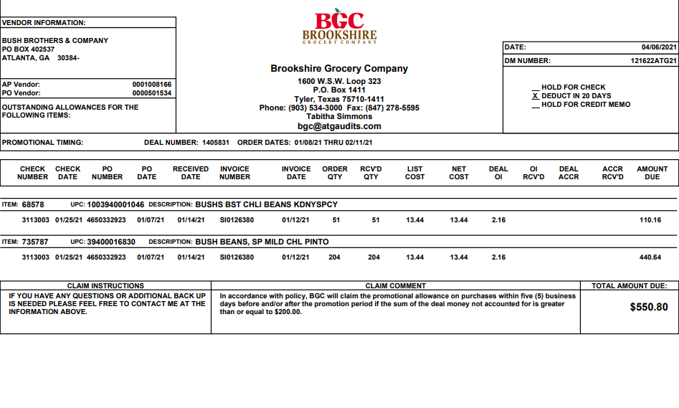

8. Deduction Type: Returns

Products returned by the customer to the client.

Document Name | Source of the Document | Action by Accenture
Customer Invoice | Acosta Relay – search for the invoice under Backup Documentation, document type 2. | Step up the claim to Acosta for research
Client Order Invoice | Acosta Relay – search for this document within the Order/Invoice/PO search if one is present.

8.1 Customer Invoice for Returns: Example 1
Identification – The phrase “Procurement Claim Form” indicates the Customer Invoice pertains to a Returns deduction.

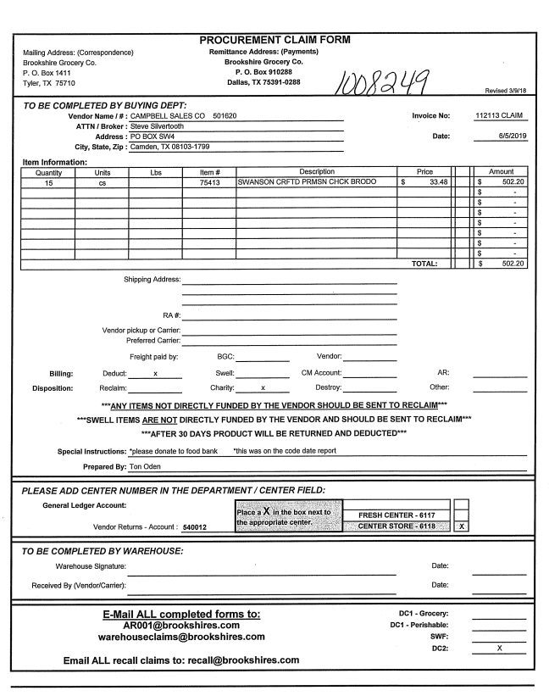

Identification – The phrase “Procurement Claim Form” indicates the Customer Invoice pertains to a Returns deduction.

8.2 Customer Invoice for Returns: Example 2

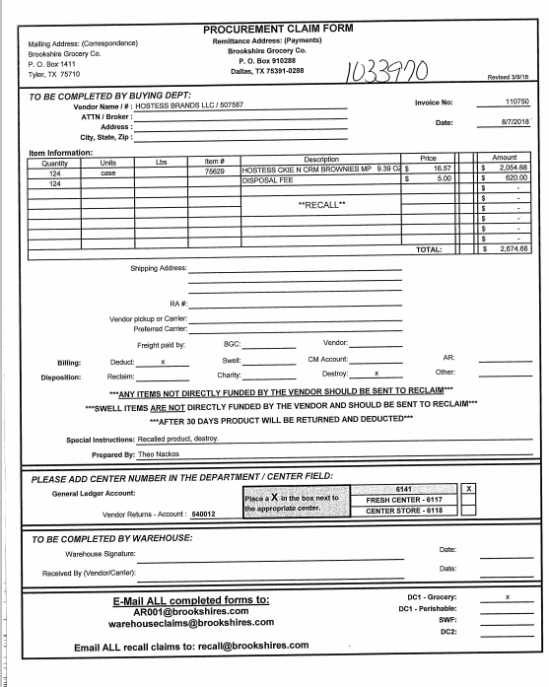
Note: Returns is a non-trade deduction and all non-trade deductions would be stepped to Acosta

For quantity & price

9. Deduction Type: Shortage

It is a deduction for shorted product on an order that the client billed the customer for.

Documents required for validating a Shortages Deduction:

Document Name | Source of the Document | Action by Accenture
Customer Invoice | Acosta Relay – search for the invoice under Backup Documentation, document type 2. | Step up the claim to Acosta for research
Order Invoice or Client Order Invoice | Acosta Relay – search for this document within the Order/Invoice/PO search.

9.1 Customer Invoice for Shortages: Example 1

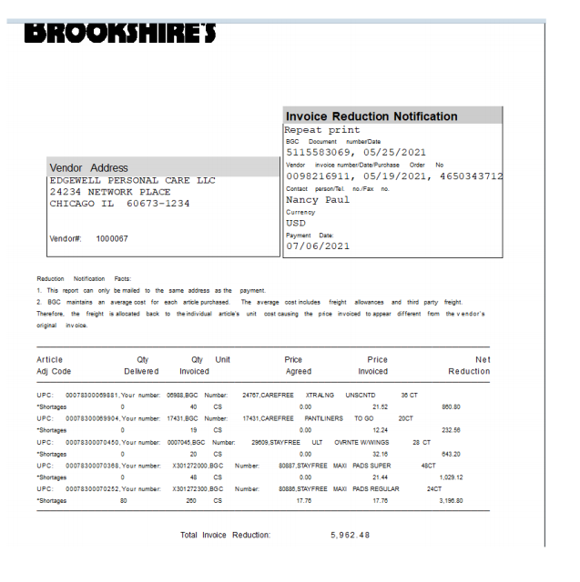
Note: Shortage is a non-trade deduction and all non-trade deductions would be stepped to Acosta

For quantity & price
Identification – The word “Shortage” indicates that the Customer Invoice pertains to a Shortage deduction.

This indicates the invoice number, invoice date & PO number. This will be used to search for information regarding the Client Order Invoice within Acosta Relay. This data is needed to validate if the particular product was ordered and invoiced.
E.g.: In this case the PO # is 4650343712

10. Deduction Type: Reclamation

Document Name | Source of the Document | Action by Accenture
Customer Invoice | Acosta Relay – search for the invoice under Backup Documentation, document type 2. | Step up the claim to Acosta for research
Client Order Invoice | Acosta Relay – search for this document within the Order/Invoice/PO search if one is present.

10.1 Customer Invoice for reclamation: example 1
Page 1
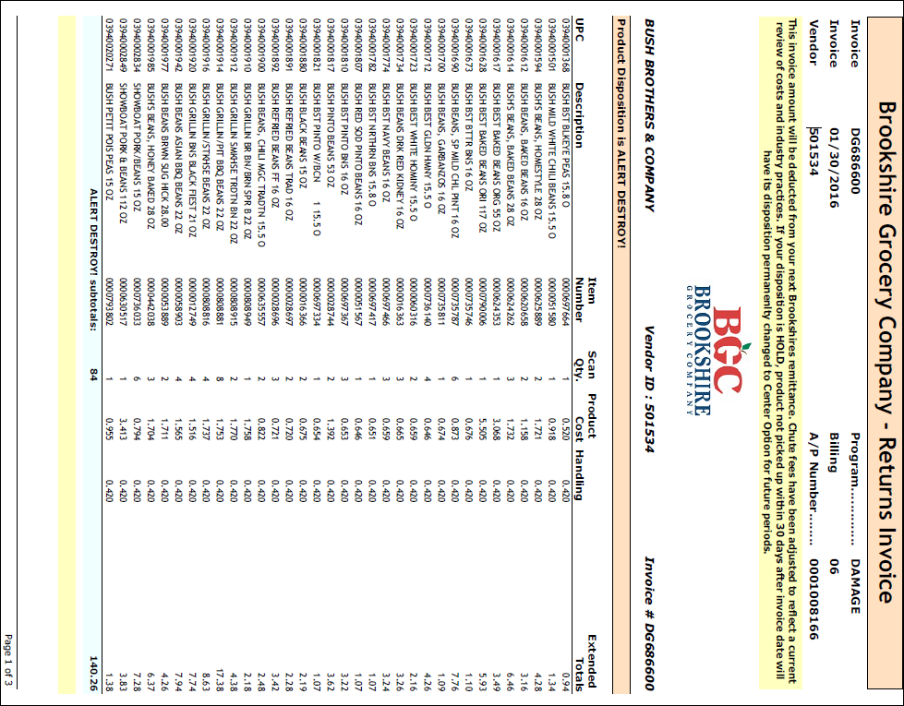
Identification – The letters “DG” indicate this Customer Invoice is for damaged goods - (Reclamation, Spoils, Damaged, and Unsaleables)

11.1 Customer Invoice for Price Protection:
This Deal Number may help with the Event Scheduler search by placing this number in the Customer Event # field.

This is an example of the “Customer Invoice” being the same document as the “Customer Contract”. In this example, the claim is for a “Price Protection” allowance being offered to the customer.
NOTE: When these customer invoices are indexed, they will have no dollar amount entered, therefore, if you search using the “deal number” in the Customer Reference # field, and show the amount as 0.00, you should be able to locate the customer invoice. ALSO, some clients will place leading zeros in front of the deal number when listing on the check remittance. These customer invoices are indexed with “no” leading zeros, therefore, we need to keep this in mind when searching as we may need to use our wild card (%) when doing our search to find the customer invoice.

These dates are customer portal dates only. These dates cannot be used to search for contracts or any type of POP. This information should be found in the comments section.
This states the reason the Customer Invoice has been issued. To figure out the cases involved, we would need to find the Purchase Order mentioned on the Customer Invoice and Customer Contract. Once found, view the Client Order Invoice for the items mentioned that should receive the Price Protection.

In this example, there are two items that total to 210 cases. If we take the total amount due ($806.40) and divide that by the total cases on the two items covered (210), we would come up with a $3.84 per case allowance due for Price Protection.

Code – This is the code the customer has assigned to the product.
UPC Code – The Universal Product Code (UPC) is 5 digits from the last number – Excluding the last digit. This code is used to validate key data elements regarding the Customer Invoice and Client Order Invoice on the Review Order screen/View Document link within Acosta Relay. This is the product in which the customer is stating that there is Price Protection due.
E.g.: In this case the UPC is the one highlighted in red 41565000173.

A total amount of 806.40 is due to cover the Price Protection for all items listed on the Customer Invoice.
Code – “ZW10” represents a Price Protection allowance.
11.2 Customer Contract for Price Protection:

These dates are customer portal dates only. These dates cannot be used to search for contracts or any type of POP. This information should be found in the comments section.

This states the reason the Customer Invoice has been issued. To figure out the cases involved, we would need to find the Purchase Order mentioned on the Customer Invoice and Customer Contract. Once found, view the Client Order Invoice for the items mentioned that should receive the Price Protection.

In this example, there are two items that total to 210 cases. If we take the total amount due ($806.40) and divide that by the total cases on the two items covered (210), we would come up with a $3.84 per case allowance due for Price Protection.
A total amount of $806.40 is due to cover the Price Protection for all items listed on the Customer Invoice.
Code – This is the code the customer has assigned to the product.
UPC Code – The Universal Product Code (UPC) is 5 digits from the last number – Excluding the last digit. This code is used to validate key data elements regarding the Customer Invoice and Client Order Invoice on the Review Order screen/View Document link within Acosta Relay. This is the product in which the customer is stating that there is Price Protection due.
E.g.: In this case the UPC is the one highlighted in red 41565000173.

Code – “ZW10” represents a Price Protection allowance.
This Deal Number may help with the Event Scheduler search by placing this number in the Customer Event # field.

12.1 Customer Invoice/Agreement for Retail Merchandising Program (Fair Share):

Refer to the Client SOP/Matrix for specific client requirements. Brookshire will not send individual backup for each monthly Fair Share deduction. The customer only provides the one letter yearly to cover the monthly deduction with the dollar amount for each vendor.
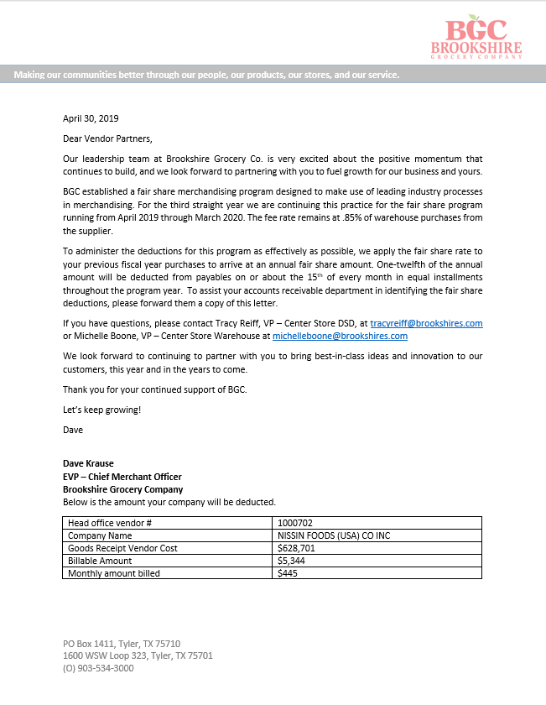

13.1 In Store Promotion: Invoices that have six digits followed by MKT are for different types of in store promotion programs. The item description on the invoice and the additional information section of the contract provide details on the promotion.

Customer Invoice for In Store Promotion: Main data from Invoice tab of Customer Invoice

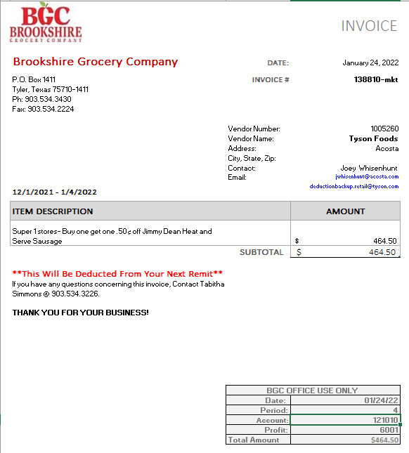
Amount of deduction. Will need to divide by allowance/redemption amount to determine total units deducted. Total units will match detail tab of invoice shown on next page.
Detail on the type of promotion that was run including allowance/redemption amount and included product.
Dates promotion ran. Will match dates on contract
Customer Invoice Reference number #, ends in MKT

13.2 Customer Invoice for In Store Promotion: Detail from second tab of customer invoice

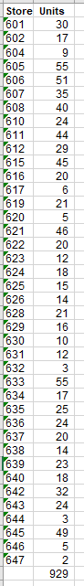

First column is the list of stores that participated by their store number

Second column is Units sold per store

Total of units sold. Multiply by promotion amount from Item Description on Iivoice tab to obtain/match invoice amount.

13.3 Contract for In Store Promotion
Dates of promotion contract
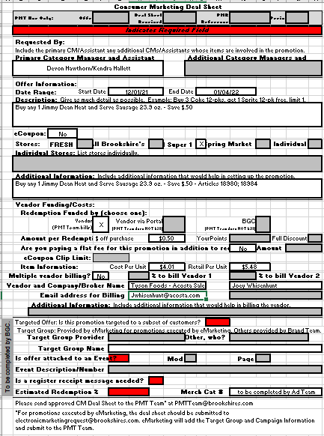
Per unit amount if not included in the description or additional information
Description/Additional information areas that contains detail on the type of promotion that was run including allowance/redemption amount and included product.

Refer to the SOPs/Generic Help File for POP requirements

BPS TEAM INFORMATION

CRA VALIDATION SPECIFIC

REPAYS
- Email the repay letter and all supporting documentation to davidbowles@brookshires.com and donnagilbert@brookshires.com for Dariy and Bread only.

CCA CLEARING INFORMATION SPECIFIC

CCA Client Specific

COMPLETE VERSION HISTORY

 | UPDATE DESCRIPTION | DATE |  |  | AUTHOR
First draft of the Brookshire |  |  | 09/27/12 | Bharath/Shuaib/ Pravin
Updated and Final |  |  | 10/5/12 | Janell Rhoden
Added information to Billback Example – How to “back into” the Customer Invoice |  |  | 11/6/12 | Janell Rhoden
Added additional wording to Scan Examples #1 and #3 |  |  | 12/12/12 | Janell Rhoden
Added additional notes in Off Invoice Example – Page 4 to assist in determining “Trade” versus “Non Trade” on Pricing Error Customer Invoices |  |  | 1/11/13 | Janell Rhoden
Added Price Protection Example |  |  | 1/18/13 | Janell Rhoden
Added additional verbiage to Off Invoice Example (Pg. 4) |  |  | 1/24/13 | Janell Rhoden
Added special note at the bottom of page 13 for Scan Customer Invoice example |  |  | 2/8/13 | Janell Rhoden
Changed verbiage in the Price Protection example |  |  | 4/1/13 | Janell Rhoden
Change on Scan example #3 – how to work with a negative amount claim (# 347). Corrected validity date information on Slotting customer invoice example (#2804) |  |  | 4/29/13 | Janell Rhoden
Fact Sheet has been added – 2 pages (#3206) |  |  | 5/6/13 | Janell Rhoden
Additional Scan example has been added – Example #4 (#3157) Verbiage has been reworded on Scan examples 1 and 3 via conference call to hopefully make these situations clearer to understand |  |  | 5/13/13 | Janell Rhoden
Added National Toolbox Link. Added link to customer sign on job aid. |  |  | 9/27/13 | Janell Rhoden
Added information on Billback, Slotting, Ad and Price Protection examples on what is needed to find the customer invoice (#5756) |  |  | 10/14/13 | Janell Rhoden
Added Portal contract copy example to the slotting examples in SOP – also added bullet regarding lump sum offers entered into the customer’s portal after initial offer is made (#4260) |  |  | 10/28/13 | Janell Rhoden
Job Aid added on Client Order Invoice Deduction Backup Process (#7073) |  |  | 3/3/14 | Janell Rhoden
Added “Grocery Co” to the “DPT Name” area as this customer is not related to Brookshire Brothers – also added note in “sign on “ area of SOP (#8026) |  |  | 4/28/14 | Janell Rhoden
Created Client Specific section and added Heinz with information regarding Delimex contracts not being in ACOSTA Relay (#9469) |  |  | 8/18/14 | Janell Rhoden
Added Procter & Gamble to client specific section with bullet regarding scan deductions acceptable POP (#9106) |  |  | 9/15/14 | Janell Rhoden
Added Ad example #2 to cover “ZW18” customer invoices (#10422) Additional information added to scan example #1 in blue information box (#10994) |  |  | 12/8/14 | Janell Rhoden
Updated Post Audit example; not all post audits are non-trade; took statement out of example as this was incorrect (#12055) |  |  | 2/16/15 | Janell Rhoden
If Brookshire acknowledges a repay procedures (12072) |  |  | 3/2/15 | Amy Bedor Salmey
Scan POP must cover number of UNITS deducted (12664) |  |  | 3/16/15 | Amy Bedor Salmey
Deduct from Vendor line stepped to UNK/UNK/CCA (12665) |  |  | 3/30/15 | Amy Bedor Salmey
Added GP specific info (13304) |  |  | 4/27/15 | Amy Bedor Samey
Added BPS question Is Req CI from CIT used for customer? (13772) |  |  |  | Amy Bedor Salmey
Moved complete version history to bottom of SOP |  |  | 7/1/15 | Amy Bedor Salmey
Moved information to new format (14730) |  |  | 10/8/15 | Amy Bedor Salmey
Email address to request coupon deduction backup (15881) |  |  | 12/21/15 | Amy Bedor Salmey
New backup contacts for CRA (16704) reformatted BPS Team info (16491) |  |  | 2/1/16 | Amy Bedor Salmey
Heinz – Brookshire will deduct for all but the bundle pricing program for HFF (17211) |  |  | 3/14/16 | Amy Bedor Salmey
Invoices may not match claim amount for McCormick (17453) |  |  | 3/28/16 | Amy Bedor Salmey
> Reclamation moved to IRC, updated invoice example (18096) |  |  | 05.23.16 | Caitlin Goodnight
> Updated scan example 1 and provided more instructions on how to handle the repay amount of the invoice (18372)  > Updated scan example 3, detail box on invoice, to explain when split claim job aid needs to be used (18378) |  |  | 06.06.16 | Caitlin Goodnight
> BB info box at beginning of section, updated process for when customer deducts for more then what the Memo Tracking supports (18254)  > Updated backup request process (18745) |  |  | 07.04.16 | Caitlin Goodnight
>Removed “Step Post Audit to Acosta” Verbiage (19056)  >Added Billback and Off Invoice Post Audit Examples (19201) |  |  | 08.29.16 | Christen Ledford
> Removed Heinz – no longer represent (19311) |  |  | 09.02.16 | Caitln Goodnight
> STARKIST – TPM day flex info added (18992) |  |  | 09.26.16 | Caitlin Goodnight
> Removed duplicated contracts & added gneric statement for POP (19418) |  |  | 10.10.16 | Caitlin Goodnight
> Gave more details on how to handle “release amount” deductions (19672)  * > GCIT updates (21433) |  |  | 10.24.16  *05.08.17 | Caitlin Goodnight
> Added Fair Share section and note in customer general info section (21741) |  |  | 06.19.17 | Caitlin Goodnight
> TYSON – fresh team info added (22781) WWAVE – retail merch info added (22599) CAMPBL – Fairshare breakdown added (22637) |  |  | 10.09.17 | Caitlin Goodnight
> DOLE – added retail merch process (22428) |  |  | 12.04.17 | Caitlin Goodnight
> Updated customer contact (23587) Retail merch invoices are not provided each deduction. (23570) Updated hyperlinks (23751) |  |  | 02.02.18 | Caitlin Goodnight
> Advance Pierre section added, how to handle Houston invoices (23868) |  |  | 03.12.18 | Caitlin Goodnight
> BROODA does not subscribe to IRI (24070) |  |  | 04.09.18 | Caitlin Goodnight
> Added Coca Cola section and promotional fee process (25974) |  |  | 10.04.18 | Caitlin Goodnight
> Keurig event # info added to clearing section (26080) Colgate validation section added and info on being a simplified customer. (26274) |  |  | 11.19.18 | Caitlin Goodnight
Added BIC for contract POP mismatch to Client Specific (26363) |  |  | 01/28/19 | Carlos Ocasio
Removed Duracell from Client Specific (26833) |  |  | 02/01/19 | Carlos Ocasio
Removed McCormick information as we no longer represent as of 2/13/19 (26829) |  |  | 02/13/19 | Carlos Ocasio
Removed Georgia Pacific as we do not process claims for this customer (27296) |  |  | 02/28/19 | Carlos Ocasio
Changed name from Brookshire Brothers to Grocery in CCA clearing information specific (27247) |  |  | 02/28/19 | Carlos Ocasio
Removed Campbells from the client specific section (27554) |  |  | 04/22/2019 | Carlos Ocasio
Removed document location and version history. Removed Tyson as Acosta no handles claims effective 04/27/19 (27728) Removed Advance Pierre as Acosta no handles claims effective 04/27/19 (27731) |  |  | 04/30/2019 | Carlos Ocasio
Updated the email address for requesting backup for trade related claims (27714) Removed Keurig from the CCA Client Specific section as we no longer represent starting 6/1/19 (27921) Removed White Wave from the client specific section as Acosta no longer handles. |  |  | 06/03/2019 | Carlos Ocasio
Added Backup Retrieval section. Transferred backup retrieval information from BPS Team section, customer is moving to the GCIT customer backup request process (28654). |  |  | 10/7/2019 | Ca-Tonya Barnwell
Process Steps section 12.1 updated screen shot and updated verbiage for Customer Invoice/Agreement for Retail Merchandising Program(Fair Share).(29073) |  |  | 12/6/19 | Ca-Tonya Barnwell
Client Specific Validation section removed Colgate (29496) and Bic (29499) specific information we no longer rep.  Ad section updated information about ad location (29654) |  |  | 2/24/20  3/9/20 | Ca-Tonya Barnwell
Backup Retrieval Information section updated email backup contact (29759)  Updated the following deduction type sections with updated examples:  Scan  Warehouse Withdrawal/Count Recount  Slotting |  |  | 3/13/20 | Ca-Tonya Barnwell
Backup Retrieval Information section added email backup contact to Automated table for CP (29794) |  |  | 3/23/20 | Ca-Tonya Barnwell
Client Specifics Validation section added client specific information for Procter and Gamble Core on Fair Share claims (29681) |  |  | 4/24/20 | Ca-Tonya Barnwell
Backup Retrieval Information section under General Backup Retreival Information added CP invoices that are under $100.00 will not be provided(29641) |  |  | 5/4/20 | Ca-Tonya Barnwell
Customer General Information section under Customer Invoice info removed embedded doc and updated verbiage for IRN invoices (30348) |  |  | 6/15/20 | Ca-Tonya Barnwell
Backup Retrieval Information section added a bullet point for GCIT in regards to IRN invoices (30652) |  |  | 8/10//20 | Ca-Tonya Barnwell

Client Specific Validation section removed Coca Cola specific(30989). | 10/09/20 | Ca-Tonya Barnwell
Client Specific Validation section added Just Born and instructions for Fair Share claims. (31806)  Backup Retrieval Information section removed email contact and added ‘Step to Sales’ (31957) | 4/9/21 | Ca-Tonya Barnwell
Client Specific section added Mars Food and is part of Retail Merchandising Program(32446) | 8/9/21 | Mary Kay Dressman
Removed the Retail Merchandisng information for Dole from the client specific information(33327). | 4/18/22 | Mary Kay Dressman
Deduction Type section added In Store Promtion invoice example and contract.(33764). | 7/18/22 | Mary Kay Dressman
Added repay informaiton to the BPS Team Information section for the CRA(34541). | 4/3/2023 | Mary Kay Dressman
Customer General Information sections added lead time requirement and document for price changes( 34975). | 5/22/2023 | Mary Kay Dressman
CRA Validation Specific section update repay contact information(34934). | 7/17/2023 | Mary Kay Dressman
Client Specific section added Mezzetta information about downstream customers. (383015) | 4/15/2024 | Mary Kay Dressman
Updated Backup Retrieval Section (404496) | 10/28/2024 | Dawn Regan
Updated Backup Retrieval Section (411546) | 01/25/2025 | Dawn Regan
Added Beiersdorf and information in Client Specific Section (412710) | 02/03/2025 | Dawn Regan
Updated event number for Markdown for Beiersdorf Inc. in Client Specific Section (427299). | 06/09/2025 | Dawn Regan
Removed Kikkoman contact from Backup Retrieval Information Section (446898) | 11/10/2025 | Dawn Regan

