WORK INSTRUCTIONS
Process | Order to Cash
DTP Name | Demoulas Supermarkets, Inc.

CURRENT VERSION HISTORY
UPDATE DESCRIPTION | DATE |  | AUTHOR
Added client specific information for Eagle Family Foods to the Client Specific Validation Information section. (475983) |  | 7/13/2026 | Lindsay McGinnis

Link to complete version history: COMPLETE VERSION HISTORY

DEDUCTION TYPES COVERED
Number | Description
 | Customer General Information
 | Backup Retrieval Information
 | Client Specific
1 | Off Invoice
2 | Billback
3 | Ad
4 | Pricing (Non Trade)
5 | Slotting/New Store Opening
6 | Unsaleable (Spoils/Reclamations) (Non Trade)
7 | Displays
8 | Coupons
9 | Returns (Non Trade)
10 | Shortages (Non Trade)
11 | Pre Pay Replenishment
12 | Merchandising
13 | Other
14 | Markdowns (Overstock/Liquidation)
15 | Scan
 | BPS Team Information

Is the customer a wholesaler/distributor, direct or indirect customer? Direct for everything but Frozen (which is indirect through C&S).

Note: DEMONE is the sign-on used to work on Acosta Relay for Demoulas (for example to search for a document and to refer the customer on Acosta Relay).

Link to customer signon job aid:
https://acostaonline.sharepoint.com/sites/AS_Reporting/Claims_Reports/Forms/AllItems.aspx?web=1

Does this customer subscribe to IRI/Nielsen data for price point verification? Yes

CUSTOMER GENERAL INFORMATION
Customer Invoice Info:

Is line level detail indexed on the customer’s documentation (customer invoice, customer check request, unsaleable/spoils, post audit, EDI 812/820 or client deduction notice if one of these documents is included)? Yes

When searching for invoices, if the customer reference begins with BB, search with the % and the numeric portion of the invoice number. Example: Customer Reference # BB2211872 - search backup documentation using %2211872. The invoice was found as 2211872-IN.

For P-Vendor validation information, see the C&S SOP.
- Demoulas receives deals that are passed through to them by C&S. These deals appear under CSWHNE, as they fall under a C&S-managed contract. Internally, we refer to these as PVendor contracts. All contracts under the C&S signon for Demoulas will start with 'NER'.

Adjustment Codes listed on Check Remittance:
ADJUSTMENT CODE / DESCRIPTION
01 / PRICING ERROR
02 / SWELL ALLOWANCE
03 / EXTENSION ERROR
06 / QUANTITY ERROR
07 / INCORRECT PRODUCT
24 / INCORRECT DISCOUNT
GA / FEE GOODS

Invoices may have a reference number ending in 500 to indicate cash discount. The cash discount is taken against gross.

If the invoice states IN STORE, the claim is for damages.

POP Info:

For Frozen only, Demoulas is an in-direct of C&S. The C&S spins will be used to verify POP

Contract Info
Demoulas contracts may show only one line of promotional detail, with a list of UPCs. In this case, the allowance shown applies to every item on the contract. Example:
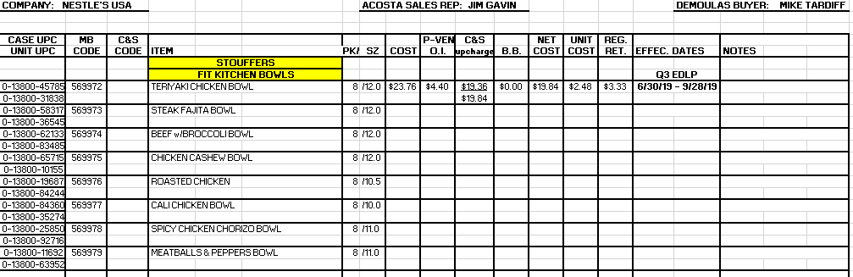

BACKUP RETRIEVAL INFORMATION

GENERAL BACKUP RETRIEVAL INFORMATION

Is GCIT responsible for obtaining backup from the customer? No
- If yes, is there a customer portal? No
- If yes, does GCIT request backup? No

Is check remittance information required to request backup? No

Non-Automated:

Customer Invoice or Note Identifier | Request From
All formats | Request backup from Sales.

CLIENT SPECIFIC VALIDATION INFORMATION

Client
BARILLA | KEN’S
BUSH | KIKKOMAN
CAMPBELLS/PEPPERIDGE | MCCAIN
CCNA | PEAK FOODS
DOLE | SOVOS-MICHAEL ANGELO
Eagle Family Foods
Ferrero USA Inc
GL Mezzetta
GORTONS
HARVEST HILL
Honest Company

BARILLA
- Demoulas receives a swell allowance from Barilla. Claims for spoils/unsaleables are considered invalid.

BUSH
- Breakdown for Trade Funds billback claims is loaded in ACOSTA Relay under POP-TPR/2019 Bush Bean Tracker.

CAMPBELLS/PEPPERIDGE
- Claims that start with 202ME or 206ME are to be sent to the deduction team to be recoded to Maine bottle deposits with a note stating that backup is sent directly to the client to the email address: Billing_Order_to_Cash_SAP@campbellsoup.com.
- Demoulas/Pepperidge Frozen claims are required to have a header note “CUST:1000006047”.

CCNA
- Events are provided by individual UPCs for brand codes for TR SOJ/Blends: SOJ/Mango UPC 05437 - SOJ/Tangerine UPC 05078 - SOJ/Pineapple UPC 05438 - SOJ/Banana UPC 05074. They need to be split to separate lines on the DBW and on the claim lines.

- Invoices reflecting “Performance allowance” will be cleared to “Marketing Accrual Fallout”. Step as “Non-Trade/Other/Ready to Clear CCA” and add following note in Client Event Name Field: MARKETING FALLOUT ACCRUAL.

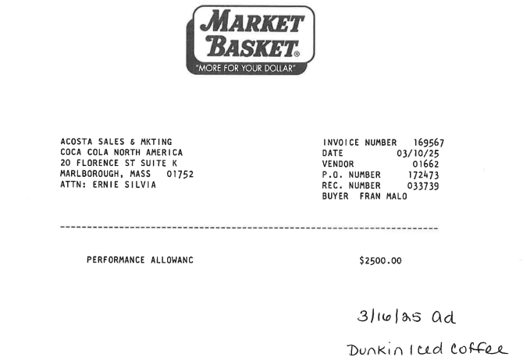

DOLE
- Invoices that reference Earth Wise Green Bags are merchandising invoices (see Merchandising deduction section).

EAGLE FAMILY FOODS
- Claims that begin with BBD and are for $0.37 for Popcorn Indiana can be validated using Contract AE 13417499, which became effective in 2022. The contract does not have an end date.

FERRERO USA, INC
- Event Numbers are not required for this Customer for Ferrero.

GL MEZZETTA
- Demoulas is a downstream/indirect of supplier UNFI.
  - All detailed deduction back up must contain full dates, including the year.
  - No "on going" EDLP contracts are allowed.
    - All EDLP contracts must contain start and end dates.

GORTONS
- Check requests do not require event numbers.

HARVEST HILL
- Demoulas is an Indirect Account for Nutrament items purchased from Imperial Distributors (IMPENE).

Honest Company
- Claims that create reflecting Customer Ref. # IN-STORE, Client Ref # IN-STORE and Header Note: (month/year) IN STORE DAMAGES can be closed as Damages without Check Remit or Customer Invoice.
KEN’S
- Kens does not issue checks for Demoulas reclamations.
- Invoices that reference PPD or PP at the bottom will have a difference between the claim total and the invoice total. The difference will be hand written. This portion is an allowance that was cleared to a pre-paid fund by Demoulas. They are now deducting for the difference. Complete the DBW. There will be a group or multiple product group totals that equal the amount of the PPD. This portion does not need to be validated.
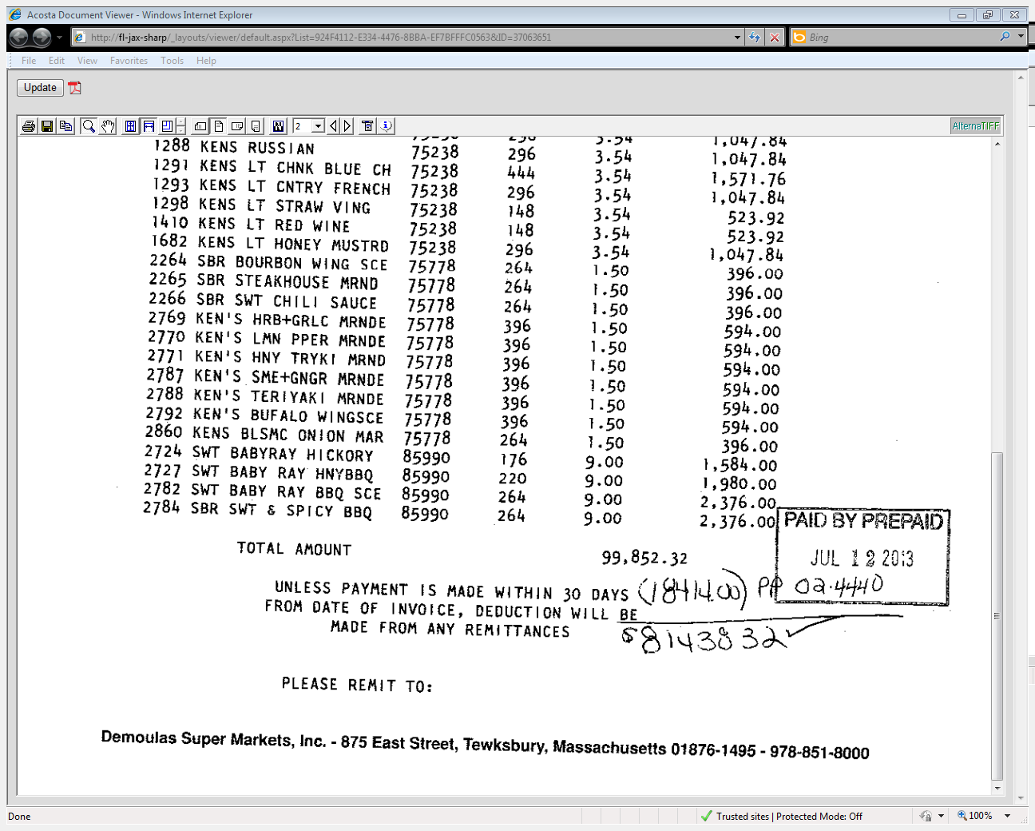
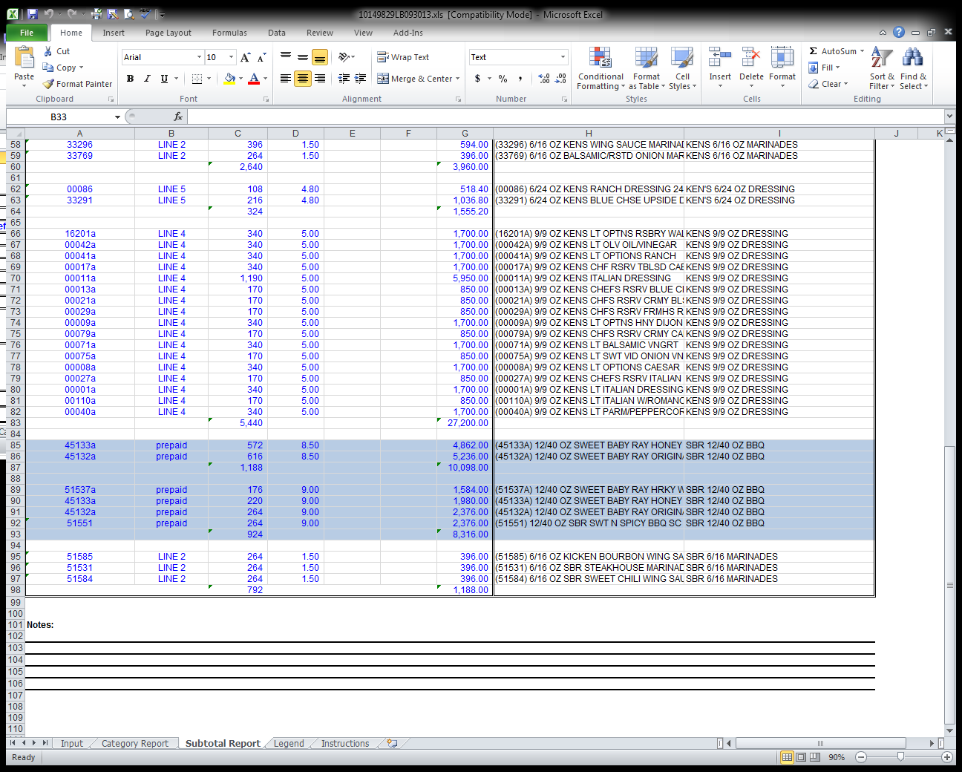
i
Two product groups equal $18,414.00 prepaid amount. Example 10,098.00 + 8,316.00 = 18,414.00

KIKKOMAN
- Deductions will be sent to the appropriate business manager for approval via e-mail by the CCA. This e-mail should ask the business manager to return the e-mail to the CRA (CCA will name the CRA) if the claim is found to be invalid. The business manager will send it on to the regional manager who will give the final approval. The CCA will close the claim. If the business manager denies the claim, an e-mail will be sent back to the CRA with instructions to begin the repay process.

MCCAIN
- Claims that are identified as 1000094226 - DEMOULAS C/O C&S FREEZER are not Acosta and should be sent to Steve.Ehret@McCain.com.

PEAK FOODS
- Demoulas is pre-paid with Peak Foods.

SOVOS-MICHAEL ANGELO
- Acosta is not the broker for Sovos-Michael Angelo at Demoulas.

PROCESS STEPS

1. Deduction Type: Off Invoice

A per case off invoice allowance is given to the customer as an automatic discount for product purchased from the client. If the customer does not receive the allowance off the face of the invoice they will deduct for it. If the customer requested an allowance that is not valid, the CSC will send a notification to the customer in writing. Customers view purchase orders as contracts. If they are not notified of allowance discrepancies, they will pay according to their purchase order total.

1.1 Customer Invoice for Off Invoice (OI): Check remittance will show Off Invoice as adjustment code 01.
i
Use the purchase order number to pull the client order invoice in Acosta Relay, under Order/Invoices/PO.

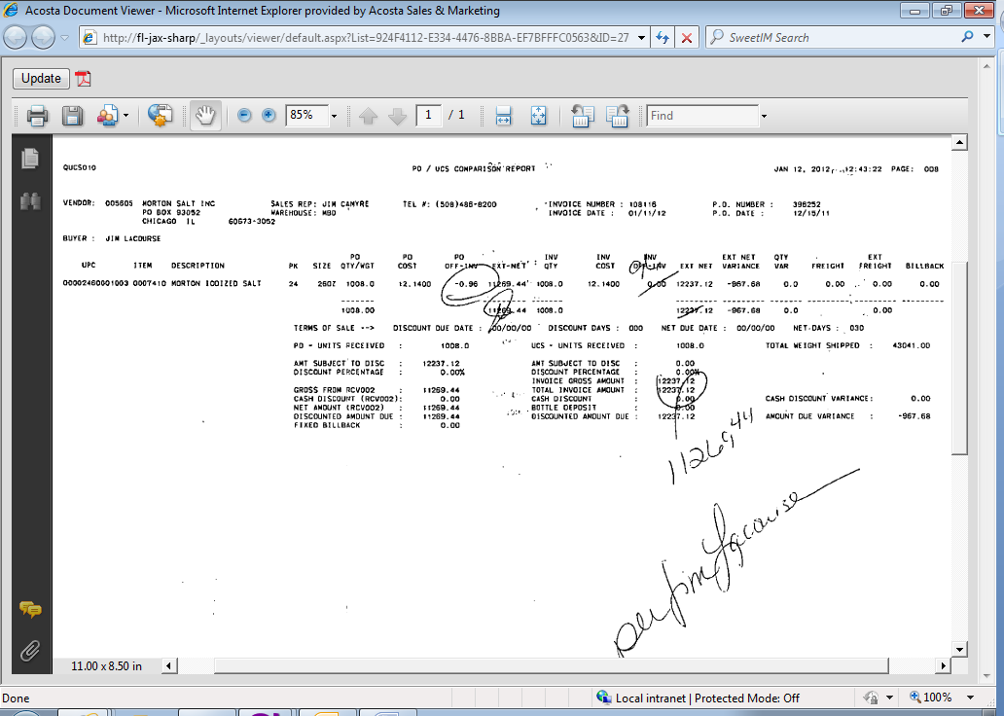
This is the total deduction amount the customer is claiming for an off invoice not given.
3
INV QTY: The number of cases the customer is claiming the OI for, which bust be validated with the client order invoice.
PO OFF-INV: The amount being claimed for the OI allowance, which must match the contract.

15
UPC: The product code on which the customer is claiming an OI was not given. This needs to match the contract and the client order invoice..
i
2

  - Customer Contract for Off invoice: Found via Search For: Event Scheduler.

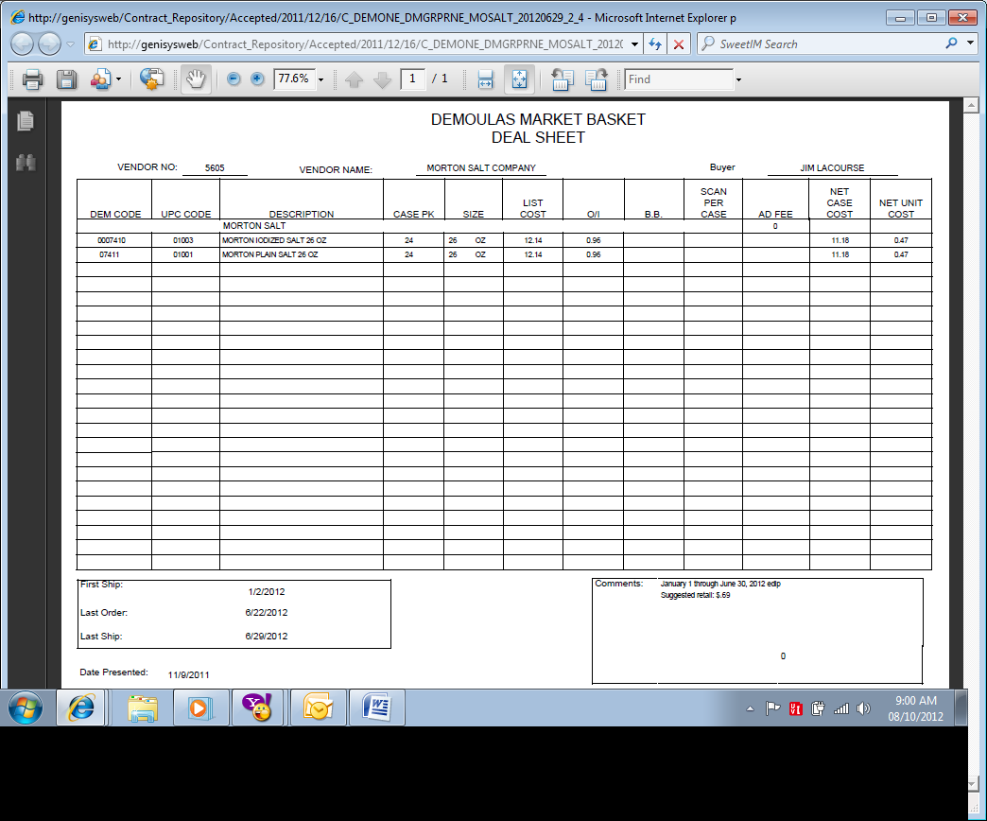
DEM CODE, UPC CODE, DESCRIPTION: The product(s) on which the customer is being offered an off invoice allowance.

2
55
15
Order/Ship Dates: The dates the off invoice allowance is offered for. The order or ship date on the client order invoice must fall within the contract dates..

O/I: The rate offered to the customer for the off invoice allowance.

1.3 Refer to the SOPs/Generic Help File for POP requirements.
Ship Date: Client order ship dates should fall on or after “First Ship dates” available on the contract.

55
UPC – UPC # 30155 should be validated with the customer invoice to confirm whether the claim is for the approved product.

15

2. Deduction Type: Billback

A billback claim is a per case allowance offered for a specific performance requirement. A per case billback allowance is claimed by the direct buying customer for product purchased from the client, or by the indirect customer for product purchased from the direct customer. This is an allowance the customer will bill the client for. This is not an automatic discount given off the face of the invoice.

  - Customer Invoice for Billback, Example 1:

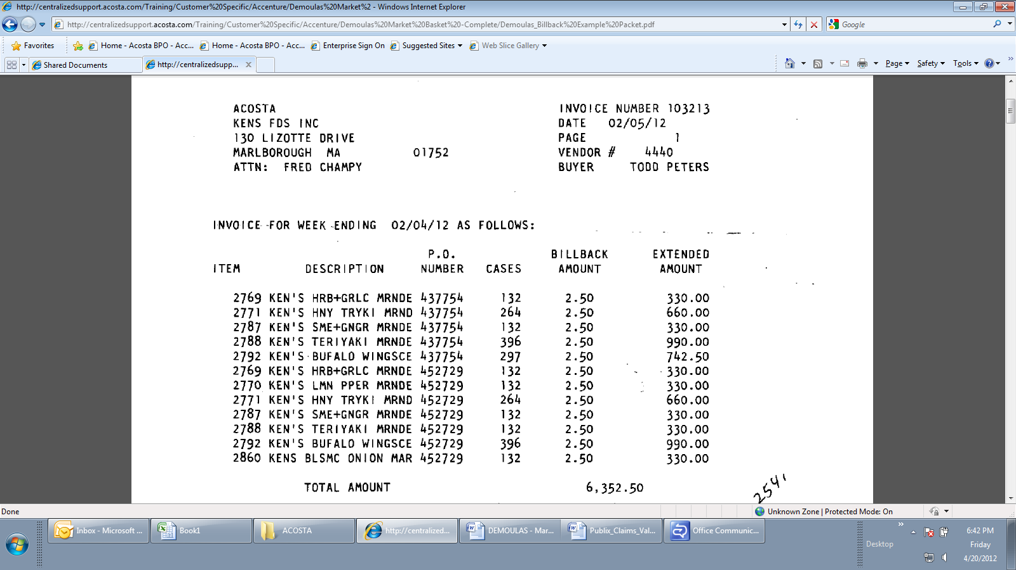
2
The PO number can be used to retrieve the client order invoice in Acosta Relay.
55
Invoice for Week Ending: The dates the customer is claiming the billback, which must fall within the contract dates.
i
3
Billback amount: This is the rate the customer is claiming for the billback allowance, which must match the contract.
Cases: The number of cases the customer is claiming for the billback which needs to be validated with the client order invoice.

15
Item & Description: The customer code and item description the customer is claiming the billback on, which must match the item(s) on the contract.

2.1 Customer Invoice for Billback, Example 2:

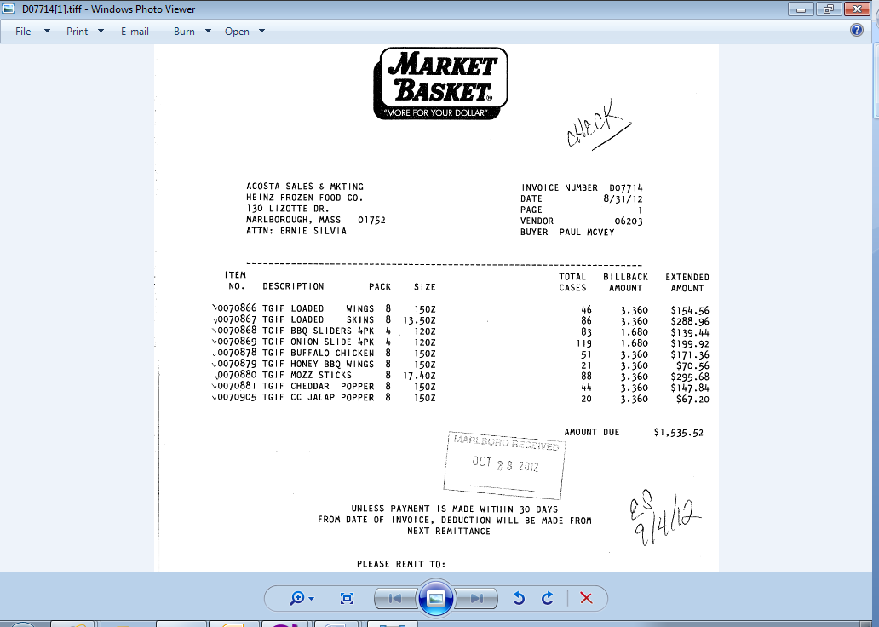
Date: The performance period which needs to fall within the ship dates on the contract.
Note: All elements of Example #1 apply to Example #2, except for the location of the performance date.
55

2.1 Customer Invoice for Billback, Example 3 – Trade Funds:

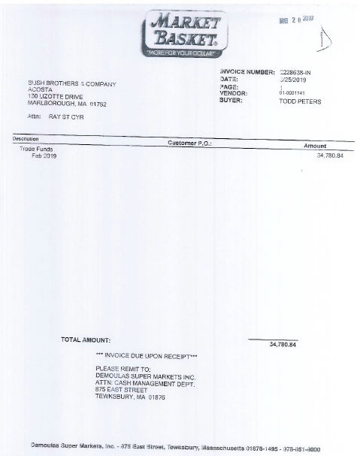
i
Identifies that the customer is claiming Trade Funds.

NOTE: Demoulas does not provide detailed backup to support this type of claim. If POP-TPR details are not found in ACOSTA Relay, the claim needs to be stepped to sales stating the detail is not found.

2.2 Customer Contract for Billback, Example 1: Found via Search For: Event Scheduler.

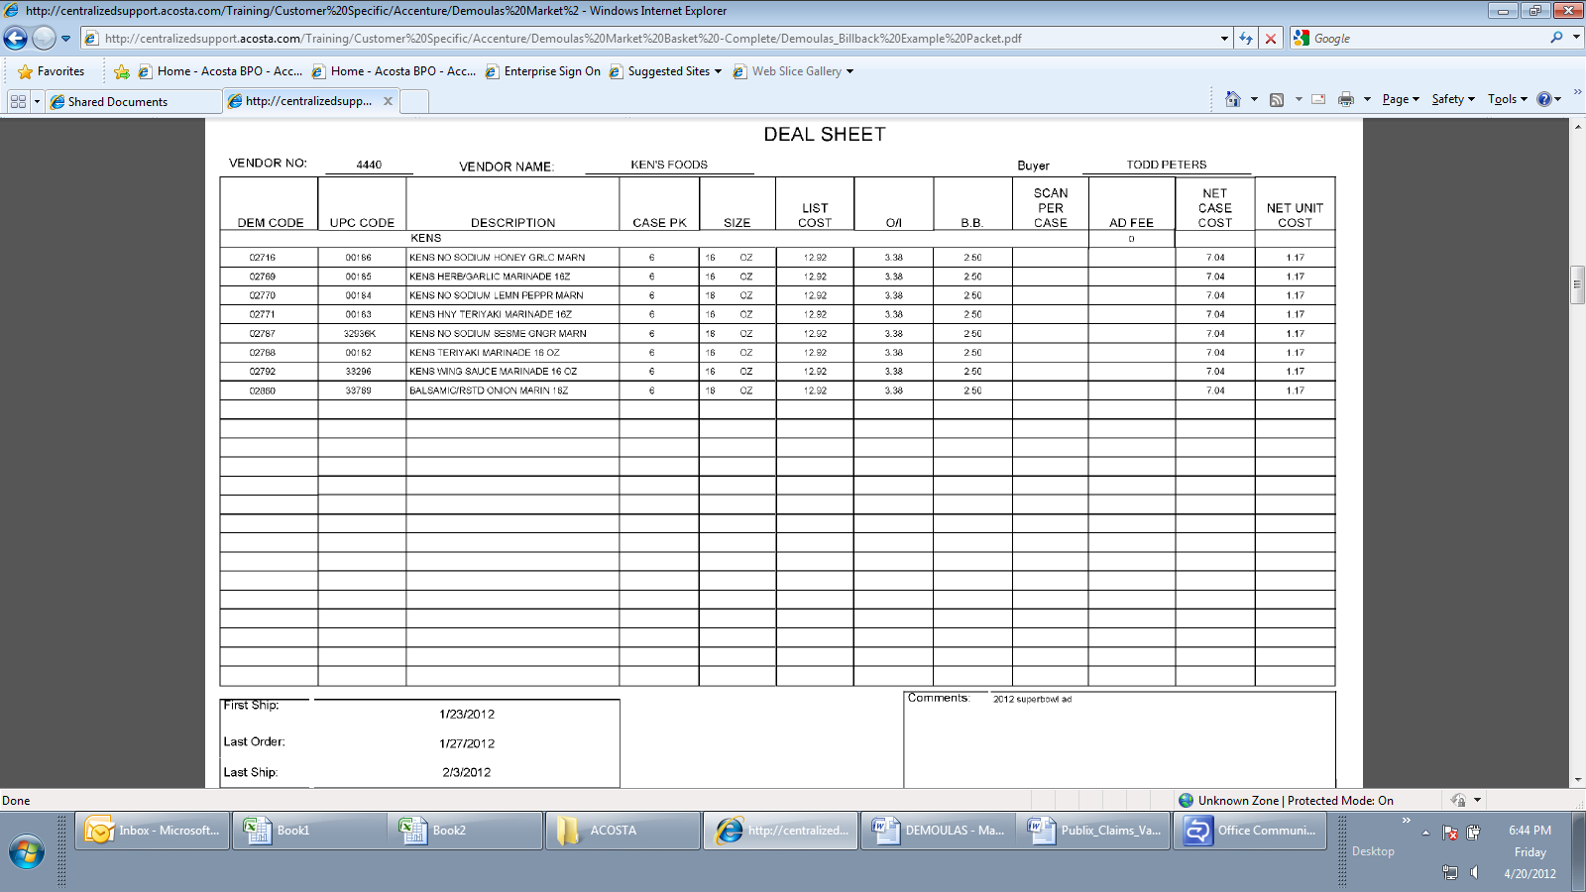
DEM Code, UPC Code & Description: The product the customer is being offered a billback on, which must the item(s) on the customer invoice.
B B: The rate offered for the billback allowance, which must match the amount on the customer invoice..
15
2
55

First Ship, Last Order & Last Ship: The dates for the promotion. The performance dates on the customer invoice need to be within the dates on the contract.

2.2 Customer Contract for Billback, Example 2: Found via Search For: Event Scheduler.
55
Order Dates/Ship Dates: The dates for the promotion. The performance dates from the customer invoice need to be within the dates on the contract.

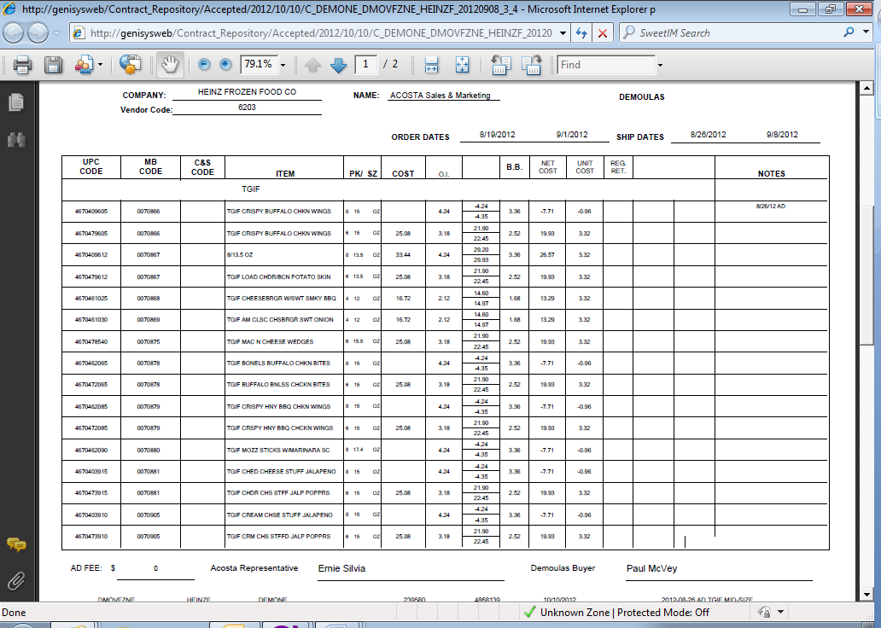
UPC Code, MB Code, C&S Code & Item: The product the customer is being offered the billback on, which must the item(s) on the customer invoice.
15
2
B. B.: The rate offered for the billback allowance, which must match the amount on the customer invoice.

2.3 Refer to the SOPs/Generic Help File for POP requirements.

3. Deduction Type: Ad

A fee for featuring a client's products in an advertisement.

3.1 Customer Invoice for Ad:

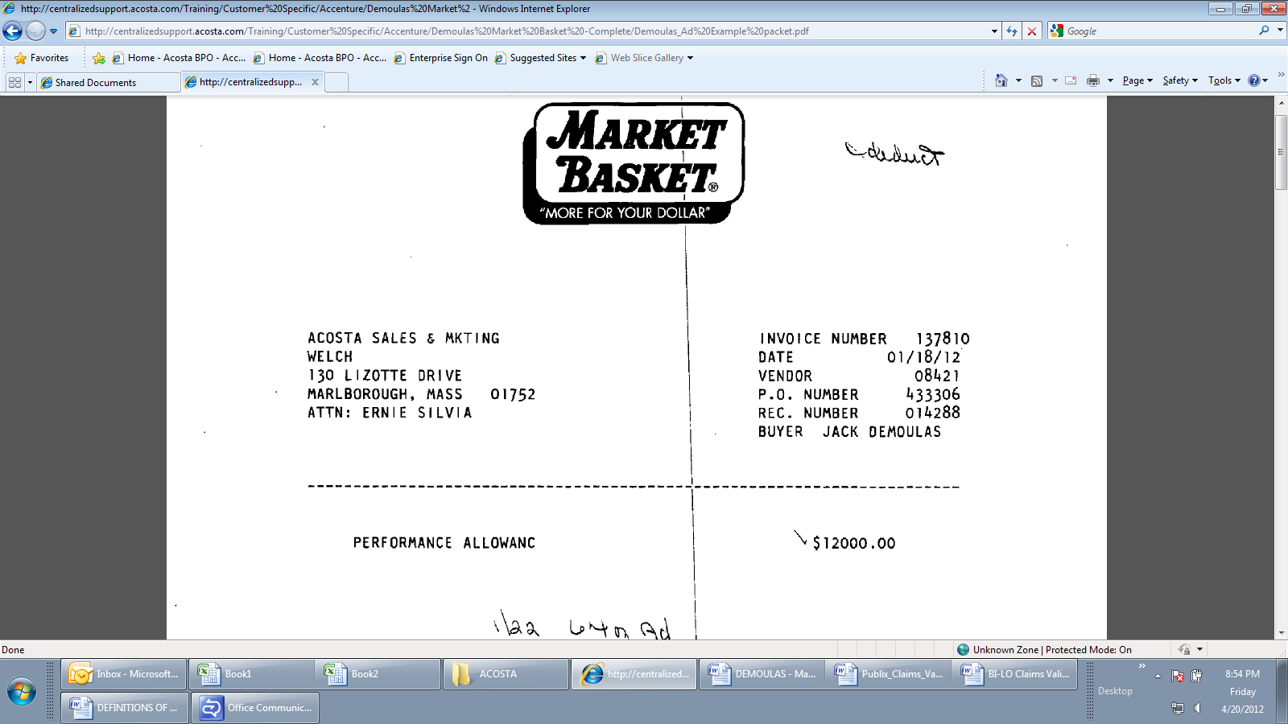
Lump sum Amount: Amount claimed by customer for the ad, which must match the amount offered on the contract.

Description of the Product/Product Group: Needs to be validated with the contract and POP.

1
i
PO Number: While an ad doesn’t typically correspond to one PO, the PO number may assist in locating the contract as the customer does not always contain the product detail.

3

2
Performance date: This needs to match the contract and the ad POP.

3.2 Customer Contract for Ad: Found via Search For: Event Scheduler.

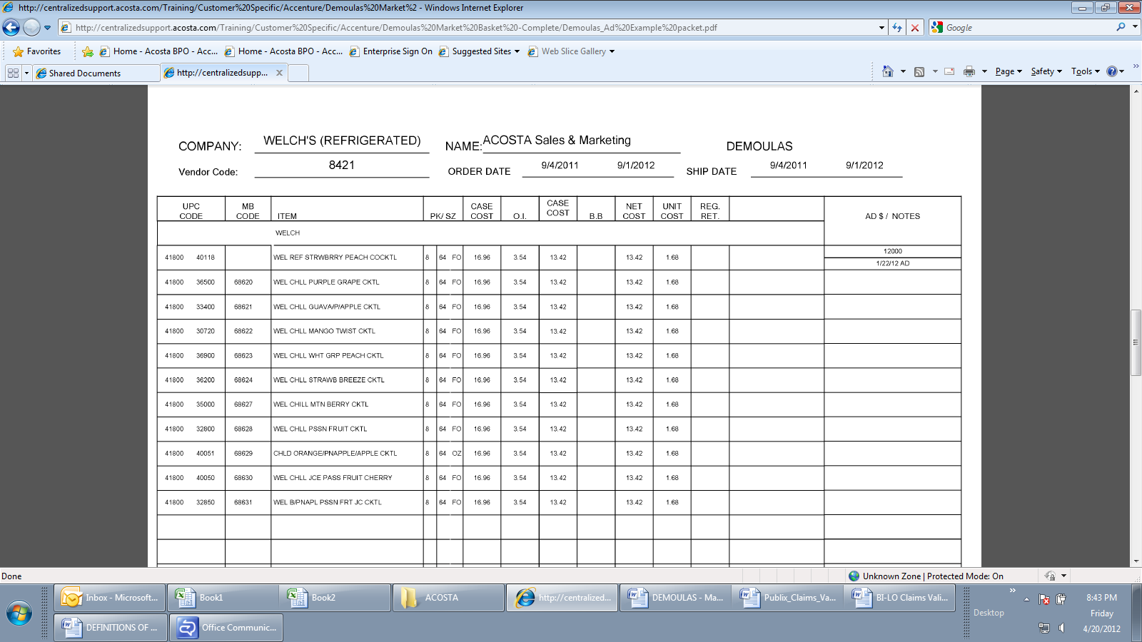
Notes: The date the ad needs to run, which needs to match the customer invoice and POP.
Ad $: The amount offered for the ad. The amount claimed on the customer invoice must match this rate.
3
2
1

UPC Code, MB Code & Item: The product the customer is being offered the ad allowance on, which must the item(s) on the customer invoice & POP.

3.3 Refer to the Proof of Performance Reporting Ads job aid for searching for ads.

4. Deduction Type: Pricing

A pricing deduction occurs when the customer's requested price on the original purchase order differs from the client's invoice.

Documents required for validating a pricing claim:

Document Name | Source of the Document | Action by Accenture
Customer Invoice | ACOSTA RELAY – search for the invoice under Backup Documentation, document type 2. | Step the claim to Acosta for research
Client Order Invoice | ACOSTA RELAY – search for this document within the Order/Invoice/PO search.

4.1 Customer Invoice for Pricing:

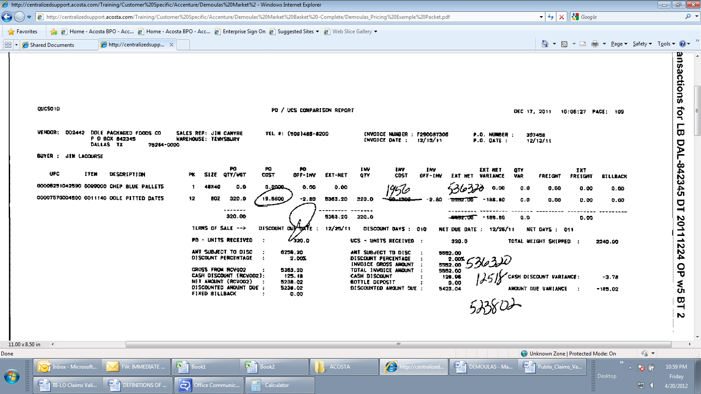
PO Cost: The amount the customer expected to be billed for the item. The customer is claiming for the variance based on the client order invoice.
UPC: The product the customer is claiming the price discrepancy on.

5. Deduction Type: Slotting

A slotting allowance is offered to the customer to purchase an item not currently stocked. It is a kind of promotional money offered to a customer as incentive to buy a new item and create a “slot” for that product on their warehouse storage shelves. It is a Trade Deduction. A slotting lump sum allowance can be offered for each item and/or an off invoice can be offered as an introductory allowance for the first 30 days.

5.1 Customer Invoice for Slotting, Example 1:

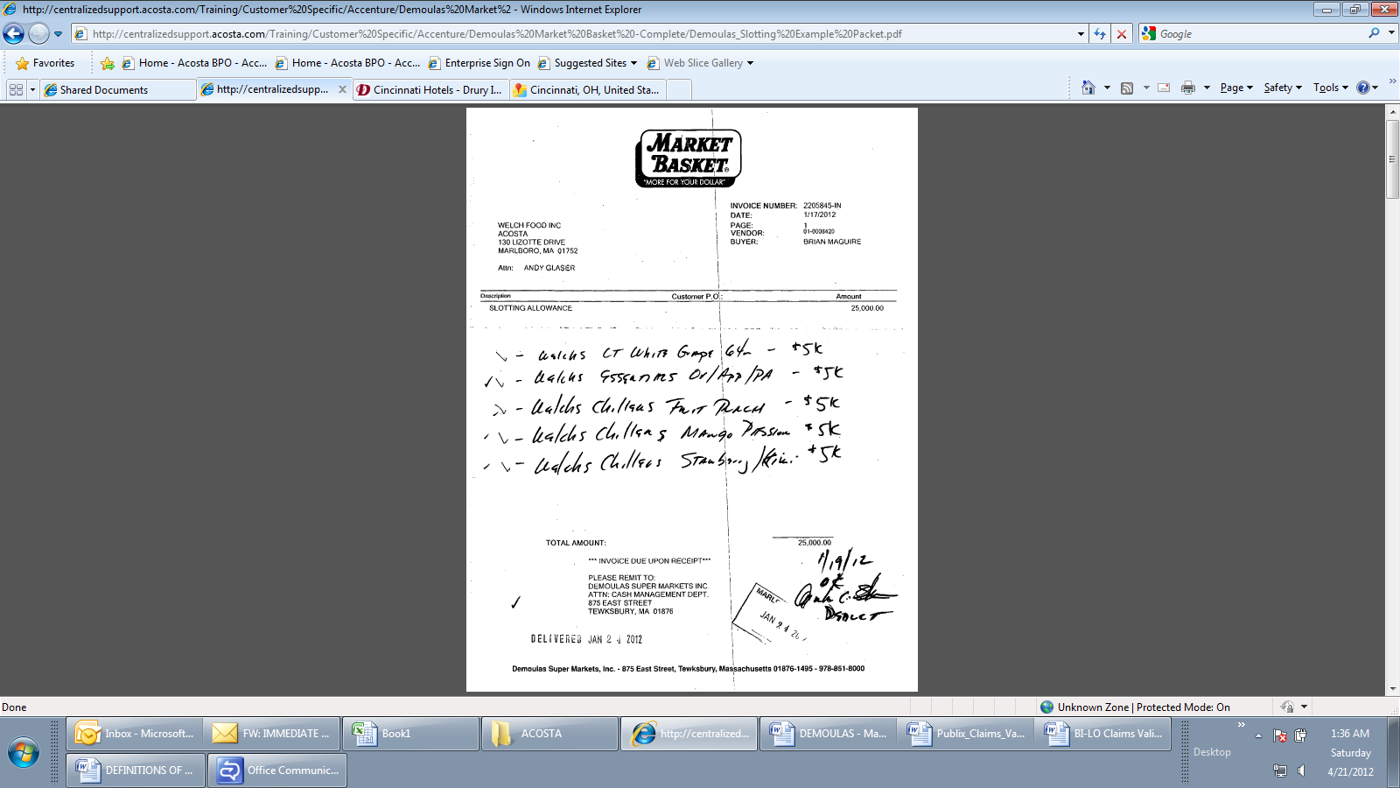
2
1
Description: The product the customer is claiming slotting for and the rate for each item. UPC details can be pulled from Acosta Relay, and validated with the contract & POP).
Total amount: The amount the customer is claiming for slotting.

5.1 Customer Invoice for Slotting, Example 2 – New Store Fill:

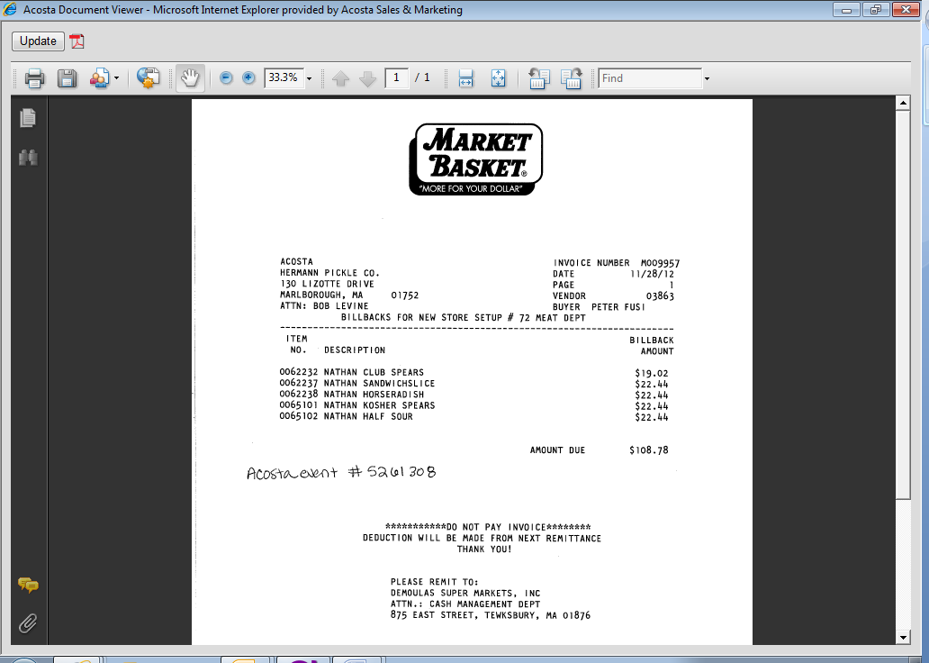
i
Use the invoice date as a reference to help validate the deduction.

25
Item No and Description: The customer item number and item description of the product the customer is claiming the new store fill allowance on. These need to match the contract.
Billback amount: The rate the customer is claiming for the billback.
15
i
This is the indicator that this deduction is for billbacks for a new store opening. A store number and department may be referenced.

5.2 Customer Contract for Slotting, Example 1: Found via Search For: Event Scheduler.

Page 1 – note that each item will be listed on a separate page of the contract.

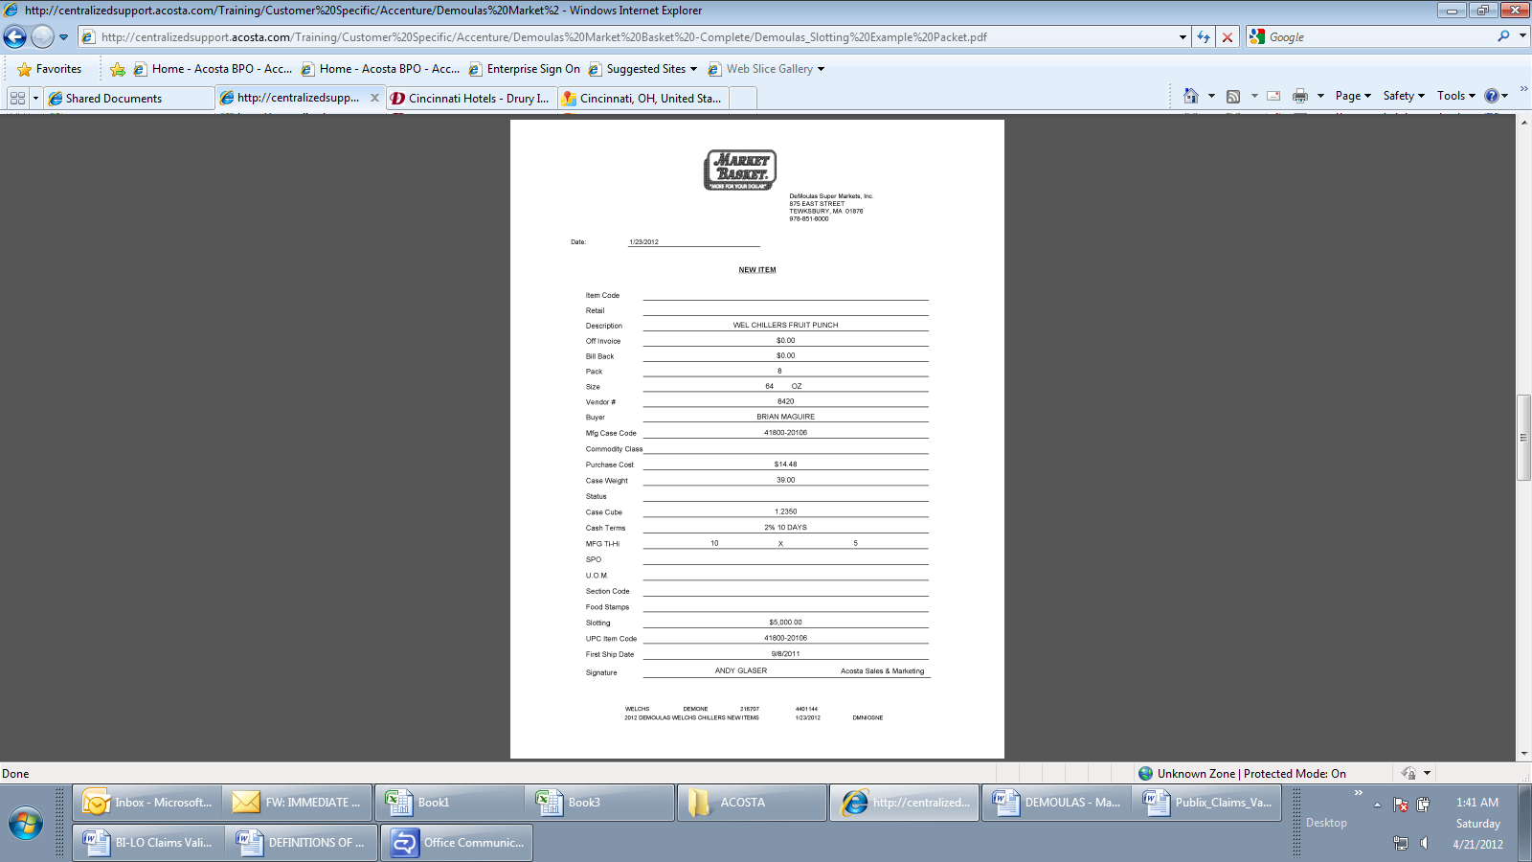
Slotting: The amount offered for the item, which must match the customer invoice..
2
UPC Item Code: The product on which slotting is being offered, which must match the customer invoice and POP.
New Item: Identifies the contract is for slotting.
i
1

5.2 Customer Contract for Slotting, Example 2 – New Store Fill: Found via Search For: Event Scheduler.

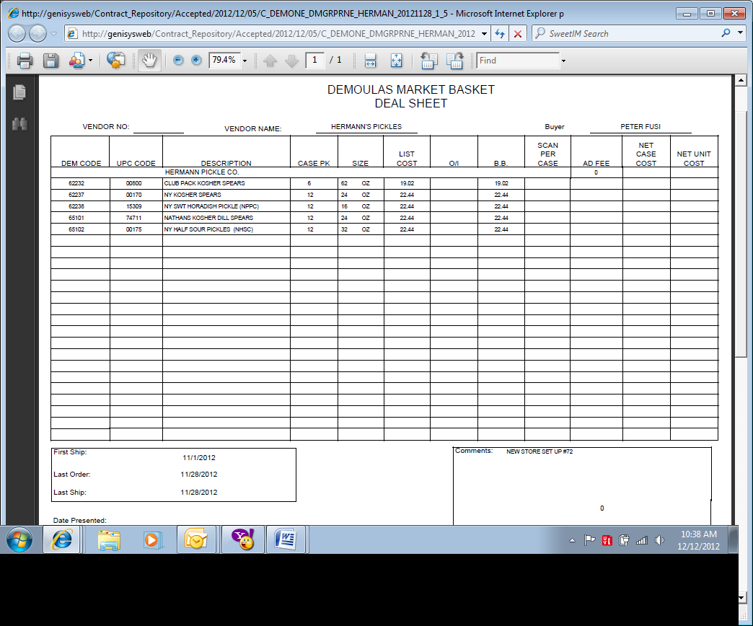
B.B.: The rate per case offered for the new store fill allowance. It must match the rate on the customer invoice.
i
Comments: The store number may be referenced on the customer invoice.
25
15
DEM Code, UPC Code & Description: The product the customer is being offered slotting on, which must the item(s) on the customer invoice & POP.

Lump sum amount -($5,000) for Slotting (New Items).
2
1
UPC Code – UPC#20102 is mentioned on the Line#5 of POP/ EDI Matching Report.
Lump sum amount -($5,000) for Slotting (New Items).
2
1
UPC Code – UPC#20104 is mentioned on the Line#6 of POP/ EDI Matching Report.
5.3 Refer to the SOPs/Generic Help File for POP requirements.

6. Deduction Type: Unsaleable/Reclamation (Non-Trade Claim)

An unsaleable claim is taken for product that cannot be sold at the stores due to damages (and short coded product).

NOTE: If the customer invoice states IN STORE, the claim is for damages.

6.1 Customer Invoice for Unsaleable / Reclamation:

Note: When Demoulas deducts for unsaleables, they list the invoice # on the check remittance as IN-STORE.
Invoices will be found in backup documentation under customer invoice or doc type 8 spoils. The invoice can be located by the dollar amount of the claim.

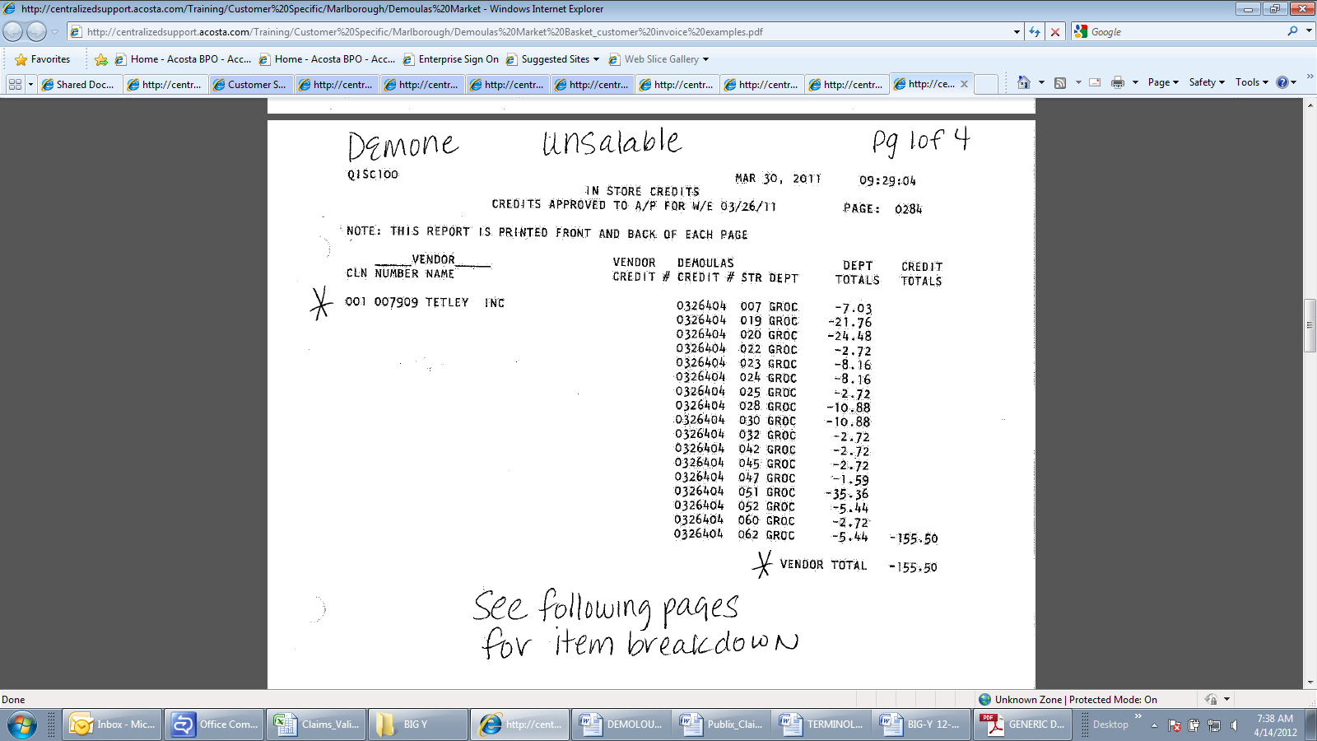
i
In Store Credits: This indicates that the claim is for unsaleable product.

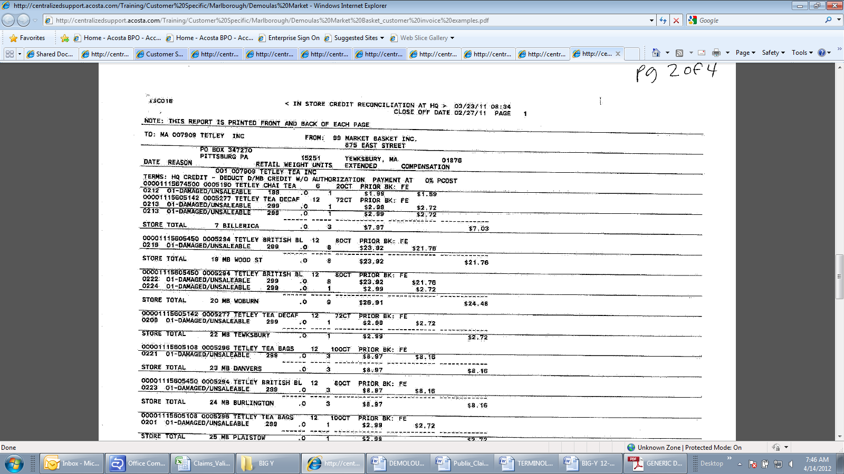
i
In Store Credit: This indicates that the claim is for unsaleable product.
i
Damaged/Unsaleable: This indicates that the claim is for unsaleable product.
Quantity: The quantity for this item claimed as a damage.
UPC: The UPC for this item claimed as a damage.
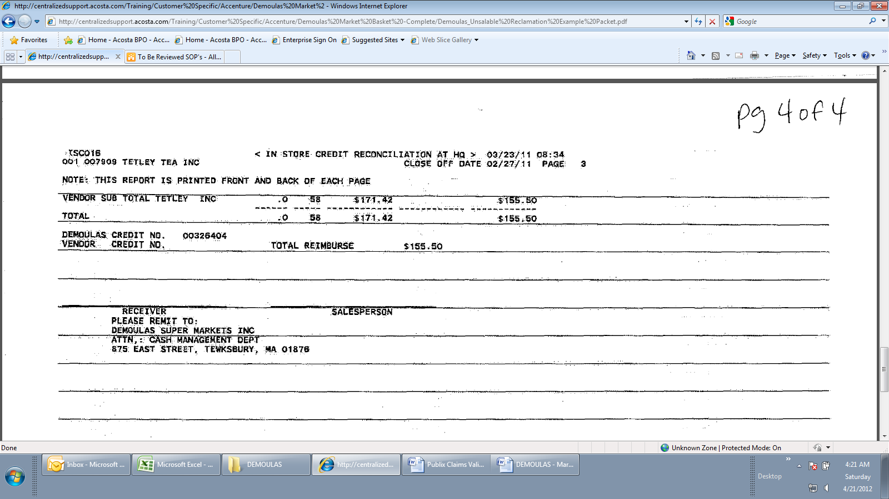
Total Reimburse: The total for the unsaleable claim.

7. Deduction Type: Displays

A display deduction is an allowance given on an in-store product display (within a specific agreed section of the store) on an end cap or displayed per the client's requirements.

7.1 Customer Invoice for Displays, Example 1:

F.B. Display– Indicates the product details which have been displayed. In this example, the product is Dole Fruit Bowls, as confirmed by the contract.
2
Description: Indicates the deduction type and time frame.
1
3
Amount – This is the amount which the customer is claiming for the display, which must match the contract..

7.2 Customer Contract for Displays, Example 1: Found via Search For: Event Scheduler.

Promotion Dates and Comments: Detail about the time frame for the display. This needs to match the customer invoice.
2
3
Ad Fee – This is the amount the customer is offered for the display.

7.3 Refer to the SOPs/Generic Help File for POP requirements.

8. Deduction Type: Coupon

This is a manufacturer coupon, typically cleared by client.
Documents required for validating a Coupon:

Document Name | Source of the Document | Action by Accenture
Customer Invoice | ACOSTA RELAY – search for the invoice under Backup Documentation, document type 2 | Step the claim to Acosta for research

8.1 Customer Invoice for Coupon:

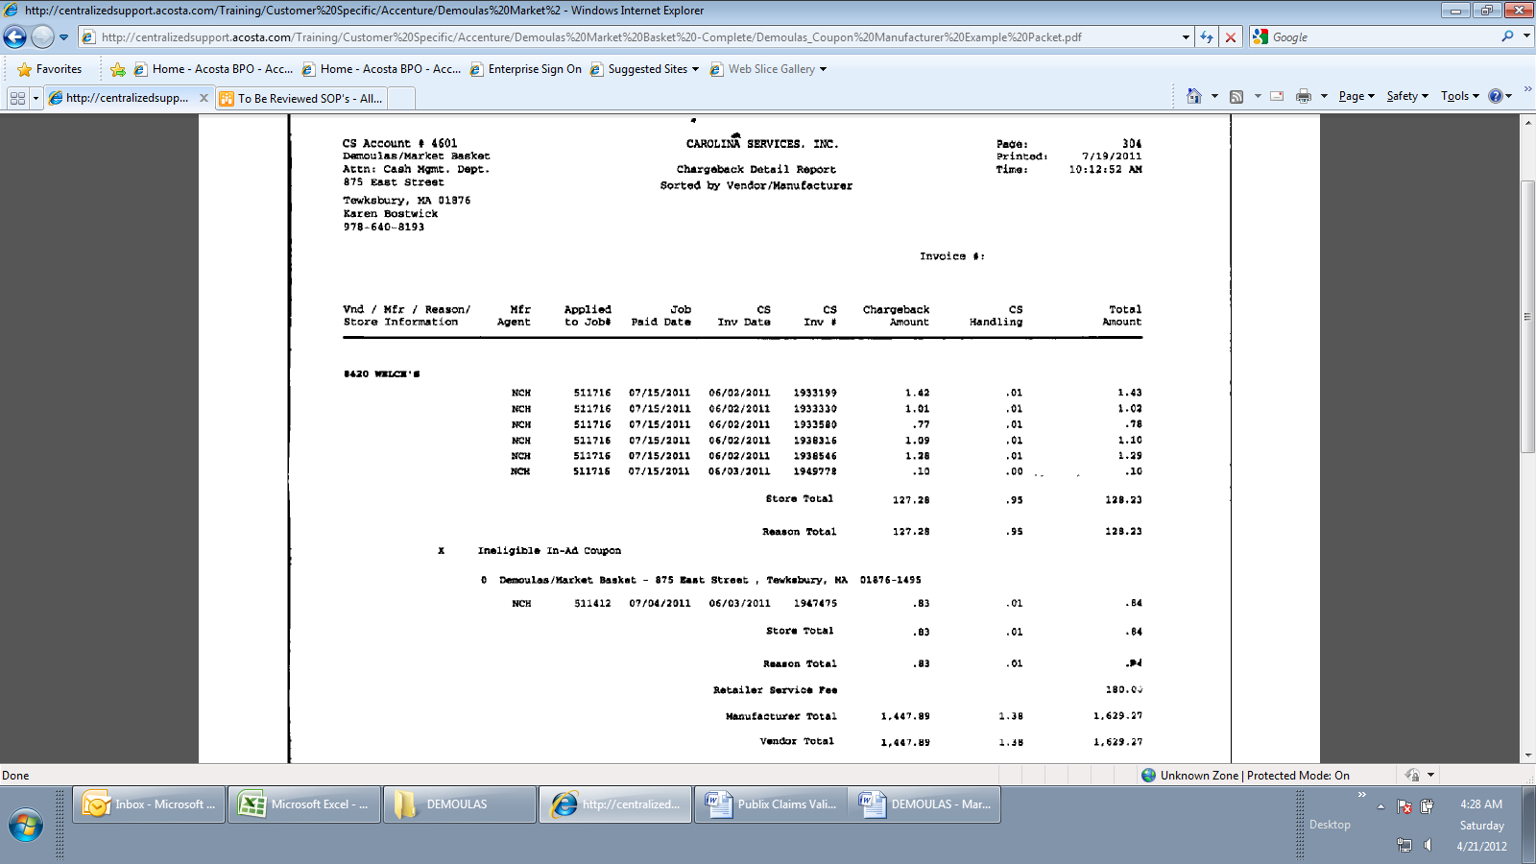
Ineligible In-Ad Coupon identifies that the CI is for coupons.
Carolina Services, Inc is a coupon clearing house.

9. Deduction Type: Returns
Products returned by the customer to the client.

Documents required for validating Returns :

Document Name | Source of the Document | Action by Accenture
Customer Invoice | ACOSTA RELAY – search for the invoice under Backup Documentation, document type 2. | Step the claim to Acosta for research
Client Order Invoice | ACOSTA RELAY – search for this document within the Order/Invoice/PO search if a PO number is referenced on the CI.

9.1 Customer Invoice for Returns:

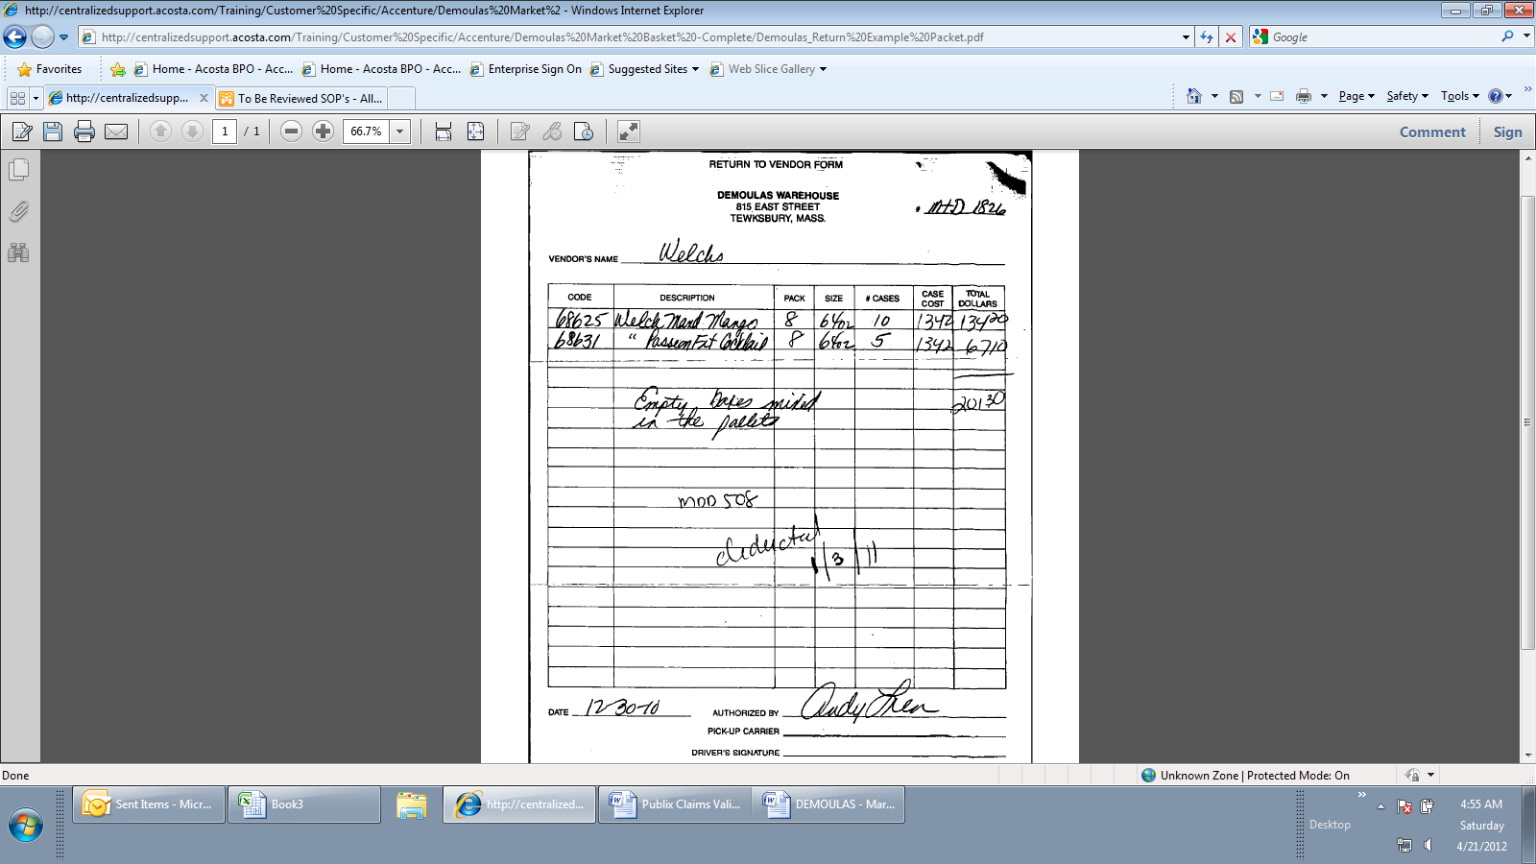
The reason product is being returned: Empty boxes mixed in the pallets.
This is the total amount being billed for product to be returned.
Return to Vendor Form or Invoices that start with RTV indicates this customer invoice is for returns.

10. Deduction Type: Shortages

It is a deduction for shorted product on an order that the client billed the customer for.
Documents required for validating Shortages:

Document Name | Source of the Document | Action by Accenture
Customer Invoice | ACOSTA RELAY – search for the invoice under Backup Documentation, document type 2. | Step the claim to Acosta for research.
Client Order Invoice | ACOSTA RELAY – search for this document within the Order/Invoice/PO search.

10.1 Customer Invoice for Shortages:

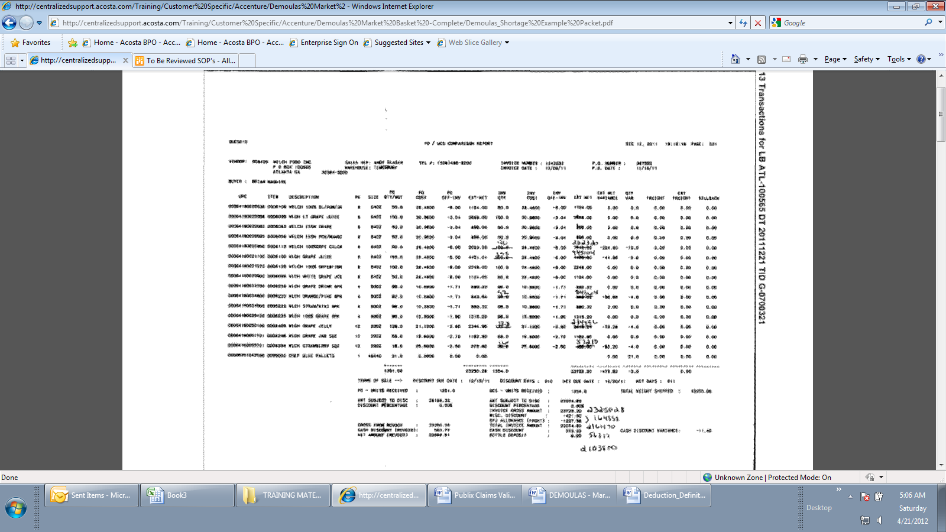

11. Deduction Type: Pre-Pay Replenshment

11.1 Customer Invoice for Pre-Pay Replenshment: Trade – Other

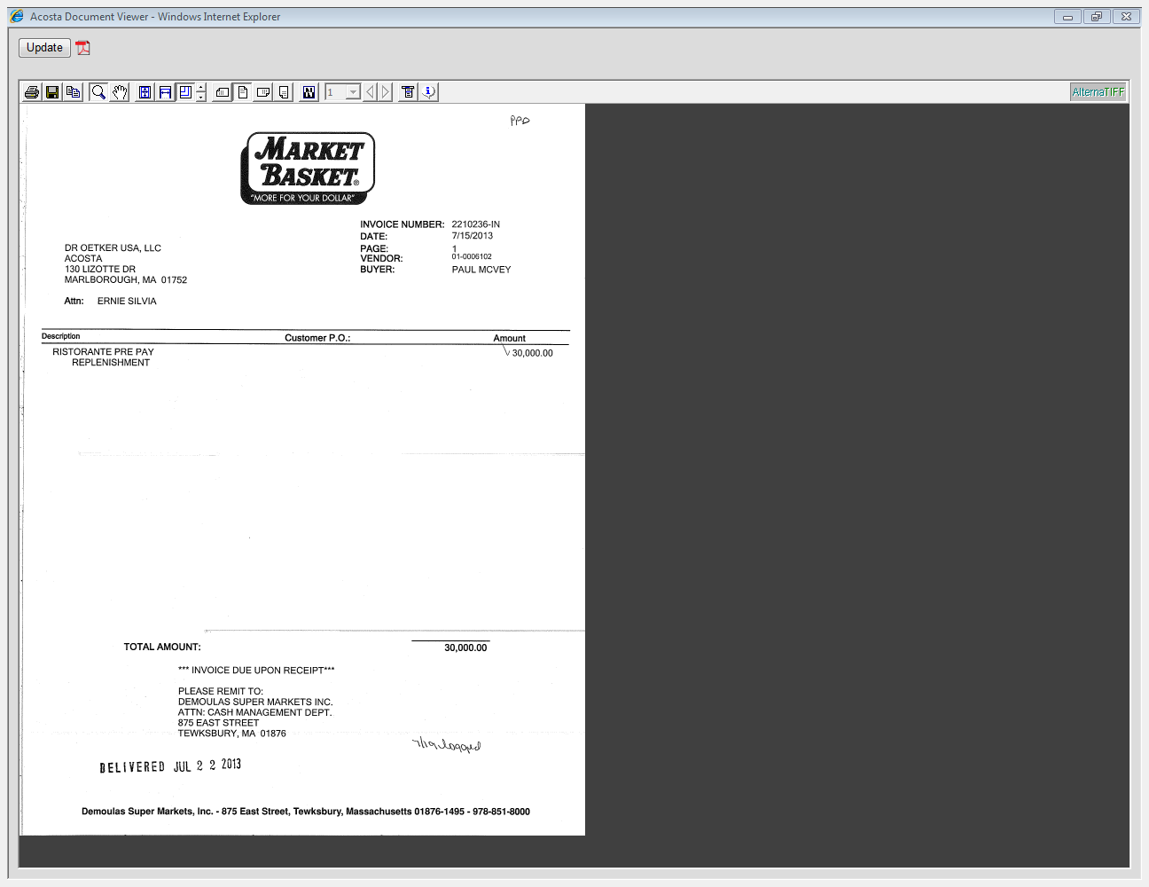
i
Indicates the invoice is for Pre Pay Replenishment

The amount the customer is billing for the replenishment, which must match the contract.

i

11.2 Customer Contract for Pre Pay Replenishment: Found via Search For: Event Scheduler.

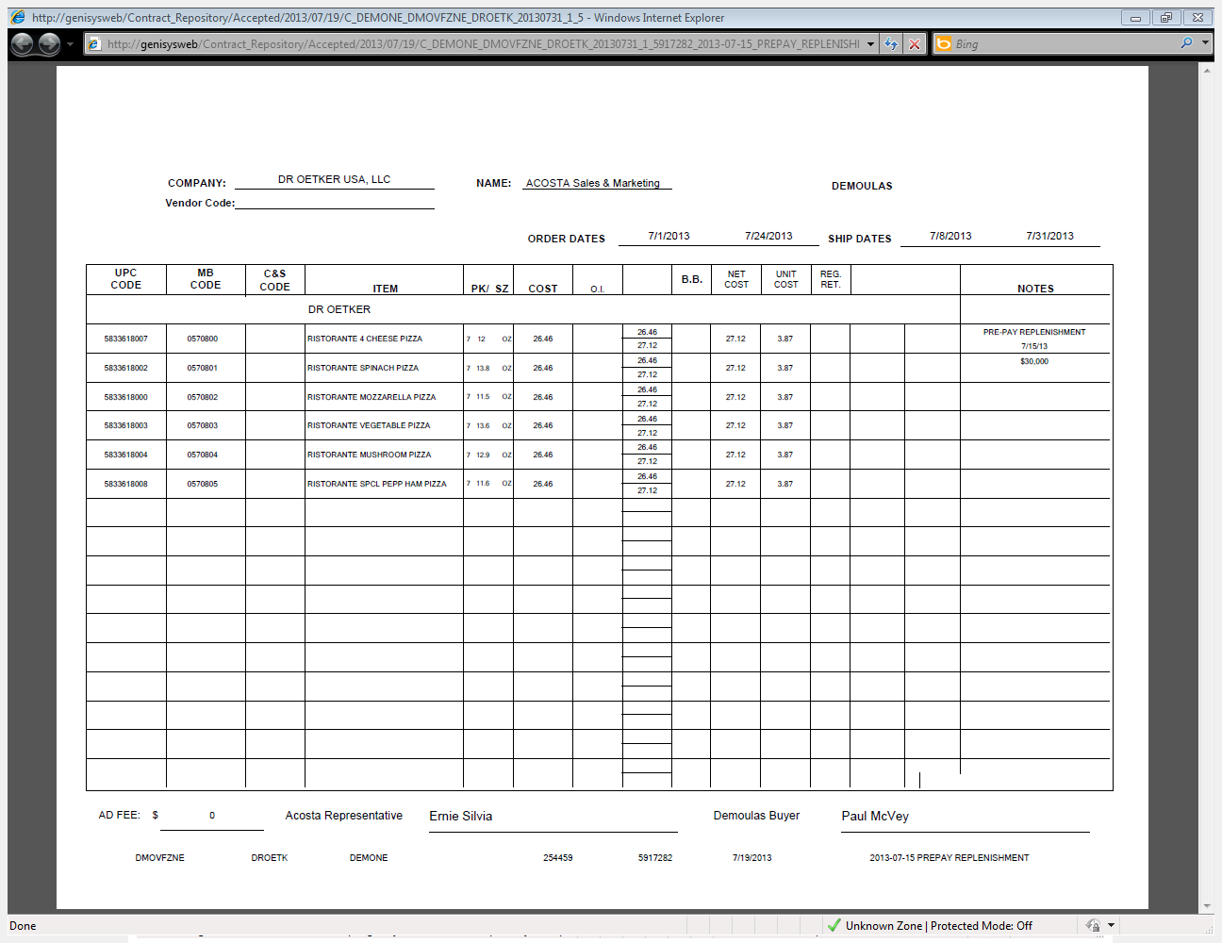
This is the amount of the Pre Pay replenishment, which must match the invoice.

i
i
Indicates the allowance is for Pre Pay Replenishment

12. Deduction Type: Merchandising

12.1 Customer Invoice for Merchandising: Trade - Other

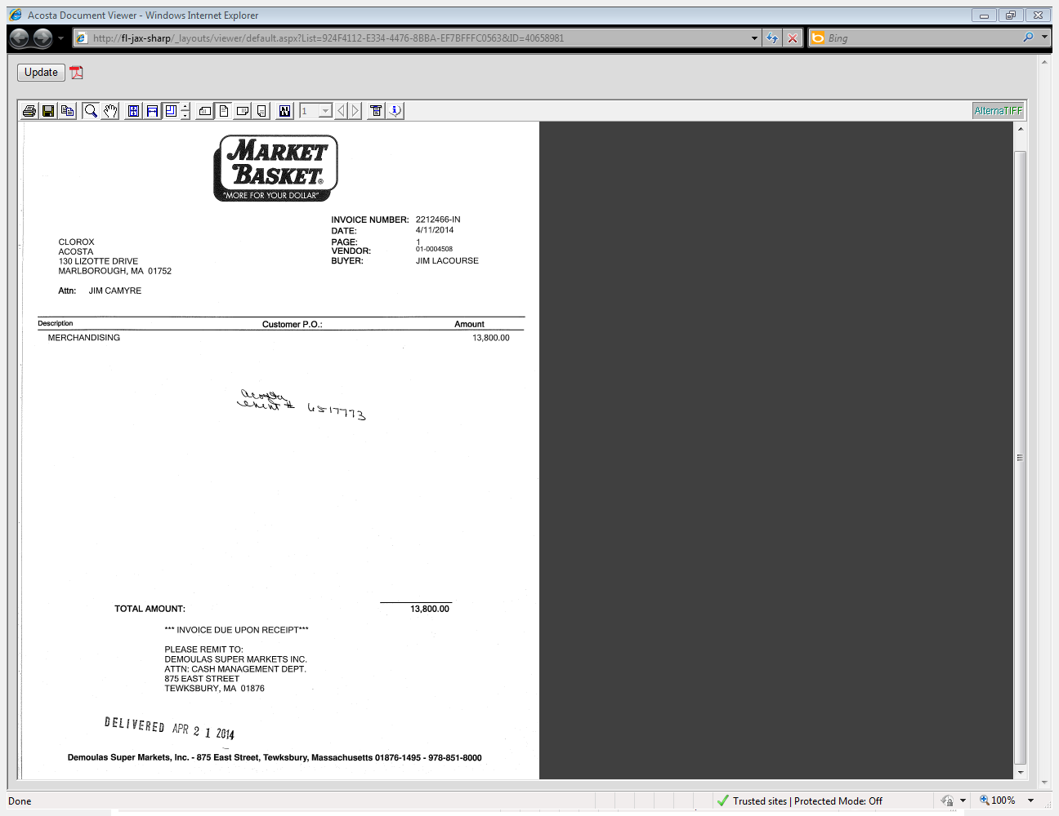
i
If the reason for deducting can not be determined, sales will need to provide additional details. In this example, detail for the claim may be found by reviewing the contract via the AE number provided.

i
Indicates the invoice is for merchandising.

This is the amount of the invoice, which must match the contract.

i

12.2 Customer Contract for Merchandising: Found via Search For: Event Scheduler.

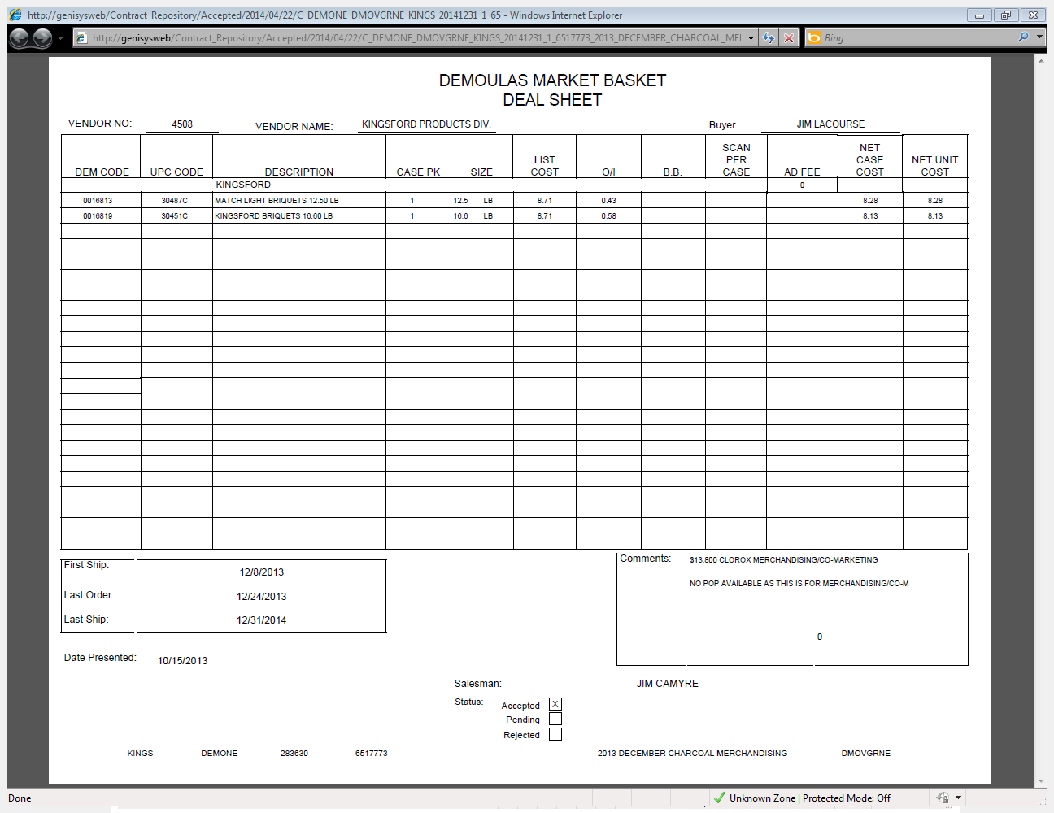
This is the amount offered for merchandising. This need to match the invoice.

i

13. Deduction Type: Other: Truckload Allowance

13.1 Customer Invoice for Other: Truckload Allowance. Trade - Other
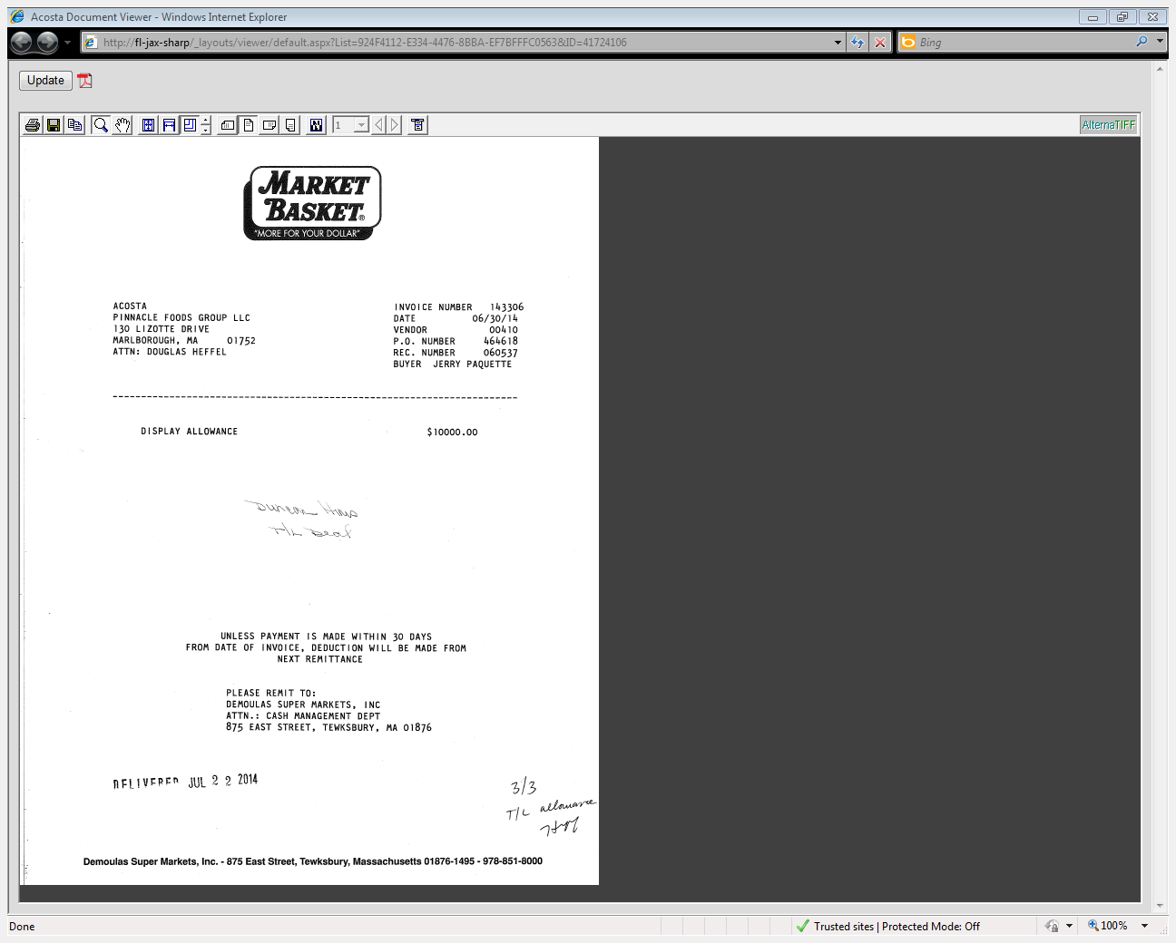
1
Duncan Hines T/L Deal: Indicates the detail of the claim. T/L stands for truckload deal.
3
i
P O Number: The customer’s PO number they are claiming truckload allowance on.

Lump Sum Amount – This is the amount which the customer is claiming for the truckload activity which they have performed per the contract.

13.2 Customer Contract for Other: Truckload Allowance. Found via Search For: Event Scheduler.

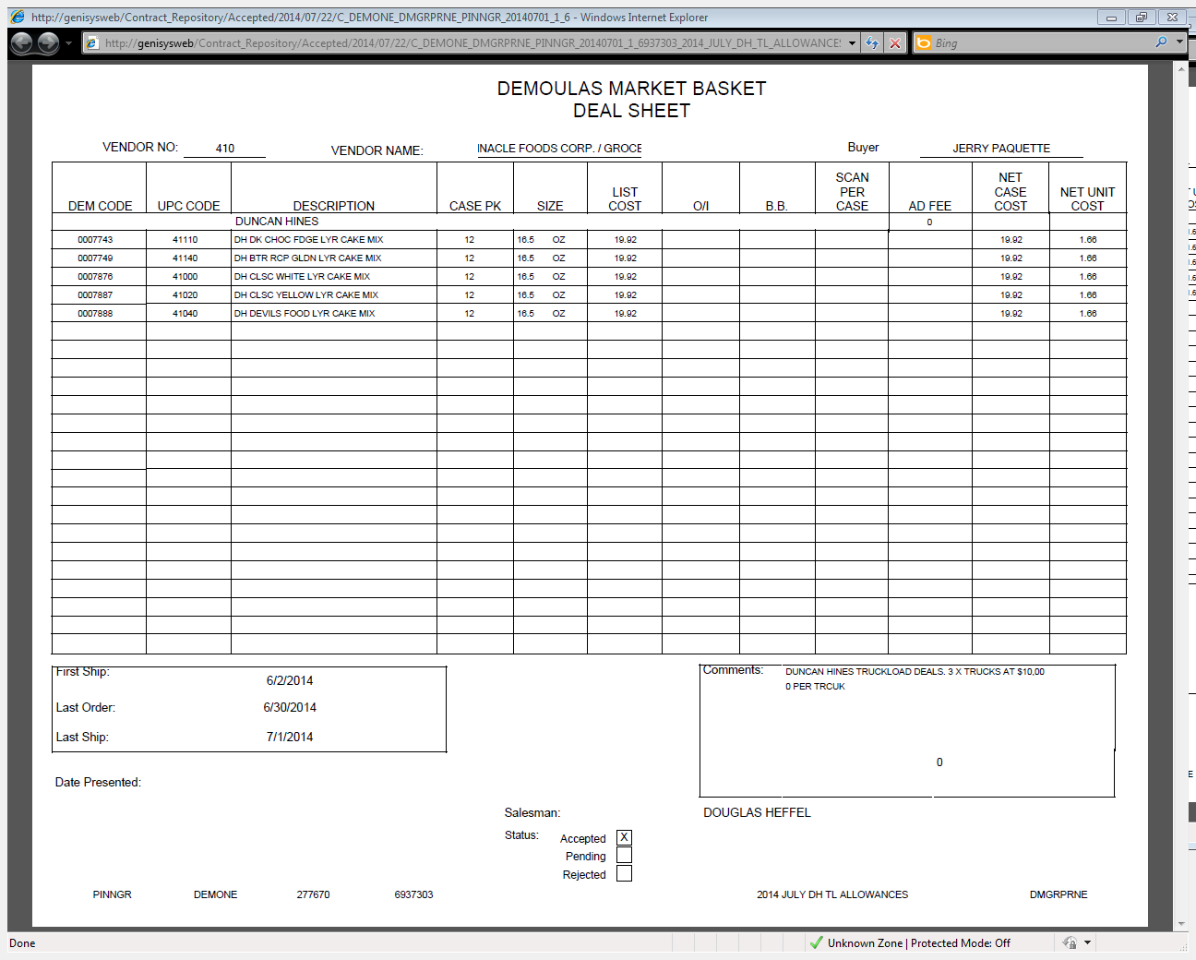
3
Comments: The details of the truckload program offer. The lump sum fee can be listed in the Ad Fee column or in the comments section.

2
Promotion Dates: The PO the customer is claiming the activity on needs to fall within these dates.

13.3 Refer to the SOPs/Generic Help File for POP requirements.

14. Deduction Type: Markdowns

Offer to reduce the shelf price of the product. Usually offered to aid in selling slow moving or discontinued items.

14.1 Customer Invoice for Markdowns: Overstock/Liquidation.

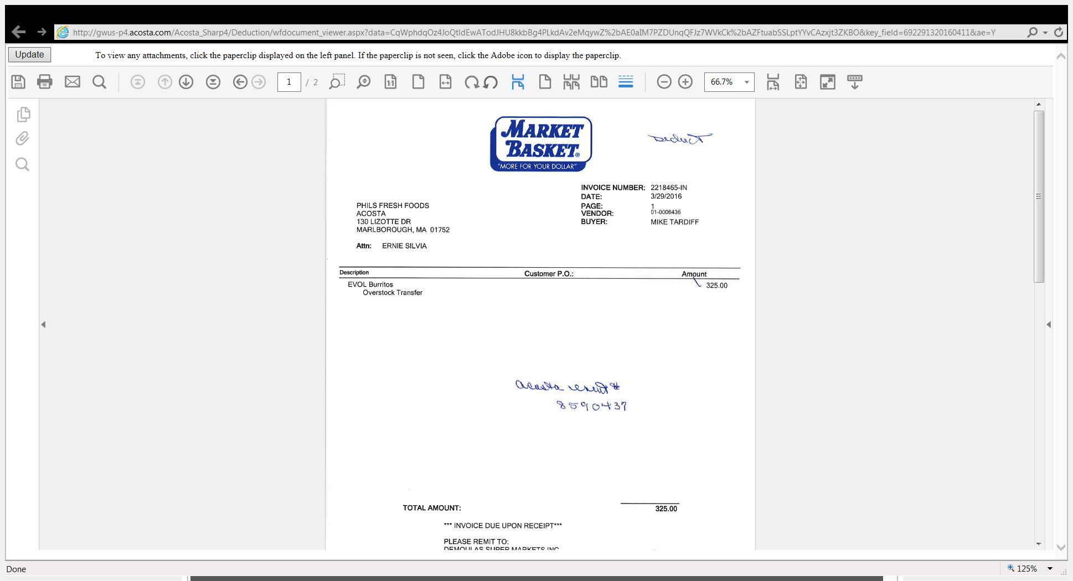
Overstock/Transfer indicates the invoice is for markdowns.

Amount: This is the amount which the customer is claiming for the markdown.

2
Description –The product claimed for the markdown.
1
i

14.2 Customer Contract for Markdowns: Overstock/Liquidation. Found via Search For: Event Scheduler.

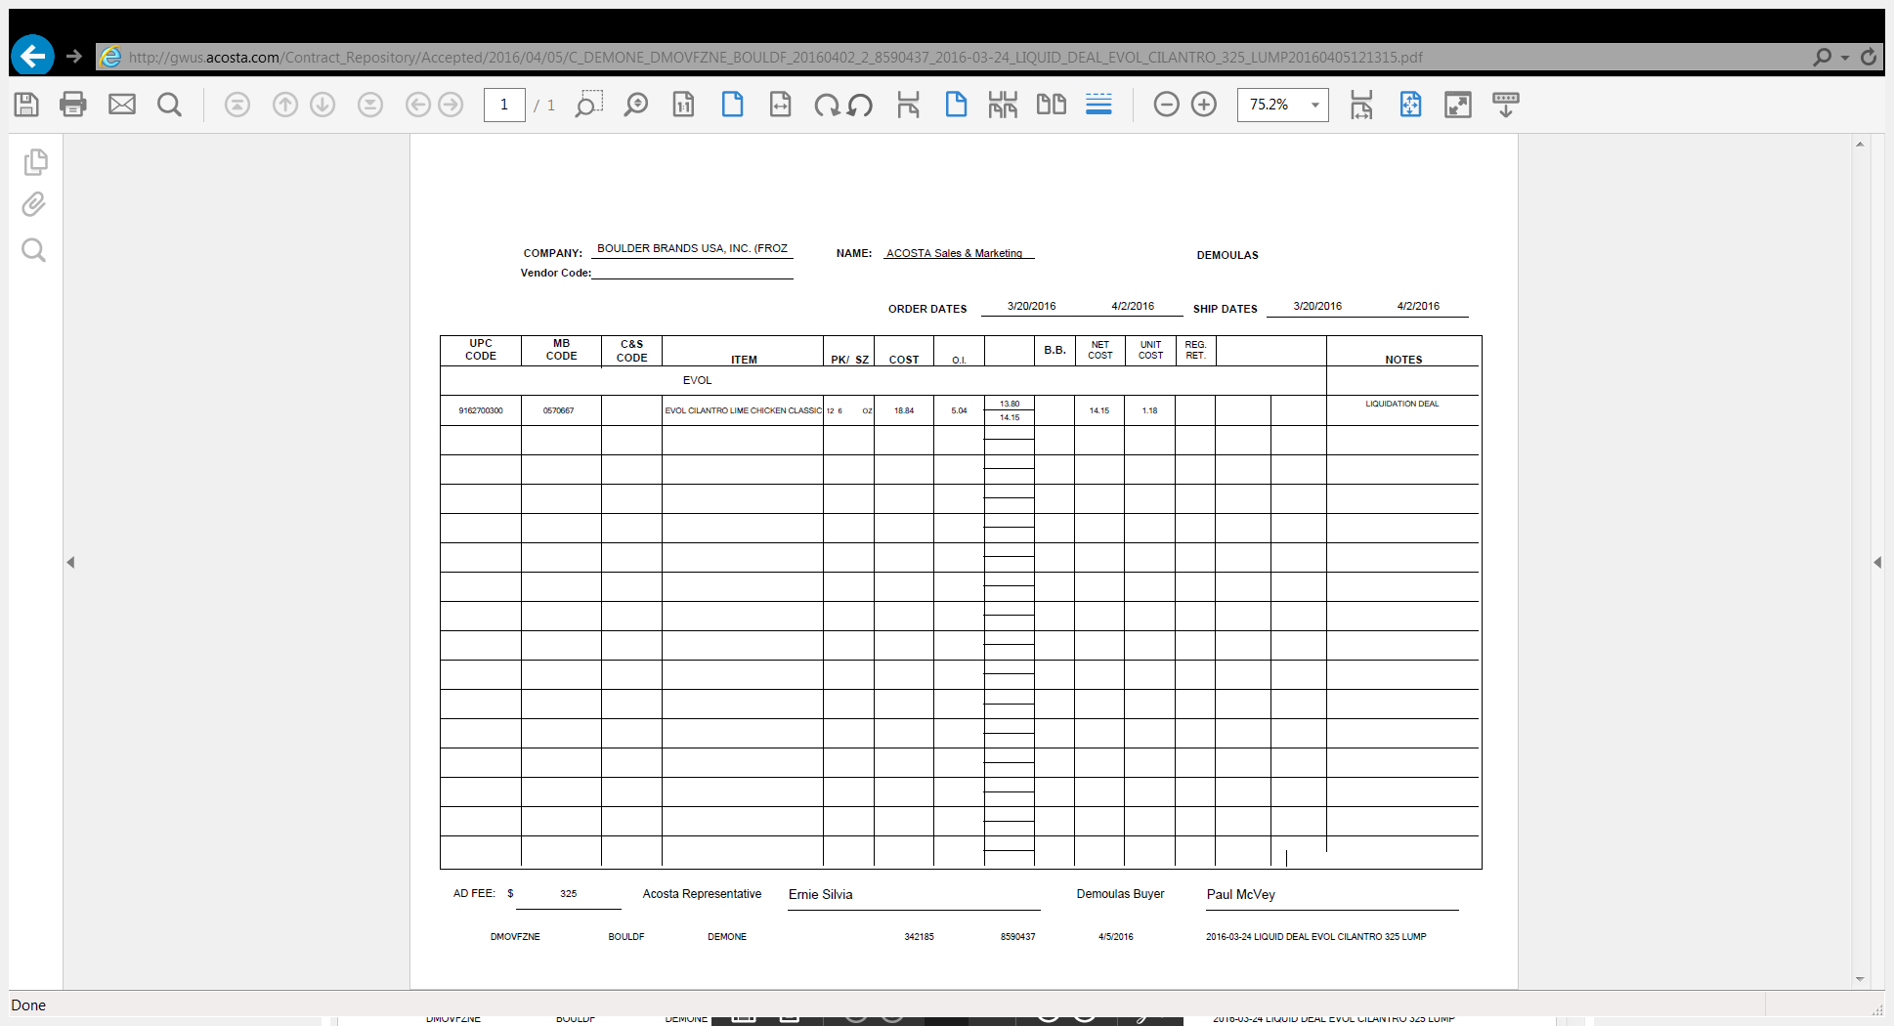
2
Ad Fee – The amount the customer is offered for the markdown.

i
Liquidation Deal: This indicates the contract is for markdowns.

UPC Code, MB Code, Item: Indicates the products on which the markdown is being offered.
1

14.3 Refer to the SOPs/Generic Help File for POP requirements.

15. Deduction Type: Scan
Scan allowances are for product scanned at the store register and are usually billed in eaches, not cases.

NOTE: When Demoulas Market Basket is offered a scan promotion, they will usually run an ad. There is no separate fee or contract for the ad. It is funded by the scan.

15.1 Customer Invoice for Scan, Example 1:

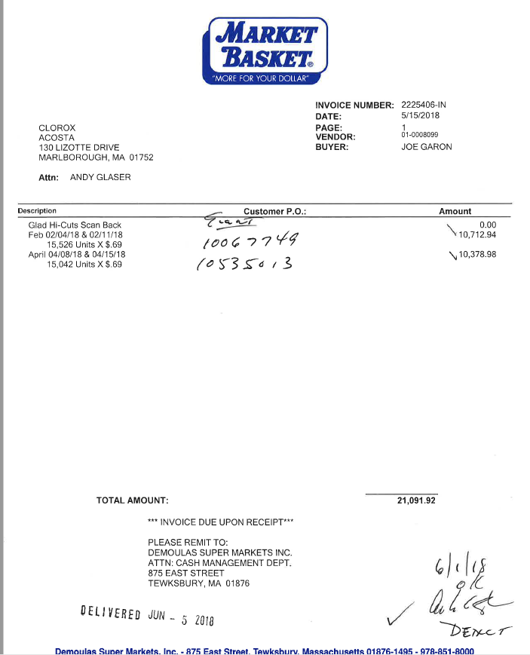
Eaches: The number of units the customer is claiming were sold during the scan.

Description: The product/product groups the customer is claiming the scan allowance on, which must match the contract.
Dates: The time frame the customer is claiming for the scan, which must fall within the dates on the contract.
In this example, the scan ran for one week in Februrary and one week in April.

3
Scan Rate/Amount: The amount the customer is claiming for the scan. The per unit scan rate must match the contract.

2
4
1

15.2 Customer Contract for Scan: Found via Search For: Event Scheduler

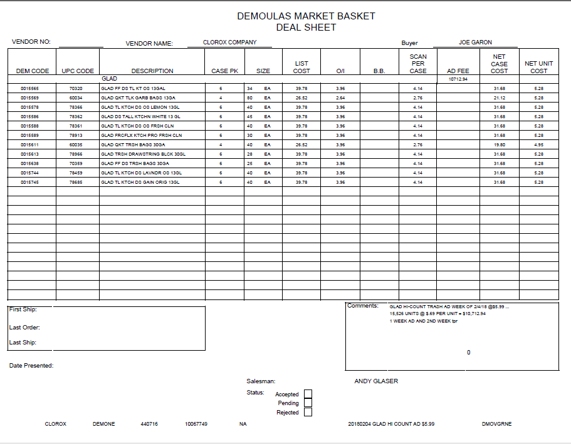
Dates: The time period during which the scan is being offered. The dates shown on the customer invoice must fall within the contract dates.

4
This contract mentions an ad in the Comments section and shows an ad fee amount in the contract detail section. Demoulas Market Basket features the scan product in an ad, but does not bill for the ad. The ad cost is covered by the scan rate. The Ad Fee field may be populated after the promotion is complete, which is why the Ad Fee and the claim amounts match exactly.

i
Scan Per Case: The amount the customer is being offered for the scan. Divide by the case pack to determine the unit rate. The rate claimed on the customer invoice must match.

DEM code, UPC code, description: The product(s) on which the customer is being offered the scan promotion. The items claimed on the customer’s invoice must match.

2
1

2.3 Refer to the SOPs/Generic Help File for POP requirements. POP for this claim is IRI data, even though an ad is mentioned in the contract.

BPS TEAM INFORMATION

REPAY INFORMATION SECTION

PRS / CRA Client Specific
- Repay packets are sent to the Sales team.

CRA VALIDATION SPECIFIC

CRA Client Specific

CCA CLEARING INFORMATION SPECIFIC

CCA Client Specific

COMPLETE VERSION HISTORY
UPDATE DESCRIPTION |  | DATE AUTHOR
First draft of the Demoulas Market Basket SOP |  |  | 04/13/2012
Additional deduction types with flow chars |  |  | 04/22/2012
Reviewed by Trainer |  |  | 06/13/2012 | Geoffrey Van Syckle
Revised flow charts & definitions |  |  | 07/12/2012 | Amol
Addition of Off Invoice Deduction Example |  |  | 07/17/2012 | Amol
Final Review by Trainer |  |  | 07/19/2012 | Geoffrey Van Syckle
Updated Section 1 Off Invoice with better document examples |  |  | 08/10/2012 | Geoffrey Van Syckle
Updated to show if customer subscribes to IRI/Nielsens data for price point verification, pg 2. |  |  | 9/10/2012 | Pam Trimble
Updated hyperlinks to deduction types |  |  | 09/13/2012 | Nagesh Kumar
Updated Section 2 with additional Billback example |  |  | 11/13/2012 | Geoffrey Van Syckle
Updated Section 2 with additional Billback example |  |  | 12/12/2012 | Geoffrey Van Syckle
Added customer Signon link (5675) |  |  | 10/7/13 | Tracy Lewis
Added C&S POP requirements for Frozen (6699) |  |  | 1/20/14 | Tracy Lewis
Added check remittance code for OI (2153), Filled-Bagel specifics (3219), Nestle EDLP (3491), Damage details added (6168) |  |  | 2/17/14 | Tracy Lewis
Added McCormick accrual check requirements to Client section (3351) |  |  | 3/31/14 | Tracy Lewis
Added Campbells/Pepperidge POP requirements to Client section (4152) Added Bayer spin requirement to Client section (7637) Removed vendor # needs to match in Billback section, this is no longer required (5484) Added searching for invoice hints to Customer specific section (7663) Added CRA process for requesting missing backup (7585) |  |  | 4/14/14 | Tracy Lewis
Added In-Store description to the Unsaleable example (6610) |  |  | 4/28/14 | Tracy Lewis
Added P-Vendor section and examples & Dole specific to Client section (6756) Added CCNA splitting lines for SOJ/Blends to Client section (4484) Changed invoice total call out on OI example (5830) Added Mama Rosie POP requirements to Client section (5704) Added Pre Pay Replenishment section and example (4910) |  |  | 5/12/14 | Tracy Lewis
Added Heinz to Client Section (10719) Added Hostess to Client section (9535) Added adjustment codes to Customer specific section (9423) |  |  | 11/10/14 | Tracy Lewis
Added Clorox pricing can be determined by check remittance to Client section (9808) Added Kens PPD invoice example to Client section (5352) |  |  | 12/8/14 | Tracy Lewis
Added Merchandising Example (8800) |  |  | 12/22/14 | Tracy Lewis
Added Michael Foods does not pay by check customer is required to deduct to Client section (11097) Added Display example (11578) Added Tyson about Deli items to Client specific (11233) |  |  | 1/19/15 | Tracy Lewis
Added claims with a client reference # ending in “500” for Lacatalis are for cash discount to client section (12365) |  |  | 2/16/15 | Tracy Lewis
Added this customer is a wholesaler/distributor, direct or indirect customer to customer sign-on box. (13429) |  |  | 4/27/15 | Tracy Lewis
Added is Req CI from CIT used for this customer to BPS Team Info section (13772) Added manufacture coupons for Pfizer are considered automatic repays to Client section (13812) |  |  | 5/25/15 | Tracy Lewis
Added percentage breakdown for CL & SW for Starkist to Client section (13942) |  |  | 6/22/15 | Tracy Lewis
Added Kikkoman approval process to Client section (13481) |  |  | 7/06/15 | Tracy Lewis
Removed spin requirement for Filled Bagel in Client section (13785) Added a note to the damage example the invoice can also be found under doc type 8 (13264) Added new contact for backup to Customer Specific section (13233) |  |  | 7/20/15 | Tracy Lewis
Added Earth Wise Green Bags are Merchandising invoices for Dole to Client Specific section (14509)  Updated line level detail in Customer Specific (15509) |  |  | 8/17/15  10/26/15 | Tracy Lewis
Removed Joanne Cook from backup request process and moved to BPS team information section (15746) |  |  | 11/09/15 | Tracy Lewis
Removed P-Vendor info section and added note in Customer General section (16249) Clean up and reorganization of information to new format structure & removal of out of date material (14730). Added Newman’s does not cut checks to Client Specifics section (15714) |  |  | 12/21/15 | Tracy Lewis
Moved display example 2 to section for Truckload Pricing (16110) |  |  | 01/18/16 | Tracy Lewis
Added Clorox CCA Specific for clearing Ad funds (18503) |  |  | 06/20/16 | Tracy Lewis
Added FSI process for Clorox to Client Specific section (18657) |  |  | 07/18/16 | Tracy Lewis
Added Overstock/Liquidation deal example to Markdown section (18328)  Removed Kraft & Heinz client specifics (19311) |  |  | 08/01/16 | Tracy Lewis
Removed Lacatalis specific for cash discount from Client Specific section and moved to Customer General Info section (19093) Added RTV indicates the invoice is for returns to the Returns Section (19452) |  |  | 09/26/16 | Tracy Lewis
Removed Lacatalis specific for cash discount from Client Specific section and moved to Customer General Info section (19093) Added RTV indicates the invoice is for returns to the Returns Section (19452)  Removed extra contract copies and POP examples (19418) |  |  | 09/26/16 | Tracy Lewis
Add Client Specific Gortons checks do not require event numbers (21359) |  |  | 05/22/17 | Laurinda Ogburn
Client specific: removed Mama Rosie’s POP information (22355) |  |  | 9/11/2017 | Suzy Fields
Added direction to the Tyson specific section for Fresh and Deli claims (22788) |  |  | 10-9-2017 | Laurie Barber
Added Nestle USA to client specific section – Prior broker exception (23148) |  |  | 12-04-2017 | Laurie Barber
Added Sabra to client specific section – Sabra does not cut checks, customer deducts (23326) |  |  | 12-18-2017 | Laurie Barber
Campbells is now following simplified POP – removed POP direction from client specific section (22355)  Updated hyperlinks for new Sharepoint Online site (23751) |  |  | 01-15-2018  02-06-2018 | Laurie Barber  Laurie Barber
Client specific section: Added Lactalis and policy for processing cash discount deductions (24605) |  |  | 6/18/2018 | Suzy Fields
Added Scan section, including info for ad funded by scan (25013) |  |  | 7/2/2018 | Suzy Fields
Client Specific section: Explanation of Nestle process for Demoulas and Shaw’s claims (25246); added Barilla swell allowance information (25265) |  |  | 7/30/2018 | Suzy Fields
Update to customer backup request information/realignment of information; no process change. |  |  | 8/13/2018 | Suzy Fields
Client specific section: Removed Newman’s Own Organic as Acosta no longer reps (25619) |  |  | 9/10/2018 | Suzy Fields
Customer General Info: Added 02 to Adjustment Code table (25812) |  |  | 9/24/2018 | Suzy Fields
Client Specific section: McCormick – added handling information for items Acosta does not represent (26064); added Peak Foods info (26179) |  |  | 11/5/2018 | Suzy Fields
Client Specific section: Added Colgate DBW instructions (26276); added Sovos-Michael Angelo representation info (26382) |  |  | 11/19/2018 | Suzy Fields
Client Specific section: Added Mama Rosie’s date flexibility detail (26417); Added McCormick info on determining whether Acosta handles certain items (26139) |  |  | 12/3/2018 | Suzy Fields
Client Specific section: Added Starbucks ad fee split (26656)  Updated Feature Vision to Numerator |  |  | 1/14/2019 | Suzy Fields
Client Specific section: Removed McCormick (26829) |  |  | 2/13/2019 | Suzy Fields
Customer general info and unsaleable sections: IN STORE indicates the claim is for damages (27116) |  |  | 2/25/2019 | Suzy Fields
Slotting section: Moved new store opening example from billback section to slotting section (27393) |  |  | 4/8/2019 | Suzy Fields
Added example of Trade Funds CI to billback section, and added Bush instructions for handling to client specific section (27654)  Removed Sabra from client specific section |  |  | 4/22/2019 | Suzy Fields
Client specific section: Removed Tyson as we no longer rep (27728)  Client specific section: Removed Clorox as we no longer rep (28157); removed Mama Rosie’s as we no longer represent (28157) |  |  | 4/26/2019  7/1/2019 | Suzy Fields
Customer General Information – Contract Info section: added example of Demoulas contract showing allowance on one item (28413) |  |  | 8/26/2019 | Suzy Fields
Client Specific section: Removed Starkist as Acosta is no longer the broker effective 10.15.19 (28760) |  |  | 10/21/2019 | Suzy Fields
Client Specific section: Removed Starbucks due to Nestle purchase (29269). Created Backup Retrieval section (29001) |  |  | 1/31/2020 | Suzy Fields
Ad section: Removed reference to Numberator and updated POP search instructions (29654) |  |  | 3/9/2020 | Suzy Fields
Client Specific section: McCain process for “C&S Freezer” claims (29851) |  |  | 4/6/2020 | Suzy Fields
Client Specific section: Added Ken’s check request info (30174)  Backup Retrieval section: Added Barilla specific backup request info (30209) Added Sunny D and Harvest Hill’s specific backup request info (30294) |  |  | 6/15/2020 | Maria Ovalles
Removed Pfizer specific info, Acosta is no longer their broker (30408) |  |  | 7/13/2020 | Maria Ovalles
Removed Pfizer specific info, Acosta is no longer their broker (30408) Removed Nestle C-Store Nestle Nutrition specific info, Acosta is no longer their broker (30503) Removed Nestle USA specific info, Acosta is no longer their broker (30502) |  |  | 7/13/2020 | Maria Ovalles
Updated backup request info (31815) |  |  | 4/5/2021 | Maria Ovalles
Updated backup request info for Campbell’s/ Pepperidge (32464) Added Repay contact info to the BPS Team Info section (32561) |  |  | 8/23/2021 | Maria Ovalles
Added Cust number header note info for Campbell’s/ Pepperidge (32659) |  |  | 9/20/2021 | Maria Ovalles
Added In Store claims info for Honest to the Client Specific (32589) |  |  | 10/4/2021 | Maria Ovalles
Updated Repay contact info to the BPS Team Info section (33146) |  |  | 2/7/2022 | Maria Ovalles
Added in-store backup info for Edgewell to the Backup Retrieval Info section (33803) |  |  | 8/1/2022 | Maria Ovalles
Added in-store backup info for Edgewell to the Backup Retrieval Info section (33803) |  |  | 6/12/2023 | Maria Ovalles
Added backup info for Jasper Wyman & Son to the Backup Retrieval Info section (34925) |  |  | 7/24/2023 | Maria Ovalles
Added EDLP info for GL Mezzetta to the Client Specific (35384) |  |  | 8/28/2023 | Maria Ovalles
Added event info for Ferrero to the Client Specific (35626) |  |  | 10/30/2023 | Maria Ovalles
Removed client/customer specific information for Lactalis from the Client Specific Validation Info Section (35696) |  |  | 11/13/2023 | Maria Ovalles
Updated Client Specific information to include Nutrament (395697). |  |  | 09/03/2024 | Katie Teare
Removed Hostess from the Client Specific section (402814) |  |  | 10/14/24 | Katie Teare
Added the client Bush to the backup retrieval information section. (418042) |  |  | 03/17/2025 | Lindsay McGinnis
Added the client Lassonde Pappas & Company, Inc to the backup retrieval information section. (444337) |  |  | 10/13/2025 | Lindsay McGinnis
Added to client specific section for CCNA; process for invoices reflecting “Performance Allowance” (453319) |  |  | 1/19/2026 | Lindsay McGinnis
Added P-Vendor information regarding contracts to the Customer General Information section (459915) |  |  | 3/2/2026 | Lindsay McGinnis
Updated backup retrieval section to reflect that all backup is requested from sales. (459447) |  |  | 3/9/2026 | Lindsay McGinnis
Removed Michael Foods from the Client Specific Validation Information section. (467692) |  |  | 5/4/2026 | Lindsay McGinnis

