WORK INSTRUCTIONS
Process | Order to Cash
DTP Name | General Trading

CURRENT VERSION HISTORY
UPDATE DESCRIPTION | DATE | AUTHOR
Updated the check remit requirement info in the Backup Retrieval Info section (35889) | 1/8/24 | Maria Ovalles

Link to complete version history: COMPLETE VERSION HISTORY

DEDUCTION TYPES COVERED
Sl. No. | Deduction Type
 | Customer General Information
 | Backup Retrieval Information
 | Client Specific Validation Information
1 | Off Invoice
2 | Bill Back
3 | Ad
4 | Slotting
5 | Fees
6 | Unsaleable / Reclamation (Non-Trade)
7 | Pricing (Non-Trade)
8 | Shortage (Non-Trade)
9 | Truck Allowance
10 | Retail Merchandising Program/ISE Program (GT Retail Support System)
 | BPS Team Information
Is the customer a wholesaler/distributor, direct or indirect customer? General Trade for grocery and dairy is considered to be wholesaler/distributor, but they buy frozen through Burris Foods as an indirect.

Note: GENENY is the sign-on used to work on ACOSTA Relay for General Trading. For frozen product, search using BURRPH. (for example to search a document and to refer the customer on ACOSTA Relay).

Link to customer signon job aid:
https://acostaonline.sharepoint.com/sites/AS_Reporting/Claims_Reports/Forms/AllItems.aspx?web=1

Does this customer subscribe to IRI/Nielsen data for price point verification? No

CUSTOMER GENERAL INFORMATION

Customer Invoice Info:

Is line level detail indexed on the customer’s documentation (customer invoice, customer check request, unsalable/spoils, post audit, EDI 812/820 or client deduction notice if one of these documents is included)? No

When General Trading deducts through Burris, they create two customer invoices. The check remit will not show both CI numbers.
In this example, the claim amount is $290.90.
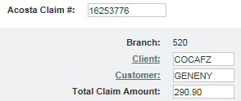

The check remit shows invoice 10907 for $290.90:
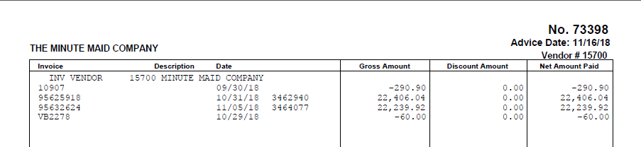

Customer invoice 10907 is for $21.90 and references invoice 19945:
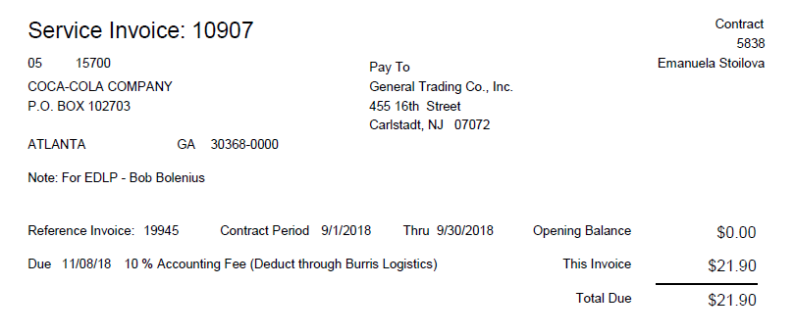

Customer invoice 19945 provides the detail the fee was taken against:
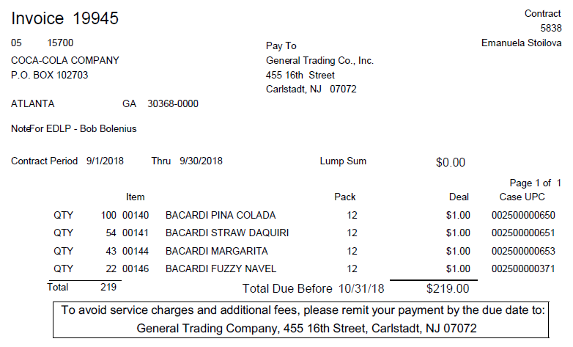

The customer invoices total to $240.90; the remaining balance is the fee General Trading claimed for deducting.

How to read the Payment Report that comes with the check remit:
i
Purchase Order 323482 is the original customer PO # that payment is being made for + under “Other Deductions” section (see below) what is being deducted. This Purchase Order # may not apply to the deductions listed below. Link the PO # as reference; however, it may not reflect the items being deducted on the claim.
i
Other Deductions = reflects the “Applied to” claims that are being deducted by the customer against this payment. In this example, there are 2 separate claims listed; however, the claim amount in ACOSTA Relay on the Claims Processing Screen will be the total of all claims listed under “Other Deductions”.
(e.g. 398660 $225.00 and 73260 $21,028.64 for a total of $21,253.64) These invoices can be found in the ACOSTA Relay repository and should be linked to the claim line and will help determine what the customer is deducting for.

Sometimes the billback amount listed on the Payment Report will not match the customer invoice. When this occurs, once you link the contract (VPF) to the claim line, reference the claims inside the VPF that have been validated to determine if the customer has taken the total amount of the customer invoice. This will assist in validating all partial claims against the customer invoice. For billbacks, run a Memo Tracking Report for the contract ship dates to validate all cases.

BACKUP RETRIEVAL INFORMATION

GENERAL BACKUP RETRIEVAL INFORMATION

Is GCIT responsible for obtaining backup from the customer? Yes
- If yes, is there a customer portal? No
- If yes, does GCIT request backup? Yes

Is check remittance information required to request backup? Yes, the check remit needs to be linked to the claim prior to stepping to sales.

GCIT SPECIFIC BACKUP RETRIEVAL INFORMATION

Non - Automated:

Customer Invoice or Note Identifier | Request From
All formats | Request from sales

CLIENT SPECIFIC VALIDATION INFORMATION

Client
Campbell’s
Georgia Pacific
Harvest Hill
Mars Food US LLC
Sunsweet

CAMPBELL’S
- For check requests for CAMPBL and PLUMO: Due to the way General Trading generates invoices, claims are excessive in length in ACOSTA Relay.
  - Check request payments for CAMPBL and PLUMO will have the DBW created without following the PPG instructions in the client SOP. The DBW will be created by client event.
  - CCAs will use the e4 Allocate based on planned spend functionality to apply spend to the PPGs within the client event tactic by adding the event to the payment, placing the line amount on the Paid Amount under Event/Tactic, ensuring Planned Spend is reflected under Allocation Metric and then clicking the Allocate button. The paid amount under Funds does not need to be manually updated when following this process.
- GT Retail Support claims are cleared in SAP and not in E4.
- Pepperidge Farm Frozen only CUST in header will need changed to CUST:1000009419.

GEORGIA PACIFIC
- There is no GCC involvement for this client/customer combination.

HARVEST HILL
- For suggested ad billback contracts, the ad is optional. If an ad cannot be located in the system, the claim will be escalated to the CRA. The CRA will reach out to sales to see if an ad was run for the promotion.

Mars Food US LLC
- This customer participates in the Mars Retail Merchandising Program

SUNSWEET
- Sunsweet does not issue checks to General Trading for damages, as General Trading will deduct.

PROCESS STEPS

1. Deduction Type: Off Invoice

A per case off invoice allowance is given to the customer as an automatic discount for product purchased from the client. If the customer does not receive the allowance off the face of the invoice they will deduct for it. If the customer requested an allowance that is not valid, the CSC will send a notification to the customer in writing. Customers view purchase orders as contracts. If they are not notified of allowance discrepancies, they will pay according to their purchase order total.

  - Customer Invoice for an Off Invoice allowance not given:

4
This is the Customer Invoice number. This can be used to search and retrieve the Order/Invoice data from the Review Order/Linked Documents link screen within ACOSTA Relay. Also, this needs to be matched with the client order invoice.
This is the Check# through which the customer has made the payment for the invoice.
i

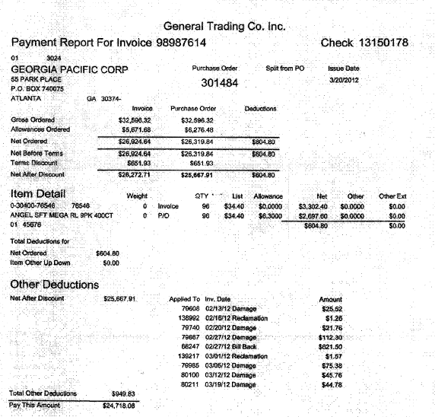
The PO number can be used to find the original order in ACOSTA Relay.
Item Detail: The product on which the customer is stating that an off invoice allowance was due but not given
2
Allowance: The rate the customer was expecting to receive for the off invoice.
Qty – The number of cases the customer is claiming they did not get an off invoice.
1
3
i
Pay This Amount: The total the customer has deducted for the off invoice they claim was not given.
2

  - Customer Contract for an Off Invoice allowance: Found via Search For: Event Scheduler.

1
Case UPC, Item, Pack: The product on which the customer is being offered an off invoice allowance. The product on the customer invoice must match.
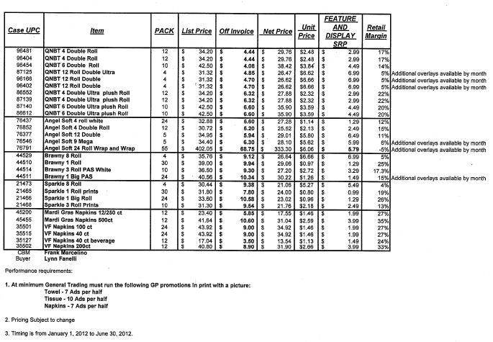
Buyer’s Name –If this is empty then we need to send the claim to Sales team for further research.
Off Invoice: The amount being offered to the customer for the OI. The rate on the customer invoice must match.
2
i
Date Range – This is the date range for which customer is being offered the off Invoice allowance.
i

1.3 Refer to the SOPs/Generic Help File for POP requirements.

2. Deduction Type: Billback

A Billback claim is a per case allowance offered for a specific performance requirement. A per case billback allowance is claimed by the direct buying customer for product purchased from the client, or by the indirect customer for product purchased from the direct customer. This is an allowance the customer will bill the client for. This is not an automatic discount given off the face of the invoice.

2.1 Customer Invoice for Billback, Example 1:

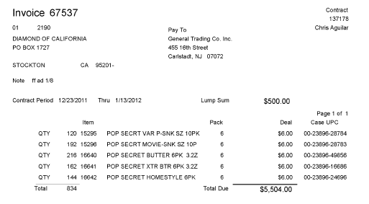
2
Deal: The rate the customer is claiming for the billback, which must match the contract.
Contract Period – The dates the customer is claiming for the billback.
5

1
Item: The product the customer is claiming the billback on, which must match the contract.

3

Qty: The number of cases the customer is requesting the billback on.

2.1 Customer Invoice for Billback, Example 2:

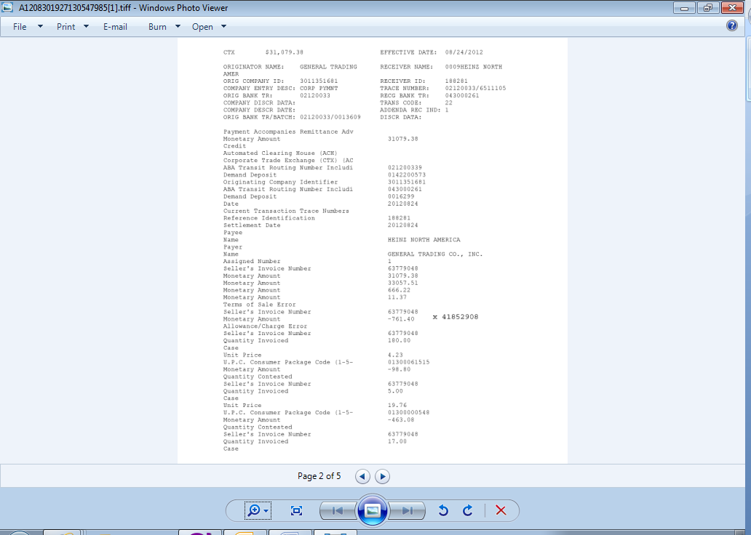
3
Quantity Invoiced: The number of cases the customer is claiming the billback on.

1
UPC Consumer Package Code: The product the customer is claiming the billback on.
Unit Price: The billback rate being claimed by the customer for each item.

2
4
Seller’s Invoice Number: The client order invoice number the customer is claiming the billback on.

2.1 Customer Invoice for Billback, Example 3:
Part 2 - Customer Payment Report Example
i
The customer invoice total is $5311.60. The customer payment report shows that the billback portion, taken against PO 3201720, is $1293.09.

The customer is deducting from this Purchase Order # 320172 the balance owed from Invoice # 72588. The Customer Payment Report is very important because it shows the customer will reference the invoice being deducted.

2.2 Customer Contract for Billback, Example 1: Found via Search For: Event Scheduler.

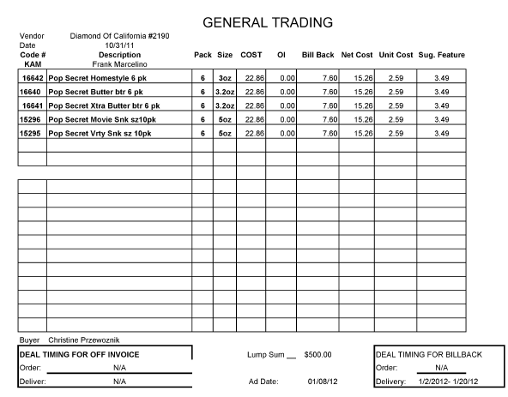
5
Bill back: The amount being offered to the customer for the billback. The rate claimed by the customer must match the contract.
2
1
Code #: The product the customer is being offered the billback on.
Delivery: The date range during which the cusomter is offered the billback. The dates on the customer’s purchase order must be within these dates

2.2 Customer Contract for Billback, Example 2: Found via Search For: Event Scheduler.

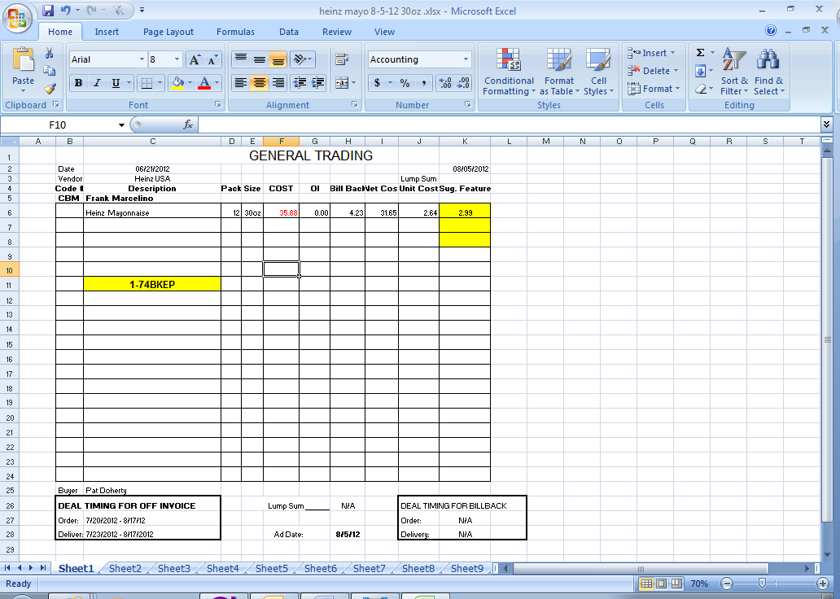
5
Deal Timing for Billback: The date range during which the customer is offered the billback. In this example, the dates for the billback were not given, so the claim would have to be escalated to sales.
i
This is the Event Number associated with this promotion.
2
Bill back: The rate offered to the customer for the billback. The amount claimed by the customer must match.

2.3 Refer to the SOPs/Generic Help File for POP requirements. NOTE: Sales Analysis reports for Grocery products should use the customer sign on GENENY. Sales Analysis reports for Frozen products should use the customer sign on BURRPH.

3. Deduction Type: Ad

A fee for featuring a client's products in an advertisement.

3.1 Customer Invoice for Ad:

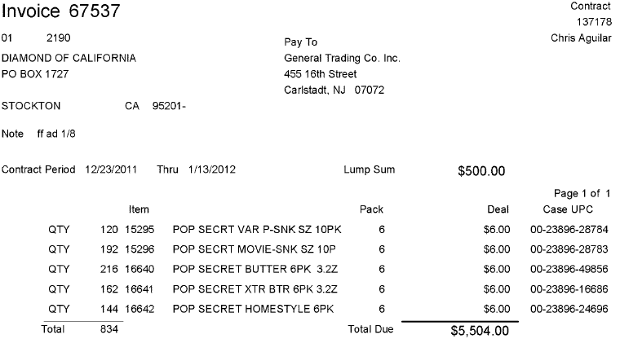
2
Note: The date the customer ad ran the ad.
3
Lump Sum: The amount the customer is claiming for the ad, which must match the contract.

1
Item & Pack: The customer’s code for the items claimed. Use the contract or APL to identify the UPCs.

3.2 Customer Contract for Ad: Found via Search For: Event Scheduler.

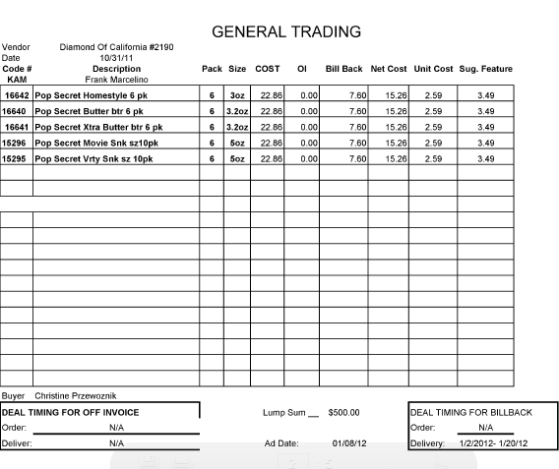
3
Lump Sum: The amount being offered for the ad. The amount on the customer invoice must match the lump sum amount on the contract.
Code #, Description, Pack & Size: The product the customer is being offered an ad on. Use the APL to identify the UPCs.

1

2
Ad Date needs to be compared with the customer invoice to validate the claim. These will be the deal dates on the customer invoice.

3.3 Refer to the Proof of Performance Reporting Ads job aid for searching for ads.

4. Deduction Type: Slotting

A slotting allowance is offered to the customer to purchase an item not currently stocked. A slotting lump sum allowance can be offered for each item and/or an off invoice can be offered as an introductory allowance for the first 30 days.

4.1 Customer Invoice for Slotting:

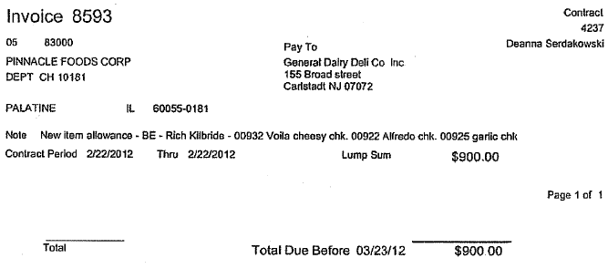
2
Lump Sum: The amount the customer is claiming for slotting, which must match the contract.
1
Item description and UPCs: The items the customer is claiming slotting on, which must match the contract.
i
Note: New Item allowance indicates that the deduction is for slotting.

4.2 Contract for Slotting: Found via Search For: Event Scheduler.

i
New Product Introduction: identifies that the contract is for slotting.
i

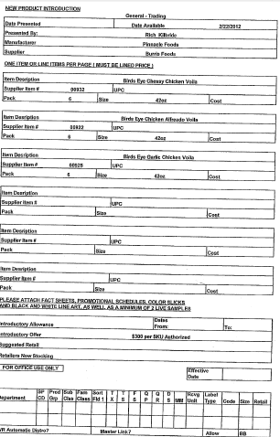
2
Supplier Item #, Pack, Size and Item Description: The product slotting is being offered on, which must match the customer invoice.
Date Available: This is the Performance date which should match with the customer contract.
1
Introductory Offer: The amount the customer is being offered for slotting.

4.3 Refer to the SOPs/Generic Help File for POP requirements. NOTE: Sales Analysis reports for Grocery products should use the customer sign on GENENY. Sales Analysis reports for Frozen products should use the customer sign on BURRPH.

5. Deduction Type: Fees/Penalties

A cost assessed by the customer for various reasons, including: handling, administrative, service and scan fees.

Documents required for validating an Fees/Penalties Deduction:

Document Name | Source of the Document | Action by Accenture
Customer Invoice | ACOSTA Relay – search for the invoice under Backup Documentation | Step up the claim to Acosta for research

5.1 Customer Invoice for Fees/Penalties:

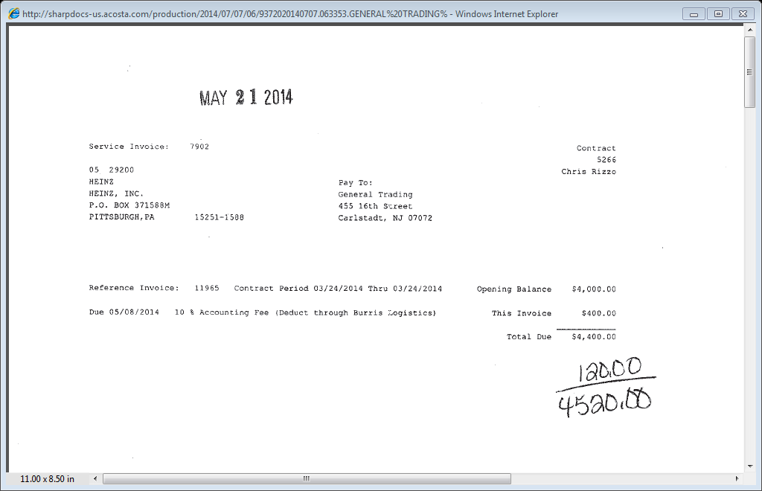
i
Fee for Deducting – This fee is the General Trade charge for deducting for this invoice.
i
Reference Invoice: The invoice(s) being claimed on this invoice. The individual invoice(s) will need to be located to determine reason for deducting.
i
Accounting Fee – This indicates this portion of the deduction is for fee.

6. Deduction Type: Unsaleable/Reclamation (Non Trade Claim)

An Unsaleable claim is taken for product that cannot be sold at the stores due to damages (and short coded product).

6.1 Customer Invoice for Unsaleable / Reclamation, Example 1:

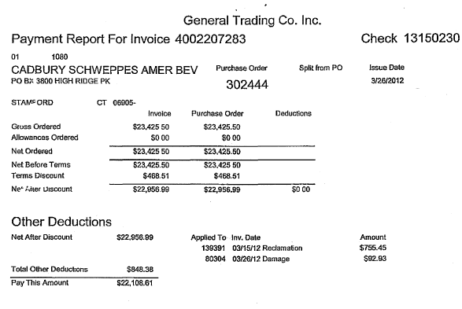
i
Deduction Type – This indicates the deduction is for unsaleables.

6.1 Customer Invoice for Unsaleable / Reclamation, Example 2:

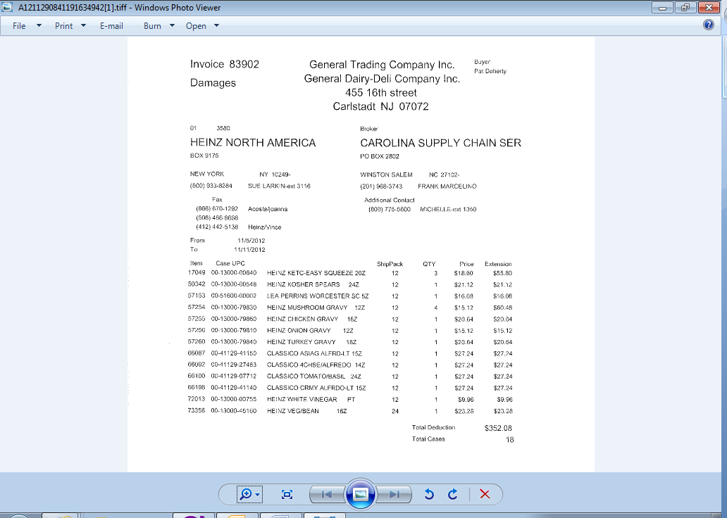
Deduction Type – This indicates the deduction is for unsaelables.
i

7. Deduction Type: Pricing – Non Trade related claim

A pricing deduction occurs when the customer's requested price on the original purchase order differs from the client's invoice.

Documents required for validating a Pricing claim

Document Name | Source of the Document | Action by Accenture
Customer Invoice | ACOSTA Relay – search for the invoice under Backup Documentation, document type 2. | Step the claim to Acosta for research
Order Invoice or Client Order Invoice | ACOSTA Relay – search for this document within the Order/Invoice/PO search.

7.1 Customer Invoice for a Pricing:

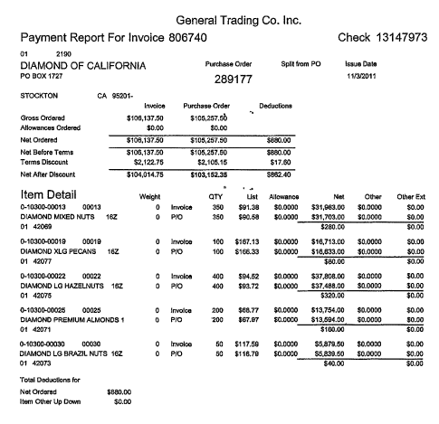
i
The difference in the Invoice amount & PO amount indicates that the deduction is for pricing.
i
Purchase Order: The order the customer is claiming the pricing discrepancy on.

7.3 Refer to the SOPs/Generic Help File for POP requirements.

8. Deduction Type: Shortage

It is a deduction for shorted product on an order that the client billed the customer for.

Documents required for validating a Shortages Deduction:

Document Name | Source of the Document | Action by Accenture
Customer Invoice | ACOSTA Relay – search for the invoice under Backup Documentation, document type 2. | Step the claim to Acosta for research
Order Invoice or Client Order Invoice | ACOSTA Relay – search for this document within the Order/Invoice/PO search.

8.1 Customer Invoice for Shortage, Example 1:

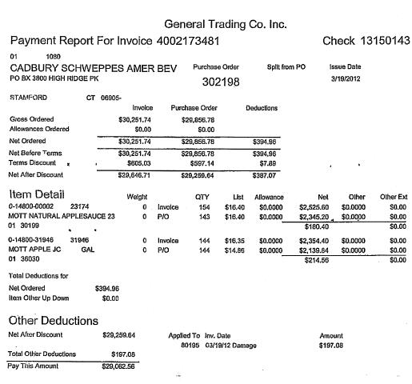
i
The difference in the Invoice quantity & PO quantity indicates that the deduction is for a shortage.
Purchase Order: The order the customer is claiming the shortage on.
i

8.2 Customer Invoice for Shortage, Example 2:

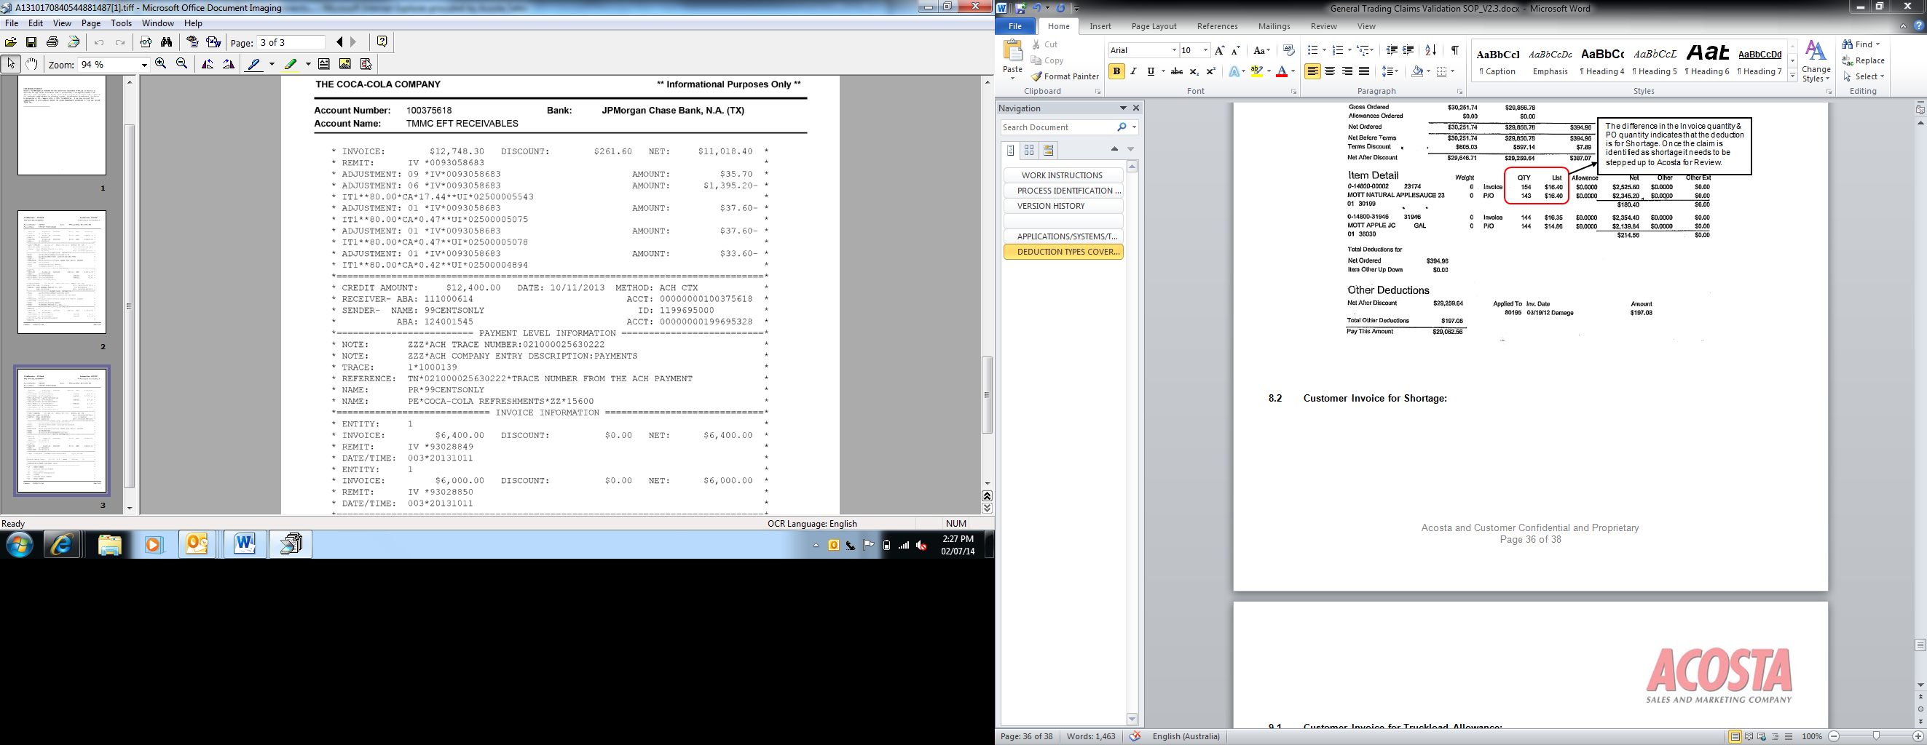
i
Adjustment 06 indicates shortage.

9. Deduction Type: Truckload Allowance

9.1 Customer Invoice for Truckload Allowance, Example 1:

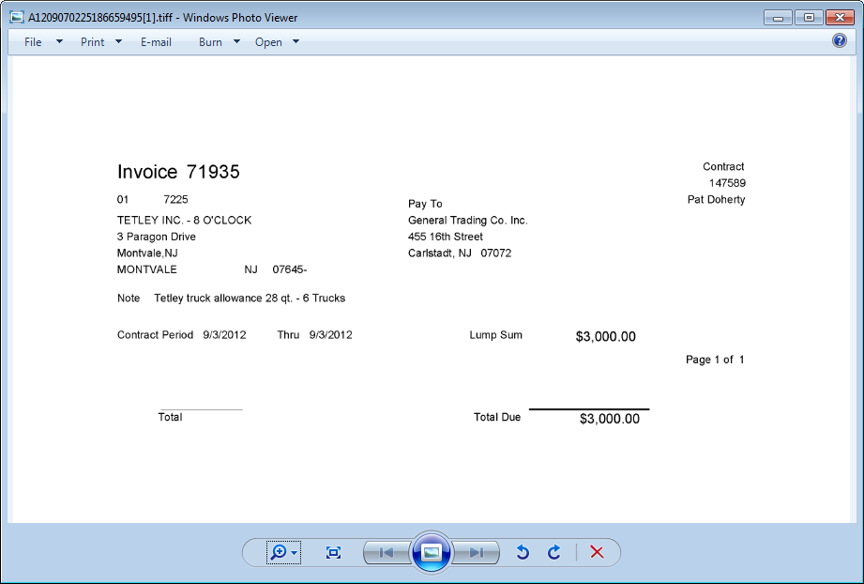
i
Contract Period: The timeframe when the customer is claiming the truckload allowance, which must match the contract.

Lump Sum: The amount the customer is claiming for the truckload allowance.

i
Note: The explanation of the deduction reason, including the product claimed. This information needs to match the contract.

i

9.1 Customer Invoice for Truck Load Allowance, Example 2:

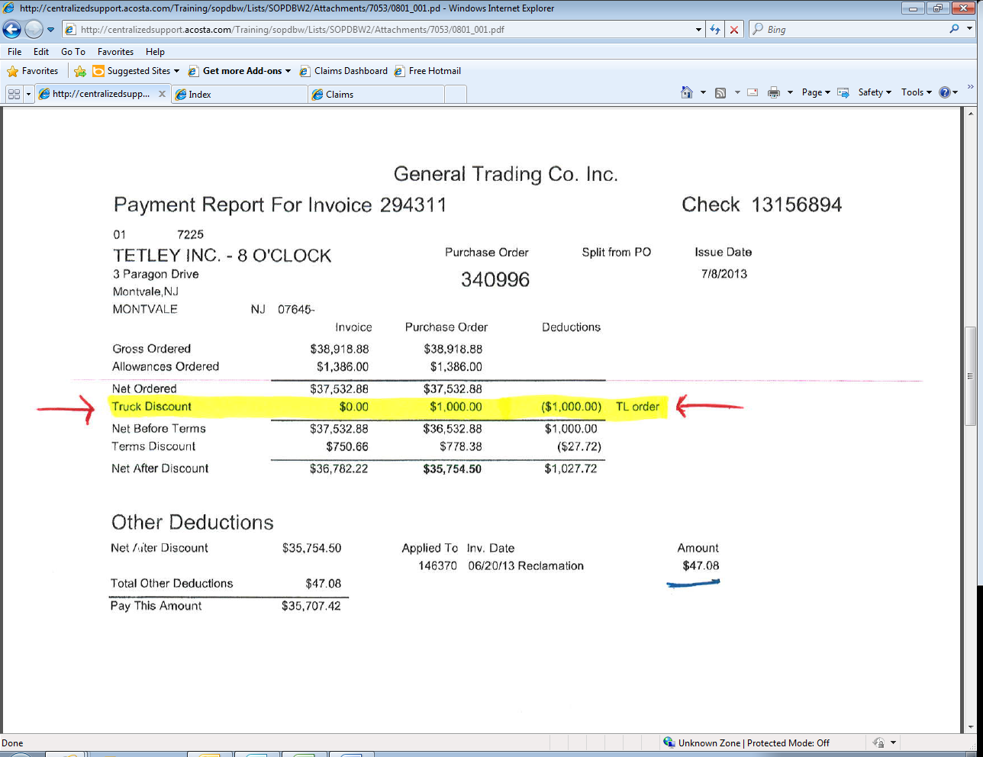
Purchase Order: the order the customer is claiming the truckload allowance on.
i
i
This is the lump sum amount of the Truckload Allowance deduction.

9.2 Customer Contract for Truckload Allowance, Example 1: Found via Search For: Event Scheduler.

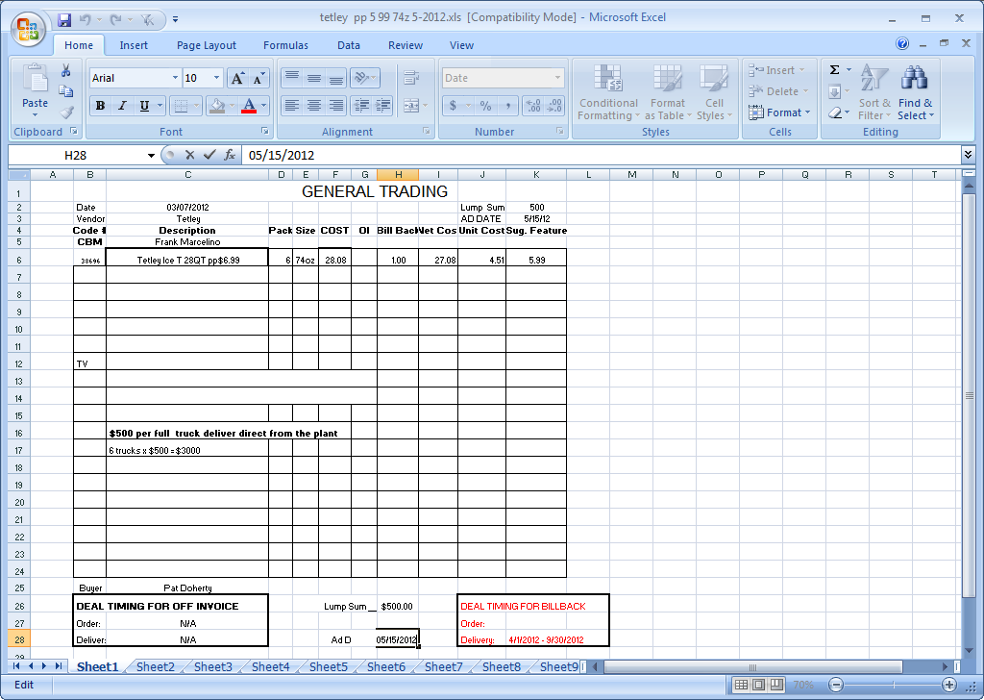
i
Deal Timing for Billback: The performance date range for the truckload allowance. The date on the customer invoice must fall within these dates.

i
The details of the offer.

Description: The product the truckload allowance is being offered on..

i

9.3 Refer to the SOPs/Generic Help File for POP requirements.

10.1 Retail Merchandising Program/ISE Program (GT Retail Support System)

GT Retail Support System is a program for retail merchandising services, and is paid based on a percentage of sales for a client’s product.

10.1 Customer Invoice for Retail Merchandising Program, Example 1:

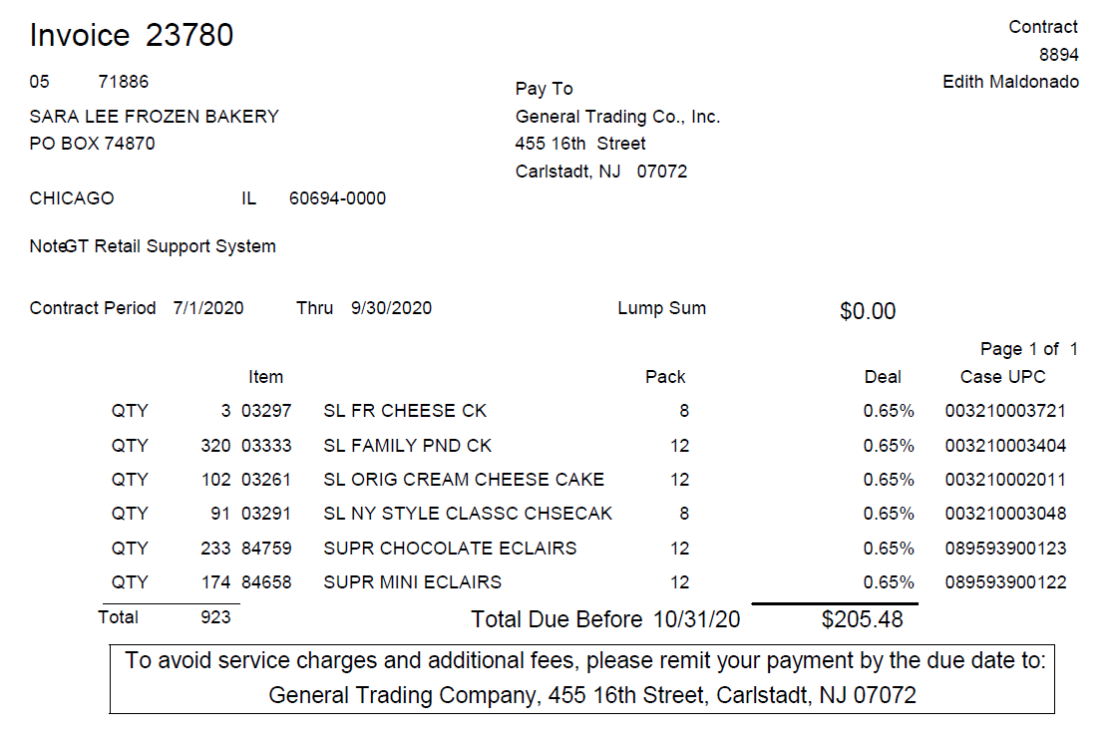
GT Retail Support System: This indicates that this deduction is for Retail Merchandising.

10.2 General Traiding GT Retail Support System announcement letter:

10.3 Refer to the Client SOP/Client Matrix for Retail Merchandising processing instructions.

BPS TEAM INFORMATION

- REPAY INFORMATION SECTION

PRS / CRA Client Specific

- CCA CLEARING INFORMATION SPECIFIC

CCA Client Specific

COMPLETE VERSION HISTORY
UPDATE DESCRIPTION | DATE | AUTHOR
First draft of the General Trading SOP | 05/07/2012
Reviewed by Geoffrey Van Syckle | 05/16/2012
Revised Flowcharts and Definitions | 06/11/2012
Updated if customer subscribes to IRI/Nielsen data for price point verification, pg 2. | 9/10/2012 | Pam Trimble
Added additional example to Section 2 | 09/13/2012 | Geoff Van Syckle
Updated hyperlinks to deduction types | 09/16/2012 | Nagesh Kumar
Updated Billback Section with sign on information for running POP reports | 11/27/2012 | Geoffrey Van Syckle
Added Section 9 Truckload Allowance | 12/11/2012 | Geoffrey Van Syckle
Added second example of Damages, Section 6 | 12/27/2012 | Geoffrey Van Syckle
Added how to read Payment Report provided with check remit | 03/18/2013 | Dellene Hubbard
Added Example # 3 to Billback Section to explain partial deduction of a customer invoice | 04/08/2013 | Dellene Hubbard
Added customer Signon link (5675) | 10/7/13 | Tracy Lewis
Added CCNA to Client Specific this customer is Direct and not a check request for CCNA.(6117) | 11/25/13 | Tracy Lewis
>Added Pinnacle specifics for Contract dates  >Updated Invoice example 2.1  >Added Shortage invoice example  >Added Client specific for Heinz Grocery deductions  >Added example of truck load allowance  >Added Specifics on Partial deductions for DPSG | 3/3/14 | Christen Ledford
Added Heinz service fee to Client section (7607) | 4/14/14 | Tracy Lewis
Added Clorox info on step codes to Client section (8355) | 5/12/14 | Tracy Lewis
Added Signon information for frozen (4173) | 5/26/14 | Tracy Lewis
Updated the Fee section with additional notes(10515) | 11/10/14 | Tracy Lewis
Added Clorox specific on how to locate contract for monthly accrual (5495) | 12/22/14 | Tracy Lewis
Added Morton does not process as check request to Client specific section (11092) | 1/19/15 | Tracy Lewis
Added customer will accept partial payments if the unpaid portion is invalid for Pinnacle to client section (12463) | 3/2/15 | Tracy Lewis
Added this customer is a wholesaler/distributor, direct or indirect customer to customer sign-on box. (13429) | 4/27/15 | Tracy Lewis
Added is Req CI from CIT used for this customer to BPS Team Info section (13772) Added Nestle spin location for POP to Client section (13826) | 5/25/15 | Tracy Lewis
Added percentage breakdown for CL & SW for Starkist to Client section (13956) | 6/22/15 | Tracy Lewis
Updated General Trading is considered to be wholesaler/distributor for Grocery in customer signon section (14483)  Updated line level detail in Customer Specific (15509)  Clean up and reorganization of information to new format structure & removal of out of date material (14730). | 7/20/15  10/26/15 | Tracy Lewis
Added Clorox CCA Specific for clearing Ad funds (18485) | 06/20/16 | Tracy Lewis
Added Sunsweet specific for damages to Client Specific section (18574) Removed Kraft & Heinz client specifics (19311) | 09/12/16 | Tracy Lewis
Updated CIT to show GCIT (21433) | 5-9-17 | Whitney Eiss
Updated contract period box on customer invoice for billback example 1 (22625) | 9-25-17 | Whitney Eiss
Updated client specific section for Nestle (22355) | 9-29-17 | Whitney Eiss
Removed client specific information for Nestle Nutrition C-Store (22355) | 12-22-17 | Whitney Eiss
> Added client specific section for Harvest Hill (23635)  > Updated links for SPO (23751) | 2-26-18 | Whitney Eiss
> Added client specific section for Nestle USA (24106) | 3-12-18 | Whitney Eiss
Added client specific section for Nestle Nutrition (25029) | 7-2-18 | Whitney Eiss
Updated client specific section for Clorox (25098), Update to customer backup request information/realignment of information, no process change. | 8-13-18 | Whitney Eiss
Updated client specific section for Georgia Pacific stating there is no GCC involvement. (25838) | 10/08/2018 | Christian Estevez
Client specific section: removed McCormick (26829); Customer general information section: added instruction on customer reference numbers (26556)  Client specific section: removed Clorox as no long rep (28157) | 2/25/2019  7/1/2019 | Suzy Fields
Removed Pinnacle specific information, as Acosta no longer handles effective 8/26/19 (28434) | 8/26/2019 | Suzy Fields
Client Specific section: Removed Starkist as Acosta is no longer the broker effective 10.15.19 (28760 | 10/21/19 | Suzy Fields
Created Backup Retrieval section (29020) Client Specific section: Added DBW instructions and CCA processing instructions for CAMPBL and PLUMO check requests (28735) | 12/2/2019 | Suzy Fields
Ad section: Removed reference to Numerator and updated instructions for POP (29654) | 3/9/2020 | Suzy Fields
General edits; removed outdated Nestle USA information (29776) | 3/23/2020 | Suzy Fields
Removed Nestle C-Store Nestle Nutrition specific info, Acosta is no longer their broker (30503) | 7/13/2020 | Maria Ovalles
Added Retail Merchandising Program example to the Process Steps section (31036) | 7/13/2020 | Maria Ovalles
Removed outdated info for CCNA from the Client Specific section (31043) | 11/2/20 | Maria Ovalles
Added backup request info for Cargill to the Backup Retrieval Info section (31660) | 4/5/21 | Maria Ovalles
Added GT retails support claims info for Campbell to the Client Specific section (32385) | 7/26/21 | Maria Ovalles
Added Retail Merchandising program info for Mars Food to the Client Specific section (32549) | 8/23/21 | Maria Ovalles
Added CUST info for Pepperidge Farm Frozen to the Client Specific section (32650) | 10/4/21 | Maria Ovalles
Added backup request info for Roland Foods to the Backup Retrieval Info section (33498) | 5/23/22 | Maria Ovalles

