WORK INSTRUCTIONS
Process | Order to Cash
DTP Name | Golub Corporation

CURRENT VERSION HISTORY
UPDATE DESCRIPTION | DATE | AUTHOR
Added process for invoices that include both PC and TM to the Customer General Information section under Customer Invoice Info. (478054) | 8/3/2026 | Lindsay McGinnis

Link to complete version history: Complete Version History

DEDUCTION TYPES COVERED
Is this customer a wholesaler/distributor, direct or indirect customer? Indirect for C&S effective 10/2/22.

Note: GOLUNE is the Sign-on used to work on ACOSTA Relay for Golub (for example to search a document and to refer the customer on ACOSTA Relay).

Sl. No. | Deduction Type
 | Customer General Information
 | Backup Retrieval Information
 | Client Specific
1 | Off-Invoice
2 | Bill Back
3 | Scan
4 | Ad
5 | Pricing (Non-trade)
6 | TPR (Chopped)
7 | Slotting
8 | Unsalable (Non-trade)
9 | Charitable
10 | Coupon
11 | Fees
12 | Freight/ Backhaul (Non-trade)
13 | Returns (Non-trade)
14 | Shortages (Non-trade)
15 | Post Audit
16 | Rebate/Accrual
17 | Other – Gas/Fuel Rewards
18 | Retail Merchandising (ISE Program)
19 | Bottle Deposits
 | BPS Team Information

Link to customer signon job aid:
https://acostaonline.sharepoint.com/sites/AS_Reporting/Claims_Reports/Forms/AllItems.aspx?web=1&id=%2Fsites%2FAS%5FReporting%2FClaims%5FReports%2F%5FCustomer%20Signon%20Listing

Does this customer subscribe to IRI/Nielsen data for price point verification? YES

CUSTOMER GENERAL INFORMATION

Customer Invoice Info:

Is line level detail indexed on the customer’s documentation (customer invoice, customer check request, unsalable/spoils, post audit, EDI 812/820 or client deduction notice if one of these documents is included)? Yes

Invoices from Northeast Share Services, if there is a “TM” code on the invoice, customer is for Tops Market, needs to be indexed and processed with customer signon: TOPSBU and promotions.
If the invoice reflects “PC” or has no code, invoice is for Price Chopper, to be indexed and processed with customer signon: GOLUNE and promotions. In some cases, invoices may include both TM and PC. When this occurs, use the customer sign-on under which the claim originated. Ensure the correct customer sign-ons are selected in the DBW grid so the claim routes through the proper workflow.

There is a 10% scan upcharge policy in place for Price Chopper. This 10% upcharge is reflected in units scanned. The invoices will reflect the 10% upcharge fractions on the units scanned (1.1 units, 2.2 units).

Golub Finance Policy - Finance Charges on Unpaid Invoices

If the header amount of the claim is different than the customer invoice the difference could be the finance charge that C&S will apply when deducting for an unpaid check request. Review the C&S check remit to confirm they are deducting for GOLUB.
(1.5% Fee explanation)

Price Chopper Invoice Number Identification:

Contract

Golub will always use the week ending dates (Saturday) on their invoices, which doesn’t always match the end date of the contract. The contract may states the end date any day during the week (Monday - Friday). The claim is ok to process. This typically occurs on the chopped deals, not the weekly merchandising promotions.

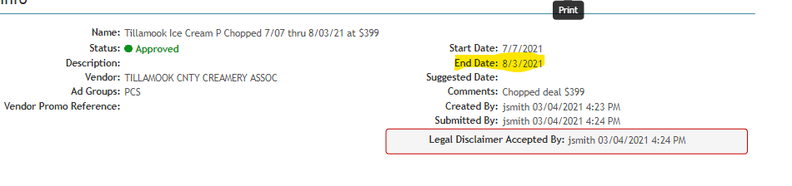

BACKUP RETRIEVAL INFORMATION

GENERAL BACKUP RETRIEVAL INFORMATION

Is GCIT responsible for obtaining backup from the customer? Yes
- If yes, is there a customer portal? No
- If yes, does GCIT request backup? Yes

Is check remittance information required to request backup? No

- Golub provides deduction invoices with the check remittance to the clients.

- If the customer invoice can be identified as a post audit, note the claim “post audit backup needed’.

GCIT SPECIFIC BACKUP RETRIEVAL INFORMATION

Automated:

Customer Invoice or Note Identifier | Request From
All Formats | nss_acctg_lockboxremittance@northeastsharedservices.com
Invoices that begin with ‘Z’ | nss_acctg_lockboxremittance@northeastsharedservices.com

Non-Automated:

Customer Invoice or Note Identifier | Request From
If noted Post Audit | nss_acctg_lockboxremittance@northeastsharedservices.com
Post Audit customer invoice items detail | nss_acctg_lockboxremittance@northeastsharedservices.com
All others

CLIENT SPECIFICS VALIDATION INFORMATION

Client
Barilla | Kens
Beiersdorf, Inc. | Nestle
Campbell | Mars Food US LLC
Cargill
Coca Cola Refreshment (CCNA) | Method
Diamond | Pompeain
Ferrero USA, Inc | Sunsweet
Harvest Hill
The J.M. Smucker Company

BARILLA
- For invoices that do not provide UPC numbers in the detail pages use any upc from the PPG description on the movement report, Ex BARILLA PAST will be Blue Box use UPC 28008.

BEIERSDORF INC.
- Claims received as GOLUNE are to be coded as Unknown, Unknown, Ready to Clear - CCA. These need to be rejected in Kantar so the client can recode in SAP and Kantar as C&S.

CAMPBELL
- The terms for check requests are 30 days, but they can be processed within a 90-day timeframe.
- For deductions that reference NCH MFG CPN:
  - Create a DBW using UPC 01251, quantity 1 and the deduction amount as the rate.
  - Code the deduction to Trade Other with comment Mfg Coupon Rejects.
  - Client event number is required.
- For Price Chopper only:
  - CUST: 10000034017 (Crossroad deductions only)
- When Price Chopper (PC) and Tops are both listed on the invoice; these will need to be manually cleared to the sales area of that claim. A credit memo will have to be completed by the CCA for the other customer portion.
  - Golub/Tops ATB claims:
    - GCC: Step as Ready to Clear - CCA with “Manually Cleared” in header notes.
    - CRA: Step to Closed after clearing in E4.
- SSA deductions - The team should follow the SSA process and template guidelines in the C&S SOP, but the Price Chopper events are listed in the attached document below.
- Tops claims must be manually transferred to payer 0000019066. GCC will step the claim as Unknown / Transfer to Another Branch / Ready to Clear - CCA. Include the following note on the claim: “Transfer to 0000019066, CCA to complete transfer manually”.

CARGILL
- Invoices that reflect “Fuel” require a contract and event.

COCA COLA (CCNA)
- Invoices billing for Simply and Ades/Punches products require additional breakdown from sales for clearing.
  - Split those amounts to separate line(s) and validate any remaining portion as normal.
  - Once the contract(s) are located for the Simply and Ades/Punches products, the GCC will step those claim line(s) to escalate contract issue with a clearing/math note requesting the breakdown for the product billed.
  - The breakdown will be provided as an UKN doc type. Once attached, the DBW must be updated to reflect the additional breakdown/claim line splits.
- Price Chopper invoices billing for Dunkin products require additional breakdown from sales for clearing. The invoices will need to be split between Dunkin brand codes based on the planner that is provided to sales by the regional.
- When the customer submits their bills for CCNA, the invoice will only have 1 item per brand code listed on the bill. Split the brand codes using the percentages below:
  - Simply Juices & Lemonade:
    - B0 73%
    - C0 16%
    - AA 11%
  - Simply OJ:
    - O9 94%
    - A5 6%
- Fairshare Check Requests will no longer be processed, instead, it will be a deduction.

DIAMOND
- Diamond will not accept customer movement reports for POP. When running IRI/Nielsen data pull all UPC items from contract using the week ending performance dates from the contract.

Ferrero USA, Inc
- Event number are not required for Ferrero USA, Inc.

HARVEST HILL
- Harvest Hill allows Golub to deduct on cut/short product.
- Deposit invoices are for Bottle Deposits
  - Step to Non-Trade/Other.
- Customer deducts through C&S
  - C&S deductions may cause duplicate claims in Relay.
  - Relay must be reviewed for prior check payments.
    - Relay may not provide a duplicate notification due to the customer reference numbers.
      - Example of Customer References - Deduction; C&S customer ref A0000044889-1207833. Check request; Customer invoice ref 01207833.

THE J.M. SMUCKER COMPANY
- Process Job Aids

Prepaid Tracker: TOPS _J M Smucker's Prepaid Tracker Ledger_July 2025.xlsx

KENS
- For scan claims Kens will not accept the detailed customer movement report information as POP.

- SBR Scan claims that have both 18oz and 14 oz on the contract:
  - There should be two separate lines, one for 18oz, the other for 14oz.
  - Pull the PPA and look at the week ending.
  - Clear the units for the 18oz, then clear the remaining to the 14oz.

- Allowance on cut product
  - Allowance on cut product claims are to be linked to the applicable contract.
  - Stepped as Trade/Other
  - Cleared to the applicable event.
  - If Ken's comes back and provides proof that Golub was notified in advance of the cut then Acosta will write a repay.

NESTLE
- Acosta does not handle Boost and Carnation Claims (GERBMST)
  - Claims will need to be stepped to Not Acosta
- The fee for Golub when they deduct through C&S should be cleared to the same event as the promotional portion of the claim.

MARS FOOD US LLC
- Golub is approved to take retail merchandising deductions from Mars.

METHOD
- Rebates/Accruals are cleared to an event without a contract. POP however, is required. Refer to the client SOP for POP requirements.

POMPEIAN
- On some Golub invoices, the customer will deduct for a CLUB item which will consist of two or more UPCs.
  - Claim will need to be split among all UPCs with the same rate on the contract.
  - When splitting by UPC, if the amount is a decimal, round up to the next whole number.
- Finance Charges claims are handle internally by Pompeian. No control number is required.

SUNSWEET
- Northeast Shared Services/ Price Chopper only handles juice for Sunsweet, no prunes.

PROCESS STEPS

- Deduction Type: Off Invoice

If the customer does not receive the allowance off the face of the invoice they will deduct for it. If the customer requested an allowance that is not valid, the CSC will send a notification to the customer in writing. Customers view purchase orders as contracts. If they are not notified of allowance discrepancies, they will pay according to their purchase order total.

  - Customer Invoice for Off-invoice: Listed below is an example of customer invoice received for an
Off-invoice claim. Need to validate the Invoice #, UPC code and OI Rate on the invoice with the contract.
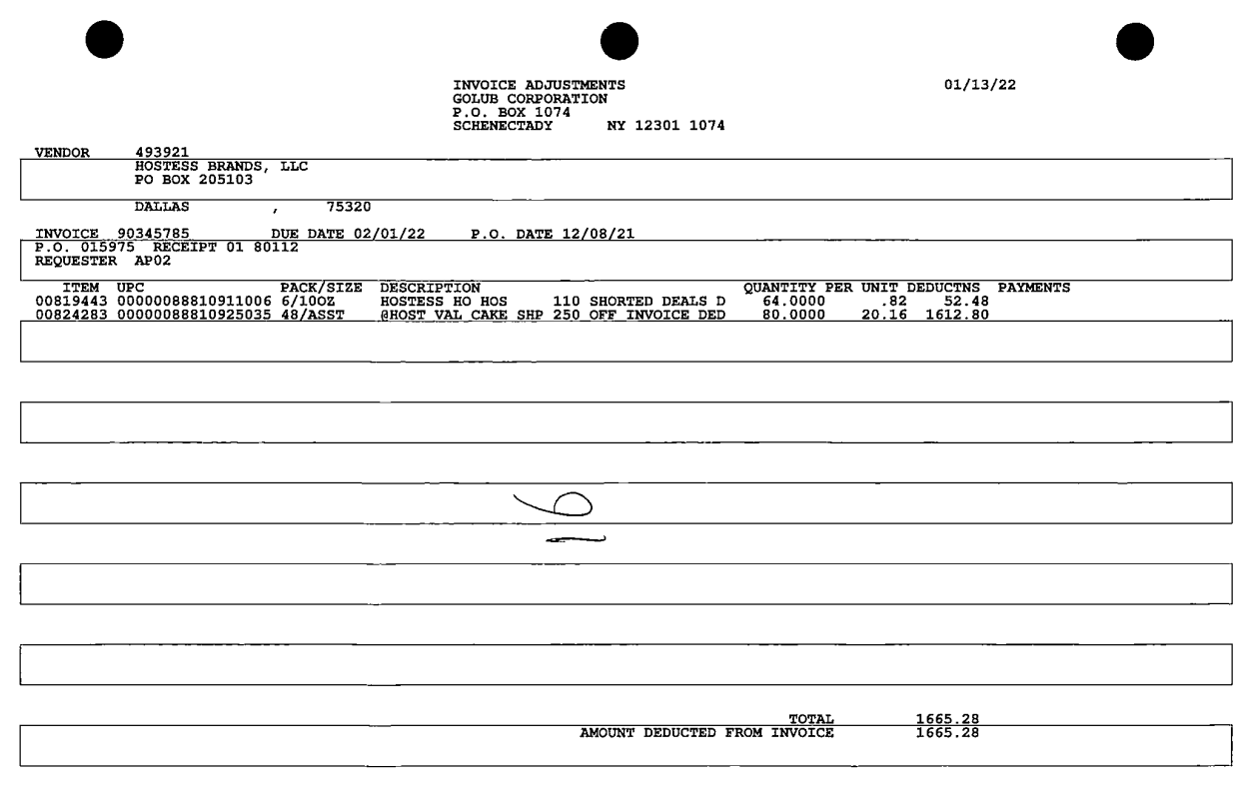
OI rate – Customer Invoice OI rate must match the Customer contract OI rate. E.g. OI rare of $20.16 can be tracked to the customer contract.
2
PO #: This is the PO number that can be used to locate the order in Acosta Relay under Orders.
i
OFF INVOICE DED: This description helps identify what kind of an allowance is being requested by the customer.
i
UPC Code – The unique product code (UPC) is the last 5 digits of the full product. This code is used to validate key data elements regarding the customer invoice and client order invoice on the Review Order /view documents link in ACOSTA Relay. This is the product in which the customer is claiming there is an off invoice. Example: In this case the UPC is the one highlighted in red 8810925035.

1

  - Customer Contract for Off-invoice: This is required to compare the details which are referenced on the customer invoice and Client Order Invoice.

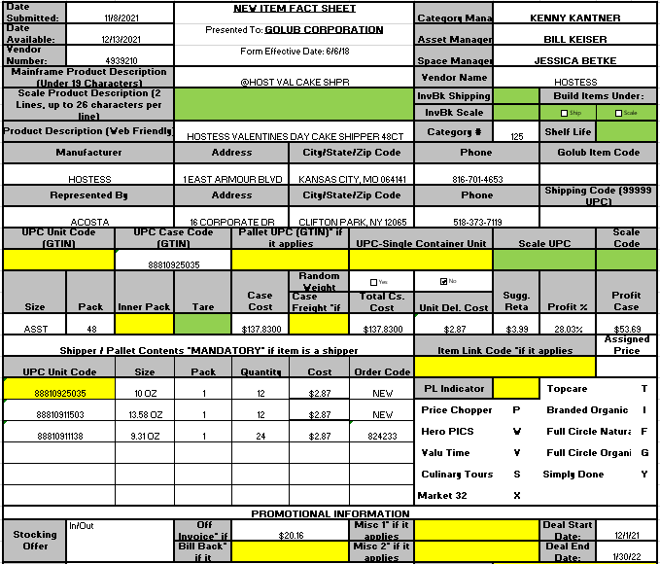
2
The Promotional Information column captures the OI Rate. This needs to be compared with the per unit rate listed on the customer invoice. The off-invoice rate of $20.16 is referenced on the customer invoice.

1
2
UPC Code – The unique product code (UPC) is the last 5 digits of the full product code. This code is used to validate the product listed on the customer invoice. In this case theUPC is highlighted in red 1740010041.
1
33
UPC Code – The unique product code (UPC) is the last 5 digits of the full product code. This code is used to validate the product listed on the customer invoice. In this case theUPC is highlighted in red 8810925035.
Deal Date: This needs to be compared with the date on the Customer invoice to ensure the transaction was performed during the contracted period.
Comments: The comments section of the contract will have the Order and Ship dates info.

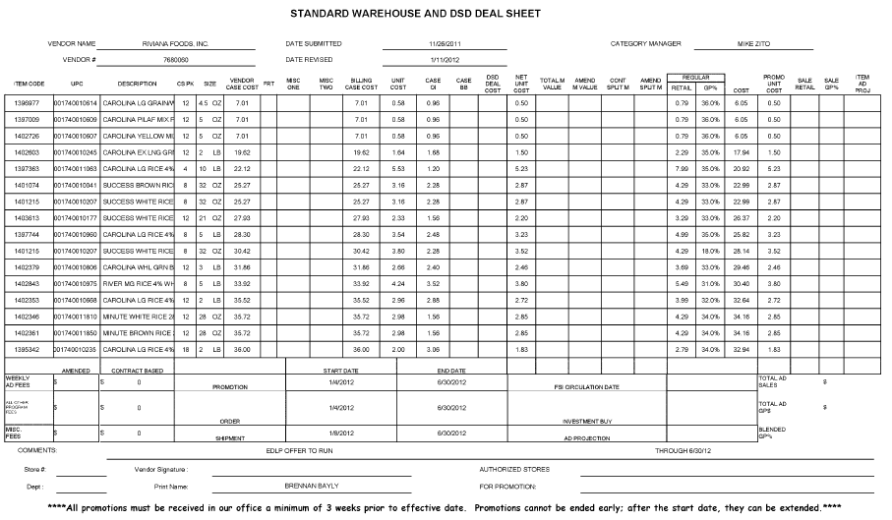
UPC Code – The unique product code (UPC) is the last 5 digits of the full product code. This code is used to validate the product listed on the customer invoice. In this case theUPC is highlighted in red 1740010041.
1
33
2
The Case OI column captures the OI Rate. This needs to be compared with the per unit rate listed on the customer invoice. The off-invoice rate of $2.28 is referenced on the customer invoice.

Ship Date: This needs to be compared with the date on the Customer invoice to ensure the transaction was performed during the contracted period.

  - Refer to the SOPs/Generic Help File for POP requirements.

- Deduction Type: Bill back

A Bill Back claim is a per case allowance offered for a specific performance requirement. A per case bill back allowance is claimed by the direct buying customer for product purchased from the client, or by the indirect customer for product purchased from the direct customer. This is an allowance the customer will bill the client for. This is not an automatic discount given off the face of the invoice.

2.1 Customer Invoice for Billback: Example 1
This is the PO number. It is used to search for the Client Order Invoice from the Orders document link within Acosta Relay. Also, this needs to be matched with the Client order invoice.
In this case the order invoice number is 063705.

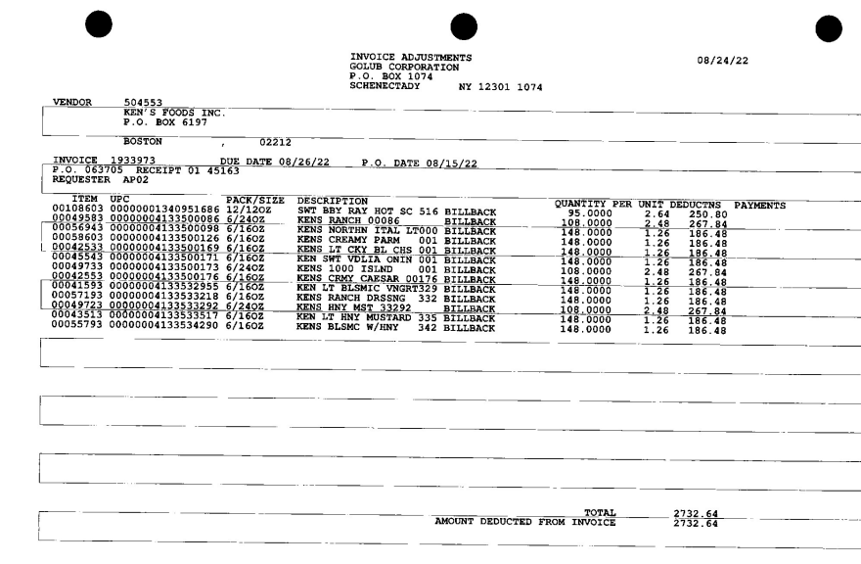
3
2
1
This is the Customer Invoice. Also, this needs to be matched with the Client order invoice.
In this case the invoice number is 1933973.
UPC Code – The unique product code (UPC) is the last 5 digits of the full product. This is the product on which the customer is claiming there is an allowance.

Bill Back: This verbiage indicates this is Bill back deduction.
Item code: This needs to match with the item code on the contract.
BB rate: This is the per unit bill back rate which needs to match with the bill back rate specified on the contract.
Quantity: Denotes the number of cases for which the customer is claiming the bill back allowance. This needs to be validated with the client order invoice.

2.1 Customer Invoice for Billback: Example 2
i
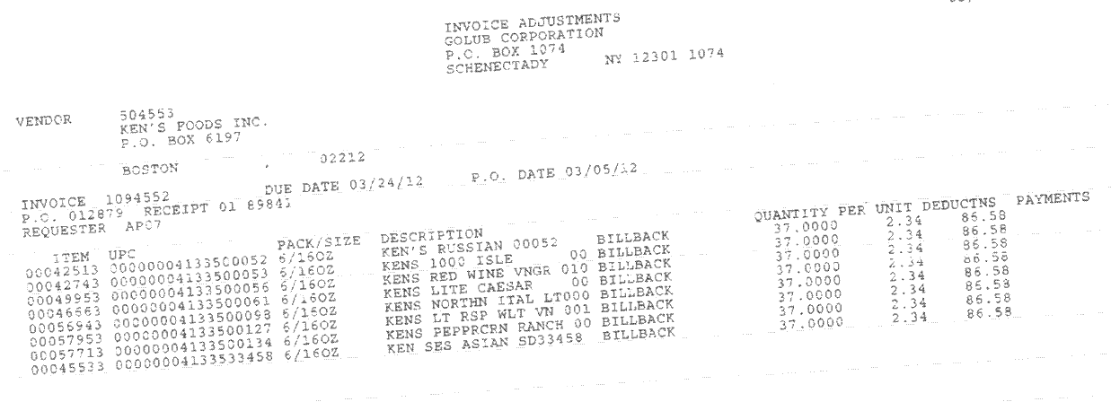
i
2
3
This is the PO number. It is used to search for the Client Order Invoice from the Orders document link within ACOSTA Relay. Also, this needs to be matched with the Client order invoice.
In this case the order invoice number is 012879.
Item code: This need to match with the item code on the contract. (In this example the item code 00042513 against UPC 500052 does not match with the item code on the contract.
This is the Customer Invoice. This would be used to retrieve the Customer Invoice from the Backup Documents document link within ACOSTA Relay. Also, this needs to be matched with the Client order invoice.
In this case the invoice number is 1094552.
Quantity: Denotes the number of cases for which the customer is claiming the bill back allowance. This needs to be validated with the client order invoice.
Bill Back: This verbiage indicates this is Bill back deduction.
i
BB rate: This is the per unit bill back rate which needs to match with the bill back rate specified on the contract.

1

UPC Code – The unique product code (UPC) is the last 5 digits of the full product. This code is used to validate key data elements regarding the customer invoice and client order invoice on the Review Order /View Documents link in ACOSTA Relay. This is the product in which the customer is claiming there is an off invoice. Example: In this case the UPC is the one highlighted in red 4133500052.

2.2 Customer contract for Bill back: Found via Search For: Event Scheduler

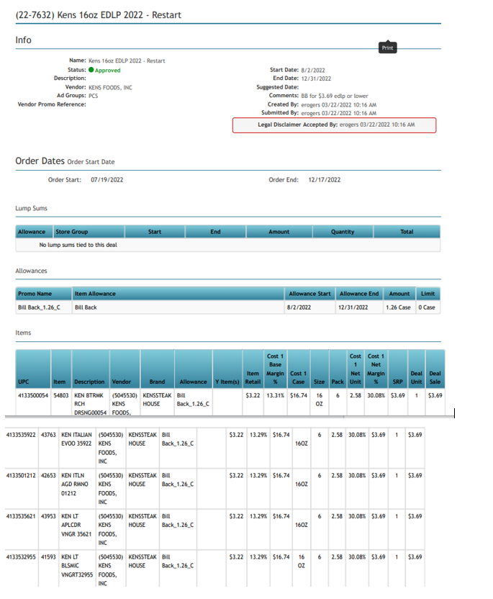
UPC Code – The unique product code (UPC) is the last 5 digits of the full product code. This code is used to validate the product listed on the customer invoice.
Bill back rates: This needs to match with the rate on the customer invoice. For example it is $1.26 which can be referenced back to the customer invoice.
2
1
33
Allowance Date: This needs to be compared with the date on the customer invoice to ensure the transaction was performed during the contracted period.

Item code: This need to match with the item code on the contract.

  - Refer to the SOPs/Generic Help File for POP requirements.
- Deduction Type: Scan

Scan allowances are for product scanned at the store register and are usually billed in eaches, not cases.
The customer should not be referencing a purchase order number while deducting for a scan allowance.

  - Customer Invoice for Scan: Example 1

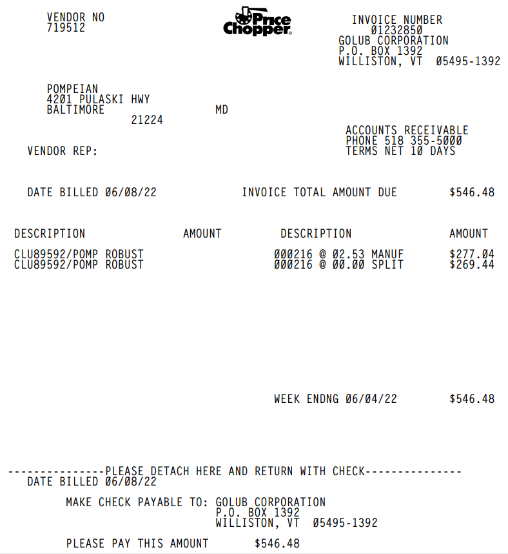
Week ending date: This is the performance period as agreed with the customer to claim the scan allowance. This should fall within the shipment date on the contract in order to validate the claim.
Deduction Amount – This is the amount that is claimed by the customer for Scan allowance.
Scan rate: This is the per unit scan rate claimed by the customer. This need to match with the scan rate specified on the contract. For instance, scan rate of $2.53 can be tracked to the contract.
2
3
1
Quantity: Denotes the number of units for which the customer is claiming the Scan allowance. This needs to be validated with the scan movement report. E.g. 216 can be referenced back to the scan movement report
Description: The product description the customer is claiming scan allowance for.
44

This page is a summary invoice. There may be additional detailed pages attached; providing weekly scan movement per item. The additional pages are not required for validation. The invoice will not provide UPC’s, instead items will be matched to the contract by description. Golub will put one item per category on the invoice, but the customer is claiming cases for every item in that category listed on the contract. The scan movement report pages can also be used as POP (see document 3.3).
If this page is not attached to the summary invoice search for the additional detail under Backup Documentation/ Doc Type 2 – Customer Invoice. Once you pull the contract, you can use the contract to match the description and allowance amount then use the contract detail to get UPC information to generate the DBW.
3.2 Customer contract for Scan: Found via Search For: Event Scheduler.

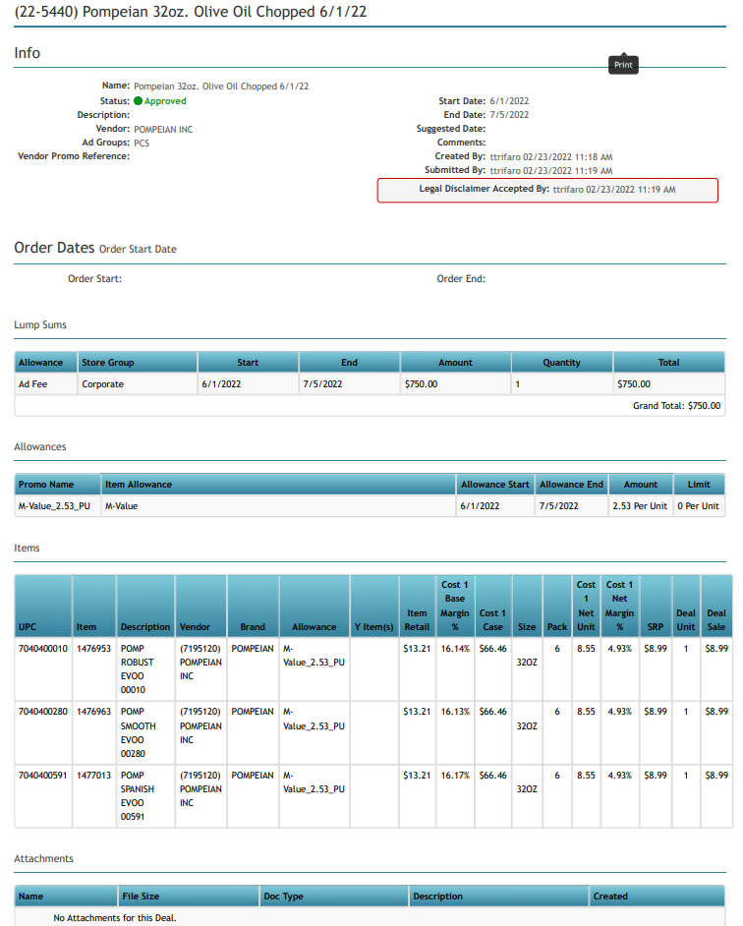
Allowance Start/End date: This is the performance period as agreed with the customer to claim the allowance. This should fall within the performance date on the contract in order to validate the claim.

Scan rate: This is the per unit scan rate. This need to be validated with the scan rate specified on the customer invoice. For instance scan rate of $2.53 can be referenced to the customer invoice.
Description: This product description should resemble the product description on the customer invoice. For example, the customer invoice stated Pompeian Robust, which is what we have on this contract.

Note: If the Week Ending date billed is one day prior to the contract start date and the contract comments, Client Event Descption field or plan notes reference “Chopped” the allowances offered are TPR (Chopped) scans. Price Choppers will begin billing the Wednesday prior to the contract start date for the promotion offered. Attach the contract and proceed with validation. Example: invoice list w/e 06/04/22 as the billing period and the contract start date is 06/01/22.
3.3 Movement report for Scan: Page 1 and 2

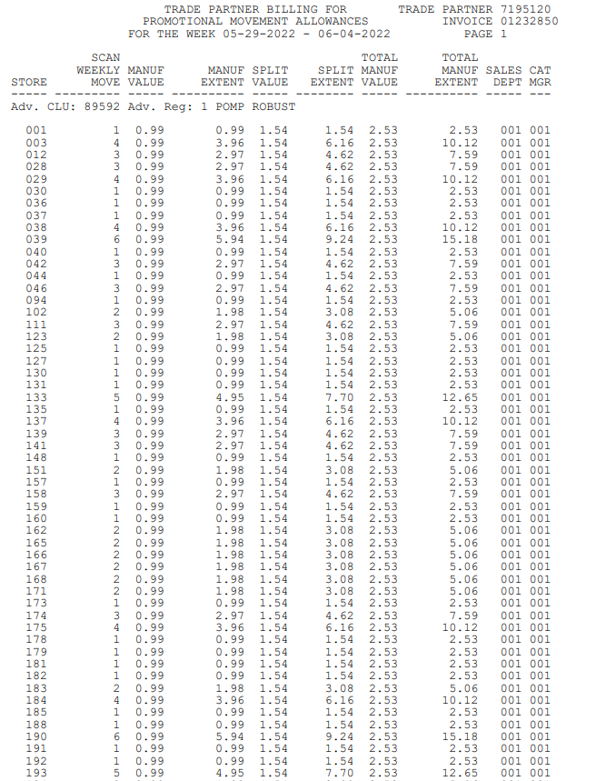
i
Scan rate: Signifies the per unit scan rate as per Manuf value 2.53. This can be referenced to the customer invoice.
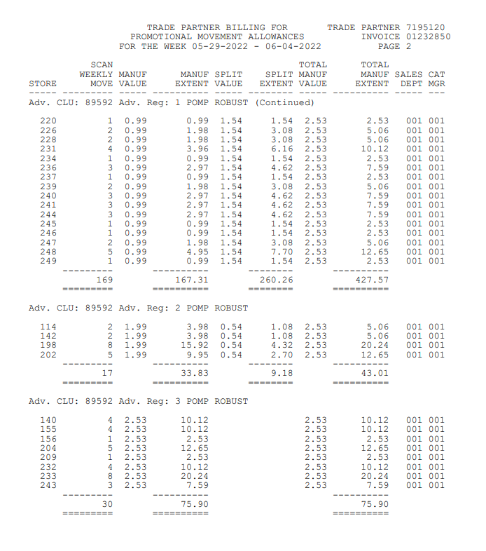
1
i
Claim Amount – This is the total amount for Scan allowance by product. These totals can be combined and referenced to the customer invoice.
Quantity: Denotes the customer has purchased enough units as per the claim . E.g. combined total of 216 can be referenced back to the customer invoice.

NOTE: If the scan movement report is not attached to the invoice, any POP listed in Generic Help under this deduction type can be used in lieu of the movement report.

  - Refer to the SOPs/Generic Help File for POP requirements.

4 Deduction Type: Ad

An Ad is a fee for featuring client’s products in an advertisement.

4.1 Customer Invoice for Ad:
Invoice: This invoice number should match the invoice number listed on page 2.

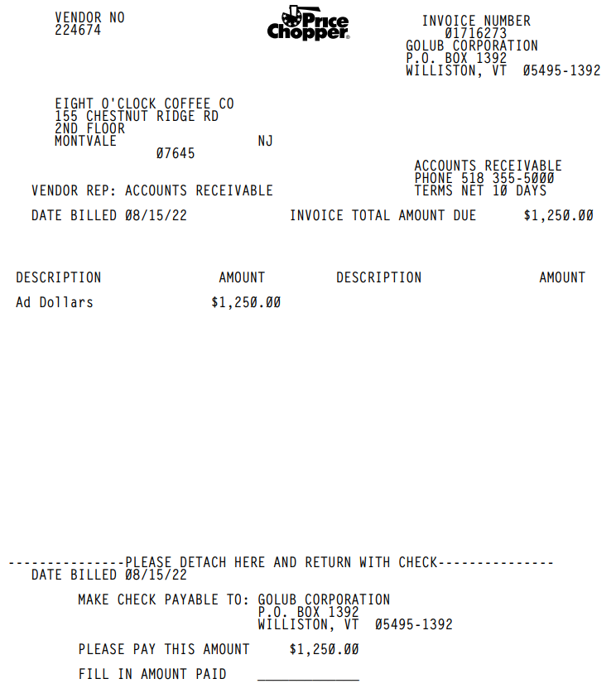
3
Deduction Fee – This is the deducted amount claimed by customer for the Ad. This needs to be verified with the contract. In this example the ad amount of $1250 can be referenced on the customer contract.

Page 2: Support Documentation

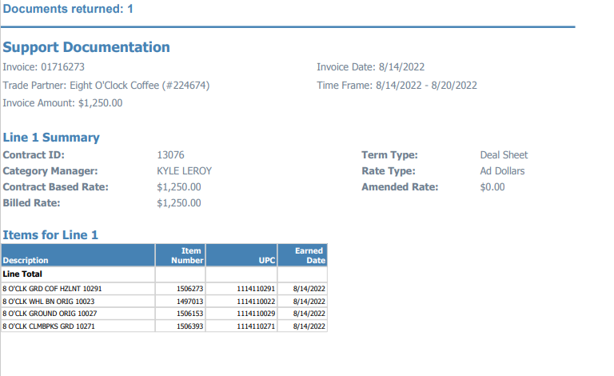
2
1
Product Description: The product for which the ad has been featured by the customer needs to be matched with the product description on the contract/ proof of performance.
Time Frame: This shows the period in which the Ad was featured and should fall within the contract dates.
Invoice: This invoice number should match the invoice number listed on page 1.

4.2 Customer contract for Ad: Found via Search For: Event Scheduler

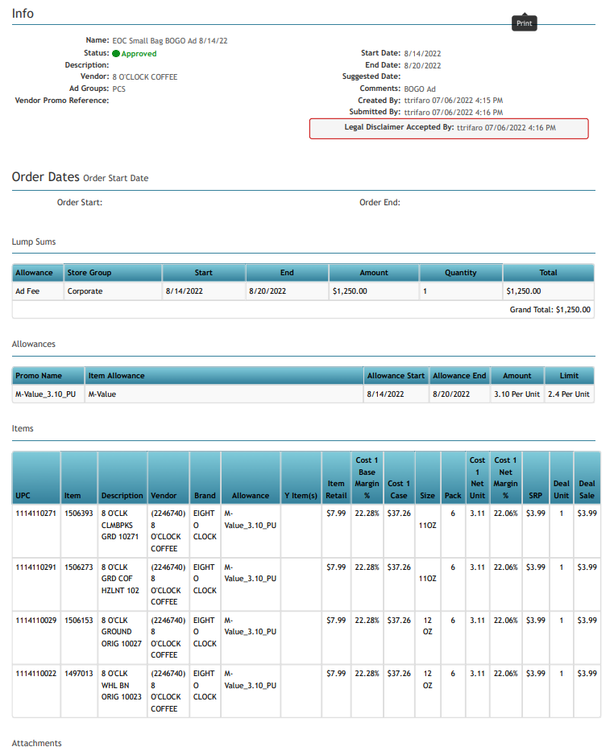
1

2
3
Ad money: Amount agreed with the customer as part of Ad deduction. This needs to be verified with the customer invoice to ensure the customer has deducted for the correct ad allowance.
Start/ End date: – Refers to the performance period during which the ad remains valid. The customer invoice date, Ad date as well as the date on the POP document should fall within this for the claim to be valid.
Item Description – This product needs to be matched with the product listed on the customer invoice & also it needs to be available in the ad.

Note: If the contract comments or the Client Event description field of the contract references “Chopped” the allowance offered is for a TPR fee and not an Ad. Refer to the TPR section of the SOP for validation.

  - Refer to the SOPs/Generic Help File for POP requirements.

5 Deduction Type: Pricing

A pricing deduction occurs when the customer’s requested price on the original purchase order differs from the client’s invoice.
  - Customer Invoice for Pricing:

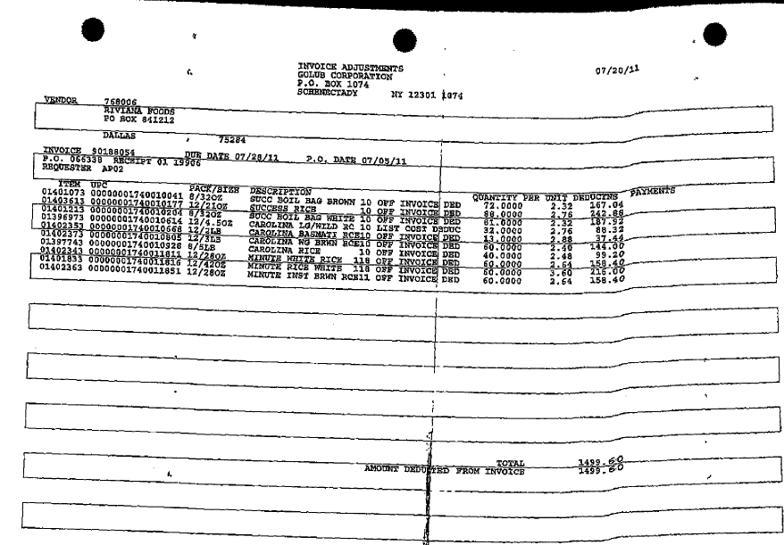
i
i
PO Number – This is used to retrieve the order/invoice data out of the Order/invoice/PO /view documents link within ACOSTA Relay.
E.g. - In this case the PO # is 066338 can be referenced to the client order invoice.

List cost deductions : This verbiage refers to ‘Pricing’ allowance

5.2 Refer to the SOPs/Generic Help File for POP requirements.

- Deduction Type: TPR Fees

A TPR (Temporary Price Reduction) allowance is offered to the customer to reduce the retail price for shelf tags. It is offered to the customer as a lump sum.

  - Customer Invoice for TPR Fee:

Page 1
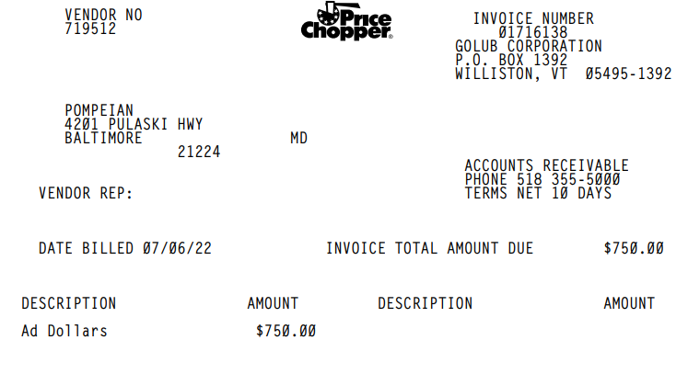
TPR Allowance: This is the TPR allowance being claimed by the customer. Needs to be validated with the contract and POP.
Performance Date: TPR’s start on Sundays. The billed date will reference the Wednesday prior to the period during which the TPR was effective. In this case the TPR start date is 7/10/22. To confirm the TPR/Chopped date refer to the Chopped schedule attached below.

Page 2 (will include detail)
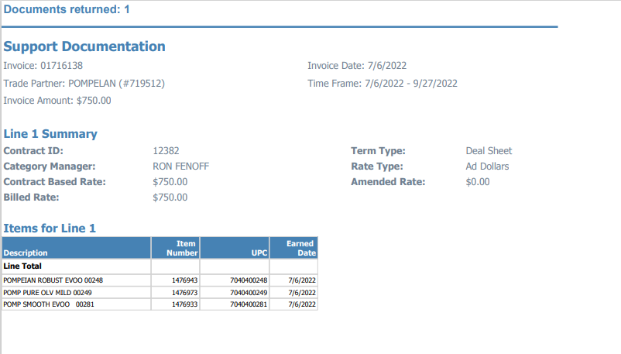
i
Hand written notes from the sales team may also be displayed on the invoice providing the TPR dates and or noting the POP “self tags”.

Performance Date: TPR’s start on Sundays. The billed date will reference the Wednesday prior to the period during which the TPR was effective. In this case the TPR start date is 7/10/22. To confirm the TPR/Chopped date refer to the Chopped schedule attached below.

- The Chopped schedule listed the promotional dates for TPR “Chopped” allowances.

NOTE: Refer to the chopped schedule below for the current/revised Christmas, New Years chopped dates.

6.2 Customer Contract for TPR Fee:
i
TPR: To verify the contracted allowance is for a TPR; the contract comments, the Client Event Description field (contract naming field) or the plan notes of the contract must reference “Chopped”. Note: The Client Event Description field information will also display on the contract. In this example Chopped is abbreviated displaying as “CHPD”.

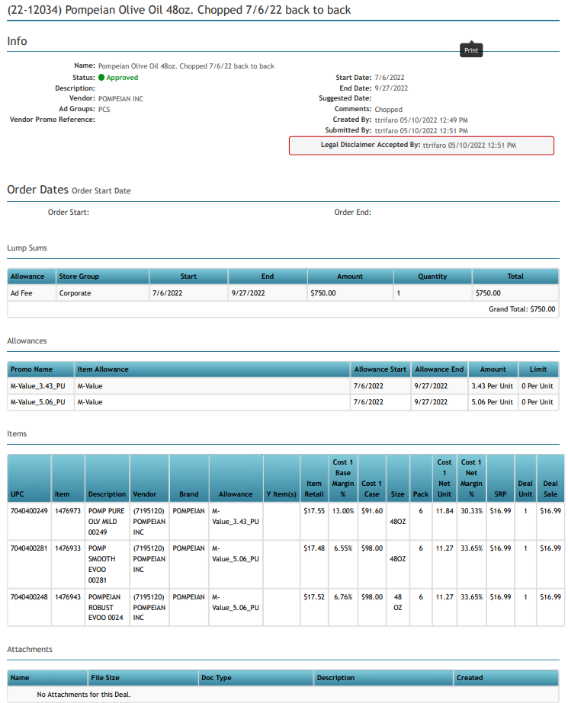
2
Start/ End date: – Refers to the performance period during which the TPR remains valid. The customer invoice date, Price reduction period date as well as the date on the POP document should fall within this for the claim to be valid.
TPR Allowance: Amount agreed with the customer as part of price reduction. This needs to be verified with the customer invoice to ensure the customer has deducted for the correct TPR allowance.
1

Price Choppers will begin billing the Wednesday prior to the contract start date for the promotion offered. Attach the contract and proceed with validation.

6.3 Refer to the SOPs/Generic Help File for POP requirements.
- Deduction Type: Slotting

A Slotting allowance is offered to the customer to purchase an item not currently stocked. It is a kind of promotional money offered to a customer as incentive to buy a new item and create a “slot” for that product on their warehouse storage shelves. It is a Trade Deduction. A slotting lump sum allowance can be offered for each item and/or an off invoice can be offered as an introductory allowance for the first 30 days.

7.0 Customer Invoice for Slotting: Example 1

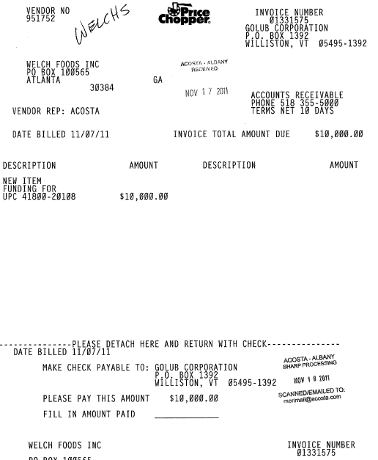
1
i
i
2
The customer invoice number, which should be on the claim as the customer reference number.
The verbiage ‘New Item’ refers the deduction is for Slotting.
Amounts: This is the lump sum amount claimed as ‘Slotting’ by the customer for stocking the new product at the store. This should be in agreement with the lump sum amount allotted as Slotting in the contract.

UPC Code – The Universal Product Code (UPC) is the last 5 digits of the full product code. This code is used to validate key data elements regarding the customer order and client order invoice in the Review Order / View Documents link of ACOSTA Relay. This is the product in which the customer is stating that there is slotting.
Example: In this case the UPC is highlighted in red
4180020108.

7.1 Customer Invoice for Slotting: Example 2

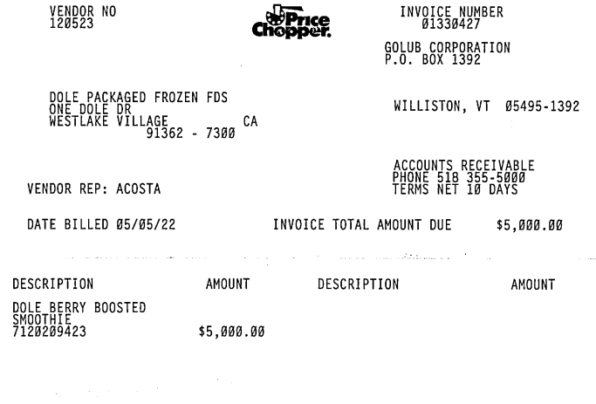
UPC Code – The Universal Product Code (UPC) is the last 5 digits of the full product code. This code is used to validate key data elements regarding the customer order and client order invoice in the Review Order / View Documents link of Acosta Relay. This is the product in which the customer is stating that there is slotting.

Amount: This is the lump sum amount claimed as ‘Slotting’ by the customer for stocking the new product at the store. This should be in agreement with the lump sum amount allotted as Slotting in the contract.

2
1
The customer invoice number, which should be on the claim as the customer reference number.

7.2 Customer Contract for Slotting:
i
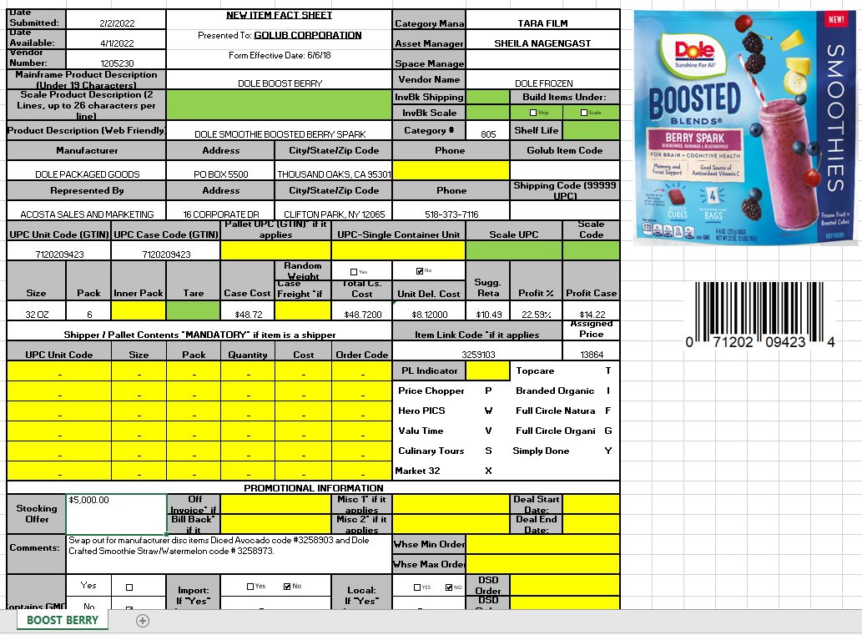
Start/ End date: Refers to performance date during which customer is offered to buy a new item not currently stocked.
Customer invoice date should fall on /between these dates in order to check the claim validity.
2
UPC Code – The Universal Product Code (UPC) is 5 digits number. This needs to be validated with the customer invoice.

1
Amounts: this is the lump sum Slotting allowance which needs to be validated with the customer invoice.

7.3 Refer to the SOPs/Generic Help File for POP requirements.

- Deduction Type: Unsaleable

An Unsaleable claim is taken for product that cannot be sold at the stores due to damages (and short coded product).

  - Customer Invoice for Unsaleable:

Page:1
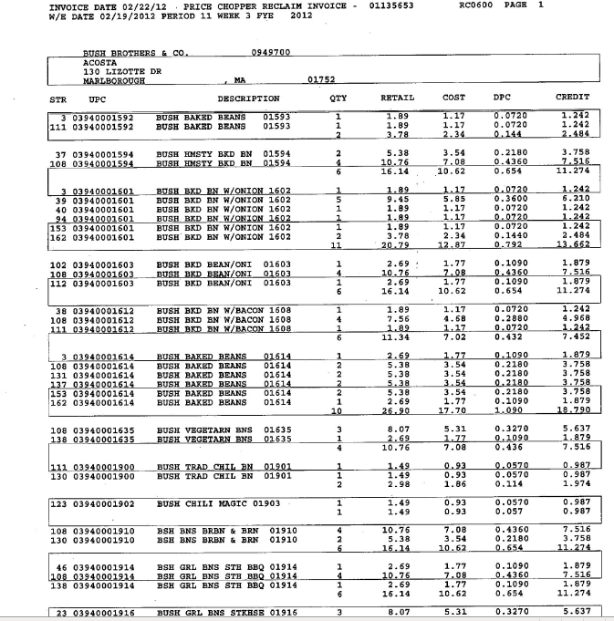
i
i
1
UPC Code – The Universal Product Code (UPC) is the last 5 digits of the full product code. This code is used to validate key data elements regarding the customer order and client order invoice in the Review Order / View Documents link of ACOSTA Relay. This is the product list in which the customer is stating that there are damages.
Example: In this case the UPC is highlighted in red
3940001592.
Invoice#: This is the customer invoice number representing damaged goods.
The verbiage ‘Reclaim’ refers the deduction is for Unsalable.

9. Deduction Type: Charitable Programs

Charitable program agreements between the client and the charitable organization usually involving the customers who will run ads or have displays in their stores promoting the charity.

9.1 Customer Invoice for Charitable Programs:

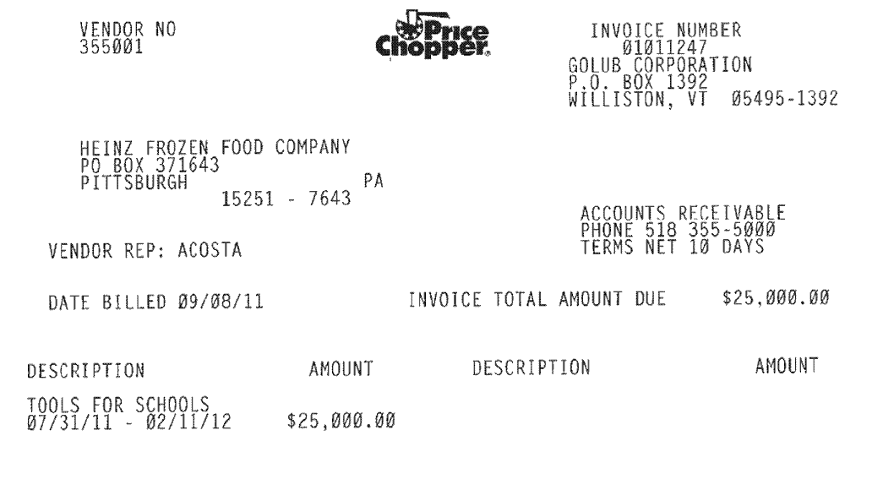
This is the charity amount which needs to match within the contract to validate the claim.
1
i
i
Description – Tools for Schools is the charity program, which needs to be matched within the Customer Agreement.
Date – this is the program date which helps us to pull out the agreement from the ACOSTA Relay.

9.2 Customer Agreement for Charitable Programs:

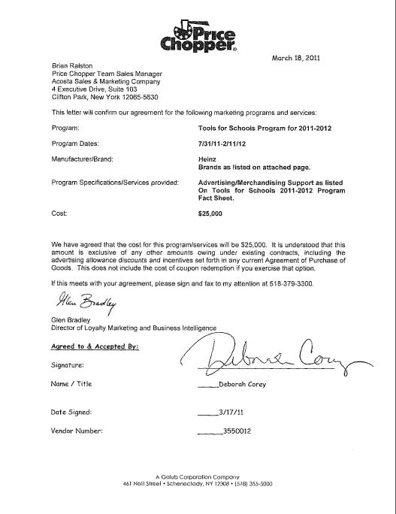
2
i
i
Program – Tools for Schools is the charity program, which needs to match with the Customer Invoice.
Date – this is the program date which needs to match with the customer invoice.
This is the charity amount which needs to match with the customer invoice to validate the claim.

9.3 Proof of performance for Charitable Programs:

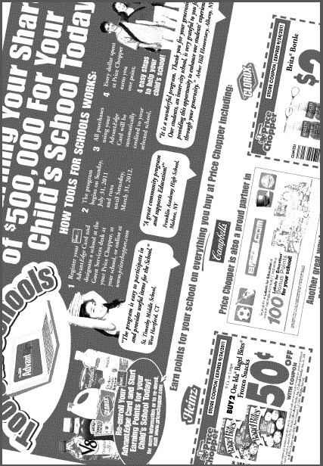
This is the proof of performance for charity program.
i

9.3 Refer to the SOPs/Generic Help File for POP requirements.

10. Deduction Type: Coupon

This is a manufacturer Coupon, typically cleared by client.

10.1 Customer Invoice for Coupon, Example 1:

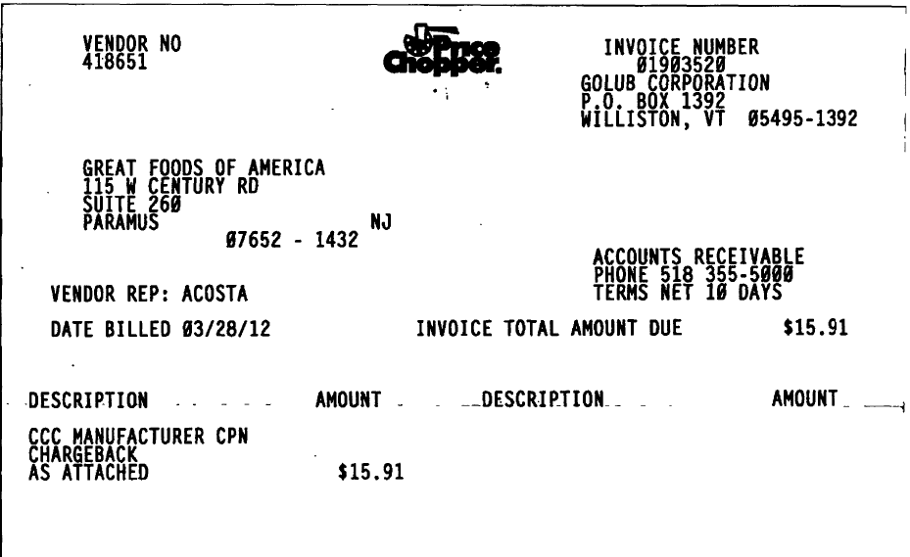
This confirms that customer has invoiced for Coupon Deduction.
Once identified as manufacturer’s Coupon deduction the claim needs to be stepped-up to Acosta.

10.1 Customer Invoice for Coupon – Example 2 (Trade): Page 1

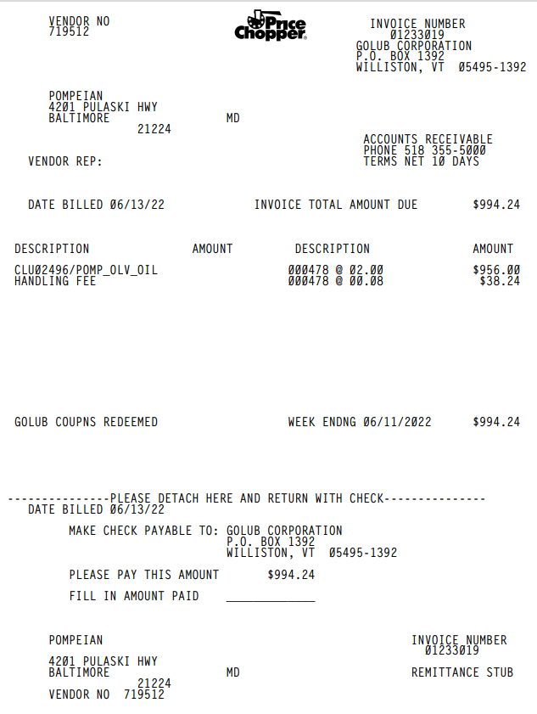
2
Week Ending 10/27/12 reflects the timeframe for which the customer is deducting. The timeframe claimed should fall within the contracted dates.
This identifies the type of allowance as coupons.
3
1
Description = quantity of coupons redeemed (478) at a rate of $2.00/per coupon + the handling fee of $.08/per coupon.
Description = provides the item description for one of the items listed on the contract,

Page 2 and 3 – coupon scan detail
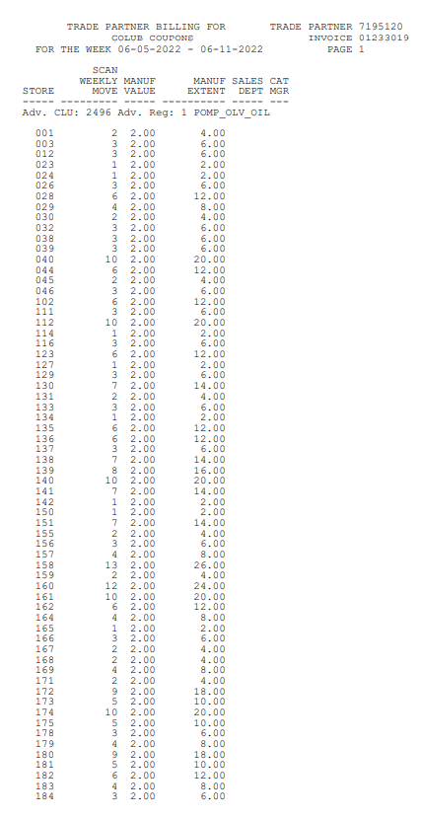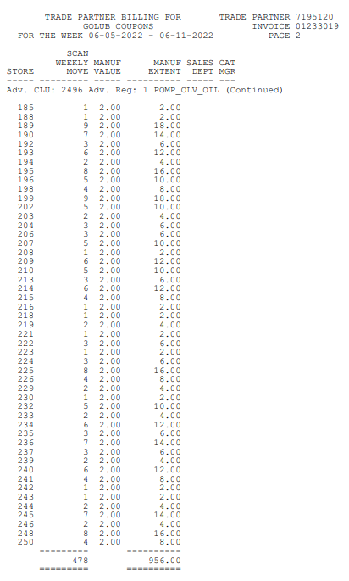
Manuf Valu = rate of $2.00/per coupon redeemed and claimed by customer.
Scan Weekly Move = the quantity of coupons redeemed at the register.

Scan Total given below.

NOTE: The detailed scan movement report can be used as the POP in lieu of the Sales Summary Report.

10.2 Customer Contract for Coupon (Trade): Found via Search For: Event Scheduler

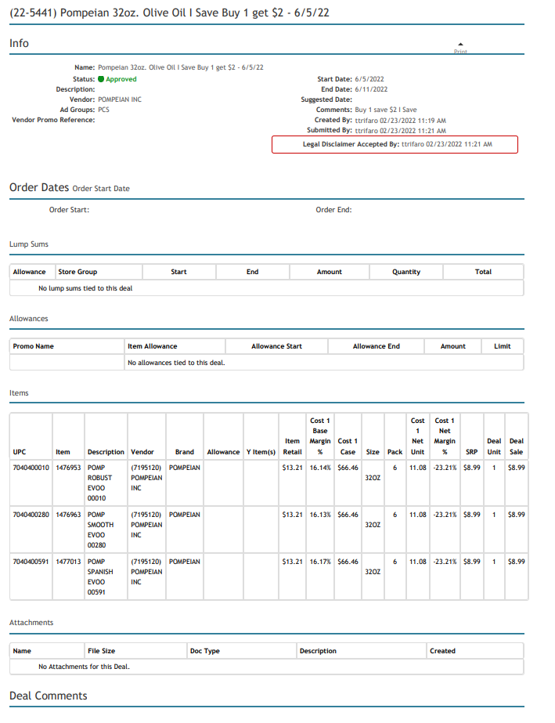
2
Promotion Start/End dates = The timeframe claimed by the customer should fall within the contracted dates.
Comments = Rate the customer was offered per coupon.
3
UPC/Item/Description = Provide the item information for all items covered for the promotion. These should match the item(s) listed on the customer invoice and claimed by the customer.
(e.g. Diamond Sliced almonds)
1

10.3 Refer to the SOPs/Generic Help File for POP requirements.

11. Deduction Type: Fees

Fees charged for various reasons and can include late delivery, miss delivery appointment or lumpier/driver fees.
.

11.1 Customer Invoice for Fees: Example #1 - Invoice Surcharge:
i

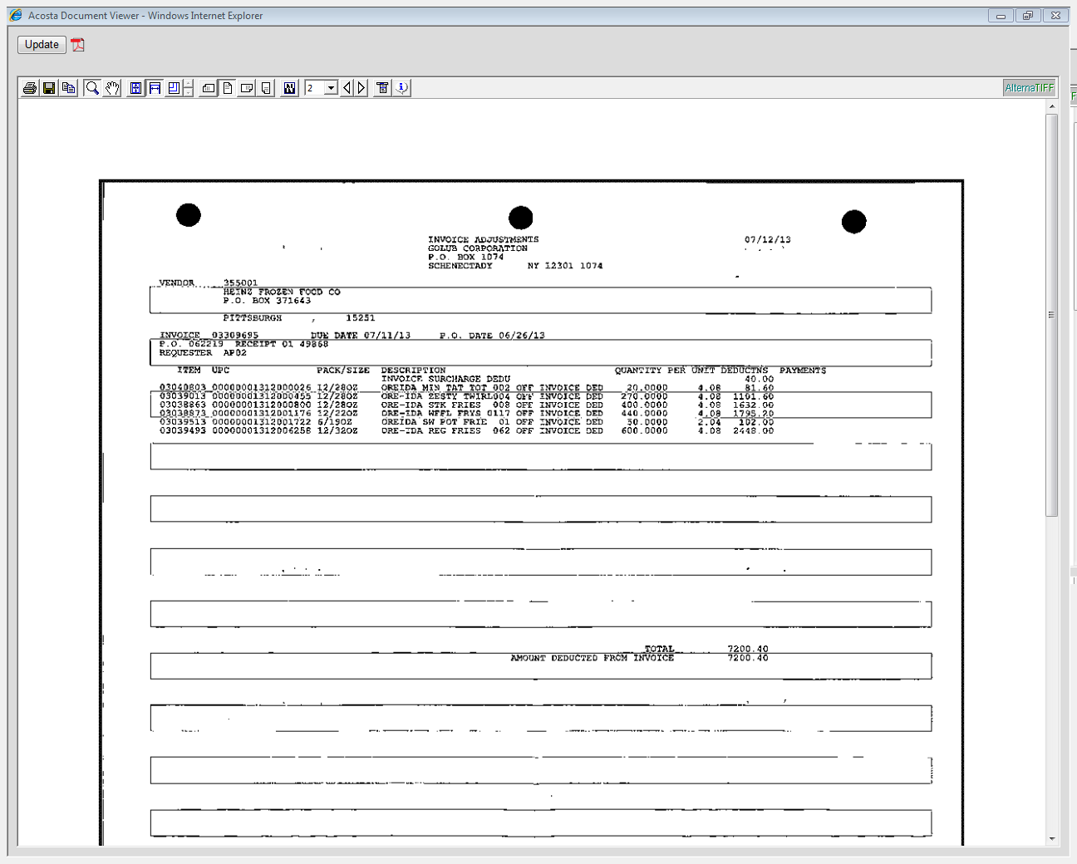
Amount of the invoice surcharge fee.
i
Any time the client order invoice does not match what Demoulas expected due to pricing, shortages, etc., Demoulas will deduct for the difference(s) and add a $40 “Invoice Surcharge” fee.

11.1 Customer Invoice for Fees: Example #2 – Handling fee:
1

Description – this is the Rate per unit (ie. 0.08) which needs match within the contract.
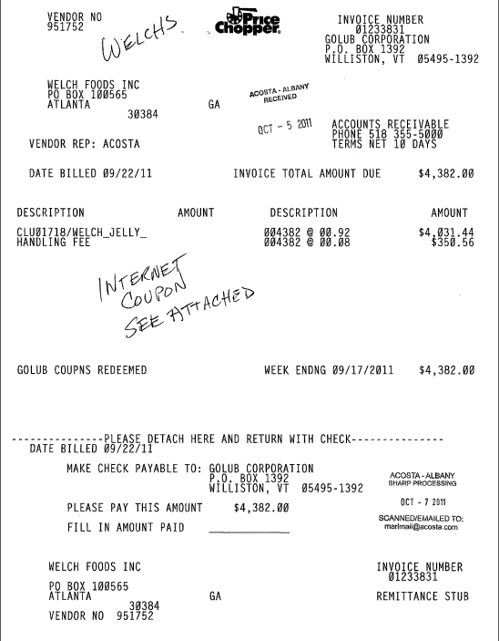
3

2

Performance date – This is the date which helps us in pull out the contract from ACOSTA Relay.
Handling Fee – this is indicates the deduction type, Fee

11.2 Customer Contract for Fees – Handling fee: Found via Search For: Event Scheduler

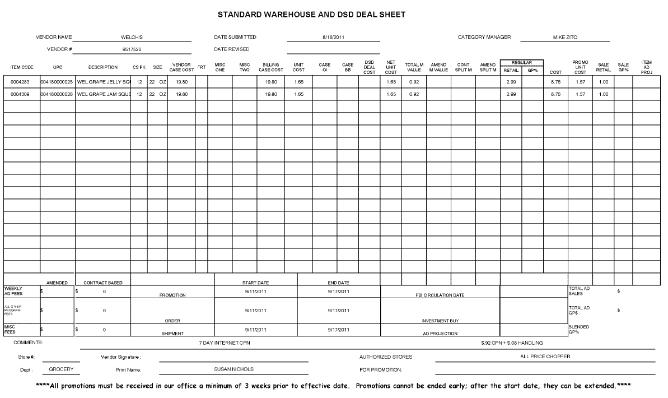
i
i
i
This Handling Fee should reflect what is being deducted for on the customer invoice.
Promotion Dates: These dates should reflect what is on the customer invoice.
Description: This description should match what was on the customer invoice. For example, Welch’s Jelly matches what is on the customer invoice.

11.3 Customer POP Movement for Fees – Handling fee:

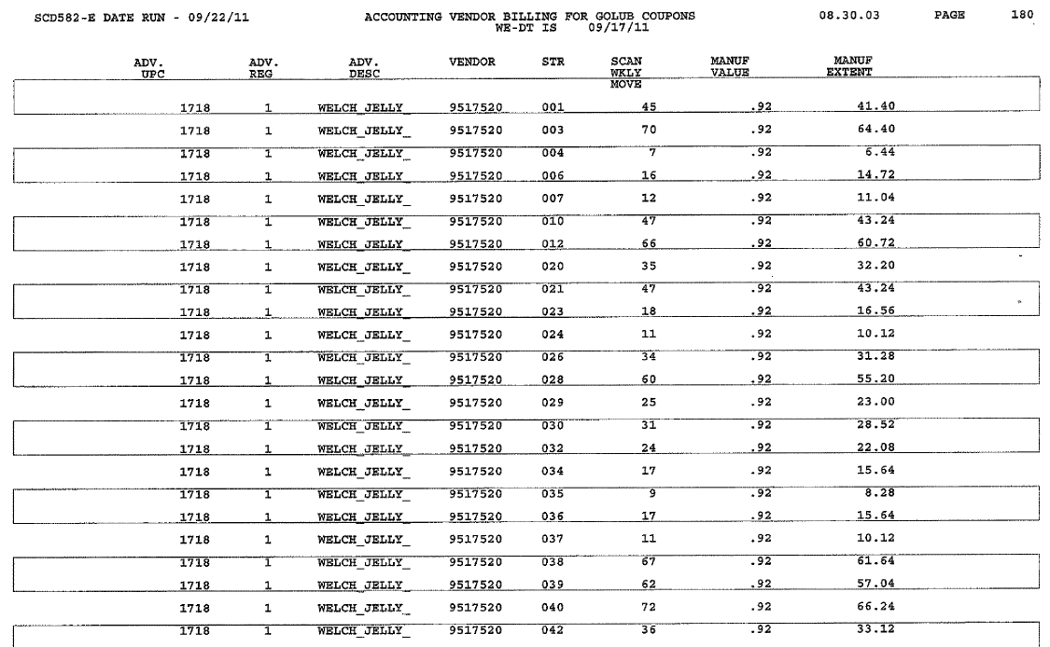

12. Deduction Type: Freight / Back Haul:

A Freight allowance is given to the customer for picking up the product via their own transportation services.

Documents required for validating a Freight claim:

12.1 Customer Invoice for Freight /Back Haul:

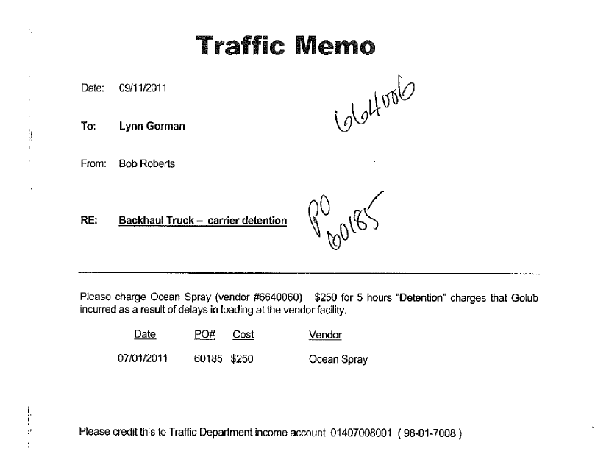
2

1

PO Number –This can be used to retrieve the Order/Invoice data out of the Order/Invoice/PO / view documents link within ACOSTA Relay if it is not attached in the claim as a back-up.
Eg: - In this case the PO # is 60185.

Deduction type –
Here it states “Backhaul Truck” that means the deduction is for Freight. Once identified as Freight deduction the claim needs to be stepped-up to Acosta.

12.2 Client order invoice for Freight /Back Haul:

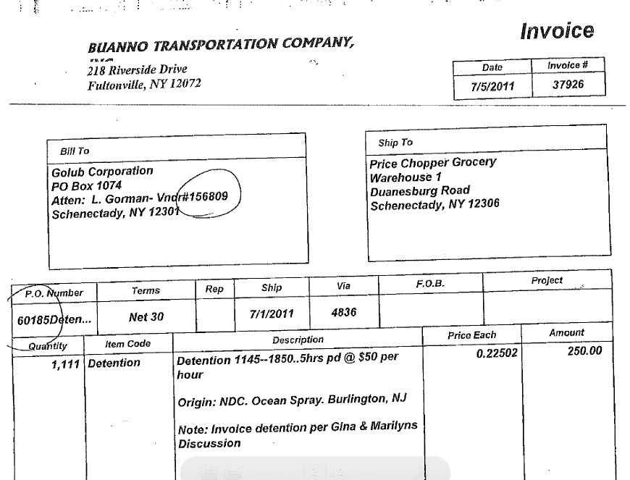
1

PO Number –This should match with the customer invoice to validate the claim. Egg: - In this case the PO # is 60185.

13. Deduction Type: Returns (Non Trade)

These are the charges for products returned by the customer to the client.

13.1 Customer Invoice for Returns:

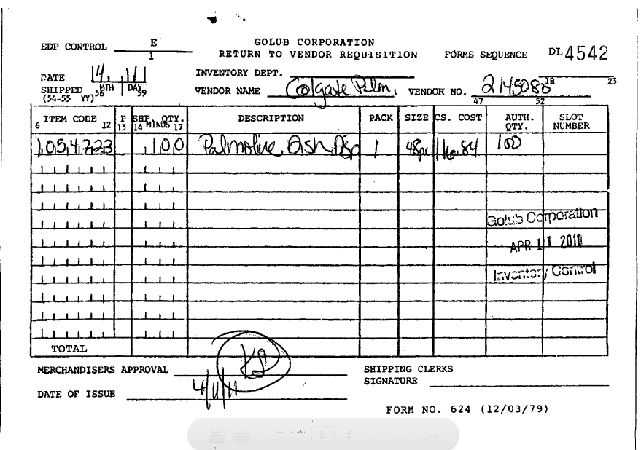
1

Deduction Type – If the description says “Return to vendor requisition” on the Customer Invoice is for Returned Goods. Once identified as Return Allowance, the claim needs to be stepped-up to Acosta for further research.

14. Deduction Type: Shortage

It is a deduction for shorted product on an order that the client billed the customer for.

14.1 Customer Invoice for Shortage, Example 1:
1

2

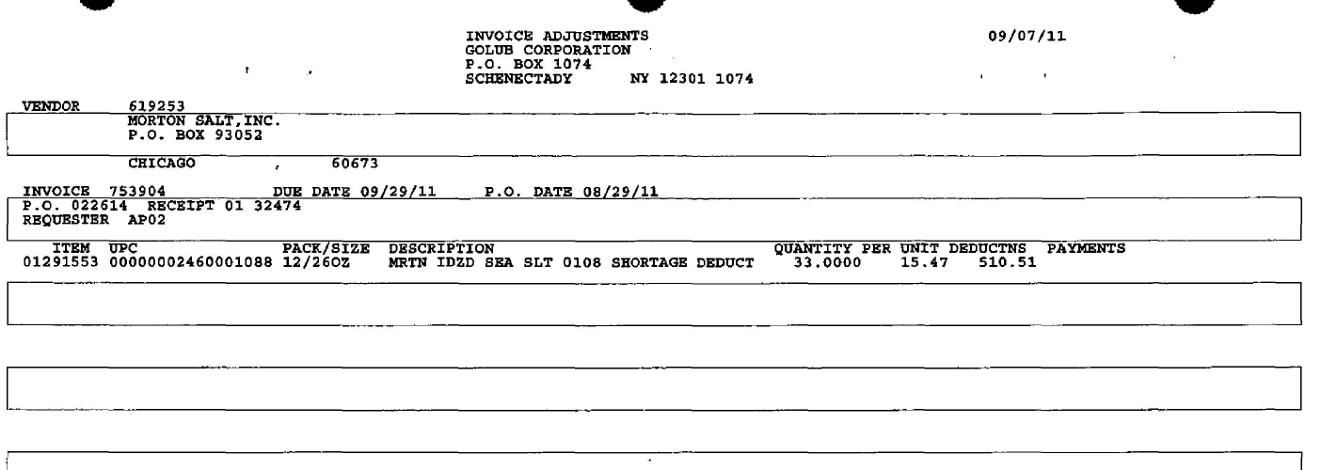
PO Number – This will be used to search for information regarding the order within ACOSTA Relay. This data is needed to validate if the particular product was ordered and invoiced...
Eg: In this case the PO # is 022614.
This number needs to be matched with client order invoice.
Deduction Type – This states that the invoice is for Shortage Deduction.
Once identified as Shortage Deduction, the Client order invoice needs to be linked and the claim needs to be stepped-up to Acosta for further research.

14.1 Customer Invoice for Shortages - Shorted Deal, Example 2:

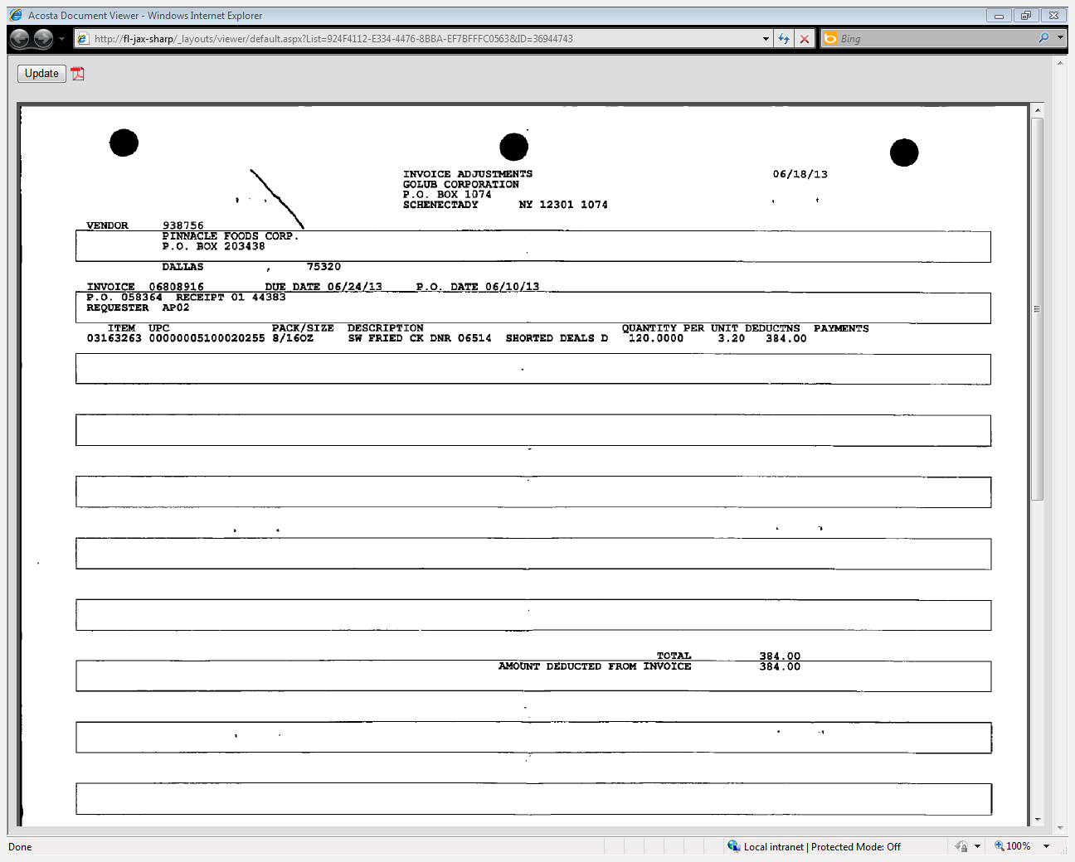
i
Identifies the client order invoice number and PO number.
i
Identification – Golub is claiming an Off Invoice allowance on shorted product. Refer to the client SOP to determine if the client will honor this. If the client does not pay allowances on shorted product, link the client order invoice, and step the claim to Escalate-Repay Process. If the client will authorize the allowance, continue with validation as shown in the Off Invoice Example.

14.2 Refer to the SOPs/Generic Help File for POP requirements.

15. Deduction Type: Post Audit:

Internal/external auditors find claims that the customer is entitled to but did not take from previous years. Post Audits should be researched in the same manner as other claims by accessing previous year’s files.

15.1 Customer Invoice for Post Audit:

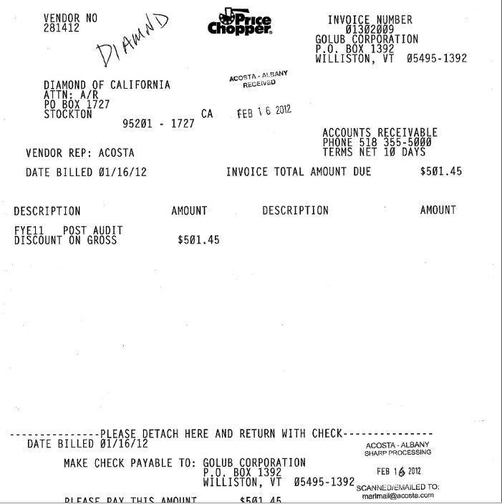
1

Identification – Invoice numbers displaying 0130 or 0140 as the first four digits of the invoice number indicates this is for a Post Audit deduction type.Once identified as Post Audit deduction the claim needs to be stepped to Acosta. Note: the third digit will go up numerically as the numerical series maxes out.

i
Deduction Type: Post Payment Audit indicates that this is for Post Audit deduction type.
Once identified as Post Audit deduction the claim needs to be stepped-up to Acosta.

16. Deduction Type: Rebate

Agreement between client and the customer for shelf placement, number of items stocked/purchased or other performance defined in the rebate agreement.

16.1 Customer Invoice for Rebate:

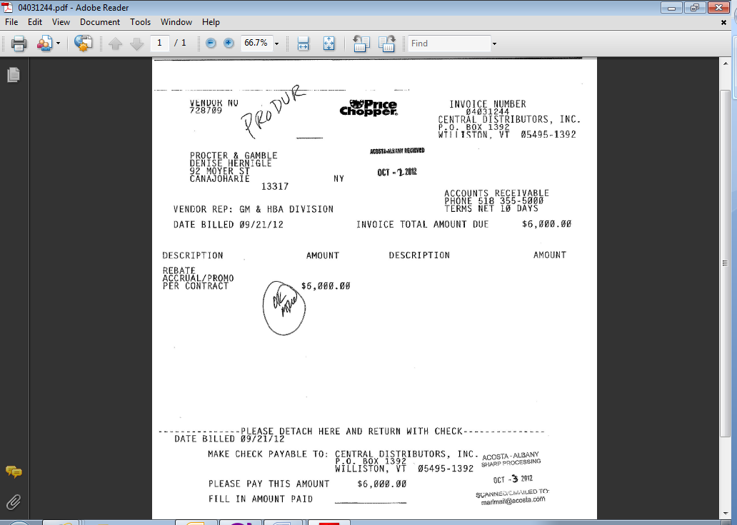
i
i
i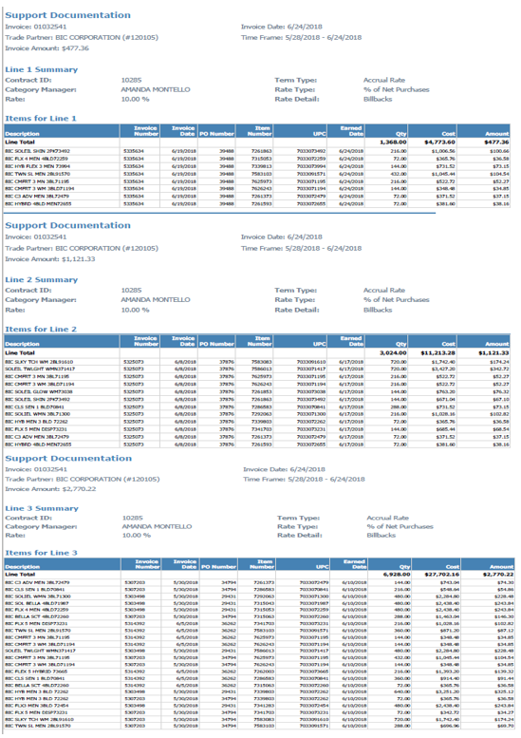
Total Invoice Amount: This is the total amount of the invoice, which should be matched up with the claim amount.

Rebate/Accrual: This indicates that this deduction is for a Rebate.

Invoice No: This is the customer invoice reference number.

16.1 Customer Invoice for Rebate: (Example 2)

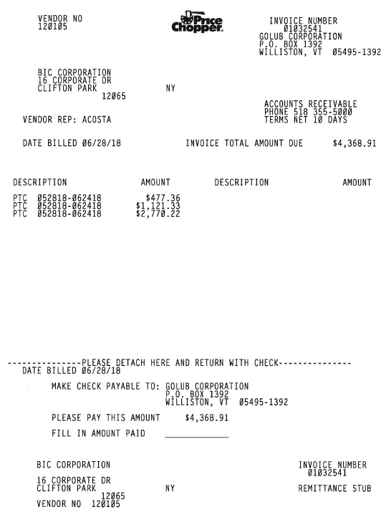
i
i
i
Rebate/Accrual: This indicates that this deduction is for a Rebate.

Total Invoice Amount: This is the total amount of the invoice, which should be matched up with the claim amount.

PTC (Period To Cover): This indicates that this deduction is for a Rebate/Accrual.

Customer Invoice for Rebate/Accrual: Page 2

The invoice detailed page will show 10% Rebate/Accrual Rate.
i
16.2 Customer Contract for Rebate/Accrual:

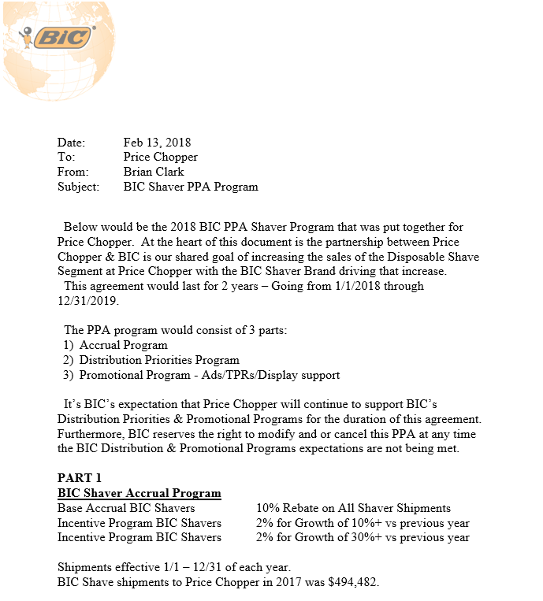
i
Agreement Dates = The timeframe claimed by the customer should fall within the agreement dates.
i
Identifies the type of allowance as Accrual.
Note: All Rebates/Accruals claims need to be stepped up to Acosta for processing.

17. Deduction Type: Other – Gas/Fuel Rewards

17.1 Customer Invoice for Gas/Fuel Rewards, Example 1:

This claim type would be validated and stepped as Trade/Other w/notes

Page 1
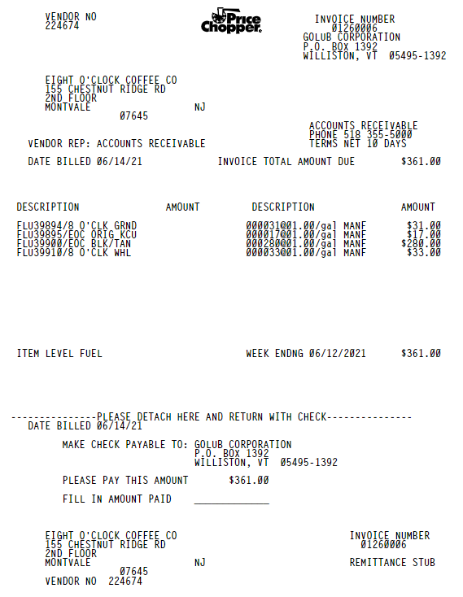
Description = FLU indicates Fuel Program. Rate/gal is the rate the customer is claiming.
(e.g. Eight O Clock Fuel Program, @ $1.00)
1
i
Invoice Total Amount Due represents the total amount claimed by the customer.
Invoice number reflects the Customer Reference # and should match with the Claims Processing Screen.
i

Page 2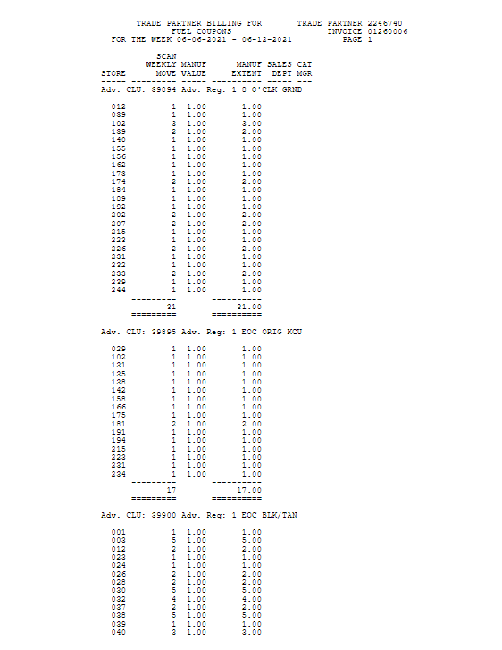
2

1

There are details on the additional pages of the invoice that show the quantity per item the customer claiming.
The additional pages of the invoice shows the time frame the customer is claiming.
i
i

17.2 Customer Contract for Gas/Fuel Rewards, Example 1:
1
2

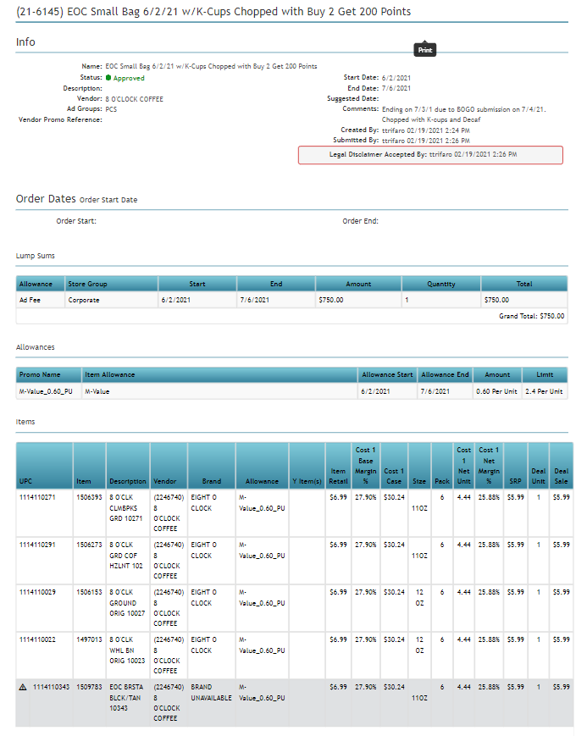
Start and End Dates reflect the promotional dates and the dates listed on the customer invoice should fall with these dates.
Name = provides the Brand and the description of the fuel/gas promotion.
NOTE: On the Gas/Fuel program every 100 points = $1.00.
In this examples Buy 2 get 200 points, it would be $2.00 but the customer bills individually.

17.3 Proof of Performance for Gas/Fuel Rewards, Example 1:

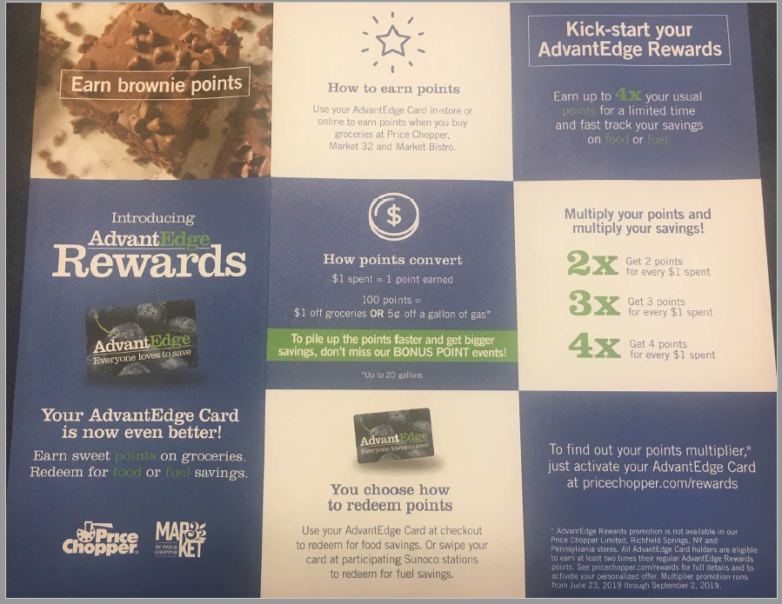

17.3 Refer to the SOPs/Generic Help File for POP requirements.

18.1 Retail Merchandising Customer Invoice Example 1:

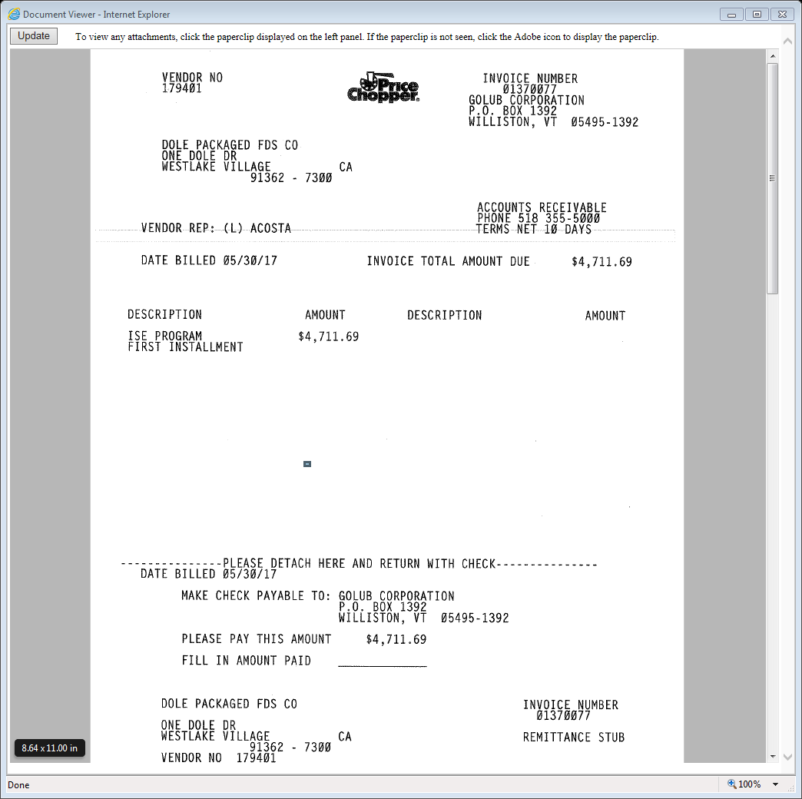
i
ISE Program: This indicates that this deduction is for Retail Merchandising.

18.1 Retail Merchandising Customer Invoice Example 2.

Page 1
i
EPC Program: This indicates that this is from a third-party vendor – Entry Point.
Page 2
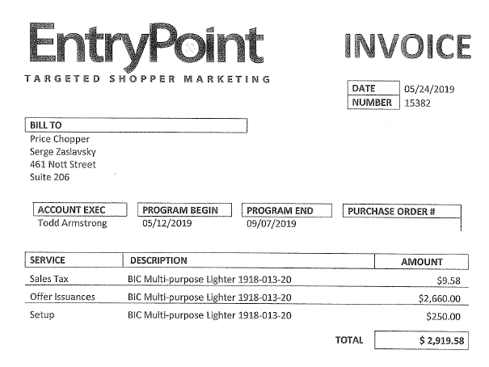

Page 3
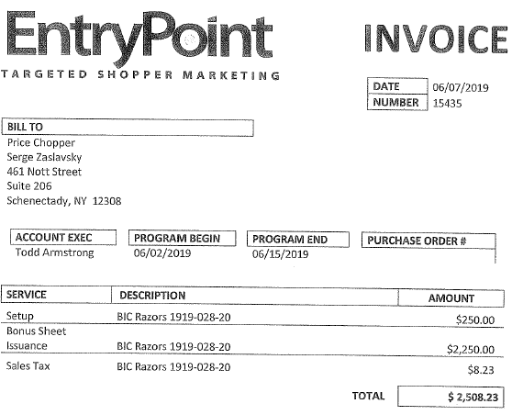

18.1 Retail Merchandising Customer Invoice Example 3.

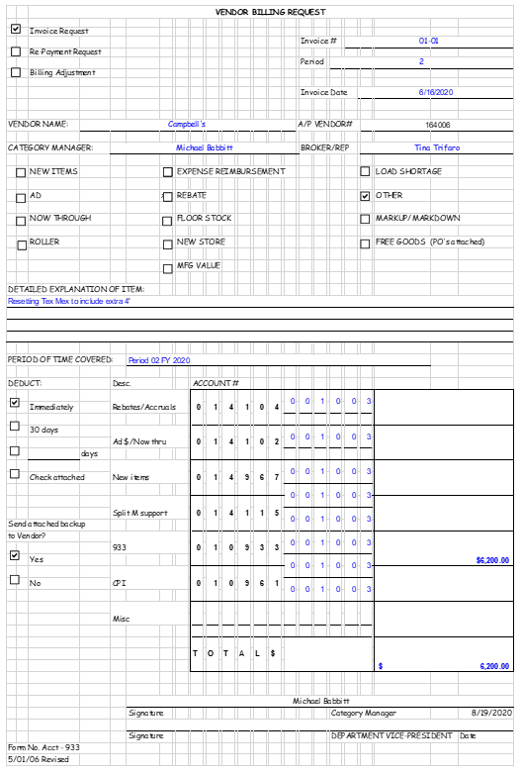

18.2 Refer to the Client SOP/Client Matrix for Retail Merchandising processing instructions.

19. Deduction Type: Bottle Deposits

Deposit Invoices are for Bottle Deposits. These should be stepped to Non-Trade/Other.

19.1 Bottle Deposit Invoice:
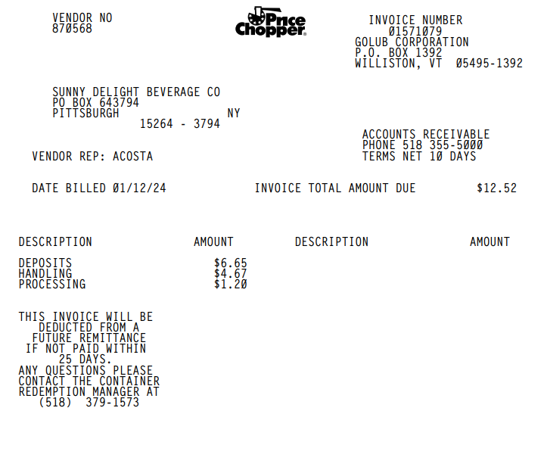
Deposits: This indicates that this deduction is for a Bottle Deposit.

BPS TEAM INFORMATION

REPAY SPECIFIC INFORMATION

INVALID PROCEDURE:

Repayment requests are sent to nss_acctg_lockboxremittance@northeastsharedservices.com

INVALID POST AUDIT PROCEDURE:
If the auditors email address is provided on the customer invoice sent the repay request to both the auditor and the customer manager listed on the claim via email.

CRA VALIDATION SPECIFIC

CRA Client Specific

CCA CLEARING INFORMATION SPECIFIC

CCA Client Specific

Barrilla
- Barilla Check request invoice number starting with 0113 are to be emailed to Laura Barat (Laura.Barat@barilla.com) and CC Karen Sandquist (Karen.Sandquist@barilla.com). No vistex claim is needed.
- C&S Service fees – clear to event number 1000056260 (fees for unpaid check requests that are deducted).

KENS
    - Allowance on cut product:
    - The claim needs noted in Ken's system that allowance on cut product is approved to be cleared to the event per the Ken's Regional Manager.
    - Check requests for food service items for Invoice Billbacks are send to fscheckrequest@kensfoods.com for processing. All other food service invoices are emailed to Gail Morgello (gmorgello@kensfoods.com) at Kens Foods.

HARVEST HILL
- Check requests with both Tops and Price Chopper on it will be processed as a single payment in TPM. The market selected should be Tops.

COMPLETE VERSION HISTORY
UPDATE DESCRIPTION | DATE | AUTHOR
First draft of the Golub SOP | 05/04/2012
Reviewed by Geoff Van Syckle | 05/04/2012
Revised Flowcharts and Definitions | 05/10/2012
Updated after Chairside Session with Hayley | 05/19/2012
Final Trainer Review | 06/06/2012
Updated if the customer subscribes to IRI/Nielsen data for price point verification, pg 2. | 9/10/2012 | Pam Trimble
Updated hyperlinks to deduction types | 09/16/2012 | Nagesh Kumar
Added Section 20 (Rebates) to SOP | 11/07/2012 | Geoffrey Van Syckle
Added example to Section 14, Coupons | 12/07/2012 | Geoffrey Van Syckle
Heinz Specific Section | 01/21/2013 | Geoffrey Van Syckle
Added Coupon Example (cleared to Trade) to Section 14 | 02/14/2013 | Dellene Hubbard
Added a Miscellaneous section and the example for Gas Rewards | 03/04/2013 | Dellene Hubbard
Added customer Signon link (5675) | 10/07/13 | Tracy Lewis
Added McCormick accrual check requirements to Client section (3351) Updated additional detail page needed information for the scan example (2344) Added items are matched to contract by description to the Scan section (2364), Added Coca Cola backup details to Client section (4632) Added Kens scan POP requirements to Client section (5307) Added Kens date exception to Client section (6539) Added invoice surcharge to Fee section (7056) | 3/31/14 | Tracy Lewis
Added shorted deal example to Shortage section (4791)  Added DPSG POP requirement to Client section (7397) Added GP DBW info to Client section (7200) | 4/14/14 | Tracy Lewis
Added date flexibility for Pinnacle to Client section (6747) | 4/28/14 | Tracy Lewis
Added Gas Rewards example to Misc section (4932) Added note to Ad example for Chopped Event dates (5726) Add Diamond POP requirements to Client section (5330) | 5/12/14 | Tracy Lewis
Added Heinz deal on cut products policy (8612) Added Heinz residual ad billings process (8581) Added GP process for residual billings to Client section (8594) | 6/9/14 | Tracy Lewis
Added a new TPR “Chopped” fee example removing the original TPR example. Added a note to section 4 ad contract concerning “Chopped” verbiage. Added the Sept. 2013- Jan. 2016 Chopped Schedules to the additional information section (9542) Added information on how to identify post audit deductions by the invoice number (9255) Added verbiage concerning the Golub scan movement report to the POP section for coupons (9228) | 6/18/14 | LaKeisha Turner
Removed the Heinz scan/ad invoice pages for the client specific section (10036) Added Category Management Support deduction details to the Clorox specific section (5952) Updated verbiage in section 3 concerning additional invoice pages (10078) Added a note to section 3 scan contract concerning “Chopped” verbiage and performance dates (8209 & 9443) | 9/15/14 | LaKeisha Turner
Added GP residual inv/contract example (10030) | 10/29/14 | LaKeisha Turner
Added GP fuel billing details (11210) | 2/16/15 | LaKeisha Turner
Added a note to section 6 TPR/Chopped contract concerning “Chopped” performance dates (12908). Removed DPSG client specifics (12946). Alphabetized the client specific section and added client hyperlinks (12950) | 3/30/15 | LaKeisha Turner
Removed “valid” from all the validity codes (13154) Added CCR specific instruction on how to identify and step bottling deductions (13015) Added Doc type search options for Unsaleables/Spoils/Reclaim invoices and doc type 30 to the Post Audit search options (13288) | 4/13/15 | LaKeisha Turner
Revised Heinz deal on cut products policy (12671). Updated the item level fuel example – enhancing the allowance rate verbiage to include Golub’s policy of 20 gallons per increment and added a part two to the POP requirements (13405). Added direct buying customer information to the customer sign-on box (13429). Added a BPS Team/CRA & CCA client specific info. Moved GP & Heinz CRA client specific info and GP & Heinz CCA client specific info to their sections under BPS team info (13451). Renamed the miscellaneous section to Other-Gas Rewards. Moved the item level fuel example from misc. to scan section. Corrected the # callouts on the Ad example to match the process flow chart – invoice and POP (13457). Removed CCR specific instruction on how to identify and step bottling deductions (13432) | 4/27/15 | LaKeisha Turner
Added Heinz scan clearing instruction (13385) Added is Req CI from CIT used for this customer to BPS Team Info section (13772) | 5/25/15 | LaKeisha Turner
Added StarKist client specifics; invoice breakout detail for CL and SW products (13943) | 6/22/15 | LaKeisha Turner
Added CCR specifics for Simply and Ades/Punches products to the client specific section and the BPS section/CRA-CCR specific section (13814) | 7/20/15 | LaKeisha Turner
Cleanup and reorganization of information (14730) | 8/31/15 | LaKeisha Turner
Removed the duplicate “GOLUB COUPNS REDEEMED” coupon example (15236) | 9/28/15 | LaKeisha Turner
Added line level detail information to the customer general section (15509) | 11/23/15 | LaKeisha Turner
Added Tyson specifics too the client specific section concerning POP (16041) | 12/7/15 | LaKeisha Turner
Client Specific section: updated Tyson POP for AD claims (16359) | 1/18/16 | LaKeisha Turner
Client Specific section: Added Tyson specifics concerning contracts for prior broker claims (16607) | 2/1/16 | LaKeisha Turner
Client Specific section: added Nestle shipment report info (17325) | 3/14/16 | LaKeisha Turner
Added CRA System & Backup Retrieval Specific for Post Audit backup request (17596) | 5/9/16 | LaKeisha Turner
BPS Team Info section: Added Clorox group ad/corporate ad CCA specifics (18498). Client Specific section: added Barilla invoice breakdown info (16811) Added the Aug. 2015- Dec 2016 Chopped Schedules to the TPR section (17772) | 6/20/16 | LaKeisha Turner
Client Specific section: Added Clorox coupon specifics (18658) | 7/4/16 | LaKeisha Turner
Client Specific section: Added Old Orchard specifics (18663) Removed all Heinz specifics (19311) | 7/18/16 | LaKeisha Turner
Removed extra contract copies and POP examples (19418) | 11/7/16 | LaKeisha Turner
BPS Team Info section: Added CRA validation instructions concerning post audits (20027) | 12/5/16 | LaKeisha Turner
Client Specific section: Added Pinnacle check remittance specifics (20313) | 1/30/17 | LaKeisha Turner
Client Specific section: Added Colgate ready to clear and contract steps specifics (21011) BPS Team Info, Customer System & Backup Retrieval section: Updated CIT to GCIT (21433) Client Specific section: Updated Nestle to Nestle Nutrition_C-Store (21471) | 3/17/17, 5/8/17 | LaKeisha Turner
Added section 22, Retail Merchandising invoice example (22096) | 9/11/17 | LaKeisha Turner
Scan section: Added a statement mentioning one item per PPG being listed on the invoice (21771) | 9/25/17 | LaKeisha Turner
Client Specific section: Added Harvest Hill specifics (22666) Added Tyson Fresh & Deli specifics (22788) | 10/9/17 | LaKeisha Turner
Client Specific section: Added Hostess specifics (22259) | 12/8/17 | LaKeisha Turner
Client Specific section: Added Method specifics (20654) | 12/18/17 | LaKeisha Turner
BPS Team Information section: Revised the post audit backup request instructions (24902) Client specific section: Added Nestle Nutrition spin report specifics (25030) Updated the Tyson Fresh & Deli specifics that once included Marcia Dunbar's to Acosta Sales (24885) | 7/2/18 | LaKeisha Turner
Client specific section: Removed outdated Tyson specifics concerning invoices for performance dates of 11/1/15 and prior (25188) Added Tyson scan invoices specifics (24884) | 7/16/18 | LaKeisha Turner
BPS Team Information section: Update to the customer backup request information/realignment of information, no process change | 8/13/18 | LaKeisha Turner
Client specific, BPS Team – CRA Validation specific and CCA Clearing Info specific sections: Added Pinnacle specifics concerning Golub Fair Share scans (25952) | 9/28/18 | LaKeisha Turner
BPS Team Information – CRA client specific section: Added GP specifics (25840) | 10/8/18 | LaKeisha Turner
Client specific section: Added McCormick not Acosta specifics (26057) | 10/22/18 | LaKeisha Turner
Added DBW instructions for Colgate in the Client Specific section (26279). Added club items invoices info for Pompeian to the Client Specific section (24775) Added Finance Charges Policy to the Customer Info section (25523) Added instructions on how to handle Finance Charges claims for Pompeian to the Client Specific section (25388) Added Price Chopped program info for Nestle to the Client Specific section (26100) Added Retail Merchandising prorate info for Colgate to the Client specific section (26235) | 12/3/18 | Maria Ovalles
Removed POP info for Nestle from the Client Specific section (26584) | 12/17/18 | Maria Ovalles
Added Rebate/Accrual PTC example to the Process Steps section (25615) | 1/14/19 | Maria Ovalles
Added Ad fees info for Starbucks to the Client Specific section (26653) Added Rebates info for Colgate to the Client Specific section (26834) | 1/28/19 | Maria Ovalles
Added Retail Merchandising / ISE Program info for Toms of Maine to the Client Specific section (26826) | 2/11/19 | Maria Ovalles
Removed McCormick/Frenchs information as Acosta no longer represents them from the Client Specific section (26829) | 2/13/19 | Maria Ovalles
Added StarKist client specifics; invoice breakout detail info (26003) | 2/25/19 | Maria Ovalles
Removed Tyson from the Client Specific section Acosta doesn’t handle claims from them (27728)  Removed Clorox from the Client Specific section, Acosta no longer represents them (28157) | 5/20/19  7/1/19 | Maria Ovalles
Added backup request contact info to the BPS Team Info section (28225)  Removed Pinnacle from the Client Specific section, no longer handle claims effective 8/26/19 (28434) | 7/29/19  8/26/19 | Maria Ovalles
Removed Old Orchard from the Client Specific section, no longer handle claims effective 9/30/19 (28634) | 9/27/19 | Maria Ovalles
Added allowance on cut product info for Kens to the Client Specific and CCA sections (28660) Removed StarKist from the Client Specific section, Acosta no longer represents them (28760) | 10/21/19 | Maria Ovalles
Transitioned customer backup requests to GCIT. Removed Customer System & Backup Retrieval section from BPS Team section and added Backup Retrieval Information section. | 11/8/19 | Maria Ovalles
Added another invoice example of Retail Merchandising to the Process Steps section (28926) Removed view document verbiage and updated backup retrieval section format. | 12/16/19 | Maria Ovalles
Removed Hostess/Superior Cake specific info Acosta is no longer their broker (29293) Added Odwalla products claims instructions for CCNA to the Client Specific section (29178) | 1/27/20 | Maria Ovalles
Removed Colgate specific info, Acosta is no longer their broker (29496) Removed Toms of Maine specific info, Acosta is no longer their broker (29497) | 2/24/20 | Maria Ovalles
Updated Campbell coupon info in the Client Specific section (29933) | 4/20/20 | Maria Ovalles
Added Invoices billing info for CCNA to the Client Specific section (30016) | 6/15/20 | Maria Ovalles
Removed Nestle Nutrition C-Store specific info, Acosta is no longer their broker (30503) | 7/13/20 | Maria Ovalles
Added another invoice example of Retail Merchandising to the Process Steps section (30632) | 8/24/20 | Maria Ovalles
Added Gas Reward contract & POP info to the Process Steps section (31007) | 10/19/20 | Maria Ovalles
Removed outdated info for CCNA from the CRA Client Specific section (31044) | 11/2/20 | Maria Ovalles
Added Scan claim instructions for Kens to the CRA Client Specific section (31160) | 11/16/20 | Maria Ovalles
Updated the Backup Retrieval Section, Customer provides Invoices with the check remit (31229) | 11/16/20 | Maria Ovalles
Updated the Backup Retrieval Section, Automatic email contact changed (31398) | 1/11/21 | Maria Ovalles
Client Specific section: Updated Barilla info (31420) | 1/25/21 | Maria Ovalles
Client Specific section: Updated Mars info (31837) | 4/5/21 | Maria Ovalles
Updated Gas/Fuel Reward info in the Process Steps section (32598) | 8/23/21 | Maria Ovalles
Removed the Gas/Fuel Reward info from the Scan section in the Process Steps section (32643) | 8/27/21 | Maria Ovalles
Updated contract info in the General info section (32859) | 11/1/21 | Maria Ovalles
Updated the Backup Retrieval Section, Automatic email contact changed (32908) Client Specific section: Added dunkin product info for CCNA (32924) | 11/15/21 | Maria Ovalles
Updated the Backup Retrieval Section (33349) | 3/21/22 | Maria Ovalles
Client Specific section: Added Merisant Swerve items info (33691) | 7/4/22 | Maria Ovalles
Removed Odwalla products claims instructions for CCNA from the Client Specific section (33620) Overall updates per meeting with Sales (34372) Added food service info for Kens to the CCA Clearing Info Specific section (34315) Added check request info for Harvest Hills to the Client Specific section (34319) | 1/16/23 | Maria Ovalles
Removed Odwalla products claims instructions for CCNA from the Client Specific section (33620) Overall updates per meeting with Sales (34372) Added food service info for Kens to the CCA Clearing Info Specific section (34315) Added check request info for Harvest Hills to the Client Specific section (34319) | 1/16/23 | Maria Ovalles
Removed Odwalla products claims instructions for CCNA from the Client Specific section (33620) Overall updates per meeting with Sales (34372) Added food service info for Kens to the CCA Clearing Info Specific section (34315) Added check request info for Harvest Hills to the Client Specific section (34319) | 1/16/23 | Maria Ovalles
Updated customer type info, Golub is now an indirect of C&S (34380) | 2/6/23 | Maria Ovalles
Added clearing instructions for Barilla to the CCA Info section (34880) Added split in for CCNA to the Client Specific section (34952) Updated backup request contact in the Backup Retrieval Info section (34953) | 5/8/23 | Maria Ovalles
Added clearing instructions for Harvest Hills to the CCA Info section (35019) Updated legacy items info & added check request info for Merisant to the Client Specific section (35032) Updated backup request contact in the Backup Retrieval Info section (35078) | 6/12/23 | Maria Ovalles
Added event & DBW info for Ferrero to the Client Specific section (35061) | 6/19/23 | Maria Ovalles
Updated DBW info for Ferrero in the Client Specific section (35429) | 9/4/23 | Maria Ovalles
Added fuel perk info for Kens to the Client Specific section (35646). Updated the food service info for Kens in the CCA Clearing Info Specific section (35671) | 11/13/23 | Maria Ovalles
Added check request terms info for Campbells to the Client Specific section (35811). | 1/22/23 | Maria Ovalles
Added additional information about the 1.5% Fee explanation under Customer General Information (36010). | 2/12/24 | Katie Teare
Added additional information about the 10% upcharge on scan invoices under Customer General Information (36084). | 2/19/24 | Katie Teare
Updated Client Specific Section to include Nestle regarding Boost and Carnation Claims (382852). | 4/22/24 | Katie Teare
Updated Harvest Hill to remove past due check request information and added information regarding how they deduct through C&S (383169). | 06/03/24 | Katie Teare
Updated EPC information in the Process Steps information (392568). | 7/22/24 | Katie Teare
Updated Kens section of Client Specific Information to include information about Food Service invoice correspondence (396295). | 09/09/24 | Katie Teare
Updated CCNA Client Specific Section regarding Fairshare – Check Requests (397071). Updated Finance Charge wording in Customer General Information (399328). | 09/30/2024 | Katie Teare
Updated Campbell’s customer number in the Client Specifics Validation Information section (400569). | 11/11/24 | Katie Teare
Updated check request information in Customer General Information Section (410889). | 01/21/25 | Dawn Regan
Added Client Beiersdorf and information to Client Specific Section (412123). | 02/03/2025 | Dawn Regan
Added client specific information for Nestle regarding deduction fees (418026). | 03/17/2025 | Lindsay McGinnis
Added client specific section for Sunsweet (418118). | 03/24/2025 | Lindsay McGinnis
Removed client specific section for Ferrero – Acosta no longer handles since 2/1/24 (421953). Update repay specific information (422243), Updated Customer General Information to include invoices that reflect PC or have no code at all (421885) | 04/21/2025 | Lindsay McGinnis
Added C&S Service fee clearing instructions for Barilla to the CCA client specific clearing section. (423362). | 04/28/2025 | Lindsay McGinnis
Reomoved Residual Billings, Fuel Perks and Food Service information from the Client Specific Validation section for Ken’s Foods. (426515). Changed verbiage in the Client Specific Validation section for Beiersdorf. (427300) | 06/02/2025 | Lindsay McGinnis
Moved verbiage regarding TM invoices to the Customer General Information section from the Customer Check Request section as it applies to both deductions and customer check requests. (430949) | 06/30/2025 | Lindsay McGinnis
Added backup retrieval information for invoices that begin with a ‘Z’ for Tops Market (431439) | 7/7/2025 | Lindsay McGinnis
Updated backup retrieval information for invoices that begin with a ‘Z’ for Tops Market (432606) | 7/14/2025 | Lindsay McGinnis
Updated backup retrieval information – all backup is requested from nss_acctg_lockboxremittance@northeastsharedservices.com. (440447) | 9/15/2025 | Lindsay McGinnis
Campbell’s client-specific: added clearing instructions for Tops and Price Chopper both being on the invoice. (454941) | 1/26/2026 | Lindsay McGinnis
Campbell’s client-specific: added Price Chopper events for SSA clearing. (456848) | 2/9/2026 | Lindsay McGinnis
Updated CCA Clearing information for Harvest Hill and Sunny D (461742) | 3/16/2026 | Lindsay McGinnis
Added information for Tops Market specifically for Campbell’s in the Client Specifics Validation Information section (462487). | 3/23/2026 | Lindsay McGinnis
Added J.M. Smucker Company to the Client Specific Validation Information section to include the Process job aids (468956) and the Prepaid Tracker (468953) | 5/11/2026 | Lindsay McGinnis
Added Cargill to the Client Specific Validation Information section to include invoices that reflect “Fuel” (469856) | 6/1/2026 | Lindsay McGinnis
Removed Merisant from the Client Specific Validation Information section (473009) | 7/20/2026 | Lindsay McGinnis
Updated all instances of Ready to Clear with Ready to Clear – CCA. | 7/27/2026 | Lindsay McGinnis

