WORK INSTRUCTIONS

Process | Order to Cash
DTP Name | Harris Teeter

CURRENT VERSION HISTORY
 | UPDATE DESCRIPTION | DATE |  | AUTHOR
Added 2026 Fee Schedule letter. (475505) |  |  | 7/6/2026 |  | Michael Huml

Link to complete version history: Complete Version History

DEDUCTION TYPES COVERED
Sl. No. | Deduction Type
 | Customer General Information
 | Backup Retrieval Information
 | Client Specific Section
1 | Off Invoice
2 | Bill Back
3 | Scan
4 | Pricing (Non Trade)
5 | Slotting
6 | Spoils (Non Trade)
7 | Display
8 | Shortage (Non Trade)
9 | Markdowns (Non Trade)
10 | Post Audit
11 | Fees (Non Trade)
12 | TPR
13 | Freight/Backhaul (Non Trade)
14 | Ad
15 | Coupon (Non Trade)
16 | Vendor Portal Invoice
17 | Cash Discount (Non Trade)
18 | Donated Product- Close Dated Product
19 | Return/Recall
20 | Sponsorship Program- Theme Event
21 | Other
22 | Retail Merchandising Program
 | BPS Team Information

Is the customer a wholesaler/distributor, direct or indirect customer? Direct Customer

Note: HARRCN is the Sign-on used to work claims within ACOSTA Relay for Harris Teeter (for example to search for a customer invoice).

Link to customer signon job aid:
https://acostaonline.sharepoint.com/sites/AS_Reporting/Claims_Reports/Forms/AllItems.aspx?web=1

Does this customer subscribe to IRI/Nielsen for price point verification? No

CUSTOMER GENERAL INFORMATION

- The deals start on Wednesday and run through Tuesday.

- The type of Ad

- E-VIC (Very Important Customers) Ads – These are the Ads that are performed electronically. The Ad copy to be linked would depend on the contract. If the contract states e-VIC (EVIC) then only the e-vic Ad which is stored under the Back-up documentation/POP-Ad (using ADCLIENT and HARRCN sign-on) needs to be linked. If the contract requires E-VIC Ad and in case E-Vic ad is not found under POP-Ad then the Sales Summary would be enough as proof of performance.

- If any item is listed in the contract and the scan rate is not listed against them then it indicates that the particular product is not part of the contract.

- Residual Billing: - Harris Teeter customer can deduct a week after the Week ending date listed in the Contract. This would be for the remaining deductable quantity of Scanned product for prior promotional period. Typically this will be for a small amount of units.

- If a customer invoice has a 10% Fee, the SCAN $ column will need to be divided by the QTY column to get the scan amount being clamed on the invoice. This amount will need to match the amount on the supporting contract.

- When filling the DBW out for a customer invoice that includes scans and a lump sum (ex. ad or display), make sure the DBW total does not include a 10% fee on the lump sum amounts. Only the scan portion of the customer invoice will have the 10% applied to it.

Customer Invoice Info:

Harris Teeter will often send an invoice with a “mother item” this item will be listed on the contract along with the other “children items” but when validating POP the mother item listed on the invoice will include cases for that item as well as the other children items on the contract.

Sometimes when searching for a Harris Teeter Invoice, you will need to use the “%” symbol before the Customer Reference Number due to sometimes an “M” will be at the end of the Customer Reference Number. If you notice this, always pick the Customer Invoice with all of the detail pages attached.

Is line level detail indexed on the customers documentation (customer invoice, customer check request, unsalable/spoils, post audit, EDI 812/820 or client deduction notice if one of these documents is included)? Yes

Markdowns are identified by items on the invoice with the “I/O” designator and that show a scan equal to 75% of the list cost after the off-invoice allowance and is typically for the date of (Fall Markdowns) from November 1 to January 30 or (Holiday Markdowns) January 1 to March 31.

All PO related claims must have the customer invoice attached to fully validate the claim.

“RGA” in the description field of an invoice indicates the deduction is for a Return.

If a line on the invoice indicates EVIC, then an EVIC contract should be used to validate:

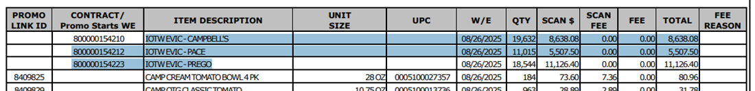

Contract Info:

When contracts open in an Excel file, be sure to check tabs at the bottom of the file, this could be where other items are listed.

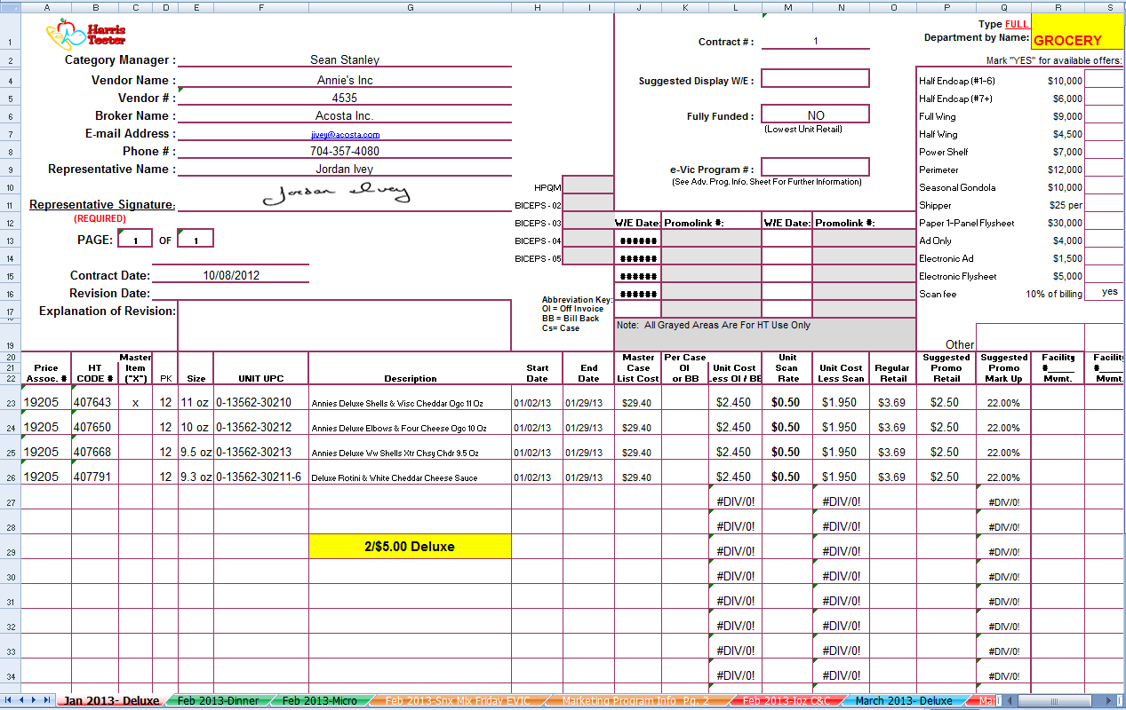
Click on each tab to be sure the item you are looking for is not on a different tab.

NOTE: The Contract dates may be provided under the W/E Date column or under Start/End date. Look in both places before requesting a contract revision.

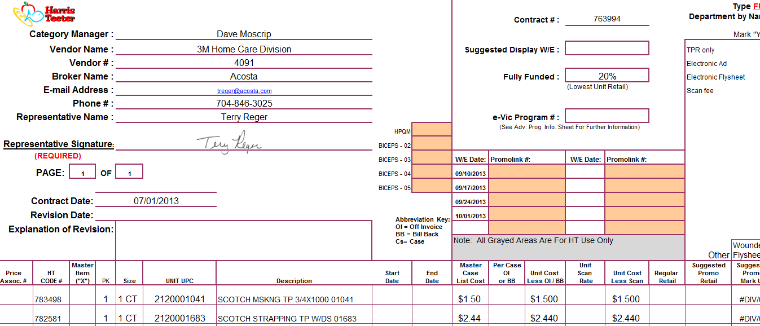

Customer Invoice may state a lump sump is for a different reason than what the contract states. This is ok , validate according to the contract as long as contract supports products, dates, and amount.

Other General Info:
Claims that create as customer check request for Harris Teeter sign-on (HARRCN), will be 3rd party check requests. A header note will be entered with details stating the check is for a 3rd party customer and the payee name will be listed as to who to make the check out to. The customer sign-on for the claim should remain as HARRCN.

Harris Teeter List Cost Change Policy:

2026 Fee Schedule:

BACKUP RETRIEVAL INFORMATION

GENERAL BACKUP RETRIEVAL INFORMATION

Is GCIT responsible for obtaining backup from the customer? YES
- If yes, is there a customer portal? YES
- If yes, does GCIT request backup? YES

Is check remittance information required to request backup? NO

- If an AR customer invoice references RGA and RGA invoice cannot be found in ACOSTA Relay,note the claim with the RGA number and step to GCIT.
- RMS Portal Instructions:
- Notice of switch from Inmar to RMS for Unsaleables:
TILLAMOOK
- Backup for DR invoices is to be requested from Melissa Glennon (MGlennon@tillamook.com).

GCIT SPECIFIC BACKUP RETRIEVAL INFORMATION

Portal:
Customer Invoice or Note Identifier | Request From
DR | RMS Portal (If backup cannot be found, reach out to Caryn Weaver – clweaver@acosta.com).

Automated:
Customer Invoice or Note Identifier | Request From
MM  VP | Lavante portal  If no backup is found in Lavante, request from HarrisTeeterAPRequest@harristeeter.com
AR | Lavante portal  If no backup is found in Lavante, request from VendorARRequest@harristeeter.com
QA | Ljenrette@harristeeter.com
-1 | Lhudson@harristeeter.com
DD | kburch@harristeeter.com
UD | dsuddreth@harristeeter.com
097 | Panoptic portal  If not found in Panoptic, contact Caryn Weaver – cweaver@acosta.com

Non - Automated:
Customer Invoice or Note Identifier | Request From
PO-related invoices: | Lavante portal  If no backup is found in Lavante, request from HarrisTeeterAPRequest@harristeeter.com
DDMMYYYY(ex.12MAR2018) | sbruce@harristeeter.com
CM  5 digits (begin with) 146,156,166,176 | Requested via inmar.tfaforms.net/4880230
Invoices stating “For more information please contact InboundLogistics@harristeeter.com” | InboundLogistics@harristeeter.com
Coupons (4 digits, begins with 92) | Requested via inmar.tfaforms.net/4880230

CLIENT SPECIFIC VALIDATION

Client
Barilla
Beiersdorf
Campbells
Coca Cola
Eagle Family Foods
Edgewell
JM Smucker
Ken’s
Mars Foods
Mars Pet Care
Method Products, Inc
Mezzetta
Nestle Coffee
Nestle Nutrition
Pepperidge Farm
Pompeian
Ricola
Seneca Foods
Sovos Brands/Noosa/Raos/Michael Angelo’s

BARILLA
- The 10% Scan Fee is built into the planned rate. These fees should put in the rate 2 and cleared to the promotion event by sub- brand.
- Markdowns for Harris Teeter are handled interally by Barilla.

BEIERSDORF INC.
- Harris Teeter claims received under Kroger sign on are to be coded to Unknown/Unknown/RTC - These need to be rejected Non-TTC in Kantar so the client can recode in SAP and Kantar as Harris Teeter. Do not change the sign on to Harris Teeter.
- Backup for DR invoices are to be requested from Alina.Skorzhenko@beiersdorf.com.
- Kroger 092-H claims received under Harris Teeter sign on are to be coded to Unknown/Unknown/RTC - These need to be rejected in Kantar so the client can recode in SAP and Kantar as Kroger. Do not change the sign on to Kroger.
- Invoices that include Coppertone: Code as Unknown/Unknown/Ready to Clear CCA. Reject in Kantar system. In the Comment Section, enter the amount that will need to be recoded back in order for Acosta to clear and the amount for Coppertone. Send a copy of the invoice to Karen Jessee (karen.jessee@sealanemkg.com) – she will clear in Kantar. When the Coppertone portion creates a new claim in AR, it is to be Closed.
- Invoices for Eucerin Suncare products belong to Karen Jesse at broker Sea Lane Marketing. She will clear in Kantar. Send invoice backup to Karen Jesse (karen.jesse@sealanemkg.com). Code as Unknown – Not Acosta – Ready to Clear CCA.
- 2026 Reset Fairshare Billing (Retail Merchandising Program) – Code as Trade-Other. Clear to event # N26HTT012 (All Brands/Categories).

CAMPBELLS
- Coding documents for EFT Payments.
- For Vendor Portal Billing invoices there are no contracts and will be cleared to a direct selling fund.
- F26 Shorted deal deductions are cleared to Trade.
  - All Raos Distinctive Dry Pasta and Distinctive Italian shorted deal deductions are cleared to tactic ID 1001U0RJC1.
  - All other Campbell Beverage/Italian/Mexican/Pacific/Soup-Broth/Specialty shorted deal deductions are cleared to tactic ID 1001U0RJBX.
- Shorted Deduct will be coded to Non-Trade – Shortages. Shorted Deals will be cleared as Trade – Other and will be cleared to the designated tactic ID for the product as it appears on the customer invoice through FY22. It will be necessary to add up all the lines on the invoice that pertain to each product group to establish the amount to be entered for each tactic ID. When validating a claim that has shorted deals, do not step any lines as Under Tolerance. No contract or POP will be required when validating.
  - F23 BEVERAGE 1001U0FPJO
  - F23 ITALIAN 1001U0FPJQ
  - F23 MEXICAN 1001U0FPJS
  - F23 PACIFIC 1001U0FPJU
  - F23 SOUP BROTH 1001U0FPJW
  - F23 SPECIALTY 1001U0FPK1
  - F24 BEVERAGE 1001U0JVPJ
  - F24 ITALIAN 1001U0JVPF
  - F24 MEXICAN 1001U0JVPH
  - F24 PACIFIC 1001U0JVPO
  - F24 SOUP BROTH 1001U0JVPD
  - F24 SPECIALTY 1001U0JVPM

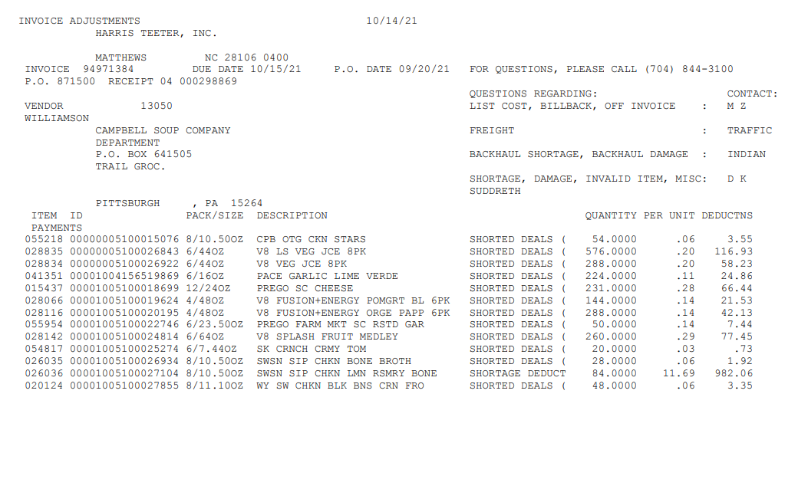

- For claims pertaining to Unsaleables/Damages, step to Invalid – Other – Repay Needed. Harris Teeter already receives a swell allowance.
- For CAMPBL and PEPPFF - If a claim is created under any Kroger sign-on and the invoice notes that it is for Harris Teeter, update the claim header to CUST: 1000009125
- GCC is to locate vendor number. Each vendor number on invoice will pertain to a different division. If the client sign-on is under a different division, GCC is to step accordingly per the sign-on changes noted in the client SOP (page 3).
  - PF Snacks DSD: 52750
  - PF Snacks Warehouse: 3276
  - PF Stuffing: 52755 (See example below)
  - PF Bakery: 52740
  - PF Frozen: 3277
  - SL Snacks: 63323
  - SL Warehouse: 8534
  - Raos/Michael Angelo’s Frozen: 009730
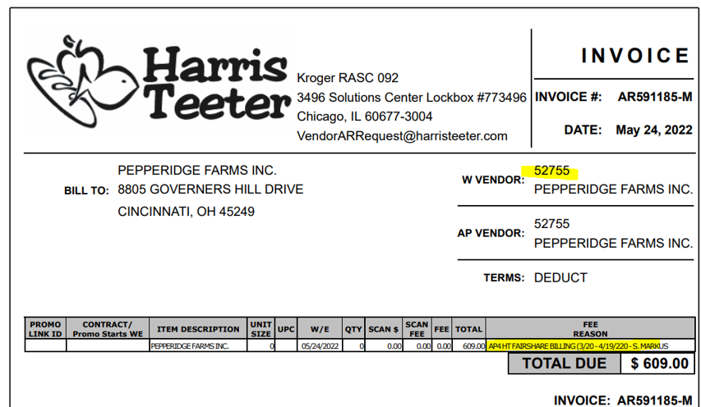

- Pepperidge Farm Snacks and Bakery need to be recoded to customer number CUST:0000060007.

COCA COLA
- Promotional related fees are split to a separate line. A fee event number is required to clear the promotional fee. Enter a line note stating that the line is for a promotional related fee.
- The Scan invoice will only show the parent item for Simply 52oz products. The claims needs to be broken down per the below document:
- Harris Teether Single Source deductions do not require breakdown. Each invoice will only use 1 brand code and event based onthe provided description. The template can still be used to generate the correct event to use.

EAGLE FAMILY FOODS
- Harris Teeter charges a 10% scan fee on their invoices. This will be cleared to a separate event, not the billback/scan event.

EDGEWELL
- Claims for Inmar coupons should be reassigned back to Edgewell in Plato with a note “Not Acosta, Inmar coupons - no additional backup.”
- Acosta does not handle DSD claims for Harris Teeter.

HARVEST HILL/SUNNY D
- For prior broker contracts: Claims for Harris Teeter do not require a contract to be attached to the claim in Relay or in the client system. Once all other required documents (invoice, POP, DBW, etc.) are attached, the claim should be stepped to Ready to Clear CCA. The CRA will use the Rebate Report to locate the event and clear the claim. If an event cannot be found in the Rebate Report, the claim should be stepped to Sales to provide an event number.

JM SMUCKER
- For Scans, the 10% scan fee is built into the rate found on the Event Detail Report.
  - Example: Invoice rate is $1.47 + (10% scan fee: 0.147) = $1.617, rounded to $1.62.
  - Rounding is acceptable and approved to clear.

MARS FOODS
- Harris Teeter is part of the Retail Merchandising Program.
- Shopper Marketing is cleared as Trade to an event.

MARS PET CARE
- Reach out to HarrisTeeterAPRequest@harristeeter.com for payment, backup requests, or follow-up inquiries pertaining to invoices.
- Contracts are not required for clearing.
- Damages are to be coded in Relay as Invalid – Other - Closed with “Damages” in the line note field. CL COL is to be added to the Check Number field since Marspact will be handling the repay request.
  - Email damages backup to pavan.kumar1@effem.com, ashish.singh@effem.com and reject in Compass (client system).

METHOD PRODUCTS, INC.
- Claims that begin with AR are not handled by Acosta. These should be stepped as Not Acosta, backup to be sent to Amy L. Tschirgi – ALTschir@scj.com.

MEZZETTA
- Claims for Vendor Portal Billing are to be coded as Trade – Shopper Marketing.

NESTLE COFFEE
- For Vendor Portal Billing invoices there are no contracts and will be cleared to Non-Trade/Service Fee/Penalty.
- 10% Scan fees are cleared to a Scan deal/event number. The Scan fee for each item on the invoice will have a seprate line on the claim and the DBW. These are coded as Trade/Other.
  - 10% fee DBW process:
    - Enter UPC
    - Fee quanity is the item qty on the invoice.
    - The rate is the Scan $ on the invoice divided by qty.
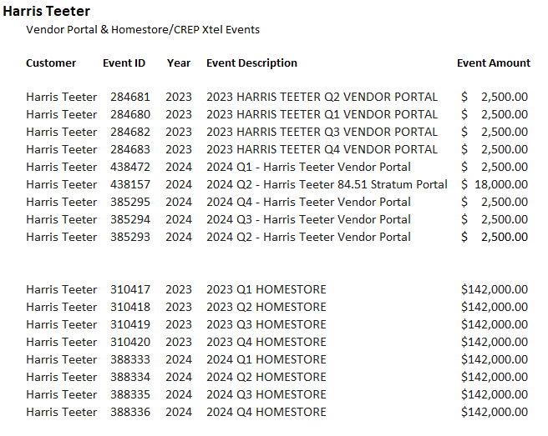
- Events to be used for Vendor Portal and Homestore claims are below. There will not be a contract.
- For Markdown claims:
  - These claims are identified by items on the invoice with the “I/O” designator and show a scan equal to 75% of the list cost after the off invoice allowance and is typically for the dates of Fall from November 1 to January 30 or Holiday January 1 to March 31. These claims do not require a contract or POP.
- For Harris Teeter Nestle Scans:
  - The scan event is TPR, while the scan fee is CTA. The scan is coded as Trade – Scan and the scan fee is coded as Trade – Other. These markdowns get cleared with a trade promotion.

NESTLE NUTRITION
- For Vendor Portal Billing for Nestle there are no contracts. However, these are still cleared to trade and require an event number; code as Trade/Other.
- Nestle is allowed a date flexibility of one week before the promo start date and one week after the promo end date.

PEPPERIDGE FARM
- If the invoice only contains Snyder Lance products and the header amount is different from the invoice, it should not be transferred back to Snyder Lance. There will be a second invoice available in AR that has the email breakdown approval from the CSL on how to clear to Pepperidge Farm. If this detail cannot be found, request it from the Sales team.

POMPEIAN
- Markdowns are coded as Non Trade and do not require a client event #, even if a contract is located and used to indicate that the items are for markdowns.

RICOLA
- Shopper Marketing claims are cleared as Trade and a require a client event number.

SENECA FOODS
- Acosta only handles Invoices for Harris Teeter for vendor 16487, vendor 16486 is NOT ACOSTA.
- Proof of performance is required for all promotions.

SOVOS BRANDS – NOOSA, RAOS, MICHAEL ANGELOS
- Shopper Marketing claims should have a contract and a TPM promotion to clear to.

PROCESS STEPS

1. Deduction Type: Off Invoice
If the customer does not receive the allowance off the face of the invoice they will deduct for it. If the customer requested an allowance that is not valid, the CSC will send a notification to the customer in writing. Customers view purchase orders as contracts. If they are not notified of allowance discrepancies, they will pay according to their purchase order total.

NOTE: Harris Teeter will take OI allowances on shorted product. You will need to use the Client Order and EDI invoice to see if this is the reason for the deduction.

  - Customer Invoice for Off-invoice, Example 1: Listed below is an example of Harris Teeter customer invoice received for an off-invoice claim. Need to validate the Invoice #, UPC code and OI Rate on the invoice with the contract.
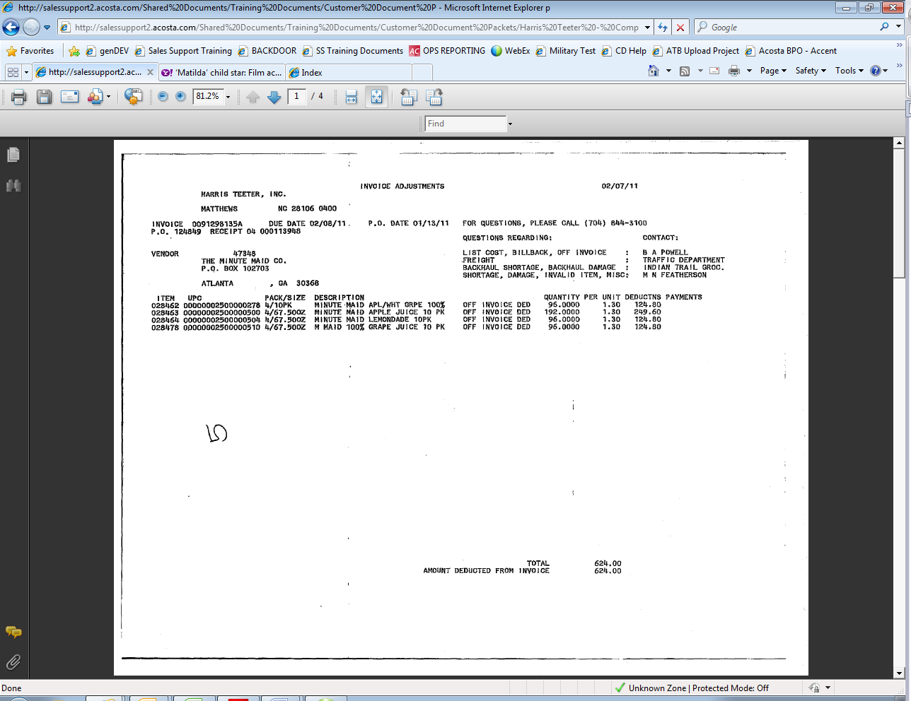
This is the Client Order Invoice number. This would be used to retrieve the Client Order Invoice from the Review Order/view document link within ACOSTA Relay. Also, this needs to be matched with the Client order invoice.
In this case the invoice number is 0091298135A. Drop the ‘A.’
This must be pulled first to determine the Order and Ship Dates.
Invoice #: this invoice number is also used to locate the customer invoice in backup documentation (Doc Type 2).

Quantity: in cases.

OI rate (in cases) – Customer Invoice OI rate must match the Customer contract OI rate.
PO Number – This will be used to search for information regarding the order within ACOSTA Relay. This data is needed to validate if the particular product was ordered and invoiced with the off invoice allowance.
Eg: - In this case the PO # is 124849.

UPC Code – The unique product code (UPC) is the last 5 digits of the full product code.

This code is used to validate key data elements regarding the customer invoice and client order invoice on the Review Order /view document link in ACOSTA Relay. This is the product in which the customer is claiming there is an off invoice. Example: In this case the UPC is the one highlighted in red 2500000278.

1.2 Customer Contract for Off-invoice, Example 1: This is required to compare the details which are referenced on the customer invoice and Client Order Invoice.
Contract can be found via "Search For" Promotions or Backup Documentation (Doc Type 17). Signon is HARRCN.

OI Allowance: This verbiage represents Off-invoice.
UPC Code – The unique product code (UPC) is the last 5 digits of the full product code. This code is used to validate the product listed on the customer invoice. In this case the UPC is highlighted red, UPC 0-25000-00504.

Ship Date: This needs to be compared with the date on the Client Order Invoice to ensure the transaction was performed during the contracted period.

The Off Invoice column captures the OI Rate. This needs to be compared with the rate listed on the customer invoice. The off-invoice rate of $1.30 is referenced on the customer invoice.

1.3 Refer to the SOPs/Generic Help File for POP requirements.

2. Deduction Type: Bill Back
A per case bill back allowance is claimed by the direct buying customer for product purchased from the client, or by the indirect customer for product purchased from the direct customer. This is an allowance the customer will bill the client for. This is not an automatic discount given off the face of the invoice.

2.1 Customer Invoice for Bill Back, Example 1: Listed below is a sample of customer invoice for a bill-back claim. The Invoice number, UPC and per unit bill back rate will be required to be validated with the customer contract.
Bill Back: This verbiage indicates this is Bill Back deduction.

Invoice Number: This number is used to locate the client order invoice within ACOSTA Relay. Drop the “A” when searching. This number is also used when searching for the customer invoice within ACOSTA Relay.

BB rate: This is the per case Bill Back rate which needs to match with the Bill Back rate specified on the contract.
QTY: quantity in cases.
UPC Code – The unique product code (UPC) is the last 5 digits of the full product code. This is the product in which the customer is claiming the Bill Back. Example: In this case the UPC is highlighted in red
1001480064608.

2.2 Customer Contract for

2.2 Customer Contract for Bill Back, Example 1: Listed below is the bill back customer contract required to compare the details which are referenced within the customer invoice. Contract can be found via "Search For" Promotions or Backup Documentation (Doc Type 17). Signon is HARRCN.

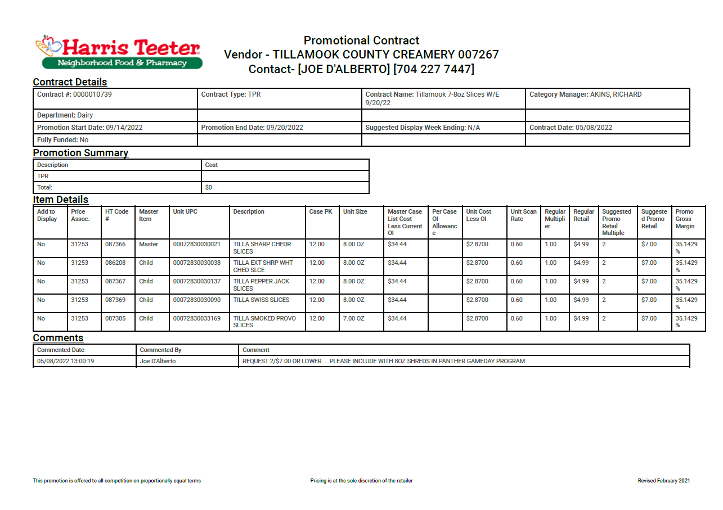
Promotion Dates: Invoice dates should match or fit within the promotion dates.
Bill Back rates: This needs to match with the rate on the customer invoice. For example it is $2 which can be found on the customer invoice.
UPC Code – Last 5 digits should match with the UPC code referenced on the customer invoice. For instance
the UPC 14800-64608-5 can be found on the customer invoice.

2.3 Refer to the SOPs/Generic Help File for POP requirements.

3. Deduction Type: Scan
Scan allowances are for product scanned at the store register and are usually billed in eaches, not cases.
The customer should not be referencing for a purchase order number while refering a scan allowance

3.1 Customer Invoice for Scan (Friday eVIC), Example 1:
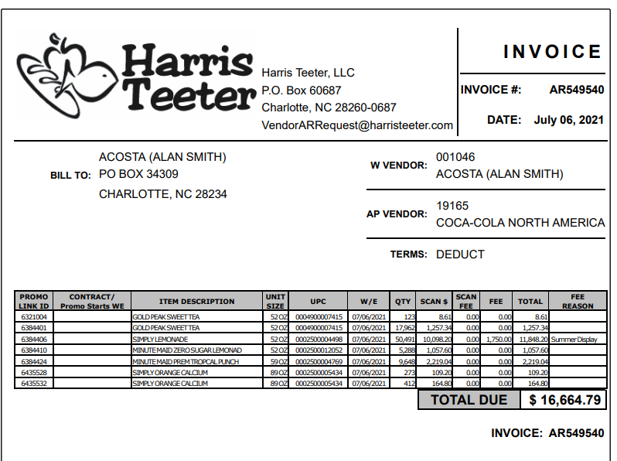
Scan Rate: The amount in the Scan $ column needs to be divided by the QTY to arrive at the scan rate, found on the contract.
Fee: If there was an amount listed here, this should be validated with the scan fee provided on the contract.
Week Ending Date (W/E) - This is the date the transaction took place and should fall within the customer contract performance dates. Harris Teeter will also deduct one week after the promotion has ended.
Invoice #: Used to search for the customer invoice in ACOSTA Relay.
Summer Display indicates a scan available these items, week ending 7/6/2021.

i

3.1 Customer Invoice for Scan, Example 2:

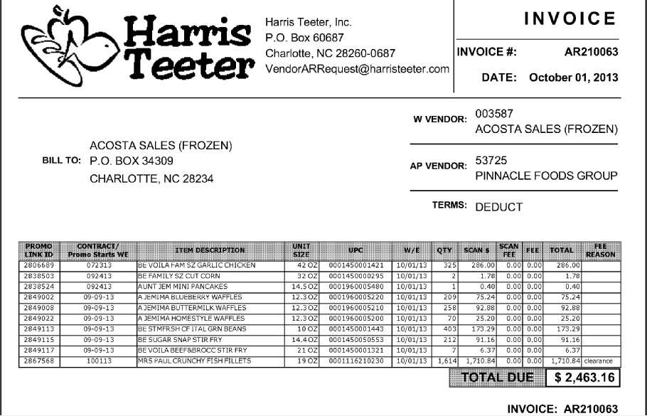
The term “clearance” in the fee reason column can mean it is for markdowns. However, if a contract can be located for the scan amount this should be coded as Trade- Scan. If GCC can not locate contract this needs to be escalated as a contract issue so the CRA can determine if this is a scan or markdown..
Invoice #: Used to search for the customer invoice in ACOSTA Relay.
Week Ending Date (W/E) - This is the date the transaction took place and should fall within the customer contract performance dates. Harris Teeter will also deduct one week after the promotion has ended.
Scan Rate: The amount in the Scan $ column needs to be divided by the QTY to arrive at the scan rate, found on the contract.

3.1 Customer Invoice for Scan, Example 3: True-up for Store TLOG Issue

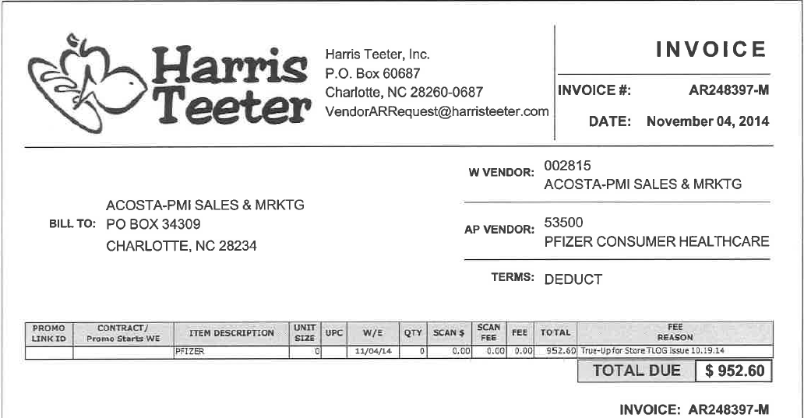
True-up for Sotre TLOG Issue will be validated as scans.

“True-up Store TLOG Issue” invoices will come in a packet with a cover letter and a breakdown (see below)

Cover Letter:
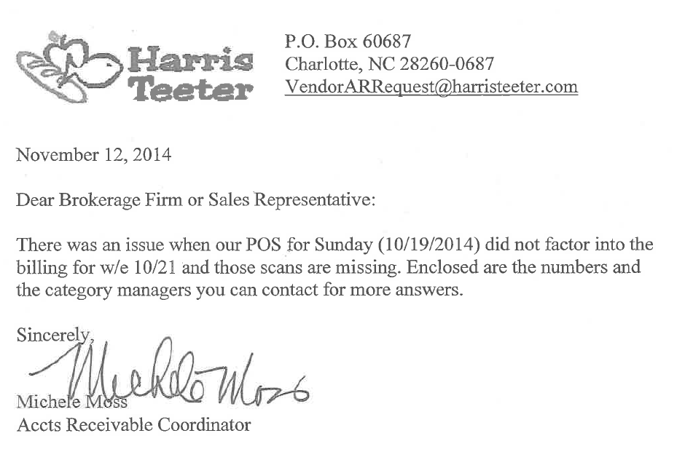
Breakdown:
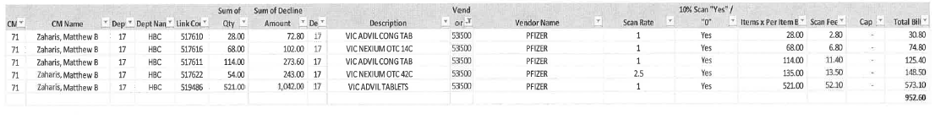

3.1 Customer Invoice for Scan, Example 4: Scan Higher Than Savings

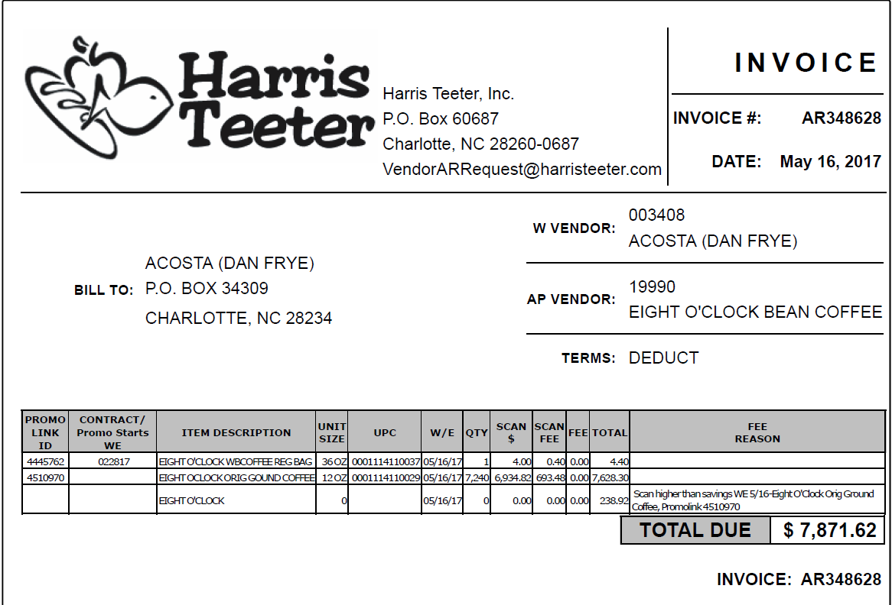
For invoices with “scan higher than savings” add the scan $ amount to the scan higher total amount, matching the Promolink ID (ex. Promolink ID 4510970 / $238.92 + 6934.82 = 7173.74).

Take this amount and divide it by the qty to determine the rate that must be matched to the contract (ex. 7173.74/7240 = .99)
3.2 Customer Contract for Scan, Example 1: The UPC Code, Scan Fee, and Unites on the contract should match with what is listed on the customer invoice

Contract can be found via "Search For" Promotions or Backup Documentation (Doc Type 17). Signon is HARRCN.

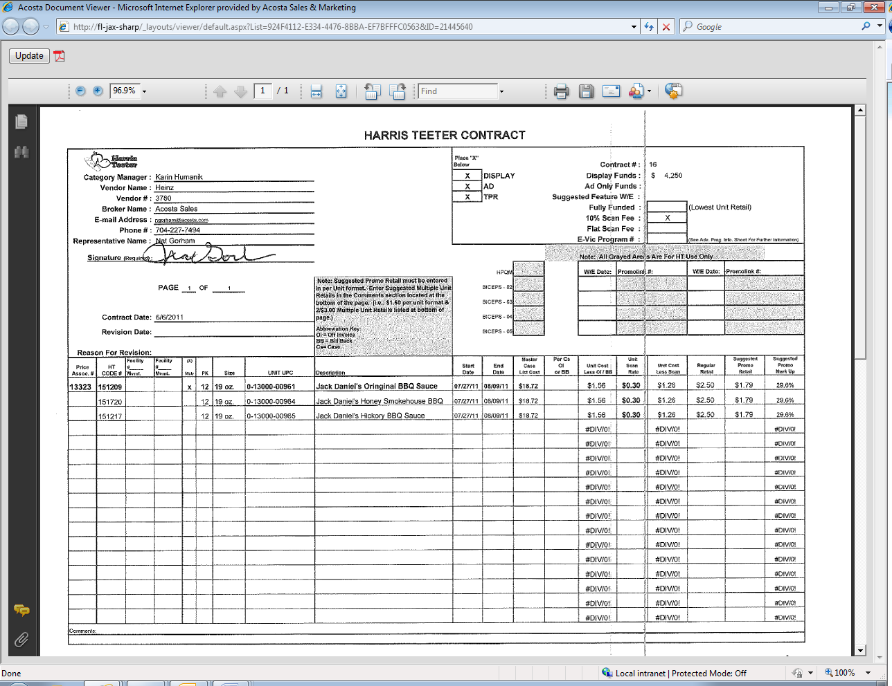
Performance dates refers to start and end dates of the promotion. The customer invoice date should fall between these dates. Harris Teeter will also deduct one week after the promotion has ended. For example: The end date for this promotion is 8/9/11, therefore Harris Teeter will deduct one week after this date which is Week Ending 8/16/11. This is an acceptable practice for Harris Teeter only.
Scan fee: The “X” indicates how the customer will deduct for the service fee.
10% Scan Fee – Harris Teeter will deduct 10% of the total scan on each customer invoice.
Flat Scan Fee – Harris Teeter will deduct a flat fee (i.e. $400, $1,000, etc.) the first time they bill against the contract (just one invoice).

UPC Code – The unique product code (UPC) is the last 5 digits of the full product code.
The first UPC listed in this group is known as the ‘Mother Item’ and should match the UPC code referenced on the customer invoice.
Scan rate: Need to validate the unit scan rate on the contract with the unit rate on the customer invoice.

3.1 Customer Contract for Scan, Example 2: Fully Funded Scan.

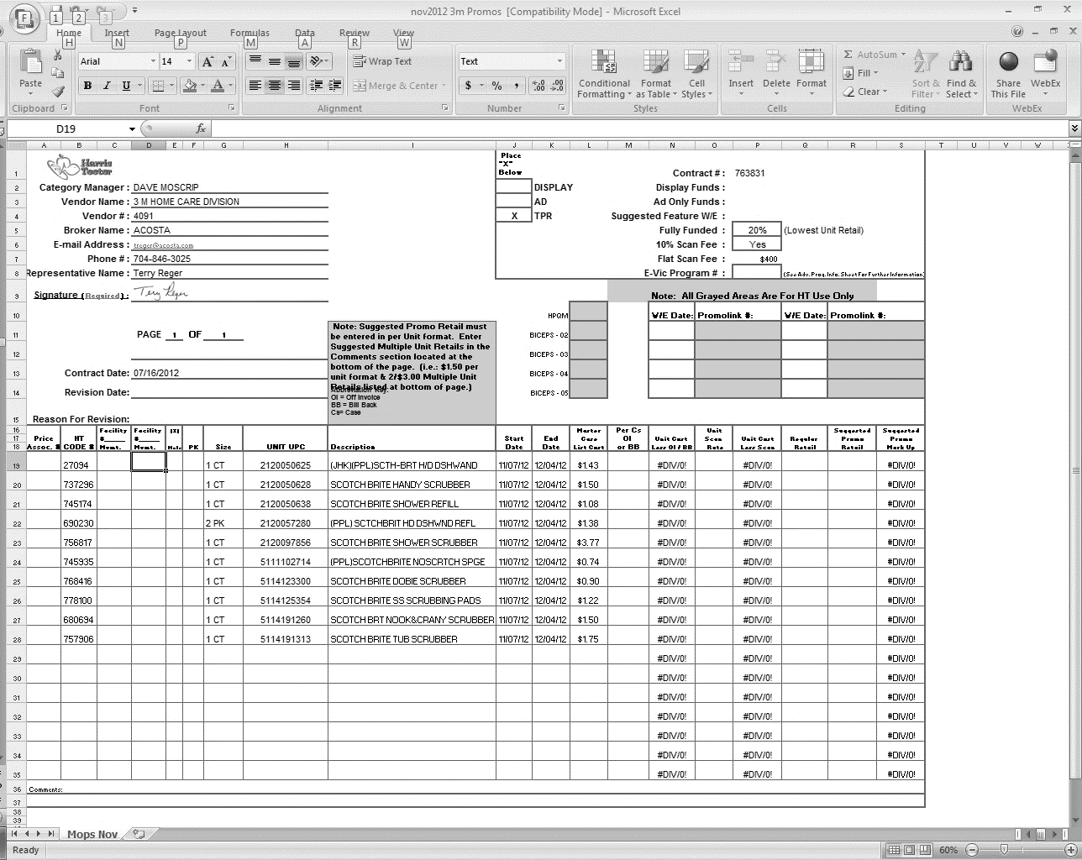
Fully Funded: A scan rate will not appear in the “Unit Scan Rate” Column for a Fully Funded Contract.
Fully Funded: Whenever this box contains information (ie: percentage rate, an “x”, a “y”, or a dollar amount) The contract supports whatever the allowance rate is on the customer invoice. Math verification of the allowance rate on the Customer Invoice vs the Customer Contract is not required.

3.2 Customer Contract for Scan, Example 3:

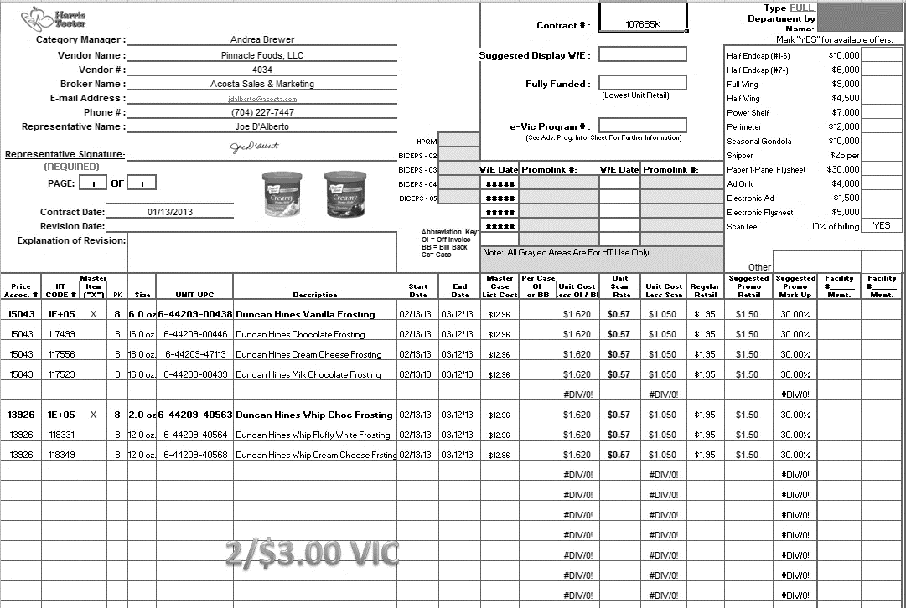
Scan Rate- this should match the rate on the Customer Invoice.
Product Description- this should match the product description on the Customer Invoice.
Scan Fee 10% of Billing- this confirms that there should be the 10% Scan Fee on the Invoice.

3.2 Customer Contract for Scan, Example 4:

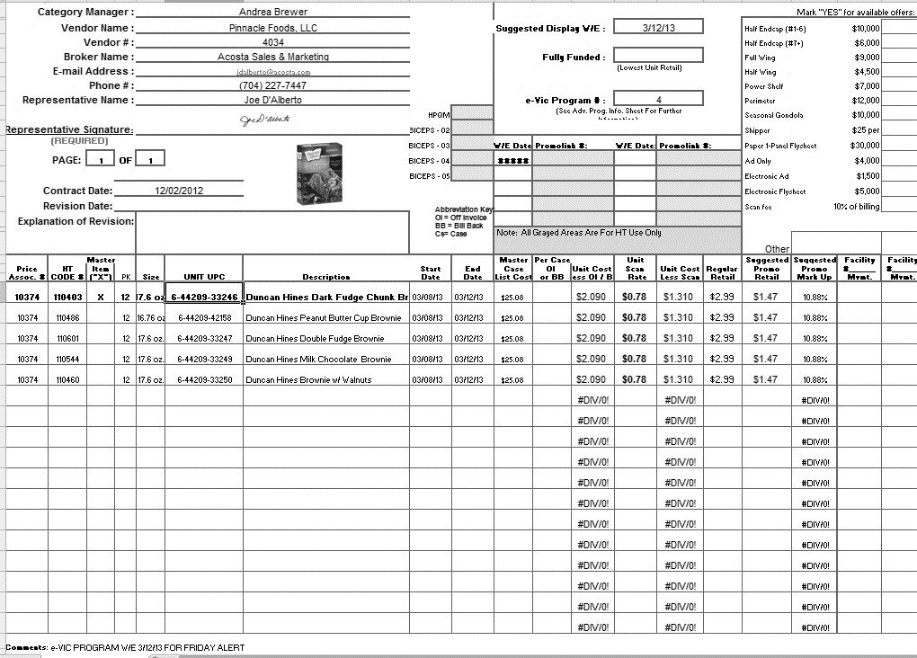
Contract start and end dates.
The description on the contract should be relevant to the description on the Customer Invoice.
Scan rate per Unit.

Indication on the contract that this is for a Friday eVIC Scan.

3.2 Customer Contract for Scan, Example 5: Note: For clearance line on invoice only

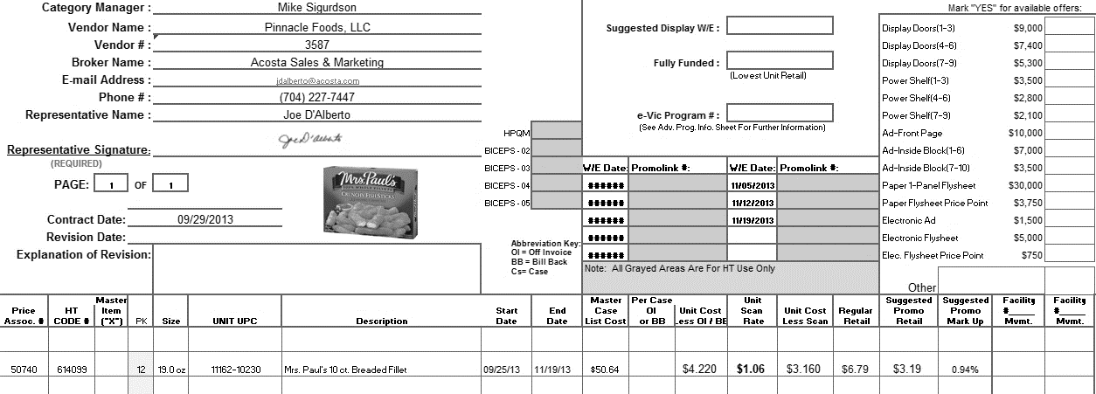
Contract start and end dates.
The description on the contract should be relevant to the description on the Customer Invoice.
Scan rate per Unit.

3.1 Customer Contract for Scan, Example 6:
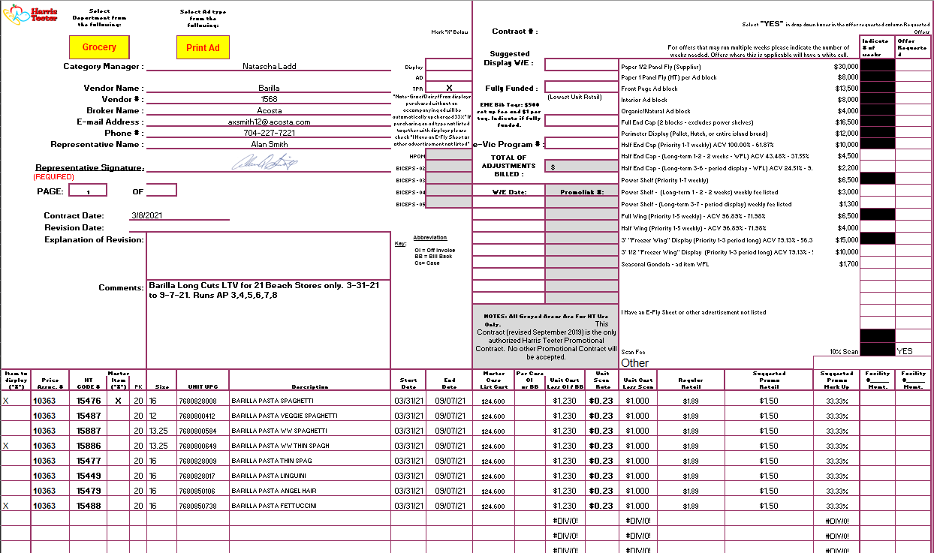

3.3 Refer to the SOPs/Generic Help File for POP requirements.

4 Deduction Type: Pricing
A pricing deduction occurs when the customer's requested price on the original purchase order differs from the client's invoice.

Documents required for validating Pricing claim:

Documents Name | Source of Document | Action by Accenture
Customer Invoice | ACOSTA Relay – search for the invoice under Backup Documentation using document type 2. | Step up the claim to Acosta for research.
Client Order Invoice | ACOSTA Relay – search for this document within the Order/Invoice/PO search.

4.1 Customer Invoice for Pricing, Example 1: Listed below is an example of customer invoice for a pricing deduction. Need to validate the UPC, Quantity and PO # with the client’s invoice.
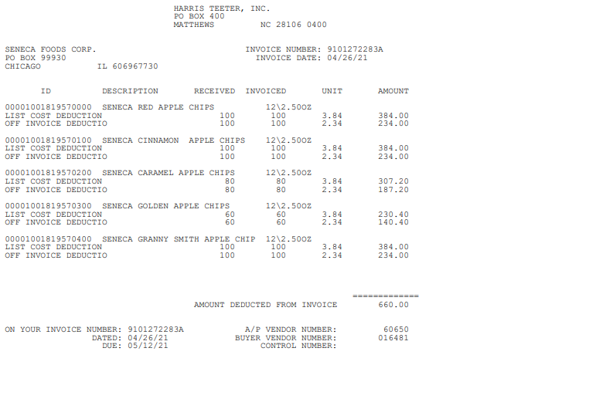
ID: This is the UPC codewe need to validate the appropriate 819570000 please refer to the client SOP or SOP matrix for specific validation guidelines).
List cost deductions: This verbiage refers to ‘Pricing’ allowance, OI, or BB. In the example above is List Cost referencing a Pricing deduction.
Invoice#: This is the Client Order Invoice number and is used to retrieve the order/invoice data out of the Order/invoice/PO /view document link within ACOSTA Relay. In this case the invoice number is 06609013.
This is also used to search for the customer invoice within ACOSTA Relay.

5 Deduction Type: Slotting
A Slotting allowance is offered to the customer to purchase an item not currently stocked. A slotting lump sum allowance can be offered for each item and/or an off invoice can be offered as an introductory allowance for the first 30 days.

5.1 Customer Invoice for Slotting, Example 1: Listed below is an example of customer invoice for slotting deduction. Need to validate the UPC, Invoice date and slotting allowance with the contract.
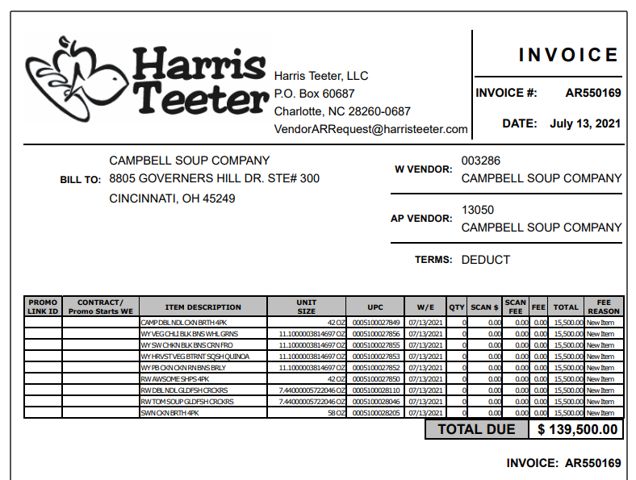
Week Ending Date: This is the date the customer took the deduction.

Fee Reason: “New Item” indicates that this deduction is for slotting.

Amounts under TOTAL indicate Slotting allowance which needs to be validated with the contract.

Invoice #: Used to search for the customer invoice in ACOSTA Relay.
UPC Code – The Universal Product Code (UPC) is the last 5 digits of the full product code. This code is used to validate key data elements regarding the customer order and client order invoice in the Review Order / View documents link of ACOSTA Relay. This is the product in which the customer is stating that there is slotting.
Example: In this case the UPC is highlighted in red
0001116210230.

5.1 Customer Contract for Slotting, Example 1: The UPC, Ship date and Slotting rate needs to be matched with client invoice.
Contract can be found via "Search For" Promotions or Backup Documentation (Doc Type 17). Signon is HARRCN.
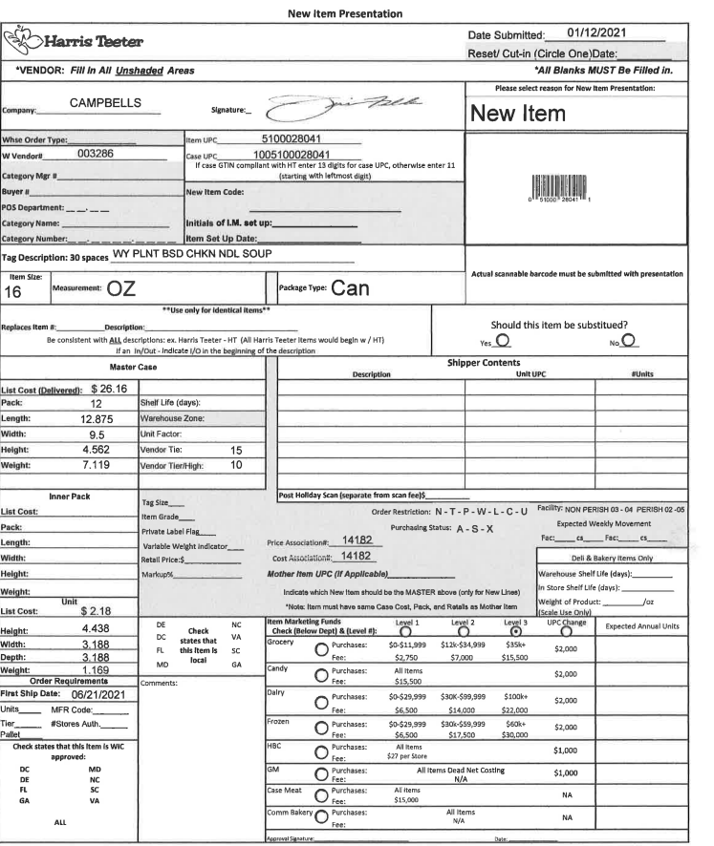

5.2 Customer Invoice for slotting, Example 2:

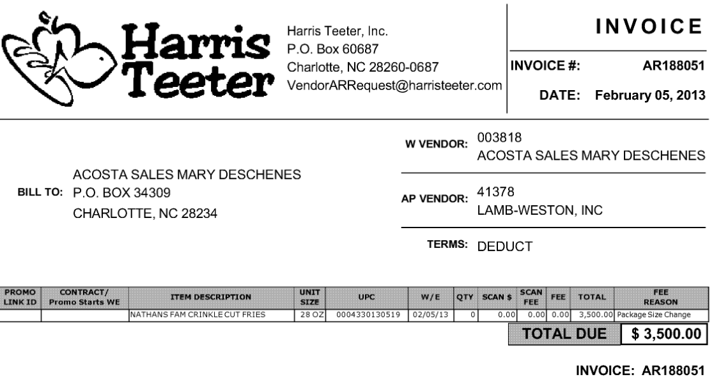

Fee Reason- The Fee Reason of “Package Size Change” indicates that this claim is for slotting.

5.3 Customer Invoice for Slotting, Example 3: The UPC, Ship date and Slotting rate needs to be matched with client invoice.
Contract can be found via "Search For" Promotions or Backup Documentation (Doc Type 17). Signon is HARRCN.
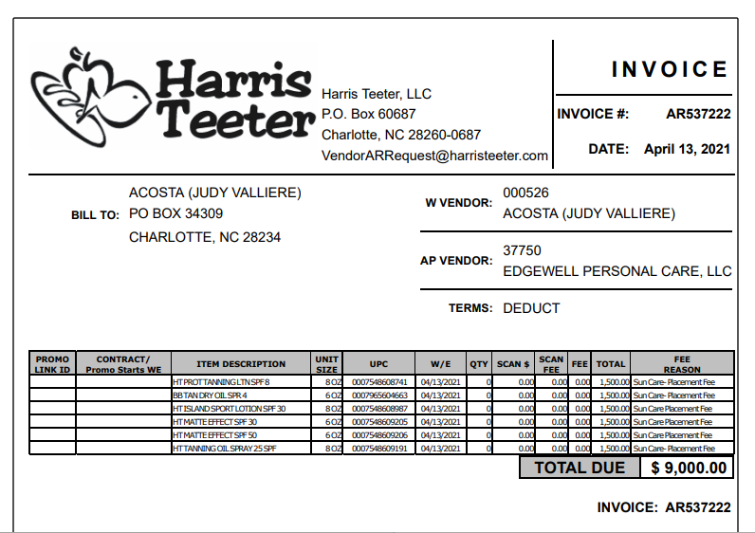
UPC Code – The Universal Product Code (UPC) is the last 5 digits of the full product code. This is the product in which the customer is stating that they slotted.

Total: this is the lump sum Slotting allowance which needs to be validated with the customer invoice.

5.3 Customer Contract for Slotting: Example 3 The UPC, Ship date and Slotting rate needs to be matched with client invoice.Contract can be found via "Search For" Promotions or Backup Documentation (Doc Type 17). Signon is HARRCN.
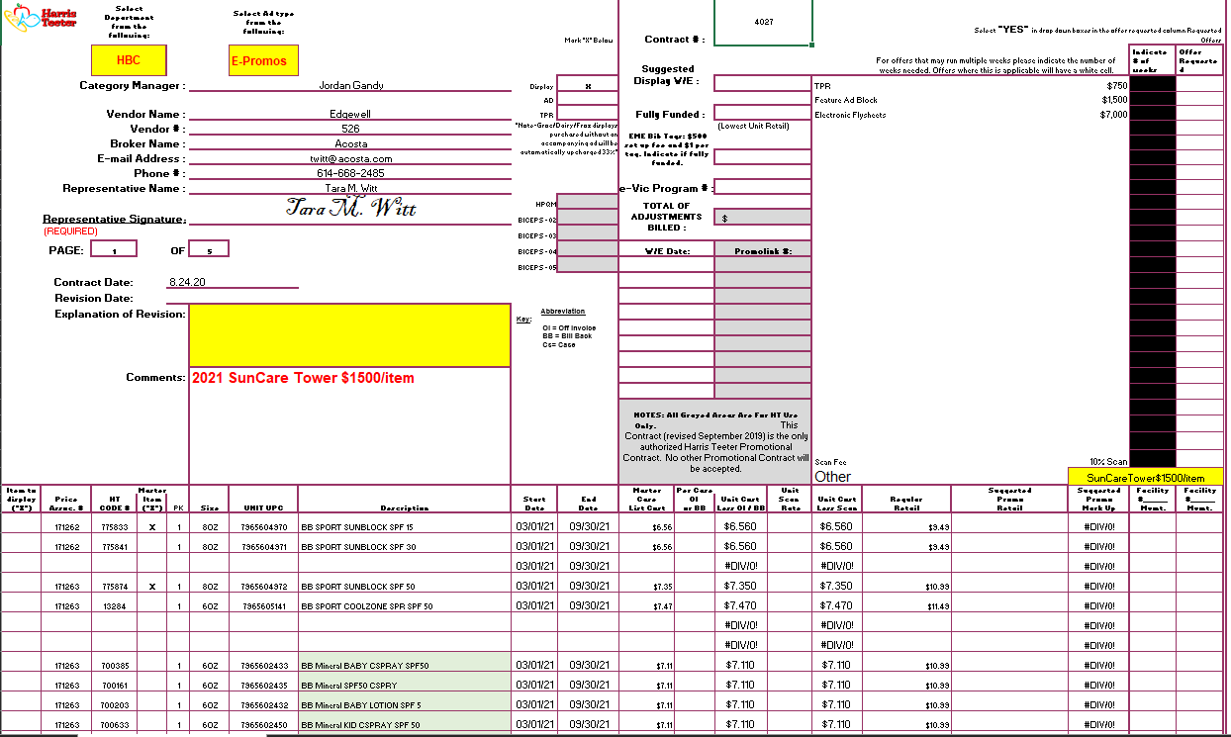
Amounts: this is the lump sum Slotting allowance which needs to be validated with the customer invoice.

5.3 Refer to the SOPs/Generic Help File for POP requirements.

6. Deduction Type: Unsalable- Spoils/ Reclamations
These claims are taken for product that cannot be sold at the stores due to damages and/or short coded
product.

* Use Web access key for customer client combination on CLS (Client Logistics Solutions). Acosta
associate will need to pull the invoice from CLS web site.

6.1 Customer Invoice for Unsalable, Example 1: Listed below is an example of cutomer invoice for unsaleable deduction.

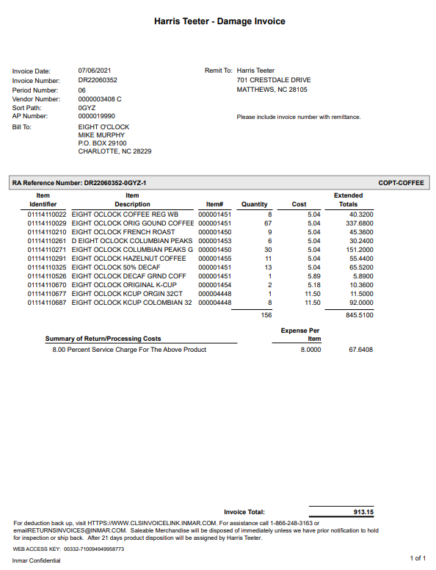
UPC Code/Item Identifier – The Universal Product Code (UPC) is the last 5 digits of the full product code. This is the product in which the customer is stating that these are unsalable.
Example: In this case the UPC is highlighted in red 01114110022.

Invoice#: This is the customer invoice number. Invoices for this customer that begin with ‘DR’ (Damaged Returns) indicate Spoils/Unsalesables.

Comments: This identifies the deduction type, in this example Damage Invoice means unsaleables.

6.1 Customer Invoice for Unsaleable- Spoils/ Reclamations, Example 2:

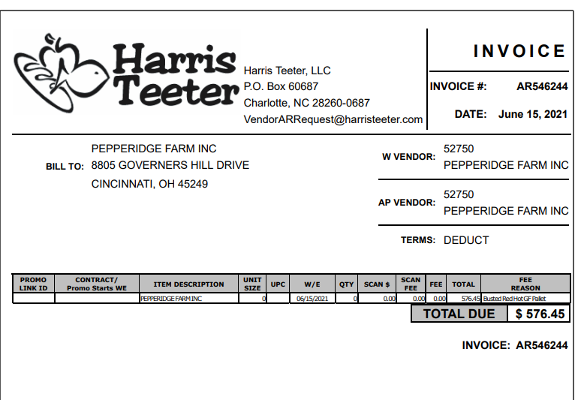
Busted pallet- This indicates that this invoice is for discontinued product or unsaleables.

6.1 Customer Invoice Damages, Example 3:
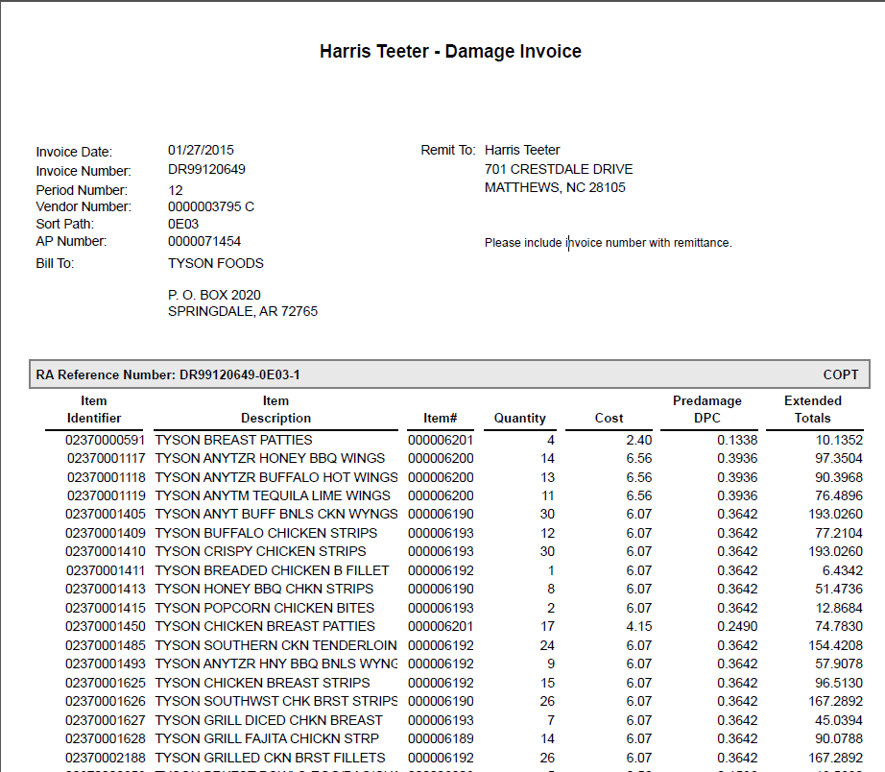
This will be the Rate 1 on the DBW.

This will be the Rate 2 on the DBW.

Invoice#: This is the customer invoice number. Invoices for this customer that begin with ‘DR’ (Damaged Returns) indicate Spoils/Unsalesables.

Comments: This identifies the deduction type, in this example Damage Invoice means unsaleables.
UPC Code – The Universal Product Code (UPC) is the last 5 digits of the full product code. This is the product in which the customer is stating that these are unsalable.
Example: In this case the UPC is highlighted in red 02370000591.

7. Deduction Type: Display
These are customer claims for an in-store product display on an end cap or displayed as per the client's requirements.

7.1 Customer Invoice for Display, Example 1
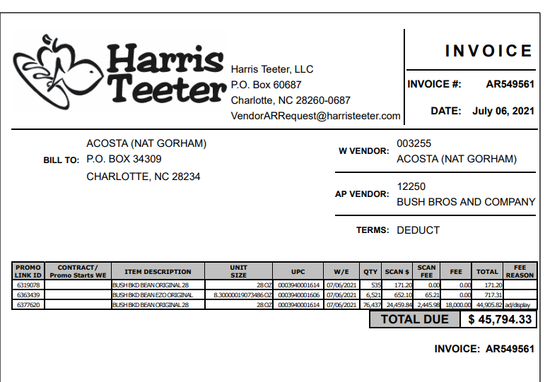
UPC: This needs to match the UPC provided on the contract.

FEE- Harris Teeter is only billing for the AD/Display if there is an amount in the FEE Column.
FEE REASON: The Fee Reason of AD//Display means this portion of the invoice is for a display.

Fee Reason: This provides the description of the deduction type for the ‘Fee’ column. In this case the customer is billing $6,500 for a Display.

7.1 Customer Contract for Display, Example 1:
Contract can be found via "Search For" Promotions or Backup Documentation (Doc Type 17). Signon HARRCN.
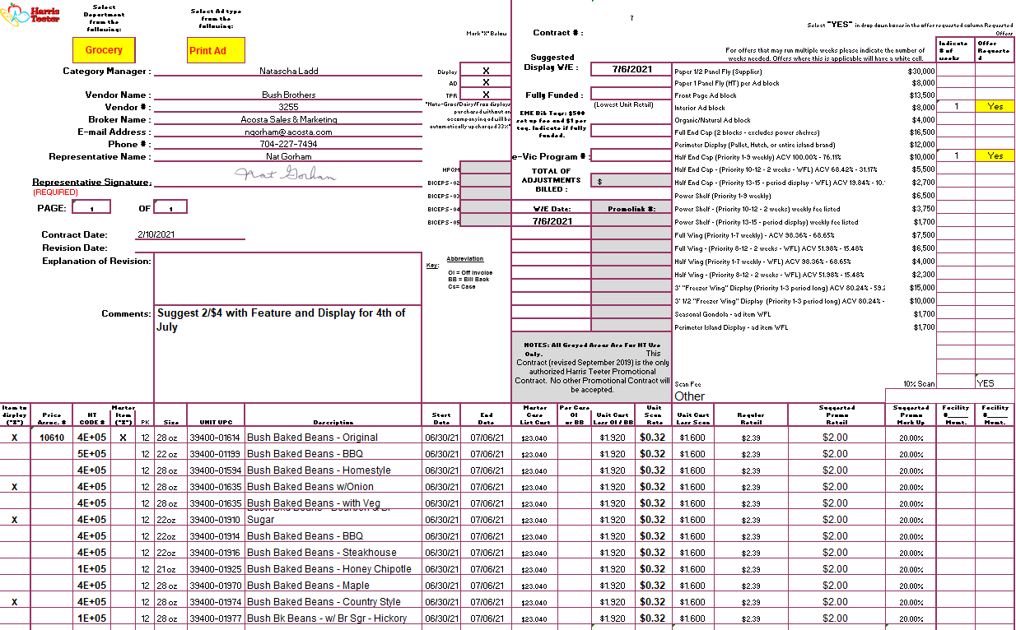

7.4 Invoice for Display, Example 4:

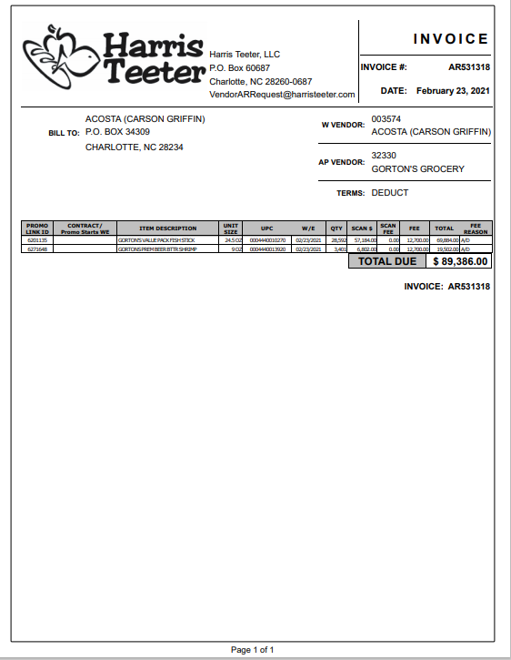
FEE REASON: The Fee Reason of AD is another term Harris Teeter uses to describe a display. Compare information to the contract.
FEE: this is the lump sum display allowance which the customer should claim for and should match the customer invoice.

7.5 Invoice for Display, Example 5:

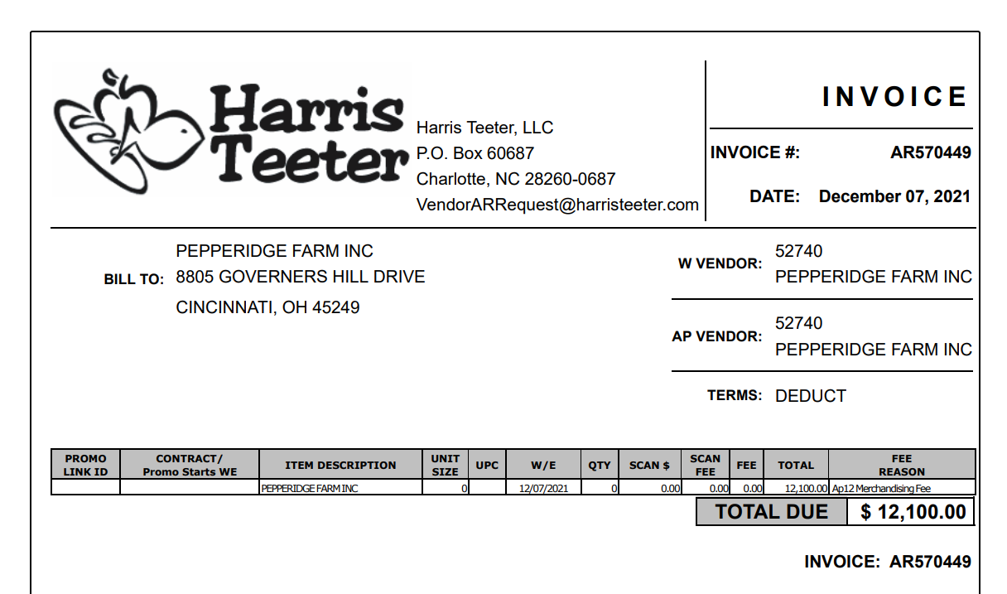
FEE REASON: The Fee Reason of Merchandising Fee indicates that this invoice is for Display.
7.5 Invoice for Display, Example 6:
FEE REASON: The Fee Reason of Merch Funds indicates that this invoice is for Display.

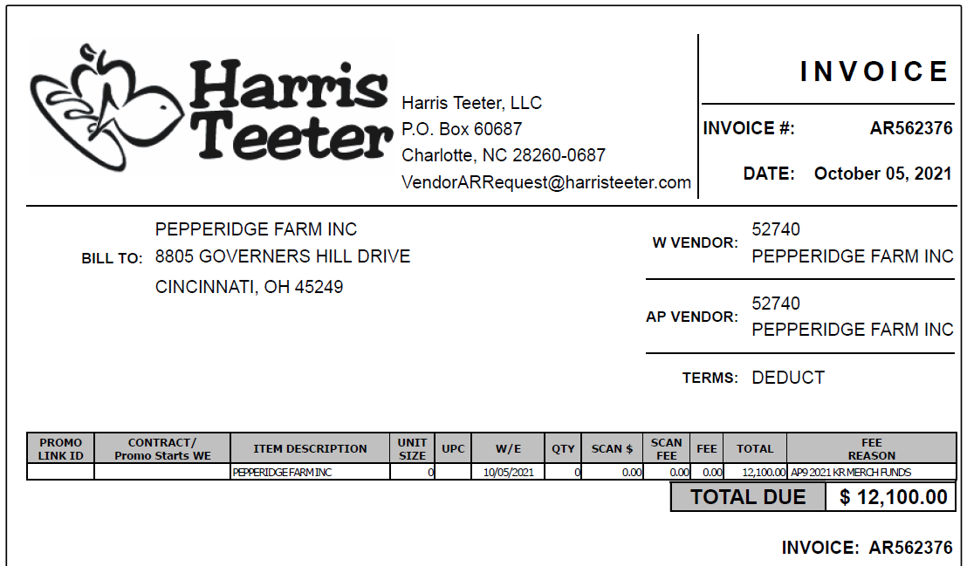

7.4 Customer Contract for Display:
Contract can be found via "Search For" Promotions or Backup Documentation (Doc Type 17). Signon is HARRCN.

Amount: this is the lump sum display allowance which the customer should claim for and should match the customer invoice.

Performance Date: the start and end date of the allowance which the Week Ending date of the customer invoice should fall within to validate the claim.
UPC: This indicates the product that is claimed by customer as displayed during the mentioned period. This needs to match the customer invoice to validate.

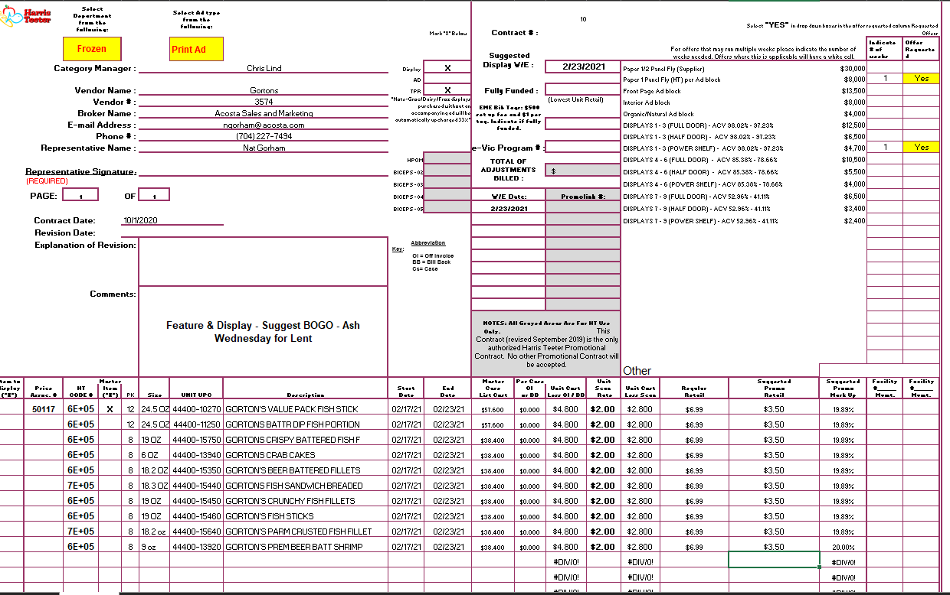

7.4 Customer Contract for Display, Example 5:

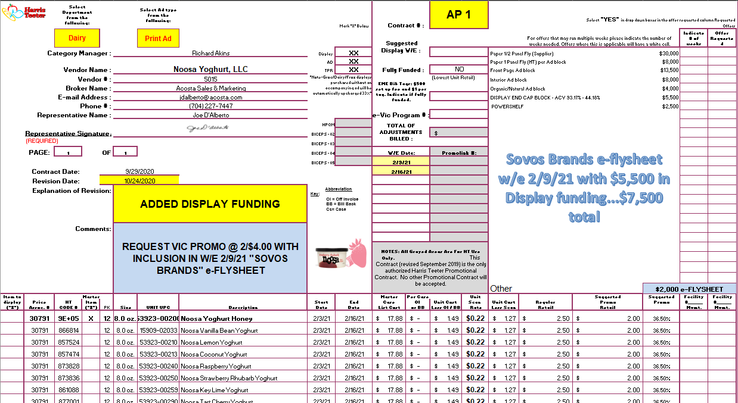

7.4 Customer contract for Display Example 7:
This note indicates that the deal is for 4th Qtr 2012 Merchandising and Display.

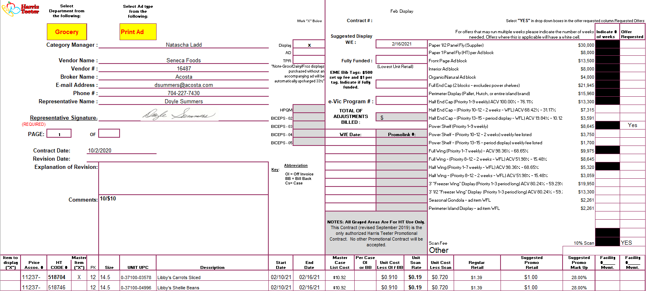
The boxes shown on the right side of the contracts are for types of Displays. If the Dollar amount from the Customer Invoice Fee is listed in one of these boxes, the Fee is for a Display.

7.3 Refer to the SOPs/Generic Help File for POP requirements.

8. Deduction Type: Shortage
These claims are for short shipment on an order that was billed by the client for customer.
Documents required for validating a Shortage claim

Document Name | Source of the Document | Action by Accenture
Customer Invoice | ACOSTA Relay – search for the invoice under Backup Documentation, document type 2. | Step up the claim to Acosta for research
Client Order Invoice | ACOSTA Relay – search for this document within the Order/Invoice/PO search.

8.1 Customer Invoice for Shortage, Example 1:

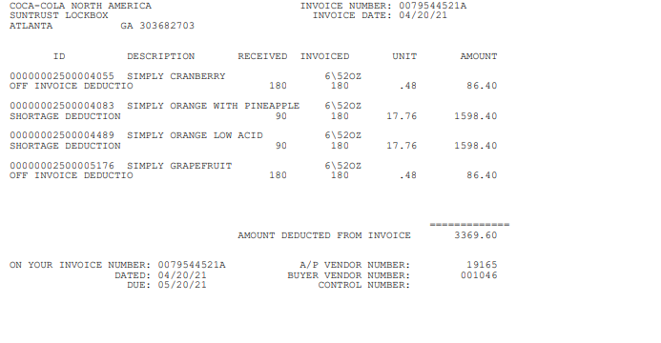
Shortage Deduction: indicates this is a shortage claim.
Invoice #: Used to search for the customer invoice in ACOSTA Relay. Drop the “A” when searching.
Use this invoice number to search for the Client Order Invoice within ACOSTA Relay.
Quantity – Refers to the count of items shorted at the time of delivery.
UPC Code – The Universal Product Code (UPC) is the last 5 digits of the full product code. This is the product in which the customer is stating there are Shortages.
.

8.1 Customer Invoice for Shortage, Example 2:

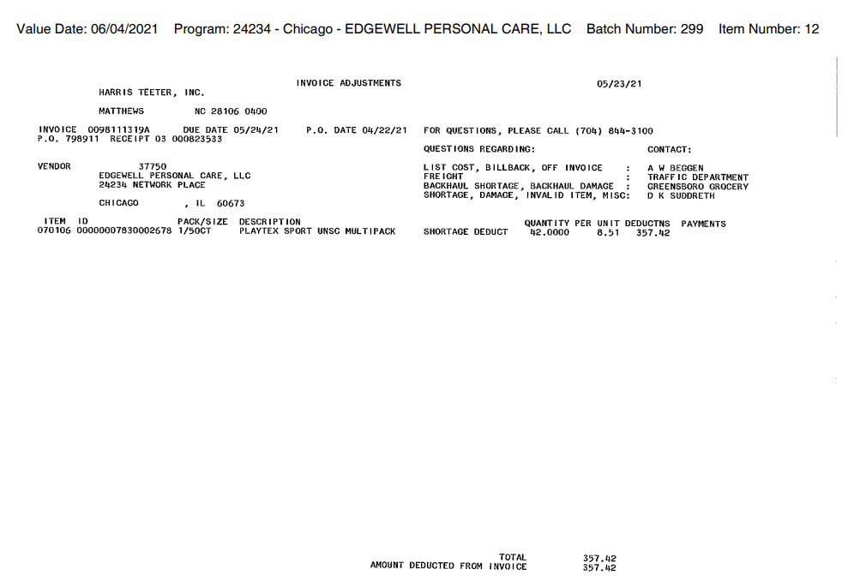

9. Deduction Type: Markdowns

These are an offer to reduce the shelf price of the product. Usually offered to aid in selling slow moving or
discontinued items.

9.1 Customer Invoice for Markdowns, Example 1 (Trade):

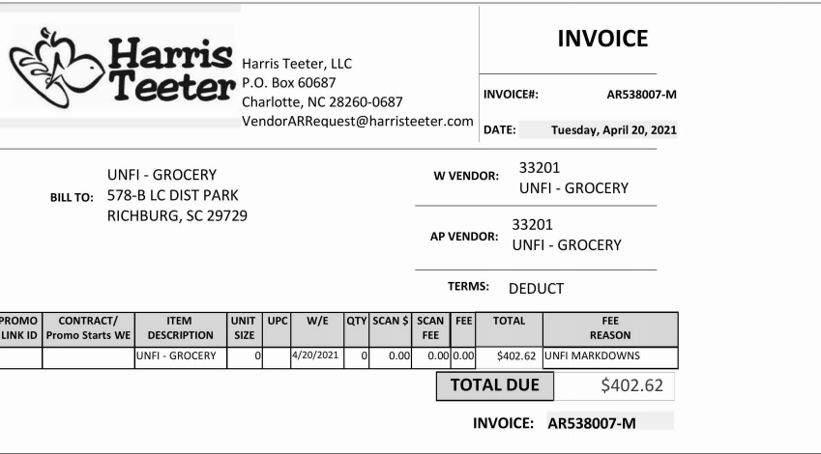
Week Ending: This is the performance date for this customer invoice.
”FEE REASON: indicates that this is a discontinued item (aka. Markdown).
Invoice #: Used to search for the customer invoice in ACOSTA Relay.
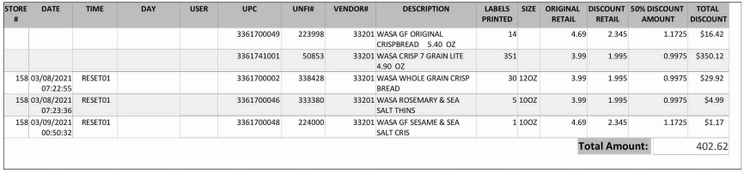
UPC Code – The Universal Product Code (UPC) is the last 5 digits of the full product code.
This is the product in which the customer is stating that there is a Markdown allowance.
Ex: - In this case the UPC is the one highlighted in red 3361700049

9.2 Customer Invoice for Markdown, Example 2:
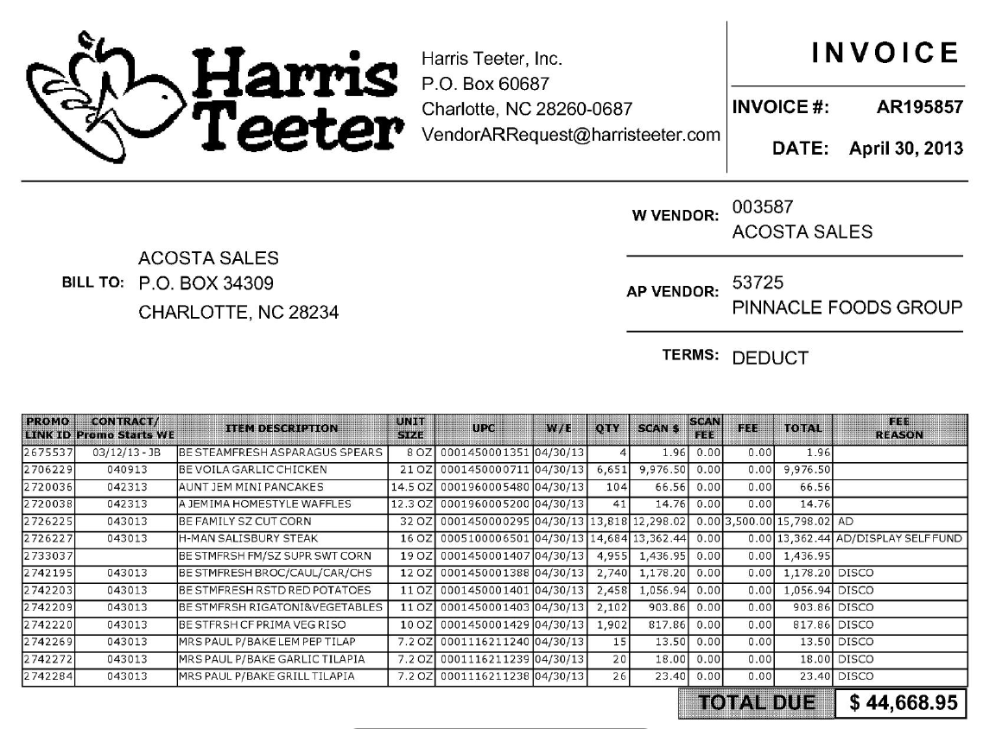
The word DISCO in the Fee Reason column indicates that these items were discounted and marked down to get rid of the product.

9.2 Contract for Markdown, Example 1:

The customer invoice may not give an indication that an item is for markdowns. If a contract is located that indicates the item is for Clearance, Discontinued, or Deletion(s), the items are for markdowns. Review the Client SOP/Matrix and/or Client specific section of this SOP for markdown Client specific processes for markdowns.

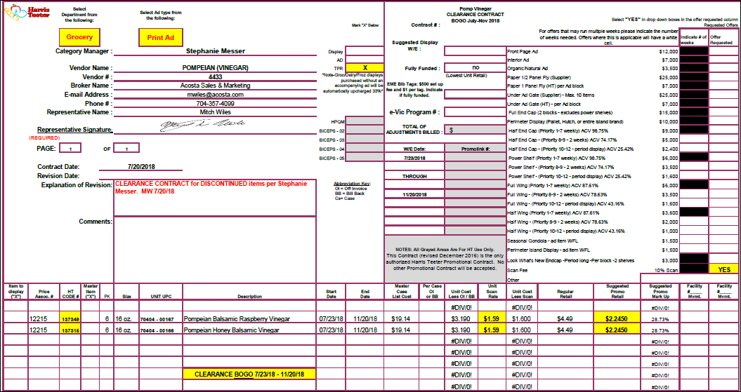

Clearance or Discontinued: This indicates that the contract is for markdown items.

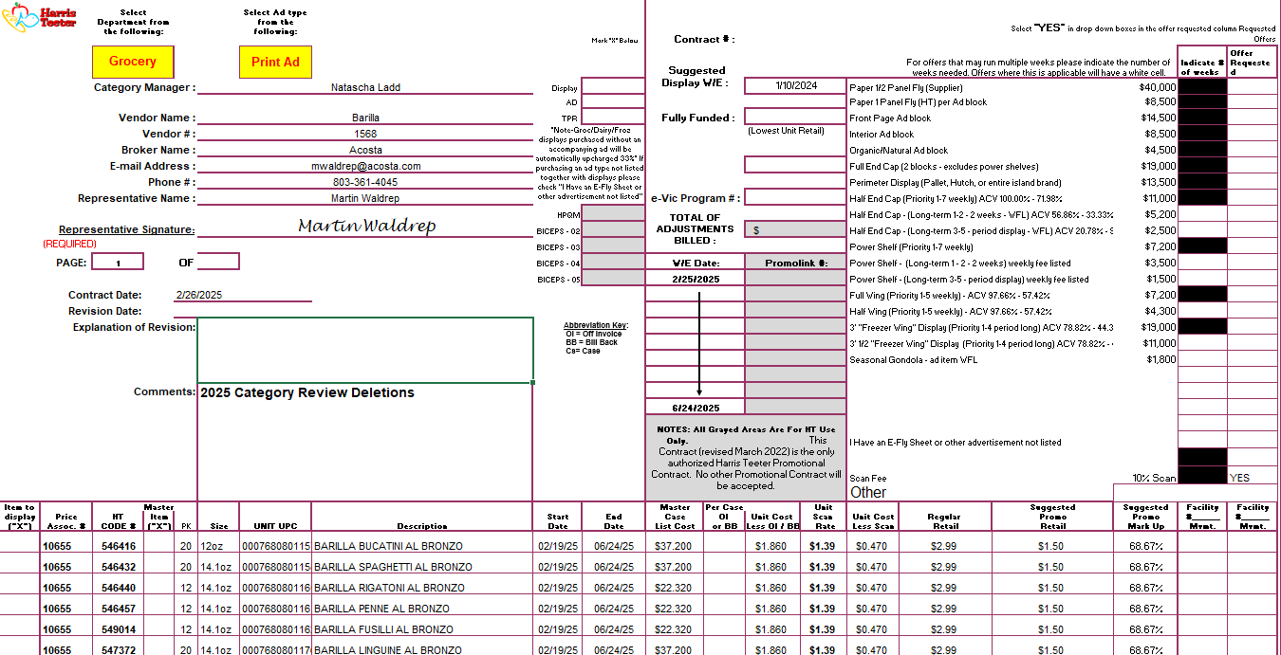
Deletions: This indicates that the contract is for markdown items.
9.3 Customer Invoice for Markdowns, Example 3 (Non-Trade):

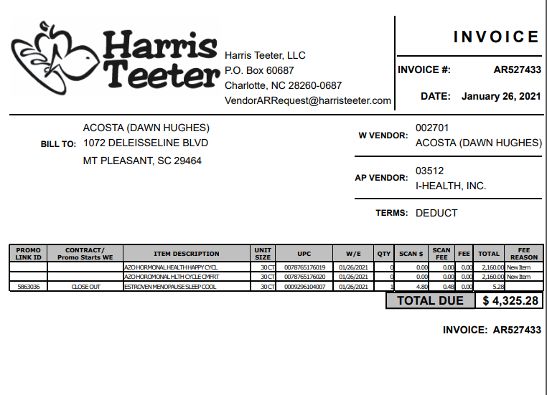
Closeout:: This indicates that the product is for markdown.

Customer Invoice for Markdowns, Example 4:

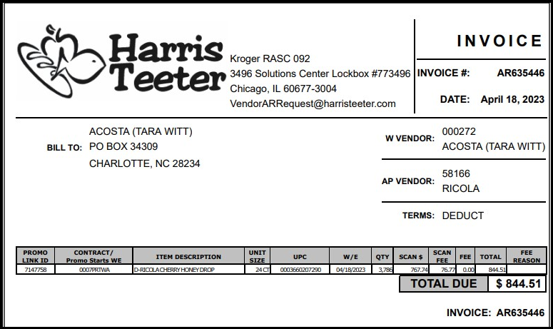
“D” in front of the description indicates this is for Markdown.

10. Deduction Type: Post Audit

NOTE: The post audit claim must first be researched to ensure the customer has not already billed for the allowance before the normal validation process can begin.

Once the post audit claim has been researched to ensure the customer has not already billed for the allowance refer to the appropriate allowance section of the SOP to continue with validation. If the post audit is for an allowance not defined in an allowance section of the SOP refer to the post audit example for validation information.

Internal/external auditors find claims that the customer is entitled to but did not take from previous years. Post Audits should be researched in the same manner as other claims by accessing previous year’s files.

10.1 Customer Invoice for Post Audit, Example 1:

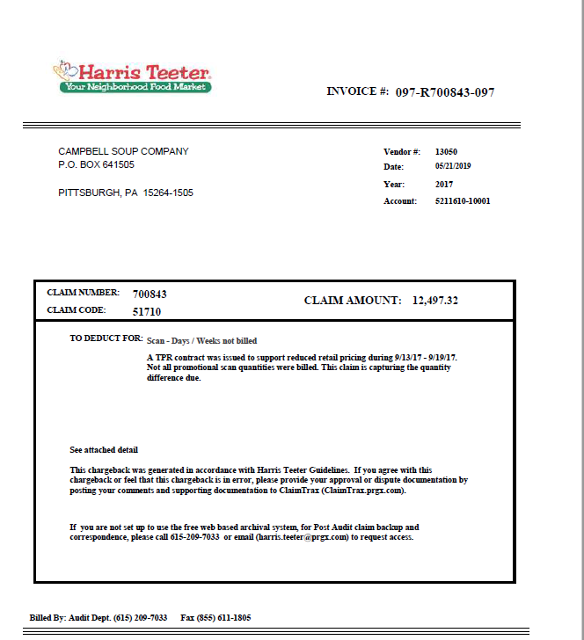
Claim amount – Deduction amount that customer has deducted for this invoice.
”097” indicates this is a Post Audit deduction.
Invoice #: Used to search for the customer invoice in ACOSTA Relay.
11. Deduction Type: Fees/Penalty
A cost assessed by the customer for various reasons, including: handling, administrative, service and scan 9933749s.

Documents required for validating an Fees/Penalties Deduction:

Document Name | Source of the Document | Action by Accenture
Customer Invoice | ACOSTA Relay – search for the invoice under Backup Documentation, document type 2. | Step up the claim to Acosta for research
Client Order Invoice | ACOSTA Relay – search for this document within the Order/Invoice/PO search.

11.1 Customer Invoice for Fees, Example 1:

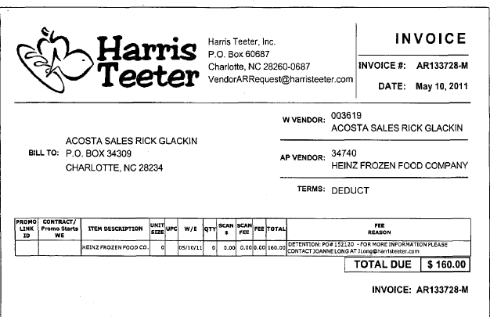
Invoice #: Used to search for the customer invoice in ACOSTA Relay.
Detention – This describes that the invoice is for a penalty fee. Once identified as a penalty fee, the PO should be linked if that information is given and the claim needs to be stepped-up to Acosta.

11.1 Customer Invoice for Fees, Example 2:
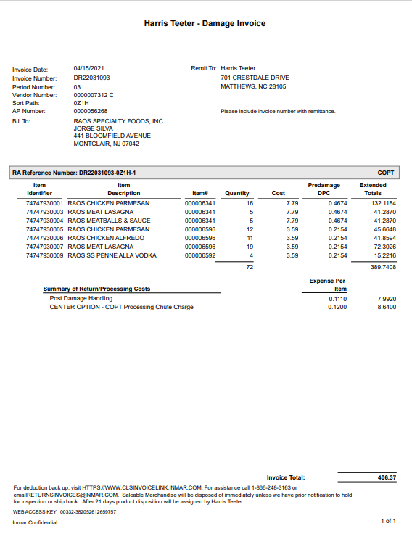

11.1 Customer Invoice for Fees, Example 3:

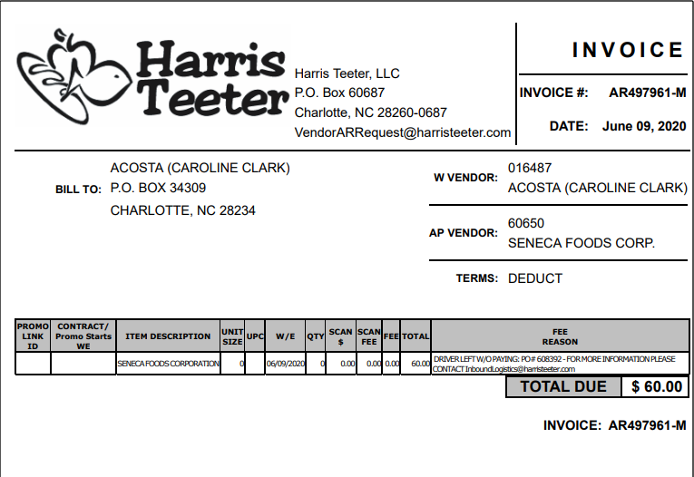

11.1 Customer Invoice for Fees (Booth Fee), Example 4:

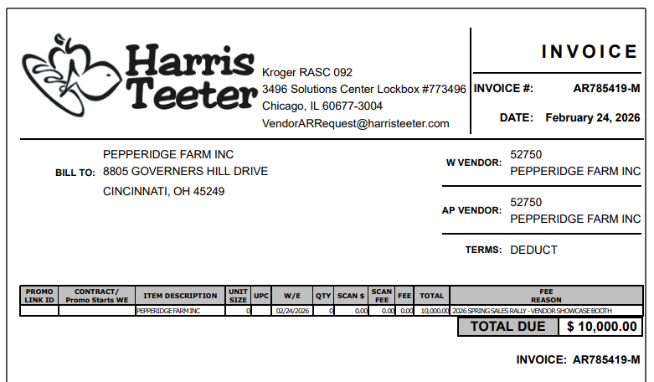

- Deduction Type: TPR

A TPR (Temporary Price Reduction) allowance is offered to the customer to reduce the retail price for shelf tags,
offered to the customer as a lump sum.

12.1 Customer Invoice for TPR, Example 1:
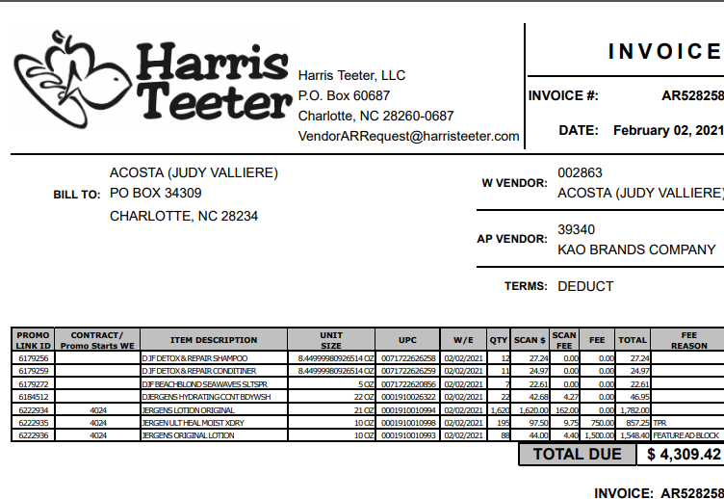
Fee Reason:The Fee Reason says “TPR” fee for $750.

12.1 Customer Contract for TPR, Example 1:
Contract can be found via "Search For" Promotions or Backup Documentation (Doc Type 17). Signon is HARRCN.
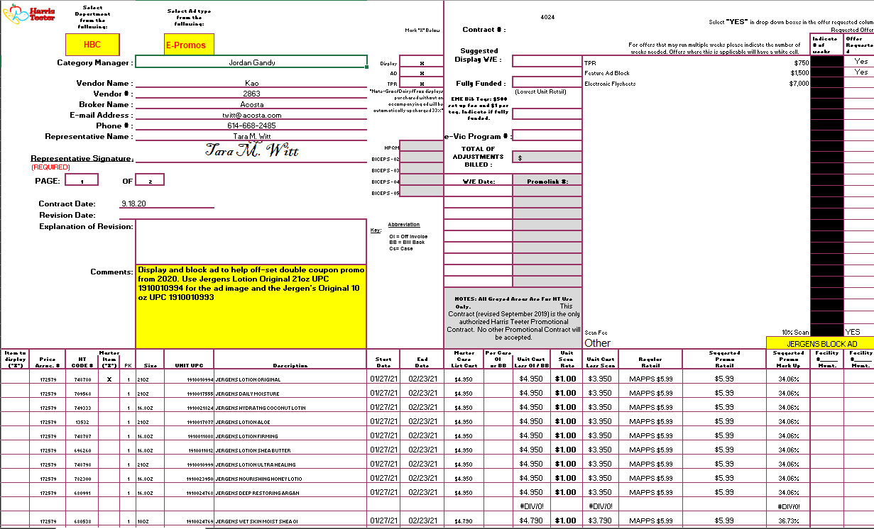
Allowance Amount: This is the TPR allowance amount that should match with the customer invoice allowance amount to validate the claim.

Allowance date: This is start and end date of the allowance for the product. The performance (Week Ending) date on the customer invoice should fall within these dates.
UPC: This product should match with the customer invoice for the TPR fee.

12.3 Refer to the SOPs/Generic Help File for POP requirements

13 Deduction Type: Freight / Back Haul:
A Freight allowance is given to the customer for picking up the product via their own transportation services.

Documents required for validating an Off Invoice claim:

Document Name | Source of the Document | Action by Accenture
Customer Invoice | ACOSTA Relay – search for the invoice under Backup Documentation, document type 2. | Step up the claim to Acosta for research
Client Order Invoice | ACOSTA Relay – search for this document within the Order/Invoice/PO search.

Client Backhaul Rates / Policy for Freight: Client policy will indicate whether or not Freight rates are available. Freight allowance is provided only in case the customer has agreed to pick-up the goods on their own (Back Haul). Customer Order/ Client Invoice needs to be referred to check the provision made for freight allowance. The Client policy on Freight allowance plays the role of a contract.

13.1 Customer Invoice for Freight, Example 1:

PO Number – This will be used to search for information regarding the order within ACOSTA Relay.
Eg: - In this case the PO # is 125899.

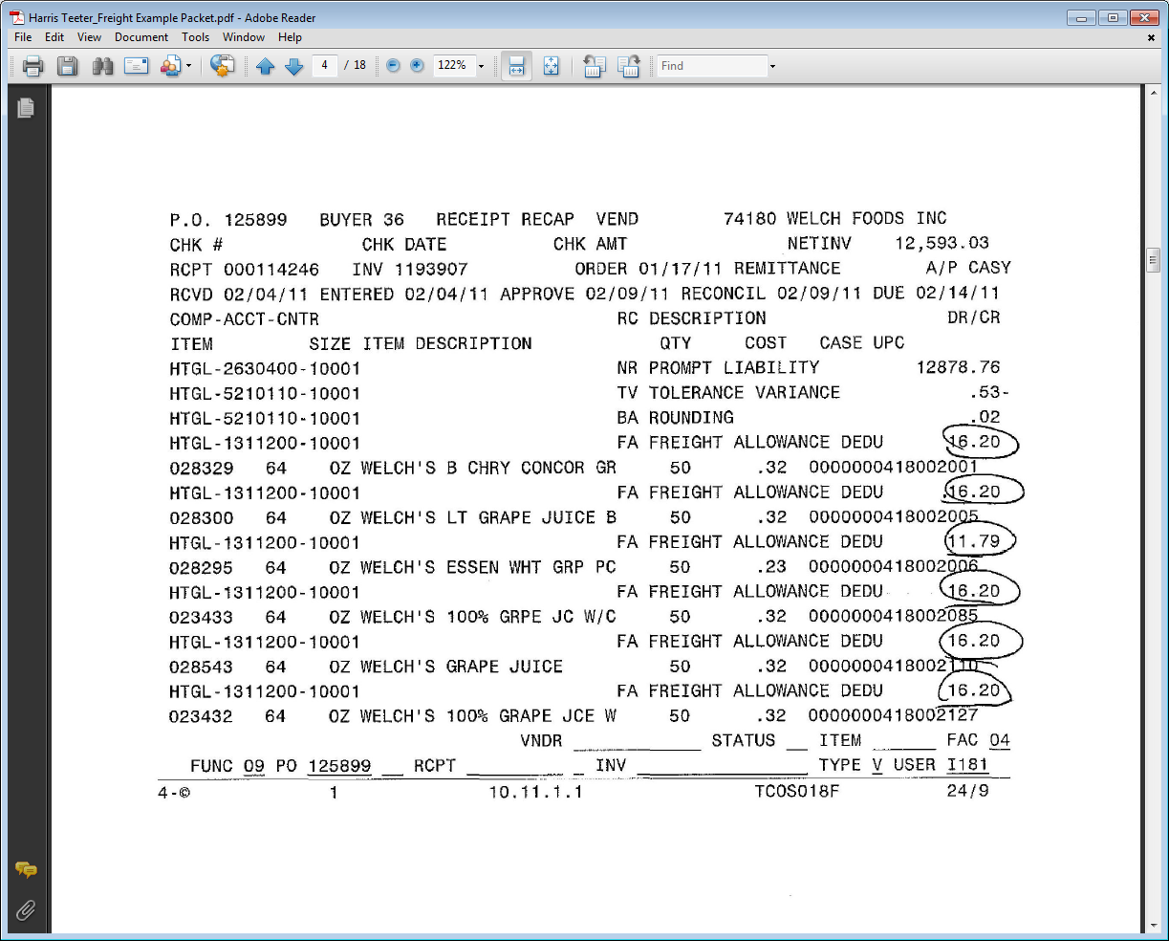
This indicates that the deduction is for freight.

13.1 Customer Invoice for Freight, Example 2:
Invoice #: Used to search for the customer invoice in ACOSTA Relay.
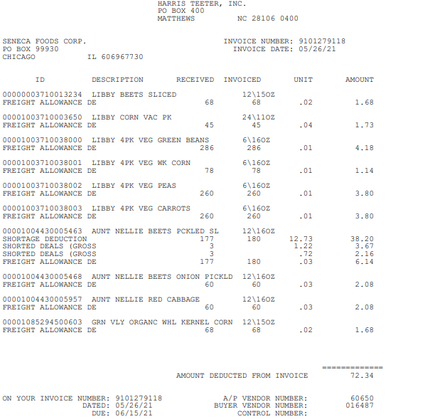
Deduction Amount: taken for freight.

This indicates that the deduction is for freight.

14 Deduction Type: Ad
An Ad is a fee for featuring client's products in an advertisement.

14.1 Customer Invoice for Ad, Example 1:
Validate the UPC, Customer Invoice number, deduction Amount and Performance period.

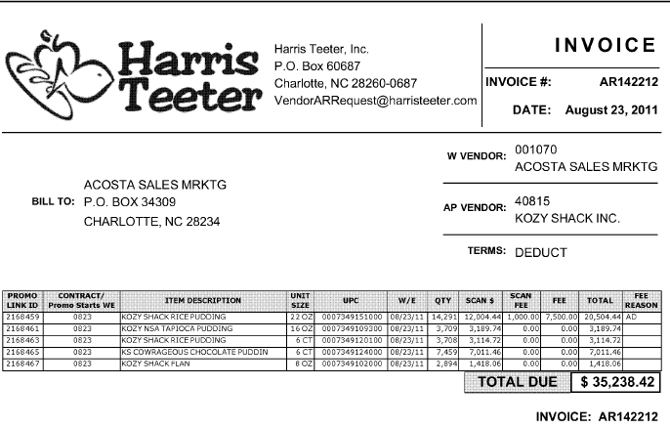
Invoice #: Used to search for the customer invoice in ACOSTA Relay.
Fee Reason: This provides the reason for the amount found in the “Fee” column. In this case the $7,500 is for an Ad.

Deduction Fee – This is the amount claimed by customer as part of Ad deduction. This needs to be verified with the contract.
Performance Date – This date needs to be verified with the Customer contract & the Ad header.
Item Description – This product needs to be matched with the product listed in the contract & also it needs to be available in the ad.

UPC Code – The Universal Product Code (UPC). In this case it is considered after the first 3 zeros. This code needs to be validated on Customer contract.
E.g.: - The UPC is the one highlighted in red 0007349151000.

Note: Harris Teeter can put "Ad" as a fee reason under both items on the invoice, but reflect ad fee only under one of them. In that case, any of those items can feature in the ad, not only the one that reflects the fee on the invoice.

14.1 Customer Contract for Ad, Example 1:
Contract can be found via "Search For" Promotions or Backup Documentation (Doc Type 17). Signon is HARRCN.

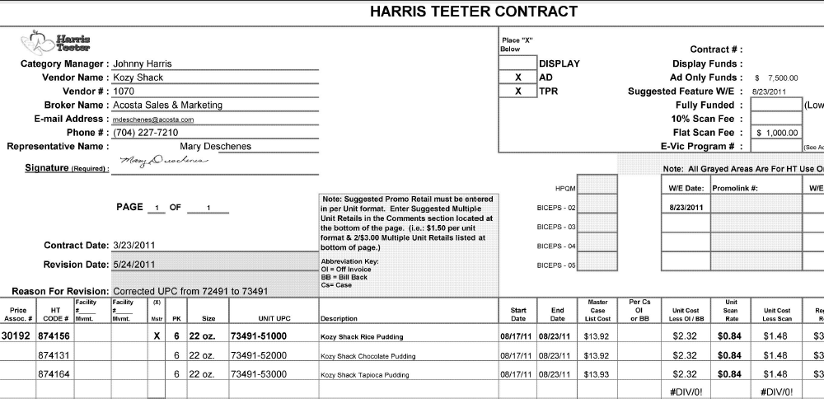
Performance Start & End dates – This needs to be compared with the Week Ending date mentioned on the customer invoice.
Item Description – This product needs to be matched with the product listed in the customer invoice & also needs to be available in the ad.

Ad only Funds: This indicates the total deduction amount for this ad, which needs to be validated with the amount found in the “Fee” column.
UPC Code – The Universal Product Code (UPC). This code needs to be validated on Customer Invoice.
E.g.: In this case the UPC is 7349151000.

14.1 Customer Invoice for Ad, Example 2:
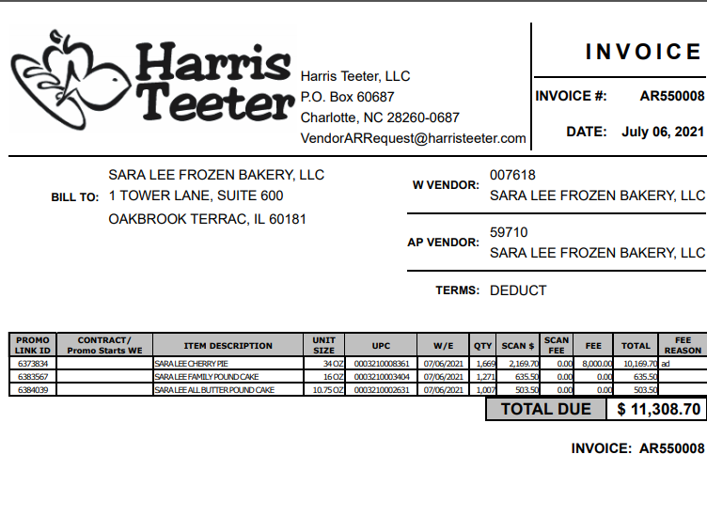
FEE REASON: The Fee Reason of AD and should match to contract.

14.1 Customer Contract for Ad, Example 5:
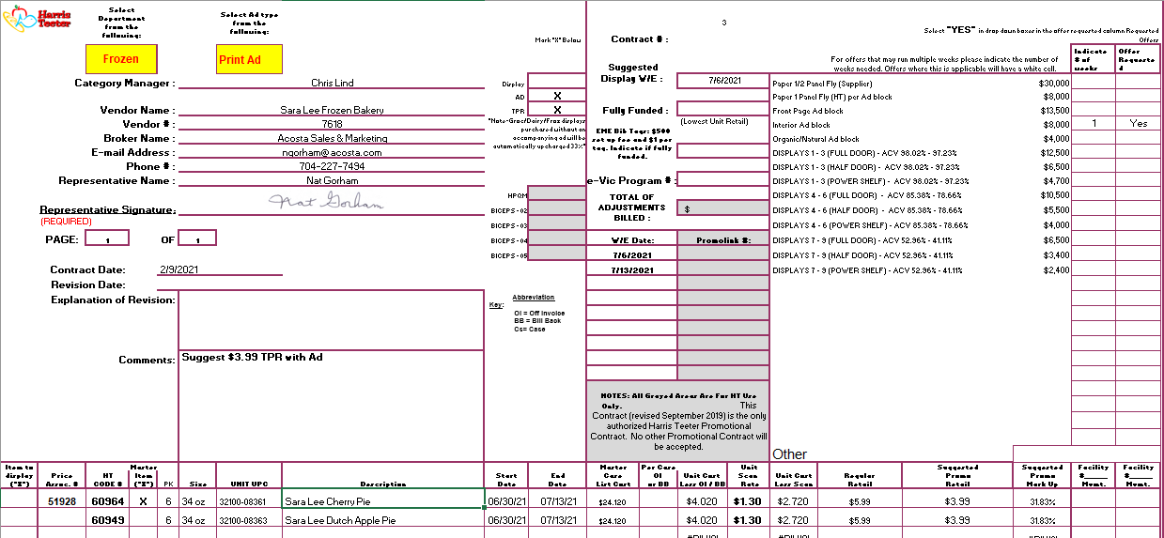
Total $ Amount for Ad is $8000.00

14.1 Cutomer Invoice for Ad, Example 6
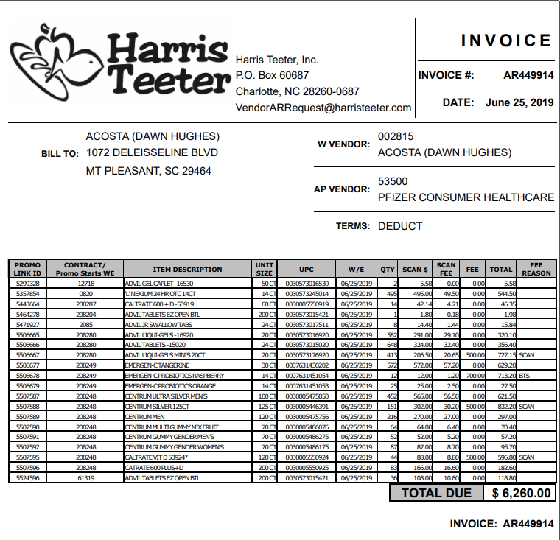
FEE REASON: The Fee Reason of BTS and should match to contract.

14.1 Customer Contract for AD Example 6:
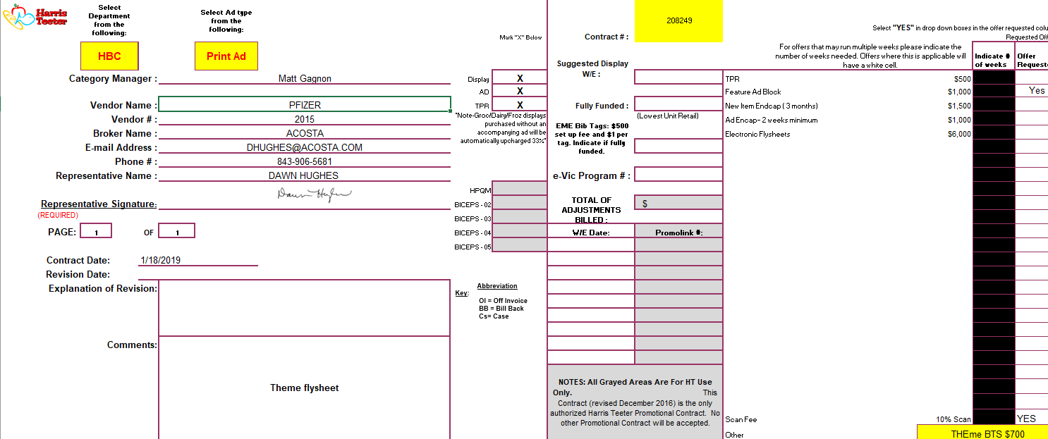
Deduction Fee – This is the amount claimed by customer as part of Ad deduction. This needs to be verified with the invoice.
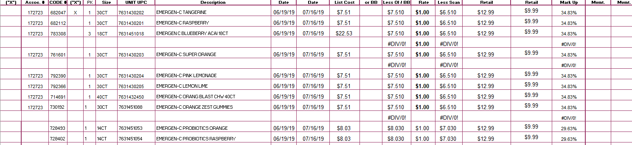
Harris Teeter will sometimes have a Display and Ad on the same line of the customer invoice as in the example below.
Total $ Amount for Ad and Display is $16000.00

14.2 Refer to the Proof of Performance Reporting Ads job aid for searching for ads. Example 1: The ad can be found in Feature Vision or under ADCLIENT/HARRCN in ACOSTA Relay.

15 Deduction Type: Coupon
This is a manufacturer Coupon, typically cleared by client.

Documents required for validating a Coupon
Document Name | Source of the Document | Action by Accenture
Customer Invoice | ACOSTA Relay – search for the invoice under Backup Documentation, document type 2 | Step up the claim to Acosta for research

15.1 Customer Invoice for Coupon, Example 1:

This is the customer reference number used to search for the customer invoice within ACOSTA Relay.

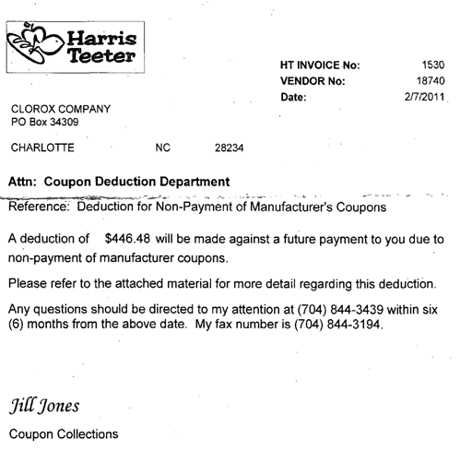
Deduction amount
This confirms that the customer invoiced for coupons.

15.1 Check Remit for Coupon, Example 2:

Harris Teeter Coupon Deductions - Harris Teeter sends all backup for coupon deductions directly to the client. Harris Teeter will not send any additional copies except to the client. When a deduction comes over for a coupon billing, notify the client the back up is sent to them and HT will not send us any additional copies.

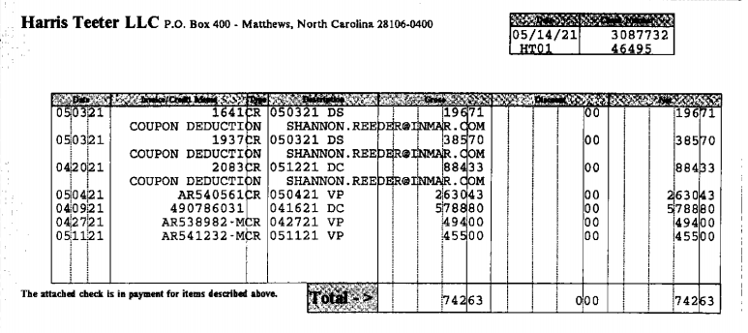

15.1 Customer Invoice for Coupon, Example 3:

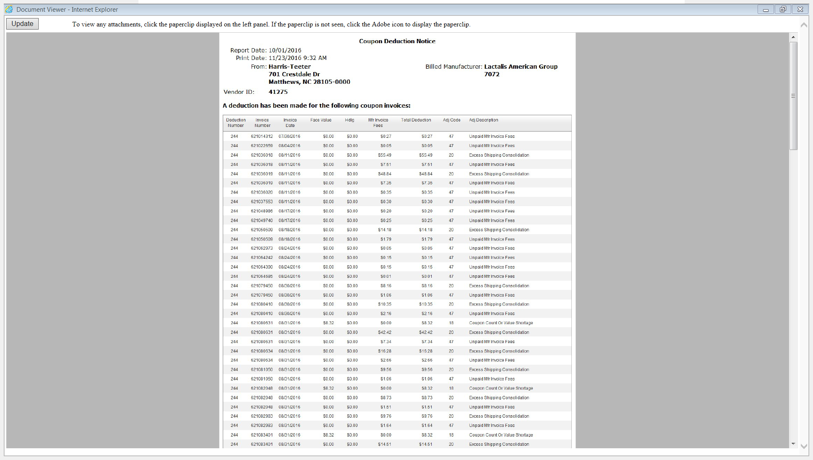
This confirms that the customer invoiced for coupons.

The invoice does not reflect the invoice number that is referenced on the check, the only way to match to the claim header is by dollar amount and the report date will match the date listed on the check remittance. You can identify these invoices they all begin with 300.

15.1 Customer Invoice for Coupon, Example 4: EXCEL versus PDF copy
Manufacturer Coupon

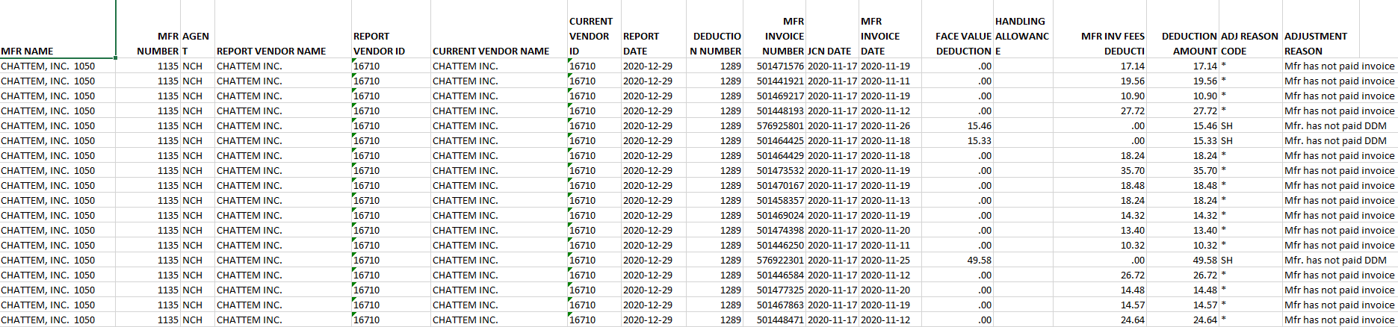

16 Deduction Type: Other

16.1 Vendor Portal Billing Invoice, Example 1:

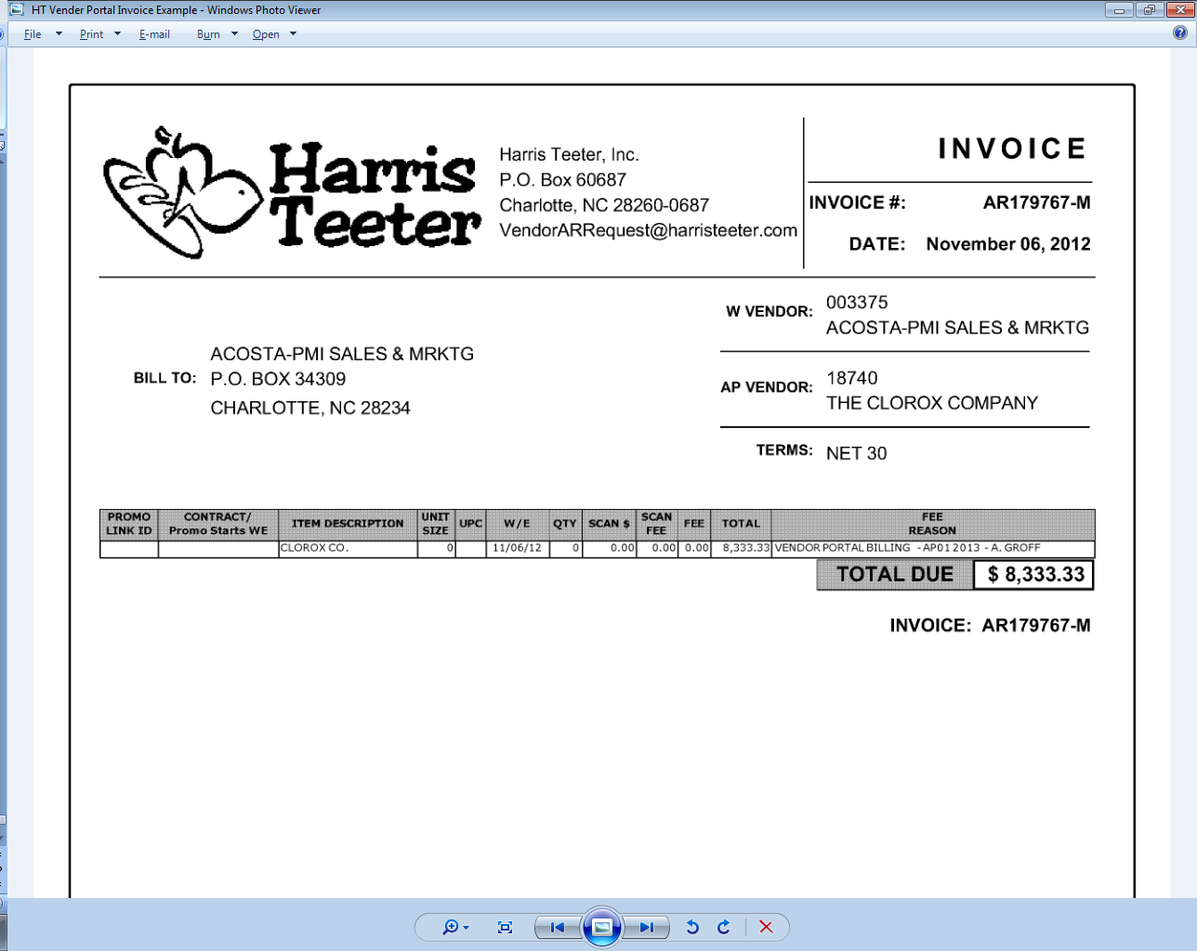
This indicates that this invoice is for Vendor Portal Billing

16.2 Contract for Vendor Portal, Example 1:

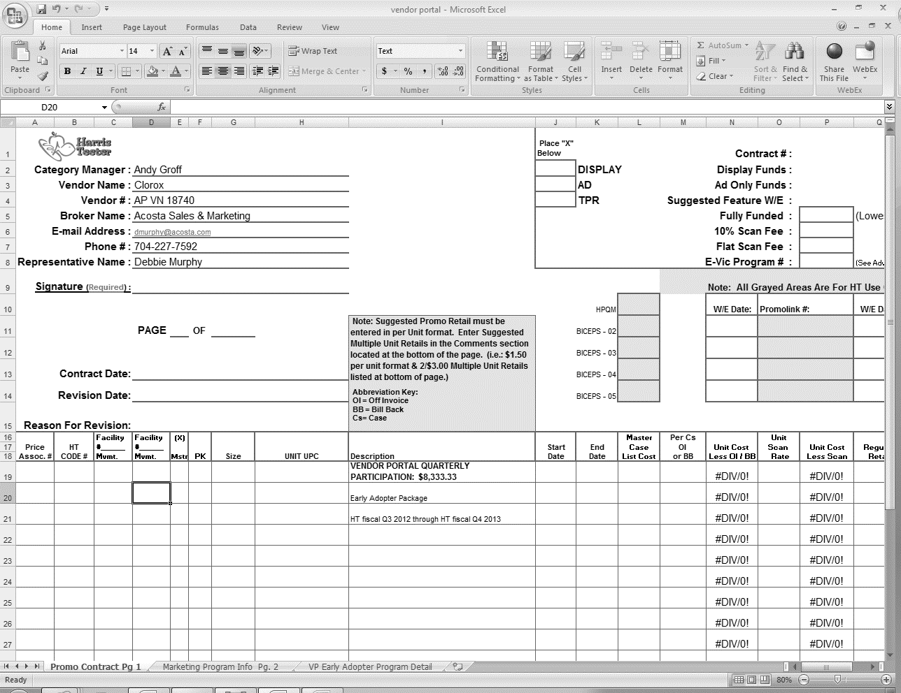
The contract should show the amount of the claim in the description field

NOTE: POP for a Vendor Portal will be email approval from the Client Regional Manager. This will have to be obtained by the ACC.

17 Deduction Type: Other Cash Discount

17.1 Invoice for Other Cash Discount, Example 1:

Harris Teeter will always label a Cash Discount Claim as “Terms Discount” on a Check Remittance. If you see this verbiage, the claim will be Non-Trade/Other and stepped to Acosta for further validation.

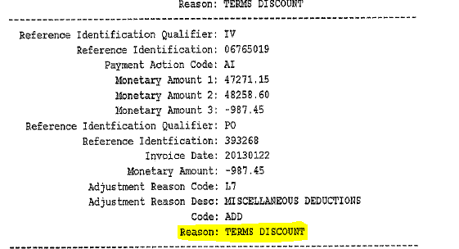

17.1 Invoice for Other Cash Discount, Example 2:

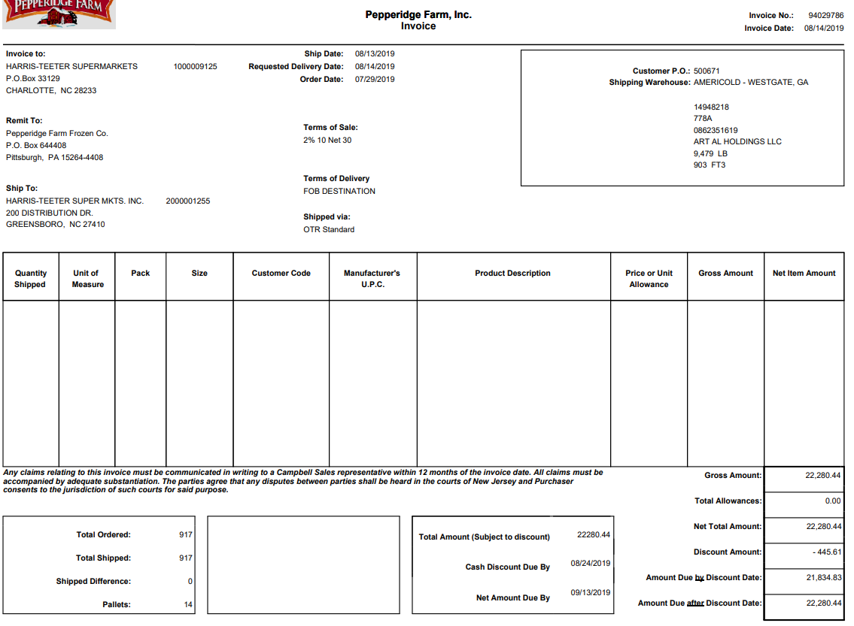
Discount Amount: is the Cash Discount amount the customer is due when they paid for the order. .

18 Deduction Type: Donated Product

18.1 Donated Product Customer Invoice, Example 1: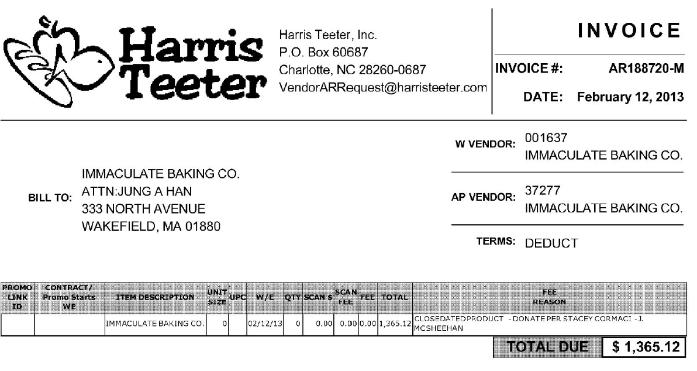

Donated Product or “CLOSEDATED” will be noted in the Fee Reason section. The GCC should step this claim to Acosta for further validation if necessary.

18.1 Customer Invoice for Donated Product Example 2:
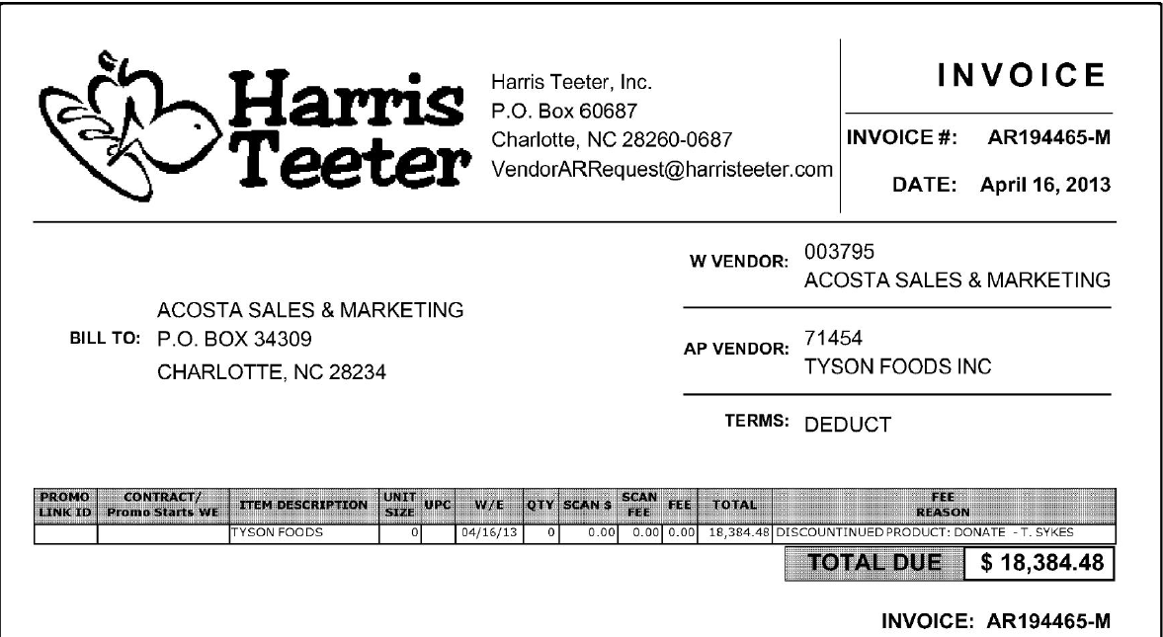
“Donate” will be noted in the Fee Reason section. The GCC should step this claim to Acosta for further validation if necessary.

18.1 Customer Invoice for Donated Product Example 3:

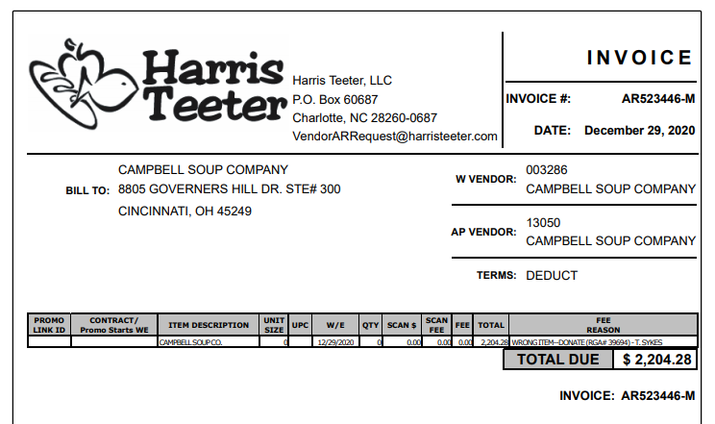
Wrong-Item: “Donate” will be noted in the Fee Reason section. The GCC should step this claim to Acosta for further validation if necessary.

19. Deduction Type: Returns/Recall

19.1 Customer Invoice for Returns, Example 1: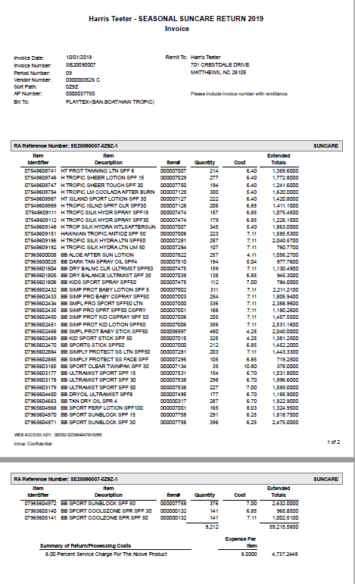
‘Summary of Return/Processing Cost ” indicates the Percent Service Charge for The Above Product.
‘Seasonal Return ” in the header’ field indicates the invoice is for returned product.

20. Deduction Type: Sponsorship Program- Theme Event

20.1 Customer Invoice for Sponsorship, Example 1:
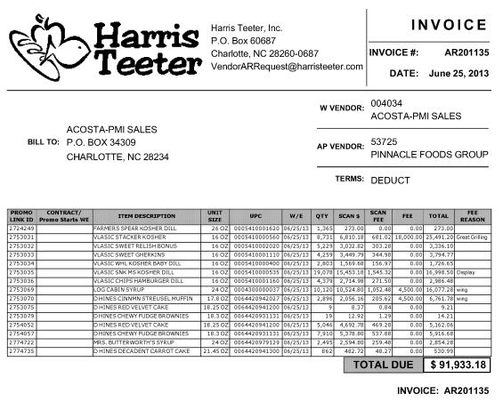
Sponsorship Fee and Details : The Fee amount is $18000.00 and the reason is “Great Grilling”. This does not cleary state that it is for a Sponsorship- we must locate a contract for the $18000 lump sum to see if this is a sponsorship or another deduction type.
The item description listed on the Invoice should be in the same product group as the items listed on the contract.
Client Name

20.2 Contract for Sponsorship, Example 1:
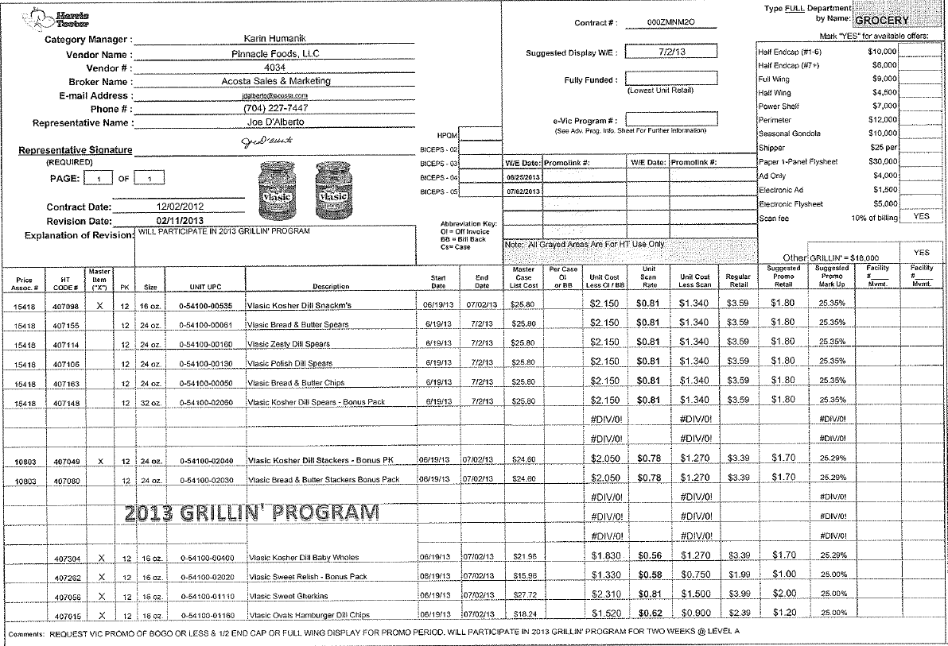
This contract is for $18000.00 “Grillin” This matches the amount and description on the Customer Invoice.
Check the product description to be sure it is the same product group as the Customer Invoice.

This note confirms that the client is going to participate in the 2013 Grilling Program, for 2 weeks at level A...See the Second Page of the contract for more details about Level A

Page # 2 of Contract
This confirms that the contract is for a $18000 Sponsorship.
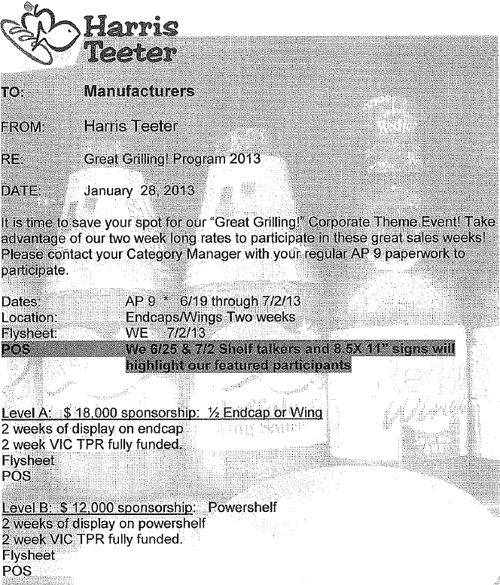

20.3 Refer to the SOPs/Generic Help File for POP requirements.

21. Deduction Type: Other

21.1 Customer Invoice (Bib Tags), Example 1:
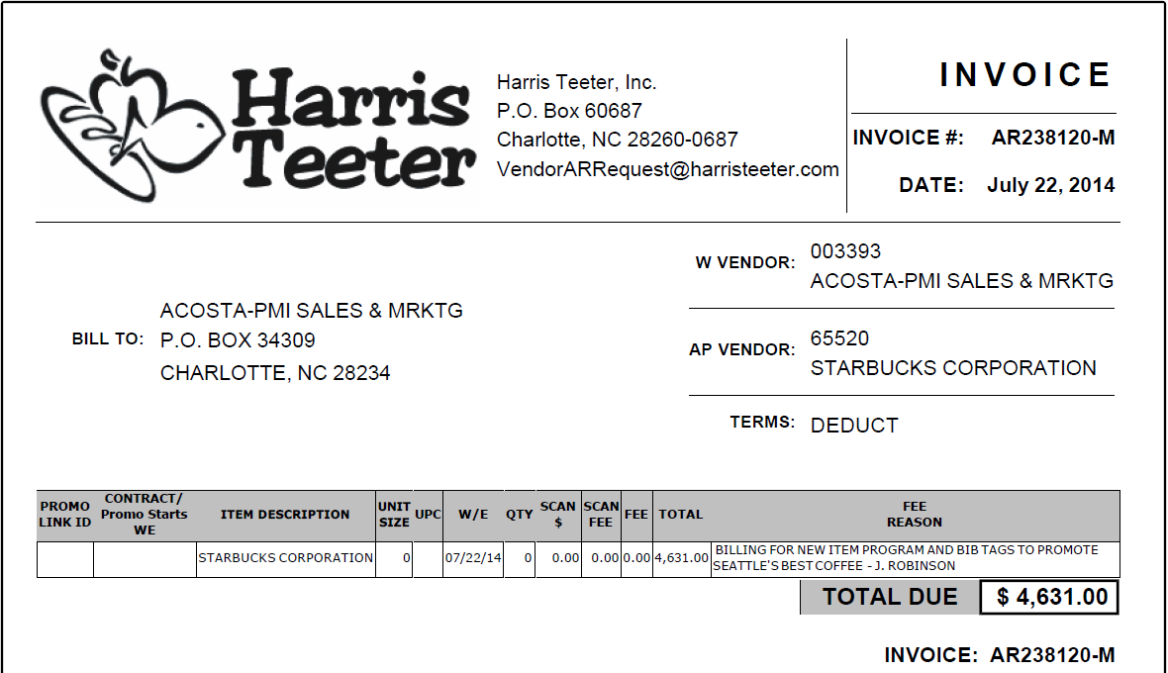
This indicates a portion of the deduction is for Bib Tags
A bib tag is label in the store showing that the customer lowered the price on a prouct to match the AD or an instore sale. This should be coded as Trade-Other

21.2 Customer Contract (Bib Tags), Example 1: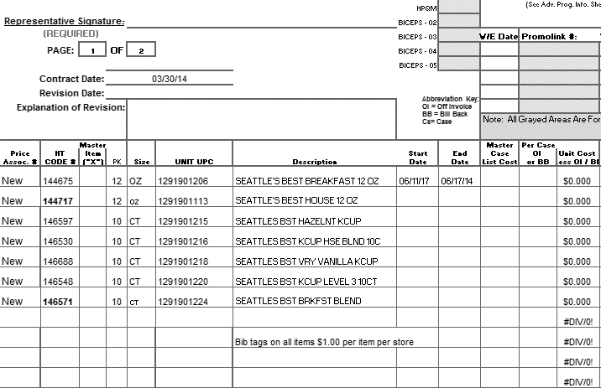
Start and End date

This indicates the amount offered for Bib tags during the start and end date listed on the contract

21.3 POP (Bib Tags), Example 1:
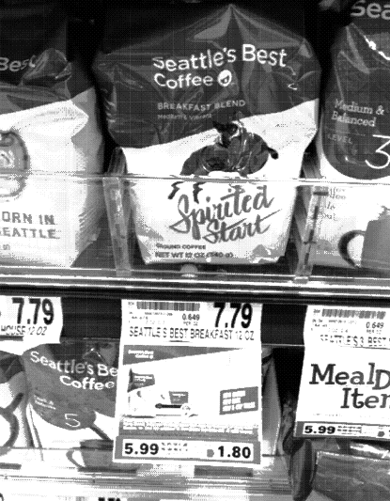

22. Deduction Type: Retail Merchandising Program

22.1 Customer Invoice Retail Merchandising Program, Example 1:

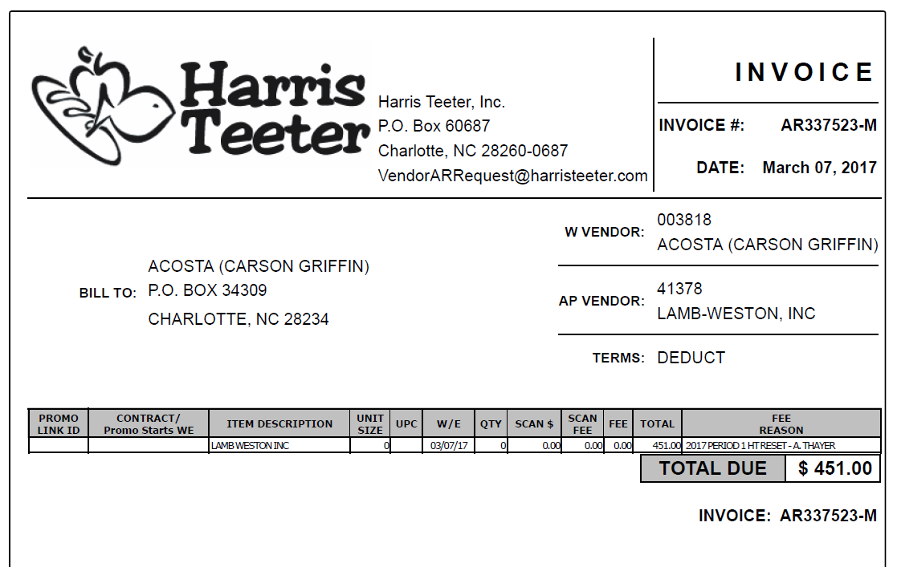
Amount: This is the amount the customer is taking for the retail merchandising program.

Deduction Type: “HT Resets” or “Single Source” indicates the claim is for retail merchandising program.

Single Source “Reset” Policy

22.1 Customer Invoice Retail Merchandising Program Fee, Example 2:

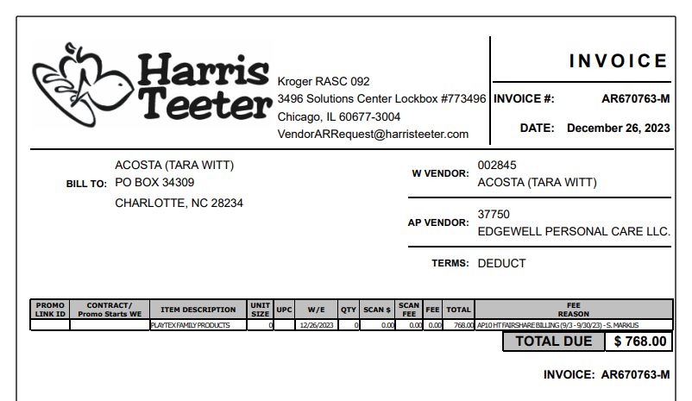
Amount: This is the amount the customer is taking for the retail merchandising program.

Deduction Type: “Fairshare Billing” indicates the claim is for retail merchandising program.

BPS TEAM INFORMATION

CRA System & Backup Retrieval Client Specific

CRA VALIDATION SPECIFIC

CRA Client Specific

CCA CLEARING INFORMATION SPECIFIC

CCA Client Specific

BARILLA:
- GCC/CRA will send the claim deemed as Markdown/disco to the CCA with YR12 in the event number box. The CCA will route and clear any Markdown line $499.99 and under. All markdown lines over $499.99 will still be set-up in Vistex with detailed note an email must be sent to David Gajus – David.gajus@barilla.com.

NESTLE COFFEE
- Backup for Vendor Portal Billing should be emailed to CategoryDevelopmentProfessionalFees@us.nestle.com & copy Claire Gloria Shin (Gloria.shin@us.nestle.com).

REPAY INFORMATION

Repay letters are sent to the Customer/Business Manager to submit to Harris Teeter.

COMPLETE VERSION HISTORY
 | UPDATE DESCRIPTION | DATE |  | AUTHOR
First draft of the Harris Teeter SOP |  |  | 04/12/2012
Addition of Flow Charts |  |  | 04/16/2012
Reviewed by Nicole Gaylor |  |  | 04/23/2012
Revised Flow charts and Definitions |  |  | 05/12/2012
Changes post Char Side training |  |  | 06/202012
Final Review by Trainer |  |  | 07/03/2012
Updating Post RKT training |  |  | 07/19/2012
Additional Review by Trainer |  |  | 07/19/2012
Update IRI/Nielsen information for price point pg 2 |  |  | 9/11/2012 |  | Rick Smith
Updated hyperlinks to deduction types |  |  | 09/16/2012 |  | Nagesh Kumar
Additional invoice example for Damage added |  |  | 10/19/2012 |  | Heather Blackwell
Additional Invoice example for Ad |  |  | 11/20/2012 |  | Heather Blackwell
Added Vendor Portal Example |  |  | 12/12/2012 |  | Heather Blackwell
Client Specific Section Added |  |  | 2/11/2013 |  | Heather Blackwell
Cash Discount exampled added, Pinnacle Portal Billing Example added. Additional Contract example for Slotting. Added example of Ad/Display being on One invoice and contract. Damages Example added. New slotting example, pack size change added. |  |  | 03/04/2013 |  | Heather Blackwell
Added a note regarding the “M” being at the end of the Customer Ref #, page 4 |  |  | 3/11/2013 |  | Heather Blackwell
Additional Scan Example added. Removed the Example from page 41 of Markdown, it stated that JB indicates that a claim is for Markdown, however that is not true. |  |  | 3/18/2013 |  | Heather Blackwell
Adding exception to Pinnacle in Client Specific Section. Updated Slotting Contract, ASAP ok as date. Note added to page 6, excel contracts with multiple tabs. |  |  | 3/25/2013 |  | Heather Blackwell
Adding Pinnacle Specific example regarding rounding. |  |  | 4/15/2013 |  | Heather Blackwell
Additional Scan Example Added- Friday eVIC (2630) |  |  | 4/22/2013 |  | Heather Blackwell
>Invoice example for Display “Wing” added  >Invoice and Contract example for TPR added (2761)  >New contract for Display added (3038)  >Return/Recall example added (2940)  >Merchandising Display example added (2309) |  |  | 4/29/2013 |  | Heather Blackwell
>New Customer Invoice/ Contract example for Display (3097)  >New Customer Invoice/Contract example for Ad (3188)  >Pinnacle specific CI added (3205)  >Colgate specific note added (3208) |  |  | 05/13/2013 |  | Heather Blackwell
>Additional Disc item Invoice attached (3533)  >Updated wording on the Scan Fee box, page (3554)  >Added Clorox specific Gold Sponsorship example (3563) |  |  | 05/27/2013 |  | Heather Blackwell
>Hain Specific information added to Client Specific section. (3469)  >Added new donated product invoice example (3888)  >Added a note to the scan fee explanation- the scan fee should be broken out on the DBW. (3938) |  |  | 6/10/2013 |  | Heather Blackwell
>Note added to OI section regarding HT taking OIs on shorted product. (4197)  >GFA client specific note added (4317) |  |  | 07/01/2013 |  | Heather Blackwell
>New Ad Example added, Electronic Fly Ad (4773)  >Clorox Specific Note added for “#” used as Ref Number (4809) |  |  | 08/05/2013 |  | Heather Blackwell
>Note added to scan example #2 CI- if multiple invoices are found in repository look at each (4653)  >Mother Item note added to scan example #3 (4659)  >Sponsorship example added (4691) |  |  | 08/12/2013 |  | Heather Blackwell
>Updated Residual Billing note on page 5 (5155)  > Added the word “Close Dated” to # 19 on the Deduction types hyperlink.  >New Pinnacle Frozen Birdseye example added to Client Specific Section. (4624)  *Added customer sign-on listing |  |  | 09/02/2013  *10/02/2013 |  | Heather Blackwell  *Caitlin Goodnight
> Added Sunny D specific event information to client specific section (5616)  > Toolbox Issue ID # 394 – Balance Bar specific  > Toolbox Issue ID # 250 & 249 – Customer Generic Info |  |  | 10/14/2013 |  | Caitlin Goodnight
> Added #10 under General Notes  > Added example 4 to scan section (5836) |  |  | 10/28/2013 |  | Caitlin Goodnight
> General notes – Added information on where to locate dates on contracts. |  |  | 11/11/2013 |  | Cairlin Goodnight
> Eight O’Clock/Bump charts added to client specific |  |  | 12/09/2013 |  | Caitlin Goodnight
> Added specific information on Clorox/Burt’s Bees (6524) |  |  | 01/06/2014 |  | Caitlin Goodnight
> Added example of destroyed product (6712)  > Added display example showing power shelf contract (6626)  > Added location of flyers to ad example 4 (7019) |  |  | 2/17/2014 |  | Caitlin Goodnight
> Added not to Hein Celestial about QH products (6549)  > Addded example 2 under return/recall (7400) |  |  | 3/17/14 |  | Caitlin Goodnight
> Added info/updated info in Clorox specific section (7799)  > Fruit if the Earth/HARRCN not handled by Acosta, client specific (7914) |  |  | 4/28/14 |  | Caitlin Goodnight
>In Pinnacle Specific switch 2 incorrect UPCs  >Added Dannon Specifics on Close Dated Products |  |  | 5/12/14 |  | Christen Ledford
>Added backup retrieval information for Invoice Related deductions.  >HT now allows deductions for Clorox  >Added Coupon deduction example  >Added Nestle Specific on Vender Portal Billings |  |  | 8/4/14 |  | Christen Ledford
>Added Starbucks Specific for 10% Fee |  |  | 9/15/14 |  | Christen Ledford
>Reworded statement for “Mother Items” on contract  >Added partial payment info for Clorox  >Added a “Per Store” Slotting Allowance Contract  >Added example of Bib Tags deduction |  |  | 9/29/14 |  | Christen Ledford
>Added Clorox/Kings/Brtia Specific (10843)  >Added Beiersdorf coupon information (10758)  >Added information on 10% Fee for Starbucks (10681) |  |  | 11/10/14 |  | Christen Ledford
>Changed verbage for list cost (9529)  >Added Contract reason mismatch from invoice specifications (9935) |  |  | 12-8-14 |  | Christen Ledford
>Updated GFAs name change to Boulder Brands (11502) |  |  | 12-22-14 |  | Christen Ledford
>Added Tyson Specific on Advantage Program (11209) |  |  | 1-5-15 |  | Christen Ledford
>Added Woudned Warriors Ad example (10641)  >Added Ad verbiage (11069)  >Added client specific information True-up for Store TLOG Issue for Wells Dairy(11108)  >Added example of True-UP for Store TLOG issue invoice example under Scans section (11211)  >Removed check request verbiage for Clorox and added in deduction information (12070)  >Updated UPC table in Pinnacle section. (12177) |  |  | 3-2-15 |  | Christen Ledford
>Added French’s Specific information on Trade Show Fees (12323) |  |  | 3-16-15 |  | Christen Ledford
>Added Starbucks specific on rounding 10% fees (13204) |  |  | 3-30-15 |  | Christen Ledford
>Added Direct customer (13429)  >Updated validity codes |  |  | 4-27-15 |  | Christen Ledford
>Update Shorted deals section (12696)  >Added Tata Specific for unsalables (13561)  >Added Tyson Specific for Damages/Unsaleables (12577)  >Added Starbucks for Scan Fees (13675)  >Added information on ASN Fees (13693) |  |  | 5-11-15 |  | Christen Ledford
>Added Request CI From CIT Information (13772) |  |  | 5-25-15 |  | Christen Ledford
>Removed Beiersdorf information (14054)  >Removed incorrect Burts Bees info. (13749) |  |  | 6-8-15 |  | Christen Ledford
>Moved Version History |  |  | 6-22-15 |  | Christen Ledford
>Moved Tyson Specific over (14014) |  |  | 7-6-15 |  | Christen Ledford
>Update J&J Snack information on WF Bars (14553)  >Added Harvest Hill swell allowance information (14855)  >Added backup request email address (14555) |  |  | 8-31-15 |  | Christen Ledford
> Cleanup and reorganization of information (14730) |  |  | 9-14-15 |  | Christen Ledford
> Added GP specific (14528)  >Added contract date info for Starkist (14884)  >Updated spelling errors (15113) |  |  | 10-12-15 |  | Christen Ledford
> Added line level detail information to the CI Info section (15509)  >Updated contact to request backup to LaDona (15665)  >Added 3rd party check request information (15669) |  |  | 10-26-15 |  | Christen Ledford
> Added client specific for Clorox unsaleables are now being cleared to events (15536)  >Added backup retrieval information from fact sheet to BPS team information section (15662)  >Removed incorrect Tyson information and added that what Acosta is now responsible for (16012)  >Added date flexibility for Neslte (16254)  >Added Clorox specific for HT vendor portal fees (16378) |  |  | 1-18-16 |  | Christen Ledford
> Added Rivana specifc for scan fees (17125) |  |  | 2-29-16 |  | Christen Ledford
> Added no events are needed Newman’s Own (16203)  >Updated the JJ Snack redemptions bill direction (14906)  >Added Barilla specific for 10% fee. (17967) |  |  | 5-9-16 |  | Christen Ledford
> Added reference to Flysheet E-Vic (18183) |  |  | 6-6-16 |  | Christen Ledford
> Added client specific that Acosta is not responsible for TYSIBP until 5/1/16 (17952)  >Added Clorox specific for promotion dates (18507)  >Added Pinnacle Specific that claims can be cleared outside the contract dates one week (18776)  >Removed the POP requirements for Displays, refer to client for required POP (19167) |  |  | 8-19-16 |  | Christen Ledford
> Added repay specific for Pinnacle (18883)  >Removed “Step PA to Acosta” Verbiage (19056) |  |  | 8-29-16 |  | Christen Ledford
> Added GP process for Global (19369) |  |  | 9-12-16 |  | Christen Ledford
> Added Campbells Reset Deduction approval (19395)  >Added Reclaim invoice example (19528)  >Added Acosta is not responsible for Plum Organics for Cambells (19529)  >Added information on Reset fees for Clorox (19687) |  |  | 11-7-16 |  | Christen Ledford
Removed Boulder Brands client specifics (19016) Removed EBRO info from Client Specifics, Acosta no longer the broker (17640) Removed extra contract copies and POP examples (19418) |  |  | 11-21-16 |  | Tracy Lewis
Removed GP from Client Specific Acosta no longer reps (19722) Added coupon backup contact to BPS Team Info section (20068) Added PO# requirement when requesting backup in BPS Team Info section (20069) |  |  | 12-19-16 |  | Tracy Lewis
Added mfg coupon backup example to Coupon section (20068) |  |  | 01-02-17 |  | Tracy Lewis
Added Sales exception for Colgate to Client Specific section (21011) |  |  | 03-17-17 |  | Tracy Lewis
Added Sales exception for Colgate to Client Specific section (21011) Updated fund for resets for Campbells in Client Specific section (20332) Updated post audit contact in BPS Team Info section (20742) Updated Pinnacle breakdown information (20982) Added Retail Merchandising Example (21033) Updated Retail Merchandising Program process for Campbells in Client Specific section (20246) |  |  | 04-10-17 |  | Tracy Lewis
CAMPBL rest approval contact updates (21373) GCIT updates (21433) Updated Nestle to Nestle Nut/CStore (21471) |  |  | 05-22-17 |  | Caitlin Goodnight
Added client specific section for repays for Mars Foods (21701) |  |  | 05-25-17 |  | Whitney Eiss
Added client specific section for POP for (21900) |  |  | 06-23-17 |  | Whitney Eiss
Added client specific section for Toms of Maine under BPS Team Information (20832) |  |  | 07-31-17 |  | Whitney Eiss
> Added scan invoice example for scan higher than savings (21993)  > Added CCA client specific for Lamb Weston (22181) |  |  | 08-14-17 |  | Whitney Eiss
> Updated the client specific section for Campbell’s (22392) |  |  | 08-28-17 |  | Whitney Eiss
> Updated the client specific section for Pinnacle (21806) |  |  | 09-11-17 |  | Whitney Eiss
Update IRI/Nielsen information for price point pg 2 (22706) |  |  | 10-9-17 |  | Whitney Eiss
> Added client specific section for Noosa (23002)  > Added invoice example for returns (23149) |  |  | 12-18-17 |  | Whitney Eiss
> Updated client specific section for Wells Dairy (23822)  > Updated hyperlink to SPO link for Harris Teeter Birds Eye Breakdown spreadsheet and other SPO links (23751)  > Updated client specific section for Tyson (23767)  > Updated client specific section for Barilla and added client specific section for Barilla in CCA section (23840) |  |  | 2-26-18 |  | Whitney Eiss
> Removed client specific information for French’s (23861) |  |  | 3-12-18 |  | Whitney Eiss
> Added client specific section for Pinnacle to the CCA section (24032) |  |  | 3-26-18 |  | Whitney Eiss
> Updated client specific section for Hain (24176) |  |  | 4-23-18 |  | Whitney Eiss
> Removed client specific section for Eight O’Clock Coffee (24482)  > Removed client specific section for Diamond (24573)  > Removed client specific section for Newman’s |  |  | 6-4-18 |  | Whitney Eiss
Updated client specific section for Hain Celestial (24367) |  |  | 6-18-18 |  | Whitney Eiss
Added client specific section for Ainsworth (25332), Update to customer backup request information/realignment of information, no process change. |  |  | 8-13-18 |  | Whitney Eiss
> Removed Noosa info (25915) |  |  | 10.22.18 |  | Caitlin Goodnight
> Added information on markdown contract to markdown section. Added Pompeian to client table and added markdown info to client section. (26128) |  |  | 11.05.18 |  | Caitlin Goodnight
> Added simplified customer info to Colgate (26280) |  |  | 11.19.18 |  | Caitlin Goodnight
Pinnacle specific Scan Claims, updated mother UPC information. (26744) |  |  | 12/31/18 |  | Carlos Ocasio
Updated the Scan fee process for Starbucks (26170) Updated GCC/CRA event process for Ken’s (26737) |  |  | 01/14/18 |  | Carlos Ocasio
Added EFT coding documents to the Campbell’s specific section (26476) |  |  | 03/11/19 |  | Carlos Ocasio
Added Retail Merchandising to the Mars Food client specific (27240) |  |  | 03/25/19 |  | Carlos Ocasio
Added new Return example to Return/Recall section (27119). CCA Clearing/Keurig specific, events can be setup under and cleared under Kroger (27439). |  |  | 4/22/19 |  | Pam Trimble
Pinnacle specific, all signons step to Ready to Clear (26927).  Tyson specific removed, no longer handle claims effective 04/27/19 (27728). |  |  | 4/26/19 |  | Pam Trimble
Removed Ainsworth as we no longer represent since 5/1/19 (27796) |  |  | 5/20/2019 |  | Carlos Ocasio
Removed Danno, no longer represent 6/21/19 (28133)  Removed Clorox specific information as Acosta no longer represent (28157) |  |  | 6/25/2019  07/01/2019 |  | Pam Trimble  Carlos Ocasio
Updated the customer general information that PO related claims must have the invoice attached to validate the claim(28092) |  |  | 07/19/2019 |  | Carlos Ocasio
Created backup retrieval section, removed backup retrieval information from BPS Team section. (28405).  Removed Pinnacle specific information, no longer handle claims eff 8/26/19 (28434). |  |  | 08/26/2019 |  | Ca-Tonya Barnwell  Pam Trimble
Updated Post Audit example from ATG to 097 (28571) Added Chattem to the client specific section in regards to Markdowns. Also added Chattem to the CCA specific section with email address to send backup for Markdowns (28468) |  |  | 09/27/2019 |  | Ca-Tonya Barnwell
Added email address to send backup for Markdowns in the client specific section. (28468)  Removed Starkist no longer rep as of 10/15/19 (28760) |  |  | 10/21/19 |  | Ca-Tonya Barnwell
Client Specific Validation section for Colgate added Retail Merchandising claims should be prorated to an event provided by Sales. (29058)  Client Specific Validation section added Nestle Coffee and CCA Clearing Information Specific section added email contacts.(29005) |  |  | 12/6/19 |  | Ca-Tonya Barnwell
Backup Retrieval Information section updated customer portal info from No to Yes and realigned information in the Non Automated table. |  |  | 1/13/20 |  | Ca-Tonya Barnwell
Client Specific Validation section transferred Starbucks client specific information to Nestle Coffee and removed information due to rounding issues for Starbucks(29275) |  |  | 1/17/20 |  | Ca-Tonya Barnwell
Process Steps section added additional example for Returns (29332) |  |  | 1/31/20 |  | Ca-Tonya Barnwell
Client Specific Validation section removed Colgate (29496) and Toms of Maine (29497) specific information we no longer rep  Ad section updated information about ad location (29654) |  |  | 2/24/20  3/9/20 |  | Ca-Tonya Barnwell
Backup Retrieval Information section added/updated additional backup contacts in the Automated table for DD,VP,UP and MM(30160)  Client Specific Validaton section removed information for Retail Merchandising Program for Campbells and Pepperidge Farms(30289) |  |  | 6/5/20 |  | Ca-Tonya Barnwell
Client Specific Validation section removed C-Store from Nestle Nutrition no longer rep as of 6/30 (30503) |  |  | 7/13/20 |  | Ca-Tonya Barnwell
Client Specific Validation section added bullet point for Vendor Portal Billing invoices for Campbells specific (30498) |  |  | 8/7//20 |  | Ca-Tonya Barnwell
Client Specific Validation section added bullet point for Vendor Portal Billing invoices for Chattem (31162)  Client Specific Validation section added Edgewell specific for Inmar coupons(31066) |  |  | 11/6/20 |  | Ca-Tonya Barnwell
CCA Clearing Information Specific section added instructions for Markdows/discontinued claims for Barilla.(31363)  Backup Retrieval Information section updated email contact under Non Automated table for CM and 5 digits (31505) |  |  | 1/25/21 |  | Ca-Tonya Barnwell
Client Specific Validation section for Chattem added email contacts to request backup for AR invoices(32098) |  |  | 5/31/21 |  | Ca-Tonya Barnwell
Deductions Type Covered: Coupon section added another example excel versus pdf copy(32164) |  |  | 6/4/21 |  | Ca-Tonya Barnwell
Added Tillamook section (32324)  Client Specific Validation section removed Balance Bar (termed 2013) 23749, Atkins (termed 2020) 29331 and Lamb Weston (termed 2019) 27539 |  |  | 7/12/21 |  | Kristin Jones
Removed section for AMG Invoices. (32519) |  |  | 9/6/21 |  | Michael Huml
Added Freight/Backhaul invoice example to Campbell’s client-specific section. (32814) |  |  | 11/15/2021 |  | Michael Huml
Added invoice example and clearing instructions for shorted deals and shorted deduct to Campbell’s client-specific section. Removed previous direction for shorted deals. (32914)  Added direction to Campbell’s client specific section pertaining to handling unsaleables/damages. (32904) |  |  | 11/29/2021 |  | Michael Huml
Added Display invoice example. (33046) |  |  | 1/10/2022 |  | Michael Huml
Added new contact to backup retrieval section. (33142)  Added instruction for Allowance on Shorted Product to Harvest Hill client-specific section. (33126) |  |  | 2/7/2022 |  | Michael Huml
Added event numbers for Tillamook resets to client-specific section. (33148) |  |  | 3/11/2022 |  | Michael Huml
Added I-Health client-specific section, added year-long reset event. (33271)  Edgewell client-specific – Acosta doesn’t handle DSD claims. (33408) |  |  | 4/11/2022 |  | Michael Huml
Added example of Display invoice. (33540)  Added new GCIT instructions for requesting backup – HT using Lavante portal. (33810) |  |  | 8/22/2022 |  | Michael Huml
Campbell’s client-specific – sign-on change if invoice notes it’s for Harris Teeter. (33896)  Campbell’s client-specific – updated Shorted Deals events for FY2023. (33912) |  |  | 8/29/2022 |  | Michael Huml
Cumalative updates from SOP cleanup meeting w/ advisor: Remove Hain Celestial client-specific section; Remove JJ Snack client-specific section; Remove Wells Dairy client-specific section; Section 3.1 - update label from Invoice to Contract; Remove Section 7.4, Example 6; Remove Section 7.4, Example 8; Remove Section 7.4, Example 9; Remove Section 13.1, Invoice Example 1; Remove Section 14.1, Contract Example 1; Remove Section 14.1, Invoice Example 7; Remove Section 14.1, Contract Example 7; Remove Section 19.1, Invoice Example 1; Remove Keurig from CCA client-specific section. (33973) |  |  | 9/19/2022 |  | Michael Huml
Campbell’s client-specific: added division information for Fair Share billing. (33976) |  |  | 9/26/2022 |  | Michael Huml
Added additional instructions to Backup Retrieval Information. (34082) |  |  | 10/17/2022 |  | Michael Huml
Removed Harvest Hill client-specific section. (33974)  Removed Sunny D client-specific section. (33975) |  |  | 11/14/2022 |  | Michael Huml
Mezzetta client-specific section added. Added instructions for vendor portal billing. (34272) |  |  | 12/26/2022 |  | Michael Huml
Added Kikkoman client-specific section. Acosta does not handle Harris Teeter deductions for Kikkoman. (34222) |  |  | 1/17/2023 |  | Michael Huml
Mars Ice Cream client-specific: added event numbers for clearing Damages. (34410) |  |  | 1/30/2023 |  | Michael Huml
DR invoices now being pulled in RMS Portal. Tillamook client-specific: DR invoices requested from Melissa Glennon. (34857) |  |  | 4/24/2023 |  | Michael Huml
Price change lead time information added to Customer General Information section. (34909) |  |  | 5/8/2023 |  | Michael Huml
Added RMS portal instructions document and notice of switch from Inmar to RMS in Backup Retrieval Information section. (35029) |  |  | 5/29/2023 |  | Michael Huml
Campbell’s client-specific: revised verbiage for claims with Kroger sign-on if invoice is for Harris Teeter. (35029) |  |  | 5/29/2023 |  | Michael Huml
Backup Retrieval – Backup for coupon deductions are requested from BVasser@harristeeter.com. (35326) |  |  | 8/14/2023 |  | Michael Huml
Added invoice example for Markdowns. (35355) |  |  | 8/14/2023 |  | Michael Huml
Added Method client-specific section. Acosta does not handle Harris Teeter claims for Method. (35230) |  |  | 8/28/2023 |  | Michael Huml
Added Mars Pet Care client-specific section – reach out to HarrisTeeterAPRequest@harristeeter.com instead of using portal. (35519) |  |  | 10/9/2023 |  | Michael Huml
CCNA client-specific: added scan breakdown document. (35610) |  |  | 11/20/2023 |  | Michael Huml
Updated backup retrieval information for AR invoices. (35895)  Mars Petcare client-specific: claims can be cleared without contract. (35871) |  |  | 1/8/2024 |  | Michael Huml
Nestle Coffee client-specific: added instructions and events for clearing Vendor Portal and Homestore claims 2023-2024. (35954) |  |  | 1/29/2024 |  | Michael Huml
Added fee invoice example for fairshare billing/retail merchandising. (35987) |  |  | 2/5/2024 |  | Michael Huml
Updated backup retrieval information for Coupon and CM invoices. (36176) |  |  | 3/11/2024 |  | Michael Huml
Added Pepperidge Farm client-specific: added instructions for Snyder Lance invoices. (36247)  SOP Scrub – Removed fact sheet and attached info; removed info pertaining to contracts prior to 2012; removed duplicate mother item info; removed Method client-specific; removed Tillamook client-specific; removed outdated information under General Information; removed Chattem client-specific; removed I-Health client-specific; removed Kikkoman client-specific; removed ROTO and C-Block examples; removed BTS examples; removed duplicate Ad examples; removed obsolete Ad examples; removed obsolete Returns examples; removed Destroyed section; added “RGA” indicates Returns; removed CCA Chattem client-specific; CCA Barilla client-specific – replaced Dan Reardon contact info with David Gajus; removed outdated TPR example; removed outdated scan example; removed outdated Display examples. (380879)  Mars Foods client-specific: updated instructions for Retail Merchandising. (381183) |  |  | 3/25/2024 |  | Michael Huml
Mars Foods client-specific: removed repay request instructions. (381347) |  |  | 4/8/2024 |  | Michael Huml
Campbell’s client-specific: added FY24 shorted deals events. (384212) |  |  | 5/13/2024 |  | Michael Huml
Added Method Products, Inc. client-specific section: claims beginning with AR are not handled by Acosta. (392662) |  |  | 7/8/2024 |  | Michael Huml
Sovos client-specific: Shopper Marketing claims should have a contract and a TPM promotion to clear to. (398484) |  |  | 9/16/2024 |  | Michael Huml
Ricola client-specific: Shopper Marketing claims are cleared as Trade and require an event number. (399824)  JM Smucker client-specific: 10% scan fee is built into the event rate. (No ticket) |  |  | 9/30/2024 |  | Michael Huml
Campbell’s client-specific: Added Farm Snacks customer number. (402734) |  |  | 10/14/2024 |  | Michael Huml
Added Beiersdorf and information to Client Specific Section (411379) (411466). |  |  | 01/21/2025 |  | Dawn Regan
Updated information for Beiersdorf in Client Specific Section (413519). Added Seneca Foods and information to Client Specific Section (413964). |  |  | 02/03/2025 |  | Dawn Regan
Removed information for Kens in BPS Team Information Section and in Client Specific Section (412265). |  |  | 02/17/2025 |  | Dawn Regan
Campbell’s client-specific: Customer recode number also applies to Bakery. (417825). |  |  | 3/10/2025 |  | Michael Huml
Added information for client Method Products in Client Specific Section. (421672). |  |  | 4/14/2025 |  | Dawn Regan
Beiersdorf client-specific: Acosta does not represent Coppertone. (424650). |  |  | 5/12/2025 |  | Michael Huml
Mars Petcare client-specific: added instructions for Damages. (425287). |  |  | 5/19/2025 |  | Michael Huml
Beiersdorf client-specific: added additional instructions for Coppertone deductions. (427301). |  |  | 6/9/2025 |  | Michael Huml
Added contract example for Markdowns and updated verbiage to reflect that Deletions are considered Markdowns. (429500). |  |  | 6/23/2025 |  | Michael Huml
Removed Mars Ice Cream client-specific section. (432798). |  |  | 7/14/2025 |  | Michael Huml
Mars Petcare client-specific: added instructions for Damages. (432800).  Mars Food client-specific: added instructions for Shopper Marketing. (431834) |  |  | 7/21/2025 |  | Michael Huml
Beiersdorf client-specific: added instructions for invoices that include Coppertone. (438130).  Beiersdorf client-specific: updated verbiage for bullet point 1 to add rejected as Non-TTC in Kantar. (438296) |  |  | 8/25/2025 |  | Michael Huml
Campbell’s client-specific: Vendor #009730 is Raos/MA Frozen. (442479) |  |  | 10/6/2025 |  | Michael Huml
EVIC contract needed for EVIC lines on CI. (444315) |  |  | 10/13/2025 |  | Michael Huml
Beiersdorf client-specific: added instructions for Eucerin Suncare products. (447129) |  |  | 11/3/2025 |  | Michael Huml
Added Harvest Hill - Sunny D client-specific section: added validation instructions for prior broker contracts. (445456) |  |  | 11/17/2025 |  | Michael Huml
Updated coupon invoice identifier. (449215) |  |  | 11/24/2025 |  | Michael Huml
Updated backup request instructions for 097 invoices. (450630) |  |  | 12/8/2025 |  | Michael Huml
Added identification information for Markdown invoices. (453638) |  |  | 1/12/2026 |  | Michael Huml
Nestle Coffee client-specific: added instructions for Markdowns and Scan/Scan fees. (454855)  Campbell’s client-specific: added instructions and tactic IDs for shorted deal deductions. (455198) |  |  | 1/26/2026 |  | Michael Huml
Added Food Show Booth Fee invoice example. (462656) |  |  | 3/23/2026 |  | Michael Huml
Eagle client-specific: added instructions for 10% fee on invoices. (464579) |  |  | 4/13/2026 |  | Michael Huml
Beiersdorf client-specific: added instructions for 2026 Fairshare Billing. (470468)  Seneca Foods client-specific: POP required for all promotions. (470633) |  |  | 5/25/2026 |  | Michael Huml
CCNA client-specific: added instructions for Single Source deductions. (470641) |  |  | 6/1/2026 |  | Michael Huml
Updated backup request instructions for 097 customer reference number. (473262) |  |  | 6/15/2026 |  | Michael Huml

