WORK INSTRUCTIONS
Process | Order to Cash
DTP Name | Hy-Vee_Lomar_Perishable Dist of Iowa (PDI)

CURRENT VERSION HISTORY
UPDATE DESCRIPTION | DATE |  | AUTHOR
Updated backup request contact for RBC invoices. (467610) |  | 4/27/2026 | Michael Huml

Link to complete version history: COMPLETE VERSION HISTORY

DEDUCTION TYPES COVERED
Sl. No. | Deduction Type
 | Customer General Information
 | Backup Retrieval Information
 | Client Specific Information
1 | Off Invoice
2 | Billback
3 | Warehouse Withdrawal (Count/Recount)
4 | Ad
5 | Slotting
6 | Unsaleables (Spoils/Reclamations) (Non Trade)
7 | Service Fees / Penalty ( Non Trade)
8 | Shortages (Non Trade)
9 | Post Audit
10 | Scans
11 | Pricing
12 | Food Show
13 | Other (Supplier Relations/Funded/Marketing Support)
14 | Returned Product
15 | Freight/Backhaul Allowance
16 | Other (Non Trade) (Long/Overage)
 | BPS Team Information

Is this customer a wholesaler/distributor, direct or indirect customer? Direct

NOTE: HYVEDM is the main sign-on used to work on ACOSTA Relay for Hy-Vee (for example to search a document and to refer the customer on ACOSTA Relay). If documentation is not found using the HYVEDM sign-on, search under PERIDM and/or HYLODM (formerly LOMADM). Perishable Distributors of Iowa (PDI) and Lomar are divisions of Hy-Vee. Claims for PDI are worked under sign-on PERIDM and claims for Lomar are worked under sign-on HYLODM.

PDI warehouses refrigerated product. Lomar warehouses specialty product. Hy-Vee warehouses all remaining types of product.

Hy-Vee is a deduct-only customer. The only check requests we receive will be for individual stores pertaining to DSD billbacks. Invoices for Supplier Relations Partnership fees may be submitted as check requests or may be deducted. See the client specific section for processing instructions. If any other document for Hy-Vee is indexed as a customer check request, it is an indexing error.

Link to customer sign-on job aid:
https://acostaonline.sharepoint.com/sites/AS_Reporting/Claims_Reports/Forms/AllItems.aspx?web=1

Does this customer subscribe to IRI/Nielsen for price point verification? Yes

CUSTOMER GENERAL INFORMATION

Customer Invoice Info:

Is line level detail indexed on the customer’s documentation (customer invoice, customer check request, unsaleable/spoils, post audit, EDI 812/820 or client deduction notice if one of these documents is included)? YES

Red Media and Supplier Relations are the same. The lump sum on the contract is for the entire year.

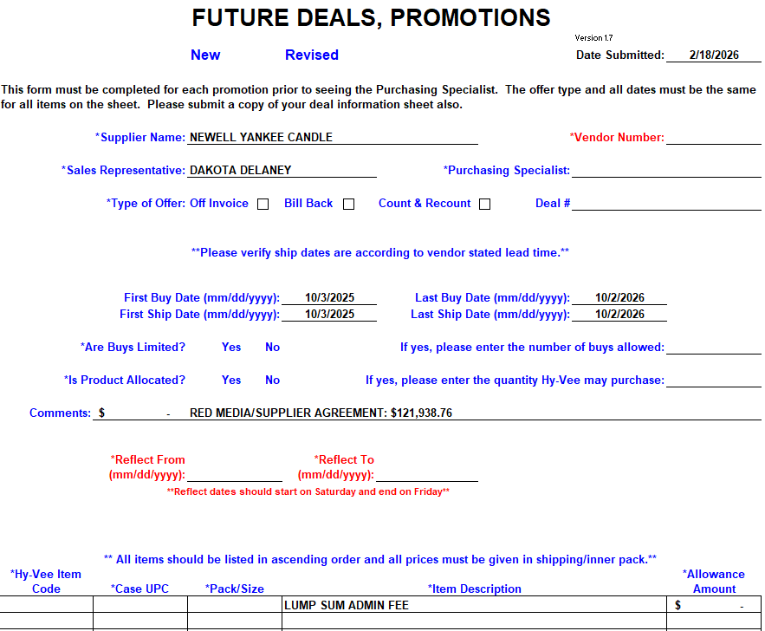
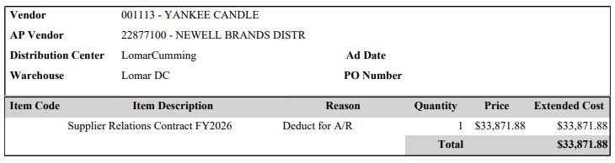

Hy-Vee customer invoices often show comments that reference “week ending”, followed by a date. When searching for the contract, the date shown as “week ending” has to be in the same week the contract ends. For example:

The contract can end any day between 6/17/2013 and 6/23/2013.

Claim reason Special Price: Hy-Vee invoices show a reason code of Special Price on many different types of claims, including billback, count/recount, slotting, display, WOW Buy or E-Buy offers. Review the contract to determine what the claim is actually for.

Customer invoice number: Many Hy-Vee customer invoice numbers begin with BILLBACK. However, this does not necessarily mean the claim is for a billback. It could also be a count/recount.

Fuel Saver claims: Hy-Vee always bases Fuel Saver claims on 20 gallons. The claim amount will be 20 times the contract rate. Example: The customer invoice states FS [product] 0.40; the contract states Fuel Saver Cents Off: $0.02, with a comment of SRP of $5.99 w/.02 Fuel Saver.
Customer Invoice:
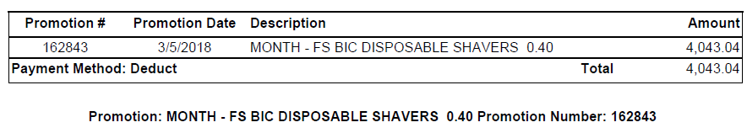

Contract:
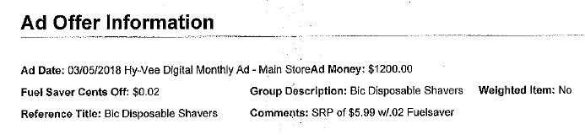

Fiscal Month customer invoices:
Rather than creating a customer invoice with a specific date range, Hy-Vee may submit bills showing Fiscal Month <month> <year>.
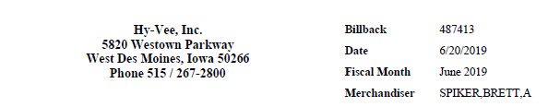

While their fiscal year starts in October, Hy-Vee’s fiscal months align with calendar months. In this example, they are billing for June 1, 2019 – June 30, 2019. Check the comment section of the customer invoice, as they may specify a smaller time frame (e.g. week ending 6/16/2019) within the fiscal month.

Attached are the codes Hy-Vee uses on their check remits.

Contract Info:

Once a contract has been submitted to Hy-Vee, there is no way to revise it if anything changes (usually it is that the dates are extended, but could also be that product is added, the rate changes, etc.). If a contract is found but the detail on the customer invoice does not match, check the VPF Plan Notes and/or Plan or Event Attachments for documentation supporting a deal revision.

E-Buy: Hy-Vee contracts that show E-Buy Offer Form are to be treated as a count/recount. E-Buy contracts do not show a deal amount. They show a regular Store Case Price and a Special Store Cost. The difference between the two is the E-Buy offer amount. In this example, the deal amount is $21.38 per case. ($51.38 regular price - $30.00 special cost = $21.38)
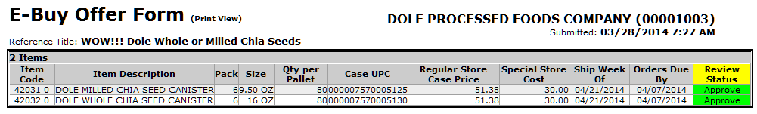

Hy-Vee customer invoices and contracts often reference “term” when referring to their billing periods. This verbiage may be in the Reference Title, or may be in the Comments section.
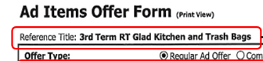
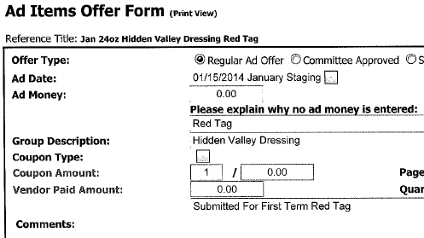

Hy-Vee terms are four months each and are defined as January – April (1st term), May – August (2nd term) and September – December (3rd term).

Ad Offers, Store Pre-Orders and Future Deals contracts will now be pulled for Pending, Approved and Finalized statuses, see examples of Pending status below.

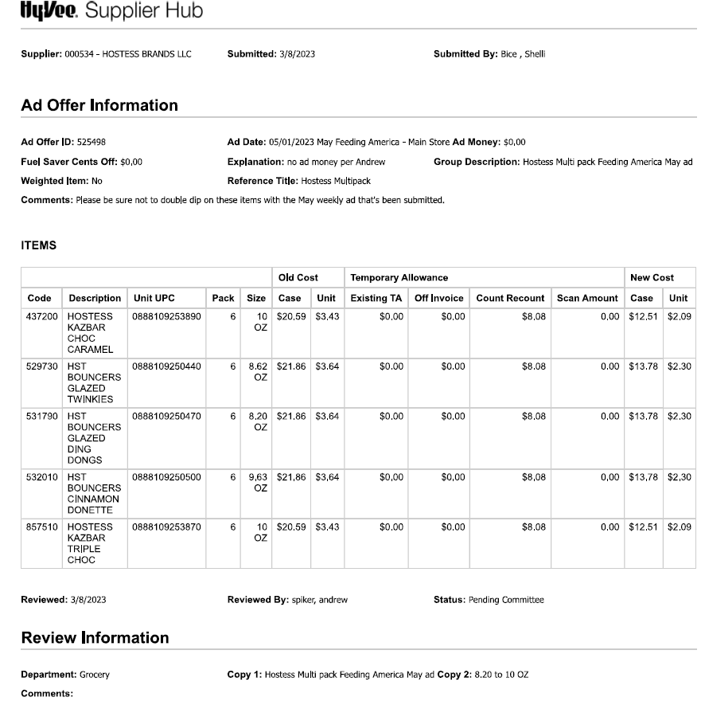

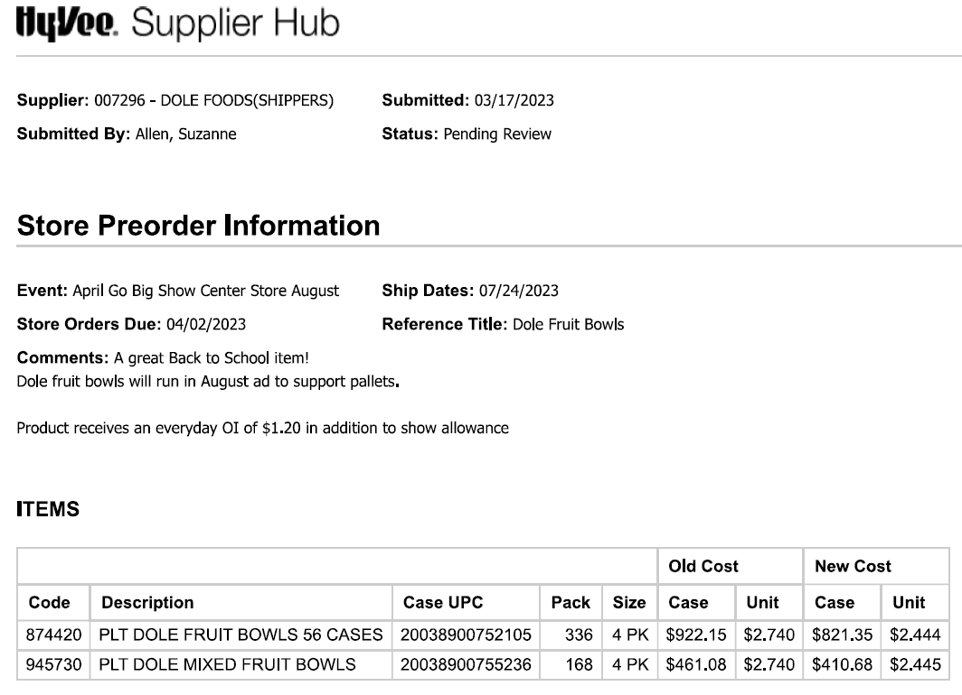

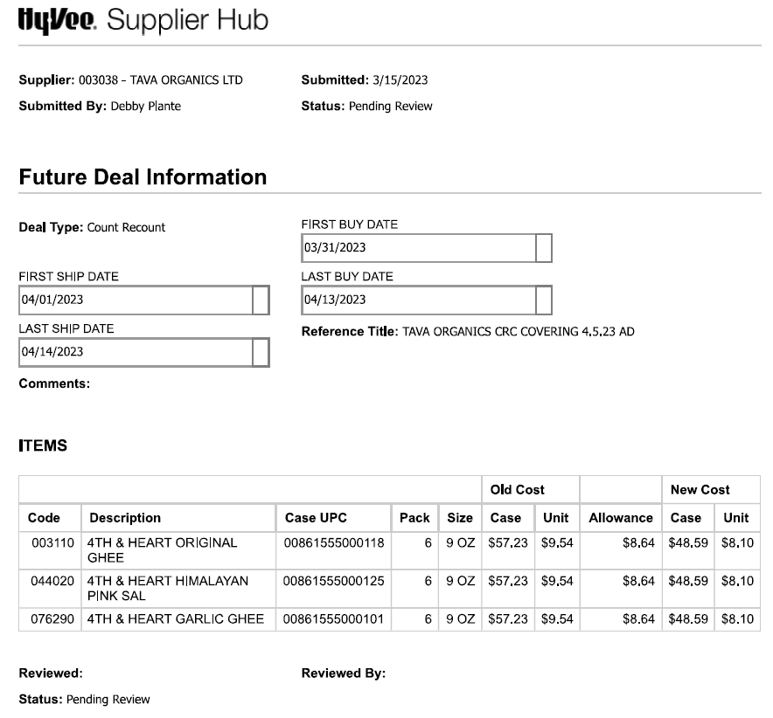

Other General Info:

- Hy-Vee has two warehouse divisions – Chariton, Iowa and Cherokee, Iowa. There will usually be a deduction for each division. The deductions do not always occur at the same time, but most offers are made to both Chariton and Cherokee.
- Hy-Vee requires a minimum of 60 day notification for pending price increases (see attached policy).

BACKUP RETRIEVAL INFORMATION

GENERAL BACKUP RETRIEVAL INFORMATION

Is GCIT responsible for obtaining backup from the customer? Yes
- If yes, is there a customer portal? Yes
- If yes, does GCIT request backup? Yes

Is check remittance information required to request backup? Yes, for backup requests going through sales.

GCIT SPECIFIC BACKUP RETRIEVAL INFORMATION

Portal:

Customer Invoice or Note Identifier | Request From
6 digit number | Pull from customer portal

Automated:

Customer Invoice or Note Identifier | Request From
TG | mhorabik@atgaudits.com
RBC | audit@crimminsaudit.net

Non - Automated:

Customer Invoice or Note Identifier | Request From
All formats excluding TG and RBC | Request from sales

CLIENT SPECIFIC VALIDATION INFORMATION
Client
Barilla
Bush
Campbell’s/Pepperidge Farm
Cargill (Truvia)
Coca Cola
Dole
Edgewell
Harvest Hill
J M Smucker
Kikkoman
King Arthur Flour
Mars Wrigley Confectionary US
Nestle Coffee Partners
Newell

BARILLA
- Hy-Vee admin fees are split to a separate line, coded as Trade – Other, and stepped Ready to Clear-CCA. The event info for these is blue box tactic YR08.
- Hy-Vee receives a swell allowance from Barilla. Claims for spoils/unsaleables are considered invalid.
- Barilla participates in the Supplier Relations program.

BUSH
- Bush participates in the Supplier Relations program.

CAMPBELL’S/PEPPERIDGE FARM
- Pacific Foods claims for Lomar Distrbutiong update the customer # in the header to CUST:1000009354.
- A claim for Temp Trip Device is considered a freight violation charge. Step the claim as Non-Trade/Freight and note “send to deduction team for recode”.
- While Hy-Vee does not subscribe to Nielsen, they do subscribe to IRI. A weekly file containing info on all Campbell’s brands is loaded in ACOSTA Relay that is to be used to validate POP and price point per client SOP. Search for POP:Movement/TPR using CAMPMST/RPTCUST.
- Repositrak fees are considered non-trade unacceptable spends.
- Claims for cross dock fees are coded Non-Trade/Freight and sent on the closed claim feed with the note: Crossdock fees.
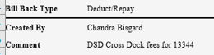

CARGILL (TRUVIA)
- Repositrak fees are cleared to an event. Search for the contract/event in AR using %repositrak% in the Event Description.

COCA COLA
- Supplier Relations Partnership Fees are paid as a check request for CCNA.

- HyVee is allowed a seven (7) day date shift.

DOLE
- Admin Fees will be split to a separate line, coded as Trade / Other, and cleared to the same promotional event.
- The customer invoice number on a hard copy Dole invoice will not show the F2.
- Repositrak fees are cleared to a Client Event #.

EDGEWELL
- Red Media is a lump sum event cleared as Trade – Other. DBW is created based off event and PPG provided by Sales.
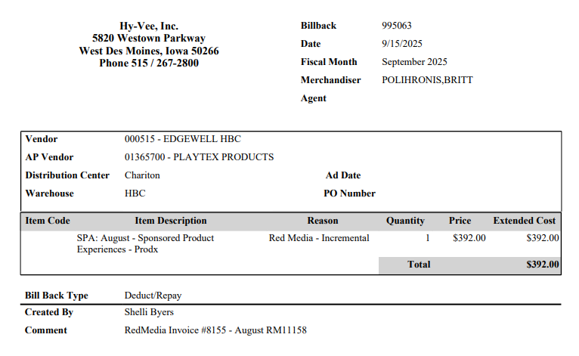

HARVEST HILL
- Harvest Hill will accept Hy-Vee deductions for missed OI on cut/shorted product if the claim is under $1000. If the claim is over $1000, it must be discussed with the RSM and SVP for potential repay.

J M SMUCKER
- PO related claim deductions will always have a cash discount amount that is not on the invoice remittance.
- Directions for working and researching PO-related claims:
  - Deduction amount minus the backup amount will be considered CASH DISCOUNT (validated by JMS DRS).
  - Shortages and overages will be netted and the amount sent to JMS DRS to resolve if results in a deduction amount (shortage is more that overage) – if overage is higher than shortage, see below additional direction to manage.
  - Remaining amount (e.g. list cost, off invoice, etc.) will be deemed PROMOTION/TRADE and researched/validated by Acosta CRA.
  - If the OSD portion results in an OA over our $100 threshold, once the shortage portion is resolved, the remaining amount will be transferred to Acosta to manage as PROMOTION/TRADE.
  - Deduction will need to be split in HR per normal rules.
- If GCC is unable to locate invoice in Relay, the GCC will look for invoice remittance (not the check remittance – but a customer invoice type) in AR.
  - If located and does not match the claim header amount- factor in the cash discount – 2% of the PO total, there will be no backup for the cash discount portion.
  - If no backup is located, then check for cash discount via the Patch Report.
  - If the claim header is more than the cash discount, backup will then need to be requested from Hy-Vee.
- Invoices with “Deduct Shortage” are OI allowances on shorted product and are to be cleared to a penalty fee.
- Proof of Performance issues with FHS and Coffee items are approved to clear without Sales approval.
- For claims with invoices beginning with a “1” – IRI data will likely be insufficient. Client has approved these claims for clearing with insufficient POP.
- When searching for claims in HR, search by the customer reference number (external number) with an asterisk at the end. This will show if there are multiple records for the same reference number.

KING ARTHUR FLOUR
- When a deduction comes in with a customer reference # ****Short Pay, the customer invoice number will not match the claim header. These deductions need to be escalated for customer invoice. The CRA will need to contact sales to determine which Hy-Vee invoice makes up the short pay. 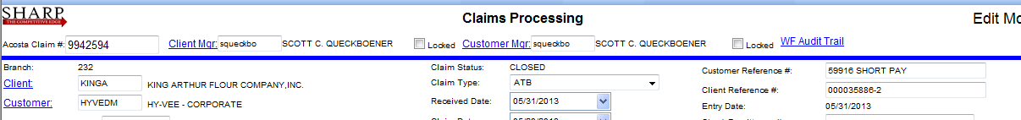

KIKKOMAN
- Kikkoman does not participate in the ReposiTrak program. Non-participating clients are billed quarterly. In addition to the customer invoice, attach the Hy-Vee ReposiTrak letter and step the claim Non-Trade/Service Fee, Awaiting Processing by CCA.

MARS WRIGLEY CONFECTIONARY US
- Damages/Unsaleables are cleared to the below client event #s.
  - CORE CE #1001P0003FMN239D
  - KIND CE # 1001P0003FMJ239D

NESTLE COFFEE PARTNERS
- Nestle Coffee participates in the Supplier Relations program.
- For Hy-Vee Starbucks that Acosta handles, the vendor #000371.
- For Hy-Vee PDI Starbucks that Acosta does not clear, the Vendor #006997 – PDI.
- For any other - Acosta doesn't handle any ready to drink items. These are handled by Nestle.
- Starbuck Quarterly Swell are considered trade and cleared with an event/contract. Code as Trade/Other and clear to event.

NEWELL
- Claims for WOW Buy are coded as Trade-Other. A WOW Buy is a discount that is provided at 20% or higher to the customer and their stores.
- Product ships to the stores beginning on the dates on the forms. Once products have been shipped to the stores, they bill. Therefore, the week ending date of the invoice will exceed 7 days compared to the contract date.
- Markdowns do not require a contract.

PROCESS STEPS

- Deduction Type: Off Invoice (OI)

A per case off invoice allowance (OI) is given to the customer as an automatic discount for product purchased from the client. If the customer does not receive the allowance off the face of the invoice they will deduct for it. If the customer requested an allowance that is not valid, the CSC will send a notification to the customer in writing. Customers view purchase orders as contracts. If they are not notified of allowance discrepancies, they will pay according to their purchase order total.

NOTE: Hy-Vee may group missed OI on cut product claims in under freight on their invoice. The claim will need to be researched for the possible OI issue before coding it as freight.
  - Customer Invoice for Off Invoice (OI), example 1:

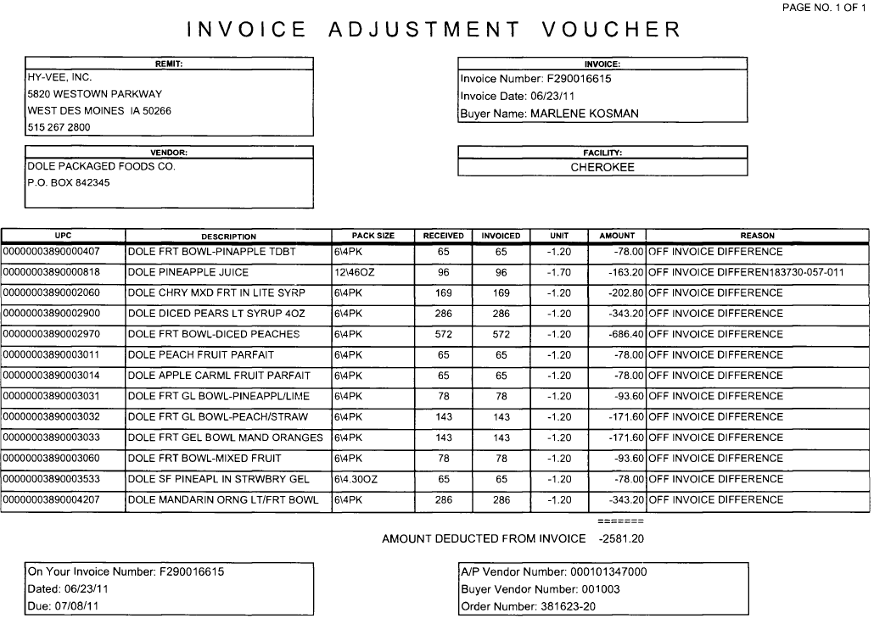
Invoiced: The quantity for which the OI is claimed must match quantity shown on the client order invoice.

Unit: The rate per case Off Invoice allowance amount being claimed. This amount must match the contract.

Invoice Date: The invoice date for the order must be within the contract dates.
Invoice Number: The customer reference number for an OI claim will be the client order invoice number.
4
1
2
3
5
UPC: The products on which the customer is stating that an off invoice allowance was due and not reflected on the client order invoice.
i2
Reason: This indicates that the claim is for off invoice allowance not given or given at a different rate than expected.

i
Order Number.: The customer’s PO number (without the -20).

4

Invoice Number: The customer invoice references the client order invoice number.

1.1 Customer Invoice for Off Invoice (OI), example 2 – OI taken on shorted product:

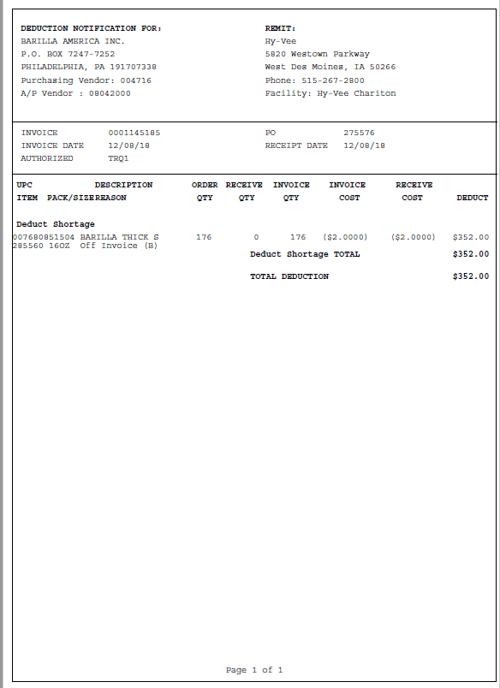
1
UPC, Description, Item, Pack/Size : The product(s) on which the customer is stating that an off invoice allowance was due and not reflected on the client order invoice.
i
Deduct Shortage TOTAL: This verbiage indicates that Hy-Vee is claiming an OI on product that was cut from their order.

Invoice Date: The invoice date for the order must be within the contract dates.
5
4
Invoice/PO: The client order invoice number and Hy-Vee PO number they are claiming the OI on.
3
Order Qty/Receive Qty/Invoice Qty: The quantity ordered, received and billed. According to Hy-Vee’s policy, if product is cut during a promotion period, they will claim the OI, even though they did not receive the product.

Invoice Cost/Receive Cost: The rate per case off invoice allowance amount being claimed.
2

  - Customer Contract for Off Invoice: Found via Search For: Event Scheduler.

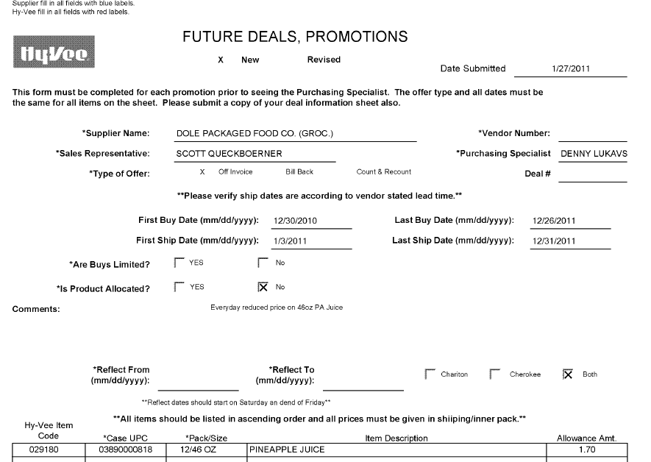
1
Hy-Vee Item Code: The customer’s store code for the item. If the UPC is not shown on the customer invoice, use the APL, DBW or contract to cross reference to the corresponding UPC.
First Ship Date/Last Ship Date: The ship date on the client order invoice must fall within these dates.

5
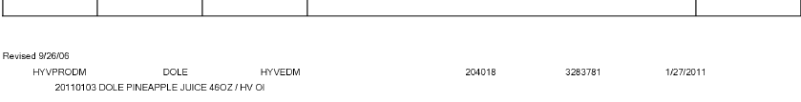
2
Allowance Amt: The per case Off Invoice allowance amount. This amount needs to match the customer invoice to validate the claim.
If this amount is shown on the client order invoice for this item, the claim is invalid.

1
Case UPC: The product the customer is being offered an off invoice allowance on. It must match the UPC on the customer invoice and client order invoice.

1

Refer to the SOPs/Generic Help File for POP requirements.

2. Deduction Type: Billback (BB)

A Billback claim is a per case allowance offered for a specific performance requirement.
A per case billback allowance is claimed by the direct buying customer for product purchased from the client, or by the indirect customer for product purchased from the direct customer. This is an allowance the customer will bill the client for. This is not an automatic discount given off the face of the invoice.

  - Customer Invoice for Billback, example 1:

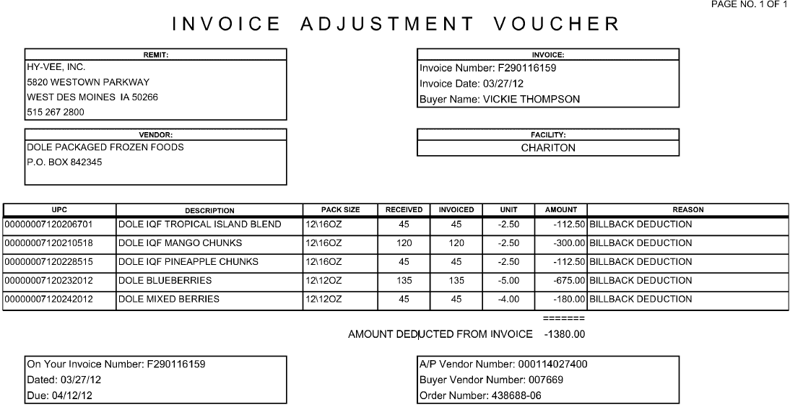
UPC: The products the customer is claiming the billback allowance on.

4
i
i
3
1
2
5
Invoice Number: The customer invoice references the client order invoice number.
Invoice Number: The client order invoice number
Invoice date: The shipment date of the product must be between the dates on the contract.
Reason: This identifies that the invoice is for a billback allowance.

Unit: The rate per case billback allowance being claimed by the customer. This amount must match the contract.

Invoiced: The quantity the customer is deducting for. This quantity must match the client order invoice.

Order Number: This is the customer’s PO number (without the -06).

3
4

2.1 Customer Invoice for Billback, example 2:

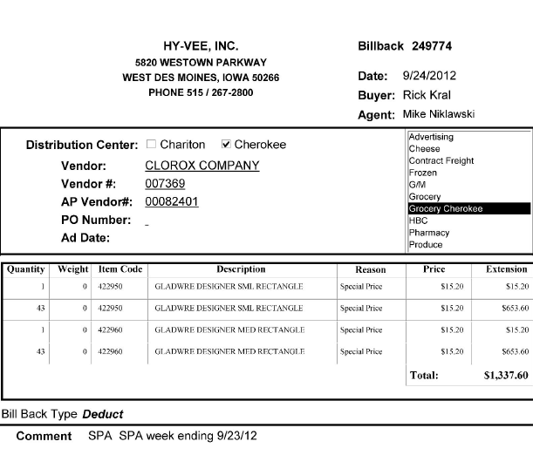
2
3
1
Price: The per case billback rate Hy-Vee is claiming. Note: The column title is “price”, but the claim is identified as a billback via the contract.
i
Billback: While the customer invoice number starts with Billback, the customer may not be deducting for a billback claim. Verify the type of claim by reviewing the contract.

Quantity – The number of cases Hy-Vee is claiming the allowance for.

Item Code: The customer’s store code for the item. If the UPC is not shown on the customer invoice, use the APL, DBW or contract to cross reference to the corresponding UPC.
5
Comment: The week Hy-Vee is claiming the allowance for. This date must fall within the ship dates on the contract. When billed in this format, Hy-Vee is claiming for all the cases received during the specified week.

2.1 Billback Allowance, example 3: Hy-Vee Cross Network Program claims (also known as Prebook claims) work like surveys. The offer is made to the individual stores; the promoted product is usually shippers or pallets; the stores submit their orders; Hy-Vee places the orders and also submits the customer check requests. The distinguishing characteristic for Cross Network Program claims is that the deduction is taken in advance of the product actually shipping. Refer to the client-specific section or client SOP for how to handle claims for future-dated performance. The customer’s order form for the prebook claim is used as the contract. It will be page 2 of the customer invoice.

Page 1 – Customer Invoice, product detail:
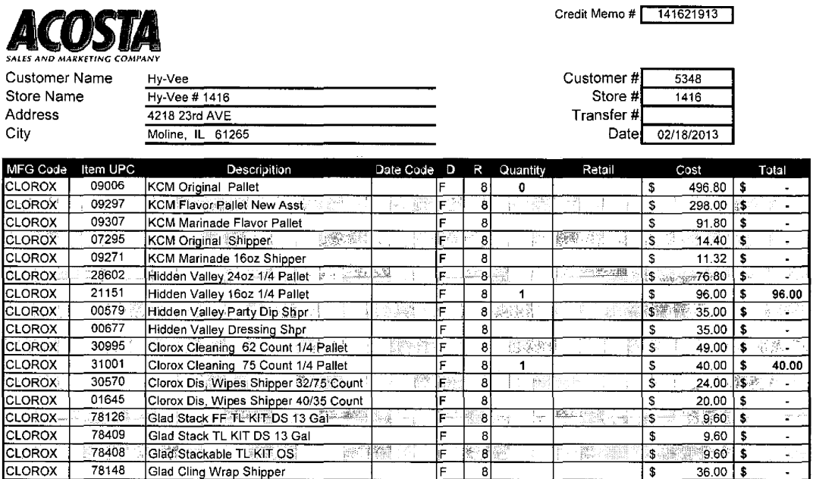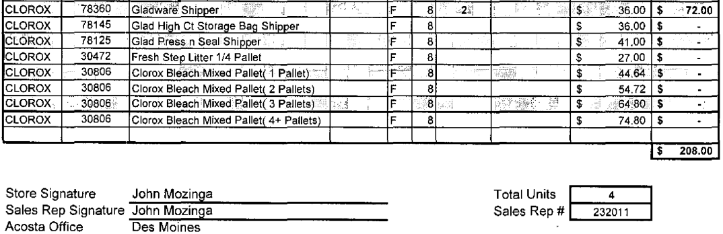
2
Rate – The rate Hy-Vee is claiming for the billback.

1
3
Item UPC: The product on which the customer is claiming a billback.
Quantity – The number of cases Hy-Vee is claiming the allowance for.

Page 2 – The second page of a prebook order form is the contract:

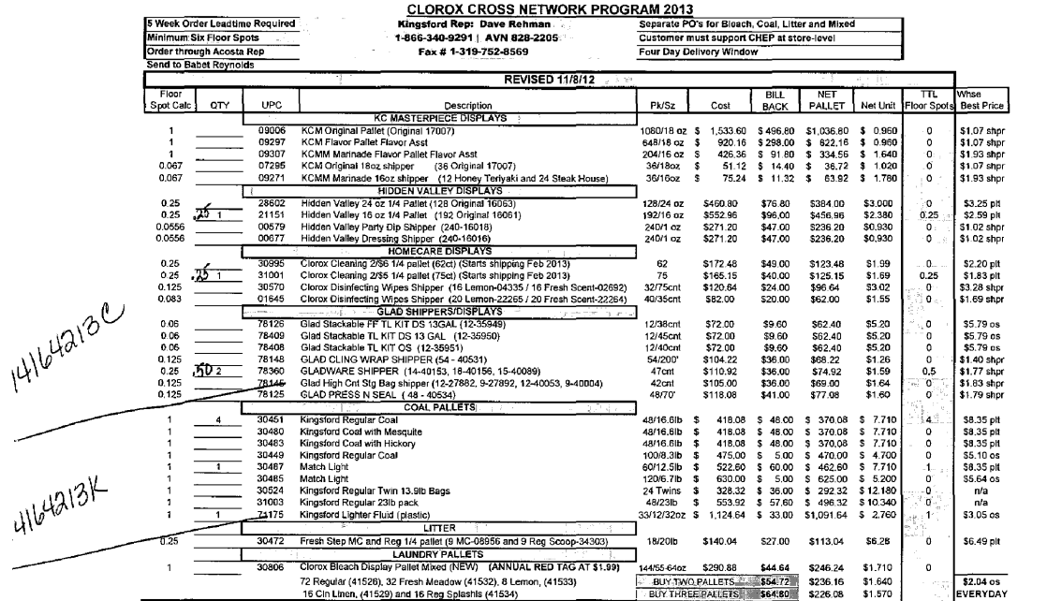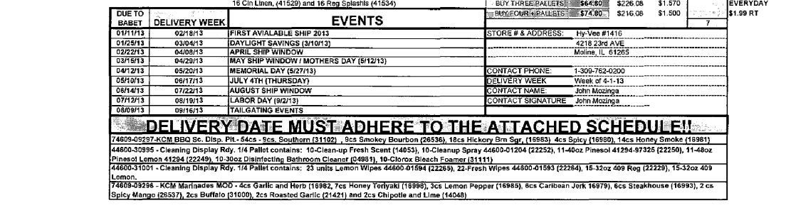
5
Delivery Week: The week Hy-Vee is claiming the allowance for. Notice that page 1 shows a document date of 02/18/2013, but the delivery week is not until the week of 04/01/2013. The product will ship the week prior to the date shown or the same week shown on the customer invoice. Prebook billbacks are ordered and deducted for well in advance of the product actually shipping. Performance cannot be verified until the product ships. Reference the client SOP to find out client requirements for claims where performance has not happened when the deduction is taken.

2.2 Contract Copy for Billback, example 1: Found via Search For: Event Scheduler.

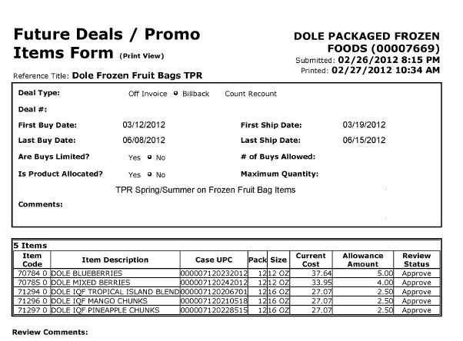
5
First Ship Date/Last Ship Date: The product the customer is deducting for must be shipped within these dates.

2
1
Items Code, Item Description, Case UPC, Pack & Size: The products that a billback allowance is being offered on. This must match the customer invoice and client order invoice.

Allowance Amount: The per case billback allowance amount being offered to the customer. This amount must match the customer invoice.

2.2 Contract Copy for Billback, example 2: Found via Search For: Event Scheduler.

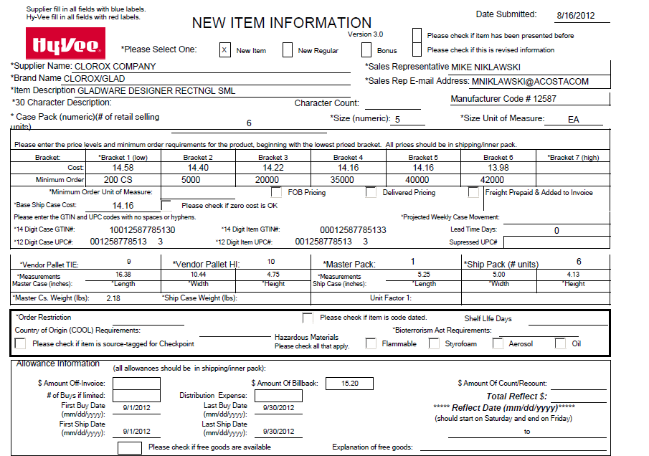
2
1
$ Amount of Billback: The amount being offered for the billback. This must match the customer invoice.

12 Digit Case UPC #: The client’s UPC code that identifies the specific product on which a billback is being offered.

5
First Ship Date/Last Ship Date: The time period for which Hy-Vee was offered the billback allowance. The performance date on the customer invoice must fall within these dates.

2.2 Contract Copy for Billback, example 3: Found via Search For: Event Scheduler.

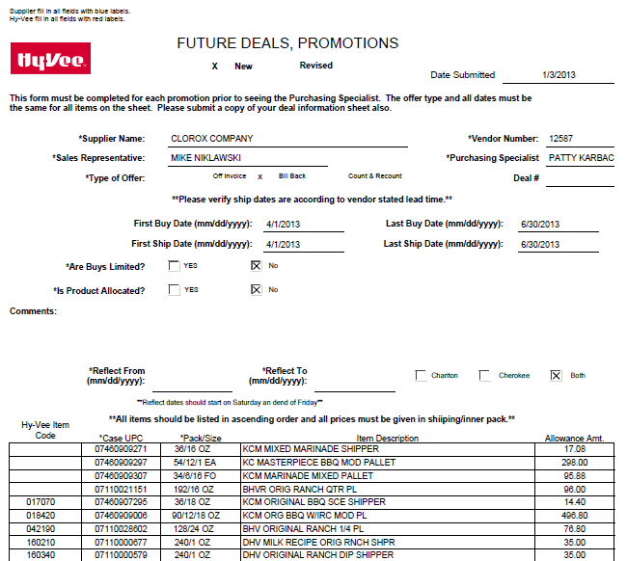
1
5
2
Allowance Amt: The amount Hy-Vee is being offered as a billback.

Hy-Vee Item Code/Case UPC: The product the customer is being offered a billback on. This code must match the customer invoice and POP.

First Ship Date/Last Ship Date: The product the customer is deducting for must be shipped within the contract dates to be a valid deduction.

Refer to the SOPs/Generic Help File for POP requirements.

3. Deduction Type: Warehouse Withdrawal (Count/Recount)

Warehouse Withdrawal/Count Recount (C/RC) is for cases shipped to stores from the main customer’s warehouse.

NOTE: For all Count/Recount promotions for all vendors, Hy-Vee charges the following promotional fees:
CRC Fees
Minimum $ | Maximum $ | Fee
$0.00 | $1,000.00 | $50.00
$1,001.00 | $2,000.00 | $150.00
$2,001.00 | $3,000.00 | $300.00
$3,001.00 + |  | $400.00

There is a maximum of $400 for each warehouse (Chariton and Cherokee) so the total fee for a count/recount would be a maximum of $800.

Hy-Vee CRC claims will use a Future Deals form, not an Ad Offer form. PDI CRC claims will use the Ad Offer form. See PDI contract example for determining dates.

3.1 Customer Invoice for Warehouse Withdrawal (Count/Recount), example 1:

3
Qty: The number of cases of each product the customer is deducting for.

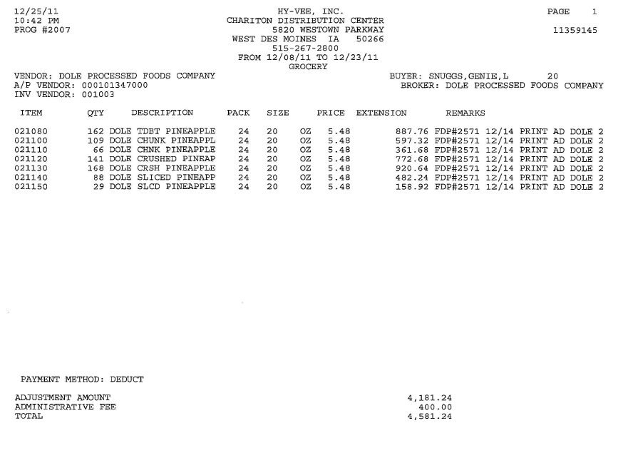
Price: The amount the customer is claiming per case, which must match the contract.
NOTE: Even though Hy-Vee calls this column “price”, the contract verifies that this is a count/recount claim.

Item: The customer’s store code for the item. If the UPC is not shown on the customer invoice, use the APL, DBW or contract to cross reference to the corresponding UPC.
2
1
4
From/To: The date range when the customer is claiming the count/recount allowance. These dates have to fall within the contract dates.

3.1 Customer Invoice for Warehouse Withdrawal (Count/Recount), example 2:

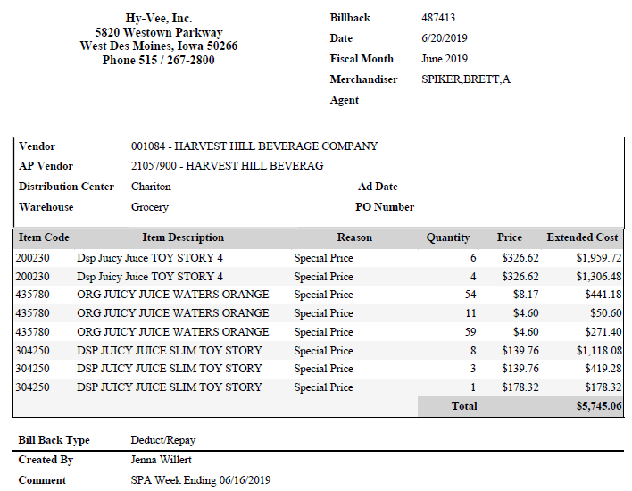
Price: The amount the customer is claiming per case. This needs to math the contract.
NOTE: Even though Hy-Vee calls this column “price”, the claim is a for a count/recount.

1
3
Quantity: The number of cases the customer is deducting for.
2
Item Code: The customer’s store code for the item. If the UPC is not shown on the customer invoice, use the APL, DBW or contract to cross reference to the corresponding UPC.
Comment: The week the customer is deducting for.
NOTE: The customer invoice number and verbiage at the bottom of the customer invoice both state “Billback”; the Reason Code states “Special Price”. However, the contract verifies that the customer is claiming a count/recount offer.

4

3.1 Customer Invoice for Warehouse Withdrawal (Count/Recount), example 3:

NOTE: This customer invoice does not identify the type of deduction. Search for a contract with the same products and rates, and with dates that cover the billing period on the customer invoice. The contract identifies this as a Count/Recount.
4
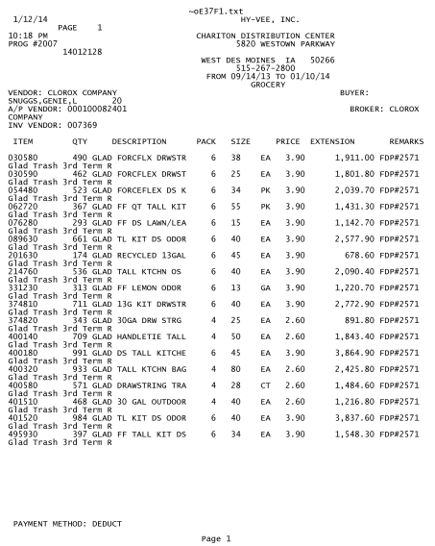
3
Quantity: The number of cases the customer is deducting for.
Item: The customer’s store code for the item. If the UPC is not shown on the customer invoice, use the APL, DBW or contract to cross reference to the corresponding UPC.
2
1
From/To: The dates the customer is claiming the count/recount must fall within the ship dates on the contract.
Price: The amount the customer is claiming per case. This needs to match the contract for a valid claim.
NOTE: Even though Hy-Vee calls this column “price”, the contract verifies that this is a count/recount claim.

3.1 Customer Invoice for Warehouse Withdrawal (Count/Recount), example 4, PDI:
4
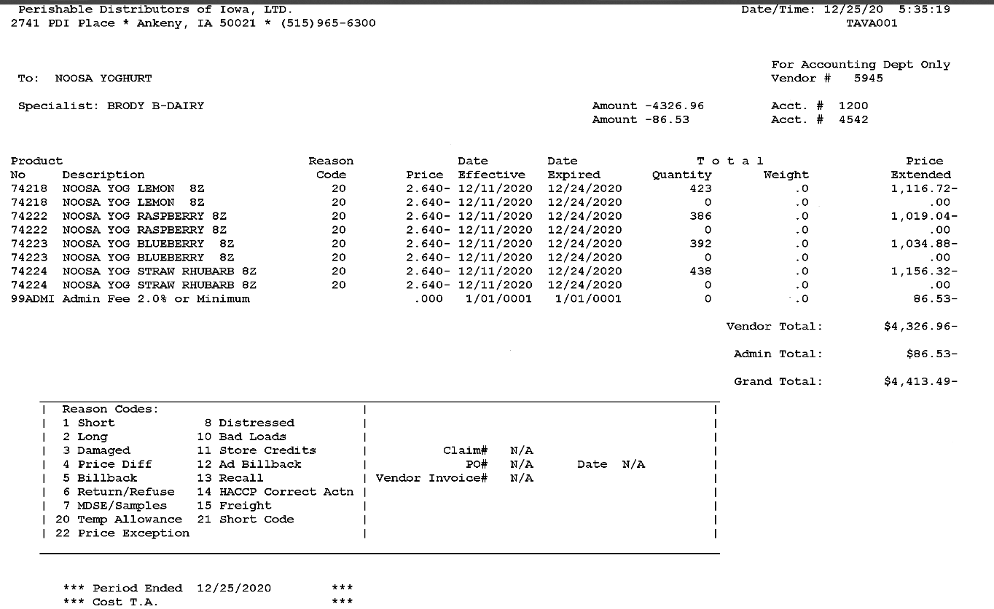
Admin Fee: PDI charges a fee when deducting for CRCs.

i
i
Reason Code: Reason Code 20 is Temporary Allowance. PDI uses this for CRCs.

3
Quantity: The number of cases the customer is deducting for.
Dates: The dates the customer is claiming the allowance.
2
Price: The amount the customer is claiming per case.

1
Item: The customer’s store code for the item and description.
3.2 Customer Contract for Warehouse Withdrawal (Count/Recount), example 1: Found via Search For: Event Scheduler

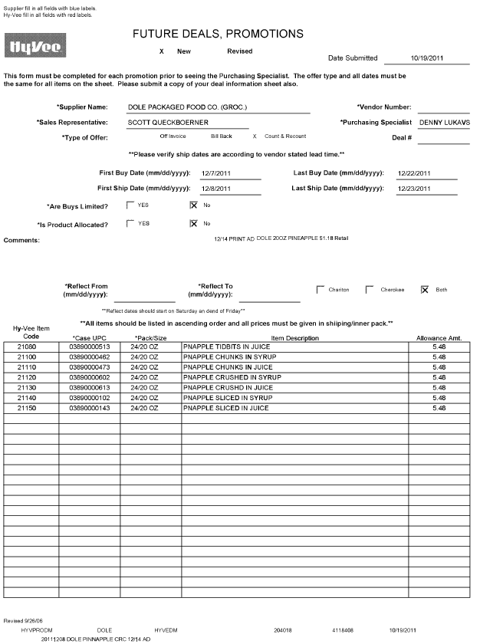
Case UPC: The manufacturer’s code to identify each product.

Allowance Amt: The rate offered to the customer. The rate on the customer invoice must match the rates on the contract.

1
Hy-Vee Item Code: The customer’s store code for each item. This code is referenced on the customer invoice, and must match.
1
2
i
4
First Ship Dates/Last Ship Dates: The allowance dates on the customer invoice must fall within these dates.

Type of Offer: The contract indicates that it is for a count/recount allowance.

3.2 Customer Contract for Warehouse Withdrawal (Count/Recount), example 2: Found via: Search For: Event Scheduler.

i
Deal Type: This indicates that the contract is for a count/recount allowance.

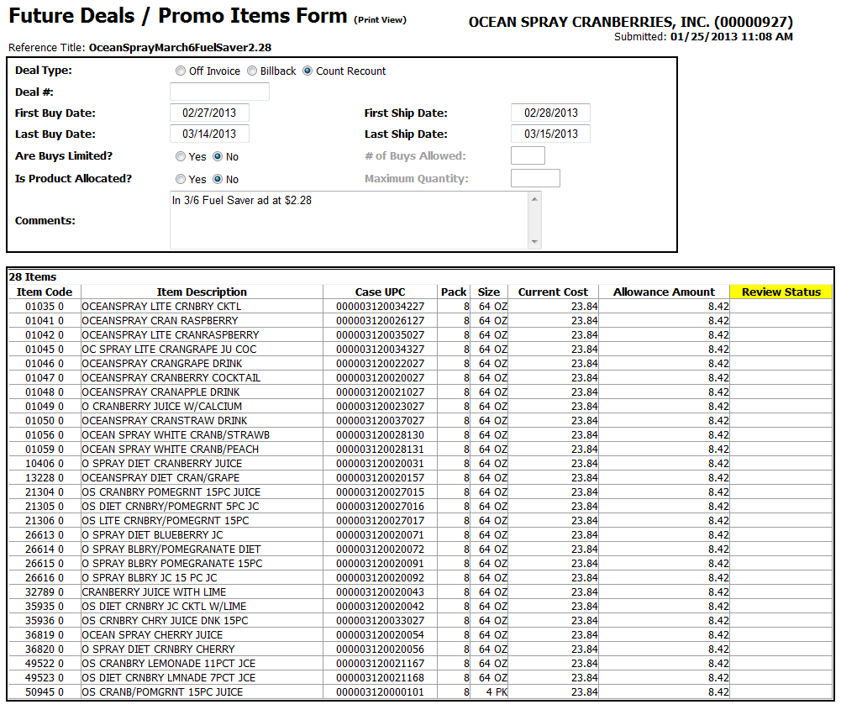
1
Item Code/Case UPC: The customer’s store code for the item and the client’s UPC the count/recount is offered on. If the UPC is not shown on the customer invoice, use the APL, DBW or contract to cross reference to the corresponding UPC.
2
4
First Ship Date/Last Ship Date: The dates when the customer can claim the count/recount allowance. The dates on the customer invoice must fall within these dates for the claim to be valid.

Allowance Amount: The allowance per case the customer is being offered. The amount on the customer invoice must match.

3.2 Customer Contract for Warehouse Withdrawal (Count/Recount), example 3: Found via: Search For: Event Scheduler

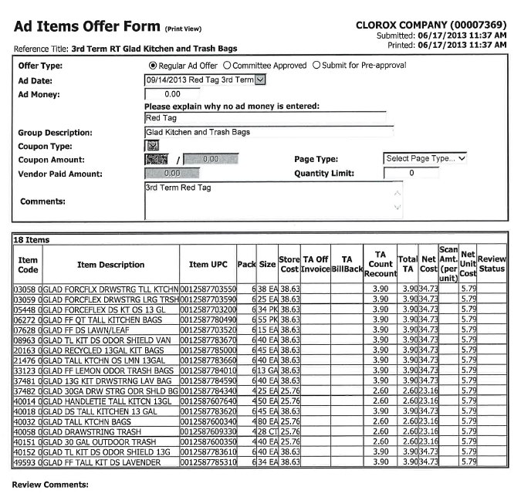
2
1
4
Ad Date: The date shown is the first date for the CRC. Because this is a 3rd Term offer, it runs through January (three months). No ad money is offered, so this is not an ad offer.
Reference Title: The customer invoice may show the contract Reference Title below each item listed. If so, this can be used to verify that the correct contract is linked.

Item Code – Item UPC: The Item Code is the customer’s internal code for each item. The Item UPC is the manufacturer’s case code for each item. NOTE: Do not consider the ending 0 when looking for the case code. Eg: The first item in this example is 70355.
TA Count Recount: The allowance per case the customer is being offered. This must match the amount on the customer invoice. This column identifies that the offer is for warehouse withdrawal/count-recount.
i

3.2 Customer Contract for E-Buy Warehouse Withdrawal (Count/Recount), example 4: Found via: Search For: Event Scheduler

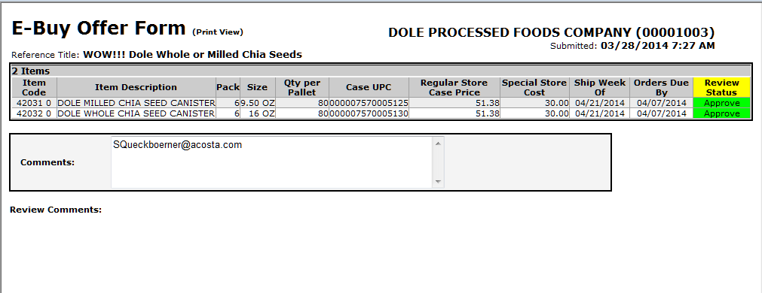
1
Product Detail: The products that the C/RC is valid for.

Date: The start date for the promotion. Use this date for validation

2
2
Rate: The rate is determined by calculating the difference between the regular cost & the special cost.

NOTE: E-Buy contracts do not show a deal amount. They show a Regular Store Case Price and a Special Store Cost. The difference between the two is the deal amount being offered. (In this example, $21.38.)

3.2 Customer Contract for Warehouse Withdrawal (Count/Recount), example 5 - Survey: Found via: Search For: Event Scheduler

1st tab of contract:

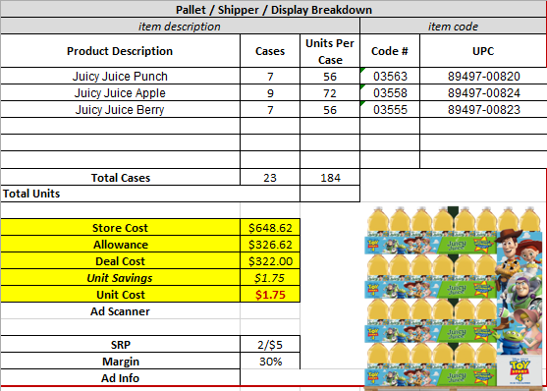
2
Allowance: The amount offered for the Count/Recount.

1
Product Detail: The individual products that make up the shipper.

2nd tab of contract:
4
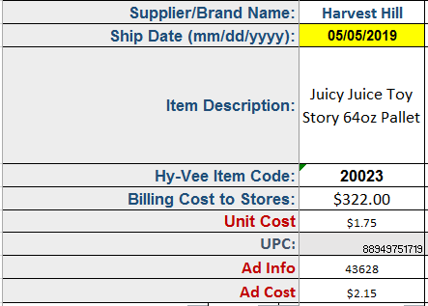
1
Ship Date: Surveys only show the first date product can ship to the stores. Performance can take place any time after this date.

Product Information: The description, store code and UPC of the pallet for the C/RC.

3.2 Customer Contract for Warehouse Withdrawal (Count/Recount), example 6 – Future Deal: Found via Search For: Event Scheduler

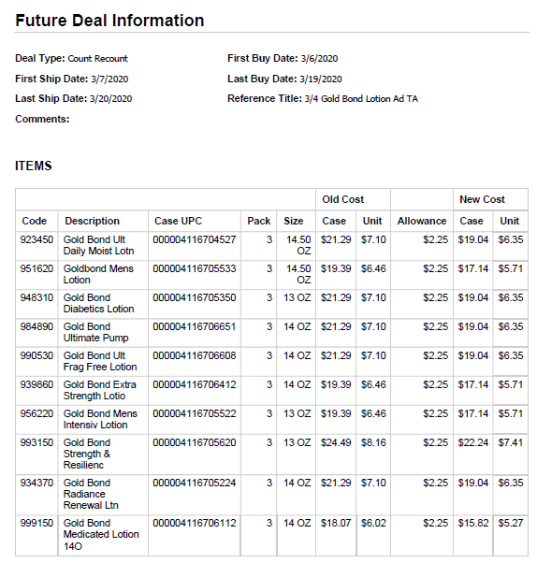
Allowance: The rate for the C/RC.

2
1
Product Detail: The products that the C/RC is valid for.

4
Buy Dates/Ship Dates: The dates when the Warehouse Withdrawal (Count/Recount) promotion is valid.
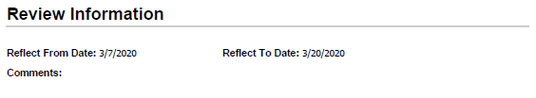

Refer to the SOPs/Generic Help File for POP requirements.

3.2 Customer Contract for Warehouse Withdrawal (Count/Recount), example 7 – Store Preorder Information: Found via Search For: Event Scheduler

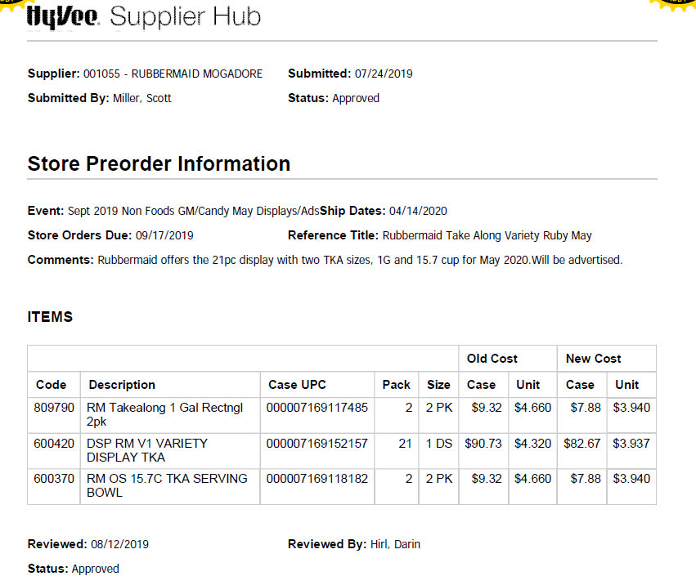
2
Rate: The rate is determined by calculating the difference between the old case cost & the new case cost.

1
Product Detail: The products that the C/RC is valid for.

4
i
Store Orders Due: The deadline for the individual stores to place their orders to Hy-Vee.

Ship Dates: The start date for the promotion. Use this date for validation

3.2 Customer Contract for Warehouse Withdrawal (Count/Recount), example 8 – PDI: Found via Search For: Event Scheduler

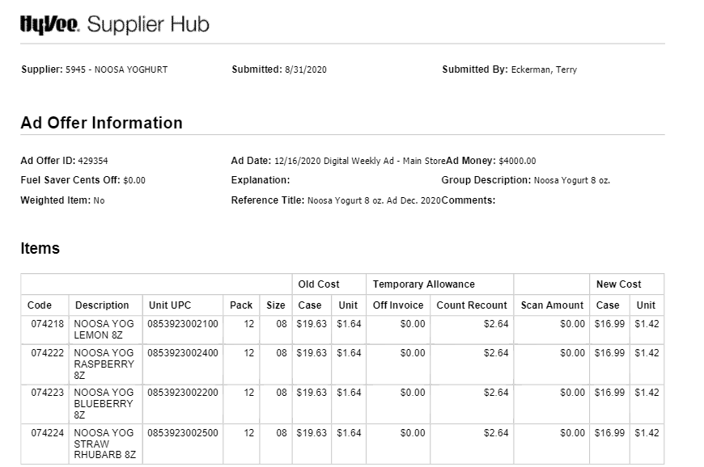
Ad Date: The Ad Offer form only provides an ad date. When using the form to valiate PDI CRCs, the CRC is valid starting the Friday before the ad date through the Thursday after the ad date for a total of 14 days. For example, an ad date of 12/16/20 will support a CRC for dates 12/11-12/24/20.
4
1
Product Detail: The products that the C/RC is valid for.

4. Deduction Type: Ad
Rate: The CRC rate offered.

2

A fee for featuring a client's products in an advertisement.

NOTE: The ad date shown on the Hy-Vee contract is ‘suggested’. Hy-Vee will decide when they want to run the ad. The actual date the ad ran can be found on the count/recount contract, which should be found in the same VPF. See example on section 4.5.
The ad may be in print format (4.6), online (.com), Fuel Saver or in the Seasons Magazine (4.3) [Seasons Magazine ads run during each season of the year, ie summer, winter, autumn/fall, spring.]

4.1 Customer Invoice for Ad, example 1:

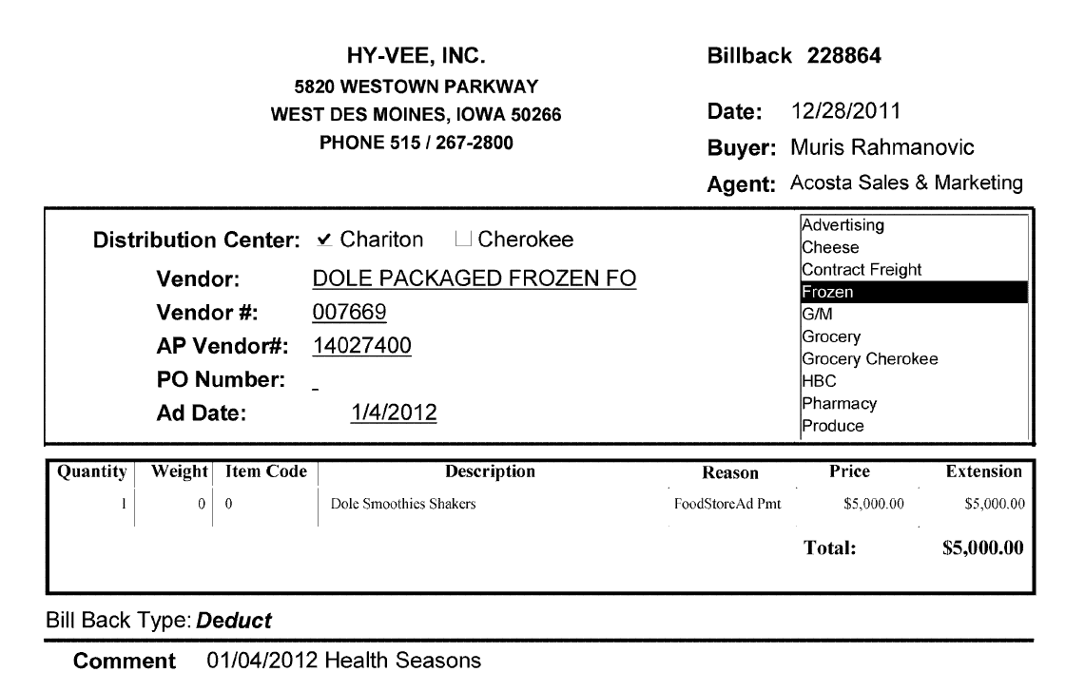
3
Ad Date: The date the ad ran, which needs to match the contract and POP. (See note above on ‘suggested’ ad dates for Hy-Vee.)

2
Reason: This indicates that the claim is for an ad.
i
Price: The lump sum amount the customer is claiming for the ad allowance, which must match the contract.
1

Description: The product /product group the ad claim is for, which needs to match the contract and POP.

4.1 Customer Invoice for Ad, example 2 – Hy-Vee invoice for PERIDM Perishable Distributors of Iowa division:

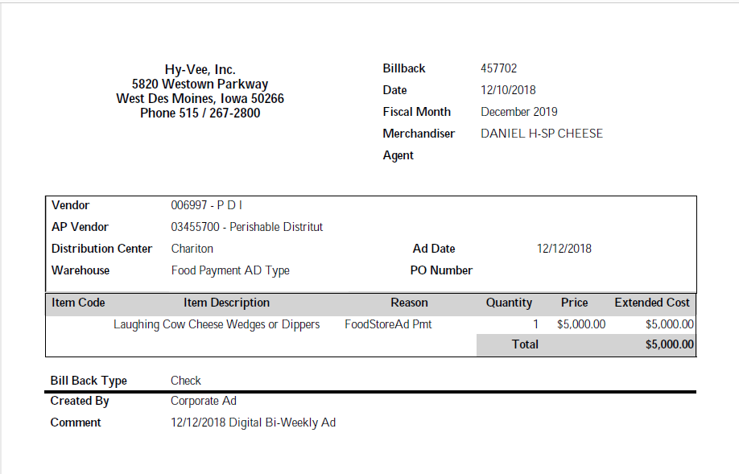
i
3
Price: The lump sum amount the customer is claiming for the ad allowance, which must match the contract.
Reason: This indicates that the claim is for an ad.
AP Vendor: This indicates that the claim is for the PERIDM Perishable Distributors of Iowa division..
i
1
Item Description: The product /product group the ad claim is for. This needs to match the contract and POP.
2
Comment: This is the date the ad ran, which must match with the contract and POP.

4.2 Customer Contract for an Ad, Example 1: Found via Search For: Event Scheduler.

Ad Money: The amount being offered for the ad. The amount on the customer invoice must match the contract amount.

1
3
Must Describe Offer: The product/product group for which the ad is being offered. This must match the product/product group shown on the customer invoice and in the ad.

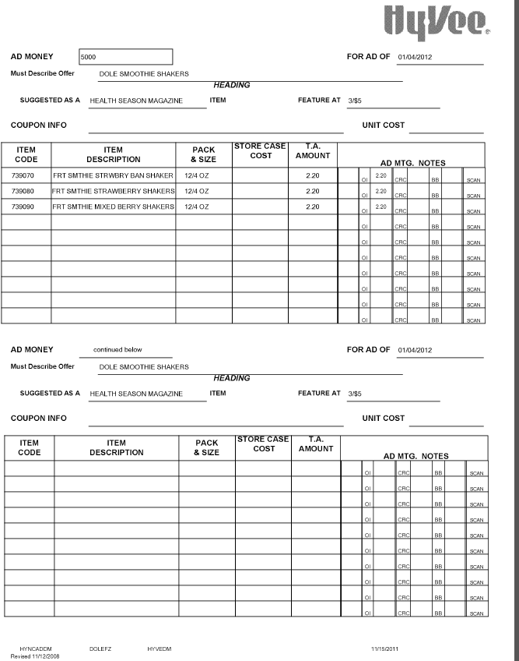
For Ad Of: The date on which the ad is to be run. This date should match the ad date shown on the customer invoice. (See note above on ‘suggested’ ad dates for Hy-Vee.)
2
1
Item Code: The customer’s store code for the item. If the UPC is not shown on the customer invoice, use the APL, DBW or contract to cross reference to the corresponding UPC.

4.2 Customer Contract for an Ad, Example 2: Found via Search For: Event Scheduler. NOTE: The Ad Items Offer Form shows a suggested ad date. To confirm the actual date, you have to look in the VPF and use the ad date shown on the C/RC contract.

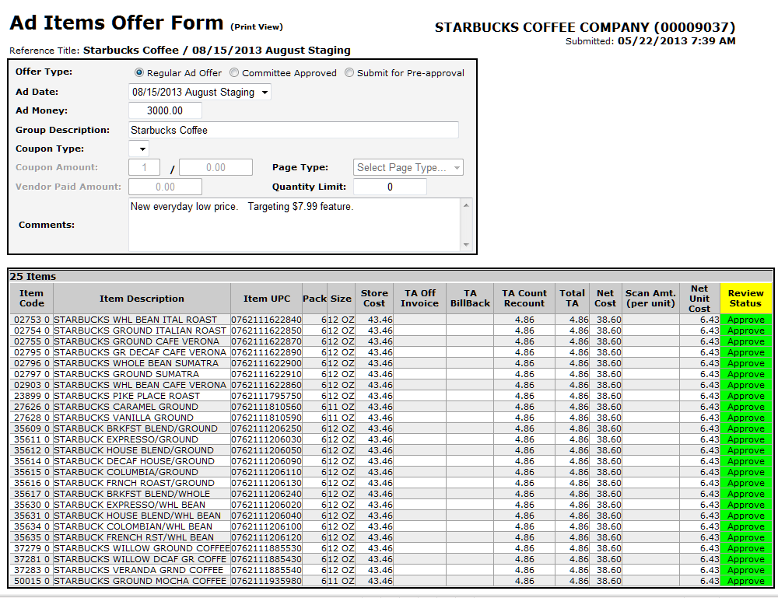
Ad Money: This is the amount being offered for the ad. The amount on the customer invoice must match the contract amount.

3
i
Ad Date: The ad date shown on the Ad Items Offer Form is a suggested date. The actual date for the ad is shown on the CRC contract found in the same VPF.

1
Item Code/Item UPC: The customer’s store code for the item, and the client’s UPC for the item, which identify the product to be featured in the ad.

4.2 Customer Contract for an Ad, Example 2, continued: Found via Search For: Event Scheduler. NOTE: The Ad Items Offer Form shows a suggested ad date. To confirm the actual date, look in the VPF and use the ad date shown on the C/RC contract.

VPF:
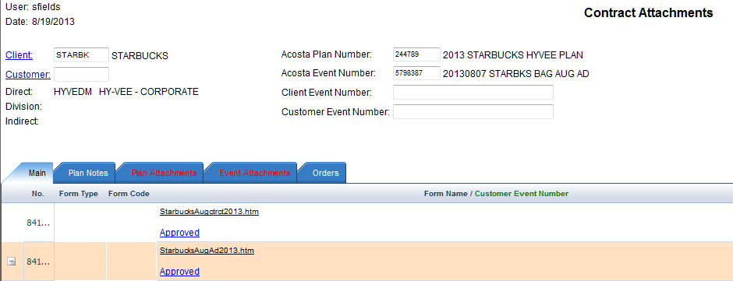
NOTE: Offers for Hy-Vee ads always require two contracts. The Ad Items Offer Form shows the suggested ad date. The CRC contract shows the actual date for the ad. The ad date shown on the CRC contract must match the customer invoice and POP.
i

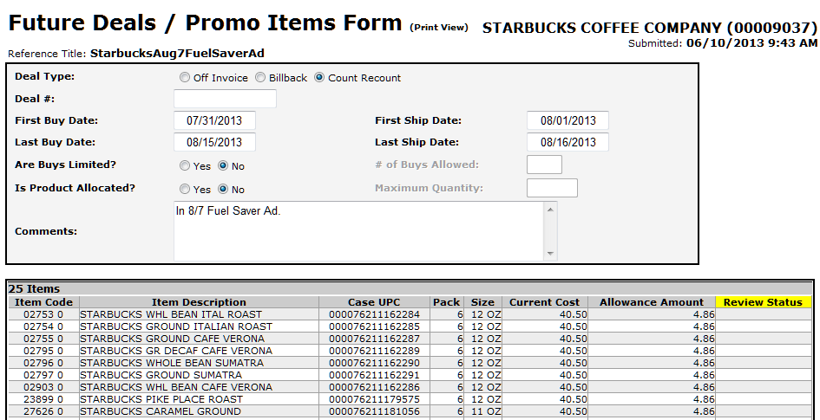
2
Comments: The date shown in the Comments section of the C/RC contract is the date the ad is required to run. This needs to match the customer invoice and POP.

4.2 Customer Contract for an Ad, Example 3: Found via Search For: Event Scheduler.

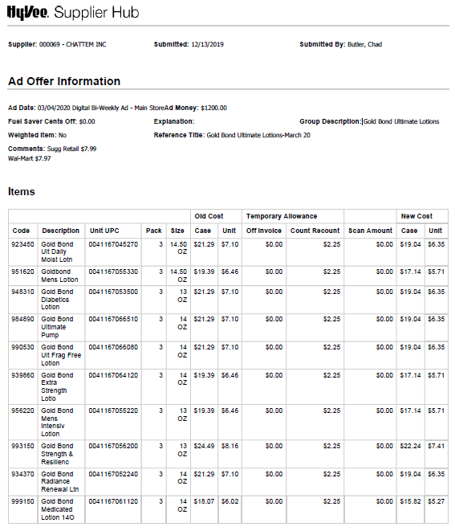
Code, Description, Unit UPC, Pack & Size: The detail for the products to be featured in the ad.
1
Ad Date: The date on which the ad is to be run. This date should match the ad date shown on the customer invoice.
2
3
Ad Money: This is the amount being offered for the ad. The amount on the customer invoice must match the contract amount.

4.2 Customer Contract for an Ad, Example 4 – Ad Offer with Fuel Saver: Found via Search For: Event Scheduler.

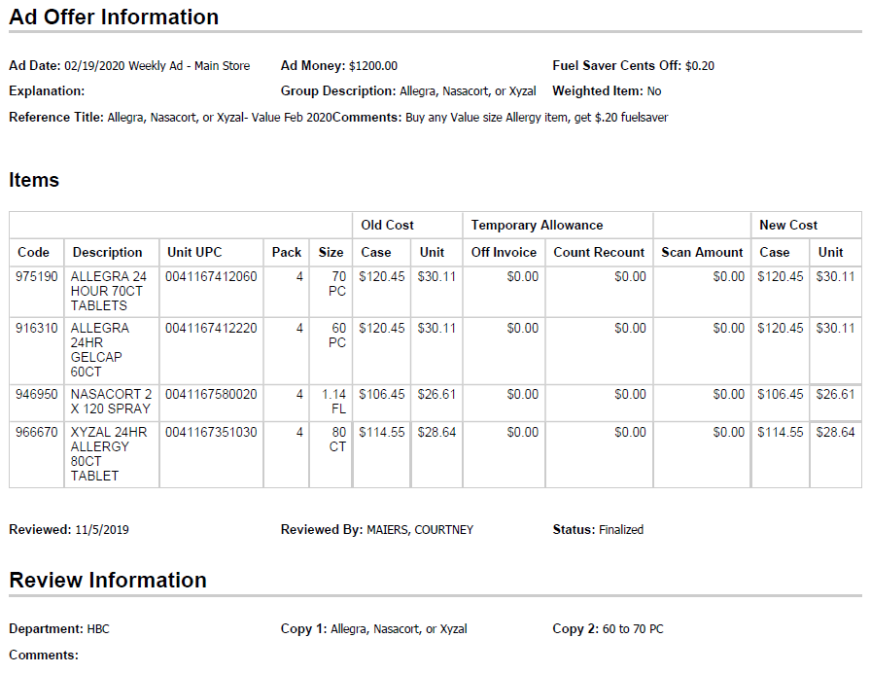
1
Code, Description, Unit UPC, Pack & Size: The detail for the products to be featured in the ad.
Fuel Saver Cents Off: The amount being offered for the fuel saver promotion. The amount on the customer invoice must match the contract amount. See the Customer General Informaiton section on how the Fuel Saver promotion is calculated.

3
3
Ad Money: The amount being offered for the ad. The amount on the customer invoice must match the contract amount.

2
Ad Date: The date on which the ad is to be run. This date should match the ad date shown on the customer invoice.

4.3 Refer to the SOPs/Generic Help File for POP requirements.

5. Deduction Type: Slotting

A slotting allowance is offered to the customer to purchase an item not currently stocked. It is a kind of promotional money offered to a customer as incentive to buy a new item and create a “slot” for that product on their warehouse storage shelves. It is a Trade Deduction. A slotting lump sum allowance can be offered for each item and/or an off invoice can be offered as an introductory allowance for the first 30 days.

5.1 Customer Invoice for Slotting:

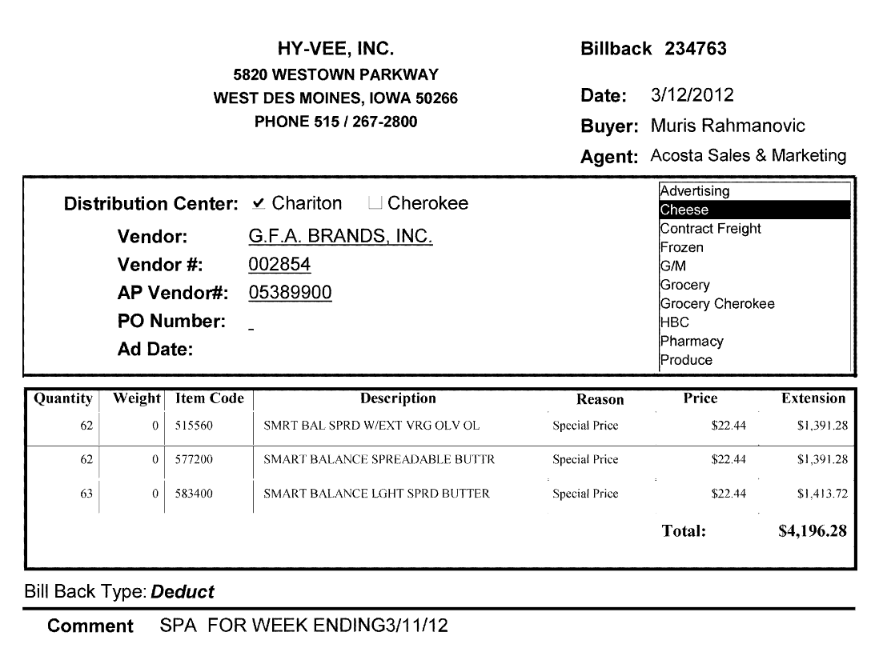
Price: The amount the customer is claiming per case. This needs to be verified with the customer contract and plan notes/plan attachments for a valid claim. The amount on the customer invoice will include Hy-Vee’s markup as outlined in the VPF.
NOTE: Even though Hy-Vee calls this column ‘price’, the contract verifies that this is a slotting claim.

1
Item Code: The customer’s store code for the item. If the UPC is not shown on the customer invoice, use the APL, DBW or contract to cross reference to the corresponding UPC.
2
i
Comment: The performance date for slotting the product.

5.2 Customer Contract for a Slotting Allowance: Found via Search For: Event Scheduler.
NOTE: The amount on the customer invoice will not match the exact amount listed on the contract, because there are also fees associated with the new item placement. The Plan Notes or Plan Attachments tab within the VPF must note the fees (see next page).
i
Page 1
Please Select One: NEW ITEM identifies that the contract is for slotting.

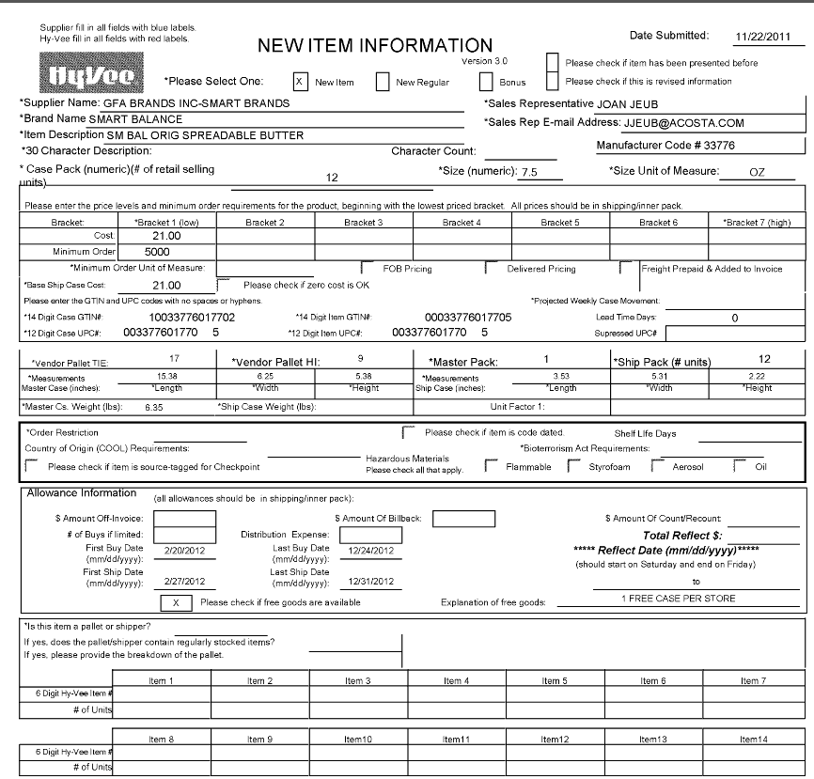
Explanation for Free Goods: This section authorizes Hy-Vee to receive one free case of the listed product per store.

UPC Code – The product codes listed on the customer invoice must match the contract UPCs.

2
1
i
Cost: The cost of the product. If Hy-Vee is offered free cases, they will deduct for this cost plus an upcharge that must be approved in the VPF.
Order and Ship Dates: This is the first date that product will be available for order/ship.
Note: The customer may purchase the product outside of these dates.

i

Page 2
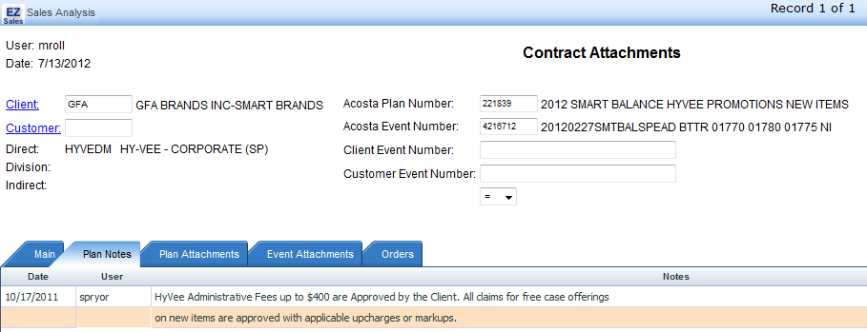
i
Plan Notes/Plan Attachments: Either the Plan Notes tab of the VPF or the document linked under the Plan Attachments tab of the VPF must approve Hy-Vee charging additional fees on top of the cost of the product.

For slotting free case offers, Hy-Vee adds a markup fee to the deduction. If the invoice amount and the claim amount do not match, and the deduction is for New Item/Slotting-Free Case Offered, the difference is the customer markup.

5.2 Customer Contract for Slotting Allowance, example 2 – Fast to First: Found via Search For: Event Scheduler.

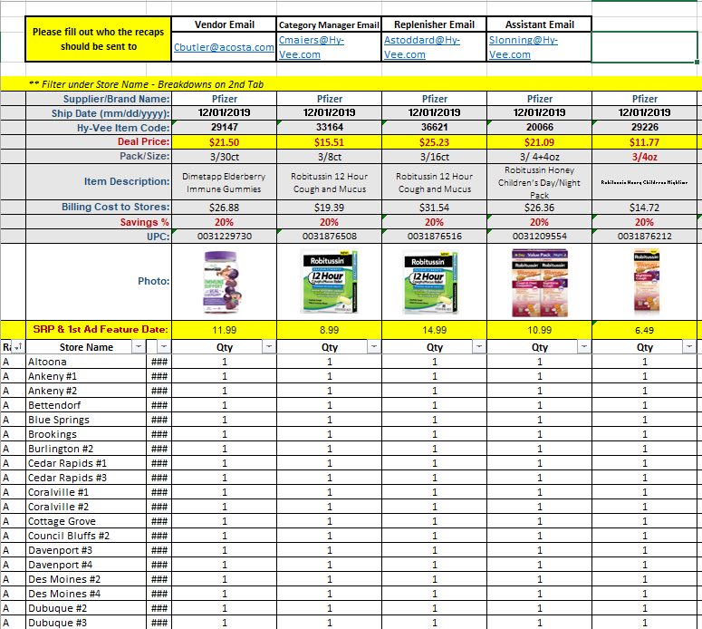
Deal Price/Billing Cost to Stores/Savings%: The Deal Price is how much Hy-Vee receives for the new item. This is based on calculating the Billing Cost to Stores by the Savings % and subtracting the total from the Billings Cost to Stores. Ex: Billing Cost $19.39 x 20% = $3.878. $19.39-$3.878 = $15.512 which was rounded to $15.51. Hy-Vee may choose to round up to the next penny ($15.52) when they deduct.
1
UPC Code: The product codes listed on the customer invoice must match the contract UPCs.

2

Refer to the SOPs/Generic Help File for POP requirements.

6 Deduction Type: Unsaleable (Spoils/Reclamations)

An unsaleable claim is taken for product that cannot be sold at the stores due to damages (and short coded product).

Documents required for validating an unsaleable claim:
Document Name | Source of the Document
Customer Invoice | ACOSTA Relay – search for the invoice under Backup Documentation, doc type 2 or doc type 8

6.1 Customer Invoice for Unsaleables/Damages, Example 1:

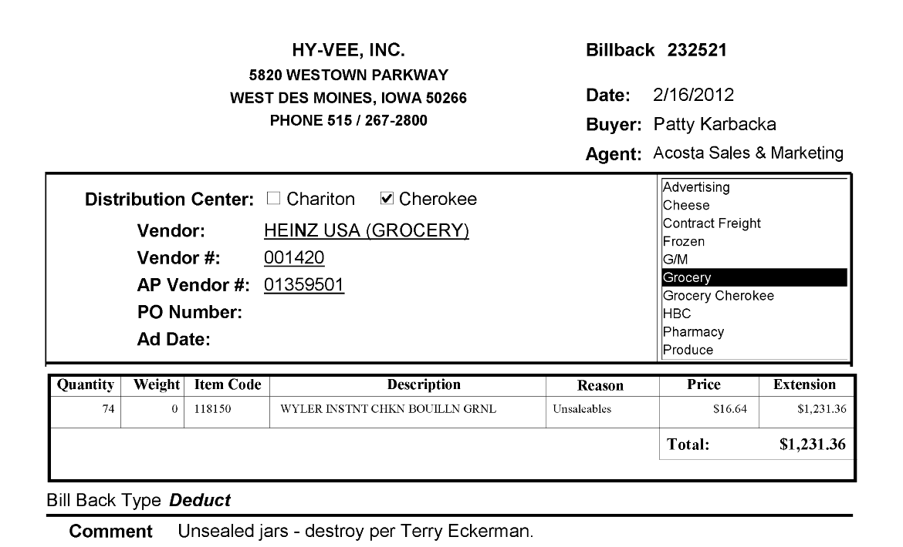
Reason: This identifies that the claim is for unsaleable product.
i

6.1 Customer Invoice for Unsalesable/Damages, Example 2:

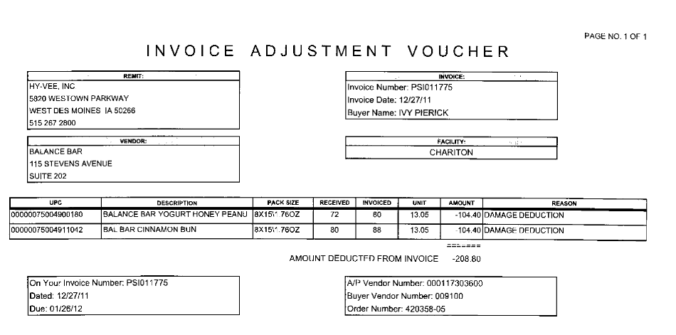
i
Reason: This identifies that the claim is for unsaleable product.

6.1 Customer Invoice for Unsalesable/Damages, Example 3:

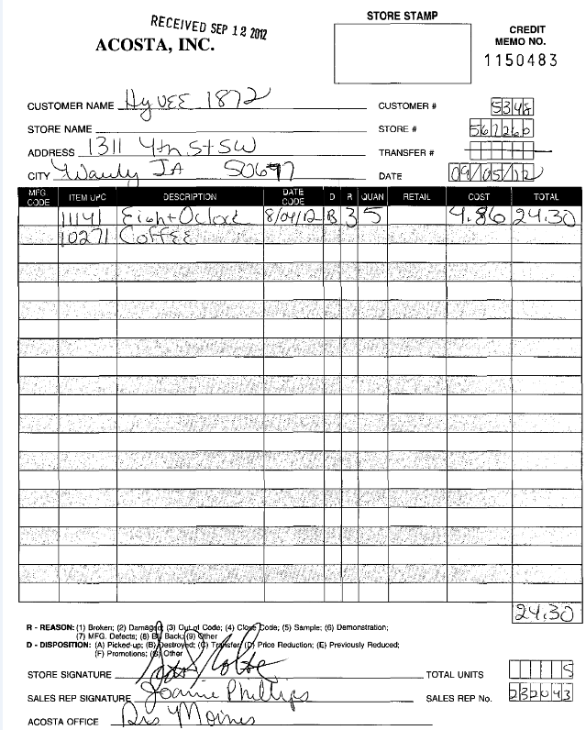
D & R (Reason and Disposition): The information in these fields identify that the claim is for unsaleable product. Refer to the key at the bottom of the invoice.
In this example, Disposition (D) = B, which is destroyed. Reason (R) = 3, which is out of code.
i

6.1 Customer Invoice for Unsalesable/Damages, Example 4 – Recalled Product:

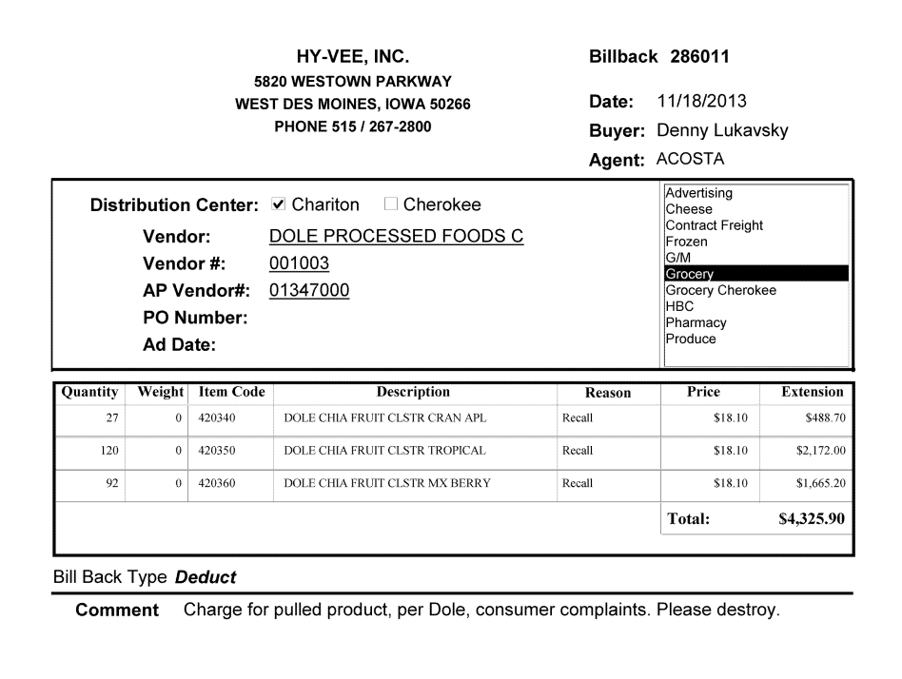
i
Reason: RECALL identifies that this claim is for product that was deemed unsaleable and recalled by the client..

6.1 Customer Invoice for Unsaleable/Damages, Example 5 – Outdated Product:

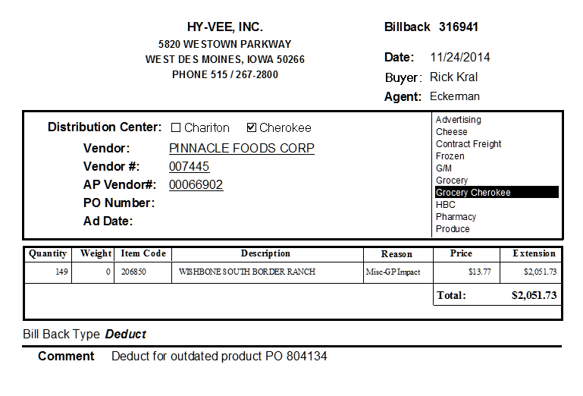
Reason: Misc, along with the Comment, show this claim is for product that was past its last sell-by date.
i

6.1 Customer Invoice for Unsaleable/Damages, Example 6 – PDI Short-dated Product:

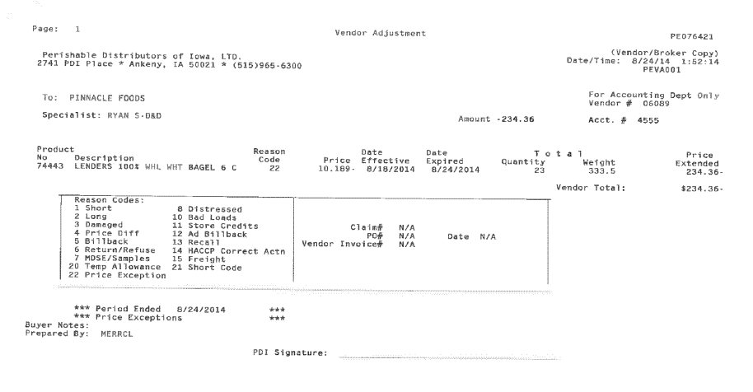
i
Reason Code: Compare the Reason Code above to the code chart below.

NOTE: PDI does not always strictly adhere to the Reason Code legend when creating customer invoices. Code 22 can be used for pricing, and for promotions, including slotting. Claims need to be stepped to sales for confirmation of what PDI is deducting for.

6.1 Customer Invoice for Unsaleable/Damages, Example 7 – Vendor Up/Down:

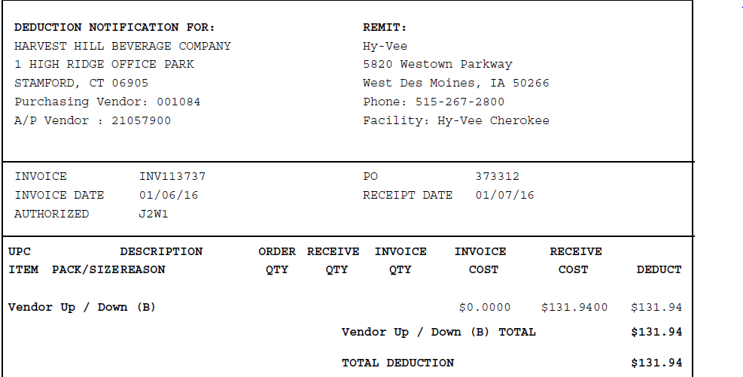
i
Reason: Swell allowance deducted against the client order invoice and customer PO shown on the customer invoice. Hy-Vee is deducting for a swell allowance not given on the COI.

Refer to the SOPs/Generic Help File for POP requirements.

7. Deduction Type: Service Fees/Penalty

A cost assessed by the customer for various reasons, including: handling, administrative, service and scan fees.

Documents required for validating a Fees claim

Document Name | Source of the Document | Action by Accenture
Customer Invoice | ACOSTA Relay – search for the invoice under Backup Documentation, document type 2 | Step the claim to Acosta for research.

7.1 Customer Invoice for ReposiTrak Fees: Hy-Vee’s policy document is imbedded below this invoice example.

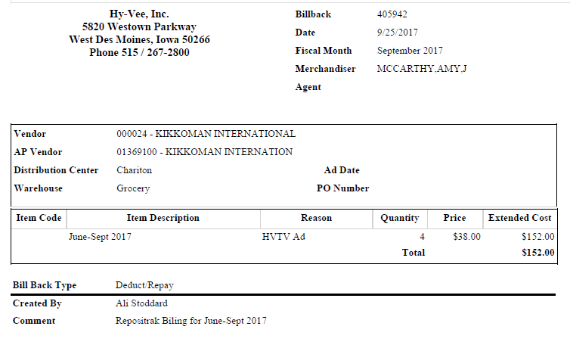

7.2 Customer Invoice for No Temp Trip Fees:
Perishable and frozen products must be transported on temperature controlled trucks. To assure proper transportation and quality, the temperature in the trucks that deliver the product needs to be monitored. Hy-Vee charges a fee if the truck does not have an automatic monitoring device (Temp Trip).

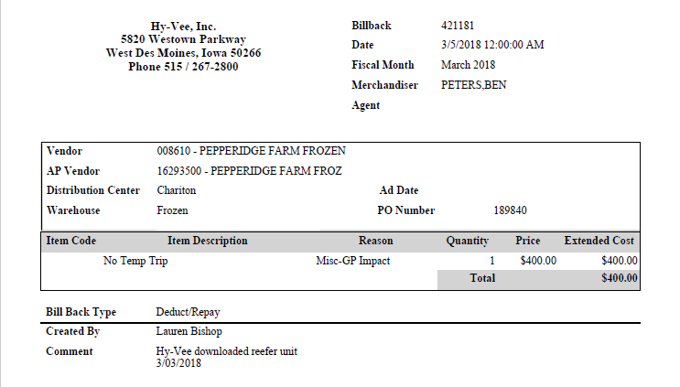

Hy-Vee policy for Late Loads:

Refer to the SOPs/Generic Help File for POP requirements.

7.3 Customer Invoice for No Show/Late Fees:
Considered a service fee and follows Generic Help as Non-Trade Fees.

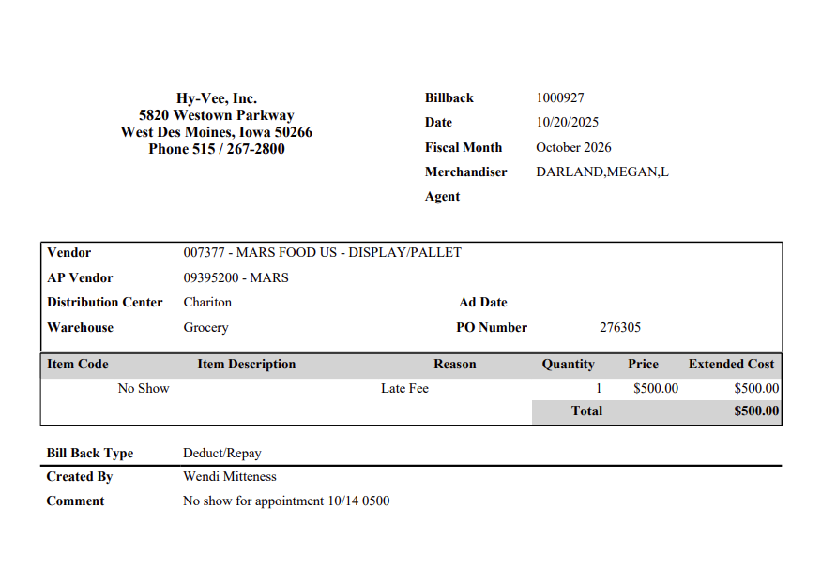

Refer to the SOPs/Generic Help File for POP requirements.
8. Deduction Type: Shortages

This is a deduction for shorted product that did not ship with the order but that the client billed the customer for.

Documents required for validating a Shortages Deduction:

Document Name | Source of the Document | Action by Accenture
Customer Invoice | ACOSTA Relay – search for the invoice under Backup Documentation, document type 2. | Step the claim to Acosta for research.
Client Order Invoice | ACOSTA Relay – search for this document within the Order/Invoice/PO search.

8.1 Customer Invoice for Shortages:
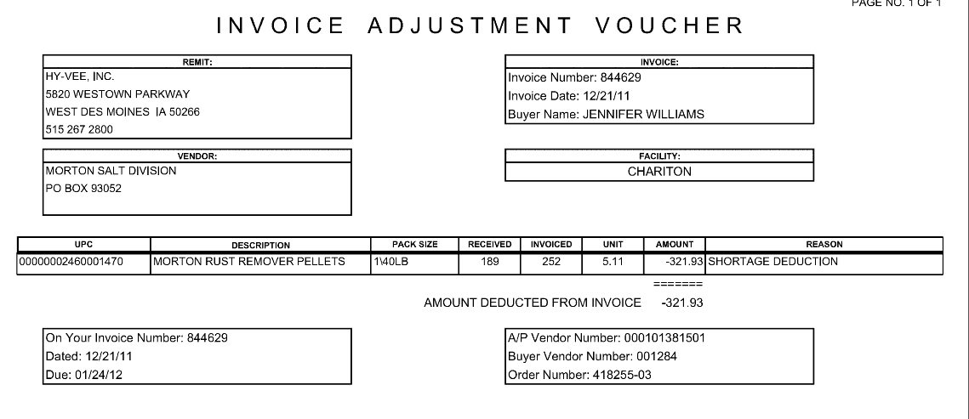
Invoice Number: This is both the customer reference number and the client order invoice number. This can be used to find the order in ACOSTA Relay.
Reason: This identifies that the claim is for shortage.
i
i
4
Invoice Number: The customer invoice references the client order invoice number.

Refer to the SOPs/Generic Help File for POP requirements.

9. Deduction Type: Post Audit

Internal and external auditors find claims that the customer is entitled to but did not take from previous years.

NOTE: The post audit claim must first be researched to ensure the customer has not already billed for the allowance before the normal validation process can begin.

Once the post audit claim has been researched to ensure the customer has not already billed for the allowance, refer to the appropriate allowance section of the SOP to continue with validation. If the post audit is for an allowance not defined in an allowance section of the SOP, refer to the post audit example for validation information.

Post Audit policies:

9.1 Customer Invoice for Post Audit, example 1:
i
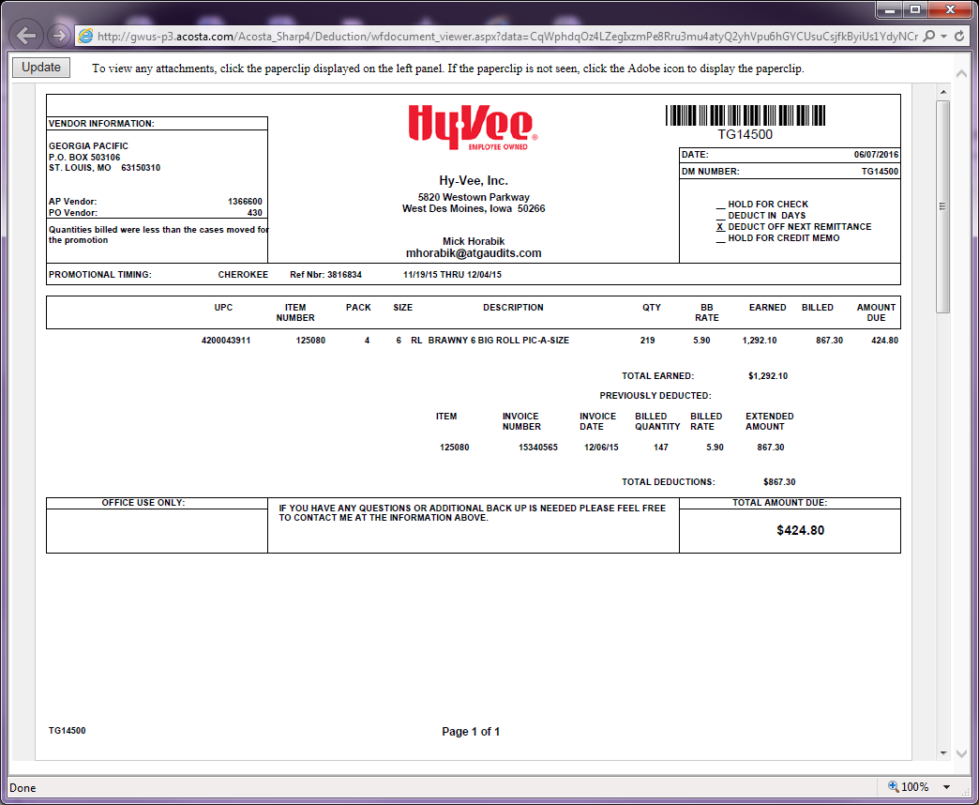
Additional information that helps identify this as a post audit deduction:
- A comment mentioning a previous billing discrepancy
- An e-mail address that contains the word audit
- Past dates
- A comment stating ‘previously deducted’
QTY: The quantity being claimed for the post audit.
i
Invoice #: Hy-Vee invoice numbers that start with TG are for Post Audit deductions.
Total Amount Due: This is the amount claimed by the customer for the post audit.
i
i

The invoice above will be followed by supporting documentation showing the details the auditor used to arrive at the post audit amount:

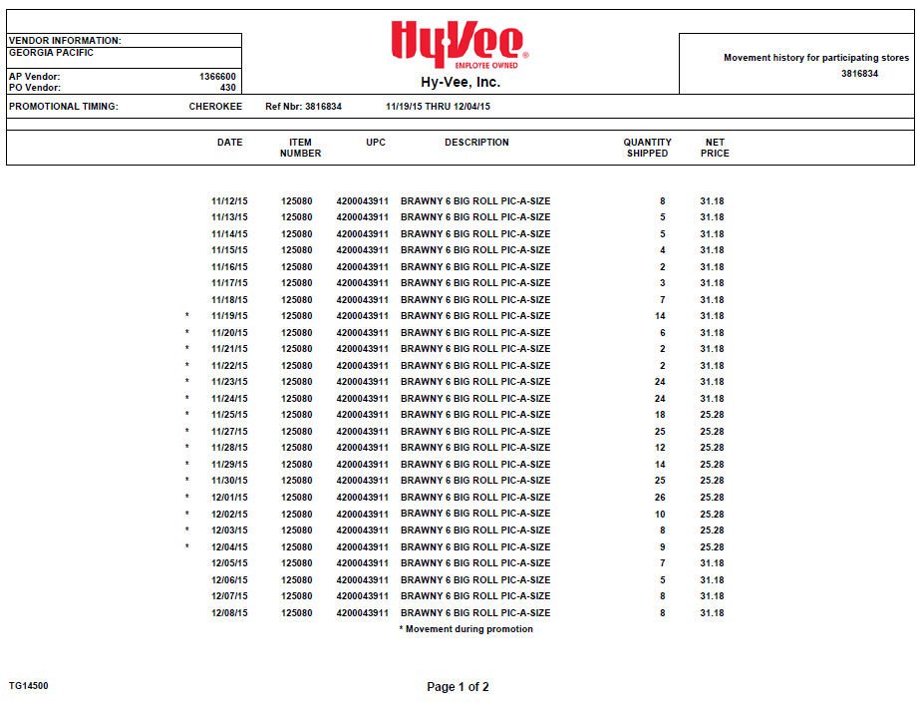
i
Quantities shipped: The * denotes the product being considered for the post audit.. The total of the * rows will equal the quantity claimed on the post audit cover sheet.

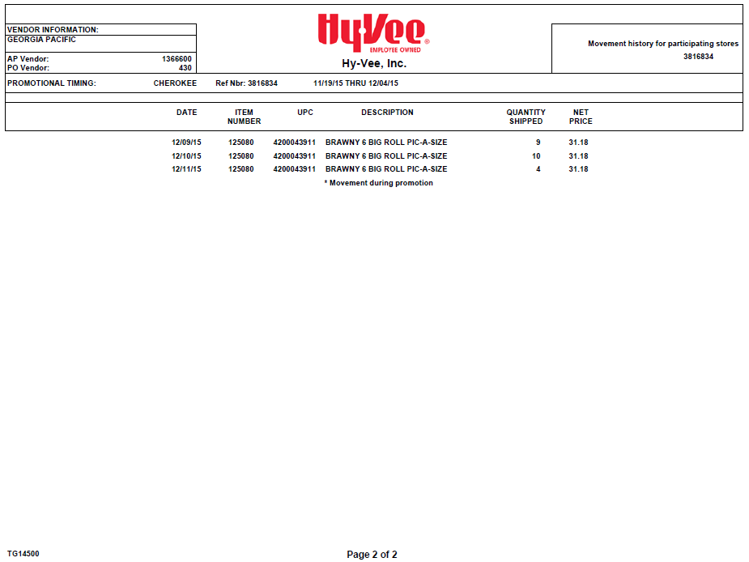

9.1 Customer Invoice for Post Audit, example 2:
Additional information that helps identify this as a post audit deduction:
- A comment mentioning a previous billing discrepancy
- An e-mail address that contains the word audit
- Past dates
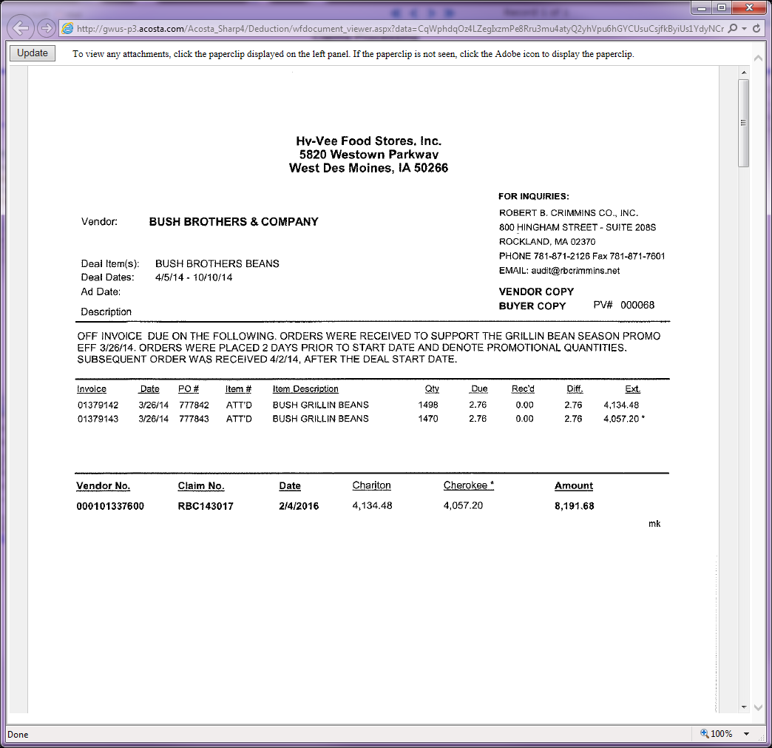
i
i
Claim No.: Hy-Vee invoice numbers that start with RBC are for Post Audit deductions.
i
Detail.: The quantity and rate being claimed for each PO considered by the auditor. This summarizes the detail on the following pages of the customer invoice.

The invoice above will be followed by supporting documentation showing the details the auditor used to arrive at the post audit amount:

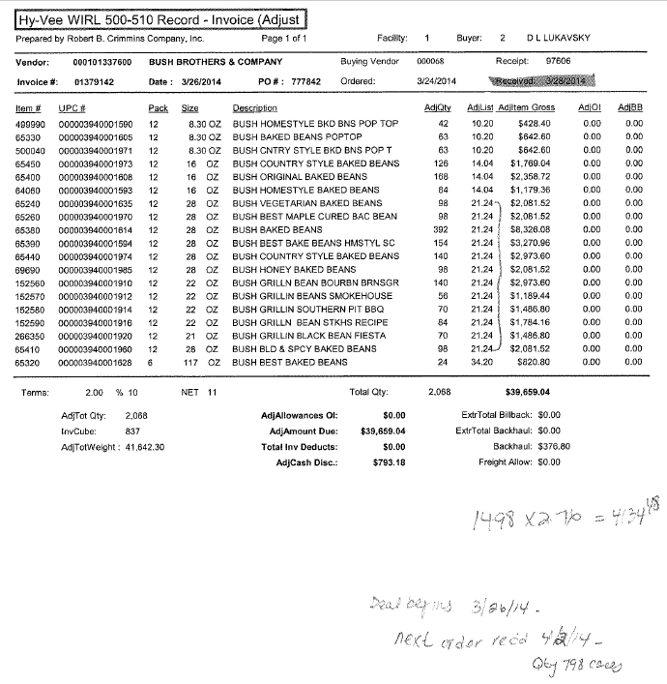
Detail.: The quantity for each UPC, and the handwritten notes from the auditor that went into the claim amount for the PO referenced at the top of the page.
In this example, the products being considered for the post audit are designated by a bracket.
i

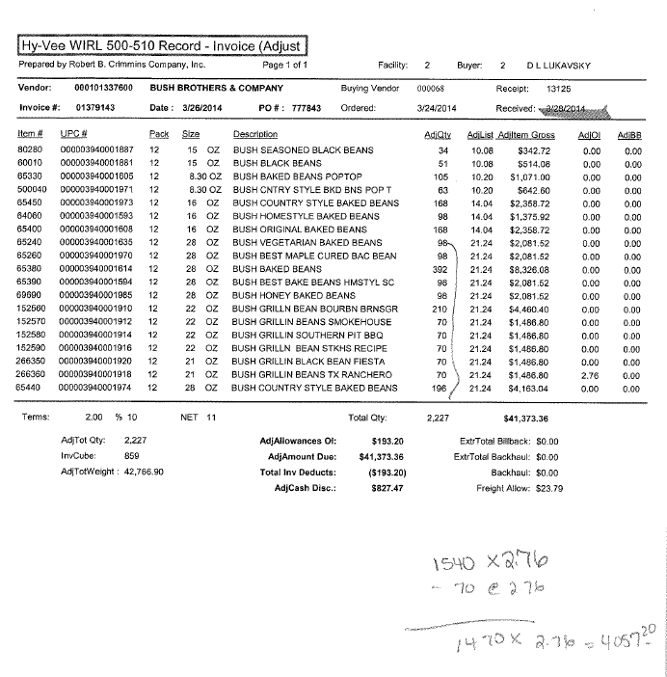
Detail.: The quantity for each UPC, and the handwritten notes from the auditor that went into the claim amount for the PO referenced at the top of the page. In this example, note that the above detail shows that $2.76 was received on UPC 01918, and at the right, those 70 cases are backed out of the total for the PO.
i

The auditor may include additional detail pages regarding the deal(s) that was running at the time. Unless those pages include quantity information, they do not need to be considered for validation.

Refer to the SOPs/Generic Help File for POP requirements.

10. Deduction Type: Scan

Scan allowances are for product scanned at the store register and are usually billed in eaches, not cases.

10.1 Customer Invoice for a Scan:

Page 1 (of 7 total)

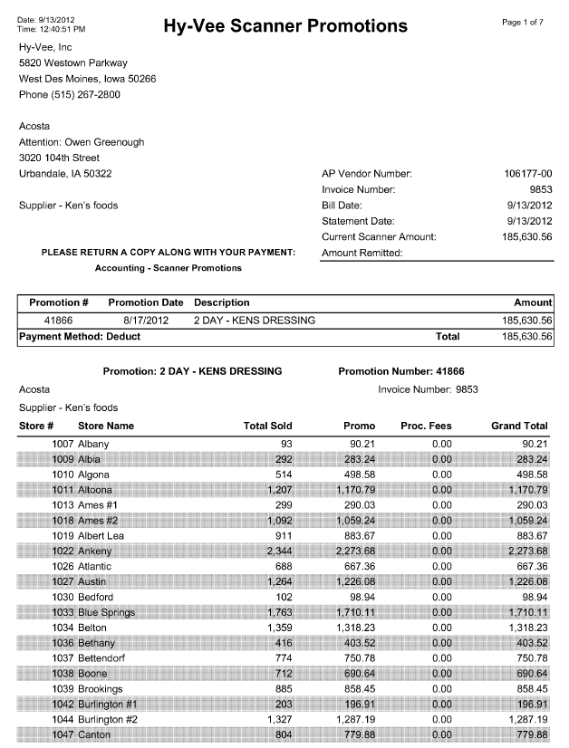
i
4
Promotion Date: The date claimed must fall within the dates on the customer contract.
Note: This is only a 2 day sale, running August 17-18.
Description: This is a general description of the items the scan allowance has been offered on. The contract will provide details of all the items.

Page 7 (of 7 total)

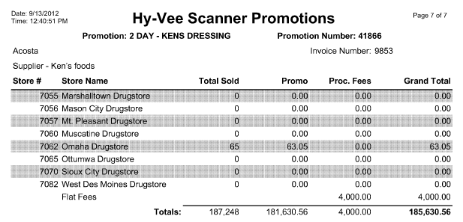
2
3
Promo: The total allowance amount the customer is deducting. Take the total allowance amount divided by the quantity to determine the per each scan rate they are claiming. (in this example: $181,630.56 divided by 187,248 = $.97 each)

The allowance rate on the invoice must match the rate listed on the contract.
Total Sold: The number of eaches/units that the customer is taking the scan allowance on.

10.2 Contract for a Scan: Found via Search for: Event Scheduler

Page 1
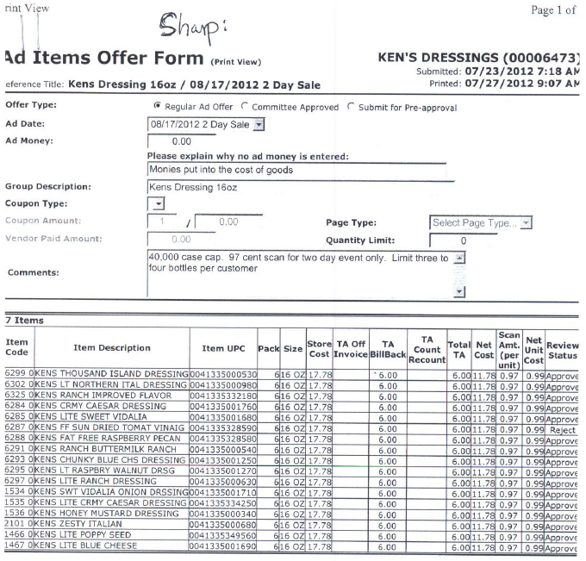
1
Item Code, Item Description, Item UPC: The product detail the scan allowance is being offered on..

2
Scan Amt. (per unit): The scan rate the customer is being offered.
i
Group Description: The product/product groups the scan allowance is being offered on.
4
Ad Date: This is the promotion period, and needs to match to the dates on the customer invoice.
Note: This is only a 2 day sale, starting on August 17.

NOTE: The customer invoice shows only units sold per store and will not provide quantity per UPC. If the contract has one rate and multiple events, escalate the claim for SOP gap. The CRA will need to submit an SOP ticket that provides client-specific instructions for how to breakout the claim by PPG.

Refer to the SOPs/Generic Help File for POP requirements.

11. Deduction Type: Pricing

A pricing deduction occurs when the customer's requested price on the original purchase order differs from the client's invoice.

Documents required for validating a Pricing claim
Document Name | Source of the Document | Action by Accenture
Customer Invoice | ACOSTA Relay – search for the invoice under Backup Documentation, document type 2. | Step the claim to Acosta for research
Order Invoice or Client Order Invoice | ACOSTA Relay – search for this document within the Order/Invoice/PO search.

11.1 Customer Invoice for Pricing:
i
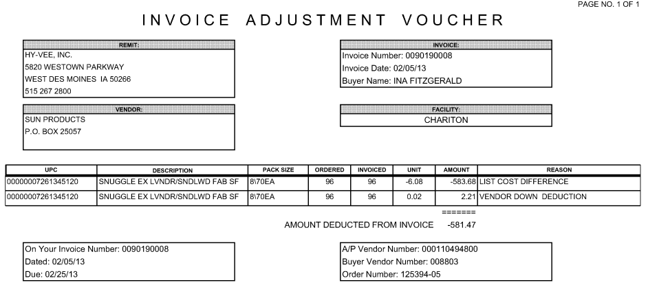
Reason: List Cost Difference Identifies that the claim is for pricing.
Invoice Number: This is both the customer reference number and the client order invoice number. This can be used to find the order in ACOSTA Relay.
i
i
i
Unit: The difference between the price the customer expected to pay and the price they were billed.
i
UPC: The product on the customer invoice needs to match the items on the client order invoice.
i
On Your Invoice Number: This is both the customer reference number and the client order invoice number. This can be used to find the order in ACOSTA Relay.
Order Number: The customer’s PO number, without the -05.

Refer to the SOPs/Generic Help File for POP requirements.

12. Food Show

12.1 Customer Invoice for Food Show Participation:

Hy-Vee generates two customer invoices for food show participation. NOTE: The customer invoices are indexed separately.

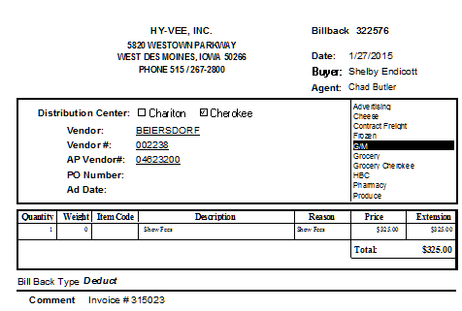
i
2
i
Vendor: The client being billed for participating in the food show.

Description/Reason: Identifies that this is a food show claim.

i
PRICE: The amount the customer is claiming for the client’s participation in their food show. This amount must match the amount on the contract.

Comment: This customer invoice does not provide the dates for the food show. To identify the food show dates, you must search for and link an additional customer invoice with the Invoice # shown in the Comment section. (See next page.)

12.2 Customer Invoice for Food Show Participation:
i
Invoice Number: This customer invoice provides the dates for the food show. Search for this customer invoice using the Invoice # shown in the Comment section of the other customer invoice as shown in the example above.

Hy-Vee generates two customer invoices for food show participation. NOTE: The customer invoices are indexed separately.

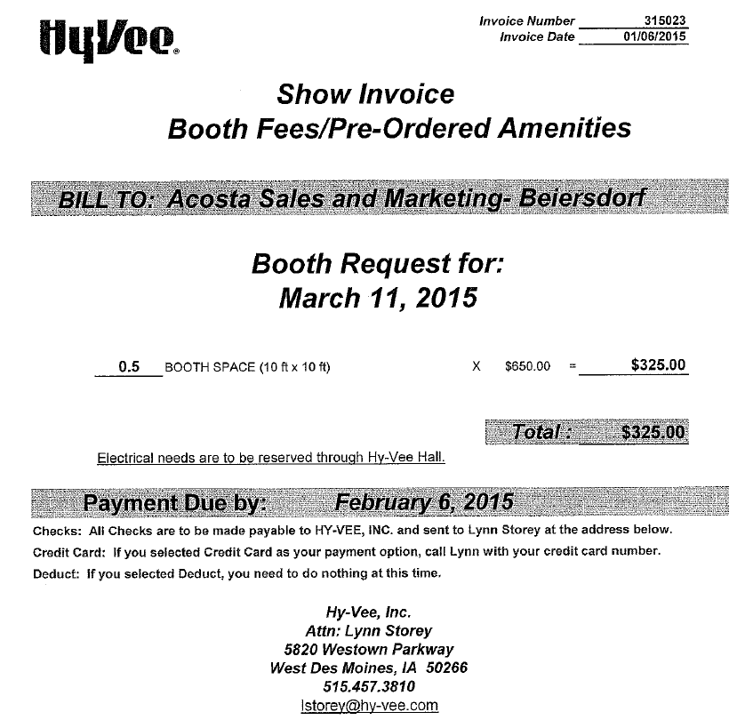
2
Booth Request for [date]: This provides the date for the food show. The date shown on the customer invoices must coincide with the contract date.

3
i
BILL TO: The name of the client being billed for participating in the food show.

TOTAL: The amount the customer is claiming for the client’s participation in their food show. This amount must match the contract.

12.3 Customer Invoice for Food Show Participation:
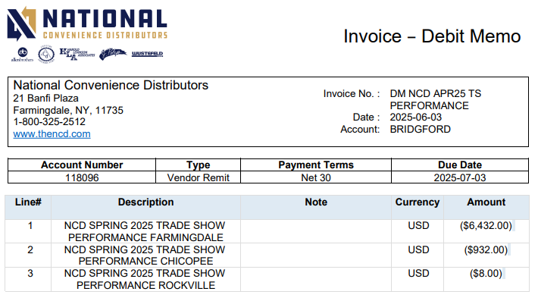
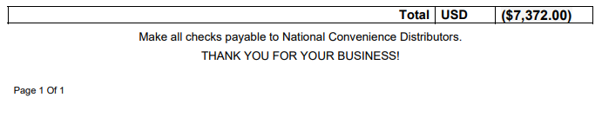
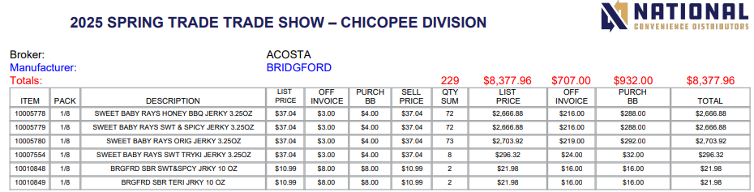

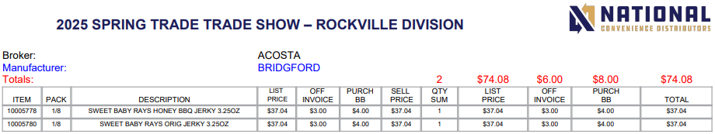
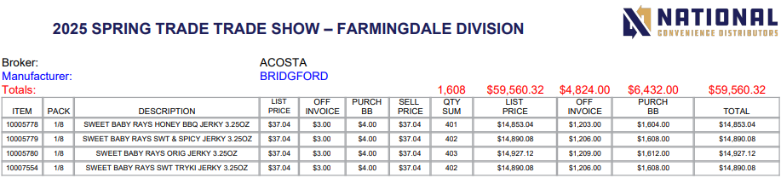

12.1 Contract for Food Show participation: Found via Search For: Event Scheduler.

3
i
March 2015 HBC Show: This provides the date for the food show. The date shown on the customer invoices must coincide with this date.

The name of the client being billed for participating in the food show.

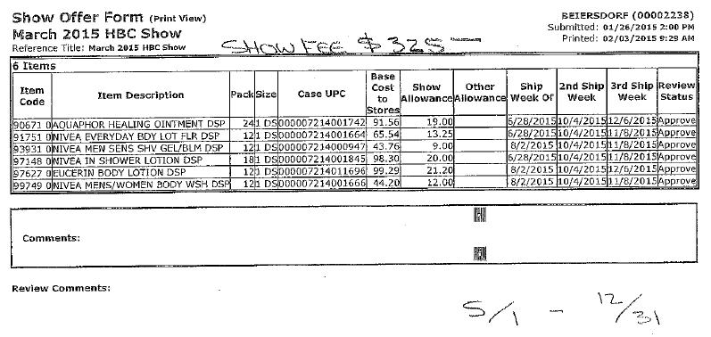
While product detail is provided on the contract, it is not necessary for validation of the booth fee charge.

2
1
Show Fee: The amount the customer is offered for the client’s participation in their food show. This amount must match the customer invoices.

Refer to the SOPs/Generic Help File for POP requirements.

13.1 Customer Invoice for Other (Supplier Relations/Funded.Marketing Support Agreement) claim:

The Supplier Relations program is a special program that clients may partcipate in. Claims can come in as deductions or check requests and may reference Supplier Relations or simply state “Funded” in the invoice detail.

13.1 Invoice Example #1:

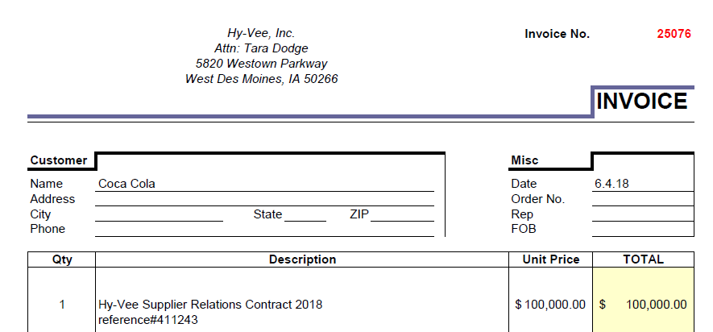

13.1 Invoice Example #2:

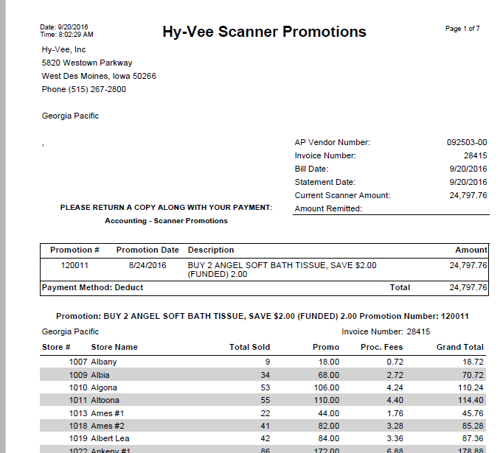

13.Contract for Other (Supplier Relations/Funded.Marketing Support Agreement) claim: An agreement will be available as a contract for each client participating in the program. The agreement outlines the terms of the deal.

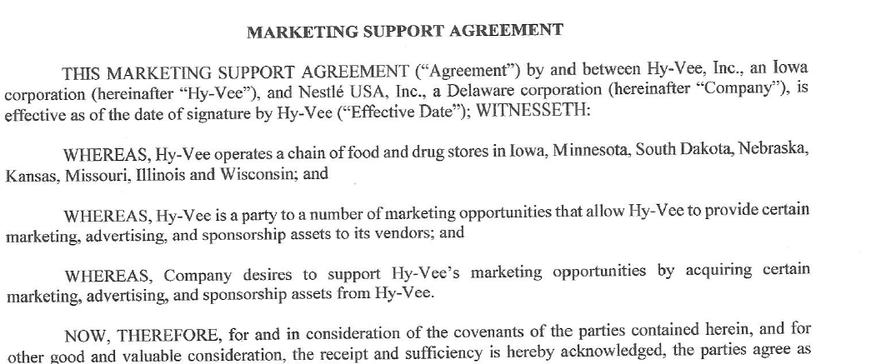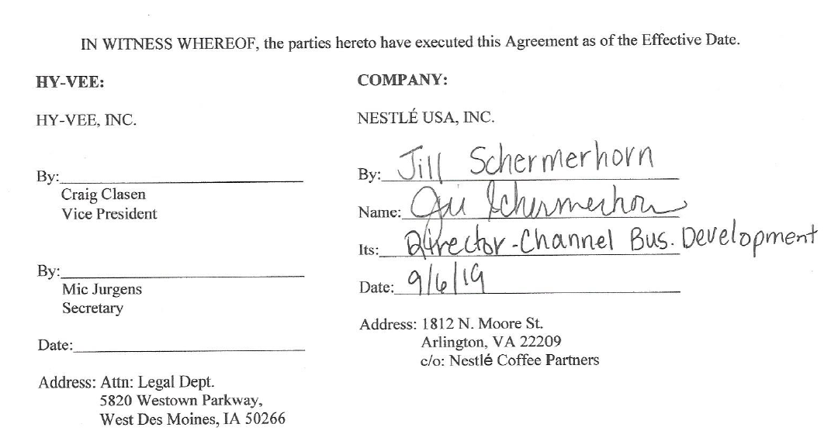
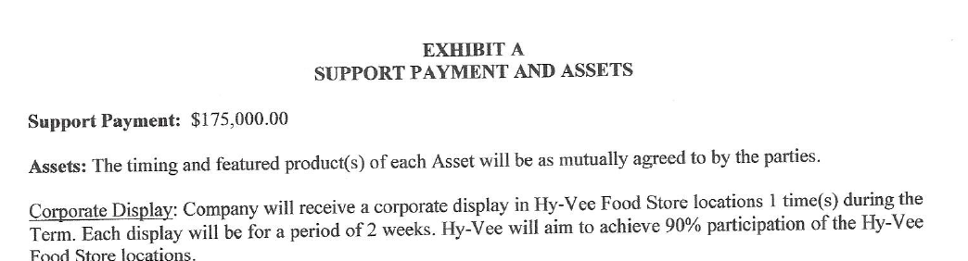
14.1 Customer Invoice for Returned Product:

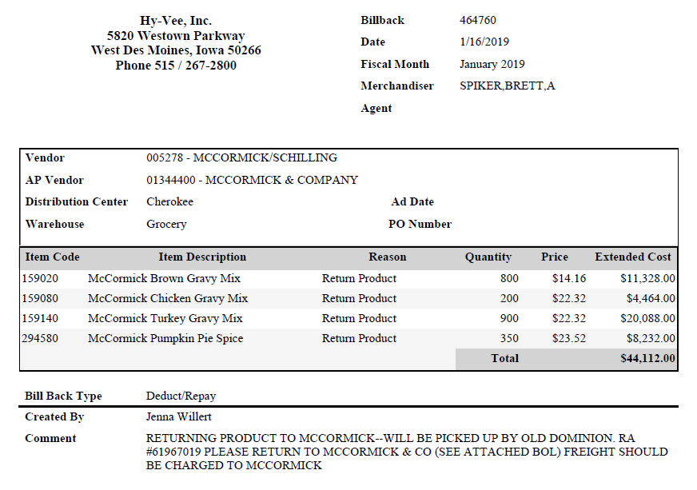
i
Returning Product: This indicates that Hy-Vee is deducting for product that was sent back to the client.

15. Deduction Type: Freight/Backual

This is a deduction for product received over what the client billed the customer for.

A Freight allowance is given to the customer for picking up the product via their own transportation services.

Document Name | Source of the Document | Action by Accenture
Customer Invoice | SHARP – search for the invoice under Backup Documentation, document type 2. | Step up the claim to Acosta for research
Client Order Invoice | SHARP – search for this document within the Order/Invoice/PO search.

Hy-Vee will group missed OI on cut product claims in under freight on their invoice. The claim will need to be researched for the possible OI issue before coding it as freight.

15.1 Customer Invoice for Freight, Example 1:
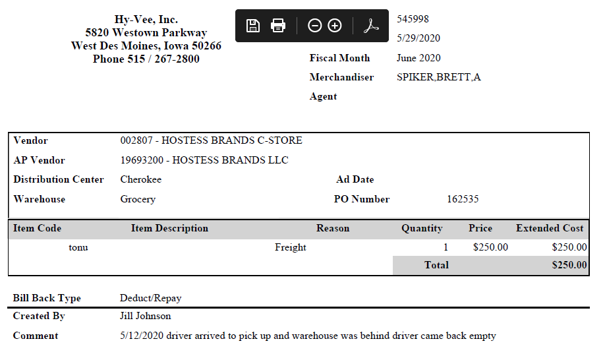
i
Explains the reason for the freight claim.
Identifies the claim as being for Freight.

i

15.1 Customer Invoice for Freight, Example 2:

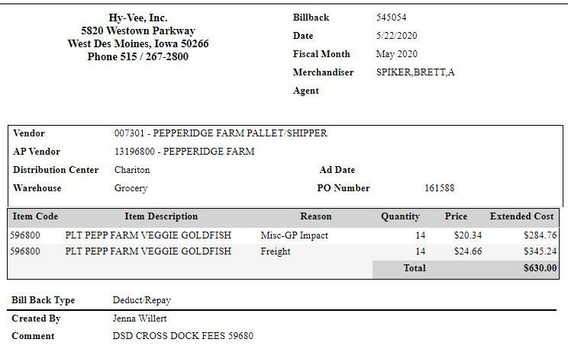
Cross Dock fees – charges for Hy-Vee moving pallets from their distribution center to their stores.
i
16. Deduction Type: Other (Non Trade) (Overages)

This is a deduction for product received over what the client billed the customer for.

16.1 Customer Invoice for Overages:

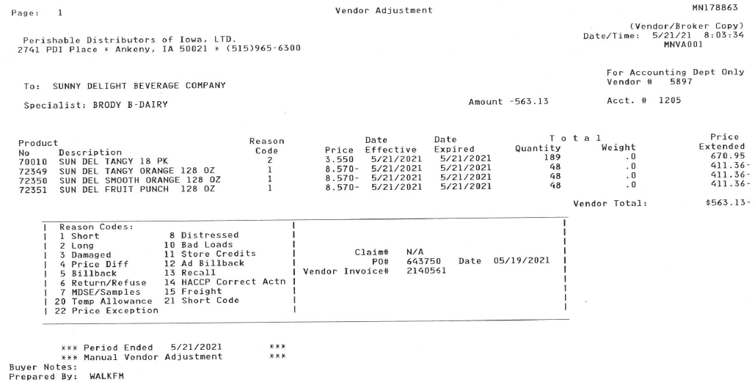
Reason code 2 – Long is for Overages. Product received in excess of what the customer billed for. This will appear as a credit on the invoice and will offset any deductions taken against the client order invoice.
i

BPS TEAM INFORMATION

CRA VALIDATION SPECIFIC

CRA Client Specific

CCA CLEARING INFORMATION SPECIFIC

CCA Client Specific

COMPLETE VERSION HISTORY
UPDATE DESCRIPTION | DATE |  | AUTHOR
First draft of the Hy-Vee SOP |  | 4/27/2012 |  | Prathima Sriram
Updated by Michelle |  | 7/12/2012 |  | Michelle Roll
Update IRI/Nielsen information for price point pg 2 |  | 9/11/2012 |  | Rick Smith
Updated hyperlinks to deduction types |  | 9/16/2012 |  | Nagesh Kumar
Updated Invoice Example for Unsaleables/Damages |  | 10/05/2012 |  | Michelle Roll
Updated slotting section to reflect free case & upcharge fee and added a BB example |  | 10/16/2012 |  | Kristin Jones
Updated/fixed Ad copy example |  | 11/13/2012 |  | Michelle Roll
Added Coupon Examples |  | 11/16/2012 |  | Michelle Roll
Added a new count-recount example, different invoice and contract example; Added scan example; Separated Count/recount from Scan example |  | 4/1/2013 |  | Michelle Roll
Added details about Clorox bills being displayed as a pallet rate on the invoice and an each rate on the contract (2499); Added Pricing example (2119); Added 3rd billback example – diff inv type (2161) |  | 4/15/2013 |  | Michelle Roll
General edits. Added example for prebook order deductions to billback section and to client specific section (3322). |  | 6/3/2013 |  | Suzy Fields
General edits. Updated instruction on cross-referencing customer code to UPC (3247) |  | 6/10/2013 |  | Suzy Fields
Added note that HyVee corporate always deducts and only check requests are for indirect BBs (4572); moved Client Specific section in front of OI section; added 2nd ad claim example with instructions for determining actual ad date (2817, 5169); added note clarifying “week ending” customer invoices (5126) |  | 09/02/2013 |  | Suzy Fields
Added link to customer sign-on job aid (5675); added link to National PA Toolbox |  | 10/04/2013 |  | Suzy Fields
Included explanation in scan section on how to process claim with multiple event #s (5768) |  | 11/11/2013 |  | Suzy Fields
Added direction to search for all documentation under both HYVEDM and PERIDM (5643); updated Toolbox info-no exceptions |  | 11/25/2013 |  | Suzy Fields
Added Dole specific direction on fees for DBW (5470); added recall customer invoice example to Unsaleables section (6301); added P&G process to client specific section (5320); added new example of CRC customer invoice and contract (6921) |  | 2/17/2014 |  | Suzy Fields
Updated info for additional sign-ons; explanation of Hy-Vee “term” (5887) |  | 5/26/2014 |  | Suzy Fields
Updates for focus customer: contract formats, suggested ad date/when ad actually runs, types of ads, “prebook” definition, claim reason “special price”, time frame to receive backup, offers apply to both divisions/warehouses,”billback” on customer invoice vs deduction type, (8609); explanation of Markup fee on slotting claims (7990) |  | 5/30/2014 |  | Suzy Fields
Added explanation of E-Buy offer to Notes section and example to CRC section (9202); updated references to search for promotions to say search for: Event Scheduler. |  | 9/1/2014 |  | Suzy Fields
Removed Procter & Gamble (PRODUR) process direction from client specific section (10277) |  | 10/27/2014 |  | Suzy Fields
Added general note regarding date revisions on Hy-Vee contracts (11292) |  | 12/8/2014 |  | Suzy Fields
Client Specific Section: added Sun Products 2015 event info (12008); Created CCA Info section and added Ebro approval to clear across brands for one promotion (12355); added example of PDI short code dated unsaleable claim (12265); added explanation of dates on HyVee flyer and contract requirements (12562) |  | 3/2/2015 |  | Suzy Fields
Client Specific section: added admin fee process for GAPAC (12694); added Georgia Pacific instruction for DSD charges (13006) |  | 3/30/2015 |  | Suzy Fields
Client Specific section: added Nestle POP instructions (13121); added Beiersdorf Fee clearing direction (13246); updated validity code references to reflect 4.1 system change (13197) |  | 4/13/2015 |  | Suzy Fields
Client Specific section and CCA section: added Pinnacle process for claims outside of deal dates (13344); updated instruction about PDI invoice codes in section 6.6 (13412); added information on customer type (13429) |  | 4/27/2015 |  | Suzy Fields
Added Food Show section/example (13453) |  | 5/11/2015 |  | Suzy Fields
Added BPS Team Information section; added CIT backup process; moved CCA section to subsection under BPS Team section (13772) |  | 5/25/2015 |  | Suzy Fields
Removed Beiersdorf info as Acosta no longer brokers effective 6.1.15 (14054) |  | 6/8/2015 |  | Suzy Fields
Added example of new Hy-Vee contract format to general notes section (14690) |  | 8/3/2015 |  | Suzy Fields
Cleanup and reorganization of information, removed Display section because example was for a billback (14730); clarified backup request process (15104) |  | 9/14/2015 |  | Suzy Fields
Added line level detail statement to Customer General Info section (15509) |  | 10/26/2015 |  | Suzy Fields
Contract Info section: Added updated example and explanation for flyers used as contracts (15653) |  | 10/26/2015 |  | Suzy Fields
Contract Info section: Added callout to review Deal Type on Supplier Hub contract example #3 (15849) |  | 12/7/2015 |  | Suzy Fields
BPS Team Information Section: Added CRA Client Specific section; Added process steps for Georgia Pacific backup requests (15657) |  | 12/21/2015 |  | Suzy Fields
Client specific section: Old Orchard closed claim feed process (16419); added example of Vendor Up/Down invoice to Unsaleables section (16583) |  | 2/1/2016 |  | Suzy Fields
Client specific section: added Heinz fee instruction (17215); removed client manager step information (17130) |  | 3/14/2016 |  | Suzy Fields
Removed Ebro from CCA Client Specific section (17640) |  | 4/11/2016 |  | Suzy Fields
Moved backup up request info to BPS section and clarified CRA direction (18084) |  | 5/23/2016 |  | Suzy Fields
Removed flyer examples and updated note that flyer can no longer be used as a contract. (18450) |  | 6/20/2016 |  | Suzy Fields
Client specific section: Added admin fee instruction for Barilla (18069) |  | 7/4/2016 |  | Suzy Fields
Client specific section: Updated stepping instruction for Old Orchard (18663) |  | 7/18/2016 |  | Suzy Fields
Post Audit section-update header and customer invoice examples (19056); Client speciric section: removed Heinz information (19311) |  | 8/29/2016 |  | Suzy Fields
Client specific section: added date shift info (19318) |  | 9/12/2016 |  | Suzy Fields
Post audit section: updated instructions and examples (19056) |  | 9/26/2016 |  | Suzy Fields
Removed extra contract examples and POP examples (19418) |  | 10/10/2016 |  | Suzy Fields
Added backup request contact info for post audit invoices to BPS Team Information section (19657) |  | 11/7//2016 |  | Suzy Fields
General info section: explanation on use of plan notes/ plan attachments; Slotting section: clarification on CI and contract verbiage, plan notes/plan attachments (21041) |  | 3/27/2017 |  | Suzy Fields
Client information section and BPS/CCA section: Updated Pinnacle processing information (21049) |  | 3/31/2017 |  | Suzy Fields
Client specific section and BPS/CCA client specific section: Updated Barilla processing information for admin fees (21067); Shopper Marketing Funds section added and GP Shopper Marketing Funds added to client specific section (21142) |  | 4/10/2017 |  | Suzy Fields
Added info on missed OI on cut product claims to general info and OI sections (21396); updated CIT information to GCIT (21433) ); updated Nestle name to Nestle Nutrition_C-Store (21471) |  | 5/8/2017 |  | Suzy Fields
Removed Sun Products information from client specific section (21793) |  | 6/19/2017 |  | Suzy Fields
Client specific section: added direction on Harvest Hill claims for missed OI on cut product (22037) |  | 7/17/2017 |  | Suzy Fields
Client specific section: Updated Nestle Nutrition C Store reports location (22521); 1/30/2018 – updated hyperlink to Customer Sign-on Job Aid (23751) |  | 9/11/2017 |  | Suzy Fields
Fees/Penalty section: added ReposiTrak example and Hy-Vee letter to clients; client specific section: added Kikkoman/ReposiTrak instruction (23792) |  | 3/12/2018 |  | Suzy Fields
Fees/Penalty section: added example of Temp Trip Device customer invoice; Client specific section: Campbell’s/Pepperidge Farm - Added instructions for Temp Trip Device/No Temp Trip claims (24358) |  | 4/23/2018 |  | Suzy Fields
Client Specific section: added Bic instruction for Repositrack fees (24581) |  | 6/18/2018 |  | Suzy Fields
Client Specific section: updated Nestle shipment report info (25026) |  | 7/2/2018 |  | Suzy Fields
Customer General Info section: updated check request info to include Supplier Relations Partnership fees (25031); Client Specific section: added Coca Cola and payment direction for Supplier Relations Partnership fees (25031) |  | 7/16/2018 |  | Suzy Fields
Client Specific section: added Barilla swell allowance info (25270) |  | 7/30/2018 |  | Suzy Fields
Update to customer backup request information/realignment of information; no process change. Client specific section: added Ainsworth and stepping instructions for RTC claims. (25335); added Bic instruction for Hot Deal claims (25277) |  | 8/13/2018 |  | Suzy Fields
Updated contract and processing info on Cross Network Program (prebook) claims (25592) |  | 8/27/2018 |  | Suzy Fields
Added Fuel Saver rate calculation info to Customer Invoice section (25445) |  | 9/24/2018 |  | Suzy Fields
Client specific section: added Coca Cola fee process (25978) |  | 10/8/2018 |  | Suzy Fields
Removed reference to Doc Type 5 |  | 10/12/2018 |  | Suzy Fields
Client specific section: Coca Cola date flexibility (26126) |  | 11/5/2018 |  | Suzy Fields
Client specific section: Added Colgate DBW instructions (26291) |  | 11/19/2018 |  | Suzy Fields
Client specific section: Removed Nestle Nutrition and spin requirement (26580) |  | 12/17/2018 |  | Suzy Fields
Client specific section: Removed McCormick (26829) |  | 2/13/2019 |  | Suzy Fields
Updated IRI/Nielsen subscription info (27097) |  | 2/15/2019 |  | Suzy Fields
Ad section: Added example of Hy-Vee Perishable Distributors invoice (26859) |  | 2/25/2019 |  | Suzy Fields
Client specific section: Removed Georgia Pacific as Acosta no longer handles for Hy-Vee (27298) |  | 2/28/2019 |  | Suzy Fields
Added section for returned product (27105) |  | 3/11/2019 |  | Suzy Fields
Client Specific section: Added IRI info for Campbell’s/Pepperidge Farm (27266). Fee section: Imbedded Late Loads 2019 fee schedule (27437) |  | 3/25/2019 |  | Suzy Fields
Off Invoice section: Added example of customer invoice for OI taken on shorted product (27726); Removed Ainsworth Pet as we no longer represent (27796)  Client specific section: Removed Clorox as we no longer represent (28157) |  | 5/20/2019  7/1/2019 |  | Suzy Fields
Customer General Info section: Added explanation of Hy-Vee’s fiscal month billings; removed survey info from General Info Contract section. Warehouse Withdrawal/Count Recount section: Updated CI example and updated contract (flyer/survey) example. (28270) |  | 7/29/2019 |  | Suzy Fields
Removed Pinnacle specific information, as we no longer handle effective 8/26/2019 (28434) |  | 8/26/2019 |  | Suzy Fields
Backup Retrieval Information section added (28861) |  | 11/4/2019 |  | Suzy Fields
Backup Retrieval section: updated to say that there is a portal for certain deduction backup (29028). Client Specific section: added Colgate WOW Buy instruction (28941) |  | 12/16/2019 |  | Suzy Fields
Client Specific section: added Newell WOW Buy instruction (29196); removed Old Orchard, as Acosta no longer represents (28915) |  | 2/10/2020 |  | Suzy Fields
Client Specific section: removed Bic information as Acosta no longer represents (29499); removed Colgate information as Acosta no longer represents (29496) |  | 2/24/2020 |  | Suzy Fields
General edits throughout; Added Fast to First to slotting section; updated document examples; updated Lomar sign-on (29939) |  | 4/20/2020 |  | Suzy Fields
In Customer General Info/Customer Invoice, added check remit codes (30277). In CRC section, added example 7 for Store preorder information contract and updated example 4 w/ callout boxes (30308). Re-termed Shopper Marketing section (13), cleaned up General info – moved various info to appropriate sections, added Bush, Nestle Coffee, and Hostess sections, updated Barilla section for Supplier Relations, added Freight section (30437). |  | 6/29/2020 |  | Kristin Jones
Added 2nd Freight/Backhual example for Misc-GP Impact/Crossdock Fees (30518). In Backup Retrieval, updated info about check remit (30576). |  | 7/27/2020 |  | Kristin Jones
In Barilla section, updated event info for admin fees (30605). |  | 8/10/2020 |  | Kristin Jones
In BPS/CCA section, removed Barilla info (30892). |  | 10/05/2020 |  | Kristin Jones
Added Lomar & PDI to the SOP name & File name (31127). In Coke section, removed info about promo fees (31046). In Slotting, 2nd contract example, updated the rate explanation (31088). |  | 11/02/2020 |  | Kristin Jones
In customer sign-on box, added claim sign-ons for PDI & Lomar (31187). |  | 11/16/2020 |  | Kristin Jones
In Campbell’s section, added info for Repositrak fees (31265). |  | 01/04/2021 |  | Kristin Jones
In CRC section, added ‘promotional’ in front of ‘fees’ at beginning fee info. Renamed Fees/Penalty section to Service Fees/Penalty & removed first invoice example (31388) |  | 01/25/2021 |  | Kristin Jones
Updated CRC section w/ PDI invoice & contract (Add Offer) examples (31518). |  | 02/08/2021 |  | Kristin Jones
Updated Nielsen question to Yes (32107). |  | 05/17/2021 |  | Kristin Jones
Created section 16 – Other Non Trade Overages (32472). |  | 08/09/2021 |  | Kristin Jones
In Campbell’s section, added cross dock fee info (32731). |  | 10/18/2021 |  | Kristin Jones
In Client Specific section, added Cargill (33019). |  | 01/24/2022 |  | Kristin Jones
Added Mars Wrigley specific section (33205). |  | 02/21/2022 |  | Kristin Jones
Added Campbell’s specific for Pacific/Lomar claims (33193). |  | 03/07/2022 |  | Kristin Jones
In Freight section, removed call out to GP-Impact (33476). |  | 04/25/2022 |  | Kristin Jones
In Customer General Information under the Contract Info section, Ad Offers, Store Pre-Orders and Future Deals contracts will now be pulled for Pending, Approved and Finalized statuses, added examples of Pending status (34841). |  | 05/08/2023 |  | Aimee Porritt
In Customer General Information under the Other General Information section, added Price Increase Lead Time policy (34989). |  | 07/03/2023 |  | Aimee Porritt
In the Client Specific Validation Information section under Dole, added Repositrak fees are cleared to a Client Event # (35822). |  | 01/15/2024 |  | Aimee Porritt
In the Client Specific Validation Information section under Nestle Coffee Partners, added Hy-Vee Starbucks vendor # that Acosta handles, Hy-Vee PDI Starbucks vendor # that Acosta does not clear, and Acosta doesn’t handle any ready to drink items information (36063). |  | 03/11/2024 |  | Aimee Porritt
In the Client Specific Validation Information section under Nestle Coffee Partners, added Starbuck Quarterly Swell are considered trade and cleared with an event/contract. Code as Trade/Other and clear to event (36207). |  | 03/18/2024 |  | Aimee Porritt
Client Specific Information for Dole updated information on Admin Fees. (392825) |  | 8/5/24 |  | Mary Kay Dressman
Removed Hosess from the Client Specific section. (402814) |  | 10/14/2024 |  | Pam Jaeger
Updated the admin fee event for Barilla (406935), updated the JMS section to include PO information (407427). |  | 1/6/2025 |  | Katie Teare
Added information for JM Smuckers in Client Specific Section (415747). |  | 2/24/2025 |  | Dawn Regan
JM Smucker client-specific: added validation instructions for PO-related claims. (424922). |  | 5/12/2025 |  | Michael Huml
Added Trade Show (Food Show) invoice example. (428612) |  | 6/16/2025 |  | Michael Huml
JM Smucker client-specific: added instructions for invoices with verbiage, “deduct shortage.”. (433545) |  | 7/21/2025 |  | Michael Huml
JM Smucker client-specific: POP issues with FHS and Coffee items are approved to clear without getting sales approval. (438228) |  | 8/25/2025 |  | Michael Huml
JM Smucker client-specific: client approves clearing of claims with invoices beginning with “1” with insufficient POP. (439329) |  | 9/1/2025 |  | Michael Huml
JM Smucker client-specific: added instructions for searching for claims in HR and identifying multiple records. (440370) |  | 9/15/2025 |  | Michael Huml
Newell client-specific: added information pertaining to date flexibility. (440858) |  | 9/22/2025 |  | Michael Huml
Edgewell client-specific: added instruction for Edgewell Red Media claims. (446024) |  | 10/27/2025 |  | Michael Huml
Added service fee invoice example. (450741) |  | 12/8/2025 |  | Michael Huml
Red Media and Supplier Relations are the same. Added invoice and contract examples. (462148) |  | 3/16/2025 |  | Michael Huml
Newell client-specific: markdowns do not require a contract. (464262) |  | 4/6/2026 |  | Michael Huml

