WORK INSTRUCTIONS

Process | Order to Cash
DTP Name | K-V-A-T Food Stores Claims Validation Documents

VERSION HISTORY
UPDATE DESCRIPTION | DATE | AUTHOR
Added Customer Invoice information regarding KVAT splitting claims due to Netting Down Payments. | 06/08/26 | Dawn Regan

Link to complete version history: Complete Version History

DEDUCTION TYPES COVERED
Sl. No. | Deduction Type
 | Customer General Information
 | Backup Retrieval Information
 | Client Specific Validation Information
1 | Off Invoice
2 | Billback
3 | Count/Recount
4 | Scan
5 | Ad
6 | Pricing
7 | Slotting
8 | Unsaleable
9 | Markdown
10 | Display
11 | Food Shows
12 | Coupons
13 | Fees
14 | Freight
15 | Returns
16 | Shortages
17 | Post Audit
18 | Retail Merchandising Fee
 | BPS Team Information
Is the customer a wholesaler/distributor, direct or indirect customer? Direct

Note: MIDMKX is the sign-on used to work on K-VAT Food Stores (for example to search for a document and to refer the customer on ACOSTA Relay). Documents will reference K-VAT, Mid Mountain and Food City. All are K-VAT documents and will use the MIDMKX signon.

Link to customer signon job aid:
https://acostaonline.sharepoint.com/sites/AS_Reporting/Claims_Reports/Forms/AllItems.aspx?web=1

Does this customer subscribe to IRI/Nielsen for price point verification? Yes - Food City (Groc)

CUSTOMER GENERAL INFORMATION

Customer Invoice Info:
- Is line level detail indexed on the customer’s documentation (customer invoice, customer check request, unsalable/spoils, post audit, EDI 812/820 or client deduction notice if one of these documents is included)? Yes
- A suffix of ‘SW’ at the end of an order invoice number on the check remit indicates that amount is for swell allowance.
- K-VAT invoices beginning with a ‘PM’ prefix include an S or T in the Type column. The S represents spoils or scans and the T stands for tracking.
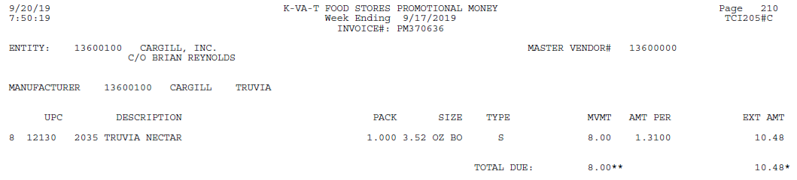
- Items labeled with T are count/recount and must have a contract.
- Items labeled with an S will not always have a contract because it may be for discontinued items. If no contract is located to support an item marked with an S, step as Contract Not Found. If the BM/BMA provides a contract, the S is for a scan. If a contract is not provided, the BM/BMA will provide a note that states the item has been discontinued.
- If the customer invoice states Deleted/Discontinued for the respective UPC and the allowance is stated as a scan or a count/recount allowance, validate it as a markdown.
- KVAT will sometimes split a customer invoice between multiple checks. If this occurs, the claim total will be less than the invoice total and there will be claims in ACOSTA Relay with the same customer reference number creating a duplicate error. Refer to the GCC Step Code Job Aid/Split Claim Job Aid on how to proceed.

Contract Info:
- K-VAT contracts are loaded via Event Scheduler. Use the unit and case UPC when searching for contracts, as either UPC can be on the contract.
- Promotional Calendar:
- Scan contracts start on Wednesday and end on Tuesday.
- Tracking contracts run from Saturday to Saturday. This results in Wednesday, Thursday and Friday of contract start date being omitted on a tracking invoice, but is picked up on Wednesday, Thursday and Friday following the contract end date. Tracking claims will end the Saturday following the end date of the contract and are valid based on customer promotional policy.
- On the Contract:
  - Specification on the allowance rate fields:
    - Monthly / Roller Per Case Truck: Count/Recount (C/RC)
    - Monthly / Roller Per Case Scan: Scan
    - Per Unit Scan (Closeout): Markdown
    - Rates can also be located in the Personalized Offers sections of the contract.
  - Ad requirements for promotions:
    - If a contract has the Weekly Ad, Monthly Ad or Special Ad boxes marked, an ad is required as part of performance per generic help. An ad may also be mentioned in the comment section.

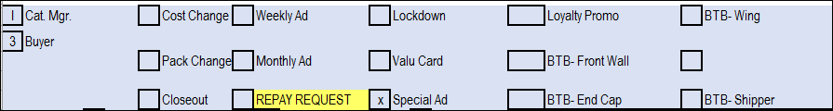

POP Info:
- A Sales Summary from ACOSTA Relay is used to support K-VAT claims unless there are specific requirements in the client SOP for POP. If the sales summary does not provide enough sales, IRI/Neilson can be used following client and generic help POP requirements.
- Ads are located under ADCLIENT/MIDMKX in backup documentation.

Other General Info:
- Close-out Policy
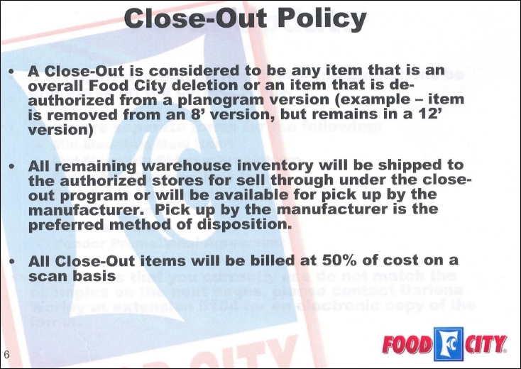
- Failure Fee
  - If a new item fails to perform at a rate of 6 cases per week after being in the store for 9 months, a failure fee will be charged.
  - This is in addition to supporting
    - Closeout Program
      - A Close-Out is considered to be any item that is an overall Food City deletion or an item that is de-authorized from a planogram version (example – item is removed from an 8’ version, but remains in a 12’ version).
      - All remaining warehouse inventory must be picked up by the manufacturer.
      - All Close-Out items will be billed at 50% of cost on a scan basis.
    - Pick-up full cases at Food City Distribution Center .
    - Final clean up thru Reclaim.
  - DSD no failure fee. Credit store at time of pick up.

NOTE: Sometimes K-VAT will order through the customer Merchants Distributors Incorporated (MDI). If this is the case, the claim may come over with the MERCCN customer sign-on; however, contracts will be found using MIDMKX sign on. POP must be run at the direct customer level, using the MERCCN sign on. Some clients that K-VAT purchases through MDI are:

Alcon | Meda Consumer Health Care
Alva-Amco | Ricola
Combe Inc | Purdue Pharma
Idelle Labs | W.M. Barr
Tom's of Maine | KAO Jergens Lotion
 | Evercare

Note: For Alcon, you must change the customer sign-on from MERCCN to MIDMKX so that the correct client/customer manager is notified.

BACKUP RETRIEVAL INFORMATION

GENERAL BACKUP RETRIEVAL INFORMATION

Is GCIT responsible for obtaining backup from the customer? Yes
- If yes, is there a customer portal? No
- If yes, does GCIT request backup? Yes

Is check remittance information required to request backup? No

Georgia Pacific
- Backup is available in TPM attached to the check remit and should be pulled from Client System prior to requesting from sales if invoice is not available with check remit, GCIT/CRA request from sales.

GCIT SPECIFIC BACKUP RETRIEVAL INFORMATION

Portal:

Customer Invoice or Note Identifier | Request From
6 digit number (may have N or N space before number; is not the client’s COI format) | Pull from CLS/Inmar portal

Non - Automated:

Customer Invoice or Note Identifier | Request From
All formats | Request from sales

CLIENT SPECIFIC VALIDATION INFORMATION

CLIENT
CAMPBELLS
KENS
MARSFOOD
POMPEIAN
TRI-UNION SEAFOODS (dba Chicken of the Sea)

CAMPBELLS
- Customer invoices billing for ‘price overage’ are for Topco. These are validated with the new item forms (contract).
- DSD Labels are coded Retail Merchandising with a line note “DSD Label fee.”
- Quarterly Space Management Fee is Retail Merchandising.
- K-VAT is an Accrual Check customer, and should not be deducting for anything other than slotting.
- DSD shipments KVAT will pay the invoice without taking the OI and a credit will create. Within one (1) week, a deduction(s) will come in for the OI allowances. A pricing template will be provided for the credits by Paige Stacy as a customer invoice in AR. Amy Haydon will provide an excel document customer invoice for the debit(s). The credit(s) will have a customer reference number with at lead "CK" and the debits will have a 2020 or 2021 lead customer reference number. All credits that go together will have the same customer reference number and marry up with any debit(s) received one (1) week later. To be offset, a spreadsheet needs created with a credit tab and a debit tab with the ticket number as provided on the customer invoices, amount and claim number. Use a VLOOKUP to match the credits to the debits to determine what needs to be offset. To clear, send the ATB line information to E4_SAP_Requests@campbellsoup.com and ask them to offset. The claims are stepped trade/off invoice/closed with a MANUALLY CLEARED note in the header. If the debit than the credit and it is over tolerance, the difference needs to follow normal validation process. Sample spreadsheet provided. No DBW or contract is required for the credit and debit offset.
- FY26 KVAT Markdown Client Events (see below).

KEN’S
• Customer invoices that being with PM that have a T in the TYPE column in the body of the customer invoice may be for product bought through AWG. The rate in the AMT PER column will be the OI amount on the Mid Mountain contracts. The rate may be off by a few pennies and is ok to proceed with validation.
- Customer invoices with PM with Type T buy thru AWG. There are fixed events in Kens for KVAT AWG to use to clear:
  - AWG events for 5/1/25 - 4/30/26
- 26E-153-006A Ken’s
- 26E-153-033A – SBR

MARS FOOD
- Mid Mountain/KVAT is part of the Retail Merchandising Program. (ISE) claims are coded as trade and cleared to an event .
- Q3 2022 Markdown Events:
  - Kind - 1001P00043PL239D
  - Core - 1001P00043PN239D

POMPEIAN

- PM Invoices with tracking “ “ and contracts will have one rate but there will be two event numbers in the multi feature. One for the billback portion and one for the scan. Each type will have the rate listed in the notes and the total for both will add up to the rate on the invoice.

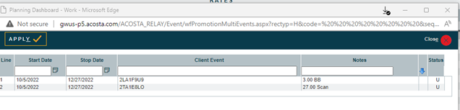

TRI-UNION SEAFOODS (dba Chicken of the Sea)
- When validating KVAT invoices check the KVAT contract rate against the invoice. If the rate matches what is on the invoice, then that is the contract to be used for validation. If the rate does not match, then locate the AWG contract as this will only contain a lump sum amount. The rate will not be listed on the AWG contract. To validate using this contract, use product and date range. The contract will state KVAT, but the event number will be an AWG event. Client event name would list AWG lump sum.

PROCESS STEPS

1. Deduction Type: Off Invoice

A per case off invoice allowance is given to the customer as an automatic discount for product purchased from the client. If the customer does not receive the allowance off the face of the invoice, they will deduct for it. If the customer requested an allowance that is not valid, the CSC will send a notification to the customer in writing. Customers view purchase orders as contracts. If they are not notified of allowance discrepancies, they will pay according to their purchase order total.

1.1 Customer Invoice for Off Invoice:

Page # 1:

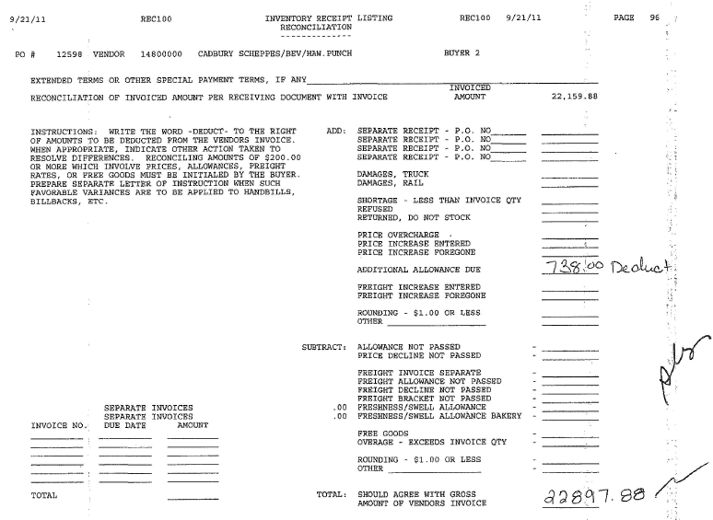
Additional Allowance Due: The total amount of the deduction taken by the customer for the missed OI.

Missed OI claims reference the client order invoice number. The customer invoice references the customer’s PO number. Once the PO is linked to the claim, the PO number on this document will cross reference with the customer reference number on the claim, which is the client order invoice number..

Page # 2:
Allowance Due – AD indicates a missed off invoice deduction. The customer handwrites the total amount for each item on the right-hand margin.

PO # – This number is used to search for the order record in ACOSTA Relay.

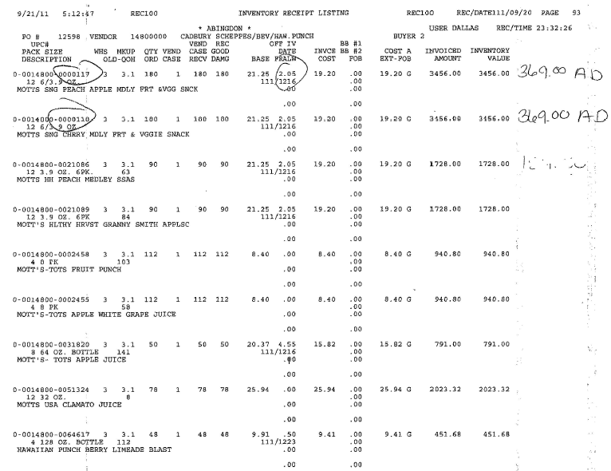
Off IV: The amount the customer expected to receive as the OI Allowance.
Qty Ord: The quantity on the customer invoice needs to match the quantity on the client order Invoice.
UPC #: The product the customer is claiming an OI was due on but not given.

  - Customer Invoice for Off Invoice Not Given, Example 2:

PO Number: The customer’s purchase order can be used to search for the Client Order Invoice in ACOSTA RELAY.

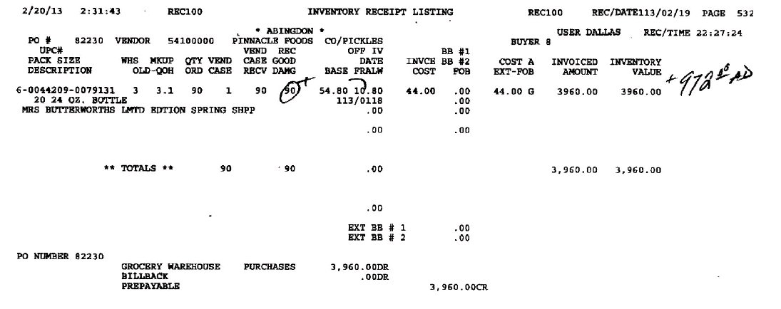
UPC#: The product on which the customer is claiming an off invoice allowance was due but not given.

Off IV: The amount the customer is claiming for the OI Allowance.
Allowance Due: AD indicates a missed off invoice deduction. The customer handwrites the total amount on the right-hand margin.
Qty –The quantity the customer is claiming they did not get an OI allowance on..

1.2 Customer Contract for Off Invoice, example 1: Found via Search For: Event Scheduler.

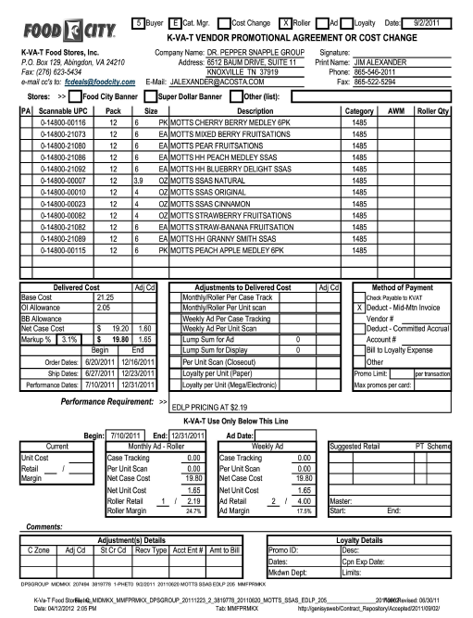
OI Allowance: The per case Off Invoice amount offered, which must match the rate on the customer invoice.

Order Dates/Ship Dates: The order and/or ship dates on the client order invoice must fall within these dates.

Scannable UPC: The product on which the customer is being offered an off invoice allowance. This code needs to match the UPC on the customer invoice.

1.2 Customer Contract for Off Invoice, example 2: Found via Search For: Event Scheduler.
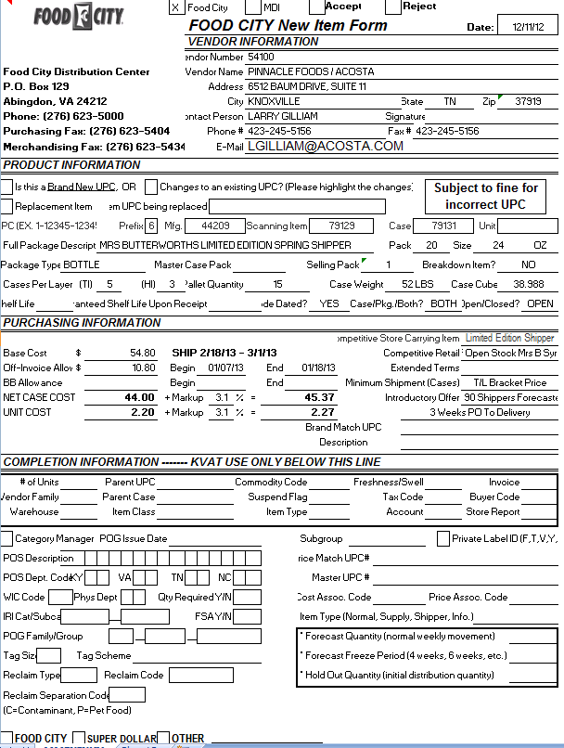
Ship: The ship date on the client order invoice needs to fall within the ship dates on the contract.

Case: The product the customer is being offered an OI on. The product on the customer invoice must match.

Off-Invoice Allow:– The per case Off Invoice allowance amount. The amount on the customer invoice must match.

Refer to the SOPs/Generic Help File for POP requirements.

2. Deduction Type: Billback
i
i

A Billback claim is a per case allowance offered for a specific performance requirement. A per case billback allowance is claimed by the direct buying customer for product purchased from the client, or by the indirect customer for product purchased from the direct customer. This is an allowance the customer will bill the client for. This is not an automatic discount given off the face of the invoice.

2.1 Customer Invoice for Billback:
PO#: The customer’s purchase order number can be used to search for the client order invoice in ACOSTA Relay. This is also part of the customer invoice number. When searching for the customer invoice number use the wildcard, i.e. “%14243”.

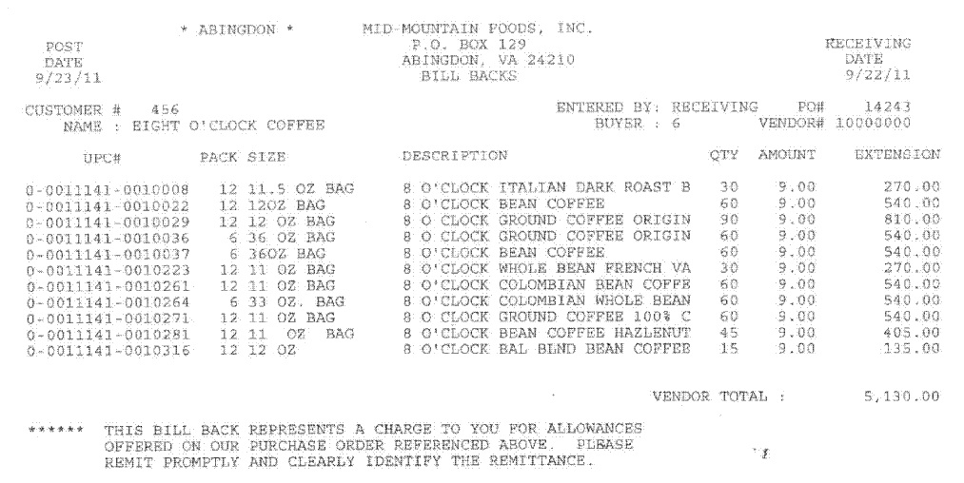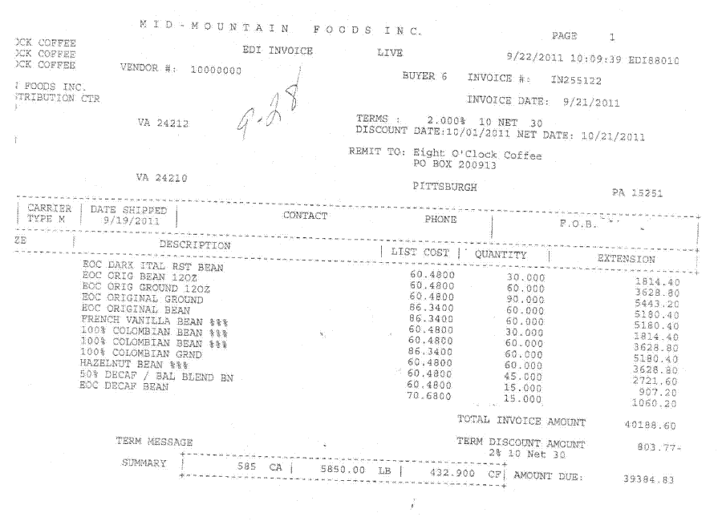
UPC#: The product on which the customer is claiming the billback allowance, which must match the contract.

Amount: The per case allowance the customer has deducted for the billback, which must match the contract..
Qty: The number of cases the customer is claiming for the billback allowance, which must match the client order invoice.

2.2 Customer Contract for Billback: Found via Search For: Event Scheduler.

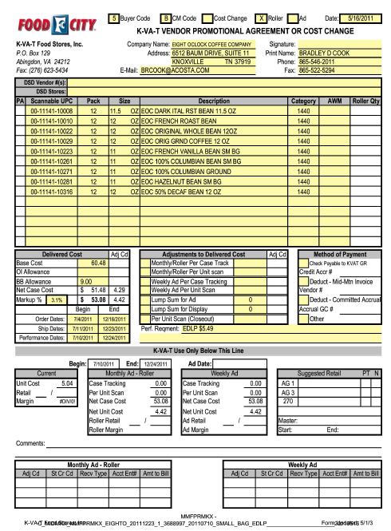
BB Allowance: The per case billback allowance being offered. The amount claimed on the customer invoice must match.

Scannable UPC: The product on which the customer is being offered a billback. The product on the customer invoice must match.

Order start and end date: The order and/or ship dates on the client order invoice must fall within these dates.

See Client SOP/Matrix and Generic Help for scan allowance POP requirements.

3. Deduction Type: Count/Recount
Warehouse Withdrawal/Count Recount is for cases shipped to stores from the main customer’s warehouse.

3.1 Customer Invoice for Count/Recount – Example 1:

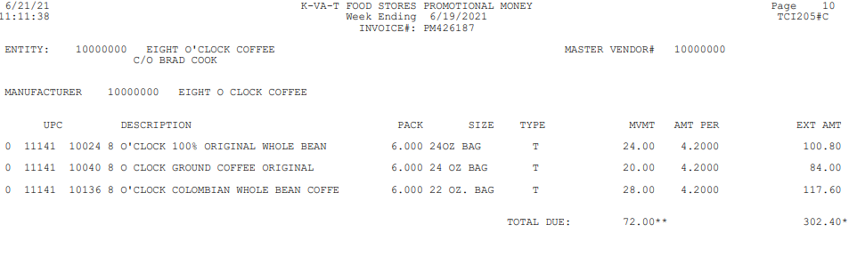
MVMT: This is quantity the customer is claiming for the count/recount.
Type: “T” indicates that this is a count/recount claim.

UPC: The product on which the customer is claiming the count/recount allowance, which must match the contract.

AMT PER: This is the per case amount the customer is deducting for the count/recount allowance.
Week Ending: The date the customer is claiming the count/recount, which must fall within the dates on the contract.

3.1 Customer Invoice for Count/Recount, Example 2:

If the extended amount for a UPC on a PM invoice does not calculate correctly, it can be because two promotions are running at the same time. To do the math, divide the quantity by 2. Multiply that by the rate shown for the first amount. Subtract that from the extended amount to get the leftover amount. Divide that by the halved qty to get the 2nd rate.
4
Week Ending: The date on the customer invoice must fall within the dates on the contract.

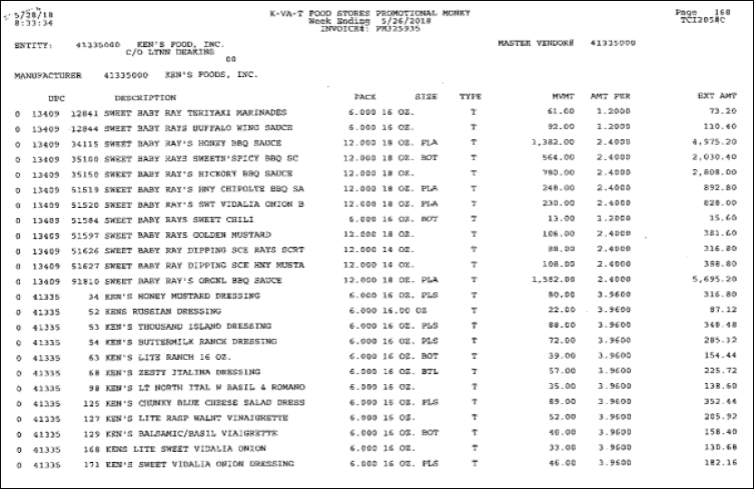
If you do the math for this item, the DBW does not show the correct extended amount.

1382 x $2.40= $3316.80 (not the $4975.20 shown on the invoice)

To get the correct data to enter into the DBW, divide the quantity in half.

1382/2 = 691 qty

Take that quantity and multiply by the rate shown on the invoice.

691 x $2.40= $1658.40 Enter the UPC into the DBW using this rate and qty.

Subtract the extended amount from the first rate from the extended amount on the invoice.

$4975.20 - $1658.40= $3316.80

Divide that amount by the halved quantity to get the 2nd rate.

$3316.80/691= $4.80 Enter the UPC into the DBW a 2nd time with a 691 qty and $4.80 rate.

A contract must be located for both rates. If a contract is not located for both rates, sales must be alerted.

UPC: The product on which the customer is claiming the count/recount allowance, which must match the contract.

1

3.2 Contract for Count-Recount, example 1: Found via Search For: Event Scheduler.

Performance Dates & Begin/End Dates: The dates the customer is claiming for the count/recount must fall within one of these sets of dates. Dates do not have to be provided in both boxes.

4
2
1
Scannable UPC: The product on which the customer is being offered a count/recount. The items on the customer invoice must match.

Monthly/Roller Per Case Track: Case Track indicates that the contract is for a count/recount.

3.2 Contract for Count-Recount, example 2: Two promotion amounts on one contract. Found via Search For: Event Scheduler.

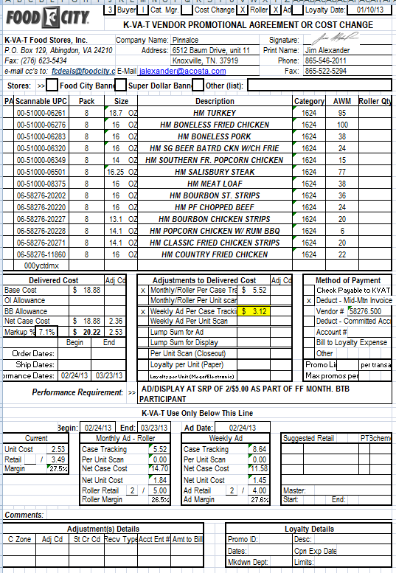
Monthly/Roller Per Case Tracking and Weekly Ad Per Case Tracking: The amount in these two fields will need to be added together to equal the allowance rate on the customer Invoice. ($5.52 + $3.12 = $8.64, which needs to match the amount listed on the customer Invoice.)

3.2 Contract for Count-Recount, example 3: Found via Search For: Event Scheduler.
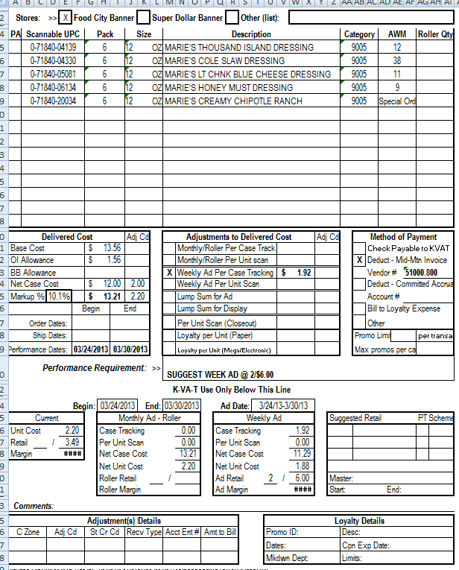
Weekly Ad Per Case Tracking: This indicates that the offer is for a count/recount. This amount needs to match the allowance rate on the customer invoice. An ad copy needs to be included as POP.

See Client SOP/Matrix and Generic Help for scan allowance POP requirements.
4. Deduction Type: Scan

Scan allowances are for product scanned at the store register and are usually billed in eaches/units, not cases.

4.1 Customer Invoice for Scan, example 1:

i
4
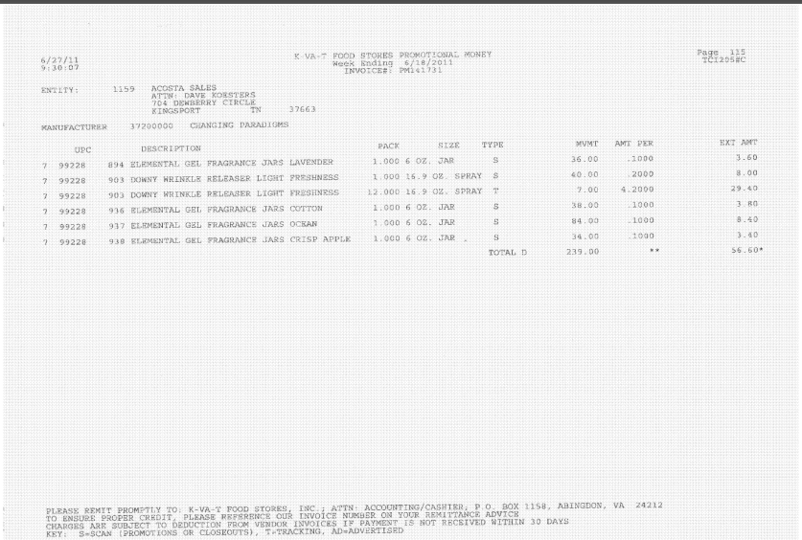
TYPE: Search for a contract for the dates, rates and items. If a contract is found, Type S identifies the claim as a scan. If there is no contract, Type S means the claim is for a markdown.

UPC, Description, Pack & Size: The product on which the customer is claiming the scan allowance, which must match the contract.
1
3
MVMT: The number of units scanned for each product.
Amt Per: The scan rate per unit for each product, which must match the contract.
2
Week Ending: This is the promotion period during which the customer is claiming the scan, which must fall within the dates on the contract.

4.1 Customer Invoice For Scan, example 2:

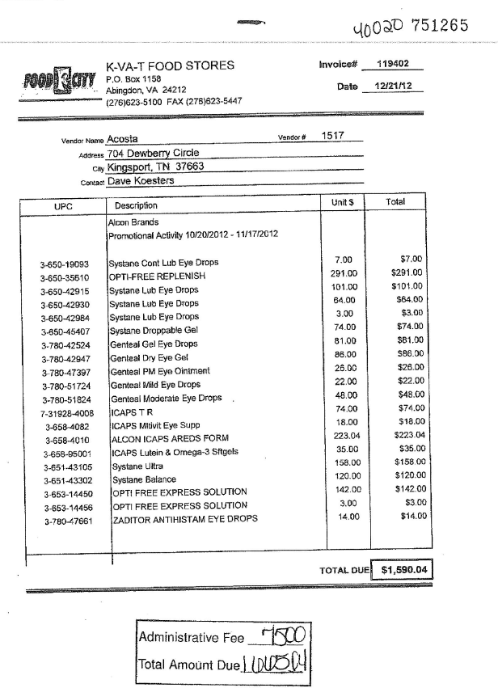
i
To verify the claim total, add the Total Due and the Administrative Fee.
1
UPC, Description, Pack & Size: The product on which the customer is claiming the scan allowance, which must match the contract.
2
Total: This customer only shows the extended total for each product.
4
Promotional Activity <Dates>: The period during which the customer is claiming the scan, which must fall within the dates on the contract.

4.1 Customer Invoice for Scan, example 3 - Midnite Madness:

Midnite Madness is a scan program. Both the invoice shown below and the itemized detail page are needed to validate the claim. If the itemized details are not provided with the invoice, the CRA will need to request the additional backup from the sales team.

Page 1:
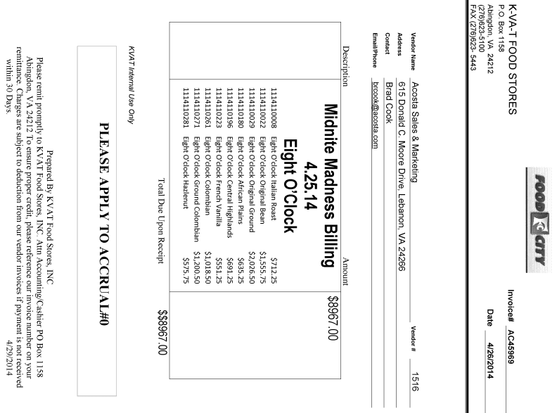
UPC Code: This is the product on which the customer is claiming the scan allowance, which must match the contract.
Not all Midnite Madness invoices will have the UPC on this invoice. The UPCs will be located on the detailed backup provided from sales.
1
Performance Date: This is a week ending date. NOTE: This may show a week ending date or a date range.
4

4.1 Customer Invoice for Scan, example 3 - Midnite Madness:

The itemized detail needs to be linked to the claim in order to compare the invoice, contracts and quanitity on POP. If the itemized details are not provided with the invoice, the CRA will need to request the additional backup from the sales team.

Page 2: Detailed backup

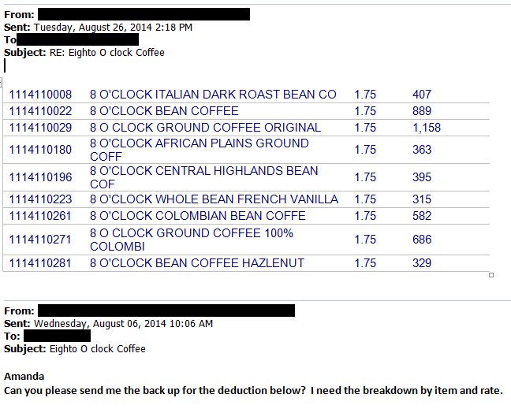
UPC Code: This is the product on which the customer is claiming the scan allowance, which must match the contract.
Scan Rate: The rate per unit for the products, which must match the contract.
This is product quantity.

4.1 Customer Invoice For Scan, example 4 - Loyalty – Mega

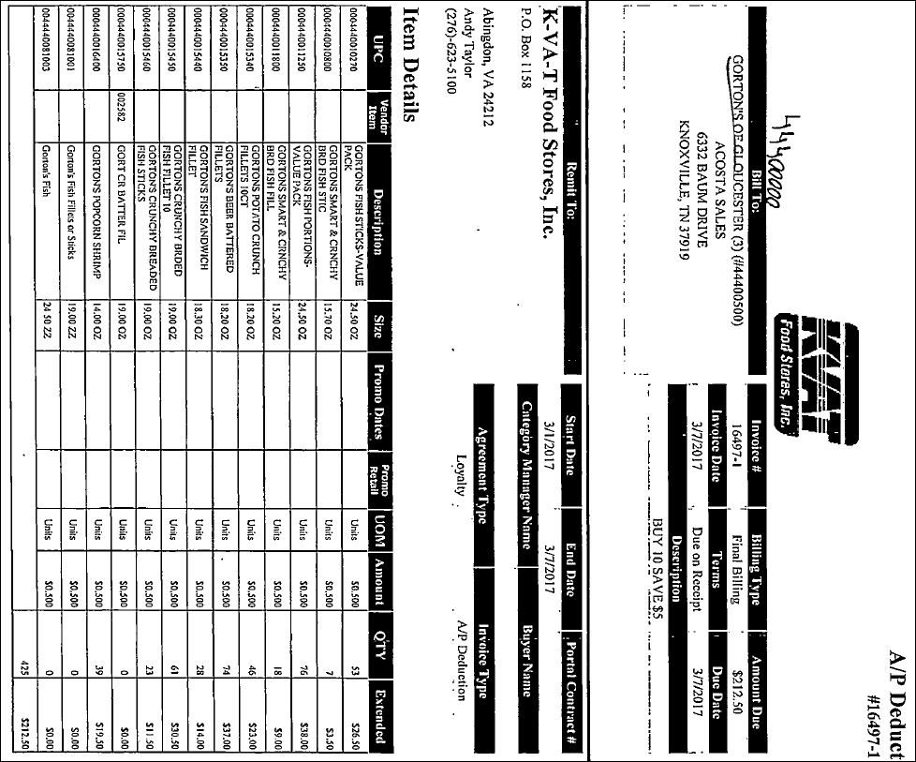
AGREEMENT TYPE: Loyalty is an indication that the invoice is for a scan. The Description gives more details on the promotion.
Start/End Date: The promotion period during which the customer is claiming the scan allowance.
UPC: The product on which the customer is claiming the scan allowance, which must match the contract.
QTY: The number of units claimed for the scan.
Amount: The rate per unit being claimed for the scan.
1

4.1 Customer Invoice For Scan, example 5 - Fuel Bucks
K-VAT Fuel Bucks are deductions for an allowance amount offered towards fuel.

Page 1

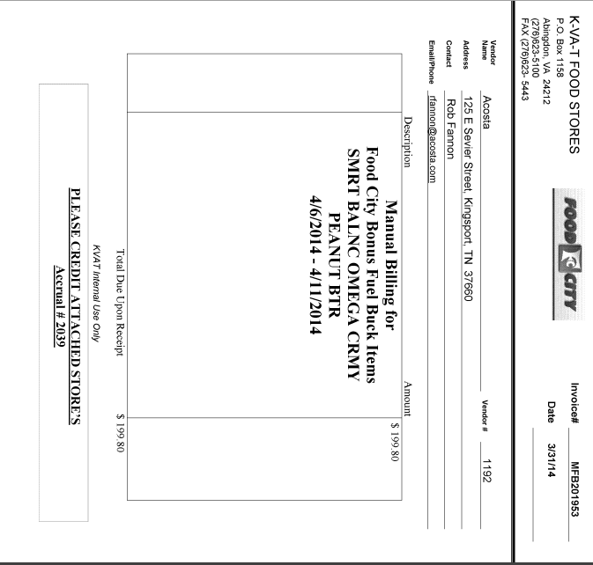
Dates: The promotion period during which the customer is claiming the scan allowance, which must fall within the dates on the contract.
Description: Identifies the type of scan promotion the customer is claiming.
Description: The product/product group on which the customer is claiming the scan allowance, which must match the contract.

.

Page 2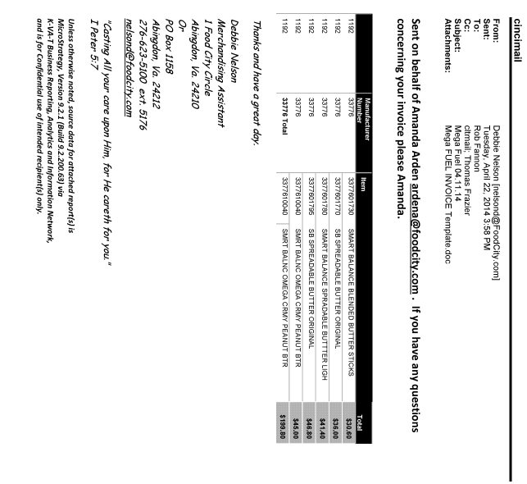
NOTE: Before the DBW can be created, locate the contract using the performance dates and items in order to get the rate being billed for. The total on the invoice has to be divided by the rate to calculate the quantity.
Item: The product on which the customer is claiming the scan allowance, which must match the contract.

4.2 Customer Contract for Scan, example 1: Found via Search For: Event Scheduler.

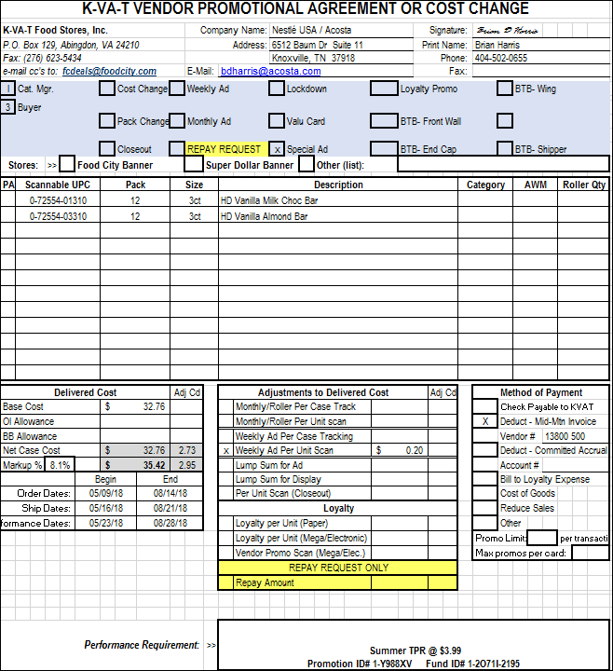
Special Ad: An ad is required as additional performance for this invoice. See the Customer General Information Contract Information section of this SOP for more info.
Performance Dates: The dates when the promotion is valid. The performance dates on the customer invoice must be within these dates.
Weekly Ad Per Unit Scan: The rate claimed on the customer invoice must match the rate on the contract.
NOTE: The Scan Rate may also be found in the Monthly/Roller Per Unit Scan field on the contract.
Scannable UPC: This is the product on which the customer is being offered the scan allowance.

4.2 Contract for Scan, example 2 – Super Mega Event: Found via Search For: Event Scheduler.

This is a type of Scan allowance offered to the consumers if they purchase 10 items that are on deal in the store.

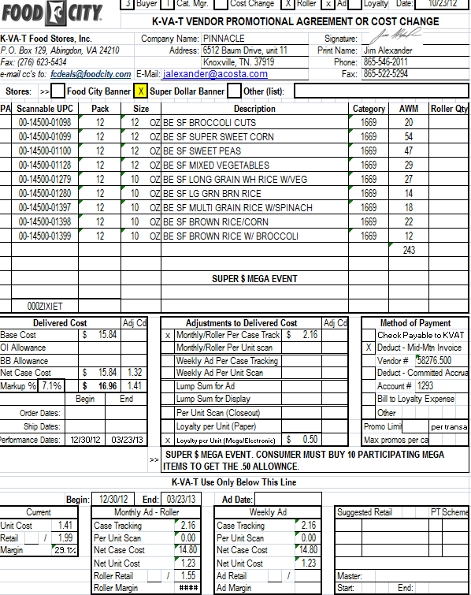
Performance Dates: The performance date on the customer invoice must be within these dates.
Super $ Mega Event: This indicates the type of scan being offered.
Loyalty per Unit (Mega/Electronic): The rate per unit for the Super Mega Event. The rate on the customer invoice must match.
Sometimes the contracts will be for K-VAT’s Super Dollar banner, instead of the typical Food City banner.
Scannable UPC: The product on which the customer is being offered a scan allowance. The product on the customer invoice must match.
4.2 Contract for scan, example 3 - Midnite Madness: Found via Search For: Event Scheduler.

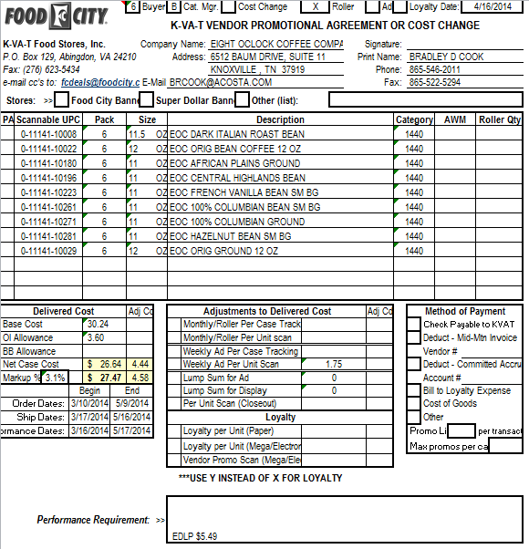
Weekly Ad Per Unit Scan: The amount being offered to the customer for the scan. The rate on the customer invoice must match.
Scannable UPC: The product on which the customer is being offered a scan allowance. The product on the customer invoice must match.

Performance Dates: The performance date on the customer invoice needs to be within these dates.

4.2 Contract For Scan, example 4 - Loyalty – Mega Found via Search For: Event Scheduler.

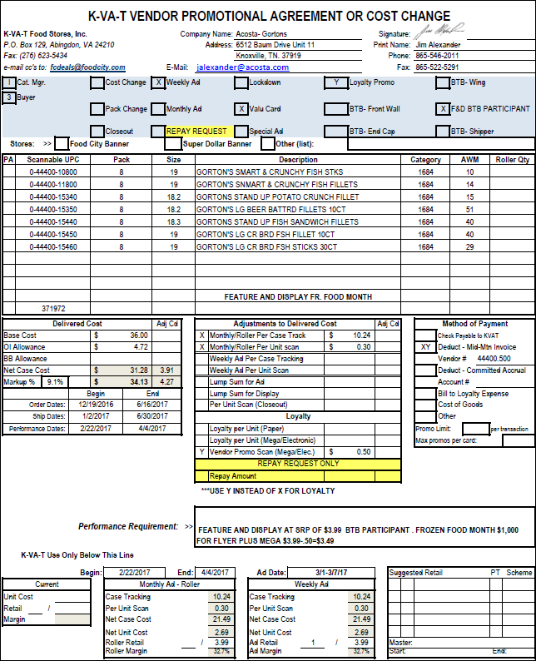
Performance Requirement: Additional information about the promotion is provided here.
Performance Date: The promotion period the Mega discount is being offered.
Vendor Promo Scan (Mega/Elec): The scan rate per unit for a Mega promo. The rate on the customer invoice must match the rate on the contract.
Scannable UPC: The product on which the customer is being offered a scan allowance. The products on the customer invoice must match.

4.2 Contract For Scan, example 5 - Fuel Perks Found via Search For: Event Scheduler.

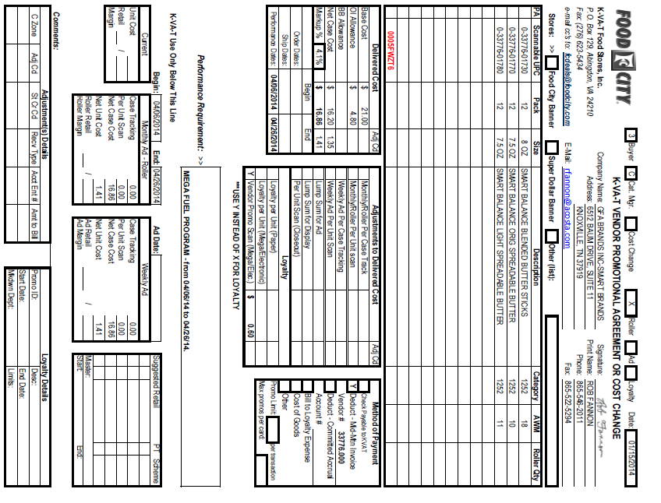
Performance Dates: The promotion period the Mega discount is being offered. The dates claimed on the customer invoice must fall within these dates.
Vendor Promo Scan (Mega/Elec):The scan rate per unit for the Mega promo. The rate on the customer invoice must match the rate on the contract.
Scannable UPC, Pack, Size, Description: The product on which the customer is being offered a scan allowance. The items claimed on the customer invoice must match.

1

See Client SOP/Matrix and Generic Help for scan allowance POP requirements.

5. Deduction Type: Ad

A fee for featuring a client's products in an advertisement.

5.1 Customer Invoice for Ad, example 1:

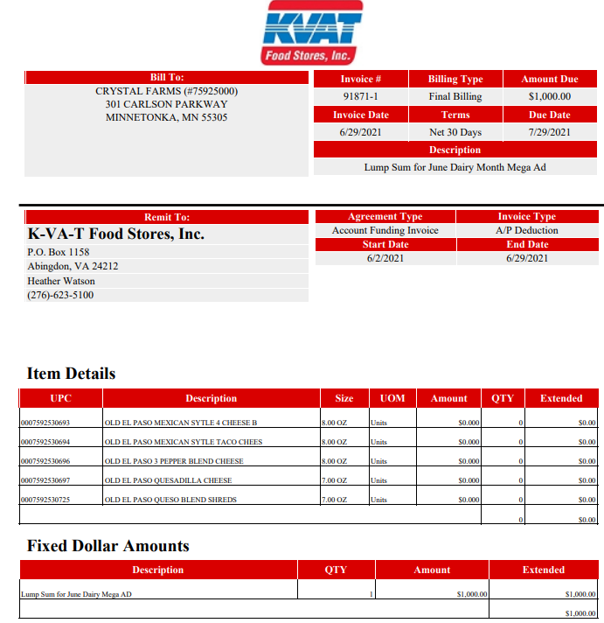
Amount: The amount claimed by customer for the ad, which must match the contract.
Description: Identifies that the customer is invoicing for an ad.
Contract Dates: The dates for the ad need to match the contract dates.

5.1 Customer Invoice for Ad, example 2:
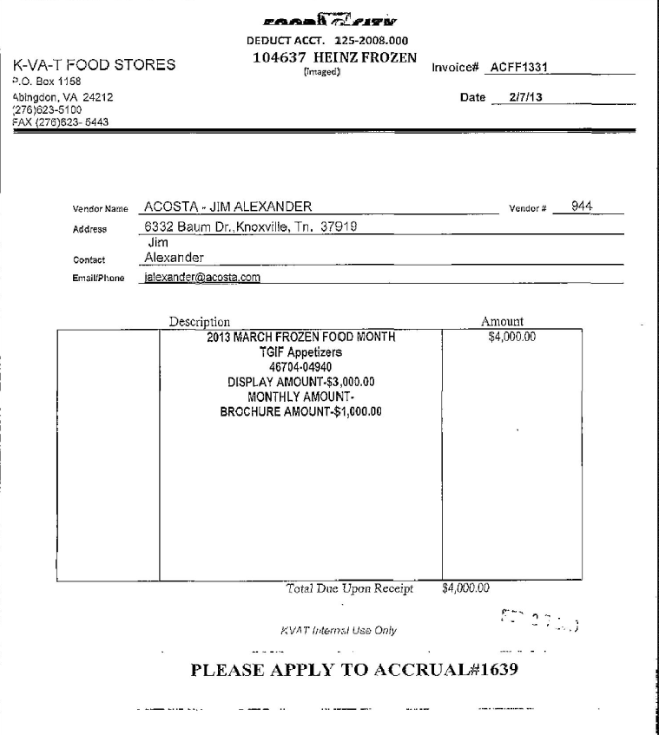
Description: The product/product group the customer is advertising, which must match the contract.
Description: In this example, the customer is billing for both a display (for $3000.00) and ad (for $1000.00).
Lump sum Amount – Amount claimed by customer for the ad, which must match the contract.

5.1 Customer Invoice for Ad, example 3:
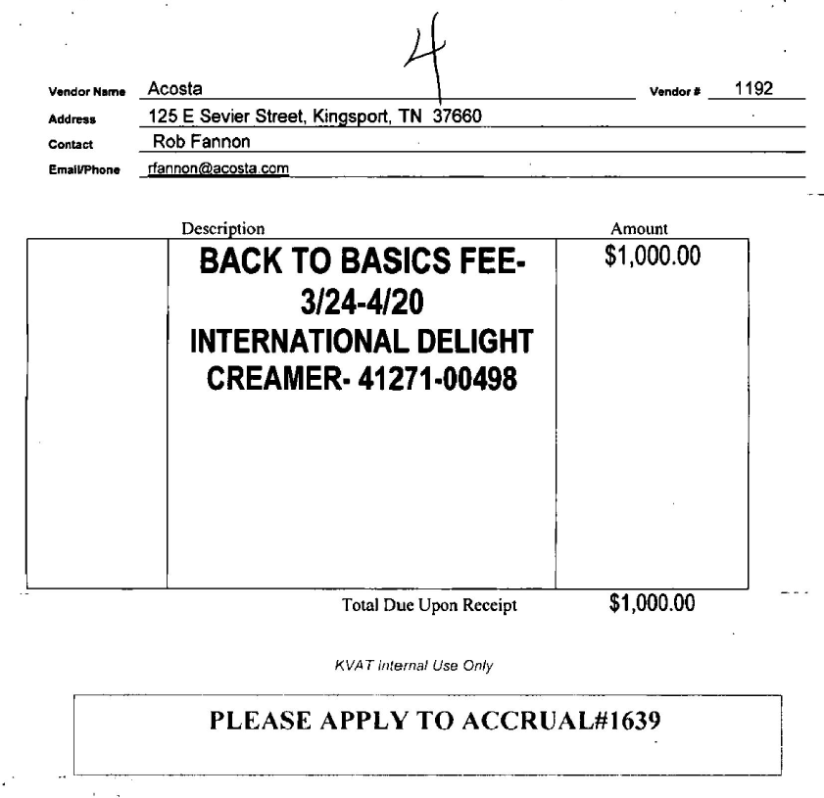
Description: The product/product group the customer is advertising, which must match the contract.
K-VAT is billing for a Back to Basics ad fee.
Amount: Amount claimed by customer for the ad, which must match the contract.
Performance Dates: The dates for the ad need to match the contract dates.

5.1 Customer Invoice for Ad – Example 4:

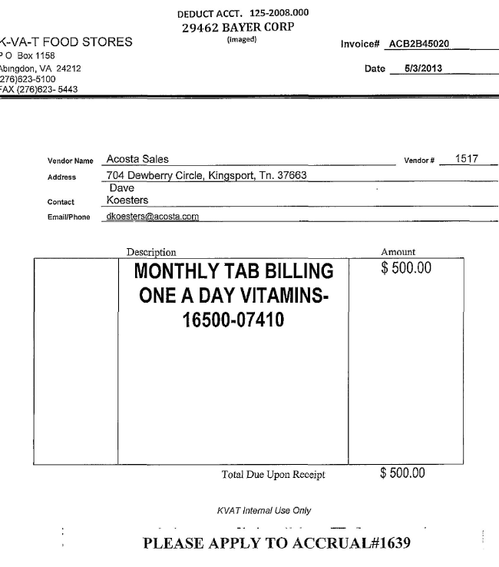
Amount: Amount claimed by customer for the ad, which must match the contract.
Monthly Tab Billing identifies this as an ad claim.
Description: The product the customer is advertising, which must match the contract.
The invoice date should be within 2 weeks after the end date on the contract. Because this is the date the invoice was created, it may not align with the dates on the contract.

5.2 Customer Contract for Ad, example 1 - Found via Search For: Event Scheduler.
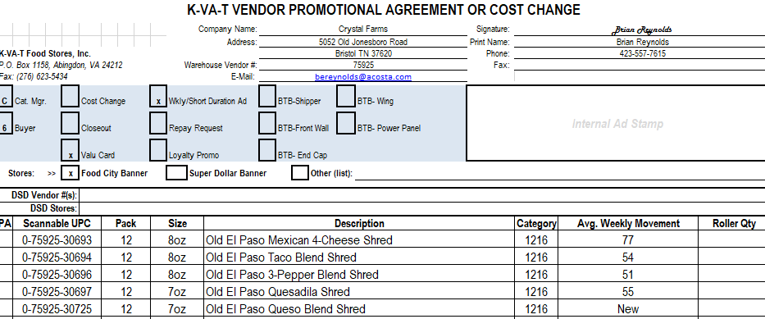
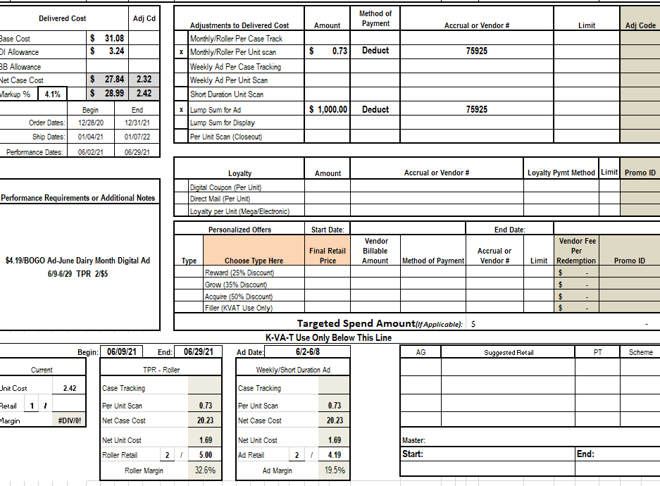
Scannable UPC, Pack, Size, Description: The product on which the customer is being offered an ad allowance, which must match the customer invoice and POP.

Lump Sum for Ad: The amount being offered for the ad.
Identifies that the contract is for an ad.
Performance Dates/Begin & End: The dates the ad needs to run.

5.2 Customer Contract for Ad, example 2: Back To Basics (BTB) ad Found via Search For: Event Scheduler.

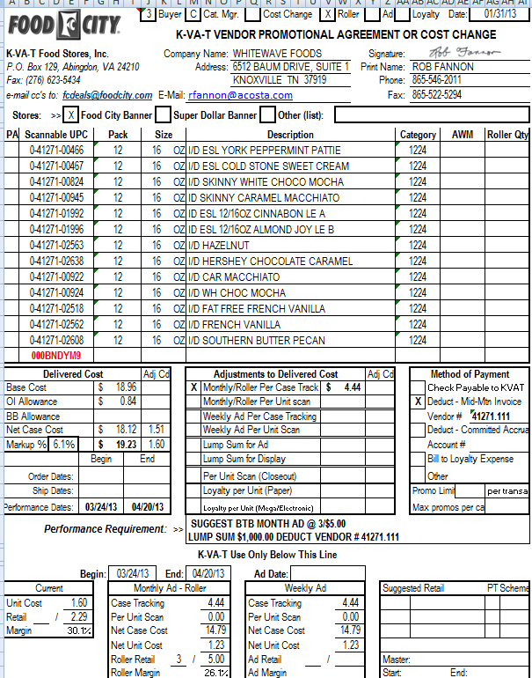
3
Lump Sum for Ad: The amount being offered for the ad.
2
Performance Dates/Begin & End: The dates the ad needs to run.

1
Scannable UPC, Pack, Size, Description: The product on which the customer is being offered an ad allowance, which must match the customer invoice and POP.

See Client SOP/Matrix and Generic Help for scan allowance POP requirements.

6. Deduction Type: Pricing

A pricing deduction occurs when the customer's requested price on the original purchase order differs from the client's invoice.

Documents required for validating a Pricing claim:

Document Name | Source of the Document | Action by Accenture
Customer Invoice | ACOSTA RELAY – search for the invoice under Backup Documentation, document type 2. | Step the claim to Acosta for research.
Client Order Invoice | ACOSTA RELAY – search for this document within the Order/Invoice/PO search.

6.1 Customer Invoice for Pricing:

Page #1:
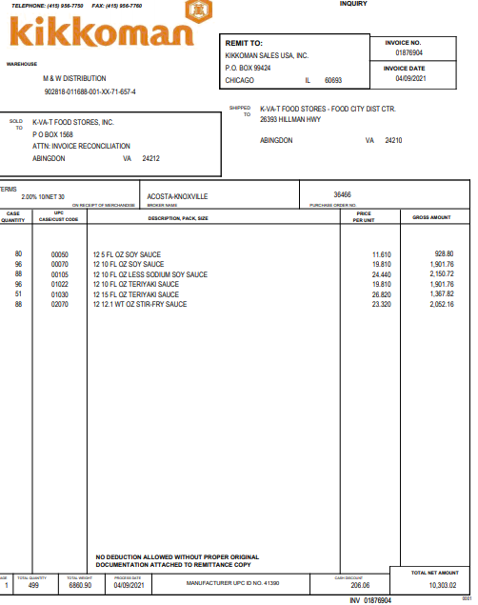

Page # 2:
Price Overcharge: Indicates that this is a pricing deduction.

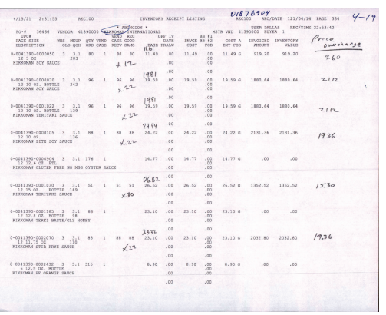
Deduction Amount: This is the amount being deducted for pricing. In this example the total is $105.86

See Client SOP/Matrix and Generic Help for scan allowance POP requirements.

7. Deduction Type: Slotting

A Slotting allowance is offered to the customer to purchase an item not currently stocked. It is a kind of promotional money offered to a customer as incentive to buy a new item and create a “slot” for that product on their warehouse storage shelves. It is a Trade Deduction. A slotting lump sum allowance can be offered for each item and/or an off invoice can be offered as an introductory allowance for the first 30 days.

7.1 Customer Invoice for Slotting:

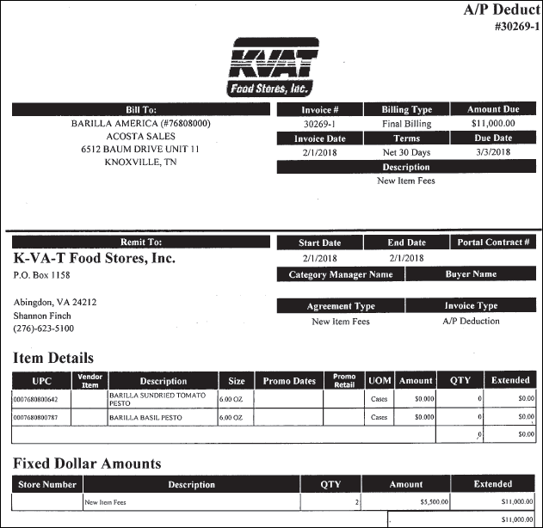
Item Details: This section provides the UPC and item description for the new items.
1
Description: New Item Fees indicates this invoice is for Slotting.
Amount Due: Deduction amount that the customer has claimed for slotting, which must match the contract.
2

7.2 Customer Contract for Slotting: Found via Search For: Event Scheduler.

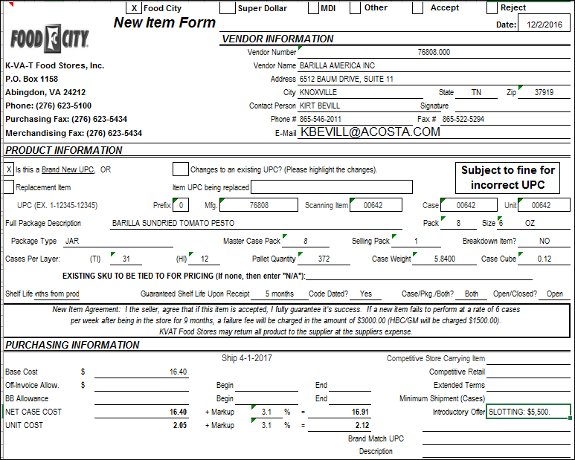
2
Introductory Offer: The amount being offered for slotting the product referenced on the New Item Form.
1
The UPCs and description of the product the slotting offer is for.

Ship: Slotting contracts generally reference only a first available date. Performance can take place any time on or after that date.

See Client SOP/Matrix and Generic Help for scan allowance POP requirements.

8. Deduction Type: Unsaleable / Reclamation

An Unsaleable claim is taken for product that cannot be sold at the stores due to damages (and short coded product).

8.1 Customer Invoice for Unsalable/Reclamation, example 1:

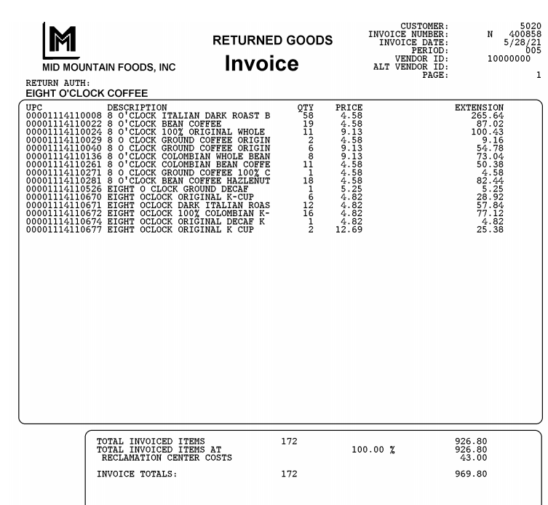
Reclamation Costs: This indicates that the customer invoice is for unsaleable product.

Customer Invoice for Unsalable/Reclamation, example 1:

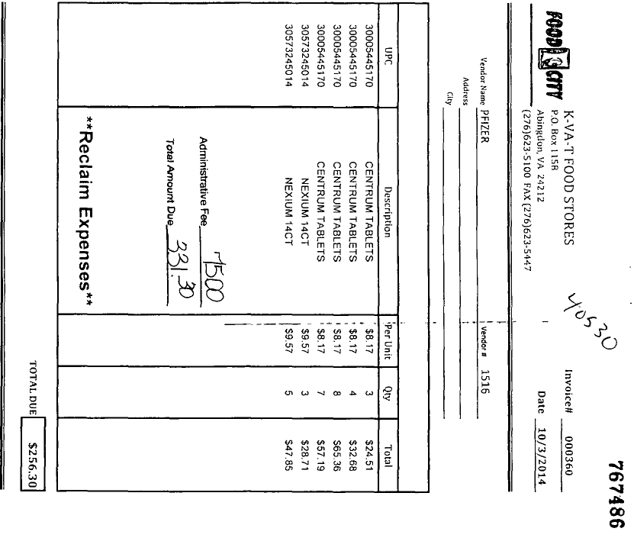
Reclaim Expenses: This indicates that the customer invoice is for unsaleable product.
i

i

See Client SOP/Matrix and Generic Help for scan allowance POP requirements.

9. Deduction Type: Markdowns

Offer to reduce the shelf price of the product. Usually offered to aid in selling slow moving or discontinued items.

Week Ending: The week referenced here needs to be within the performance dates provided on the contract.

9.1 Customer Invoice for Markdowns, example 1:
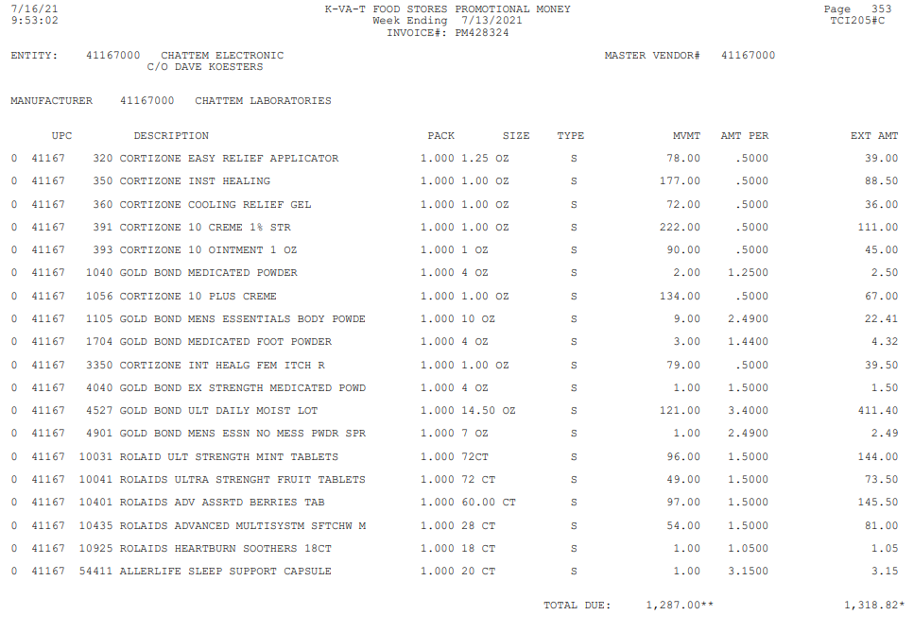
UPC: This is the product on which the customer is claiming the markdown allowance, which must match the contract.

Type: ‘S’ indicates that the allowance is for scans or markdowns. Items labelled with an ‘S’ will not always have a contract because it may be discontinued items. If you’re unable to locate a contract to support an item marked with an ‘S’, step claim to sales, “contract needed”.
If the customer invoice has a note that says DELIST, it means that the item has been discontinued and a contract was not offered. Step the claim to sales, contract needed.
MVMT: The number of units the customer is claiming for the markdown.
AMT PER: The scan rate per unit for the given products, which must match the contract.

NOTE: Markdowns can be cleared to an event without a contract with client approval. The Client SOP or matrix needs to be checked to see if the client allows this.
9.2 Customer Invoice for Markdowns, example 2:

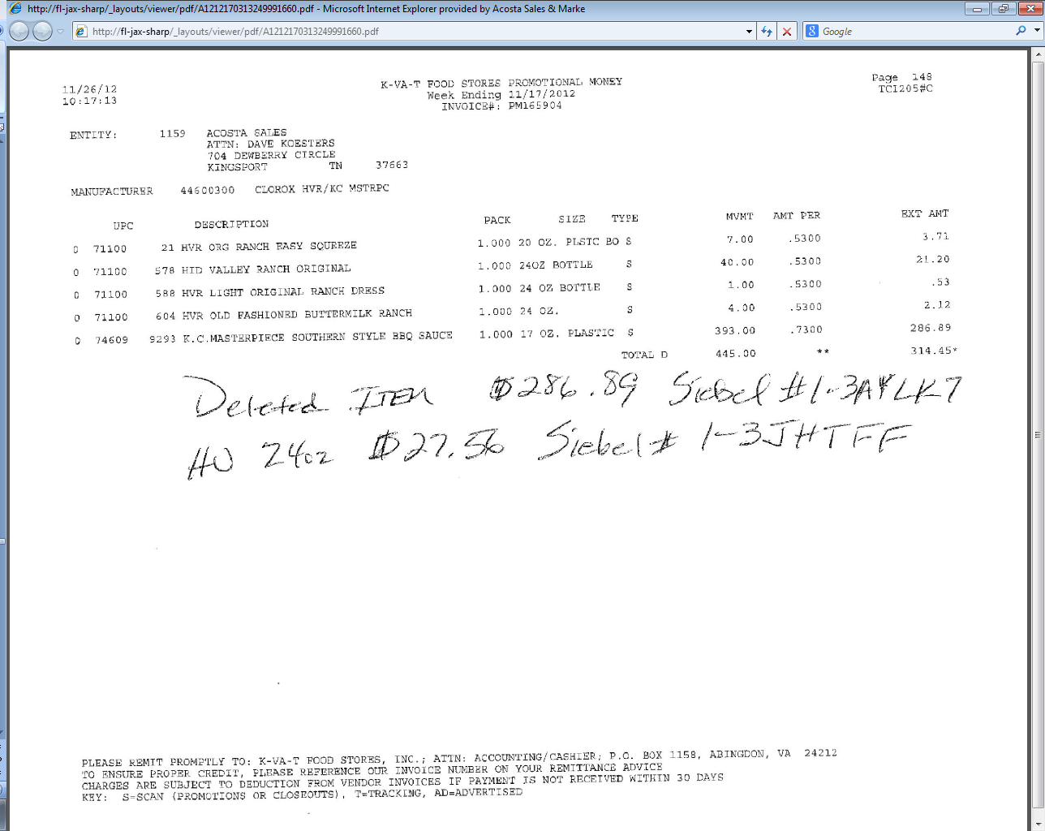
MVMT: The number of units the customer is claiming for the markdown.
The BM may write a note giving the information on the deleted item, along with the Event # to clear the deduction to. ‘Deleted item’ identifies this as a markdown claim.
AMT PER: The rate per unit for the given products, which must match the contract.
UPC: The product on which the customer is claiming the markdown allowance, which must match the contract.

Week Ending: The week referenced here needs to be within the performance dates provided on the contract.

See Client SOP/Matrix and Generic Help for scan allowance POP requirements.

10. Deduction Type: Display

A Display deduction is an allowance given on an in-store product display (within a specific agreed section of the store) on an end cap or displayed per the client's requirements.

10.1 Customer Invoice for Display, example 1:

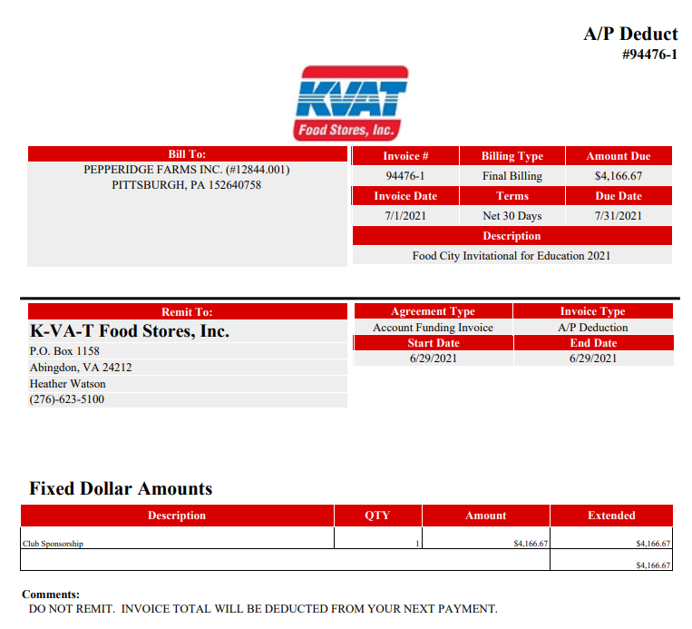
Description: This identifies the claim as a display and lists the product/product group that was featured.

Amount: The amount the customer is claiming for the display, which must match the contract.
Contract Dates: The dates when the customer is claiming they displayed the product, which must fall within the contract dates.

10.2 Customer Contract for Display: Found via Search For: Event Scheduler.

See Client SOP/Matrix and Generic Help for display POP requirements

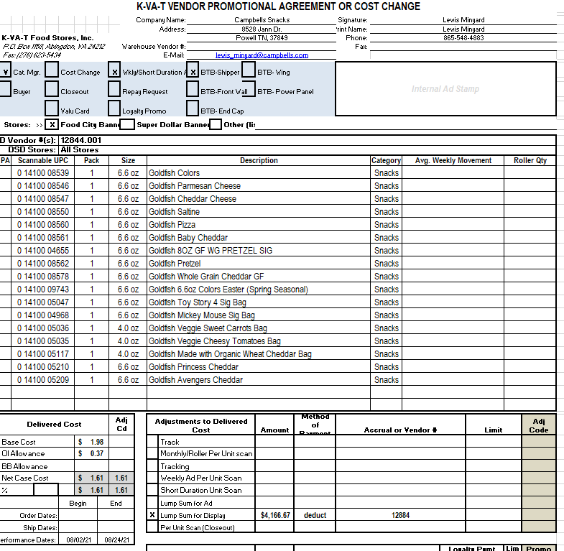

10.1 Customer Invoice for display, example 2:

Display Amount: This identifies the claim type as a display.

Description: The customer is claiming that they displayed the product during the month of March, which must fall within the contract dates.

Display Amount: The amount the customer is claiming for the display, which must match the contract.
(In this example, the $1,000 ad amount will be claimed separately.)

10.1 Customer Invoice for display, example 3:
Scannable UPC, Pack, Size & Description: The product the display offer is for.

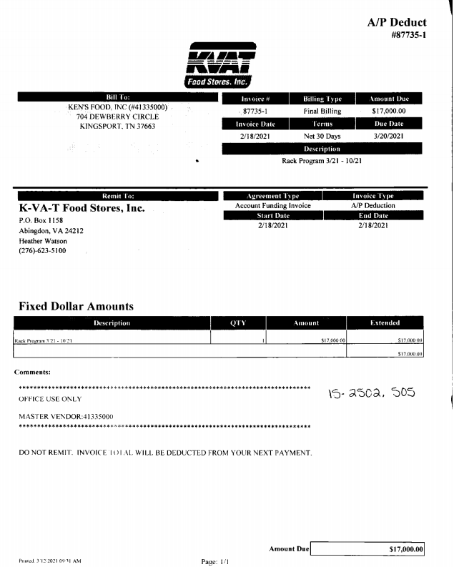

10.2 Customer Contract for Display: Example 3 Found via Search For: Event Scheduler.

See Client SOP/Matrix and Generic Help for display POP requirements

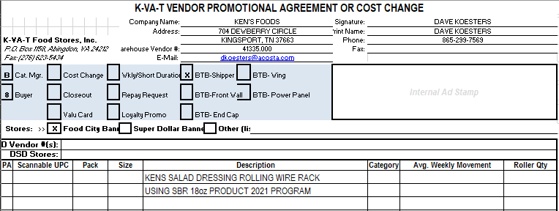
f

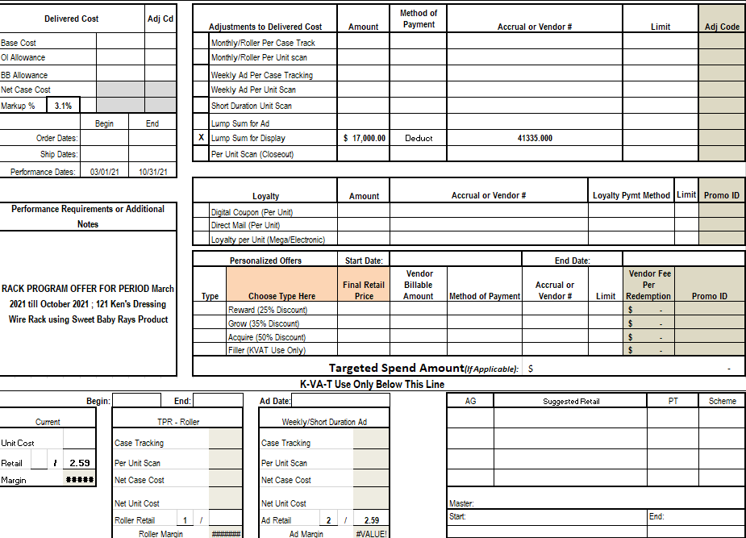

10.3 Customer Invoice for display: Example 4 Back to Basics:

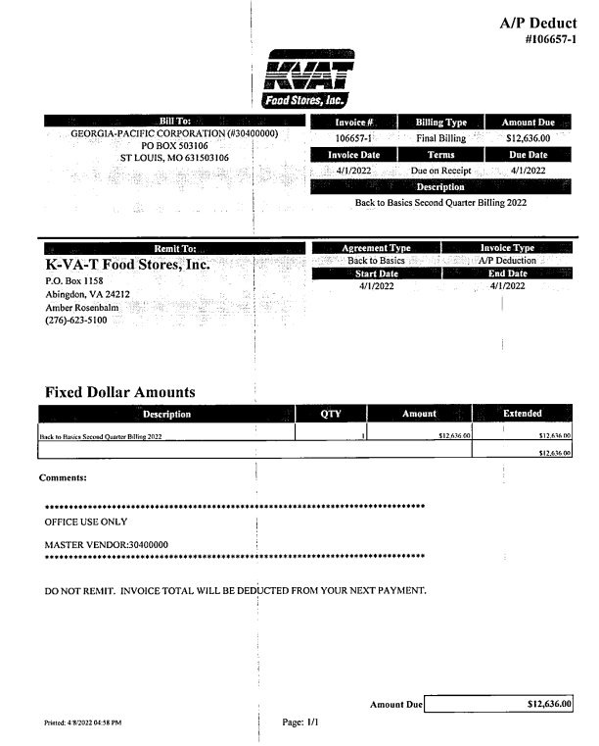
Amount: The amount the customer is claiming for the display, which must match the contract. May be deducted in quarter increments.
If billing quarterly this will state quarter being deducted

10.4 Customer Contract for Display: Example 4 Back to Basics

Found via Search For: Event Scheduler.

See Client SOP/Matrix and Generic Help for display POP requirements

BTB means Back to Basics

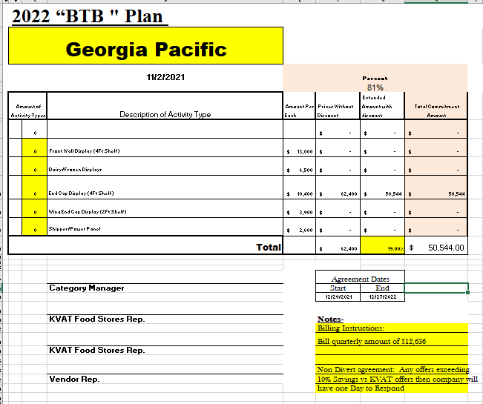
Display: This identifies this as a display for Back to Basics.. Can be any of the types shown.

Contract Info Total amount of contrat, dates of contact, and notes can state bill in installments.

11. Deduction Type: Food Show

An event sponsored by a wholesaler exhibiting various clients’ products to indirect customers.

11.1 Customer Invoice for Food Show, example 1 – Booth Rental:

$DISTRIBUTION$: The amount the customer is claiming for the food show allowance.

Ledger Description & Purpose: This identifies that the customer is billing for a food show.

11.1 Customer Invoice for Food Show, example 2, Product used at Food Show:

UPC: The product used at the food show, which must match the contract.

This identifies that the customer is billing for a product used at a food show.

Subtotal: The cost of the product used at the food show.

11.2 Customer Contract for Food Show, example 1: Found via Search For: Event Scheduler.

Adjustments to Delivered Cost & Performance Requirement: The amount being offered for the food show. While the field says ‘Display’, the performance requirement note shows that this is for a food show.
Scannable UPC, Pack, Size & Description: The product the food show offer is for.

Performance Start & End Dates: The dates claimed on the customer invoice need to fall within the contract dates.

11.2 Contract for Food Show, example 2 – Participation Agreement: Found via Search For: Event Scheduler.

Booth reservation: The cost of participating in the food show. The amount claimed on the customer’s invoice must match the contract.
Food Show: Identifies that this is for a food show, and the date(s) of the food show. The date of the food show may not match this date exactly, but should be relatively close to it.

12. Deduction Type: Coupons

This is a manufacturer Coupon, typically cleared by client.

Document Name | Source of the Document | Action by Accenture
Customer Invoice | ACOSTA RELAY – search for the invoice under Backup Documentation, document type 2. | Step the claim to Acosta for research.

12.1 Customer Invoice for Coupons, example 1:

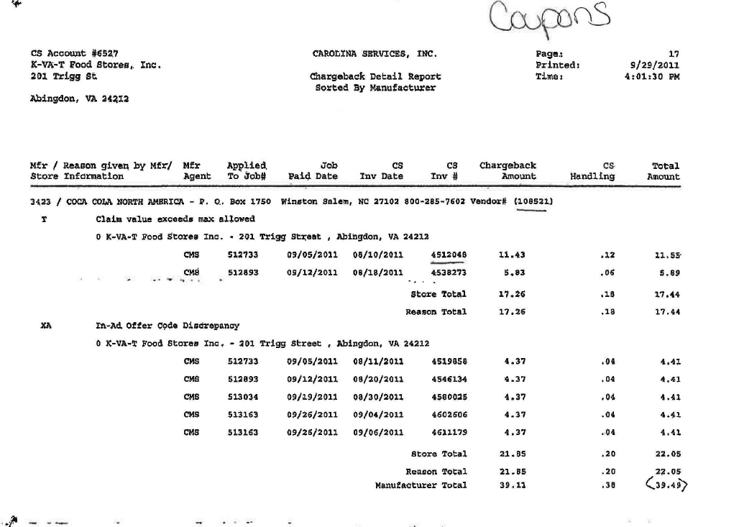
Carolina Services, Inc: identifies that this is a coupon deduction.

12.2 Customer Invoice for Coupons, example 2:
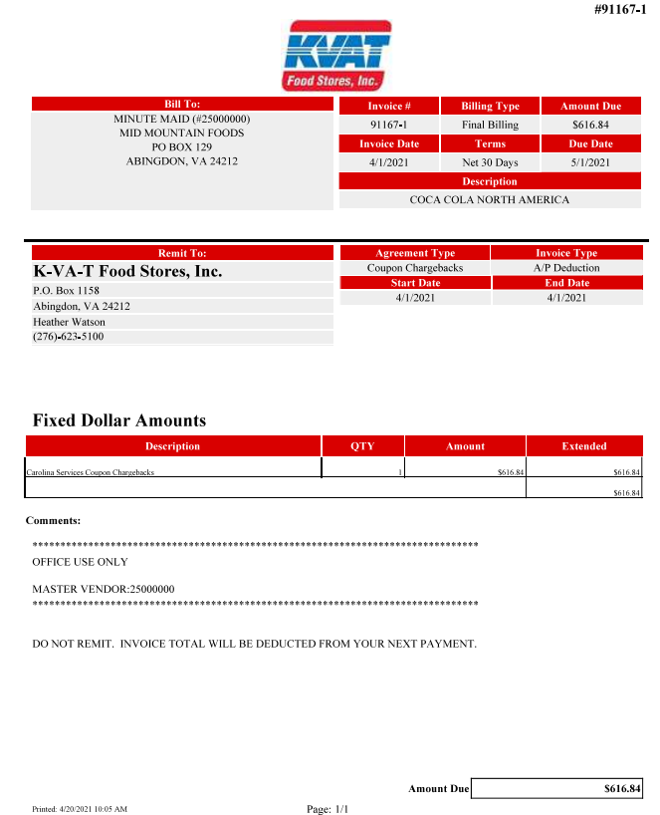

12.2 Customer Invoice for Coupons, example 3:
Page 1:

Coupon Statements: This identifies that the invoice is for a coupon deduction.

12.2 Customer Invoice for Coupons, example 2:
Page 2:

Statement Total: The amount the customer is deducting for coupons.

13. Deduction Type: Penalty Fees

A cost assessed by the customer for various reasons, including: handling, administrative, service and scan fees.

13.1 Customer Invoice for Fee, example 1 – Late Delivery:

Delivery Information: The details for the late delivery fee. The PO was scheduled to deliver by 5:00 pm on 09/29/11. The actual time it arrived was 7:50 PM. A fee was assessed because the truck was 2 hours and 50 minutes late for the appointment.
Deduction Type: This identifies that the customer is charging a fee for a missed/late delivery appointment.
.

Example 2:

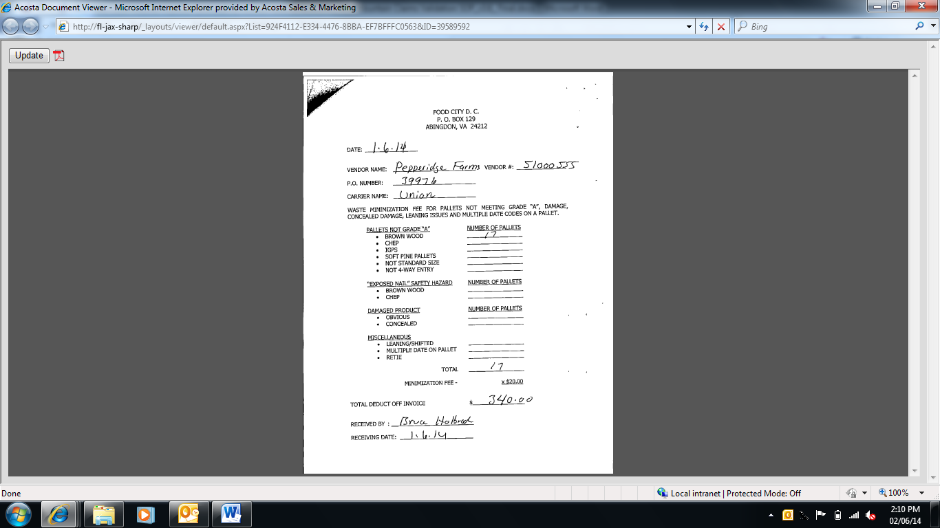
Total amount of invoice.
The customer is charging a fee because the pallets the order shipped on were not of good quality.

Example 3:

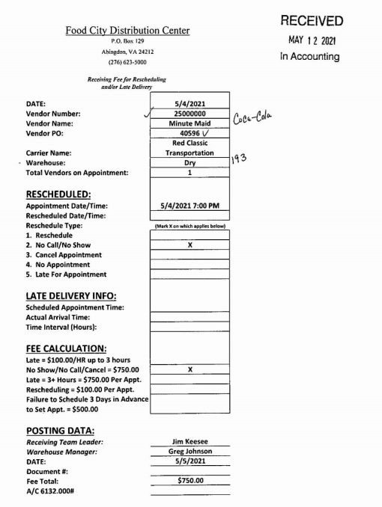

14. Deduction Type: Freight

A Freight allowance is given to the customer for picking up the product via their own transportation services.

Document Name | Source of the Document | Action by Accenture
Customer Invoice | ACOSTA RELAY – search for the invoice under Backup Documentation, document type 2. | Step the claim to Acosta for research.
Client Order Invoice | ACOSTA RELAY – search for this document within the Order/Invoice/PO search.

14.1 Customer Invoice for Freight: Example 1

Deduct From Vendor: The customer is claiming that a freight allowance was not given (or given in the correct amount) on the two POs listed.
Once identified as freight allowance, the claim needs to be stepped to Acosta for further research.

14.1Customr Invoice for Freight: Example 1
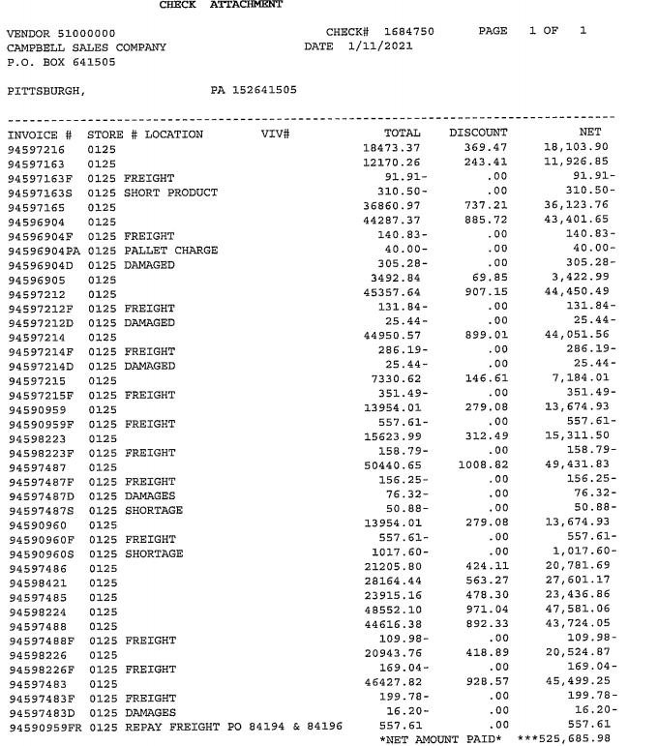

15. Deduction Type: Returns

Products returned by the customer to the client.

Document Name | Source of the Document | Action by Accenture
Customer Invoice | ACOSTA RELAY – search for the invoice under Backup Documentation, document type 2. | Step the claim to Acosta for research.
Client Order Invoice | ACOSTA RELAY – search for this document within the Order/Invoice/PO search.

15.1 Customer Invoice for Returns:

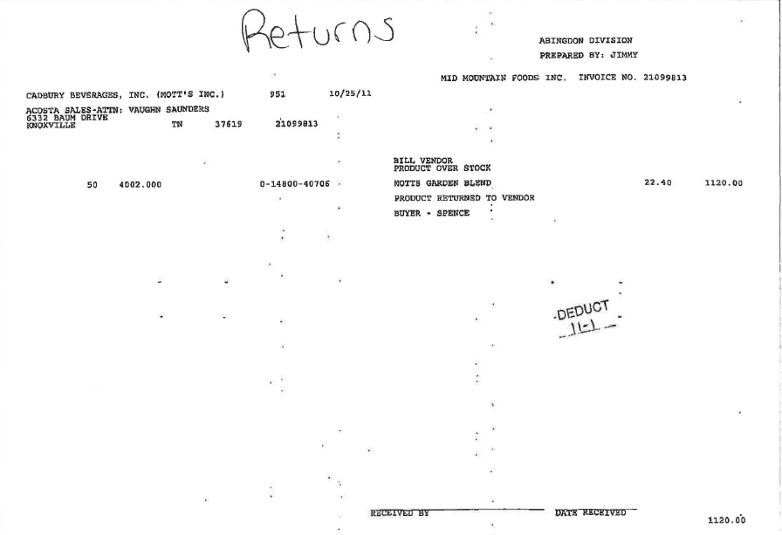
Product Returned to Vendor: Identifies that the invoice is for returns.
Once identified as a return, the claim needs to be stepped to Acosta for further research.
15.1 Customer Invoice for Returns:
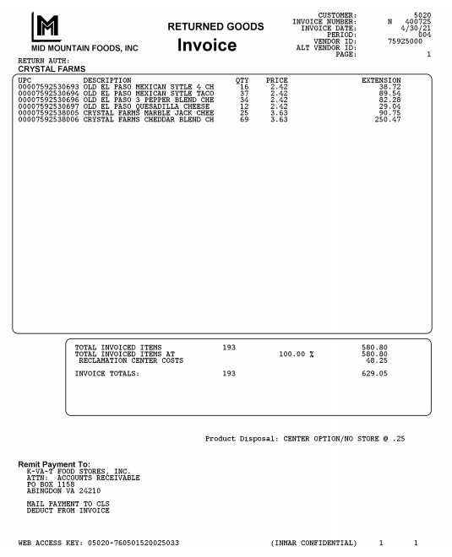

16. Deduction Type: Shortage

It is a deduction for shorted product on an order that the client billed the customer for.

Documents required for validating an Shortage deduction:

Document Name | Source of the Document | Action by Accenture
Customer Invoice | ACOSTA RELAY – search for the invoice under Backup Documentation, document type 2. | Step the claim to Acosta for research.
Client Order Invoice | ACOSTA RELAY – search for this document within the Order/Invoice/PO search.

16.1 Customer Invoice for Shortage:

kv
Deduction Type – This states that the invoice is for a Shortage Deduction.
Once identified as a shortage deduction the claim needs to be stepped to Acosta for further research.
PO #: The customer’s purchase order where they are claiming they were billed for product that was not delivered.

17. Deduction Type: Post Audit

NOTE: The post audit claim must first be researched to ensure the customer has not already billed for the allowance before the normal validation process can begin.

Once the post audit claim has been researched to ensure the customer has not already billed for the allowance, refer to the appropriate allowance section of the SOP to continue with validation. If the post audit is for an allowance not defined in an allowance section of the SOP, refer to the post audit example for validation information.

Internal/external auditors find claims that the customer is entitled to but did not take from previous years. Post Audits should be researched in the same manner as other claims by accessing previous year’s files.

17.1 Customer Invoice for Post Audit Example 1:

Page # 1:
ATG: indicates that this is a Post Audit deduction.

Page # 2:

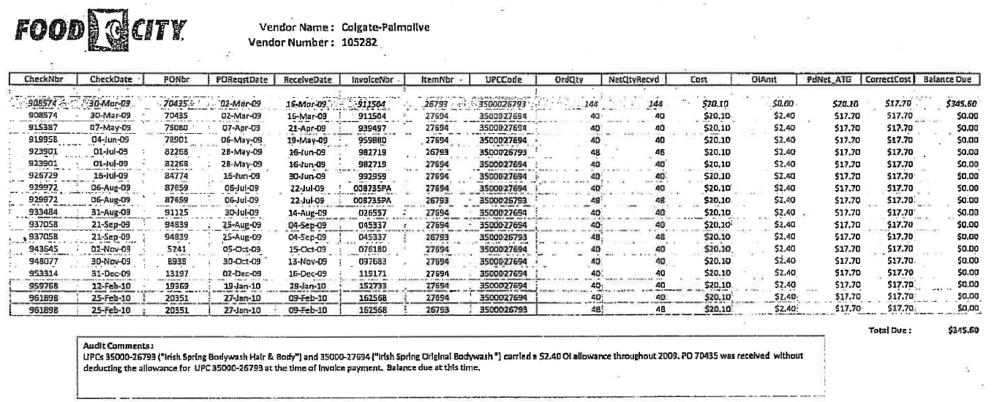
PO Number: The list of orders the auditor is claiming an allowance was due but not given.

Audit Comments: The reason the auditor is claiming the post audit deduction.

17.2 Customer Invoice for Post Audit, Example 2:

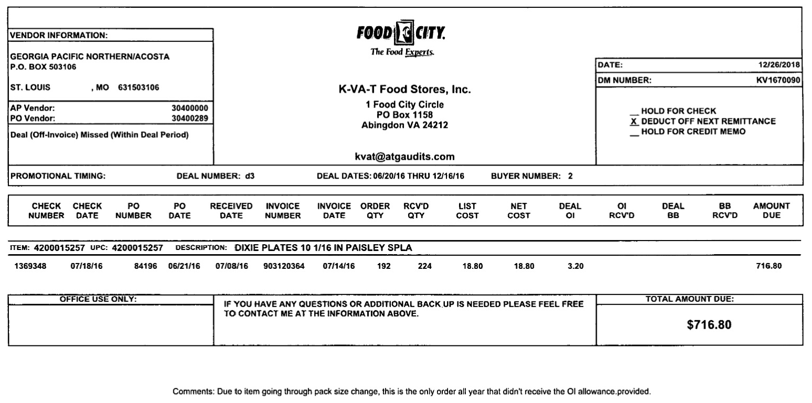
The prefix KV and the e-mail address kvat@atgaudits indicates that this is a Post Audit invoice.

18. Retail Merchandising Fee
See Client SOP/Matrix and Client Specific section of this SOP for validation process.

18.1 Customer Invoice Example 1 – CAT Team Billing:

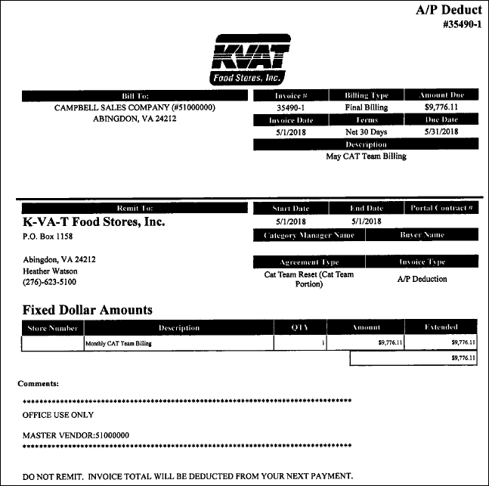
Description: ‘CAT Team Billing’ is for retail merchandising/resets.

BPS TEAM INFORMATION

CRA VALIDATION SPECIFIC

- ISM Labels (Shelf Labels):
The GCC will need to attach the customer invoice and step to ESCALATE – CUSTOMER INVOICE. The CRA will need to work with the sales team to determine if these claims are valid and if a contract or client approval is required.

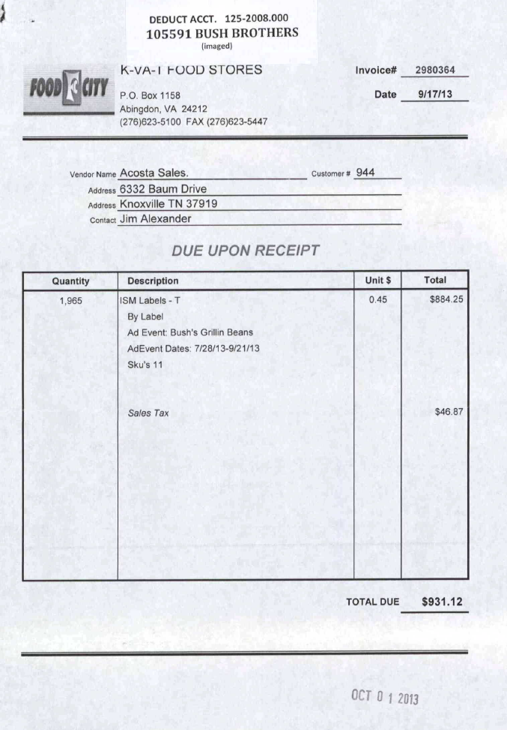

CCA CLEARING INFORMATION SPECIFIC

CCA Client Specific

COMPLETE VERSION HISTORY

UPDATE DESCRIPTION | DATE | AUTHOR
First draft of the Mid Mountain SOP | 04/05/2012
Additional Changes with flow chart | 04/22/2012
Reviewed by Nicole Gaylor | 04/26/2012
Updated with revised flow chart & deduction definitions suggested by Pam | 05/15/2012
Chairside observations | 6/27/2012 | Narendra Gangaram
Final Review by Trainer | 07/13/2012
Update IRI/Nielsen information for price point pg 2 | 9/11/2012 | Rick Smith
Added question #23 to the Process Steps | 09/14/2012 | Geoffrey Van Syckle
Updated hyperlinks to deduction types | 09/16/2012 | Nagesh Kumar
Client Specific Section Added | 12/11/2012 | Heather Blackwell
Mega Event Scan Example added | 02/20/2013 | Heather Blackwell
Wording/example update for Clorox Specific Example | 02/25/2013 | Heather Blackwell
Pinnacle Specific example added for Back to Basics. Additional Scan Customer Invoice Example Added | 03/04/2013 | Heather Blackwell
Adding note to Client Specific Section regarding Mid Mtn buying through MDI. Added a note to the Scan Contract example (Super Mega Event) regarding the “Super Dollar” Banner. Additional OI example added. | 3/11/2013 | Heather Blackwell
Added ACC Only section for Pinnacle non-trade | 3/18/2013 | Heather Blackwell
Update to the Performance Date on Count/Recount Example, pg 26 | 3/25/2013 | Heather Blackwell
Added note to page 30- scan rate can also be found in the Monthly Ad Unit Scan field. | 04/08/2013 | Heather Blackwell
Added note regarding Pinnacle Damage claims (2532) | 4/22/2013 | Heather Blackwell
>Example of two per case allowance contract added to Count/Recount (2660)  >Example of additional CRC contract added (2907)  >Example of Ad/Display invoice added to both Ad and Display section (2267) | 4/29/2013 | Heather Blackwell
>Colgate specific note added to Client section- Contracts for Markdowns under CSD  >New Ad example added, Back To Basics (3284)  >Nestle specific example added for ref invoices (3375) | 05/13/2013 | Heather Blackwell
>Clorox specific example of Golf Tournament (3586) | 05/27/2013 | Heather Blackwell
>Updated the IRI/Nielsen Data- Nielsen Data is available in ACOSTA RELAY for Food City which is part of Mid Mountain. (3805)  >New CI for Ad example added (3898) | 06/17/2013 | Heather Blackwell
>Note added to page 30 as reminder that qty on Sales Summary is Cases, sometimes qty on Invoice will be units. (4522)  *Added customer sign-on listing | 08/12/2013  *10/02/2013 | Heather Blackwell  *Caitlin Goodnight
> Pinnacle specific note for Mega Event deductions added to client specific section (5503) | 11-11-13 | Caitlin Goodnight
> Added example of Mega Event to Pinnacle section (6248)  > ISM Labels (Shelf Labels) – Added CRA specific section with GCC instructions (6302) | 12-9-13 | Caitlin Goodnight
> Added New Item and Close-out Policy (6415) | 01-06-14 | Caitlin Goodnight
> Added client table of contents  > Added note to Back to Basics example about DBW to Pinnacle section (7293)  > Added Waste minimization fee for Pallets to Fee invoice example (6978)**  > Moved “Sometimes Mid Mountain will order through the Customer” section to customer information section  > Added Bayer specifics as they will always be billed in units. (6560)** | 03-03-14 | Caitlin Goodnight  **Christen Ledford
> Added Tyson section – fuel bucks (7367) | 04-14-14 | Caitlin Goodnight
> Pinnacle/Not Acosta (7903)  > Nestle – Markdown process | 05-26-14 | Caitlin Goodnight
> Added fuel buck example (8717) | 07-21-14 | Caitlin Goodnight
> Added Midnite Madness example to scan section (8874)  > Campbells - Customer invoices billing for “price overage” are for Topco. These are validated with the new item forms (contract). (9125) | 11-24-14 | Caitlin Goodnight
> Added unsaleable example 2 (11199) | 02-02-15 | Caitlin Goodnight
> Added info on trade show participation fee – French (12323) | 03-16-15 | Caitlin Goodnight
> Removed Bayer information (13200) | 04-13-15 | Caitlin Goodnight
> Removed screen shot fact sheet and typed to allow “ctrl+f” function.  > Added new promotional calendar information (12687)  > Rephrased that this is a direct customer (13429) | 04-27-15 | Caitlin Goodnight
> Check remit suffix SW is for swell allowance (13404)  > Tyson - Mid Mountain claims are created from a customer invoice. These claims have to be processed the day they are received.Handle claims for TYSFDS (Deli/Fresh), TYSIBP, and TYSWBF. (14017)  > Removed Beiersdorf information, no longer rep (14054) | 06-08-15 | Caitlin Goodnight
> Clean up and reorganization of information (14730)  > White wave markdown information added (14526)  *> Added line level data info (15509)  ** > Updated BPS team template | 09.14.15  *10.12.15  **01.11.16 | Caitlin Goodnight
> TYSON - Net Cost or Cost Change or Cost Extension contract info (17279) | 05.23.16 | Caitlin Goodnight
> CLOROX – Added date flexibility info (18512)  > Updated CRA backup retrival info per customer invoice matrix  > GAPAC – Added claim validation process (18461) | 06.20.16 | Caitlin Goodnight
> Updated post audit section header (19056) | 09.02.16 | Caitlin Goodnight
> Removed duplicated contracts & added generic statement for POP (19418) | 10.10.16 | Caitlin Goodnight
> Name change from Mid Mountain to K-VAT (20936) | 03.13.16 | Caitlin Goodnight
> COLGAT – Add GCC to sales stepping exceptions (21011) | 03.17.17 | Caitlin Goodnight
> Removed, “Refer to client SOP for approval needed to validate tracking claims due to this date policy vs policy issue”. (21319) Updated Nestle to Nestle Nut/CStore (21471) | 05.08.17 | Caitlin Goodnight
> Added Mega event example to the scan section (21394) Nestle USA Monthly CAT Team Billings coded as Not Acosta (21677)  * Updated hyperlink (23751) | 07.03.17  *01.30.18 | Caitlin Goodnight
> BARILL markdown info added to client specific and cca clearing sections (23838) | 02.26.18 | Caitlin Goodnight
> Removed Frenchs info (23861) BARILL markdown info added to client specific and cca clearing sections (23838) | 03.26.18 | Caitlin Goodnight
> Scrubbed Customer Info: Moved BU request info to BPS section. Removed 2015 Back to Basics schedule. Scrubbed Client Info: Haven’t handled Pinnacle for KVAT since 2014. Removed specific section and clearing section.  > Added Post Audit invoice example (24310) | 05.07.18 | Caitlin Goodnight
> TYSON – removed info about check request (25110) Added PM invoice example with two rates for one UPC. (25100) | 07.16.18 | Caitlin Goodnight
> Combined fuel perks to scan section (25441) Added retail merchandising section (25442) Added Ainsworth, GCC stepping process (25336) Update to customer backup request information/realignment of information, no process change. | 08.13.18 | Caitlin Goodnight
> Removed White Wave. No longer rep. (25874) For count.recount claims, perf dates or begin/end dates can be used to validate (25919) | 09.28.18 | Caitlin Goodnight
> Added simplified customer info to Colgate validation section (26285) | 11.19.18 | Caitlin Goodnight
> Added info on ad requirements to customer general contract section. Updated scan contract example 1 to mor recent contract. (25899) Sop Scrub – Updated slotting invoice and contract example. | 12.03.18 | Caitlin Goodnight
Updated customer sign-on for Neilson Reports (26700) | 12/31/2018 | Carlos Ocasio
Added Ken’s to the Client Specific section (26740) | 01/14/2019 | Carlos Ocasio
Removed document location and version history. Removed Tyson as Acosta no handles claims effective 04/27/19 (27728) | 04/30/2019 | Carlos Ocasio
Removed Ainsworth as we no longer represent since 5/1/19 (27796)) | 5/20/2019 | Carlos Ocasio
Updated the contract info section that rates can be located in the Personalized Offers section(27906)  Removed Pinnacle specific information, no longer handle claims effective 08/26/19 (28434) | 07/19/2019  09/04/2019 | Carlos Ocasio
Added to the Nestle USA client specific section that Markdowns do not need POP (28424) | 10/21/2019 | Carlos Ocasio
SOP scrub for typos and outdated information (28709) | 11/18/2019 | Suzy Fields
Created Backup Retrieval Information section (29033) | 12/2/2019 | Suzy Fields
Client Specific section: Removed Georgia Pacific info as client took them in-house (29281) | 1/27/2020 | Suzy Fields
Client Specific section: Removed Colgate information as Acosta no longer represents (29496) | 2/24/2020 | Suzy Fields
Client Specific section: Campbell’s/Pepperidge Farms: Added instructions for DSD Labels (29341); added Quarterly Space Management Fee instructions (29666) | 3/9/2020 | Suzy Fields
Client Specific section: Campbell’s/Pepperidge Farms: added Accrual Check information (29773) | 3/23/2020 | Suzy Fields
Client Specific section: Campbell’s/Pepperidge Farms: added Accrual Check information (29773) | 3/23/2020 | Suzy Fields
Client Specific section removed Nestle USA (30502) and Nestle C-Store no longer rep as of 6/30 (30503) | 7/13/20 | Ca-Tonya Barnwell
Client Specific Validation Information section for Campbells added instructions for DSD shipment invoices.(31783) | 4/9/21 |  | Ca-Tonya Barnwell
Client Specific Validation Information section added Mars Food-Mid Mountain/KVAT is part of the Retail Merchandising Program (31971) | 5/3/21 |  | Ca-Tonya Barnwell
Display deduction type added example for Back to Basics(33549). | 5/23/2022 |  | Mary Kay Dressman
Client Specific section for Mars added Q3 Markdown events (33959). | 9/12/2022 |  | Mary Kay Dressman
Client specific section for Ken’s add information on product bought through AWG(34341). | 1/17/23 |  | Mary Kay Dressman
Added Mars Wrigley Confectionery to the Client Specific section and included damage event number for calendar year 2023(34406). | 1/30/2023 |  | Mary Kay Dressman
Added Pompeian to the Client Specific section with information on Type T invoices and invoice/contract has one rate but is comprised of two events(34426). | 2-6-2023 |  | Mary Kay Dressman
Client Specific section added information for Chicken of the Sea and lump sums on contracts(34945). | 6/12/2023 |  | Mary Kay Dressman
Client Specific section removed information on Nestle Nutrition as no longer work claims(35306). | 8/7/2023 |  | Mary Kay Dressman
Client Specific section added information for Ken’s and buying thru AWG(35453). | 10/23/2023 |  | Mary Kay Dressman
Updated information pertaining to Kens in Client Specific Validation Information Section (409182). | 12/16/24 |  | Dawn Regan
Removed Mars Wrigley Confection from Client Specific Section. (412510) | 1/20/25 |  | Pam Jaeger
Removed information for Kens in Client Specific Validation Section (412530) | 2/3/25 |  | Dawn Regan
Updated information for Chicken of the Sea in the Client Specific Validation Section (417622) | 2/10/25 |  | Dawn Regan
Removed FY23/FY24 events for Kens in the Client Specific Validation Section (427723) | 6/16/25 |  | Dawn Regan
Updated events for Kens/AWG in the Client Specific Validation Section (431174) | 7/14/25 |  | Dawn Regan
Updated event for Kens in the Client Specific Validation Section (440531) | 9/29/25 |  | Dawn Regan
Updated Client name for Chicken of the Sea in Client Specific Section (441542) | 10/6/25 |  | Dawn Regan
Updated verbiage in Markdown Section (448388). | 11/17/25 |  | Dawn Regan
Added markdown events for Campbells in Client Specific Validation Information Section (450120). | 12/8/2025 |  | Dawn Regan
Added information for Georgia Pacific in Backup Retrieval Information Section (452141). | 12/22/25 |  | Dawn Regan

